BEACON EDUCATIONAL CONSULT
MARKING GUIDE — MOCK EXAMINATION 2026/2027
MATHEMATICS — BASIC 9 (JHS 3) — Chapter 9: Change of Subject, Substitution & Factorisation (B9.2.2.1)

Curriculum Standard (NaCCA CCP, Sept 2020): B9.2.2.1 — Demonstrate an understanding of (i) change of subject (ii) substituting values to evaluate expressions, and (iii) factorize expressions that have simple binomial as a factor.
Indicators tested: B9.2.2.1.1 Perform change of subject of a given formula and use it to solve problems; B9.2.2.1.2 Substitute values into given formulae to evaluate them and use them to solve problems; B9.2.2.1.3 Factorise expressions that have simple binomial factors.

SECTION A: ANSWER KEY
Qn | Ans | Content Focus | Indicator
1 | B | Change of subject (simple) | B9.2.2.1.1
2 | C | Change of subject (simple) | B9.2.2.1.1
3 | A | Change of subject (circumference) | B9.2.2.1.1
4 | D | Change of subject (triangle area) | B9.2.2.1.1
5 | A | Change of subject (motion) | B9.2.2.1.1
6 | B | Change of subject (rectangle) | B9.2.2.1.1
7 | C | Change of subject (two steps) | B9.2.2.1.1
8 | B | Change of subject (square root) | B9.2.2.1.1
9 | A | Change of subject (perimeter) | B9.2.2.1.1
10 | C | Change of subject (squares) | B9.2.2.1.1
11 | D | Use a changed subject (rectangle, curriculum exemplar) | B9.2.2.1.1
12 | B | Use a changed subject (circle, curriculum exemplar) | B9.2.2.1.1
13 | C | Use a changed subject (triangle, curriculum exemplar) | B9.2.2.1.1
14 | B | Use a changed subject (cylinder, curriculum exemplar) | B9.2.2.1.1
15 | D | Substitute into an expression | B9.2.2.1.2
16 | A | Substitute two values | B9.2.2.1.2
17 | D | Substitute with a negative value (curriculum exemplar) | B9.2.2.1.2
18 | A | Substitute a negative value | B9.2.2.1.2
19 | B | Substitute into brackets | B9.2.2.1.2
20 | D | Substitute into a formula | B9.2.2.1.2
21 | A | Substitute into a volume formula (curriculum exemplar) | B9.2.2.1.2
22 | D | Substitute into the SI formula | B9.2.2.1.2
23 | B | Substitute into a motion formula | B9.2.2.1.2
24 | D | Substitute into squares | B9.2.2.1.2
25 | C | Substitute into a fraction | B9.2.2.1.2
26 | A | Substitute under a root | B9.2.2.1.2
27 | D | Common factor (curriculum exemplar) | B9.2.2.1.3
28 | C | Common factor (curriculum exemplar) | B9.2.2.1.3
29 | B | Negative common factor (curriculum exemplar) | B9.2.2.1.3
30 | C | Common factor (curriculum exemplar) | B9.2.2.1.3
31 | A | Numerical common factor | B9.2.2.1.3
32 | C | Variable common factor | B9.2.2.1.3
33 | B | Common factor with powers | B9.2.2.1.3
34 | D | Difference of two squares | B9.2.2.1.3
35 | A | Factorisation by grouping | B9.2.2.1.3
36 | D | Quadratic trinomial | B9.2.2.1.3
37 | A | Numerical common factor | B9.2.2.1.3
38 | C | Difference of two squares | B9.2.2.1.3
39 | B | Common factor of terms | B9.2.2.1.3
40 | C | Common factor with two variables | B9.2.2.1.3

Full answer key: BCADA BCBAC DBCBD ADABD ADBDC ADCBC ACBDA DACBC

SECTION A: WORKED SOLUTIONS
1. Answer: B. Subtract a from both sides: x = b − a. [B9.2.2.1.1]
2. Answer: C. Divide both sides by 2: x = y/2. [B9.2.2.1.1]
3. Answer: A. Divide both sides by 2π: r = C/(2π). [B9.2.2.1.1]
4. Answer: D. 2A = bh → h = 2A/b. [B9.2.2.1.1]
5. Answer: A. at = v − u → t = (v − u)/a. [B9.2.2.1.1]
6. Answer: B. Divide by l: b = A/l. [B9.2.2.1.1]
7. Answer: C. y + 2 = 3x → x = (y + 2)/3. [B9.2.2.1.1]
8. Answer: B. r² = A/π → r = √(A/π). [B9.2.2.1.1]
9. Answer: A. l + b = P/2 → l = P/2 − b. [B9.2.2.1.1]
10. Answer: C. 2as = v² − u² → a = (v² − u²)/(2s). [B9.2.2.1.1]
11. Answer: D. b = A/l = 24 ÷ 8 = 3 cm (curriculum exemplar). [B9.2.2.1.1]
12. Answer: B. r² = 154 ÷ 22/7 = 154 × 7/22 = 49 → r = 7 cm (curriculum exemplar). [B9.2.2.1.1]
13. Answer: C. h = 2A/b = 108 ÷ 12 = 9 cm (curriculum exemplar). [B9.2.2.1.1]
14. Answer: B. πr² = 22/7 × 49 = 154; h = 1,540 ÷ 154 = 10 cm. [B9.2.2.1.1]
15. Answer: D. 2² + 3 × 2 = 4 + 6 = 10. [B9.2.2.1.2]
16. Answer: A. 2 × 4 − 3 × 1 = 8 − 3 = 5. [B9.2.2.1.2]
17. Answer: D. x − b = 7; 7² − 3 × 7 = 49 − 21 = 28 (curriculum exemplar). [B9.2.2.1.2]
18. Answer: A. 3 × 1 − 2 × (−1) + 1 = 3 + 2 + 1 = 6. [B9.2.2.1.2]
19. Answer: B. (5 + 3)(5 − 3) = 8 × 2 = 16. [B9.2.2.1.2]
20. Answer: D. ½ × 10 × 3² = ½ × 10 × 9 = 45. [B9.2.2.1.2]
21. Answer: A. ⅓ × 22/7 × 7² × 21 = ⅓ × 22 × 7 × 21 = 1,078 cm³ (curriculum exemplar). [B9.2.2.1.2]
22. Answer: D. I = (500 × 4 × 3)/100 = 60. [B9.2.2.1.2]
23. Answer: B. v = 5 + 2 × 4 = 13. [B9.2.2.1.2]
24. Answer: D. 7² − 3² = 49 − 9 = 40. [B9.2.2.1.2]
25. Answer: C. (2 × 5 + 2)/3 = 12/3 = 4. [B9.2.2.1.2]
26. Answer: A. √(9 + 16) = √25 = 5. [B9.2.2.1.2]
27. Answer: D. Common factor x: x(3 + 4y) (curriculum exemplar). [B9.2.2.1.3]
28. Answer: C. HCF 4b: 4b(3a + 4) (curriculum exemplar). [B9.2.2.1.3]
29. Answer: B. Factor −13x: −13x(y − 3) (curriculum exemplar). [B9.2.2.1.3]
30. Answer: C. HCF 2y: 2y(4 − y) (curriculum exemplar). [B9.2.2.1.3]
31. Answer: A. 5(x + 2). [B9.2.2.1.3]
32. Answer: C. x(x + 3). [B9.2.2.1.3]
33. Answer: B. HCF 3a: 3a(2a − 3). [B9.2.2.1.3]
34. Answer: D. 4(x² − 4) = 4(x + 2)(x − 2). [B9.2.2.1.3]
35. Answer: A. Group: a(x + y) + b(x + y) = (a + b)(x + y). [B9.2.2.1.3]
36. Answer: D. 2x² + 4x + x + 2 = 2x(x + 2) + 1(x + 2) = (2x + 1)(x + 2). [B9.2.2.1.3]
37. Answer: A. 7(p − q). [B9.2.2.1.3]
38. Answer: C. (x + 3)(x − 3). [B9.2.2.1.3]
39. Answer: B. HCF of 6 and 9 is 3; common letters x and y → 3xy. [B9.2.2.1.3]
40. Answer: C. HCF 5mn: 5mn(3m − 2n). [B9.2.2.1.3]

SECTION B: MARKING SCHEME

1. Change of subject [10 marks]
(a) Make x the subject of y = 3x − 5. y + 5 = 3x → x = (y + 5)/3. [2 marks]
(b) Make b the subject of A = ½(a + b)h. 2A = (a + b)h → 2A/h = a + b → b = 2A/h − a. [3 marks]
(c) Make u the subject of v² = u² + 2as. u² = v² − 2as → u = √(v² − 2as). [3 marks]
(d) Make l the subject of T = 2π√(l/g). T² = 4π²(l/g) → l = gT²/(4π²). [2 marks]
[Total: 10 marks]

2. Using changed subjects with the figures [10 marks]
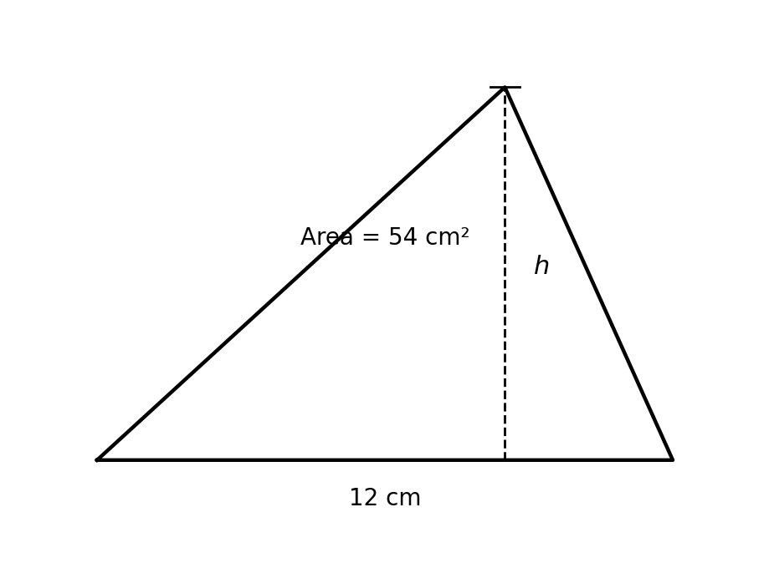
Fig. 1 — Triangle with base 12 cm and height h; area 54 cm².
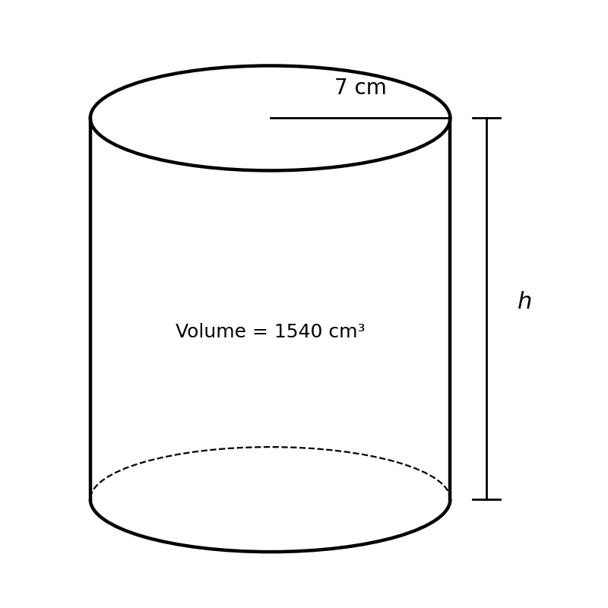
Fig. 2 — Cylinder with radius 7 cm and height h; volume 1,540 cm³.
(a) The area of a rectangle is 24 cm² and its length is 8 cm. Find the width (curriculum exemplar). b = A/l = 24/8 = 3 cm. [2 marks]
(b) A circle has an area of 154 cm². Taking π = 22/7, find its radius (curriculum exemplar). r² = A ÷ π = 154 × 7/22 = 49 → r = 7 cm. [3 marks]
(c) Using Fig. 1, the triangle has an area of 54 cm². Find h (curriculum exemplar). h = 2A/b = (2 × 54)/12 = 108/12 = 9 cm. [2 marks]
(d) Using Fig. 2, the cylinder has a volume of 1,540 cm³. Taking π = 22/7, find h. h = V ÷ πr² = 1,540 ÷ (22/7 × 49) = 1,540 ÷ 154 = 10 cm. [3 marks]
[Total: 10 marks]

3. Substitution [10 marks]
(a) Find the value of (x − b)² − 3(x − b) when x = 2 and b = −5 (curriculum exemplar). x − b = 2 − (−5) = 7; so 7² − 3 × 7 = 49 − 21 = 28. [3 marks]
(b) Evaluate 3p² − 2pq + q² when p = 2 and q = −1. 3 × 4 − 2 × 2 × (−1) + 1 = 12 + 4 + 1 = 17. [3 marks]
(c) The volume of a cone is ⅓πr²h. Find the volume when r = 7, h = 21 and π = 22/7 (curriculum exemplar). ⅓ × 22/7 × 49 × 21 = 22 × 7 × 7 = 1,078 cm³. [2 marks]
(d) Using v = u + at, find v when u = 5, a = 2 and t = 4. v = 5 + 2 × 4 = 13. [2 marks]
[Total: 10 marks]

4. Factorisation (curriculum exemplars) [10 marks]
Factorise each expression.
(a) 3x + 4xy x(3 + 4y). [2 marks]
(b) 12ab + 16b 4b(3a + 4). [2 marks]
(c) −13xy + 39x −13x(y − 3). [2 marks]
(d) 8y − 2y² 2y(4 − y). [2 marks]
(e) ax + ay + bx + by a(x + y) + b(x + y) = (a + b)(x + y). [2 marks]
[Total: 10 marks]

5. Mixed: substitution and factorisation [10 marks]
(a) Make h the subject of E = mgh. h = E/(mg). [2 marks]
(b) Hence find h when E = 500, m = 2 and g = 10. h = 500/(2 × 10) = 25. [2 marks]
(c) Factorise completely 4x² − 16. 4(x² − 4) = 4(x + 2)(x − 2). [3 marks]
(d) Hence solve 4x² − 16 = 0. 4(x + 2)(x − 2) = 0 → x = −2 or x = 2. [3 marks]
[Total: 10 marks]

6. Create and solve [10 marks]
(a) Write a formula from a real-life situation of your own, then change its subject to a different letter. Any valid formula correctly transposed. Example: cost C = 5n for n items; making n the subject gives n = C/5. Award 2 marks for the formula, 2 for the correct transposition. [4 marks]
(b) Write an algebraic expression of your own and factorise it completely. Any factorisable expression correctly factorised. Example: 9x + 6x² = 3x(3 + 2x). Award 1 mark for the expression, 2 for correct factorisation. [3 marks]
(c) Substitute values of your own into your expression from (b) and evaluate it. Correct substitution and evaluation. Example: at x = 2: 9(2) + 6(4) = 18 + 24 = 42. Award 1 mark for substitution, 2 for the correct value. [3 marks]
[Total: 10 marks]

CURRICULUM BLUEPRINT
Qn | Content Focus | Indicator | Marks
1 | Change of subject (simple) | B9.2.2.1.1 | 1
2 | Change of subject (simple) | B9.2.2.1.1 | 1
3 | Change of subject (circumference) | B9.2.2.1.1 | 1
4 | Change of subject (triangle area) | B9.2.2.1.1 | 1
5 | Change of subject (motion) | B9.2.2.1.1 | 1
6 | Change of subject (rectangle) | B9.2.2.1.1 | 1
7 | Change of subject (two steps) | B9.2.2.1.1 | 1
8 | Change of subject (square root) | B9.2.2.1.1 | 1
9 | Change of subject (perimeter) | B9.2.2.1.1 | 1
10 | Change of subject (squares) | B9.2.2.1.1 | 1
11 | Use a changed subject (rectangle, curriculum exemplar) | B9.2.2.1.1 | 1
12 | Use a changed subject (circle, curriculum exemplar) | B9.2.2.1.1 | 1
13 | Use a changed subject (triangle, curriculum exemplar) | B9.2.2.1.1 | 1
14 | Use a changed subject (cylinder, curriculum exemplar) | B9.2.2.1.1 | 1
15 | Substitute into an expression | B9.2.2.1.2 | 1
16 | Substitute two values | B9.2.2.1.2 | 1
17 | Substitute with a negative value (curriculum exemplar) | B9.2.2.1.2 | 1
18 | Substitute a negative value | B9.2.2.1.2 | 1
19 | Substitute into brackets | B9.2.2.1.2 | 1
20 | Substitute into a formula | B9.2.2.1.2 | 1
21 | Substitute into a volume formula (curriculum exemplar) | B9.2.2.1.2 | 1
22 | Substitute into the SI formula | B9.2.2.1.2 | 1
23 | Substitute into a motion formula | B9.2.2.1.2 | 1
24 | Substitute into squares | B9.2.2.1.2 | 1
25 | Substitute into a fraction | B9.2.2.1.2 | 1
26 | Substitute under a root | B9.2.2.1.2 | 1
27 | Common factor (curriculum exemplar) | B9.2.2.1.3 | 1
28 | Common factor (curriculum exemplar) | B9.2.2.1.3 | 1
29 | Negative common factor (curriculum exemplar) | B9.2.2.1.3 | 1
30 | Common factor (curriculum exemplar) | B9.2.2.1.3 | 1
31 | Numerical common factor | B9.2.2.1.3 | 1
32 | Variable common factor | B9.2.2.1.3 | 1
33 | Common factor with powers | B9.2.2.1.3 | 1
34 | Difference of two squares | B9.2.2.1.3 | 1
35 | Factorisation by grouping | B9.2.2.1.3 | 1
36 | Quadratic trinomial | B9.2.2.1.3 | 1
37 | Numerical common factor | B9.2.2.1.3 | 1
38 | Difference of two squares | B9.2.2.1.3 | 1
39 | Common factor of terms | B9.2.2.1.3 | 1
40 | Common factor with two variables | B9.2.2.1.3 | 1
B1 | Change of subject of formulae | B9.2.2.1.1 | 10
B2 | Using changed subjects with figures (curriculum exemplars) | B9.2.2.1.1 | 10
B3 | Substitution into expressions and formulae | B9.2.2.1.2 | 10
B4 | Factorisation (curriculum exemplars) | B9.2.2.1.3 | 10
B5 | Mixed substitution & factorisation (solve via factors) | B9.2.2.1.2 / .3 | 10
B6 | Create & solve: formulae and factorisation | B9.2.2.1.3 | 10
 | TOTAL |  | 100

CURRICULUM COVERAGE BY INDICATOR
Curriculum Area | Section A | Section B | Total | %
B9.2.2.1.1 Change of subject; using changed subjects to solve problems | 14 | 20 (B1, B2) | 34 | 34%
B9.2.2.1.2 Substitution into expressions and formulae | 12 | 20 (B3, B5) | 32 | 32%
B9.2.2.1.3 Factorisation with simple binomial factors | 14 | 20 (B4, B6) | 34 | 34%
Note: Section A q1–14 change of subject (14 marks); q15–26 substitution (12); q27–40 factorisation (14). Section B: B1–B2 change of subject incl. figure problems (20); B3 substitution (10); B4 factorisation (10); B5 mixes substitution and factorisation (10, credited to .2 with .3 in part c–d); B6 create-and-solve (10).

COGNITIVE-LEVEL DISTRIBUTION
Cognitive Level | Section A | Section B | Total | %
Remember | 0 | 0 | 0 | 0%
Understand | 2 | 0 | 2 | 2%
Apply | 35 | 50 | 85 | 85%
Analyse | 3 | 0 | 3 | 3%
Evaluate | 0 | 0 | 0 | 0%
Create | 0 | 10 | 10 | 10%

DIFFICULTY DISTRIBUTION
Difficulty | Section A | Section B | Total | %
Easy | 15 | 10 (B4) | 25 | 25%
Moderate | 19 | 30 (B1, B2, B3) | 49 | 49%
Challenging | 6 | 20 (B5, B6) | 26 | 26%

QUALITY-CONTROL SUMMARY
Check | Status
Curriculum alignment | All three indicators of B9.2.2.1 covered: change of subject (.1), substitution (.2), factorisation with simple binomial factors (.3).
Section structure | Section A: 40 objectives (40 marks). Section B: 6 structured questions (60 marks). Total 100 marks, 2 hours.
Answer key balance | A=10, B=10, C=10, D=10. Zero consecutive repeats. No sustained cycling pattern.
Diagrams (BECE style) | Fig. 1 — triangle (base 12 cm, height h, area 54 cm²) and Fig. 2 — cylinder (radius 7 cm, height h, volume 1,540 cm³), mirroring the CCP's figure-based exemplars; used in Section A q13–14 and Section B Q2.
Curriculum exemplars used | Rectangle 24 cm²/8 cm; circle 154 cm²; triangle 54 cm²; cone ⅓πr²h (r = 7, h = 21); (x − b)² − 3(x − b) with x = 2, b = −5; and the full factorisation set 3x + 4xy, 12ab + 16b, −13xy + 39x, 8y − 2y² — all from the CCP.
Distractor quality | Plausible errors: inverted transpositions (a − b), forgetting to divide all terms, sign slips with negatives, factor pairs that expand to near-misses, and never an option algebraically equal to the key.
Marking guide completeness | Every Section B part carries explicit marks (each question sums to 10); full worked steps shown.
Blueprint | 46-row blueprint (40 objectives + 6 structured) sums to exactly 100 marks.
Coverage | .1 = 34%, .2 = 32%, .3 = 34% — balanced across the three indicators.
Cognitive spread | Understand 2%, Apply 85%, Analyse 3%, Create 10%.
Difficulty spread | Easy 25%, Moderate 49%, Challenging 26%.

