BEACON EDUCATIONAL CONSULT
MOCK EXAMINATION — 2026/2027 ACADEMIC YEAR
MATHEMATICS — BASIC 9 (JHS 3)
Chapter 9: Change of Subject, Substitution & Factorisation (Curriculum Standard B9.2.2.1)
Time Allowed: 2 Hours Total Marks: 100

INSTRUCTIONS TO CANDIDATES
1. Write your name and index number on the answer sheet provided.
2. This paper consists of TWO sections: Section A (Objectives) and Section B (Structured Questions).
3. Section A: Answer ALL forty (40) questions. Each question carries 1 mark. Choose the correct option from A to D.
4. Section B: Answer ALL six (6) questions. Each question carries 10 marks. Show all necessary workings.
5. Study all diagrams carefully before answering the questions that refer to them.
6. Take π = 22/7 where required. Use a non-programmable calculator where necessary.

SECTION A: OBJECTIVE TEST (40 MARKS)
Answer ALL questions in this section. Choose the correct answer from A to D.
1. Make x the subject of the formula x + a = b.
A. x = a − b
B. x = b − a
C. x = b + a
D. x = −b − a
2. Make x the subject of the formula 2x = y.
A. x = y − 2
B. x = y + 2
C. x = y/2
D. x = 2y
3. Make r the subject of the formula C = 2πr.
A. r = C/(2π)
B. r = C − 2π
C. r = C/π
D. r = 2πC
4. Make h the subject of the formula A = ½bh.
A. h = A/b
B. h = A/(2b)
C. h = ½Ab
D. h = 2A/b
5. Make t the subject of the formula v = u + at.
A. t = (v − u)/a
B. t = (v − u) × a
C. t = v − u/a
D. t = (v + u)/a
6. Make b the subject of the formula A = l × b.
A. b = A − l
B. b = A/l
C. b = A × l
D. b = l/A
7. Make x the subject of the formula y = 3x − 2.
A. x = (y − 2)/3
B. x = 3(y + 2)
C. x = (y + 2)/3
D. x = y/3 + 2
8. Make r the subject of the formula A = πr².
A. r = √(Aπ)
B. r = √(A/π)
C. r = 2A/π
D. r = A/π
9. Make l the subject of the formula P = 2(l + b).
A. l = P/2 − b
B. l = 2P − b
C. l = P − 2b
D. l = (P − b)/2
10. Make a the subject of the formula v² = u² + 2as.
A. a = (v − u)/(2s)
B. a = (v² − u²) × 2s
C. a = (v² − u²)/(2s)
D. a = (v² + u²)/(2s)
11. The area of a rectangle is 24 cm². If the length is 8 cm, the width is (curriculum exemplar)
A. 16 cm
B. 6 cm
C. 4 cm
D. 3 cm
12. A circle has an area of 154 cm². Taking π = 22/7, its radius is (curriculum exemplar)
A. 14 cm
B. 7 cm
C. 49 cm
D. 22 cm
Questions 13 and 14 refer to Fig. 1 and Fig. 2 below.
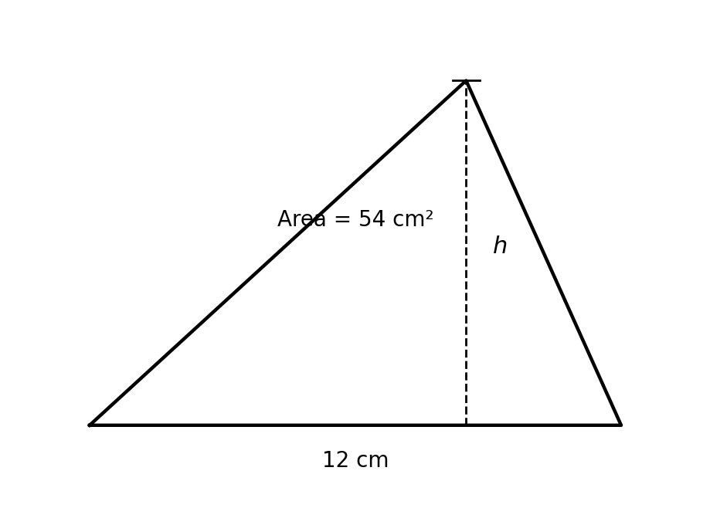
Fig. 1 — Triangle, area 54 cm².
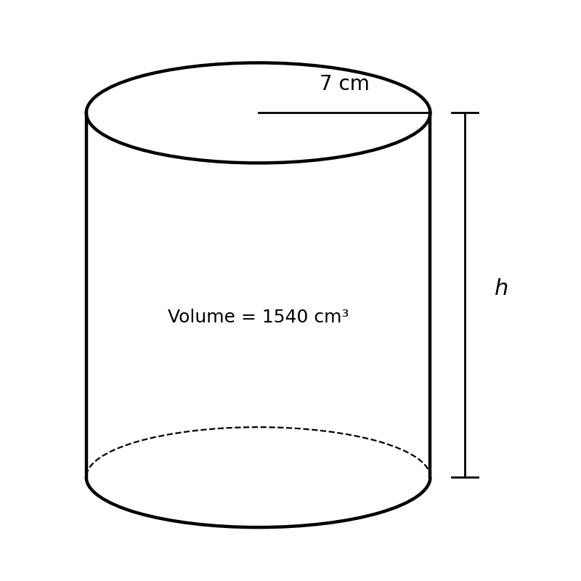
Fig. 2 — Cylinder, volume 1,540 cm³.
13. The triangle has an area of 54 cm². The value of the height h is (curriculum exemplar)
A. 4.5 cm
B. 108 cm
C. 9 cm
D. 12 cm
14. The cylinder has a volume of 1,540 cm³. Taking π = 22/7, the value of the height h is
A. 44 cm
B. 10 cm
C. 22 cm
D. 100 cm
15. Find the value of x² + 3x when x = 2.
A. 8
B. 7
C. 12
D. 10
16. Evaluate 2a − 3b when a = 4 and b = 1.
A. 5
B. 11
C. −1
D. 6
17. Find the value of (x − b)² − 3(x − b) when x = 2 and b = −5 (curriculum exemplar).
A. 49
B. 21
C. 7
D. 28
18. Evaluate 3m² − 2m + 1 when m = −1.
A. 6
B. 0
C. 2
D. 4
19. Evaluate (p + q)(p − q) when p = 5 and q = 3.
A. 8
B. 16
C. 2
D. 34
20. Using s = ½gt², find s when g = 10 and t = 3.
A. 90
B. 30
C. 15
D. 45
21. The volume of the shape is ⅓πr²h. The volume when r = 7, h = 21 and π = 22/7 is (curriculum exemplar)
A. 1,078 cm³
B. 462 cm³
C. 3,234 cm³
D. 154 cm³
22. Using I = PRT/100, find I when P = 500, R = 4 and T = 3.
A. 600
B. 120
C. 6,000
D. 60
23. Using v = u + at, find v when u = 5, a = 2 and t = 4.
A. 14
B. 13
C. 7
D. 11
24. Evaluate a² − b² when a = 7 and b = 3.
A. 44
B. 16
C. 4
D. 40
25. Evaluate (2x + y)/3 when x = 5 and y = 2.
A. 3
B. 3 1/3
C. 4
D. 6
26. Evaluate √(a² + b²) when a = 3 and b = 4.
A. 5
B. 25
C. 1
D. 7
27. Factorise 3x + 4xy (curriculum exemplar).
A. xy(3 + 4)
B. x(4 + 3y)
C. 3x(1 + 4y)
D. x(3 + 4y)
28. Factorise 12ab + 16b (curriculum exemplar).
A. 4a(3b + 4)
B. 4b(3a + 4b)
C. 4b(3a + 4)
D. 16b(3a + 1)
29. Factorise −13xy + 39x (curriculum exemplar).
A. −13x(y + 3)
B. −13x(y − 3)
C. −13x(3 − y)
D. 13x(y − 3)
30. Factorise 8y − 2y² (curriculum exemplar).
A. y(8 − y)
B. 2y(4 − 2y)
C. 2y(4 − y)
D. 2y(4 + y)
31. Factorise 5x + 10.
A. 5(x + 2)
B. 5(x + 10)
C. x(5 + 2)
D. 5x + 2
32. Factorise x² + 3x.
A. x² + 3
B. 3x(x + 1)
C. x(x + 3)
D. (x + 3)
33. Factorise 6a² − 9a.
A. 6a(a − 9)
B. 3a(2a − 3)
C. 3a(2a + 3)
D. 9a(a − 3)
34. Factorise completely 4x² − 16.
A. (x + 4)(x − 4)
B. 4(x − 2)²
C. (2x − 4)(x + 2)
D. 4(x + 2)(x − 2)
35. Factorise ax + ay + bx + by.
A. (a + b)(x + y)
B. (a − b)(x + y)
C. (a + x)(b + y)
D. (a + b)(x − y)
36. Factorise 2x² + 5x + 2.
A. (2x + 1)(x − 2)
B. (2x − 1)(x − 2)
C. (x + 1)(2x + 2)
D. (2x + 1)(x + 2)
37. Factorise 7p − 7q.
A. 7(p − q)
B. 7(p + q)
C. 7p − q
D. p − 7q
38. Factorise x² − 9.
A. (x + 9)(x − 1)
B. (x + 3)²
C. (x + 3)(x − 3)
D. (x − 3)²
39. The highest common factor of 6x²y and 9xy² is
A. 6xy
B. 3xy
C. xy
D. 3x²y²
40. Factorise 15m²n − 10mn².
A. 5mn(3m + 2n)
B. 5mn(3 − 2n)
C. 5mn(3m − 2n)
D. 10mn(3m − 2n)

SECTION B: STRUCTURED QUESTIONS (60 MARKS)
Answer ALL questions in this section. Show all workings clearly.

1. Change of subject
(a) Make x the subject of y = 3x − 5. [2 marks]
(b) Make b the subject of A = ½(a + b)h. [3 marks]
(c) Make u the subject of v² = u² + 2as. [3 marks]
(d) Make l the subject of T = 2π√(l/g). [2 marks]
[Total: 10 marks]

2. Using changed subjects with the figures
Fig. 1 — Triangle with base 12 cm and height h; area 54 cm².
Fig. 2 — Cylinder with radius 7 cm and height h; volume 1,540 cm³.
(a) The area of a rectangle is 24 cm² and its length is 8 cm. Find the width (curriculum exemplar). [2 marks]
(b) A circle has an area of 154 cm². Taking π = 22/7, find its radius (curriculum exemplar). [3 marks]
(c) Using Fig. 1, the triangle has an area of 54 cm². Find h (curriculum exemplar). [2 marks]
(d) Using Fig. 2, the cylinder has a volume of 1,540 cm³. Taking π = 22/7, find h. [3 marks]
[Total: 10 marks]

3. Substitution
(a) Find the value of (x − b)² − 3(x − b) when x = 2 and b = −5 (curriculum exemplar). [3 marks]
(b) Evaluate 3p² − 2pq + q² when p = 2 and q = −1. [3 marks]
(c) The volume of a cone is ⅓πr²h. Find the volume when r = 7, h = 21 and π = 22/7 (curriculum exemplar). [2 marks]
(d) Using v = u + at, find v when u = 5, a = 2 and t = 4. [2 marks]
[Total: 10 marks]

4. Factorisation (curriculum exemplars)
Factorise each expression.
(a) 3x + 4xy [2 marks]
(b) 12ab + 16b [2 marks]
(c) −13xy + 39x [2 marks]
(d) 8y − 2y² [2 marks]
(e) ax + ay + bx + by [2 marks]
[Total: 10 marks]

5. Mixed: substitution and factorisation
(a) Make h the subject of E = mgh. [2 marks]
(b) Hence find h when E = 500, m = 2 and g = 10. [2 marks]
(c) Factorise completely 4x² − 16. [3 marks]
(d) Hence solve 4x² − 16 = 0. [3 marks]
[Total: 10 marks]

6. Create and solve
(a) Write a formula from a real-life situation of your own, then change its subject to a different letter. [4 marks]
(b) Write an algebraic expression of your own and factorise it completely. [3 marks]
(c) Substitute values of your own into your expression from (b) and evaluate it. [3 marks]
[Total: 10 marks]

