BEACON EDUCATIONAL CONSULT
MARKING GUIDE — END-OF-YEAR MOCK EXAMINATION 2026/2027
MATHEMATICS — BASIC 9 (JHS 3) — Full B9 Common Core Programme

Scope (NaCCA CCP, Sept 2020): Strand 1 Number (B9.1.1.1–B9.1.4.1), Strand 2 Algebra (B9.2.1.1–B9.2.3.1), Strand 3 Geometry and Measurement (B9.3.1.1–B9.3.3.1), Strand 4 Handling Data (B9.4.1.1–B9.4.2.1), as covered in Chapter Mocks 1–18.

SECTION A: ANSWER KEY
Qn | Ans | Content Focus | Standard
1 | A | Place value (Ch 1) | B9.1.1.1
2 | B | Significant figures (Ch 1) | B9.1.1.1
3 | C | Standard form (Ch 1) | B9.1.1.1
4 | B | Rational vs irrational (Ch 2) | B9.1.1.2
5 | C | Union of sets (Ch 2) | B9.1.1.2
6 | D | Percentages mentally (Ch 3) | B9.1.2.1
7 | B | LCM (Ch 3) | B9.1.2.1
8 | A | Decimal multiplication (Ch 4) | B9.1.2.2
9 | D | Decimal division (Ch 4) | B9.1.2.2
10 | A | Simplifying surds (Ch 5) | B9.1.2.4
11 | C | Multiplying surds (Ch 5) | B9.1.2.4
12 | A | Fraction of a quantity (Ch 6) | B9.1.3.1
13 | D | Rounding (Ch 6) | B9.1.3.1
14 | C | Sharing in a ratio (Ch 7) | B9.1.4.1
15 | D | Rates (Ch 7) | B9.1.4.1
16 | A | Proportion (Ch 7) | B9.1.4.1
17 | D | Simultaneous equations (Ch 8) | B9.2.1.1
18 | A | Substitution method (Ch 8) | B9.2.1.1
19 | B | Change of subject (Ch 9) | B9.2.2.1
20 | C | Substitution with negatives (Ch 9) | B9.2.2.1
21 | B | Factorisation (Ch 9) | B9.2.2.1
22 | C | Linear inequalities (Ch 10) | B9.2.3.1
23 | D | Two-step inequality (Ch 10) | B9.2.3.1
24 | B | Inequalities on a number line (Ch 10, Fig. 1) | B9.2.3.1
25 | D | Co-interior angles (Ch 11, Fig. 2) | B9.3.1.1
26 | C | Polygon angle sum (Ch 11) | B9.3.1.1
27 | A | Incentre (Ch 12) | B9.3.1.2
28 | D | Circumcentre of a right triangle (Ch 12) | B9.3.1.2
29 | C | Cuboid surface area (Ch 13) | B9.3.2.1
30 | B | Cube from edges (Ch 13) | B9.3.2.1
31 | C | Vector addition (Ch 14) | B9.3.2.2
32 | B | Parallel vectors (Ch 14) | B9.3.2.2
33 | D | Enlargement from a grid (Ch 15, Fig. 3) | B9.3.3.1
34 | C | Area scale factor (Ch 15) | B9.3.3.1
35 | A | Mode (Ch 16) | B9.4.1.1
36 | D | Histogram mode (Ch 16, Fig. 4) | B9.4.1.1
37 | B | Extreme data (Ch 17) | B9.4.1.2
38 | A | Mean (Ch 17) | B9.4.1.2
39 | B | Dependent events (Ch 18) | B9.4.2.1
40 | A | Probability scale (Ch 18) | B9.4.2.1

Full answer key: ABCBC DBADA CADCD ADABC BCDBD CADCB CBDCA DBABA

SECTION A: WORKED SOLUTIONS
1. 7 is in the hundredths place: 0.07.
2. 45 678 → 45 700 (3 s.f.).
3. 0.0052 = 5.2 × 10⁻³.
4. √8 = 2√2 is irrational; √49 = 7, 0.5 and 22/7 are rational.
5. Union counts the intersection once: n(A) + n(B) − n(A∩B).
6. ¼ × 480 = 120.
7. Multiples: 36 is the least common multiple.
8. 3.45 × 2.1 = 7.245.
9. 0.72 ÷ 0.08 = 72 ÷ 8 = 9.
10. √50 = √25 × √2 = 5√2.
11. √3 × √12 = √36 = 6.
12. 3/5 × 250 = 150.
13. 7.865 → 7.9 (1 d.p.).
14. 5 parts: 45/5 = 9; smaller = 2 × 9 = 18.
15. 1 pen = 2.50; 8 pens = 20.00.
16. x = 6 × 10/15 = 4.
17. Adding: 2x = 10 → x = 5, y = 2.
18. 2x + 6 = 12 → x = 3.
19. r² = A/π → r = √(A/π).
20. (−2)² − 3(−2) = 4 + 6 = 10.
21. HCF 3x: 3x(2x + 3).
22. x < 9 − 4 = 5.
23. 2x ≥ 10 → x ≥ 5.
24. Open circle at 3 with arrow right: x > 3.
25. Co-interior angles: x = 180° − 115° = 65°.
26. (10 − 2) × 180° = 1 440°.
27. The incentre is equidistant from the three sides.
28. R = half the hypotenuse = 6 cm.
29. 2(20 + 15 + 12) = 94 cm².
30. Edge = 48/12 = 4; SA = 6 × 16 = 96 cm².
31. (2 − 5, 3 + 1) = (−3, 4).
32. (6, 9) = 3(2, 3): parallel.
33. Each Q-vertex = 2 × P-vertex: k = 2.
34. Areas scale by k² = 9.
35. 3 occurs three times.
36. Tallest bar: 30–39.
37. The mean uses every value, so extremes pull it most.
38. 40/5 = 8.
39. 2/5 × 1/4 = 2/20 = 1/10.
40. A certain event always happens: P = 1.

FIGURES (REPRINTED FOR MARKING)
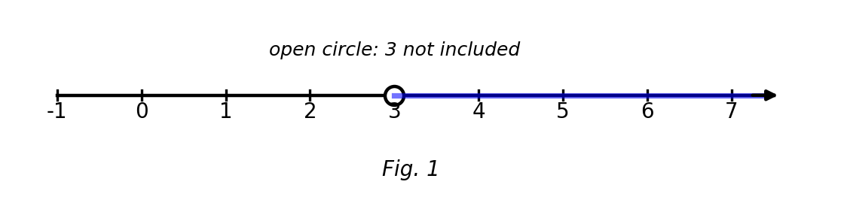
Fig. 1 — number line.
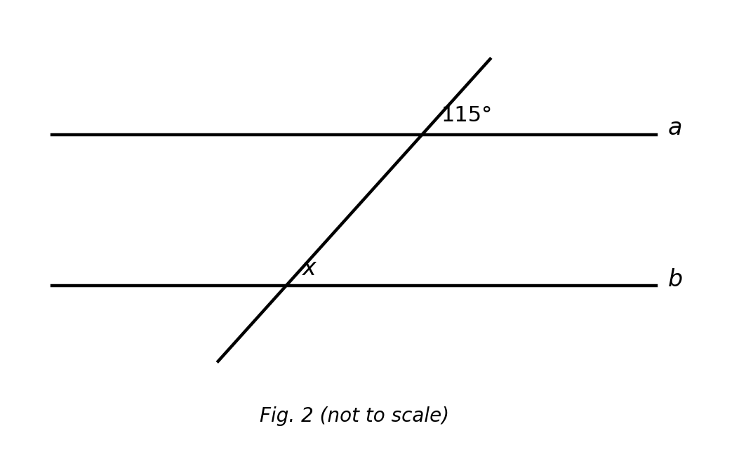
Fig. 2 — parallel lines a and b cut by a transversal (not to scale).
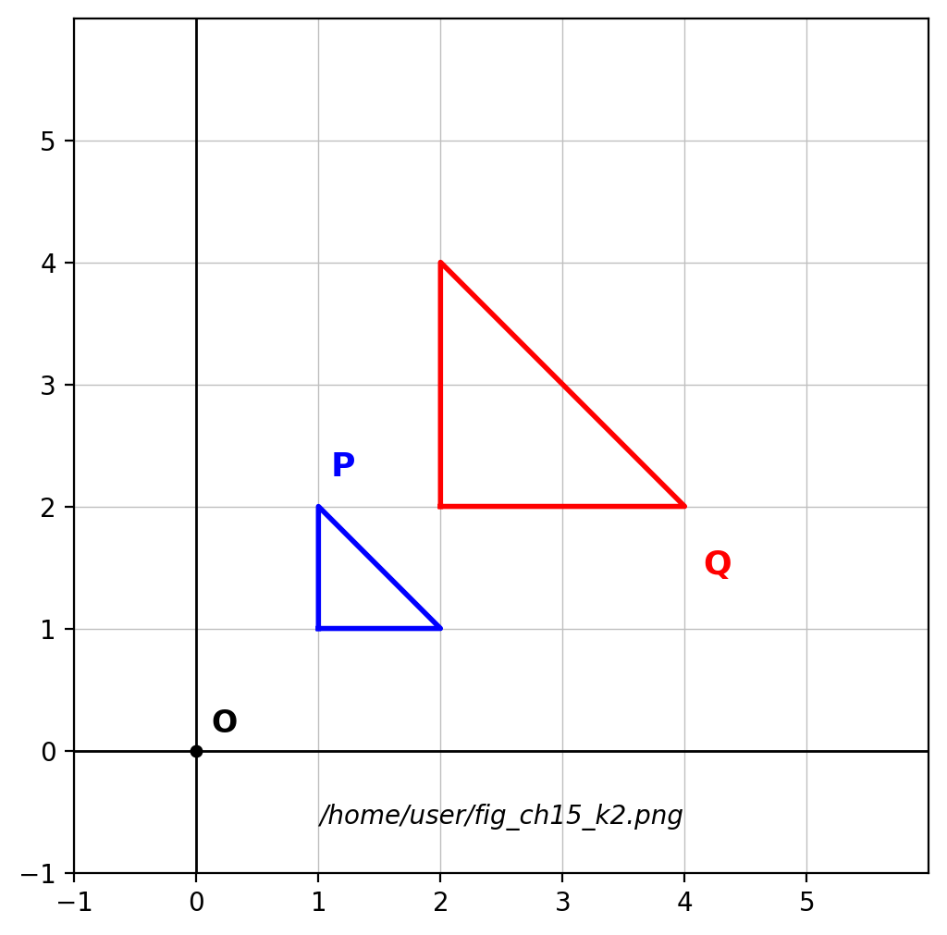
Fig. 3 — object P and image Q on a grid.
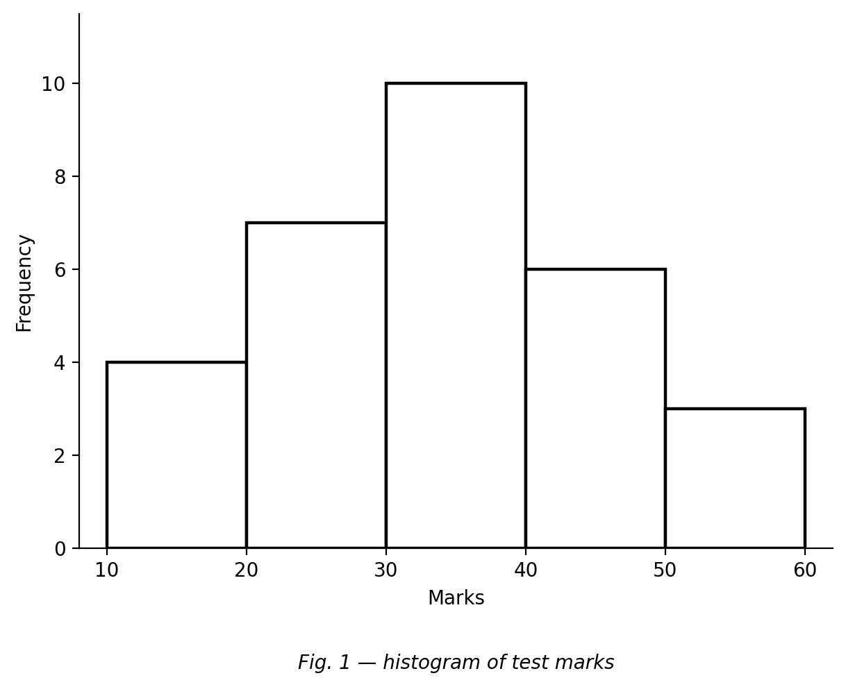
Fig. 4 — histogram of test marks.

SECTION B: MARKING SCHEME

1. Number [10 marks]
(a) Write 0.000786 in standard form. 7.86 × 10⁻⁴. [2 marks]
(b) Round 62.995 to one decimal place. 63.0. [2 marks]
(c) Simplify √72. √72 = √(36 × 2) = 6√2. [3 marks]
(d) Share GH₵ 120 in the ratio 1 : 2 : 3. Total 6 parts → 20, 40 and 60. [3 marks]
[Total: 10 marks]

2. Algebra [10 marks]
(a) Solve the simultaneous equations 2x + y = 11 and x − y = 1. Adding: 3x = 12 → x = 4; y = x − 1 = 3. [4 marks]
(b) Make t the subject of v = u + at. t = (v − u)/a. [2 marks]
(c) Solve 3x − 5 ≤ 10 and indicate the solution on a number line. 3x ≤ 15 → x ≤ 5; closed dot at 5 with shading/arrow to the left. [4 marks]
[Total: 10 marks]

3. Geometry I: angles, circles & prisms [10 marks]
(a) Calculate each interior angle of a regular hexagon. Sum = (6−2)×180° = 720°; each = 720°/6 = 120°. [3 marks]
(b) A right-angled triangle has hypotenuse 14 cm. Find the circumradius. The circumcentre is the midpoint of the hypotenuse: R = 14/2 = 7 cm. [3 marks]
(c) A triangular prism has right-triangle cross-section 3 cm, 4 cm, 5 cm and length 12 cm. Find its surface area. 2(½×3×4) + (3+4+5)×12 = 12 + 144 = 156 cm². [4 marks]
[Total: 10 marks]

4. Geometry II: vectors & enlargement [10 marks]
(a) P(2, −1) and Q(5, 3). Express PQ as a column vector. PQ = (5−2, 3−(−1)) = (3, 4). [2 marks]
(b) Show that PQ is parallel to (6, 8). (6, 8) = 2(3, 4): a scalar multiple, so parallel. [2 marks]
(c) Find the magnitude of PQ. √(9 + 16) = √25 = 5 units. [2 marks]
(d) Find the image of (3, −2) under an enlargement with centre O and scale factor −2. (−6, 4). [2 marks]
(e) Under this enlargement, areas are multiplied by what factor? k² = 4. [2 marks]
[Total: 10 marks]

5. Statistics [10 marks]
The values 1, 2, 3, 4, 5 occur with frequencies 2, 5, 8, 3, 2 respectively.
(a) Write down the mode. 3 (frequency 8). [2 marks]
(b) Calculate the mean. (2 + 10 + 24 + 12 + 10)/20 = 58/20 = 2.9. [3 marks]
(c) Find the median. 10th and 11th values: cumulative 2, 7, 15 → both 3; median = 3. [3 marks]
(d) Calculate the range. 5 − 1 = 4. [2 marks]
[Total: 10 marks]

6. Probability [10 marks]
(a) A bag has 4 green and 3 yellow balls. Find P(green). 4/7. [2 marks]
(b) Two balls are drawn without replacement. Find P(green then green). 4/7 × 3/6 = 12/42 = 2/7. [3 marks]
(c) Find P(the two balls are different colours). P(GY) + P(YG) = 4/7×3/6 + 3/7×4/6 = 2/7 + 2/7 = 4/7. [3 marks]
(d) Express P(green then green) as a percentage to 1 decimal place. 2/7 ≈ 0.2857 = 28.6%. [2 marks]
[Total: 10 marks]

CURRICULUM BLUEPRINT
Qn | Content Focus | Standard | Marks
1 | Place value (Ch 1) | B9.1.1.1 | 1
2 | Significant figures (Ch 1) | B9.1.1.1 | 1
3 | Standard form (Ch 1) | B9.1.1.1 | 1
4 | Rational vs irrational (Ch 2) | B9.1.1.2 | 1
5 | Union of sets (Ch 2) | B9.1.1.2 | 1
6 | Percentages mentally (Ch 3) | B9.1.2.1 | 1
7 | LCM (Ch 3) | B9.1.2.1 | 1
8 | Decimal multiplication (Ch 4) | B9.1.2.2 | 1
9 | Decimal division (Ch 4) | B9.1.2.2 | 1
10 | Simplifying surds (Ch 5) | B9.1.2.4 | 1
11 | Multiplying surds (Ch 5) | B9.1.2.4 | 1
12 | Fraction of a quantity (Ch 6) | B9.1.3.1 | 1
13 | Rounding (Ch 6) | B9.1.3.1 | 1
14 | Sharing in a ratio (Ch 7) | B9.1.4.1 | 1
15 | Rates (Ch 7) | B9.1.4.1 | 1
16 | Proportion (Ch 7) | B9.1.4.1 | 1
17 | Simultaneous equations (Ch 8) | B9.2.1.1 | 1
18 | Substitution method (Ch 8) | B9.2.1.1 | 1
19 | Change of subject (Ch 9) | B9.2.2.1 | 1
20 | Substitution with negatives (Ch 9) | B9.2.2.1 | 1
21 | Factorisation (Ch 9) | B9.2.2.1 | 1
22 | Linear inequalities (Ch 10) | B9.2.3.1 | 1
23 | Two-step inequality (Ch 10) | B9.2.3.1 | 1
24 | Inequalities on a number line (Ch 10, Fig. 1) | B9.2.3.1 | 1
25 | Co-interior angles (Ch 11, Fig. 2) | B9.3.1.1 | 1
26 | Polygon angle sum (Ch 11) | B9.3.1.1 | 1
27 | Incentre (Ch 12) | B9.3.1.2 | 1
28 | Circumcentre of a right triangle (Ch 12) | B9.3.1.2 | 1
29 | Cuboid surface area (Ch 13) | B9.3.2.1 | 1
30 | Cube from edges (Ch 13) | B9.3.2.1 | 1
31 | Vector addition (Ch 14) | B9.3.2.2 | 1
32 | Parallel vectors (Ch 14) | B9.3.2.2 | 1
33 | Enlargement from a grid (Ch 15, Fig. 3) | B9.3.3.1 | 1
34 | Area scale factor (Ch 15) | B9.3.3.1 | 1
35 | Mode (Ch 16) | B9.4.1.1 | 1
36 | Histogram mode (Ch 16, Fig. 4) | B9.4.1.1 | 1
37 | Extreme data (Ch 17) | B9.4.1.2 | 1
38 | Mean (Ch 17) | B9.4.1.2 | 1
39 | Dependent events (Ch 18) | B9.4.2.1 | 1
40 | Probability scale (Ch 18) | B9.4.2.1 | 1
B1 | Number (standard form, rounding, surds, ratio) | B9.1.1.1 / B9.1.2.4 / B9.1.3.1 / B9.1.4.1 | 10
B2 | Algebra (simultaneous, subject, inequalities) | B9.2.1.1 / B9.2.2.1 / B9.2.3.1 | 10
B3 | Geometry I (angles, circles, prisms) | B9.3.1.1 / B9.3.1.2 / B9.3.2.1 | 10
B4 | Geometry II (vectors, enlargement) | B9.3.2.2 / B9.3.3.1 | 10
B5 | Statistics (mode, mean, median, range) | B9.4.1.1 / B9.4.1.2 | 10
B6 | Probability (dependent events) | B9.4.2.1 | 10
 | TOTAL |  | 100

COVERAGE SUMMARY BY STRAND
Strand | Standards | Section A (marks) | Section B (marks) | Total Marks | % Coverage
Strand 1: Number | B9.1.1.1 – B9.1.4.1 | A1–A16 (16) | B1 (10) | 26 | 26%
Strand 2: Algebra | B9.2.1.1 – B9.2.3.1 | A17–A24 (8) | B2 (10) | 18 | 18%
Strand 3: Geometry and Measurement | B9.3.1.1 – B9.3.3.1 | A25–A34 (10) | B3 + B4 (20) | 30 | 30%
Strand 4: Handling Data | B9.4.1.1 – B9.4.2.1 | A35–A40 (6) | B5 + B6 (20) | 26 | 26%
Note: the weighting mirrors the BECE emphasis in which Number and Geometry together carry over half the paper; every B9 standard tested in Chapter Mocks 1–18 is sampled at least once across Sections A and B.

COGNITIVE-LEVEL DISTRIBUTION
Cognitive Level | Section A | Section B | Total | %
Remember | 3 | 0 | 3 | 3%
Understand | 6 | 10 | 16 | 16%
Apply | 29 | 50 | 79 | 79%
Analyse | 2 | 0 | 2 | 2%
Evaluate | 0 | 0 | 0 | 0%
Create | 0 | 0 | 0 | 0%

DIFFICULTY DISTRIBUTION
Difficulty | Section A | Section B | Total | %
Easy | 18 | 10 (B5) | 28 | 28%
Moderate | 19 | 30 (B1, B2, B3) | 49 | 49%
Challenging | 3 | 20 (B4, B6) | 23 | 23%

QUALITY-CONTROL SUMMARY
Check | Status
Curriculum alignment | Samples every strand of the B9 CCP as delivered in Chapter Mocks 1–18: Number, Algebra, Geometry & Measurement, Handling Data.
Section structure | Section A: 40 objectives (40 marks). Section B: 6 structured questions (60 marks). Total 100 marks, 2 hours.
Answer key balance | A=10, B=10, C=10, D=10. Zero consecutive repeats. No sustained cycling pattern.
Diagrams (BECE style) | Four figures: number line for an inequality, parallel lines with a marked angle, an enlargement grid, and a histogram.
Integration | Items blend skills across chapters (e.g. cube edge → surface area; vector → parallelism → magnitude; enlargement → area factor), as BECE integrated items do.
Distractor quality | Cross-chapter traps: s.f. rounding direction, √49 vs √8, union formula signs, co-interior vs corresponding, k vs k², with/without replacement.
Marking guide completeness | Every Section B part carries explicit marks (each question sums to 10); full workings shown; all figures reprinted for the marker.
Blueprint | 46-row blueprint (40 objectives + 6 structured) sums to exactly 100 marks.
Coverage | Strand 1 = 26%, Strand 2 = 18%, Strand 3 = 30%, Strand 4 = 26%.
Cognitive spread | Remember 3%, Understand 16%, Apply 79%, Analyse 2%.
Difficulty spread | Easy 28%, Moderate 49%, Challenging 23%.

