BEACON EDUCATIONAL CONSULT
END-OF-YEAR MOCK EXAMINATION — 2026/2027 ACADEMIC YEAR
MATHEMATICS — BASIC 9 (JHS 3)
Covers the full B9 Common Core Programme (Strands 1–4)
Time Allowed: 2 Hours Total Marks: 100

INSTRUCTIONS TO CANDIDATES
1. Write your name and index number on the answer sheet provided.
2. This paper consists of TWO sections: Section A (Objectives) and Section B (Structured Questions).
3. Section A: Answer ALL forty (40) questions. Each question carries 1 mark. Choose the correct option from A to D.
4. Section B: Answer ALL six (6) questions. Each question carries 10 marks. Show all necessary workings.
5. All diagrams are NOT drawn to scale unless on a grid. Study them carefully before answering.
6. Use a non-programmable calculator where necessary.

SECTION A: OBJECTIVE TEST (40 MARKS)
Answer ALL questions in this section. Choose the correct answer from A to D.
1. In 3.074, the value of the digit 7 is
A. 0.07
B. 0.7
C. 0.007
D. 7
2. 45 678 written to 3 significant figures is
A. 46 000
B. 45 700
C. 45 678
D. 45 600
3. 0.0052 in standard form is
A. 5.2 × 10³
B. 5.2 × 10⁻²
C. 5.2 × 10⁻³
D. 52 × 10⁻⁴
4. Which of the following numbers is irrational?
A. √49
B. √8
C. 0.5
D. 22/7
5. For any two sets A and B, n(A ∪ B) =
A. n(A) × n(B)
B. n(A) − n(B)
C. n(A) + n(B) − n(A ∩ B)
D. n(A) + n(B) + n(A ∩ B)
6. 25% of 480 is
A. 48
B. 96
C. 240
D. 120
7. The LCM of 12 and 18 is
A. 6
B. 36
C. 72
D. 108
8. 3.45 × 2.1 =
A. 7.245
B. 6.555
C. 72.45
D. 7.2450 × 10
9. 0.72 ÷ 0.08 =
A. 8
B. 0.9
C. 90
D. 9
10. √50 in simplest surd form is
A. 5√2
B. 25√2
C. 2√5
D. 10√5
11. √3 × √12 =
A. √15
B. 3√12
C. 6
D. 36
12. 3/5 of GH₵ 250 is
A. GH₵ 150
B. GH₵ 50
C. GH₵ 100
D. GH₵ 75
13. 7.865 rounded to one decimal place is
A. 7.8
B. 7.87
C. 8.0
D. 7.9
14. GH₵ 45 shared in the ratio 2 : 3 gives the smaller share as
A. GH₵ 20
B. GH₵ 22.50
C. GH₵ 18
D. GH₵ 27
15. If 5 pens cost GH₵ 12.50, then 8 pens cost
A. GH₵ 18.50
B. GH₵ 16.00
C. GH₵ 25.00
D. GH₵ 20.00
16. If x/6 = 10/15, then x =
A. 4
B. 9
C. 25
D. 100
17. The solution of x + y = 7 and x − y = 3 is
A. x = 5, y = 3
B. x = 2, y = 5
C. x = 4, y = 3
D. x = 5, y = 2
18. If 2x + 3y = 12 and y = 2, then x =
A. 3
B. 9
C. 4
D. 6
19. Making r the subject of A = πr² gives
A. r = A/π
B. r = √(A/π)
C. r = √(Aπ)
D. r = A²/π
20. Substituting a = −2 into a² − 3a gives
A. 2
B. −10
C. 10
D. −2
21. 6x² + 9x factorises as
A. 9x(x + 1)
B. 3x(2x + 3)
C. 3(2x² + 3x) only
D. x(6x + 9) only
22. The solution of x + 4 < 9 is
A. x > 5
B. x < 13
C. x < 5
D. x < −5
23. The solution of 2x − 3 ≥ 7 is
A. x ≤ 5
B. x > 5
C. x ≥ 2
D. x ≥ 5
Question 24 refers to Fig. 1.
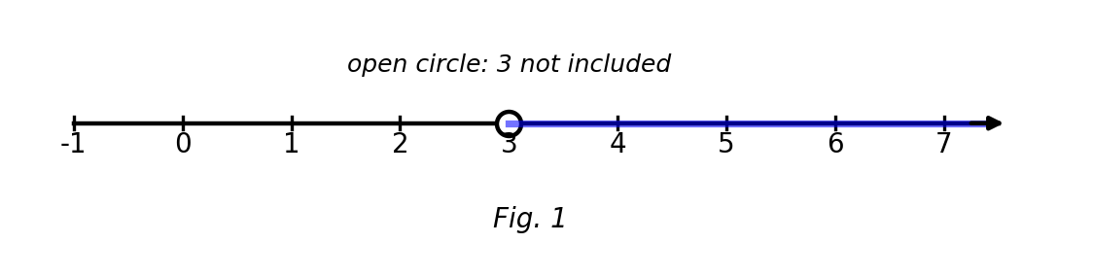
Fig. 1 — number line.
24. The number line represents
A. x ≤ 3
B. x > 3
C. x ≥ 3
D. x < 3
Question 25 refers to Fig. 2.
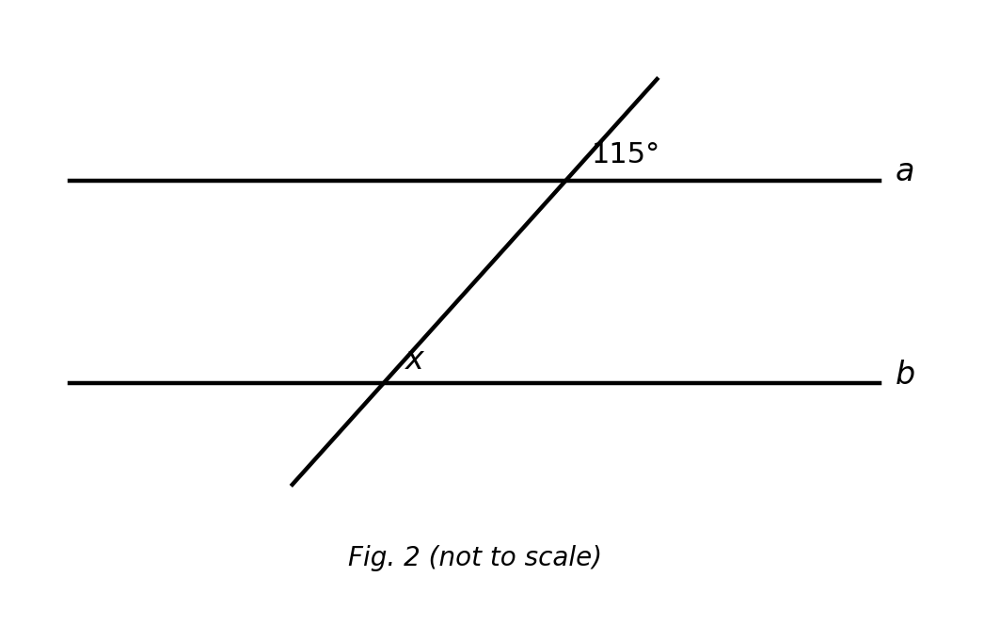
Fig. 2 — parallel lines a and b cut by a transversal (not to scale).
25. Lines a and b are parallel. The value of x is
A. 115°
B. 25°
C. 75°
D. 65°
26. The sum of the interior angles of a decagon is
A. 1 260°
B. 1 800°
C. 1 440°
D. 1 080°
27. The incentre of a triangle is equidistant from
A. the three sides
B. the diagonals
C. the three vertices
D. the midpoints of the sides
28. The circumradius of a right-angled triangle with hypotenuse 12 cm is
A. 12 cm
B. 3 cm
C. 24 cm
D. 6 cm
29. The surface area of a cuboid 5 cm × 4 cm × 3 cm is
A. 47 cm²
B. 120 cm²
C. 94 cm²
D. 60 cm²
30. A cube has total edge length 48 cm. Its surface area is
A. 384 cm²
B. 96 cm²
C. 64 cm²
D. 16 cm²
31. (2, 3) + (−5, 1) =
A. (7, 2)
B. (−3, 2)
C. (−3, 4)
D. (3, 4)
32. The vector (6, 9) is parallel to
A. (−2, 3)
B. (2, 3)
C. (9, 6)
D. (3, 2)
Question 33 refers to Fig. 3.
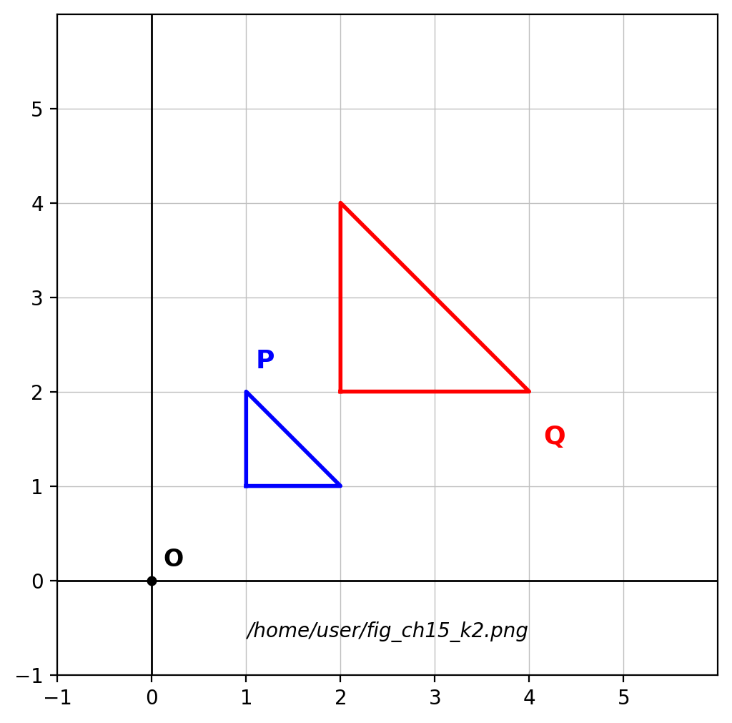
Fig. 3 — object P and image Q on a grid.
33. The scale factor of the enlargement mapping P onto Q is
A. 4
B. ½
C. −2
D. 2
34. Under an enlargement of scale factor 3, areas are multiplied by
A. 3
B. 6
C. 9
D. 27
35. The mode of 2, 3, 3, 5, 7, 3, 8 is
A. 3
B. 5
C. 8
D. 2
Question 36 refers to Fig. 4.
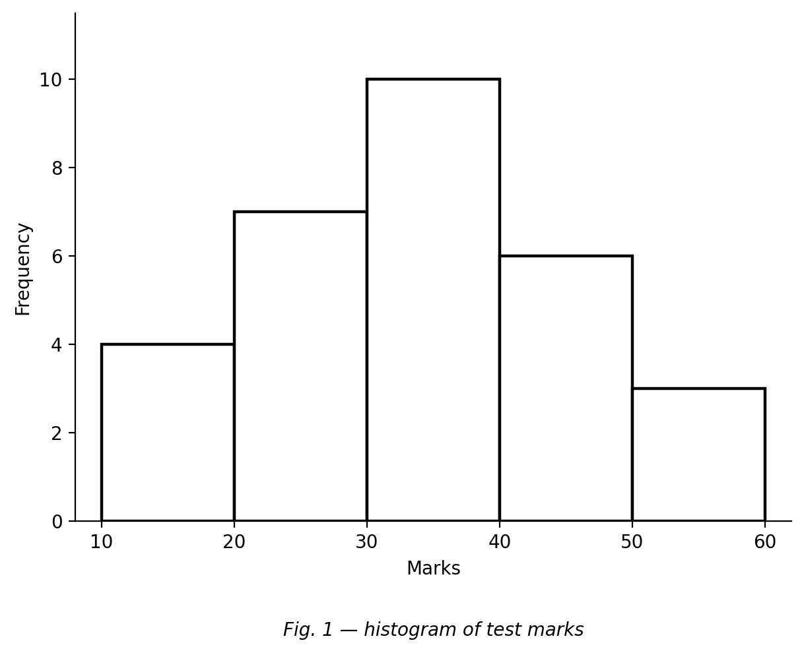
Fig. 4 — histogram of test marks.
36. The modal class is
A. 50–59
B. 10–19
C. 20–29
D. 30–39
37. Adding one extreme value to a data set affects which measure the most?
A. the median
B. the mean
C. the mode
D. none of them
38. The mean of 4, 6, 8, 10, 12 is
A. 8
B. 10
C. 40
D. 6
39. A bag has 2 blue and 3 yellow marbles. Two are drawn without replacement. P(blue then blue) =
A. 3/10
B. 1/10
C. 4/25
D. 1/4
40. The probability of a certain event is
A. 1
B. 0
C. ½
D. 2

SECTION B: STRUCTURED QUESTIONS (60 MARKS)
Answer ALL questions in this section. Show all workings clearly.

1. Number
(a) Write 0.000786 in standard form. [2 marks]
(b) Round 62.995 to one decimal place. [2 marks]
(c) Simplify √72. [3 marks]
(d) Share GH₵ 120 in the ratio 1 : 2 : 3. [3 marks]
[Total: 10 marks]

2. Algebra
(a) Solve the simultaneous equations 2x + y = 11 and x − y = 1. [4 marks]
(b) Make t the subject of v = u + at. [2 marks]
(c) Solve 3x − 5 ≤ 10 and indicate the solution on a number line. [4 marks]
[Total: 10 marks]

3. Geometry I: angles, circles & prisms
(a) Calculate each interior angle of a regular hexagon. [3 marks]
(b) A right-angled triangle has hypotenuse 14 cm. Find the circumradius. [3 marks]
(c) A triangular prism has right-triangle cross-section 3 cm, 4 cm, 5 cm and length 12 cm. Find its surface area. [4 marks]
[Total: 10 marks]

4. Geometry II: vectors & enlargement
(a) P(2, −1) and Q(5, 3). Express PQ as a column vector. [2 marks]
(b) Show that PQ is parallel to (6, 8). [2 marks]
(c) Find the magnitude of PQ. [2 marks]
(d) Find the image of (3, −2) under an enlargement with centre O and scale factor −2. [2 marks]
(e) Under this enlargement, areas are multiplied by what factor? [2 marks]
[Total: 10 marks]

5. Statistics
The values 1, 2, 3, 4, 5 occur with frequencies 2, 5, 8, 3, 2 respectively.
(a) Write down the mode. [2 marks]
(b) Calculate the mean. [3 marks]
(c) Find the median. [3 marks]
(d) Calculate the range. [2 marks]
[Total: 10 marks]

6. Probability
(a) A bag has 4 green and 3 yellow balls. Find P(green). [2 marks]
(b) Two balls are drawn without replacement. Find P(green then green). [3 marks]
(c) Find P(the two balls are different colours). [3 marks]
(d) Express P(green then green) as a percentage to 1 decimal place. [2 marks]
[Total: 10 marks]

