…………………………………………………………… SCHOOL
MATHEMATICS
BECE-PREP MOCK EXAMINATION — PAPER 7 (DIAGRAM-BASED)
Academic Year: 2026/2027

Class: JHS 1 (Basic 7) Time: 2 hours Total Marks: 100
Curriculum Coverage: NaCCA CCP Mathematics B7 — ALL STRANDS, with diagrams (1. Number; 2. Algebra; 3. Geometry and Measurement; 4. Handling Data)

INSTRUCTIONS TO CANDIDATES
1. This paper consists of two sections: Section A (Objective Test) and Section B (Written Response).
2. Answer ALL questions in Section A and ALL questions in Section B.
3. Study each diagram carefully before answering the question on it. Diagrams are not necessarily drawn to scale.
4. In Section A, choose the correct option from A to D and write the letter in the space provided.
5. In Section B, show ALL your working clearly. Marks are awarded for correct methods as well as answers.
6. Where required, take π = 22/7. Give fractions in their lowest terms unless told otherwise.

SECTION A: OBJECTIVE TEST (30 marks)
Answer ALL questions in this section. Each question carries 1 mark.
1. Figure 1 shows two straight lines intersecting. Find the size of the angle marked x.
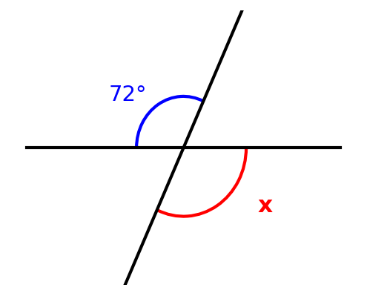
A. 108°
B. 72°
C. 18°
D. 288°

2. In Figure 2, AOB is a straight line. Find the size of the angle marked y.
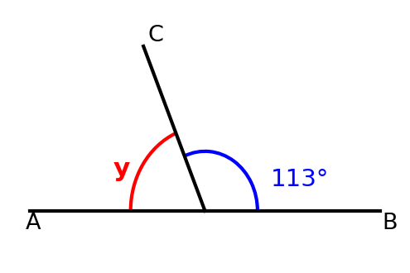
A. 67°
B. 247°
C. 113°
D. 23°

3. Figure 3 shows a rectangle. Find its perimeter.
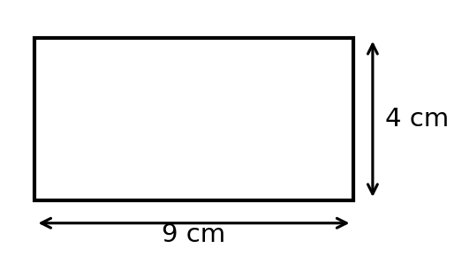
A. 36 cm
B. 13 cm
C. 26 cm
D. 18 cm

4. Figure 4 shows a triangle with a base of 12 cm and a height of 5 cm. Find its area.
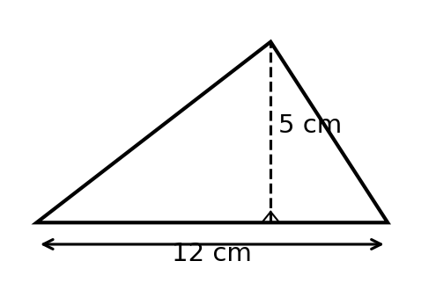
A. 30 cm²
B. 60 cm²
C. 17 cm²
D. 34 cm²

5. Figure 5 shows a circle with centre O and radius 7 cm. Find the circumference of the circle. [Take π = 22/7]
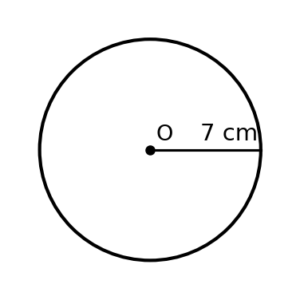
A. 22 cm
B. 154 cm
C. 7 cm
D. 44 cm

6. Figure 6 shows the favourite fruit of 30 learners. How many learners were surveyed altogether?
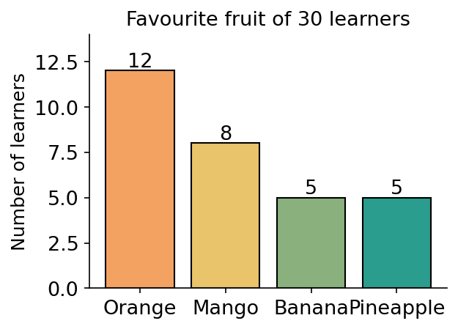
A. 25
B. 30
C. 12
D. 20

7. Figure 7 shows how 30 learners travel to school. What fraction of the learners cycle to school?
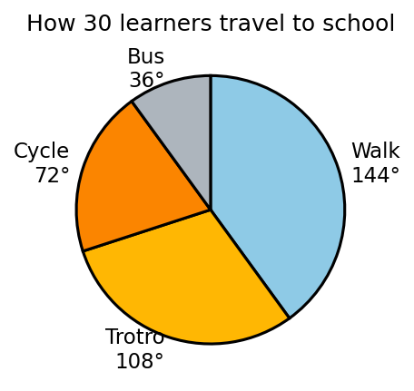
A. 1/5
B. 1/4
C. 1/3
D. 2/5

8. In Figure 8, the point P(3, 2) is translated by the vector (2, 3). What are the coordinates of the image of P?
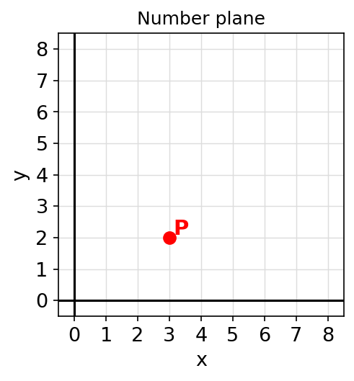
A. (5, 1)
B. (1, 5)
C. (5, 5)
D. (6, 6)

9. Figure 9 shows triangles made with matchsticks: 1 triangle uses 3 sticks, 2 triangles use 5 sticks, 3 triangles use 7 sticks. How many matchsticks are needed to make 5 triangles in this pattern?
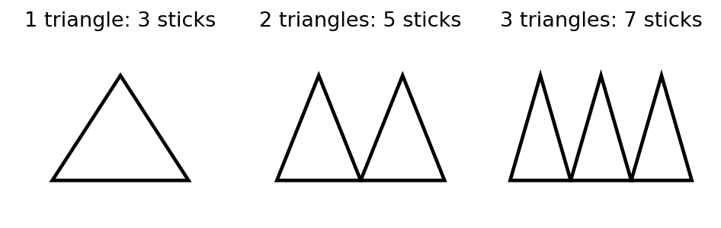
A. 15
B. 10
C. 13
D. 11

10. Figure 10 shows a balanced scale. Find the value of x.
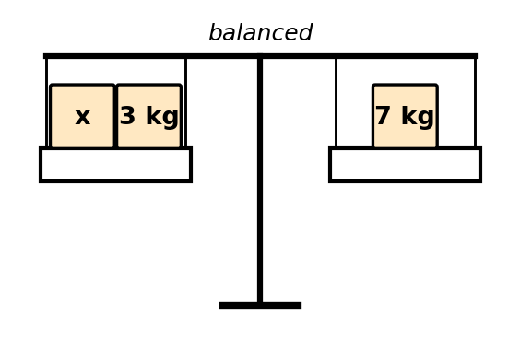
A. 4
B. 10
C. 3
D. 21

11. What is the value of the digit 6 in the number 3,672,104,000?
A. 6,000,000
B. 60,000,000
C. 600,000,000
D. 6,000

12. Round 8,976 to the nearest hundred.
A. 8,900
B. 8,980
C. 9,100
D. 9,000

13. Express 3/8 as a decimal.
A. 0.375
B. 0.625
C. 3.8
D. 0.38

14. Find 15% of 240.
A. 15
B. 36
C. 24
D. 30

15. GH₵210.00 is shared between two friends in the ratio 2 : 5. How much does the friend with the bigger share receive?
A. GH₵60.00
B. GH₵105.00
C. GH₵150.00
D. GH₵70.00

16. What is the next term in the pattern 1, 8, 27, 64, …?
A. 81
B. 100
C. 125
D. 216

17. Simplify: 6a + 4a − 3a
A. 7a
B. 13a
C. 7
D. 7a²

18. If m = 4, evaluate 3m − 7.
A. 5
B. 19
C. 1
D. 12

19. Solve the equation: x − 8 = 15.
A. 7
B. 120
C. 23
D. 8

20. Which expression represents “half of a number h”?
A. 2h
B. h/2
C. h − 2
D. h + 2

21. Find the complement of 28°.
A. 62°
B. 118°
C. 152°
D. 28°

22. Find the perimeter of a square of side 2.5 cm.
A. 6.25 cm
B. 10 cm
C. 5 cm
D. 25 cm

23. Find the circumference of a circle of diameter 35 cm. [Take π = 22/7]
A. 70 cm
B. 55 cm
C. 385 cm
D. 110 cm

24. How many lines of symmetry has a rectangle?
A. 1
B. 4
C. 2
D. 8

25. The bearing of a lighthouse from a harbour is 300°. Find the back bearing.
A. 060°
B. 120°
C. 240°
D. 300°

26. Find the mean of the numbers 5, 9, 11 and 15.
A. 11
B. 9
C. 40
D. 10

27. Find the median of the numbers 6, 2, 9 and 4.
A. 5
B. 6
C. 9
D. 4

28. A bag contains 3 blue balls and 7 yellow balls. A ball is picked at random. What is the probability that it is NOT blue?
A. 3/10
B. 7/10
C. 7/3
D. 3/7

29. “A fair die will show a number less than 7” is an event that is
A. impossible
B. possible
C. certain
D. unlikely

30. Express 0.6 as a percentage.
A. 6%
B. 0.6%
C. 60%
D. 16%

SECTION B: WRITTEN RESPONSE (70 marks)
Answer ALL questions in this section. Show all your working clearly.
Question 1
Figure 11 shows the cedi notes Ama has in her purse.
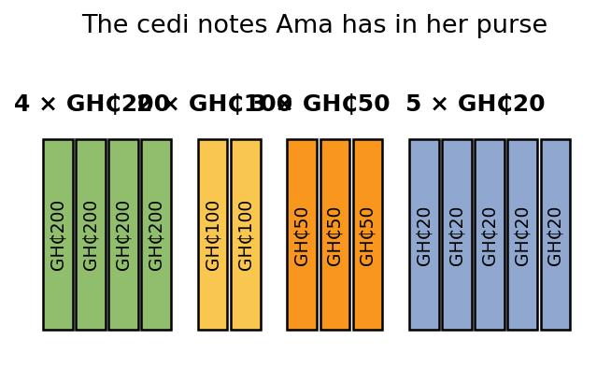
(a) Find the total amount of money Ama has. ........................... [3 marks]
(b) Ama buys a school bag and pays GH₵1,500.00 with the money from her purse topped up with more notes. If the bag costs the total in her purse, find the change she receives. .. [2 marks]
(c) Express the change as a fraction of the GH₵1,500.00 paid, in its lowest terms. .............. [2 marks]
(d) She then spends 20% of the total money she had on a book. How much does the book cost? ............ [3 marks]

Question 2
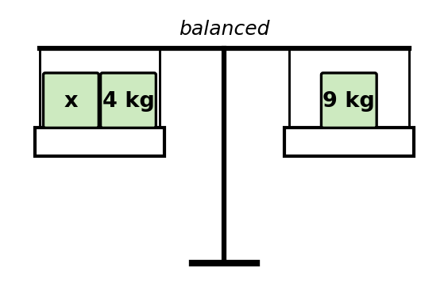
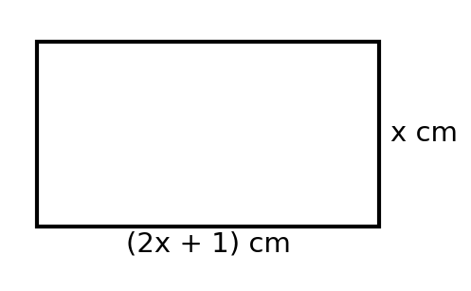
(a) Figure 12 shows a balanced scale. Write an equation for the balance. .................. [2 marks]
(b) Solve the equation to find x. ............................... [2 marks]
(c) Figure 13 shows a rectangle. Write an expression for its perimeter in terms of x, and simplify it. ........ [3 marks]
(d) If x = 4, find the perimeter of the rectangle. ......................... [3 marks]

Question 3
Figure 14 shows a rectangle of length 15 cm and width 8 cm.
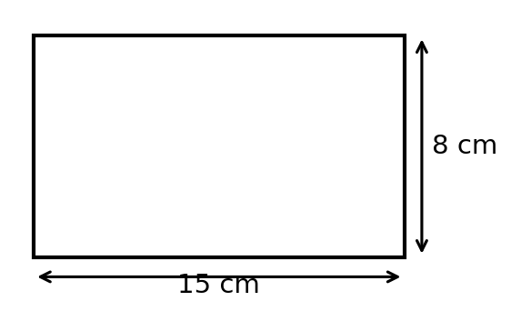
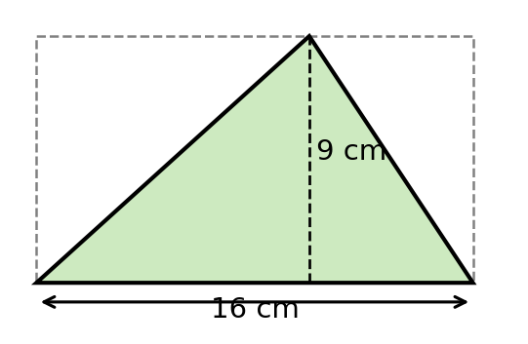
(a) Find the perimeter of the rectangle. ............................ [2 marks]
(b) Find the area of the rectangle. .............................. [2 marks]
(c) Figure 15 shows a triangle drawn inside a rectangle of the same base and height. Explain why the area of the triangle is half the area of the rectangle. .. [2 marks]
(d) Hence find the area of the triangle in Figure 15. ........................ [2 marks]
(e) Find the difference between the area of the rectangle in Figure 14 and the area of the triangle in Figure 15. .... [2 marks]

Question 4
Figure 16 shows two straight lines intersecting.
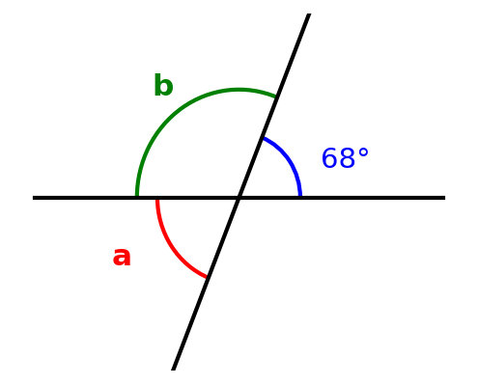
(a) Find the size of the angle marked a. ............................ [2 marks]
(b) Find the size of the angle marked b. ............................ [3 marks]
(c) Give the reason for each of your answers in (a) and (b). ...................... [2 marks]
(d) Find the reflex angle between the two lines at the point of intersection (the reflex angle of the 68° angle). .... [3 marks]

Question 5
Figure 17 shows a circle with centre O and radius 14 cm.
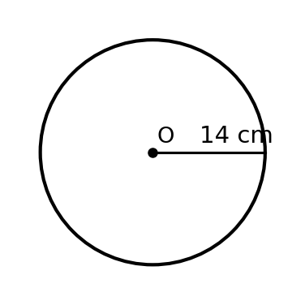
(a) Find the diameter of the circle. .............................. [1 marks]
(b) Calculate the circumference of the circle. [Take π = 22/7] ..................... [3 marks]
(c) A learner walks round the garden three times. How far does she walk? .................. [2 marks]
(d) A bicycle wheel of radius 14 cm makes 5 complete revolutions. How far does the bicycle move, in metres? [Take π = 22/7] .. [4 marks]

Question 6
Figure 18 shows the favourite sport of 30 JHS 1 learners.
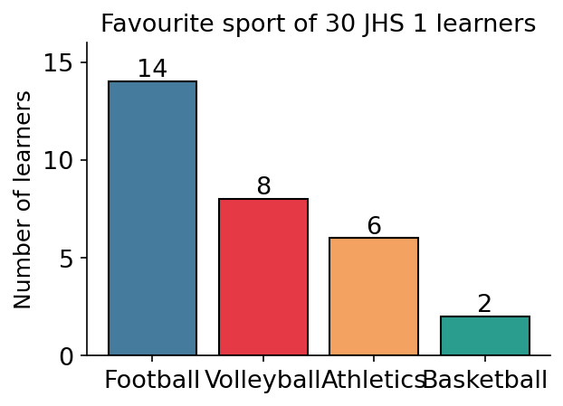
(a) Which sport is the most popular? .............................. [1 marks]
(b) How many learners were surveyed altogether? .......................... [1 marks]
(c) How many more learners prefer football to basketball? ....................... [2 marks]
(d) If one learner is picked at random, find the probability that his or her favourite sport is volleyball. Give your answer as a fraction in its lowest terms. .. [3 marks]
(e) If the data is drawn as a pie chart, calculate the angle that represents football. ............. [3 marks]

Question 7
Figure 19 shows a map of Abura. The market is due north of the school, the church is due east, the hospital is due south and the farm is due west.
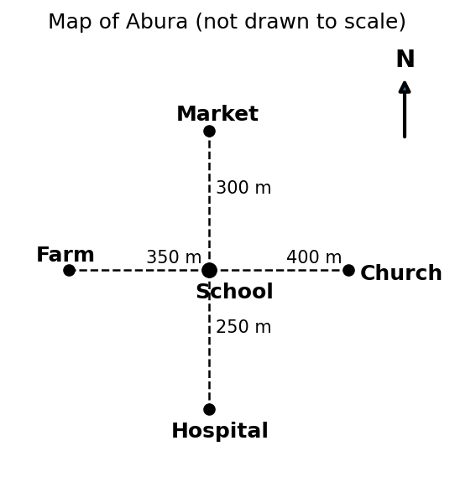
(a) Find the bearing of the market from the school. ......................... [2 marks]
(b) Find the bearing of the church from the school. ......................... [2 marks]
(c) Find the back bearing of the church from the school. ....................... [2 marks]
(d) Ama walks from the school to the market and then straight to the church. Find the total distance she walks. ..... [2 marks]
(e) Write the displacement of the church from the school as a column vector (east, north). ............ [2 marks]

END OF PAPER

ANSWER KEY — SECTION A
Question | Answer | Curriculum Area | Indicator | Cognitive Level
1 | B | Vertically opposite angles | B7.3.1.1.3 | Understand
2 | A | Angles on a straight line | B7.3.1.1.3 | Apply
3 | C | Perimeter of a rectangle | B7.3.2.1 | Apply
4 | A | Area of a triangle | B7.3.2.2.2 | Apply
5 | D | Circumference of a circle | B7.3.2.1.2 | Apply
6 | B | Reading a bar chart | B7.4.1.1.3 | Apply
7 | A | Reading a pie chart | B7.4.1.1.3 | Apply
8 | C | Translation on the number plane | B7.3.3.1.3 | Apply
9 | D | Generalising a pattern | B7.2.1.1.3 | Analyse
10 | A | Balance model for equations | B7.2.3.1.2 | Understand
11 | C | Place value | B7.1.1.1 | Understand
12 | D | Rounding whole numbers | B7.1.1.1.3 | Apply
13 | A | Fraction to decimal | B7.1.3.1 | Apply
14 | B | Percent of a quantity | B7.1.4.1.5 | Apply
15 | C | Sharing in a given ratio | B7.1.4.1 | Apply
16 | C | Cube-number pattern | B7.2.1.1.3 | Analyse
17 | A | Collecting like terms | B7.2.2.1.2 | Apply
18 | A | Substitution | B7.2.2.1.4 | Apply
19 | C | Solving linear equations | B7.2.3.1.4 | Apply
20 | B | Translating words into algebra | B7.2.2.1.1 | Understand
21 | A | Complementary angles | B7.3.1.1.2 | Apply
22 | B | Perimeter of a square | B7.3.2.1 | Apply
23 | D | Circumference from diameter | B7.3.2.1.2 | Apply
24 | C | Reflectional symmetry | B7.3.3.1.1 | Remember
25 | B | Back bearing | B7.3.2.3.2 | Apply
26 | D | Mean of ungrouped data | B7.4.1.2.1 | Apply
27 | A | Median of ungrouped data | B7.4.1.2.2 | Apply
28 | B | Probability of the complement | B7.4.2.1.3 | Apply
29 | C | Classifying likelihood | B7.4.2.1.2 | Understand
30 | C | Decimal to percentage | B7.1.4.1 | Apply

MARKING SCHEME — SECTION B
Question 1
(a) (4 × 200) + (2 × 100) + (3 × 50) + (5 × 20) = 800 + 200 + 150 + 100 = GH₵1,250.00
[2 marks for correct products; 1 mark for GH₵1,250.00]
(b) Change = GH₵1,500.00 − GH₵1,250.00 = GH₵250.00
[1 mark for method; 1 mark for GH₵250.00]
(c) 250/1500 = 25/150 = 1/6
[1 mark for 250/1500; 1 mark for 1/6]
(d) 20% of GH₵1,250.00 = 20/100 × 1,250 = GH₵250.00
[2 marks for method; 1 mark for GH₵250.00]

Question 2
(a) x + 4 = 9
[2 marks]
(b) x = 9 − 4 = 5
[1 mark for operation; 1 mark for x = 5]
(c) P = 2[(2x + 1) + x] = 2(3x + 1) = 6x + 2
[2 marks for setup; 1 mark for 6x + 2]
(d) 6(4) + 2 = 24 + 2 = 26 cm
[2 marks: 1 for substitution; 1 for 26 cm]

Question 3
(a) P = 2(15 + 8) = 46 cm
[1 mark for method; 1 mark for 46 cm]
(b) A = 15 × 8 = 120 cm²
[1 mark for method; 1 mark for 120 cm²]
(c) The diagonal of the rectangle divides it into two equal (congruent) triangles, so each triangle covers exactly half of the rectangle: A = ½ × base × height
[2 marks: 1 for the halving idea; 1 for the formula]
(d) A = ½ × 16 × 9 = 72 cm²
[1 mark for method; 1 mark for 72 cm²]
(e) 120 − 72 = 48 cm²
[1 mark for using both areas; 1 mark for 48 cm²]

Question 4
(a) a = 68°
[2 marks]
(b) b = 180° − 68° = 112°
[2 marks: 1 for method; 1 for 112°]
(c) (a) Vertically opposite angles are equal. (b) Angles on a straight line are supplementary (sum to 180°)
[1 mark each]
(d) Reflex angle = 360° − 68° = 292°
[2 marks: 1 for method; 1 for 292°]

Question 5
(a) d = 2 × 14 = 28 cm
[1 mark]
(b) C = 2πr = 2 × 22/7 × 14 = 88 cm
[2 marks for substitution; 1 mark for 88 cm]
(c) 3 × 88 = 264 cm
[1 mark for method; 1 mark for 264 cm]
(d) Distance = 5 × 88 = 440 cm = 4.4 m
[2 marks for 440 cm; 2 marks for conversion to 4.4 m]

Question 6
(a) Football
[1 mark]
(b) 14 + 8 + 6 + 2 = 30 learners
[1 mark]
(c) 14 − 2 = 12 learners
[1 mark for method; 1 mark for 12]
(d) 8/30 = 4/15
[2 marks for 8/30; 1 mark for 4/15]
(e) (14 ÷ 30) × 360° = 168°
[2 marks for method; 1 mark for 168°]

Question 7
(a) 000° (due north)
[2 marks]
(b) 090° (due east)
[2 marks]
(c) 090° + 180° = 270°
[1 mark for method; 1 mark for 270°]
(d) School→Market = 300 m. Market→Church = √(300² + 400²) = √250,000 = 500 m (a 3–4–5 right triangle). Total distance walked = 300 + 500 = 800 m
[1 mark for 500 m (Pythagoras/magnitude); 1 mark for 800 m]
(e) (400, 300) written as a column vector
[2 marks]

CURRICULUM ASSESSMENT BLUEPRINT
Question | Strand | Sub-strand / Area | Content Standard / Indicator | Cognitive Level | Marks
A1 | 3. Geometry and Measurement | Vertically opposite angles | B7.3.1.1.3 | Understand | 1
A2 | 3. Geometry and Measurement | Angles on a straight line | B7.3.1.1.3 | Apply | 1
A3 | 3. Geometry and Measurement | Perimeter of a rectangle | B7.3.2.1 | Apply | 1
A4 | 3. Geometry and Measurement | Area of a triangle | B7.3.2.2.2 | Apply | 1
A5 | 3. Geometry and Measurement | Circumference of a circle | B7.3.2.1.2 | Apply | 1
A6 | 4. Handling Data | Reading a bar chart | B7.4.1.1.3 | Apply | 1
A7 | 4. Handling Data | Reading a pie chart | B7.4.1.1.3 | Apply | 1
A8 | 3. Geometry and Measurement | Translation on the number plane | B7.3.3.1.3 | Apply | 1
A9 | 2. Algebra | Generalising a pattern | B7.2.1.1.3 | Analyse | 1
A10 | 2. Algebra | Balance model for equations | B7.2.3.1.2 | Understand | 1
A11 | 1. Number | Place value | B7.1.1.1 | Understand | 1
A12 | 1. Number | Rounding whole numbers | B7.1.1.1.3 | Apply | 1
A13 | 1. Number | Fraction to decimal | B7.1.3.1 | Apply | 1
A14 | 1. Number | Percent of a quantity | B7.1.4.1.5 | Apply | 1
A15 | 1. Number | Sharing in a given ratio | B7.1.4.1 | Apply | 1
A16 | 2. Algebra | Cube-number pattern | B7.2.1.1.3 | Analyse | 1
A17 | 2. Algebra | Collecting like terms | B7.2.2.1.2 | Apply | 1
A18 | 2. Algebra | Substitution | B7.2.2.1.4 | Apply | 1
A19 | 2. Algebra | Solving linear equations | B7.2.3.1.4 | Apply | 1
A20 | 2. Algebra | Translating words into algebra | B7.2.2.1.1 | Understand | 1
A21 | 3. Geometry and Measurement | Complementary angles | B7.3.1.1.2 | Apply | 1
A22 | 3. Geometry and Measurement | Perimeter of a square | B7.3.2.1 | Apply | 1
A23 | 3. Geometry and Measurement | Circumference from diameter | B7.3.2.1.2 | Apply | 1
A24 | 3. Geometry and Measurement | Reflectional symmetry | B7.3.3.1.1 | Remember | 1
A25 | 3. Geometry and Measurement | Back bearing | B7.3.2.3.2 | Apply | 1
A26 | 4. Handling Data | Mean of ungrouped data | B7.4.1.2.1 | Apply | 1
A27 | 4. Handling Data | Median of ungrouped data | B7.4.1.2.2 | Apply | 1
A28 | 4. Handling Data | Probability of the complement | B7.4.2.1.3 | Apply | 1
A29 | 4. Handling Data | Classifying likelihood | B7.4.2.1.2 | Understand | 1
A30 | 4. Handling Data | Decimal to percentage | B7.1.4.1 | Apply | 1
B1 | 1. Number | Number | B7.1.1.1; B7.1.2.2; B7.1.3.1; B7.1.4.1 | Apply | 10
B2 | 2. Algebra | Algebra | B7.2.3.1.2; B7.2.3.1.4; B7.2.2.1 | Apply | 10
B3 | 3. Geometry and Measurement | Geometry and Measurement | B7.3.2.1; B7.3.2.2.1; B7.3.2.2.2 | Apply | 10
B4 | 3. Geometry and Measurement | Geometry (angles) | B7.3.1.1.3 | Apply | 10
B5 | 3. Geometry and Measurement | Measurement | B7.3.2.1.2 | Apply | 10
B6 | 4. Handling Data | Handling Data | B7.4.1.1.3; B7.4.2.1.3 | Apply | 10
B7 | 3. Geometry and Measurement | Bearings and vectors | B7.3.2.3.1; B7.3.2.3.2; B7.3.2.3.4 | Analyse | 10

COVERAGE SUMMARY
Strand | Questions | Marks | % of Paper
1. Number | A11–A15, B1 | 15 | 15%
2. Algebra | A9, A10, A16–A20, B2 | 17 | 17%
3. Geometry and Measurement | A1–A5, A8, A21–A25, B3–B5, B7 | 51 | 51%
4. Handling Data | A6, A7, A26–A30, B6 | 17 | 17%
TOTAL | 37 | 100 | 100%

COGNITIVE-LEVEL DISTRIBUTION
Cognitive Level (Bloom's) | Section A | Section B | Total Marks | % of Paper
Remember | 1 (A24) | 0 | 1 | 1%
Understand | 5 (A1, A10, A11, A20, A29) | 0 | 5 | 5%
Apply | 22 | 6 (B1–B6) | 82 | 82%
Analyse | 2 (A9, A16) | 1 (B7) | 12 | 12%

DIFFICULTY DISTRIBUTION
Difficulty | Questions | %
Easy | A1, A2, A3, A10, A13, A17, A19, A21, A24, A26, A29, B3(a–b) | ~27%
Moderate | A4, A5, A6, A7, A8, A12, A14, A15, A18, A22, A23, A25, A27, A28, A30, B1(a–b), B2(a–b), B4, B5(a–c), B6(a–c), B7(a–d) | ~50%
Challenging | A9, A16, A20, B1(c–d), B2(c–d), B3(c–e), B5(d), B6(d–e), B7(e) | ~23%

QUALITY-CONTROL SUMMARY
1. Diagram-based design: 19 original figures (angle diagrams, dimensioned rectangle/triangle/circle, matchstick pattern, balance models, cedi-note illustration, bar charts, pie chart, number plane, and a map) carry 10 MCQs and all 7 written questions, so learners interpret real visual information as in the BECE.
2. Curriculum alignment: every question is traceable to a supplied NaCCA CCP B7 content standard/indicator (see blueprint). No content outside the B7 curriculum was introduced (bearing work uses cardinal points and right angles; the map leg market→church uses the 3-4-5 right triangle under Pythagoras as a challenge, consistent with B7 vector/magnitude work).
3. Originality: original BECE-style examination; all questions and all figures newly created for this paper; no WAEC, textbook or copyrighted questions or images reproduced; not to be presented as an official BECE paper.
4. MCQ quality: 30 items, four options each, one defensible answer, distractors from common errors (e.g. A3 half-perimeter, A4 forgetting the ½, A5 using the radius as circumference, A7 reading 72 as 72/360 wrong-way, A8 adding only one coordinate, A23 using πr instead of πd).
5. Answer-key distribution: A=9, B=7, C=9, D=5 — varied positions, no predictable pattern.
6. Arithmetic verified: every answer independently recomputed (e.g. notes: 800+200+150+100 = 1,250; change 250 = 1/6 of 1,500; 20% of 1,250 = 250; 6x+2 at x=4 = 26; 2×22/7×14 = 88; 5×88 cm = 4.4 m; pie angle 14/30×360 = 168°; √(300²+400²) = 500, walk = 800 m).
7. Marks: Section A = 30; Section B = 7 × 10 = 70; total = 100. All internal allocations add up correctly.
8. Cognitive demand: diagram reading (Understand/Apply), calculation, justification of angle facts (Q4c) and analysis of patterns and maps (A9, A16, B7).
9. Ghanaian contexts used naturally: cedi notes, school bag and book purchases, trotro/walking to school, favourite fruits and sports, map of Abura, learners' names (Ama).
10. Language: clear Ghanaian school English; terminology consistent with the NaCCA curriculum ('number plane', 'back bearing', 'column vector', 'reflex angle', 'learners').

