…………………………………………………………… SCHOOL
MATHEMATICS
BECE-PREP MOCK EXAMINATION — PAPER 8 (HARDER + DIAGRAM-BASED)
Academic Year: 2026/2027

Class: JHS 1 (Basic 7) Time: 2 hours Total Marks: 100
Curriculum Coverage: NaCCA CCP Mathematics B7 — ALL STRANDS with diagrams; raised difficulty

INSTRUCTIONS TO CANDIDATES
1. This paper consists of two sections: Section A (Objective Test) and Section B (Written Response).
2. Answer ALL questions in Section A and ALL questions in Section B.
3. Study each diagram carefully before answering. Diagrams are not necessarily drawn to scale.
4. In Section A, choose the correct option from A to D and write the letter in the space provided.
5. In Section B, show ALL your working clearly. Marks are awarded for methods as well as answers.
6. Where required, take π = 22/7. Give fractions in their lowest terms unless told otherwise.

SECTION A: OBJECTIVE TEST (30 marks)
Answer ALL questions in this section. Each question carries 1 mark.
1. In Figure 1, two angles of the triangle are 58° and 47°. Find the angle marked x.
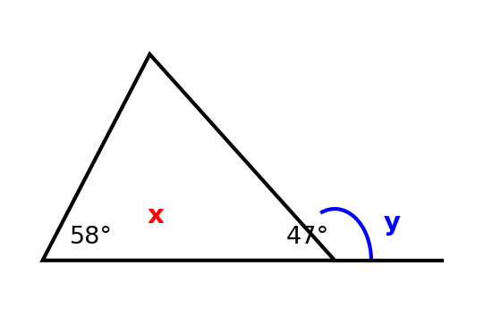
A. 105°
B. 75°
C. 133°
D. 95°

2. In Figure 2, the machine multiplies the input by 3 and then adds 2. What is the output when the input is 5?
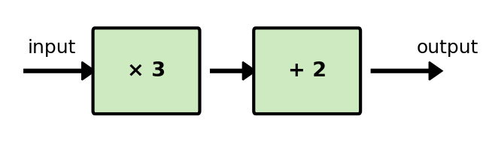
A. 15
B. 17
C. 13
D. 10

3. In Figure 3, one bag symbol stands for 4 learners. How many learners have red bags?
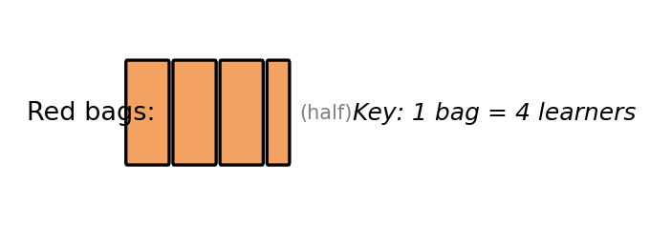
A. 12
B. 7
C. 14
D. 16

4. Figure 4 shows a balanced scale. Find the value of x.
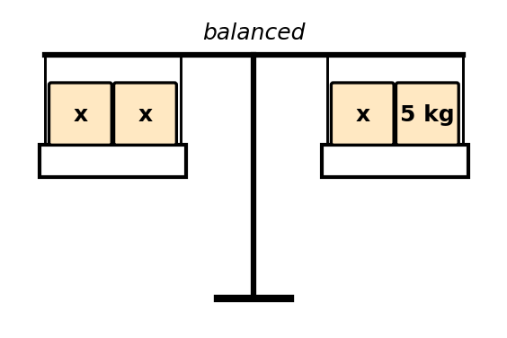
A. 2.5
B. 10
C. 3
D. 5

5. Figure 5 shows an L-shape with the dimensions given in centimetres. Find its perimeter.
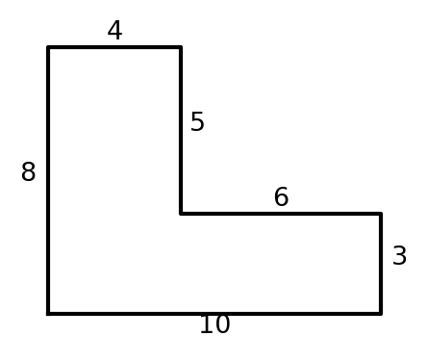
A. 36 cm
B. 32 cm
C. 46 cm
D. 40 cm

6. Figure 6 shows a rectangle of 6 cm by 4 cm with a shaded triangle of base 4 cm and height 4 cm inside it. What fraction of the rectangle is shaded?
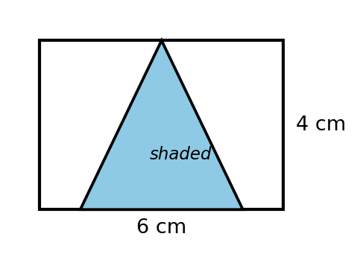
A. 1/2
B. 2/3
C. 1/4
D. 1/3

7. Figure 7 shows books read from Monday to Friday. The mean number of books per day is 6. How many books were read on Thursday?
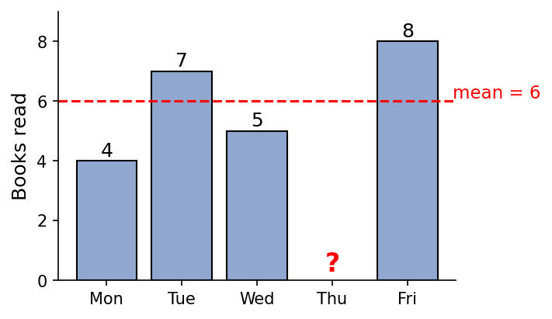
A. 24
B. 6
C. 30
D. 5

8. Figure 8 shows the angles at the centre of a pie chart. One sector is missing. Find the angle of the missing sector.
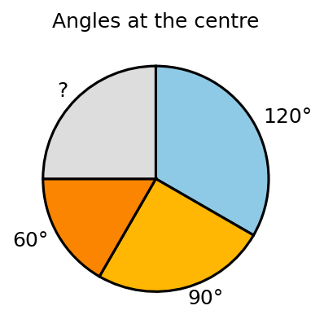
A. 60°
B. 90°
C. 120°
D. 270°

9. Figure 9 shows a triangle (object) and its image after a reflection. What is the mirror line?
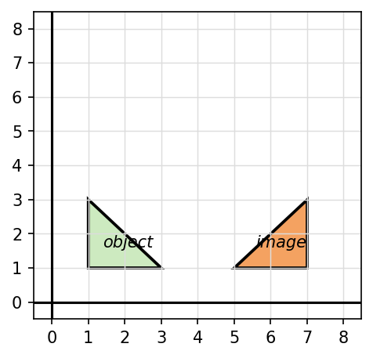
A. x = 3
B. y = 4
C. x = 2
D. x = 4

10. Figure 10 shows a 10 cm by 6 cm rectangle with a 2 cm square corner cut out. Find the perimeter of the resulting shape.
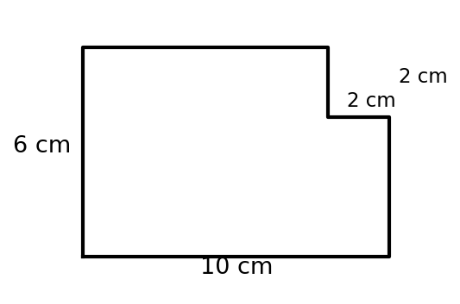
A. 28 cm
B. 36 cm
C. 32 cm
D. 56 cm

11. The mean of five numbers is 12. Four of the numbers are 9, 11, 13 and 15. Find the fifth number.
A. 12
B. 48
C. 60
D. 15

12. A price is increased by 25% and then decreased by 25%. What is the overall change?
A. No change
B. A decrease of 5%
C. A decrease of 6.25%
D. An increase of 6.25%

13. Find 2.5% of GH₵4,000.00.
A. GH₵10.00
B. GH₵250.00
C. GH₵100.00
D. GH₵1,000.00

14. The ratio of boys to girls in a class is 3 : 4. If there are 49 learners altogether, how many boys are there?
A. 28
B. 21
C. 12
D. 16

15. Simplify: 3³ × 3² ÷ 3⁴
A. 3
B. 9
C. 27
D. 81

16. What is the next term in the pattern 2, 5, 10, 17, 26, …?
A. 35
B. 36
C. 37
D. 38

17. If 5p − 2 = 18, what is the value of 3p?
A. 4
B. 16
C. 60
D. 12

18. An equilateral triangle has a perimeter of (6x + 3) cm. Find the length of one side.
A. (2x + 1) cm
B. (3x + 2) cm
C. (2x + 3) cm
D. (3x + 1.5) cm

19. Simplify: (12x ÷ 4) + 2x × 3
A. 9x
B. 18x
C. 3x
D. 15x

20. Solve the equation: x/2 + 3 = 7.
A. 2
B. 5
C. 8
D. 20

21. An angle is twice its complement. Find the angle.
A. 60°
B. 30°
C. 120°
D. 45°

22. At 4 o'clock, what is the smaller angle between the hour hand and the minute hand of a clock?
A. 90°
B. 60°
C. 120°
D. 150°

23. A square and an equilateral triangle have equal perimeters. If the side of the square is 9 cm, find the side of the triangle.
A. 12 cm
B. 9 cm
C. 6 cm
D. 36 cm

24. Find the magnitude of the vector (5, 12).
A. 17 units
B. 60 units
C. 7 units
D. 13 units

25. The bearing of a town A from a town B is 250°. Find the bearing of B from A.
A. 110°
B. 070°
C. 290°
D. 020°

26. The median of the seven numbers 3, 5, 7, 9, 11, 13 and x is 9. Which of the following could be the value of x?
A. 6
B. 7
C. 8
D. 10

27. Find the mean of the first ten counting numbers (1 to 10).
A. 5
B. 6
C. 55
D. 5.5

28. A fair die is rolled once. What is the probability of NOT obtaining a prime number?
A. 1/3
B. 1/2
C. 2/3
D. 1/6

29. A bag contains only red and blue balls. The probability of picking a red ball is 0.4. If there are 12 blue balls, how many balls are in the bag altogether?
A. 8
B. 20
C. 30
D. 48

30. In a pie chart, the sector for Mathematics has an angle of 90°. If a learner is picked at random, what is the probability that his or her favourite subject is Mathematics?
A. 1/2
B. 90/100
C. 1/4
D. 1/3

SECTION B: WRITTEN RESPONSE (70 marks)
Answer ALL questions in this section. Show all your working clearly.
Question 1
Figure 11 shows the plan of an L-shaped school garden (all angles are right angles).
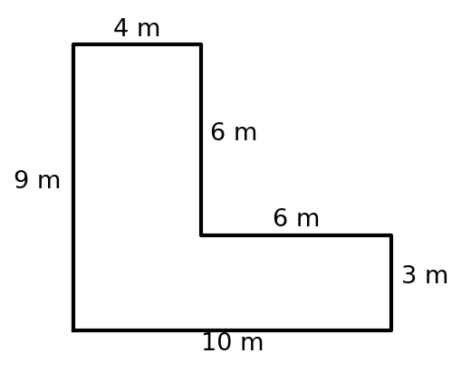
(a) Find the perimeter of the garden. ............................. [2 marks]
(b) By splitting the shape into two rectangles, find its area. ..................... [4 marks]
(c) Grass is laid on the garden at a cost of GH₵5.00 per square metre. Find the total cost of the grass. ....... [4 marks]

Question 2
Figure 12 shows a function machine that multiplies the input by 4 and subtracts 3.
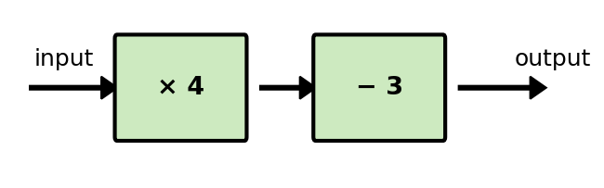
(a) Find the output when the input is 7. ............................ [1 marks]
(b) Write the rule of the machine in terms of n. .......................... [2 marks]
(c) The output of the machine is 33. Find the input. ........................ [3 marks]
(d) A second machine multiplies the input by 2 and adds 1. Find the input for which both machines give the same output. .. [4 marks]

Question 3
Figure 13 shows a triangle with two of its angles 58° and 47°. The base of the triangle is produced to form the exterior angle y.
(a) Find the angle marked x. ................................ [2 marks]
(b) Find the exterior angle marked y. ............................. [3 marks]
(c) Give the reason for your answer in (b). ........................... [2 marks]
(d) Classify the triangle according to its angles. ......................... [1 marks]
(e) Find the reflex angle of y. ............................... [2 marks]

Question 4
Figure 14 shows the number of mangoes sold by a trader from Monday to Friday. The mean number of mangoes sold per day is 50.
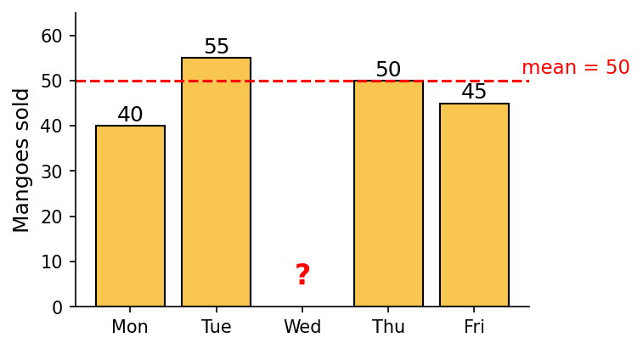
(a) Find the total number of mangoes sold in the five days. ...................... [2 marks]
(b) Find the number of mangoes sold on Wednesday. ......................... [3 marks]
(c) Copy the chart and draw the bar for Wednesday. ......................... [2 marks]
(d) If one day is picked at random, find the probability that more than 50 mangoes were sold on that day. ....... [3 marks]

Question 5
Figure 15 shows a 12 cm by 8 cm rectangle with a 3 cm square cut from one corner. The shaded part is the rectangle without the square.
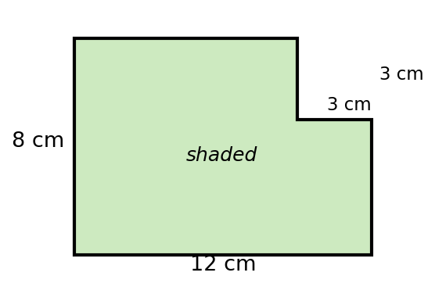
(a) Find the area of the full rectangle. ............................ [1 marks]
(b) Find the area of the shaded part. ............................. [2 marks]
(c) Express the shaded area as a fraction of the area of the full rectangle, in its lowest terms. ......... [3 marks]
(d) Find the perimeter of the shaded shape, and explain briefly why it is equal to the perimeter of the full rectangle. .. [4 marks]

Question 6
Figure 16 shows the favourite subjects of 36 learners drawn as a pie chart. The angle for French is not shown.
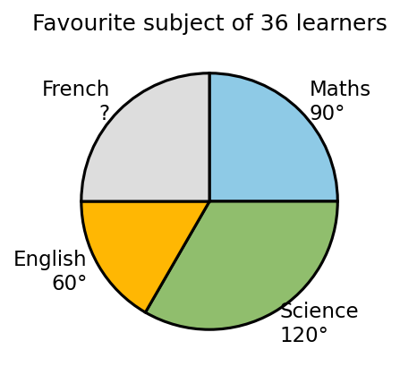
(a) Calculate the angle of the French sector. ........................... [2 marks]
(b) How many learners chose Science? .............................. [3 marks]
(c) If a learner is picked at random, find the probability that his or her favourite subject is English. ....... [2 marks]
(d) How many more learners chose Mathematics than English? ...................... [3 marks]

Question 7
Figure 17 shows a school S. The market M is on a bearing of 060° from S, and the church C is on a bearing of 150° from S. SM = 300 m and SC = 400 m.
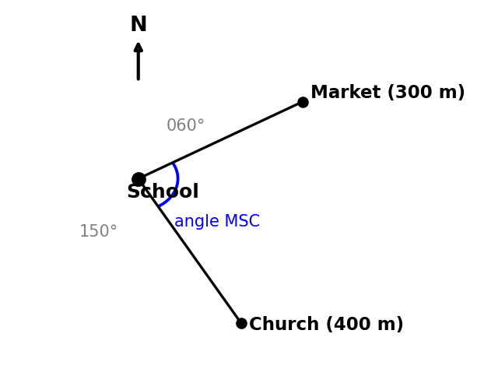
(a) Find the size of the angle MSC. .............................. [2 marks]
(b) Find the back bearing of the market from the school. ....................... [2 marks]
(c) Find the back bearing of the church from the school. ....................... [2 marks]
(d) Find the straight-line distance from the market to the church. .................... [2 marks]
(e) Describe the direction of the church from the school in ordinary language. ................ [2 marks]

END OF PAPER

ANSWER KEY — SECTION A
Question | Answer | Curriculum Area | Indicator | Cognitive Level
1 | B | Angles of a triangle | B7.3.1.1 | Apply
2 | B | Function machine | B7.2.1.1.3 | Apply
3 | C | Reading a pictogram | B7.4.1.1.3 | Apply
4 | D | Balance model for equations | B7.2.3.1.2 | Apply
5 | A | Perimeter of a composite shape | B7.3.2.1 | Analyse
6 | D | Area as a fraction | B7.3.2.2.2 | Analyse
7 | B | Mean with a missing value | B7.4.1.2.1 | Analyse
8 | B | Pie chart angles | B7.4.1.1.3 | Apply
9 | D | Finding the mirror line | B7.3.3.1.2 | Analyse
10 | C | Perimeter invariance | B7.3.2.1 | Analyse
11 | A | Mean with an unknown | B7.4.1.2.1 | Analyse
12 | C | Successive percentage changes | B7.1.4.1 | Analyse
13 | C | Percent of a quantity | B7.1.4.1.5 | Apply
14 | B | Ratio and totals | B7.1.4.1 | Apply
15 | A | Powers of natural numbers | B7.1.2.3 | Apply
16 | C | Square-number pattern | B7.2.1.1.3 | Analyse
17 | D | Two-step equations | B7.2.3.1.4 | Apply
18 | A | Perimeter in algebra | B7.2.2.1 | Apply
19 | A | Operations on algebraic terms | B7.2.2.1.3 | Apply
20 | C | Solving linear equations | B7.2.3.1.4 | Apply
21 | A | Complementary angles problem | B7.3.1.1.2 | Analyse
22 | C | Clock angles | B7.3.1.1 | Understand
23 | A | Equal perimeters | B7.3.2.1 | Analyse
24 | D | Magnitude of a vector | B7.3.2.3.4 | Apply
25 | B | Back bearing | B7.3.2.3.2 | Apply
26 | D | Median with an unknown | B7.4.1.2.2 | Analyse
27 | D | Mean of a data set | B7.4.1.2.1 | Apply
28 | B | Probability of the complement | B7.4.2.1.3 | Apply
29 | B | Probability and totals | B7.4.2.1.3 | Analyse
30 | C | Pie chart and probability | B7.4.1.1.3 | Apply

MARKING SCHEME — SECTION B
Question 1
(a) P = 9 + 4 + 6 + 6 + 3 + 10 = 38 m
[1 mark for all six sides; 1 mark for 38 m]
(b) Bottom rectangle: 10 × 3 = 30 m²; top rectangle: 4 × 6 = 24 m²; total = 54 m²
[2 marks for the two rectangle areas; 2 marks for 54 m²]
(c) 54 × GH₵5.00 = GH₵270.00
[2 marks for method; 2 marks for GH₵270.00]

Question 2
(a) 4(7) − 3 = 28 − 3 = 25
[1 mark]
(b) Output = 4n − 3
[2 marks]
(c) 4n − 3 = 33 ⇒ 4n = 36 ⇒ n = 9
[1 mark for equation; 1 mark for 4n = 36; 1 mark for n = 9]
(d) 4n − 3 = 2n + 1 ⇒ 2n = 4 ⇒ n = 2 (check: 4(2)−3 = 5; 2(2)+1 = 5)
[2 marks for setting up; 1 mark for 2n = 4; 1 mark for n = 2]

Question 3
(a) x = 180° − (58° + 47°) = 180° − 105° = 75°
[1 mark for sum 105°; 1 mark for 75°]
(b) y = 180° − 75° = 105° (or 58° + 47° = 105°)
[2 marks: 1 for method; 1 for 105°]
(c) The exterior angle of a triangle equals the sum of the two opposite interior angles (or: angles on a straight line sum to 180°)
[2 marks]
(d) Acute-angled triangle (all angles less than 90°: 58°, 47°, 75°)
[1 mark]
(e) 360° − 105° = 255°
[1 mark for method; 1 mark for 255°]

Question 4
(a) 5 × 50 = 250 mangoes
[1 mark for method; 1 mark for 250]
(b) 250 − (40 + 55 + 50 + 45) = 250 − 190 = 60 mangoes
[2 marks for sum 190; 1 mark for 60]
(c) Bar of height 60 drawn on Wednesday
[2 marks: 1 for correct height; 1 for correct position/labelling]
(d) Days above 50: Tue (55) and Wed (60) = 2 days; P = 2/5
[2 marks for identifying 2 days; 1 mark for 2/5]

Question 5
(a) 12 × 8 = 96 cm²
[1 mark]
(b) 96 − (3 × 3) = 96 − 9 = 87 cm²
[1 mark for 9 cm²; 1 mark for 87 cm²]
(c) 87/96 = 29/32
[2 marks for 87/96; 1 mark for 29/32]
(d) P = 2(12 + 8) = 40 cm. The two cut edges (3 cm each) replace the two removed edges (3 cm each), so the total is unchanged
[2 marks for 40 cm; 2 marks for a correct explanation]

Question 6
(a) 360° − (90° + 120° + 60°) = 360° − 270° = 90°
[1 mark for sum 270°; 1 mark for 90°]
(b) (120 ÷ 360) × 36 = 12 learners
[2 marks for method; 1 mark for 12]
(c) 60° ÷ 360° = 1/6
[1 mark for 60/360; 1 mark for 1/6]
(d) Maths: (90 ÷ 360) × 36 = 9; English: (60 ÷ 360) × 36 = 6; difference = 3 learners
[2 marks for the two numbers; 1 mark for 3]

Question 7
(a) 150° − 60° = 90°
[2 marks]
(b) 60° + 180° = 240°
[1 mark for method; 1 mark for 240°]
(c) 150° + 180° = 330°
[1 mark for method; 1 mark for 330°]
(d) Angle MSC = 90°, so MC = √(300² + 400²) = √250,000 = 500 m (3–4–5 triangle)
[1 mark for Pythagoras/magnitude; 1 mark for 500 m]
(e) South-east of the school (bearing 150° is between south and east, closer to south — south-south-easterly)
[2 marks for a correct direction description]

CURRICULUM ASSESSMENT BLUEPRINT
Question | Strand | Sub-strand / Area | Content Standard / Indicator | Cognitive Level | Marks
A1 | 3. Geometry and Measurement | Angles of a triangle | B7.3.1.1 | Apply | 1
A2 | 4. Handling Data | Function machine | B7.2.1.1.3 | Apply | 1
A3 | 4. Handling Data | Reading a pictogram | B7.4.1.1.3 | Apply | 1
A4 | 2. Algebra | Balance model for equations | B7.2.3.1.2 | Apply | 1
A5 | 3. Geometry and Measurement | Perimeter of a composite shape | B7.3.2.1 | Analyse | 1
A6 | 3. Geometry and Measurement | Area as a fraction | B7.3.2.2.2 | Analyse | 1
A7 | 4. Handling Data | Mean with a missing value | B7.4.1.2.1 | Analyse | 1
A8 | 4. Handling Data | Pie chart angles | B7.4.1.1.3 | Apply | 1
A9 | 3. Geometry and Measurement | Finding the mirror line | B7.3.3.1.2 | Analyse | 1
A10 | 3. Geometry and Measurement | Perimeter invariance | B7.3.2.1 | Analyse | 1
A11 | 1. Number | Mean with an unknown | B7.4.1.2.1 | Analyse | 1
A12 | 1. Number | Successive percentage changes | B7.1.4.1 | Analyse | 1
A13 | 1. Number | Percent of a quantity | B7.1.4.1.5 | Apply | 1
A14 | 1. Number | Ratio and totals | B7.1.4.1 | Apply | 1
A15 | 1. Number | Powers of natural numbers | B7.1.2.3 | Apply | 1
A16 | 2. Algebra | Square-number pattern | B7.2.1.1.3 | Analyse | 1
A17 | 2. Algebra | Two-step equations | B7.2.3.1.4 | Apply | 1
A18 | 2. Algebra | Perimeter in algebra | B7.2.2.1 | Apply | 1
A19 | 2. Algebra | Operations on algebraic terms | B7.2.2.1.3 | Apply | 1
A20 | 2. Algebra | Solving linear equations | B7.2.3.1.4 | Apply | 1
A21 | 3. Geometry and Measurement | Complementary angles problem | B7.3.1.1.2 | Analyse | 1
A22 | 3. Geometry and Measurement | Clock angles | B7.3.1.1 | Understand | 1
A23 | 3. Geometry and Measurement | Equal perimeters | B7.3.2.1 | Analyse | 1
A24 | 3. Geometry and Measurement | Magnitude of a vector | B7.3.2.3.4 | Apply | 1
A25 | 4. Handling Data | Back bearing | B7.3.2.3.2 | Apply | 1
A26 | 4. Handling Data | Median with an unknown | B7.4.1.2.2 | Analyse | 1
A27 | 4. Handling Data | Mean of a data set | B7.4.1.2.1 | Apply | 1
A28 | 4. Handling Data | Probability of the complement | B7.4.2.1.3 | Apply | 1
A29 | 4. Handling Data | Probability and totals | B7.4.2.1.3 | Analyse | 1
A30 | 4. Handling Data | Pie chart and probability | B7.4.1.1.3 | Apply | 1
B1 | 3. Geometry and Measurement | Composite shapes | B7.3.2.1; B7.3.2.2 | Apply | 10
B2 | 2. Algebra | Mappings and equations | B7.2.1.1.3; B7.2.3.1.4 | Analyse | 10
B3 | 3. Geometry and Measurement | Angles | B7.3.1.1 | Apply | 10
B4 | 4. Handling Data | Handling Data | B7.4.1.1.3; B7.4.1.2.1; B7.4.2.1.3 | Apply | 10
B5 | 1 + 3 (mixed) | Area, perimeter and fractions | B7.3.2.1; B7.3.2.2; B7.1.3.1 | Analyse | 10
B6 | 4. Handling Data | Pie charts and probability | B7.4.1.1.3; B7.4.2.1.3 | Apply | 10
B7 | 3. Geometry and Measurement | Bearings and vectors | B7.3.2.3.1; B7.3.2.3.2; B7.3.2.3.4 | Analyse | 10

COVERAGE SUMMARY
Strand | Questions | Marks | % of Paper
1. Number | A11–A15, part of B5 | 15 | 15%
2. Algebra | A16–A20, B2 | 15 | 15%
3. Geometry and Measurement | A1, A5, A6, A9, A10, A21–A24, B1, B3, B7, part of B5 | 40 | 40%
4. Handling Data | A2, A3, A7, A8, A25–A30, B4, B6 | 30 | 30%
TOTAL | 37 | 100 | 100%

COGNITIVE-LEVEL DISTRIBUTION
Cognitive Level (Bloom's) | Section A | Section B | Total Marks | % of Paper
Understand | 1 (A22) | 0 | 1 | 1%
Apply | 16 | 5 (B1, B3–B6) | 66 | 66%
Analyse | 13 (A5–A7, A9–A12, A16, A21, A23, A26, A29) | 2 (B2, B5, B7 counted) | 33 | 33%
This is a deliberately harder paper: 13 of 30 MCQs and 3 written questions target Analyse (missing-value means, composite shapes, perimeter invariance, mirror lines, equal perimeters, equating two machines, bearings with Pythagoras). Recall items are omitted by design.
DIFFICULTY DISTRIBUTION
Difficulty | Questions | %
Easy | A2, A3, A8, A13, A15, A19, A22, A27, B1(a), B3(a) | ~18%
Moderate | A1, A4, A14, A17, A18, A20, A24, A25, A28, A30, B1(b–c), B2(a–c), B3(b–e), B4(a–c), B6, B7(a–c) | ~47%
Challenging | A5, A6, A7, A9, A10, A11, A12, A16, A21, A23, A26, A29, B2(d), B4(d), B5, B7(d–e) | ~35%

QUALITY-CONTROL SUMMARY
1. Harder + diagram-based: 16 original figures (function machines, balance, L-shapes, corner-cut shapes, shaded triangle, triangle with exterior angle, pictogram, bar charts with missing bars, pie charts with missing sectors, reflection grid, bearings map) carry 10 MCQs and all 7 written questions; difficulty raised through reverse reasoning, missing values, and invariance ideas — all within B7 CCP scope.
2. Curriculum alignment: every question is traceable to a supplied NaCCA CCP B7 content standard/indicator (see blueprint). The triangle-angle items rest on the curriculum's own exemplar ('Two angles of a triangle add up to 98°. What is the size of the third angle?'); Pythagoras appears only as vector magnitude (indicator B7.3.2.3.4).
3. Originality: original BECE-style examination; all questions and figures newly created; no WAEC, textbook or copyrighted questions or images reproduced; not to be presented as an official BECE paper.
4. MCQ quality: 30 items, one defensible answer each, sophisticated distractors (e.g. A5 adding only visible labels, A10 subtracting the cut from the perimeter, A12 'no change', A17 giving p instead of 3p, A23 using the square's perimeter, A26 choosing a value that shifts the median).
5. Answer-key distribution: A=7, B=8, C=8, D=7 — varied positions, no predictable pattern.
6. Arithmetic verified: every answer independently recomputed (e.g. L-shape P = 38 m, A = 54 m², cost GH₵270; 4n−3 = 33 → 9; 4n−3 = 2n+1 → 2; 250−190 = 60; shaded 87/96 = 29/32; corner-cut perimeter = 40 cm; French sector = 90°; angle MSC = 90°, MC = 500 m).
7. Marks: Section A = 30; Section B = 7 × 10 = 70; total = 100. All internal allocations add up correctly.
8. Cognitive demand: Understand 1%, Apply 66%, Analyse 33% — analysis tripled relative to standard papers.
9. Ghanaian contexts used naturally: cedis (GH₵), mango seller, school garden grass, favourite subjects, map with school/market/church, learners' names (Ama).
10. Language: clear Ghanaian school English; terminology consistent with the NaCCA curriculum.

