………………………………………………… SCHOOL
SCIENCE
BECE-PREP MOCK EXAMINATION — PAPER 11 (BASIC 7 SCIENCE FULL MOCK)
Academic Year: 2026/2027

Class: JHS 1 (Basic 7) Time: 2 hours Total Marks: 100
Curriculum Coverage: NaCCA CCP Science B7 — ALL FIVE STRANDS with original diagrams

INSTRUCTIONS TO CANDIDATES
1. This paper consists of two sections: Section A (Objective Test) and Section B (Written Response).
2. Answer ALL questions in Section A and ALL questions in Section B.
3. Study each diagram carefully before answering. Diagrams are not necessarily drawn to scale.
4. In Section A, choose the correct option from A to D and write the letter in the space provided.
5. In Section B, show ALL your working clearly. Marks are awarded for methods as well as answers.
6. Where required, take g = 10 m/s².

SECTION A: OBJECTIVE TEST (30 marks)
Answer ALL questions in this section. Each question carries 1 mark.
1. In Figure 1, the organelle labelled X is a chloroplast. What is the function of the chloroplast?
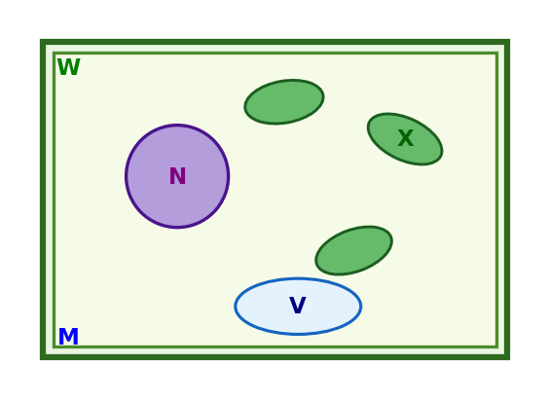
A. It makes food for the plant
B. It stores water only
C. It digests food
D. It gives the cell support

2. Figure 2 shows an animal cell. Which of these structures is found in a plant cell but NOT in an animal cell?
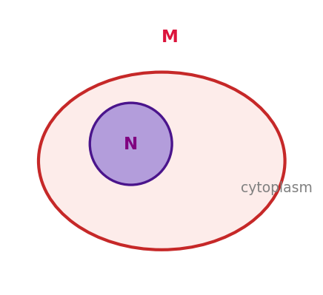
A. Nucleus
B. Cell membrane
C. Cell wall
D. Cytoplasm

3. In Figure 3 of the water cycle, the process labelled P, by which water vapour rises from the sea, is called…
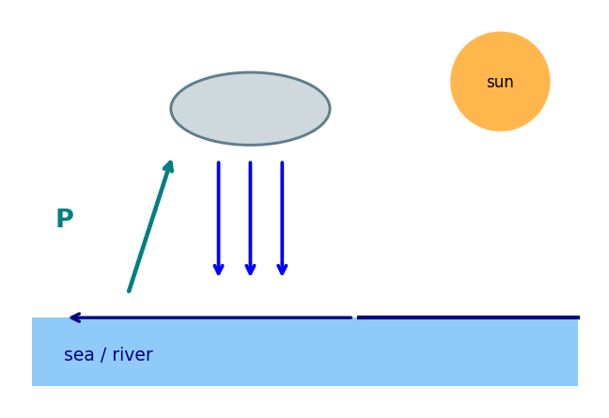
A. Condensation
B. Evaporation
C. Precipitation
D. Collection

4. Figure 4 shows the life cycle of the housefly. Which stage comes immediately after the larva stage?
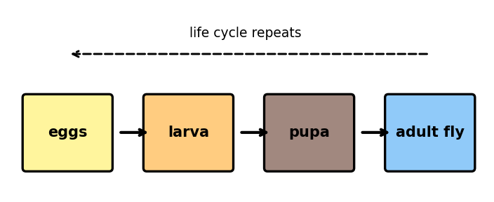
A. Eggs
B. Adult
C. Larva
D. Pupa

5. In Figure 5, most of the digested food is absorbed into the blood from the part labelled X. Which part is X?
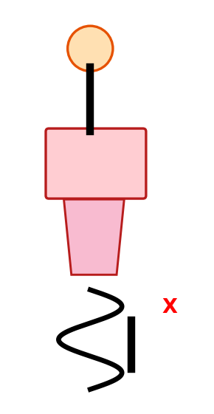
A. Stomach
B. Large intestine
C. Small intestine
D. Mouth

6. The end product of the digestion of protein in humans is…
A. Amino acids
B. Glucose
C. Fatty acids
D. Vitamins

7. Figure 6 shows the Sun and the inner planets. Which planet is second from the Sun?
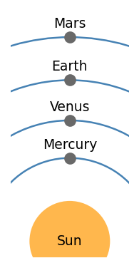
A. Mercury
B. Venus
C. Earth
D. Mars

8. In Figure 7, the grasshopper feeds on the plant. In this food chain the grasshopper is a…
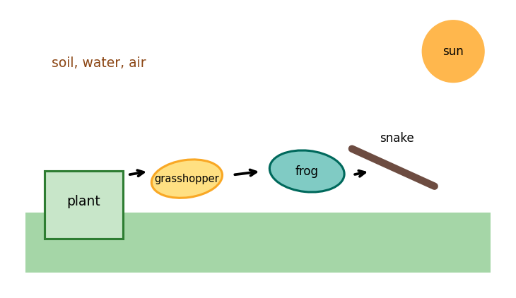
A. Producer
B. Secondary consumer
C. Decomposer
D. Primary consumer

9. Figure 8 shows a simple circuit. What happens to the bulb when the switch is opened?
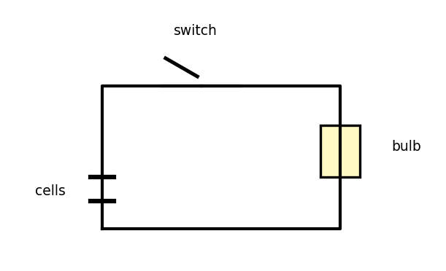
A. It glows brighter
B. It goes off
C. It glows dimmer
D. Nothing changes

10. In Figure 9, the fulcrum lies between the effort and the load. This is an example of a…
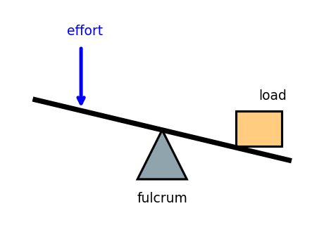
A. First-class lever
B. Second-class lever
C. Third-class lever
D. Fourth-class lever

11. In Figure 10, a ball of mass 2 kg rests 5 m above the ground. Taking g = 10 m/s², find its potential energy.
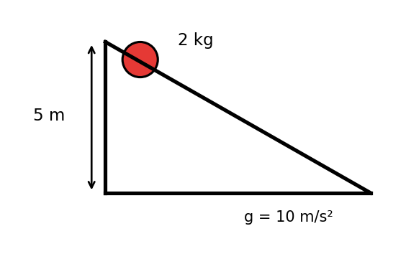
A. 20 J
B. 50 J
C. 10 J
D. 100 J

12. A moving object of mass 3 kg has a speed of 4 m/s. Calculate its kinetic energy. (KE = ½mv²)
A. 12 J
B. 36 J
C. 24 J
D. 48 J

13. In Figure 11, heat travels along the metal rod from the flame to the ice. This way of transferring heat is called…
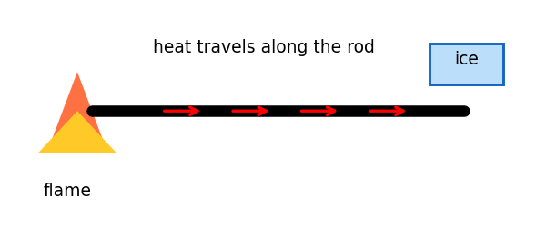
A. Convection
B. Conduction
C. Radiation
D. Insulation

14. In Figure 12, the angle of incidence at the mirror is 35°. What is the angle of reflection?
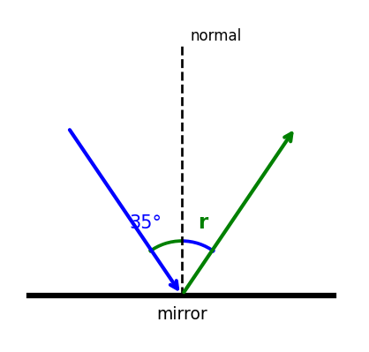
A. 35°
B. 55°
C. 70°
D. 17.5°

15. In Figure 13, the ray of light bends towards the normal as it enters the glass block because light…
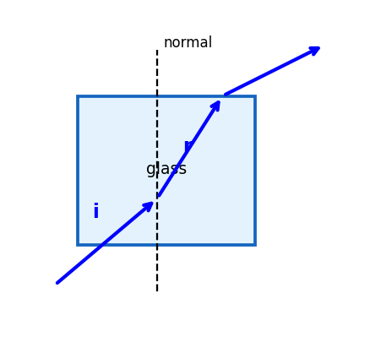
A. Speeds up in glass
B. Stops in glass
C. Slows down in glass
D. Is completely reflected

16. In Figure 14, the region marked X around the bar magnet, where the magnet can attract iron, is called the…
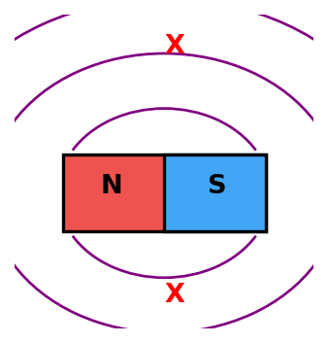
A. Electric field
B. Gravity field
C. Energy field
D. Magnetic field

17. Newton's First Law of motion states that a body stays at rest or keeps moving uniformly unless it is acted upon by…
A. A balanced force
B. An unbalanced force
C. Its own energy
D. Friction only

18. A machine uses 500 J of work input to do 400 J of work output. What is its efficiency?
A. 40%
B. 50%
C. 75%
D. 80%

19. Which of these is a renewable source of energy?
A. Solar
B. Coal
C. Crude oil
D. Natural gas

20. Kwashiorkor is a deficiency disease caused by lack of enough…
A. Carbohydrate
B. Fat
C. Protein
D. Vitamin C

21. Which of these diseases is caused by a virus?
A. Malaria
B. COVID-19
C. Cholera
D. Kwashiorkor

22. Which of these elements is a noble gas?
A. Oxygen
B. Chlorine
C. Iron
D. Helium

23. The chemical symbol for potassium is…
A. K
B. P
C. Po
D. Pt

24. Which of these materials is a liquid at room temperature?
A. Salt
B. Iron
C. Water
D. Oxygen

25. A goat is an example of which type of domestic animal?
A. Poultry
B. Ruminant
C. Monogastric
D. Fish

26. Which of these plant nutrients is an organic fertilizer?
A. NPK
B. Urea
C. Ammonium sulphate
D. Poultry manure

27. Which of these are biotic factors of an ecosystem?
A. Plants and animals
B. Sunlight
C. Rainfall
D. Temperature

28. The farming system in which different crops are grown together in the same field at the same time is…
A. Land rotation
B. Crop rotation
C. Mixed cropping
D. Monocropping

29. In a torchlight, the energy change when the bulb is switched on is…
A. Electrical → chemical → light
B. Light → electrical → chemical
C. Heat → light → electrical
D. Chemical → electrical → light and heat

30. Which of these is the best scientific way of managing household waste?
A. Open burning
B. Segregation and recycling
C. Dumping in a river
D. Burying plastics

SECTION B: WRITTEN RESPONSE (70 marks)
Answer ALL questions in this section. Show all your working clearly.
Question 1
Figure 15 shows a plant cell with six parts labelled 1 to 6.
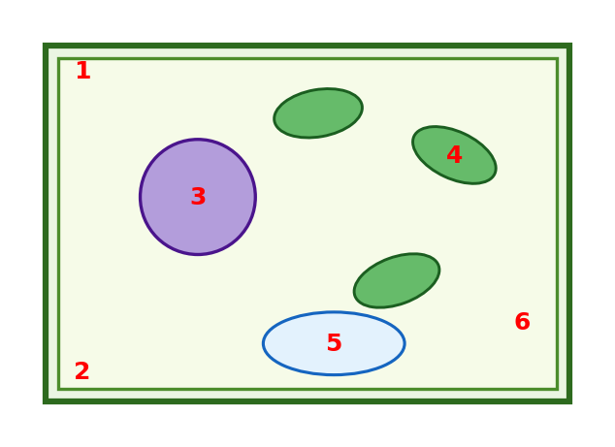
(a) Name the parts labelled 1, 2, 3 and 4. ............................ [4 marks]
(b) State one function of the nucleus (part 3). .......................... [2 marks]
(c) State one function of the chloroplast (part 4). ......................... [2 marks]
(d) Which part of the cell controls what enters and leaves the cell? ................... [2 marks]

Question 2
Figure 16 shows part of the water cycle. The processes A, B and C are marked.
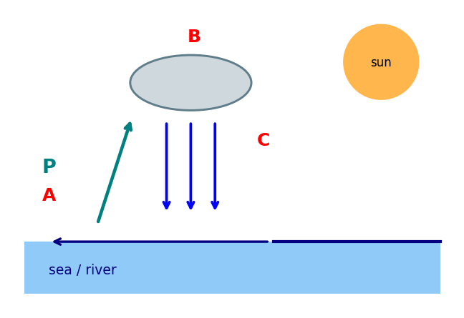
(a) Name the processes A, B and C. .............................. [3 marks]
(b) Explain briefly how clouds are formed in the water cycle. ..................... [2 marks]
(c) State two importance of the water cycle in nature. ........................ [2 marks]
(d) Name one natural source of water in your community. ....................... [1 marks]
(e) Why is the water cycle described as a repeated pattern of change in nature? ............... [2 marks]

Question 3
Figure 17 shows the digestive system of a human with four parts labelled 1 to 4.
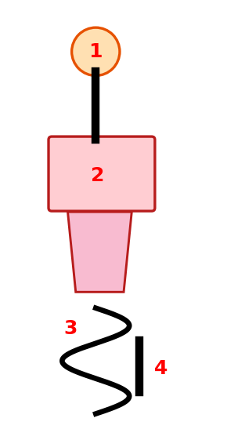
(a) Name the parts labelled 1, 2, 3 and 4. ............................ [4 marks]
(b) In which part does most of the absorption of digested food take place? Give one reason. ........... [2 marks]
(c) State the end products of the digestion of (i) starch and (ii) protein. ................. [2 marks]
(d) Name the process by which digested food passes into the blood. .................... [2 marks]

Question 4
Figure 18 shows a simple ecosystem with four organisms labelled A, B, C and D.
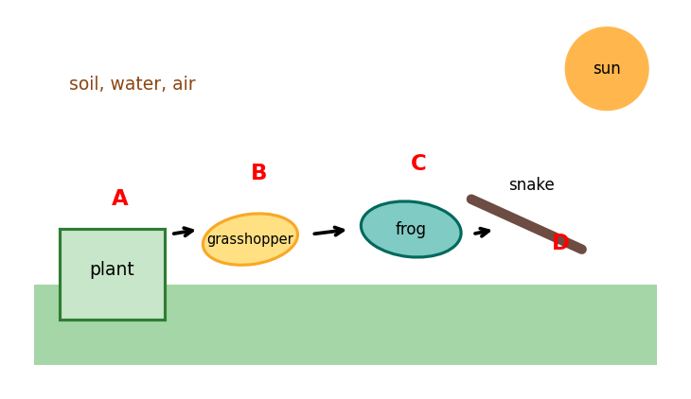
(a) Write the food chain of the ecosystem using the letters A to D. ................... [2 marks]
(b) Is organism D a producer, a consumer or a decomposer? Explain. .................... [2 marks]
(c) Name one biotic and one abiotic factor of the ecosystem shown. .................... [2 marks]
(d) What happens to the energy as it passes along the food chain? .................... [2 marks]
(e) State one way human beings can protect this ecosystem. ...................... [2 marks]

Question 5
Figure 19 shows (a) a 4 kg ball at a height of 3 m and (b) a 2 kg object moving at 6 m/s. Take g = 10 m/s².
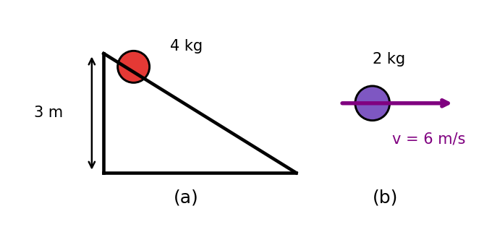
(a) Calculate the potential energy of the ball in figure (a). ..................... [2 marks]
(b) Calculate the kinetic energy of the object in figure (b). ..................... [2 marks]
(c) As the ball falls to the ground, state the energy change that takes place. ................ [2 marks]
(d) State the law of conservation of energy. ........................... [2 marks]
(e) Give one practical way of conserving energy in the home. ...................... [2 marks]

Question 6
Figure 20 shows a simple electric circuit. Figure 21 shows a lever.
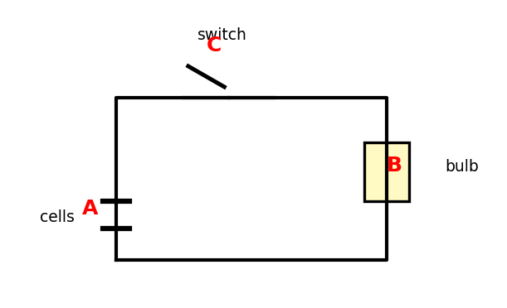
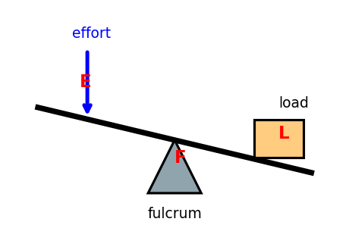
(a) In Figure 20, name the components labelled A and B. ....................... [2 marks]
(b) What happens to the bulb when the switch is opened, and why? .................... [2 marks]
(c) State the class of the lever shown in Figure 21 and explain how it helps the user. ............. [2 marks]
(d) A machine does 300 J of work output using 400 J of work input. Calculate its efficiency. ........... [2 marks]
(e) Name one simple machine used on a farm. ........................... [2 marks]

Question 7
Figure 22 shows the lunch of a learner, Akosua. The plate contains rice, beans, fish and vegetables.
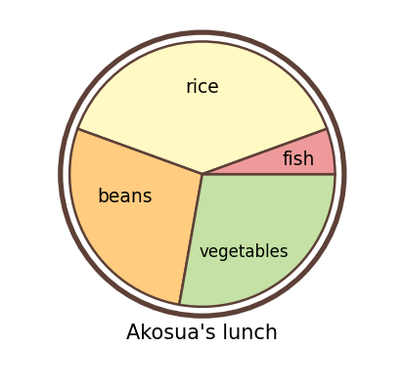
(a) Name the main food nutrient supplied by each of rice, beans, fish and vegetables. ............. [3 marks]
(b) Which deficiency disease results from a lack of protein in the diet? .................. [1 marks]
(c) State two symptoms of the disease in (b). ........................... [2 marks]
(d) Give two ways of preventing deficiency diseases. ........................ [2 marks]
(e) Name one viral disease and state one way it spreads from person to person. ................ [2 marks]

END OF PAPER

ANSWER KEY — SECTION A
Question | Answer | Curriculum Area | Indicator | Cognitive Level
1 | A | Plant cell organelles | B7.1.2.1.2 | Apply
2 | C | Plant and animal cells | B7.1.2.1.1; B7.1.2.1.2 | Apply
3 | B | The water cycle | B7.2.1.1.1 | Apply
4 | D | Life cycle of the housefly | B7.2.2.1.1 | Apply
5 | C | Digestion in humans | B7.3.1.1.2; B7.3.1.1.3 | Apply
6 | A | End products of digestion | B7.3.1.1.3 | Understand
7 | B | The inner planets | B7.3.2.1.1 | Apply
8 | D | Ecosystem interactions | B7.3.3.1.1 | Apply
9 | B | Basic electric circuits | B7.4.2.2.1; B7.4.2.2.2 | Apply
10 | A | Levers | B7.4.4.2.2 | Apply
11 | D | Potential energy (PE = mgh) | B7.4.1.1.1 | Apply
12 | C | Kinetic energy (KE = ½mv²) | B7.4.1.1.1 | Apply
13 | B | Heat transfer | B7.4.1.2.1 | Apply
14 | A | Reflection of light | B7.4.1.3.1 | Apply
15 | C | Refraction of light | B7.4.1.3.1 | Analyse
16 | D | Magnets | B7.4.4.1.4 | Understand
17 | B | Newton's First Law | B7.4.4.1.2; B7.4.4.1.3 | Understand
18 | D | Efficiency of machines | B7.4.4.2.3 | Apply
19 | A | Sustainable energy | B7.5.4.1.1 | Understand
20 | C | Deficiency diseases | B7.5.2.1.1 | Apply
21 | B | Viral diseases | B7.5.2.2.1 | Apply
22 | D | The periodic table | B7.1.1.2.1 | Understand
23 | A | Chemical symbols | B7.1.1.2.1 | Understand
24 | C | States of matter | B7.1.1.1.1 | Apply
25 | B | Domestic animals | B7.2.4.1.2 | Apply
26 | D | Plant nutrients | B7.2.3.1.1 | Apply
27 | A | Ecosystem components | B7.3.3.1.1 | Apply
28 | C | Farming systems | B7.3.4.1.2 | Apply
29 | D | Energy conversion | B7.4.3.1.2 | Analyse
30 | B | Waste management | B7.5.1.1.1 | Apply

MARKING SCHEME — SECTION B
Question 1
(a) 1 = cell wall; 2 = cell membrane; 3 = nucleus; 4 = chloroplast
[1 mark for each correct name]
(b) The nucleus controls all the activities of the cell (and contains the genetic material).
[1 mark for function; 1 mark for a clear statement]
(c) The chloroplast traps sunlight and uses it to make food for the plant (photosynthesis).
[1 mark for trapping sunlight; 1 mark for making food]
(d) The cell membrane (part 2).
[1 mark for identifying; 1 mark for naming]

Question 2
(a) A = evaporation; B = condensation; C = precipitation
[1 mark for each process]
(b) Water vapour rises, cools and condenses around tiny dust particles to form tiny water droplets that gather as clouds.
[1 mark for cooling/condensing; 1 mark for droplets forming clouds]
(c) Any two of: it replenishes fresh water for life; it supports plant and animal life; it helps regulate weather and climate; it purifies water. (1 mark each)
[2 marks]
(d) Any one of: river, stream, rain, well, spring, lake, dam.
[1 mark]
(e) Because the same water is used again and again: it moves continuously through evaporation, condensation and precipitation in a repeating (cyclic) process.
[1 mark for 'repeats/continuous'; 1 mark for reference to the stages]

Question 3
(a) 1 = mouth; 2 = stomach; 3 = small intestine; 4 = large intestine
[1 mark for each correct name]
(b) The small intestine (part 3). It is very long / has a large surface area, so most digested food is absorbed there.
[1 mark for small intestine; 1 mark for the reason]
(c) (i) starch → glucose; (ii) protein → amino acids
[1 mark for each end product]
(d) Absorption
[2 marks]

Question 4
(a) A → B → C → D (plant → grasshopper → frog → snake)
[1 mark for the order; 1 mark for using the letters]
(b) D is a consumer (carnivore): it feeds on other animals and cannot make its own food.
[1 mark for consumer; 1 mark for the explanation]
(c) Biotic: plant/grasshopper/frog/snake (any one); abiotic: sun/soil/water/air (any one).
[1 mark for each factor]
(d) Energy decreases (is lost as heat) at each stage; less energy passes to the next organism.
[1 mark for 'decreases/is lost'; 1 mark for the explanation]
(e) Any one of: do not dump chemicals or waste in the habitat; protect the vegetation; control bush burning; protect the animals. (Accept other reasonable answers.)
[2 marks]

Question 5
(a) PE = mgh = 4 × 10 × 3 = 120 J
[1 mark for mgh = 4 × 10 × 3; 1 mark for 120 J]
(b) KE = ½mv² = ½ × 2 × 6² = 36 J
[1 mark for ½mv² = ½ × 2 × 36; 1 mark for 36 J]
(c) Potential energy is converted into kinetic energy as it falls.
[1 mark for naming both forms; 1 mark for the direction of conversion]
(d) Energy cannot be created or destroyed; it can only be changed from one form to another.
[2 marks]
(e) Any one of: switch off lights and fans when not in use; use energy-saving bulbs; turn off the gas when not cooking; close the fridge door quickly. (Accept other reasonable answers.)
[2 marks]

Question 6
(a) A = cells (battery); B = bulb (lamp)
[1 mark for each component]
(b) The bulb goes off, because opening the switch breaks (opens) the circuit, so current can no longer flow.
[1 mark for 'goes off'; 1 mark for the reason]
(c) It is a first-class lever (fulcrum between effort and load). It multiplies the effort force, so a small effort can lift a bigger load.
[1 mark for first class; 1 mark for the explanation]
(d) Efficiency = work output/work input × 100% = 300/400 × 100% = 75%
[1 mark for the formula; 1 mark for 75%]
(e) Any one of: cutlass, hoe, shovel, spade, wheelbarrow, crowbar, sickle.
[2 marks]

Question 7
(a) Rice = carbohydrate; beans = protein; fish = protein; vegetables = vitamins (and minerals).
[1 mark for each correct nutrient (3 marks max)]
(b) Kwashiorkor
[1 mark]
(c) Any two of: swollen tummy/belly, thin wasted limbs, swollen face, reddish hair, pale skin, sores. (1 mark each)
[2 marks]
(d) Any two of: eat a balanced diet; eat protein-rich foods (beans, fish, eggs, milk); eat a variety of foods; nutrition education. (1 mark each)
[2 marks]
(e) Any one of: COVID-19 (spread by droplets/coughing/close contact); Ebola (contact with body fluids); H1N1 influenza (droplets). (1 mark for the disease; 1 mark for the spread)
[2 marks]

CURRICULUM ASSESSMENT BLUEPRINT
Question | Strand | Sub-strand / Area | Content Standard / Indicator | Cognitive Level | Marks
A1 | 1. Diversity of Matter | Plant cell organelles | B7.1.2.1.2 | Apply | 1
A2 | 1. Diversity of Matter | Plant and animal cells | B7.1.2.1.1; B7.1.2.1.2 | Apply | 1
A3 | 2. Cycles | The water cycle | B7.2.1.1.1 | Apply | 1
A4 | 2. Cycles | Life cycle of the housefly | B7.2.2.1.1 | Apply | 1
A5 | 3. Systems | Digestion in humans | B7.3.1.1.2; B7.3.1.1.3 | Apply | 1
A6 | 3. Systems | End products of digestion | B7.3.1.1.3 | Understand | 1
A7 | 3. Systems | The inner planets | B7.3.2.1.1 | Apply | 1
A8 | 3. Systems | Ecosystem interactions | B7.3.3.1.1 | Apply | 1
A9 | 4. Forces and Energy | Basic electric circuits | B7.4.2.2.1; B7.4.2.2.2 | Apply | 1
A10 | 4. Forces and Energy | Levers | B7.4.4.2.2 | Apply | 1
A11 | 4. Forces and Energy | Potential energy (PE = mgh) | B7.4.1.1.1 | Apply | 1
A12 | 4. Forces and Energy | Kinetic energy (KE = ½mv²) | B7.4.1.1.1 | Apply | 1
A13 | 4. Forces and Energy | Heat transfer | B7.4.1.2.1 | Apply | 1
A14 | 4. Forces and Energy | Reflection of light | B7.4.1.3.1 | Apply | 1
A15 | 4. Forces and Energy | Refraction of light | B7.4.1.3.1 | Analyse | 1
A16 | 4. Forces and Energy | Magnets | B7.4.4.1.4 | Understand | 1
A17 | 4. Forces and Energy | Newton's First Law | B7.4.4.1.2; B7.4.4.1.3 | Understand | 1
A18 | 4. Forces and Energy | Efficiency of machines | B7.4.4.2.3 | Apply | 1
A19 | 5. Humans and the Environment | Sustainable energy | B7.5.4.1.1 | Understand | 1
A20 | 5. Humans and the Environment | Deficiency diseases | B7.5.2.1.1 | Apply | 1
A21 | 5. Humans and the Environment | Viral diseases | B7.5.2.2.1 | Apply | 1
A22 | 1. Diversity of Matter | The periodic table | B7.1.1.2.1 | Understand | 1
A23 | 1. Diversity of Matter | Chemical symbols | B7.1.1.2.1 | Understand | 1
A24 | 1. Diversity of Matter | States of matter | B7.1.1.1.1 | Apply | 1
A25 | 2. Cycles | Domestic animals | B7.2.4.1.2 | Apply | 1
A26 | 2. Cycles | Plant nutrients | B7.2.3.1.1 | Apply | 1
A27 | 3. Systems | Ecosystem components | B7.3.3.1.1 | Apply | 1
A28 | 3. Systems | Farming systems | B7.3.4.1.2 | Apply | 1
A29 | 5. Humans and the Environment | Energy conversion | B7.4.3.1.2 | Analyse | 1
A30 | 5. Humans and the Environment | Waste management | B7.5.1.1.1 | Apply | 1
B1 | 1. Diversity of Matter | Living cells | B7.1.2.1.1; B7.1.2.1.2 | Apply | 10
B2 | 2. Cycles | The water cycle | B7.2.1.1.1; B7.2.1.1.2 | Analyse | 10
B3 | 3. Systems | Digestion in humans | B7.3.1.1.2; B7.3.1.1.3 | Analyse | 10
B4 | 3. Systems | Ecosystems and interactions | B7.3.3.1.1 | Analyse | 10
B5 | 4. Forces and Energy | Forms and conservation of energy | B7.4.1.1.1; B7.4.3.1.1; B7.4.3.1.2; B7.4.3.1.3 | Apply | 10
B6 | 4. Forces and Energy | Electricity and simple machines | B7.4.2.2.1; B7.4.2.2.2; B7.4.4.2.2; B7.4.4.2.3 | Apply | 10
B7 | 5. Humans and the Environment | Nutrition, deficiency and viral diseases | B7.5.2.1.1; B7.5.2.2.1 | Apply | 10

COVERAGE SUMMARY
Strand | Questions | Marks | % of Paper
1. Diversity of Matter | A1, A2, A22–A24, B1 | 15 | 15%
2. Cycles | A3, A4, A25, A26, B2 | 14 | 14%
3. Systems | A5–A8, A27, A28, B3, B4 | 26 | 26%
4. Forces and Energy | A9–A18, B5, B6 | 30 | 30%
5. Humans and the Environment | A19–A21, A29, A30, B7 | 15 | 15%
TOTAL | 37 | 100 | 100%

COGNITIVE-LEVEL DISTRIBUTION
Cognitive Level (Bloom's) | Section A | Section B | Total Marks | % of Paper
Understand | 5 (A16, A17, A19, A22, A23) | 0 | 5 | 5%
Apply | 23 | 4 (B1, B5, B6, B7) | 63 | 63%
Analyse | 2 (A15, A29) | 3 (B2, B3, B4) | 32 | 32%
Analysis targets the water cycle as a system, digestion and absorption, energy flow in food chains, refraction, and tracing energy conversions — with numerical applications of PE, KE and machine efficiency carrying the Apply band.
DIFFICULTY DISTRIBUTION
Difficulty | Questions | %
Easy | A2, A4, A7, A10, A16, A19, A23, A24, B1(a), B3(a) | ~20%
Moderate | A1, A3, A5, A6, A8, A9, A13, A14, A17, A20–A22, A25–A28, A30, B1(b–d), B2(a–c), B3(b,d), B4(a–c), B5(b–d), B6(a–c), B7(a–b) | ~45%
Challenging | A11, A12, A15, A18, A29, B2(d–e), B3(c,e), B4(d–e), B5(e), B6(d–e), B7(c–e) | ~35%

QUALITY-CONTROL SUMMARY
1. Diagram-based: 22 original figures (plant and animal cells, the water cycle, housefly life cycle, human digestive system, inner planets, ecosystem food chain, electric circuits, levers, a ramp with a raised ball, heat conduction along a rod, reflection at a mirror, refraction through a glass block, a bar magnet with field lines, a food plate) carry 14 MCQs and all 7 written questions — every written question is asked on its figures.
2. Curriculum alignment: every question is traceable to a supplied NaCCA CCP B7 Science content standard/indicator (see blueprint): materials and the periodic table, living cells, the water cycle, the housefly life cycle, plant nutrients, domestic animals, digestion, the inner planets, ecosystems, farming systems, forms of energy (PE = mgh, KE = ½mv²), heat transfer, light, electricity and electronics, energy conservation, force and motion, magnets, levers and efficiency, waste management, deficiency and viral diseases, and sustainable energy.
3. Originality: original BECE-style examination; all questions and figures newly created; no WAEC, textbook or copyrighted questions or images reproduced; not to be presented as an official BECE paper.
4. MCQ quality: 30 items, one defensible answer each, distractors model common errors (e.g. A1 confusing chloroplast with vacuole, A11 dropping the height factor, A12 using mv² instead of ½mv², A14 halving the angle, A18 using output as input, A29 reversing the energy chain).
5. Answer-key distribution: A=7, B=8, C=7, D=8 — varied positions, no predictable pattern.
6. Science and arithmetic verified: every quantitative answer independently recomputed (PE = 2 × 10 × 5 = 100 J; KE = ½ × 3 × 4² = 24 J; efficiency 400/500 = 80%; angle of reflection = 35°; PE = 4 × 10 × 3 = 120 J; KE = ½ × 2 × 6² = 36 J; efficiency 300/400 = 75%), and every factual answer checked against the curriculum content.
7. Marks: Section A = 30; Section B = 7 × 10 = 70; total = 100. All internal allocations add up correctly.
8. Cognitive demand: Understand 5%, Apply 63%, Analyse 32%.
9. Ghanaian contexts used naturally: Akosua's school lunch, farm tools (cutlass, hoe), Ghanaian farming systems, community water sources, household waste management, local ecosystems.
10. Language: clear Ghanaian school English; terminology consistent with the NaCCA curriculum.

