………………………………………………… SCHOOL
MATHEMATICS
BECE-PREP MOCK EXAMINATION — PAPER 9 (BASIC 8 FULL MOCK)
Academic Year: 2026/2027

Class: JHS 2 (Basic 8) Time: 2 hours Total Marks: 100
Curriculum Coverage: NaCCA CCP Mathematics B8 — ALL STRANDS with original diagrams

INSTRUCTIONS TO CANDIDATES
1. This paper consists of two sections: Section A (Objective Test) and Section B (Written Response).
2. Answer ALL questions in Section A and ALL questions in Section B.
3. Study each diagram carefully before answering. Diagrams are not necessarily drawn to scale.
4. In Section A, choose the correct option from A to D and write the letter in the space provided.
5. In Section B, show ALL your working clearly. Marks are awarded for methods as well as answers.
6. Where required, take π = 22/7. Give fractions in their lowest terms unless told otherwise.

SECTION A: OBJECTIVE TEST (30 marks)
Answer ALL questions in this section. Each question carries 1 mark.
1. In Figure 1, two parallel lines are cut by a transversal. The marked angle is 62°. Find the angle marked a.
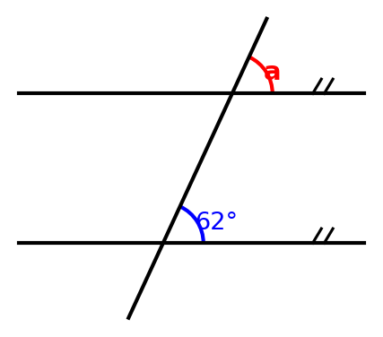
A. 62°
B. 118°
C. 28°
D. 128°

2. In Figure 2, two angles of the triangle are 40° and 65°. Find the exterior angle marked x.
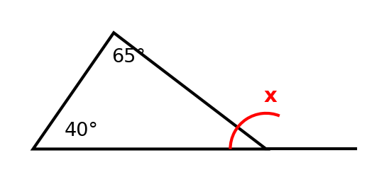
A. 75°
B. 45°
C. 105°
D. 290°

3. In Figure 3, three angles of the quadrilateral are marked. Find the angle marked x.
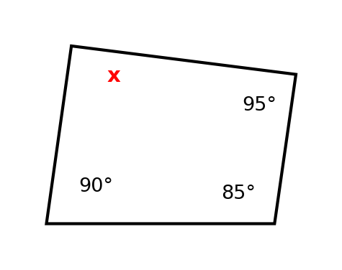
A. 80°
B. 90°
C. 100°
D. 270°

4. Figure 4 shows a right-angled triangle with the two shorter sides 5 cm and 12 cm. Find the hypotenuse.
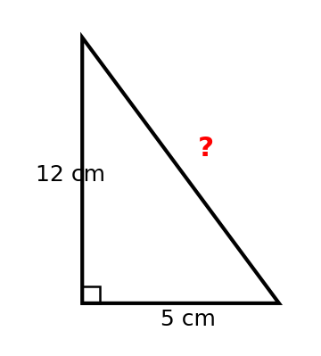
A. 17 cm
B. 7 cm
C. 13 cm
D. 18 cm

5. In Figure 5, a ladder rests against a wall. The foot of the ladder is 0.7 m from the wall and the top is 2.4 m above the ground. How long is the ladder?
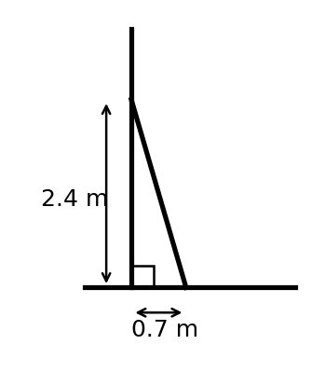
A. 2.5 m
B. 3.1 m
C. 1.7 m
D. 3.5 m

6. Figure 6 shows a circle of radius 3.5 m. Find its area. (Take π = 22/7.)
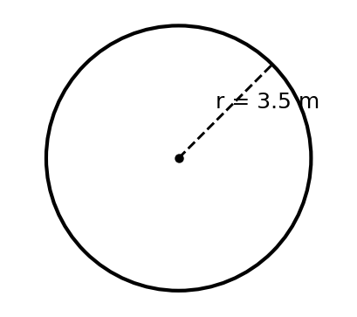
A. 22 m²
B. 38.5 m²
C. 77 m²
D. 12.25 m²

7. In Figure 7, the sides of the right-angled triangle are marked. Find tan θ.
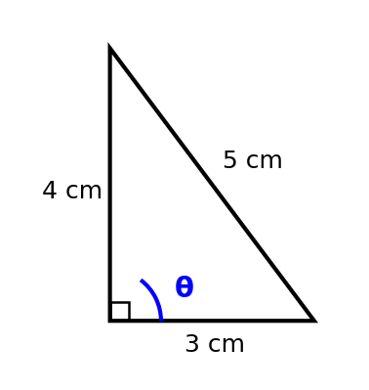
A. 3/4
B. 3/5
C. 4/5
D. 4/3

8. Figure 8 shows the graph of a straight line through the points marked. What is the gradient of the line?
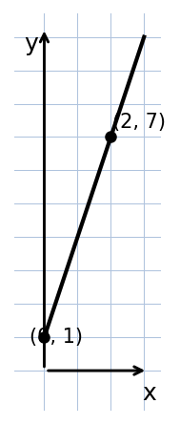
A. 3
B. 1/3
C. 2
D. 1

9. In Figure 9, the vectors a = (2, 3) and b = (3, −1) are drawn on a grid. Find a + b as a column vector.
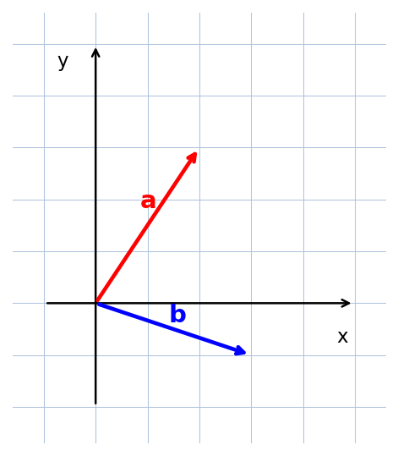
A. (1, 4)
B. (6, 3)
C. (5, 2)
D. (5, 4)

10. In Figure 10, the triangle ABC has been rotated about the origin O to give A′B′C′. What rotation maps ABC onto A′B′C′?
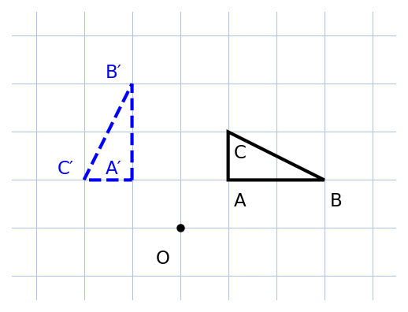
A. 90° clockwise
B. 180° about O
C. 270° clockwise
D. 90° anticlockwise

11. Figure 11 shows the sales of a small business from Monday to Friday. Find the mean daily sales.
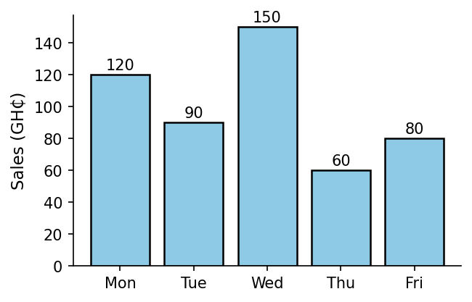
A. GH₵100
B. GH₵90
C. GH₵110
D. GH₵150

12. Figure 12 shows the games played by 35 learners. How many learners play football or volleyball (or both)?
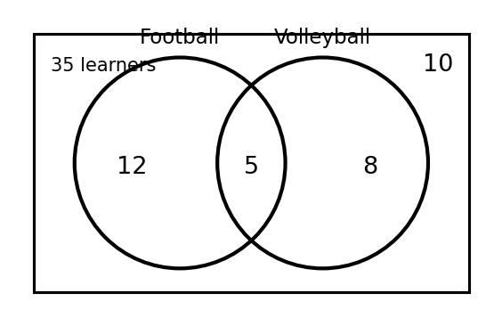
A. 17
B. 25
C. 35
D. 5

13. Figure 13 shows the solution of an inequality on a number line. Which inequality is shown?
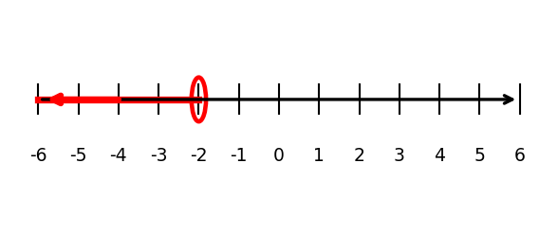
A. x < −2
B. x ≤ −2
C. x > −2
D. x ≥ −2

14. Figure 14 shows a stem-and-leaf diagram of the marks of 12 learners. Find the median mark.
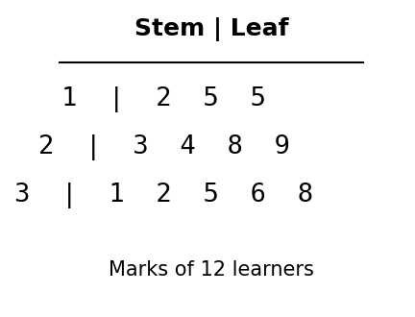
A. 24
B. 28.5
C. 29
D. 30

15. Write 8,765,049 in standard form.
A. 8.765049 × 10⁵
B. 87.65049 × 10⁵
C. 0.8765049 × 10⁶
D. 8.765049 × 10⁶

16. Express 56,734 correct to two significant figures.
A. 56,000
B. 56,700
C. 58,000
D. 57,000

17. Simplify: 2⁵ × 2³ ÷ 2⁶
A. 2
B. 4
C. 8
D. 16

18. Evaluate (3²)³.
A. 243
B. 81
C. 729
D. 512

19. Expand and simplify: 3(2x − 4) + 2(x + 3)
A. 5x − 1
B. 8x − 18
C. 8x − 6
D. 6x − 6

20. Factorise completely: 12ab + 16b
A. 4b(3a + 4)
B. 4(3ab + 4b)
C. 2b(6a + 8)
D. 12b(a + 4)

21. Solve the inequality: 3x − 5 ≥ 10
A. x ≤ 5
B. x ≥ 5
C. x > 5
D. x ≥ 3

22. A whole number n is less than 17. Which inequality represents this?
A. n ≤ 17
B. n > 17
C. n ≥ 17
D. n < 17

23. Which of these numbers is NOT a perfect square?
A. 49
B. 75
C. 144
D. 100

24. The common factors of 36 and 42 are 1, 2, 3 and 6. What is their greatest common factor?
A. 6
B. 12
C. 3
D. 21

25. Kofi bought 8 notebooks at GH₵12.00 each and 12 pens at GH₵5.00 each. How much did he spend altogether?
A. GH₵160
B. GH₵148
C. GH₵164
D. GH₵156

26. Write 3/8 as a decimal.
A. 0.38
B. 0.375
C. 0.308
D. 0.83

27. A man shared GH₵2,477.25 equally among his three children. How much did each receive?
A. GH₵825.25
B. GH₵852.75
C. GH₵825.75
D. GH₵625.75

28. A bag contains 3 red, 2 green and 1 pink bottle top. One is picked at random. Find P(red).
A. 1/2
B. 1/3
C. 3/5
D. 2/3

29. A fair coin is tossed and a fair die is rolled. Find the probability of getting a head and an even number.
A. 1/2
B. 1/6
C. 3/4
D. 1/4

30. A box contains 3 blue pens and 4 pink pens. A pen is taken, its colour noted and replaced; then another pen is taken. Find the probability that the first is blue and the second is pink.
A. 12/42
B. 6/49
C. 12/49
D. 3/7

SECTION B: WRITTEN RESPONSE (70 marks)
Answer ALL questions in this section. Show all your working clearly.
Question 1
Figure 15 shows a Venn diagram for 80 farmers in a village who grow maize (M) and rice (R). 50 farmers grow maize and 60 grow rice. x farmers grow both crops.
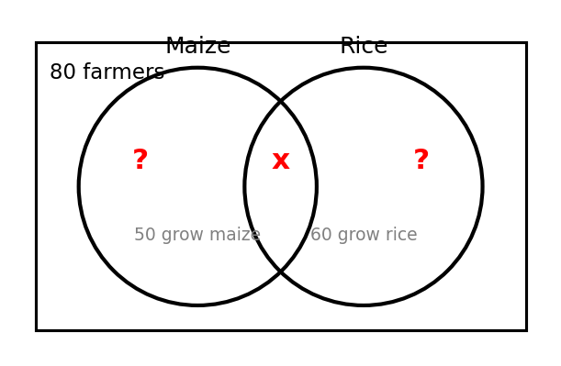
(a) Write an equation in x and solve it to find x. ......................... [3 marks]
(b) How many of the farmers grow maize only? ........................... [2 marks]
(c) How many of the farmers grow rice only? ........................... [1 marks]
(d) If a farmer is picked at random, find the probability that the farmer grows both crops. ........... [2 marks]
(e) Express the number who grow maize only as a fraction of all the farmers, in its lowest terms. ......... [2 marks]

Question 2
Answer the following algebra questions.
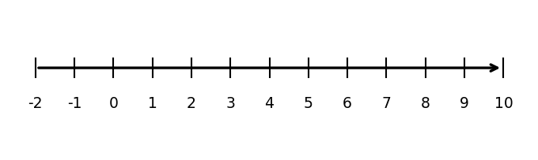
(a) Expand and simplify: 3(2x − 4) + 2(x + 3) ........................... [3 marks]
(b) Factorise completely: 12ab + 16b .............................. [2 marks]
(c) Evaluate 2x² + 3y when x = −2 and y = 3. ........................... [2 marks]
(d) Solve the inequality: 5x − 3 ≥ 2x + 9 ............................ [2 marks]
(e) Show the solution of (d) on the number line in Figure 16. ..................... [1 marks]

Question 3
Figure 17 shows two parallel lines cut by a transversal. Figure 18 shows a pentagon with four of its angles marked.
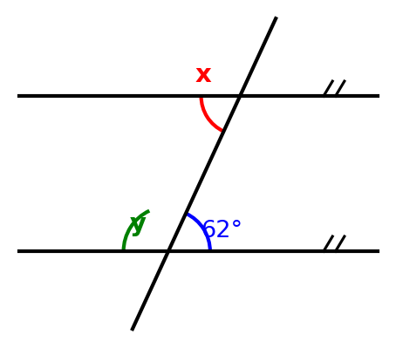
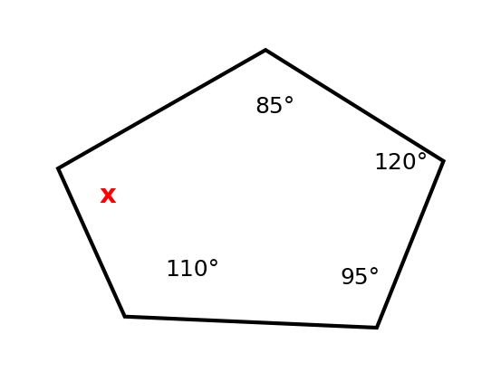
(a) In Figure 17, find the value of x. ............................. [2 marks]
(b) In Figure 17, find the value of y. ............................. [2 marks]
(c) In Figure 18, find the angle marked x. ............................ [3 marks]
(d) Find the sum of the interior angles of a regular octagon. ..................... [3 marks]

Question 4
Figure 19 shows a ladder leaning against a wall. Figure 20 shows a circular school garden.
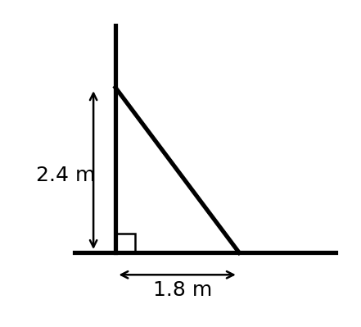
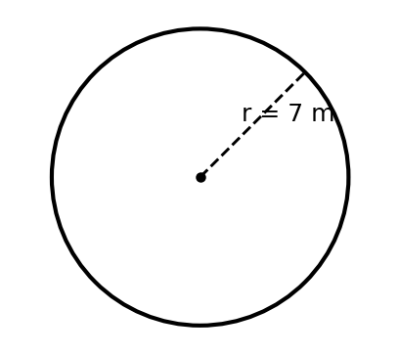
(a) In Figure 19, the foot of the ladder is 1.8 m from the wall and the top is 2.4 m above the ground. Find the length of the ladder. .. [3 marks]
(b) The garden in Figure 20 has radius 7 m. Find its area. (Take π = 22/7.) ................. [3 marks]
(c) Find the circumference of the garden. ............................ [2 marks]
(d) Fencing wire costs GH₵8.50 per metre. Find the cost of fencing the garden. ................ [2 marks]

Question 5
Figure 21 shows the vectors u = (3, 1) and v = (1, 2) on a grid. Figure 22 shows a triangle T with vertices P(1, 1), Q(3, 1) and R(1, 3).
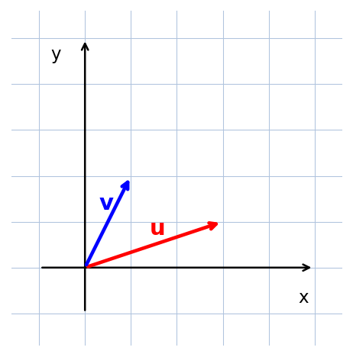
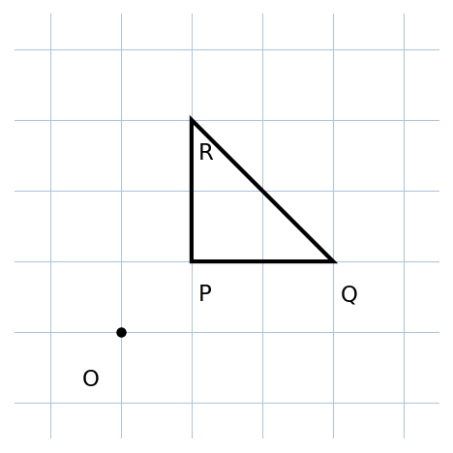
(a) Find u + v as a column vector. .............................. [2 marks]
(b) Find 2u as a column vector. ............................... [2 marks]
(c) Find 2u − v as a column vector. .............................. [2 marks]
(d) Triangle T is rotated 90° anticlockwise about the origin O. Find the coordinates of the image of R. ....... [2 marks]
(e) What property do triangle T and its image share? Explain briefly. ................... [2 marks]

Question 6
Figure 23 shows the number of yam tubers sold by a trader from Monday to Friday. The mean number sold per day is 26.
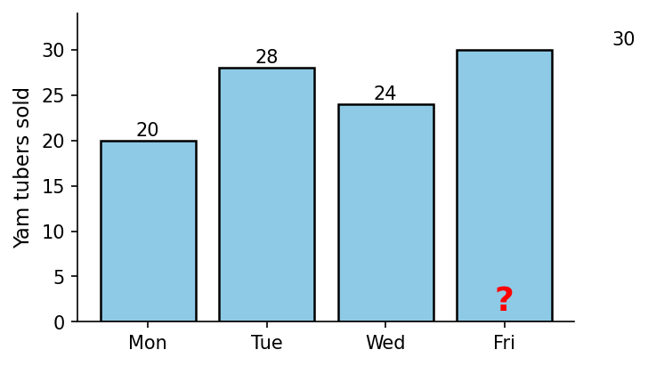
(a) Find the total number of tubers sold in the five days. ...................... [2 marks]
(b) Find the number of tubers sold on Thursday. .......................... [2 marks]
(c) Copy the chart and draw the bar for Thursday. ......................... [2 marks]
(d) Find the median and the mode of the data. ........................... [2 marks]
(e) The trader says the mode best represents his daily sales. Do you agree? Give a reason. ............ [2 marks]

Question 7
Figure 24 shows a bag containing 3 red (R), 2 green (G) and 1 pink (P) bottle tops. A bottle top is picked at random, its colour noted and it is replaced; then a second top is picked.
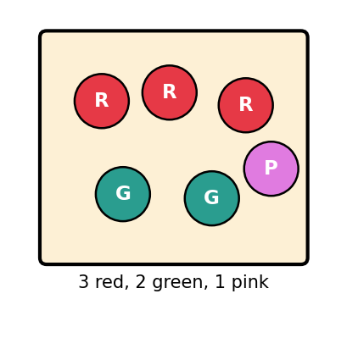
(a) Find the probability of picking a red bottle top. ........................ [2 marks]
(b) Find the probability that both bottle tops picked are red. ..................... [2 marks]
(c) Find the probability that the first is green and the second is pink. .................. [2 marks]
(d) Express P(red) as a percentage. .............................. [2 marks]
(e) If the experiment is repeated 200 times, how many red tops would you expect to be picked altogether? ....... [2 marks]

END OF PAPER

ANSWER KEY — SECTION A
Question | Answer | Curriculum Area | Indicator | Cognitive Level
1 | A | Corresponding angles | B8.3.1.1.1 | Apply
2 | C | Exterior angle of a triangle | B8.3.1.1.2 | Analyse
3 | B | Angle sum of a quadrilateral | B8.3.1.1.2 | Apply
4 | C | Pythagoras' theorem | B8.3.2.1.2 | Apply
5 | A | Pythagoras' theorem in context | B8.3.2.1.3 | Analyse
6 | B | Area of a circle | B8.3.2.1.1 | Apply
7 | D | Trigonometric ratios | B8.3.2.1.5 | Apply
8 | A | Gradient of a line | B8.2.1.1.1 | Apply
9 | C | Addition of vectors | B8.3.2.2.1 | Apply
10 | D | Rotation on a coordinate plane | B8.3.3.1.2 | Analyse
11 | A | Mean of ungrouped data | B8.4.1.2.1 | Apply
12 | B | Union of two sets | B8.1.1.2.2 | Analyse
13 | A | Solution sets of inequalities | B8.2.3.1.3 | Understand
14 | B | Median of ungrouped data | B8.4.1.2.1 | Analyse
15 | D | Standard form | B8.1.1.1.4 | Apply
16 | D | Significant figures | B8.1.1.1.5 | Apply
17 | B | Laws of indices | B8.1.2.3.2 | Apply
18 | C | Laws of indices | B8.1.2.3.2 | Apply
19 | C | Removing brackets | B8.2.2.1.1 | Apply
20 | A | Factorisation | B8.2.2.1.4 | Apply
21 | B | Solving linear inequalities | B8.2.3.1.2 | Apply
22 | D | Writing inequalities | B8.2.3.1.1 | Understand
23 | B | Perfect squares | B8.1.1.2.1 | Understand
24 | A | Factors and sets | B8.1.1.2.2 | Analyse
25 | D | Word problems on decimals | B8.1.2.2.3 | Apply
26 | B | Fractions and decimals | B8.1.2.1.1 | Understand
27 | C | Division of decimals | B8.1.2.2.3 | Analyse
28 | A | Probability of a single event | B8.4.2.1.1 | Apply
29 | D | Independent events | B8.4.2.1.2 | Analyse
30 | C | Independent events with replacement | B8.4.2.1.2 | Analyse

MARKING SCHEME — SECTION B
Question 1
(a) 50 + 60 − x = 80 ⇒ 110 − x = 80 ⇒ x = 30
[1 mark for the equation; 1 mark for 110 − x = 80; 1 mark for x = 30]
(b) Maize only = 50 − 30 = 20 farmers
[1 mark for method; 1 mark for 20]
(c) Rice only = 60 − 30 = 30 farmers
[1 mark]
(d) P(both) = 30/80 = 3/8
[1 mark for 30/80; 1 mark for 3/8]
(e) 20/80 = 1/4
[1 mark for 20/80; 1 mark for 1/4]

Question 2
(a) 3(2x − 4) + 2(x + 3) = 6x − 12 + 2x + 6 = 8x − 6
[1 mark for 6x − 12; 1 mark for 2x + 6; 1 mark for 8x − 6]
(b) 12ab + 16b = 4b(3a + 4)
[1 mark for factor 4b; 1 mark for 4b(3a + 4)]
(c) 2(−2)² + 3(3) = 2(4) + 9 = 8 + 9 = 17
[1 mark for 8 + 9; 1 mark for 17]
(d) 5x − 3 ≥ 2x + 9 ⇒ 3x ≥ 12 ⇒ x ≥ 4
[1 mark for 3x ≥ 12; 1 mark for x ≥ 4]
(e) Shaded line from 4 to the right with a solid (filled) circle at 4
[1 mark for solid circle at 4 and shading to the right]

Question 3
(a) x = 62° (alternate angles are equal)
[1 mark for 62°; 1 mark for the reason]
(b) y = 180° − 62° = 118° (co-interior / angles on the same side)
[1 mark for method; 1 mark for 118°]
(c) Sum of interior angles of a pentagon = (5 − 2) × 180° = 540°; x = 540° − (110° + 95° + 120° + 85°) = 540° − 410° = 130°
[1 mark for 540°; 1 mark for 410°; 1 mark for 130°]
(d) (8 − 2) × 180° = 6 × 180° = 1080°
[1 mark for (8 − 2) × 180°; 1 mark for 1080°]

Question 4
(a) Length² = 1.8² + 2.4² = 3.24 + 5.76 = 9; length = √9 = 3.0 m
[1 mark for 1.8² + 2.4²; 1 mark for 9; 1 mark for 3.0 m]
(b) Area = πr² = 22/7 × 7 × 7 = 154 m²
[1 mark for 22/7 × 49; 1 mark for 154 m²]
(c) C = 2πr = 2 × 22/7 × 7 = 44 m
[1 mark for method; 1 mark for 44 m]
(d) Cost = 44 × GH₵8.50 = GH₵374.00
[1 mark for method; 1 mark for GH₵374.00]

Question 5
(a) u + v = (3 + 1, 1 + 2) = (4, 3)
[1 mark for (3 + 1, 1 + 2); 1 mark for (4, 3)]
(b) 2u = 2(3, 1) = (6, 2)
[1 mark for method; 1 mark for (6, 2)]
(c) 2u − v = (6, 2) − (1, 2) = (5, 0)
[1 mark for (6, 2) − (1, 2); 1 mark for (5, 0)]
(d) Rotation 90° anticlockwise: (x, y) → (−y, x); R(1, 3) → (−3, 1)
[1 mark for the rule; 1 mark for (−3, 1)]
(e) The triangles are congruent: rotation preserves side lengths and angle sizes (same shape and size).
[1 mark for congruent/same size and shape; 1 mark for the explanation]

Question 6
(a) Total = 5 × 26 = 130 tubers
[1 mark for method; 1 mark for 130]
(b) Thursday = 130 − (20 + 28 + 24 + 30) = 130 − 102 = 28 tubers
[2 marks for 130 − 102; 1 mark for 28]
(c) Bar of height 28 drawn for Thursday
[2 marks: 1 for correct height; 1 for correct labelling]
(d) Ordered data: 20, 24, 28, 28, 30. Median = 28; mode = 28
[1 mark for each of median 28 and mode 28]
(e) Sample answer: Agree — the mode (28) equals the median here and is the value actually sold on most days. (Accept any reasonable justification, e.g. disagree with reference to the mean 26.)
[2 marks for a justified choice]

Question 7
(a) P(red) = 3/6 = 1/2
[1 mark for 3/6; 1 mark for 1/2]
(b) P(red and red) = 1/2 × 1/2 = 1/4
[1 mark for the product; 1 mark for 1/4]
(c) P(green then pink) = 2/6 × 1/6 = 2/36 = 1/18
[1 mark for 2/6 × 1/6; 1 mark for 1/18]
(d) 1/2 = 50%
[1 mark for method; 1 mark for 50%]
(e) Expected reds = 1/2 × 200 = 100
[1 mark for method; 1 mark for 100]

CURRICULUM ASSESSMENT BLUEPRINT
Question | Strand | Sub-strand / Area | Content Standard / Indicator | Cognitive Level | Marks
A1 | 3. Geometry and Measurement | Corresponding angles | B8.3.1.1.1 | Apply | 1
A2 | 3. Geometry and Measurement | Exterior angle of a triangle | B8.3.1.1.2 | Analyse | 1
A3 | 3. Geometry and Measurement | Angle sum of a quadrilateral | B8.3.1.1.2 | Apply | 1
A4 | 3. Geometry and Measurement | Pythagoras' theorem | B8.3.2.1.2 | Apply | 1
A5 | 3. Geometry and Measurement | Pythagoras' theorem in context | B8.3.2.1.3 | Analyse | 1
A6 | 3. Geometry and Measurement | Area of a circle | B8.3.2.1.1 | Apply | 1
A7 | 3. Geometry and Measurement | Trigonometric ratios | B8.3.2.1.5 | Apply | 1
A8 | 2. Algebra | Gradient of a line | B8.2.1.1.1 | Apply | 1
A9 | 3. Geometry and Measurement | Addition of vectors | B8.3.2.2.1 | Apply | 1
A10 | 3. Geometry and Measurement | Rotation on a coordinate plane | B8.3.3.1.2 | Analyse | 1
A11 | 4. Handling Data | Mean of ungrouped data | B8.4.1.2.1 | Apply | 1
A12 | 1. Number | Union of two sets | B8.1.1.2.2 | Analyse | 1
A13 | 2. Algebra | Solution sets of inequalities | B8.2.3.1.3 | Understand | 1
A14 | 4. Handling Data | Median of ungrouped data | B8.4.1.2.1 | Analyse | 1
A15 | 1. Number | Standard form | B8.1.1.1.4 | Apply | 1
A16 | 1. Number | Significant figures | B8.1.1.1.5 | Apply | 1
A17 | 1. Number | Laws of indices | B8.1.2.3.2 | Apply | 1
A18 | 1. Number | Laws of indices | B8.1.2.3.2 | Apply | 1
A19 | 2. Algebra | Removing brackets | B8.2.2.1.1 | Apply | 1
A20 | 2. Algebra | Factorisation | B8.2.2.1.4 | Apply | 1
A21 | 2. Algebra | Solving linear inequalities | B8.2.3.1.2 | Apply | 1
A22 | 2. Algebra | Writing inequalities | B8.2.3.1.1 | Understand | 1
A23 | 1. Number | Perfect squares | B8.1.1.2.1 | Understand | 1
A24 | 1. Number | Factors and sets | B8.1.1.2.2 | Analyse | 1
A25 | 1. Number | Word problems on decimals | B8.1.2.2.3 | Apply | 1
A26 | 1. Number | Fractions and decimals | B8.1.2.1.1 | Understand | 1
A27 | 1. Number | Division of decimals | B8.1.2.2.3 | Analyse | 1
A28 | 4. Handling Data | Probability of a single event | B8.4.2.1.1 | Apply | 1
A29 | 4. Handling Data | Independent events | B8.4.2.1.2 | Analyse | 1
A30 | 4. Handling Data | Independent events with replacement | B8.4.2.1.2 | Analyse | 1
B1 | 1. Number | Sets: union and intersection | B8.1.1.2.2 | Apply | 10
B2 | 2. Algebra | Algebraic expressions and inequalities | B8.2.2.1.1; B8.2.2.1.4; B8.2.3.1.2 | Apply | 10
B3 | 3. Geometry and Measurement | Angles: parallel lines and polygons | B8.3.1.1.1; B8.3.1.1.2 | Apply | 10
B4 | 3. Geometry and Measurement | Pythagoras and circle measurement | B8.3.2.1.1; B8.3.2.1.3 | Apply | 10
B5 | 3. Geometry and Measurement | Vectors and rotation | B8.3.2.2.1; B8.3.3.1.2; B8.3.3.1.3 | Analyse | 10
B6 | 4. Handling Data | Measures of central tendency | B8.4.1.1.3; B8.4.1.2.1; B8.4.1.2.2 | Analyse | 10
B7 | 4. Handling Data | Probability of independent events | B8.4.2.1.1; B8.4.2.1.2 | Apply | 10

COVERAGE SUMMARY
Strand | Questions | Marks | % of Paper
1. Number | A12, A15–A18, A23–A27, B1 | 20 | 20%
2. Algebra | A8, A13, A19–A22, B2 | 16 | 16%
3. Geometry and Measurement | A1–A7, A9, A10, B3, B4, B5 | 39 | 39%
4. Handling Data | A11, A14, A28–A30, B6, B7 | 25 | 25%
TOTAL | 37 | 100 | 100%

COGNITIVE-LEVEL DISTRIBUTION
Cognitive Level (Bloom's) | Section A | Section B | Total Marks | % of Paper
Understand | 4 (A13, A22, A23, A26) | 0 | 4 | 4%
Apply | 17 | 5 (B1–B4, B7) | 67 | 67%
Analyse | 9 (A2, A5, A10, A12, A14, A24, A27, A29, A30) | 2 (B5, B6) | 29 | 29%
The paper is a full Basic 8 mock with a normal BECE-style demand curve; analysis items include exterior angles, Pythagoras in context, rotations read off a grid, union of sets, medians from stem-and-leaf diagrams and independent-event probabilities.
DIFFICULTY DISTRIBUTION
Difficulty | Questions | %
Easy | A3, A13, A15, A16, A22, A23, A26, B1(a–c), B3(a–b) | ~18%
Moderate | A1, A4, A6, A8, A9, A11, A17, A18, A20, A21, A24, A25, A28, B1(d–e), B2(a–c), B4, B7 | ~48%
Challenging | A2, A5, A7, A10, A12, A14, A19, A27, A29, A30, B2(d–e), B3(c–d), B5, B6(e) | ~34%

QUALITY-CONTROL SUMMARY
1. Diagram-based: 24 original figures (parallel lines with transversals, triangles with exterior angles, quadrilateral and pentagon angle problems, right-angled triangles and a ladder, circular garden, trigonometric triangle, linear graph, vector grids, rotation grids, bar charts, Venn diagrams, number lines, stem-and-leaf diagram, bag of bottle tops) carry 14 MCQs and all 7 written questions — every written question is asked on its figure.
2. Curriculum alignment: every question is traceable to a supplied NaCCA CCP B8 content standard/indicator (see blueprint): laws of indices, standard form, sets and Venn diagrams, expansion/factorisation, linear inequalities, gradient y = mx + c, parallel-line angles, polygon angle sums, Pythagoras' theorem, trigonometric ratios, circle area, vector components, rotation, central tendency and independent-event probability.
3. Originality: original BECE-style examination; all questions and figures newly created; no WAEC, textbook or copyrighted questions or images reproduced; not to be presented as an official BECE paper.
4. MCQ quality: 30 items, one defensible answer each, distractors model common errors (e.g. A4 adding 5 + 12, A6 using 22/7 × 3.5, A9 adding only one component, A17 adding powers, A19 forgetting the +6, A26 rounding 3/8 to 0.38).
5. Answer-key distribution: A=8, B=8, C=7, D=7 — varied positions, no predictable pattern.
6. Arithmetic verified: every answer independently recomputed (e.g. exterior angle 105°; quadrilateral x = 90°; pentagon x = 130°; octagon sum 1080°; √(1.8² + 2.4²) = 3.0 m; 22/7 × 49 = 154 m²; circumference 44 m; cost GH₵374.00; 2u − v = (5, 0); R(1,3) → (−3, 1); total 130 tubers, Thursday 28; median = mode = 28; 110 − x = 80 ⇒ x = 30; 3x ≥ 12 ⇒ x ≥ 4; P(both red) = 1/4; P(green then pink) = 1/18).
7. Marks: Section A = 30; Section B = 7 × 10 = 70; total = 100. All internal allocations add up correctly.
8. Cognitive demand: Understand 4%, Apply 67%, Analyse 29%.
9. Ghanaian contexts used naturally: cedis (GH₵), yam trader, maize and rice farmers, school garden, Kofi's shopping, bottle tops, learners' names (Ama, Kofi).
10. Language: clear Ghanaian school English; terminology consistent with the NaCCA curriculum.

