………………………………………………… SCHOOL
MATHEMATICS
BECE-PREP MOCK EXAMINATION — PAPER 10 (BASIC 9 FULL MOCK)
Academic Year: 2026/2027

Class: JHS 3 (Basic 9) Time: 2 hours Total Marks: 100
Curriculum Coverage: NaCCA CCP Mathematics B9 — ALL STRANDS with original diagrams

INSTRUCTIONS TO CANDIDATES
1. This paper consists of two sections: Section A (Objective Test) and Section B (Written Response).
2. Answer ALL questions in Section A and ALL questions in Section B.
3. Study each diagram carefully before answering. Diagrams are not necessarily drawn to scale.
4. In Section A, choose the correct option from A to D and write the letter in the space provided.
5. In Section B, show ALL your working clearly. Marks are awarded for methods as well as answers.
6. Where required, take π = 22/7. Give fractions in their lowest terms unless told otherwise.

SECTION A: OBJECTIVE TEST (30 marks)
Answer ALL questions in this section. Each question carries 1 mark.
1. In Figure 1, five angles of a hexagon are marked. Find the angle marked x.
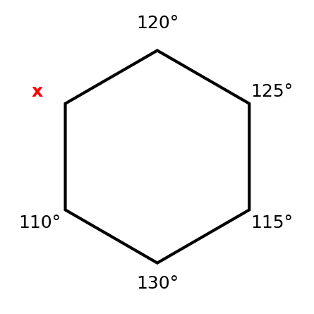
A. 130°
B. 120°
C. 60°
D. 300°

2. Figure 2 shows two similar triangles. Find the side marked x.
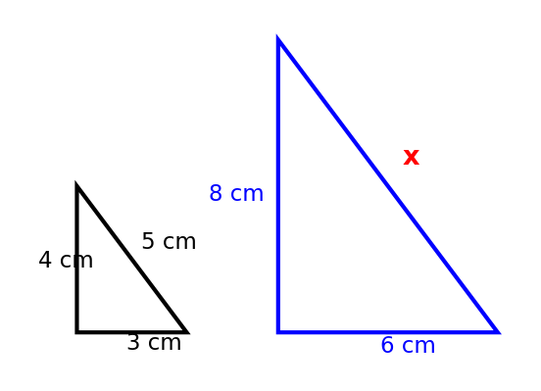
A. 10 cm
B. 9 cm
C. 12 cm
D. 7.5 cm

3. Figure 3 shows a cuboid with the dimensions marked. Find its total surface area.
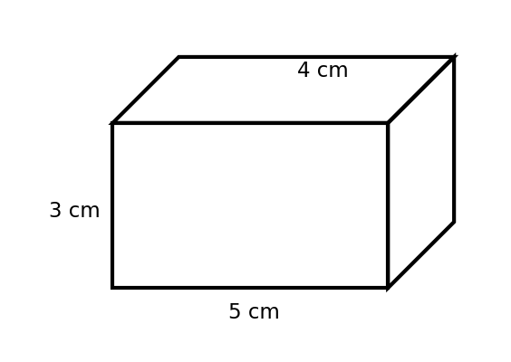
A. 60 cm²
B. 71 cm²
C. 94 cm²
D. 120 cm²

4. Figure 4 shows a triangular prism with a right-angled triangular cross-section. Find its total surface area.
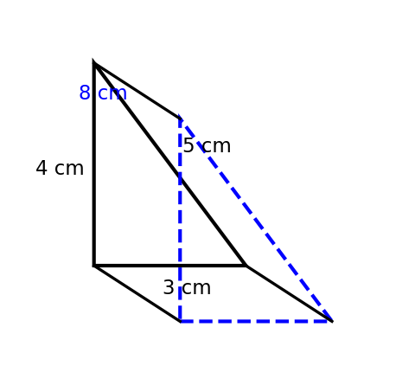
A. 120 cm²
B. 60 cm²
C. 96 cm²
D. 108 cm²

5. Figure 5 shows the net of a solid. Which solid can be made from this net?
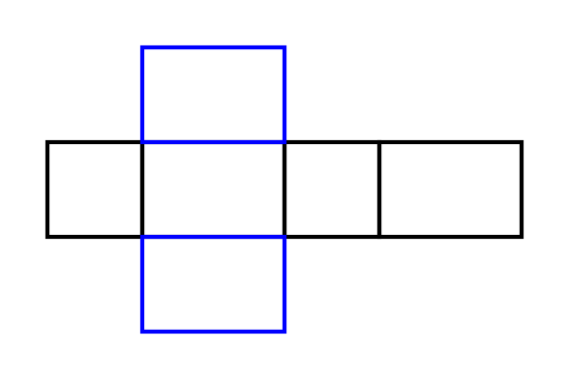
A. Triangular prism
B. Cylinder
C. Cuboid
D. Square-based pyramid

6. In Figure 6, triangle PQR is enlarged from the origin O with scale factor 2. What are the coordinates of the image of R?
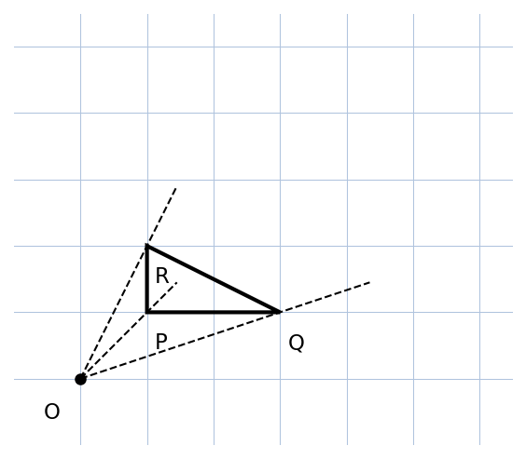
A. (2, 2)
B. (2, 4)
C. (4, 2)
D. (3, 2)

7. Figure 7 shows the graphs of y = x + 1 and y = 3x − 1. What is the solution of these simultaneous equations?
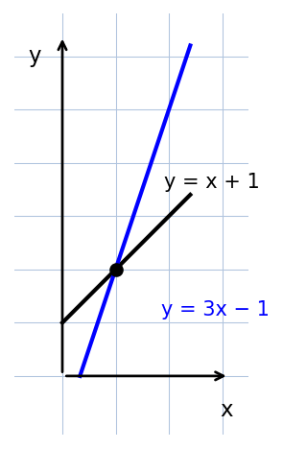
A. (2, 1)
B. (2, 3)
C. (0, 1)
D. (1, 2)

8. Figure 8 shows the solution of an inequality on a number line. Which inequality is shown?
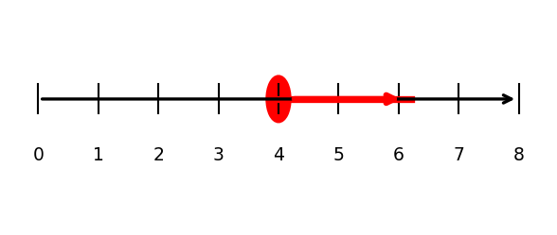
A. x > 4
B. x < 4
C. x ≥ 4
D. x ≤ 4

9. In Figure 9, the vectors u and v are shown head-to-tail and the dashed arrow is their resultant. Write u + v as a column vector.
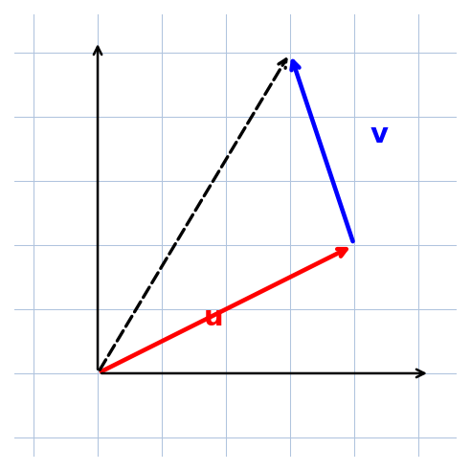
A. (3, 5)
B. (5, 1)
C. (3, −1)
D. (5, 5)

10. In Figure 10, the place B is on a bearing of 065° from the place A. Find the bearing of A from B.
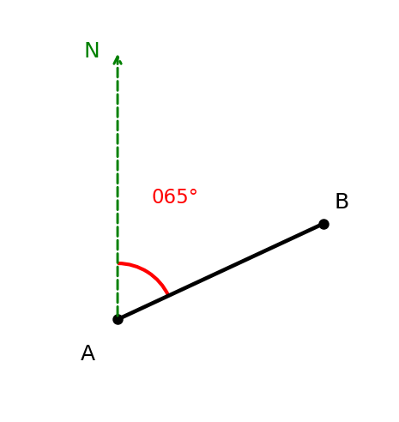
A. 065°
B. 155°
C. 290°
D. 245°

11. Figure 11 shows the point P(3, 4) and the origin O. Find the length OP.
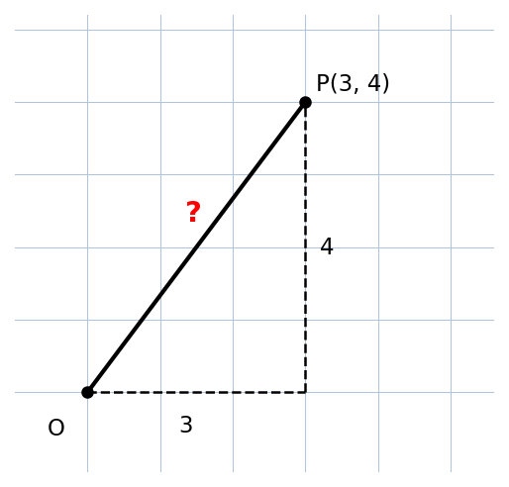
A. 7
B. 12
C. 5
D. 25

12. Figure 12 shows a histogram of the waiting times of patients at a clinic. Which class is the modal class?
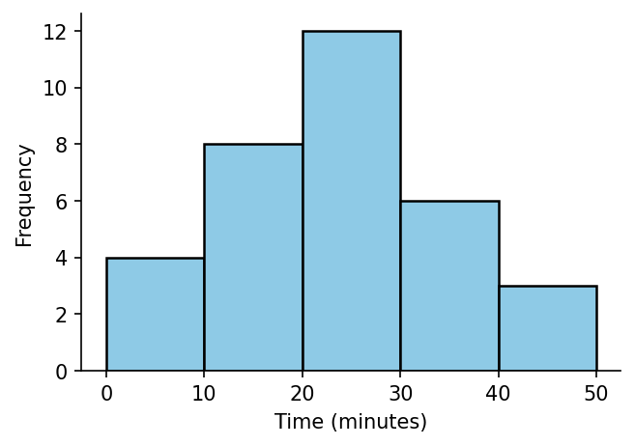
A. 20–30
B. 30–40
C. 10–20
D. 40–50

13. Figure 13 shows a box-and-whisker plot of a data set. Find the interquartile range.
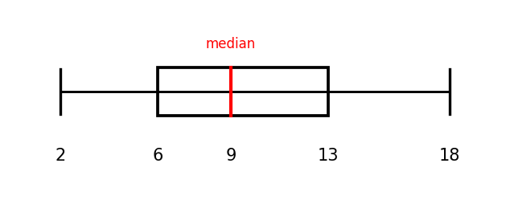
A. 7
B. 16
C. 11
D. 9

14. Simplify: √27
A. 9√3
B. 3√3
C. 3√2
D. 2√3

15. Simplify: 3√5 + 2√5 − √5
A. 4√5
B. 5√5
C. 6√5
D. √5

16. Which of these is a compound surd?
A. √2
B. 5
C. 7√3
D. √1

17. Use the distributive property to evaluate 5 × 17 + 5 × 3.
A. 100
B. 88
C. 105
D. 95

18. Make b the subject of the formula P = 2(l + b).
A. b = P − 2l
B. b = (P − l)/2
C. b = P/2 − l
D. b = P/2 + l

19. Find the value of 2(x − b) − 3(x − b) when x = 5 and b = 2.
A. 3
B. −3
C. −1
D. 0

20. Factorise completely: 21pq − 14pr
A. 7(3pq − 2pr)
B. 7p(3q − 2r)
C. p(21q − 14r)
D. 21p(q − r)

21. Solve the inequality: (2x + 7)/5 > 2
A. x < 1.5
B. x ≥ 1.5
C. x > 8.5
D. x > 1.5

22. A woman deposits GH₵2,000.00 in a savings scheme at 5% simple interest per year for 3 years. How much interest does she earn?
A. GH₵250.00
B. GH₵300.00
C. GH₵100.00
D. GH₵30.00

23. A jacket costs three times as much as a shirt. A shirt costs GH₵45.00. Find the total cost of 2 shirts and 1 jacket.
A. GH₵135.00
B. GH₵180.00
C. GH₵270.00
D. GH₵225.00

24. Write 5,060,000 in standard form.
A. 5.06 × 10⁶
B. 50.6 × 10⁵
C. 5.06 × 10⁷
D. 0.506 × 10⁷

25. Express 47,382 correct to three significant figures.
A. 47,382
B. 47,380
C. 47,000
D. 47,400

26. The mean of five numbers is 12. One of the numbers, 30, is removed. What is the mean of the remaining four numbers?
A. 9
B. 7.5
C. 10.5
D. 8

27. A bag contains 4 blue and 6 red marbles. Two marbles are drawn one after the other without replacement. Find the probability that both are red.
A. 36/100
B. 4/15
C. 2/5
D. 1/3

28. Which measure of central tendency is most affected when an extreme value is added to a data set?
A. The median
B. The mode
C. The mean
D. All are affected equally

29. Which of these shows the commutative property of addition?
A. a + b = b + a
B. a(b + c) = ab + ac
C. (a + b) + c = a + (b + c)
D. a × 0 = 0

30. Evaluate: 1/2 + 1/3 × 3/4
A. 5/8
B. 5/6
C. 3/4
D. 1

SECTION B: WRITTEN RESPONSE (70 marks)
Answer ALL questions in this section. Show all your working clearly.
Question 1
Figure 14 shows a right-angled triangle with two sides of length 2 cm.
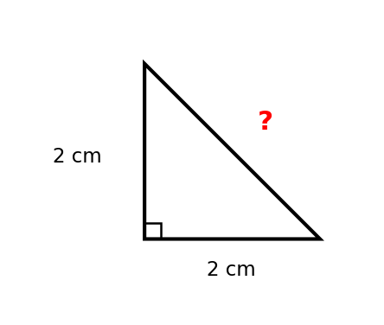
(a) Find the exact length of the hypotenuse, giving your answer as a surd in its simplest form. .......... [2 marks]
(b) Simplify: √72 .................................... [2 marks]
(c) Simplify: 3√5 + 2√5 − √5 ................................ [2 marks]
(d) Use a calculator to find √12 to one decimal place. ........................ [2 marks]
(e) Show that √8 × √2 = 4. ................................. [2 marks]

Question 2
Figure 15 shows a rectangle with the dimensions marked in centimetres. Its perimeter is 36 cm.
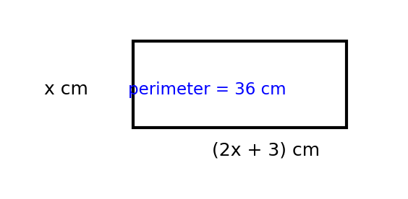
(a) Write an expression in x for the perimeter of the rectangle. .................... [2 marks]
(b) Find the value of x. .................................. [2 marks]
(c) Find the area of the rectangle. .............................. [2 marks]
(d) Make u the subject of the formula v = u + at. ......................... [2 marks]
(e) Factorise completely: 21pq − 14pr ............................. [2 marks]

Question 3
Figure 16 shows the graphs of y = 2x − 1 and y = −x + 5.
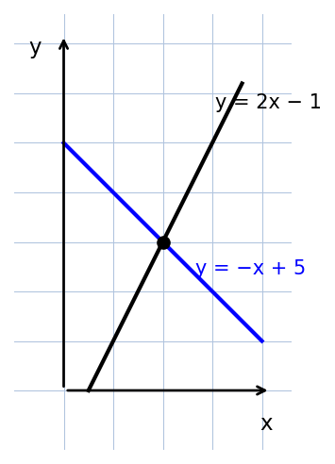
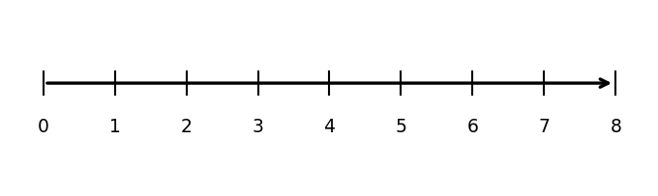
(a) Use Figure 16 to find the coordinates of the point where the two lines meet. ............... [2 marks]
(b) Solve the simultaneous equations y = 2x − 1 and y = −x + 5 algebraically. ................ [3 marks]
(c) From Figure 16, write down the value of y when x = 0 for each line. .................. [2 marks]
(d) Solve the inequality: 5 − 2x < 1 .............................. [2 marks]
(e) Show the solution of (d) on the number line in Figure 17. ..................... [1 marks]

Question 4
Figure 18 shows a hexagon with five of its angles marked. Figure 19 shows two similar triangles.
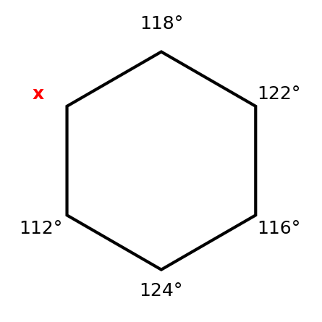
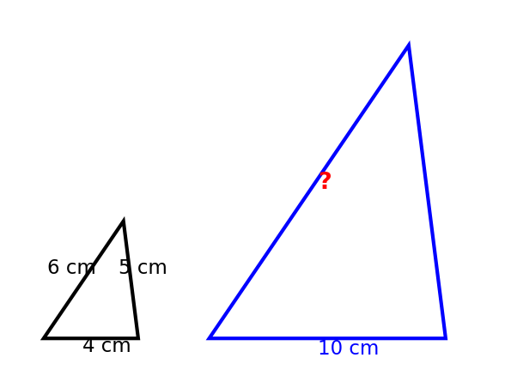
(a) In Figure 18, find the angle marked x. ............................ [3 marks]
(b) Find the sum of the interior angles of a 12-sided polygon. ..................... [2 marks]
(c) In Figure 19, the shortest side of the small triangle is 4 cm and the shortest side of the large triangle is 10 cm. Find the length of the longest side of the large triangle. .. [3 marks]
(d) State two properties of similar triangles. .......................... [2 marks]

Question 5
Figure 20 shows a triangular prism with a right-angled triangular cross-section of sides 6 cm, 8 cm and 10 cm and length 12 cm. Figure 21 shows the points P(3, 4) and Q(−2, 1) and the origin O.
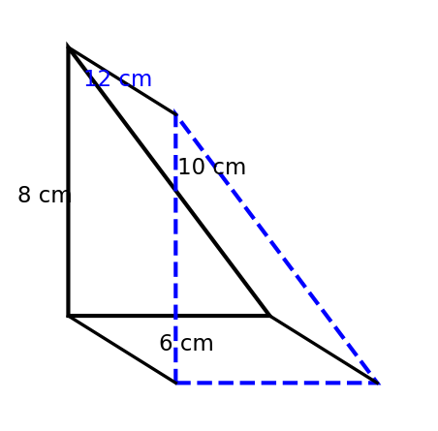
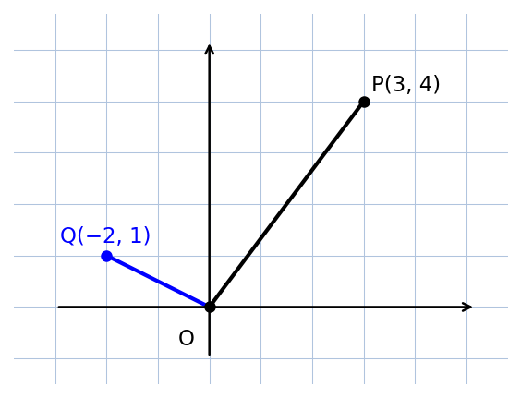
(a) Find the area of one triangular face of the prism. ........................ [2 marks]
(b) Find the total surface area of the prism. ........................... [3 marks]
(c) Write OP as a position vector and find its length. ........................ [3 marks]
(d) Write OQ as a position vector. .............................. [2 marks]

Question 6
Figure 22 shows three places A, K and M. K is on a bearing of 050° from A and AK = 6 km. M is on a bearing of 140° from A and AM = 8 km. Figure 23 shows the vectors u = (4, 2) and v = (1, 3).
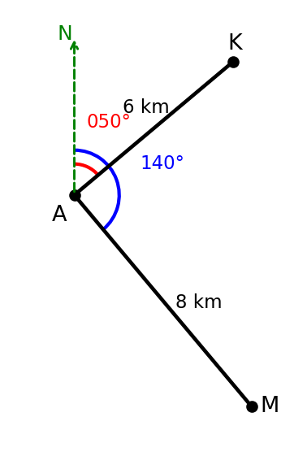
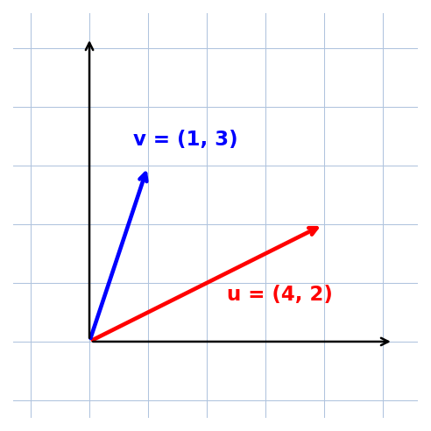
(a) Find the bearing of A from K. ............................... [2 marks]
(b) Find the size of the angle KAM. .............................. [2 marks]
(c) Find the distance KM. ................................. [3 marks]
(d) Find u + v as a column vector. .............................. [1 marks]
(e) Find 2u − v as a column vector. .............................. [2 marks]

Question 7
Figure 24 shows a histogram of the waiting times, in minutes, of 40 patients at a clinic. Figure 25 shows a bag containing 4 green (G) and 2 yellow (Y) counters.
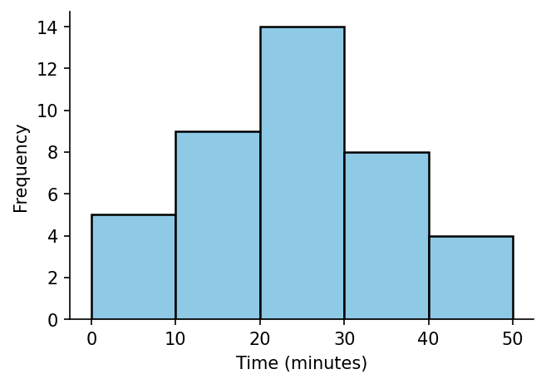
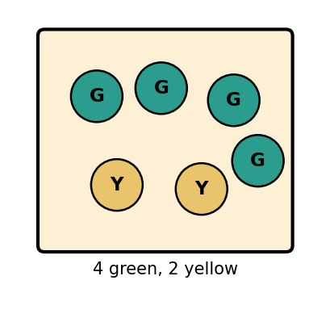
(a) Which class of the histogram is the modal class? Give a reason. ................... [2 marks]
(b) How many patients waited less than 30 minutes? ......................... [2 marks]
(c) The mean waiting time is 22.5 minutes. One more patient arrives and waits 3 hours. State what happens to the mean and explain why. .. [2 marks]
(d) Two counters are drawn from the bag one after the other WITHOUT replacement. Find the probability that both counters are green. .. [2 marks]
(e) Find the probability that the first counter is green and the second is yellow. .............. [2 marks]

END OF PAPER

ANSWER KEY — SECTION A
Question | Answer | Curriculum Area | Indicator | Cognitive Level
1 | B | Angles of a polygon | B9.3.1.1.1 | Apply
2 | A | Similar triangles | B9.3.1.1.2 | Apply
3 | C | Surface area of a cuboid | B9.3.2.1.2 | Apply
4 | D | Surface area of a triangular prism | B9.3.2.1.3 | Apply
5 | C | Nets of 3-D shapes | B9.3.2.1.1 | Understand
6 | B | Enlargement on a coordinate plane | B9.3.3.1.2 | Apply
7 | D | Simultaneous equations by graph | B9.2.1.1.3 | Analyse
8 | C | Inequalities on the number line | B9.2.3.1.2 | Apply
9 | A | Triangle law of vector addition | B9.3.2.2.2 | Apply
10 | D | Bearings | B9.3.2.2 | Apply
11 | C | Position vectors and magnitude | B9.3.2.1.4 | Apply
12 | A | Mode from a histogram | B9.4.1.1.3 | Apply
13 | A | Box-and-whisker plots | B9.4.1.2.2 | Analyse
14 | B | Simplifying surds | B9.1.2.4.3 | Apply
15 | A | Adding and subtracting surds | B9.1.2.4.2 | Apply
16 | C | Simple and compound surds | B9.1.2.4.1 | Understand
17 | A | Number properties | B9.1.2.1.4 | Apply
18 | C | Change of subject | B9.2.2.1.1 | Apply
19 | B | Substitution and evaluation | B9.2.2.1.2 | Apply
20 | B | Factorisation | B9.2.2.1.3 | Apply
21 | D | Solving inequalities | B9.2.3.1.1 | Apply
22 | B | Simple interest | B9.1.4.1.2 | Apply
23 | D | Decimal word problems | B9.1.2.2.2 | Apply
24 | A | Standard form | B9.1.1.1.2 | Apply
25 | D | Significant figures | B9.1.1.1.1 | Apply
26 | B | Effect of extreme values on the mean | B9.4.1.2.3 | Analyse
27 | D | Dependent events | B9.4.2.1.1 | Analyse
28 | C | Effect of extreme values | B9.4.1.2.3 | Analyse
29 | A | Number properties | B9.1.2.1.2 | Understand
30 | C | Order of operations with fractions | B9.1.3.1.2 | Apply

MARKING SCHEME — SECTION B
Question 1
(a) Hypotenuse = √(2² + 2²) = √8 = 2√2 cm
[1 mark for √8; 1 mark for 2√2 cm]
(b) √72 = √(36 × 2) = 6√2
[1 mark for √(36 × 2); 1 mark for 6√2]
(c) 3√5 + 2√5 − √5 = 4√5
[1 mark for collecting like surds; 1 mark for 4√5]
(d) √12 = 3.464… ≈ 3.5
[1 mark for 3.46; 1 mark for 3.5]
(e) √8 × √2 = √16 = 4
[1 mark for √16; 1 mark for 4]

Question 2
(a) P = 2((2x + 3) + x) = 2(3x + 3) = 6x + 6
[1 mark for 2(3x + 3); 1 mark for 6x + 6]
(b) 6x + 6 = 36 ⇒ 6x = 30 ⇒ x = 5
[1 mark for 6x = 30; 1 mark for x = 5]
(c) Length = 2(5) + 3 = 13 cm; area = 13 × 5 = 65 cm²
[1 mark for 13 cm; 1 mark for 65 cm²]
(d) v = u + at ⇒ u = v − at
[2 marks]
(e) 21pq − 14pr = 7p(3q − 2r)
[1 mark for factor 7p; 1 mark for 7p(3q − 2r)]

Question 3
(a) The lines meet at (2, 3)
[1 mark for x = 2; 1 mark for y = 3]
(b) 2x − 1 = −x + 5 ⇒ 3x = 6 ⇒ x = 2; y = 2(2) − 1 = 3
[1 mark for 3x = 6; 1 mark for x = 2; 1 mark for y = 3]
(c) y = 2x − 1: y = −1 when x = 0; y = −x + 5: y = 5 when x = 0
[1 mark for each intercept]
(d) 5 − 2x < 1 ⇒ −2x < −4 ⇒ x > 2 (inequality sign reverses)
[1 mark for −2x < −4; 1 mark for x > 2]
(e) Open circle at 2 and shading to the right
[1 mark]

Question 4
(a) Sum = (6 − 2) × 180° = 720°; x = 720° − (118° + 122° + 116° + 124° + 112°) = 720° − 592° = 128°
[1 mark for 720°; 1 mark for 592°; 1 mark for 128°]
(b) (12 − 2) × 180° = 10 × 180° = 1800°
[1 mark for the formula; 1 mark for 1800°]
(c) Scale factor = 10 ÷ 4 = 2.5; longest side = 6 × 2.5 = 15 cm
[1 mark for scale factor 2.5; 1 mark for method; 1 mark for 15 cm]
(d) Corresponding angles are equal; corresponding sides are in the same ratio (proportional).
[1 mark for each property]

Question 5
(a) Area of triangle = 1/2 × 6 × 8 = 24 cm²
[1 mark for 1/2 × 6 × 8; 1 mark for 24 cm²]
(b) Total surface area = 2 × 24 + (6 + 8 + 10) × 12 = 48 + 288 = 336 cm²
[1 mark for 2 × 24; 1 mark for 24 × 12 = 288; 1 mark for 336 cm²]
(c) OP = (3, 4); |OP| = √(3² + 4²) = √25 = 5
[1 mark for (3, 4); 1 mark for √25; 1 mark for 5]
(d) OQ = (−2, 1)
[1 mark each for −2 and 1]

Question 6
(a) Bearing of A from K = 050° + 180° = 230°
[1 mark for adding 180°; 1 mark for 230°]
(b) Angle KAM = 140° − 50° = 90°
[2 marks]
(c) KM = √(6² + 8²) = √100 = 10 km
[1 mark for 36 + 64; 1 mark for √100; 1 mark for 10 km]
(d) u + v = (4 + 1, 2 + 3) = (5, 5)
[1 mark]
(e) 2u − v = (8 − 1, 4 − 3) = (7, 1)
[1 mark for (8, 4) − (1, 3); 1 mark for (7, 1)]

Question 7
(a) The modal class is 20–30, because it has the highest bar (frequency 14).
[1 mark for 20–30; 1 mark for the reason]
(b) 5 + 9 + 14 = 28 patients
[1 mark for the sum; 1 mark for 28]
(c) The mean increases, because 180 minutes is much greater than the mean of 22.5 minutes (new mean ≈ 26.3 minutes).
[1 mark for 'increases'; 1 mark for the reason]
(d) P(green and green) = 4/6 × 3/5 = 12/30 = 2/5
[1 mark for 4/6 × 3/5; 1 mark for 2/5]
(e) P(green then yellow) = 4/6 × 2/5 = 8/30 = 4/15
[1 mark for 4/6 × 2/5; 1 mark for 4/15]

CURRICULUM ASSESSMENT BLUEPRINT
Question | Strand | Sub-strand / Area | Content Standard / Indicator | Cognitive Level | Marks
A1 | 3. Geometry and Measurement | Angles of a polygon | B9.3.1.1.1 | Apply | 1
A2 | 3. Geometry and Measurement | Similar triangles | B9.3.1.1.2 | Apply | 1
A3 | 3. Geometry and Measurement | Surface area of a cuboid | B9.3.2.1.2 | Apply | 1
A4 | 3. Geometry and Measurement | Surface area of a triangular prism | B9.3.2.1.3 | Apply | 1
A5 | 3. Geometry and Measurement | Nets of 3-D shapes | B9.3.2.1.1 | Understand | 1
A6 | 3. Geometry and Measurement | Enlargement on a coordinate plane | B9.3.3.1.2 | Apply | 1
A7 | 2. Algebra | Simultaneous equations by graph | B9.2.1.1.3 | Analyse | 1
A8 | 2. Algebra | Inequalities on the number line | B9.2.3.1.2 | Apply | 1
A9 | 3. Geometry and Measurement | Triangle law of vector addition | B9.3.2.2.2 | Apply | 1
A10 | 3. Geometry and Measurement | Bearings | B9.3.2.2 | Apply | 1
A11 | 3. Geometry and Measurement | Position vectors and magnitude | B9.3.2.1.4 | Apply | 1
A12 | 4. Handling Data | Mode from a histogram | B9.4.1.1.3 | Apply | 1
A13 | 4. Handling Data | Box-and-whisker plots | B9.4.1.2.2 | Analyse | 1
A14 | 1. Number | Simplifying surds | B9.1.2.4.3 | Apply | 1
A15 | 1. Number | Adding and subtracting surds | B9.1.2.4.2 | Apply | 1
A16 | 1. Number | Simple and compound surds | B9.1.2.4.1 | Understand | 1
A17 | 1. Number | Number properties | B9.1.2.1.4 | Apply | 1
A18 | 2. Algebra | Change of subject | B9.2.2.1.1 | Apply | 1
A19 | 2. Algebra | Substitution and evaluation | B9.2.2.1.2 | Apply | 1
A20 | 2. Algebra | Factorisation | B9.2.2.1.3 | Apply | 1
A21 | 2. Algebra | Solving inequalities | B9.2.3.1.1 | Apply | 1
A22 | 1. Number | Simple interest | B9.1.4.1.2 | Apply | 1
A23 | 1. Number | Decimal word problems | B9.1.2.2.2 | Apply | 1
A24 | 1. Number | Standard form | B9.1.1.1.2 | Apply | 1
A25 | 1. Number | Significant figures | B9.1.1.1.1 | Apply | 1
A26 | 4. Handling Data | Effect of extreme values on the mean | B9.4.1.2.3 | Analyse | 1
A27 | 4. Handling Data | Dependent events | B9.4.2.1.1 | Analyse | 1
A28 | 4. Handling Data | Effect of extreme values | B9.4.1.2.3 | Analyse | 1
A29 | 1. Number | Number properties | B9.1.2.1.2 | Understand | 1
A30 | 1. Number | Order of operations with fractions | B9.1.3.1.2 | Apply | 1
B1 | 1. Number | Surds | B9.1.2.4.1; B9.1.2.4.2; B9.1.2.4.3 | Apply | 10
B2 | 2. Algebra | Algebraic modelling, subject and factorisation | B9.2.2.1.1; B9.2.2.1.3; B9.2.2.1.4 | Apply | 10
B3 | 2. Algebra | Simultaneous equations and inequalities | B9.2.1.1.3; B9.2.3.1.1; B9.2.3.1.2 | Analyse | 10
B4 | 3. Geometry and Measurement | Polygons and similar triangles | B9.3.1.1.1; B9.3.1.1.2 | Apply | 10
B5 | 3. Geometry and Measurement | Surface area and position vectors | B9.3.2.1.3; B9.3.2.1.4 | Apply | 10
B6 | 3. Geometry and Measurement | Bearings and vectors | B9.3.2.2.1; B9.3.2.2.2 | Analyse | 10
B7 | 4. Handling Data | Descriptive statistics and dependent events | B9.4.1.1.3; B9.4.1.2.3; B9.4.2.1.1; B9.4.2.1.2 | Analyse | 10

COVERAGE SUMMARY
Strand | Questions | Marks | % of Paper
1. Number | A14–A17, A22–A25, A29, A30, B1 | 20 | 20%
2. Algebra | A7, A8, A18–A21, B2, B3 | 26 | 26%
3. Geometry and Measurement | A1–A6, A9–A11, B4, B5, B6 | 39 | 39%
4. Handling Data | A12, A13, A26–A28, B7 | 15 | 15%
TOTAL | 37 | 100 | 100%

COGNITIVE-LEVEL DISTRIBUTION
Cognitive Level (Bloom's) | Section A | Section B | Total Marks | % of Paper
Understand | 3 (A5, A16, A29) | 0 | 3 | 3%
Apply | 22 | 4 (B1, B2, B4, B5) | 62 | 62%
Analyse | 5 (A7, A13, A26, A27, A28) | 3 (B3, B6, B7) | 35 | 35%
Analysis is deliberately weighted toward simultaneous equations, dependent probability, extreme-value effects on the mean, bearings with Pythagoras and interquartile range — the new demands of the Basic 9 curriculum.
DIFFICULTY DISTRIBUTION
Difficulty | Questions | %
Easy | A5, A8, A12, A16, A17, A29, B2(a), B4(b) | ~16%
Moderate | A1–A4, A6, A9, A11, A14, A15, A18, A20, A22–A25, B1, B2(b–e), B3(a–c), B4(a), B5(a,d), B7(a–b) | ~48%
Challenging | A7, A10, A13, A19, A21, A26–A28, A30, B3(d–e), B4(c–d), B5(b–c), B6, B7(c–e) | ~36%

QUALITY-CONTROL SUMMARY
1. Diagram-based: 25 original figures (hexagon angle problems, similar triangles, cuboid and triangular prisms with nets, enlargement with rays, simultaneous-equation graphs, inequality number lines, vector triangles, bearings maps, position-vector grids, histograms, box-and-whisker plot, surd triangle, algebraic rectangle, bag of counters) carry 13 MCQs and all 7 written questions — every written question is asked on its figures.
2. Curriculum alignment: every question is traceable to a supplied NaCCA CCP B9 content standard/indicator (see blueprint): surds and their rules, number properties, decimals and fractions in context, standard form and significant figures, simple interest, change of subject, substitution, factorisation, simultaneous equations by graph, inequalities, polygon angle sums, similar triangles, surface area of prisms, position vectors, bearings with vector addition, histograms and modal class, effect of extreme values, and dependent-event probability.
3. Originality: original BECE-style examination; all questions and figures newly created; no WAEC, textbook or copyrighted questions or images reproduced; not to be presented as an official BECE paper.
4. MCQ quality: 30 items, one defensible answer each, distractors model common errors (e.g. A3 forgetting two faces of the cuboid, A4 missing the triangular ends, A6 enlarging from P instead of O, A10 giving the forward bearing, A13 giving the full range instead of the interquartile range, A14 writing 9√3 instead of 3√3, A18 giving the wrong subject, A27 using with-replacement probabilities).
5. Answer-key distribution: A=8, B=7, C=8, D=7 — varied positions, no predictable pattern.
6. Arithmetic verified: every answer independently recomputed (e.g. hexagon x = 120°; similar triangles x = 10 cm; cuboid surface area 94 cm²; prism 108 cm²; enlargement R(1,2) → (2,4); intersection (1,2) and (2,3); vector sums (3,5), (5,5), (7,1); back bearing 245° and 230°; |OP| = 5; IQR = 13 − 6 = 7; √27 = 3√3; 3√5 + 2√5 − √5 = 4√5; √8 × √2 = 4; 6x + 6 = 36 ⇒ x = 5, area 65 cm²; 5 − 2x < 1 ⇒ x > 2; pentagon-type sums 720° − 592° = 128°; scale factor 2.5 ⇒ 15 cm; prism surface area 336 cm²; KM = 10 km; 5 + 9 + 14 = 28; P(GG) = 2/5; P(GY) = 4/15; (6/10)(5/9) = 1/3).
7. Marks: Section A = 30; Section B = 7 × 10 = 70; total = 100. All internal allocations add up correctly.
8. Cognitive demand: Understand 3%, Apply 62%, Analyse 35%.
9. Ghanaian contexts used naturally: cedis (GH₵), savings scheme with simple interest, clinic waiting times, places A, K and M on a bearings map, bag of coloured counters.
10. Language: clear Ghanaian school English; terminology consistent with the NaCCA curriculum.

