[SCHOOL NAME]
INTEGRATED SCIENCE (SCIENCE)
PRACTICAL QUESTIONS - DIAGRAM MODE
Farming Systems (10.1 - 10.7)
____________________________________________________________________________________________
CLASS: Basic 7 (JHS 1)
TIME: 1 hour 30 minutes
MARKS: 50 2025/2026 Academic Year
____________________________________________________________________________________________
INSTRUCTIONS TO CANDIDATES
1. Answer ALL the questions in this paper.
2. Every question is based on a diagram. Study each diagram carefully before you answer the questions that follow it.
3. Write your answers in the spaces provided. The marks for each question are printed beside it.
4. Where a question asks for a stated number of points, give that number. Any extra answers will not be marked.
5. You may refer back to any diagram at any time.
____________________________________________________________________________________________
SECTION A - DIAGRAM STUDY
Study each diagram and answer the questions that follow it.
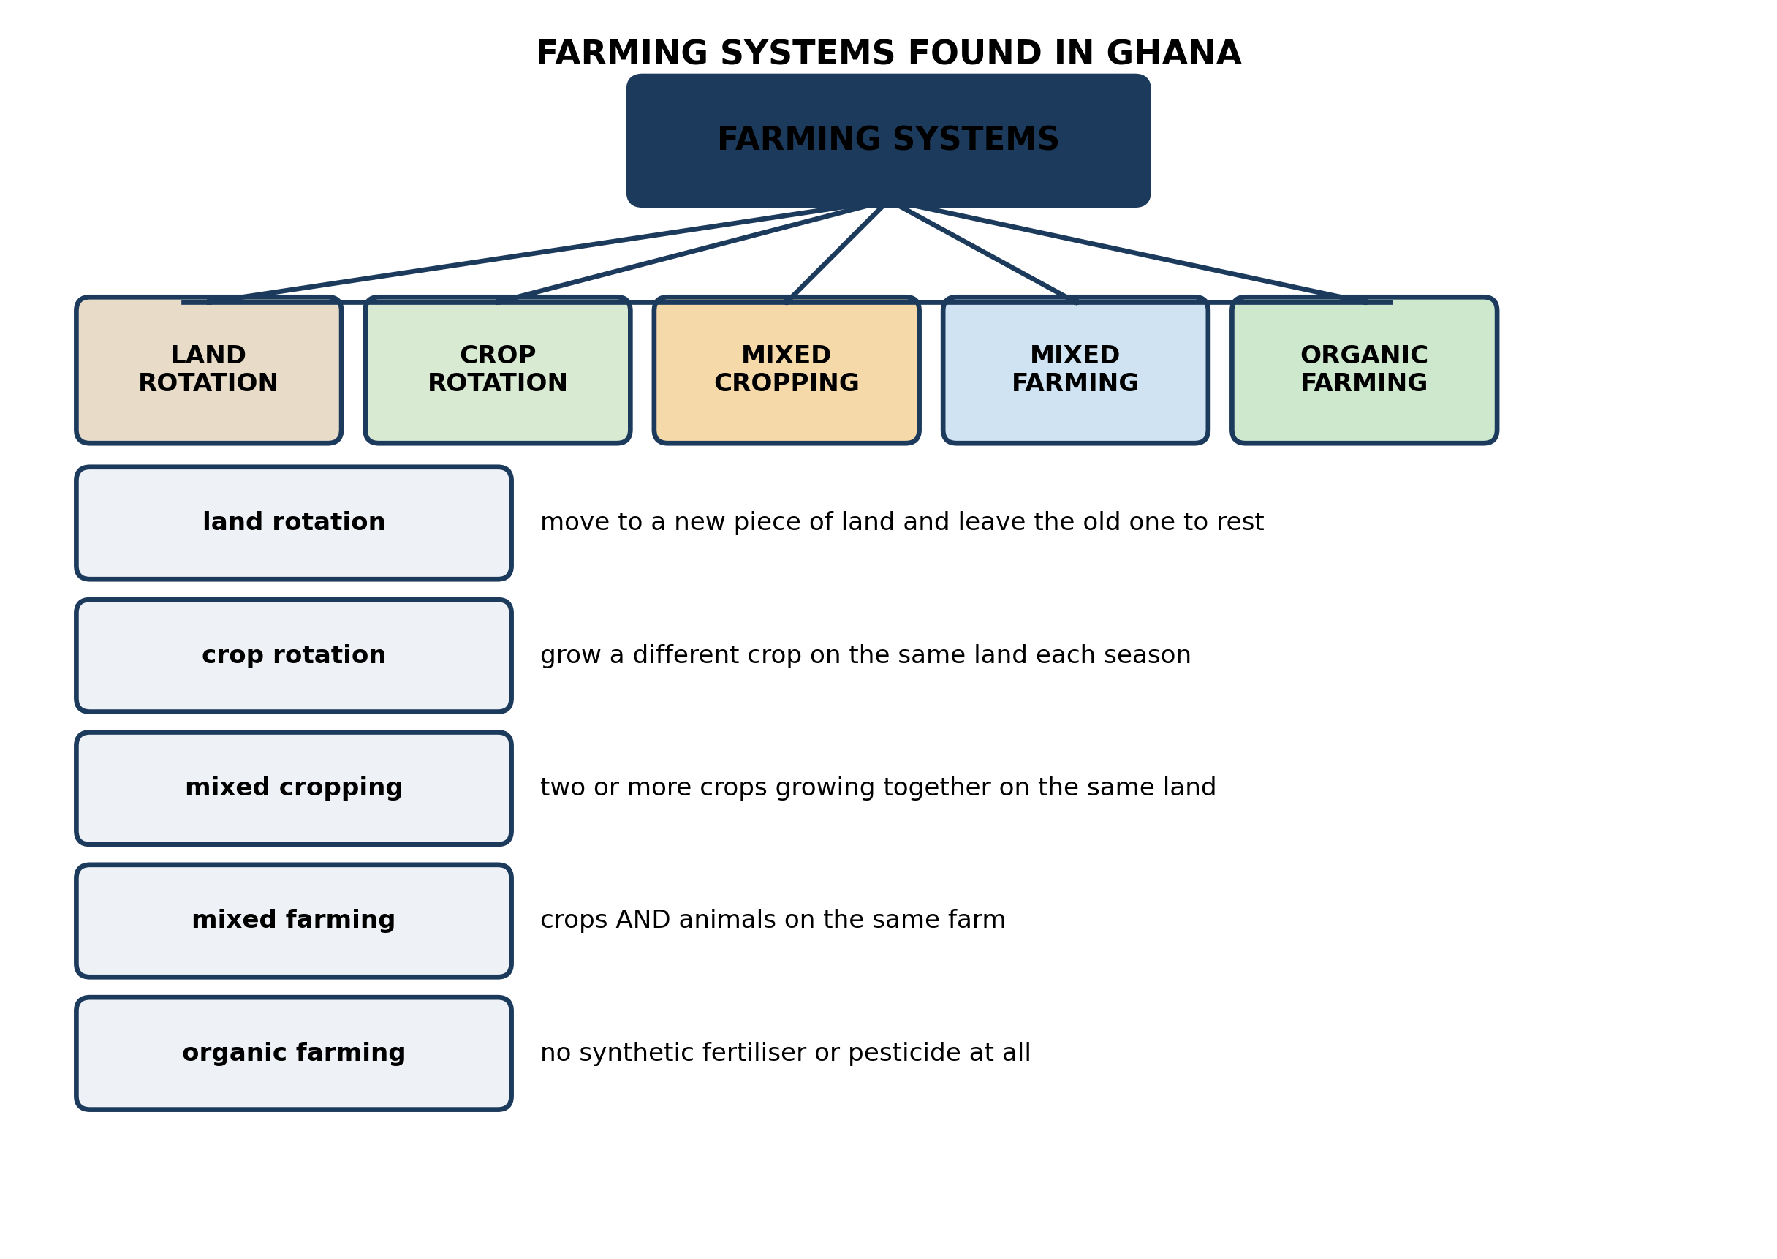
Fig. 1: Farming systems found in Ghana

10.1 10.1 Types of Farming Systems in Ghana
1. A farmer in the Northern Region has a large area of land and only a small family to work it. A farmer just outside Kumasi has a small plot and a large family. Suggest a SUITABLE farming system for each, and explain why each suits that farmer. [4 marks]
2. Name any THREE farming systems shown in the diagram. [3 marks]
____________________________________________________________________________________________
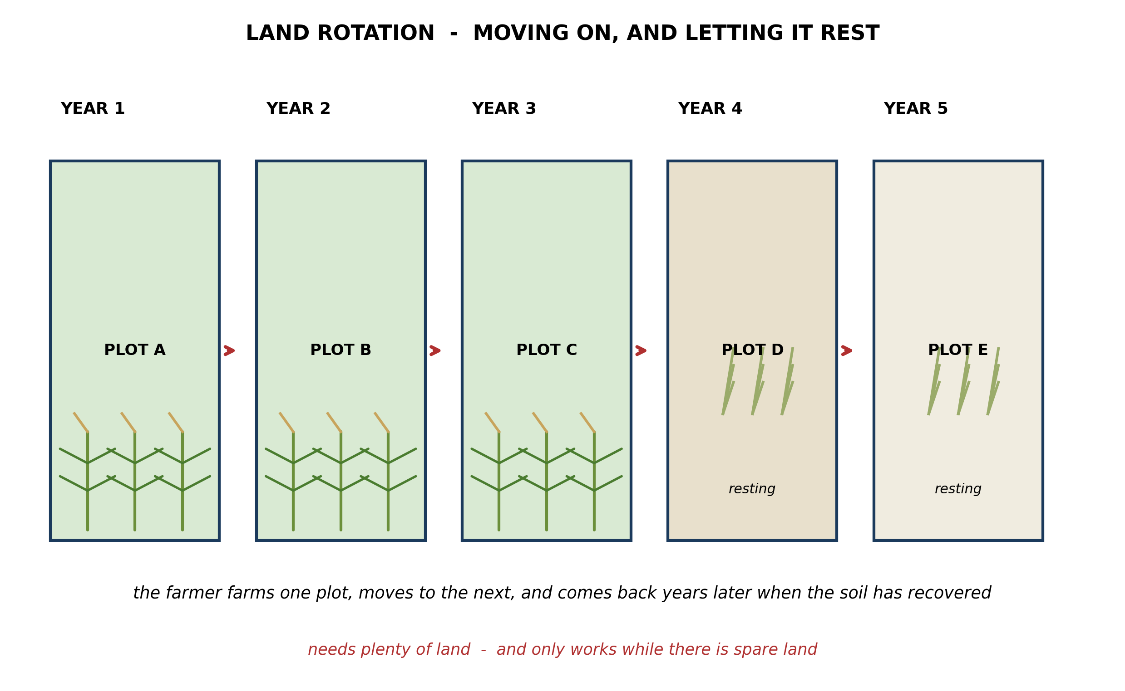
Fig. 2: Land rotation

10.2 10.2 Land Rotation Farming
3. Explain why leaving a plot FALLOW restores the fertility of the soil, and explain why the system stops working when a village grows and the spare land runs out. [4 marks]
____________________________________________________________________________________________
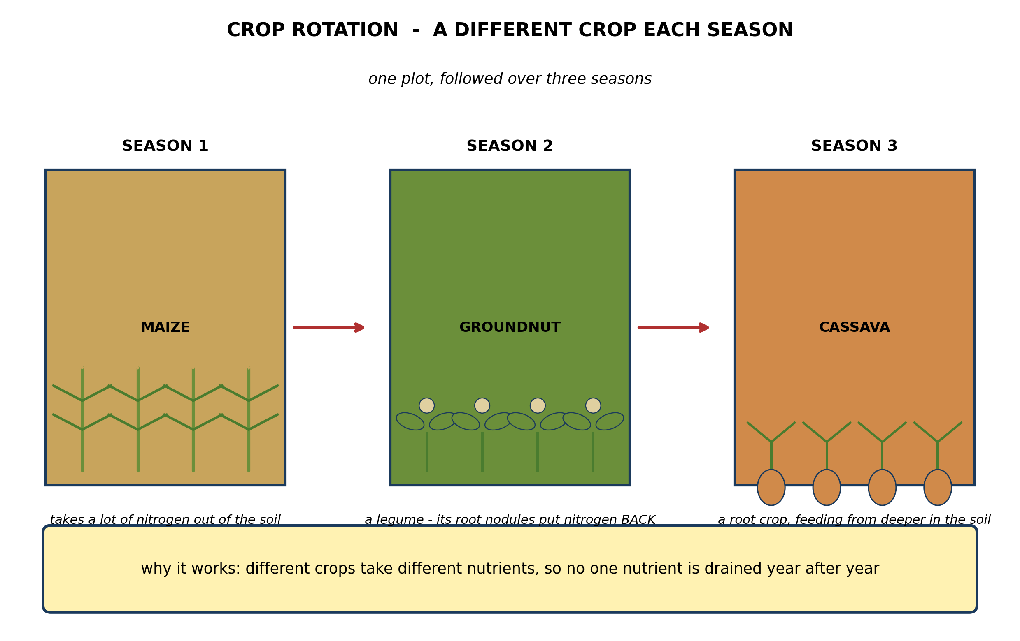
Fig. 3: Crop rotation

10.3 10.3 Crop Rotation Farming
4. Explain why growing GROUNDNUTS between two maize crops helps the second maize crop, referring to what each crop does to the soil. [4 marks]
5. State TWO advantages of crop rotation. [3 marks]
____________________________________________________________________________________________
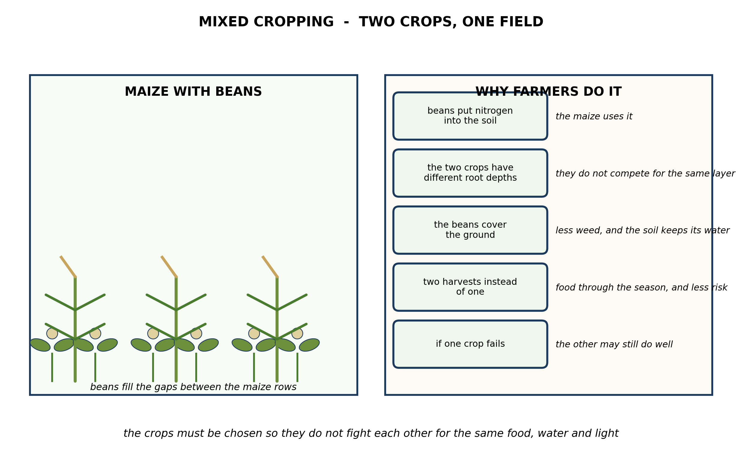
Fig. 4: Mixed cropping

10.4 10.4 Mixed Cropping
6. The diagram shows maize grown with beans. Explain TWO ways in which the beans help the maize, and suggest ONE way in which the two crops might harm each other. [4 marks]
7. State TWO reasons why a farmer practises mixed cropping. [3 marks]
____________________________________________________________________________________________
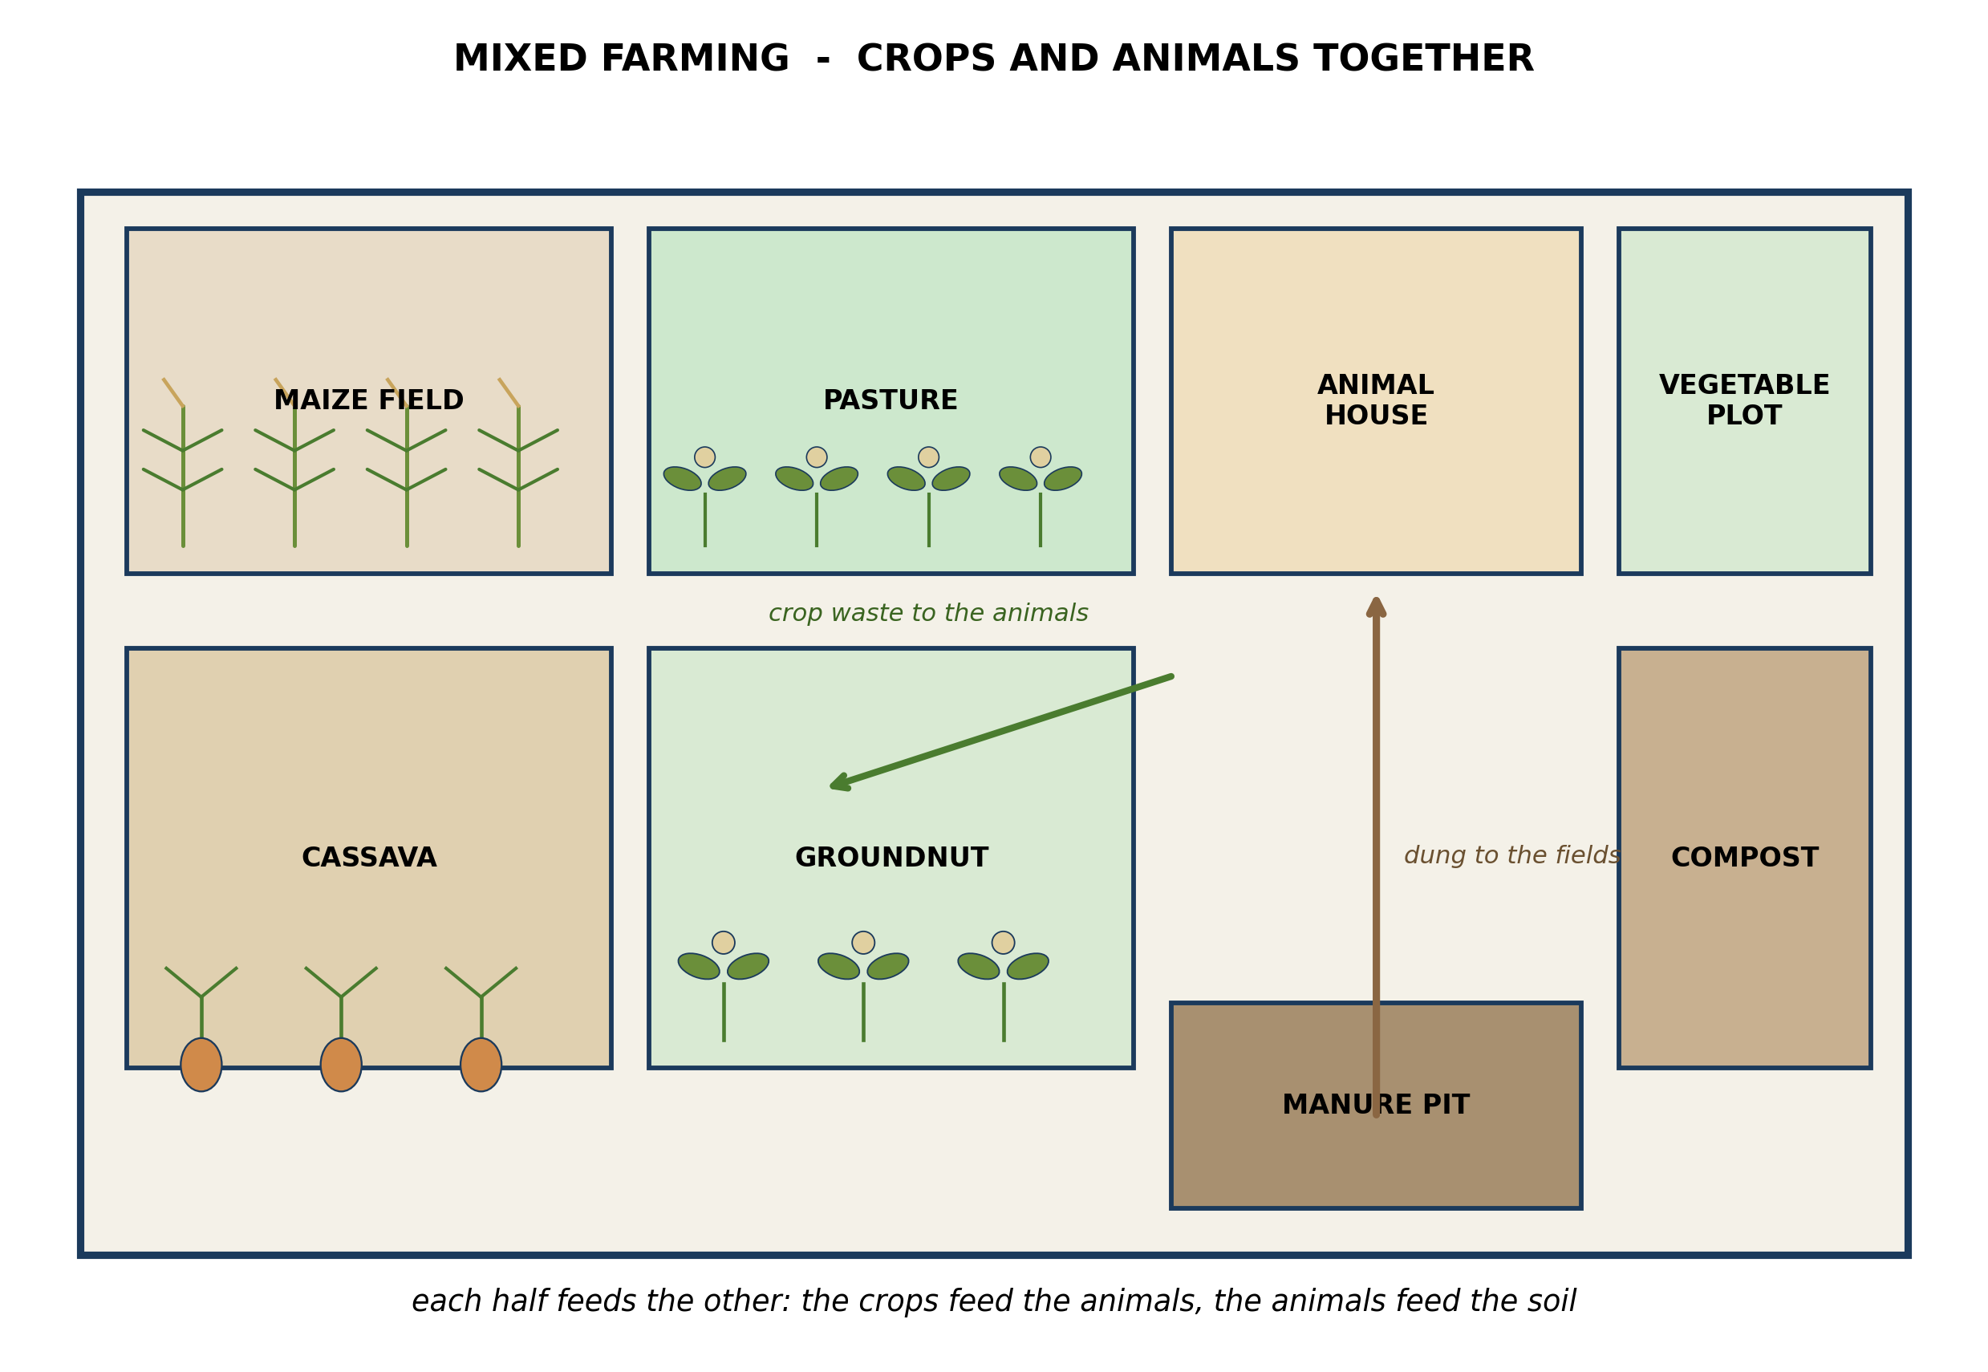
Fig. 5: Mixed farming

10.5 10.5 Mixed Farming
8. On a mixed farm the animals depend on the crops and the crops depend on the animals. Give TWO examples of each. [4 marks]
9. Explain what is meant by a MIXED FARM. [3 marks]
____________________________________________________________________________________________
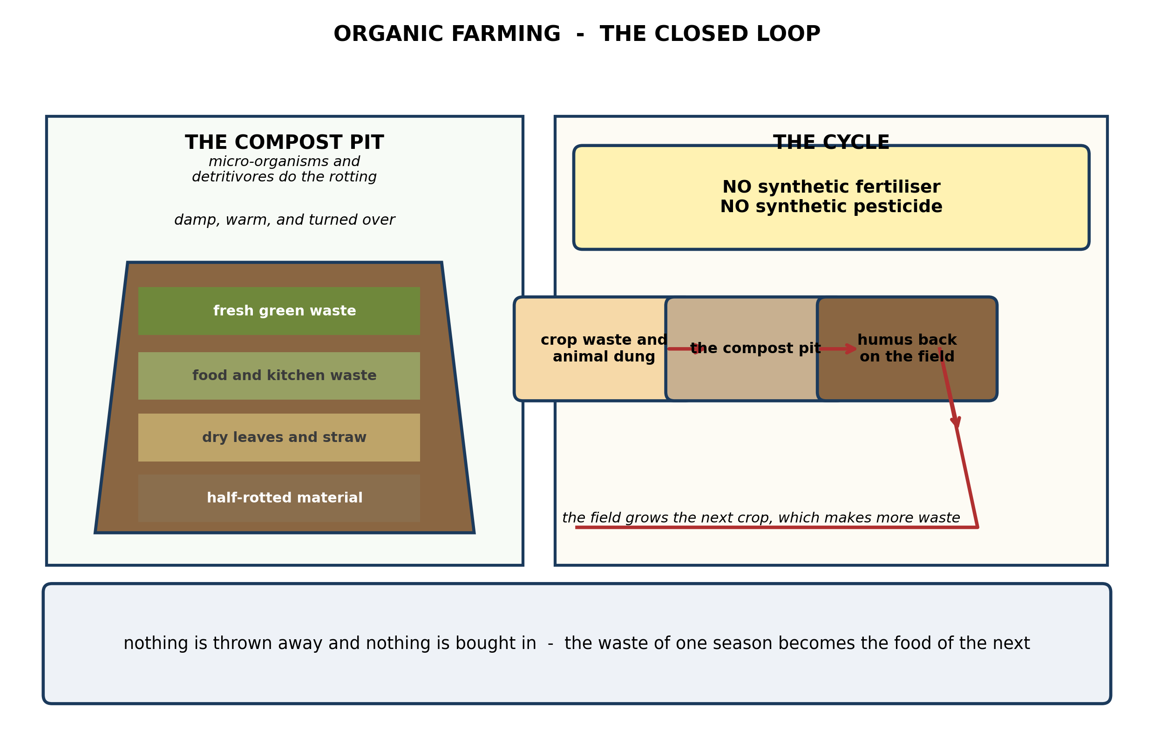
Fig. 6: Organic farming

10.6 10.6 Organic Farming
10. Explain why organic farming depends so heavily on the compost pit, and explain why yields are often LOWER in the first years after a farmer converts to it. [4 marks]
11. The diagram shows different layers in the compost pit. Explain why the heap needs BOTH fresh green waste and dry material, and why it has to be turned over. [3 marks]
____________________________________________________________________________________________
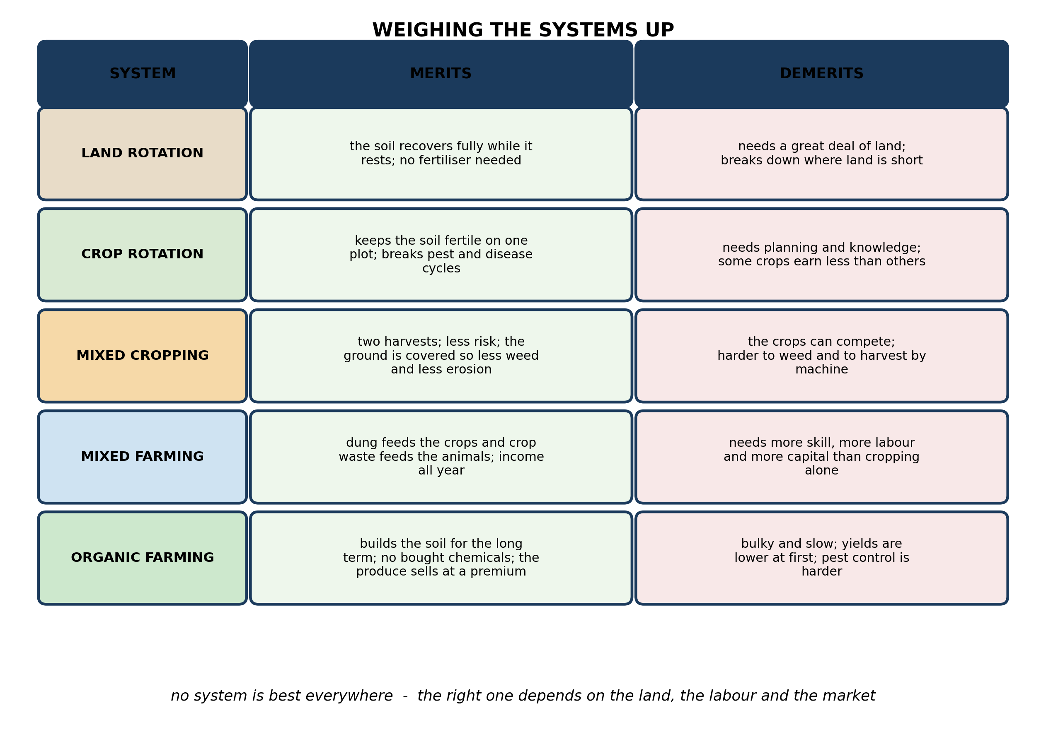
Fig. 7: Weighing the systems up

10.7 10.7 Merits and Demerits of Each Farming System
12. A farmer has a small plot on the edge of a large town, plenty of family labour, and very little money to buy chemicals. Which farming system would you advise, and why? [3 marks]
____________________________________________________________________________________________
SECTION B - PRACTICAL TASK
Study the apparatus and answer the questions that follow it.
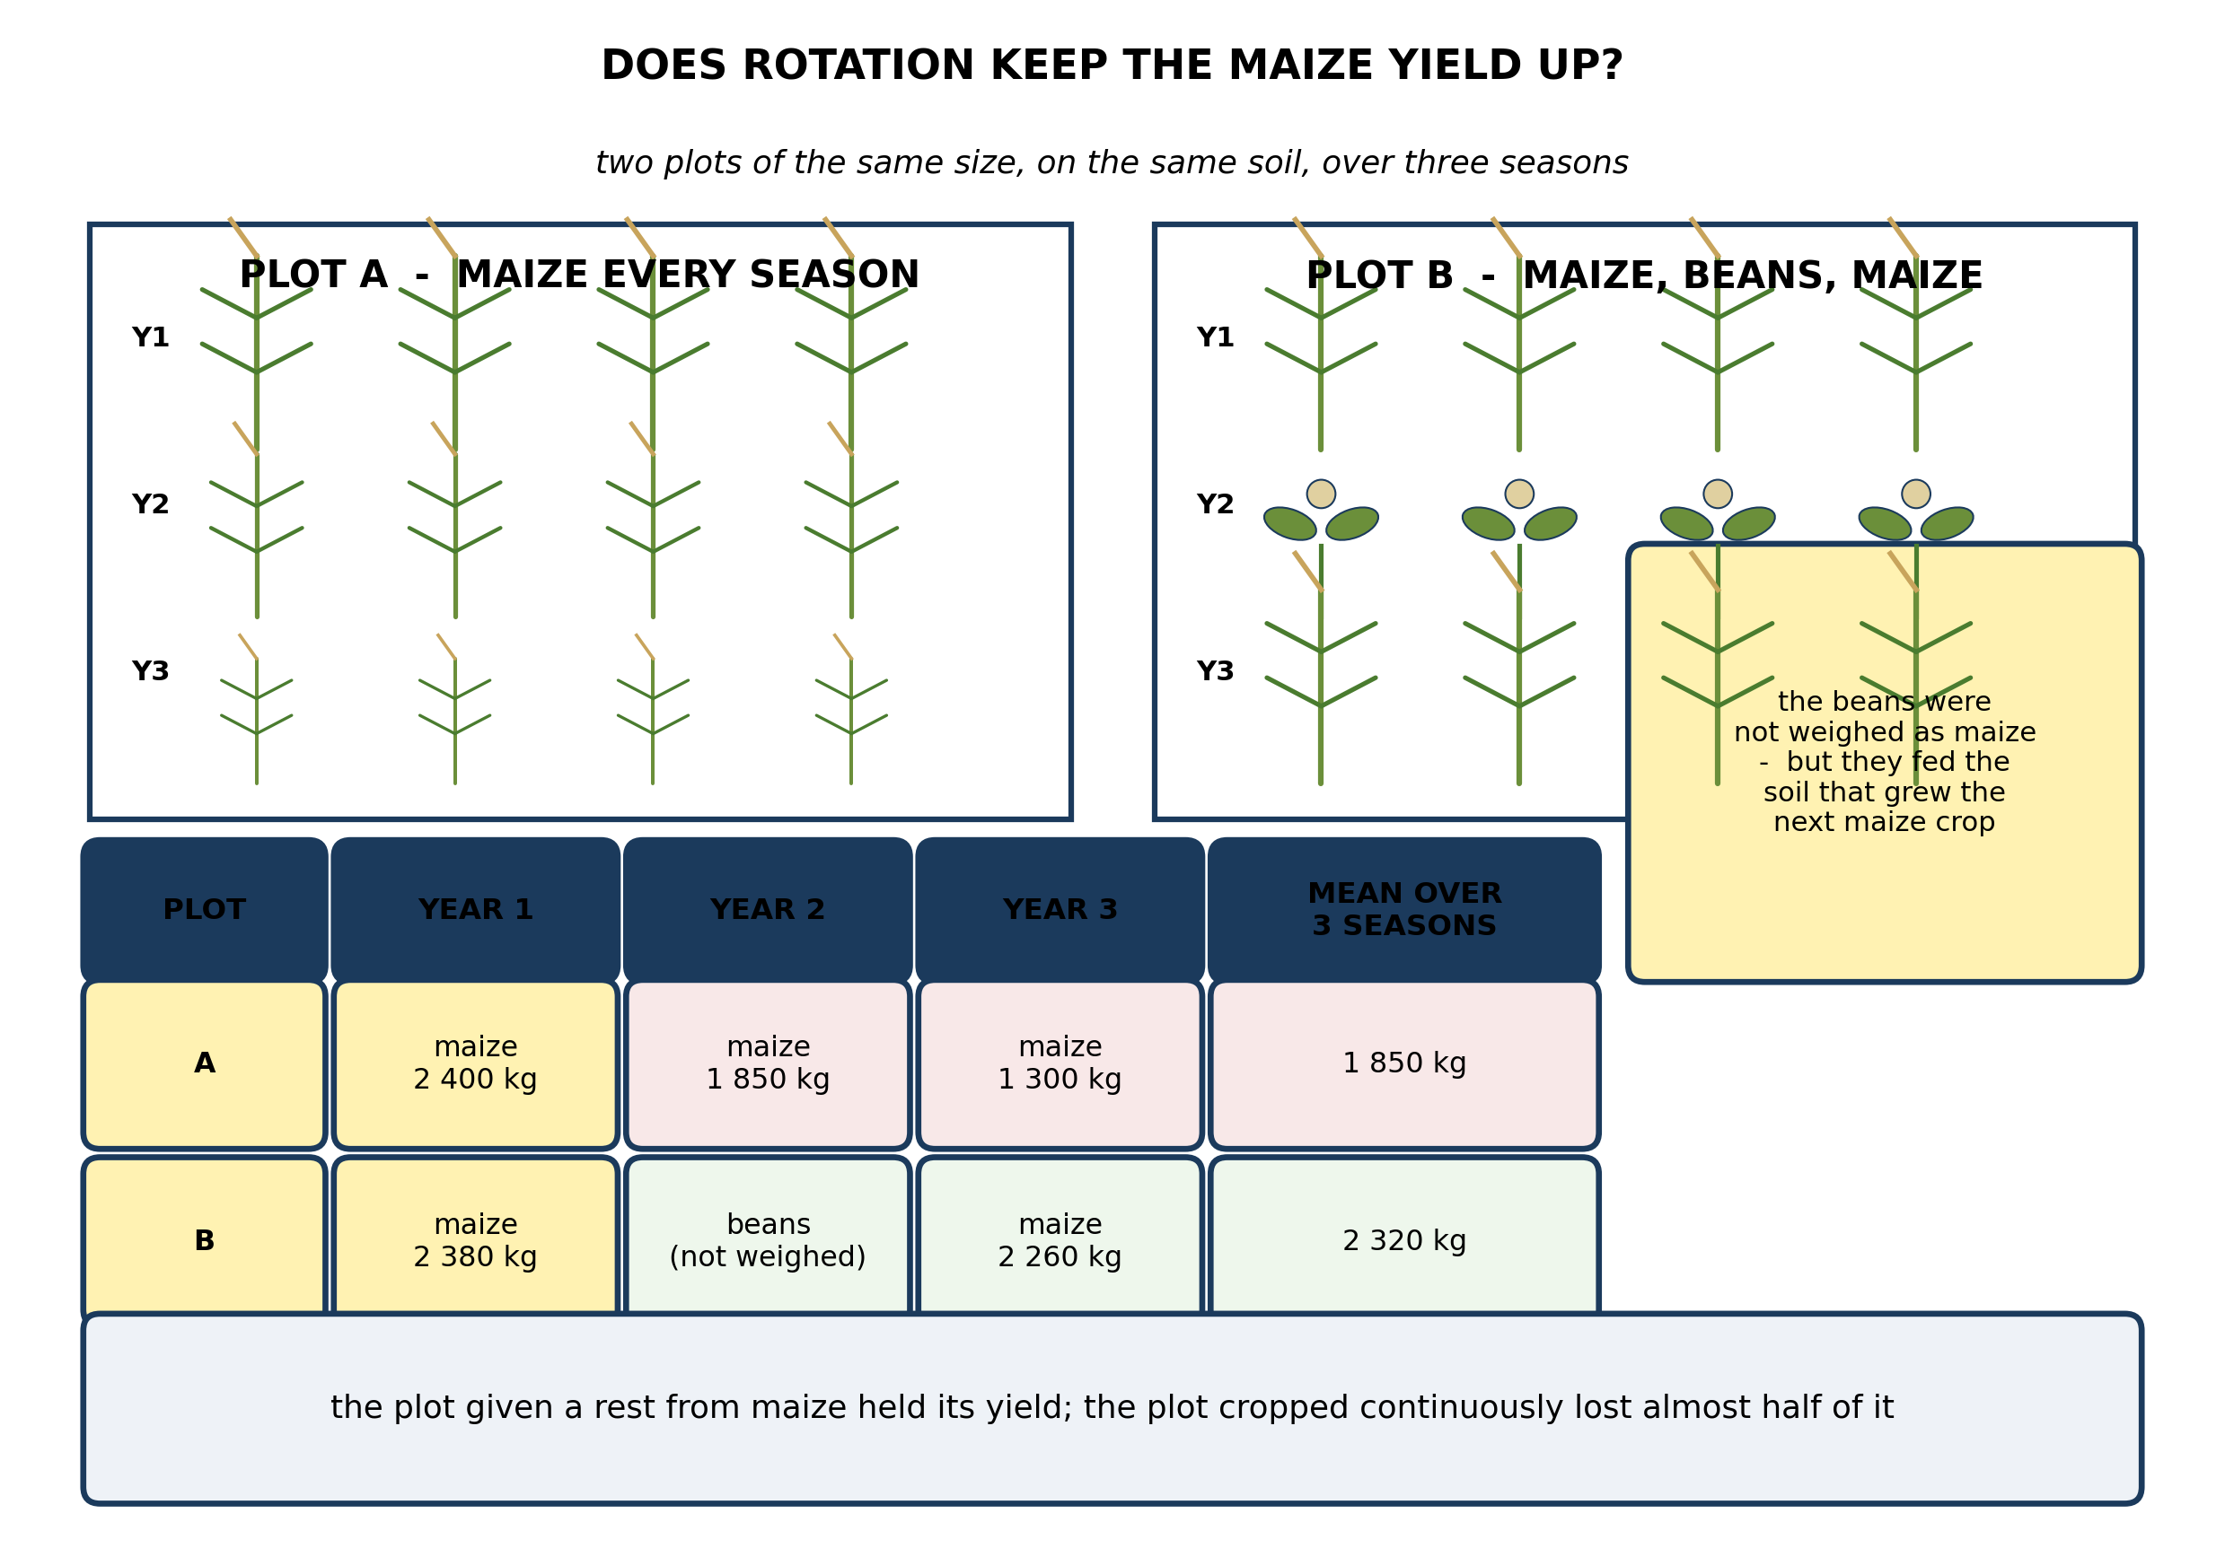
Fig. 8: Does rotation keep the maize yield up?

13. Use the results to explain why plot B held its yield while plot A did not, referring to what each crop did to the soil. [3 marks]
14. Suggest TWO things the pupils must keep the same for this comparison to be fair, and explain why each matters. [3 marks]
15. State what is meant by the YIELD of a crop. [2 marks]
____________________________________________________________________________________________

ANSWER KEY AND MARKING SCHEME
Accept any other correct and relevant answer. Award marks for correct points, not for repeating the question.
10.1 10.1 Types of Farming Systems in Ghana
Q1
For the Northern Region farmer: land rotation. It asks little of each hectare - the plot is cropped, then abandoned to recover by itself while the family moves on - so a small workforce can still farm a large area, and there is land to spare. For the Kumasi farmer: mixed cropping, ideally within an organic system. Land is scarce and expensive, so the aim is to get as much as possible off every square metre; mixed cropping gives two harvests from the same ground, and the large family supplies the labour it needs for careful planting, weeding and composting. The nearby town also provides a market that will pay more for organic produce. Nothing about land rotation would suit him: he has no spare land to rotate onto.
Q2
Any three of: land rotation, crop rotation, mixed cropping, mixed farming, organic farming.
10.2 10.2 Land Rotation Farming
Q3
While a plot lies fallow, wild plants grow on it and die back, and their remains rot into humus, replacing the nutrients the crop removed; the soil structure recovers as roots and soil organisms work through it, and any pest or disease specific to the cropped plant dies out for want of a host. The system only works, though, on two conditions: that there is always more land to move to, and that each plot is left long enough - usually several years - to recover properly. As a village grows, spare land disappears and the fallow period has to be cut short. Plots go back into cultivation before they have recovered, yields fall, and the system collapses into continuous cropping on exhausted ground. That is why it is now rare in the densely farmed parts of southern Ghana.
10.3 10.3 Crop Rotation Farming
Q4
Maize is a heavy feeder, particularly of nitrogen, so a maize crop takes a great deal out of the soil and leaves it poorer. Groundnuts are legumes, and legumes carry nodules on their roots containing bacteria that fix nitrogen from the air into the soil, so a groundnut crop puts nitrogen back rather than taking it out. Placing the groundnut between the two maize crops restores what the first maize crop removed, so the second maize crop finds the nitrogen it needs. There is a second benefit: pests and diseases specific to maize cannot survive a season without maize to live on, so the break in the sequence reduces their build-up - which continuous maize cannot do.
Q5
Any two, each stated. Different crops take different nutrients, so no single nutrient is drained season after season. A legume in the sequence puts nitrogen back into the soil. It breaks the life cycle of pests and diseases specific to one crop. A deep-rooted crop following a shallow-rooted one opens up the soil and reaches food lower down. It reduces the need to buy fertiliser.
10.4 10.4 Mixed Cropping
Q6
How the beans help: first, they are legumes, so the bacteria in their root nodules fix nitrogen from the air into the soil, and the maize can use it. Second, the bean plants spread across the ground between the maize rows and shade it, so fewer weeds can establish and the soil loses less water by evaporation. How they might harm each other: both are growing on the same ground at the same time, so they compete for water and for the same nutrients - nitrogen above all, if the beans are not fixing enough to spare. A climbing bean may also pull the maize stems over, and dense bean growth can shade young maize plants too heavily.
Q7
Any two, each stated. It gives two harvests from the same piece of land instead of one. It spreads the risk: if one crop fails, the other may still do well. The ground cover reduces weeds and protects the soil from erosion. A legume partner feeds the other crop.
10.5 10.5 Mixed Farming
Q8
Animals depending on crops, any two: crop residues such as maize stover, cassava leaves and groundnut haulms are fed to them; grain and cassava tubers are fed to pigs and poultry; the animals are grazed on the stubble and weeds left after harvest. Crops depending on animals, any two: their dung and urine are collected and spread on the fields as manure; their droppings go into the compost pit; grazing animals clear the weeds and stubble and their hooves work crop residue into the ground; where oxen are used they supply the power to plough.
Q9
A farm on which crops are grown and animals are kept at the same time, and where the two are deliberately linked rather than merely side by side: the crop waste and residues feed the animals, and the animal dung and urine are returned to the land to feed the next crop.
10.6 10.6 Organic Farming
Q10
Organic farming uses no synthetic fertiliser, so every nutrient the crop takes up has to be released by the decay of organic matter. The compost pit is where that decay is managed: it turns crop waste and dung into humus, which releases its nutrients slowly and also improves the structure and water-holding of the soil. Without it the farm has no nutrient supply at all. Yields are lower at first because the soil has been accustomed to fertiliser that delivers nutrients quickly and in quantity, whereas compost releases them gradually and in smaller amounts. The soil's structure, its water-holding and its population of organisms all take several seasons to build up. Over time the gap narrows and the soil is in better heart than before.
Q11
The green waste is soft, moist and rich in nitrogen, which the micro-organisms need to build their bodies and multiply. The dry straw and leaves are rich in carbon and hold the heap open so that air can circulate and the mass does not collapse into a slimy, smelly, airless lump. Too much of either and the heap either rots badly or barely rots at all. Turning it over mixes the two materials, lets fresh air into the middle so the decomposers can respire, and stops the outside drying out while the inside goes short of oxygen.
10.7 10.7 Merits and Demerits of Each Farming System
Q12
Organic farming, using mixed cropping within it. The plot is small, so a somewhat lower yield per hectare matters less than the cost of the inputs; the large family supplies the labour that organic farming demands for composting, weeding and hand control of pests; and the nearby town provides a market that will pay a premium for organic produce, which makes up for the smaller harvest. Having little money for chemicals is no obstacle, because none are bought. Mixed cropping suits the small area for the same reason - it gets two harvests off the same ground.
PRACTICAL TASK
Q13
Plot A grew maize in all three seasons. Maize takes a great deal of nitrogen and other nutrients out of the soil, and nothing was put back, so the soil was drained a little more each season - which is exactly what the figures show: 2 400 kg, then 1 850 kg, then 1 300 kg, a loss of nearly half in three seasons. In plot B the beans of year two were legumes, so their root nodules put nitrogen back into the soil instead of taking it out, and they were not maize, so the pests and diseases of maize had no host for a season. When maize was planted again in year three the soil still had what it needed, so the yield held at 2 260 kg. The beans were not weighed as maize, but their effect shows up clearly in the maize crop that followed them.
Q14
Any two, each explained. Both plots must be the same size and on the same type of soil - otherwise the difference in yield could be due to the plot rather than to the rotation. The same maize variety must be used, planted at the same spacing and on the same date. Both plots must receive the same watering and weeding. The grain must be harvested and dried the same way before weighing - if one plot's grain is weighed while still damp it will weigh more and the comparison will be worthless.
Q15
The amount of the crop harvested from a given area of land - for example, the mass of grain in kilograms obtained from one hectare.

BLUEPRINT / TEST SPECIFICATION
# | Content standard | Code | Items | Marks | % of Marks
10.1 | 10.1 Types of Farming Systems in Ghana | B7/JHS1.3.4.1 | 2 | 7 | 14%
10.2 | 10.2 Land Rotation Farming | B7/JHS1.3.4.1 | 1 | 4 | 8%
10.3 | 10.3 Crop Rotation Farming | B7/JHS1.3.4.1 | 2 | 7 | 14%
10.4 | 10.4 Mixed Cropping | B7/JHS1.3.4.1 | 2 | 7 | 14%
10.5 | 10.5 Mixed Farming | B7/JHS1.3.4.1 | 2 | 7 | 14%
10.6 | 10.6 Organic Farming | B7/JHS1.3.4.1 | 2 | 7 | 14%
10.7 | 10.7 Merits and Demerits of Each Farming System | B7/JHS1.3.4.1 | 1 | 3 | 6%
10.1 | Practical task | B7/JHS1.3.4.1 | 3 | 8 | 16%
TOTAL | - | - | 15 | 50 | 100%
Distribution by cognitive level
Cognitive level | Marks | % of Marks
Understand | 14 | 28%
Apply | 21 | 42%
Analyse | 15 | 30%
TOTAL | 50 | 100%
Distribution by difficulty
Difficulty | Marks | % of Marks
Easy | 3 | 6%
Moderate | 28 | 56%
Challenging | 19 | 38%
TOTAL | 50 | 100%

QUALITY-CONTROL SUMMARY
1. Is every question answered from a diagram?
Yes. All 15 questions sit under a figure, and each is unanswerable - or at least materially harder - without reading it. Questions 3, 8, 10 and 17 ask pupils to go beyond the diagram, but each still starts from something the figure shows.
2. Is the content within the Basic 7 curriculum?
Yes. Every question traces to the content standards for this sub-strand (B7/JHS1.3.4.1), and nothing is tested beyond the depth the Basic 7 syllabus sets for it.
3. Are the diagrams clear and unambiguous?
Yes. Each is drawn so that only one reading is sensible: the particle boxes differ in spacing alone, the syringes are labelled with how far each squashes, and the periodic table marks the regions in words as well as by position.
4. Is the level right for JHS 1?
Yes. Questions ask pupils to read, describe and explain what is drawn. Only Question 17 asks for an inference beyond the figure, and it is worth 3 of the 40 marks.
5. Do the marks add up?
Yes: 15 questions totalling 50 marks, matching the figure on the front page. The blueprint, cognitive and difficulty tables all sum to the same total.
6. Are the answers correct and complete?
Yes. Each answer states the point the question is worth, with the acceptable alternatives given where a question is open.
EXAMINER NOTES (for the teacher, not for candidates)
- Pitched at the compulsory diagram question of BECE Paper 2: 72% of the marks are at Apply level or above and 38% are Challenging.
- Q3 on land rotation is the one that separates a description from an explanation. Almost every pupil can say 'the farmer moves to another plot'. Very few can say what the fallow actually DOES - wild growth rots into humus, the structure recovers, the crop-specific pests starve. Push them on the second half too: the system needs spare land, and once the village grows it has none.
- Q4 on the groundnut between two maize crops is the paper's best question. The mechanism is nitrogen fixation by the legume's root nodules, and it is worth naming the nodules. The second mark, on breaking the pest cycle, is the one that is usually missed - rotation helps for two separate reasons, not one.
- Q6 asks pupils to argue both ways, which is harder than it looks. They will list the benefits of the beans happily and then insist there is no downside. There is: two crops on one piece of ground are competing for the same water and nutrients. A farmer who cannot see that will over-plant.
- Q10 is the question that justifies the whole 10.6 strand. Organic farming is not 'farming without chemicals' - it is farming where the nutrient supply has been replaced by a compost pit. If the pit is not managed, the farm has no nutrients at all. The lower early yields follow from the same fact: compost releases slowly, fertiliser does not.
- The rotation experiment in Fig. 8 needs two plots and three seasons, which is more than one class can usually manage. If time is short, run it as a demonstration started by a previous year group, or use the school farm's own records. The numbers are representative rather than real, and it is worth saying so to the class.
- Q15 on the meaning of yield looks trivial and is not. Pupils routinely confuse the yield of a crop with the size of an individual plant, and then wonder why a plot of stunted-looking plants out-yields a plot of tall ones.

