[SCHOOL NAME]
INTEGRATED SCIENCE (SCIENCE)
PRACTICAL QUESTIONS - DIAGRAM MODE
Force and Motion Part 1 (14.1 - 14.8)
____________________________________________________________________________________________
CLASS: Basic 7 (JHS 1)
TIME: 1 hour 30 minutes
MARKS: 50 2025/2026 Academic Year
____________________________________________________________________________________________
INSTRUCTIONS TO CANDIDATES
1. Answer ALL the questions in this paper.
2. Every question is based on a diagram. Study each diagram carefully before you answer the questions that follow it.
3. Write your answers in the spaces provided. The marks for each question are printed beside it.
4. Where a question asks for a stated number of points, give that number. Any extra answers will not be marked.
5. You may refer back to any diagram at any time.
____________________________________________________________________________________________
SECTION A - DIAGRAM STUDY
Study each diagram and answer the questions that follow it.
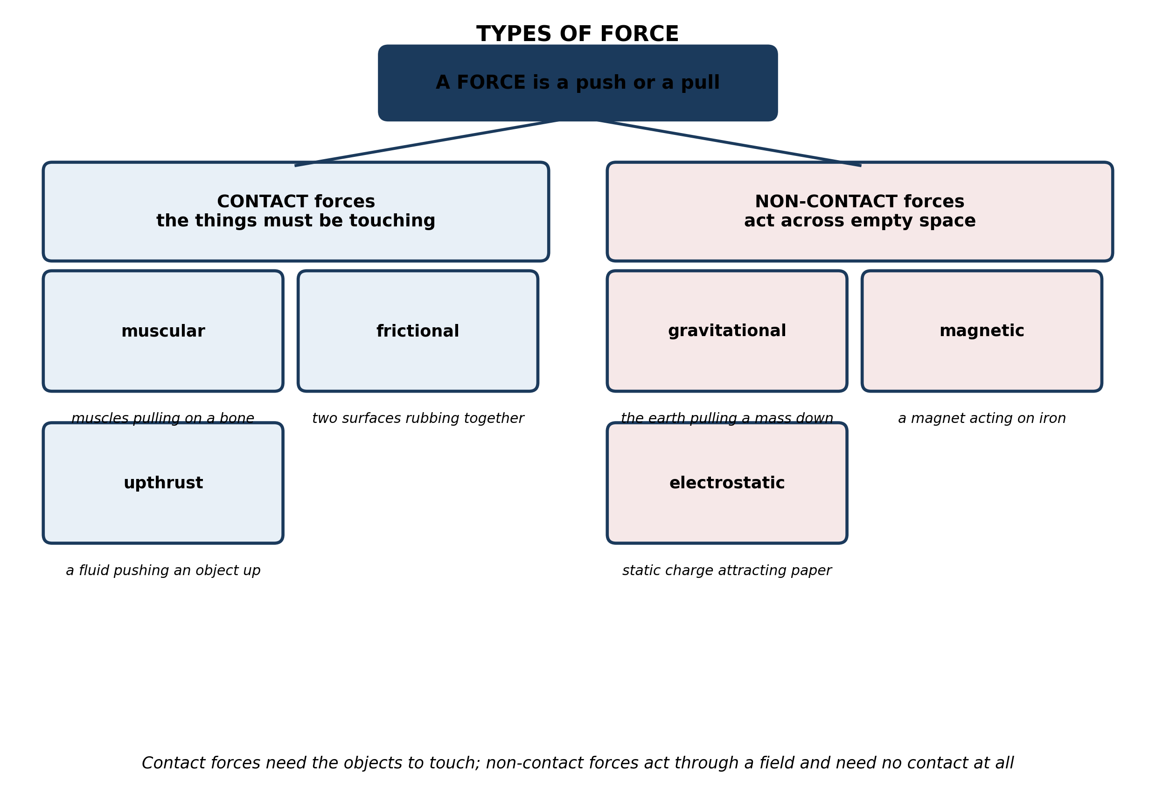
Fig. 1: Types of force

14.1 14.1 What is Force?
1. For each of the following, say whether the force is a CONTACT force or a NON-CONTACT force, and give a reason in each case: (a) the force that makes a compass needle swing; (b) the force that stops your foot slipping on a tiled floor; (c) the force that pulls a coconut down from a tree; (d) the force of a bulldozer blade on a mound of earth. [4 marks]
2. State what is meant by a FORCE, and name any TWO forces. [3 marks]
____________________________________________________________________________________________
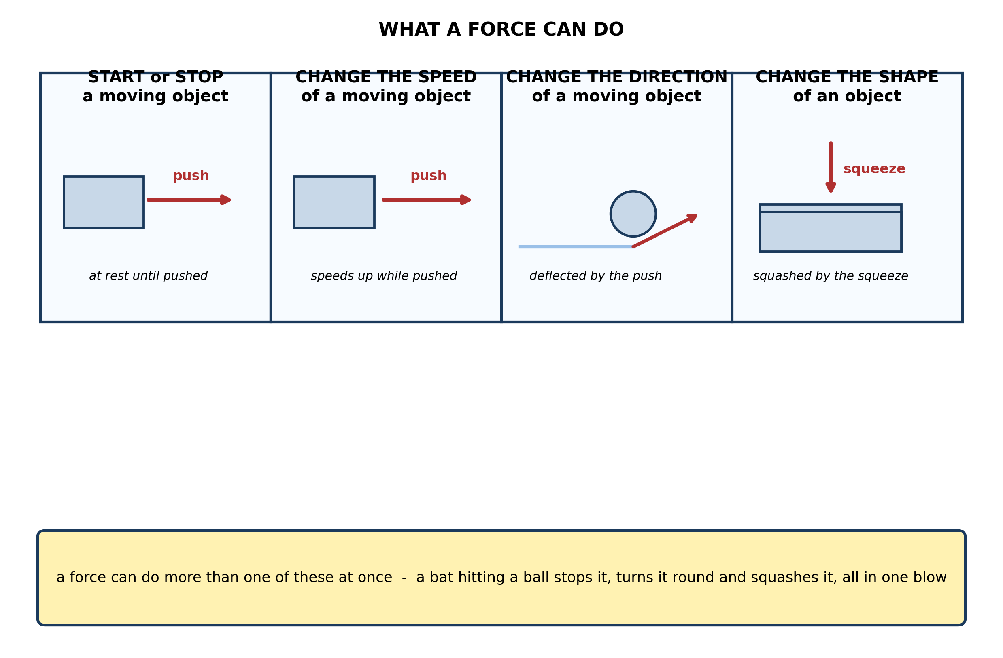
Fig. 2: What a force can do

14.2 14.2 Balanced and Unbalanced Forces
3. A goalkeeper catches a fast ball. Use the diagram to state THREE different effects the force of his hands has on the ball. [3 marks]
____________________________________________________________________________________________
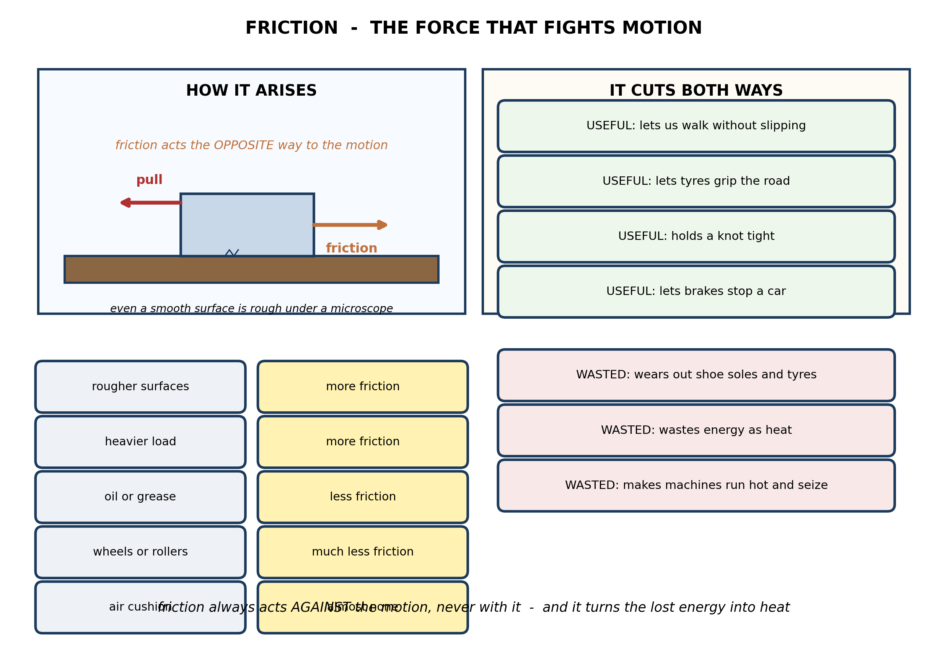
Fig. 3: Friction

14.3 14.3 Inertia
4. Friction is said both to HELP us and to WASTE our effort. Give ONE everyday example of each, and explain in each case what the friction is actually doing. [4 marks]
5. State TWO ways of REDUCING friction and TWO ways of INCREASING it. [3 marks]
____________________________________________________________________________________________
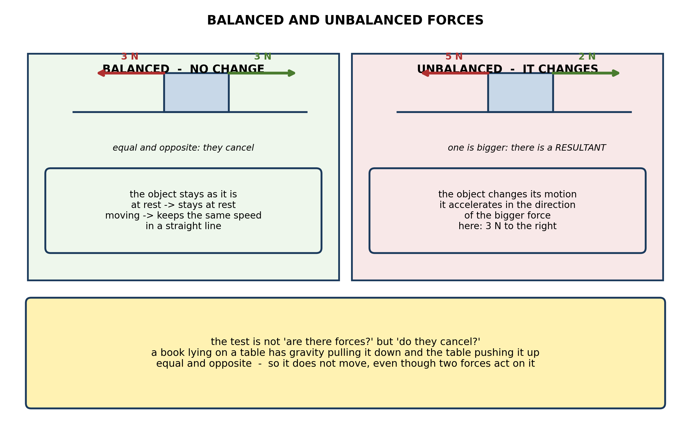
Fig. 4: Balanced and unbalanced forces

14.4 14.4 Newton's First Law of Motion
6. A book lies on a table. Gravity pulls it down with a force of 6 N and the table pushes up on it with a force of 6 N. Explain why the book does not move even though two forces act on it, and describe what would happen if the table were taken away. [4 marks]
7. Two teams pull in a tug of war. Team A pulls with 800 N and team B pulls with 800 N, and the rope does not move. State the resultant force on the rope, and explain what changes when team A begins to win. [3 marks]
____________________________________________________________________________________________
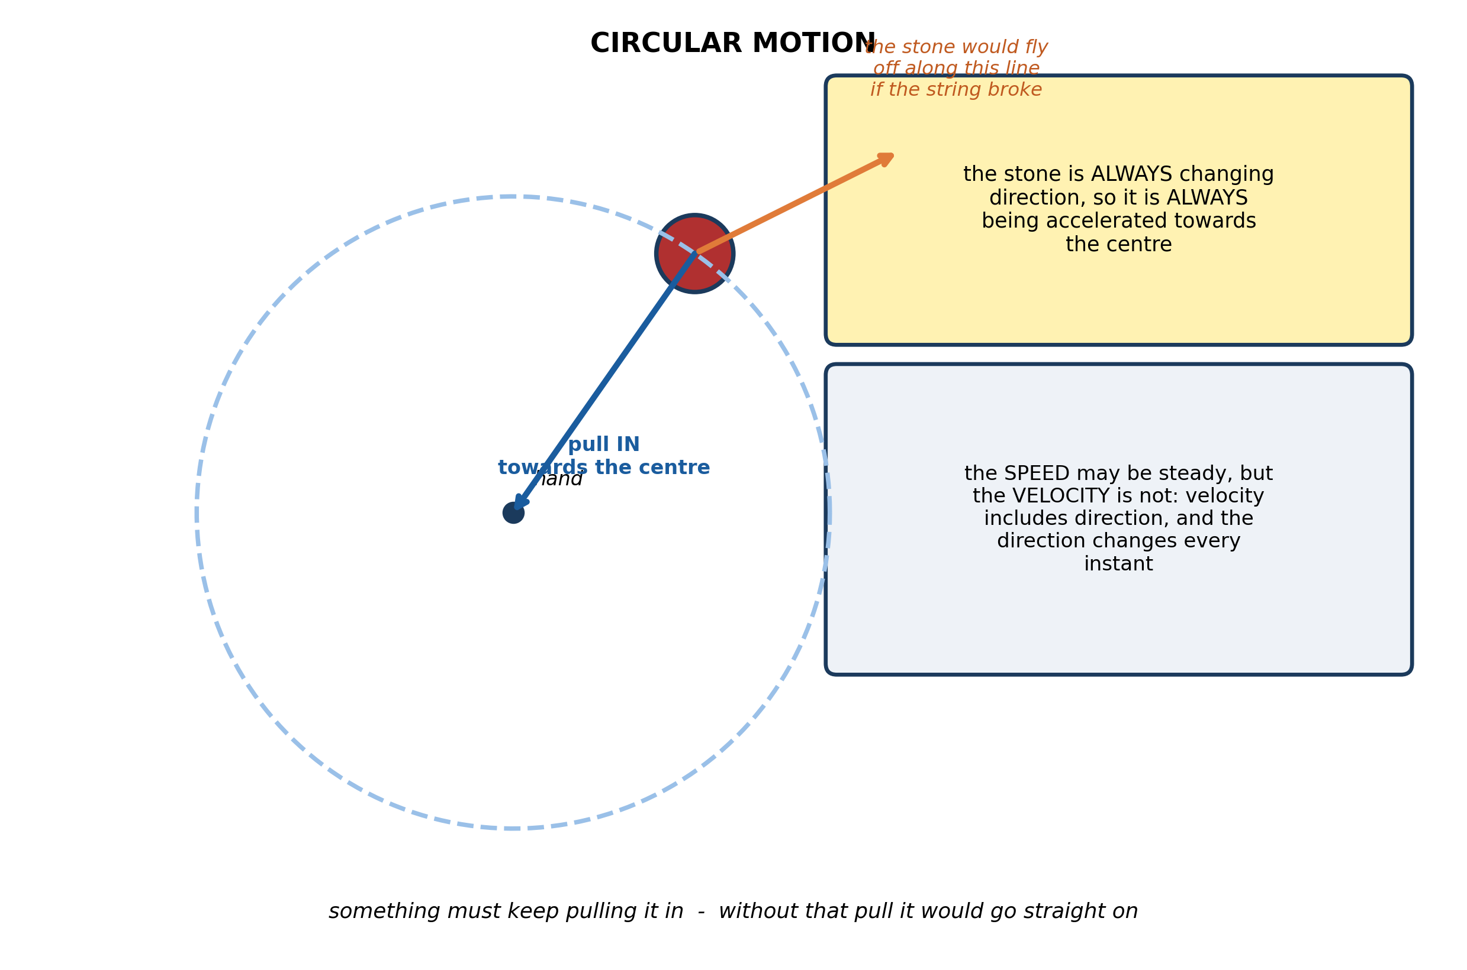
Fig. 5: Circular motion

14.5 14.5 Applications of Newton's First Law
8. A stone is tied to a string and whirled round in a circle at a steady speed. Explain why the stone is ACCELERATING even though its speed never changes, and state what supplies the force causing it. [4 marks]
____________________________________________________________________________________________
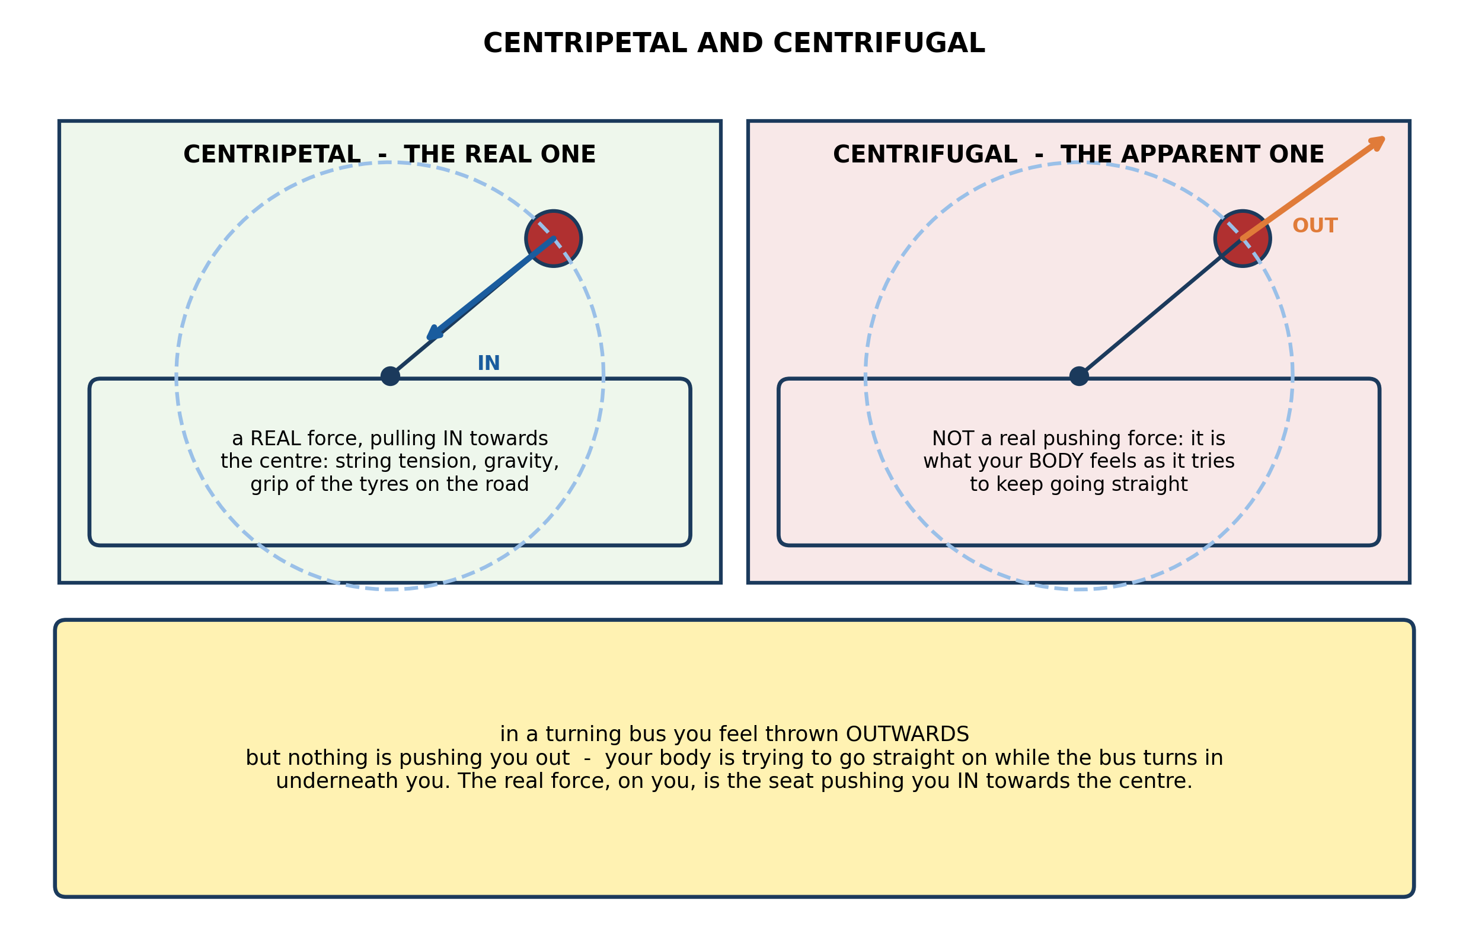
Fig. 6: Centripetal and centrifugal

14.6 14.6 Magnets: Types and Characteristics
9. A passenger standing in a bus that turns sharply to the left feels herself thrown over to the right. Explain what is really happening to her, and explain why the sensation is misleading. [4 marks]
10. State the DIFFERENCE between a centripetal force and the centrifugal force. [3 marks]
____________________________________________________________________________________________
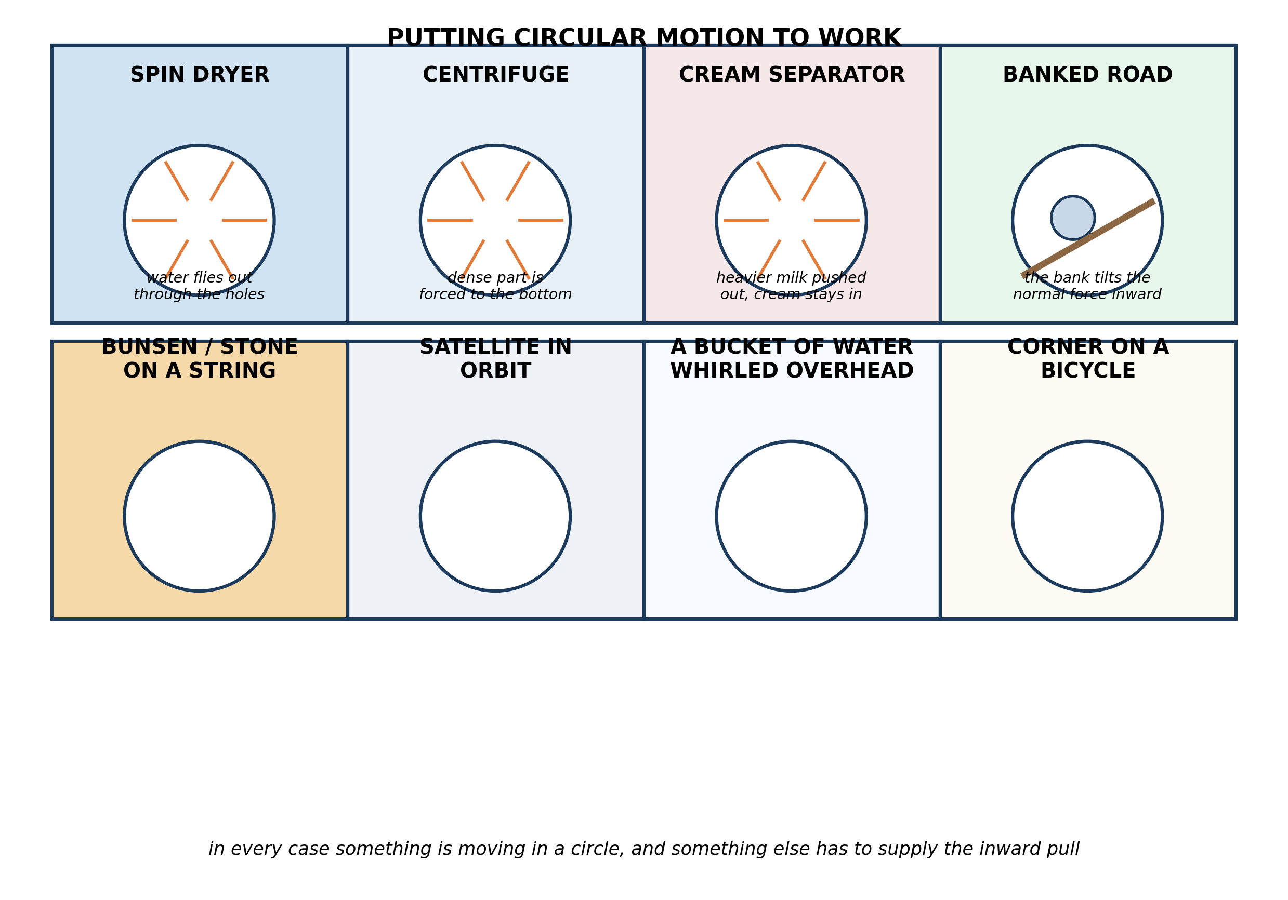
Fig. 7: Putting circular motion to work

14.7 14.7 Repulsion, Attraction and Orientation
11. Explain how a SPIN DRYER gets water out of wet clothes, using the idea of circular motion. [3 marks]
____________________________________________________________________________________________
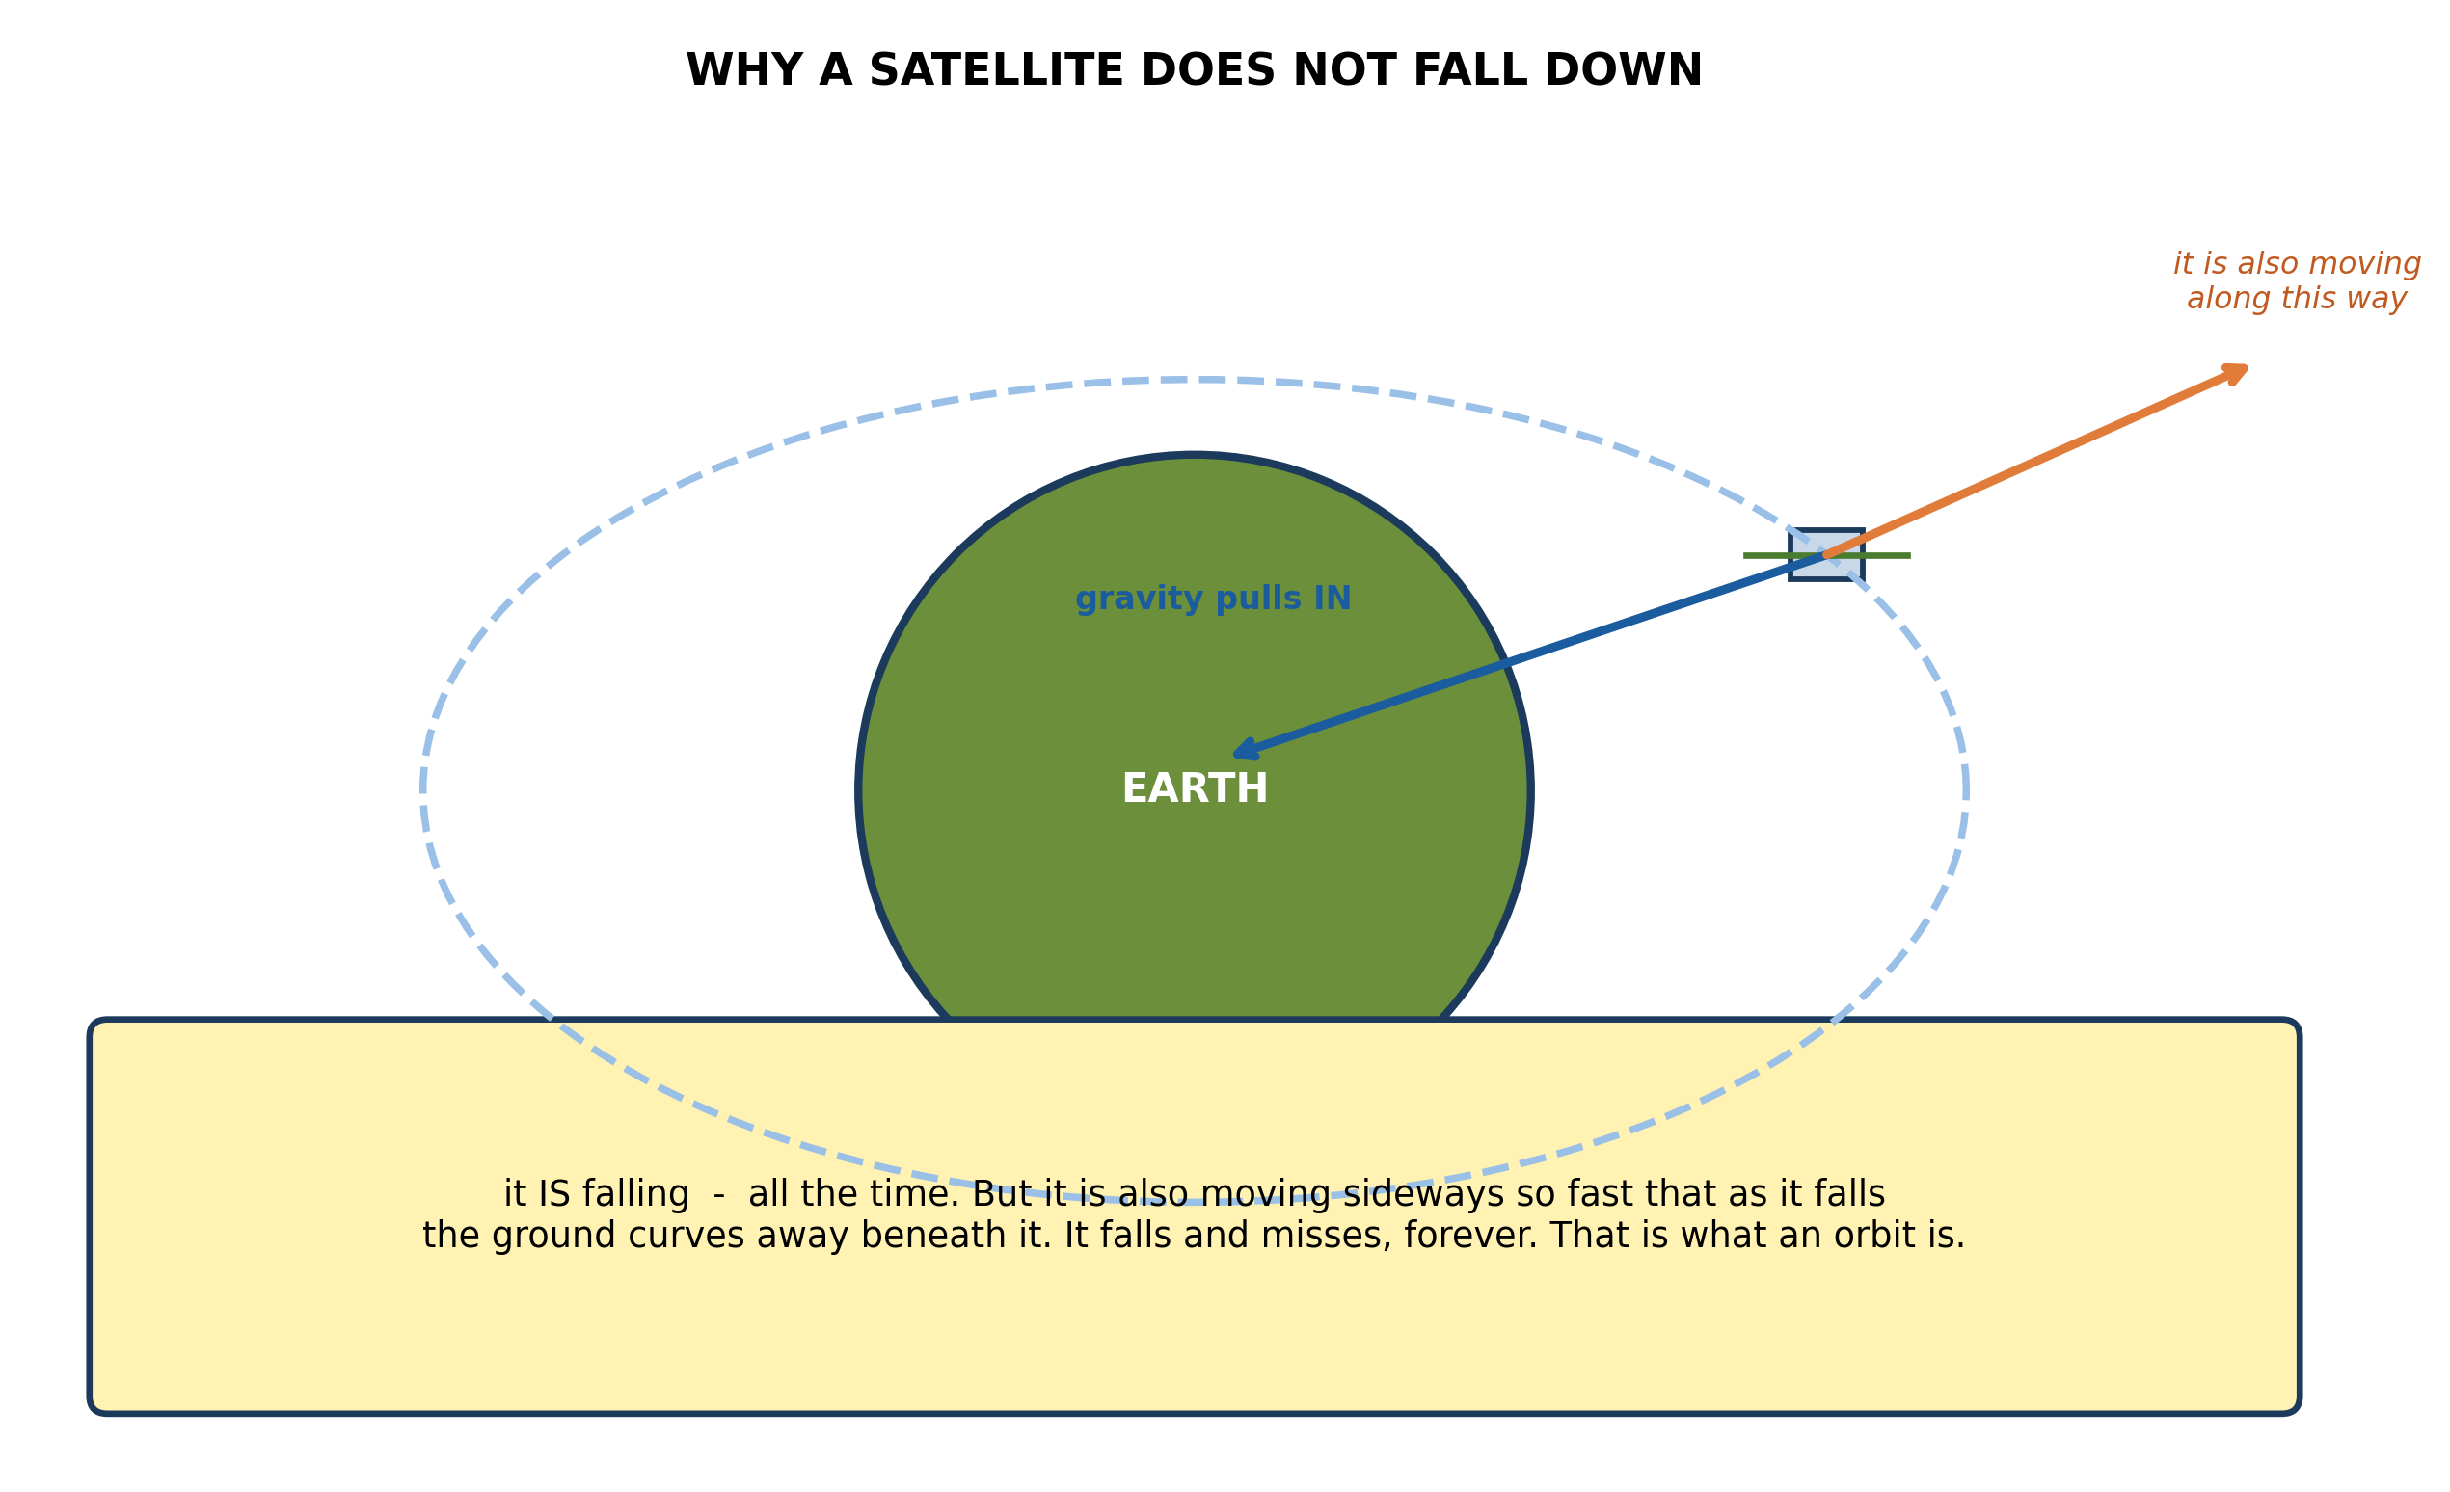
Fig. 8: Why a satellite does not fall down

14.8 14.8 Uses of Magnets
12. Explain why a satellite in orbit does not fall to the earth, even though gravity is pulling on it the whole time. [3 marks]
____________________________________________________________________________________________
SECTION B - PRACTICAL TASK
Study the apparatus and answer the questions that follow it.
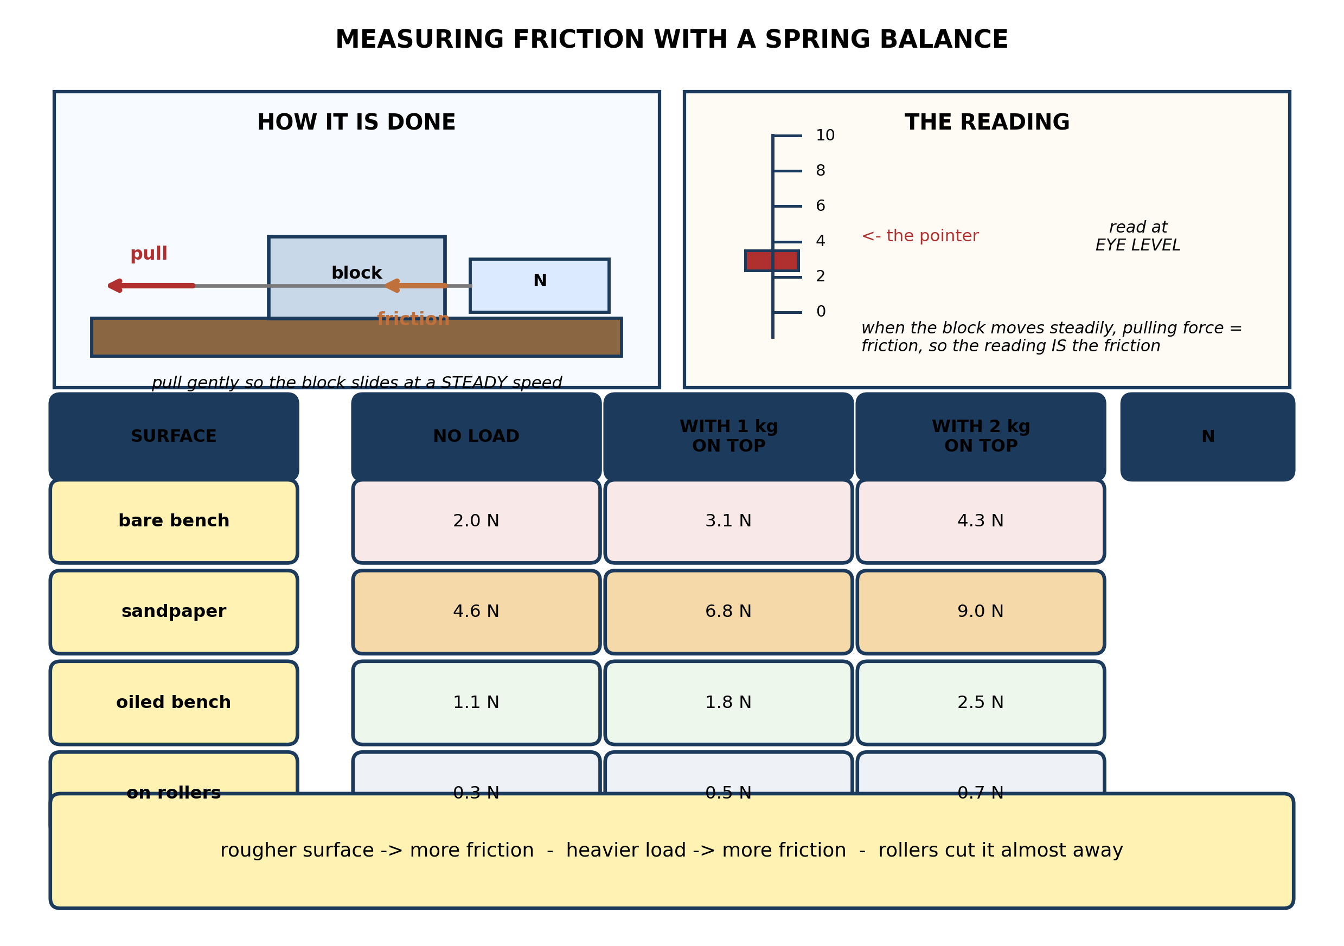
Fig. 9: Measuring friction with a spring balance

13. From the results table, state TWO conclusions the pupils can draw, quoting figures from the table to support each. [3 marks]
14. Explain why the block has to be pulled at a STEADY speed for this method to give the friction, and explain what the reading would show if the block were accelerating instead. [3 marks]
15. State TWO things the pupils must keep the same when they compare the four surfaces, and explain why each matters. [3 marks]
____________________________________________________________________________________________

ANSWER KEY AND MARKING SCHEME
Accept any other correct and relevant answer. Award marks for correct points, not for repeating the question.
14.1 14.1 What is Force?
Q1
(a) Non-contact. The magnet and the compass needle never touch - the magnet acts through the air and the case by its magnetic field. (b) Contact. Friction only arises where the sole of the foot and the surface of the tile are actually pressed together and rubbing. (c) Non-contact. Gravity pulls the coconut down through the air all the way to the ground with nothing touching it; it acts through the earth's gravitational field. (d) Contact. The blade has to be pushed right against the earth before it can push it - the force disappears the moment the blade is lifted clear.
Q2
A force is a push or a pull acting on an object; it can change the object's motion or its shape. Any two named forces: muscular (frictional), friction, gravitational (weight), magnetic, electrostatic, upthrust, tension.
14.2 14.2 Balanced and Unbalanced Forces
Q3
1. It STOPS the ball - the ball was moving and the force from his gloves brings it to rest. 2. It CHANGES THE DIRECTION of the ball - if he palms it away rather than holding it, the force deflects it along a new path. 3. It CHANGES THE SHAPE of the ball - the ball squashes against his gloves for the moment of the catch, then springs back. All three come from the same single blow, which is the point the diagram makes.
14.3 14.3 Inertia
Q4
Where it helps - walking. To move forward you push backwards against the ground with your foot. Friction opposes the tendency of your foot to slide backwards, so it gives you something to push against and you move forward. On a wet or polished floor there is little friction, your foot slides, and you cannot walk properly. Where it wastes - the bearings in a bicycle wheel or a car engine. The metal surfaces rub as they turn, friction opposes the turning, and the work done against it is converted into heat. Energy that came from the rider's muscles or from the fuel ends up warming the bearings instead of moving the machine. That is why bearings are greased, and why they wear out and have to be replaced.
Q5
Reducing, any two: put oil or grease between the surfaces; use wheels, rollers or ball bearings so the surfaces roll instead of sliding; make the surfaces smoother; separate them with a cushion of air as a hovercraft does. Increasing, any two: make the surfaces rougher, as with sandpaper or a tyre tread; press the surfaces together harder, as a heavier load does; use a material that grips more, such as rubber.
14.4 14.4 Newton's First Law of Motion
Q6
The two forces on the book are equal in size and opposite in direction, so they cancel each other: the resultant force on the book is zero. A resultant of zero means no change in motion, so the book stays exactly as it is - at rest. It is not that no forces act on it; two do. It is that together they add to nothing. Take the table away and the upward push disappears. The forces are now unbalanced: 6 N downwards with nothing opposing it. The book therefore accelerates downwards - it falls, and it goes faster the longer it falls.
Q7
The resultant is 800 N - 800 N = 0 N. The pulls are equal and opposite, so they cancel and the rope stays at rest. When team A begins to win, their pull has become greater than team B's. The forces are now unbalanced, there is a resultant in A's direction, and the rope accelerates towards team A. It is not that team B has stopped pulling - B's pull is simply now the smaller of the two.
14.5 14.5 Applications of Newton's First Law
Q8
Acceleration is a change in velocity, and velocity is not the same thing as speed: velocity includes the direction of motion. The stone's speed is constant, but its direction is changing at every instant, because to stay on the circle it must be turning all the time. So its velocity is continually changing, and therefore it is accelerating - even though nothing about the speed changes. Because the direction turns towards the centre, the acceleration is towards the centre, and so there must be a resultant force towards the centre. Here that force is the tension in the string, pulling inward along its length. Cut the string and the force vanishes; the stone then stops turning and goes straight on along the tangent, which is exactly what the diagram shows.
14.6 14.6 Magnets: Types and Characteristics
Q9
Nothing is pushing her to the right. Before the turn, she and the bus are both moving straight ahead. As the bus turns left, the floor and whatever she is holding push on her and turn her left too - that inward push is the centripetal force, and it is what makes her follow the curve instead of continuing straight. But her body tends, by inertia, to keep going in the original straight line, so relative to the turning bus she drifts towards the right-hand side and ends up pressed against it. What she feels as an outward 'centrifugal force' is simply her own body trying to carry straight on while the bus turns underneath her. The real force on her is inward, towards the centre of the turn - the outward feeling is an effect of her own inertia, not a force at all.
Q10
A centripetal force is a REAL force acting towards the centre of the circle - the tension in a string, the pull of gravity, or the grip of tyres on a road - and it is what keeps an object moving in a circle instead of going straight. The centrifugal force is NOT a real force at all: it is the apparent outward effect you feel because your body tends to keep moving in a straight line while whatever is carrying you turns inward beneath you.
14.7 14.7 Repulsion, Attraction and Orientation
Q11
The drum spins the clothes round in a circle at high speed. To keep something moving in a circle there must be a force pulling it inward, and for the clothes that force comes from the drum wall pushing on them. But the water in the cloth is only loosely held, and the drum has holes in it, so the wall cannot push on the water. With no inward force to hold it in the circle, the water simply continues in a straight line - out through the holes and into the outer casing. The faster the drum spins, the greater the inward force the water would need, and so the more of it is thrown out.
14.8 14.8 Uses of Magnets
Q12
It is falling - continuously. Gravity is the inward force that bends its path, and it never stops acting on the satellite. But the satellite also has a very large sideways speed, and as it falls towards the earth the earth's surface curves away beneath it at just the same rate, so the satellite keeps missing the ground. Gravity curves its path into a closed loop around the earth rather than letting it fly off in a straight line, and with no air up there to slow it down it keeps its speed. An orbit is a permanent fall that never lands.
PRACTICAL TASK
Q13
1. A rougher surface gives more friction. With no load on the block, the bare bench gives 2.0 N but sandpaper gives 4.6 N - more than twice as much for the same block and the same load. Oiling the bench cuts it to 1.1 N, which is lower than the bare bench. 2. A heavier load gives more friction. On the bare bench the reading rises from 2.0 N with no load to 3.1 N with 1 kg on top and 4.3 N with 2 kg - roughly doubling as the load goes up. A third conclusion: rollers almost remove friction entirely, cutting the reading from 2.0 N to 0.3 N.
Q14
If the block is moving at a steady speed its motion is not changing, so the forces on it must be balanced: the pull forwards is exactly equal to the friction backwards, and the balance reading therefore IS the friction. If the block were accelerating, the forces would no longer be balanced - the pull would have to be greater than the friction in order to produce the acceleration. The reading would then be higher than the true friction, and it would not settle to a steady value because the block would keep gaining speed.
Q15
Any two, each explained. The same block must be used, pulled on the same face, so that the area in contact is the same in every trial. The pull must be horizontal in each case - if the balance is tilted, part of the pull goes into lifting the block rather than overcoming friction, and the reading is not the friction. The same load must be used when comparing one surface with another. The balance should be checked to read zero before each trial, and read at eye level to avoid a parallax error.

BLUEPRINT / TEST SPECIFICATION
# | Content standard | Code | Items | Marks | % of Marks
14.1 | 14.1 What is Force? | B7/JHS1.4.4.1 | 2 | 7 | 14%
14.2 | 14.2 Balanced and Unbalanced Forces | B7/JHS1.4.4.1 | 1 | 3 | 6%
14.3 | 14.3 Inertia | B7/JHS1.4.4.1 | 2 | 7 | 14%
14.4 | 14.4 Newton's First Law of Motion | B7/JHS1.4.4.1 | 2 | 7 | 14%
14.5 | 14.5 Applications of Newton's First Law | B7/JHS1.4.4.1 | 1 | 4 | 8%
14.6 | 14.6 Magnets: Types and Characteristics | B7/JHS1.4.4.1 | 2 | 7 | 14%
14.7 | 14.7 Repulsion, Attraction and Orientation | B7/JHS1.4.4.1 | 1 | 3 | 6%
14.8 | 14.8 Uses of Magnets | B7/JHS1.4.4.1 | 1 | 3 | 6%
14.1 | Practical task | B7/JHS1.4.4.1 | 3 | 9 | 18%
TOTAL | - | - | 15 | 50 | 100%
Distribution by cognitive level
Cognitive level | Marks | % of Marks
Understand | 12 | 24%
Apply | 19 | 38%
Analyse | 19 | 38%
TOTAL | 50 | 100%
Distribution by difficulty
Difficulty | Marks | % of Marks
Easy | 3 | 6%
Moderate | 28 | 56%
Challenging | 19 | 38%
TOTAL | 50 | 100%

QUALITY-CONTROL SUMMARY
1. Is every question answered from a diagram?
Yes. All 15 questions sit under a figure, and each is unanswerable - or at least materially harder - without reading it. Questions 3, 8, 10 and 17 ask pupils to go beyond the diagram, but each still starts from something the figure shows.
2. Is the content within the Basic 7 curriculum?
Yes. Every question traces to the content standards for this sub-strand (B7/JHS1.4.4.1), and nothing is tested beyond the depth the Basic 7 syllabus sets for it.
3. Are the diagrams clear and unambiguous?
Yes. Each is drawn so that only one reading is sensible: the particle boxes differ in spacing alone, the syringes are labelled with how far each squashes, and the periodic table marks the regions in words as well as by position.
4. Is the level right for JHS 1?
Yes. Questions ask pupils to read, describe and explain what is drawn. Only Question 17 asks for an inference beyond the figure, and it is worth 3 of the 40 marks.
5. Do the marks add up?
Yes: 15 questions totalling 50 marks, matching the figure on the front page. The blueprint, cognitive and difficulty tables all sum to the same total.
6. Are the answers correct and complete?
Yes. Each answer states the point the question is worth, with the acceptable alternatives given where a question is open.
EXAMINER NOTES (for the teacher, not for candidates)
- Pitched at the compulsory diagram question of BECE Paper 2: 76% of the marks are at Apply level or above and 38% are Challenging.
- Q8 is the best question here, and the one that decides whether a pupil understands circular motion or has merely memorised the word. The whole answer hangs on one distinction: speed is how fast, velocity is how fast AND which way. A stone on a string has constant speed and constantly changing velocity, so it is accelerating. Pupils who say 'its speed is constant so there is no acceleration' have the wrong definition, not a missing fact.
- Q9 on the turning bus is the same idea from inside. Nothing pushes the passenger outwards. She keeps going straight; the bus turns in underneath her. If a pupil finishes the answer still believing a centrifugal force pushed her, they have not got it - and this is the single most common misconception in the whole strand.
- Q12 on the satellite is worth doing aloud at the board. 'It is falling and missing' is the sentence to aim for; it is short, it is correct, and it is memorable in a way that 'gravity is balanced by centrifugal force' is not - that answer is wrong and very common.
- Q4 on friction both helping and wasting is where pupils show whether they can argue both sides. Most can give one example of friction being a nuisance (wearing out soles) but cannot say what it does when it helps, which is: give you something to push against.
- The friction experiment needs a spring balance reading to at least 0.1 N, a wooden block with a hook, and a set of masses. Reading the balance while the block is actually moving at a steady speed is the awkward part - a slow, steady pull takes practice, and it is worth letting each group have several attempts before recording.
- If spring balances are short, the whole class can work from one balance passed round, or the four surfaces can be tested by different groups and the results pooled on the board.

