[SCHOOL NAME]
INTEGRATED SCIENCE (SCIENCE)
PRACTICAL QUESTIONS - DIAGRAM MODE
Understanding the Environment (20.1 - 20.5)
____________________________________________________________________________________________
CLASS: Basic 7 (JHS 1)
TIME: 1 hour 30 minutes
MARKS: 50 2025/2026 Academic Year
____________________________________________________________________________________________
INSTRUCTIONS TO CANDIDATES
1. Answer ALL the questions in this paper.
2. Every question is based on a diagram. Study each diagram carefully before you answer the questions that follow it.
3. Write your answers in the spaces provided. The marks for each question are printed beside it.
4. Where a question asks for a stated number of points, give that number. Any extra answers will not be marked.
5. You may refer back to any diagram at any time.
____________________________________________________________________________________________
SECTION A - DIAGRAM STUDY
Study each diagram and answer the questions that follow it.
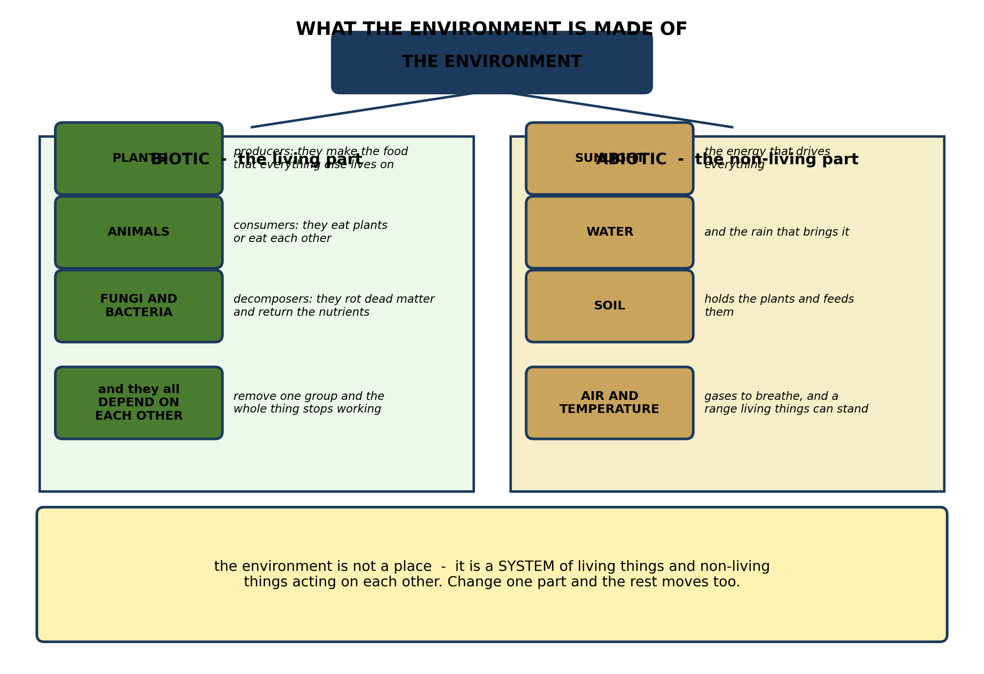
Fig. 1: What the environment is made of

20.1 20.1 Landforms in Ghana: Plateau, Plain, Mountain and Valley
1. Explain the difference between the BIOTIC and ABIOTIC parts of the environment, and explain why a change in a NON-LIVING part can destroy the living part. [4 marks]
2. Name THREE living (biotic) and THREE non-living (abiotic) parts of the environment. [3 marks]
3. A dam is built across a river and the land below it no longer floods each year. Explain TWO effects this would have on the living things in that area. [3 marks]
____________________________________________________________________________________________
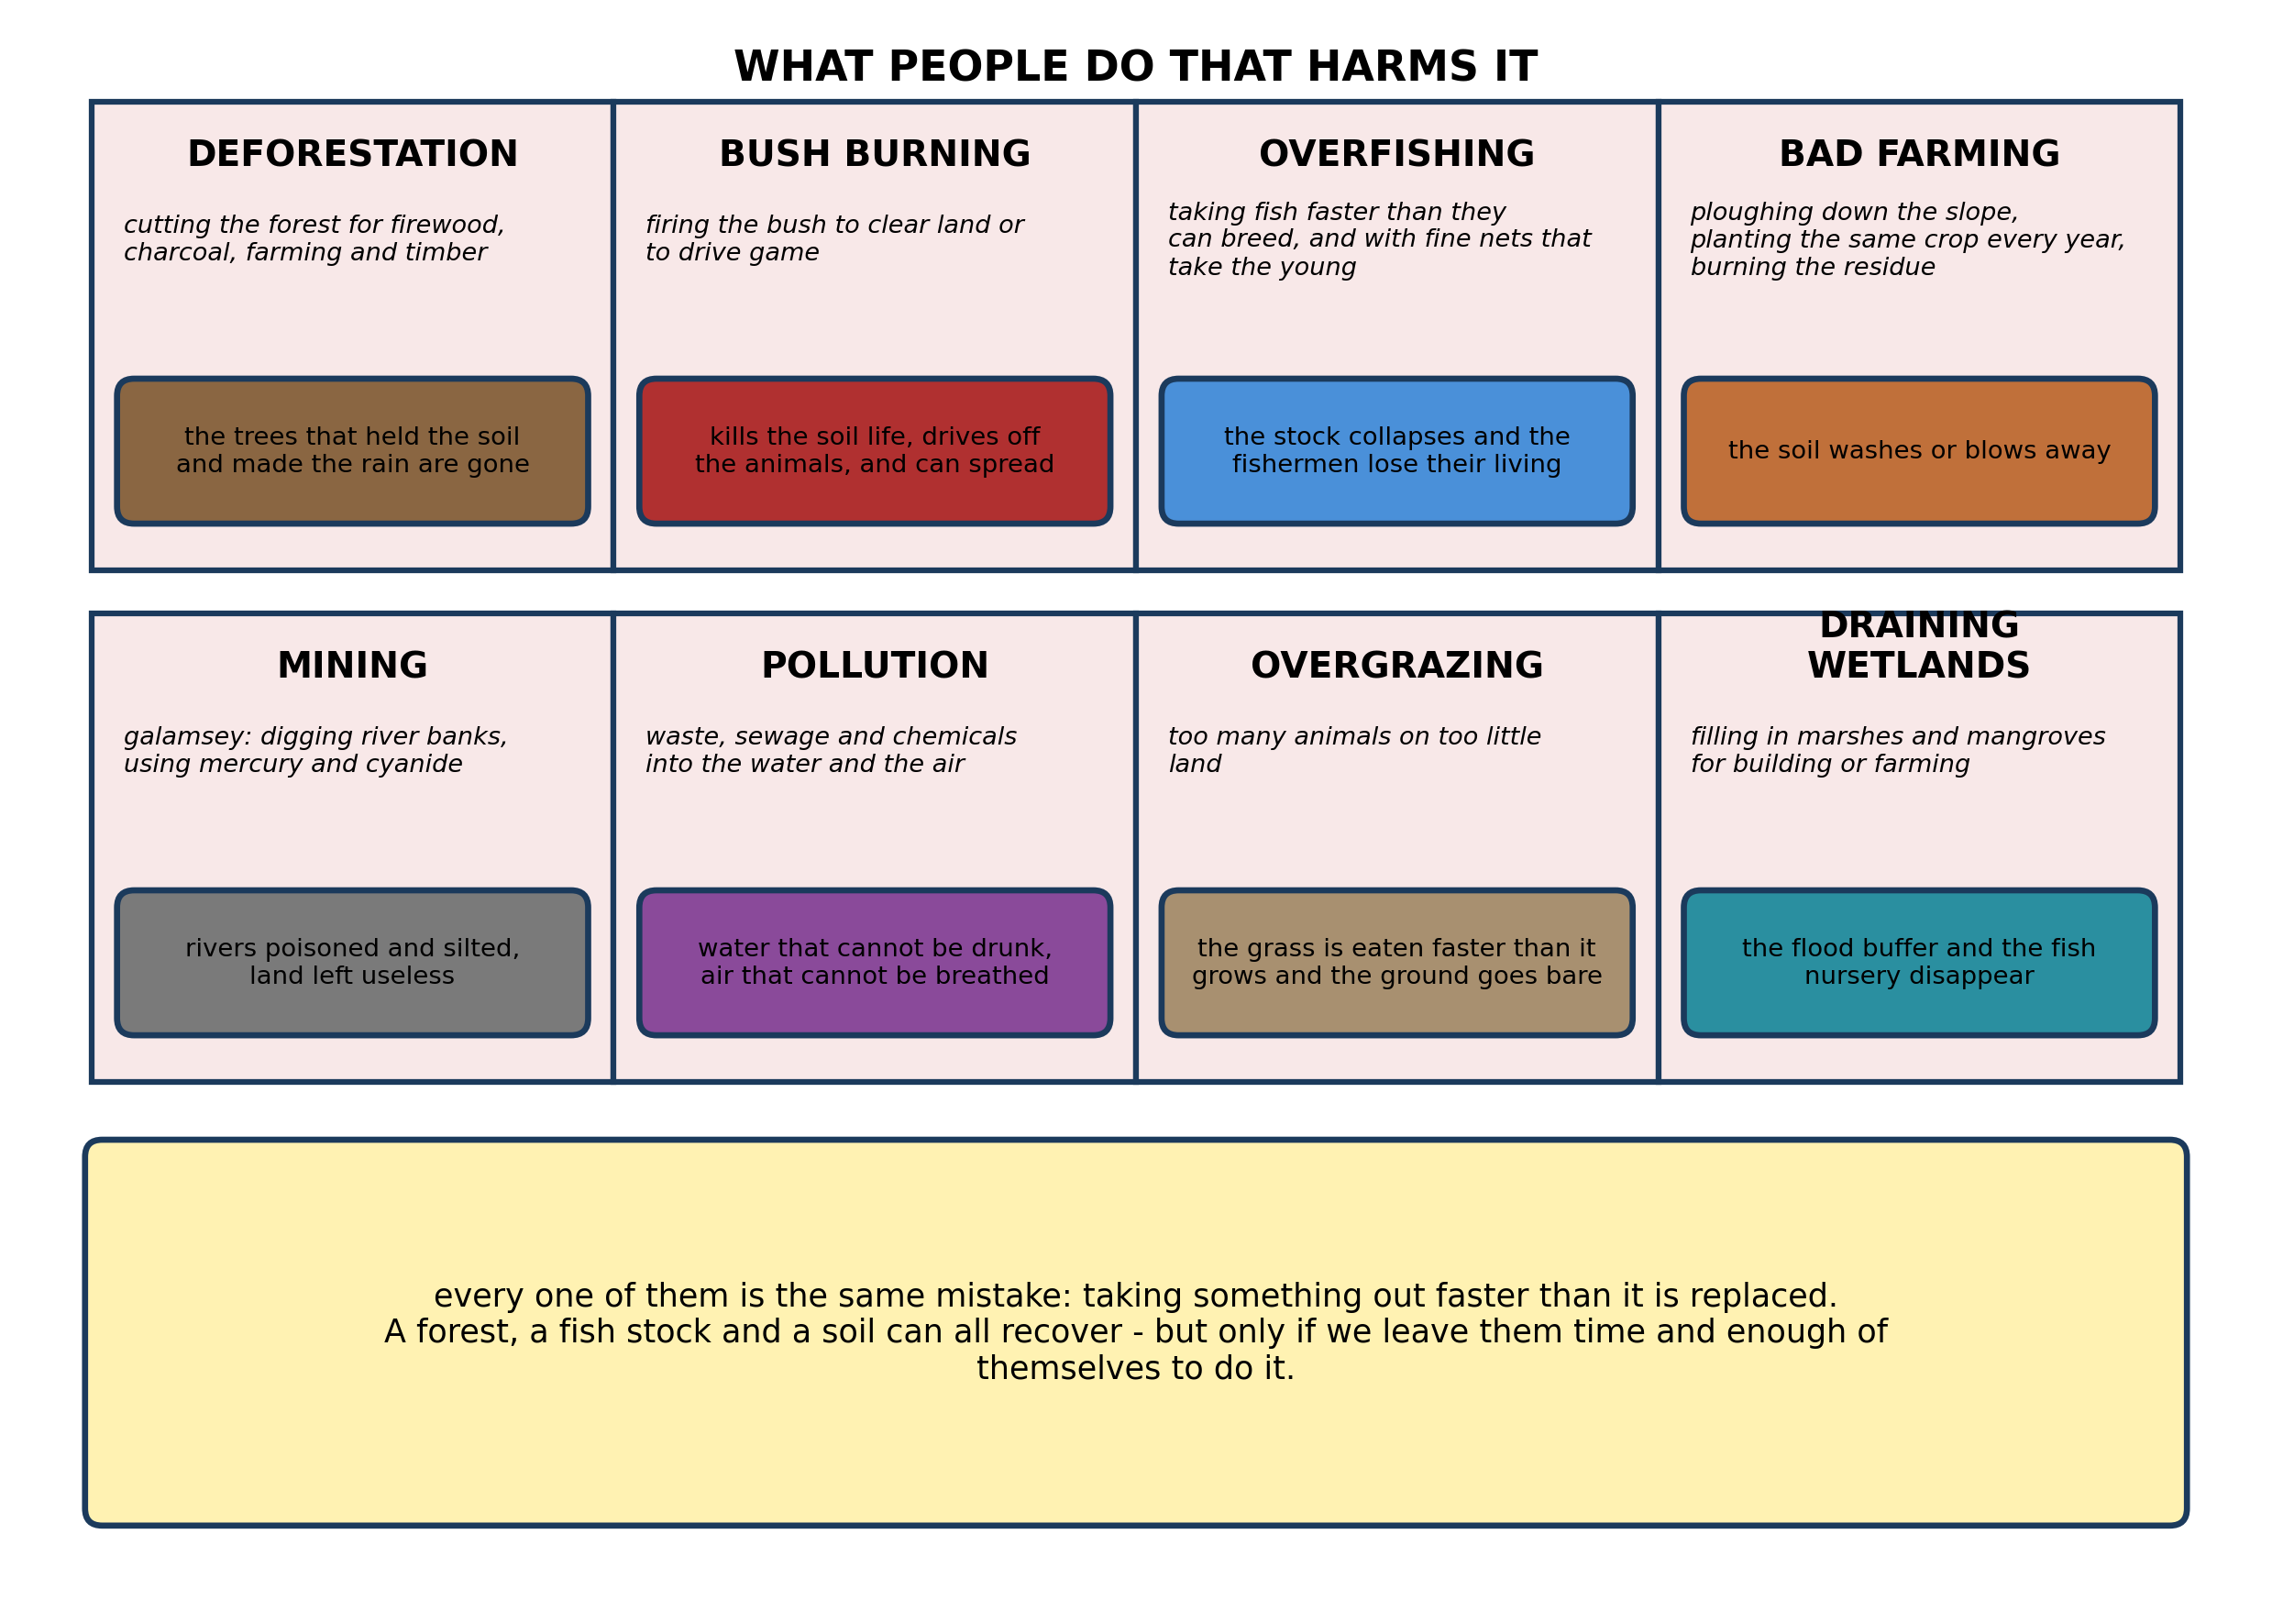
Fig. 2: What people do that harms it

20.2 20.2 Plants and Animals Found in Different Landforms
4. Explain why galamsey does far more damage than simply removing the gold. Refer to what it does to the soil, to the water, and to the people downstream. [4 marks]
5. Name THREE human activities that harm the environment. [3 marks]
____________________________________________________________________________________________
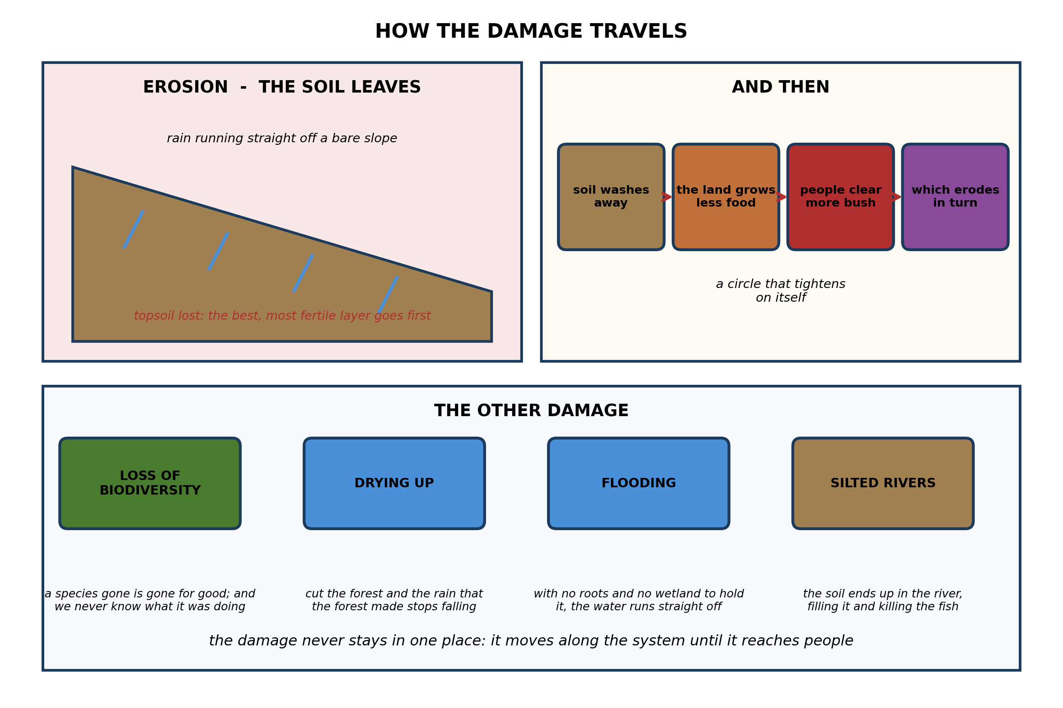
Fig. 3: How the damage travels

20.3 20.3 How Animals Adapt to Different Landforms
6. Explain how soil erosion can set going a CIRCLE that makes itself worse, so that poor farmers end up damaging more land. [4 marks]
7. Explain why cutting down a forest on a hillside makes flooding worse in the valley below. [3 marks]
8. State THREE effects of damaging the environment. [3 marks]
____________________________________________________________________________________________
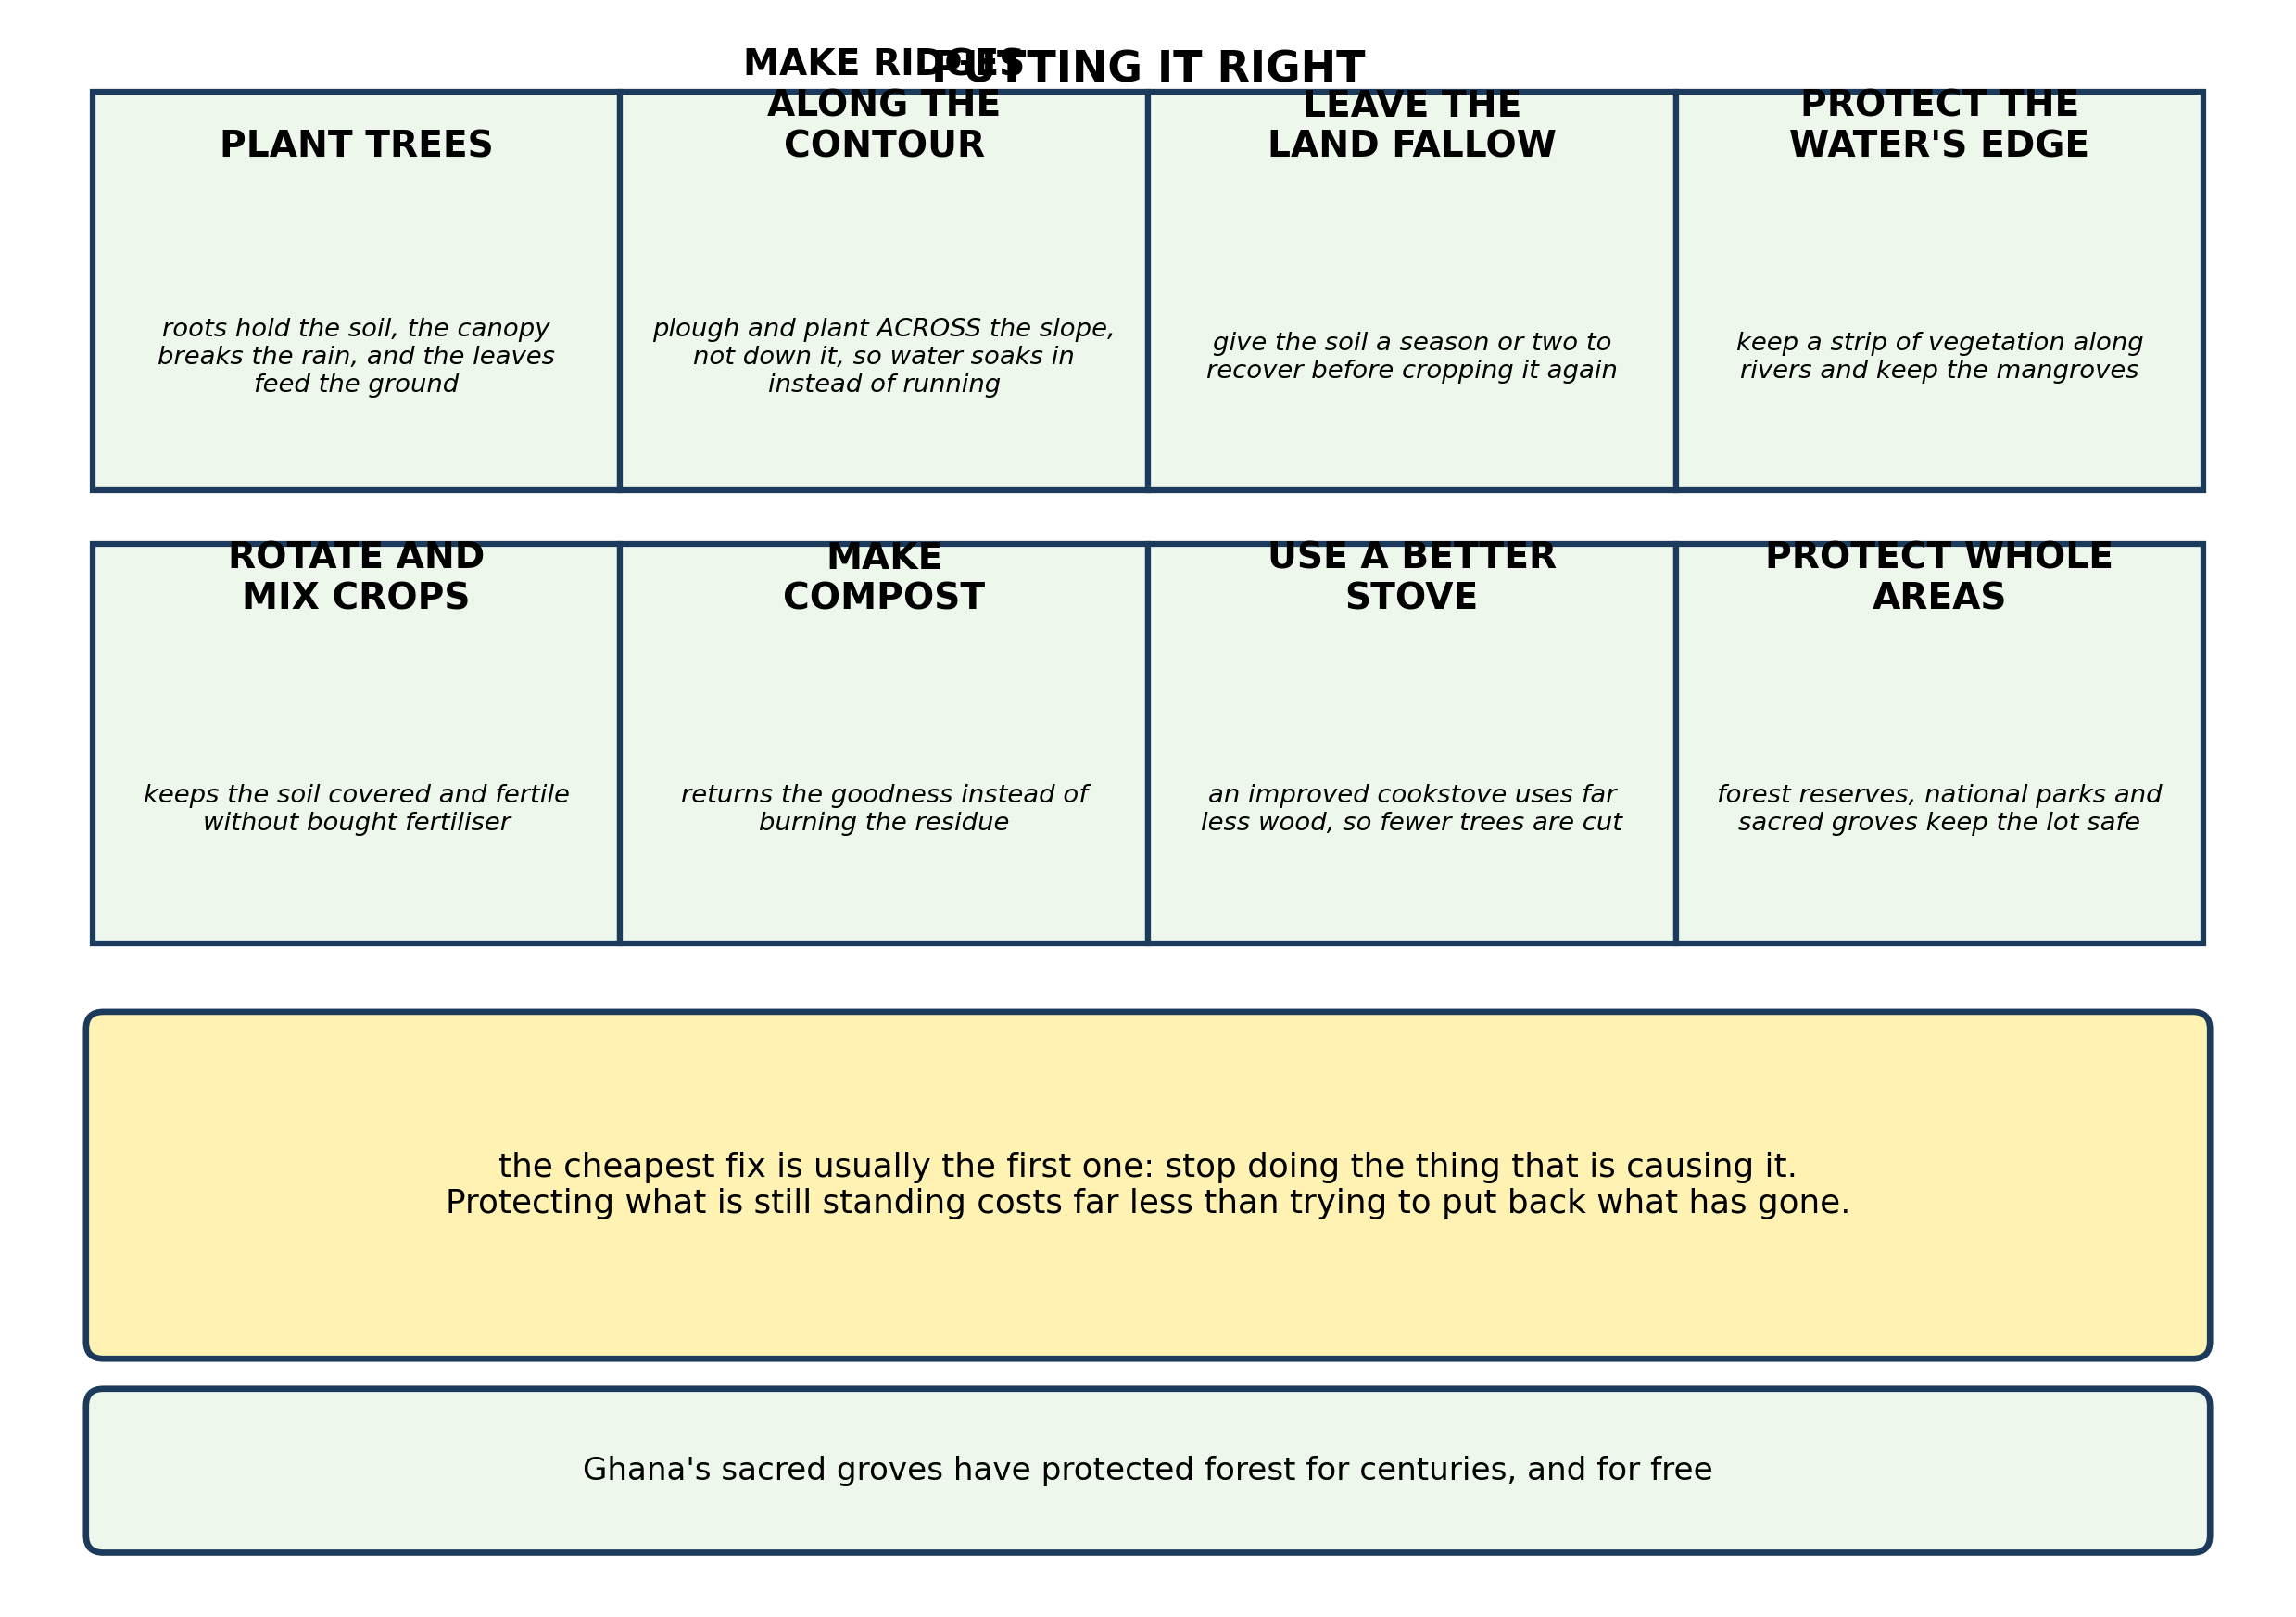
Fig. 4: Putting it right

20.4 20.4 How Plants Survive in Different Landforms
9. A village's hillside farms are losing their soil. Suggest TWO practical things the farmers could do, and explain in each case exactly HOW it would stop the soil being lost. [4 marks]
10. Explain why keeping a strip of vegetation along a river bank protects both the RIVER and the FARMER. [3 marks]
____________________________________________________________________________________________
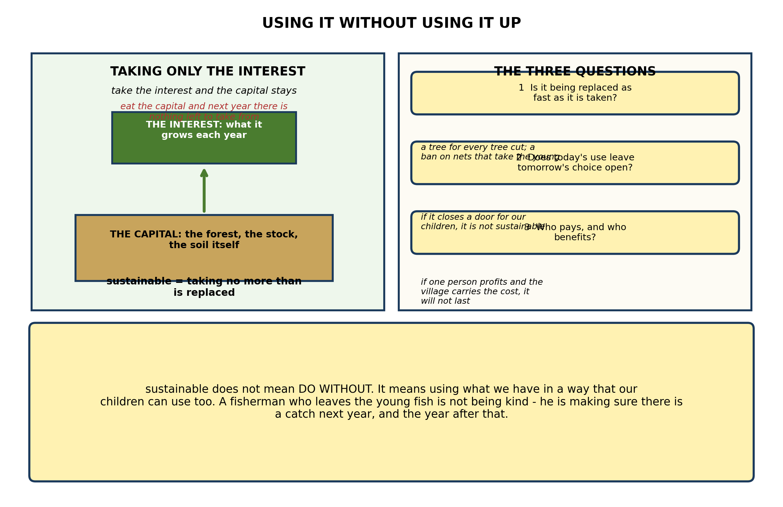
Fig. 5: Using it without using it up

20.5 20.5 Associations Among Plants and Animals
11. Explain what is meant by using the environment SUSTAINABLY, using the idea of capital and interest from Fig. 5. [4 marks]
12. State what is meant by the SUSTAINABLE use of the environment, and give ONE example. [3 marks]
____________________________________________________________________________________________
SECTION B - PRACTICAL TASK
Study the apparatus and answer the questions that follow it.
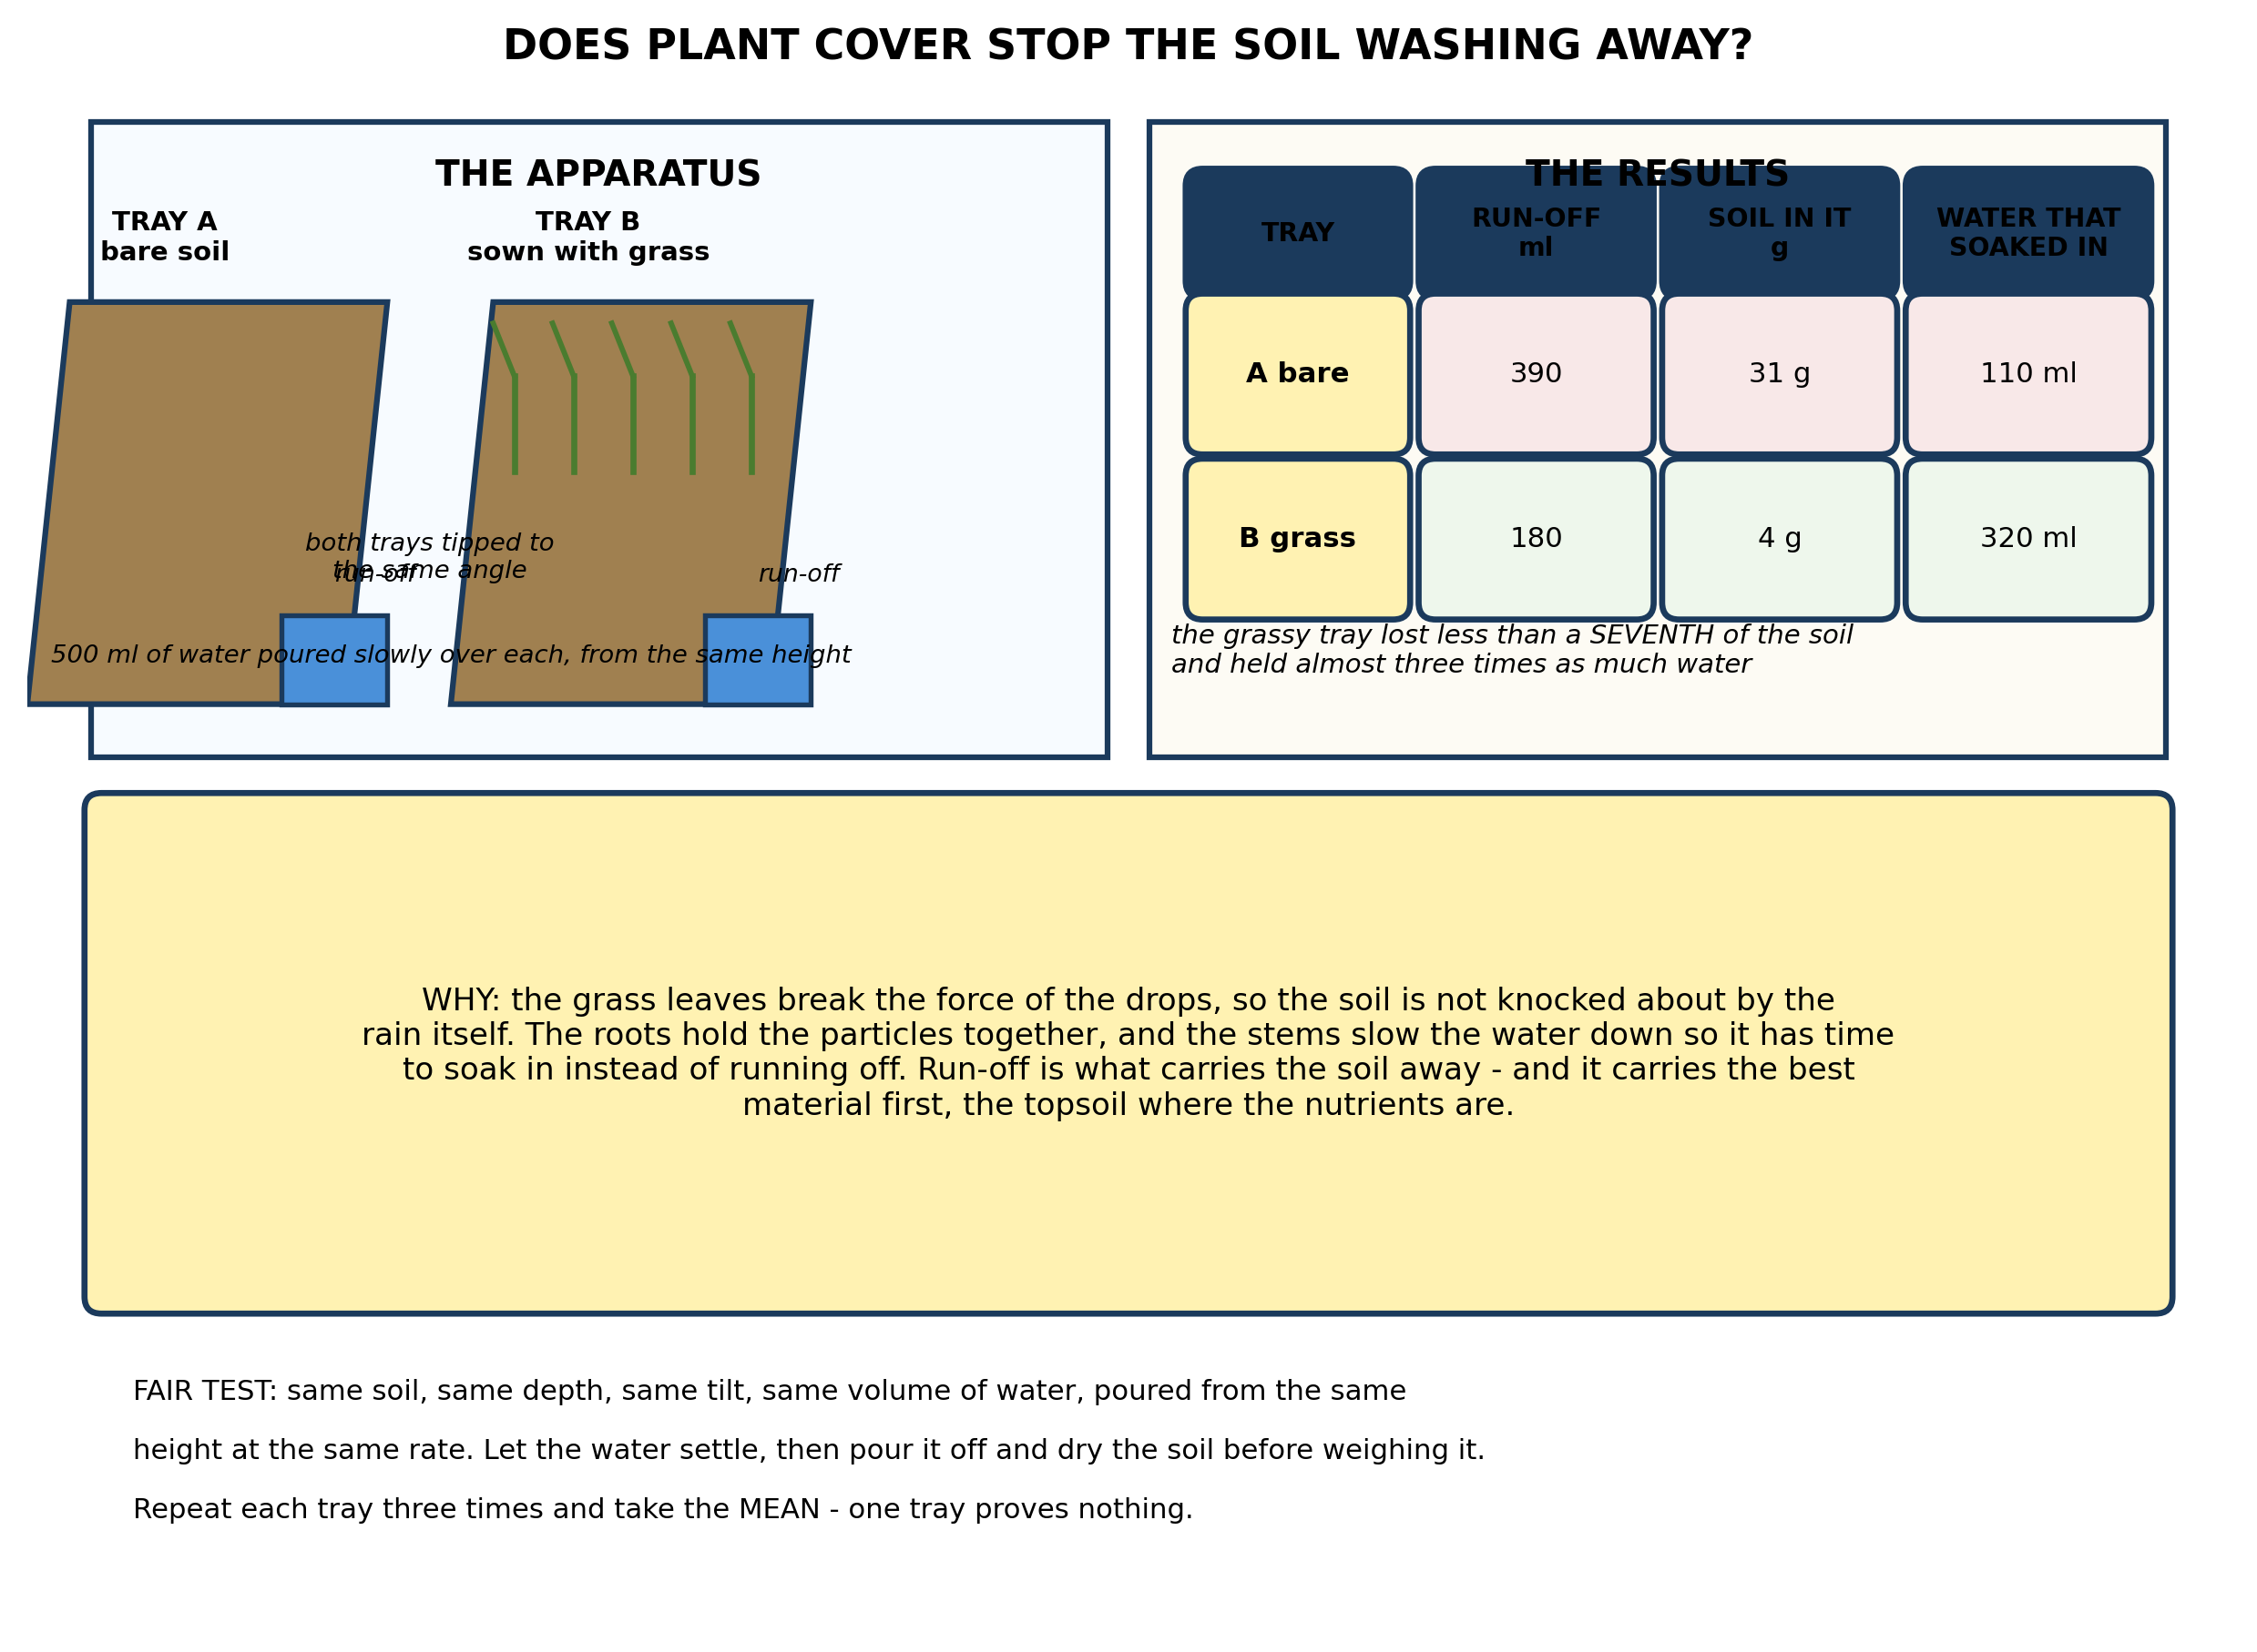
Fig. 6: Does plant cover stop the soil washing away?

13. From the results, explain why the grassy tray lost so much less soil and held so much more water, referring to what the grass actually does. [3 marks]
14. State THREE things the pupils must keep the same for this comparison to be fair, and explain why each matters. [3 marks]
15. Suggest ONE change to the method that would test something further, and say what you would expect to find and why. [3 marks]
____________________________________________________________________________________________

ANSWER KEY AND MARKING SCHEME
Accept any other correct and relevant answer. Award marks for correct points, not for repeating the question.
20.1 20.1 Landforms in Ghana: Plateau, Plain, Mountain and Valley
Q1
The biotic part is everything that is alive - plants, animals, fungi, bacteria. The abiotic part is the non-living surroundings: sunlight, water, soil, air, temperature, minerals. They are not separate boxes, because the living part depends on the non-living part absolutely. The plants need sunlight, water, carbon dioxide and minerals from the soil before they can make any food at all; the animals then depend on the plants; the decomposers depend on the dead remains; and when they rot it, the nutrients go back into the soil for the plants again. So change an abiotic factor and the whole living system moves. Take away the water and the plants stop growing, the animals that eat them starve or move away, and the decomposers run out of material. That is why an environment is described as a SYSTEM rather than a place - and why a change in something as ordinary as rainfall can empty a landscape of its animals.
Q2
Biotic, any three: plants, animals, fungi, bacteria. Abiotic, any three: sunlight, water, soil, air, temperature, minerals, rainfall.
Q3
Any two, each explained. The floodplain plants that depended on the annual flood for water and for the silt it deposited would die back or be replaced by species that can manage without it; the plant community changes, and with it the animals that fed on those plants. Fish that used the flooded margins as a nursery, or that spawned upstream, would lose those breeding grounds, so the fish population falls - and with it the fishermen and the birds that ate them. Animals that moved onto the plain in the dry season would lose the grazing. And the soil would no longer be refreshed with silt each year, so it becomes steadily less fertile.
20.2 20.2 Plants and Animals Found in Different Landforms
Q4
Because the gold is a small part of what gets disturbed. Getting at it means stripping the vegetation and the topsoil off the bank and washing enormous quantities of soil and gravel, so the soil structure, the seed bank and the soil life that took centuries to build are destroyed and the land is left unable to grow anything. All that disturbed soil ends up in the river, silting it, blocking the light and smothering the gravel beds where fish spawn - so the fish disappear and the fishermen downstream lose their living. And the mercury and cyanide used to separate the gold go into the water as well. Mercury does not wash away; it accumulates up the food chain, so it ends up concentrated in the fish that people eat. So the real cost is not the gold that was taken. It is a river that no longer supports fish, a bank that no longer supports crops, and a water supply that is no longer safe - and the people who pay are not the people who took the gold.
Q5
Any three: deforestation, bush burning, overfishing, bad farming (monocropping, ploughing down the slope, burning crop residue), mining or galamsey, pollution, overgrazing, draining wetlands.
20.3 20.3 How Animals Adapt to Different Landforms
Q6
Once the topsoil washes or blows away, the land grows less food, because the topsoil is where the nutrients and the organic matter are. A family getting a smaller harvest from a plot has to find the missing food somewhere, and the usual answer is to clear another piece of bush and plant more land. But the new plot has the same soil and the same slope, so it erodes in turn, and in a few years it too is exhausted - so the family clears more again. Each step is forced by the one before: less soil, less food, more land cleared, less soil. The circle tightens because the remedy the family can afford - more land - is the very thing that makes the problem worse, and it keeps going until there is no more land left to clear.
Q7
The trees were intercepting the rain on their leaves and slowing it, so it reached the ground gently; their roots were holding the soil together and opening channels in it, so much of the water soaked in instead of running off. Without them, the rain hits bare ground at full force, the surface seals and compacts, and the water runs straight off carrying soil with it. So instead of arriving gradually over days, the same rain arrives in the valley within hours - a flood. And the soil it carries fills the river bed and the drains, so the channel holds less and the next flood is worse still.
Q8
Any three, each stated. Loss of soil through erosion. Loss of biodiversity - species dying out. Rivers and streams drying up or silting. Flooding, because water runs off faster than it used to. Lower crop yields. Loss of fish stocks. Water that is no longer safe to drink.
20.4 20.4 How Plants Survive in Different Landforms
Q9
Any two, each explained by mechanism. Plant hedges, grass strips or trees along the contour - across the slope rather than down it - so that the stems slow the water running downhill and the roots bind the soil particles together; the water then has time to soak in instead of carrying the soil away. Plough and plant on the contour, making ridges across the slope, so each ridge acts as a small dam that catches the water and any soil it is carrying. Keep crop residue on the surface as a mulch instead of burning it, so that raindrops hit the residue rather than bare soil and the surface does not seal. Plant trees on the steepest land and farm only the gentler ground. Terrace the slope, so that each level is flat and the water cannot accelerate downhill.
Q10
The strip's roots bind the bank so that it does not collapse into the water, and its stems slow the water running off the field so that soil is filtered out and dropped before it reaches the river, rather than silting it. The vegetation also shades the water, keeping it cooler, and its leaves and insects feed the fish. For the farmer it holds his soil on his own land rather than washing it into the river, so his field stays fertile; it keeps the river channel clear, so it floods his land less often; and it gives him a crop of poles, fodder or fruit into the bargain.
20.5 20.5 Associations Among Plants and Animals
Q11
The capital is the stock itself - the forest, the breeding fish, the soil. The interest is what that stock produces each year without being reduced: the timber the forest puts on in a year, the surplus of young fish, the humus the soil rebuilds. Using the environment sustainably means taking the interest and leaving the capital intact, so that next year there is the same stock producing the same surplus, and the year after that, indefinitely. Using it unsustainably means eating into the capital: felling more trees than grow back, netting the young fish before they have spawned, cropping the soil year after year without putting anything back. That yields more today and nothing tomorrow. Sustainable does not mean doing without - it means arranging things so that the taking can go on.
Q12
Using the environment to meet our needs now without reducing its ability to meet the needs of people in future - in short, taking no more than is replaced. Any one example: cutting only mature trees and planting a seedling for each one felled. Or fishing with a net whose mesh lets the young fish through, so that the stock can breed. Or leaving a field fallow so that the soil recovers between crops.
PRACTICAL TASK
Q13
The bare tray lost 31 g of soil and the grassy tray only 4 g - less than a seventh - and the grassy tray soaked up 320 ml of water against 110 ml, nearly three times as much. The grass does three things. Its leaves intercept the water so that it does not strike the soil at full force and knock the particles about. Its roots bind the particles together so they cannot easily be lifted and carried. And its stems slow the water flowing down the slope, giving it time to soak in instead of running off. Run-off is what carries soil away, so slowing the water does both jobs at once: more water in the soil and less soil in the run-off. And the first soil to go is the topsoil, the layer with the nutrients in it - which is why erosion does far more damage than the mass of soil lost suggests.
Q14
Any three, each explained. The same soil, at the same depth and firmed down the same amount in both trays - otherwise one tray simply has more soil available to lose. Both trays at the same angle of tilt, so that gravity pulls the water down both at the same rate. The same volume of water, poured from the same height at the same rate, so that the force of the water is the same. The same size and shape of tray. And the soil collected must be dried before it is weighed, or the water clinging to it will be weighed as if it were soil.
Q15
Any one, tested and explained. Test steeper slopes: tip both trays at a greater angle, and expect both to lose more soil, because water moves faster down a steeper slope and carries more - which is why contour planting matters most on steep land. Test bare soil against soil covered with a mulch of dried grass rather than living plants: expect the mulch to give much of the protection, since it is the covering of the surface that breaks the force of the drops - which would show that leaving crop residue on the field is worth doing even before any roots have grown. Test a third tray with grass only a week old against the established one, to find out how quickly the protection develops.

BLUEPRINT / TEST SPECIFICATION
# | Content standard | Code | Items | Marks | % of Marks
20.1 | 20.1 Landforms in Ghana: Plateau, Plain, Mountain and Valley | B7/JHS1.5.5.1 | 3 | 10 | 20%
20.2 | 20.2 Plants and Animals Found in Different Landforms | B7/JHS1.5.5.1 | 2 | 7 | 14%
20.3 | 20.3 How Animals Adapt to Different Landforms | B7/JHS1.5.5.1 | 3 | 10 | 20%
20.4 | 20.4 How Plants Survive in Different Landforms | B7/JHS1.5.5.1 | 2 | 7 | 14%
20.5 | 20.5 Associations Among Plants and Animals | B7/JHS1.5.5.1 | 2 | 7 | 14%
20.1 | Practical task | B7/JHS1.5.5.1 | 3 | 9 | 18%
TOTAL | - | - | 15 | 50 | 100%
Distribution by cognitive level
Cognitive level | Marks | % of Marks
Understand | 12 | 24%
Apply | 19 | 38%
Analyse | 19 | 38%
TOTAL | 50 | 100%
Distribution by difficulty
Difficulty | Marks | % of Marks
Easy | 3 | 6%
Moderate | 28 | 56%
Challenging | 19 | 38%
TOTAL | 50 | 100%

QUALITY-CONTROL SUMMARY
1. Is every question answered from a diagram?
Yes. All 15 questions sit under a figure, and each is unanswerable - or at least materially harder - without reading it. Questions 3, 8, 10 and 17 ask pupils to go beyond the diagram, but each still starts from something the figure shows.
2. Is the content within the Basic 7 curriculum?
Yes. Every question traces to the content standards for this sub-strand (B7/JHS1.5.5.1), and nothing is tested beyond the depth the Basic 7 syllabus sets for it.
3. Are the diagrams clear and unambiguous?
Yes. Each is drawn so that only one reading is sensible: the particle boxes differ in spacing alone, the syringes are labelled with how far each squashes, and the periodic table marks the regions in words as well as by position.
4. Is the level right for JHS 1?
Yes. Questions ask pupils to read, describe and explain what is drawn. Only Question 17 asks for an inference beyond the figure, and it is worth 3 of the 40 marks.
5. Do the marks add up?
Yes: 15 questions totalling 50 marks, matching the figure on the front page. The blueprint, cognitive and difficulty tables all sum to the same total.
6. Are the answers correct and complete?
Yes. Each answer states the point the question is worth, with the acceptable alternatives given where a question is open.
EXAMINER NOTES (for the teacher, not for candidates)
- Pitched at the compulsory diagram question of BECE Paper 2: 76% of the marks are at Apply level or above and 38% are Challenging.
- Q4 on galamsey is the paper's most important question, and in much of Ghana it is not an abstraction. The point to draw out is that the gold is a small part of what gets disturbed: the soil, the river and the mercury are the real cost, and the people who pay are downstream of the people who profited.
- Q6 on the erosion circle is the one that pupils find genuinely uncomfortable, and worth spending time on. Poor farmers clear more bush not because they are careless but because they have no alternative - and clearing more bush is what makes the problem worse. It is a circle, and the honest answer is that the family cannot break it alone.
- Q11 on capital and interest is the clearest way I know to teach sustainability. Take the interest, leave the capital. It also settles the argument that sustainability means doing without: it does not, it means arranging the taking so it can continue.
- The erosion practical needs two trays or wooden boxes with a lip at the lower end, the same soil in both, a measuring cylinder, and something to catch the run-off. Grass seed needs sowing two or three weeks beforehand, so plan ahead - or use a square of turf lifted intact, which works just as well and needs no notice.
- The soil in the run-off must be dried before weighing, or you weigh water with it. Filtering through filter paper and leaving it overnight, or drying it in an oven if you have one, both work.
- If you cannot get turf or seed, the mulch variant in Q15 is easier: scatter dried grass over the bare tray. It still shows most of the effect, because most of the protection comes from covering the surface.

