[SCHOOL NAME]
INTEGRATED SCIENCE (SCIENCE)
PRACTICAL QUESTIONS - DIAGRAM MODE
Agricultural Tools and Machinery (15.1 - 15.4)
____________________________________________________________________________________________
CLASS: Basic 7 (JHS 1)
TIME: 1 hour 30 minutes
MARKS: 50 2025/2026 Academic Year
____________________________________________________________________________________________
INSTRUCTIONS TO CANDIDATES
1. Answer ALL the questions in this paper.
2. Every question is based on a diagram. Study each diagram carefully before you answer the questions that follow it.
3. Write your answers in the spaces provided. The marks for each question are printed beside it.
4. Where a question asks for a stated number of points, give that number. Any extra answers will not be marked.
5. You may refer back to any diagram at any time.
____________________________________________________________________________________________
SECTION A - DIAGRAM STUDY
Study each diagram and answer the questions that follow it.
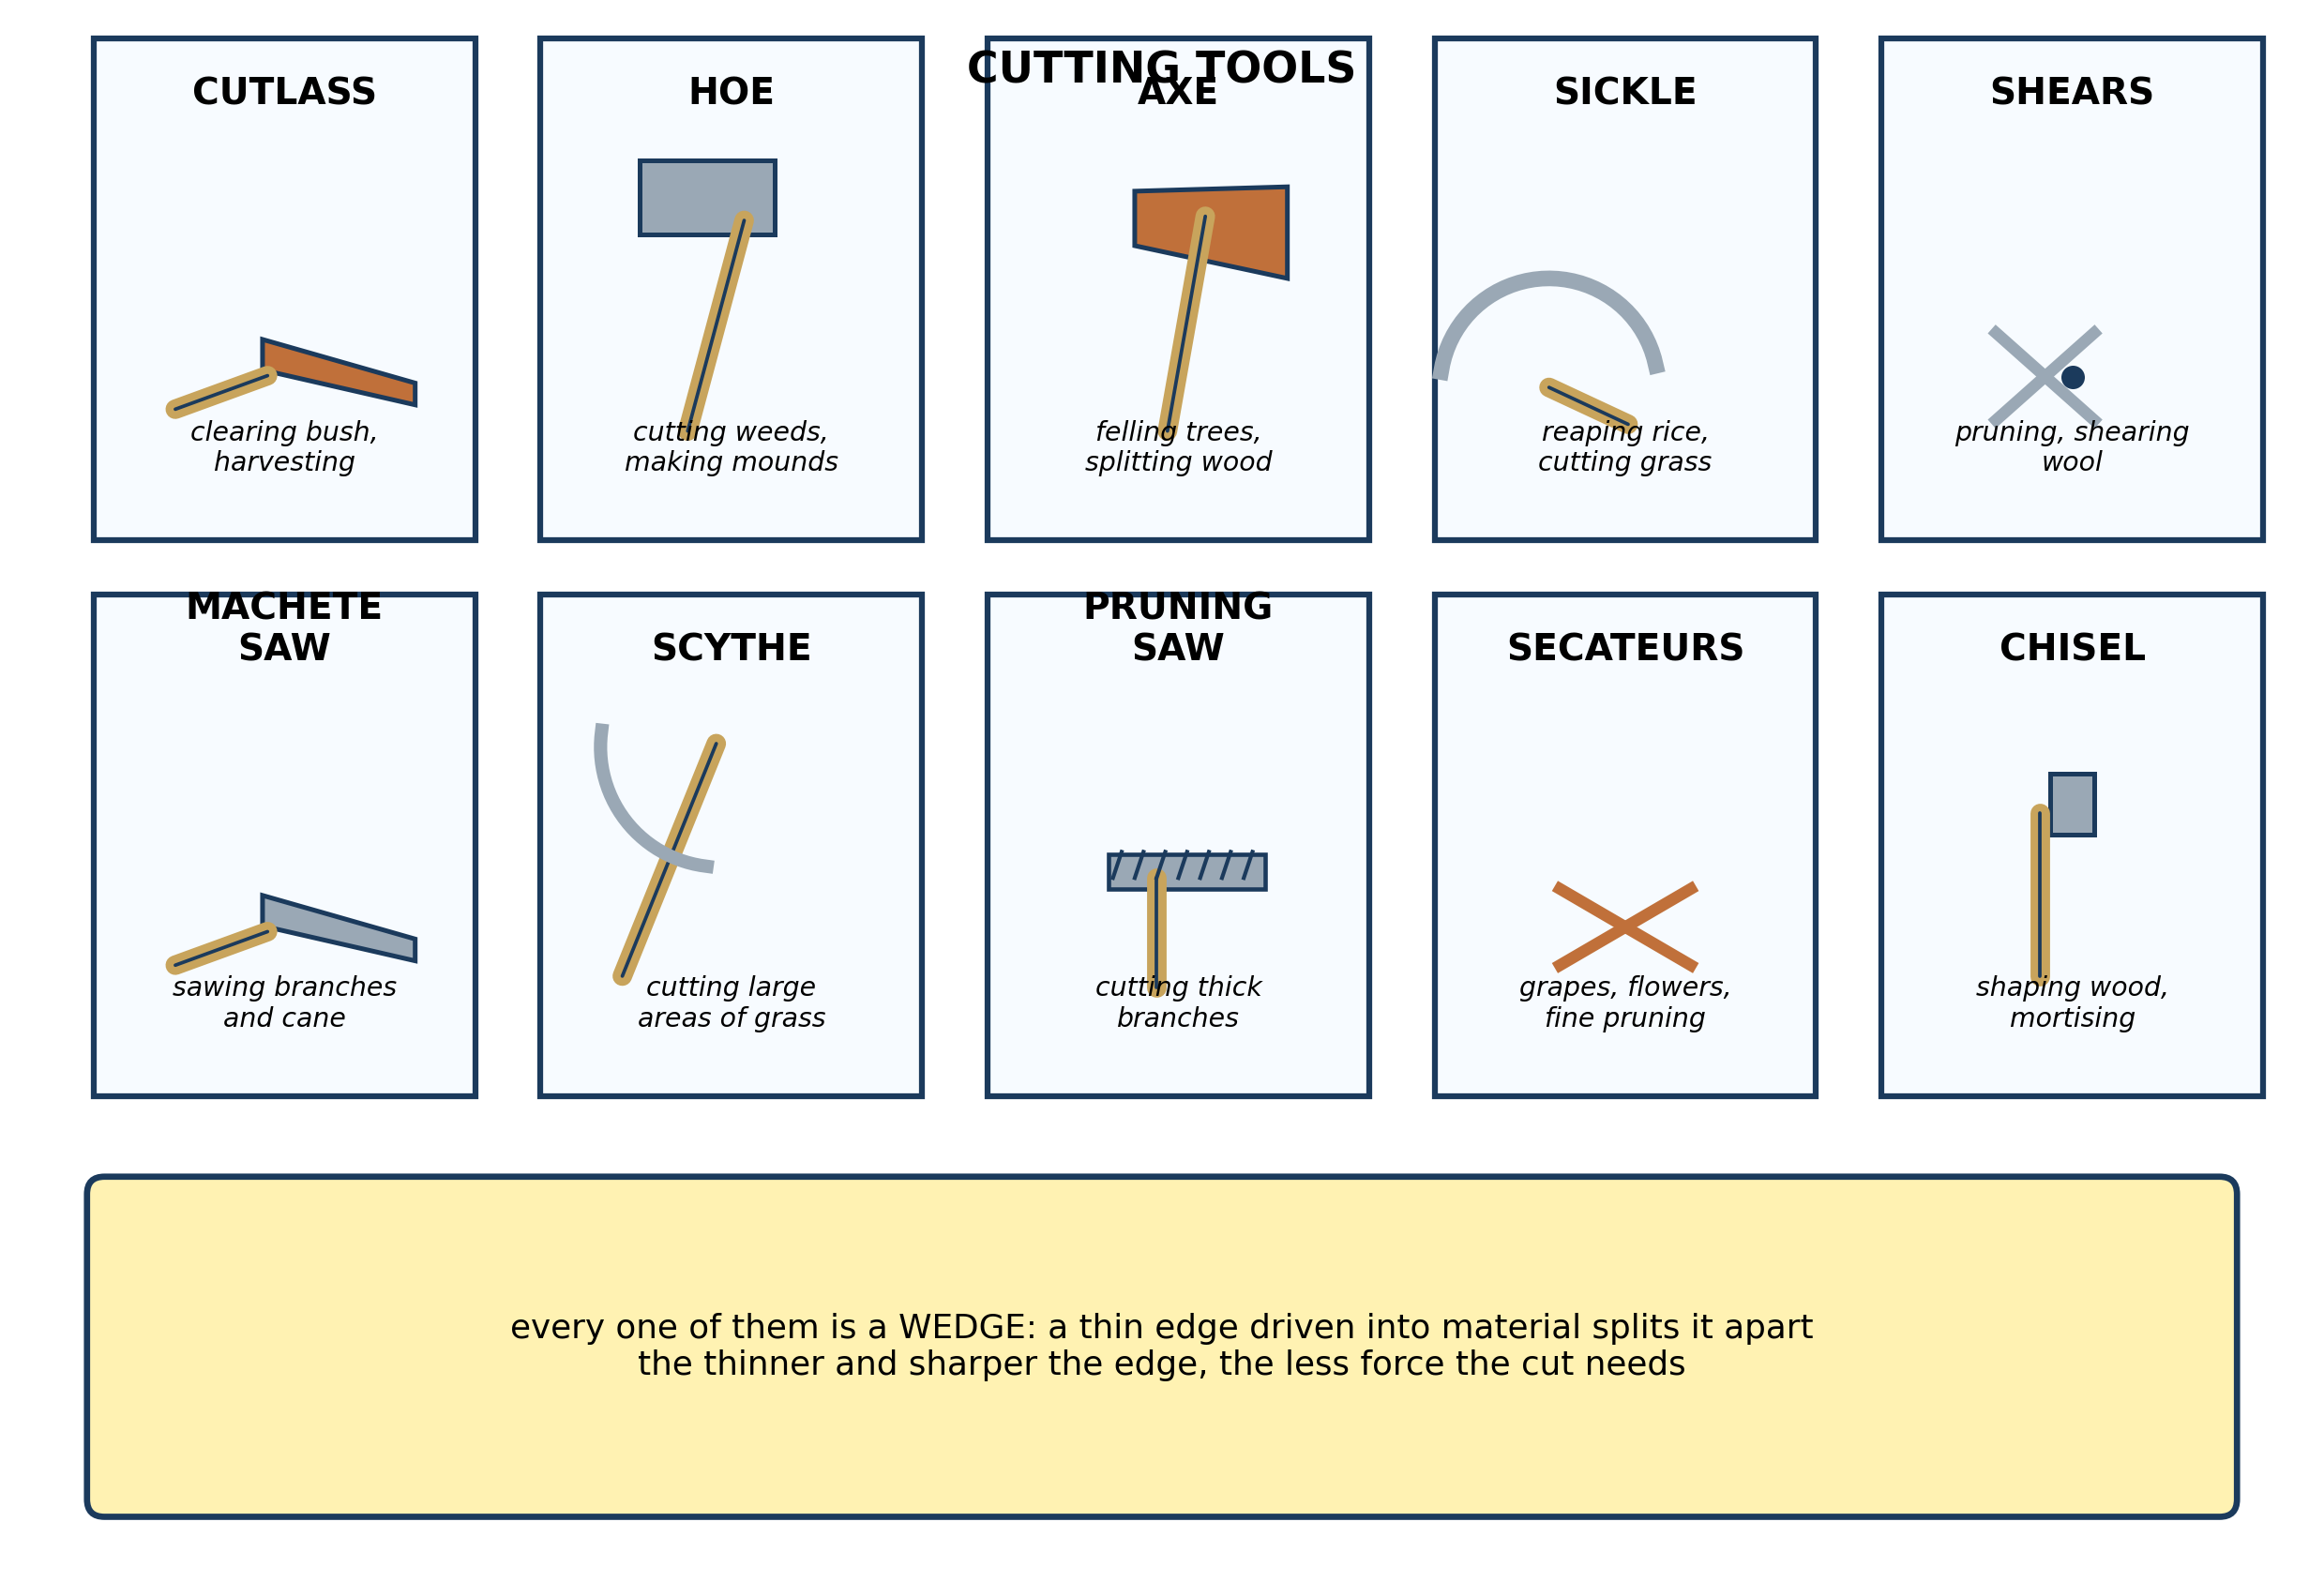
Fig. 1: Cutting tools

15.1 15.1 Basic and Simple Agricultural Tools
1. Every cutting tool in Fig. 1 is a WEDGE. Explain what this means, and use it to explain why a cutlass with a thin blade cuts through a stem more easily than one with a thick blade. [4 marks]
2. Name any THREE cutting tools shown in the diagram. [3 marks]
3. For each job, name the most suitable cutting tool and give a reason for your choice: (a) clearing thick bush before planting; (b) reaping a field of rice by hand; (c) trimming a hedge into shape. [3 marks]
____________________________________________________________________________________________
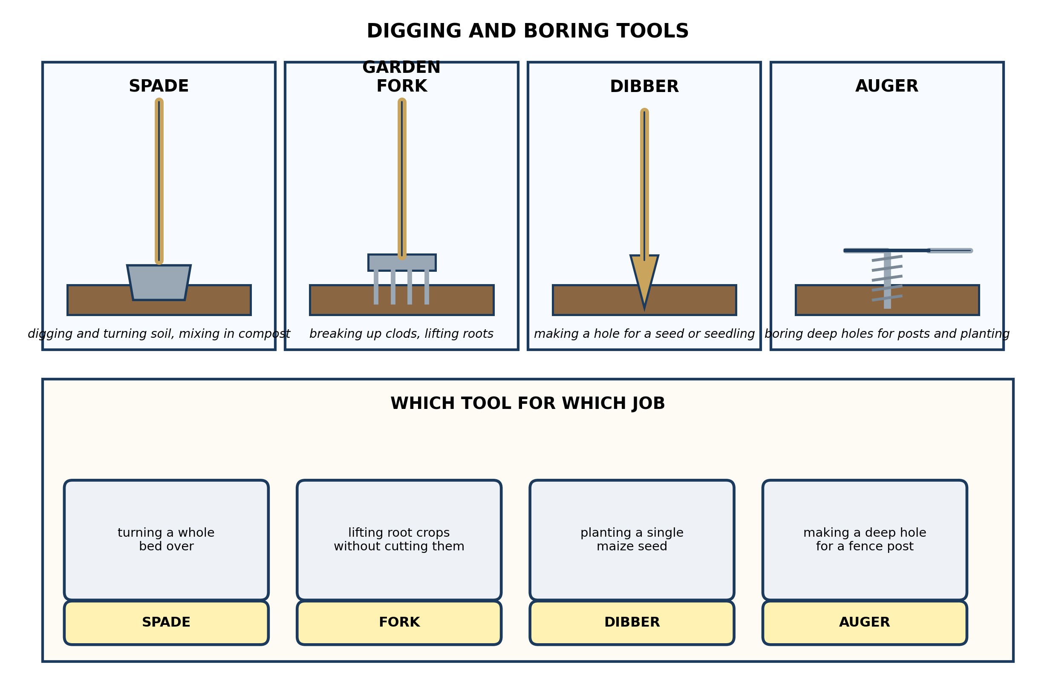
Fig. 2: Digging and boring tools

15.2 15.2 Importance of Proper Handling and Maintenance of Agricultural Tools
4. Explain why a GARDEN FORK is better than a SPADE for lifting root crops such as cassava or yam, and explain why a spade is better than a fork for turning a bed over. [4 marks]
5. State the use of a DIBBER and the use of an AUGER. [3 marks]
6. A farmer wants to plant maize on a plot where the soil is hard and dry. Suggest which digging tool he should use to open the holes, and explain why a DIBBER would not do. [3 marks]
____________________________________________________________________________________________
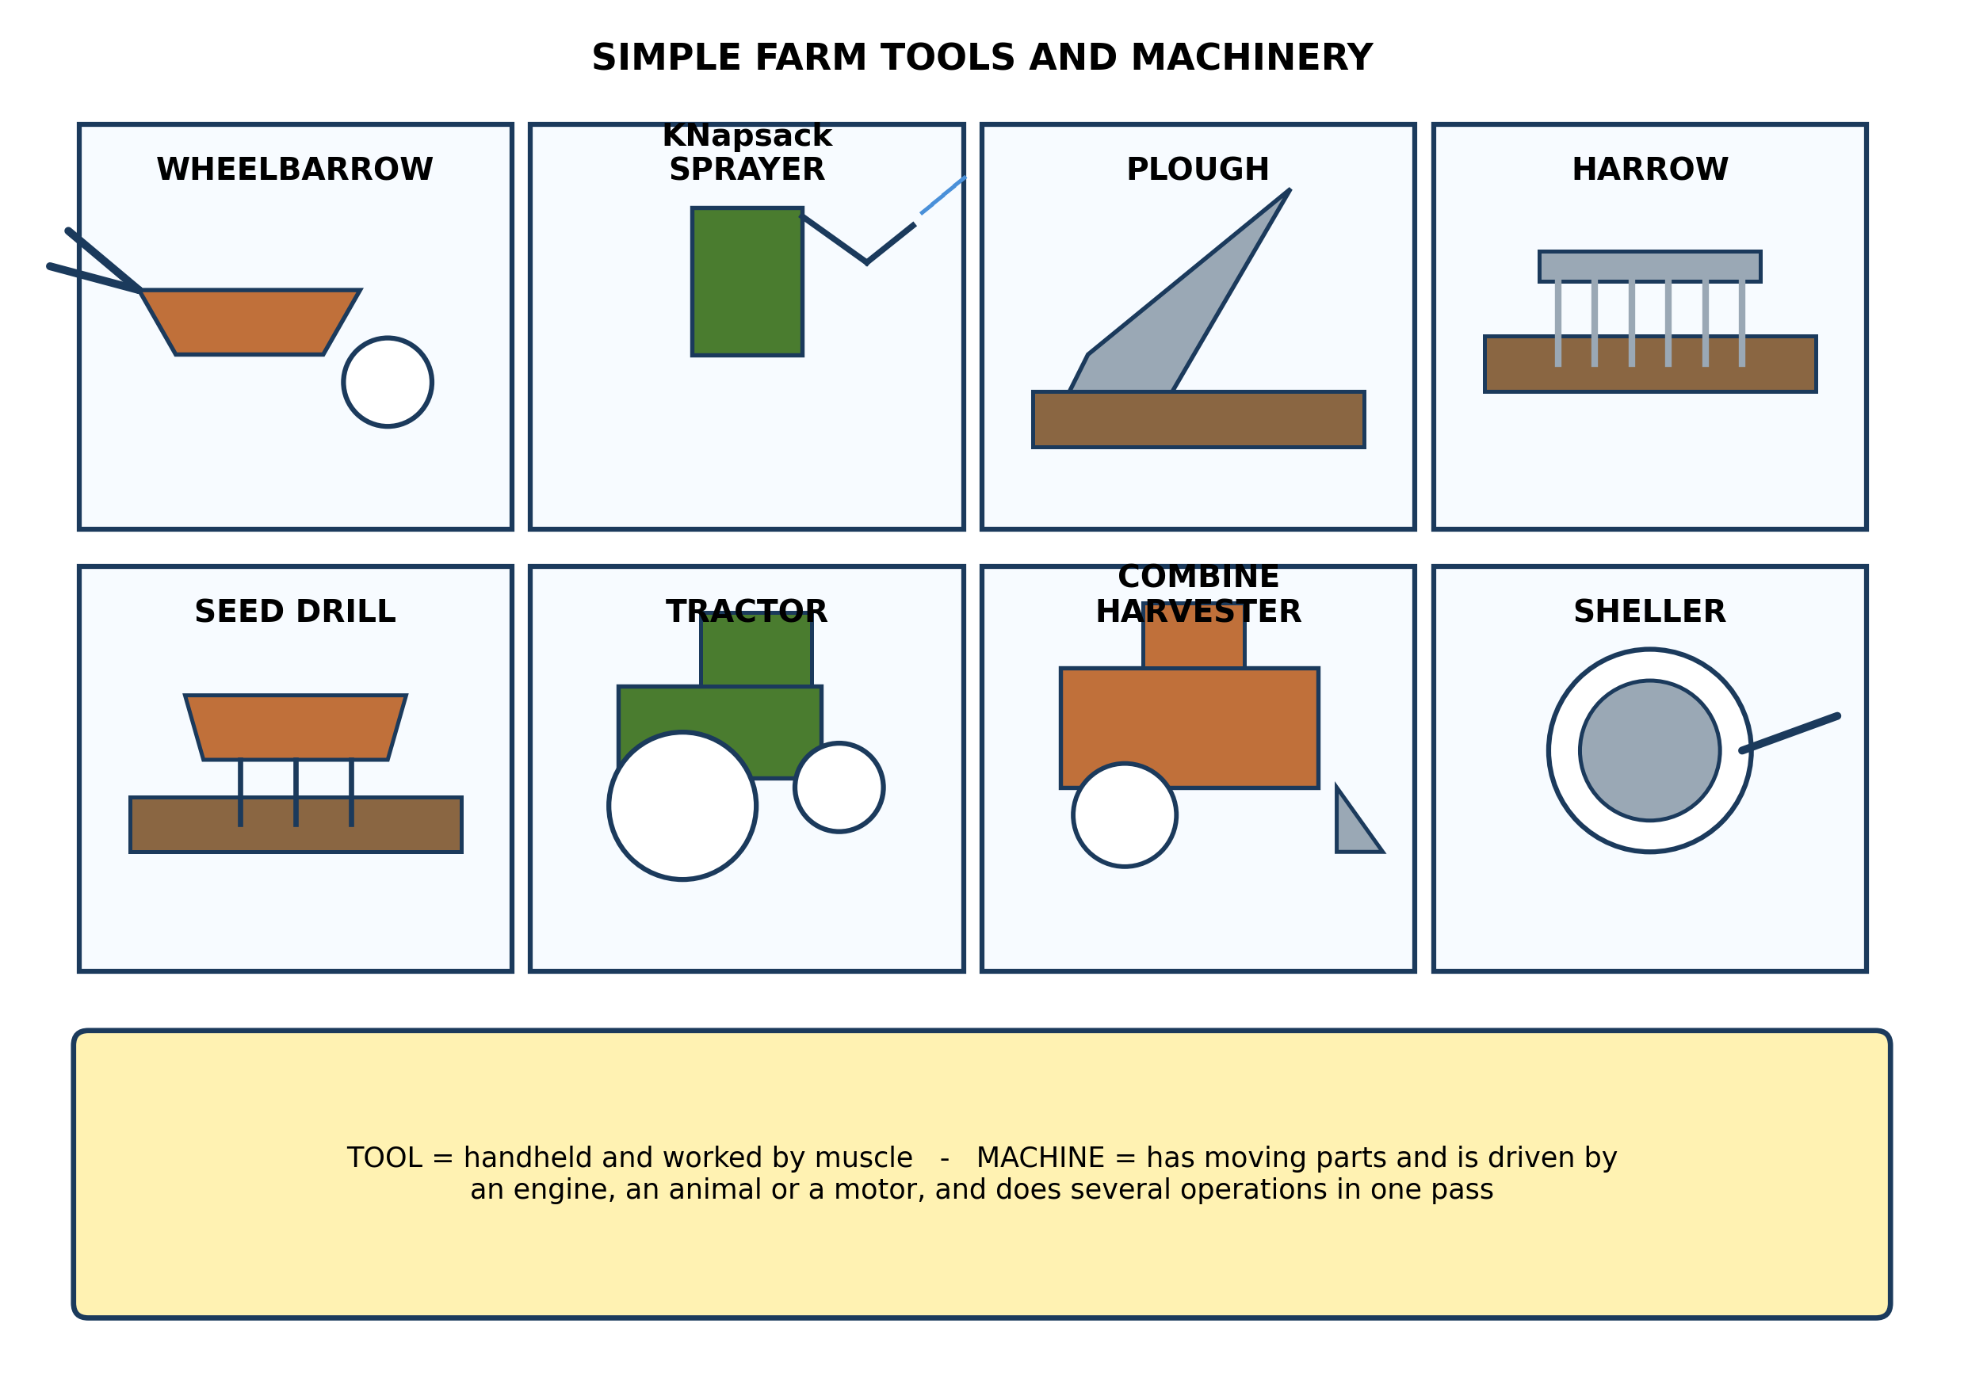
Fig. 3: Simple farm tools and machinery

15.3 15.3 Rules for Handling Agricultural Tools Safely
7. The diagram separates TOOLS from MACHINES. Explain the difference, and say which of the following are tools and which are machines, giving a reason each time: a hoe, a knapsack sprayer, a tractor-drawn plough, a combine harvester. [4 marks]
8. Give TWO reasons why a farmer might use a tractor-drawn plough rather than a hand hoe. [3 marks]
9. Suggest which item from Fig. 3 a farmer should use for each of the following, and give a reason each time: (a) moving a heap of compost to the far end of the field; (b) applying weedkiller to a maize field; (c) harvesting and threshing a large area of rice. [3 marks]
____________________________________________________________________________________________
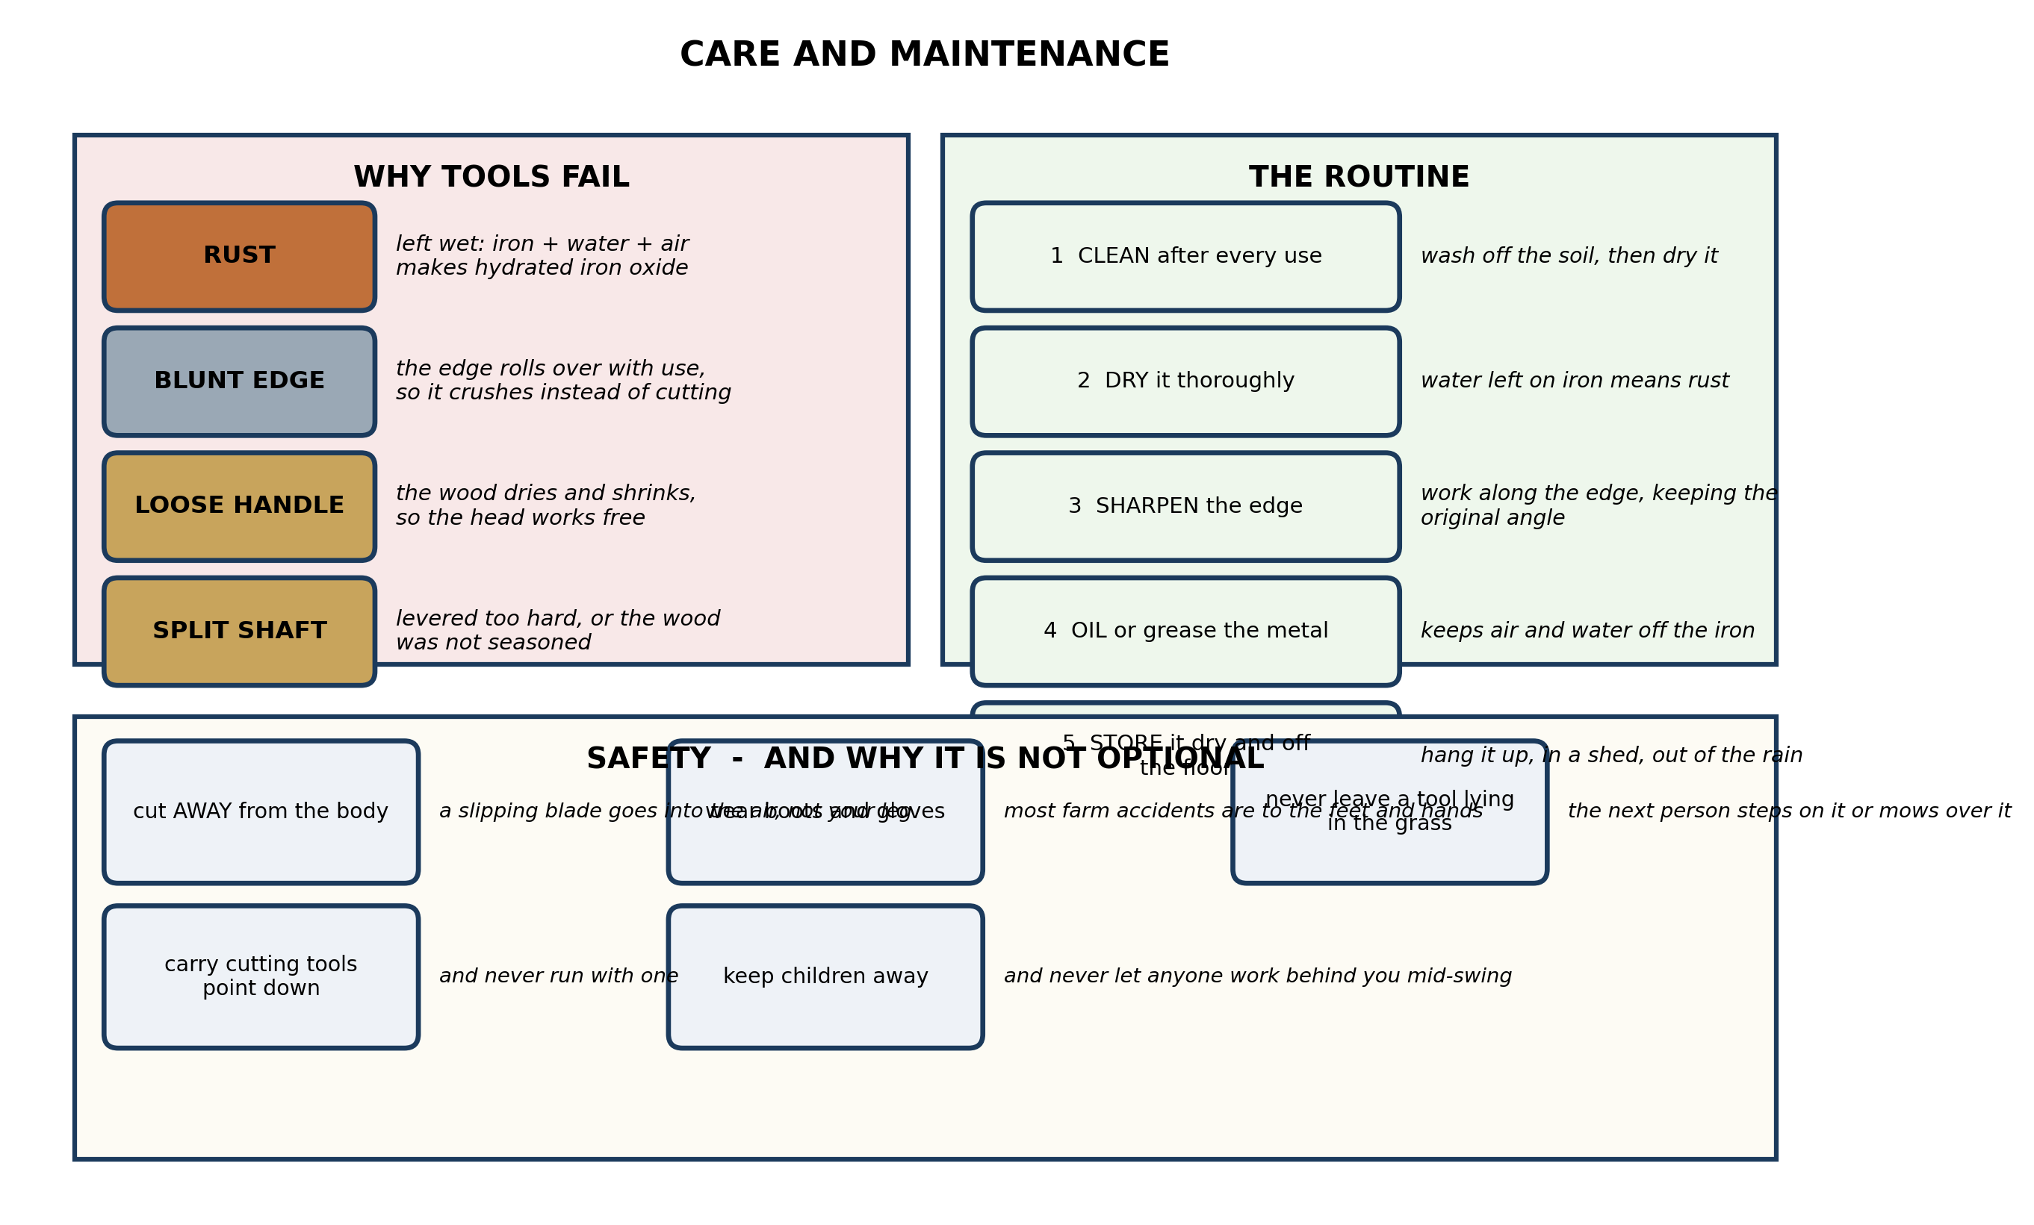
Fig. 4: Care and maintenance

15.4 15.4 Maintaining Agricultural Tools in the Community
10. Explain why iron tools rust, and explain why BOTH drying and oiling are needed rather than just one of them. [4 marks]
11. State THREE things that should be done to a hand tool after use. [3 marks]
12. The head of a cutlass is loose and is likely to come off. Describe what should be done about it, and explain why working with it in that state is dangerous. [3 marks]
____________________________________________________________________________________________
SECTION B - PRACTICAL TASK
Study the apparatus and answer the questions that follow it.
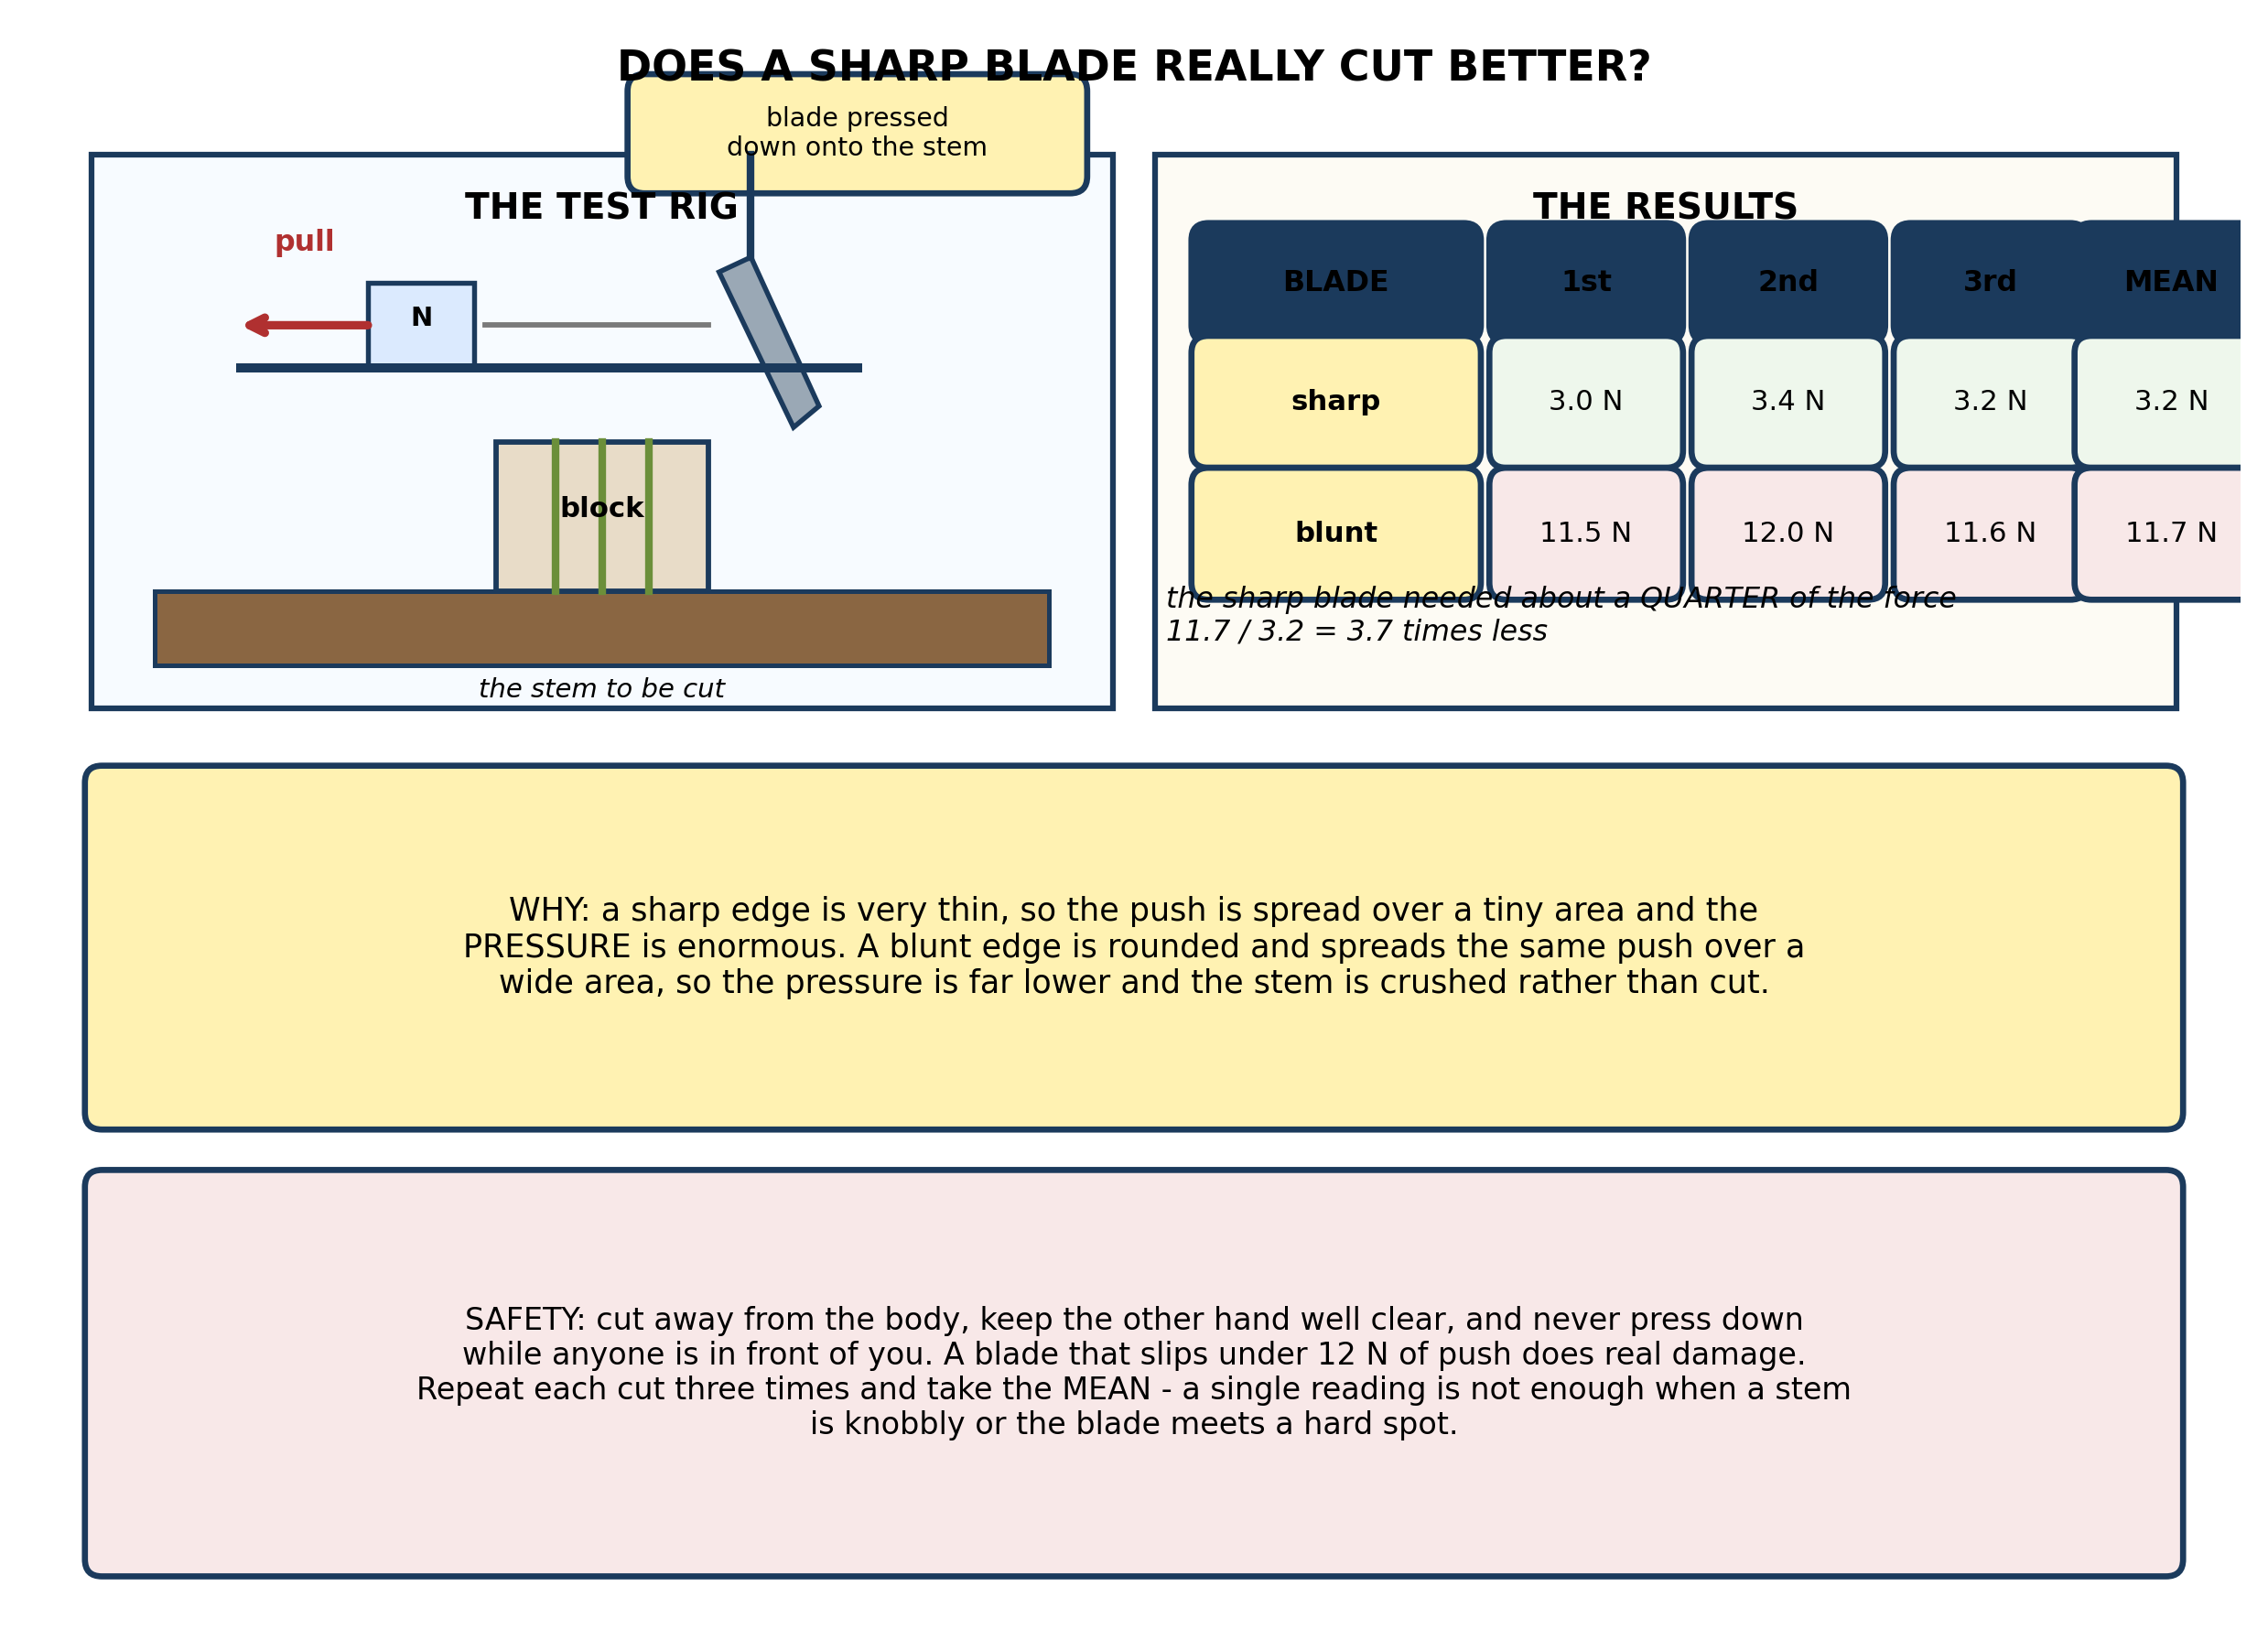
Fig. 5: Does a sharp blade really cut better?

13. Use the results to explain why the SHARP blade needed so much less force, referring to PRESSURE. [4 marks]
14. Explain why each cut was repeated THREE times and a mean taken, and suggest ONE other thing the pupils must keep the same for the comparison to be fair. [3 marks]
15. Suggest TWO safety precautions the pupils must take, and explain what accident each one prevents. [3 marks]
____________________________________________________________________________________________

ANSWER KEY AND MARKING SCHEME
Accept any other correct and relevant answer. Award marks for correct points, not for repeating the question.
15.1 15.1 Basic and Simple Agricultural Tools
Q1
A wedge is two sloping faces meeting at a thin edge, and a cutting tool works by driving that thin edge into the material so that the sloping faces force the material apart sideways. What actually does the cutting is PRESSURE - the push divided by the area it acts on. A thin blade puts the same push onto a very small area of contact, so the pressure at the edge is enormous, high enough to part the fibres cleanly. A thick blade spreads the same push over a much wider area, the pressure is far lower, and the blade crushes and tears instead of cutting - so more force is needed and the cut is ragged. That is exactly why sharpening works: it grinds metal away from behind the edge and makes the contact area small again.
Q2
Any three of: cutlass, hoe, axe, sickle, shears, machete saw, scythe, pruning saw, secateurs, chisel.
Q3
(a) A cutlass (or machete). It has a long heavy blade that will take down woody growth, and it is long enough to use without stooping. (b) A sickle. Its curved blade lets you gather a handful of stems and cut them with one pull, which is far faster than cutting them one at a time. (c) Shears for a long run of hedge, or secateurs for individual stems. Both give a clean cut that does not crush the stem, which matters because a crushed stem is left open to disease - a cutlass would bruise it.
15.2 15.2 Importance of Proper Handling and Maintenance of Agricultural Tools
Q4
For lifting root crops: a fork has separate tines with gaps between them, so it slides down into the soil around the roots and lifts them out with the soil falling away between the tines. The roots pass between the tines rather than being cut, so the crop comes up whole and undamaged - which matters because a cut tuber rots in storage. A spade has a solid blade that will slice straight through any root in its path. For turning a bed over, the solid blade is exactly what is wanted: it lifts a whole slice of soil and turns it over, burying weeds and working compost in thoroughly. A fork would let most of the soil dribble straight back through the gaps and would leave the bed half turned.
Q5
A dibber is a pointed stick or rod used to make a small hole at the right depth for a single seed or a seedling. An auger is a screw-shaped boring tool used to make deep, wide holes - for fence posts, or for planting trees and cassava cuttings - and it brings the loosened soil up as it turns.
Q6
He should use a hoe, or an auger if he has one. A dibber is only a pointed stick pushed in by hand; in hard dry ground it simply cannot be forced deep enough, and forcing it either bends the point or drives the seed too deep to come up. A hoe has a steel blade on a long handle, so the farmer can use leverage and his own weight to break the crust first and then open a proper hole, and an auger is designed precisely to bore into ground that a stick will not enter.
15.3 15.3 Rules for Handling Agricultural Tools Safely
Q7
A tool is handheld, has no moving parts of its own, and is worked directly by the user's muscles. A machine has moving parts and is driven by something other than the user's hands - an engine, a motor or a draught animal - and it usually does several operations in one pass. Hoe: a tool - one solid implement with no moving parts, worked entirely by the arms. Knapsack sprayer: a machine - it has a pump, a hose and a nozzle, moving parts that pressurise the liquid and break it into a spray; the user only works the pump. Tractor-drawn plough: a machine - the share and the mouldboard do the work and it is pulled by an engine rather than pushed by a person. Combine harvester: a machine, and the clearest case - an engine drives many moving parts and it reaps, threshes and cleans the grain in a single operation.
Q8
Any two, each stated. It works far faster and covers a much larger area in a day, which matters where the land has to be prepared within a short planting window. It turns the soil deeper and more thoroughly, bringing fresh soil to the top and burying weeds properly. It needs far less human labour, which matters where labour is scarce or expensive, or where the household is small.
Q9
(a) A wheelbarrow. It carries a heavy load with the weight taken by the wheel, so one person can move far more than they could carry in their arms, and it tips out exactly where it is wanted. (b) A knapsack sprayer. It carries the chemical on the back and pumps it out as a fine spray, so the crop is covered evenly and far less chemical is used than if it were watered on. (c) A combine harvester. It cuts, threshes and cleans the grain in one pass, a job that would take many people many days by hand.
15.4 15.4 Maintaining Agricultural Tools in the Community
Q10
Rusting is the reaction of iron with oxygen and water together - it needs both, and it will not happen in dry air, nor in water with no air dissolved in it. A hoe left with wet soil stuck to it therefore has everything the reaction needs: iron, water from the soil, and air all around it. The surface turns to hydrated iron oxide, which flakes away and exposes fresh metal underneath. Drying removes the water, so the reaction cannot start. Oiling then lays a barrier over the metal so that air, and any water that later reaches it, cannot touch the iron. Drying alone does not last, because damp air and dew will wet the tool again as soon as it is put away. Oiling alone does not work on a tool that is already wet, because the water is trapped underneath the film. So it is: dry first, then oil, then store dry.
Q11
Any three, each stated. Wash or wipe off the soil and plant sap. Dry it thoroughly. Sharpen the edge, if it is a cutting tool, working along the edge and keeping the original angle. Oil or grease the metal parts. Check that the handle is tight and not split. Store it hanging up in a dry shed rather than left on the ground.
Q12
The head should be re-seated: driven back on firmly, with the handle replaced if the wood has shrunk or split, and a wedge or a nail driven in to hold it tight. Working with a loose head is dangerous because the blade can fly off the handle in the middle of a swing. A cutlass head is heavy, sharp and travelling fast at the instant it comes free, so it can strike the user or anyone working nearby. This is the commonest avoidable accident with hand tools on the farm, and the check takes a few seconds.
PRACTICAL TASK
Q13
Pressure is the push divided by the area it acts on. A sharp edge is extremely thin, so the whole push is concentrated onto a line of contact only a tiny fraction of a millimetre wide; the pressure there is enormous, high enough to part the fibres of the stem cleanly with very little effort. A blunt edge is rounded, so the same push is spread over a much wider area, the pressure is far lower, and the blade crushes and tears rather than cutting - which takes far more force. The results show exactly that: the sharp blade cut with a mean of 3.2 N against 11.7 N for the blunt one, about 3.7 times less. Sharpening works precisely because it grinds metal away from behind the edge and makes that contact area small again.
Q14
Repeating and averaging guards against the fact that individual stems differ - one may be knobbly, woody, damp or dry - and against slips in reading the balance. A single reading may be high or low for a reason that has nothing to do with which blade was used; the mean of three is far more likely to reflect the blade. What must be kept the same: the same kind of stem, of the same thickness, cut at the same point along it, for both blades; and the same angle of blade to stem. Ideally the same person should do every cut, pressing at the same steady rate.
Q15
Any two, each explained. Cut away from the body and keep the other hand well clear, so that if the blade slips it travels into empty air rather than into a hand or a leg. Never press down while anyone is standing in front of or beside the rig: under 12 N of push a slipping blade travels a long way and fast. Rest the stem on a firm block instead of holding it in the hand, so the blade cannot reach the fingers. Wear closed shoes in case the blade or the block is dropped.

BLUEPRINT / TEST SPECIFICATION
# | Content standard | Code | Items | Marks | % of Marks
15.1 | 15.1 Basic and Simple Agricultural Tools | B7/JHS1.4.5.1 | 3 | 10 | 20%
15.2 | 15.2 Importance of Proper Handling and Maintenance of Agricultural Tools | B7/JHS1.4.5.1 | 3 | 10 | 20%
15.3 | 15.3 Rules for Handling Agricultural Tools Safely | B7/JHS1.4.5.1 | 3 | 10 | 20%
15.4 | 15.4 Maintaining Agricultural Tools in the Community | B7/JHS1.4.5.1 | 3 | 10 | 20%
15.1 | Practical task | B7/JHS1.4.5.1 | 3 | 10 | 20%
TOTAL | - | - | 15 | 50 | 100%
Distribution by cognitive level
Cognitive level | Marks | % of Marks
Understand | 12 | 24%
Apply | 22 | 44%
Analyse | 16 | 32%
TOTAL | 50 | 100%
Distribution by difficulty
Difficulty | Marks | % of Marks
Easy | 3 | 6%
Moderate | 27 | 54%
Challenging | 20 | 40%
TOTAL | 50 | 100%

QUALITY-CONTROL SUMMARY
1. Is every question answered from a diagram?
Yes. All 15 questions sit under a figure, and each is unanswerable - or at least materially harder - without reading it. Questions 3, 8, 10 and 17 ask pupils to go beyond the diagram, but each still starts from something the figure shows.
2. Is the content within the Basic 7 curriculum?
Yes. Every question traces to the content standards for this sub-strand (B7/JHS1.4.5.1), and nothing is tested beyond the depth the Basic 7 syllabus sets for it.
3. Are the diagrams clear and unambiguous?
Yes. Each is drawn so that only one reading is sensible: the particle boxes differ in spacing alone, the syringes are labelled with how far each squashes, and the periodic table marks the regions in words as well as by position.
4. Is the level right for JHS 1?
Yes. Questions ask pupils to read, describe and explain what is drawn. Only Question 17 asks for an inference beyond the figure, and it is worth 3 of the 40 marks.
5. Do the marks add up?
Yes: 15 questions totalling 50 marks, matching the figure on the front page. The blueprint, cognitive and difficulty tables all sum to the same total.
6. Are the answers correct and complete?
Yes. Each answer states the point the question is worth, with the acceptable alternatives given where a question is open.
EXAMINER NOTES (for the teacher, not for candidates)
- Pitched at the compulsory diagram question of BECE Paper 2: 76% of the marks are at Apply level or above and 40% are Challenging.
- Q1 is the question that turns 15.1 from a naming exercise into science. Every cutting tool is a wedge, and what does the work is pressure - force over area. Pupils who can say 'the sharp edge concentrates the force onto a tiny area' have understood the whole set of tools; pupils who can only list them have not. Q13 in the practical asks the same thing with numbers attached.
- Q4 on fork versus spade is the best application question here, because the answer reverses: the gaps that make a fork useless for turning a bed are exactly what make it right for lifting tubers. Look for pupils who notice that the property is the same in both cases and the job is what changes.
- Q7 on tools versus machines runs into the wheelbarrow, which is genuinely awkward - it has a wheel but no engine and does nothing by itself. I left it out of the question for that reason, but a sharp pupil may raise it; the honest answer is that it is a compound tool that uses a wheel and lever, not a machine in the sense used here.
- Q10 on rust is worth doing properly. Pupils know 'iron rusts when wet' but not that it needs oxygen AND water together, and that is why drying alone does not hold and oiling a wet tool does nothing. The five-step routine then makes sense instead of being a list to memorise.
- The cutting experiment needs a rigid frame, a spring balance reading to 0.1 N, and a blade that can be changed. Use a fresh green stem such as a cassava or hibiscus cutting of a consistent thickness, and cut several to the same gauge beforehand. Twelve newtons will overload a 10 N balance, so use a 20 N or 50 N one for the blunt blade.
- The blunt blade should be genuinely blunt - rub the edge on a stone, or use an old knife. Do not let pupils use a razor-sharp blade for this; a sharp enough edge to give 3 N will cut fingers before anyone notices.

