[SCHOOL NAME]
INTEGRATED SCIENCE (SCIENCE)
PRACTICAL QUESTIONS - DIAGRAM MODE
Animal Production (6.1 - 6.5)
____________________________________________________________________________________________
CLASS: Basic 7 (JHS 1)
TIME: 1 hour 30 minutes
MARKS: 50 2025/2026 Academic Year
____________________________________________________________________________________________
INSTRUCTIONS TO CANDIDATES
1. Answer ALL the questions in this paper.
2. Every question is based on a diagram. Study each diagram carefully before you answer the questions that follow it.
3. Write your answers in the spaces provided. The marks for each question are printed beside it.
4. Where a question asks for a stated number of points, give that number. Any extra answers will not be marked.
5. You may refer back to any diagram at any time.
____________________________________________________________________________________________
SECTION A - DIAGRAM STUDY
Study each diagram and answer the questions that follow it.
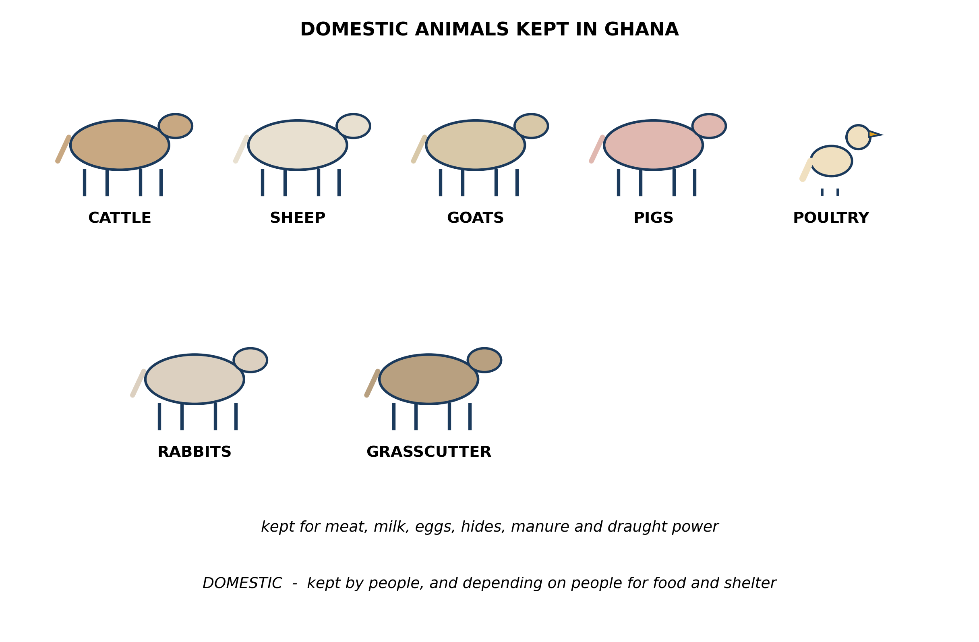
Fig. 1: Domestic animals kept in Ghana

6.1 6.1 Types of Domestic Animals in Ghana
1. The diagram calls all these animals DOMESTIC. Explain what makes an animal domestic, and use your answer to explain why a grasscutter kept in a cage is domestic while one living wild in the bush is not. [4 marks]
2. From the diagram, state TWO ways in which POULTRY differ from the other animals shown. [3 marks]
3. From the diagram, name TWO animals kept mainly for MILK and TWO kept mainly for MEAT. [2 marks]
____________________________________________________________________________________________
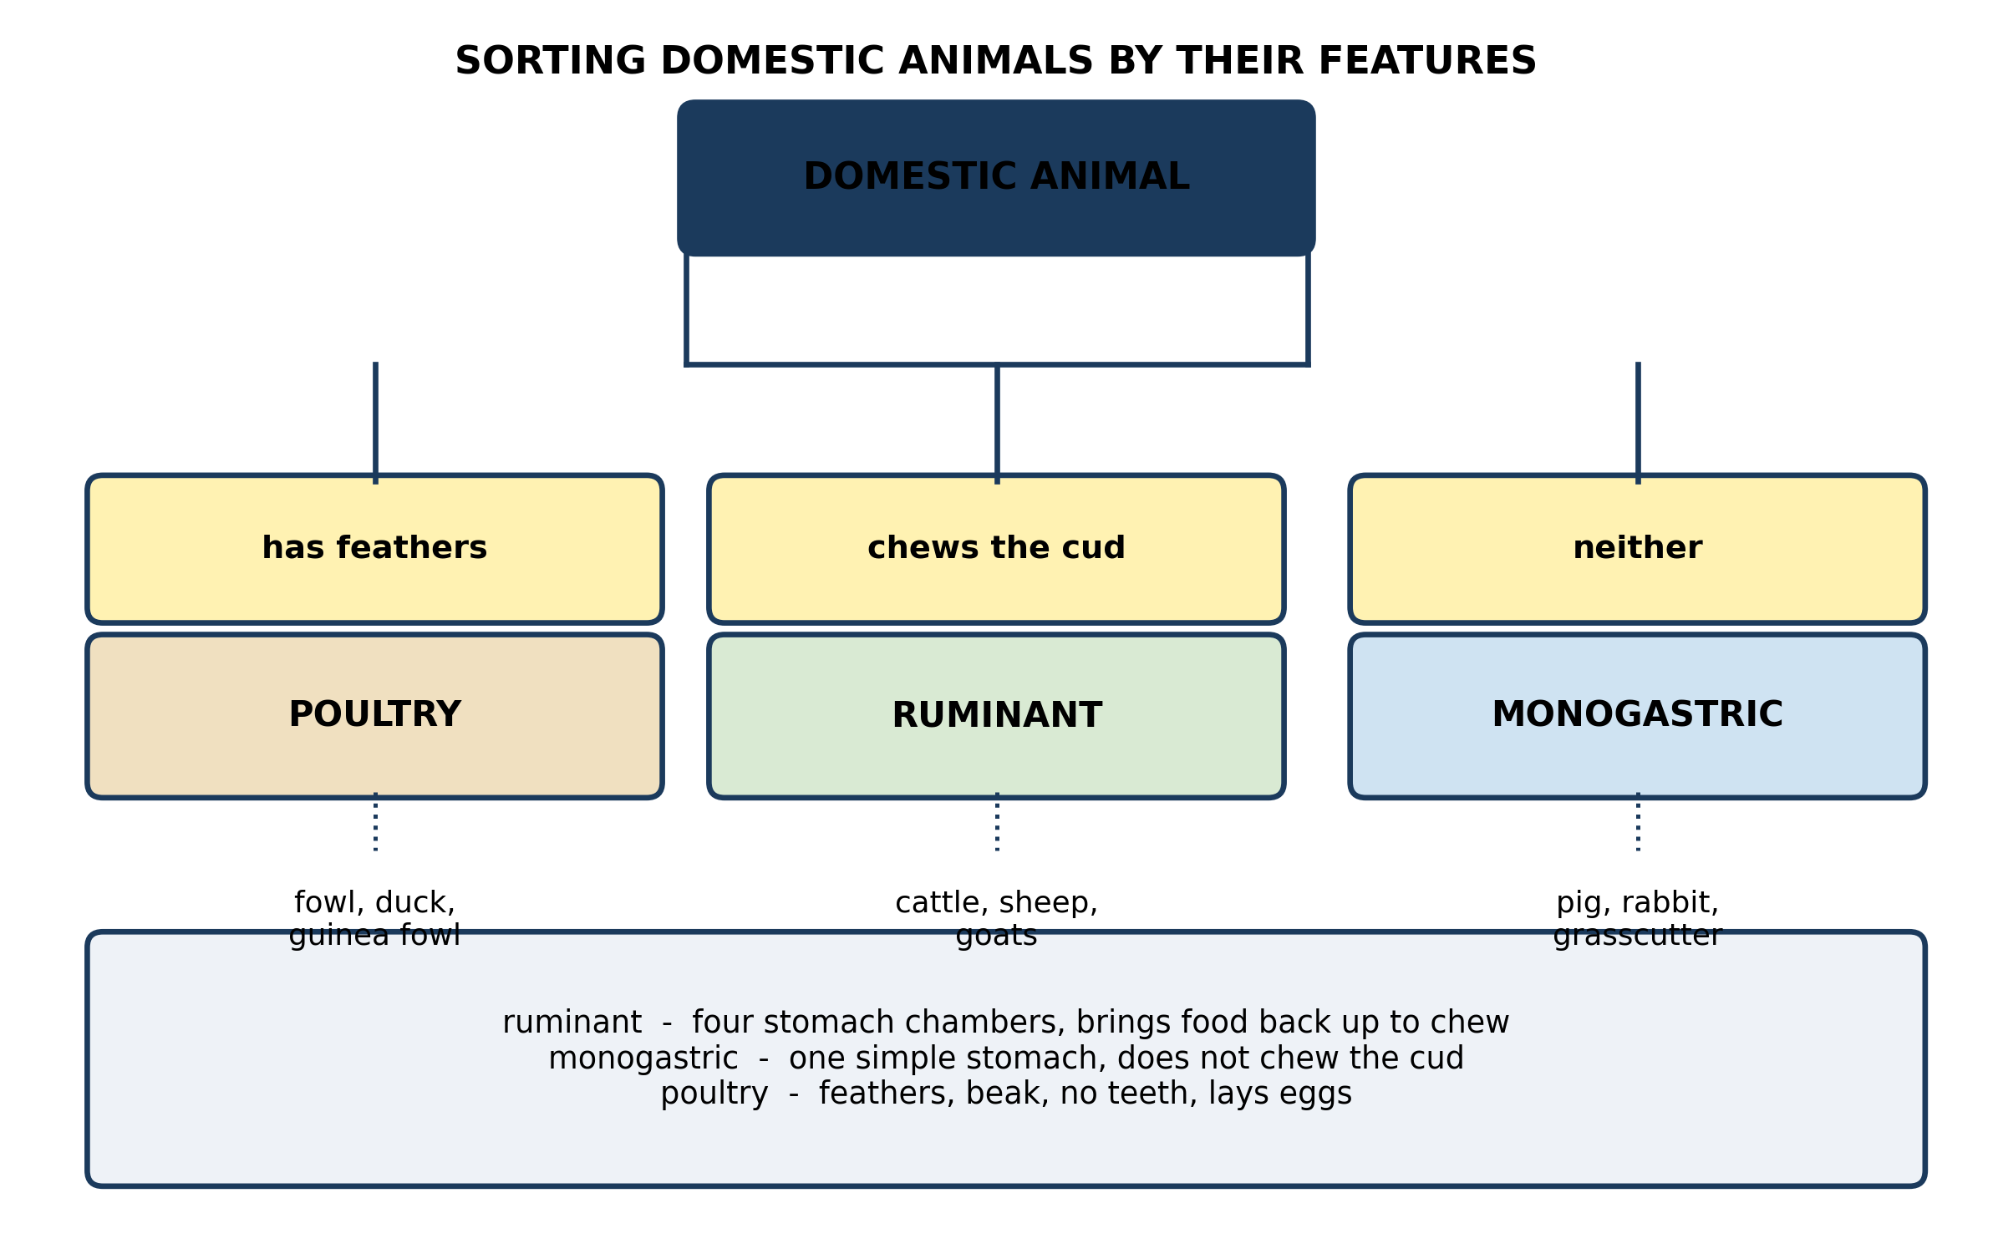
Fig. 2: Sorting domestic animals by their features

6.2 6.2 Classifying Domestic Animals: Ruminants, Monogastrics and Poultry
4. Use the key to explain what 'chews the cud' means, and explain why doing it puts an animal in the ruminant group. [3 marks]
5. A farmer has just bought an animal. It has hooves, but it does not chew the cud. Use the key to say which group it belongs to, and name one animal it could be. [3 marks]
____________________________________________________________________________________________
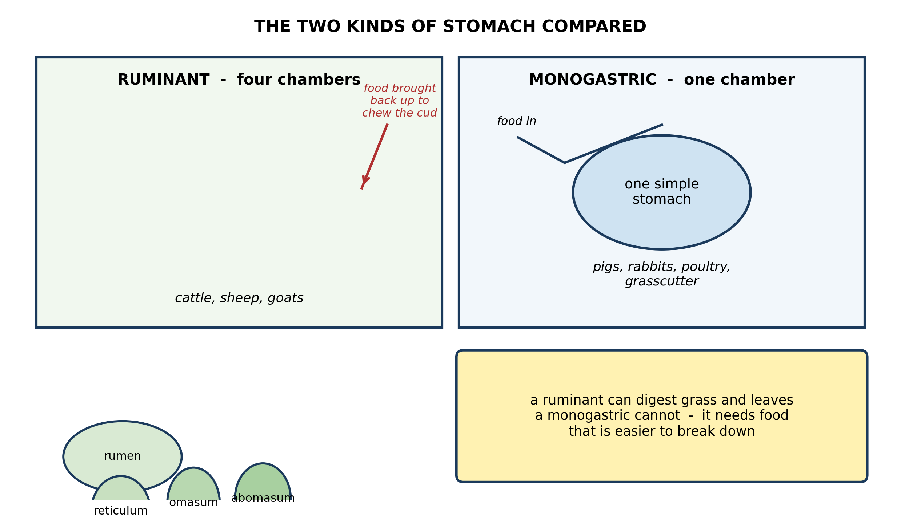
Fig. 3: The two kinds of stomach compared

6.3 6.3 Differences and Similarities Among Ruminants, Monogastrics and Poultry
6. Use the diagrams to explain why a ruminant such as a cow can live on grass, while a pig cannot. [4 marks]
7. A very young calf lives mainly on its mother's milk and cannot digest grass well. Suggest why, using the diagram. [3 marks]
____________________________________________________________________________________________
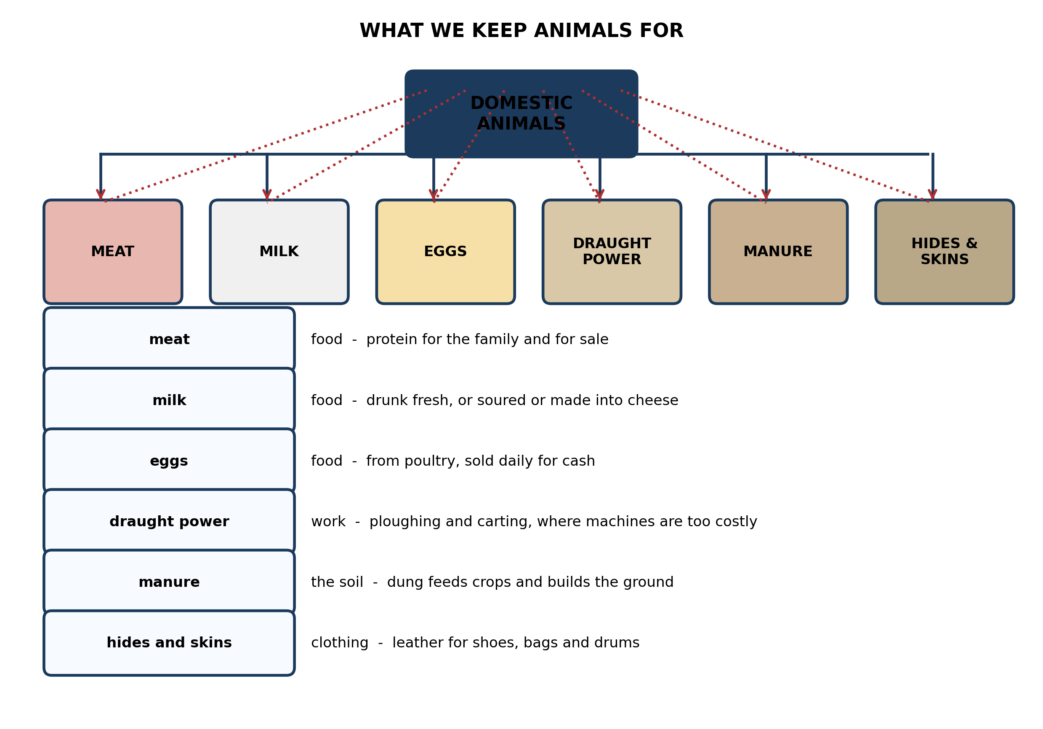
Fig. 4: What we keep animals for

6.4 6.4 Domestic and Commercial Uses of Animals
8. A smallholder farmer has no tractor and cannot afford to hire one. State which use of animals from the diagram matters most to him, and explain why. [4 marks]
9. A pupil says the most important use of animals is MEAT. Explain why this is too narrow a way of looking at it for a smallholder farmer. [3 marks]
____________________________________________________________________________________________
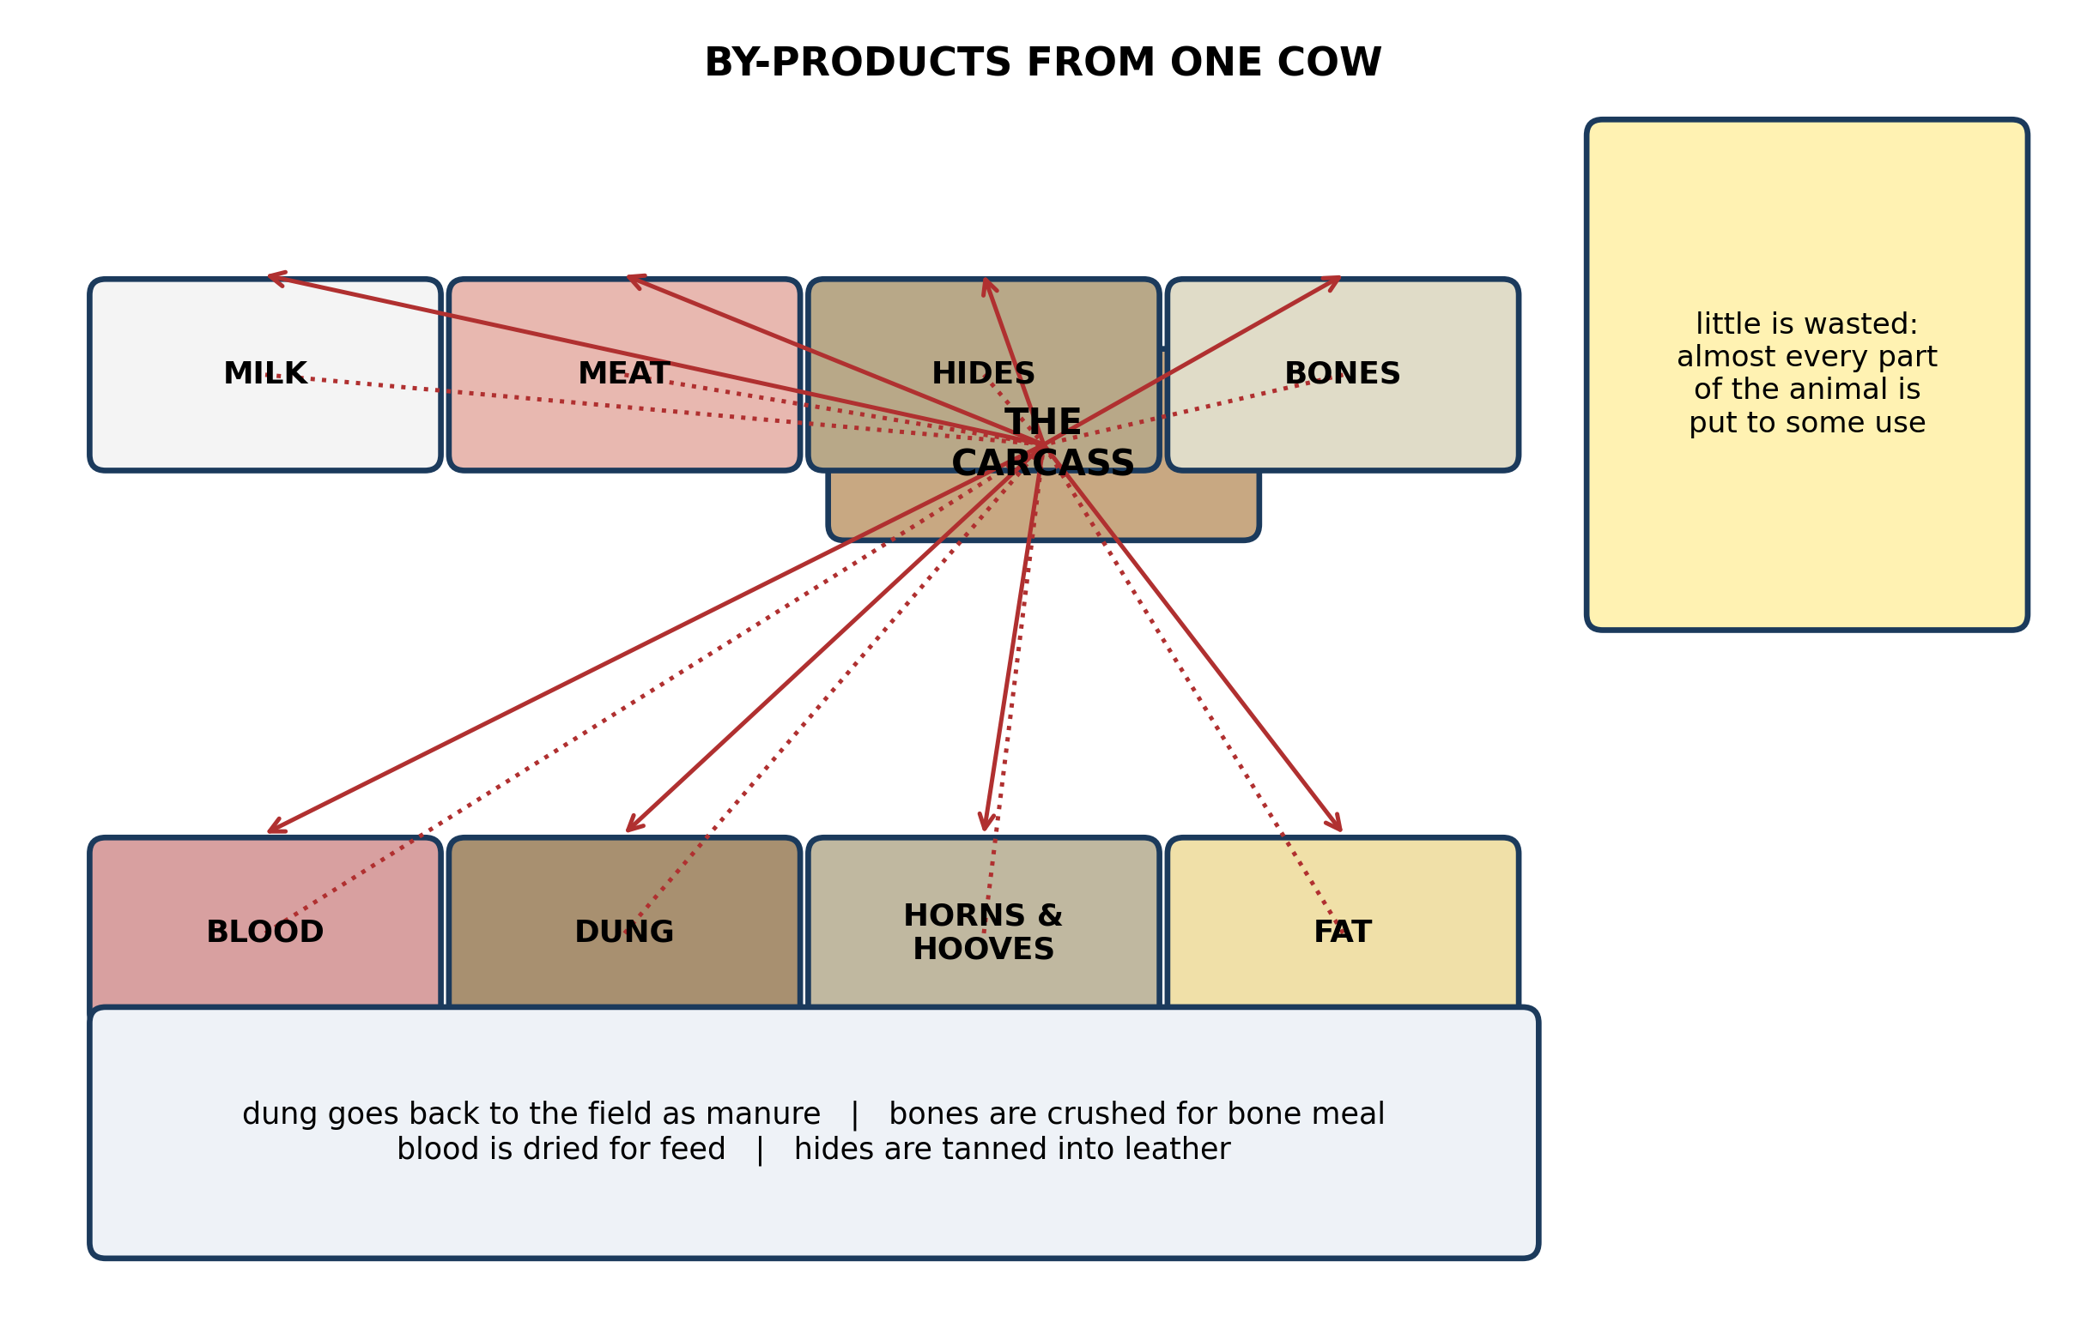
Fig. 5: By-products from one cow

6.5 6.5 By-Products of Animals and Their Importance
10. The diagram lists DUNG among the by-products. Explain why, on a mixed farm, calling dung a by-product undervalues it. [4 marks]
11. Give TWO things that hides and skins are used for, and explain what has to happen to a hide before it can be used. [3 marks]
____________________________________________________________________________________________
SECTION B - PRACTICAL TASK
Study the apparatus and answer the questions that follow it.
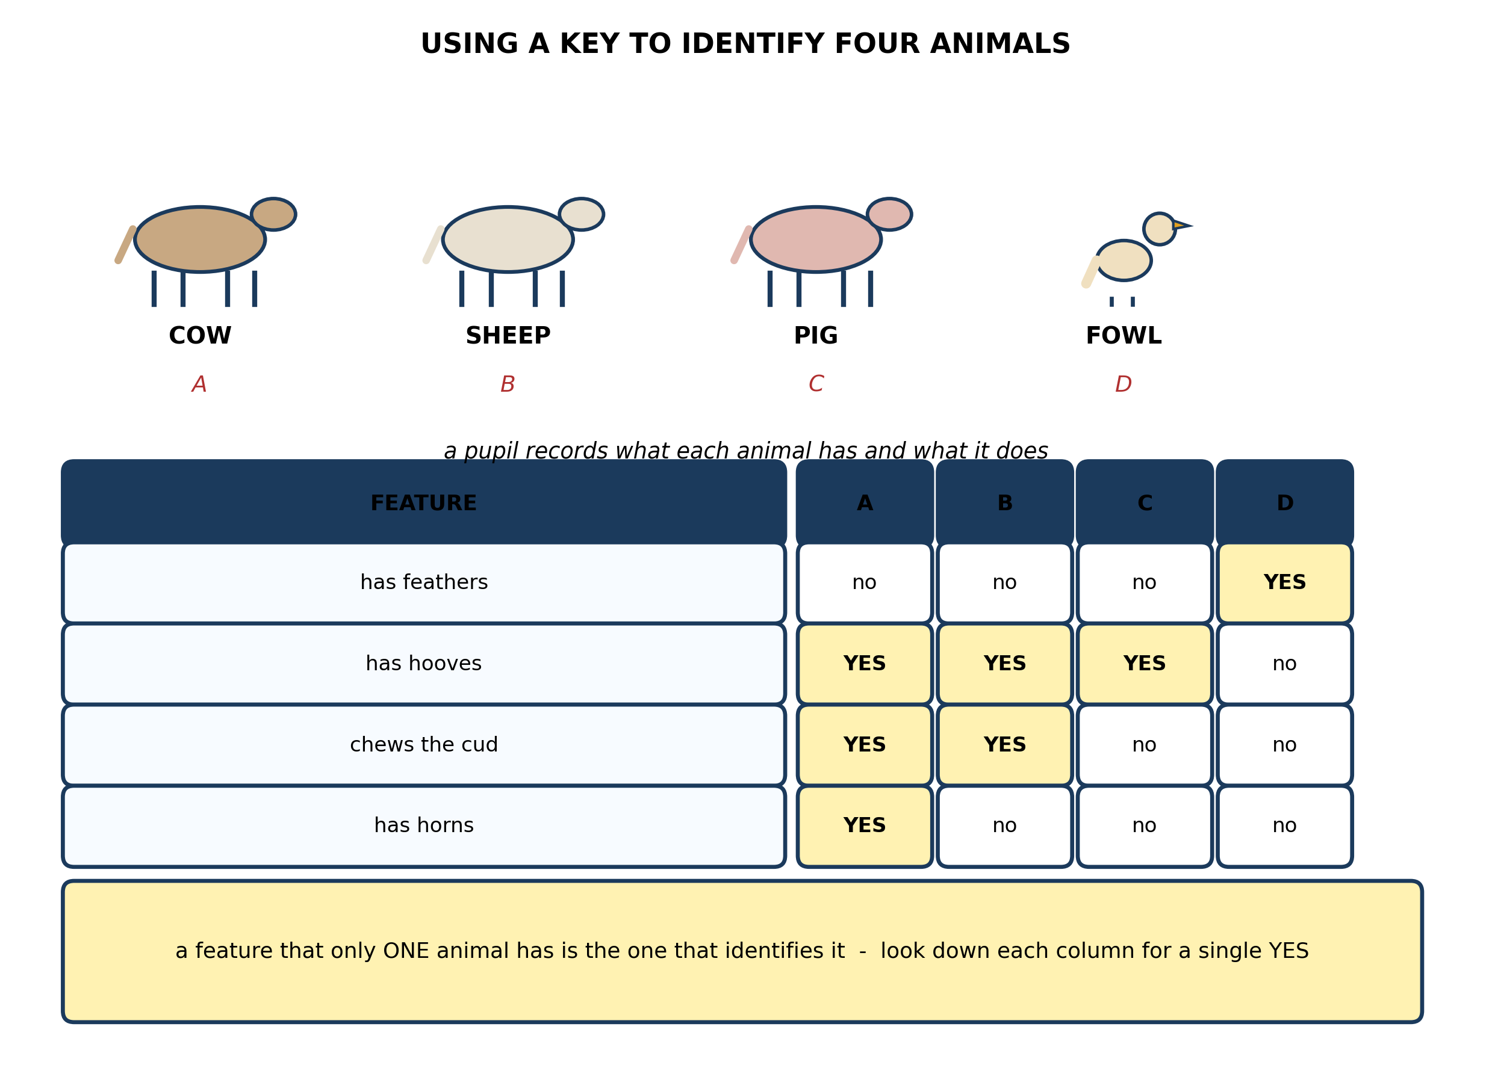
Fig. 6: Using a key to identify four animals

12. Use the table to identify animals A, B, C and D, giving the reason in each case. [4 marks]
13. Explain why 'has hooves' is a poor feature for identifying these animals, while 'has horns' is a good one. [4 marks]
14. A pupil adds a fifth animal, a GOAT, to the table. State what you would expect in its column, and explain what problem this would cause. [3 marks]
15. State what a DICHOTOMOUS KEY is, and explain why each step in it offers only two choices. [3 marks]
____________________________________________________________________________________________

ANSWER KEY AND MARKING SCHEME
Accept any other correct and relevant answer. Award marks for correct points, not for repeating the question.
6.1 6.1 Types of Domestic Animals in Ghana
Q1
An animal is domestic when people keep it, feed it, house it and control its breeding, so that it depends on people rather than fending for itself. That is a RELATIONSHIP, not a kind of animal - which is why the same species can be domestic in one place and wild in another. The caged grasscutter is fed by its keeper, protected from weather and predators, and bred from animals the keeper chose, so it is domestic. The one in the bush finds its own food and shelter, escapes its own predators and breeds with whichever partner it meets, so it is wild. Nothing about the animal's body changed - only its relationship with people did.
Q2
Any two, each stated: poultry have feathers, while the others have hair or bristles; poultry have a beak and no teeth; poultry lay eggs with a hard shell rather than giving birth to live young; poultry have two legs and wings, while the others walk on four legs. Any two of these earns the marks.
Q3
Milk: cattle, goats (sheep are also correct). Meat: cattle, sheep, goats, pigs, poultry, rabbits, grasscutter - any two of these.
6.2 6.2 Classifying Domestic Animals: Ruminants, Monogastrics and Poultry
Q4
Chewing the cud means bringing food back up from the stomach into the mouth to chew it a second time, after it was first swallowed almost unchewed. It puts the animal in the ruminant group because only an animal with a four-chambered stomach can do it: the food is swallowed to the first chamber, softened there, brought back up, chewed properly, then swallowed again to pass through the rest of the chambers. A monogastric animal has one simple stomach and no way of bringing food back up, so it cannot chew the cud - which makes the behaviour a reliable test for the group.
Q5
It has hooves, so it is not poultry - the key sends poultry off on the feathers branch. It does not chew the cud, so it is not a ruminant. That leaves the 'neither' branch, so it is MONOGASTRIC. It could be a pig, a rabbit or a grasscutter - any one of those named earns the mark.
6.3 6.3 Differences and Similarities Among Ruminants, Monogastrics and Poultry
Q6
Grass is largely cellulose, the tough material in plant cell walls, and very few animals can break it down. The cow can, because its rumen - the biggest of the four chambers - holds huge numbers of micro-organisms that digest cellulose for it. The four chambers also give the food a long time and a great deal of space to be worked on, and chewing the cud breaks the grass into smaller pieces so the microbes can get at more of it. The pig has one simple stomach and no such chamber, so cellulose passes straight through it undigested. The pig has to be given food that is easier to break down - grains, roots, kitchen waste - instead of grass.
Q7
A newborn calf's rumen is still small and undeveloped, and the population of micro-organisms that does the digesting has not yet built up in it. So the young calf is, in effect, a monogastric animal at this stage: milk goes straight to the abomasum, the true stomach, and is digested there. Only as the calf starts eating solid feed does the rumen grow and the microbes establish themselves, and only then does the animal become a functioning ruminant able to live on grass.
6.4 6.4 Domestic and Commercial Uses of Animals
Q8
Draught power. Without a tractor, the farmer still has to plough, harrow and cart, and animals are the only source of pulling power available to him. A pair of oxen or a donkey lets him prepare land that he could not work by hoe, and prepare it in time for the rains, which is the difference between a crop and no crop. Draught power also comes round every season, unlike meat which can only be had once. Manure would be the second most important, because the animals feed his soil as well as pull his plough.
Q9
Meat can only be had once, at the end, and getting it means the animal is gone. While the animal is alive it gives other things repeatedly: milk or eggs every day, draught power every season, and manure every year. A living animal is also a store of wealth that can be sold in an emergency - school fees, a hospital bill, a failed harvest - which is often worth more to a household than the meat would be. So meat is the least useful of the uses for most of the animal's life, and the last one a farmer would choose.
6.5 6.5 By-Products of Animals and Their Importance
Q10
A by-product is a leftover of little account, and dung is not that. On a mixed farm the dung is the link that joins the two halves together: the crops feed the animal, and the animal's dung feeds the soil that grows the crops. It returns organic matter and nutrients to the ground, which keeps the soil crumbly, holds water and feeds the organisms in it. Without it the farmer would have to buy fertiliser for exactly the nutrients the animals have already produced. So the dung is what makes the farm a system rather than two separate activities - it is central to how the farm works, not a leftover from it.
Q11
Any two uses: shoes and sandals, bags and belts, drums, chairs and stools, jackets. Before it can be used a hide has to be treated - cleaned, salted or dried, and then tanned. If it is not treated it either rots, because it is protein and micro-organisms feed on it, or it dries stiff and brittle and cracks. Tanning is what turns a perishable skin into leather that lasts.
PRACTICAL TASK
Q12
A is the cow - it has hooves, chews the cud and has horns. B is the sheep - it has hooves and chews the cud, but has no horns. C is the pig - it has hooves but does not chew the cud. D is the fowl - it is the only one with feathers, and it has no hooves and does not chew the cud.
Q13
'Has hooves' is YES for A, B and C at the same time, so it splits the four animals into a group of three and a group of one and then stops: it cannot tell you which of the three you have. A feature only identifies an animal if it belongs to that animal and to no other, so that following it down the table leaves exactly one possibility. 'Has horns' is YES for A alone, so it picks out the cow on its own and settles the question in a single step. That is the whole principle behind a key: each feature should cut the remaining animals into two, and keep cutting until one is left.
Q14
A goat would show no feathers, hooves YES, chews the cud YES and - for many goats - horns YES. That makes its column the same as the cow's, or the same as the sheep's, so the table can no longer separate them: two animals now share a column and the key fails. The pupil would have to add another feature that tells them apart, something like size, the shape of the horns, the coat, or the presence of a beard. The point is that a key has to be built for the animals actually in front of you, and a feature that worked for four may stop working at five.
Q15
A dichotomous key is a tool for identifying an organism by working through a series of paired statements and choosing the one that fits. Each step offers exactly two choices, and they are opposites - has feathers or does not, chews the cud or does not. That guarantees the animal must take one branch or the other and cannot fall between them, so every animal follows exactly one path through the key and arrives at exactly one name. With more than two choices at a step, or choices that overlap, an animal could take two paths and the key would give two different answers.

BLUEPRINT / TEST SPECIFICATION
# | Content standard | Code | Items | Marks | % of Marks
6.1 | 6.1 Types of Domestic Animals in Ghana | B7/JHS1.2.4.1 and B7/JHS1.2.4.2 | 3 | 9 | 18%
6.2 | 6.2 Classifying Domestic Animals: Ruminants, Monogastrics and Poultry | B7/JHS1.2.4.1 and B7/JHS1.2.4.2 | 2 | 6 | 12%
6.3 | 6.3 Differences and Similarities Among Ruminants, Monogastrics and Poultry | B7/JHS1.2.4.1 and B7/JHS1.2.4.2 | 2 | 7 | 14%
6.4 | 6.4 Domestic and Commercial Uses of Animals | B7/JHS1.2.4.1 and B7/JHS1.2.4.2 | 2 | 7 | 14%
6.5 | 6.5 By-Products of Animals and Their Importance | B7/JHS1.2.4.1 and B7/JHS1.2.4.2 | 2 | 7 | 14%
6.1 | Practical task | B7/JHS1.2.4.1 and B7/JHS1.2.4.2 | 4 | 14 | 28%
TOTAL | - | - | 15 | 50 | 100%
Distribution by cognitive level
Cognitive level | Marks | % of Marks
Understand | 11 | 22%
Apply | 20 | 40%
Analyse | 19 | 38%
TOTAL | 50 | 100%
Distribution by difficulty
Difficulty | Marks | % of Marks
Easy | 2 | 4%
Moderate | 29 | 58%
Challenging | 19 | 38%
TOTAL | 50 | 100%

QUALITY-CONTROL SUMMARY
1. Is every question answered from a diagram?
Yes. All 15 questions sit under a figure, and each is unanswerable - or at least materially harder - without reading it. Questions 3, 8, 10 and 17 ask pupils to go beyond the diagram, but each still starts from something the figure shows.
2. Is the content within the Basic 7 curriculum?
Yes. Every question traces to the content standards for this sub-strand (B7/JHS1.2.4.1 and B7/JHS1.2.4.2), and nothing is tested beyond the depth the Basic 7 syllabus sets for it.
3. Are the diagrams clear and unambiguous?
Yes. Each is drawn so that only one reading is sensible: the particle boxes differ in spacing alone, the syringes are labelled with how far each squashes, and the periodic table marks the regions in words as well as by position.
4. Is the level right for JHS 1?
Yes. Questions ask pupils to read, describe and explain what is drawn. Only Question 17 asks for an inference beyond the figure, and it is worth 3 of the 40 marks.
5. Do the marks add up?
Yes: 15 questions totalling 50 marks, matching the figure on the front page. The blueprint, cognitive and difficulty tables all sum to the same total.
6. Are the answers correct and complete?
Yes. Each answer states the point the question is worth, with the acceptable alternatives given where a question is open.
EXAMINER NOTES (for the teacher, not for candidates)
- Pitched at the compulsory diagram question of BECE Paper 2: 78% of the marks are at Apply level or above and 38% are Challenging.
- Q1 is the question that decides whether a pupil understands 'domestic' at all. Most will define it as 'an animal that lives with people' and stop, which does not survive the grasscutter test. The point is that it is a RELATIONSHIP - kept, fed, housed, bred by people - not a kind of animal, so the same species can be either.
- Q6 on why a cow can live on grass and a pig cannot is the heart of 6.3. Pupils know the ruminant has four chambers but rarely know WHY that matters: the rumen is a fermentation vat holding micro-organisms that digest cellulose. Without that, four chambers are just a fact to memorise.
- Q7 on the newborn calf is the question I would not want to cut. It is the same idea turned round - a calf is functionally monogastric until its rumen develops - and it tests whether the pupil has understood 6.3 or only learned the diagram.
- Q10 on dung is deliberately contrary. The diagram files it under by-products, and the question asks the pupil to reject that. On a mixed farm the dung is the coupling between the animal half and the crop half; a pupil who sees that has understood farming as a system.
- Q13 is the best question in the practical. Pupils think a feature that narrows things down is useful; the insight is that a feature must be UNIQUE to identify. 'Has hooves' narrows four to three and then stops. 'Has horns' settles it in one step.
- Q14 extends that: add a goat and the key breaks, because the goat shares a column with the cow or the sheep. Good pupils will say the key has to be rebuilt for the animals actually present. This is the most transferable idea in the paper.

