[SCHOOL NAME]
INTEGRATED SCIENCE (SCIENCE)
PRACTICAL QUESTIONS - DIAGRAM MODE
Climate Change (19.1 - 19.4)
____________________________________________________________________________________________
CLASS: Basic 7 (JHS 1)
TIME: 1 hour 30 minutes
MARKS: 50 2025/2026 Academic Year
____________________________________________________________________________________________
INSTRUCTIONS TO CANDIDATES
1. Answer ALL the questions in this paper.
2. Every question is based on a diagram. Study each diagram carefully before you answer the questions that follow it.
3. Write your answers in the spaces provided. The marks for each question are printed beside it.
4. Where a question asks for a stated number of points, give that number. Any extra answers will not be marked.
5. You may refer back to any diagram at any time.
____________________________________________________________________________________________
SECTION A - DIAGRAM STUDY
Study each diagram and answer the questions that follow it.
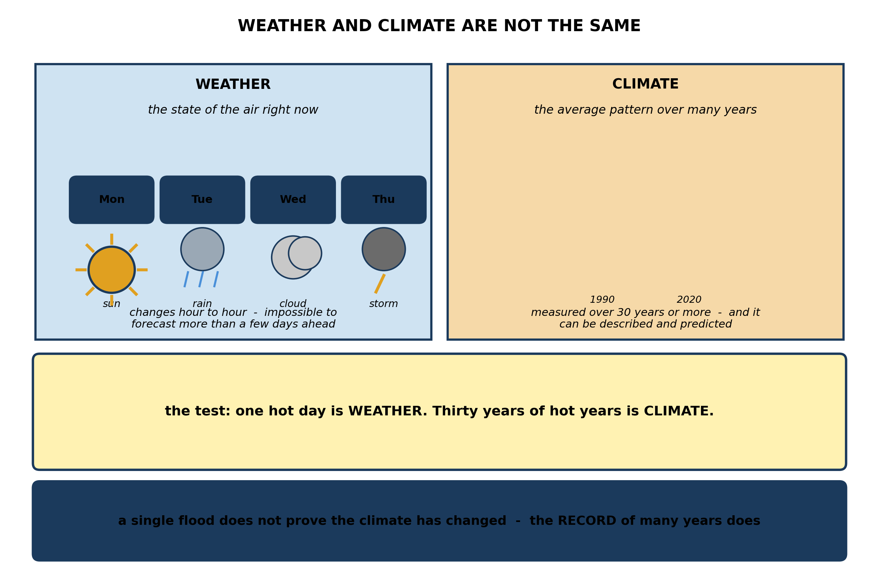
Fig. 1: Weather and climate are not the same

19.1 19.1 What is Sustainable Energy?
1. Explain the difference between WEATHER and CLIMATE. A pupil says that because it rained heavily in Accra last Tuesday, the climate must be changing. Explain why this does not follow. [4 marks]
2. State what is meant by WEATHER and by CLIMATE. [3 marks]
3. A farmer wants to know what to plant this season. Explain why knowing the CLIMATE of his area is more useful to him than knowing tomorrow's WEATHER. [3 marks]
____________________________________________________________________________________________
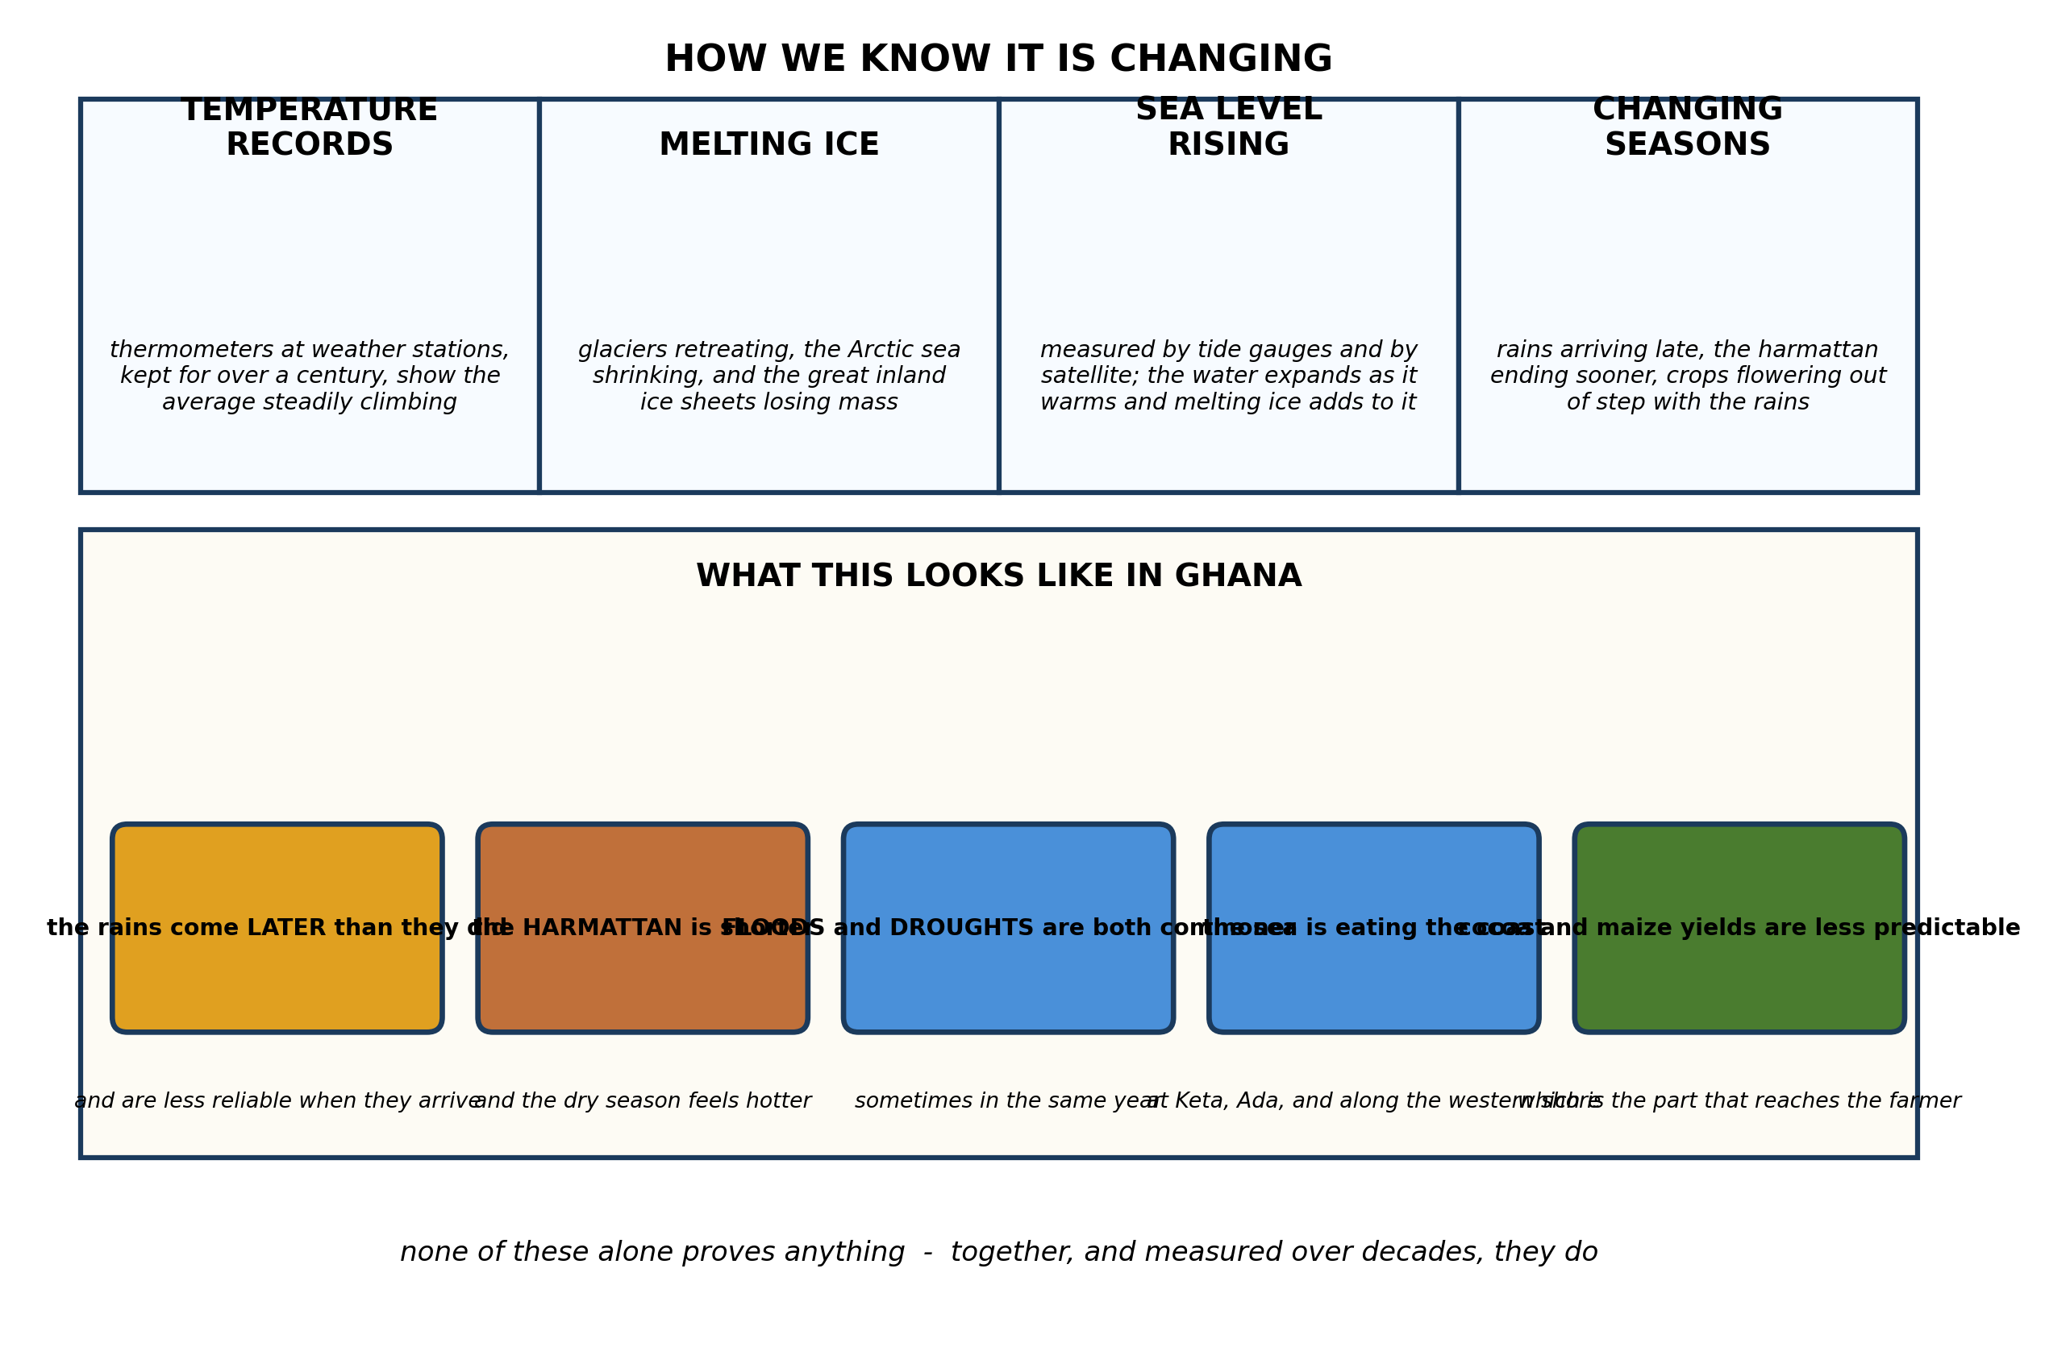
Fig. 2: How we know it is changing

19.2 19.2 Greenhouse Effects on the Environment
4. Explain why scientists need several DIFFERENT kinds of evidence before they will say the climate is changing, and describe TWO of those kinds of evidence. [4 marks]
5. State THREE pieces of evidence that the climate is changing. [3 marks]
6. The rains now arrive in your district about three weeks later than they did thirty years ago. Suggest TWO ways a farmer could check whether this is really happening rather than just remembering it differently. [3 marks]
____________________________________________________________________________________________
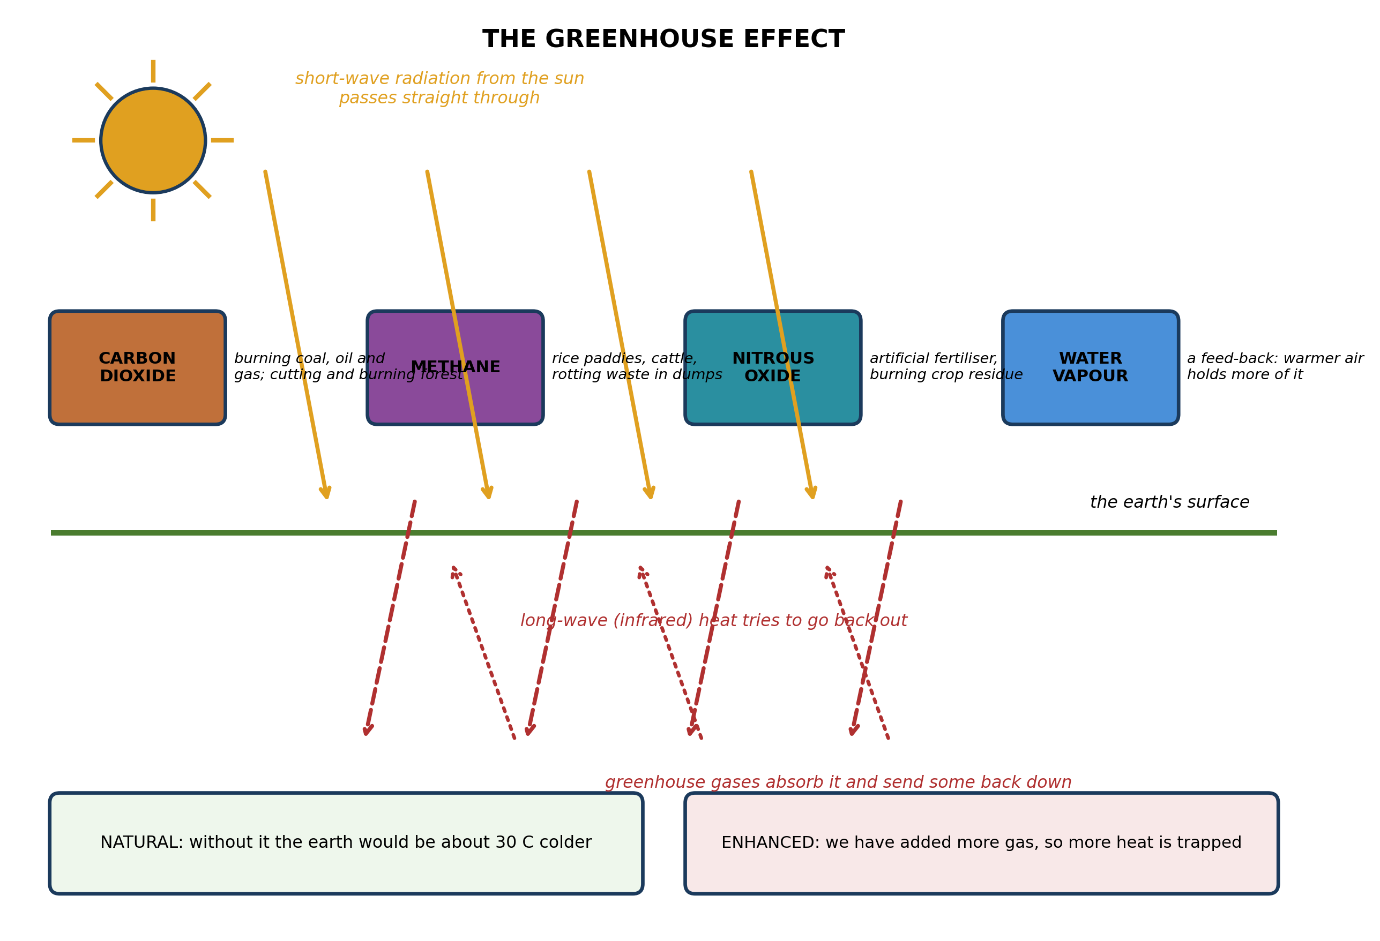
Fig. 3: The greenhouse effect

19.3 19.3 Sustainable Energy Choices and Scientific Ideas
7. Explain how the greenhouse effect works, and explain why it is wrong to say that the greenhouse effect is itself a bad thing. [4 marks]
8. Name TWO human activities that add carbon dioxide to the air, and explain for each how it does so. [3 marks]
9. Name THREE greenhouse gases. [3 marks]
____________________________________________________________________________________________
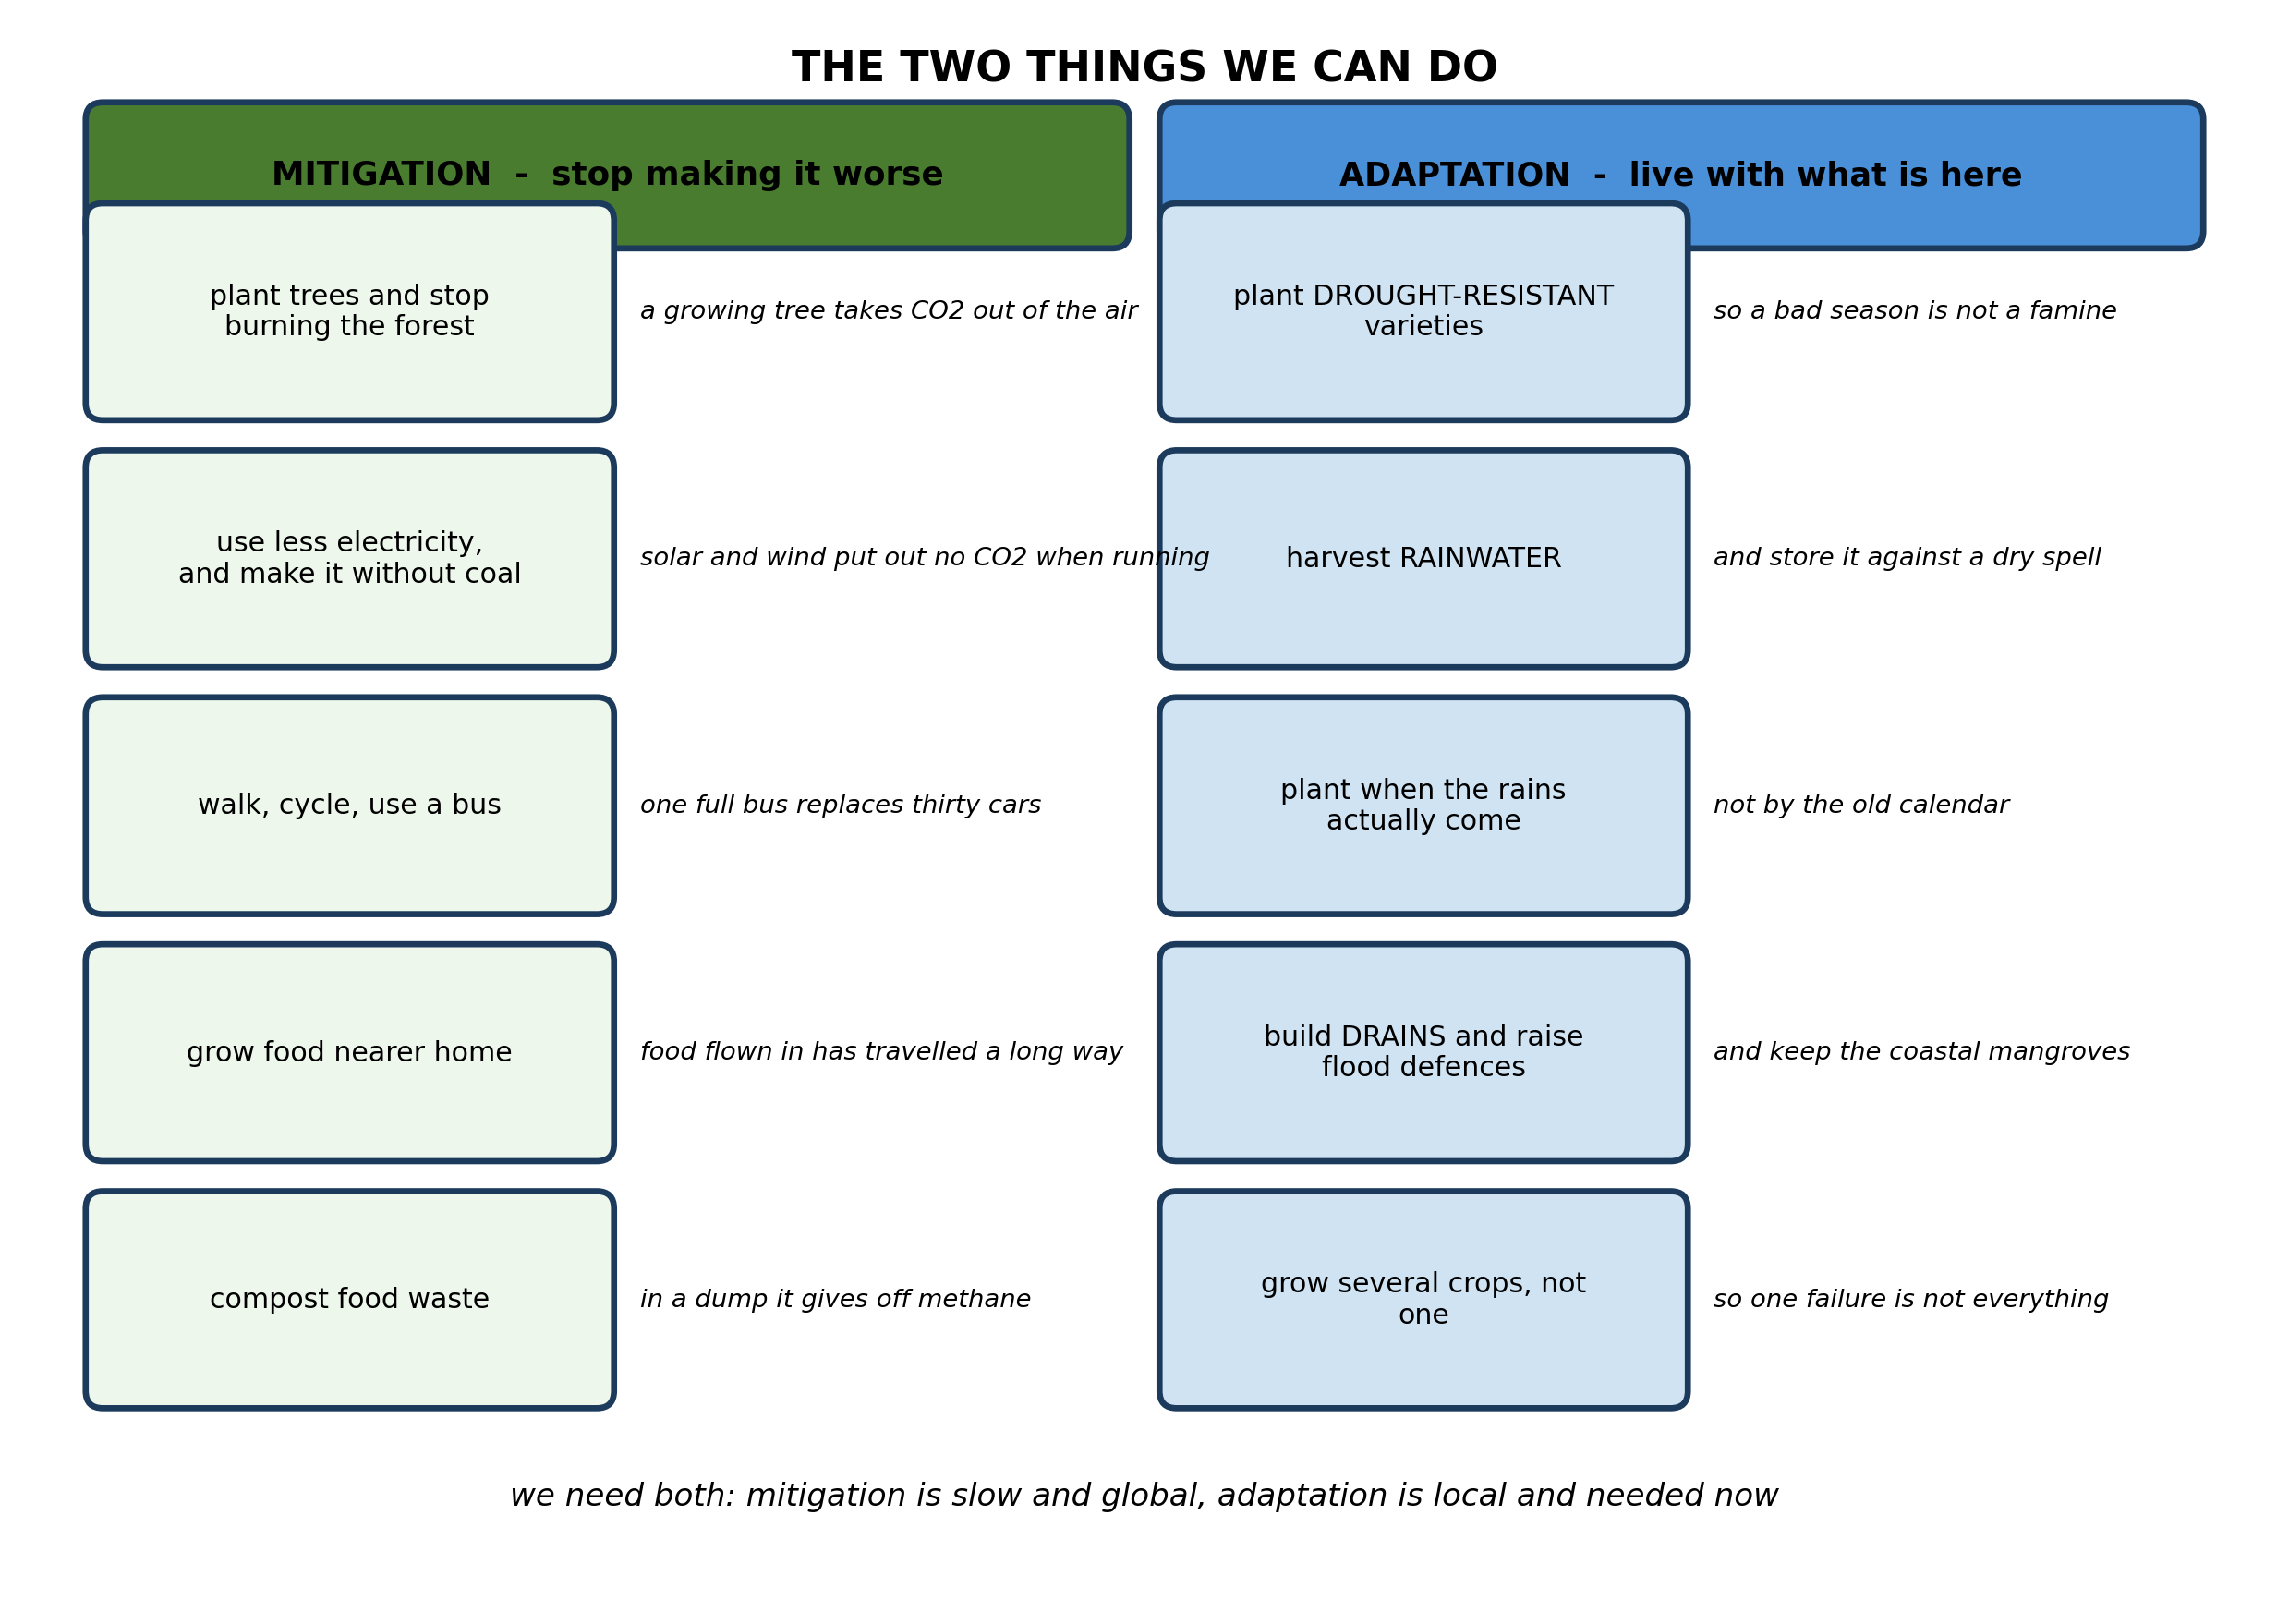
Fig. 4: The two things we can do

19.4 19.4 Designing Local Energy Solutions
10. Explain the difference between MITIGATION and ADAPTATION, and give ONE example of each that a farming family in northern Ghana could actually carry out. [4 marks]
11. Explain why a farmer should plant several DIFFERENT crops rather than only one, as a way of adapting to a changing climate. [3 marks]
12. State TWO effects of climate change on Ghana. [3 marks]
____________________________________________________________________________________________
SECTION B - PRACTICAL TASK
Study the apparatus and answer the questions that follow it.
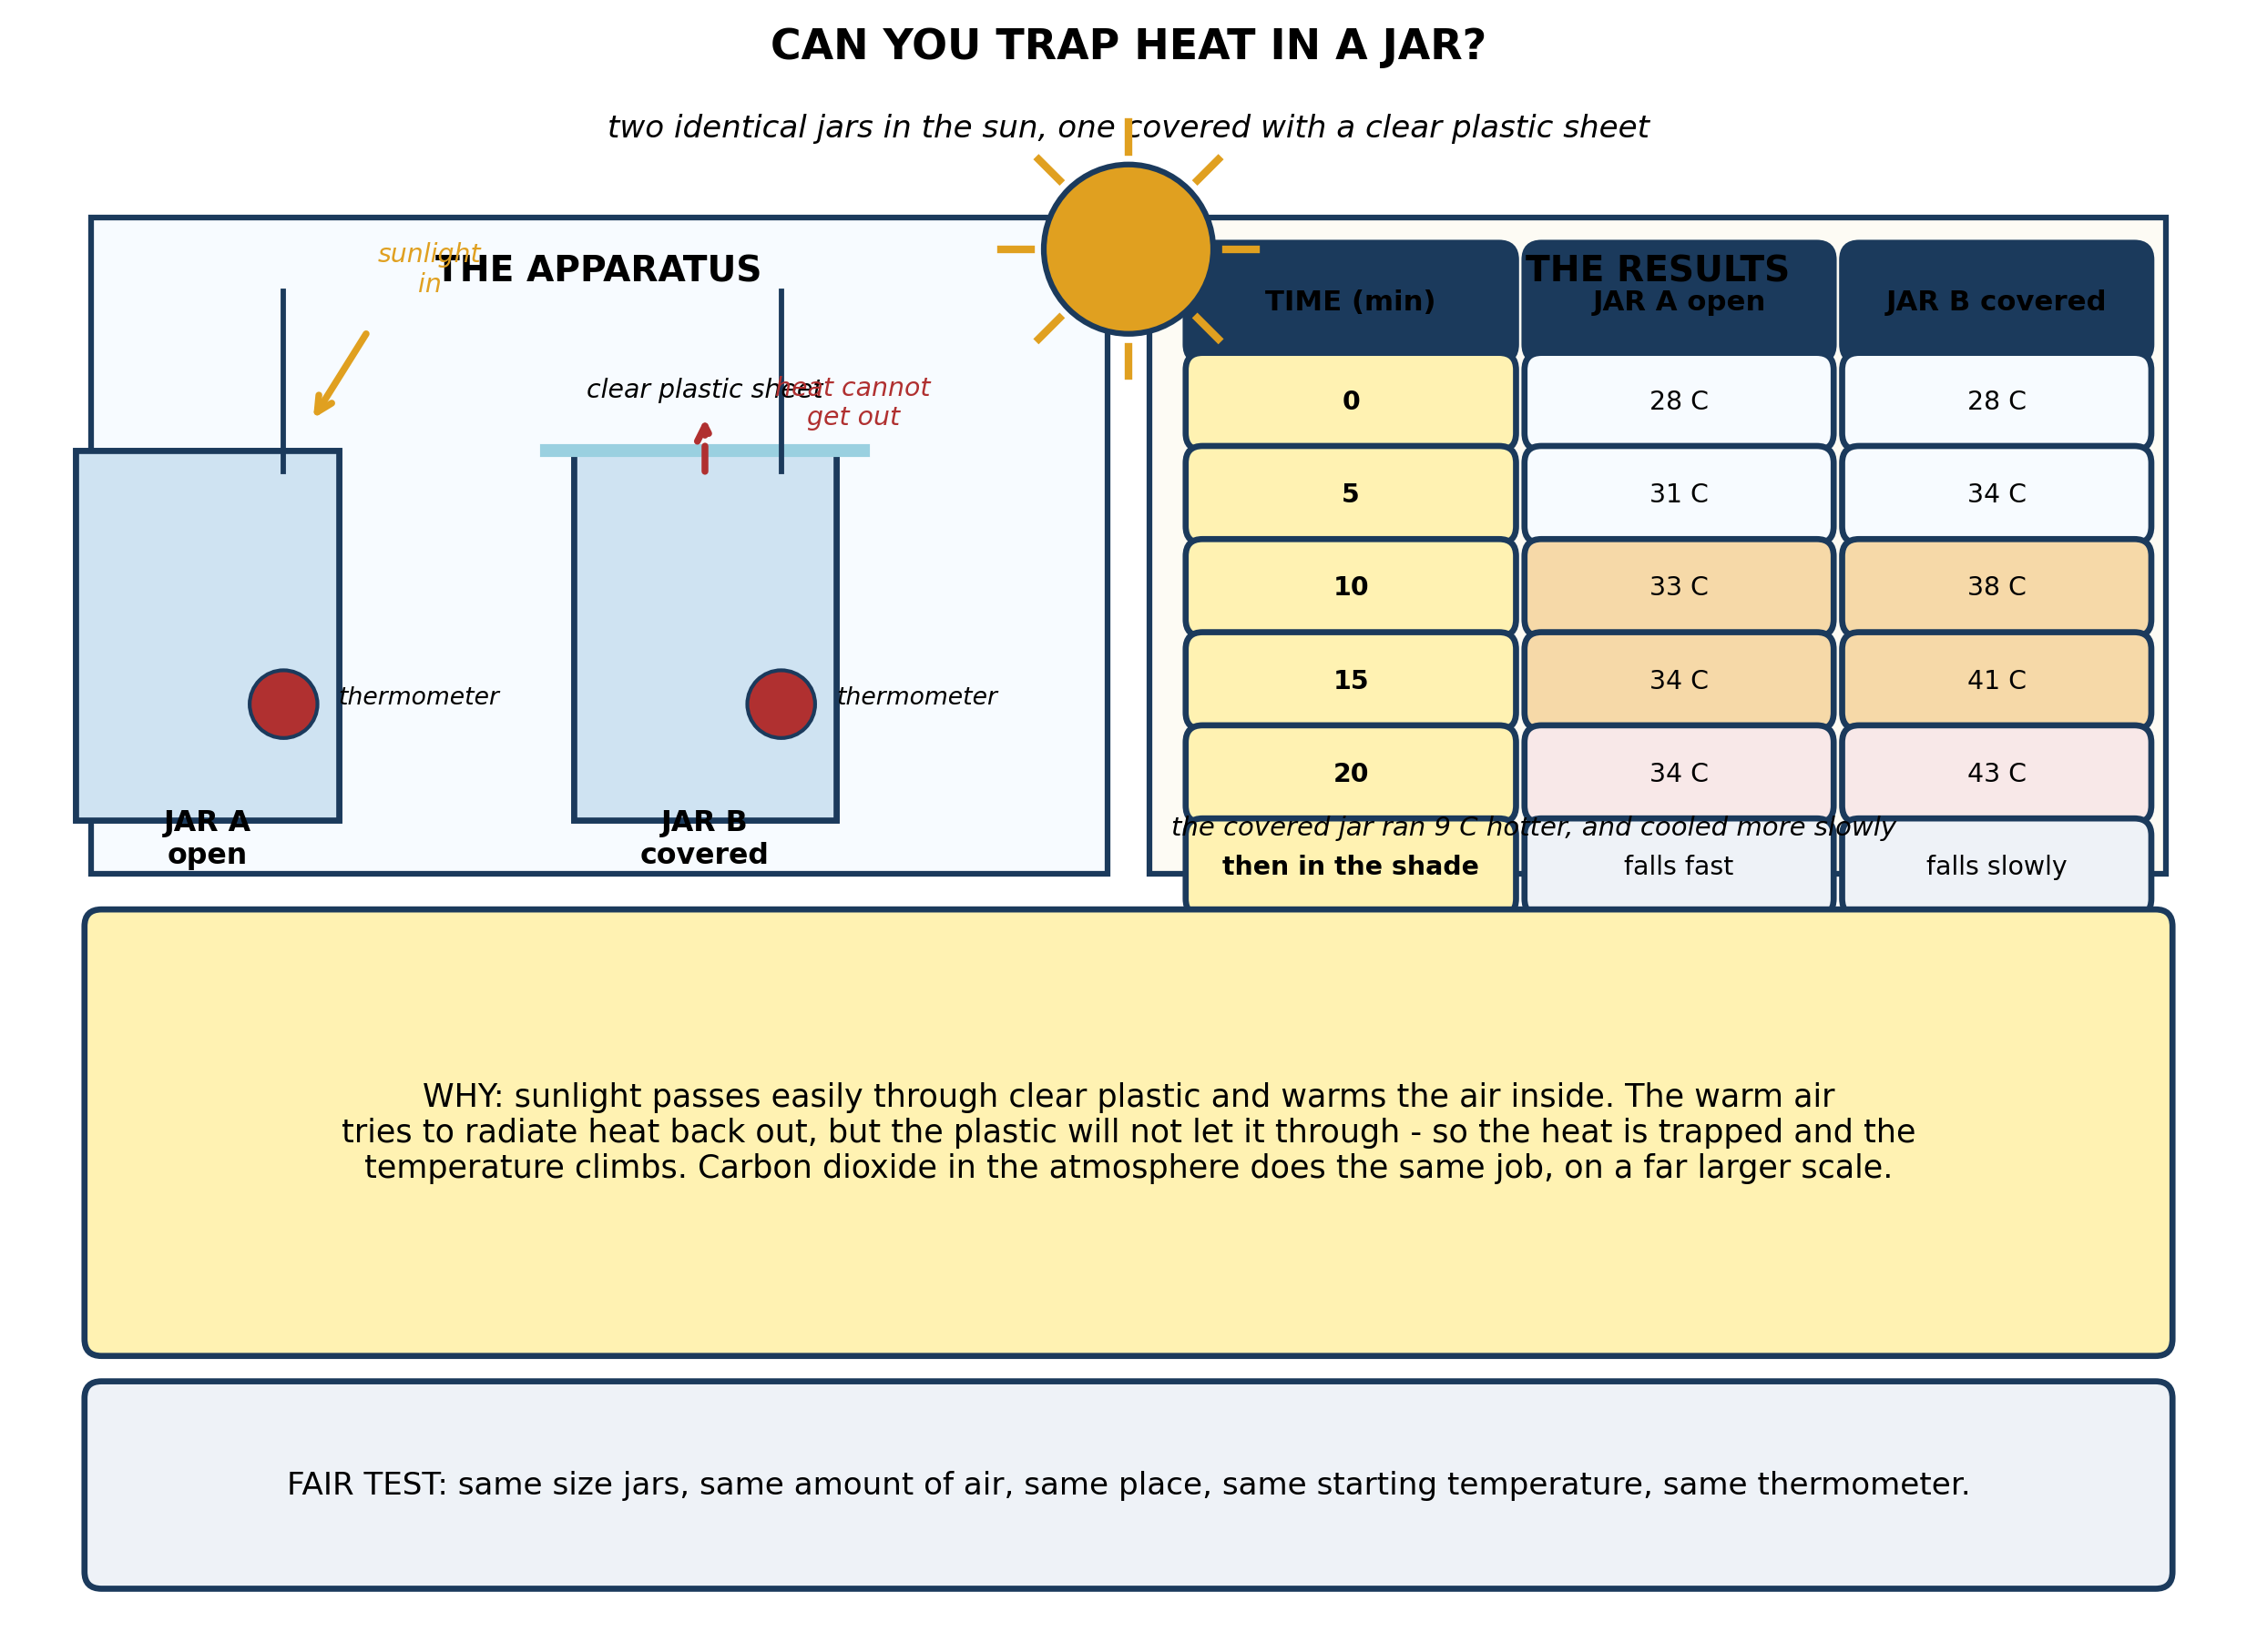
Fig. 5: Can you trap heat in a jar?

13. From the results, explain why the covered jar got hotter than the open one, and explain carefully how this models the greenhouse effect - and ONE important way in which the model is NOT like the real thing. [4 marks]
14. State THREE things the pupils must keep the same for this comparison to be fair, and explain why each matters. [3 marks]
15. The covered jar also COOLED more slowly when the jars were moved into the shade. Explain why, and suggest ONE improvement that would make the experiment a better test. [3 marks]
____________________________________________________________________________________________

ANSWER KEY AND MARKING SCHEME
Accept any other correct and relevant answer. Award marks for correct points, not for repeating the question.
19.1 19.1 What is Sustainable Energy?
Q1
Weather is the state of the atmosphere at a particular place and moment - whether it is hot, raining, windy or clear - and it can change within the hour. Climate is the average pattern of weather in a place, measured over many years, usually thirty or more. One heavy rainstorm is a single weather event: Accra has always had heavy rainstorms, and one of them tells you nothing about the average. To say the climate has changed you need the record - the total rainfall, the number of rainy days, the dates the rains began and ended, measured every year for decades and compared. If those averages have moved, the climate has changed; if they have not, last Tuesday was simply weather. This matters because it is the difference between an opinion based on one memory and a conclusion based on evidence.
Q2
Weather is the condition of the atmosphere at a particular place and time. Climate is the average weather of a place, measured over a long period, usually thirty years or more.
Q3
The weather forecast tells him whether to harvest or spray tomorrow, but it says nothing about what to plant. What he needs is the average pattern: when the rains usually start, how long they last, how much rain falls, and how variable all of that is. That is climate, and it decides whether maize will mature before the rains stop, or whether he should choose a shorter-season or a drought-resistant variety instead. He also needs to know the range - how bad the worst year in twenty has been - because planting a crop that fails one year in five is a different decision from planting one that fails one year in twenty. A forecast for tomorrow cannot tell him any of it.
19.2 19.2 Greenhouse Effects on the Environment
Q4
Because climate varies naturally from year to year and from decade to decade, so any single measurement could be a fluctuation rather than a trend. If several independent lines of evidence all point the same way, the chance that they are all the same coincidence becomes very small. Independent means measured by different methods in different places: one thermometer record is not independent of another from the same station, but ice extent, sea level and the timing of the seasons are genuinely separate. Two kinds of evidence: temperature records, kept by weather stations all over the world for over a century, which show the average climbing; and the retreat of glaciers and the shrinking of Arctic sea ice, measured by satellite and by direct survey. Further kinds: sea level, measured by tide gauges and satellite, rising both because ice melts and because warm water expands; and the seasons shifting, with plants flowering earlier and rains arriving later.
Q5
Any three, each stated. Temperature records from weather stations show the average rising. Glaciers are retreating and Arctic sea ice is shrinking. Sea level is rising. The seasons are shifting - rains arriving later, plants flowering earlier. Floods and droughts are both becoming more frequent.
Q6
Any two, each explained. Ask the meteorological service or the agricultural extension office for the district's rainfall records over the last thirty years and look at the date the rains began in each year - the record settles it where memory does not. Ask older farmers in several different villages the same question: if they say the same thing independently and describe the same shift, that is worth far more than one person's recollection. Keep a record himself - write down the date the rains start every year from now on, so that in ten years there is data rather than memory. Watch for indirect signs, such as whether the planting calendar his father used still works.
19.3 19.3 Sustainable Energy Choices and Scientific Ideas
Q7
Sunlight is mostly short-wave radiation, and it passes through the atmosphere and warms the earth's surface. The warm surface radiates that energy back out, but as long-wave infrared radiation, which greenhouse gases - carbon dioxide, methane, water vapour, nitrous oxide - absorb and re-radiate in all directions, including back downwards. So some of the heat that would have escaped into space is kept in. Without that effect at all, the earth would be roughly 30 C colder than it is and life as we know it would not exist: the natural greenhouse effect is what makes the planet habitable, and it is not a bad thing. What is a problem is the ENHANCED greenhouse effect. By burning coal, oil and gas, and by clearing and burning forest, we have added far more carbon dioxide to the air than was there before, so more of the outgoing heat is trapped and the average temperature climbs. The effect is not the problem; the extra gas is.
Q8
Any two, each explained. Burning coal, oil or gas for electricity, transport and industry: the carbon in the fuel combines with oxygen and goes straight into the air as carbon dioxide. Cutting down and burning forest: the carbon the trees had locked up in their wood is released at once when they burn, and gradually as the rest rots - and with the trees gone, far less carbon dioxide is taken out of the air in future. A third: making cement, which releases carbon dioxide from the limestone as well as from the fuel used to heat it.
Q9
Any three of: carbon dioxide, methane, nitrous oxide, water vapour, chlorofluorocarbons.
19.4 19.4 Designing Local Energy Solutions
Q10
Mitigation means acting on the cause - reducing the amount of greenhouse gas going into the air, so that the problem gets less worse in future. Adaptation means adjusting to the changes that are already happening, so that the damage is smaller. They are different timescales with different aims, and we need both. Mitigation the family could do: plant trees on their land and keep them, since a growing tree takes carbon dioxide out of the air; and stop burning crop residue, which releases it all at once. Adaptation: plant a shorter-season or drought-resistant variety of maize or millet, so the crop matures even if the rains start late or stop early - and this matters now, because the rains in the north are already less reliable. Another: dig a small dugout or set up a rainwater tank to carry water through a dry spell.
Q11
Because a changing climate makes the season less predictable, and different crops fail under different conditions: a late start suits one, a dry spell suits another, heavy rain a third. If all the land is in one crop, one bad season takes everything. With several crops, the failure of one is not the loss of the whole harvest, so the family still eats. Mixed cropping also keeps the ground covered, which cuts the loss of water from the soil and protects it from heavy rain; and if one of the crops is a legume it keeps the soil fertile without bought fertiliser. The whole point is spreading risk at a time when the risk can no longer be predicted.
Q12
Any two, each stated. The rains arrive later and are less reliable, so crops fail more often. Floods and droughts are both more frequent, sometimes in the same year. Rising sea level is eroding the coast at Keta, Ada and along the western shore. Higher temperatures reduce the yields of cocoa and maize. The harmattan is shorter and the dry season hotter. Water supplies are less reliable.
PRACTICAL TASK
Q13
Sunlight passes easily through the clear plastic and warms the air and the surfaces inside the jar. The warm air then tries to radiate that heat back out, but the plastic will not let long-wave infrared through, so the heat is trapped and the temperature keeps climbing - 43 C in the covered jar against 34 C in the open one. This models the greenhouse effect: short-wave sunlight comes in, is absorbed, is re-radiated as long-wave heat, and something in between stops the heat getting out. In the atmosphere that something is the greenhouse gases rather than a sheet of plastic. The important difference is that a jar also traps heat by stopping CONVECTION - no warm air can rise out of it - whereas the real greenhouse effect works purely by absorbing and re-radiating radiation. The atmosphere is not a lid, it is a filter. So the model gets the radiation right and the containment wrong, and it is better to say so than to pretend the jar is the atmosphere.
Q14
Any three, each explained. Both jars the same size and shape, with the same volume of air, so that one is not simply heating a smaller amount of air. Both in the same place in the sun at the same time, so both receive the same sunlight. Both starting at the same temperature, so the comparison measures the heating rather than a difference that was there at the beginning. The same thermometer for both - or two thermometers checked against each other in the same water first, since otherwise the readings differ by however much the instruments disagree.
Q15
The plastic sheet that stopped heat getting in by radiation also stops it getting out the same way, so the covered jar loses heat more slowly as well as gaining it faster - the barrier works in both directions. That is actually a fair part of the model: greenhouse gases slow the escape of heat around the clock, not just during the day, which is why nights warm faster than days in a warming world. For an improvement: repeat the whole run on three separate days and take the mean, since one twenty-minute run under changing cloud is not much evidence. Or run a third jar, uncovered but with the same amount of air, as a second control. Or record the temperature every minute instead of every five, which shows the shape of the curve rather than five points.

BLUEPRINT / TEST SPECIFICATION
# | Content standard | Code | Items | Marks | % of Marks
19.1 | 19.1 What is Sustainable Energy? | B7/JHS1.5.4.1 | 3 | 10 | 20%
19.2 | 19.2 Greenhouse Effects on the Environment | B7/JHS1.5.4.1 | 3 | 10 | 20%
19.3 | 19.3 Sustainable Energy Choices and Scientific Ideas | B7/JHS1.5.4.1 | 3 | 10 | 20%
19.4 | 19.4 Designing Local Energy Solutions | B7/JHS1.5.4.1 | 3 | 10 | 20%
19.1 | Practical task | B7/JHS1.5.4.1 | 3 | 10 | 20%
TOTAL | - | - | 15 | 50 | 100%
Distribution by cognitive level
Cognitive level | Marks | % of Marks
Understand | 12 | 24%
Apply | 22 | 44%
Analyse | 16 | 32%
TOTAL | 50 | 100%
Distribution by difficulty
Difficulty | Marks | % of Marks
Easy | 3 | 6%
Moderate | 27 | 54%
Challenging | 20 | 40%
TOTAL | 50 | 100%

QUALITY-CONTROL SUMMARY
1. Is every question answered from a diagram?
Yes. All 15 questions sit under a figure, and each is unanswerable - or at least materially harder - without reading it. Questions 3, 8, 10 and 17 ask pupils to go beyond the diagram, but each still starts from something the figure shows.
2. Is the content within the Basic 7 curriculum?
Yes. Every question traces to the content standards for this sub-strand (B7/JHS1.5.4.1), and nothing is tested beyond the depth the Basic 7 syllabus sets for it.
3. Are the diagrams clear and unambiguous?
Yes. Each is drawn so that only one reading is sensible: the particle boxes differ in spacing alone, the syringes are labelled with how far each squashes, and the periodic table marks the regions in words as well as by position.
4. Is the level right for JHS 1?
Yes. Questions ask pupils to read, describe and explain what is drawn. Only Question 17 asks for an inference beyond the figure, and it is worth 3 of the 40 marks.
5. Do the marks add up?
Yes: 15 questions totalling 50 marks, matching the figure on the front page. The blueprint, cognitive and difficulty tables all sum to the same total.
6. Are the answers correct and complete?
Yes. Each answer states the point the question is worth, with the acceptable alternatives given where a question is open.
EXAMINER NOTES (for the teacher, not for candidates)
- Pitched at the compulsory diagram question of BECE Paper 2: 76% of the marks are at Apply level or above and 40% are Challenging.
- Q1 is the question that has to come first, because the confusion it addresses is universal and fatal to the rest of the strand. 'It rained heavily on Tuesday' is weather. Thirty years of records is climate. Pupils who cannot separate these will accept or dismiss climate change on the strength of one afternoon, and the point of 19.2 is that they should do neither.
- Q7 is the paper's best question and the one most likely to change a pupil's mind. The greenhouse effect is not a bad thing - without it the earth would be about 30 C colder and there would be nobody here to discuss it. The problem is the ENHANCED greenhouse effect. Getting pupils to make that distinction is worth more than any list of gases.
- Q13 asks pupils to say how the jar model is WRONG, not just how it is right. A jar traps heat partly by stopping convection; the atmosphere works purely by radiation. Pupils who can say what a model does not show have understood modelling, which is the skill the whole strand is quietly teaching.
- Q10 on mitigation versus adaptation is the one with consequences for Ghana. Mitigation is slow and global; adaptation is local and needed now. A northern farmer cannot wait for the world's emissions to fall - he needs a shorter-season variety this season. Both matter, and mixing them up wastes effort.
- The jar experiment needs two identical jars, two thermometers, and a sheet of clear plastic or cling film, run in direct sun for twenty minutes. It works best between 11am and 2pm. If the day is cloudy the difference will be smaller but still visible.
- A common error worth pre-empting: pupils put the thermometer in the sun rather than in the jar, or lift the plastic to read it, letting all the warm air out. Say both before they start.

