[SCHOOL NAME]
INTEGRATED SCIENCE (SCIENCE)
PRACTICAL QUESTIONS - DIAGRAM MODE
Conservation of Energy (13.1 - 13.4)
____________________________________________________________________________________________
CLASS: Basic 7 (JHS 1)
TIME: 1 hour 30 minutes
MARKS: 50 2025/2026 Academic Year
____________________________________________________________________________________________
INSTRUCTIONS TO CANDIDATES
1. Answer ALL the questions in this paper.
2. Every question is based on a diagram. Study each diagram carefully before you answer the questions that follow it.
3. Write your answers in the spaces provided. The marks for each question are printed beside it.
4. Where a question asks for a stated number of points, give that number. Any extra answers will not be marked.
5. You may refer back to any diagram at any time.
____________________________________________________________________________________________
SECTION A - DIAGRAM STUDY
Study each diagram and answer the questions that follow it.
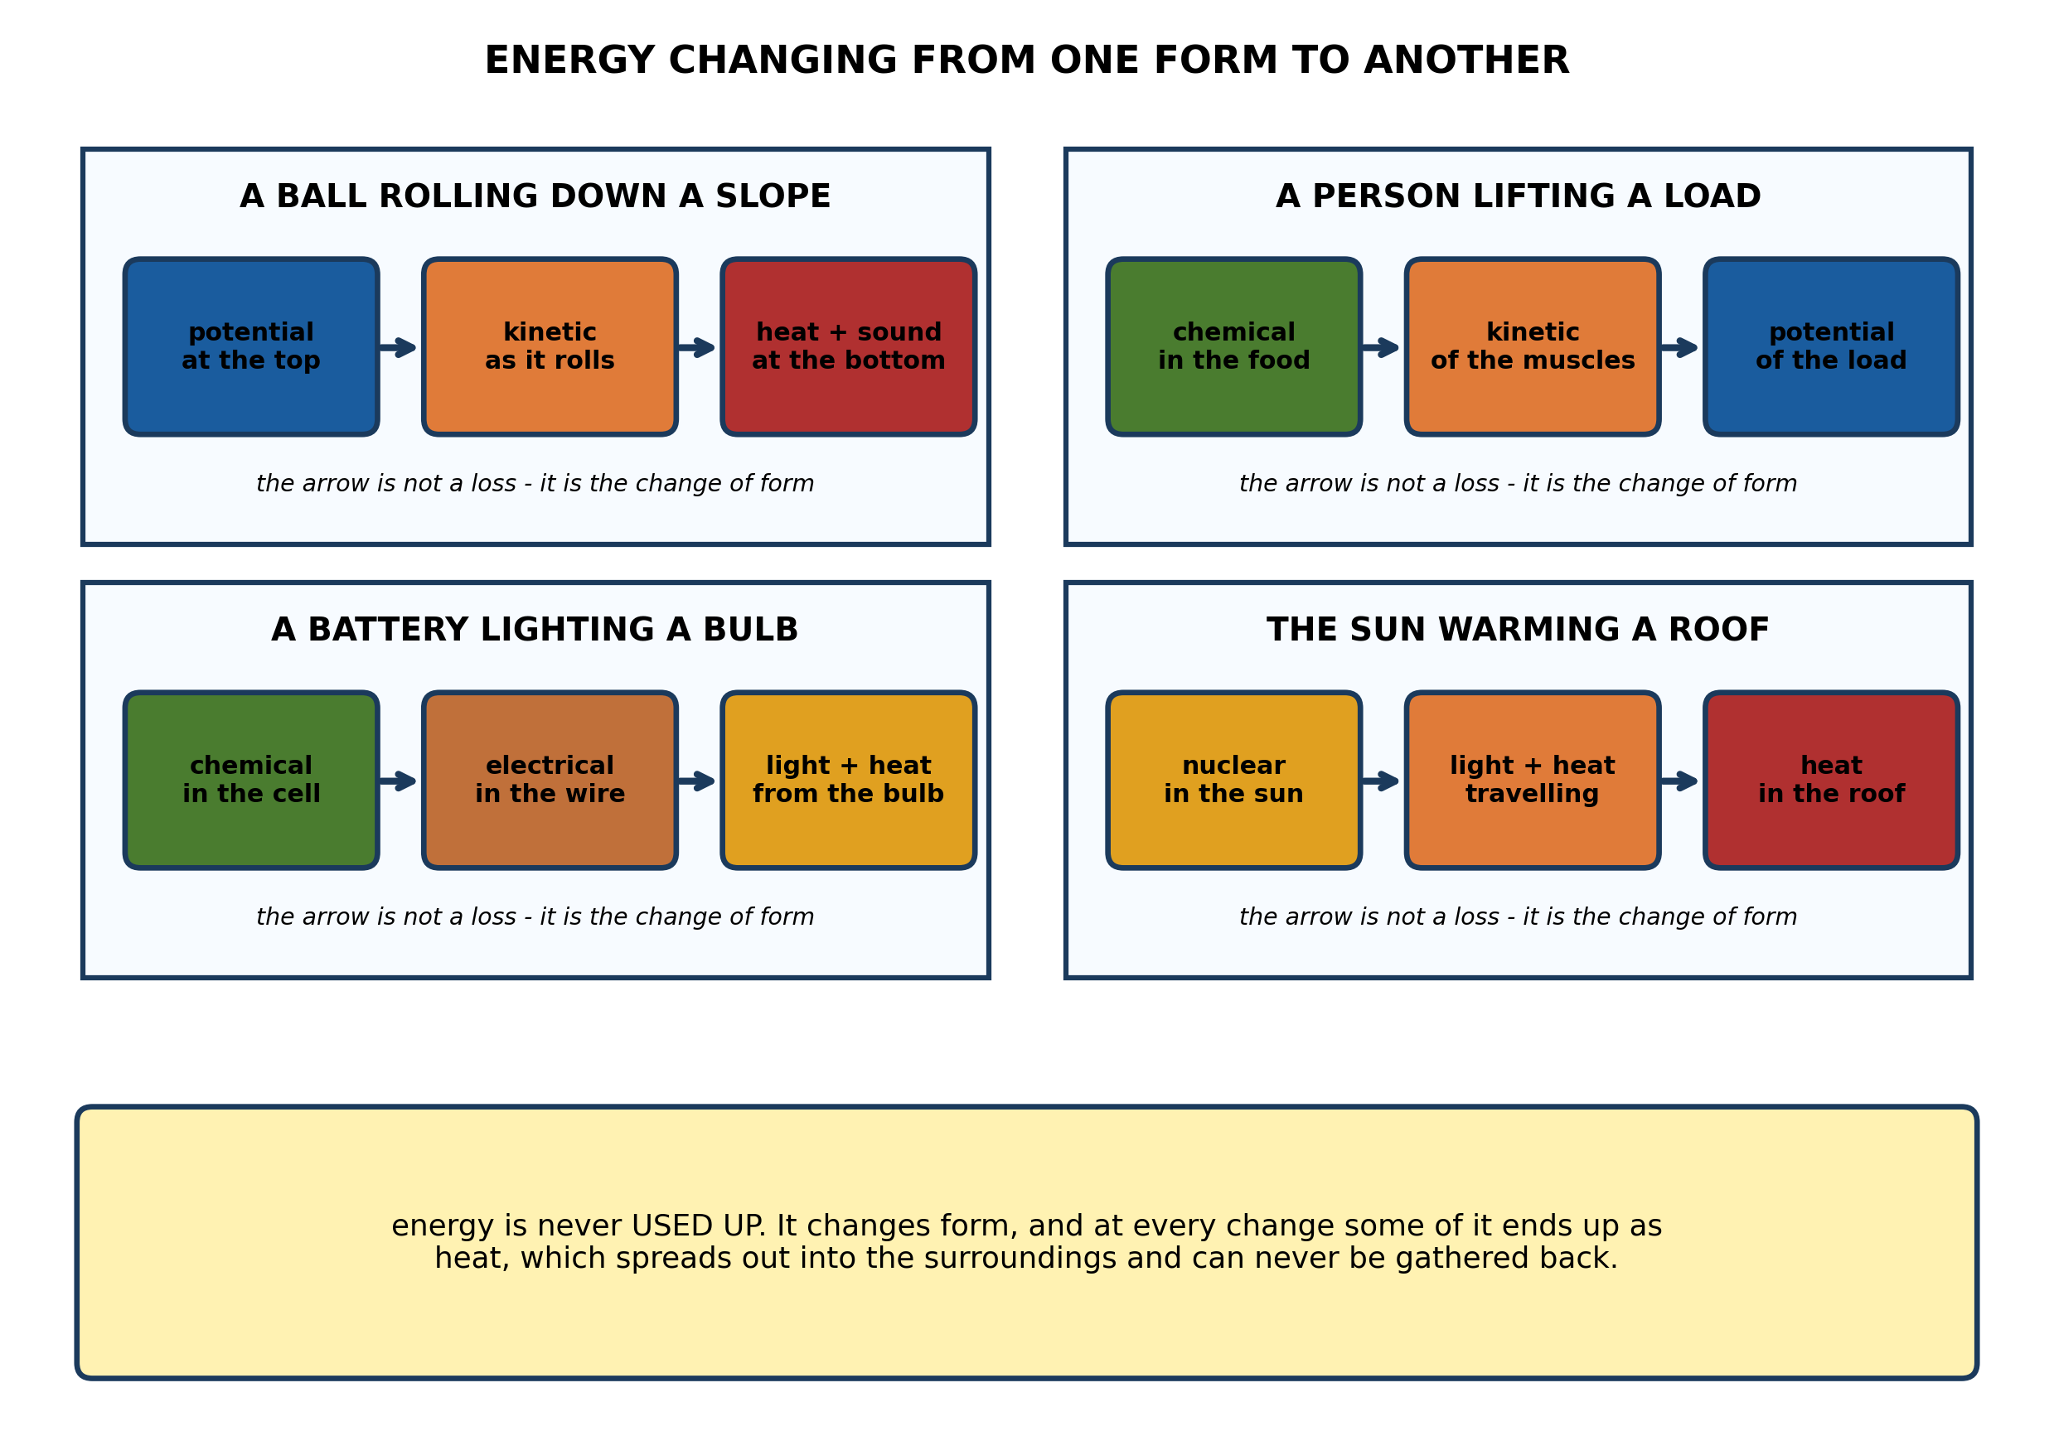
Fig. 1: Energy changing from one form to another

13.1 13.1 The Law of Conservation of Energy
1. A ball rolls down a slope. Describe the energy changes that take place, and explain why the ball eventually comes to a stop even though energy cannot be destroyed. [4 marks]
2. Name any THREE forms of energy. [3 marks]
3. For each of the following, state the energy change that takes place: (a) a torch being switched on; (b) a piece of charcoal burning; (c) a bowstring being pulled back and then released. [3 marks]
____________________________________________________________________________________________
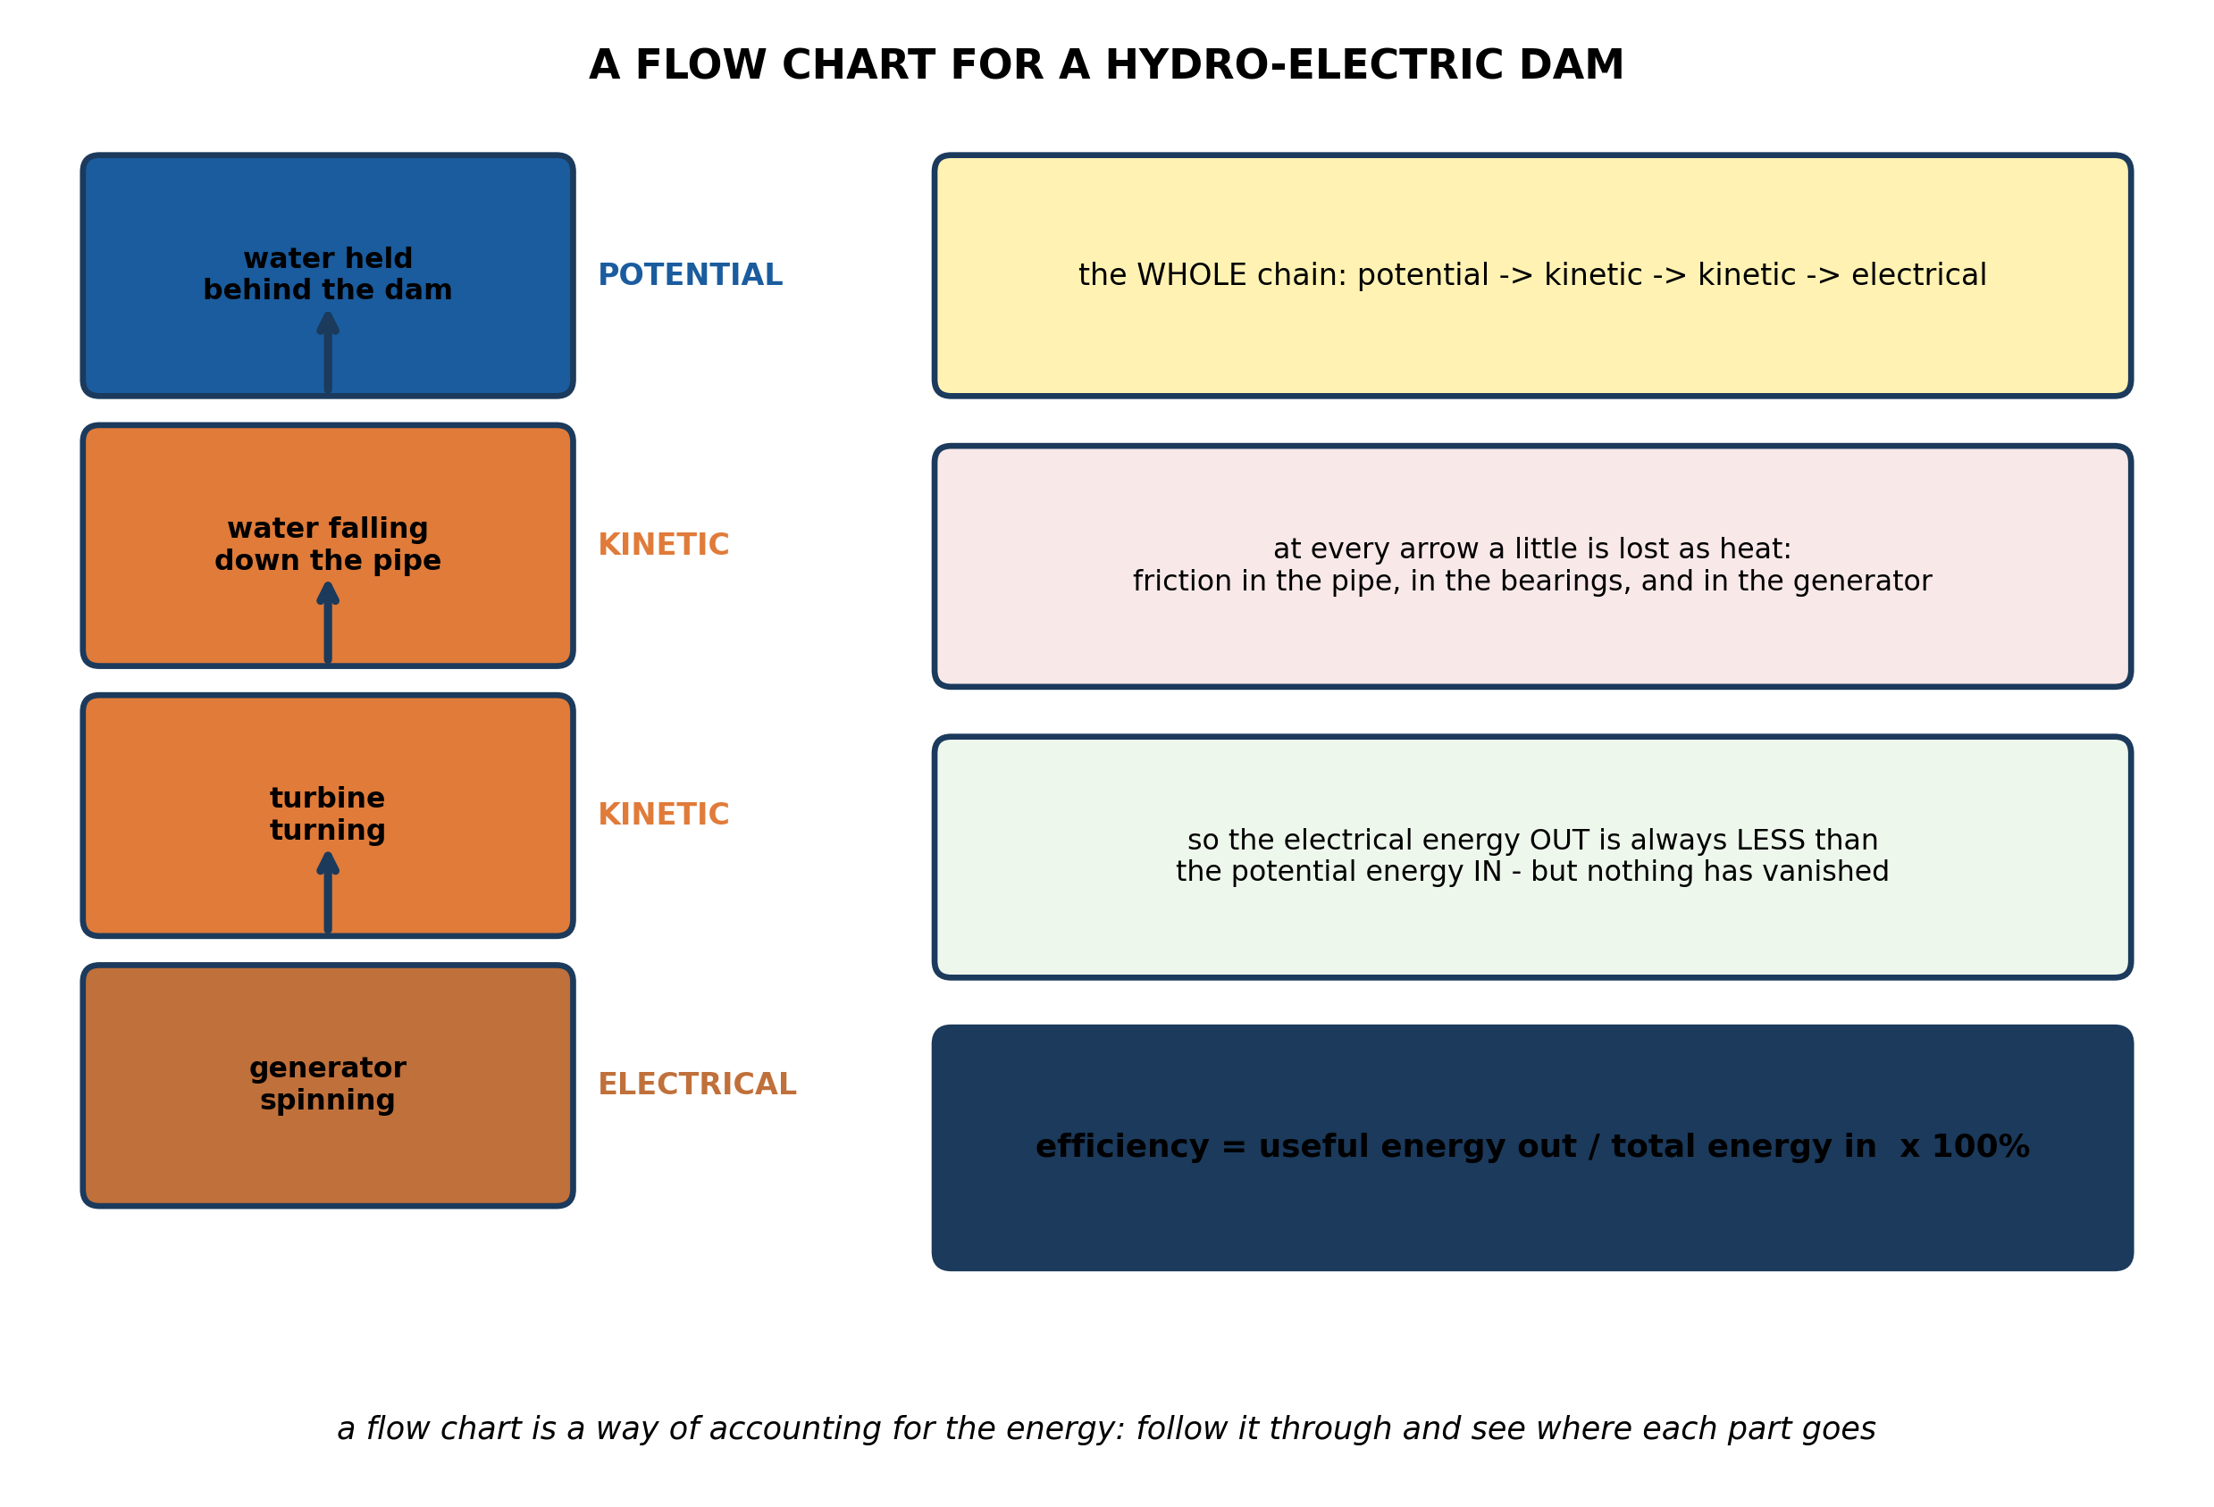
Fig. 2: A flow chart for a hydro-electric dam

13.2 13.2 Energy Conversion
4. Describe the energy flow chart for a hydro-electric dam, naming the form of energy at each stage. [4 marks]
5. Explain why the ELECTRICAL energy produced by a hydro-electric dam is always less than the POTENTIAL energy stored in the water behind it, and say what has happened to the difference. [3 marks]
6. State what is meant by the EFFICIENCY of an energy conversion. [3 marks]
____________________________________________________________________________________________
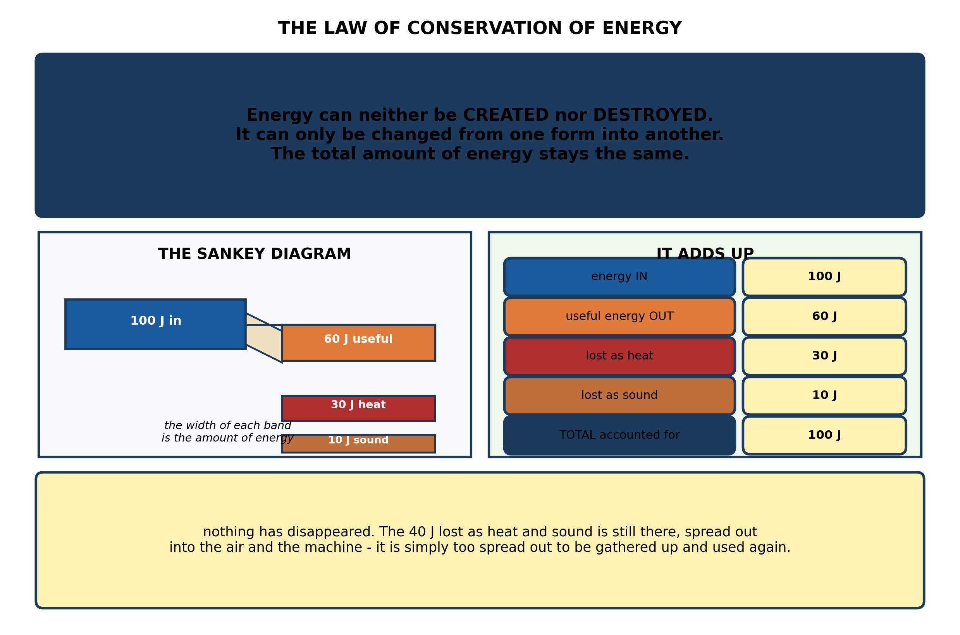
Fig. 3: The law of conservation of energy

13.3 13.3 Everyday Examples of Energy Conversion
7. State the law of conservation of energy. A pupil says that if energy cannot be destroyed, a car ought to run for ever on one tank of fuel. Explain why the pupil is wrong. [4 marks]
8. A machine takes in 100 J of energy and delivers 60 J of useful energy, 30 J as heat and 10 J as sound. Show that this agrees with the law of conservation of energy, and calculate the efficiency. [3 marks]
9. State what a SANKEY diagram shows, and what the width of each band represents. [3 marks]
____________________________________________________________________________________________
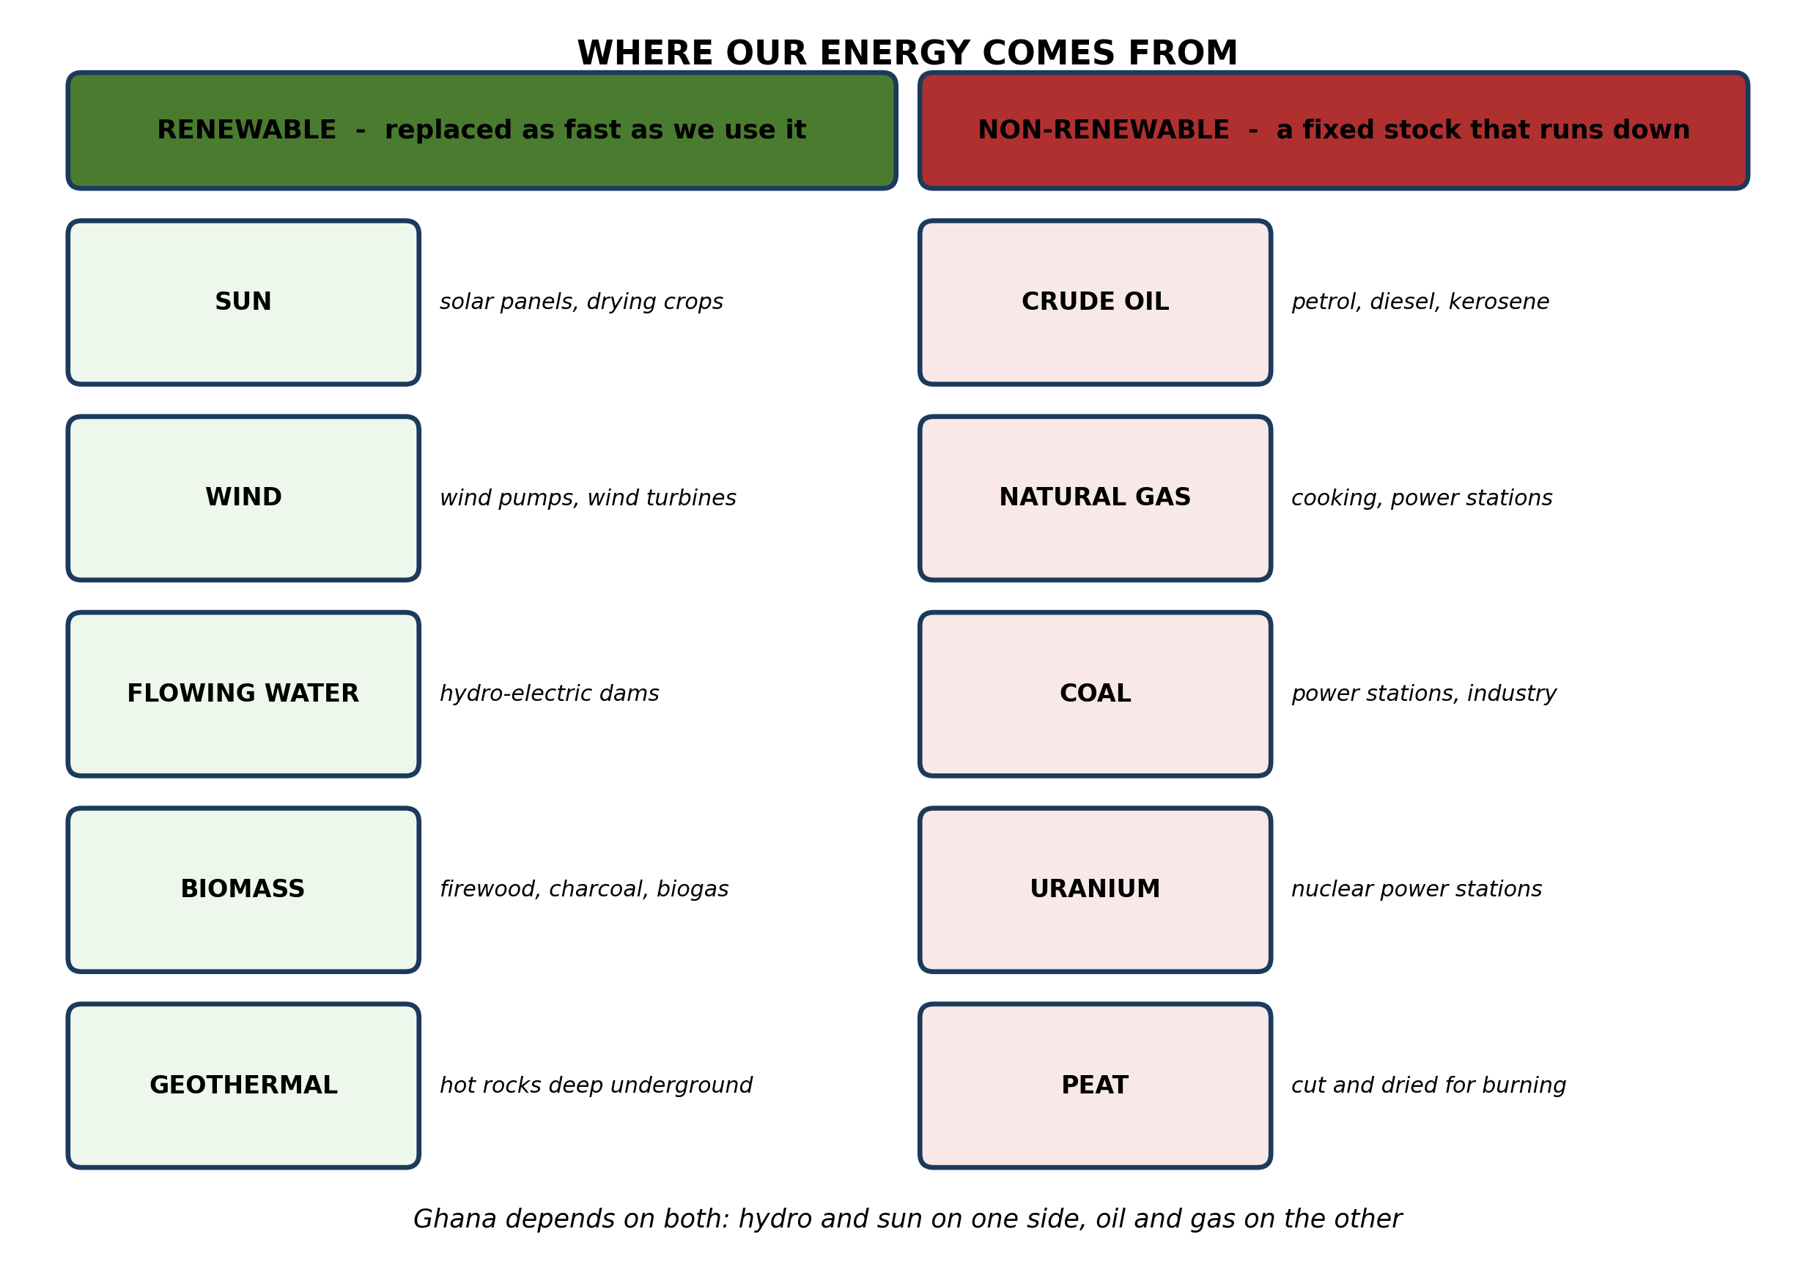
Fig. 4: Where our energy comes from

13.4 13.4 Conserving Energy for Future Use
10. Explain the difference between a RENEWABLE and a NON-RENEWABLE source of energy, and explain why calling firewood renewable is true only under one condition. [4 marks]
11. A village in the Northern Region needs energy for COOKING and for LIGHTING. Suggest ONE renewable source for each, and explain why each suits that village. [3 marks]
12. Name THREE non-renewable sources of energy, and state one use of each. [3 marks]
____________________________________________________________________________________________
SECTION B - PRACTICAL TASK
Study the apparatus and answer the questions that follow it.
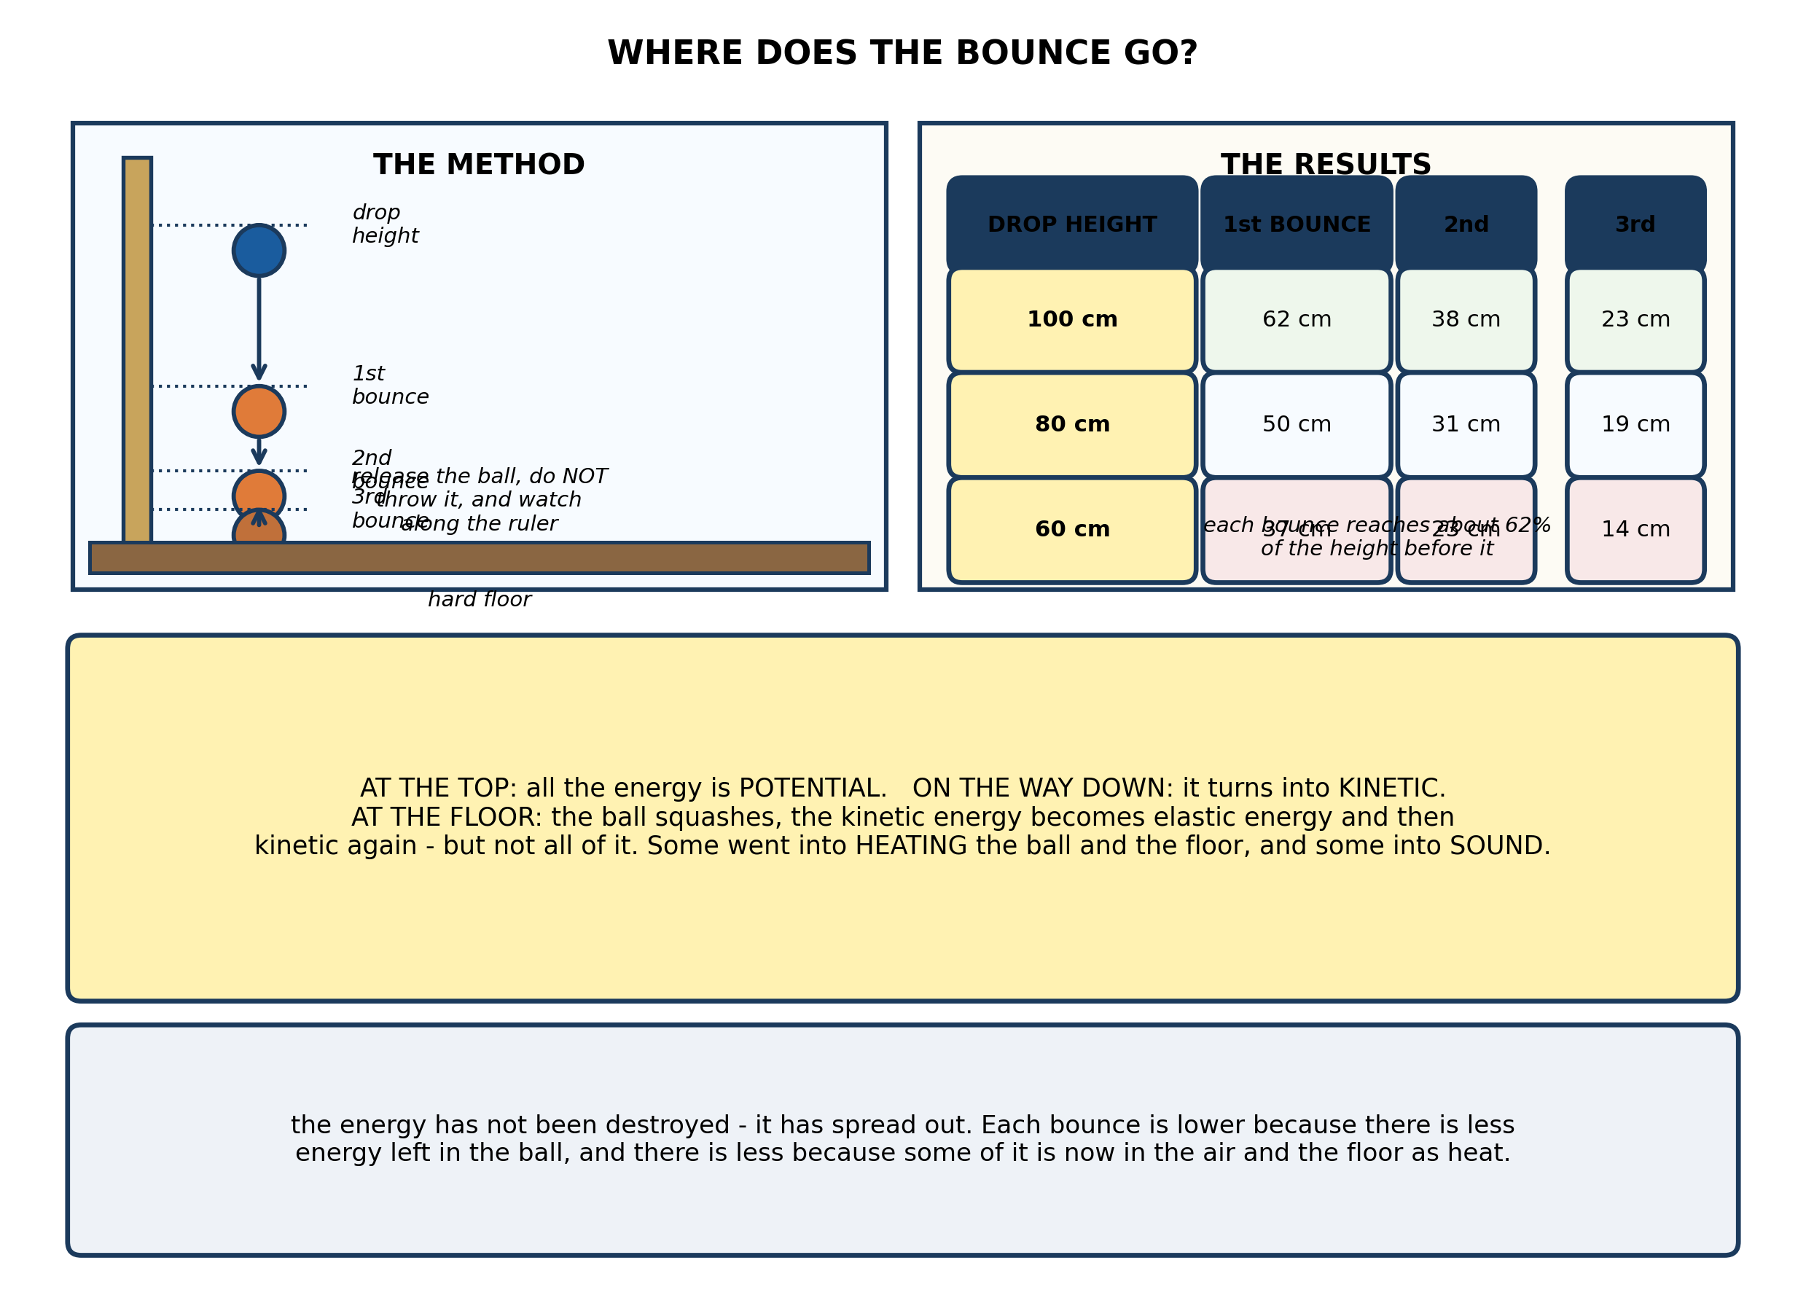
Fig. 5: Where does the bounce go?

13. Describe the energy changes as the ball falls and bounces, and explain why each bounce is lower than the one before it even though energy is conserved. [4 marks]
14. From the results, state what fraction of its height the ball reaches after each bounce, and use it to calculate the height of the SECOND bounce if the ball is dropped from 40 cm. [3 marks]
15. State TWO difficulties in measuring the bounce height accurately, and say how each one could be reduced. [3 marks]
____________________________________________________________________________________________

ANSWER KEY AND MARKING SCHEME
Accept any other correct and relevant answer. Award marks for correct points, not for repeating the question.
13.1 13.1 The Law of Conservation of Energy
Q1
At the top of the slope the ball has gravitational POTENTIAL energy because of its height above the bottom. As it rolls down, that potential energy is converted into KINETIC energy and the ball speeds up. Once it is on the flat, friction with the ground and air resistance act against its motion, so the kinetic energy is gradually converted into HEAT - warming the ball, the ground and the air very slightly - and into SOUND. So the ball slows and stops. The energy has not been destroyed: there is exactly as much as there was at the top. But it is now spread out as low-grade heat in the surroundings, far too scattered to be gathered back together and used again. Conservation of energy is not the same as conservation of usefulness.
Q2
Any three of: gravitational potential, kinetic, heat, light, sound, chemical, electrical, nuclear, elastic (strain).
Q3
(a) Chemical energy stored in the cells becomes electrical energy in the circuit, which becomes light and heat at the bulb. (b) Chemical energy stored in the charcoal becomes heat and light. (c) Pulling back: kinetic energy from your arm becomes elastic potential energy stored in the bent bow and stretched string. On release: that elastic potential energy becomes kinetic energy of the string and the arrow, with some heat and sound.
13.2 13.2 Energy Conversion
Q4
Water held behind the dam: gravitational POTENTIAL energy, because it is high up. Water falling down the pipe: KINETIC energy, as the potential energy is converted into movement. Water striking the turbine: KINETIC energy of the spinning turbine and shaft. Generator: the spinning shaft drives the generator and the output is ELECTRICAL energy, carried by cables to homes, where it becomes light, heat or kinetic energy depending on the appliance. At every stage some energy leaves the useful path as heat - friction between the water and the pipe, friction in the turbine bearings, electrical resistance in the generator windings - and as sound.
Q5
At every conversion a little energy leaves the useful path. Some water splashes or leaks past the turbine without driving it. Friction between the water and the pipe wall, and in the turbine bearings, turns energy into heat. The generator has resistance in its windings, which warms it, and friction in its own bearings. Turbulence and the impact of the water make sound. All of that is energy that still exists but is no longer in the electrical output. So the electrical energy out is less than the potential energy in, and the difference has become heat in the water, the machine and the air, plus a little sound. Nothing has been destroyed - the useful output is simply smaller than the input.
Q6
The fraction of the energy put in that comes out in the useful form, usually given as a percentage: efficiency = (useful energy output / total energy input) x 100%. The rest is not destroyed, but has been converted into forms that are not wanted.
13.3 13.3 Everyday Examples of Energy Conversion
Q7
The law states that energy can neither be created nor destroyed; it can only be changed from one form into another, and the total amount in a closed system stays constant. The pupil is right that none of the fuel's energy is destroyed, but wrong to think that means it stays available. As the car runs, the chemical energy in the fuel is converted into kinetic energy, heat and sound. The heat goes into the engine, the exhaust gases, the tyres, the road and the air, where it spreads out. Once energy is spread out as low-grade heat it cannot be gathered back up and concentrated again to drive the car. So the car does not run for ever - not because the energy has gone, but because it has become unavailable. This is the difference between conserving energy and conserving its usefulness.
Q8
Total energy out = 60 J + 30 J + 10 J = 100 J, which is exactly the energy put in. Every joule is accounted for, so the law holds. Efficiency = useful energy output / total energy input x 100% = 60 / 100 x 100 = 60%.
Q9
A Sankey diagram is an energy-flow diagram drawn to scale. The width of each band is proportional to the amount of energy flowing along that path. One band carries the total input in, and it splits into a band for the useful output and separate bands for each loss, so you can see at a glance how much is wasted and where it goes.
13.4 13.4 Conserving Energy for Future Use
Q10
A renewable source is one that natural processes replace at least as fast as we use it, so the stock does not run down - sun, wind, flowing water, geothermal heat, and biomass that is properly managed. A non-renewable source is a fixed stock laid down over millions of years that we are using far faster than it can ever be replaced - oil, natural gas, coal, uranium, peat; once it is burnt it is gone for good. Firewood is renewable only if trees are replanted and allowed to grow at least as fast as they are cut. In parts of Ghana wood is taken for firewood and charcoal faster than it regrows, and there it behaves exactly like a non-renewable source: the stock falls year by year. Being renewable is not a property of the material alone, it is a property of how fast we use it.
Q11
For cooking: biogas made from animal dung and crop waste in a digester - the village has animals, the gas burns cleanly, and the slurry left over is a rich fertiliser for the fields. A well-managed woodlot is an acceptable alternative, but only if the village plants as fast as it cuts. For lighting: solar, because the north has long hours of strong sunshine for much of the year with little cloud. A panel and a battery need no fuel and no connection to the national grid, which matters in a remote village, and the running cost is almost nothing.
Q12
Any three, each with a use. Crude oil - petrol and diesel for vehicles. Natural gas - cooking and power stations. Coal - power stations and industry. Uranium - nuclear power stations. Peat - cut, dried and burnt as a domestic fuel.
PRACTICAL TASK
Q13
Held at the drop height, the ball has gravitational POTENTIAL energy. As it falls that becomes KINETIC energy, and it is moving fastest just before it strikes the floor. On impact the ball squashes, so the kinetic energy becomes ELASTIC potential energy in the deformed rubber and the compressed air inside; as it springs back, that elastic energy becomes kinetic energy again and the ball leaves the floor. But not all of it comes back. Some was turned into heat by internal friction as the rubber deformed, some into sound, and some into heating the floor. So the ball leaves the floor with less kinetic energy than it arrived with, rises to a lower height, and each bounce is about 62% of the one before. Energy is conserved - the total is unchanged - but with every bounce more of it is spread out as heat and sound, and less is left in the ball as movement.
Q14
Dropped from 100 cm the first bounce is 62 cm, so about 62% - a fraction of 0.62 - of the drop height. The second bounce is 38 cm, and 38 / 62 = 0.61, again about 62% of the first bounce. So each bounce reaches roughly 0.62 of the height before it. Dropped from 40 cm: the first bounce is about 0.62 x 40 = 25 cm, and the second is about 0.62 x 25 = 15.5 cm, so roughly 15 or 16 cm. Accept any answer in the range 15-16 cm, and accept a slightly different constant such as 0.6 if the pupil has used it consistently.
Q15
Any two, each with a fix. The top of the bounce lasts only an instant, so it is hard to read against the ruler - have one pupil watch from directly in front at eye level and call it out, or film the bounce and step through it frame by frame. Parallax: the eye must be level with the top of the ball; if it is above or below, the reading is wrong - so the observer should kneel or stand to get level. The ball may not bounce straight up or may spin - use a flat hard floor and release it cleanly without pushing. Always read the same part of the ball each time, so the measurement is consistent.

BLUEPRINT / TEST SPECIFICATION
# | Content standard | Code | Items | Marks | % of Marks
13.1 | 13.1 The Law of Conservation of Energy | B7/JHS1.4.3.1 | 3 | 10 | 20%
13.2 | 13.2 Energy Conversion | B7/JHS1.4.3.1 | 3 | 10 | 20%
13.3 | 13.3 Everyday Examples of Energy Conversion | B7/JHS1.4.3.1 | 3 | 10 | 20%
13.4 | 13.4 Conserving Energy for Future Use | B7/JHS1.4.3.1 | 3 | 10 | 20%
13.1 | Practical task | B7/JHS1.4.3.1 | 3 | 10 | 20%
TOTAL | - | - | 15 | 50 | 100%
Distribution by cognitive level
Cognitive level | Marks | % of Marks
Understand | 12 | 24%
Apply | 22 | 44%
Analyse | 16 | 32%
TOTAL | 50 | 100%
Distribution by difficulty
Difficulty | Marks | % of Marks
Easy | 3 | 6%
Moderate | 28 | 56%
Challenging | 19 | 38%
TOTAL | 50 | 100%

QUALITY-CONTROL SUMMARY
1. Is every question answered from a diagram?
Yes. All 15 questions sit under a figure, and each is unanswerable - or at least materially harder - without reading it. Questions 3, 8, 10 and 17 ask pupils to go beyond the diagram, but each still starts from something the figure shows.
2. Is the content within the Basic 7 curriculum?
Yes. Every question traces to the content standards for this sub-strand (B7/JHS1.4.3.1), and nothing is tested beyond the depth the Basic 7 syllabus sets for it.
3. Are the diagrams clear and unambiguous?
Yes. Each is drawn so that only one reading is sensible: the particle boxes differ in spacing alone, the syringes are labelled with how far each squashes, and the periodic table marks the regions in words as well as by position.
4. Is the level right for JHS 1?
Yes. Questions ask pupils to read, describe and explain what is drawn. Only Question 17 asks for an inference beyond the figure, and it is worth 3 of the 40 marks.
5. Do the marks add up?
Yes: 15 questions totalling 50 marks, matching the figure on the front page. The blueprint, cognitive and difficulty tables all sum to the same total.
6. Are the answers correct and complete?
Yes. Each answer states the point the question is worth, with the acceptable alternatives given where a question is open.
EXAMINER NOTES (for the teacher, not for candidates)
- Pitched at the compulsory diagram question of BECE Paper 2: 76% of the marks are at Apply level or above and 38% are Challenging.
- Q7 is the question the whole strand exists to answer, and it is the one that catches the able pupils as well as the weak ones. 'Energy cannot be destroyed, so why does the car stop?' The answer is the distinction between conservation and AVAILABILITY: the energy is all still there, spread out as low-grade heat. Pupils who reach for 'it is used up' have missed the law they have just stated. Worth doing at the board before the class meets the practical.
- Q1 is the same idea in a simpler setting, and it is a good one to set first. The sentence to aim for is 'it has not gone, it has spread out'.
- Q10 on firewood is where 13.4 stops being a list. Being renewable is not a property of the material - it is a property of the rate at which we take it. In much of Ghana firewood is being cut faster than it regrows, so in practice it is behaving as a non-renewable source. Pupils in the north will have seen this.
- Q5 and Q8 are the pair that turn the law into arithmetic. Q8 is deliberately easy - 60 + 30 + 10 = 100 - so the pupil who gets it wrong has an accounting problem, not a physics problem.
- The bouncing-ball practical needs a metre rule clamped vertically, a hard floor (a concrete or tiled one, not a mat), and a ball with a good bounce - a tennis ball or a rubber ball, not a football. The awkward part is reading the top of the bounce; a phone video stepped through frame by frame is worth the trouble if you have one.
- Watch for pupils who throw the ball down instead of releasing it - that adds energy at the start and the first bounce comes out anomalously high. The instruction to release, not throw, is worth saying twice.

