[SCHOOL NAME]
INTEGRATED SCIENCE (SCIENCE)
PRACTICAL QUESTIONS - DIAGRAM MODE
Crop Production (5.1 - 5.6)
____________________________________________________________________________________________
CLASS: Basic 7 (JHS 1)
TIME: 1 hour 30 minutes
MARKS: 50 2025/2026 Academic Year
____________________________________________________________________________________________
INSTRUCTIONS TO CANDIDATES
1. Answer ALL the questions in this paper.
2. Every question is based on a diagram. Study each diagram carefully before you answer the questions that follow it.
3. Write your answers in the spaces provided. The marks for each question are printed beside it.
4. Where a question asks for a stated number of points, give that number. Any extra answers will not be marked.
5. You may refer back to any diagram at any time.
____________________________________________________________________________________________
SECTION A - DIAGRAM STUDY
Study each diagram and answer the questions that follow it.
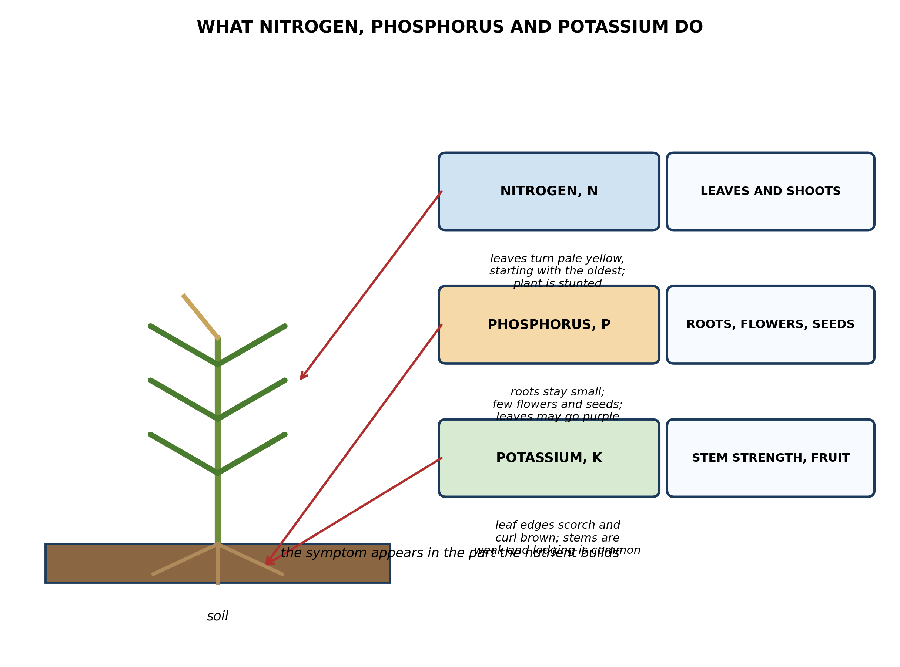
Fig. 1: What nitrogen, phosphorus and potassium do

5.1 5.1 What are Plant Nutrients?
1. A farmer's maize has pale yellow leaves, but only the OLDEST leaves are yellow while the youngest ones at the top are still green. Use the diagram to name the nutrient that is missing, and explain why the symptom appears in the oldest leaves first. [4 marks]
2. From the diagram, name TWO plant nutrients and state one thing each does for the crop. [2 marks]
____________________________________________________________________________________________
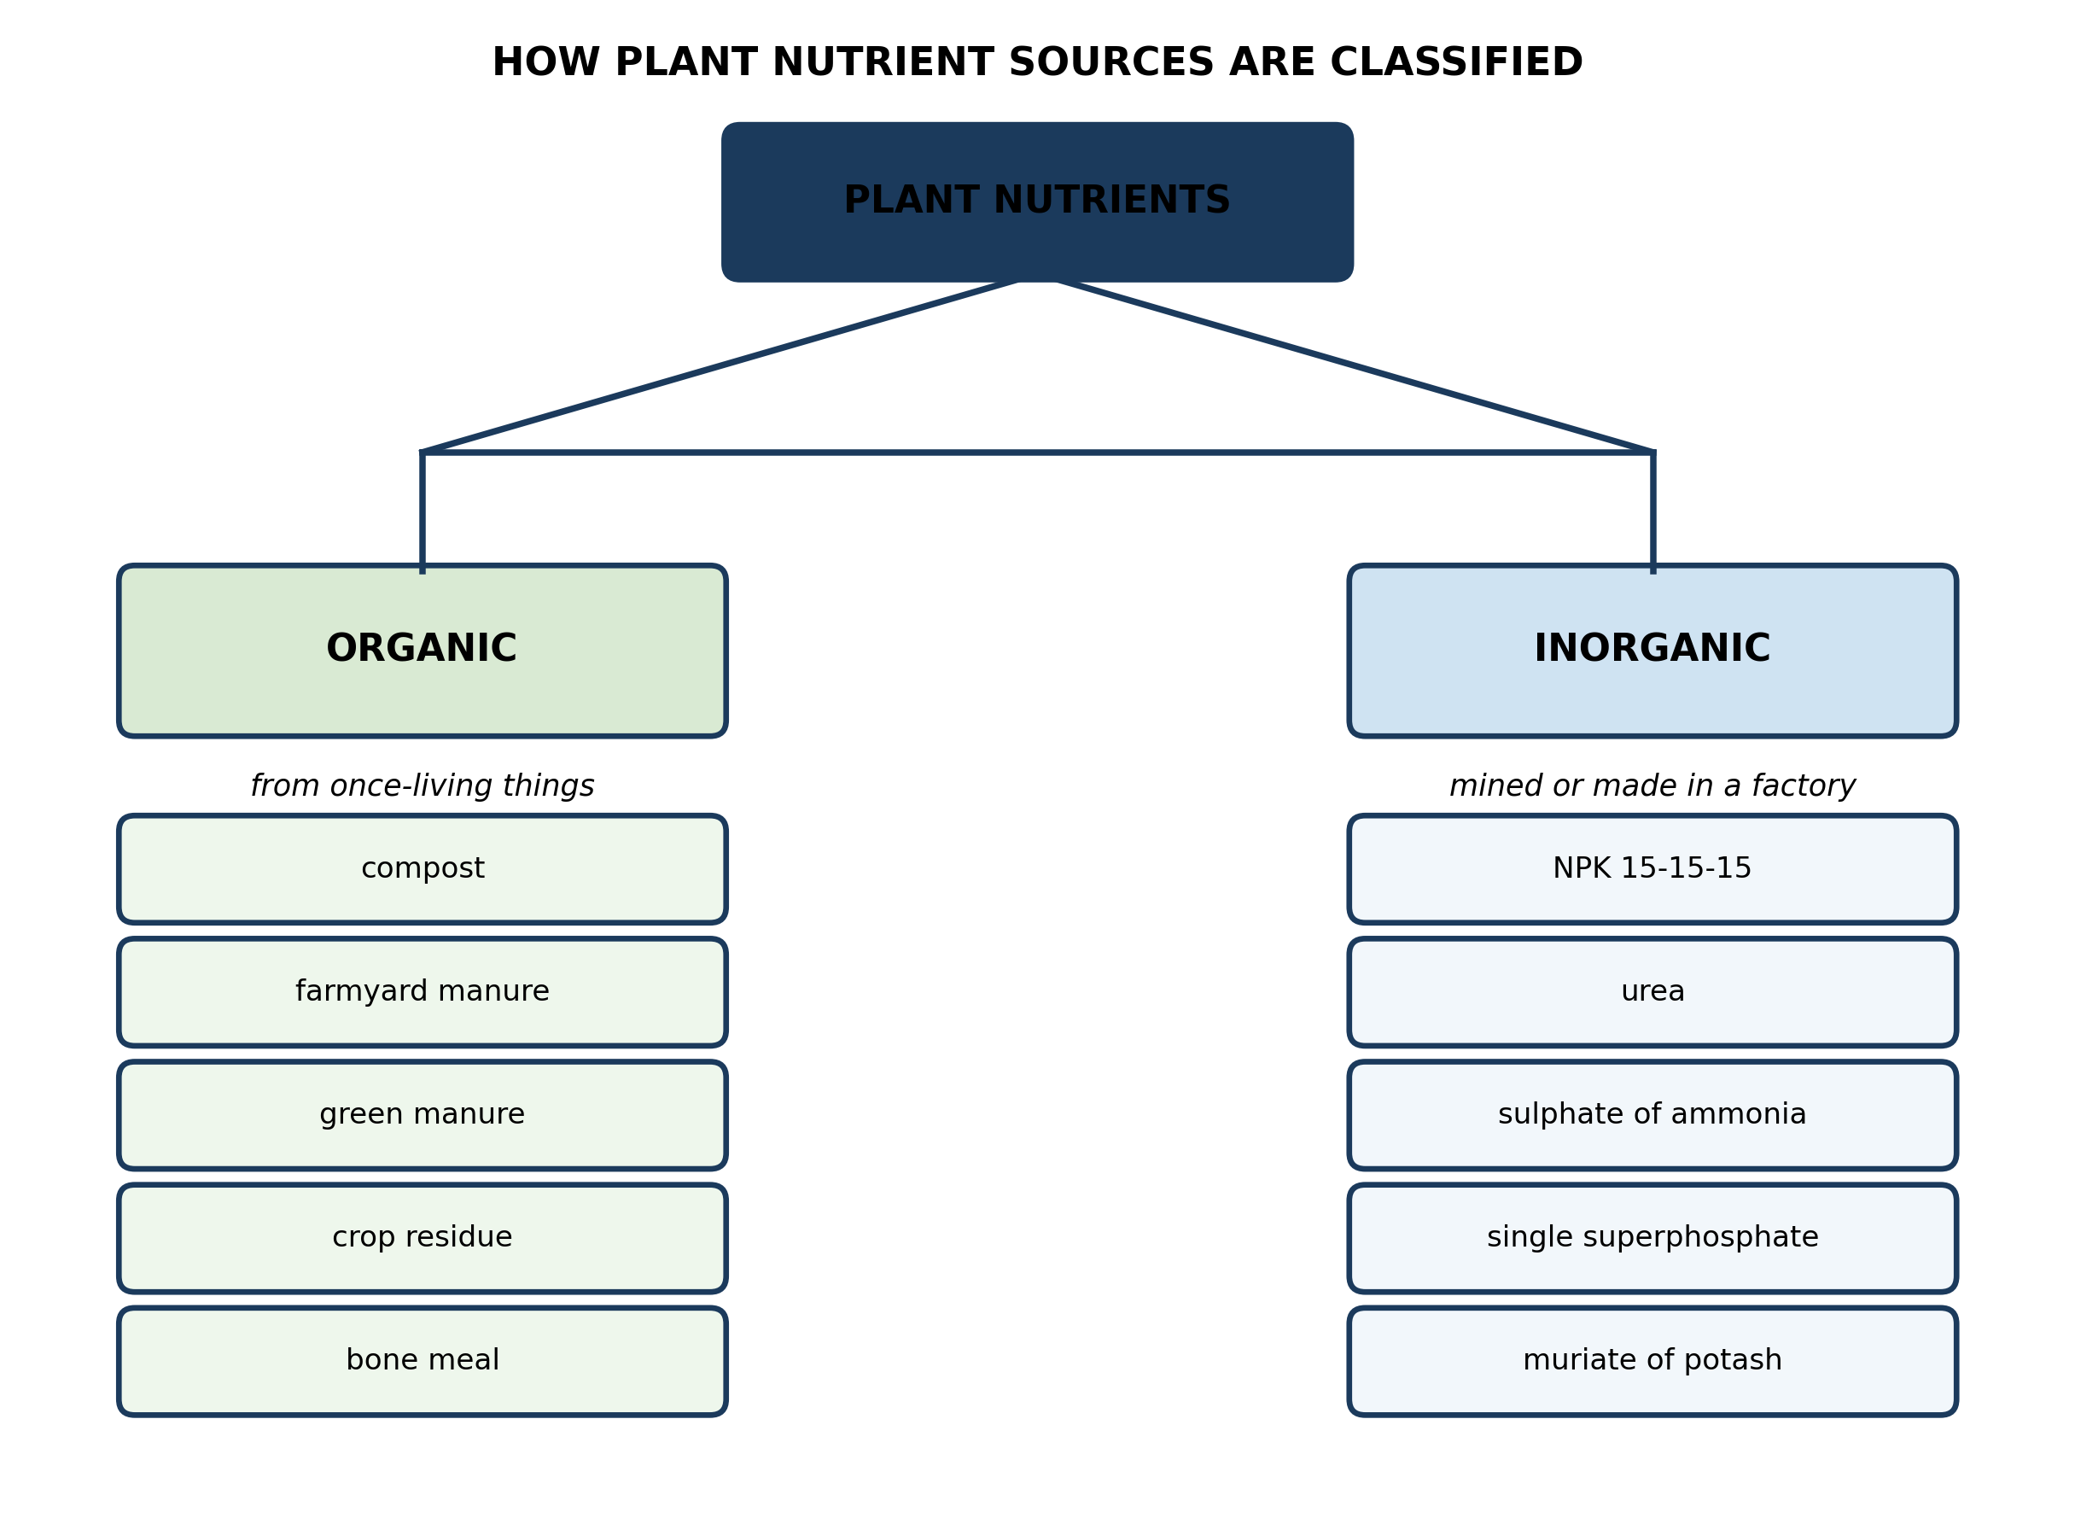
Fig. 2: How plant nutrient sources are classified

5.2 5.2 Organic and Inorganic Nutrient Sources
3. Urea is made in a factory from ammonia gas. Use the diagram to say whether urea is an ORGANIC or an INORGANIC nutrient source, and explain why. [3 marks]
4. At the end of harvest a farmer digs the old maize stalks and leaves back into the soil instead of burning them. Classify this material using the diagram, and explain why it will not feed the next crop straight away. [3 marks]
____________________________________________________________________________________________
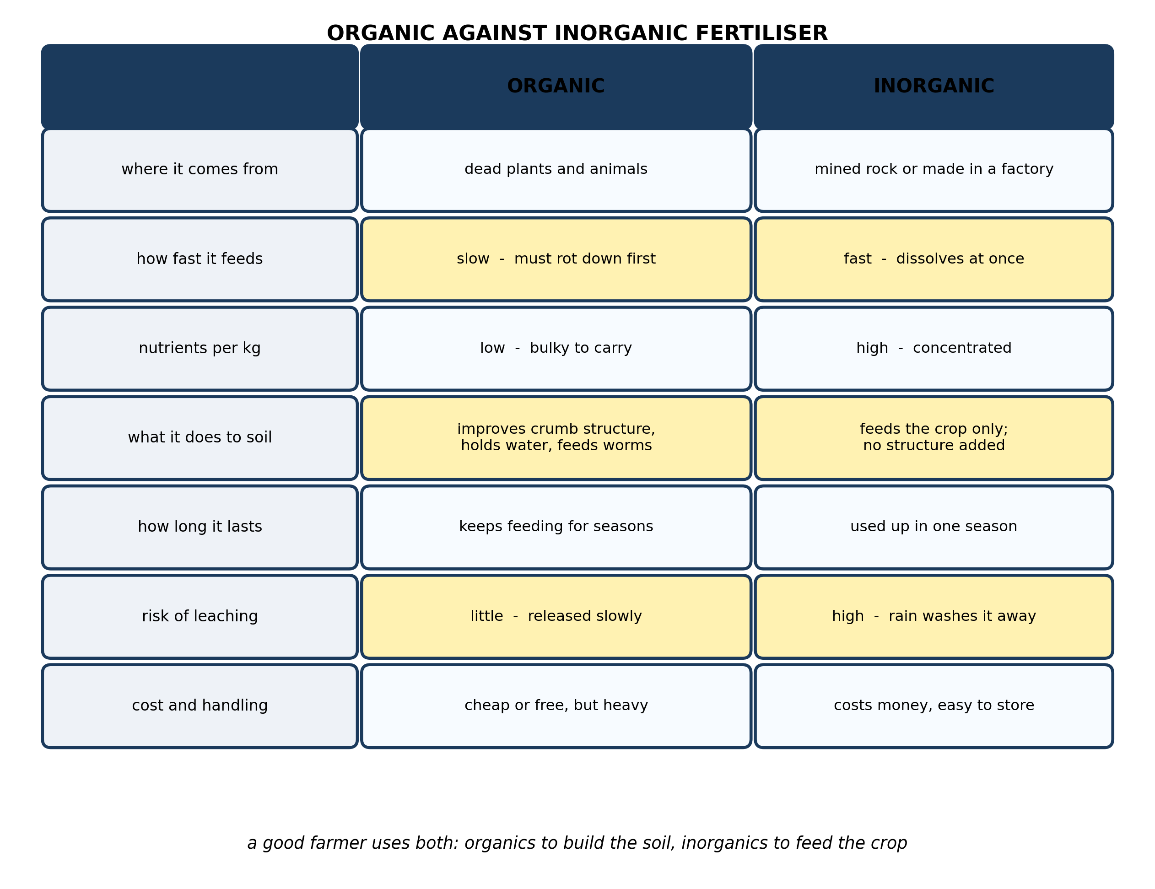
Fig. 3: Organic against inorganic fertiliser

5.3 5.3 Differences Between Organic and Inorganic Fertilizers
5. The diagram shows that organic fertiliser improves the soil while inorganic does not. Explain why a farmer who can afford both would still choose to apply inorganic fertiliser as well. [4 marks]
6. Heavy rain falls the day after fertiliser is applied to two fields, one given compost and one given NPK. Use the diagram to state which field loses more of its fertiliser, and explain why. [3 marks]
____________________________________________________________________________________________
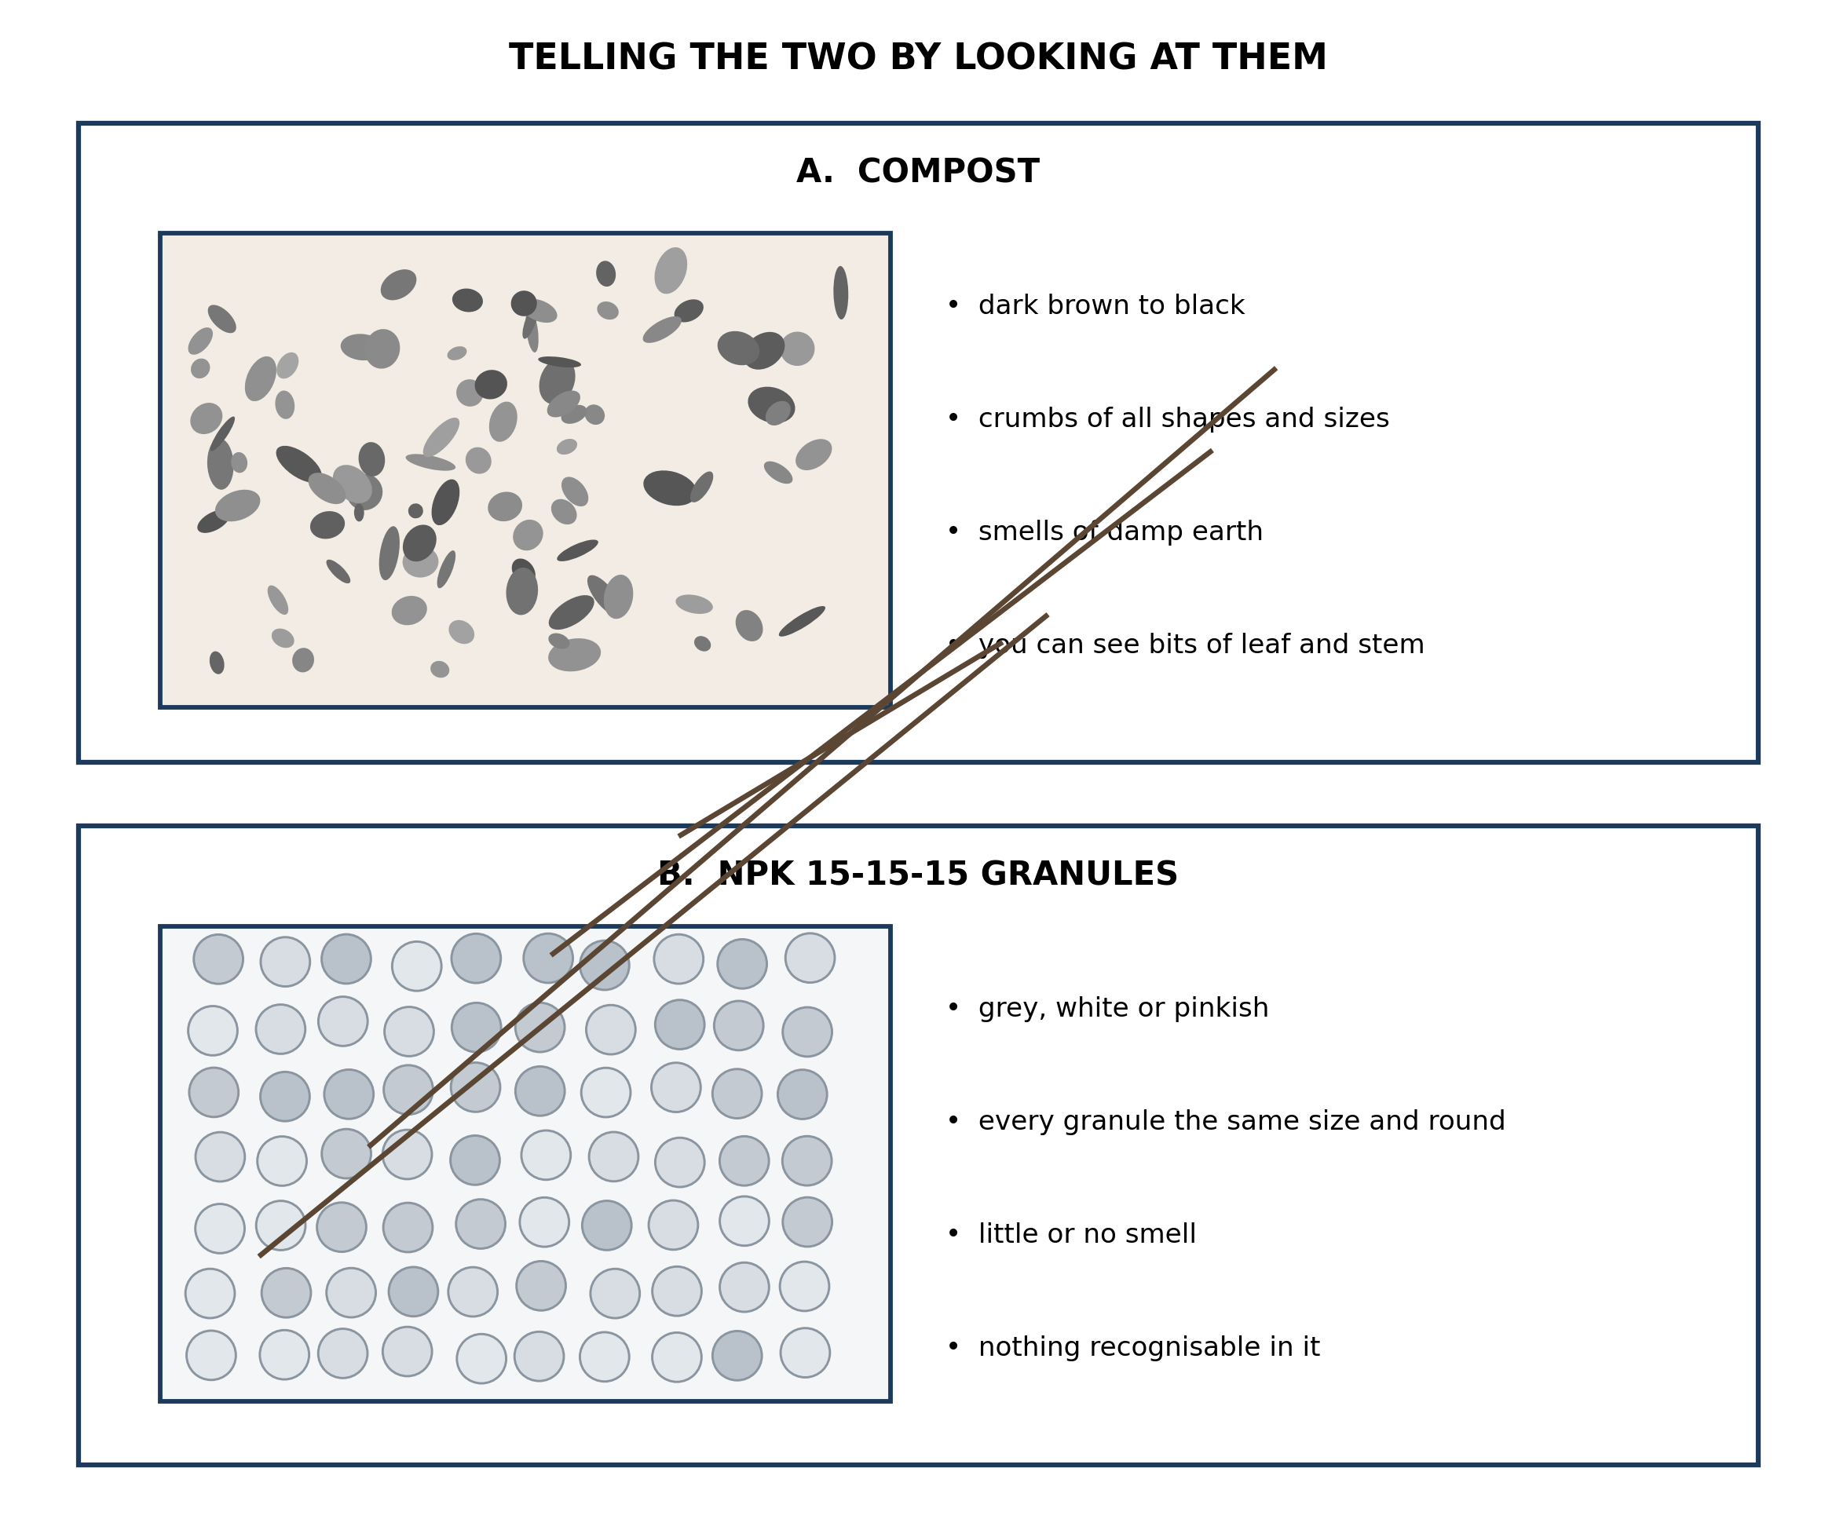
Fig. 4: Telling the two by looking at them

5.4 5.4 Physical Characteristics of Plant Nutrients
7. You are given a fertiliser sample with no label. Describe how you would tell from looking at it whether it is compost or NPK, and explain WHY the two look so different. [4 marks]
8. A pupil says that compost must be better than NPK because it is natural. Use the diagram to explain why 'natural' is not the point. [3 marks]
____________________________________________________________________________________________
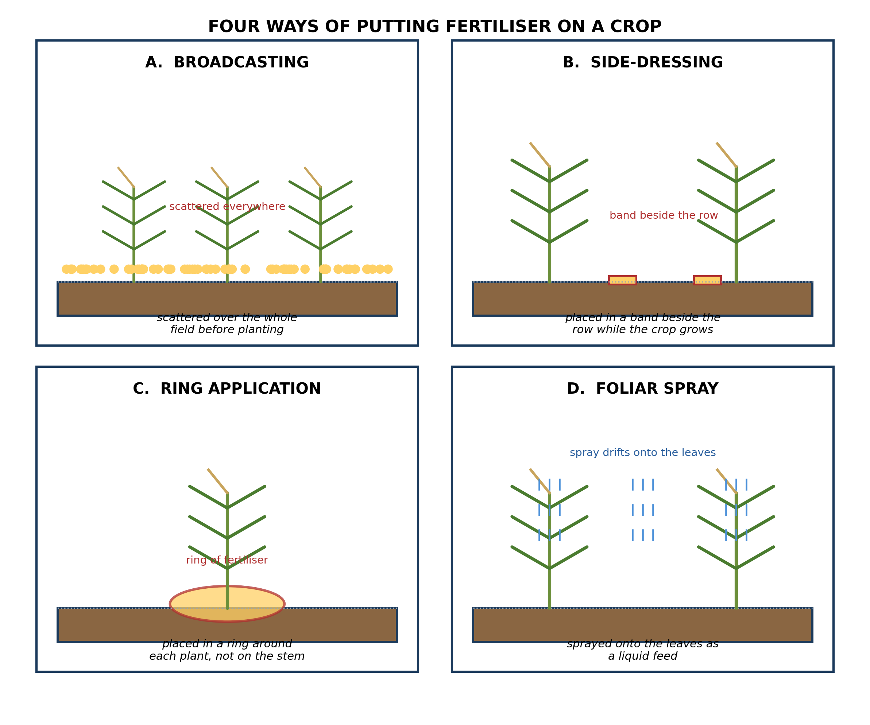
Fig. 5: Four ways of putting fertiliser on a crop

5.5 5.5 How Plant Nutrients Are Applied in the Field
9. A farmer wants to feed a maize crop that is already knee-high and growing fast. State which method from the diagram is best, and explain why broadcasting would be a poorer choice. [4 marks]
10. In ring application, the diagram shows the fertiliser placed in a ring AROUND the plant rather than against it. Explain why putting it directly against the stem would harm the plant. [3 marks]
____________________________________________________________________________________________
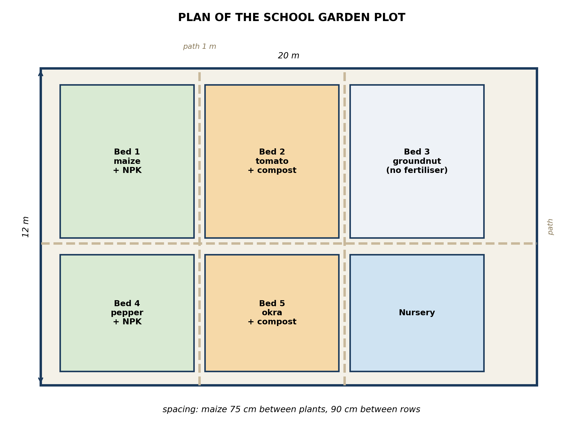
Fig. 6: Plan of the school garden plot

5.6 5.6 Practical Application in the School Garden
11. The plan leaves a path between every bed. Explain why the paths are needed, describing the harm that walking on the beds would do. [4 marks]
12. The plan gives NPK to Bed 1 and compost to Bed 2 rather than giving NPK to every bed. Suggest TWO reasons why a plan might do this. [3 marks]
____________________________________________________________________________________________
SECTION B - PRACTICAL TASK
Study the apparatus and answer the questions that follow it.
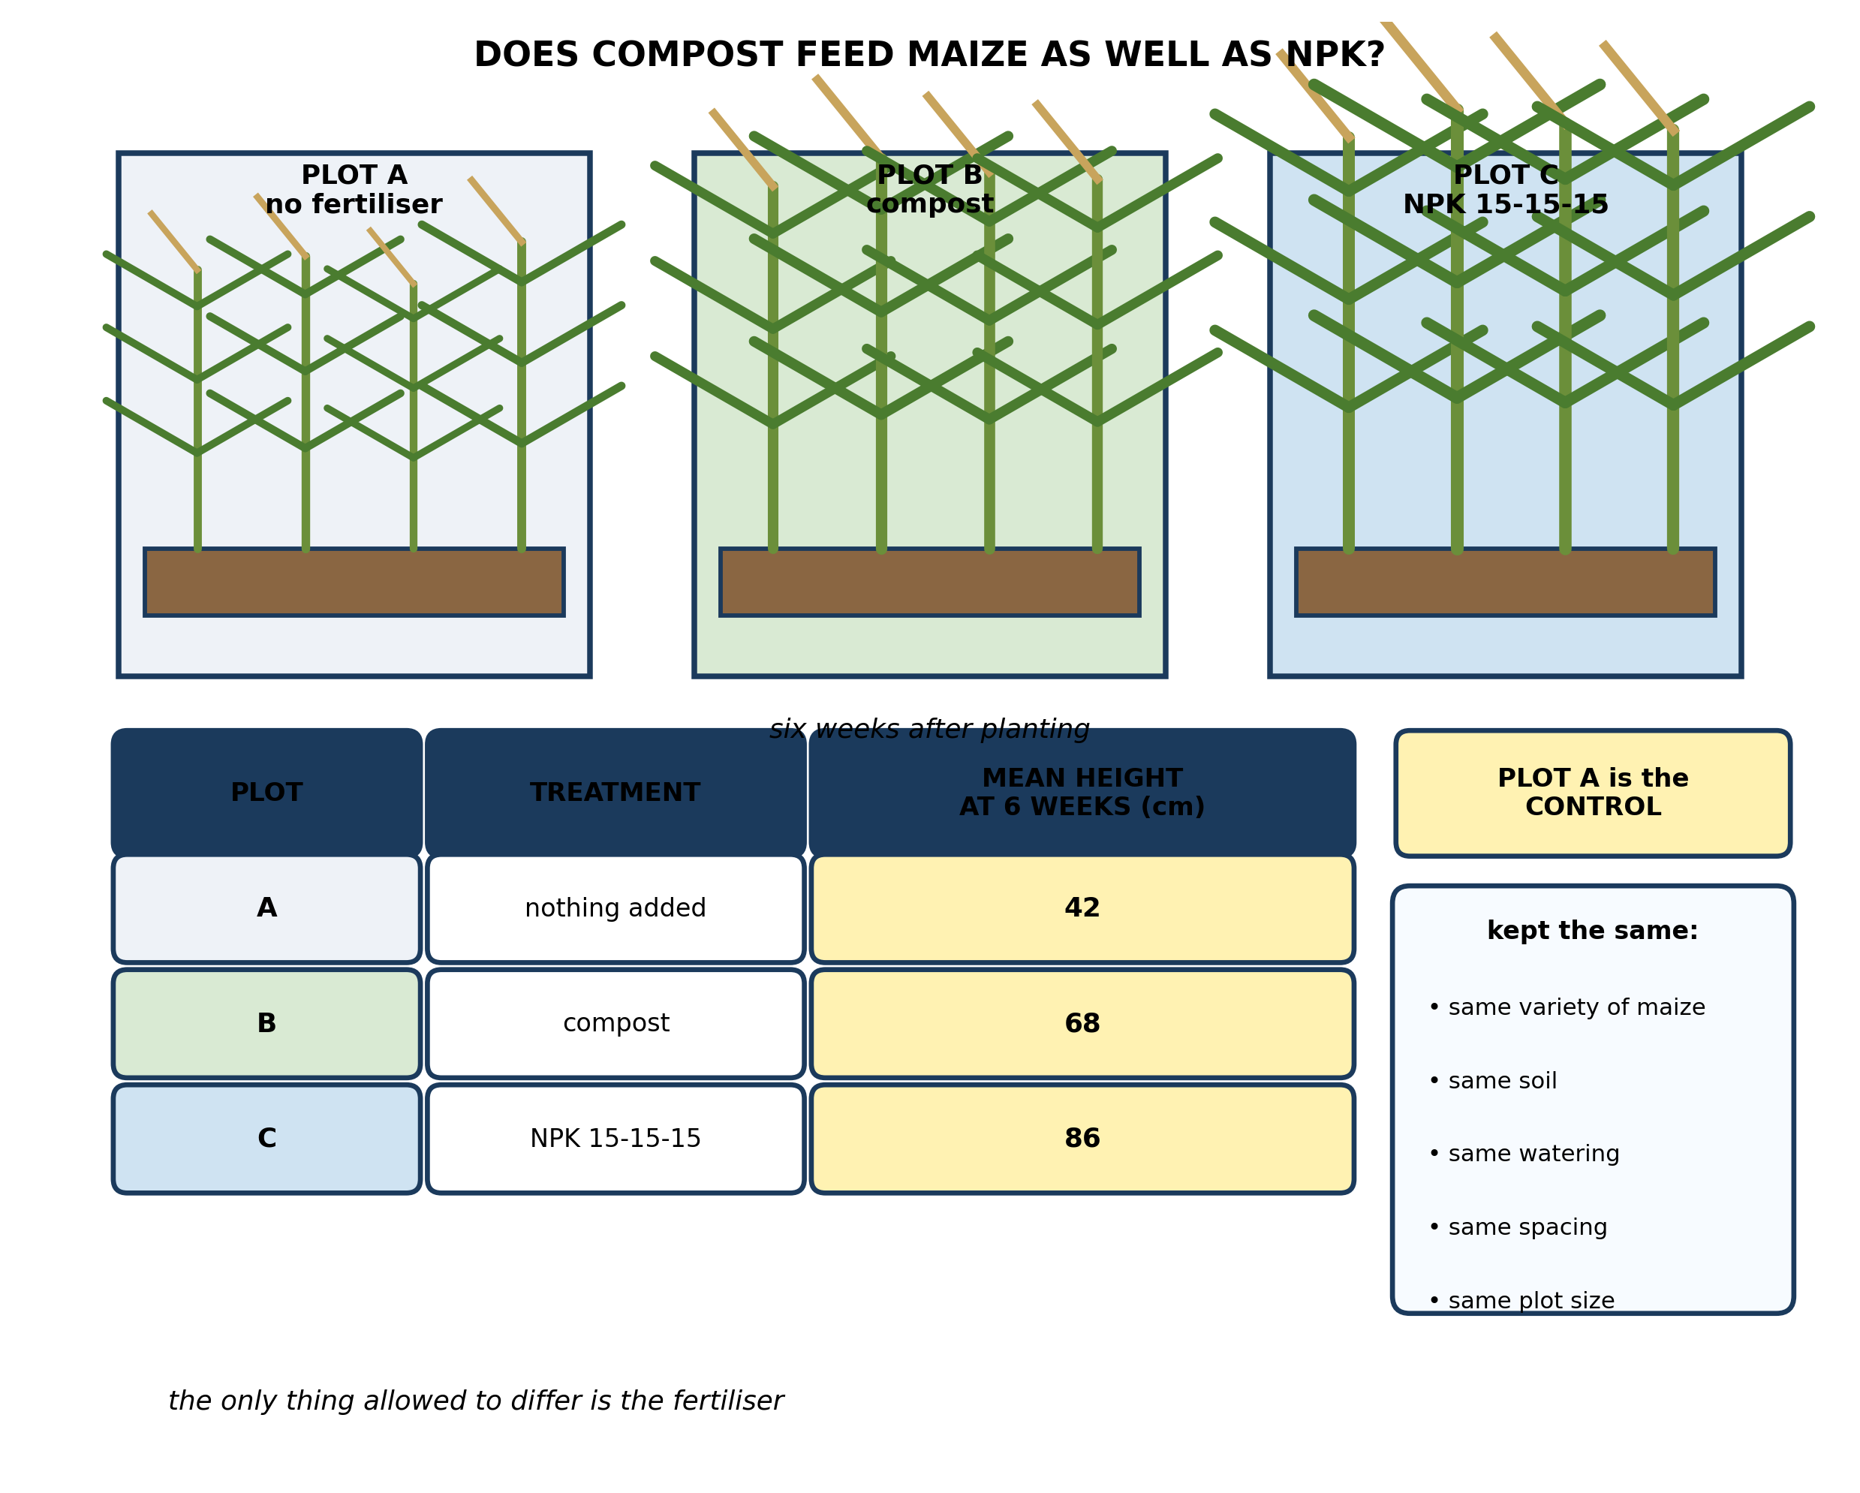
Fig. 7: Does compost feed maize as well as NPK?

13. From the results, state which treatment produced the tallest maize, and calculate how much taller it was than the maize given no fertiliser at all. [4 marks]
14. Explain why Plot A, which is given no fertiliser at all, is needed in this experiment. [3 marks]
15. State TWO things the experiment keeps the same in all three plots, and explain why each one matters. [3 marks]
____________________________________________________________________________________________

ANSWER KEY AND MARKING SCHEME
Accept any other correct and relevant answer. Award marks for correct points, not for repeating the question.
5.1 5.1 What are Plant Nutrients?
Q1
Nitrogen. The diagram links nitrogen with the leaves and shoots, and pale yellow leaves are its deficiency symptom. The reason the oldest leaves show it first is that nitrogen can be moved about inside the plant. When the soil cannot supply enough, the plant takes the nitrogen out of its oldest, lowest leaves and moves it up to the young growing leaves at the top, because new growth matters more to the plant than old leaves do. So the old leaves are drained first and go yellow, while the young ones stay green for a while longer. As the shortage gets worse the yellowing spreads upwards.
Q2
Any two, each with a correct job. Nitrogen - builds the leaves and shoots, so the plant grows green and tall. Phosphorus - builds the roots, flowers and seeds. Potassium - strengthens the stem and helps the fruit and seeds fill.
5.2 5.2 Organic and Inorganic Nutrient Sources
Q3
Inorganic. The diagram sorts nutrient sources by where they come from, not by whether they contain carbon: organic means it comes from once-living plants or animals, and inorganic means it is mined from rock or made in a factory. Urea is made in a factory, so it goes on the inorganic side even though it is a nitrogen fertiliser like compost or manure. The test is the SOURCE, not the nutrient it supplies.
Q4
It is an ORGANIC nutrient source - the diagram lists crop residue, and the stalks and leaves are dead plant material, so they come from once-living things. It will not feed the next crop straight away because the nutrients in it are still locked up inside the dead tissue. They are only released as micro-organisms in the soil rot the material down, and that takes time - weeks or months. Until it has decayed, the nutrients are there but the plant roots cannot take them up. That is exactly why organic sources are described as slow.
5.3 5.3 Differences Between Organic and Inorganic Fertilizers
Q5
Because they do different jobs, and the crop needs both done in the same season. Inorganic fertiliser releases its nutrients at once, so it can feed a hungry crop at the moment the crop needs it - a young maize plant at three weeks cannot wait months for compost to rot. It is also concentrated, so a small bag carries a lot of nutrient, which is what makes it possible to apply enough. Organic material, meanwhile, is slow and bulky: it builds the soil for next season and the seasons after, but it cannot meet a sudden demand. So the farmer uses the inorganic fertiliser to feed THIS crop and the organic matter to build the soil for the ones that follow.
Q6
The field given NPK loses more. The diagram gives the reason: NPK has a high risk of leaching, while compost has little. Inorganic fertiliser dissolves as soon as it is wet, so the nutrients are sitting in the soil water in a form that rain can simply carry down past the roots and away. Compost holds its nutrients inside solid decaying material that has to be rotted down first, so there is far less dissolved nutrient in the water for the rain to wash out. The NPK is not only wasted, it can pollute the watercourse it drains into.
5.4 5.4 Physical Characteristics of Plant Nutrients
Q7
Look at the colour, the shape of the pieces and whether anything is recognisable. Compost is dark brown to black and made of crumbs and flakes of all different shapes and sizes, it smells of damp earth, and you can often still pick out a bit of leaf or stem. NPK granules are pale - grey, white or pinkish - every granule is the same size and round, there is little smell, and nothing in it is recognisable. They look different because they are made differently. Compost is decayed plant and animal matter, so it is a jumble of whatever went into the heap, broken down unevenly. NPK is manufactured: the nutrients are mixed to a set recipe and then formed into uniform granules, so every one matches the next.
Q8
What matters is what the fertiliser does, not where it came from. The diagram compares the two on things that affect the crop: how fast the nutrients are released, how much nutrient there is per kilogram, what it does to the soil, how long it lasts, and how easily it is washed away. On some of those compost is better, and on others NPK is better - NPK carries far more nutrient per kilogram and feeds the crop immediately. Calling one 'natural' tells you none of that. A farmer choosing between them needs to know whether the crop needs feeding now or whether the soil needs building, and that is a question about the crop, not about whether the bag came from a heap or a factory.
5.5 5.5 How Plant Nutrients Are Applied in the Field
Q9
Side-dressing. The diagram shows the fertiliser being placed in a band beside the row while the crop is growing, which is exactly this situation - the crop is already up and needs feeding now. It is better than broadcasting because the band is put right next to the roots, so the nutrient is where the plant can reach it and little is wasted. Broadcasting scatters the fertiliser over the whole field, so most of it lands between the rows where there are no roots to take it up; that part is wasted, and on a sloping field it washes away. Broadcasting is also for before planting, and this crop is already growing.
Q10
Fertiliser is a salt, and against the stem it draws water out of the living tissue by osmosis and burns it. A ring of concentrated fertiliser touching the stem scorches the bark and can kill the growing point, which kills the whole plant. The ring is placed out at the edge of the root spread for two reasons: that is where the feeding roots actually are, and it keeps the fertiliser clear of the stem so the stem is not damaged.
5.6 5.6 Practical Application in the School Garden
Q11
The paths let pupils reach every bed to weed, water, apply fertiliser and harvest without having to tread on the soil the crops are growing in. Walking on the beds would compact the soil, pressing the particles together and squeezing out the air spaces between them. Once that happens the roots cannot get the oxygen they need for respiration, water drains poorly and runs off the surface instead of soaking in, and the roots cannot push through the hard ground. Compacted soil also makes it much harder for the crop to take up nutrients even when they are present. The paths confine the trampling to ground where nothing is expected to grow.
Q12
Any two, each explained. NPK costs money and compost often does not, so using compost on some beds keeps the cost down while still feeding the crop. Rotating the compost around the beds over the years builds up the soil everywhere in the end, rather than leaving the NPK beds dependent on bought fertiliser for ever. Different crops have different demands - a hungry crop like maize is worth the expense of NPK, while another may do well enough on compost. And it lets the school compare the two side by side on its own ground, which is worth more to the pupils than being told.
PRACTICAL TASK
Q13
NPK 15-15-15, in Plot C, produced the tallest maize at 86 cm. The maize with nothing added, in Plot A, reached 42 cm. The difference is 86 - 42 = 44 cm, so the NPK maize was 44 cm taller. For comparison, the compost plot reached 68 cm, which is 26 cm taller than the control, so compost also had a clear effect but a smaller one than NPK over these six weeks.
Q14
Plot A is the control, and without it the experiment shows nothing. It measures what the maize does on its own in that soil, with that water and that weather. Because every other condition is the same across the plots, any difference between A and the others must be down to the fertiliser. If Plot A were missing, a height of 86 cm in Plot C would be meaningless - the maize might have grown that tall anyway on this soil, and you would have no way of telling whether the NPK made any difference at all or whether the good soil and the rain did it all.
Q15
Any two, each explained. The same variety of maize in every plot, because a taller variety would grow taller whatever it was fed, and the comparison would be worthless. The same soil in every plot, because a richer soil would feed the plants itself and you could not tell whether the fertiliser or the soil produced the extra growth. The same watering, because a plot that got more water would grow better regardless of the fertiliser. The same spacing, because crowded plants compete with each other for light, water and nutrients and are stunted for that reason. The same plot size, so that the mean height is worked out from a fair number of plants in each case.

BLUEPRINT / TEST SPECIFICATION
# | Content standard | Code | Items | Marks | % of Marks
5.1 | 5.1 What are Plant Nutrients? | B7/JHS1.2.3.1 | 2 | 6 | 12%
5.2 | 5.2 Organic and Inorganic Nutrient Sources | B7/JHS1.2.3.1 | 2 | 6 | 12%
5.3 | 5.3 Differences Between Organic and Inorganic Fertilizers | B7/JHS1.2.3.1 | 2 | 7 | 14%
5.4 | 5.4 Physical Characteristics of Plant Nutrients | B7/JHS1.2.3.1 | 2 | 7 | 14%
5.5 | 5.5 How Plant Nutrients Are Applied in the Field | B7/JHS1.2.3.1 | 2 | 7 | 14%
5.6 | 5.6 Practical Application in the School Garden | B7/JHS1.2.3.1 | 2 | 7 | 14%
5.1 | Practical task | B7/JHS1.2.3.1 | 3 | 10 | 20%
TOTAL | - | - | 15 | 50 | 100%
Distribution by cognitive level
Cognitive level | Marks | % of Marks
Understand | 11 | 22%
Apply | 15 | 30%
Analyse | 24 | 48%
TOTAL | 50 | 100%
Distribution by difficulty
Difficulty | Marks | % of Marks
Easy | 2 | 4%
Moderate | 27 | 54%
Challenging | 21 | 42%
TOTAL | 50 | 100%

QUALITY-CONTROL SUMMARY
1. Is every question answered from a diagram?
Yes. All 15 questions sit under a figure, and each is unanswerable - or at least materially harder - without reading it. Questions 3, 8, 10 and 17 ask pupils to go beyond the diagram, but each still starts from something the figure shows.
2. Is the content within the Basic 7 curriculum?
Yes. Every question traces to the content standards for this sub-strand (B7/JHS1.2.3.1), and nothing is tested beyond the depth the Basic 7 syllabus sets for it.
3. Are the diagrams clear and unambiguous?
Yes. Each is drawn so that only one reading is sensible: the particle boxes differ in spacing alone, the syringes are labelled with how far each squashes, and the periodic table marks the regions in words as well as by position.
4. Is the level right for JHS 1?
Yes. Questions ask pupils to read, describe and explain what is drawn. Only Question 17 asks for an inference beyond the figure, and it is worth 3 of the 40 marks.
5. Do the marks add up?
Yes: 15 questions totalling 50 marks, matching the figure on the front page. The blueprint, cognitive and difficulty tables all sum to the same total.
6. Are the answers correct and complete?
Yes. Each answer states the point the question is worth, with the acceptable alternatives given where a question is open.
EXAMINER NOTES (for the teacher, not for candidates)
- Pitched at the compulsory diagram question of BECE Paper 2: 78% of the marks are at Apply level or above and 42% are Challenging.
- Q1 is the best question in the paper and the one most pupils will get wrong. They will name nitrogen happily - the diagram gives them the symptom - and then say the oldest leaves yellow 'because they are oldest'. The real answer is that nitrogen is MOBILE inside the plant: the plant strips it out of the old leaves and sends it to the growing tip, so the old leaves pay first. Teach it as 'the plant sacrifices the old to feed the new'.
- Q3 on urea is the classification trap. Pupils reason 'urea contains carbon, so it is organic'. The diagram sorts by SOURCE, not by chemistry: once-living versus mined or manufactured. Urea is made in a factory, so it is inorganic. Expect the argument and settle it early.
- Q6 on leaching after heavy rain is worth doing as a class discussion, because it is the reason inorganic fertiliser is both expensive and environmentally costly, and it makes the case for organic matter concrete rather than pious.
- Q10 on why ring application must not touch the stem is the one where pupils have real experience to draw on - many have seen a plant 'burnt' by fertiliser. Let them say what they saw, then give them the reason: the salt draws water out of the living tissue by osmosis.
- The maize experiment in Fig. 7 is cheap to run in a school garden with three small plots and a metre rule, and the numbers in the table are realistic for six weeks. Run it for real if the timing allows; measuring their own plants once a week makes Q13 to Q15 easy and makes the idea of a control obvious.
- If you want a calculation extension, ask pupils to work out how many maize plants fit Bed 1 at 75 cm by 90 cm spacing. I left this out of the paper because the bed dimensions on the plan are schematic rather than to scale, and the sum would be arguable - but with real bed measurements from your own garden it works well.

