[SCHOOL NAME]
INTEGRATED SCIENCE (SCIENCE)
PRACTICAL QUESTIONS - DIAGRAM MODE
Digestion (7.1 - 7.7)
____________________________________________________________________________________________
CLASS: Basic 7 (JHS 1)
TIME: 1 hour 30 minutes
MARKS: 50 2025/2026 Academic Year
____________________________________________________________________________________________
INSTRUCTIONS TO CANDIDATES
1. Answer ALL the questions in this paper.
2. Every question is based on a diagram. Study each diagram carefully before you answer the questions that follow it.
3. Write your answers in the spaces provided. The marks for each question are printed beside it.
4. Where a question asks for a stated number of points, give that number. Any extra answers will not be marked.
5. You may refer back to any diagram at any time.
____________________________________________________________________________________________
SECTION A - DIAGRAM STUDY
Study each diagram and answer the questions that follow it.
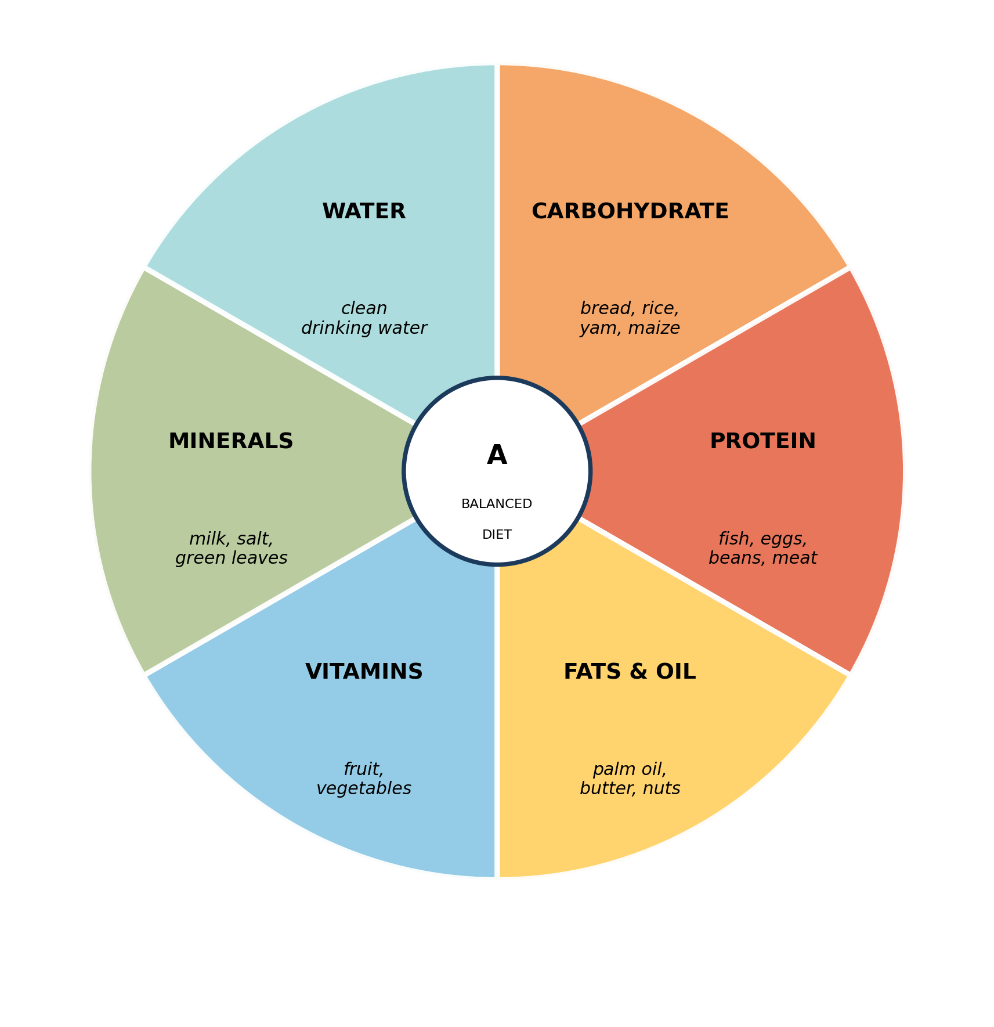
Fig. 1: A balanced diet

7.1 7.1 What is Food? Nutrients and Their Importance
1. Use the diagram to explain why a person who eats only maize and fish every day is not getting a balanced diet, even though they never feel hungry. [4 marks]
2. From the diagram, name TWO classes of food and give one food source of each. [2 marks]
____________________________________________________________________________________________
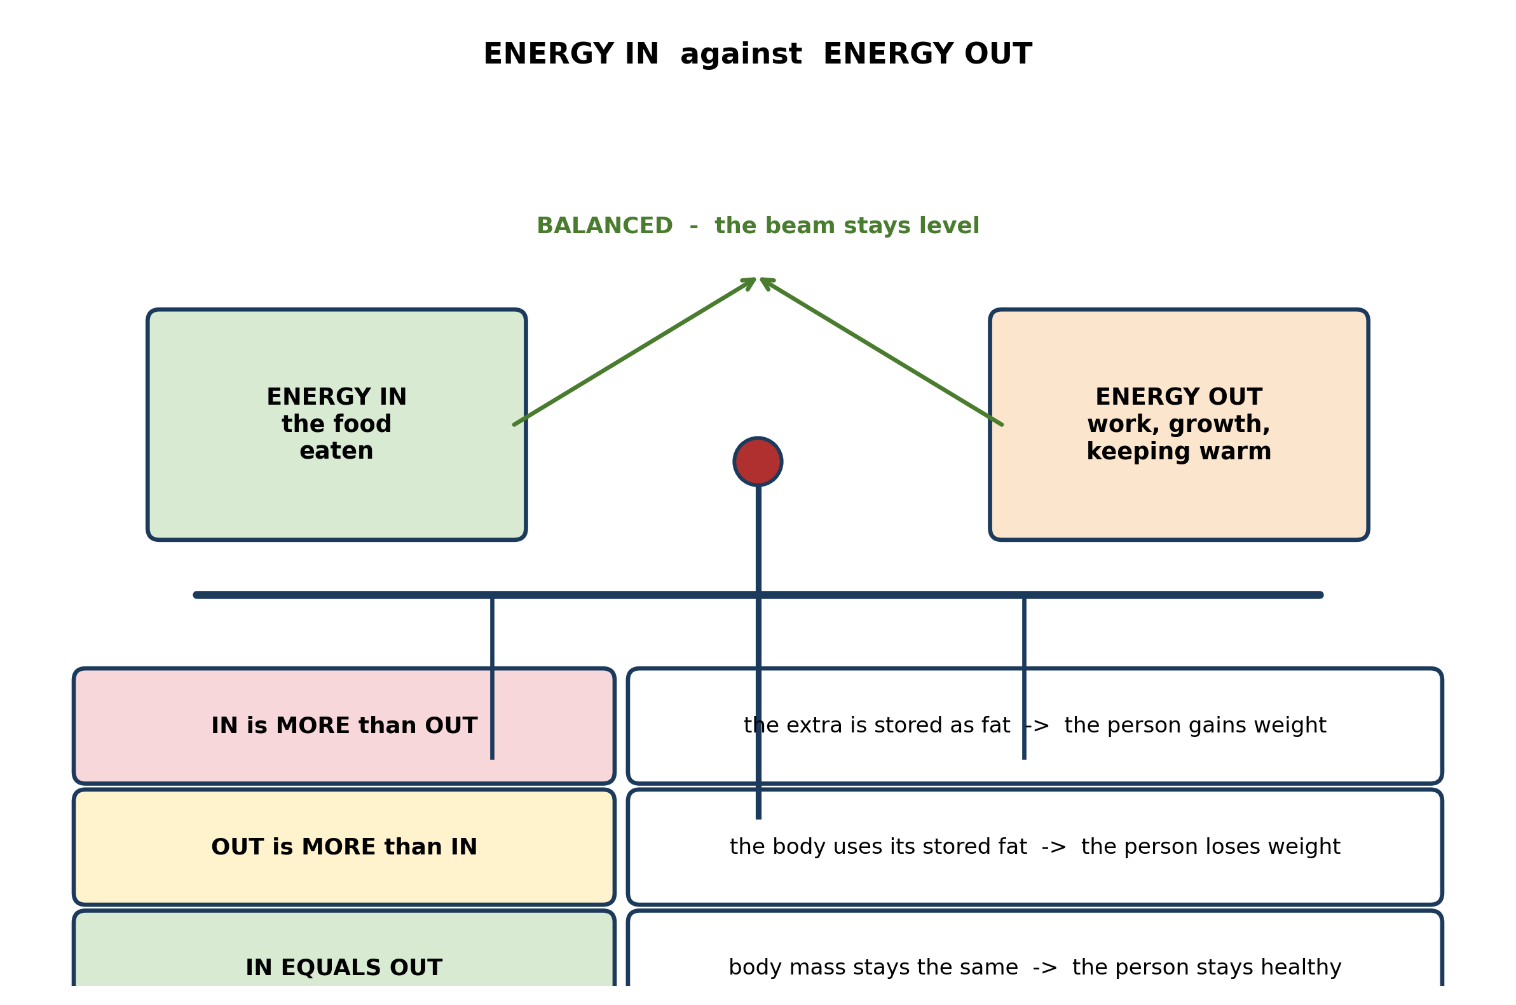
Fig. 2: Energy in against energy out

7.2 7.2 Why Humans Need to Eat
3. A pupil says that if you want to lose weight you should simply stop eating fat, because fat is what makes people fat. Use the diagram to explain why this is only half right. [3 marks]
____________________________________________________________________________________________
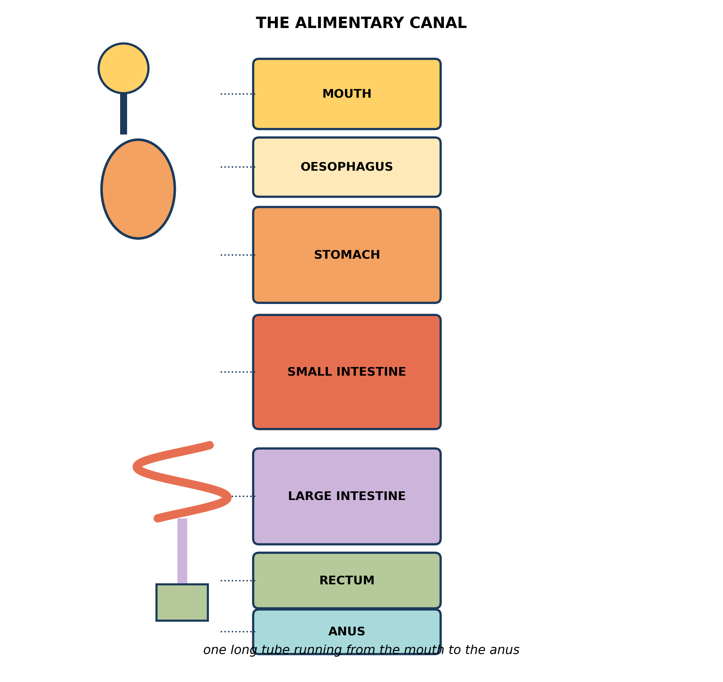
Fig. 3: The alimentary canal

7.3 7.3 The Digestive System: Parts of the Alimentary Canal
4. Use the diagram to explain why the alimentary canal has to be a LONG tube, and state what would happen to a person if a large part of the small intestine had to be removed by surgery. [4 marks]
5. The diagram shows that the oesophagus is part of the alimentary canal, but that no digestion takes place there. Explain how it can be part of the canal and yet do no digesting. [3 marks]
____________________________________________________________________________________________
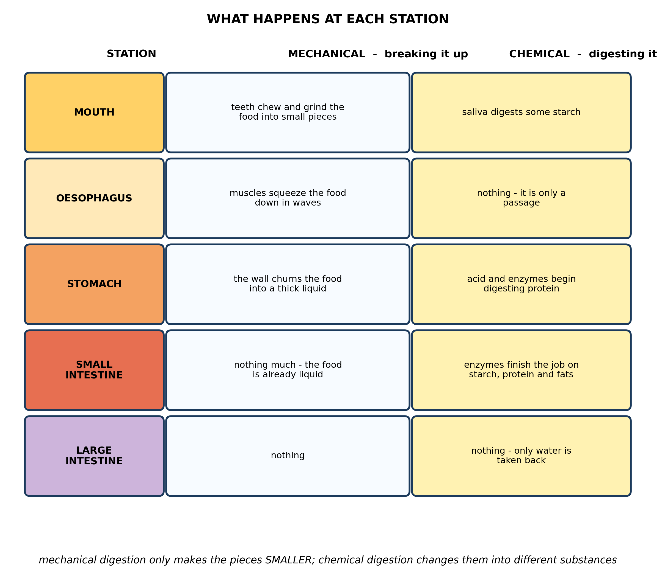
Fig. 4: What happens at each station

7.4 7.4 What Happens to Food at Each Stage of Digestion
6. Use the diagram to explain the difference between MECHANICAL and CHEMICAL digestion, giving one example of each. [3 marks]
7. Explain why chewing food thoroughly helps CHEMICAL digestion later on, even though almost no chemical digestion is finished in the mouth. [4 marks]
____________________________________________________________________________________________
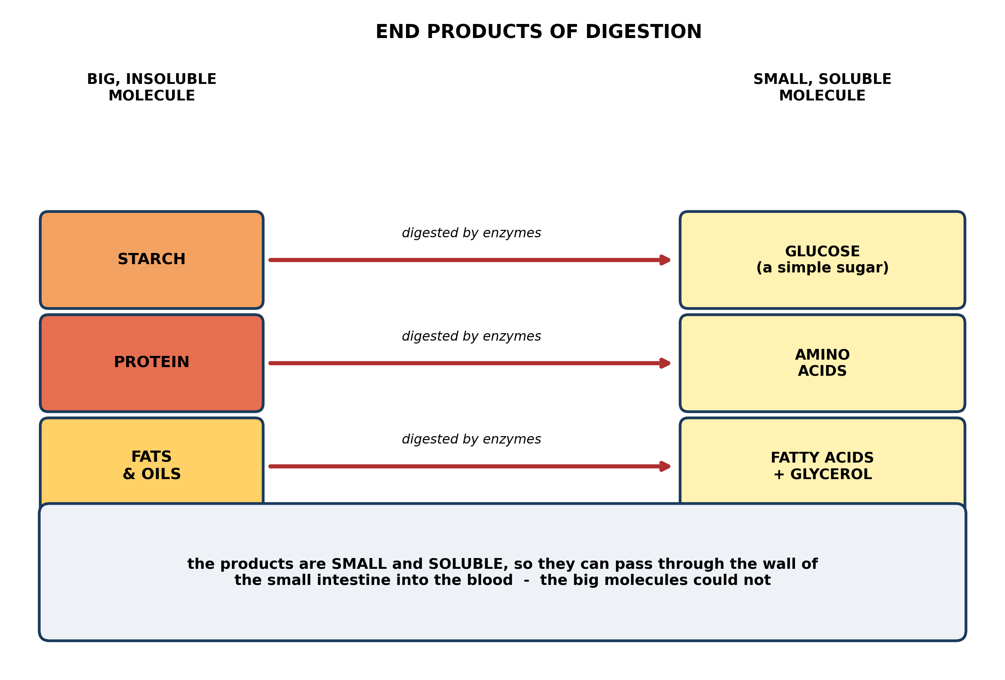
Fig. 5: End products of digestion

7.5 7.5 End Products of Digestion: Starch, Protein and Fats
8. Use the diagram to explain why a patient who cannot digest food properly can be kept alive by giving glucose solution straight into a vein. [3 marks]
9. Explain, using the diagram, why the body cannot use starch directly, even though starch is made entirely of glucose units joined together. [4 marks]
____________________________________________________________________________________________
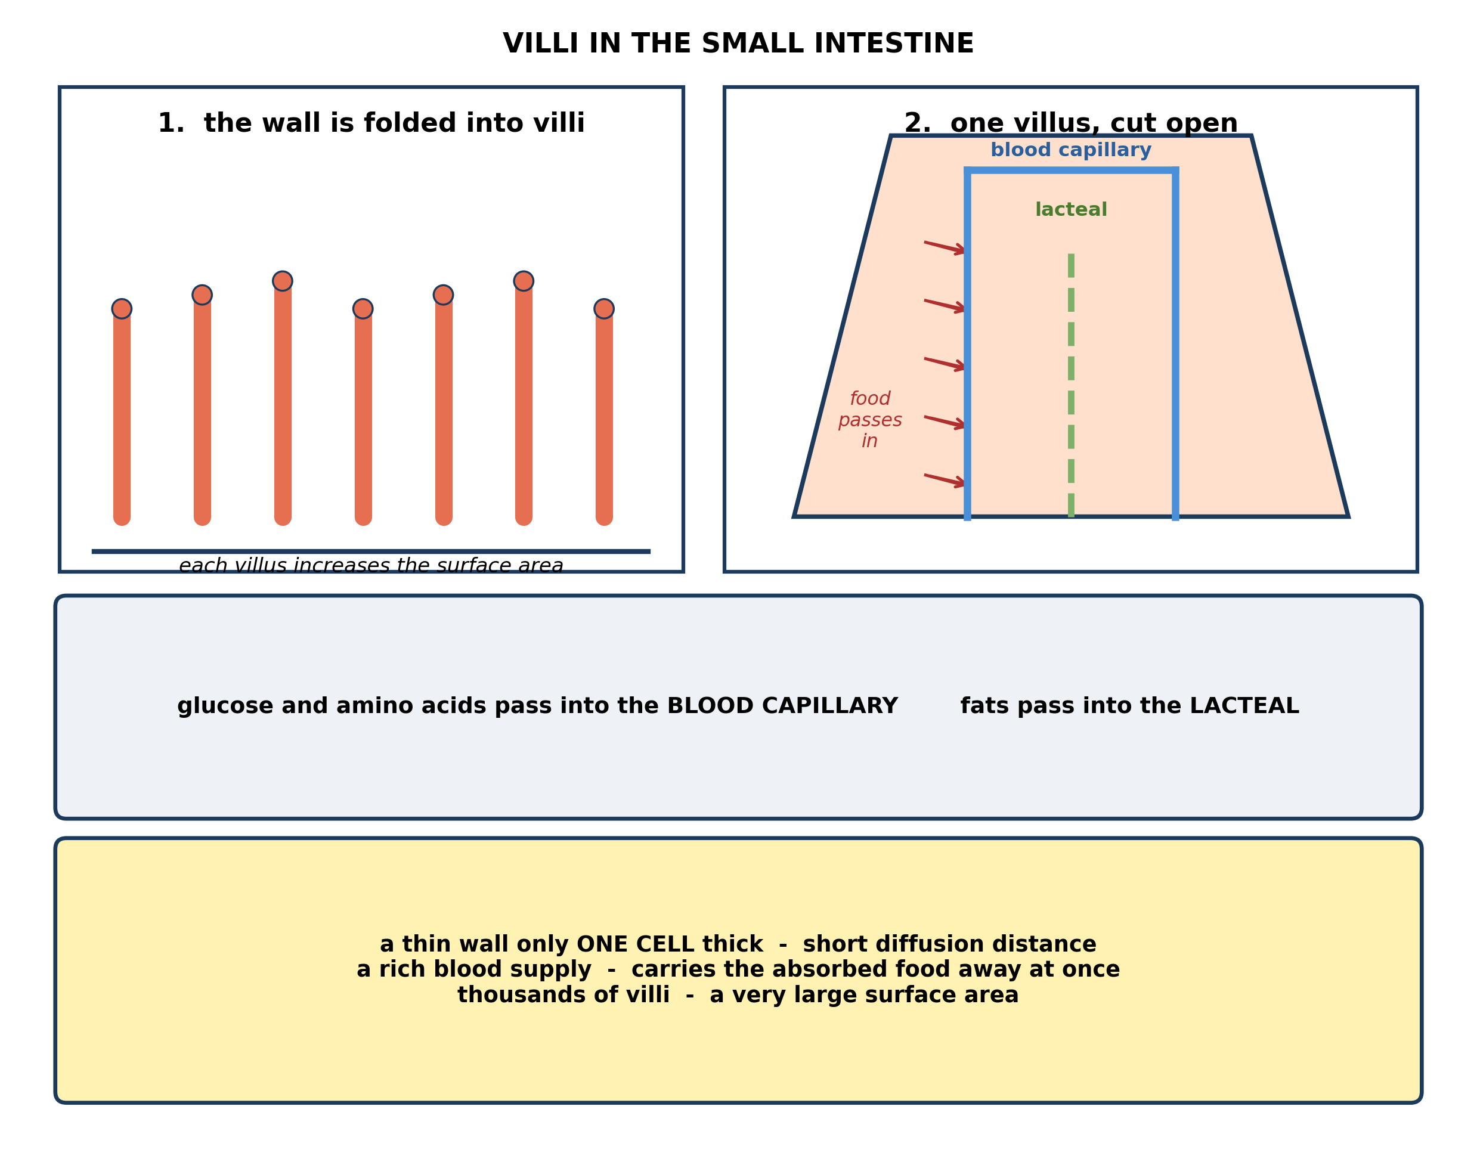
Fig. 6: Villi in the small intestine

7.6 7.6 Absorption of Digested Food in the Small Intestine
10. Explain, using the diagram, how the villi make absorption FAST. Refer to TWO features shown. [4 marks]
11. From the diagram, state where the digested FATS go after absorption, and explain why they do not travel the same way as glucose. [3 marks]
____________________________________________________________________________________________
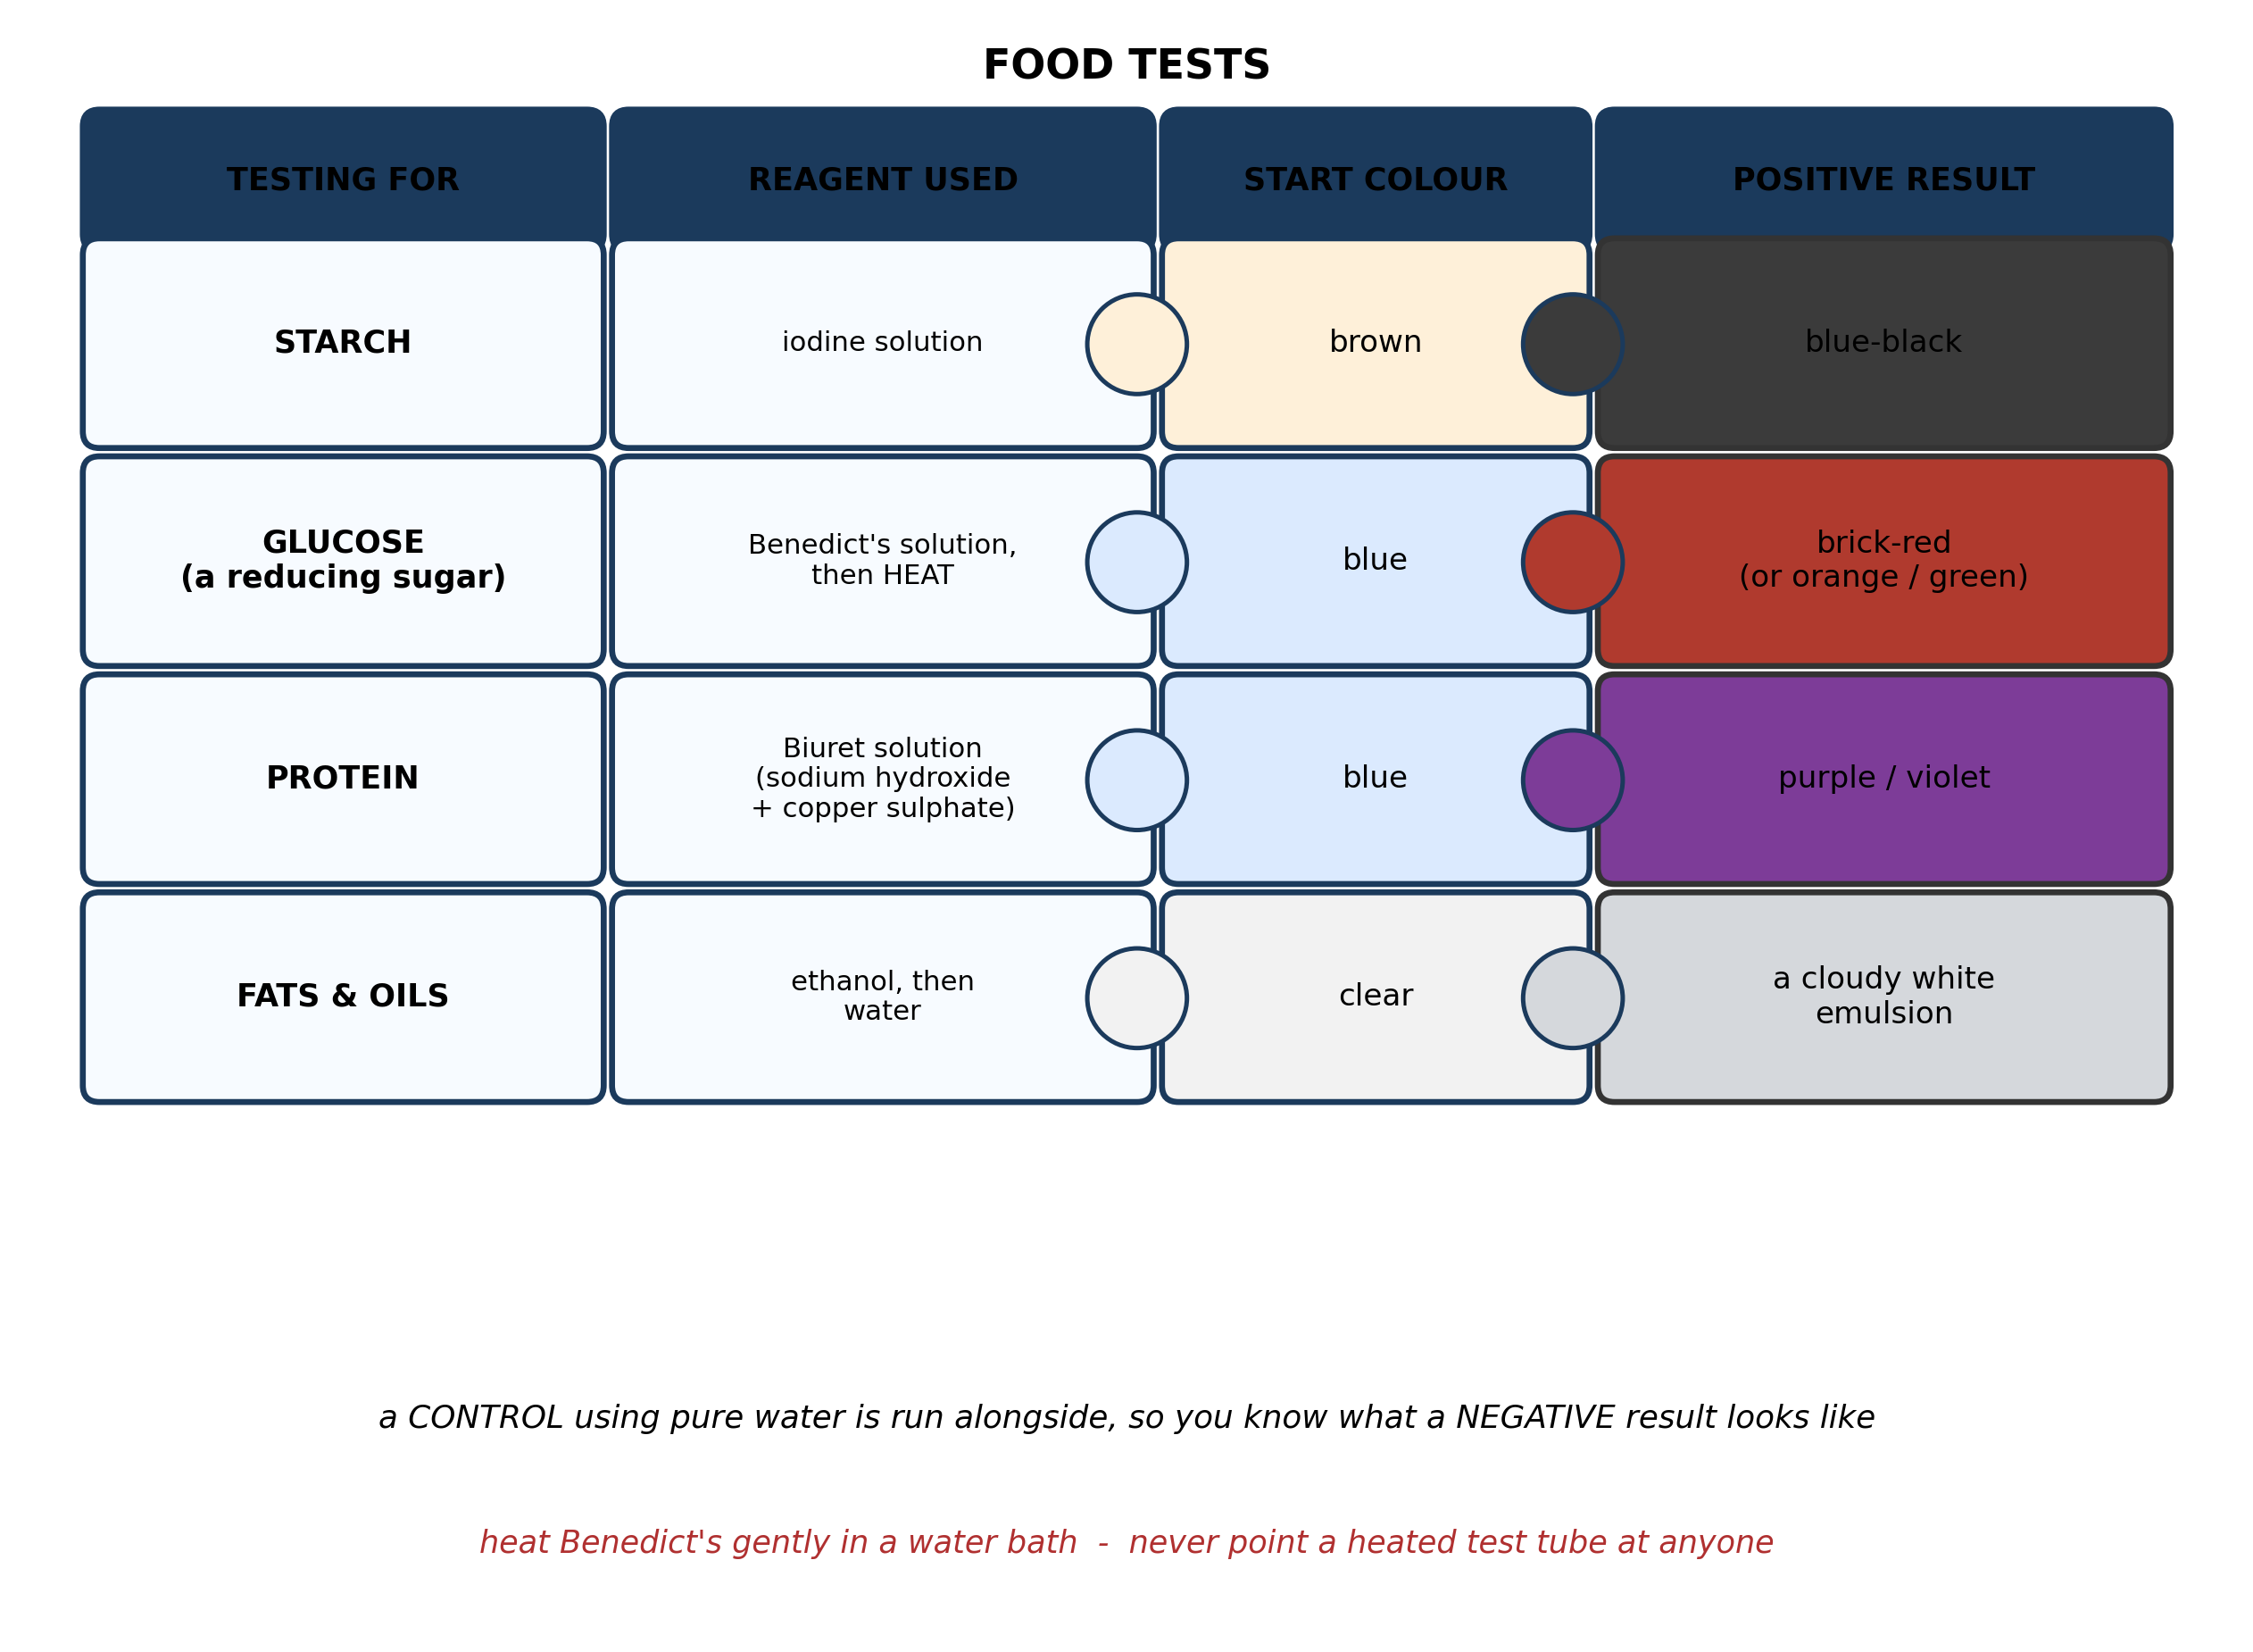
Fig. 7: Food tests

7.7 7.7 Food Tests: Starch, Glucose, Protein, Fats and Oils
12. Describe how you would test a sample of food for STARCH. State the reagent you would use, what you would do, and the colour that shows a positive result. [3 marks]
13. A pupil tests a food sample with Benedict's solution, heats it, and gets a GREEN colour instead of the brick-red shown in the diagram. Explain what this result shows. [3 marks]
____________________________________________________________________________________________
SECTION B - PRACTICAL TASK
Study the apparatus and answer the questions that follow it.
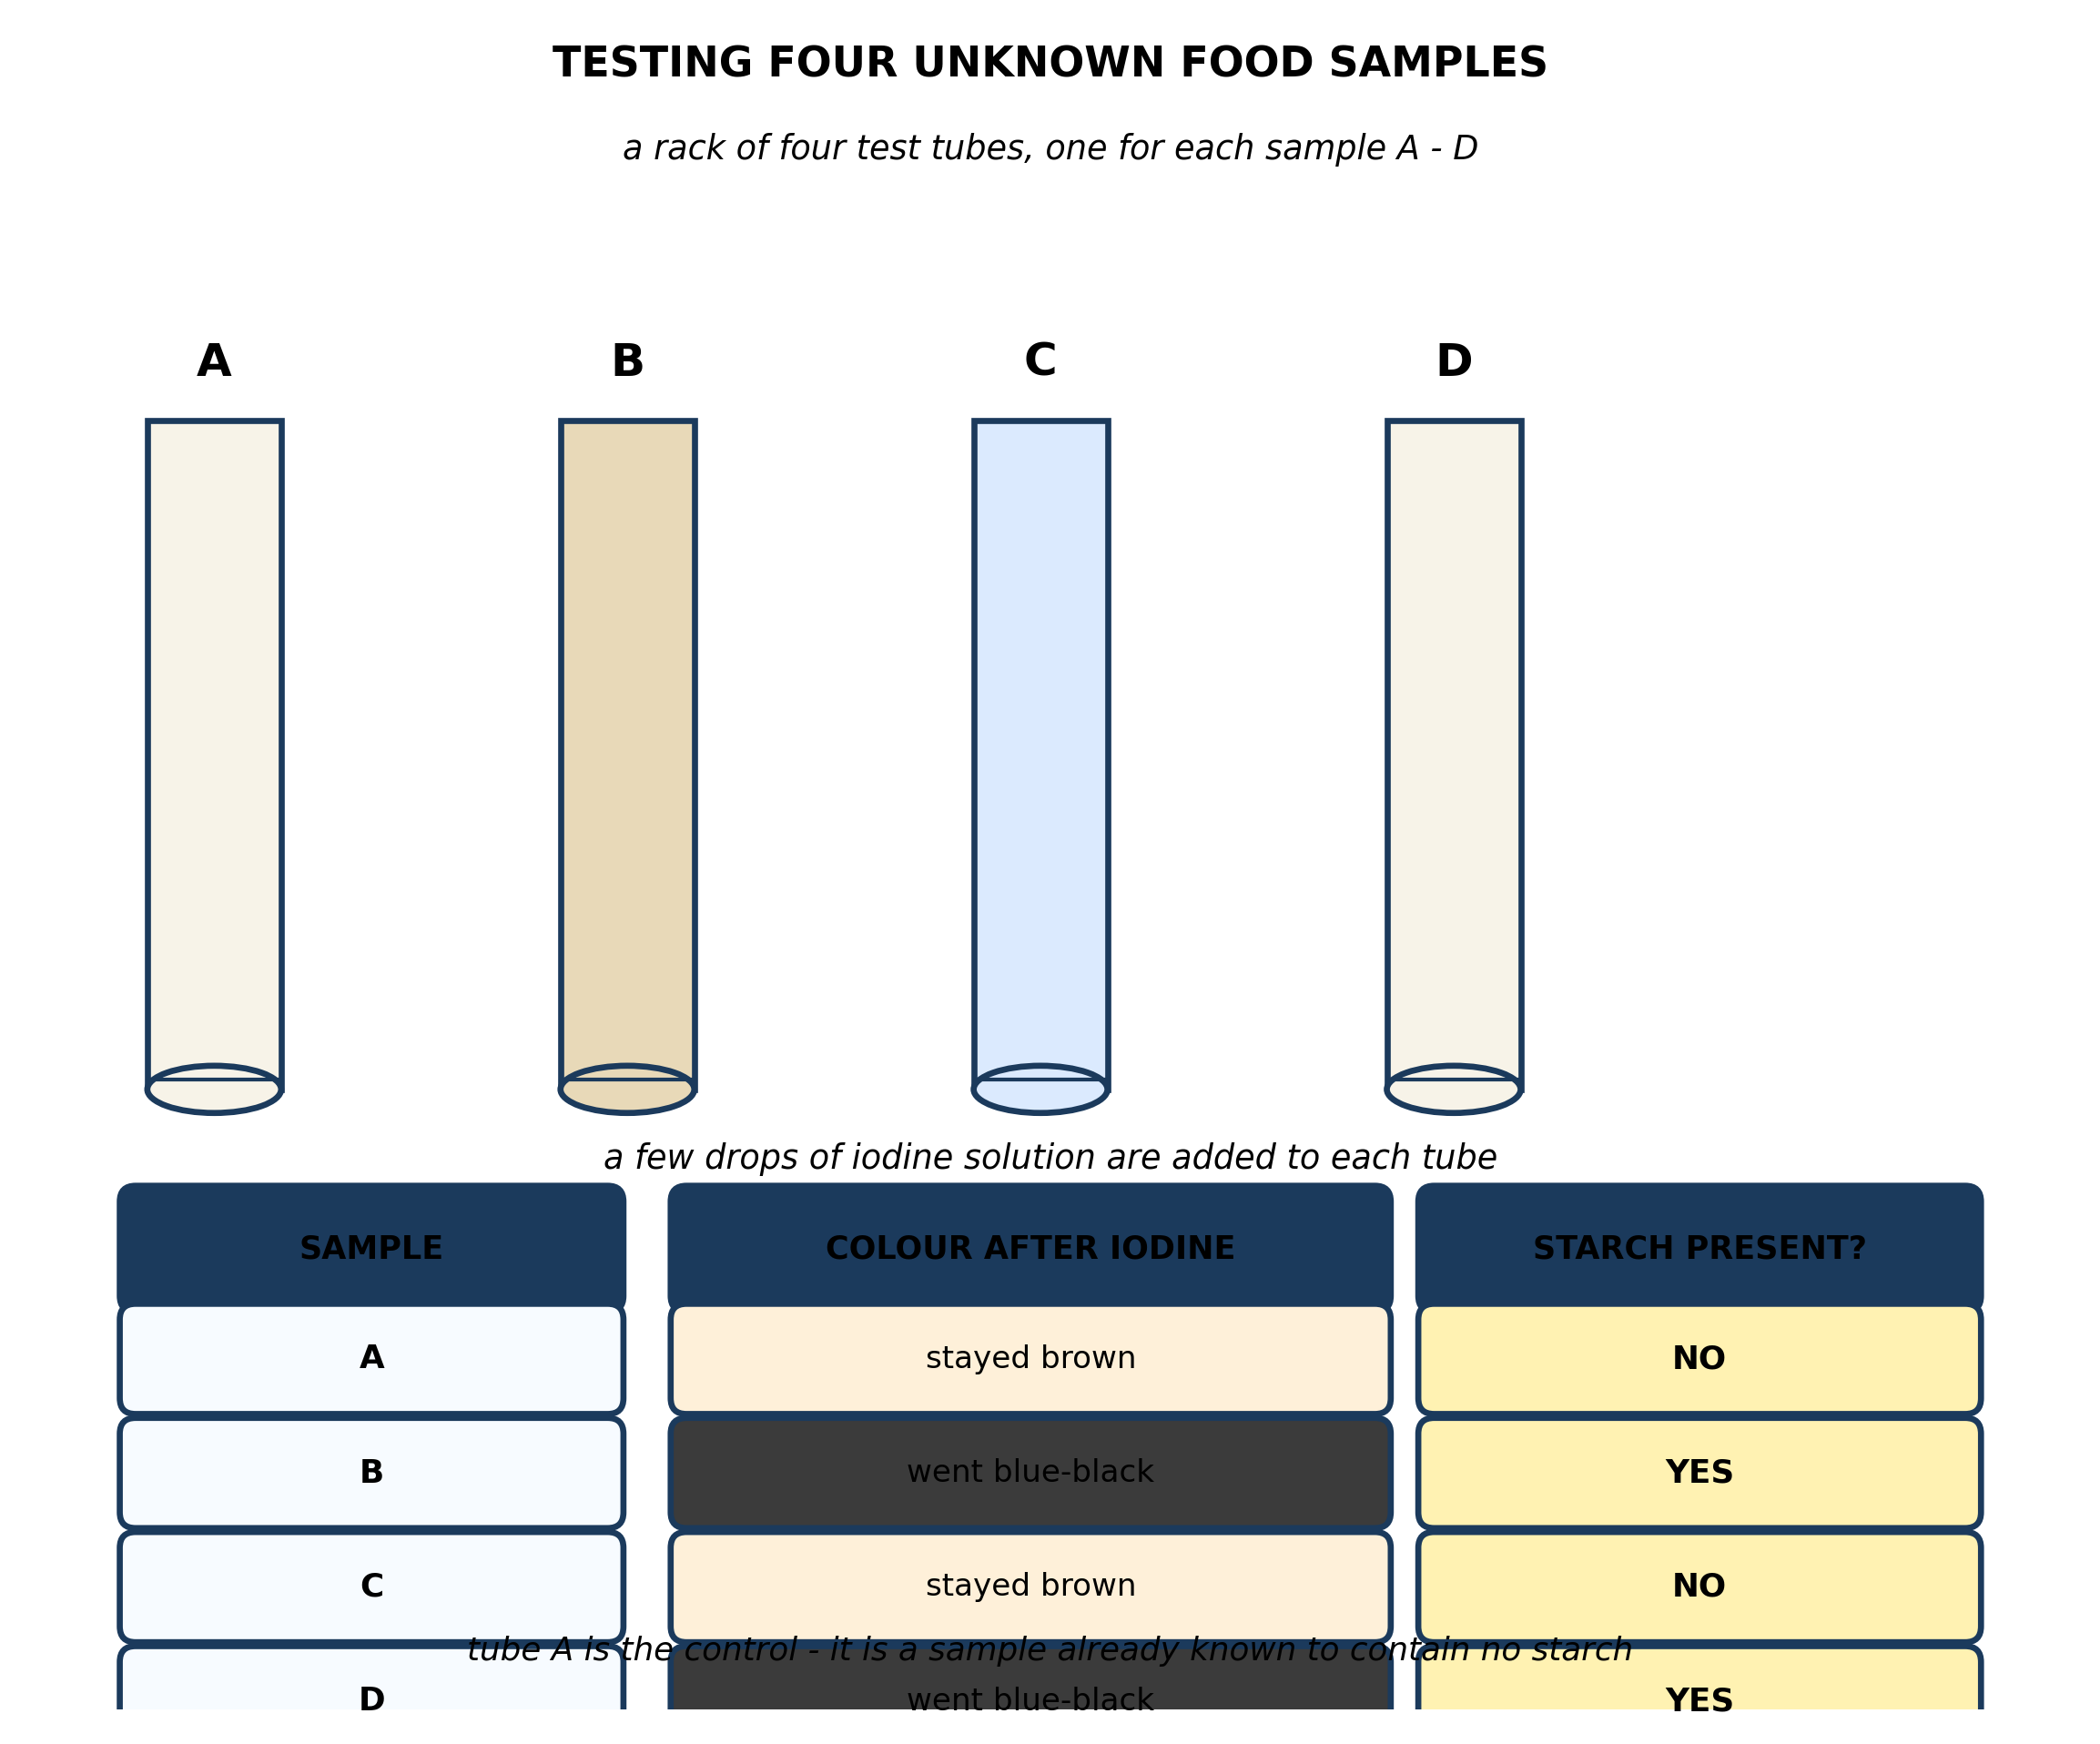
Fig. 8: Testing four unknown food samples

14. From the diagram, state which samples contain starch, and describe what you would do to check that this result is reliable. [4 marks]
15. The pupil writes in the conclusion that samples A and C contain no food nutrients at all. Explain why the results do not support this. [3 marks]
____________________________________________________________________________________________

ANSWER KEY AND MARKING SCHEME
Accept any other correct and relevant answer. Award marks for correct points, not for repeating the question.
7.1 7.1 What is Food? Nutrients and Their Importance
Q1
Maize supplies carbohydrate and fish supplies protein, so two of the six classes are covered and that is enough to fill the stomach and stop hunger. But the diagram shows six classes, and the other four are missing: fats and oil, vitamins, minerals and water. Not feeling hungry is not the test - a balanced diet means having all the classes in the right amounts, and each missing one has its own consequence. Without vitamin C the gums bleed and wounds heal slowly; without iron the blood cannot carry oxygen properly and the person is anaemic and tired; without calcium the bones stay weak; without enough fat the body cannot absorb some vitamins at all. So the person is fed but not nourished.
Q2
Any two, each with a correct source: carbohydrate - bread, rice, yam, maize; protein - fish, eggs, beans, meat; fats and oil - palm oil, butter, nuts; vitamins - fruit and vegetables; minerals - milk, salt, green leaves; water - clean drinking water.
7.2 7.2 Why Humans Need to Eat
Q3
The diagram shows that body mass depends on the BALANCE between energy in and energy out, not on eating fat as such. Cutting out fat does reduce the energy coming in, so on that point the pupil is right. But it is only half the answer, because the other side of the balance matters just as much: a person who eats only a little fat but takes in more carbohydrate than they use will still store the excess as body fat and gain weight. The body converts surplus energy from any class of food into stored fat. To lose weight the person must either take in less energy or use more, so that energy out exceeds energy in.
7.3 7.3 The Digestive System: Parts of the Alimentary Canal
Q4
The canal has to be long because its two jobs - digesting the food and absorbing the digested products - both need time and surface. A long tube gives the food time to pass slowly enough for the enzymes to finish their work, and it gives a large enough area of wall for the products to be absorbed through. If a large part of the small intestine were removed, both would suffer: the food would pass through too quickly for digestion to be completed, and there would be far less wall to absorb through. The undigested, unabsorbed food would be passed out as diarrhoea, and the person would lose weight and become malnourished even while eating normally.
Q5
Being part of the alimentary canal is about being part of the ROUTE the food takes, not about carrying out digestion. The canal is defined as the tube running from the mouth to the anus, and the oesophagus is a section of that tube. But the different sections have different jobs, and the oesophagus's job is only to carry the food - its muscles squeeze the food downwards in waves to the stomach. The diagram makes the point by listing 'nothing' in the chemical column for the oesophagus: it is a passage, not a place where food is broken down.
7.4 7.4 What Happens to Food at Each Stage of Digestion
Q6
Mechanical digestion breaks the food into smaller pieces without changing what it is - the teeth chew and grind it in the mouth, or the stomach wall churns it into a liquid, and it is still the same substance, only in smaller bits. Chemical digestion changes the food into a DIFFERENT substance, using enzymes and acid - for example saliva beginning to turn starch into sugar, or the stomach's enzymes attacking protein. One changes the size, the other changes the substance.
Q7
Chewing is mechanical digestion, and its effect is to break the food into many small pieces. Doing that greatly increases the SURFACE AREA of the food, and the enzymes that do the chemical digestion later can only attack the surface they can reach. So the more the food is broken up, the more of it the enzymes in the stomach and small intestine can work on at the same time, and the faster and more completely the chemical digestion goes. Chewing also mixes the food thoroughly with saliva and makes it easier to swallow. So although chewing does not itself finish any chemical digestion, it prepares the food so that the chemical digestion which follows can do its job properly.
7.5 7.5 End Products of Digestion: Starch, Protein and Fats
Q8
The diagram shows that glucose is the END PRODUCT of starch digestion - it is already small and soluble, so it is in exactly the form the body can use. Because it needs no further digesting, it can be put directly into the blood and the whole digestive system is bypassed. The patient is getting the product their gut would have produced but cannot, delivered by a route that does not depend on the gut working.
Q9
Although starch is built from glucose units, it is one enormous molecule, and it is far too big to pass through the wall of the small intestine and into the blood. It is also insoluble. The glucose units have to be separated from one another first, because only the individual small, soluble glucose molecules are able to cross the gut wall. So the body is not rejecting the glucose - it simply cannot reach it while it is locked up in the large molecule. Digestion is the unlocking, and until it happens the glucose in the starch is unavailable.
7.6 7.6 Absorption of Digested Food in the Small Intestine
Q10
Any two, each explained. There are thousands of villi, and the folds they make give an enormously large surface area, so a great deal of digested food can pass through the wall at the same moment. The wall of each villus is only one cell thick, so the food has a very short distance to travel to get into the blood, which makes diffusion quick. Each villus has a rich blood supply, and the blood carries the absorbed food away immediately, which keeps the concentration difference steep so that more food keeps diffusing in. A villus also has a lacteal, so fats are carried away too.
Q11
Fats pass into the LACTEAL, not into the blood capillary. The diagram shows the two vessels separately, with glucose and amino acids going to the capillary and fats to the lacteal. They take a different route because the products of fat digestion are handled differently by the body - they are taken up into the lymphatic system rather than being carried straight to the liver in the blood.
7.7 7.7 Food Tests: Starch, Glucose, Protein, Fats and Oils
Q12
Add a few drops of iodine solution to the food sample - or to a solution or paste made from it - in a test tube or on a white tile. Iodine starts brown. If starch is present the colour changes to blue-black; if starch is absent it stays brown. A control using pure water or a sample known to contain no starch is run alongside for comparison.
Q13
A green colour still shows that a reducing sugar such as glucose is present - the test has not failed, and the answer is not 'no sugar'. Benedict's is not simply a yes-or-no test: the colour it turns depends on roughly HOW MUCH reducing sugar there is. Brick-red means a lot; orange or green means a smaller amount. So the pupil's sample contains some glucose, but less of it than a sample giving brick-red. The pupil should report it as a positive result for a small amount of reducing sugar, and could compare the colour against known samples to estimate how much.
PRACTICAL TASK
Q14
Samples B and D contain starch - the iodine in those two tubes changed from brown to blue-black, which is the positive result, while A and C stayed brown. To check the result is reliable I would repeat the test: carry it out again on fresh portions of each of the four samples, and check that the same two give blue-black a second time. I would also make the comparison fair by using the same number of drops of iodine in every tube and the same amount of each sample. Results that can be repeated are the ones worth trusting.
Q15
The iodine test tests for STARCH and for nothing else. All the results show is that A and C contain no detectable starch - they say nothing at all about glucose, protein, fats, vitamins or minerals. Sample A or C could be almost pure protein and the iodine test would still stay brown, because iodine does not react with protein. To claim a sample contains no nutrients you would have to test it separately for each class, using Benedict's for glucose, Biuret for protein and ethanol for fats. A negative result in one test is only ever evidence about that one nutrient.

BLUEPRINT / TEST SPECIFICATION
# | Content standard | Code | Items | Marks | % of Marks
7.1 | 7.1 What is Food? Nutrients and Their Importance | B7/JHS1.3.1.1 | 2 | 6 | 12%
7.2 | 7.2 Why Humans Need to Eat | B7/JHS1.3.1.1 | 1 | 3 | 6%
7.3 | 7.3 The Digestive System: Parts of the Alimentary Canal | B7/JHS1.3.1.1 | 2 | 7 | 14%
7.4 | 7.4 What Happens to Food at Each Stage of Digestion | B7/JHS1.3.1.1 | 2 | 7 | 14%
7.5 | 7.5 End Products of Digestion: Starch, Protein and Fats | B7/JHS1.3.1.1 | 2 | 7 | 14%
7.6 | 7.6 Absorption of Digested Food in the Small Intestine | B7/JHS1.3.1.1 | 2 | 7 | 14%
7.7 | 7.7 Food Tests: Starch, Glucose, Protein, Fats and Oils | B7/JHS1.3.1.1 | 2 | 6 | 12%
7.1 | Practical task | B7/JHS1.3.1.1 | 2 | 7 | 14%
TOTAL | - | - | 15 | 50 | 100%
Distribution by cognitive level
Cognitive level | Marks | % of Marks
Understand | 11 | 22%
Apply | 13 | 26%
Analyse | 26 | 52%
TOTAL | 50 | 100%
Distribution by difficulty
Difficulty | Marks | % of Marks
Easy | 2 | 4%
Moderate | 28 | 56%
Challenging | 20 | 40%
TOTAL | 50 | 100%

QUALITY-CONTROL SUMMARY
1. Is every question answered from a diagram?
Yes. All 15 questions sit under a figure, and each is unanswerable - or at least materially harder - without reading it. Questions 3, 8, 10 and 17 ask pupils to go beyond the diagram, but each still starts from something the figure shows.
2. Is the content within the Basic 7 curriculum?
Yes. Every question traces to the content standards for this sub-strand (B7/JHS1.3.1.1), and nothing is tested beyond the depth the Basic 7 syllabus sets for it.
3. Are the diagrams clear and unambiguous?
Yes. Each is drawn so that only one reading is sensible: the particle boxes differ in spacing alone, the syringes are labelled with how far each squashes, and the periodic table marks the regions in words as well as by position.
4. Is the level right for JHS 1?
Yes. Questions ask pupils to read, describe and explain what is drawn. Only Question 17 asks for an inference beyond the figure, and it is worth 3 of the 40 marks.
5. Do the marks add up?
Yes: 15 questions totalling 50 marks, matching the figure on the front page. The blueprint, cognitive and difficulty tables all sum to the same total.
6. Are the answers correct and complete?
Yes. Each answer states the point the question is worth, with the acceptable alternatives given where a question is open.
EXAMINER NOTES (for the teacher, not for candidates)
- Pitched at the compulsory diagram question of BECE Paper 2: 78% of the marks are at Apply level or above and 40% are Challenging.
- Q9 is the question that separates pupils who have the idea from those who have the words. 'Starch is made of glucose, so why can't the body use it?' The answer is size and solubility: the glucose is there, but locked inside a molecule too big to cross the gut wall. Pupils who say 'it is too big' without saying WHY that matters - it cannot get through into the blood - have not finished.
- Q7 on chewing is a surface-area question dressed up as a health-advice question. The chain is: chew, smaller pieces, larger surface area, more enzymes working at once, faster complete digestion. Four links, four marks. Most pupils stop at 'it helps you swallow'.
- Q3 on cutting out fat is the misconception I most want caught. Body mass is a BALANCE, and surplus carbohydrate is stored as fat just as surely as eaten fat is. Pupils who get this have understood 7.2 rather than memorised it.
- Q13 on the green Benedict's result is worth doing even if you have covered food tests before, because pupils treat these tests as pass or fail. They are not - the colour indicates roughly how much. A green result is a POSITIVE result for a small amount.
- Q15 is the same lesson at the level of experimental reasoning: a negative result in one test is evidence about one nutrient only. Pupils write 'contains no nutrients' straight after an iodine test. Insist they name the nutrient the test actually looked for.
- Fig. 8 is a real experiment that any school can run with iodine and four samples - floor, gari, sugar solution and cooked rice work well and give two positives and two negatives. Get pupils to predict first, then test; the predictions are where the thinking shows.

