[SCHOOL NAME]
INTEGRATED SCIENCE (SCIENCE)
PRACTICAL QUESTIONS - DIAGRAM MODE
Earth Science - The Water Cycle (3.1 - 3.5)
____________________________________________________________________________________________
CLASS: Basic 7 (JHS 1)
TIME: 1 hour 30 minutes
MARKS: 50 2025/2026 Academic Year
____________________________________________________________________________________________
INSTRUCTIONS TO CANDIDATES
1. Answer ALL the questions in this paper.
2. Every question is based on a diagram. Study each diagram carefully before you answer the questions that follow it.
3. Write your answers in the spaces provided. The marks for each question are printed beside it.
4. Where a question asks for a stated number of points, give that number. Any extra answers will not be marked.
5. You may refer back to any diagram at any time.
____________________________________________________________________________________________
SECTION A - DIAGRAM STUDY
Study each diagram and answer the questions that follow it.
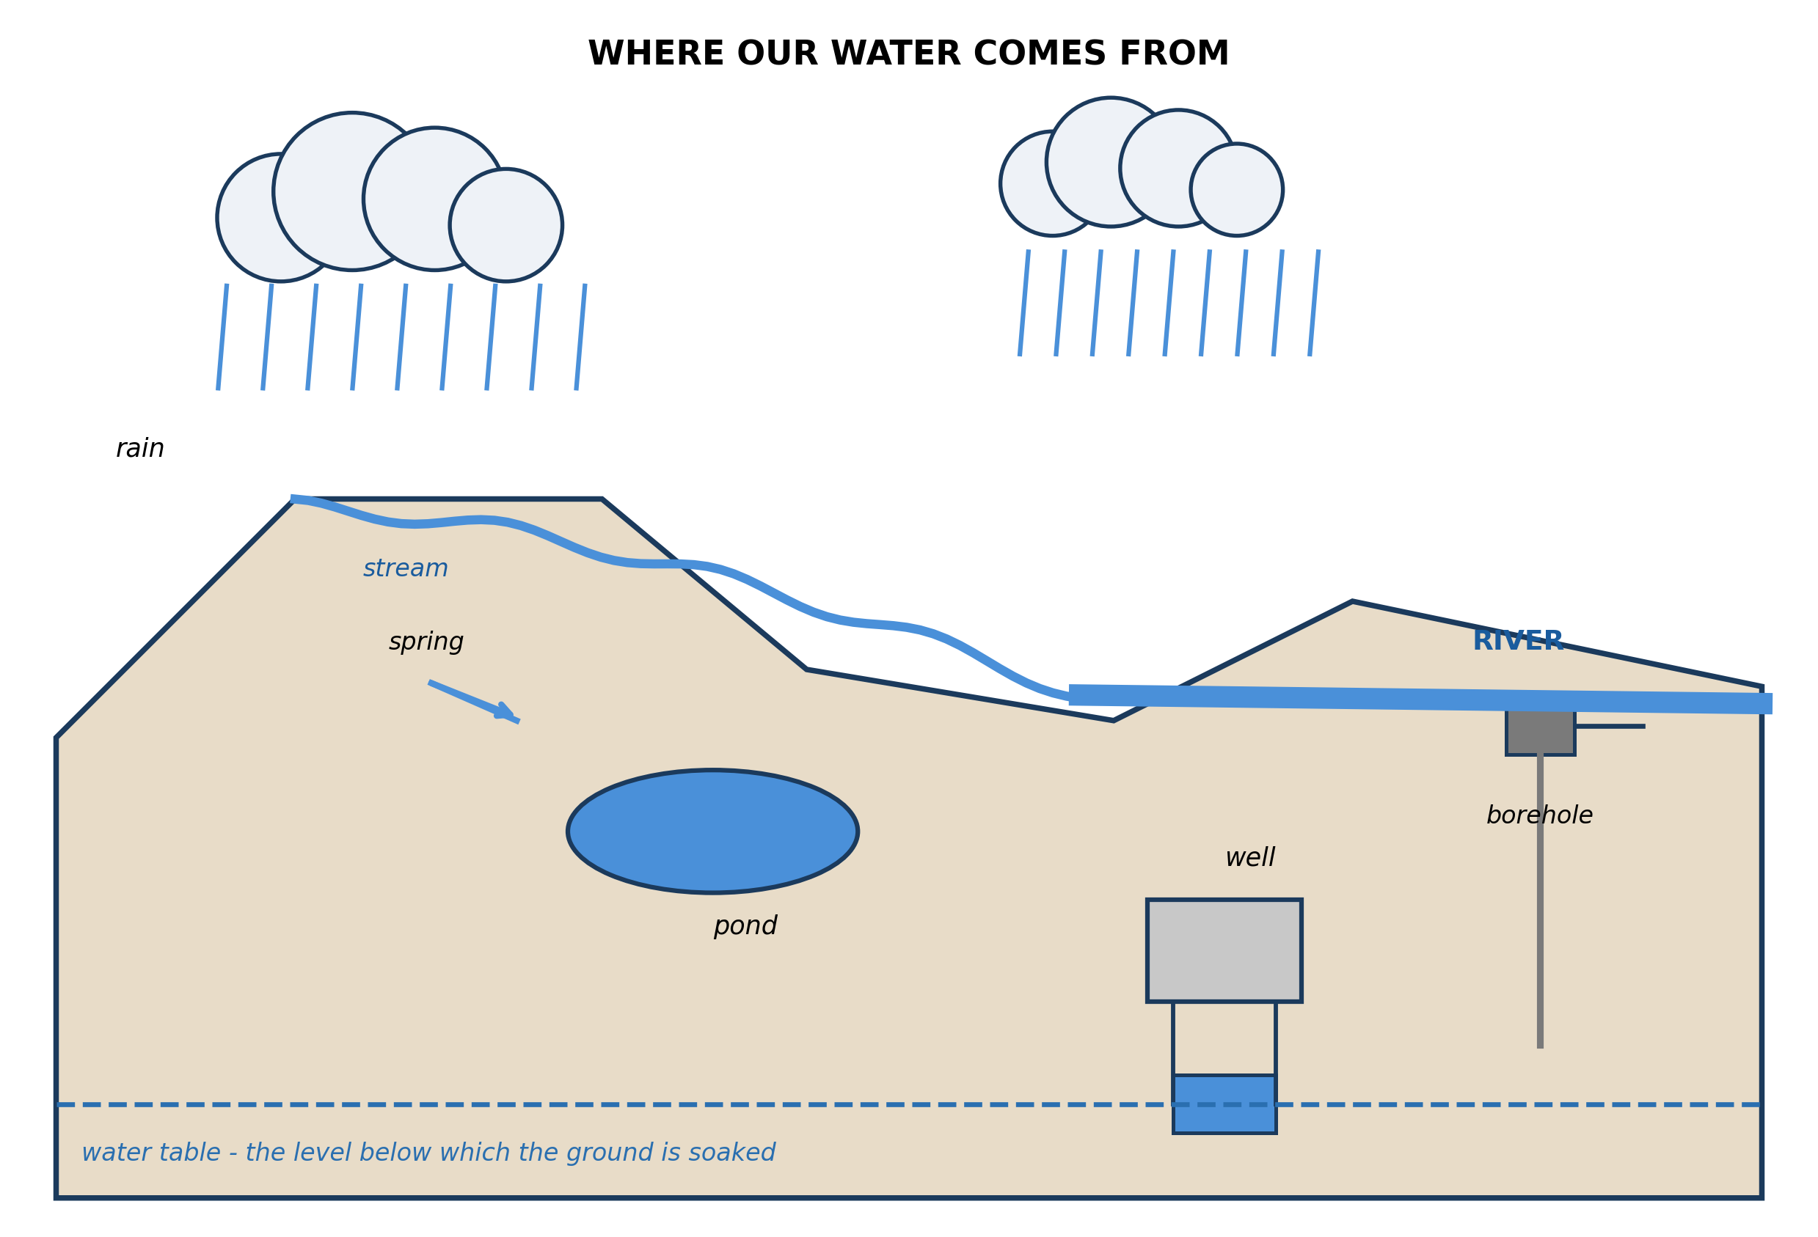
Fig. 1: Where our water comes from

3.1 3.1 Natural Sources of Water
1. The diagram shows both a well and a borehole going down below the water table. Explain why both have to reach below it, and explain what would happen to the well during a long drought. [4 marks]
2. From the diagram, name THREE sources of water and say for each whether it is SURFACE water or water from UNDERGROUND. [3 marks]
3. Name TWO sources of water shown in the diagram. [2 marks]
____________________________________________________________________________________________
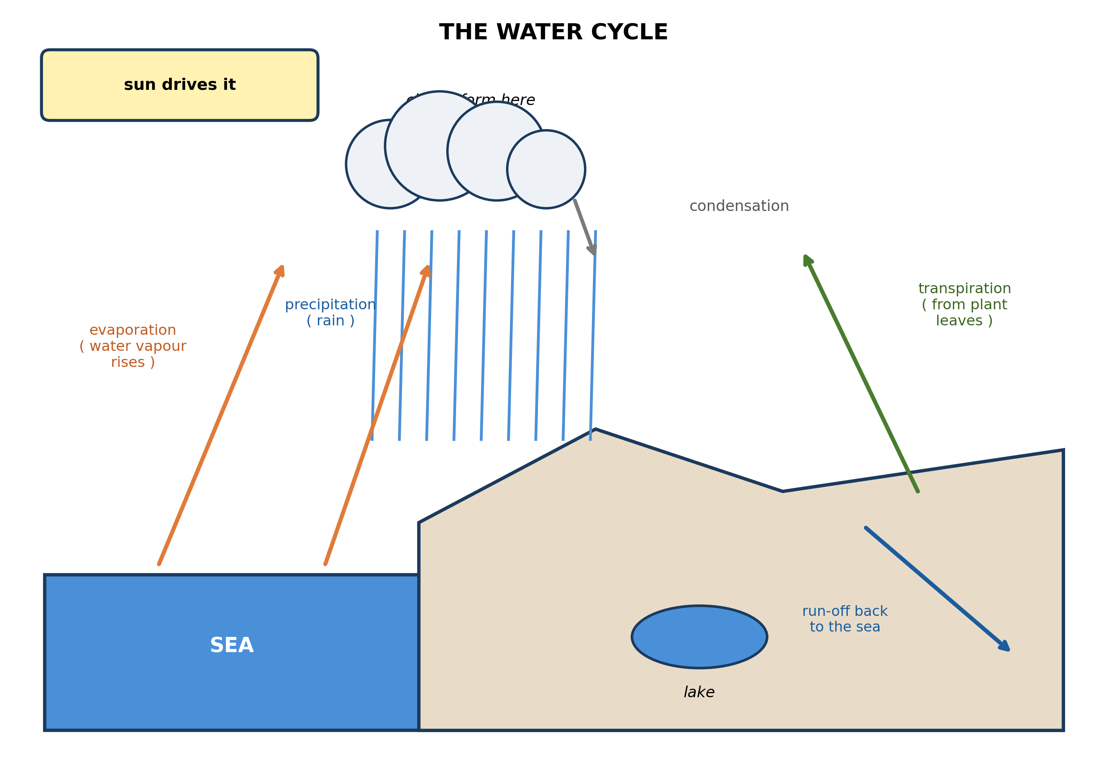
Fig. 2: The water cycle

3.2 3.2 Stages of the Water Cycle: Evaporation, Condensation, Precipitation and Transpiration
4. Explain why the SUN is essential to the water cycle, and describe what would happen to the supply of rain if the sun stopped heating the sea. [4 marks]
5. The diagram shows TRANSPIRATION as well as evaporation. In a thick forest, which of the two puts more water into the air? Explain why. [3 marks]
____________________________________________________________________________________________
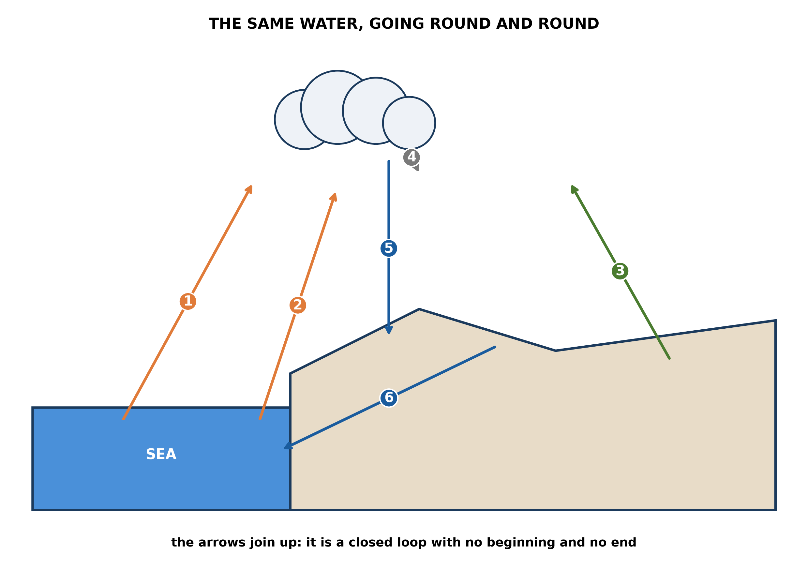
Fig. 3: The same water, going round and round

3.3 3.3 Why the Water Cycle is a Repeated Pattern in Nature
6. The diagram shows the water cycle as a closed loop. Explain what is meant by saying it is a CLOSED system, and use that idea to explain why the water falling as rain today is the same water that has been falling on the earth for millions of years. [4 marks]
7. A pupil says that because the stages are numbered 1 to 6, stage 1 must be the beginning of the cycle. Use the diagram to explain why this is wrong. [3 marks]
____________________________________________________________________________________________
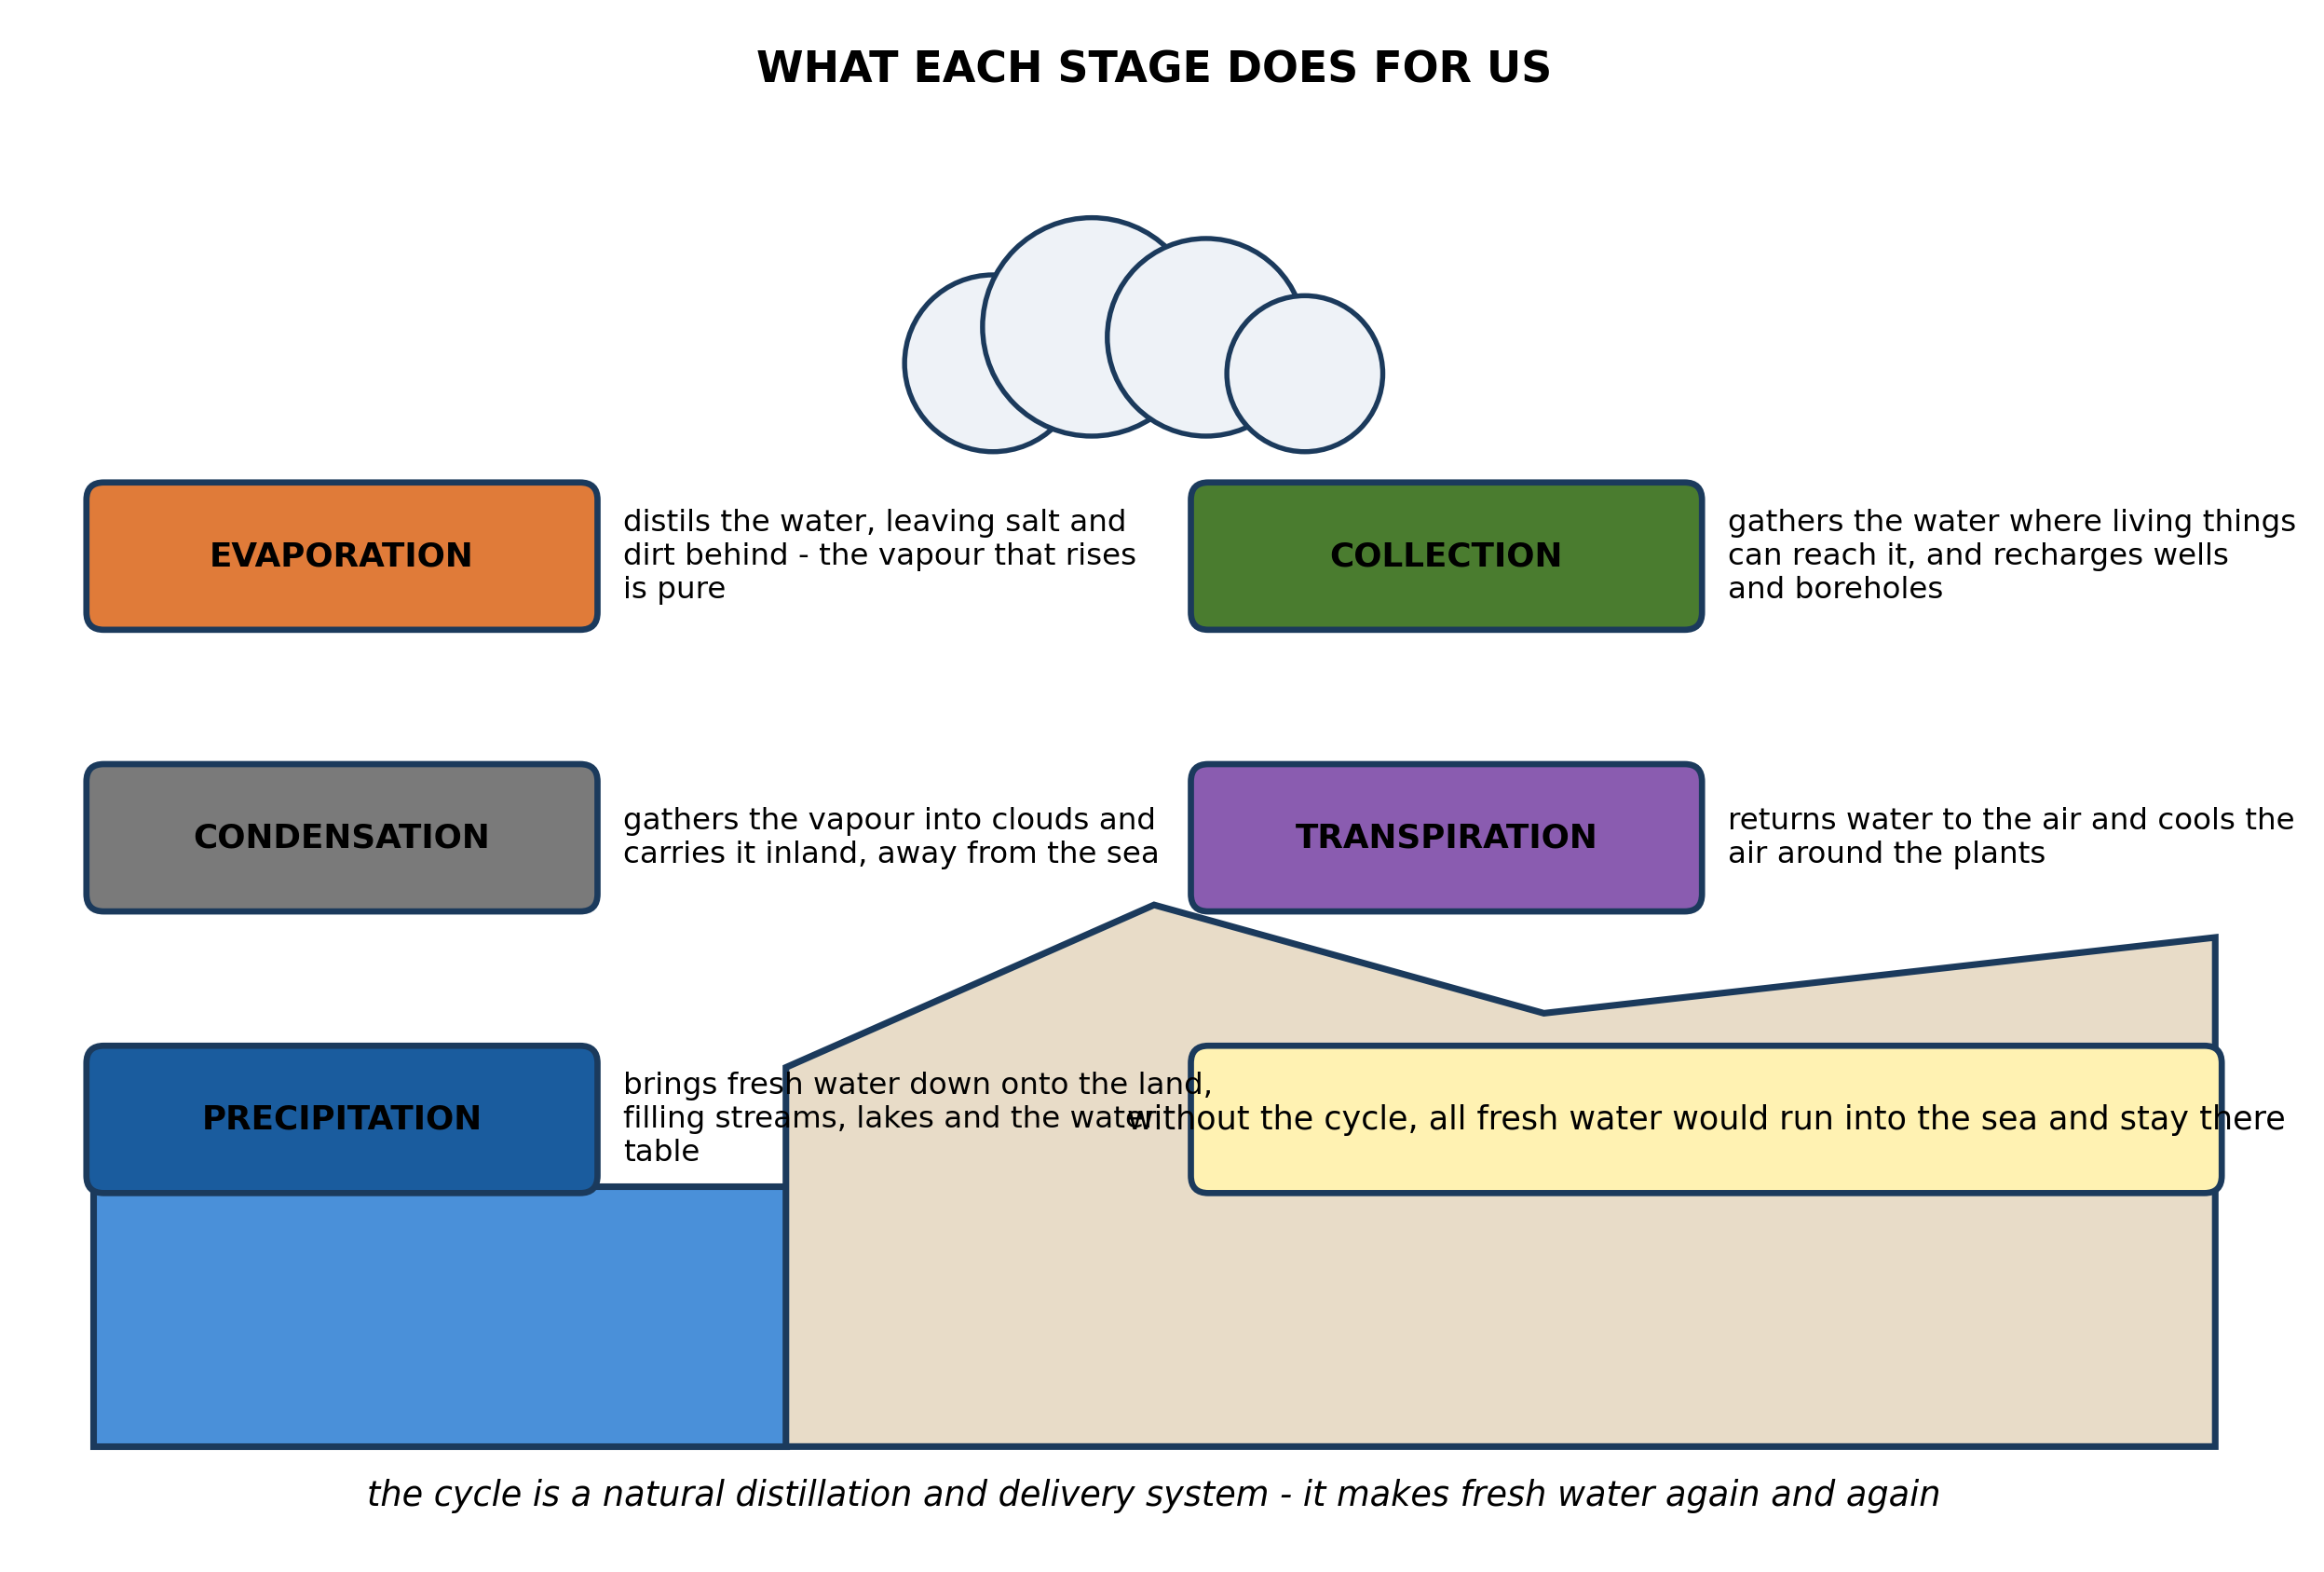
Fig. 4: What each stage does for us

3.4 3.4 Importance of the Water Cycle to the Environment
8. The diagram says that evaporation DISTILS the water. Explain what this means, and use it to explain why rain is fresh even though most of the water that evaporates comes from the salty sea. [4 marks]
9. State TWO things the water cycle does for the environment. [3 marks]
____________________________________________________________________________________________
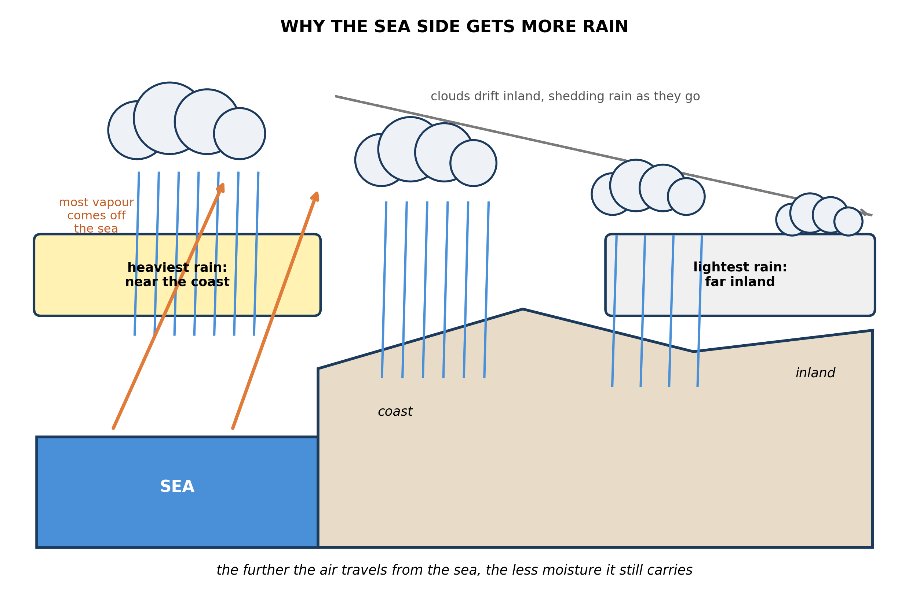
Fig. 5: Why the sea side gets more rain

3.5 3.5 The Water Cycle and Weather Patterns
10. Use the diagram to explain why a town near the coast gets more rain than a town far inland. [4 marks]
11. Explain why clearing a large area of forest would reduce the rainfall in the region downwind of it. [3 marks]
____________________________________________________________________________________________
SECTION B - PRACTICAL TASK
Study the apparatus and answer the questions that follow it.
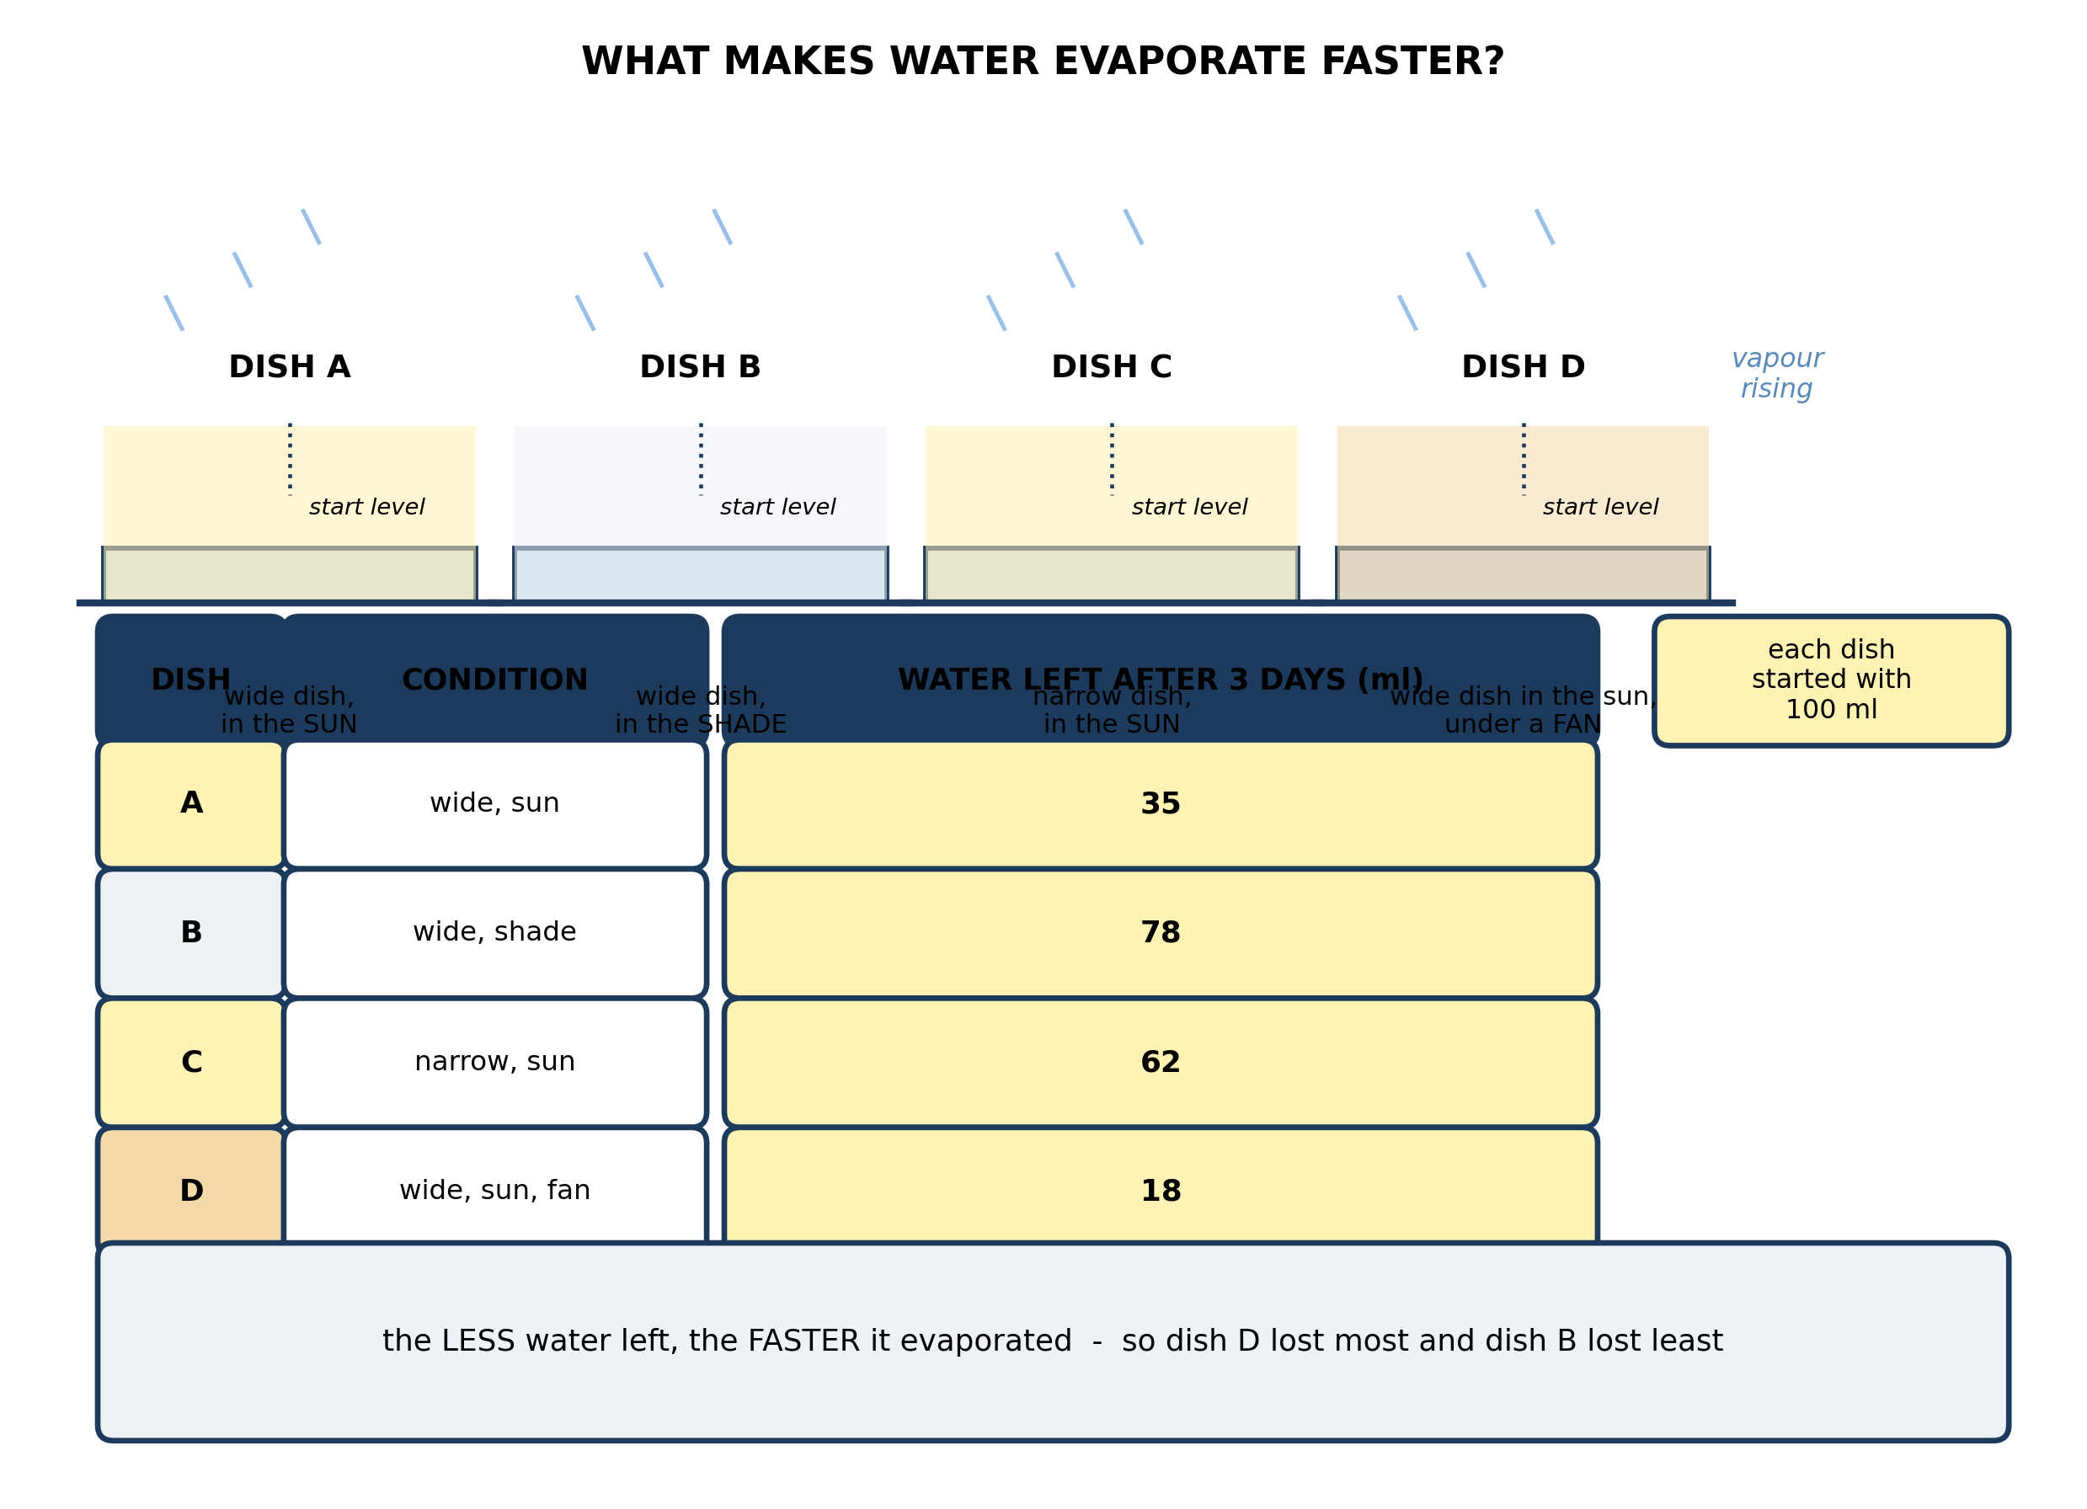
Fig. 6: What makes water evaporate faster?

12. List the four dishes in order, from the one where water evaporated FASTEST to the one where it evaporated SLOWEST, and state what each pair of dishes shows. [4 marks]
13. Explain, using the idea of particles, why dish D lost water faster than dish A. [3 marks]
14. State TWO things that must be kept the same in this experiment, and explain why each one matters. [3 marks]
15. A pupil wants to test whether putting a LID on a dish slows evaporation. Describe what he should do, and what result he would expect and why. [3 marks]
____________________________________________________________________________________________

ANSWER KEY AND MARKING SCHEME
Accept any other correct and relevant answer. Award marks for correct points, not for repeating the question.
3.1 3.1 Natural Sources of Water
Q1
The water table is the level below which the pores and cracks in the soil and rock are full of water; above it the ground is only damp and holds no free water that can be drawn off. So a well or a borehole must be dug down past that level so that water can seep in through the sides and collect at the bottom. During a long drought, little or no rain soaks into the ground to replace what is drawn out, so the water table falls. If it falls below the bottom of the well, the well yields nothing - it has run dry. A borehole is drilled much deeper precisely so that it still reaches water when the table drops, which is why boreholes keep supplying water after shallow wells have failed.
Q2
Any three, each correctly classified. Stream - surface. River - surface. Pond - surface. Spring - underground water coming to the surface. Well - underground. Borehole - underground.
Q3
Any two of: rain, stream, river, pond, spring, well, borehole.
3.2 3.2 Stages of the Water Cycle: Evaporation, Condensation, Precipitation and Transpiration
Q4
Evaporation needs energy. To turn liquid water into vapour, the molecules have to be given enough energy to break free of the liquid, and on this planet the sun supplies that energy. Without it, evaporation from the sea would almost stop. No vapour would rise, so no clouds would form, and rain would cease. The water already on the land would drain into the sea, rivers would run down and then dry, and the water table would not be recharged. The sun is the pump that drives the whole cycle; everything else in it is consequence.
Q5
Transpiration. A forest carries an enormous total area of leaf surface, and every leaf is giving off water vapour, so the amount added up over the whole canopy is very large - often larger than the water evaporating from the soil beneath. The canopy also shades the ground, which keeps the soil cooler and so reduces direct evaporation from it. Together those two effects mean that in a forest the plants, not the soil, are the main source of water vapour in the air.
3.3 3.3 Why the Water Cycle is a Repeated Pattern in Nature
Q6
A closed system is one in which nothing enters or leaves overall: the total amount stays the same and everything that happens is a change of form or a change of place. Very little water escapes into space and very little arrives from it, so the earth's stock of water is essentially fixed. What the cycle does is move it about and change it - liquid to vapour to liquid, sea to air to land and back again. Because no water is used up, the water in a raindrop today is made of molecules that have already been through countless previous cycles: through oceans, clouds, glaciers, rivers and living things. The cycle is a repeated pattern because the same water is used over and over rather than replaced.
Q7
The arrows join up: stage 6 collects the water and returns it to where stage 1 begins, so the loop closes on itself. That means any stage could be called the first - you can start at condensation, or at rain, or at collection, and you will still go through all the others and arrive back where you started. The numbers are only a convenient way of listing the stages so they can be talked about; they are not an order in time. A cycle by definition has no beginning and no end.
3.4 3.4 Importance of the Water Cycle to the Environment
Q8
Distillation means separating a liquid from the solids dissolved in it by turning the liquid into vapour and then back into liquid again. When sea water evaporates, only the water molecules leave: the salt and everything else dissolved in the sea has far too high a boiling point to evaporate at ordinary temperatures, so it is left behind in the sea. The vapour that rises is therefore pure water, and when it condenses the droplets are fresh. That is why rain is fresh despite coming mostly from the sea, and why the cycle is the earth's fresh-water supply: it is a natural distillation plant that takes salty water and delivers fresh water onto the land, over and over, with no machinery and no fuel other than the sun.
Q9
Any two, each stated. It supplies fresh water to rivers, lakes, streams and the water table, which plants, animals and people depend on. It carries water from the sea inland, so that places far from the coast still get rain. It recharges wells and boreholes. It returns water to the air and so cools and moistens it. It makes plant growth possible, and therefore food.
3.5 3.5 The Water Cycle and Weather Patterns
Q10
Most of the water vapour in the air evaporates from the sea, because that is where most of the earth's water is and where it is most exposed. The air moving inland carries that moisture with it, and as it rises and cools the vapour condenses into cloud and then falls as rain. The heaviest rain therefore falls soon after the air leaves the sea - that is, near the coast. By the time the same air has travelled far inland it has already shed much of its moisture, so there is less left to fall. That is why rainfall decreases with distance from the sea, which the diagram shows by the clouds getting smaller and the rain thinner as they move inland.
Q11
Trees return a great deal of water to the air by transpiration, and in forest that source is often larger than evaporation from the ground. Remove the trees and that water no longer enters the air, so there is less moisture available to condense into cloud and fall as rain. The forest also shades and cools the ground and slows the run-off that would otherwise rush straight to the sea. So the air passing over the cleared land picks up less moisture than it used to, and places downwind of it receive less rain.
PRACTICAL TASK
Q12
Fastest to slowest: D (18 ml left), A (35 ml), C (62 ml), B (78 ml). Comparing A with B shows that warmth speeds evaporation - same wide dish, but the one in the sun lost far more than the one in the shade. Comparing A with C shows that a larger surface area speeds it - same sun, but the wide dish lost more than the narrow one, because there is more surface for molecules to escape from. Comparing D with A shows that moving air speeds it - same dish and same sun, but the dish with a fan blowing over it lost most of all.
Q13
In both dishes the molecules are moving at a range of speeds, and the fastest ones near the surface escape into the air as vapour. In dish A that vapour collects in the still air just above the water, so the air there becomes humid and some of the escaped molecules fall back into the liquid. In dish D the fan continually sweeps the vapour away and replaces it with drier air, so the air above the water never becomes humid and molecules that escape are not coming back. Net escape stays fast, so the water level drops quicker.
Q14
Any two, each explained. Every dish must start with the same volume of water - 100 ml - because if one started with less there would be less to lose and you could not compare what is left. All four must be left for the same three days, because a dish left longer would lose more whatever its conditions. Where a pair is being compared, the two dishes must be the same size and shape so that surface area is not a second difference. The water in every dish should start at the same temperature.
Q15
He should set up two identical dishes with the same volume of water, in the same place, for the same length of time, and put a lid on one while leaving the other open - so the lid is the only difference. Then he measures how much water is left in each. He should expect the covered dish to lose far less. The lid traps the vapour, so the air in the space above the water quickly becomes saturated: as many molecules fall back in as escape, and net evaporation almost stops. Water that condenses on the underside of the lid also drips back into the dish.

BLUEPRINT / TEST SPECIFICATION
# | Content standard | Code | Items | Marks | % of Marks
3.1 | 3.1 Natural Sources of Water | B7/JHS1.2.1.1 | 3 | 9 | 18%
3.2 | 3.2 Stages of the Water Cycle: Evaporation, Condensation, Precipitation and Transpiration | B7/JHS1.2.1.1 | 2 | 7 | 14%
3.3 | 3.3 Why the Water Cycle is a Repeated Pattern in Nature | B7/JHS1.2.1.1 | 2 | 7 | 14%
3.4 | 3.4 Importance of the Water Cycle to the Environment | B7/JHS1.2.1.1 | 2 | 7 | 14%
3.5 | 3.5 The Water Cycle and Weather Patterns | B7/JHS1.2.1.1 | 2 | 7 | 14%
3.1 | Practical task | B7/JHS1.2.1.1 | 4 | 13 | 26%
TOTAL | - | - | 15 | 50 | 100%
Distribution by cognitive level
Cognitive level | Marks | % of Marks
Understand | 11 | 22%
Apply | 17 | 34%
Analyse | 22 | 44%
TOTAL | 50 | 100%
Distribution by difficulty
Difficulty | Marks | % of Marks
Easy | 2 | 4%
Moderate | 29 | 58%
Challenging | 19 | 38%
TOTAL | 50 | 100%

QUALITY-CONTROL SUMMARY
1. Is every question answered from a diagram?
Yes. All 15 questions sit under a figure, and each is unanswerable - or at least materially harder - without reading it. Questions 3, 8, 10 and 17 ask pupils to go beyond the diagram, but each still starts from something the figure shows.
2. Is the content within the Basic 7 curriculum?
Yes. Every question traces to the content standards for this sub-strand (B7/JHS1.2.1.1), and nothing is tested beyond the depth the Basic 7 syllabus sets for it.
3. Are the diagrams clear and unambiguous?
Yes. Each is drawn so that only one reading is sensible: the particle boxes differ in spacing alone, the syringes are labelled with how far each squashes, and the periodic table marks the regions in words as well as by position.
4. Is the level right for JHS 1?
Yes. Questions ask pupils to read, describe and explain what is drawn. Only Question 17 asks for an inference beyond the figure, and it is worth 3 of the 40 marks.
5. Do the marks add up?
Yes: 15 questions totalling 50 marks, matching the figure on the front page. The blueprint, cognitive and difficulty tables all sum to the same total.
6. Are the answers correct and complete?
Yes. Each answer states the point the question is worth, with the acceptable alternatives given where a question is open.
EXAMINER NOTES (for the teacher, not for candidates)
- Pitched at the compulsory diagram question of BECE Paper 2: 78% of the marks are at Apply level or above and 38% are Challenging.
- Q8 is the best question in the paper. Every pupil knows rain is fresh and the sea is salt, and almost none can say why. The answer is distillation: only water molecules evaporate, the salt stays behind. If they can explain that, they understand the cycle as a process rather than a picture to copy.
- Q6 on the closed system is where the 'repeated pattern' wording of 3.3 becomes real. Pupils will say 'the water goes round and round' without grasping that it is the SAME water. Push them on it: no water is made and none is destroyed, so today's rain has been through the cycle before, many times.
- Q7 on the numbering is a small question that catches a real confusion. Pupils treat the numbering as a sequence in time and look for a first stage. The arrows close the loop, so there isn't one.
- Q11 on deforestation reducing downwind rainfall is deliberately cross-topic - it links 3.5 to the forest's role and rewards pupils who see transpiration as a real contribution rather than a label on a diagram.
- The evaporation experiment in Fig. 6 needs four shallow dishes, a measuring cylinder, and a fan if you have one. Three days is enough to give the differences in the table. The particle explanation in Q13 is the one pupils find hardest: the fan does not change the water, it removes the vapour that has already left so fewer molecules return.
- If you have no fan, prop a book to make a draught or simply place one dish in a breeze; the direction of the result is the same and the numbers are still usable.

