[SCHOOL NAME]
INTEGRATED SCIENCE (SCIENCE)
PRACTICAL QUESTIONS - DIAGRAM MODE
Ecosystem (9.1 - 9.5)
____________________________________________________________________________________________
CLASS: Basic 7 (JHS 1)
TIME: 1 hour 30 minutes
MARKS: 50 2025/2026 Academic Year
____________________________________________________________________________________________
INSTRUCTIONS TO CANDIDATES
1. Answer ALL the questions in this paper.
2. Every question is based on a diagram. Study each diagram carefully before you answer the questions that follow it.
3. Write your answers in the spaces provided. The marks for each question are printed beside it.
4. Where a question asks for a stated number of points, give that number. Any extra answers will not be marked.
5. You may refer back to any diagram at any time.
____________________________________________________________________________________________
SECTION A - DIAGRAM STUDY
Study each diagram and answer the questions that follow it.
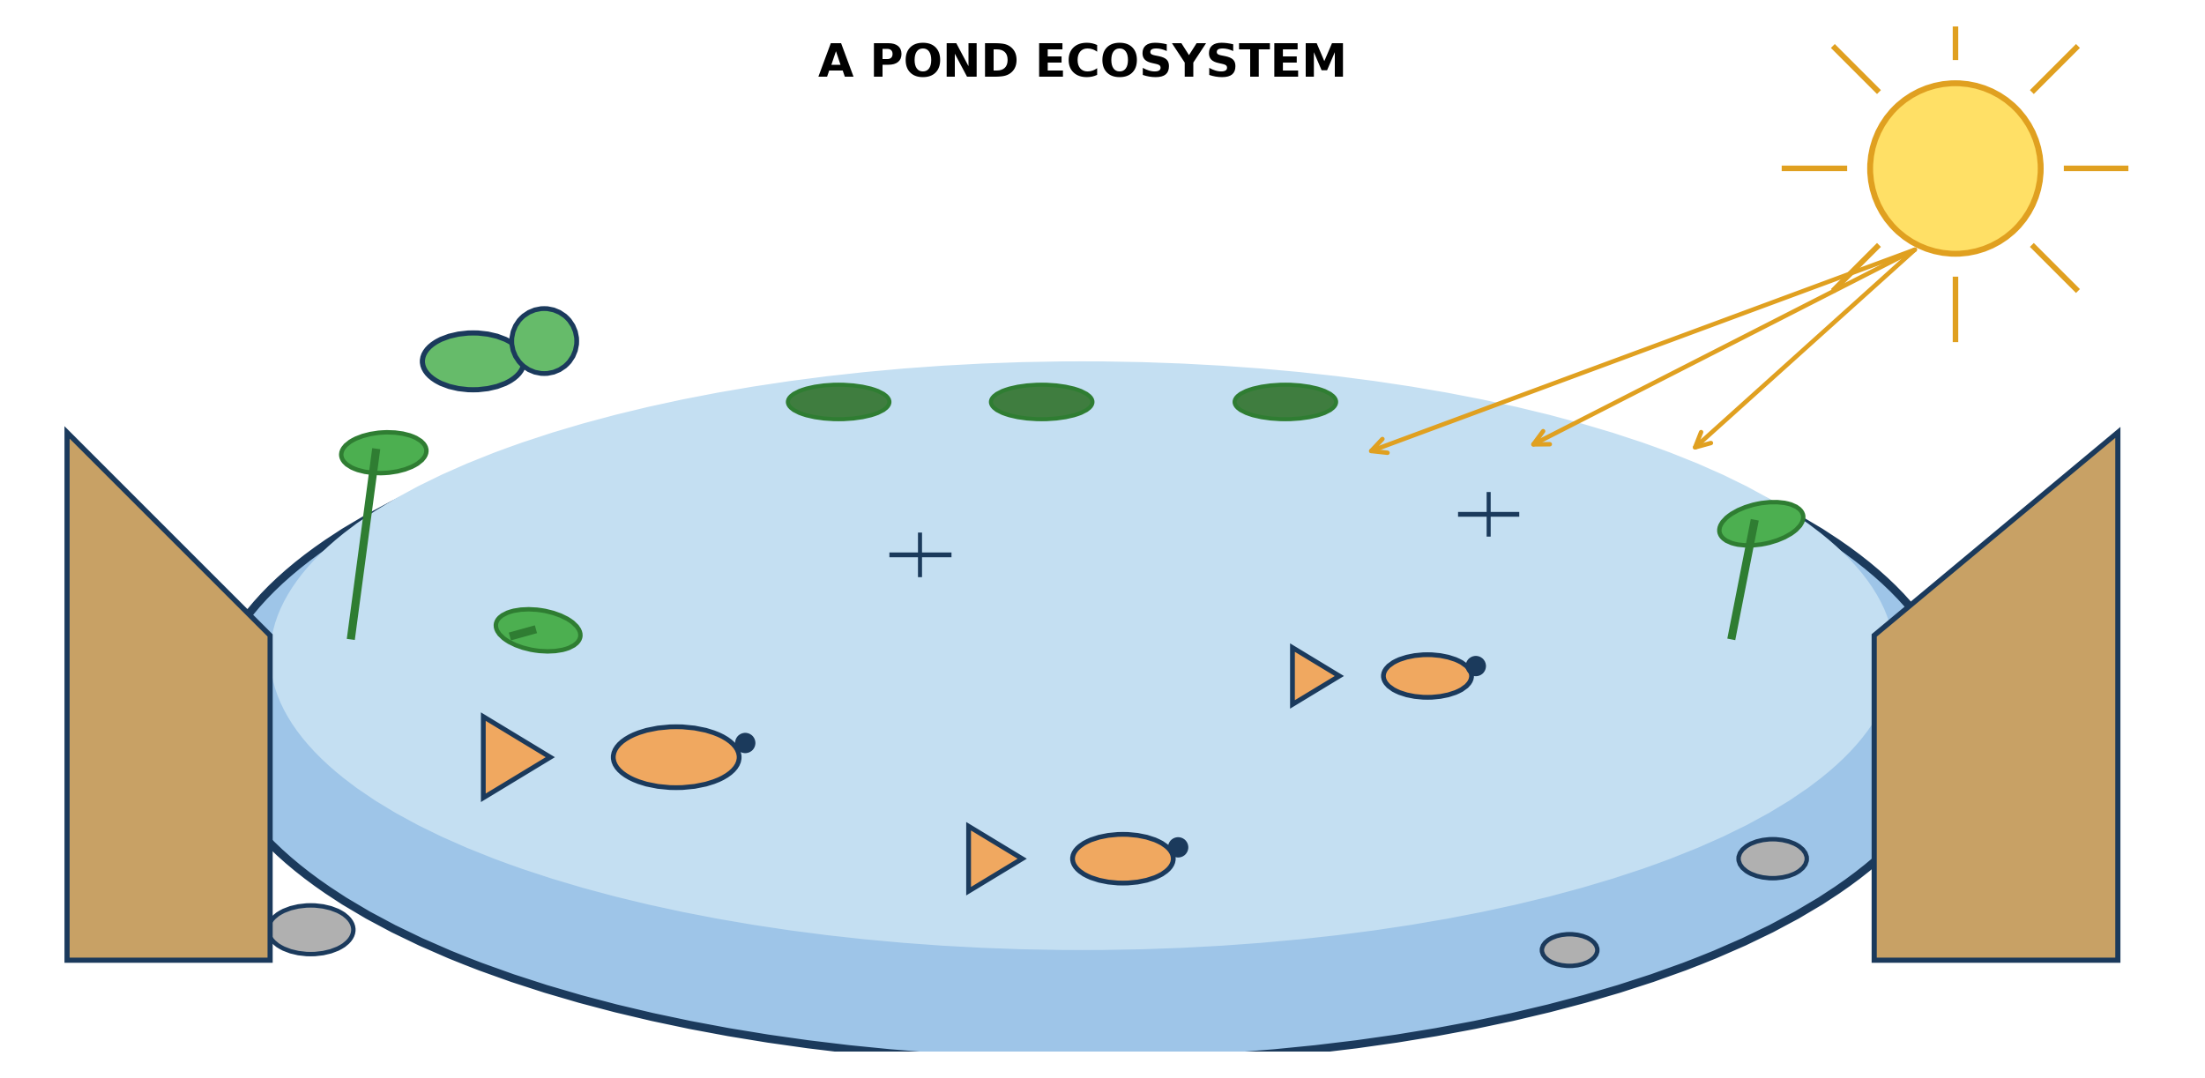
Fig. 1: A pond ecosystem

9.1 9.1 What is an Ecosystem?
1. Explain why the pond in the diagram is described as an ECOSYSTEM rather than simply as a HABITAT. [4 marks]
2. Name TWO non-living (abiotic) things shown in the diagram, and state why the living things depend on each. [3 marks]
____________________________________________________________________________________________
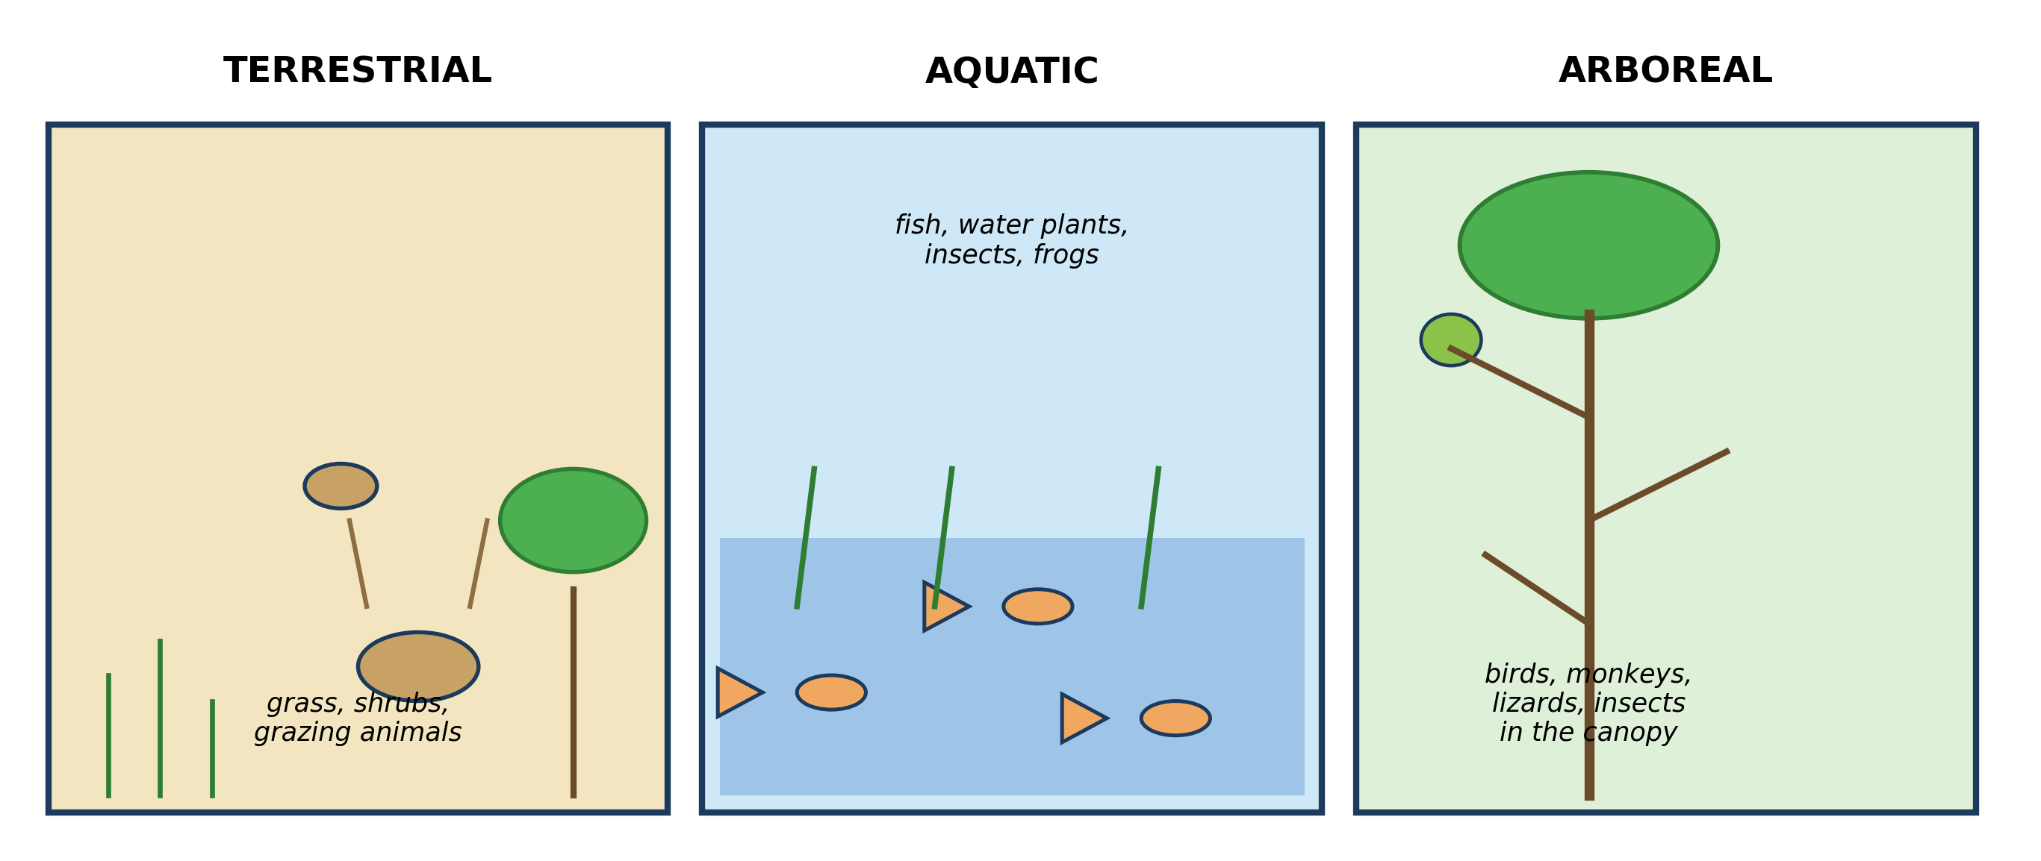
Fig. 2: Three kinds of ecosystem

9.2 9.2 Types of Ecosystems: Terrestrial, Aquatic and Arboreal
3. Choose TWO of the three ecosystems. For EACH, name one organism shown and explain ONE way it is suited to living there. [4 marks]
4. A pupil says a frog could live happily in ANY of the three ecosystems. Explain why the frog would struggle in the DRIEST of them. [3 marks]
____________________________________________________________________________________________
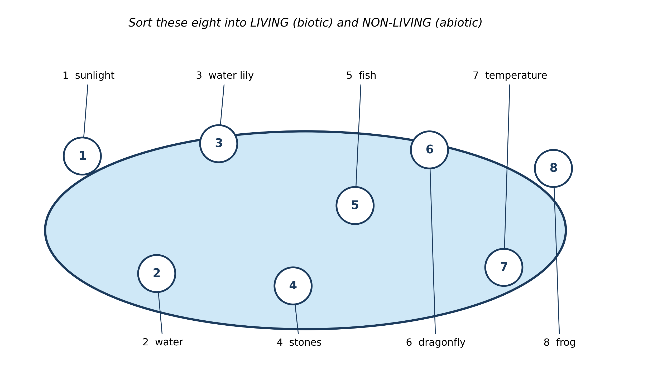
Fig. 3: Eight things in a pond, numbered

9.3 9.3 Components of an Ecosystem: Biotic and Abiotic Factors
5. Copy and complete the table by sorting the eight numbered items into LIVING (biotic) and NON-LIVING (abiotic). [3 marks]
6. Choose ONE abiotic factor from the diagram. Explain what would happen to the living things in the pond if that factor were removed or greatly reduced. [3 marks]
7. A pupil argues that sunlight is NOT part of the pond ecosystem because it comes from the sky, outside the pond. Explain why the pupil is wrong. [4 marks]
____________________________________________________________________________________________
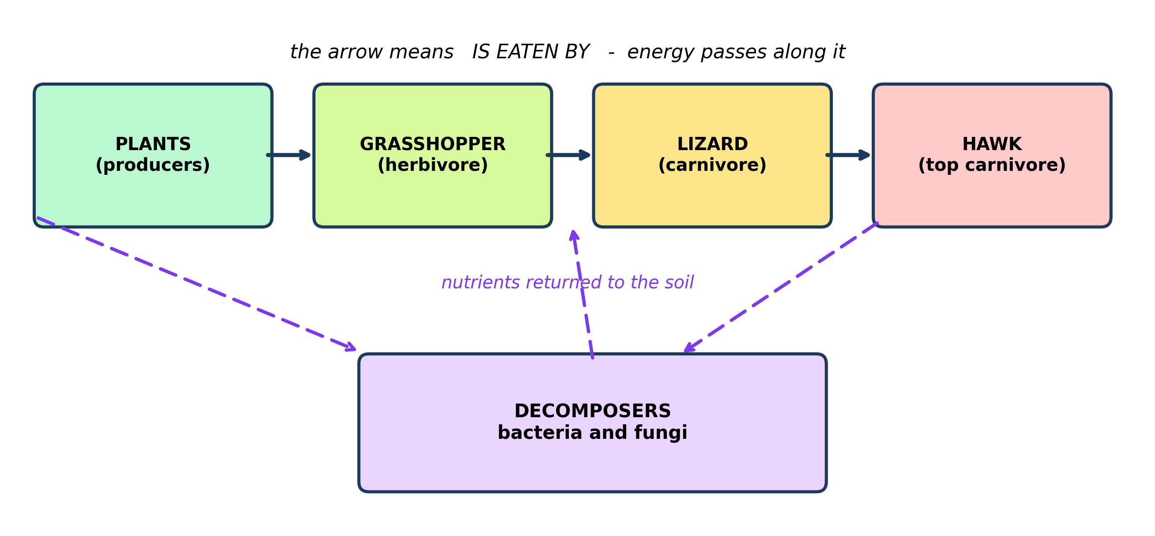
Fig. 4: How the parts of an ecosystem interact

9.4 9.4 How Components of an Ecosystem Interact
8. The diagram has arrows between the organisms. State what an arrow means in a food chain, and explain why the direction of the arrow matters. [3 marks]
9. All the LIZARDS in the ecosystem are removed. PREDICT what happens to the number of grasshoppers, and then to the number of plants. Explain the steps. [4 marks]
10. Explain the role of the DECOMPOSERS shown in the diagram, and what would happen in the ecosystem without them. [3 marks]
____________________________________________________________________________________________
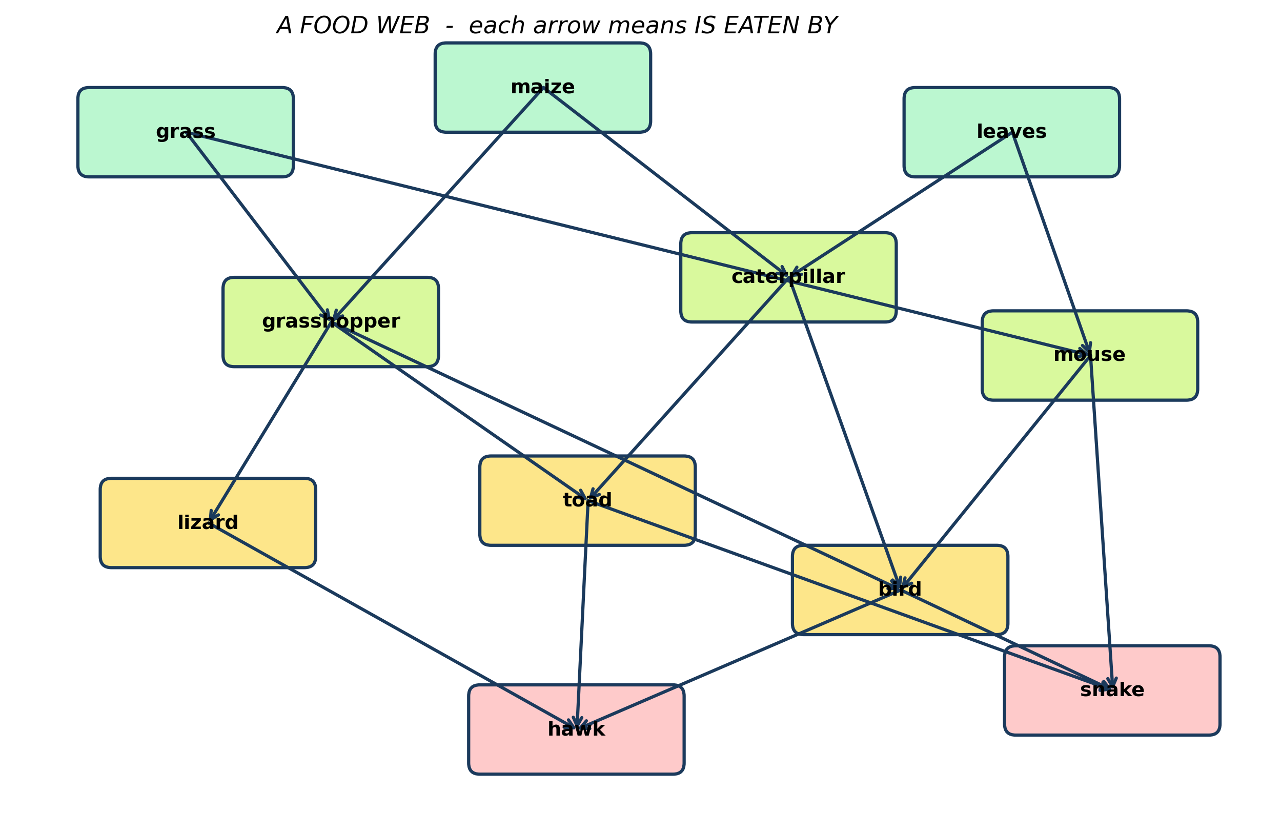
Fig. 5: A food web

9.5 9.5 Interdependence of Organisms in an Ecosystem
11. Write out TWO different food chains from the web, each with at least four links. Remember what the arrow means. [3 marks]
12. Explain why a food WEB, where an animal feeds on more than one thing, makes the ecosystem more STABLE than a single food chain. [4 marks]
13. A disease kills every GRASSHOPPER in the web. PREDICT TWO effects on the other organisms. [3 marks]
____________________________________________________________________________________________
SECTION B - PRACTICAL TASK
Study the apparatus and answer the questions that follow it.
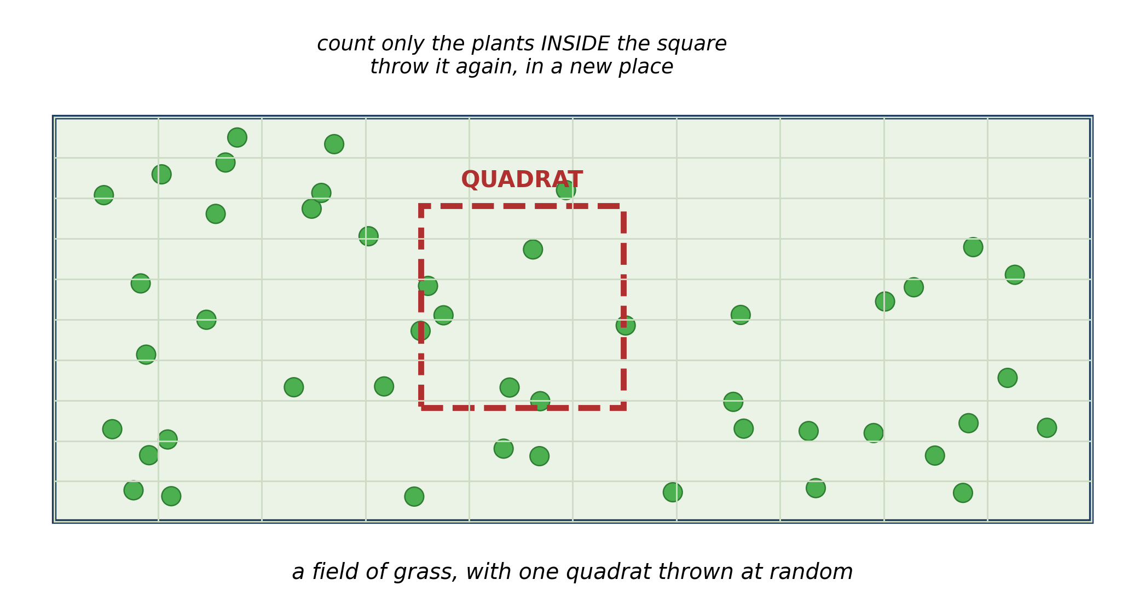
Fig. 6: Using a quadrat to sample plants

14. Describe how you would use the quadrat in the diagram to estimate how many plants are in the whole field, and explain why you would throw it more than once. [4 marks]
15. Explain why it is better to count the plants in several small squares than to try to count every plant in the whole field. [2 marks]
____________________________________________________________________________________________

ANSWER KEY AND MARKING SCHEME
Accept any other correct and relevant answer. Award marks for correct points, not for repeating the question.
9.1 9.1 What is an Ecosystem?
Q1
A habitat is only the place where an organism lives. An ecosystem is the community of living things together with the non-living parts, all interacting as one system. The diagram shows both: the fish, frog, dragonfly, plants and reeds are the living part, and the water, the sunlight, the stones and the temperature are the non-living part. What makes it an ecosystem is that they INTERACT - the plants use the sunlight to make food, the fish and insects feed on the plants, the frog feeds on the insects, and wastes and dead remains are broken back down in the water.
Q2
Any two with a reason: SUNLIGHT - the plants need it to make their food by photosynthesis, so without it no food enters the ecosystem at all. WATER - it is the habitat itself; the fish breathe the oxygen dissolved in it, the plants root in it, and every organism needs it to stay alive. STONES - they give surfaces for plants to root on and places for small animals to hide from predators. TEMPERATURE - it controls how fast the organisms grow and how much oxygen the water can hold.
9.2 9.2 Types of Ecosystems: Terrestrial, Aquatic and Arboreal
Q3
Any two, organism plus adaptation: AQUATIC - fish have gills to take oxygen out of the water and a streamlined body and fins to swim. TERRESTRIAL - grazing animals have long legs and hooves for running across open ground away from predators, and flat teeth for cropping grass. ARBOREAL - monkeys and lizards have gripping hands, feet or claws for holding branches, and birds have wings and light bones for moving between trees.
Q4
A frog breathes partly through its skin, which must stay moist for oxygen to dissolve into it, and it must return to water to lay its eggs because they have no shell. In a dry terrestrial habitat it would lose water through its skin faster than it could replace it and would dry out, and any eggs it laid would dry up too.
9.3 9.3 Components of an Ecosystem: Biotic and Abiotic Factors
Q5
LIVING (biotic): 3 water lily, 5 fish, 6 dragonfly, 8 frog. NON-LIVING (abiotic): 1 sunlight, 2 water, 4 stones, 7 temperature.
Q6
SUNLIGHT - the water lilies and reeds could not photosynthesise, so they would stop making food and would die. Every animal that feeds on them, and every animal that feeds on those, would then run out of food, so the whole pond would collapse. OR WATER - there would be no habitat at all and every organism in it would die. OR OXYGEN IN THE WATER - the fish would suffocate.
Q7
An ecosystem is defined by the things in it and how they INTERACT, not by where those things come from. Sunlight reaches the water and the plants in the pond use it to make their food; without it, no energy would enter the system at all. Because the living parts depend on it, it is one of the abiotic components of the ecosystem, even though it arrives from outside. Rain falling in, and leaves blowing in, are part of the pond ecosystem for exactly the same reason.
9.4 9.4 How Components of an Ecosystem Interact
Q8
The arrow means IS EATEN BY, and it shows the direction in which the energy and the food pass. The direction matters because energy only flows one way - from the organism being eaten to the organism that eats it. An arrow drawn the wrong way round would say that the hawk is eaten by the lizard, which is the wrong way round and changes the meaning of the whole chain.
Q9
The grasshoppers would increase at first, because the animals that were eating them are gone. As the grasshopper population grows, the grasshoppers eat more and more of the plants, so the number of plants falls. Eventually the plants cannot support the large grasshopper population, the grasshoppers run short of food and starve, and their numbers crash back down. So the number rises sharply and then falls again.
Q10
Decomposers such as bacteria and fungi break down dead plants and animals and animal waste, and in doing so they return the nutrients locked up in them back to the soil and the water. Without them, dead remains would pile up and the nutrients in them would stay locked away. The plants would run short of the nutrients they need to grow, so less food would be made, and the whole ecosystem would slowly run down.
9.5 9.5 Interdependence of Organisms in an Ecosystem
Q11
Any two with four or more links and arrows pointing the right way, e.g. grass --> grasshopper --> toad --> hawk; maize --> caterpillar --> bird --> snake; leaves --> mouse --> bird --> hawk; grass --> mouse --> snake. (The arrow means 'is eaten by'.)
Q12
In a single chain each animal has only one source of food, so if that one link fails everything above it loses its only supply and the chain collapses. In a web an animal has alternatives: if the grasshoppers die out, the toad can still eat caterpillars. Because the failure of one link can be absorbed by switching to another, the web as a whole survives a change that would destroy a chain.
Q13
Any two effects, with the reasoning: the animals that feed on grasshoppers - the lizard, the toad and the bird - would have less food, so their numbers would fall unless they can switch to caterpillars or mice. The plants the grasshoppers ate - grass and maize - would be eaten less, so they would grow more thickly. The hawk and the snake would eventually be affected too, because the animals they eat have become fewer.
PRACTICAL TASK
Q14
Throw the quadrat at random, count every plant of the kind you are studying that lies INSIDE the square, and record the number. Do the same in several different places, add the counts together and divide by the number of throws to get an average number per square metre. Then multiply that average by the total area of the field. You throw it more than once because one square may land on a patch that is unusually bare or unusually thick - several throws and an average give a fairer estimate of the whole field.
Q15
Counting the whole field would take far too long and it is very easy to miss plants or to count the same one twice, so the answer would probably be wrong anyway. Sampling a few squares is quick and, if the samples are fair, gives an answer that is close enough for the purpose.

BLUEPRINT / TEST SPECIFICATION
# | Content standard | Code | Items | Marks | % of Marks
9.1 | 9.1 What is an Ecosystem? | B7/JHS1.3.3.1 | 2 | 7 | 14%
9.2 | 9.2 Types of Ecosystems: Terrestrial, Aquatic and Arboreal | B7/JHS1.3.3.1 | 2 | 7 | 14%
9.3 | 9.3 Components of an Ecosystem: Biotic and Abiotic Factors | B7/JHS1.3.3.1 | 3 | 10 | 20%
9.4 | 9.4 How Components of an Ecosystem Interact | B7/JHS1.3.3.1 | 3 | 10 | 20%
9.5 | 9.5 Interdependence of Organisms in an Ecosystem | B7/JHS1.3.3.1 | 3 | 10 | 20%
9.1 | Practical task | B7/JHS1.3.3.1 | 2 | 6 | 12%
TOTAL | - | - | 15 | 50 | 100%
Distribution by cognitive level
Cognitive level | Marks | % of Marks
Understand | 14 | 28%
Apply | 21 | 42%
Analyse | 15 | 30%
TOTAL | 50 | 100%
Distribution by difficulty
Difficulty | Marks | % of Marks
Easy | 8 | 16%
Moderate | 23 | 46%
Challenging | 19 | 38%
TOTAL | 50 | 100%

QUALITY-CONTROL SUMMARY
1. Is every question answered from a diagram?
Yes. All 15 questions sit under a figure, and each is unanswerable - or at least materially harder - without reading it. Questions 3, 8, 10 and 17 ask pupils to go beyond the diagram, but each still starts from something the figure shows.
2. Is the content within the Basic 7 curriculum?
Yes. Every question traces to the content standards for this sub-strand (B7/JHS1.3.3.1), and nothing is tested beyond the depth the Basic 7 syllabus sets for it.
3. Are the diagrams clear and unambiguous?
Yes. Each is drawn so that only one reading is sensible: the particle boxes differ in spacing alone, the syringes are labelled with how far each squashes, and the periodic table marks the regions in words as well as by position.
4. Is the level right for JHS 1?
Yes. Questions ask pupils to read, describe and explain what is drawn. Only Question 17 asks for an inference beyond the figure, and it is worth 3 of the 40 marks.
5. Do the marks add up?
Yes: 15 questions totalling 50 marks, matching the figure on the front page. The blueprint, cognitive and difficulty tables all sum to the same total.
6. Are the answers correct and complete?
Yes. Each answer states the point the question is worth, with the acceptable alternatives given where a question is open.
EXAMINER NOTES (for the teacher, not for candidates)
- Pitched at the compulsory diagram question of BECE Paper 2: 72% of the marks are at Apply level or above and 38% are Challenging.
- Q8 is the one to insist on, and it is where marks are lost for a reason nothing to do with biology. Pupils know the feeding order perfectly well and then draw every arrow backwards. 'The arrow means IS EATEN BY' should be said in every lesson until it is automatic. Give 0 for a chain with the arrows reversed - the direction IS the answer.
- Q9 is the population question and pupils almost always stop half way. They say 'the grasshoppers increase' and stop. The full answer has three steps: increase, then the plants get eaten down, then the grasshoppers starve and crash. Mark it as three points, not one, and teach the shape.
- Q7 is the most abstract and the best test of whether a pupil has understood what an ecosystem IS. The objection - 'sunlight comes from outside so it cannot be part of the pond' - is a good objection, and the answer is that membership comes from interaction, not from location. Expect very few pupils to get this without being taught it.
- Q12, on why a web is more stable than a chain, is the hardest 'why' in the paper. The word to aim for is ALTERNATIVES: an animal with two food sources survives the loss of one. Pupils who answer 'because there are more animals' have not reached it.
- The quadrat in Fig. 6 is the cheapest practical in the syllabus - four sticks and some string, or a square bent out of wire. Twenty minutes on the school field, with pairs throwing their own quadrat, fixes Q14 and Q15 permanently, and it is the sort of question BECE sets almost every year.
- Note on Q5: 2 water and 4 stones are straightforward, but pupils sometimes put 7 temperature with the living things because 'it changes'. Temperature is not alive - it does not feed, grow, respire or reproduce. If a pupil is unsure, ask them to run those four tests on it.

