[SCHOOL NAME]
INTEGRATED SCIENCE (SCIENCE)
PRACTICAL QUESTIONS - DIAGRAM MODE
Electricity and Electronics (12.1 - 12.6)
____________________________________________________________________________________________
CLASS: Basic 7 (JHS 1)
TIME: 1 hour 30 minutes
MARKS: 50 2025/2026 Academic Year
____________________________________________________________________________________________
INSTRUCTIONS TO CANDIDATES
1. Answer ALL the questions in this paper.
2. Every question is based on a diagram. Study each diagram carefully before you answer the questions that follow it.
3. Write your answers in the spaces provided. The marks for each question are printed beside it.
4. Where a question asks for a stated number of points, give that number. Any extra answers will not be marked.
5. You may refer back to any diagram at any time.
____________________________________________________________________________________________
SECTION A - DIAGRAM STUDY
Study each diagram and answer the questions that follow it.
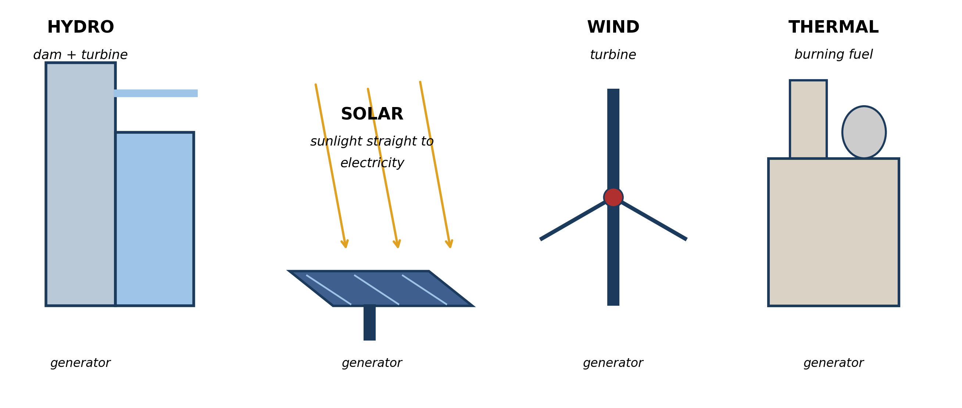
Fig. 1: Four ways of generating electricity

12.1 12.1 Forms of Electricity Generation
1. Choose TWO methods of generation shown in the diagram. For EACH one state the energy change that takes place, naming the form of energy at the start and at the end. [4 marks]
2. A town needs electricity every day of the year, including through a long dry season. Use the diagram to explain why a HYDRO dam alone would be a poor choice, and which method would be more reliable. [3 marks]
____________________________________________________________________________________________
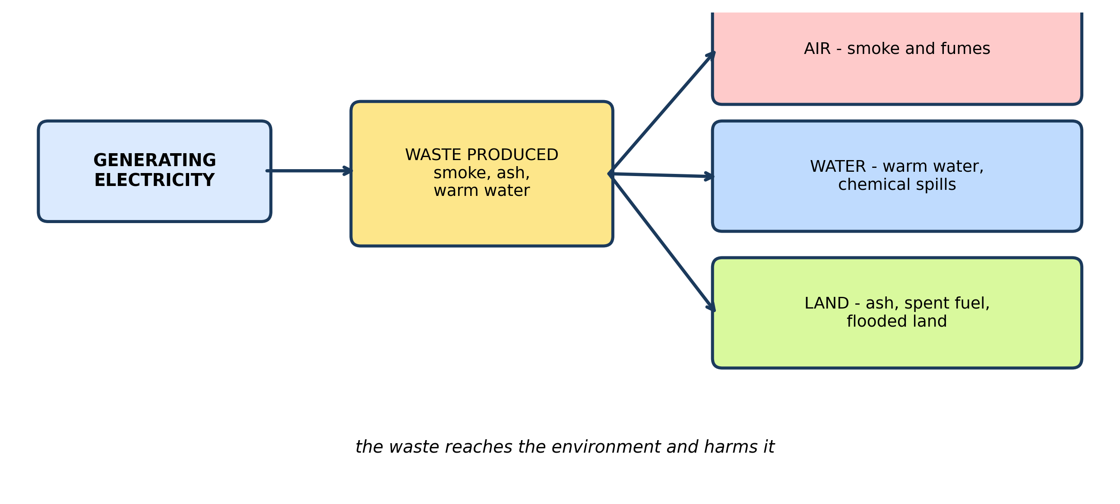
Fig. 2: How generating electricity reaches the environment

12.2 12.2 Impact on the Environment
3. Use the diagram to explain how generating electricity can harm the water in a river BELOW a dam. [3 marks]
4. A community objects to a THERMAL plant being built near their town. SUGGEST TWO environmental reasons for their objection, and ONE way the harm could be reduced. [3 marks]
____________________________________________________________________________________________
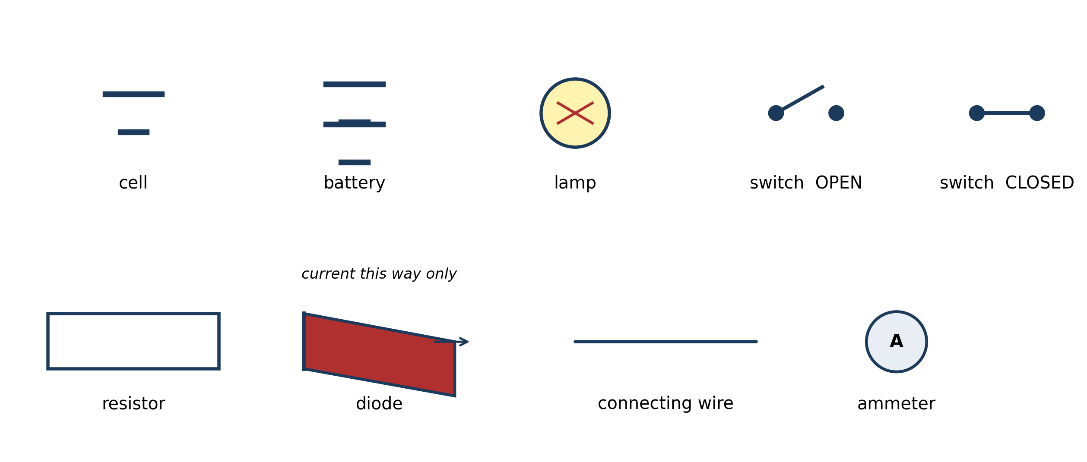
Fig. 3: Circuit symbols for common components

12.3 12.3 Basic Electronic Components
5. Name the component represented by each of these symbols: the rectangle; the triangle with a bar; the circle with an A in it. [3 marks]
6. The diagram shows a switch in two positions. Explain the difference between them in terms of what happens to the CURRENT. [3 marks]
7. Explain why a resistor is needed in a circuit that contains an LED, and what would happen without one. [3 marks]
____________________________________________________________________________________________
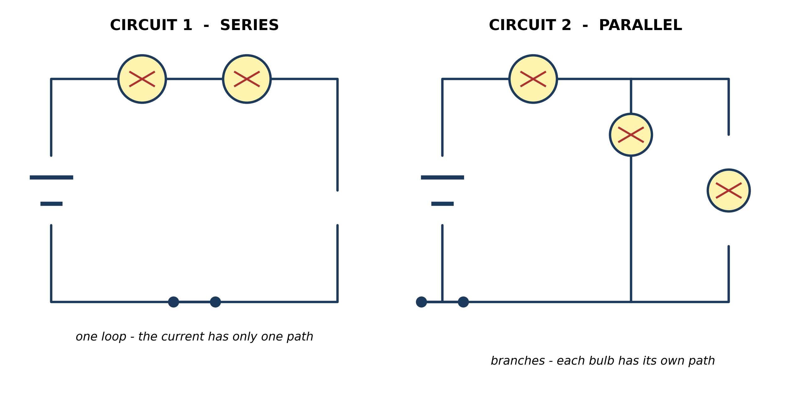
Fig. 4: A series circuit and a parallel circuit

12.4 12.4 Assembling a Simple Circuit
8. In CIRCUIT 1 (series) one of the two bulbs is unscrewed. PREDICT what happens to the other bulb, and explain why. [4 marks]
9. In CIRCUIT 2 (parallel) one of the bulbs is unscrewed. PREDICT what happens to the other bulbs, and explain why. [3 marks]
10. Explain why the rooms of a house are wired in PARALLEL and not in series. Give TWO reasons. [4 marks]
____________________________________________________________________________________________
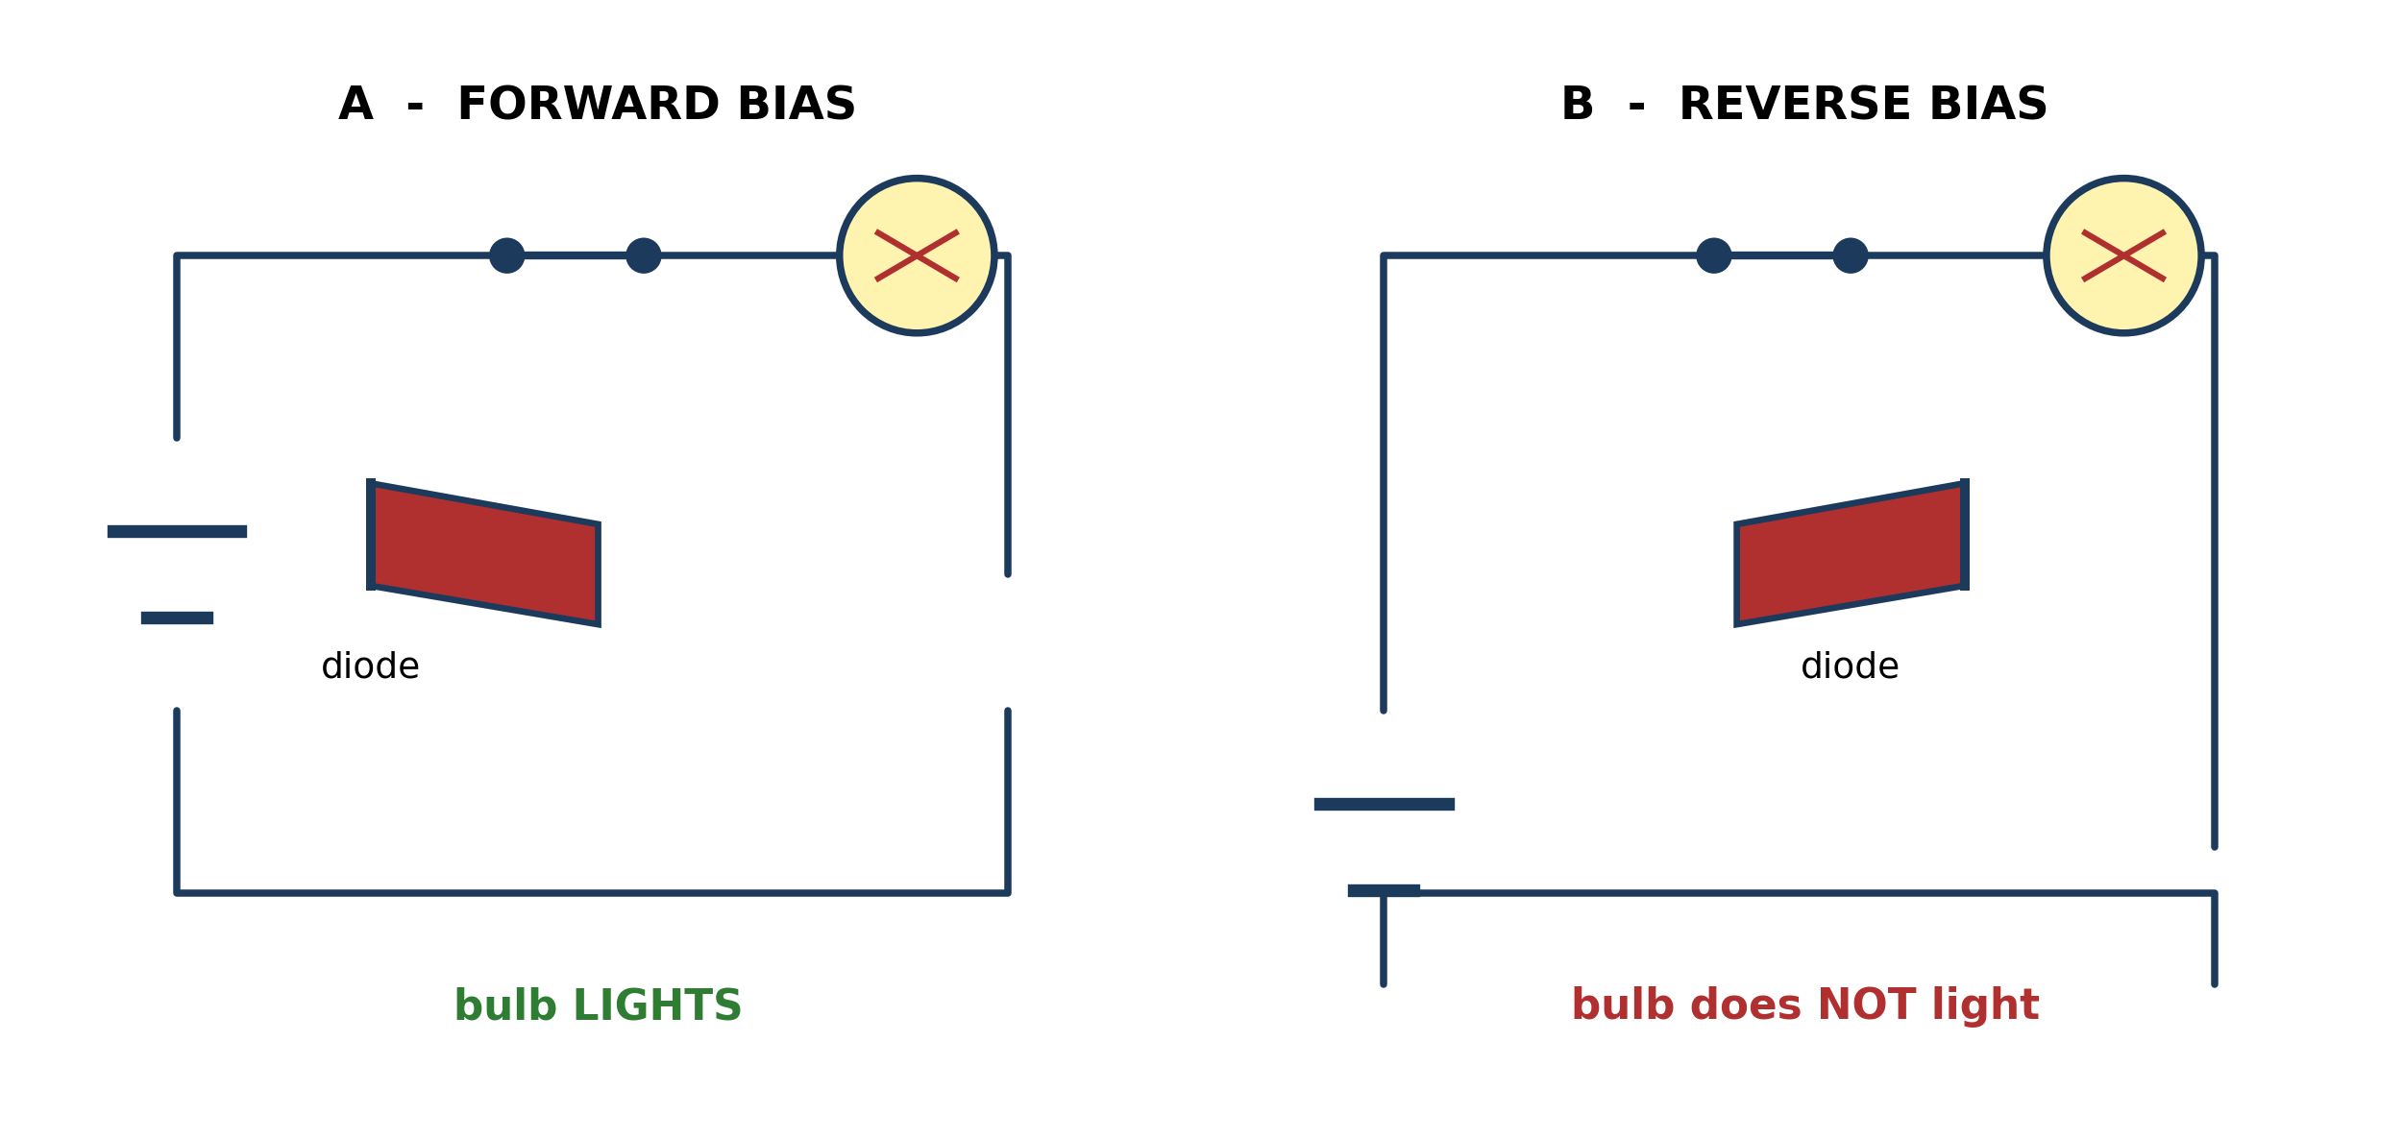
Fig. 5: The same diode connected two ways round

12.5 12.5 The P-N Junction Diode
11. State in which circuit, A or B, the bulb lights. Explain, using the diagram, why it lights in one and not the other. [4 marks]
12. State what is meant by FORWARD BIAS. [3 marks]
____________________________________________________________________________________________
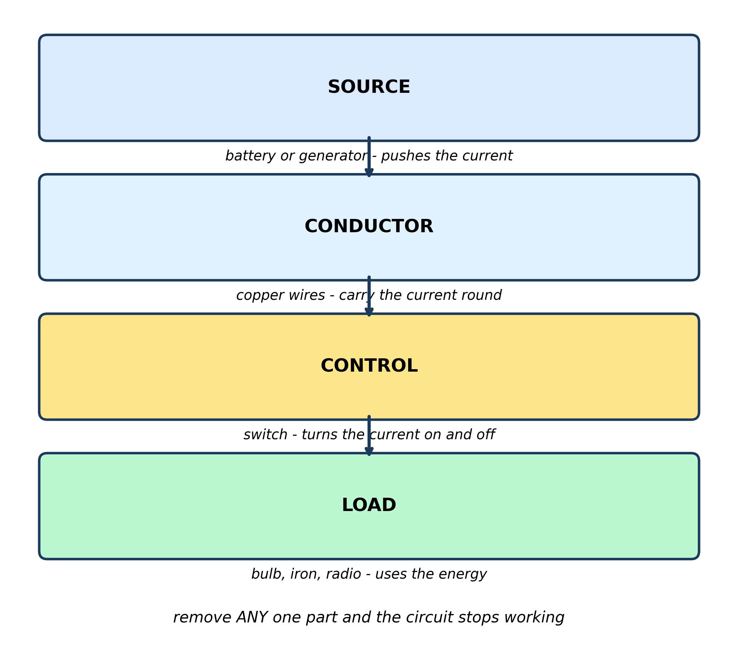
Fig. 6: What every circuit needs

12.6 12.6 Functions and Interdependence
13. Name the four parts shown, and state what each one does. [3 marks]
14. Use the diagram to explain why a bulb would not light if the conductor were broken at ANY single point. [3 marks]
____________________________________________________________________________________________
SECTION B - PRACTICAL TASK
Study the apparatus and answer the questions that follow it.
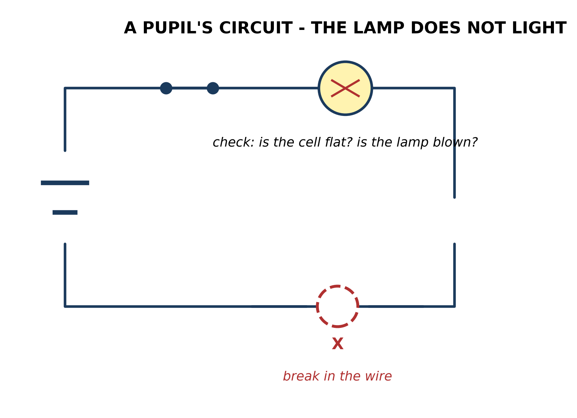
Fig. 7: A circuit that does not work

15. The switch is closed, yet the lamp does not light. SUGGEST TWO possible faults, and describe how you would test for each one. [4 marks]
____________________________________________________________________________________________

ANSWER KEY AND MARKING SCHEME
Accept any other correct and relevant answer. Award marks for correct points, not for repeating the question.
12.1 12.1 Forms of Electricity Generation
Q1
HYDRO: the potential energy of water held behind the dam changes to kinetic energy as it falls, then to electrical energy in the generator. SOLAR: light energy from the sun changes straight to electrical energy. WIND: the kinetic energy of moving air turns the turbine, changing to electrical energy. THERMAL: the chemical energy in the fuel is released as heat by burning, the heat boils water to make steam, the steam turns the turbine, and the generator changes it to electrical energy.
Q2
A hydro dam depends on water held behind it. In a long dry season the river runs low and the reservoir falls, so the dam cannot turn its turbines and generation stops. Solar would be more reliable through the dry season, because the dry season is also the sunniest time of year - the resource is greatest exactly when the dam's is least.
12.2 12.2 Impact on the Environment
Q3
The dam floods the land behind it, which changes the river's flow and the plants and animals living in it. Water released from the bottom of the reservoir is cold and low in oxygen, which harms fish downstream. Warm water poured back in after cooling the plant raises the river's temperature, which also harms the organisms living in it.
Q4
Any two reasons: the smoke from burning the fuel pollutes the air and causes breathing problems; the plant gives out gases that add to climate change; the ash has to be dumped somewhere and spoils the land. One way to reduce it: fit filters or scrubbers to the chimneys to take the smoke and harmful gases out before they reach the air, or use a cleaner fuel such as gas instead of coal or oil.
12.3 12.3 Basic Electronic Components
Q5
The rectangle is a resistor. The triangle with a bar is a diode. The circle with an A is an ammeter, which measures current.
Q6
In the OPEN position there is a gap in the circuit, so the path is broken and NO current flows. In the CLOSED position the gap is bridged, the circuit is complete, and current flows all the way round.
Q7
An LED only needs a very small current, and it has almost no resistance of its own. Without a resistor to limit the current, far too much would flow through the LED, it would overheat and it would be destroyed - it would burn out.
12.4 12.4 Assembling a Simple Circuit
Q8
The other bulb goes out. In a series circuit there is only ONE loop, so the current has only one path. Unscrewing one bulb breaks that path, the circuit is no longer complete, and current stops everywhere in the circuit - including at the other bulb.
Q9
The other bulbs stay lit, as brightly as before. In a parallel circuit each bulb is on its own branch, so each has its own separate path back to the battery. Removing one branch does not break the others, so current still flows through them.
Q10
Two reasons: each lamp or appliance can be switched on and off on its own, because breaking one branch does not stop the others - in series, switching one lamp off would put out every lamp in the house. And each appliance gets the full voltage of the supply, so they all work properly - in series the voltage would be shared out and each one would be dim or weak.
12.5 12.5 The P-N Junction Diode
Q11
It lights in circuit A. The diode acts like a one-way valve: it lets current through in the direction its arrow points, and blocks it in the other direction. In A the diode is turned so its arrow points the same way the current is trying to go - this is FORWARD BIAS, so current flows and the bulb lights. In B the diode is turned the other way round - REVERSE BIAS - so it blocks the current, the circuit is effectively broken, and the bulb stays dark.
Q12
Forward bias means the diode is connected the right way round in the circuit, so that the current is trying to flow in the direction the diode allows - the direction its arrow points. The diode conducts and current flows.
12.6 12.6 Functions and Interdependence
Q13
SOURCE (the battery or generator) pushes the current round the circuit. CONDUCTOR (the copper wires) carries the current from one part to another. CONTROL (the switch) turns the current on and off. LOAD (the bulb, iron or radio) is the part that uses the electrical energy and does the job.
Q14
The conductor is what carries the current all the way round from the source, through the load, and back again. A break anywhere in that path leaves a gap, so the circuit is no longer a complete loop and current cannot flow at all. Because the same current has to pass through every part of the loop, one break stops it everywhere.
PRACTICAL TASK
Q15
Any two with a test: THE BREAK IN THE WIRE marked X - replace that piece of wire, or test it by connecting a known-good wire across the gap and seeing if the lamp lights. A FLAT CELL - swap it for a fresh cell and see if the lamp lights. A BLOWN LAMP - swap it for a lamp known to work. A FAULTY SWITCH - connect the two wires together bypassing the switch. LOOSE CONNECTION - push each connection firm and see if the lamp flickers on.

BLUEPRINT / TEST SPECIFICATION
# | Content standard | Code | Items | Marks | % of Marks
12.1 | 12.1 Forms of Electricity Generation | B7/JHS1.4.2.1 / B7/JHS1.4.2.2 | 2 | 7 | 14%
12.2 | 12.2 Impact on the Environment | B7/JHS1.4.2.1 / B7/JHS1.4.2.2 | 2 | 6 | 12%
12.3 | 12.3 Basic Electronic Components | B7/JHS1.4.2.1 / B7/JHS1.4.2.2 | 3 | 9 | 18%
12.4 | 12.4 Assembling a Simple Circuit | B7/JHS1.4.2.1 / B7/JHS1.4.2.2 | 3 | 11 | 22%
12.5 | 12.5 The P-N Junction Diode | B7/JHS1.4.2.1 / B7/JHS1.4.2.2 | 2 | 7 | 14%
12.6 | 12.6 Functions and Interdependence | B7/JHS1.4.2.1 / B7/JHS1.4.2.2 | 2 | 6 | 12%
12.1 | Practical task | B7/JHS1.4.2.1 / B7/JHS1.4.2.2 | 1 | 4 | 8%
TOTAL | - | - | 15 | 50 | 100%
Distribution by cognitive level
Cognitive level | Marks | % of Marks
Understand | 12 | 24%
Apply | 31 | 62%
Analyse | 7 | 14%
TOTAL | 50 | 100%
Distribution by difficulty
Difficulty | Marks | % of Marks
Easy | 9 | 18%
Moderate | 19 | 38%
Challenging | 22 | 44%
TOTAL | 50 | 100%

QUALITY-CONTROL SUMMARY
1. Is every question answered from a diagram?
Yes. All 15 questions sit under a figure, and each is unanswerable - or at least materially harder - without reading it. Questions 3, 8, 10 and 17 ask pupils to go beyond the diagram, but each still starts from something the figure shows.
2. Is the content within the Basic 7 curriculum?
Yes. Every question traces to the content standards for this sub-strand (B7/JHS1.4.2.1 / B7/JHS1.4.2.2), and nothing is tested beyond the depth the Basic 7 syllabus sets for it.
3. Are the diagrams clear and unambiguous?
Yes. Each is drawn so that only one reading is sensible: the particle boxes differ in spacing alone, the syringes are labelled with how far each squashes, and the periodic table marks the regions in words as well as by position.
4. Is the level right for JHS 1?
Yes. Questions ask pupils to read, describe and explain what is drawn. Only Question 17 asks for an inference beyond the figure, and it is worth 3 of the 40 marks.
5. Do the marks add up?
Yes: 15 questions totalling 50 marks, matching the figure on the front page. The blueprint, cognitive and difficulty tables all sum to the same total.
6. Are the answers correct and complete?
Yes. Each answer states the point the question is worth, with the acceptable alternatives given where a question is open.
EXAMINER NOTES (for the teacher, not for candidates)
- Pitched at the compulsory diagram question of BECE Paper 2: 76% of the marks are at Apply level or above and 44% are Challenging.
- Q8 and Q9 are the pair the whole paper hangs on, and they are deliberately asked back to back. Pupils memorise 'in series they all go out, in parallel they stay on' without knowing why. The mark is for the REASON: series has one path, parallel has a separate branch for each bulb. Ask both, in that order, and the contrast teaches itself.
- Q10 is the payoff question - why houses are parallel. Pupils who have understood Q8 and Q9 answer it easily; pupils who only memorised the rule cannot. It is the best single test in the paper of whether the idea has landed.
- Q11 is the hardest. A diode is not intuitive, and the forward/reverse pair is exactly what BECE asks. The one sentence that unlocks it: the arrow on the diode symbol points the way current is ALLOWED to go. Say it, draw it, and test it with a real LED and a button cell - a diode that is the wrong way round is the commonest reason a pupil's first circuit fails.
- Q2 is the Applied question most pupils get wrong. They pick solar because it is 'modern' or 'clean' and lose the marks. The reasoning is about WHEN each resource is available: the dry season is the sunniest time and the worst time for a dam. Reward any answer that reasons about the timing of the resource.
- Q7 (the resistor and the LED) is beyond what most B7 classes meet in lessons, but it is the standard reason a real LED circuit burns out, and it is worth the three marks. If your class has not met LEDs, treat it as extension.
- Fig. 7 is the cheapest practical in the paper and the one to actually do: give pairs a battery, a bulb, a switch and three wires, then cut one wire and let them find the fault. Ten minutes of that makes Q15 automatic, and fault-finding is a skill BECE tests repeatedly.

