[SCHOOL NAME]
INTEGRATED SCIENCE (SCIENCE)
PRACTICAL QUESTIONS - DIAGRAM MODE
Energy (11.1 - 11.7)
____________________________________________________________________________________________
CLASS: Basic 7 (JHS 1)
TIME: 1 hour 30 minutes
MARKS: 50 2025/2026 Academic Year
____________________________________________________________________________________________
INSTRUCTIONS TO CANDIDATES
1. Answer ALL the questions in this paper.
2. Every question is based on a diagram. Study each diagram carefully before you answer the questions that follow it.
3. Write your answers in the spaces provided. The marks for each question are printed beside it.
4. Where a question asks for a stated number of points, give that number. Any extra answers will not be marked.
5. You may refer back to any diagram at any time.
____________________________________________________________________________________________
SECTION A - DIAGRAM STUDY
Study each diagram and answer the questions that follow it.
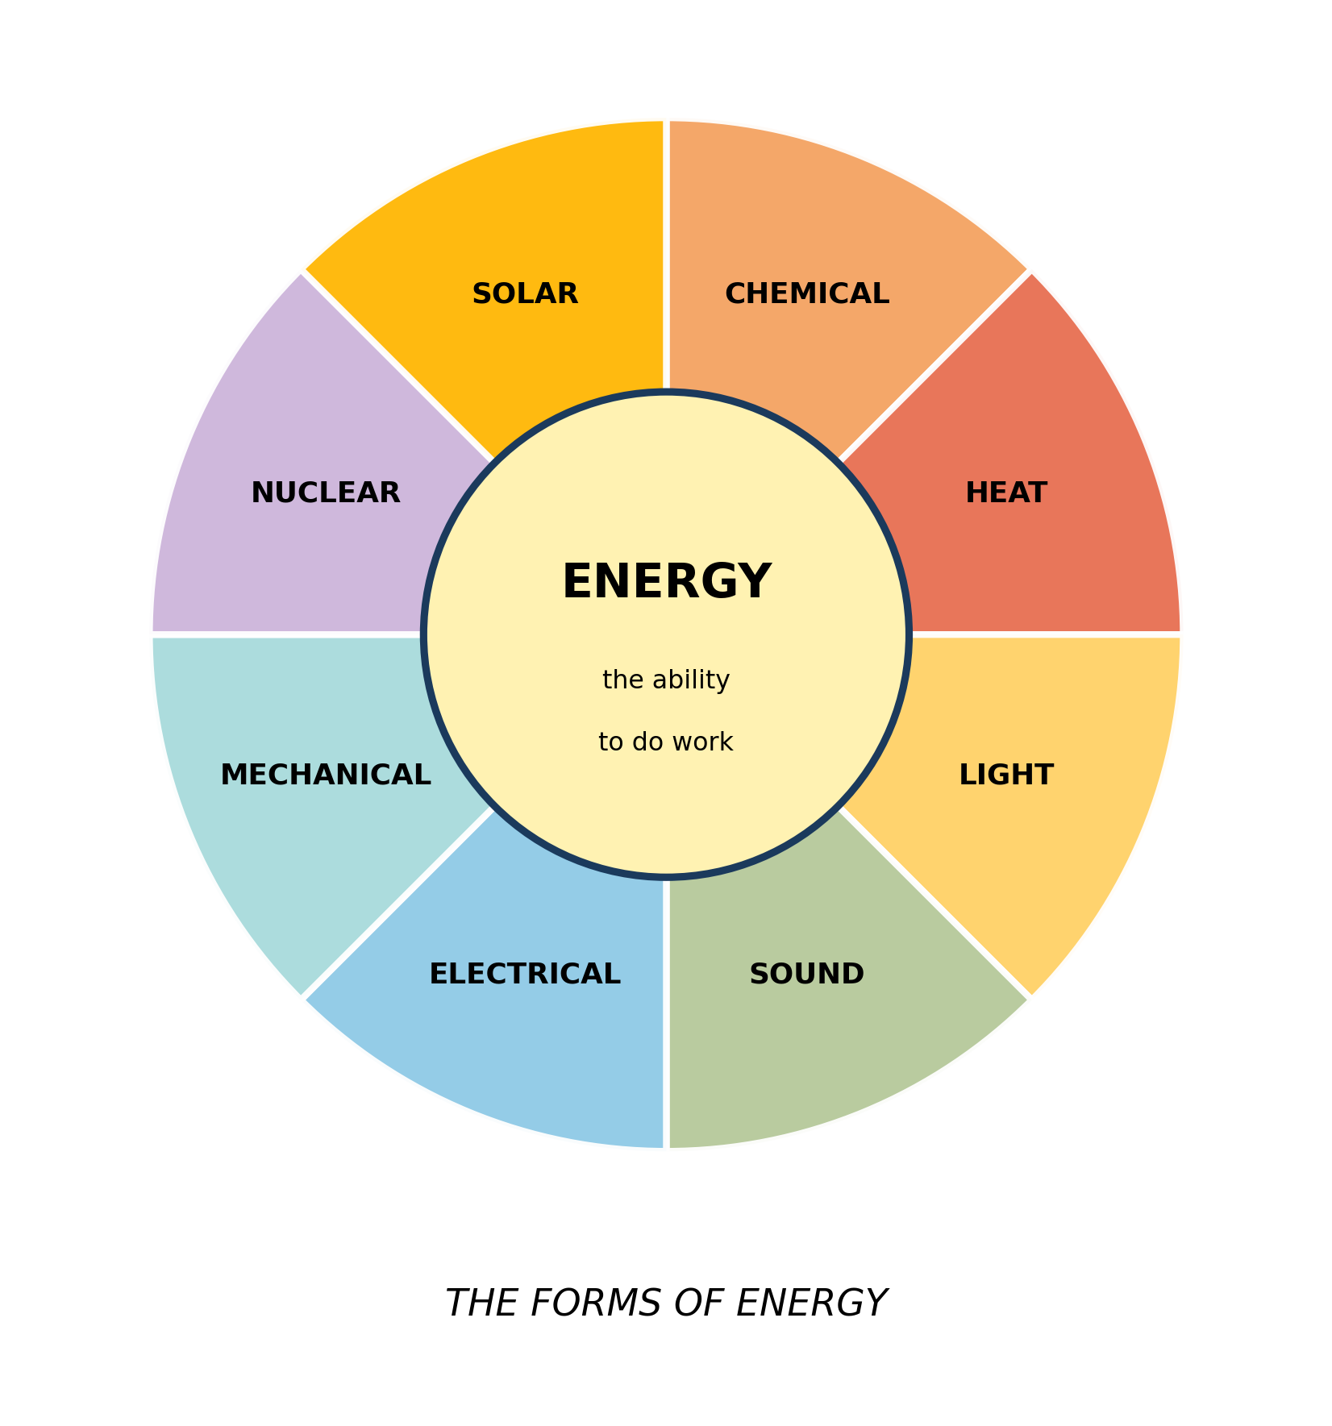
Fig. 1: The forms of energy

11.1 11.1 What is Energy?
1. State what energy is, and use the diagram to explain why a stone held high above the ground has energy even though nothing is happening to it. [4 marks]
2. From the diagram, name TWO forms of energy and give one everyday example of each. [2 marks]
____________________________________________________________________________________________
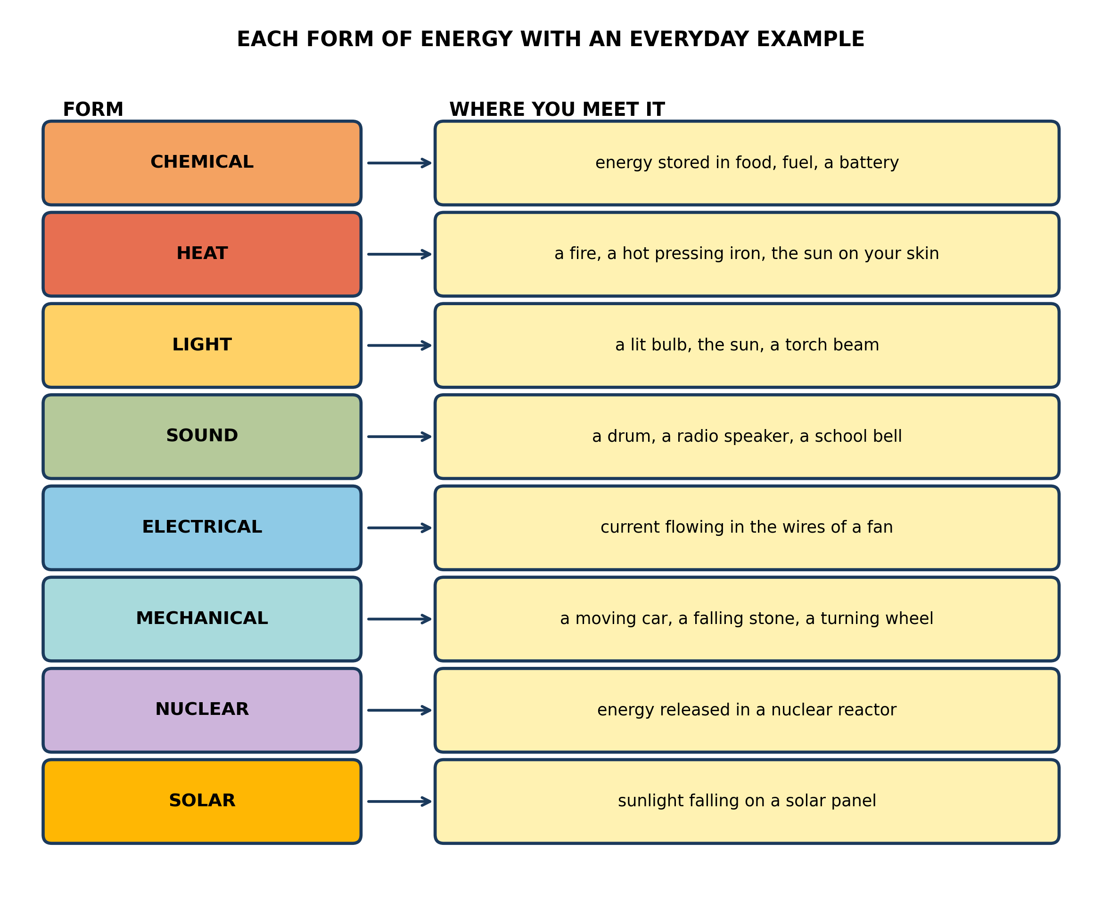
Fig. 2: Each form of energy with an everyday example

11.2 11.2 Forms of Energy
3. A pupil says a battery stores electrical energy. Use the diagram to correct this, and explain why the correction matters. [3 marks]
____________________________________________________________________________________________
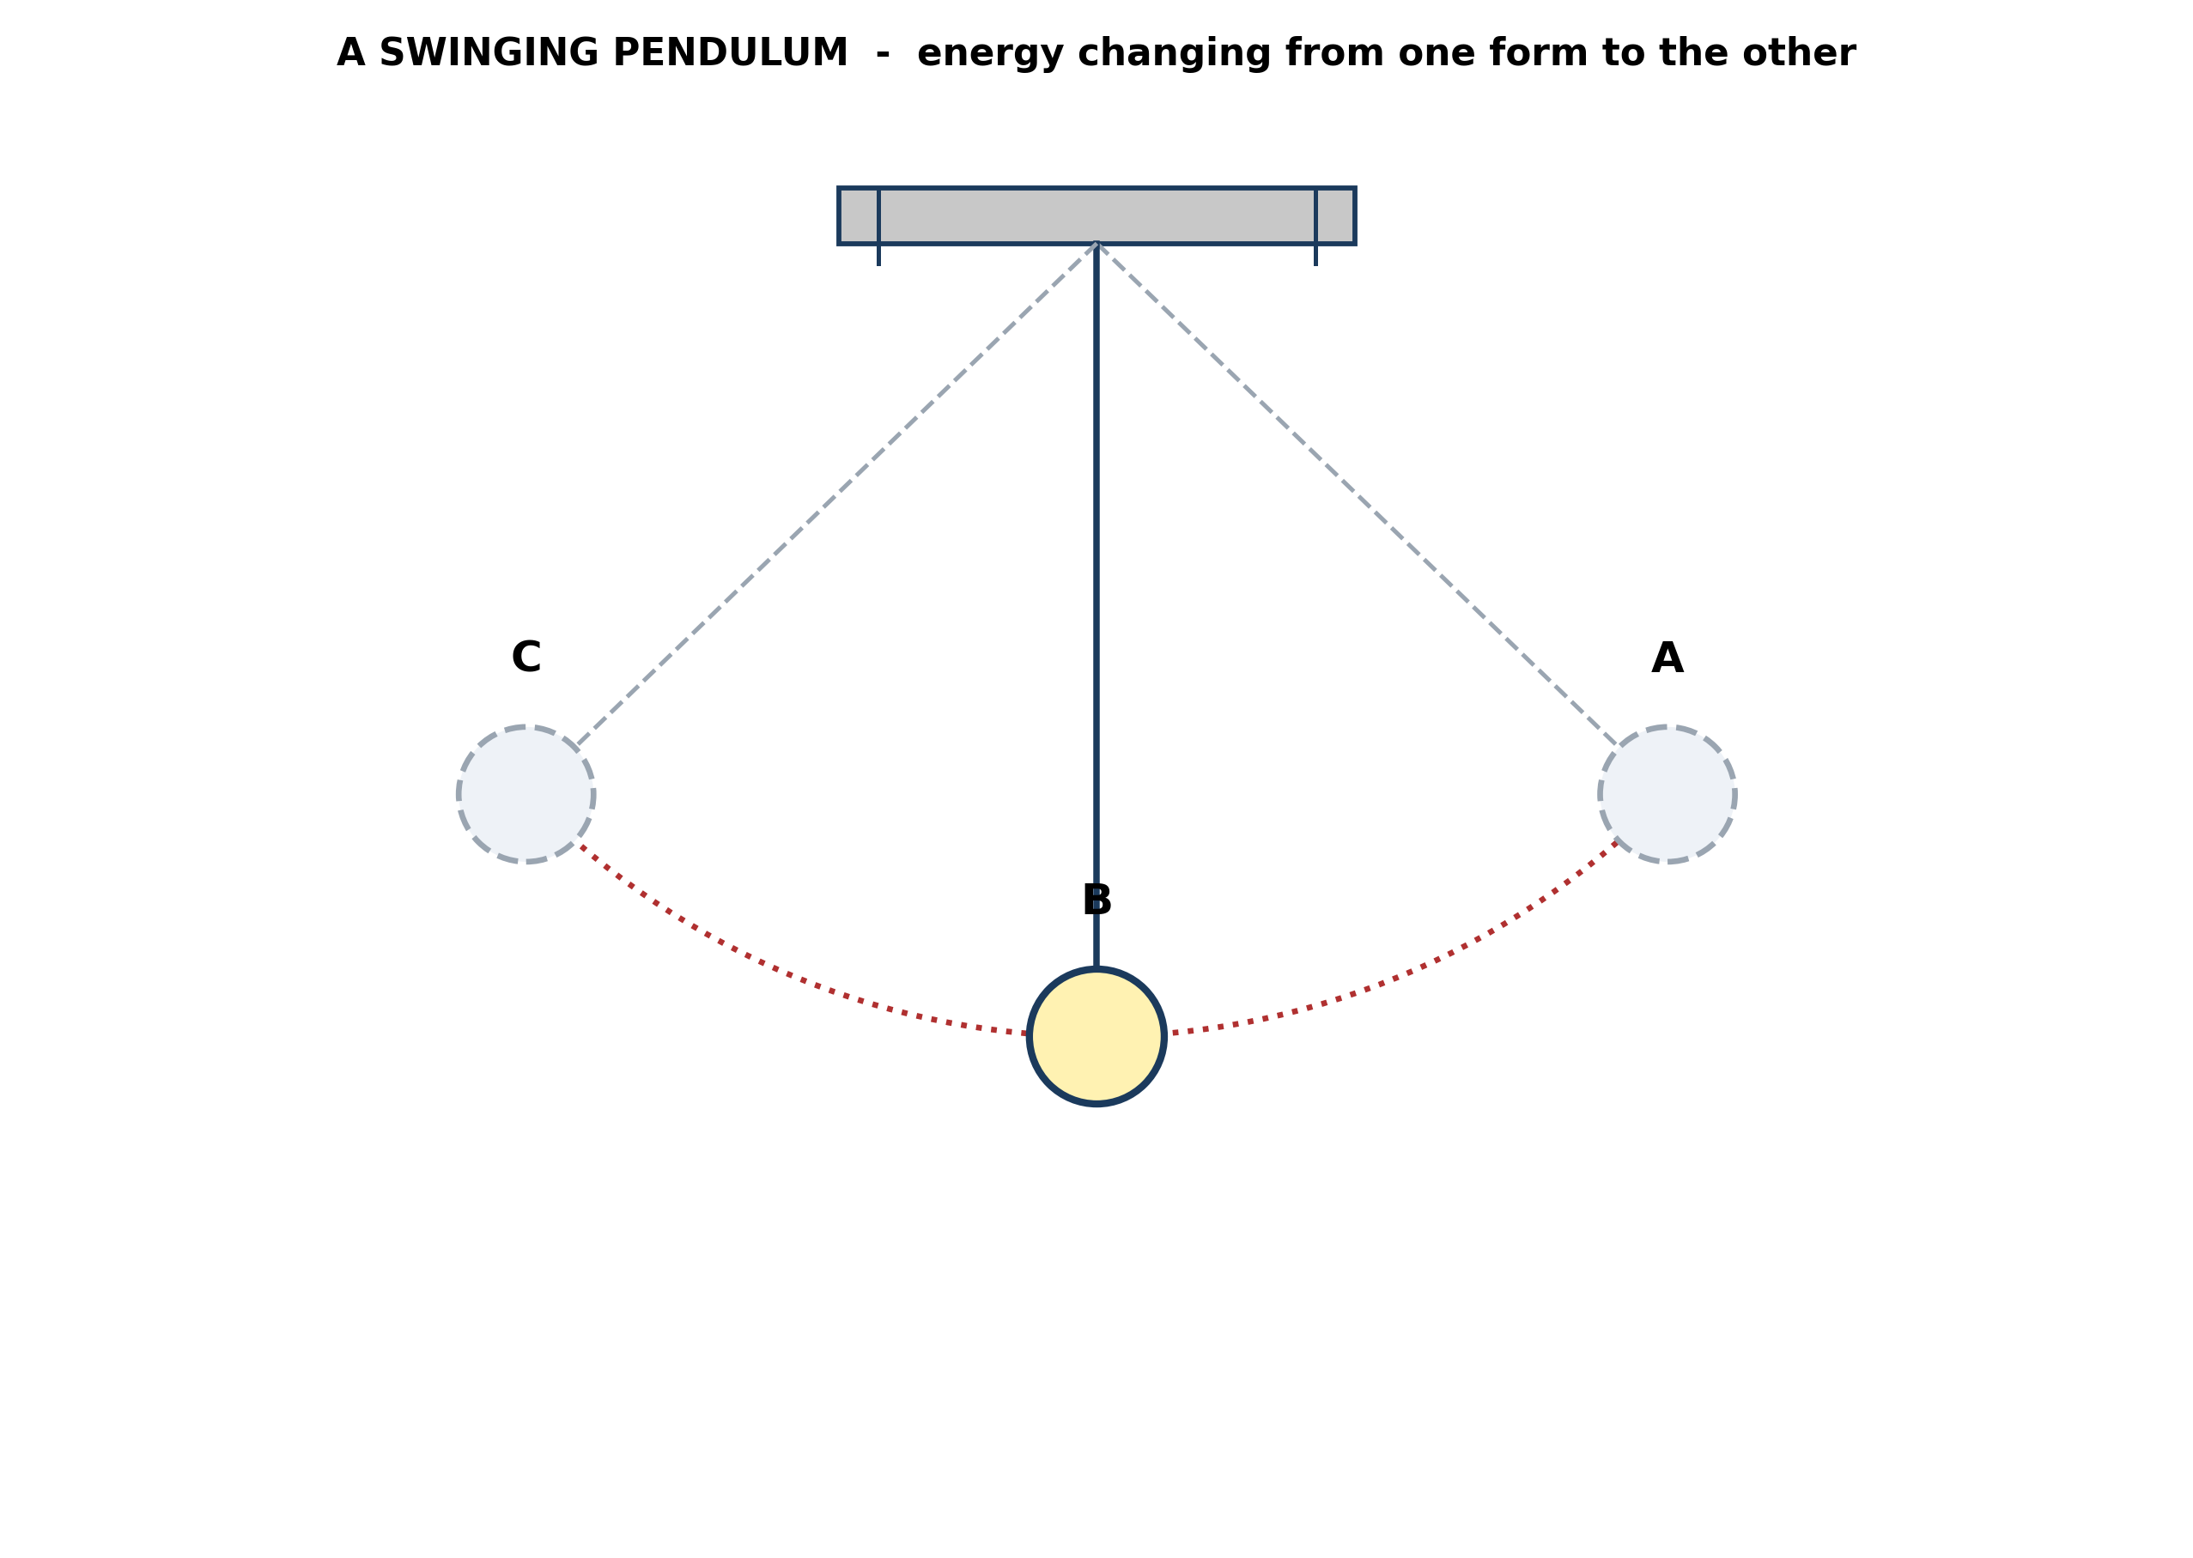
Fig. 3: A swinging pendulum

11.3 11.3 Potential and Kinetic Energy
4. Explain, using the diagram, why the bob is moving fastest at B. [4 marks]
5. In a real pendulum the swings gradually die away. State what has happened to the energy, and explain why this does not contradict the idea that energy is conserved. [3 marks]
____________________________________________________________________________________________
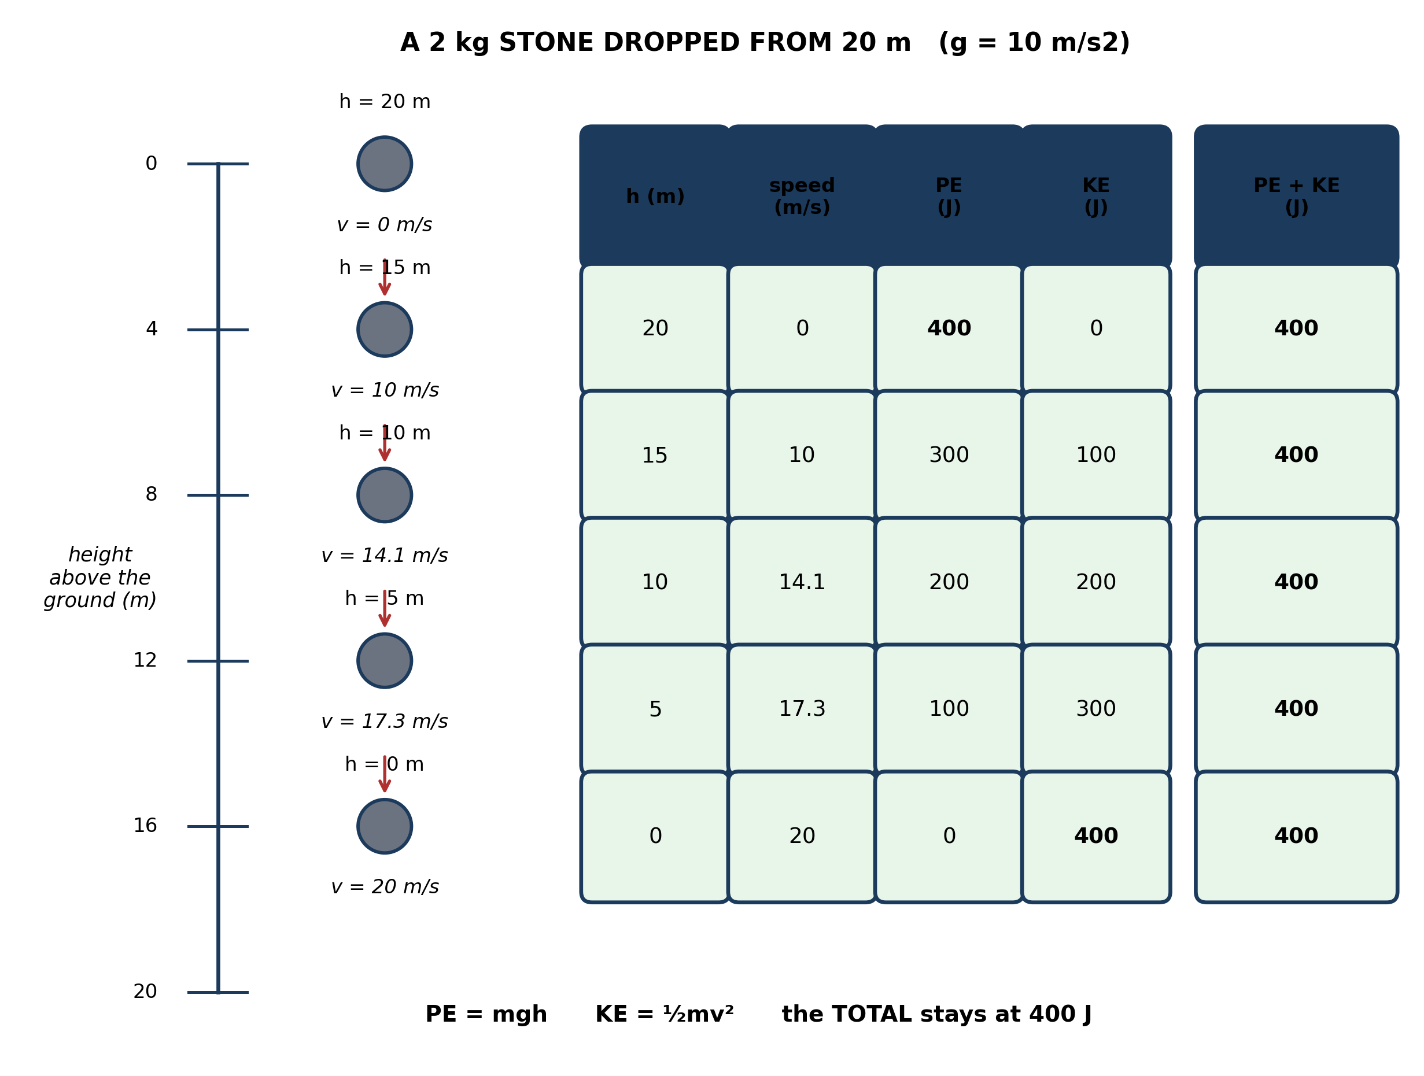
Fig. 4: A 2 kg stone dropped from 20 m

11.4 11.4 Calculating PE and KE
6. State what the last column of the table shows, and explain what this tells us about energy. [4 marks]
7. A pupil says: 'the stone has 400 J of potential energy at the top and 400 J of kinetic energy at the bottom, so it finishes with 800 J and energy has been created.' Explain what the pupil has got wrong. [3 marks]
____________________________________________________________________________________________
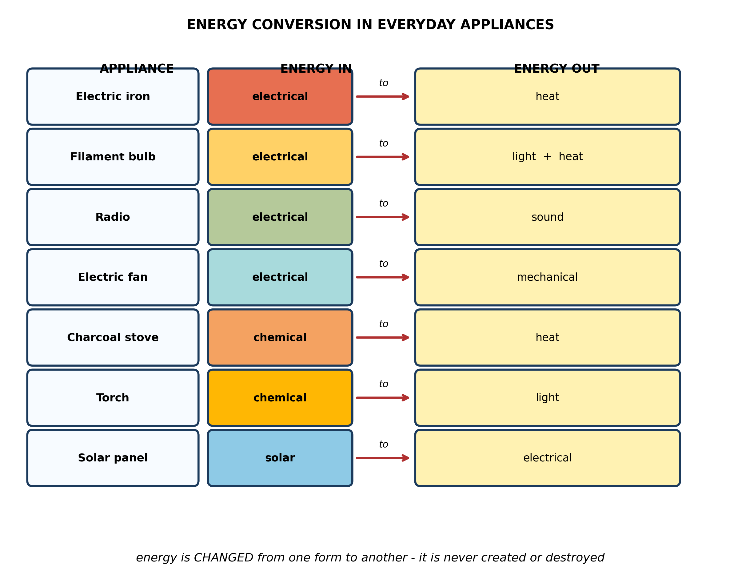
Fig. 5: Energy conversion in everyday appliances

11.5 11.5 Daily Applications of Energy
8. From the diagram, name the energy change that takes place in a torch, and explain why a torch with a flat battery gives no light. [3 marks]
9. The diagram shows that a filament bulb gives out light AND heat. A pupil says the heat is wasted. Explain why it is wasted, and suggest ONE thing that could be done about it. [3 marks]
____________________________________________________________________________________________
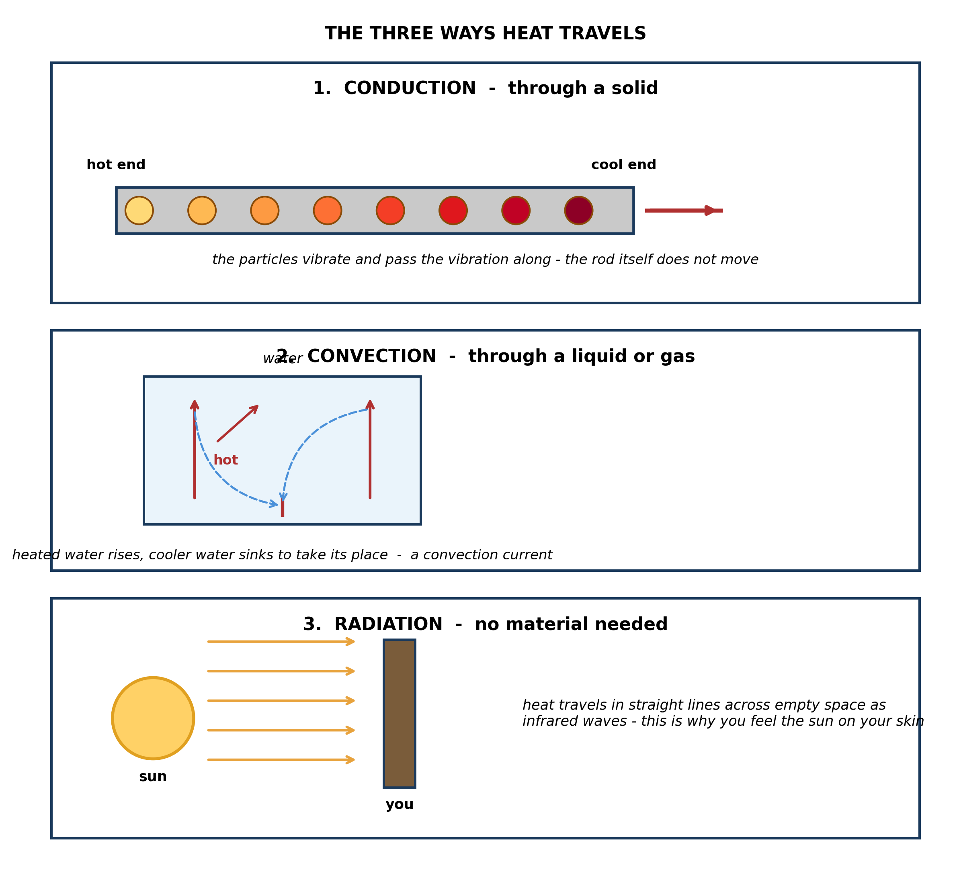
Fig. 6: The three ways heat travels

11.6 11.6 Heat Transfer
10. State which of the three ways of transferring heat does NOT need any material to travel through, and use the diagram to justify your answer. [3 marks]
11. Explain why the heated water in the convection panel RISES, using the idea of particles. [4 marks]
____________________________________________________________________________________________
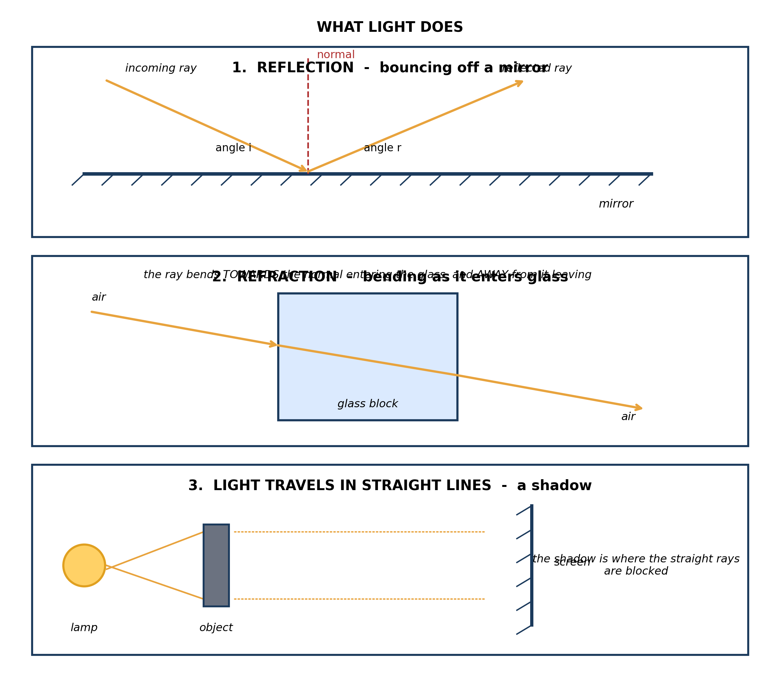
Fig. 7: What light does

11.7 11.7 Characteristics of Light
12. State the law of reflection, and use the diagram to say what the dashed line is for. [3 marks]
13. Use the diagram to explain why a stick standing in water looks bent, and state what this effect is called. [4 marks]
____________________________________________________________________________________________
SECTION B - PRACTICAL TASK
Study the apparatus and answer the questions that follow it.
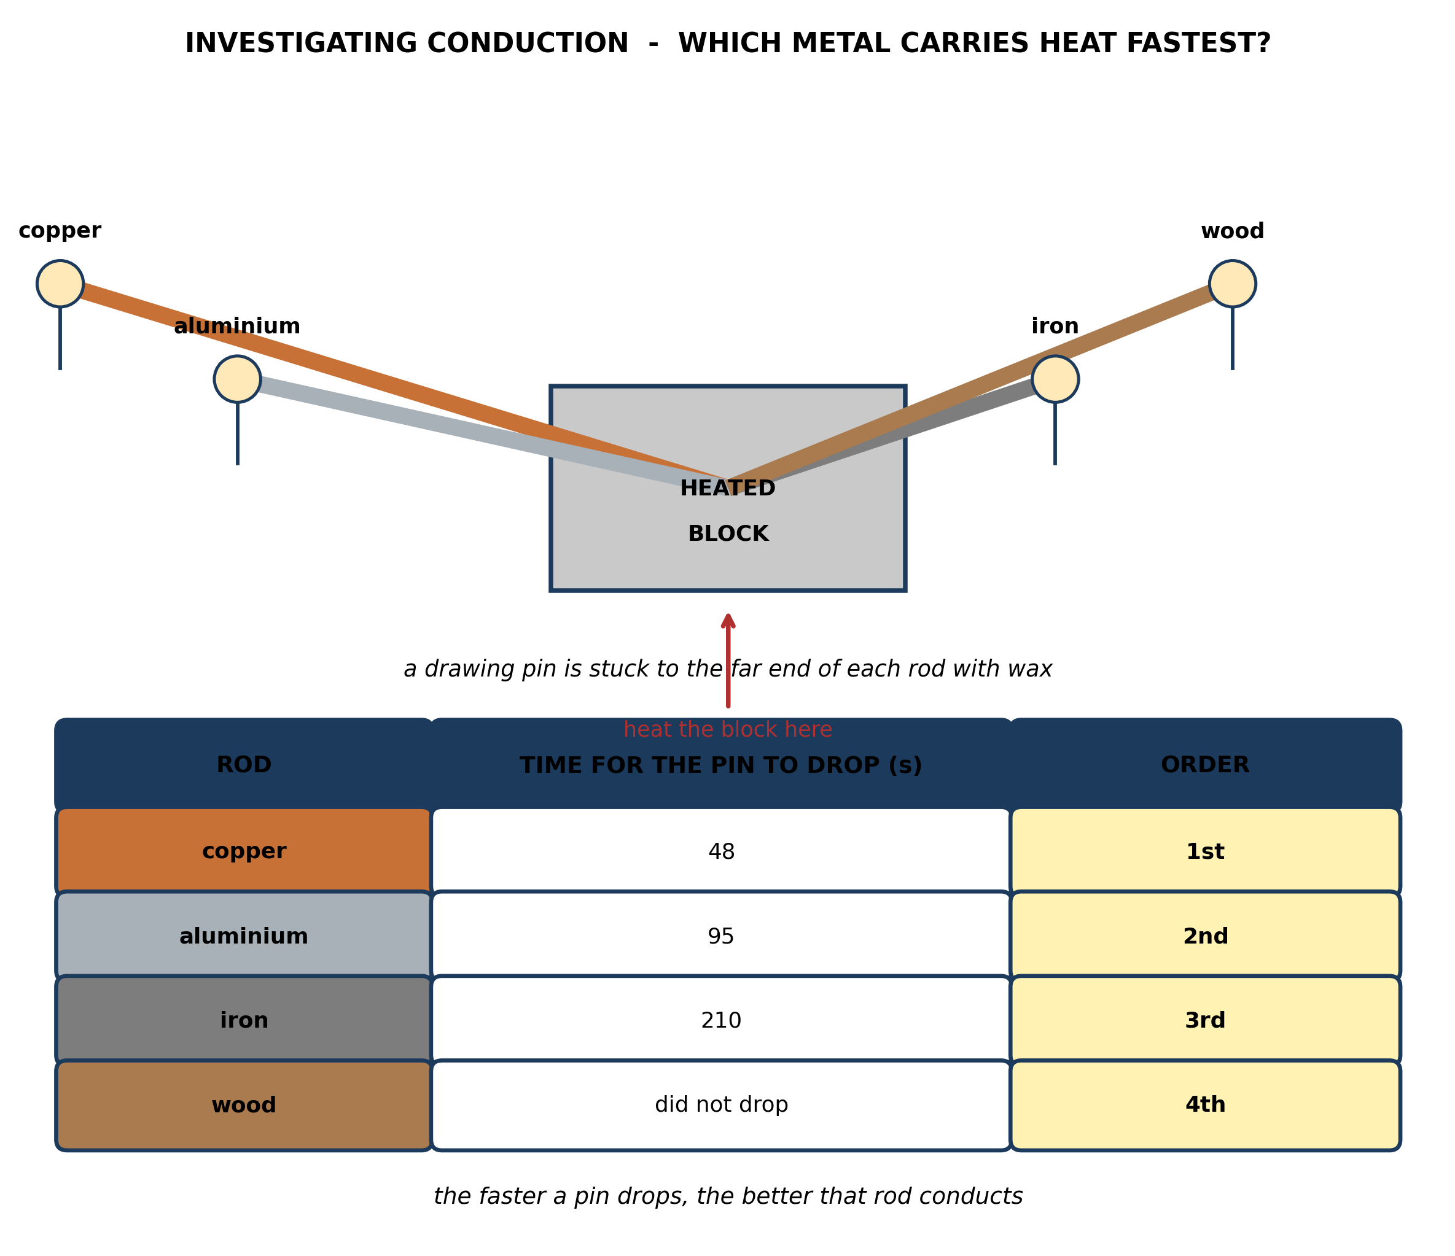
Fig. 8: Investigating conduction

14. State, with a reason, which rod you would expect the pin to fall from FIRST, and explain what the order tells you about the rods. [4 marks]
15. Explain why this experiment uses a pin stuck on with WAX rather than just feeling which rod gets hot first. [3 marks]
____________________________________________________________________________________________

ANSWER KEY AND MARKING SCHEME
Accept any other correct and relevant answer. Award marks for correct points, not for repeating the question.
11.1 11.1 What is Energy?
Q1
Energy is the ability to do work. The raised stone has stored, or potential, energy because of its position above the ground - work was done against gravity to lift it there, and that work is now stored in it. Nothing appears to be happening because the energy is stored and not yet being used, but if the stone is released it will fall, and as it falls it can do work - it can drive a nail in or break something. Energy is the ability to do work, and the stone has that ability waiting.
Q2
Any two, each with a correct example: chemical - energy stored in food, fuel or a battery; heat - from a fire or a hot iron; light - from a lit bulb or the sun; sound - from a drum or a radio; electrical - carried by the current in a wire; mechanical - a moving car or a falling stone; nuclear - released in a reactor; solar - sunlight falling on a panel.
11.2 11.2 Forms of Energy
Q3
A battery stores CHEMICAL energy, not electrical energy. The chemicals inside it react when it is connected in a circuit, and that reaction drives the current - so the battery is a store of chemical energy which is changed into electrical energy as it is used. The correction matters because the change happens at a particular point: the chemical energy is there whether or not the battery is connected, and it only becomes electrical once a circuit is made. The other forms in the diagram are the same - each is a form the energy takes at a particular stage.
11.3 11.3 Potential and Kinetic Energy
Q4
At A the bob is high and momentarily still, so its energy is almost all potential. As it swings down towards B gravity pulls it and it loses height, so its potential energy falls. That lost potential energy does not disappear - it is changed into kinetic energy, the energy of movement. B is the lowest point of the swing, so by the time the bob reaches B the greatest possible amount of energy has been changed into kinetic energy, and kinetic energy depends on speed. So the bob is moving fastest at B.
Q5
The energy has been changed into heat and sound, spread out into the air and into the pivot where the pendulum rubs. It has not been destroyed, so the total energy is still exactly the same - energy is conserved. It has simply been changed into forms that are spread so thinly and are so useless to us that the pendulum can no longer swing with them, which is why the motion dies away. The energy is still there; it has just become unavailable.
11.4 11.4 Calculating PE and KE
Q6
The last column shows that PE plus KE is 400 J at every height - it never changes. That is the point: as the stone falls, energy is not created as it speeds up and not destroyed as it loses height. It is only changed from one form into the other, with the total staying exactly the same throughout. This is what conservation of energy means - the total amount of energy in a closed system stays constant, and all that can happen is that it changes form.
Q7
The pupil has added the same energy up twice. The 400 J of kinetic energy at the bottom is not new energy - it is the very same 400 J that was potential energy at the top, changed into another form. The table shows there is never more than 400 J at any one moment: the last column is 400 throughout, not 800. Energy is conserved, which means it can only be changed from one form to another, never created.
11.5 11.5 Daily Applications of Energy
Q8
Chemical energy in the battery is changed into light energy, with some heat as well. A flat battery has run out of the chemicals that react to produce the current, so its store of chemical energy is used up. With no energy going into the torch, none can come out of it as light. The torch is only a converter - it cannot produce light without an energy input.
Q9
It is wasted because the bulb's job is to give light, and the heat is an unwanted by-product that does nothing useful - the energy going into it is not being used for the purpose the bulb was made for. Any sensible suggestion: use an LED or a fluorescent lamp instead, which produces far less heat for the same amount of light and so wastes less energy; or switch the lamp off when it is not needed.
11.6 11.6 Heat Transfer
Q10
Radiation. The diagram shows heat from the sun reaching you, and between the sun and the earth there is almost entirely empty space - there is no solid, liquid or gas in between to carry it. Conduction needs a solid and convection needs a liquid or a gas, so neither could do it. Radiation travels as infrared waves, which need no material at all.
Q11
When the water at the bottom is heated its particles gain energy and move about more vigorously, so they push each other further apart. That means the same mass of water now takes up more space - it has expanded and become less dense than the colder water around it. Being less dense, it floats up through the colder, denser water, which sinks down to take its place at the bottom. That colder water is then heated in turn, and the circulation goes on as a convection current.
11.7 11.7 Characteristics of Light
Q12
The angle of incidence equals the angle of reflection - the incoming ray and the reflected ray make equal angles with the normal. The dashed line is the NORMAL, a line drawn at right angles to the mirror at the point where the ray strikes it. It is needed because both angles are measured from it, not from the surface of the mirror - without it there is nothing to measure the angles against.
Q13
This is refraction. Light coming from the part of the stick under the water leaves the water and enters the air, and as it crosses from water into air it changes speed and bends away from the normal. Our eyes and brain always assume light has travelled in a straight line, so they trace the bent rays straight back and place the underwater part of the stick higher than it really is. That is why the stick looks bent, or broken, at the water surface.
PRACTICAL TASK
Q14
The copper rod, because copper is the best conductor of the four and so carries the heat along to the wax fastest, melting it first - as the table shows, its pin drops in 48 s. The order tells you the ranking of the rods as conductors: the sooner the pin drops, the better that material conducts heat. So copper conducts better than aluminium, aluminium better than iron, and iron conducts while wood effectively does not conduct at all.
Q15
The wax melts at a fixed temperature, so it gives a fair, measurable signal - the pin drops at the moment the end of that rod reaches the same temperature in every case. Feeling the rods with your hand is unreliable: it is a judgement that varies from person to person, it cannot be timed, and it would burn you. Using wax makes the test the same for every rod and lets you time it, so the results can be compared.

BLUEPRINT / TEST SPECIFICATION
# | Content standard | Code | Items | Marks | % of Marks
11.1 | 11.1 What is Energy? | B7/JHS1.4.1.1 / B7/JHS1.4.1.2 / B7/JHS1.4.1.3 | 2 | 6 | 12%
11.2 | 11.2 Forms of Energy | B7/JHS1.4.1.1 / B7/JHS1.4.1.2 / B7/JHS1.4.1.3 | 1 | 3 | 6%
11.3 | 11.3 Potential and Kinetic Energy | B7/JHS1.4.1.1 / B7/JHS1.4.1.2 / B7/JHS1.4.1.3 | 2 | 7 | 14%
11.4 | 11.4 Calculating PE and KE | B7/JHS1.4.1.1 / B7/JHS1.4.1.2 / B7/JHS1.4.1.3 | 2 | 7 | 14%
11.5 | 11.5 Daily Applications of Energy | B7/JHS1.4.1.1 / B7/JHS1.4.1.2 / B7/JHS1.4.1.3 | 2 | 6 | 12%
11.6 | 11.6 Heat Transfer | B7/JHS1.4.1.1 / B7/JHS1.4.1.2 / B7/JHS1.4.1.3 | 2 | 7 | 14%
11.7 | 11.7 Characteristics of Light | B7/JHS1.4.1.1 / B7/JHS1.4.1.2 / B7/JHS1.4.1.3 | 2 | 7 | 14%
11.1 | Practical task | B7/JHS1.4.1.1 / B7/JHS1.4.1.2 / B7/JHS1.4.1.3 | 2 | 7 | 14%
TOTAL | - | - | 15 | 50 | 100%
Distribution by cognitive level
Cognitive level | Marks | % of Marks
Understand | 11 | 22%
Apply | 13 | 26%
Analyse | 26 | 52%
TOTAL | 50 | 100%
Distribution by difficulty
Difficulty | Marks | % of Marks
Easy | 2 | 4%
Moderate | 28 | 56%
Challenging | 20 | 40%
TOTAL | 50 | 100%

QUALITY-CONTROL SUMMARY
1. Is every question answered from a diagram?
Yes. All 15 questions sit under a figure, and each is unanswerable - or at least materially harder - without reading it. Questions 3, 8, 10 and 17 ask pupils to go beyond the diagram, but each still starts from something the figure shows.
2. Is the content within the Basic 7 curriculum?
Yes. Every question traces to the content standards for this sub-strand (B7/JHS1.4.1.1 / B7/JHS1.4.1.2 / B7/JHS1.4.1.3), and nothing is tested beyond the depth the Basic 7 syllabus sets for it.
3. Are the diagrams clear and unambiguous?
Yes. Each is drawn so that only one reading is sensible: the particle boxes differ in spacing alone, the syringes are labelled with how far each squashes, and the periodic table marks the regions in words as well as by position.
4. Is the level right for JHS 1?
Yes. Questions ask pupils to read, describe and explain what is drawn. Only Question 17 asks for an inference beyond the figure, and it is worth 3 of the 40 marks.
5. Do the marks add up?
Yes: 15 questions totalling 50 marks, matching the figure on the front page. The blueprint, cognitive and difficulty tables all sum to the same total.
6. Are the answers correct and complete?
Yes. Each answer states the point the question is worth, with the acceptable alternatives given where a question is open.
EXAMINER NOTES (for the teacher, not for candidates)
- Pitched at the compulsory diagram question of BECE Paper 2: 78% of the marks are at Apply level or above and 40% are Challenging.
- Q1 is where the 'energy is the ability to do work' definition is usually parroted and then abandoned. The mark for the second half comes from saying the raised stone has work stored IN it because work was done to lift it, and that this waiting ability becomes real the moment it is released.
- Q7 is the best diagnostic in the paper. Half a class will add 400 and 400 and get 800, and say energy has been created. They have counted the same energy twice. The cure is the last column of Fig. 4: it is 400 at every single height, so there was never any question of 800.
- Q5 and Q6 are the pair that does the real work on conservation. Q5 is the honest case - a pendulum really does stop - and the answer is that the energy went to heat and sound and is now too spread out to use. Pupils who can hold both of these at once have the idea.
- Q4 on why the bob is fastest at B is a four-mark chain: height goes down, PE goes down, PE becomes KE, KE means speed. Mark the chain, not the conclusion - pupils who simply write 'because it is at the bottom' have skipped all four links.
- Q13 on the bent stick needs both halves: the rays bend away from the normal leaving the water, AND the brain assumes straight lines. Most pupils give only the first and score two of four.
- The conduction practical in Fig. 8 is cheap to run - four rods, a block, drawing pins and wax - and it gives a genuine ranking with a genuine timing. If you want a third practical question, ask for two fair-test variables (same length, same thickness, same mass of wax, same size of pin); both length and thickness change the time independently of the material, so both must be controlled.

