[SCHOOL NAME]
INTEGRATED SCIENCE (SCIENCE)
PRACTICAL QUESTIONS - DIAGRAM MODE
Human Health Part 1 - Food and Diet (17.1 - 17.3)
____________________________________________________________________________________________
CLASS: Basic 7 (JHS 1)
TIME: 1 hour 30 minutes
MARKS: 50 2025/2026 Academic Year
____________________________________________________________________________________________
INSTRUCTIONS TO CANDIDATES
1. Answer ALL the questions in this paper.
2. Every question is based on a diagram. Study each diagram carefully before you answer the questions that follow it.
3. Write your answers in the spaces provided. The marks for each question are printed beside it.
4. Where a question asks for a stated number of points, give that number. Any extra answers will not be marked.
5. You may refer back to any diagram at any time.
____________________________________________________________________________________________
SECTION A - DIAGRAM STUDY
Study each diagram and answer the questions that follow it.
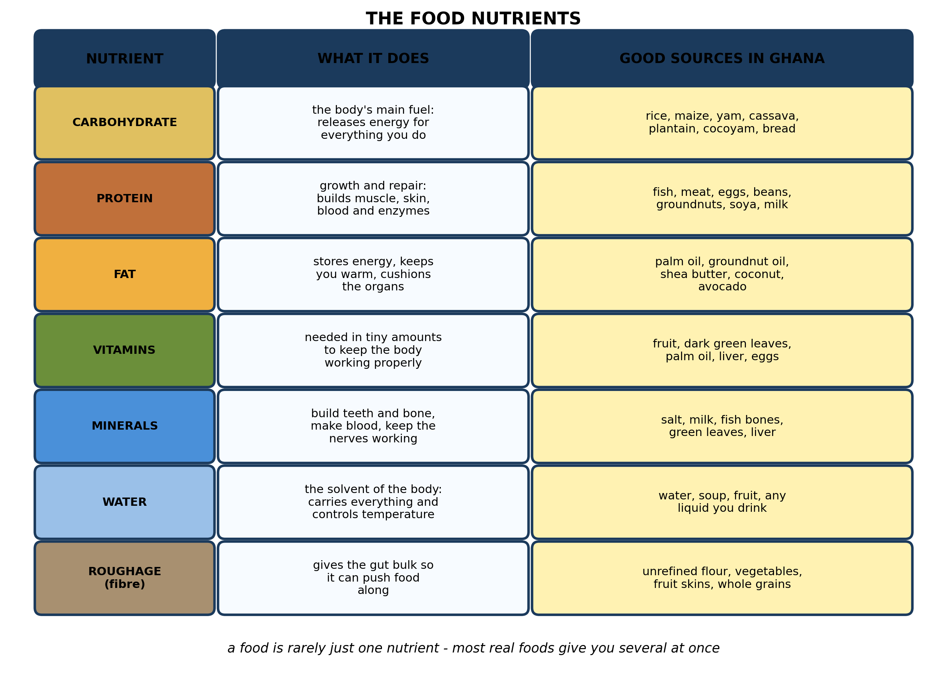
Fig. 1: The food nutrients

17.1 17.1 Food Nutrients and the Human Body
1. Explain why a child who eats a large plate of plain rice every day can still be MALNOURISHED, referring to what the rice does and does not supply. [4 marks]
2. Name THREE food nutrients. [3 marks]
3. A pupil eats gari and beans for lunch. State which nutrient each part mainly supplies, and explain why the two together make a better meal than gari alone. [3 marks]
4. State the FUNCTION of each of the following in the body: carbohydrate; protein; roughage. [3 marks]
____________________________________________________________________________________________
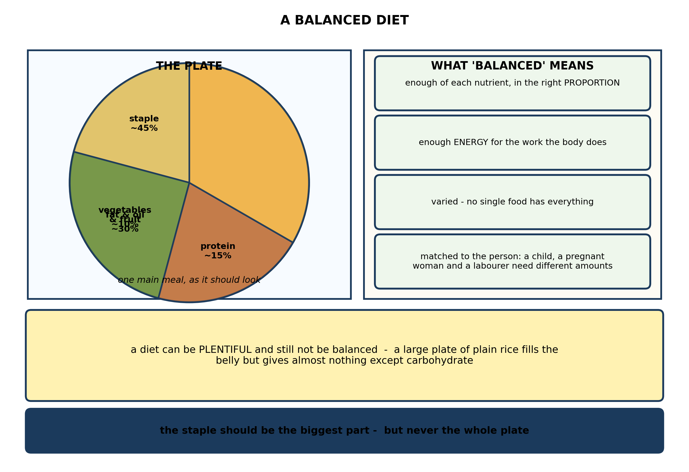
Fig. 2: A balanced diet

17.2 17.2 Deficiency Diseases: Causes, Symptoms, Effects and Prevention
5. Explain what is meant by a BALANCED DIET, and explain why the diet that suits a labourer working on a farm does not suit an office worker of the same age and the same weight. [4 marks]
6. Use the plate in Fig. 2 to describe how a school lunch should be made up, and explain why the staple should be the largest part. [3 marks]
7. State TWO reasons why a diet of only ONE food is not a balanced diet. [3 marks]
____________________________________________________________________________________________
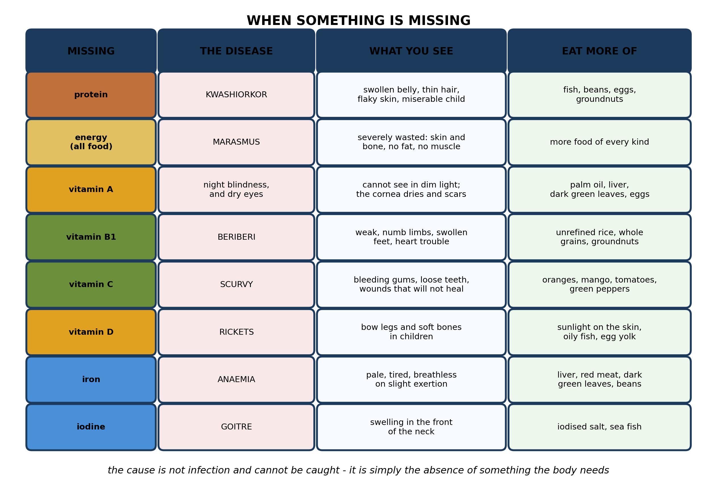
Fig. 3: When something is missing

17.3 17.3 Night Blindness, Rickets, Scurvy, Kwashiorkor and Anaemia
8. Explain why KWASHIORKOR can develop in a child who is getting enough to eat by volume, and explain why it is most often seen soon after a child has been weaned. [4 marks]
9. One child is pale, tires easily and is breathless after only slight exertion. A second child cannot see properly in dim light. Name the deficiency in each case, and for each suggest TWO foods that would correct it. [4 marks]
10. Explain why a child who eats plenty of WHITE, well-milled rice may develop beriberi, and what should be done about it. [3 marks]
11. State what is meant by a DEFICIENCY disease, and name TWO. [3 marks]
____________________________________________________________________________________________
SECTION B - PRACTICAL TASK
Study the apparatus and answer the questions that follow it.
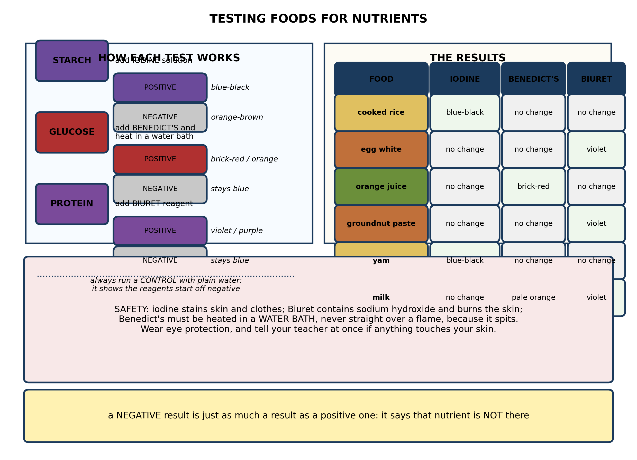
Fig. 4: Testing foods for nutrients

12. From the results, explain why MILK gave a positive result with both Benedict's solution and Biuret reagent, while COOKED RICE gave a positive result with iodine only. Say what each result tells you about the food. [4 marks]
13. Explain why a CONTROL containing plain water must be set up alongside the food tests, and say what the control should show. [3 marks]
14. A pupil tests a food with Benedict's solution and sees NO change. Describe what she must do before concluding that the food contains no glucose, and explain why. [3 marks]
15. State TWO safety precautions needed for these tests, and explain the hazard each one guards against. [3 marks]
____________________________________________________________________________________________

ANSWER KEY AND MARKING SCHEME
Accept any other correct and relevant answer. Award marks for correct points, not for repeating the question.
17.1 17.1 Food Nutrients and the Human Body
Q1
Plain rice is almost entirely carbohydrate, so it supplies energy and very little else. It gives the child the fuel to move and keep warm, but almost no protein for growth and repair, very little fat, and only traces of the vitamins and minerals the body needs - especially if the rice is well milled, which strips off the bran and germ where most of the B vitamins are. So the child may be full, and may even be taking in enough energy, yet still lack the protein to build muscle and blood, the vitamin A to keep the eyes and the lining of the gut healthy, and the iron to avoid anaemia. Malnutrition is not the same as hunger: it is a shortage of the RIGHT things, and a large plate of one single food cannot supply all seven nutrients. That is why the condition is called a deficiency rather than starvation - and why a child can look fed and still be ill.
Q2
Any three of: carbohydrate, protein, fat, vitamins, minerals, water, roughage (fibre).
Q3
Gari is made from cassava and is mainly carbohydrate - it supplies the energy. Beans are mainly protein - they supply the material for growth and repair. Together the meal supplies both energy and body-building material, and the beans add fibre, iron and some B vitamins as well. Gari alone would fill the pupil up and supply energy, but would give almost no protein, so the body would have the fuel it needs and none of the material to grow on. The beans supply exactly what the gari lacks, which is the point of combining a staple with a legume.
Q4
Carbohydrate: the body's main source of energy, released by respiration. Protein: growth and repair of tissues, and for making enzymes, some hormones and haemoglobin. Roughage (fibre): it gives the gut bulk, so that the muscles of the intestine have something to push against and can move food along - without it, constipation results.
17.2 17.2 Deficiency Diseases: Causes, Symptoms, Effects and Prevention
Q5
A balanced diet contains all seven nutrients in the right proportions and in enough quantity: sufficient energy for the work the body does, enough protein for growth and repair, and enough of each vitamin and mineral. It must also be varied, because no single food contains everything. The labourer is doing heavy physical work all day, so his muscles are respiring far harder and he needs substantially more carbohydrate and fat than the office worker. The office worker, sitting for most of the day, needs much less; if he ate the labourer's plate he would store the surplus as fat and put on weight. Their protein, vitamin and mineral needs, however, are about the same, because those depend on body size and on repair rather than on how much physical work is done.
Q6
About 45% of the plate should be the staple - rice, yam, cassava, plantain or maize - since that is where the carbohydrate comes from. About 30% should be vegetables and fruit, supplying vitamins, minerals and fibre. About 15% should be a protein food such as fish, meat, eggs, beans or groundnuts, and about 10% fat or oil. The staple is the largest part because energy is what the body uses most of, and carbohydrate is the cheapest and most straightforward way to supply it. Turning the plate round - mostly meat - would be expensive, would not supply enough energy, and would leave the body short of the fuel it needs most.
Q7
Any two, each stated. No single food contains all seven nutrients, so eating only one means some are missing altogether. Even where a nutrient is present, the proportions are wrong: one is supplied in great excess while others are absent, and excess can be as harmful as shortage. It also allows no variety, and a diet built on one food is monotonous enough that people eat less of it. Health depends on eating a range of foods.
17.3 17.3 Night Blindness, Rickets, Scurvy, Kwashiorkor and Anaemia
Q8
Kwashiorkor is a deficiency of PROTEIN, not of food in general. A child may be getting a full belly of a starchy staple - maize porridge, rice, cassava - and so be taking in enough energy, while getting almost no protein at all. Without protein the liver cannot make enough albumin, the protein that holds water inside the blood vessels, so fluid leaks out into the tissues and the belly swells; and the body cannot build new tissue, so growth stops and the hair and skin break down. It appears just after weaning because up to that point the child was getting its protein from breast milk, and the food that replaces it is usually a thin starchy gruel with almost none. The child is still being fed - but the one source of protein has been taken away and replaced by starch, and the deficiency shows within weeks.
Q9
The first child has iron-deficiency ANAEMIA. Iron is needed to make haemoglobin, the pigment in red blood cells that carries oxygen, so without it the blood cannot deliver enough oxygen to the muscles: hence the pallor, the tiredness and the breathlessness. Foods to correct it: liver, red meat, dark green leafy vegetables, beans, groundnuts, and iron-fortified foods. The second child has vitamin A deficiency causing NIGHT BLINDNESS. Vitamin A is needed to make the light-sensitive pigment in the retina that works when light is dim, so without it vision fails at dusk. Foods to correct it: red palm oil, liver, egg yolk, dark green leaves, orange-fleshed sweet potato, mango, pawpaw.
Q10
Beriberi is caused by a lack of vitamin B1, thiamine. Thiamine is concentrated in the bran and the germ of the rice grain, and both are removed when rice is milled white. So a diet built on well-milled rice can supply plenty of energy and still contain almost no vitamin B1. The remedy is to eat unrefined or parboiled rice instead, or to add other sources of thiamine to the diet - whole grains, unrefined flour, groundnuts, beans. Parboiling before milling drives the vitamin out of the husk and into the grain itself, which is why parboiled rice does not cause beriberi.
Q11
A deficiency disease is an illness caused by the lack of a particular nutrient in the diet over a period of time. It is not caused by a germ and cannot be caught from another person; it is corrected by supplying the missing nutrient. Any two examples: kwashiorkor (protein), marasmus (overall energy), night blindness (vitamin A), beriberi (vitamin B1), scurvy (vitamin C), rickets (vitamin D), anaemia (iron), goitre (iodine).
PRACTICAL TASK
Q12
Cooked rice went blue-black with iodine and gave no change with either of the other two, so it contains starch and no detectable reducing sugar or protein - which is what you would expect of a staple grain, since plants store their surplus energy as starch. Milk went violet with Biuret, so it contains protein, and gave a pale orange with Benedict's, so it also contains a reducing sugar - the lactose that milk naturally contains. So a single food can test positive for several nutrients at once, and each reagent answers a separate question: iodine asks whether starch is present, Benedict's whether a reducing sugar is present, Biuret whether protein is present. The three tests are independent, and a result with one tells you nothing about the other two.
Q13
The control is a tube containing water in place of the food, treated with exactly the same reagent and heated in exactly the same way for the same time. It shows what a negative result looks like - that is, the colour the reagent is to begin with. Without it a pupil cannot tell whether the colour they see comes from the food or is simply the reagent's own colour: Benedict's solution is blue and iodine solution is brown, and either could easily be misread as a positive result. The control should show no change: iodine staying orange-brown, Benedict's staying blue after heating, Biuret staying blue.
Q14
She must first check that the test was carried out properly - in particular that she added Benedict's solution AND then heated the tube in a water bath for several minutes. Benedict's reagent only gives its brick-red colour on heating; without it, the tube stays blue whatever the food contains. She should also compare the tube against the water control, and ideally repeat the test. Only then can she conclude that no reducing sugar is present. If she forgot the heating, the negative result means nothing at all, because the reagent was never given the conditions it needs to react.
Q15
Any two, each explained. Wear eye protection: iodine, Biuret reagent and hot Benedict's solution all damage the eye. Heat the Benedict's tube in a water bath rather than straight over a flame, because the solution spits and can throw hot liquid into the face. Wash off at once any iodine or Biuret that touches the skin and tell the teacher - iodine stains and irritates, and Biuret contains sodium hydroxide, which burns. Tie back long hair and stand up while heating, and point the mouth of the tube away from everyone.

BLUEPRINT / TEST SPECIFICATION
# | Content standard | Code | Items | Marks | % of Marks
17.1 | 17.1 Food Nutrients and the Human Body | B7/JHS1.5.2.1 | 4 | 13 | 26%
17.2 | 17.2 Deficiency Diseases: Causes, Symptoms, Effects and Prevention | B7/JHS1.5.2.1 | 3 | 10 | 20%
17.3 | 17.3 Night Blindness, Rickets, Scurvy, Kwashiorkor and Anaemia | B7/JHS1.5.2.1 | 4 | 14 | 28%
17.1 | Practical task | B7/JHS1.5.2.1 | 4 | 13 | 26%
TOTAL | - | - | 15 | 50 | 100%
Distribution by cognitive level
Cognitive level | Marks | % of Marks
Understand | 12 | 24%
Apply | 22 | 44%
Analyse | 16 | 32%
TOTAL | 50 | 100%
Distribution by difficulty
Difficulty | Marks | % of Marks
Easy | 3 | 6%
Moderate | 27 | 54%
Challenging | 20 | 40%
TOTAL | 50 | 100%

QUALITY-CONTROL SUMMARY
1. Is every question answered from a diagram?
Yes. All 15 questions sit under a figure, and each is unanswerable - or at least materially harder - without reading it. Questions 3, 8, 10 and 17 ask pupils to go beyond the diagram, but each still starts from something the figure shows.
2. Is the content within the Basic 7 curriculum?
Yes. Every question traces to the content standards for this sub-strand (B7/JHS1.5.2.1), and nothing is tested beyond the depth the Basic 7 syllabus sets for it.
3. Are the diagrams clear and unambiguous?
Yes. Each is drawn so that only one reading is sensible: the particle boxes differ in spacing alone, the syringes are labelled with how far each squashes, and the periodic table marks the regions in words as well as by position.
4. Is the level right for JHS 1?
Yes. Questions ask pupils to read, describe and explain what is drawn. Only Question 17 asks for an inference beyond the figure, and it is worth 3 of the 40 marks.
5. Do the marks add up?
Yes: 15 questions totalling 50 marks, matching the figure on the front page. The blueprint, cognitive and difficulty tables all sum to the same total.
6. Are the answers correct and complete?
Yes. Each answer states the point the question is worth, with the acceptable alternatives given where a question is open.
EXAMINER NOTES (for the teacher, not for candidates)
- Pitched at the compulsory diagram question of BECE Paper 2: 76% of the marks are at Apply level or above and 40% are Challenging.
- Q1 and Q8 are the pair that carry this paper, and they are the same argument at two levels. A child can be full and still be malnourished. A child can be weaned onto a bellyful of maize porridge and develop kwashiorkor, because the porridge has energy and no protein. The sentence worth drilling is 'malnutrition is not the same as hunger'. Pupils who get this have understood the difference between energy and body-building material, which is what the whole of 17.1 and 17.3 is about.
- Q8's second half is the one that earns the fourth mark. Kwashiorkor appears at weaning not because the child stops being fed, but because breast milk - the protein source - is replaced by starch. Almost nobody says this unprompted, and it is the difference between a description and an explanation.
- Q10 on beriberi and milled rice is a piece of genuine history that pupils find surprising: a diet can be adequate in energy and still kill, because milling removes the part of the grain that carries the vitamin.
- For the food tests you need iodine solution, Benedict's solution, Biuret (or sodium hydroxide plus copper sulphate), a water bath, and test-tube holders. Solid foods should be crushed with a little water first. The most common error by far is forgetting to heat the Benedict's tube - Q14 is aimed straight at it.
- Benedict's and Biuret can be hard to get in some schools. Iodine is usually available from a pharmacy as tincture of iodine diluted; if you can only run one test, run the starch test, and tell the class honestly that the other two are being described rather than done.
- The milk result in Fig. 4 is the most interesting row in the table, because milk is positive for two nutrients. It is worth asking the class why, and whether they expected a food to test positive more than once.

