[SCHOOL NAME]
INTEGRATED SCIENCE (SCIENCE)
PRACTICAL QUESTIONS - DIAGRAM MODE
Human Health Part 2 - Viral Diseases (17.4 - 17.7)
____________________________________________________________________________________________
CLASS: Basic 7 (JHS 1)
TIME: 1 hour 30 minutes
MARKS: 50 2025/2026 Academic Year
____________________________________________________________________________________________
INSTRUCTIONS TO CANDIDATES
1. Answer ALL the questions in this paper.
2. Every question is based on a diagram. Study each diagram carefully before you answer the questions that follow it.
3. Write your answers in the spaces provided. The marks for each question are printed beside it.
4. Where a question asks for a stated number of points, give that number. Any extra answers will not be marked.
5. You may refer back to any diagram at any time.
____________________________________________________________________________________________
SECTION A - DIAGRAM STUDY
Study each diagram and answer the questions that follow it.
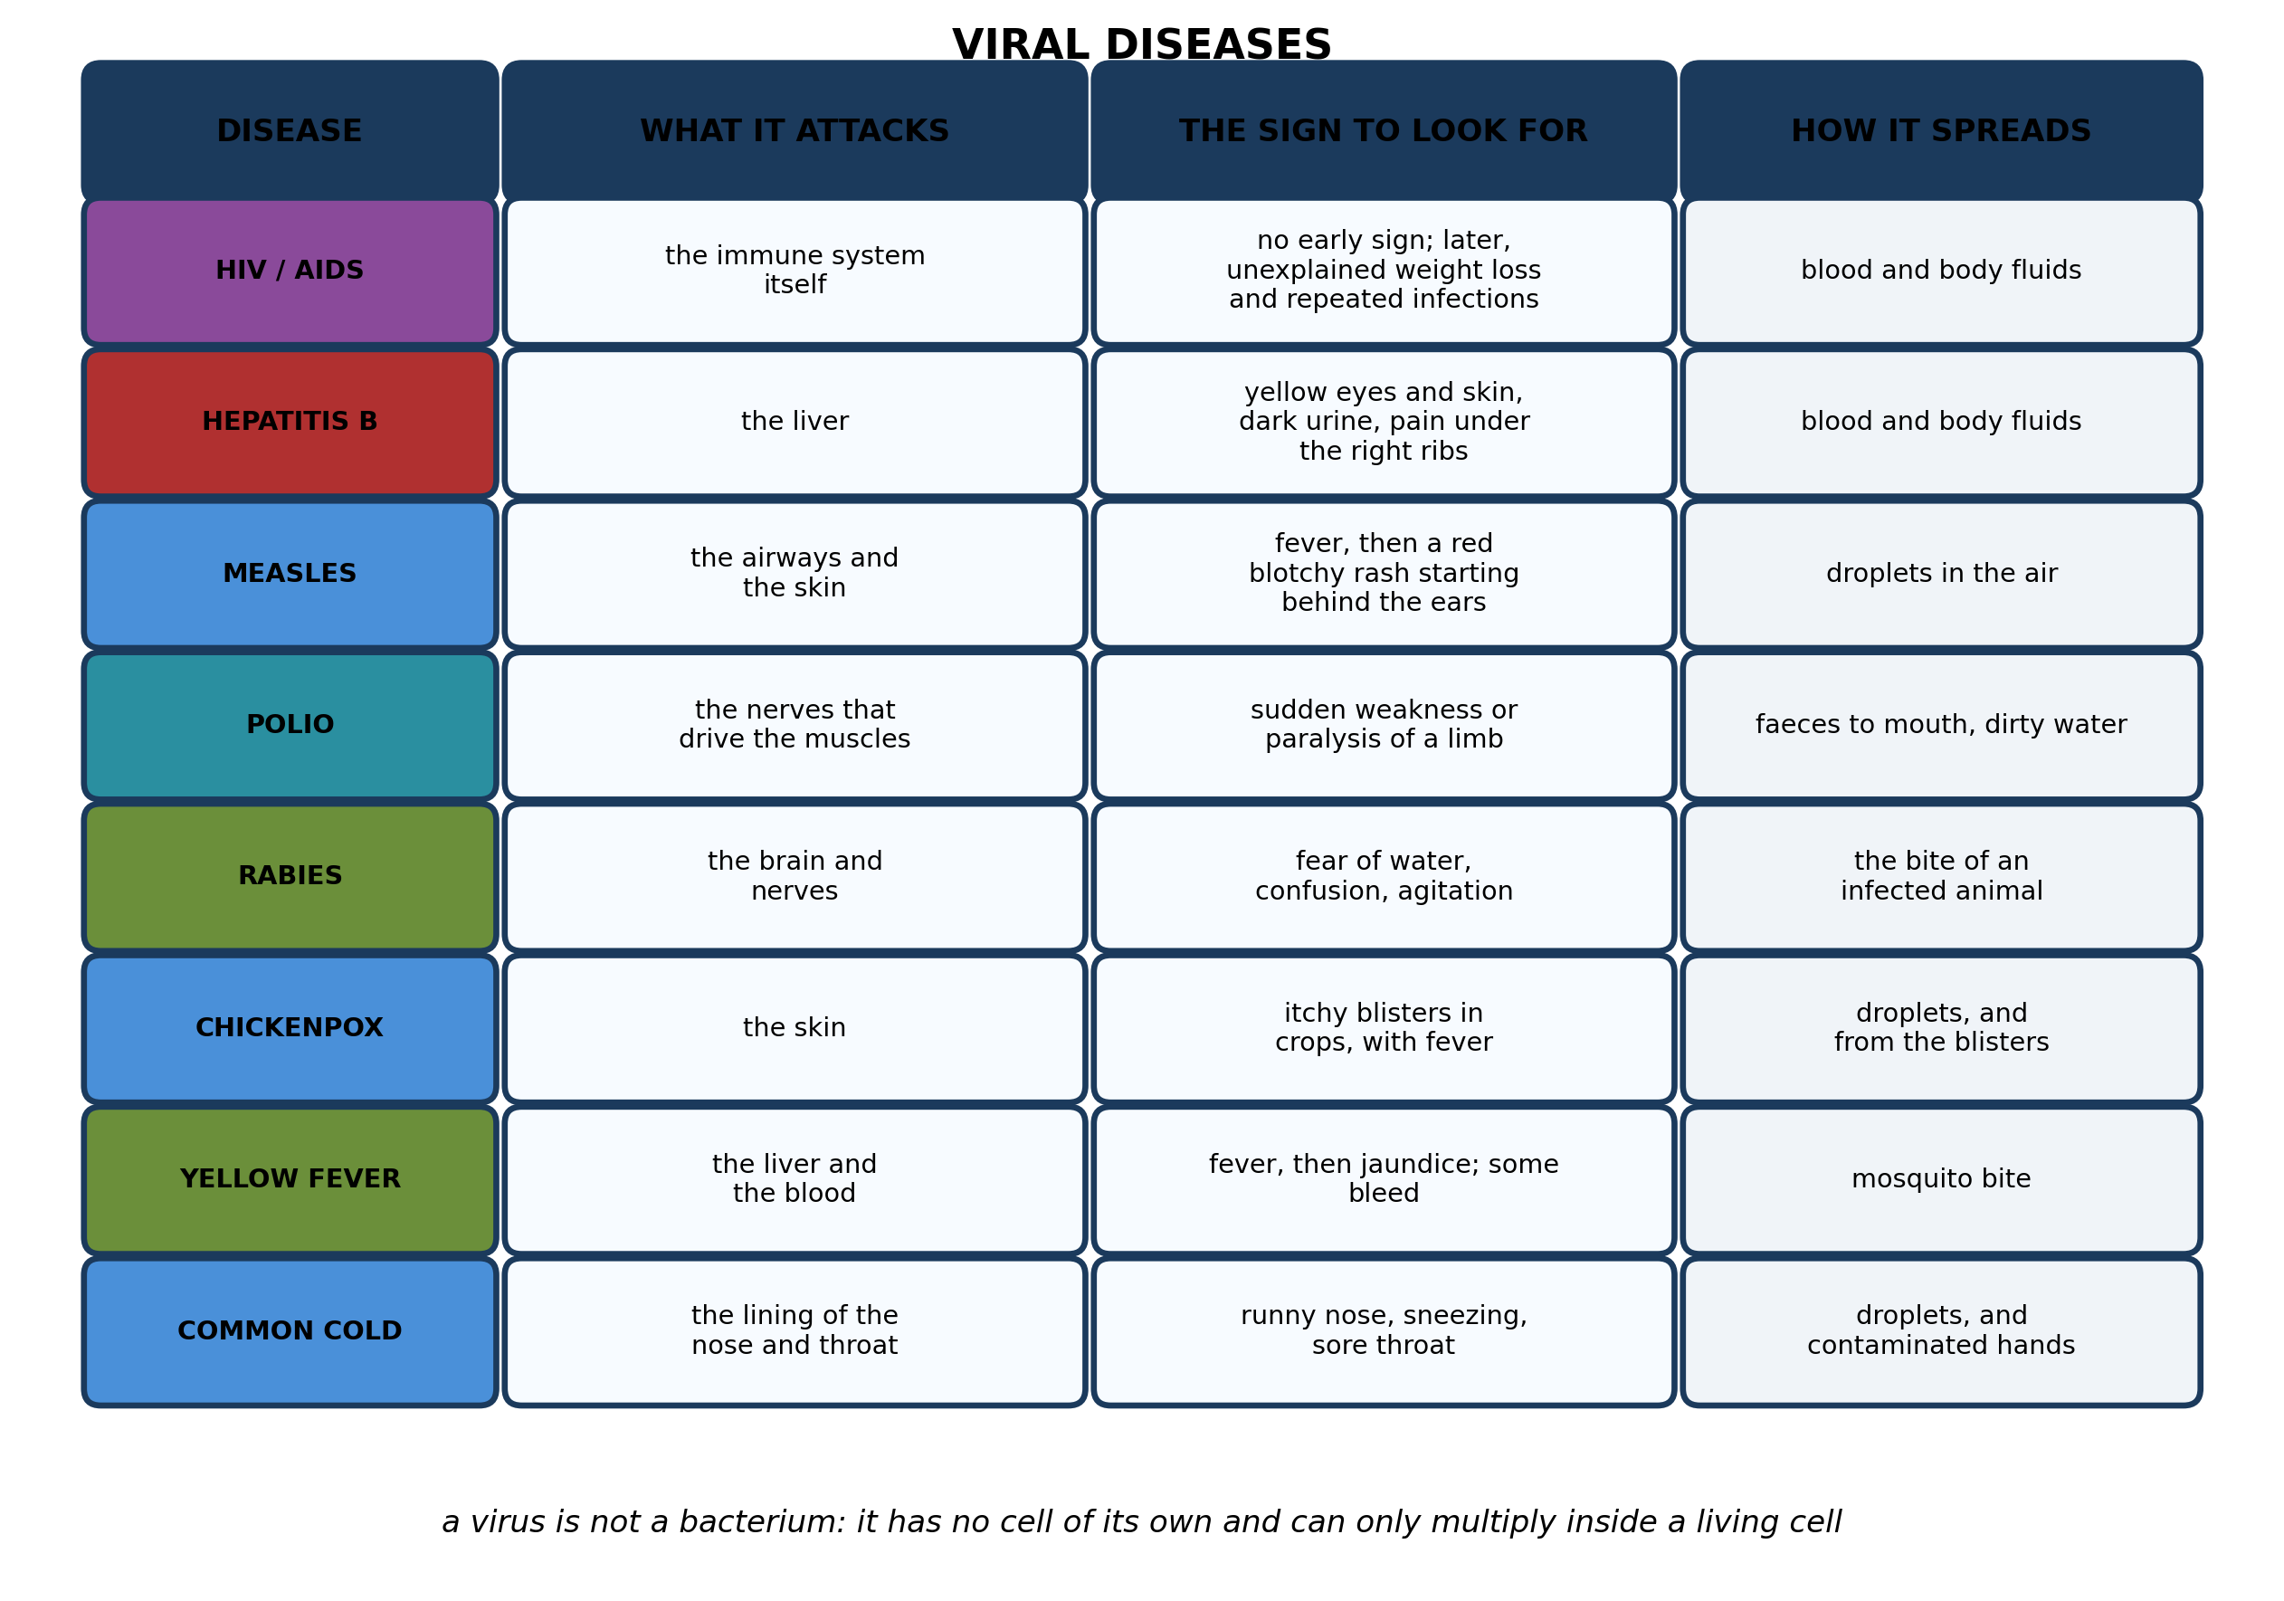
Fig. 1: Viral diseases

17.4 17.4 Nature of Viral Diseases
1. Explain why HIV is more serious than most viral infections even though the virus itself does not usually kill the person directly. [4 marks]
2. Name any THREE viral diseases shown in the diagram. [3 marks]
3. One child has a fever followed by a red blotchy rash that began behind the ears. A second child has yellow eyes and dark urine. Name the likely disease in each case, and say which part of the body each one attacks. [3 marks]
____________________________________________________________________________________________
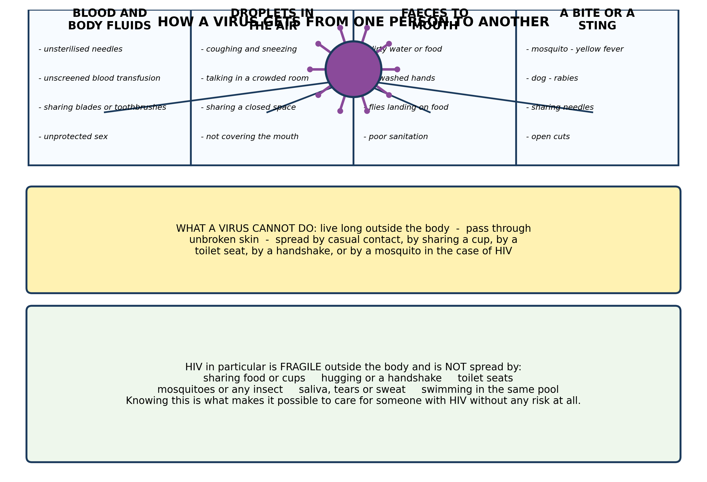
Fig. 2: How a virus gets from one person to another

17.5 17.5 COVID-19: Causes, Symptoms, Transmission and Prevention
4. Explain why HIV CANNOT be spread by sharing a cup, by a handshake or by a mosquito bite, when it IS spread by sharing a needle. Refer to what the virus needs in order to infect someone. [4 marks]
5. State THREE ways in which viruses can be spread. [3 marks]
6. A village has an outbreak of a disease spread by the FAECES-TO-MOUTH route. Suggest THREE things the village should do, and explain how each one breaks the chain. [3 marks]
____________________________________________________________________________________________
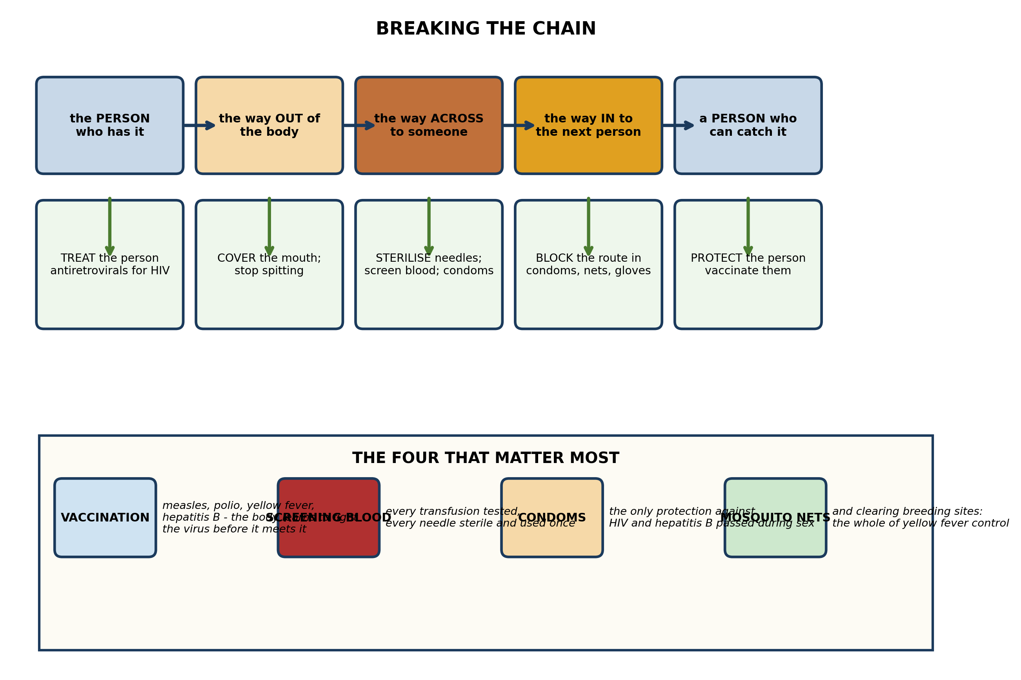
Fig. 3: Breaking the chain

17.6 17.6 Ebola and H1N1 Diseases
7. Explain how VACCINATION prevents a viral disease, and explain why it works for measles but there is still no vaccine that prevents HIV infection. [4 marks]
8. A health worker is about to take blood from a patient. State THREE precautions she should take, and explain what each one prevents. [3 marks]
9. State what is meant by SCREENING blood, and state TWO diseases it prevents. [3 marks]
____________________________________________________________________________________________
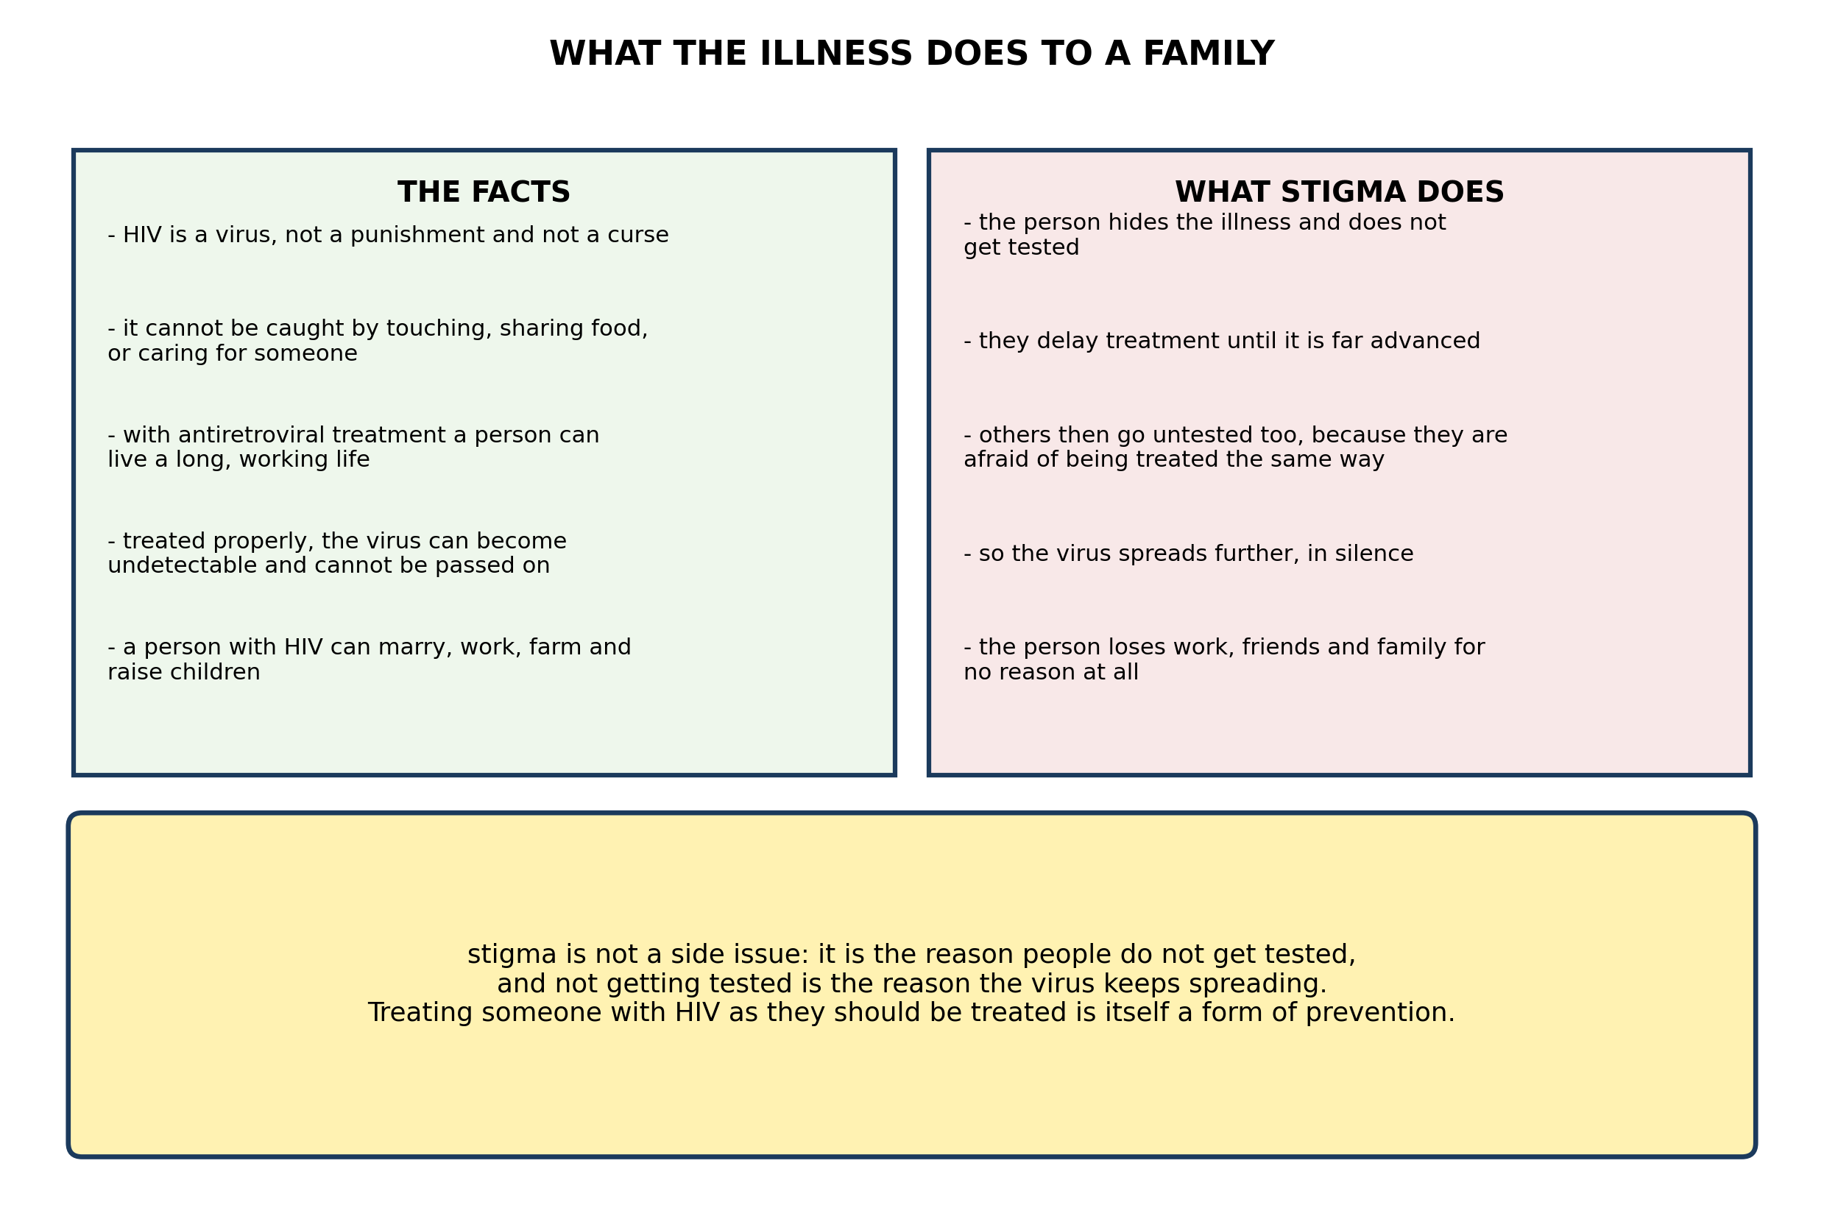
Fig. 4: What the illness does to a family

17.7 17.7 Role of Individuals, Communities and Government
10. Explain why STIGMA makes the spread of HIV worse rather than better, and explain what difference knowing the facts in Fig. 4 makes to how a family should treat a relative who has the virus. [4 marks]
11. A man in a village is found to have HIV and his family want him to move out and eat separately. Explain why this is unnecessary, and suggest what the family should do instead. [3 marks]
12. State THREE facts about living with HIV that are true today and that many people do not know. [3 marks]
____________________________________________________________________________________________
SECTION B - PRACTICAL TASK
Study the apparatus and answer the questions that follow it.
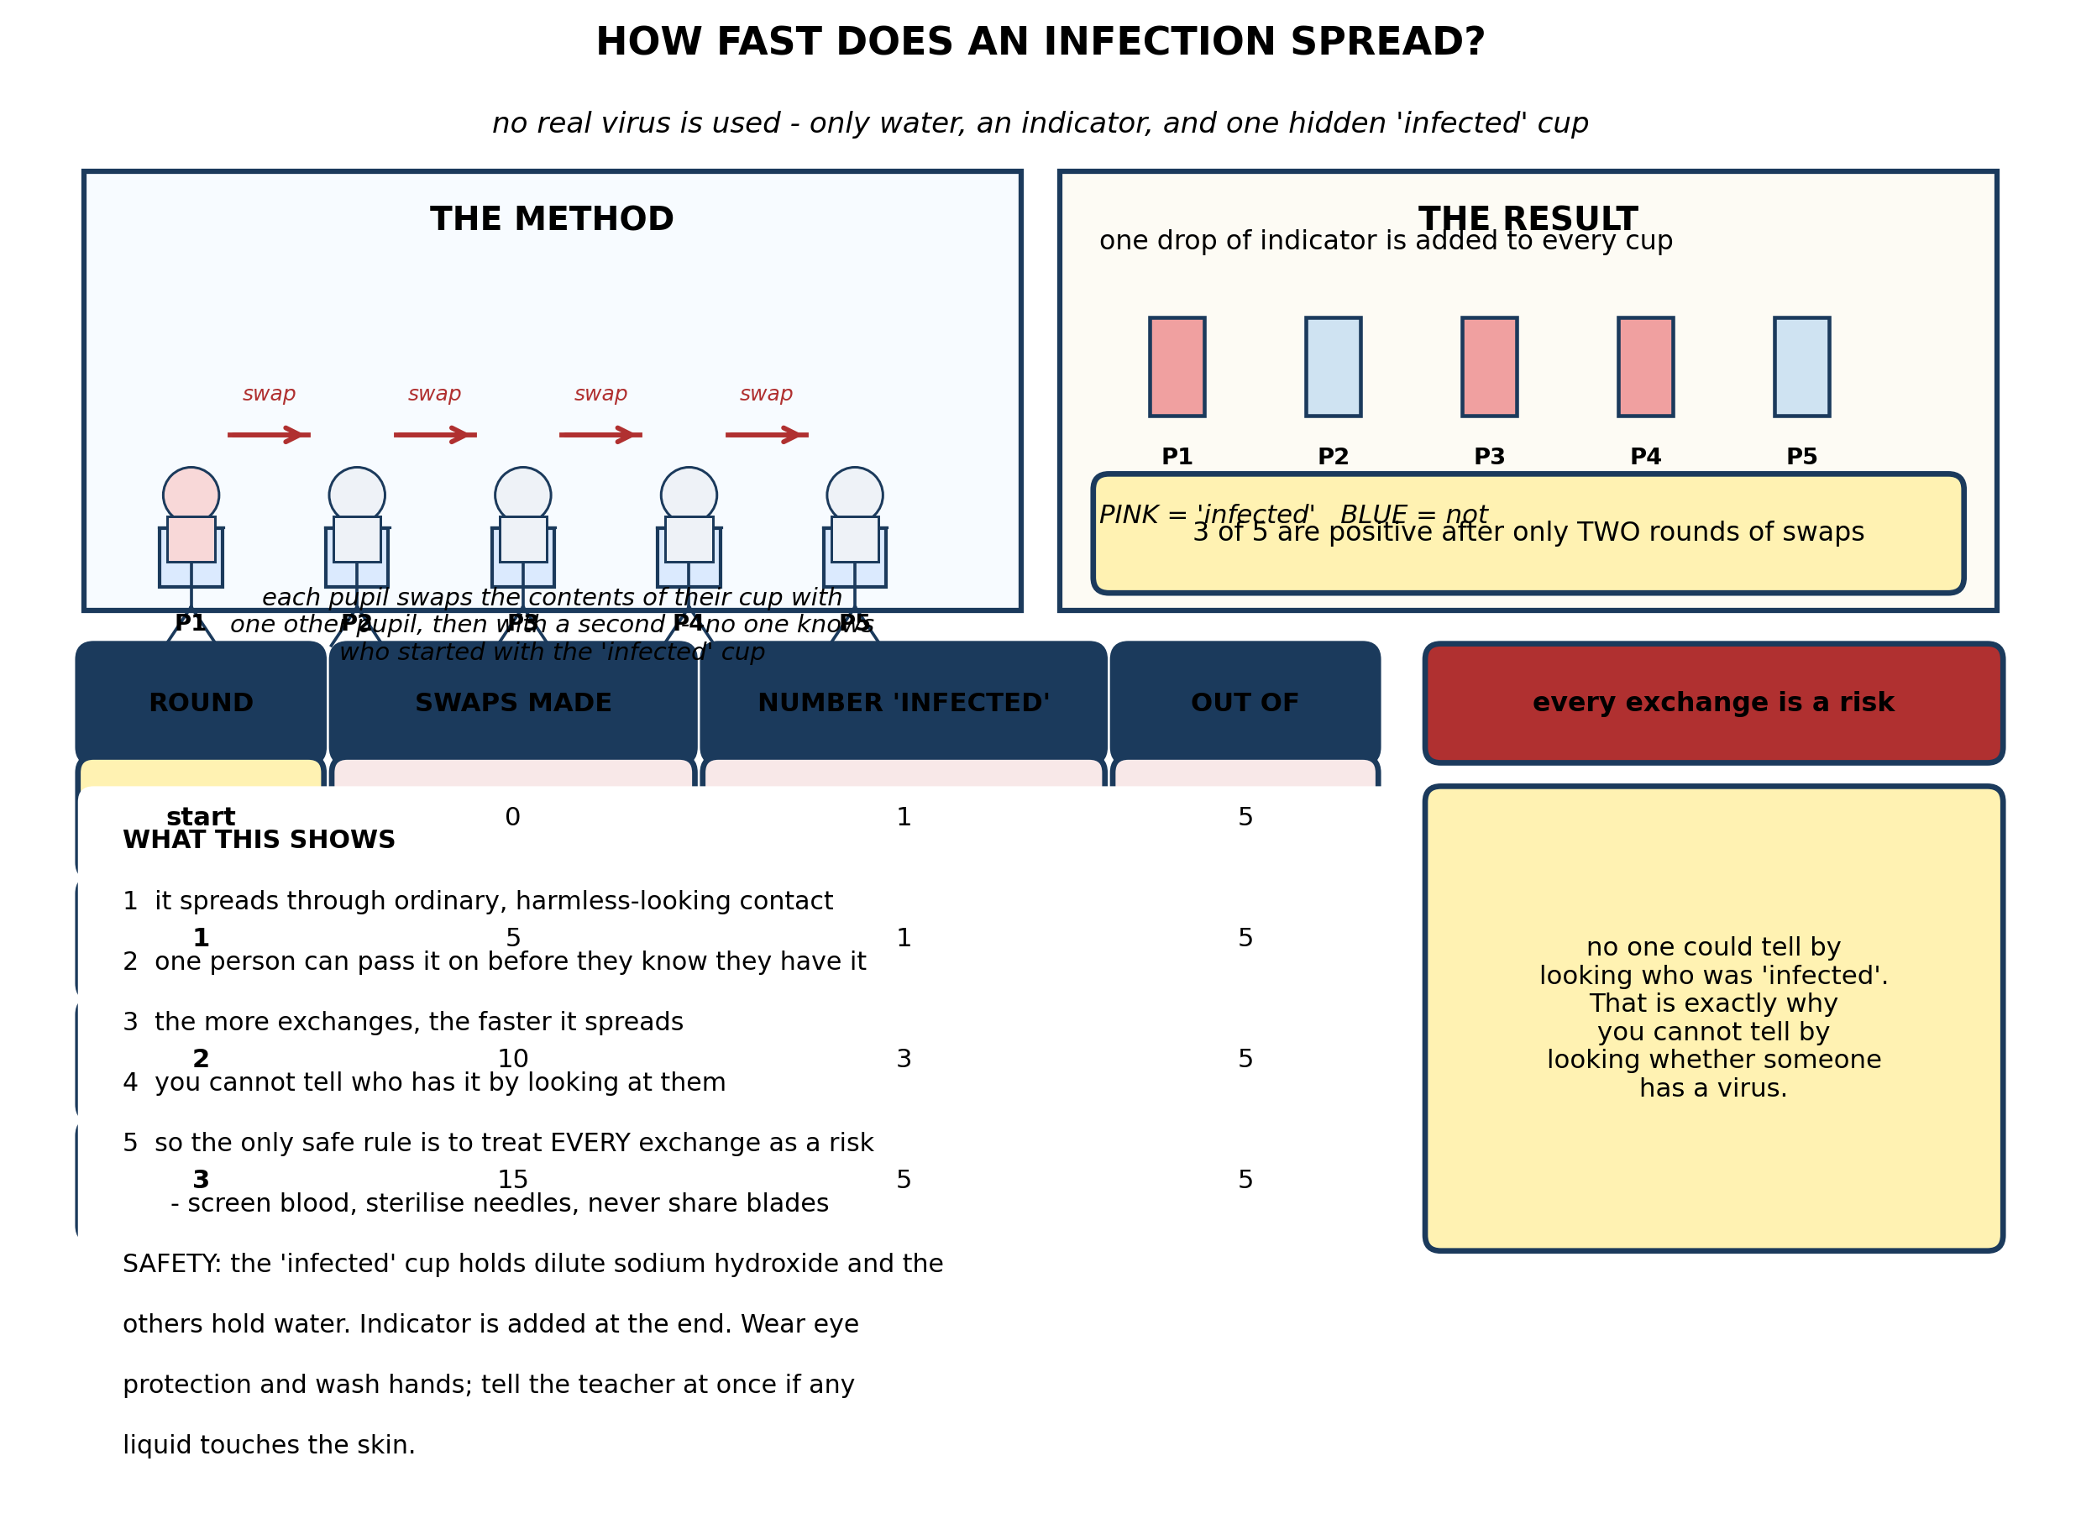
Fig. 5: How fast does an infection spread?

13. From the results, explain why the number 'infected' rose so quickly. Explain in detail what this shows about why you cannot tell by looking whether someone has a virus. [4 marks]
14. Explain why NO REAL VIRUS was used in this practical, and explain why the 'infected' cup could not be identified until the indicator was added. [3 marks]
15. State TWO safety precautions for this practical, and suggest ONE change to the method that would slow the spread, explaining why it would work. [3 marks]
____________________________________________________________________________________________

ANSWER KEY AND MARKING SCHEME
Accept any other correct and relevant answer. Award marks for correct points, not for repeating the question.
17.4 17.4 Nature of Viral Diseases
Q1
HIV attacks the immune system itself - the very cells that coordinate the body's defences against everything else. Most viruses attack one organ and the body either clears them or keeps them in check: measles attacks the airways and skin, hepatitis B attacks the liver, and the immune system deals with them. HIV destroys the system that would do the dealing. So the person does not die of HIV as such. They die of infections that a healthy body would shrug off - tuberculosis, pneumonia, severe diarrhoea, certain cancers. What makes HIV serious is not what the virus does to any one organ but that it removes the body's ability to fight anything else. That is also why the illness is called a syndrome - AIDS - rather than a single disease: the eventual illness is different in different people.
Q2
Any three of: HIV/AIDS, hepatitis B, measles, polio, rabies, chickenpox, yellow fever, the common cold.
Q3
The first child has MEASLES. The rash begins behind the ears and spreads downwards, and the virus attacks the airways and the skin. The second child has HEPATITIS B. The yellowing is jaundice, caused by the liver failing to clear bile pigment from the blood, and the virus attacks the liver. So in the first child the trouble is in the breathing passages and the skin, which is why the rash appears; in the second it is in the liver, which is why the eyes go yellow rather than the skin going blotchy.
17.5 17.5 COVID-19: Causes, Symptoms, Transmission and Prevention
Q4
To infect someone, a virus has to reach cells it can enter, in sufficient numbers, before it is destroyed. HIV is a fragile virus: it dries out and dies quickly in air, it is destroyed by stomach acid and digestive enzymes, and it can only enter through the bloodstream or through mucous membranes. Saliva, tears and sweat contain almost no virus, and sharing a cup delivers a trace amount into the mouth and then the stomach, where it is destroyed - so there is no route in and not enough virus anyway. Unbroken skin is a complete barrier, so a handshake cannot transmit it. A mosquito does not inject blood from the person it last bit; it injects saliva, and any virus in the blood it swallowed is digested - and HIV cannot multiply inside an insect in any case. A shared needle is different on every count: it carries blood, it injects that blood straight past the skin into the bloodstream, and the blood in the barrel is shielded from the air. So it is not that sharing needles is vaguely 'unhygienic' - it is that only that route delivers live virus past the skin in quantity.
Q5
Any three, each stated. Through blood and body fluids - unsterilised needles, unscreened blood transfusions, unprotected sex. By droplets in the air from coughing, sneezing and talking in a crowded room. By the faeces-to-mouth route - dirty water, unwashed hands, flies landing on food. By a bite from an infected animal or insect - a dog with rabies, a mosquito carrying yellow fever.
Q6
Any three, each explained. Boil or treat the drinking water, so that any virus in it is destroyed before anyone drinks it. Build and use pit latrines, sited well away from the water source, so that faeces cannot reach the water or the food in the first place. Wash hands with soap after using the latrine and before handling food, so that virus picked up on the hands is not carried to the mouth. Keep food covered and screened from flies, which carry virus from faeces to food on their feet and mouthparts.
17.6 17.6 Ebola and H1N1 Diseases
Q7
A vaccine contains a harmless version of the virus, or a piece of it, which the immune system recognises as foreign. The body makes antibodies against it and, crucially, produces memory cells that persist for years. If the real virus later enters the body, those memory cells recognise it at once and produce antibodies fast enough to destroy it before it can establish an infection. This works for measles because the measles virus is stable: it has essentially one form, and the antibodies made against the vaccine virus recognise the real one perfectly well. HIV is different on two counts. It mutates extremely fast, so the surface the antibodies have learned to recognise has changed by the time the response is ready - the target keeps moving. And it attacks the very immune cells that would mount the response, so the defender is being destroyed while it works. Antiretroviral drugs control HIV by interfering with the virus's replication rather than by preventing infection.
Q8
Any three, each explained. Use a new, sterile, single-use needle and put it straight into a sharps box afterwards, so that no blood from one person can enter another. Wear gloves, so that any blood cannot reach cuts or grazes on her own hands. Cover any cuts or grazes on her hands with a waterproof dressing first, so that there is no route in. Screen every donation before transfusion, so that infected blood is never given to anyone. Clean up any spill with a disinfectant such as dilute bleach, which destroys the virus.
Q9
Screening means testing every donation of blood for the presence of particular viruses before the blood is used for a transfusion; any unit that tests positive is discarded. It prevents HIV and hepatitis B (and also hepatitis C and syphilis).
17.7 17.7 Role of Individuals, Communities and Government
Q10
Stigma drives the illness underground. If having HIV means losing your job, your friends and your place in the family, then the sensible thing for someone who suspects they may be infected is not to be tested. So they are not tested, they get no treatment, they change nothing, and they may pass the virus on for years without ever knowing they have it. Meanwhile everyone else, seeing what happened to the first person, avoids testing too. The result is that a preventable and now treatable infection keeps spreading in silence. Knowing the facts removes the reason for any of it. HIV is not spread by touching, by sharing food or cups, by a toilet seat, by saliva, tears or sweat, or by any insect. A family can therefore share meals, share a home, wash clothes and nurse a relative with HIV in complete safety. The only things that must not be shared are razors, toothbrushes and needles, and any cuts should be covered. And with antiretroviral treatment taken properly the virus becomes undetectable and cannot be passed on at all.
Q11
It is unnecessary because HIV is not spread by any of the things that sharing a home involves: not by sharing food or cups, not by touching or hugging, not by toilet seats, not by saliva, tears or sweat, and not by any insect. The virus needs blood or sexual fluids to get into another person's bloodstream, and none of that happens in ordinary family life. What the family should do instead: encourage him to attend the clinic and start antiretroviral treatment promptly, and support him to keep taking it; see that he eats well; and observe the one real precaution, which is not to share razors, toothbrushes or needles with him, and to keep any cuts covered. Beyond that he should be treated exactly as before - and the family can be tested themselves if that would set their minds at rest.
Q12
Any three, each stated. With antiretroviral treatment taken properly, a person with HIV can live a long and working life. Taken properly, the drugs can make the virus undetectable in the blood, and at that point it cannot be passed on to anyone else. HIV is not spread by touching, by sharing food or cups, or by caring for someone. A person with HIV can marry, work, farm and have children who do not have the virus.
PRACTICAL TASK
Q13
The number rose quickly because each round of swaps multiplies the number of contacts. At the start one pupil out of five was 'infected'. After the first round of swaps still only one was - the exchanges simply had not happened to reach the right person. But after the second round, three of the five were positive, and by the third round all five were. Every exchange is an independent chance for the virus to move, so the total number of chances grows fast, and the number of people carrying it grows with it. And throughout, nobody could tell by looking which cups were positive: the liquid looked the same in every cup and the pupils behaved the same. That is precisely the point about a real infection. A person with HIV, or with hepatitis B, looks entirely well and feels entirely well, often for years. They do not know they have it, and neither does anyone else. No amount of looking tells you whether the person beside you is infected, and no amount of looking tells you whether you are. Only a test does. That is why the safe rule is to treat every exchange - every needle, every blade, every unscreened donation - as though it were a risk, rather than trusting appearances.
Q14
No real virus was used because this is a school. Even a harmless one would be irresponsible, and any virus that behaved the way HIV does would be dangerous. What is being modelled is not the virus but the PATTERN of spread - how many contacts, how quickly, and whether anyone can tell who is carrying it. The dilute sodium hydroxide in the 'infected' cup stands in for the virus: it is invisible in water, it passes from cup to cup exactly as a virus would, and it is revealed at the end by a colour change with the indicator. It could not be identified earlier because it is a colourless liquid in a colourless liquid. There is no visible sign - which is exactly the property being demonstrated. A person carrying a virus looks the same as everyone else.
Q15
Any two safety precautions, each explained. Wear eye protection, because the 'infected' liquid is dilute sodium hydroxide and splashes damage the eye. Wash hands at the end, and tell the teacher at once if any liquid touches the skin or the eyes. Do not drink from any cup or pipette, and put nothing in the mouth. For slowing the spread, any one with an explanation: reduce the number of exchanges - let each pupil swap with only one other per round instead of two, so there are fewer chances for the virus to move. Or 'screen' before swapping: test every cup and withdraw any that is positive, which is what screening donated blood does. Or have some pupils decline to swap at all, which is what vaccination, or never sharing a needle, does - fewer people who can catch it means the chain runs out of links.

BLUEPRINT / TEST SPECIFICATION
# | Content standard | Code | Items | Marks | % of Marks
17.4 | 17.4 Nature of Viral Diseases | B7/JHS1.5.2.2 | 3 | 10 | 20%
17.5 | 17.5 COVID-19: Causes, Symptoms, Transmission and Prevention | B7/JHS1.5.2.2 | 3 | 10 | 20%
17.6 | 17.6 Ebola and H1N1 Diseases | B7/JHS1.5.2.2 | 3 | 10 | 20%
17.7 | 17.7 Role of Individuals, Communities and Government | B7/JHS1.5.2.2 | 3 | 10 | 20%
17.4 | Practical task | B7/JHS1.5.2.2 | 3 | 10 | 20%
TOTAL | - | - | 15 | 50 | 100%
Distribution by cognitive level
Cognitive level | Marks | % of Marks
Understand | 12 | 24%
Apply | 22 | 44%
Analyse | 16 | 32%
TOTAL | 50 | 100%
Distribution by difficulty
Difficulty | Marks | % of Marks
Easy | 3 | 6%
Moderate | 27 | 54%
Challenging | 20 | 40%
TOTAL | 50 | 100%

QUALITY-CONTROL SUMMARY
1. Is every question answered from a diagram?
Yes. All 15 questions sit under a figure, and each is unanswerable - or at least materially harder - without reading it. Questions 3, 8, 10 and 17 ask pupils to go beyond the diagram, but each still starts from something the figure shows.
2. Is the content within the Basic 7 curriculum?
Yes. Every question traces to the content standards for this sub-strand (B7/JHS1.5.2.2), and nothing is tested beyond the depth the Basic 7 syllabus sets for it.
3. Are the diagrams clear and unambiguous?
Yes. Each is drawn so that only one reading is sensible: the particle boxes differ in spacing alone, the syringes are labelled with how far each squashes, and the periodic table marks the regions in words as well as by position.
4. Is the level right for JHS 1?
Yes. Questions ask pupils to read, describe and explain what is drawn. Only Question 17 asks for an inference beyond the figure, and it is worth 3 of the 40 marks.
5. Do the marks add up?
Yes: 15 questions totalling 50 marks, matching the figure on the front page. The blueprint, cognitive and difficulty tables all sum to the same total.
6. Are the answers correct and complete?
Yes. Each answer states the point the question is worth, with the acceptable alternatives given where a question is open.
EXAMINER NOTES (for the teacher, not for candidates)
- Pitched at the compulsory diagram question of BECE Paper 2: 76% of the marks are at Apply level or above and 40% are Challenging.
- Q1 is the paper's central question and the one pupils most want answered. The answer is that HIV is serious not because of what it does to an organ but because it dismantles the system that defends every organ. Pupils who say 'it causes AIDS' have given a label, not an explanation.
- Q4 on why a handshake is safe but a shared needle is not is worth the full four marks of class time. It is not enough to say 'HIV is not spread by touching' - the pupil has to say why, which means explaining what the virus needs: a route past the skin, enough of it, and cells it can enter. Once that is clear, the whole list of myths falls over by itself.
- Q7 on why there is no HIV vaccine is the hardest question here and the most rewarding. The virus mutates faster than the immune response can be trained, and it attacks the cells that would do the training. Both reasons matter.
- Q10 and Q11 are the reason 17.7 exists. Stigma is not a matter of manners - it is the mechanism by which the virus keeps spreading, because people who fear being thrown out do not get tested. Teach the facts in Fig. 2 first; the conclusion then follows without needing to be insisted on.
- The spread practical is the best lesson in the whole strand. It needs only cups, water, one hidden cup of dilute sodium hydroxide, and an indicator such as phenolphthalein or universal indicator. Wear eye protection and brief the class beforehand that no real virus is involved - say it twice, because one pupil will always worry.
- The result that surprises them is not that it spreads. It is that they cannot tell who started it. Hold that thought and the whole of 17.7 follows from it.

