[SCHOOL NAME]
INTEGRATED SCIENCE (SCIENCE)
PRACTICAL QUESTIONS - DIAGRAM MODE
Life Cycle of Organisms (4.1 - 4.6)
____________________________________________________________________________________________
CLASS: Basic 7 (JHS 1)
TIME: 1 hour 30 minutes
MARKS: 50 2025/2026 Academic Year
____________________________________________________________________________________________
INSTRUCTIONS TO CANDIDATES
1. Answer ALL the questions in this paper.
2. Every question is based on a diagram. Study each diagram carefully before you answer the questions that follow it.
3. Write your answers in the spaces provided. The marks for each question are printed beside it.
4. Where a question asks for a stated number of points, give that number. Any extra answers will not be marked.
5. You may refer back to any diagram at any time.
____________________________________________________________________________________________
SECTION A - DIAGRAM STUDY
Study each diagram and answer the questions that follow it.
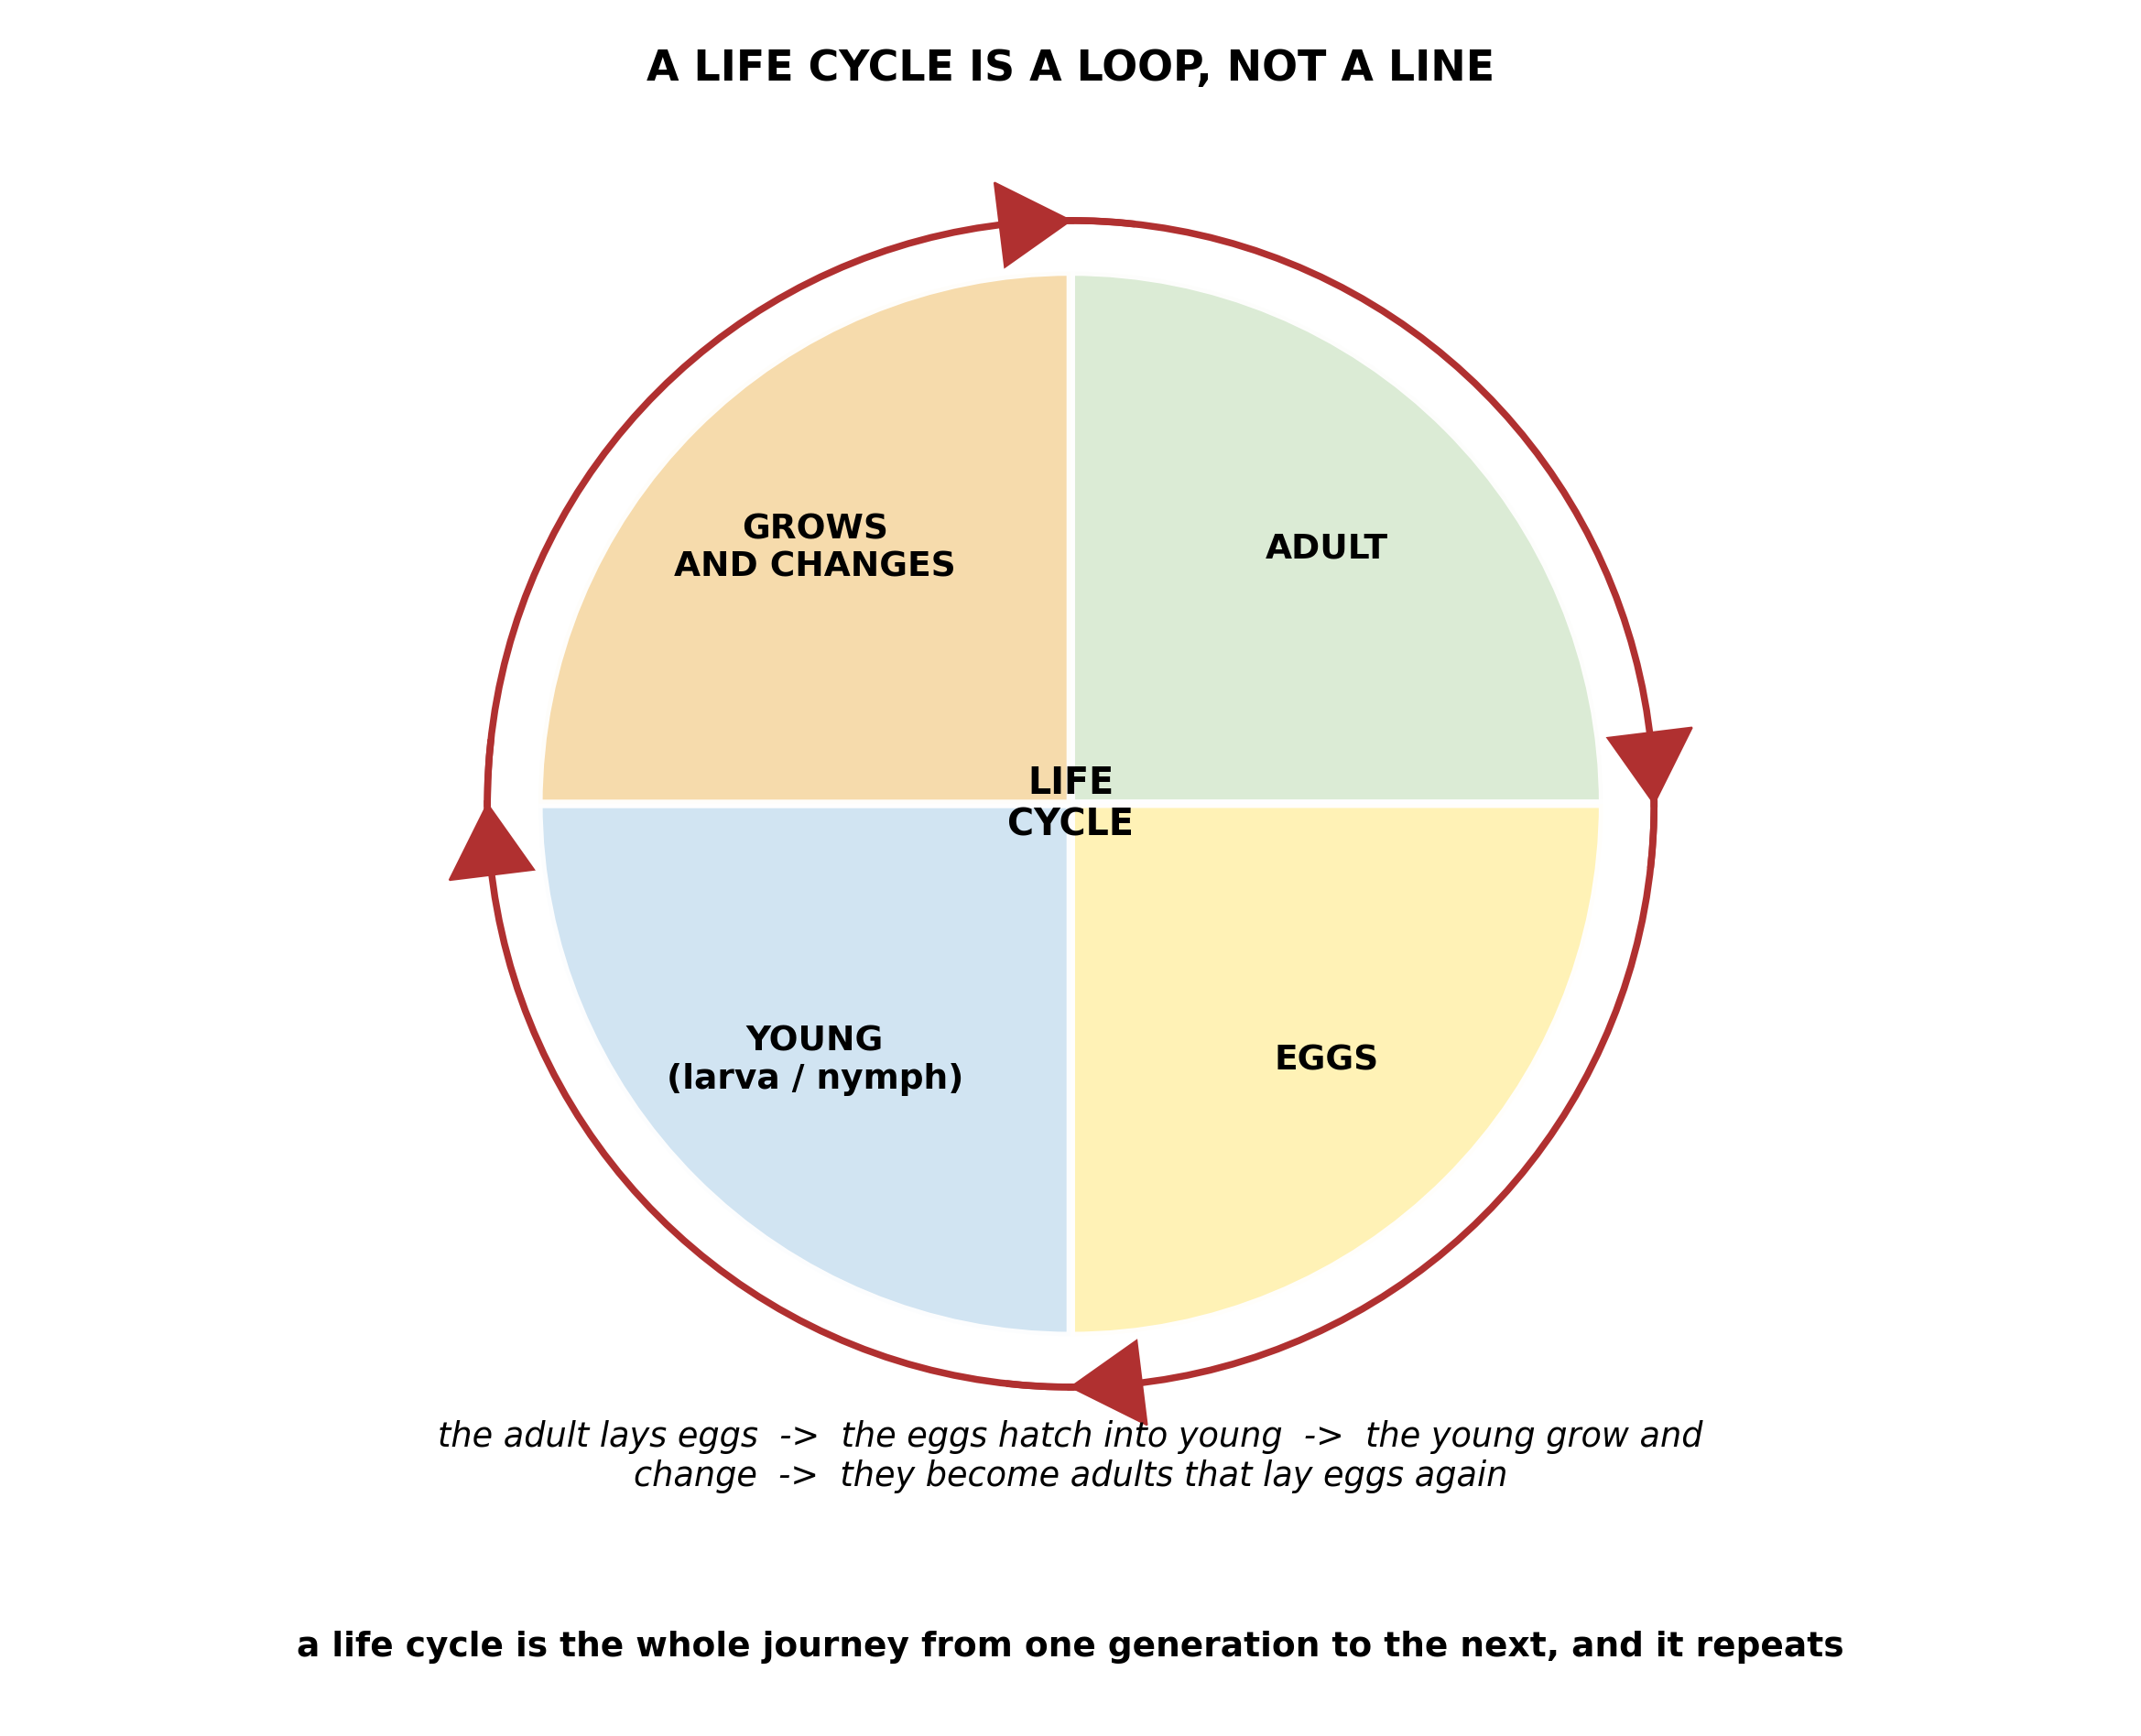
Fig. 1: A life cycle is a loop, not a line

4.1 4.1 What is a Life Cycle?
1. The diagram shows a life cycle as a wheel with arrows going round it. Explain why a life cycle is drawn as a CYCLE rather than as a straight line, and explain what would happen to the species if the loop were broken at any one point. [4 marks]
2. Name the four stages shown in the life cycle wheel. [2 marks]
____________________________________________________________________________________________
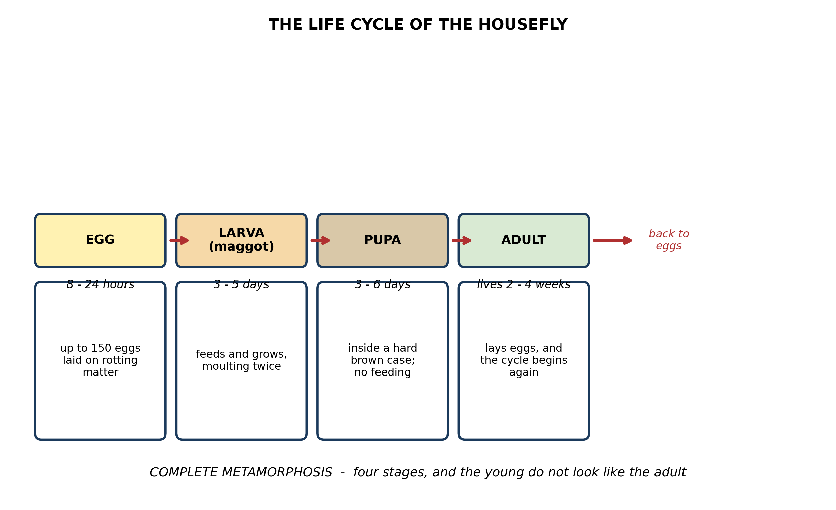
Fig. 2: The life cycle of the housefly

4.2 4.2 Stages of the Life Cycle of the Housefly: Egg → Larva → Pupa → Adult
3. The diagram shows the housefly larva moulting as it grows. Explain why a maggot has to moult, and explain what makes the housefly's development a COMPLETE metamorphosis. [4 marks]
4. Use the times given on the diagram to explain why one uncovered heap of rubbish can suddenly produce a very large number of flies within about two weeks. [3 marks]
____________________________________________________________________________________________
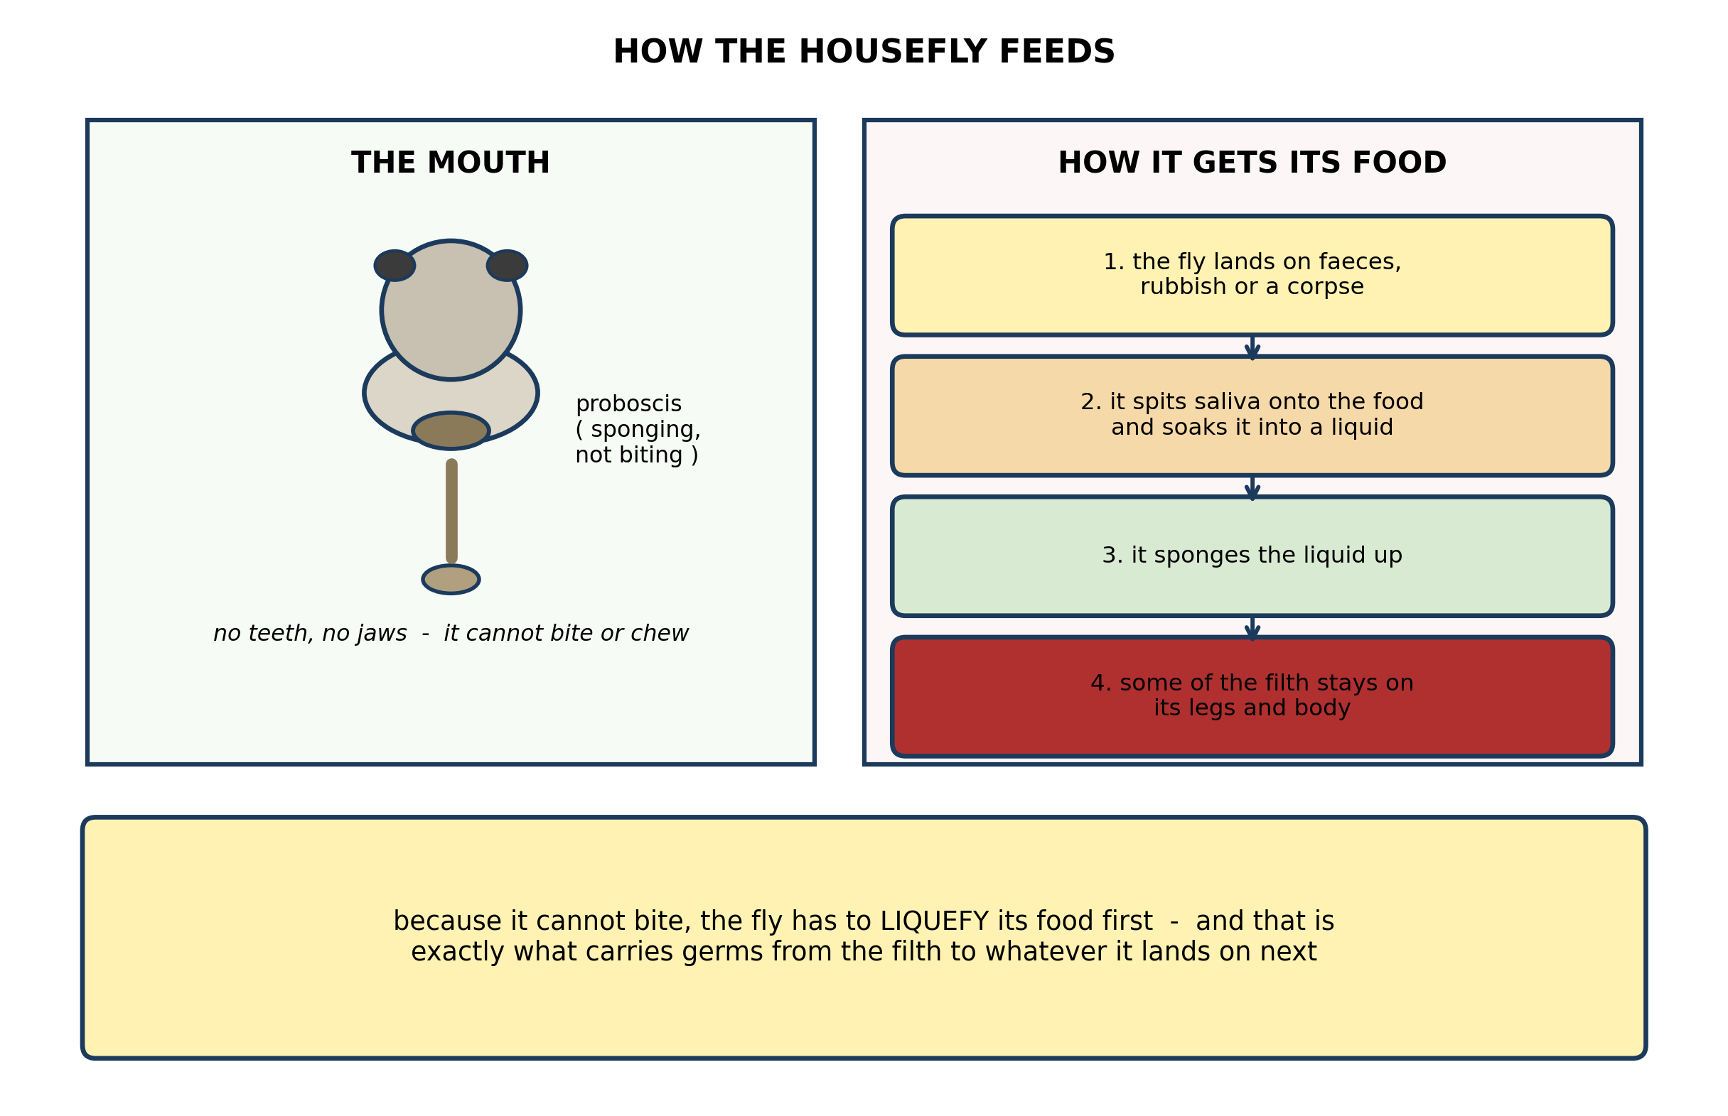
Fig. 3: How the housefly feeds

4.3 4.3 Feeding Habits of the Housefly
5. Explain the connection between the housefly's MOUTHPARTS and the way it spreads disease. Use the diagram. [4 marks]
6. The diagram shows the fly spitting saliva onto its food. Explain why it has to do this. [3 marks]
____________________________________________________________________________________________
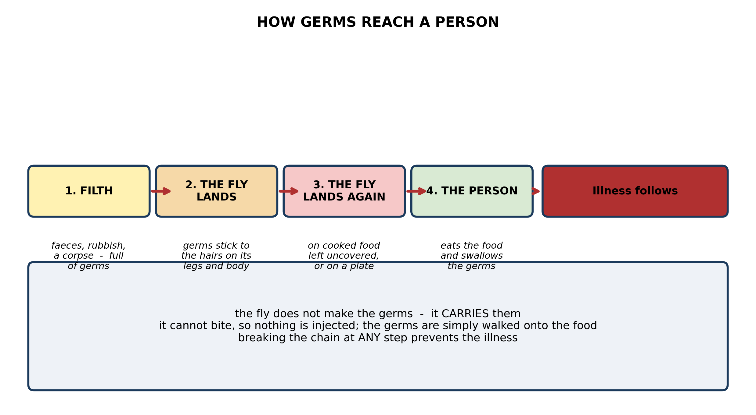
Fig. 4: How germs reach a person

4.4 4.4 How the Housefly Affects Human Health
7. Use the diagram to describe how germs get from faeces into a person's body, and state ONE point at which you would break the chain. [4 marks]
8. A pupil says 'the housefly GIVES you cholera'. Explain why this is not accurate, and why the difference matters. [3 marks]
____________________________________________________________________________________________
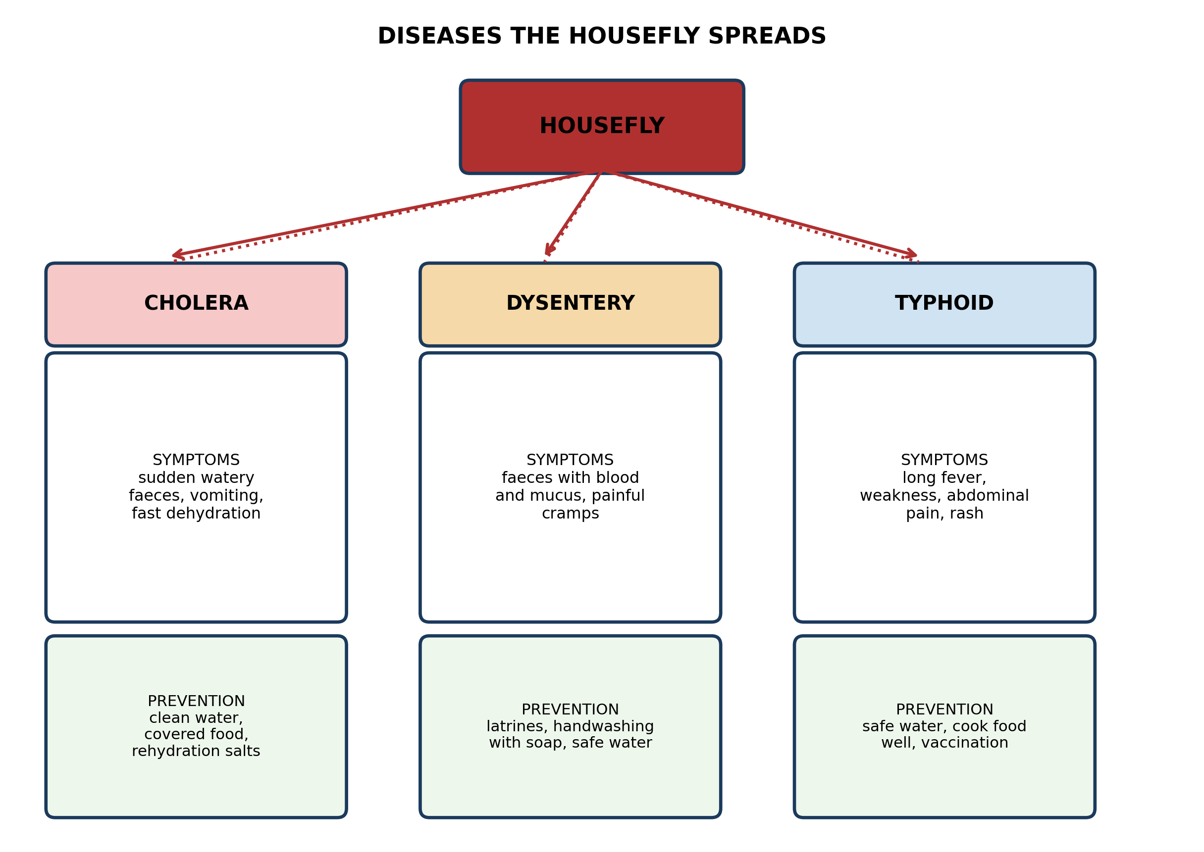
Fig. 5: Diseases the housefly spreads

4.5 4.5 Diseases Spread by the Housefly
9. From the diagram, name the disease whose prevention includes VACCINATION, and explain why vaccination on its own will not protect against the other two. [3 marks]
10. State TWO symptoms of dysentery, and state ONE way of preventing it. [3 marks]
____________________________________________________________________________________________
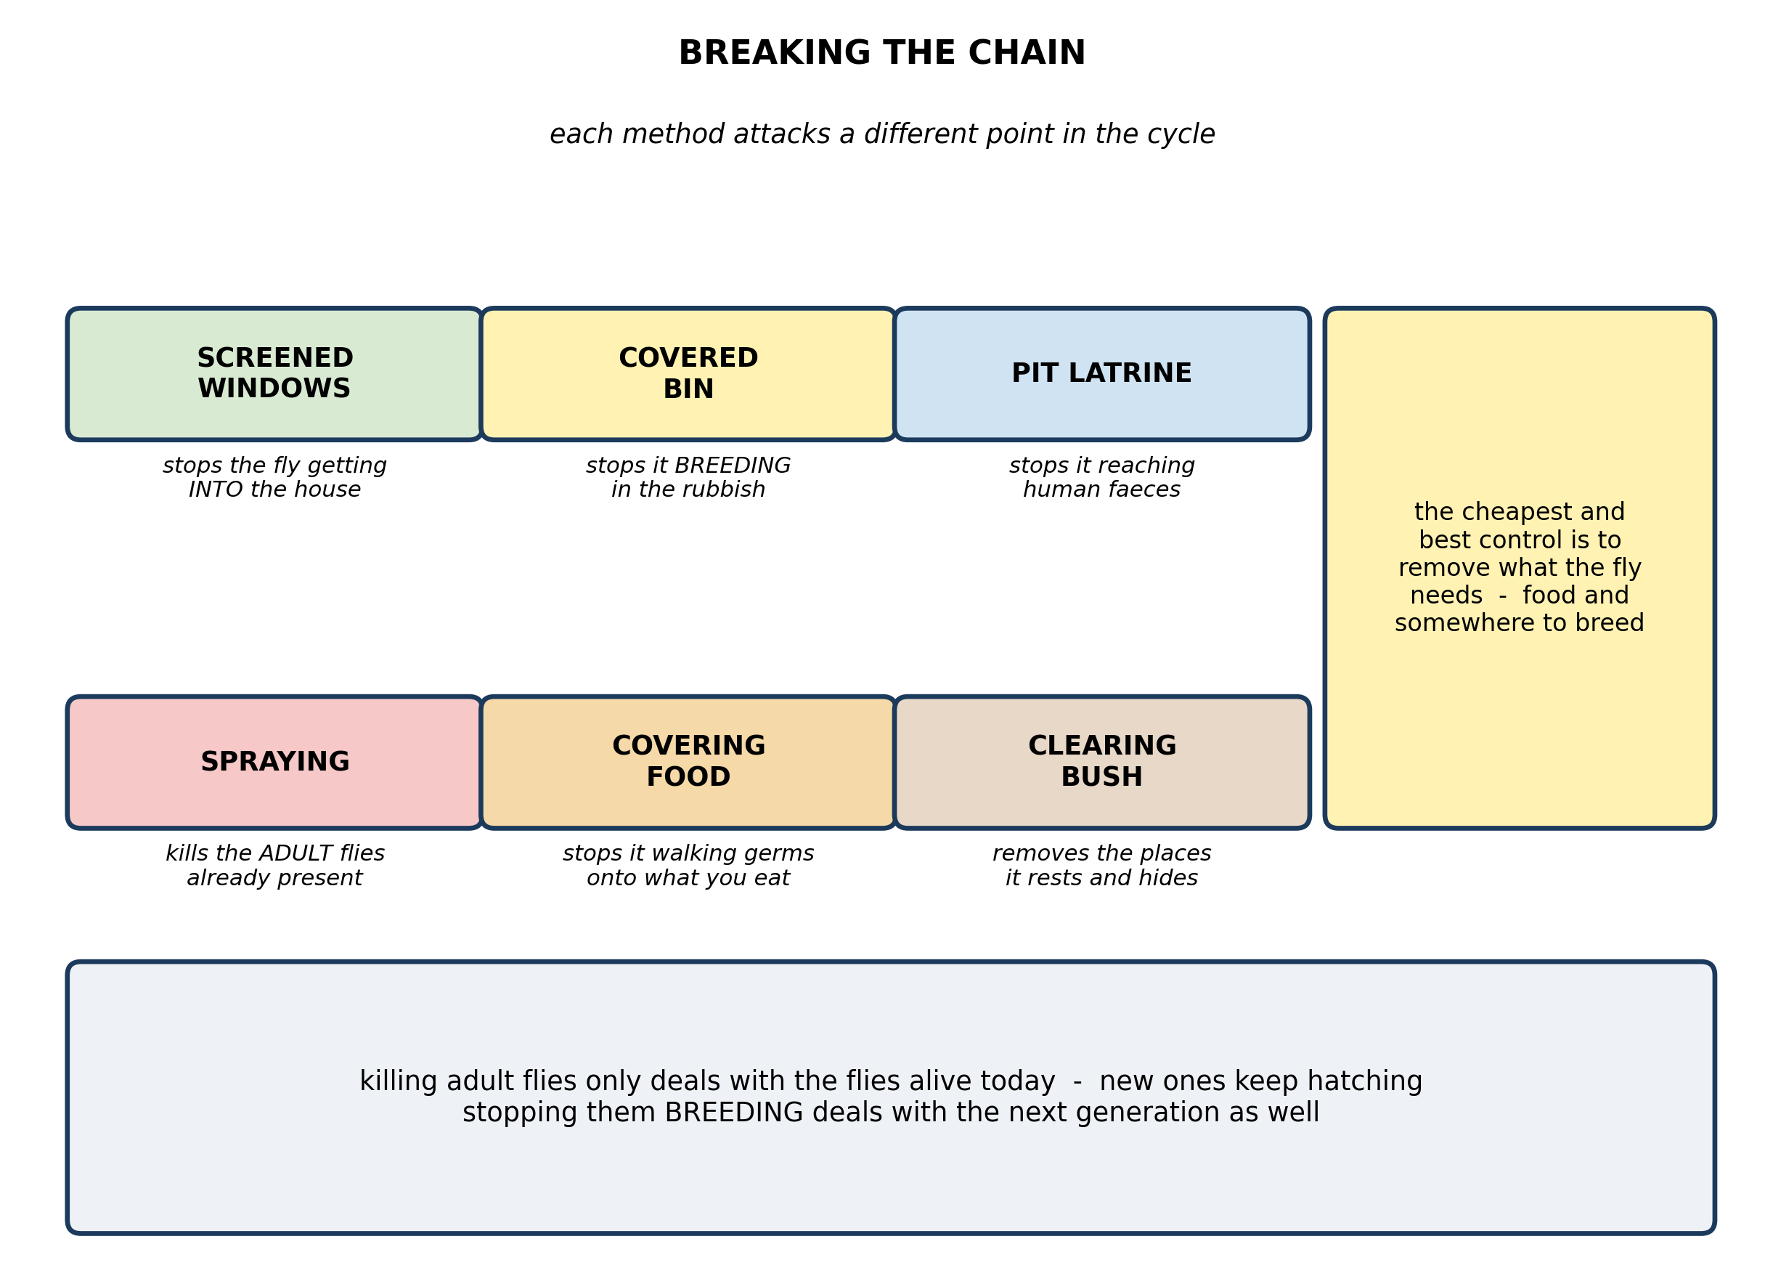
Fig. 6: Breaking the chain

4.6 4.6 How to Reduce the Effects of Housefly Activities
11. The diagram shows six ways of controlling houseflies. Explain why spraying to kill the adult flies works less well in the long run than removing the places where they breed. [4 marks]
12. State which control method stops flies getting INTO the house, and explain how it manages to do that while still letting air and light through. [3 marks]
____________________________________________________________________________________________
SECTION B - PRACTICAL TASK
Study the apparatus and answer the questions that follow it.
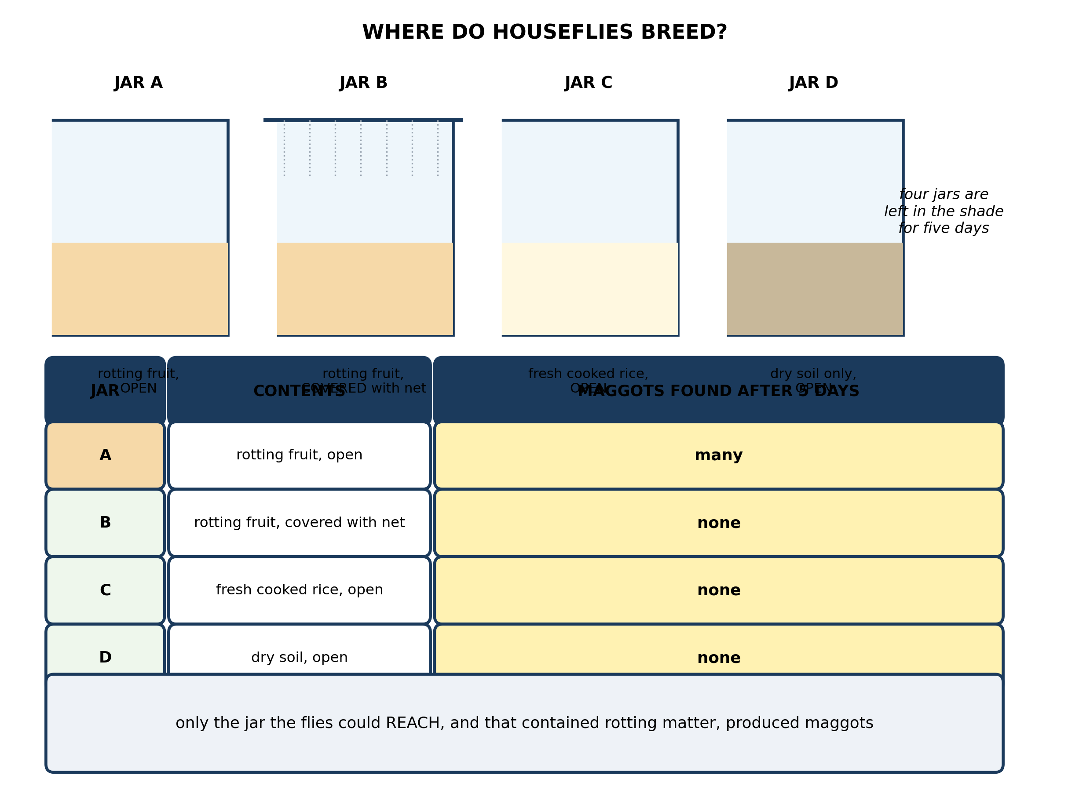
Fig. 7: Where do houseflies breed?

13. From the results, state what the experiment shows about where houseflies breed, and explain what each of the four jars contributes to that conclusion. [4 marks]
14. Before doing the experiment, a pupil predicted that maggots would appear in the rotting fruit because rotting matter turns into maggots. Explain how JAR B shows this prediction is wrong. [3 marks]
15. State TWO things that must be kept the same for all four jars, and explain why each one matters. [3 marks]
____________________________________________________________________________________________

ANSWER KEY AND MARKING SCHEME
Accept any other correct and relevant answer. Award marks for correct points, not for repeating the question.
4.1 4.1 What is a Life Cycle?
Q1
It is a cycle because it comes back to where it started: the adult produces eggs, the eggs become young, the young grow and change, and they become adults that produce eggs again. There is no real beginning or end - any stage can be a starting point, and each generation repeats what the last one did. A straight line would have a start and a finish, which is wrong. If the loop were broken at any point the species would end: if the adults died before laying eggs there would be no eggs; if the eggs did not hatch there would be no young; if the young did not survive to become adults there would be nothing to lay the next batch of eggs. Every stage is essential because every stage produces the next one.
Q2
Adult, eggs, young (larva or nymph), and growing and changing. Any order, one mark for each two named correctly.
4.2 4.2 Stages of the Life Cycle of the Housefly: Egg → Larva → Pupa → Adult
Q3
A maggot has to moult because it is wrapped in an outer skin, the cuticle, which is fairly rigid and does not grow. As the body inside gets bigger the skin becomes too tight, so the larva splits it open and wriggles out in a newer, larger one underneath - and it does this twice. It is a COMPLETE metamorphosis because there are four clearly separate stages - egg, larva, pupa and adult - and the larva looks nothing like the adult: it has no wings, no legs, no compound eyes, and it lives and feeds in a completely different way. The change is not just growth, it is a rebuilding of the body, and most of that rebuilding happens out of sight inside the pupal case. In an incomplete metamorphosis the young resemble small adults and simply get bigger.
Q4
Adding up the times, a whole generation takes only about seven to twelve days: up to a day as an egg, three to five days as a larva, and three to six days as a pupa. So in roughly two weeks every egg has become an adult. And each female lays up to 150 eggs at a time, so one heap does not produce one fly - it produces dozens or hundreds, and every one of those new females immediately lays her own 150. The numbers multiply generation by generation, which is why the flies seem to appear all at once rather than gradually.
4.3 4.3 Feeding Habits of the Housefly
Q5
The fly has a sponging proboscis and no teeth or jaws, so it cannot bite and it cannot chew. That single fact drives everything that follows. Because it cannot take in solid food, it has to turn its food into a liquid first: it spits saliva onto whatever it has landed on, soaks it up, and sponges the liquid in. So to feed at all, the fly must make close contact with the surface of its food - and when that surface is faeces or rubbish, germs stick to the hairs on its legs and body and to its mouthparts. It then flies to the next meal, often our food, and does exactly the same thing there. The mouthparts are the reason the fly must touch filth and then touch food; the feeding method IS the transmission mechanism. A biting insect would inject germs straight into the blood - the fly simply walks them onto what we are about to eat.
Q6
Because it cannot bite or chew - it has no jaws and no teeth, only a sponging proboscis with a soft pad at the end. That pad can take up liquid but cannot bite pieces off solid food or grind them. So before it can feed on anything solid the fly has to dissolve it: it pours saliva over the food to soften and liquefy it, and then sponges up the liquid that results.
4.4 4.4 How the Housefly Affects Human Health
Q7
A fly lands on faeces, rubbish or a corpse, all of which teem with germs, and some of those germs stick to the hairs on its legs and body. It then flies off and lands on food - often cooked food left uncovered on a table - and walks over it, leaving the germs behind as it feeds and as it simply treads on it. A person then eats that food without reheating it and swallows the germs, which multiply in the gut and cause illness. Any one of these steps can be broken: cover the food so the fly cannot reach it; dispose of faeces in a latrine so the fly cannot reach them in the first place; screen the windows so flies cannot get in; or reheat food thoroughly before eating it.
Q8
The fly does not cause cholera and cannot give it to anyone on its own - it carries the bacterium that does. The disease is caused by the germ, Vibrio cholerae, which comes originally from the faeces of an infected person. The fly is only the vehicle: it picks the germ up on its legs and body and delivers it to food, without being infected itself. This is called mechanical transmission. The difference matters directly for control: if the fly were the cause, killing flies would end cholera. Because it is only one route among several, a household can be completely free of flies and still get cholera from contaminated water.
4.5 4.5 Diseases Spread by the Housefly
Q9
Typhoid. A vaccine works by preparing the immune system against one particular organism, and typhoid vaccine prepares it against the typhoid bacterium only. Cholera and dysentery are caused by different organisms, so the typhoid vaccine gives no protection against either of them. Those two are prevented in other ways - safe drinking water, washing hands with soap, using a latrine, and keeping food covered.
Q10
Any two symptoms: passing faeces containing blood and mucus; painful cramps in the abdomen; frequent, urgent passing of stool; fever. Any one prevention: dispose of faeces safely in a latrine so flies cannot reach them; wash hands with soap after using the toilet and before handling food; drink safe, clean water; keep cooked food covered.
4.6 4.6 How to Reduce the Effects of Housefly Activities
Q11
Spraying kills only the adult flies that are alive at that moment. The eggs, the larvae and the pupae are all still in the rubbish, sheltered inside the rotting material and, in the pupa's case, sealed inside a hard case that the spray cannot reach. Within a week those develop into adults and the population is back where it started - so spraying has to be repeated endlessly and only ever thins the flies temporarily. Removing breeding places - covered bins, latrines, clearing away rotting matter - means the next generation is never produced at all. The population falls and stays down. Killing the adults treats the symptom; denying them somewhere to breed treats the cause.
Q12
Screening the windows - and doors - with fine mesh or netting. The holes in the mesh are smaller than a housefly, so a fly cannot pass through them, but they are large enough for air to move through freely and for light to come in. So the house stays cool, lit and ventilated, but the flies are kept outside where they cannot reach the food.
PRACTICAL TASK
Q13
Houseflies breed on rotting organic matter that they are able to reach. Jar A, rotting fruit left open, produced many maggots, so rotting fruit is a suitable breeding material. Jar C, fresh cooked rice left open, produced none, so being reachable is not enough - the material has to be rotting. Jar D, dry soil left open, produced none, because there was no food in it for a larva to eat. And Jar B, the same rotting fruit but covered with net, produced none, showing that the flies must actually reach the material to lay eggs on it. Taken together: rotting matter, within reach of a fly.
Q14
Jar B contains exactly the same rotting fruit as Jar A, in the same kind of jar, left in the same place for the same five days - and it produced no maggots at all. The only difference between the two jars is the net over B that stopped flies from landing on the fruit. If rotting matter turned into maggots by itself, Jar B would have produced them just as Jar A did. Since it did not, the maggots cannot come from the fruit: they must come from eggs laid by flies that reached it. Jar B is the control that rules the prediction out.
Q15
Any two, each explained. All four jars must be the same size and type, so that no jar gives the flies a bigger target or a different microclimate. They must all be left in the same place for the same five days, because a warmer or sunnier spot would speed up hatching and make that jar look like a better breeding site when it is only a warmer one. The same amount of material should be put in each jar. Whatever is used to cover Jar B must not shade it or change its temperature. Any of these differences would give a second explanation for the result, and the experiment would no longer show what it claims to show.

BLUEPRINT / TEST SPECIFICATION
# | Content standard | Code | Items | Marks | % of Marks
4.1 | 4.1 What is a Life Cycle? | B7/JHS1.2.2.1 | 2 | 6 | 12%
4.2 | 4.2 Stages of the Life Cycle of the Housefly: Egg → Larva → Pupa → Adult | B7/JHS1.2.2.1 | 2 | 7 | 14%
4.3 | 4.3 Feeding Habits of the Housefly | B7/JHS1.2.2.1 | 2 | 7 | 14%
4.4 | 4.4 How the Housefly Affects Human Health | B7/JHS1.2.2.1 | 2 | 7 | 14%
4.5 | 4.5 Diseases Spread by the Housefly | B7/JHS1.2.2.1 | 2 | 6 | 12%
4.6 | 4.6 How to Reduce the Effects of Housefly Activities | B7/JHS1.2.2.1 | 2 | 7 | 14%
4.1 | Practical task | B7/JHS1.2.2.1 | 3 | 10 | 20%
TOTAL | - | - | 15 | 50 | 100%
Distribution by cognitive level
Cognitive level | Marks | % of Marks
Understand | 14 | 28%
Apply | 14 | 28%
Analyse | 22 | 44%
TOTAL | 50 | 100%
Distribution by difficulty
Difficulty | Marks | % of Marks
Easy | 2 | 4%
Moderate | 29 | 58%
Challenging | 19 | 38%
TOTAL | 50 | 100%

QUALITY-CONTROL SUMMARY
1. Is every question answered from a diagram?
Yes. All 15 questions sit under a figure, and each is unanswerable - or at least materially harder - without reading it. Questions 3, 8, 10 and 17 ask pupils to go beyond the diagram, but each still starts from something the figure shows.
2. Is the content within the Basic 7 curriculum?
Yes. Every question traces to the content standards for this sub-strand (B7/JHS1.2.2.1), and nothing is tested beyond the depth the Basic 7 syllabus sets for it.
3. Are the diagrams clear and unambiguous?
Yes. Each is drawn so that only one reading is sensible: the particle boxes differ in spacing alone, the syringes are labelled with how far each squashes, and the periodic table marks the regions in words as well as by position.
4. Is the level right for JHS 1?
Yes. Questions ask pupils to read, describe and explain what is drawn. Only Question 17 asks for an inference beyond the figure, and it is worth 3 of the 40 marks.
5. Do the marks add up?
Yes: 15 questions totalling 50 marks, matching the figure on the front page. The blueprint, cognitive and difficulty tables all sum to the same total.
6. Are the answers correct and complete?
Yes. Each answer states the point the question is worth, with the acceptable alternatives given where a question is open.
EXAMINER NOTES (for the teacher, not for candidates)
- Pitched at the compulsory diagram question of BECE Paper 2: 72% of the marks are at Apply level or above and 38% are Challenging.
- Q5 is the best question in the paper. Pupils know the fly spreads disease; almost none can say WHY. The answer is the mouthparts: it cannot bite, so it must liquefy its food, so it must make contact with filth and then with our food. The feeding method is the transmission mechanism. Pupils who get this have connected 4.3 to 4.4.
- Q8 on 'the fly gives you cholera' is the companion to Q5. The distinction between cause and vehicle matters because it changes what control can achieve: a fly-free house can still have cholera from dirty water.
- Q11 on why spraying is less effective than removing breeding sites is the question that tests whether 4.6 has been understood or merely listed. Pupils like spraying because it is dramatic; the answer is that it leaves the next generation untouched.
- Q14 is the most valuable question in the practical. The belief that rotting matter turns into maggots is extremely common and extremely persistent, and Jar B is exactly the control that kills it. Do not let this one go by - ask the class to predict BEFORE the jars are opened, then hold them to it.
- The jar experiment in Fig. 7 costs nothing to run: four jars, some fruit, some net or muslin, and five days. Jar B must be covered with something flies cannot pass but air can. Run it in the last week before the topic so the results are ready to discuss.
- Note the timing arithmetic in Q4: egg plus larva plus pupa is about 7-12 days, so two weeks is one to two generations. Pupils who add the numbers get the answer; those who guess 'because there is a lot of rubbish' do not.

