[SCHOOL NAME]
INTEGRATED SCIENCE (SCIENCE)
PRACTICAL QUESTIONS - DIAGRAM MODE
Living Cells (2.1 - 2.6)
____________________________________________________________________________________________
CLASS: Basic 7 (JHS 1)
TIME: 1 hour 30 minutes
MARKS: 50 2025/2026 Academic Year
____________________________________________________________________________________________
INSTRUCTIONS TO CANDIDATES
1. Answer ALL the questions in this paper.
2. Every question is based on a diagram. Study each diagram carefully before you answer the questions that follow it.
3. Write your answers in the spaces provided. The marks for each question are printed beside it.
4. Where a question asks for a stated number of points, give that number. Any extra answers will not be marked.
5. You may refer back to any diagram at any time.
____________________________________________________________________________________________
SECTION A - DIAGRAM STUDY
Study each diagram and answer the questions that follow it.
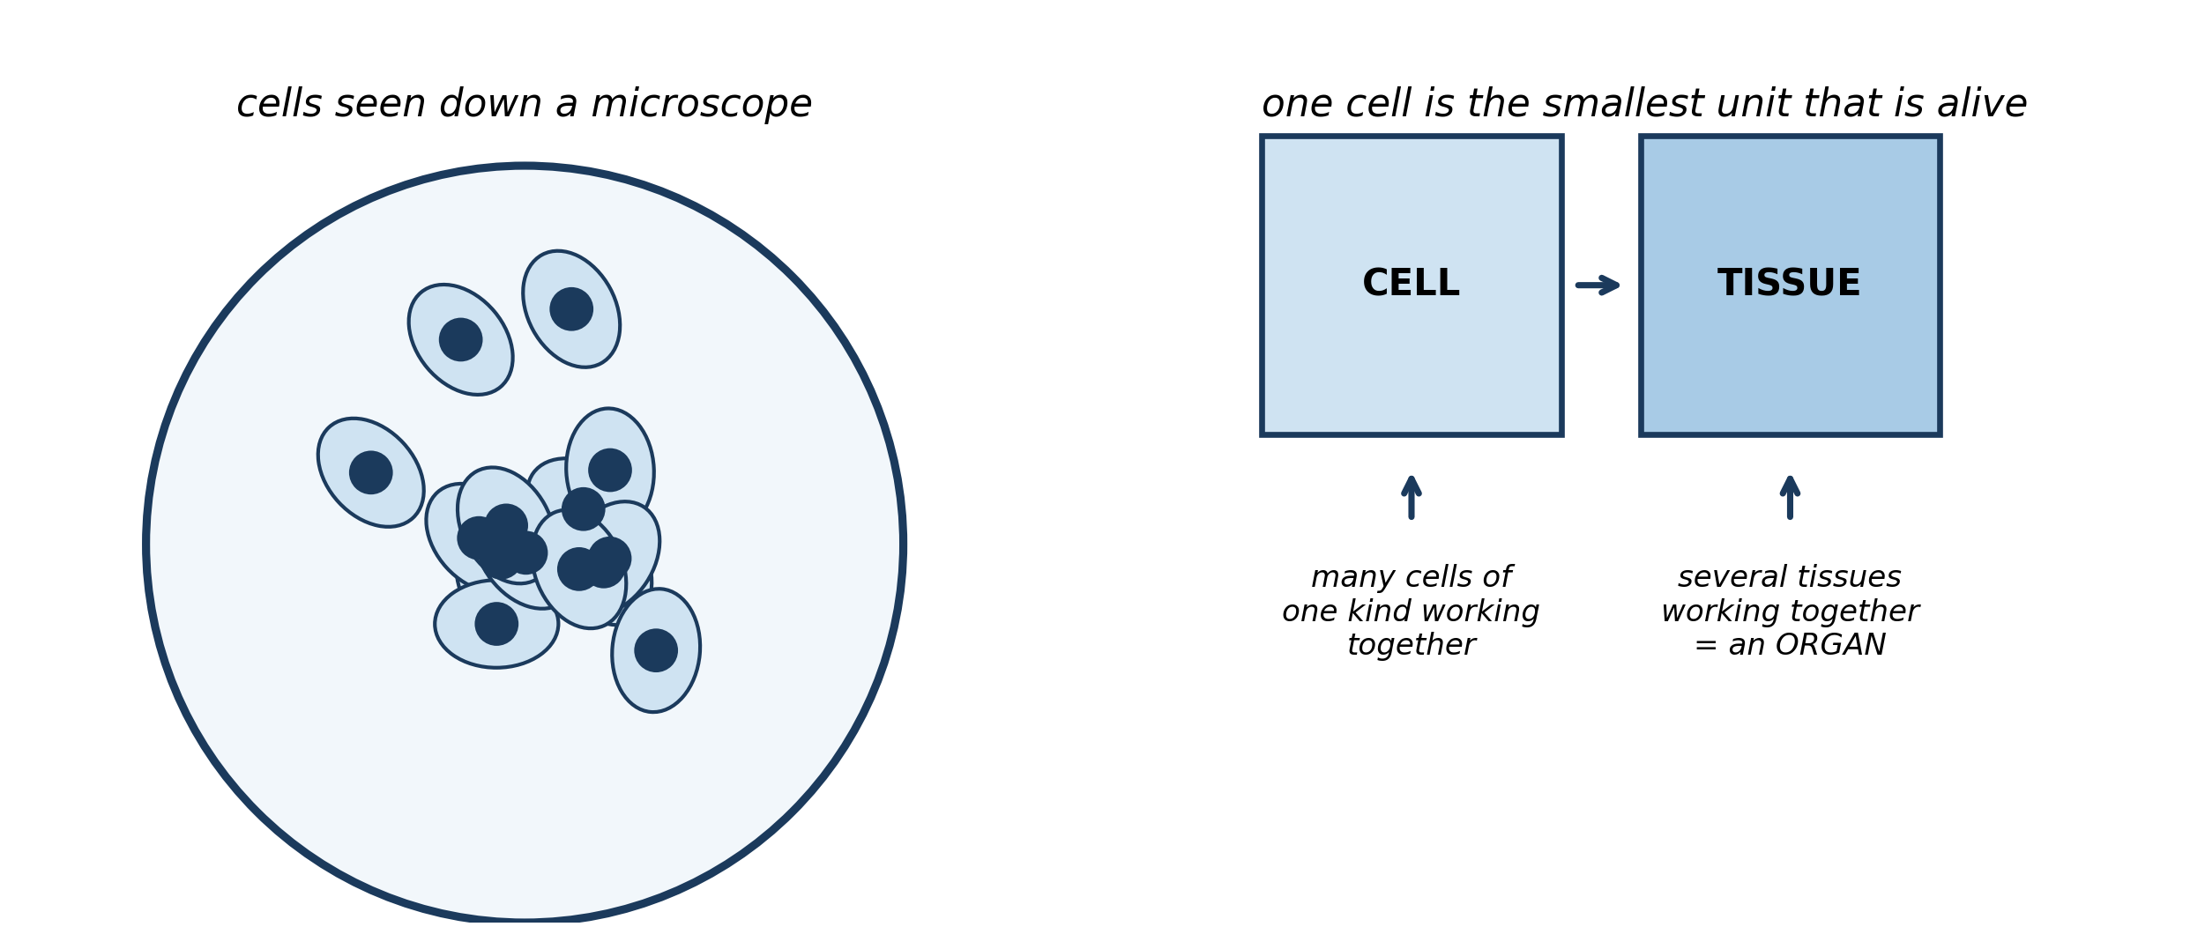
Fig. 1: Cells seen down a microscope, and how they build up

2.1 2.1 What is a Cell? Introduction to Living Cells
1. Explain why a single muscle CELL on its own cannot do the work of a muscle TISSUE. Use the diagram to support your answer. [3 marks]
2. An amoeba is a living thing made of ONE cell. State, with a reason from the diagram, whether it is a TISSUE or an ORGANISM. [3 marks]
____________________________________________________________________________________________
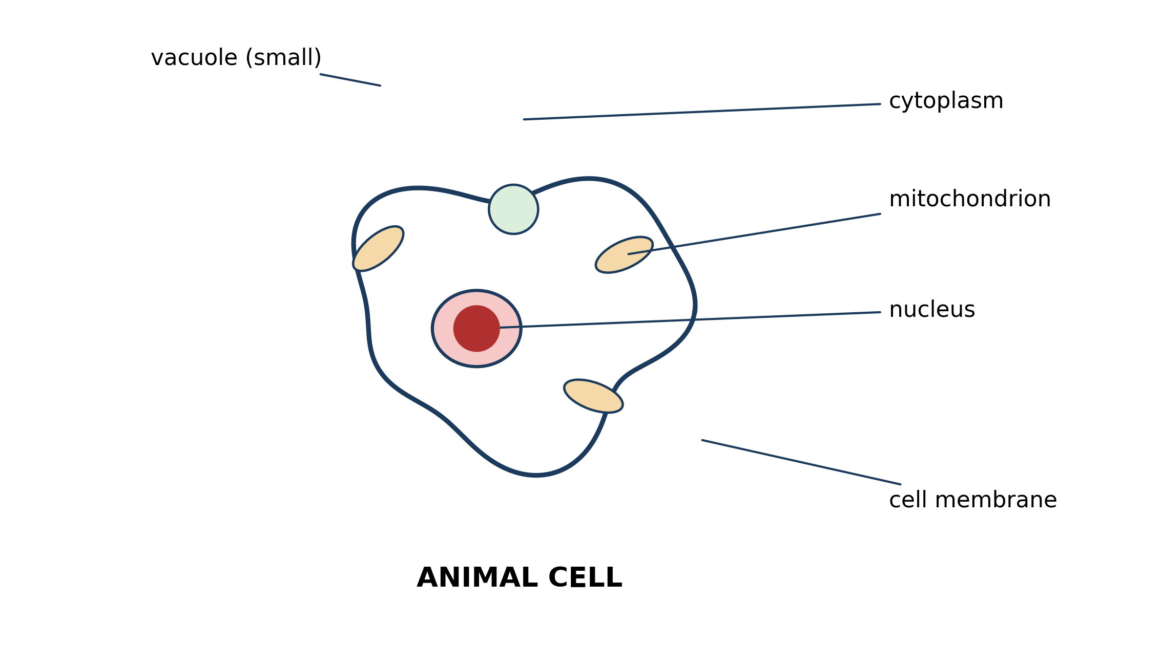
Fig. 2: An animal cell, with its parts labelled

2.2 2.2 Structure and Functions of the Animal Cell
3. Explain how the function of the CELL MEMBRANE differs from the function of the CYTOPLASM. [3 marks]
4. A poison stops the mitochondria from working. PREDICT what would happen to the cell, and explain why. [4 marks]
____________________________________________________________________________________________
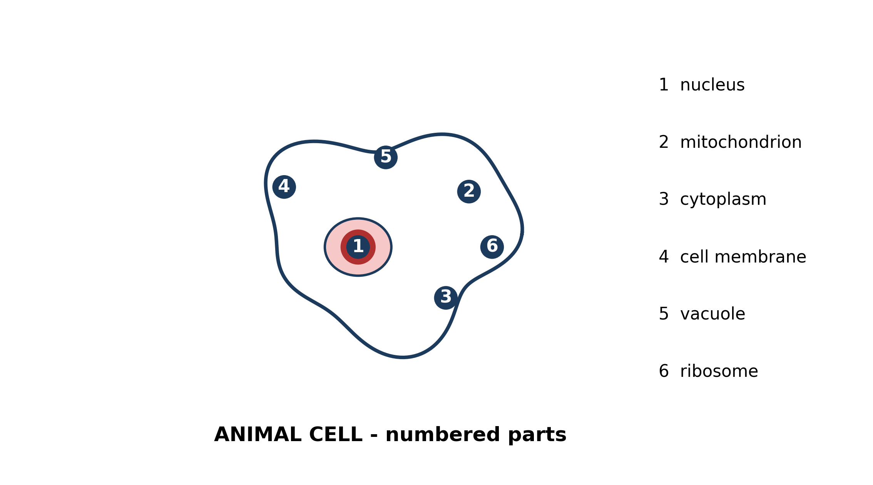
Fig. 3: An animal cell with its parts numbered

2.3 2.3 Organelles of the Animal Cell and Their Functions
5. Name the parts numbered 2 and 5, and state ONE function of each. [3 marks]
6. Explain why part 1, the nucleus, is often described as the CONTROL CENTRE of the cell. [3 marks]
____________________________________________________________________________________________
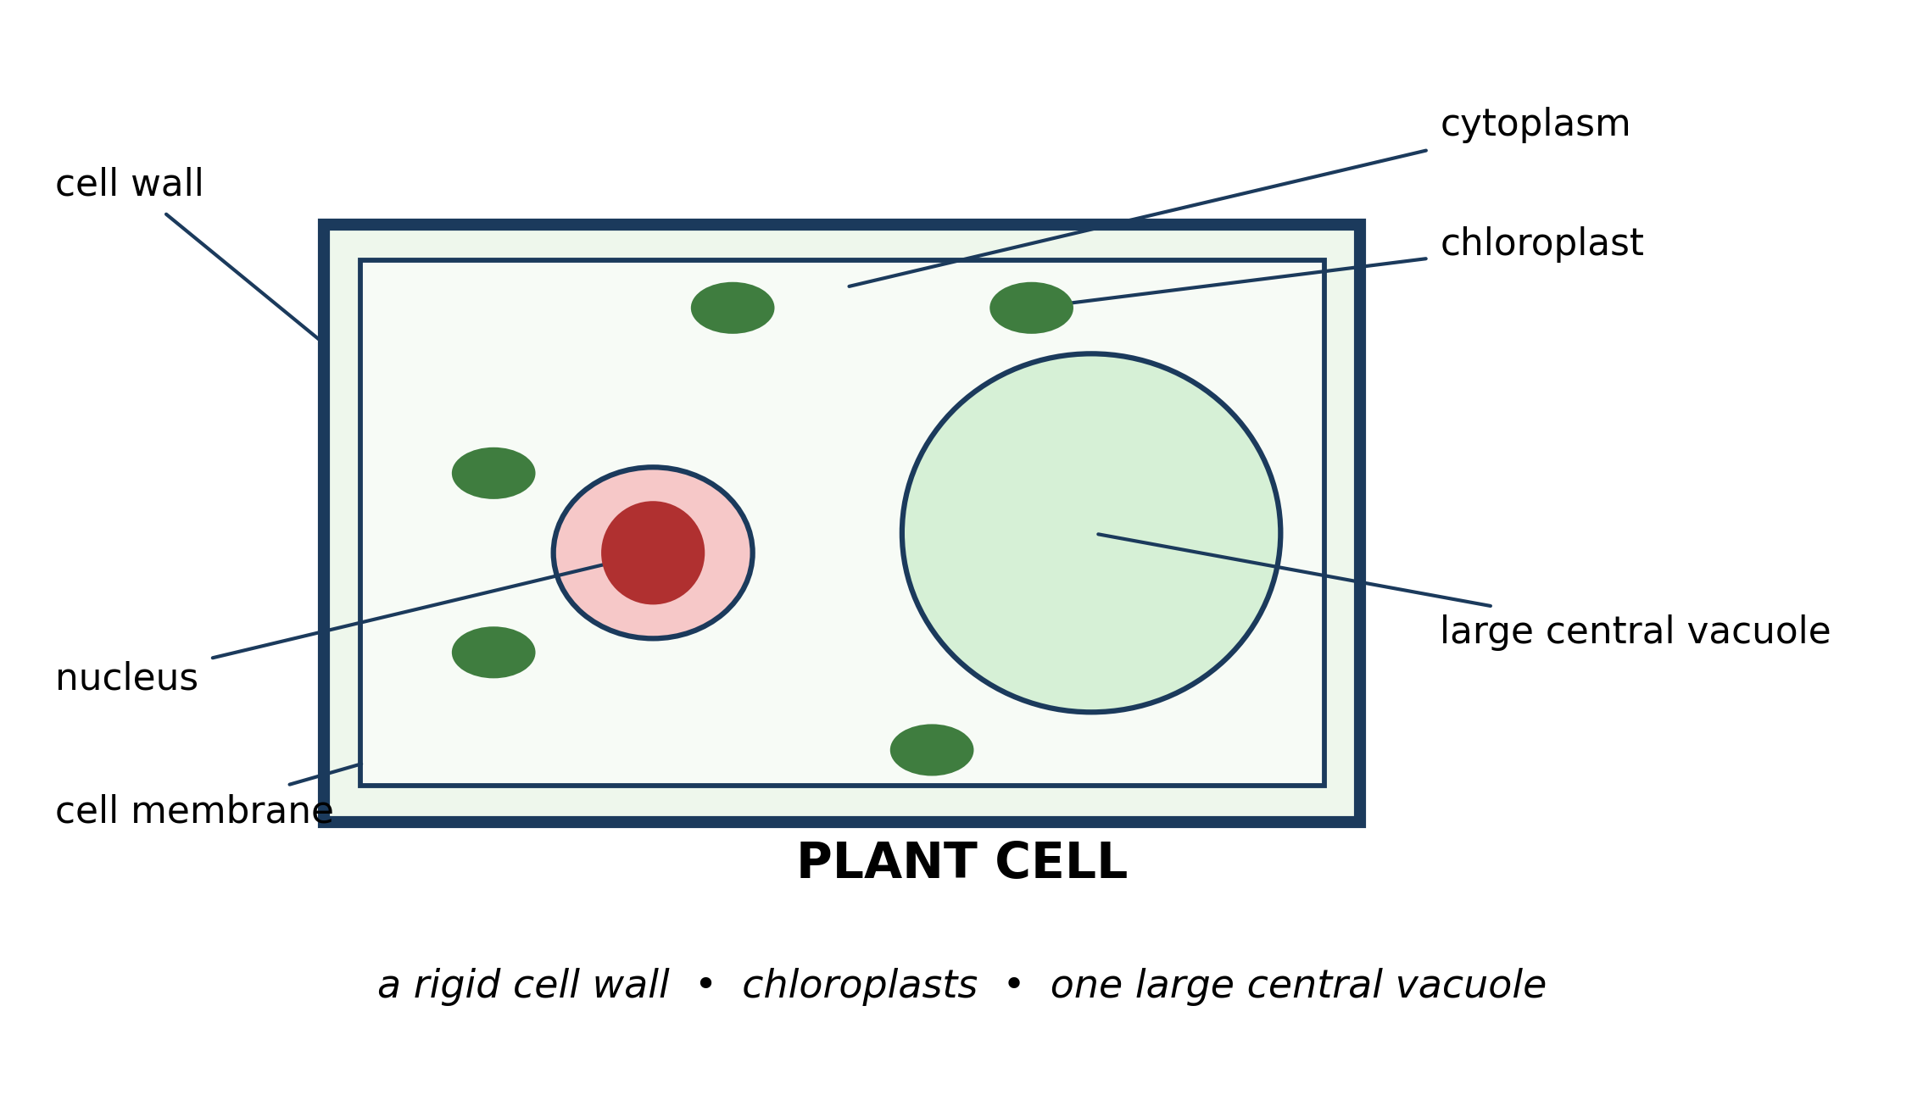
Fig. 4: A plant cell, with its parts labelled

2.4 2.4 Structure and Functions of the Plant Cell
7. Explain why a plant cell has a CELL WALL but an animal cell does not. Relate your answer to how each organism supports itself. [4 marks]
8. State the function of the LARGE CENTRAL VACUOLE, and explain why an animal cell does not need one as large. [3 marks]
____________________________________________________________________________________________
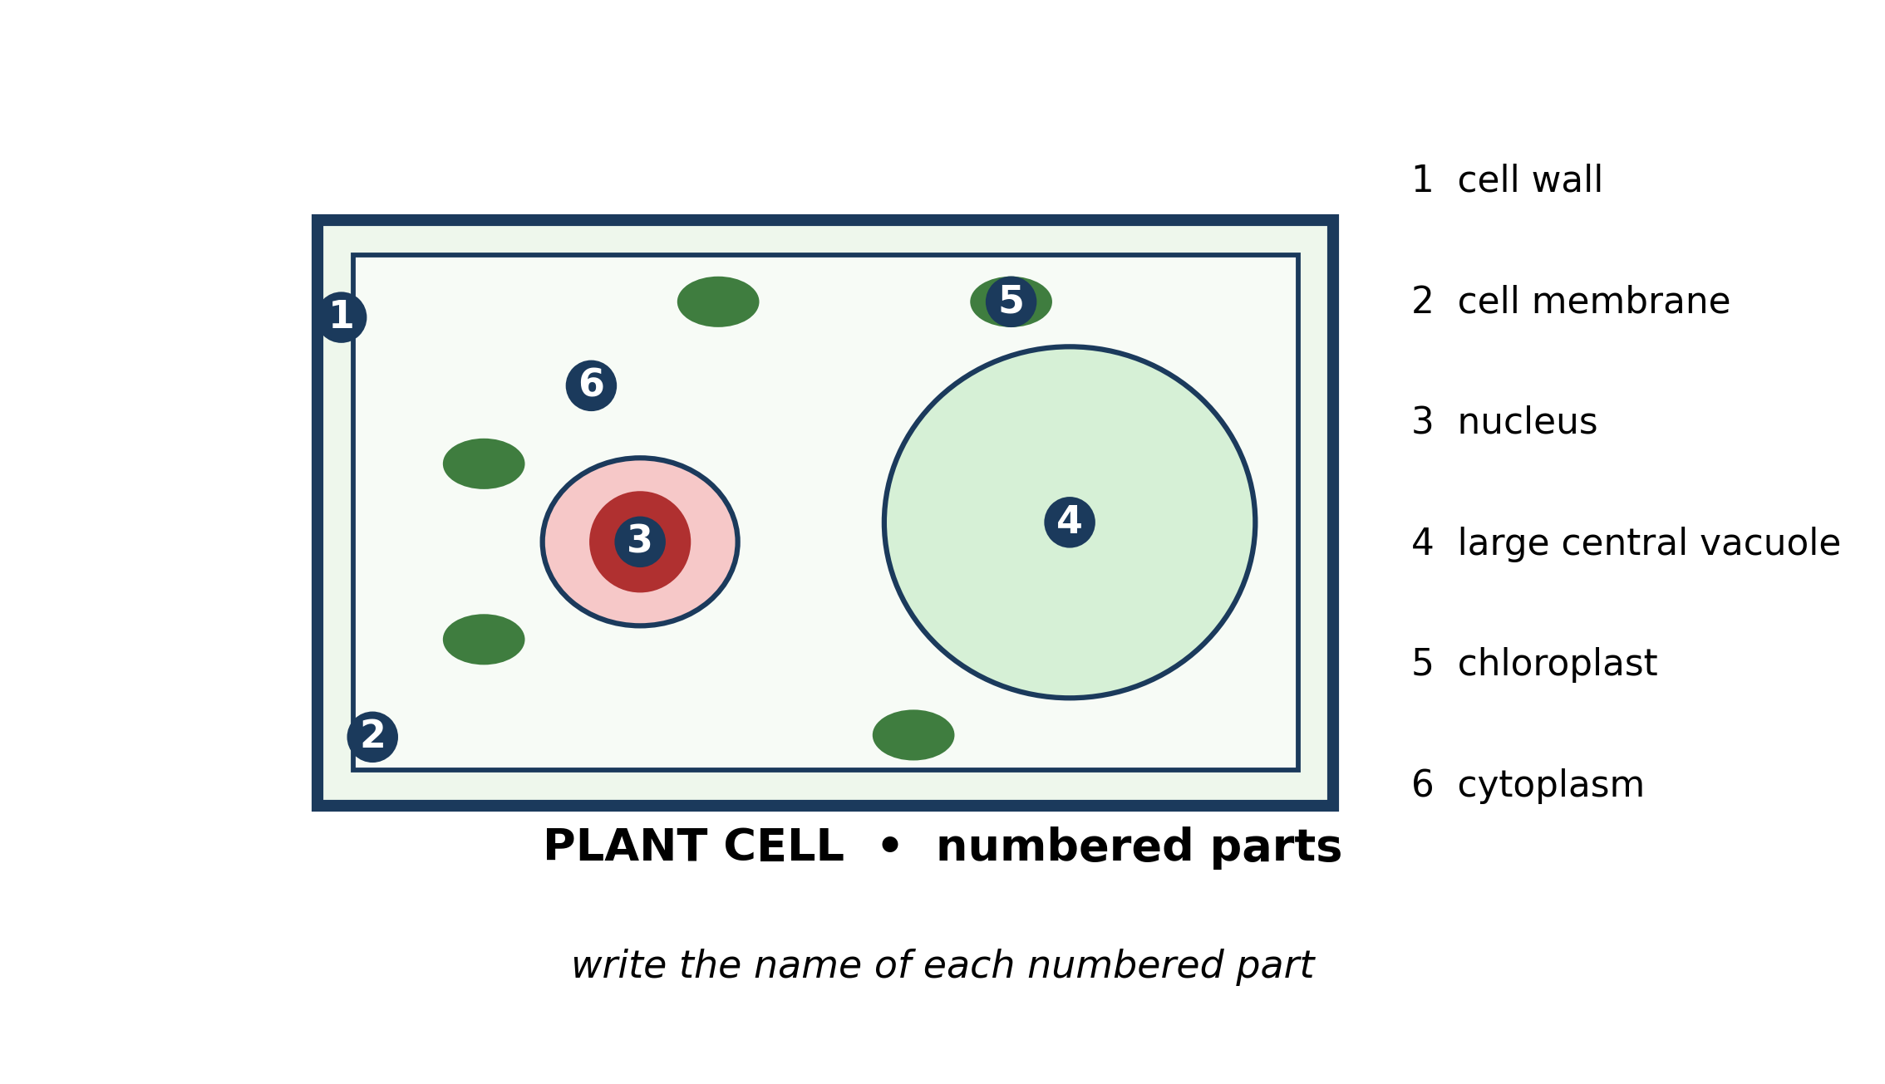
Fig. 5: A plant cell with its parts numbered

2.5 2.5 Organelles of the Plant Cell and Their Functions
9. Name the parts numbered 1, 4 and 5. [3 marks]
10. A plant kept in a dark cupboard makes FEWER chloroplasts than the same plant kept in the light. SUGGEST why, and explain what this shows about the function of the chloroplast. [3 marks]
____________________________________________________________________________________________
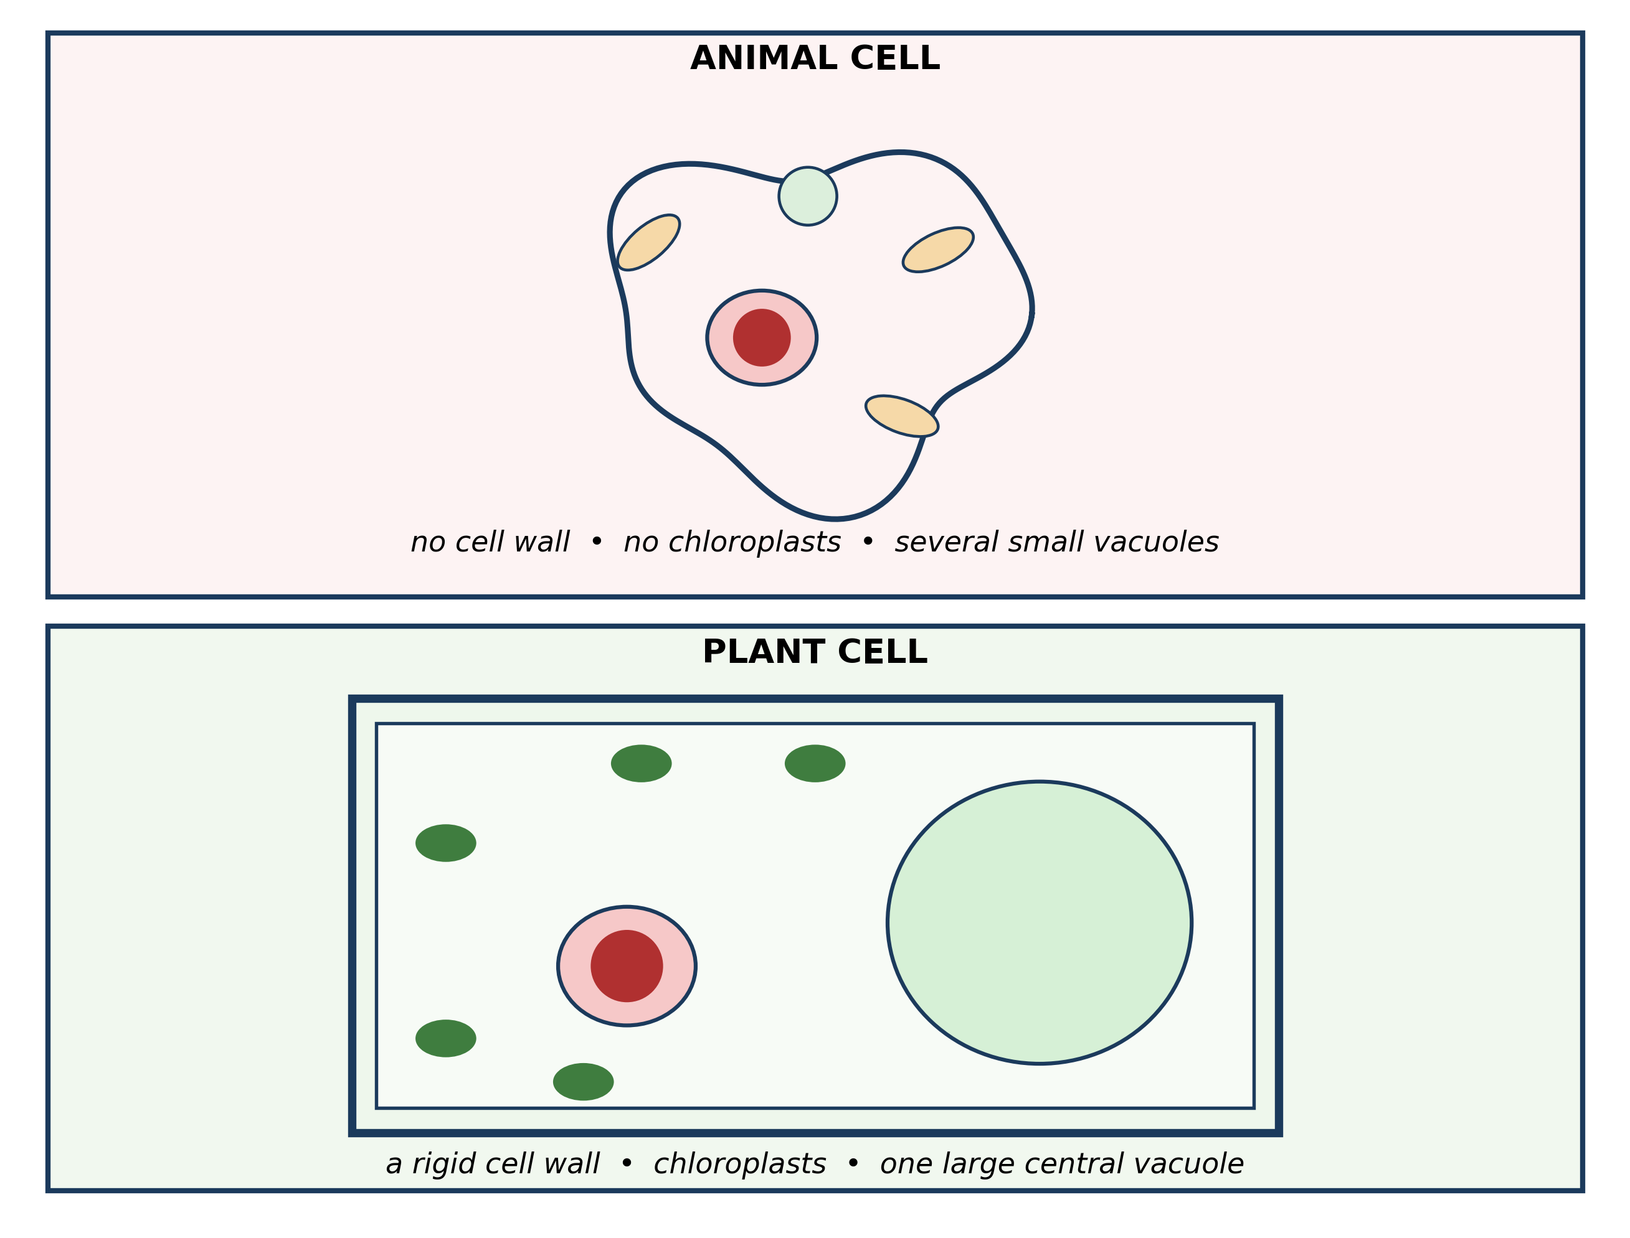
Fig. 6: An animal cell and a plant cell compared

2.6 2.6 Differences and Similarities Between Plant and Animal Cells
11. State THREE differences between the animal cell and the plant cell shown in the diagram. [3 marks]
12. Explain why a plant cell needs BOTH a cell wall AND a cell membrane, whereas an animal cell needs only a membrane. [4 marks]
13. A pupil sees a cell down a microscope and says it must be a PLANT cell because it has a nucleus. Explain why this reasoning is wrong, and say what the pupil should look for instead. [3 marks]
____________________________________________________________________________________________
SECTION B - PRACTICAL TASK
Study the apparatus and answer the questions that follow it.
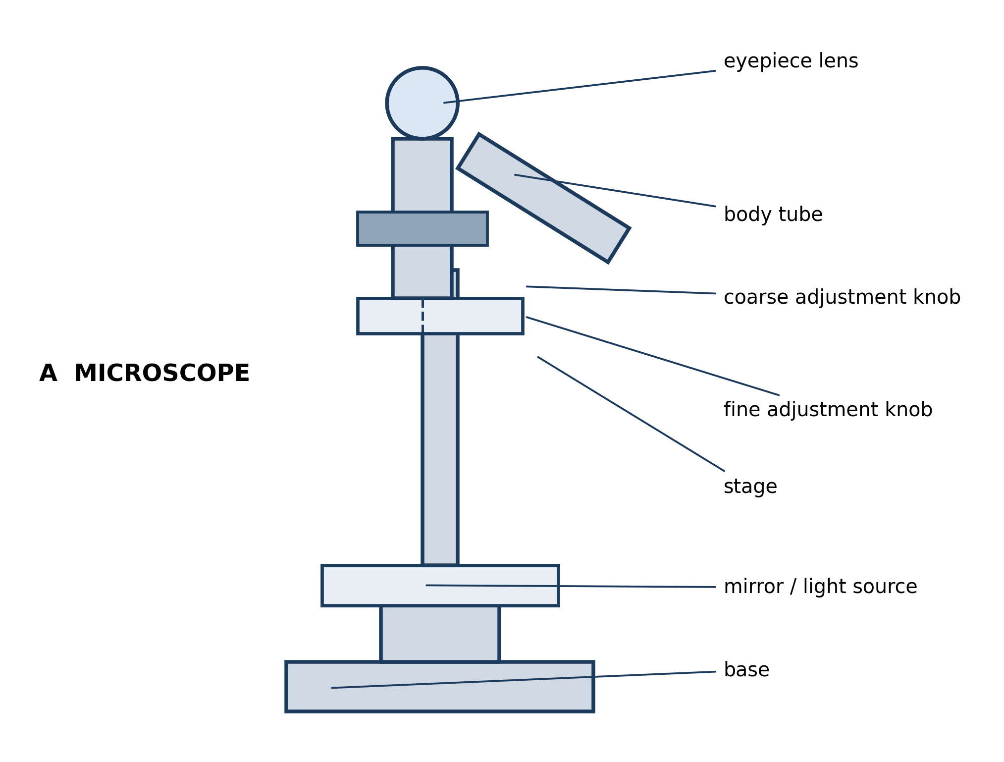
Fig. 7: A light microscope

14. A pupil looks down the microscope and sees only darkness. SUGGEST TWO things that could be wrong, and say how to put each one right. [3 marks]
15. Explain why the specimen on the slide must be thin enough for light to pass through it. [2 marks]
16. A pupil turns the coarse adjustment knob while looking down the eyepiece, and the objective lens crashes into the slide. Describe the correct method, and explain why doing it this way avoids the problem. [3 marks]
____________________________________________________________________________________________

ANSWER KEY AND MARKING SCHEME
Accept any other correct and relevant answer. Award marks for correct points, not for repeating the question.
2.1 2.1 What is a Cell? Introduction to Living Cells
Q1
A single cell can only contract with the force of one cell. A tissue is many similar cells of the same kind working together, so their combined force is far greater and is enough to move a part of the body. One cell on its own cannot produce enough force to do that work.
Q2
It is an organism, not a tissue. The diagram shows that a tissue is a group of similar cells working together as part of a larger living thing. An amoeba is a single cell that carries out all of the life processes by itself, so it is a whole organism.
2.2 2.2 Structure and Functions of the Animal Cell
Q3
The cell membrane is the outer boundary: it holds the cell together and CONTROLS which substances enter and leave. The cytoplasm is the jelly-like material inside: it fills the cell and is where the chemical reactions of the cell take place.
Q4
The cell would run out of usable energy and would eventually die. Mitochondria carry out respiration, releasing the energy in food in a form the cell can use. Without that energy the cell cannot carry out the processes - growth, repair, moving substances - that keep it alive.
2.3 2.3 Organelles of the Animal Cell and Their Functions
Q5
2 - mitochondrion: carries out respiration to release energy from food. 5 - vacuole: stores water, food and waste. (Also accept 5 - cytoplasm, which is where the cell's chemical reactions happen, depending on the reading of the figure.)
Q6
The nucleus contains the genetic material, which carries the instructions for making the cell's proteins and for everything the cell does. Because those instructions determine what the cell is and what it makes, the nucleus controls all the cell's activities.
2.4 2.4 Structure and Functions of the Plant Cell
Q7
A plant has no skeleton, so each of its cells must support itself. The cell wall is made of cellulose and is rigid, so it holds the cell firm and lets the plant stand upright. An animal has a skeleton to support its body, so its cells do not need a wall - and a wall would in fact stop them working, because animal cells such as muscle cells must be able to change shape.
Q8
The vacuole stores water and dissolved substances, and the water inside pushes the cytoplasm out against the wall so that the cell stays firm and the plant does not wilt. An animal cell does not rely on this for support because the animal has a skeleton, so its vacuoles are small and are used only for storage and for moving substances about inside the cell.
2.5 2.5 Organelles of the Plant Cell and Their Functions
Q9
1 - cell wall. 4 - large central vacuole. 5 - chloroplast.
Q10
Chloroplasts contain chlorophyll, which traps light energy for photosynthesis. A plant in the dark has no light to trap, so it makes few chloroplasts because they would be of no use. This shows that the chloroplast is the organelle where the plant makes its own food using light.
2.6 2.6 Differences and Similarities Between Plant and Animal Cells
Q11
Any three: the plant cell has a cell wall, the animal cell does not. The plant cell has chloroplasts, the animal cell does not. The plant cell has one large central vacuole, the animal cell has small vacuoles. The plant cell has a regular, fixed rectangular shape, the animal cell has a rounded, irregular shape.
Q12
The two parts do different jobs. The cell membrane controls which substances enter and leave the cell, and every cell needs this. The plant also needs the rigid cell wall outside the membrane to hold the cell firm and support the plant, because a plant has no skeleton. The wall cannot replace the membrane because it is fully permeable - it lets everything through, so it cannot control what enters or leaves.
Q13
The reasoning is wrong because BOTH plant and animal cells have a nucleus, so a nucleus does not identify which kind of cell it is. The pupil should look for a cell wall, for chloroplasts, or for one large central vacuole, and at whether the cell has a fixed rectangular shape - these are found only in plant cells.
PRACTICAL TASK
Q14
Any two with a correction: the mirror or light source is not angled at the hole in the stage - turn it so that light is reflected up through the specimen. The objective lens is not lined up with the hole in the stage - rotate the nosepiece until it clicks into place. The slide is not sitting over the hole - move the slide across. The diaphragm is closed - open it.
Q15
A light microscope forms its image using light that passes THROUGH the specimen. If the specimen is too thick, light cannot get through it and it looks dark, so nothing can be seen.
Q16
Watch the objective from the SIDE while using the coarse knob to bring it down close to the slide. Then look down the eyepiece and use the coarse knob to focus by moving the lens UP, away from the slide. Watching from the side lets you see how close the lens is and stop before it touches the slide; focusing upwards means you can never push the lens into the glass.

BLUEPRINT / TEST SPECIFICATION
# | Content standard | Code | Items | Marks | % of Marks
2.1 | 2.1 What is a Cell? Introduction to Living Cells | B7/JHS1.1.2.1 | 2 | 6 | 12%
2.2 | 2.2 Structure and Functions of the Animal Cell | B7/JHS1.1.2.1 | 2 | 7 | 14%
2.3 | 2.3 Organelles of the Animal Cell and Their Functions | B7/JHS1.1.2.1 | 2 | 6 | 12%
2.4 | 2.4 Structure and Functions of the Plant Cell | B7/JHS1.1.2.1 | 2 | 7 | 14%
2.5 | 2.5 Organelles of the Plant Cell and Their Functions | B7/JHS1.1.2.1 | 2 | 6 | 12%
2.6 | 2.6 Differences and Similarities Between Plant and Animal Cells | B7/JHS1.1.2.1 | 3 | 10 | 20%
2.1 | Practical task | B7/JHS1.1.2.1 | 3 | 8 | 16%
TOTAL | - | - | 16 | 50 | 100%
Distribution by cognitive level
Cognitive level | Marks | % of Marks
Understand | 14 | 28%
Apply | 22 | 44%
Analyse | 14 | 28%
TOTAL | 50 | 100%
Distribution by difficulty
Difficulty | Marks | % of Marks
Easy | 14 | 28%
Moderate | 18 | 36%
Challenging | 18 | 36%
TOTAL | 50 | 100%

QUALITY-CONTROL SUMMARY
1. Is every question answered from a diagram?
Yes. All 16 questions sit under a figure, and each is unanswerable - or at least materially harder - without reading it. Questions 3, 8, 10 and 17 ask pupils to go beyond the diagram, but each still starts from something the figure shows.
2. Is the content within the Basic 7 curriculum?
Yes. Every question traces to the content standards for this sub-strand (B7/JHS1.1.2.1), and nothing is tested beyond the depth the Basic 7 syllabus sets for it.
3. Are the diagrams clear and unambiguous?
Yes. Each is drawn so that only one reading is sensible: the particle boxes differ in spacing alone, the syringes are labelled with how far each squashes, and the periodic table marks the regions in words as well as by position.
4. Is the level right for JHS 1?
Yes. Questions ask pupils to read, describe and explain what is drawn. Only Question 17 asks for an inference beyond the figure, and it is worth 3 of the 40 marks.
5. Do the marks add up?
Yes: 16 questions totalling 50 marks, matching the figure on the front page. The blueprint, cognitive and difficulty tables all sum to the same total.
6. Are the answers correct and complete?
Yes. Each answer states the point the question is worth, with the acceptable alternatives given where a question is open.
EXAMINER NOTES (for the teacher, not for candidates)
- Pitched at the compulsory diagram question of BECE Paper 2: 72% of the marks are at Apply level or above and 36% are Challenging. Use it to stretch pupils who already know the labels.
- Q7 and Q12 are the two hardest and they test the same idea from different directions: WHY a plant needs a wall. Pupils can name the parts but cannot say why the plant needs one and the animal does not. The answer they must reach is support - a plant has no skeleton, so every cell must hold itself up.
- Q12 has a second layer most pupils miss: the wall cannot do the membrane's job because it is fully permeable. If a pupil says 'the wall protects the cell and the membrane controls what goes in and out', they have both halves and deserve full marks.
- Q13 is the classic reasoning error - 'it has a nucleus so it must be a plant cell'. Both cells have a nucleus. Pupils should be taught to look for the wall, the chloroplasts or the single large vacuole instead.
- Q4, Q10 and Q14 all ask pupils to PREDICT or SUGGEST rather than recall. These are the words BECE uses and the ones pupils handle worst, because there is nothing to remember - the answer has to be reasoned from the diagram or from what the organelle does.
- The microscope in Fig. 7 is the cheapest practical in the syllabus and the one most likely to appear. If your school has even one working microscope, twenty minutes with an onion skin turns Q14 to Q16 into near-free marks. If it does not, the questions still work from the diagram alone.
- Q16 is worth teaching as a routine rather than an answer: focus DOWN while watching from the side, then focus UP while looking through the eyepiece. Say it as a rhyme and pupils remember it, and it saves the slides and the objective lenses.

