[SCHOOL NAME]
INTEGRATED SCIENCE (SCIENCE)
PRACTICAL QUESTIONS - DIAGRAM MODE
Materials (1.1 - 1.6)
____________________________________________________________________________________________
CLASS: Basic 7 (JHS 1)
TIME: 1 hour 30 minutes
MARKS: 50 2025/2026 Academic Year
____________________________________________________________________________________________
INSTRUCTIONS TO CANDIDATES
1. Answer ALL the questions in this paper.
2. Every question is based on a diagram. Study each diagram carefully before you answer the questions that follow it.
3. Write your answers in the spaces provided. The marks for each question are printed beside it.
4. Where a question asks for a stated number of points, give that number. Any extra answers will not be marked.
5. You may refer back to any diagram at any time.
____________________________________________________________________________________________
SECTION A - DIAGRAM STUDY
Study each diagram and answer the questions that follow it.
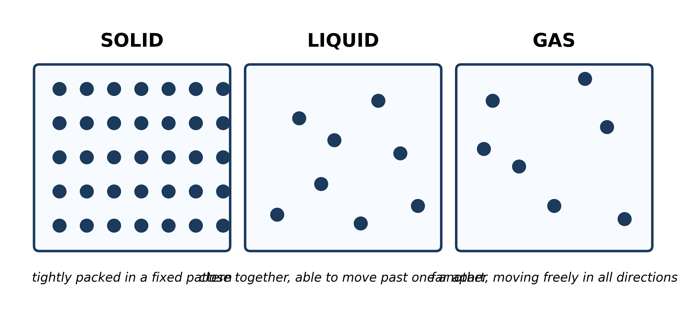
Fig. 1: The particles in a solid, a liquid and a gas

1.1 1.1 States of Matter: Solids, Liquids and Gases
1. Use the diagram to explain why a solid has BOTH a fixed shape and a fixed volume, but a gas has NEITHER. [4 marks]
2. A pupil says that the particles in the gas must be BIGGER than the particles in the solid, because they are drawn further apart. Use the diagram to explain why this is wrong. [3 marks]
3. Describe how the ARRANGEMENT of the particles and their MOVEMENT change as the substance is heated from the solid state to the gas state. [2 marks]
____________________________________________________________________________________________
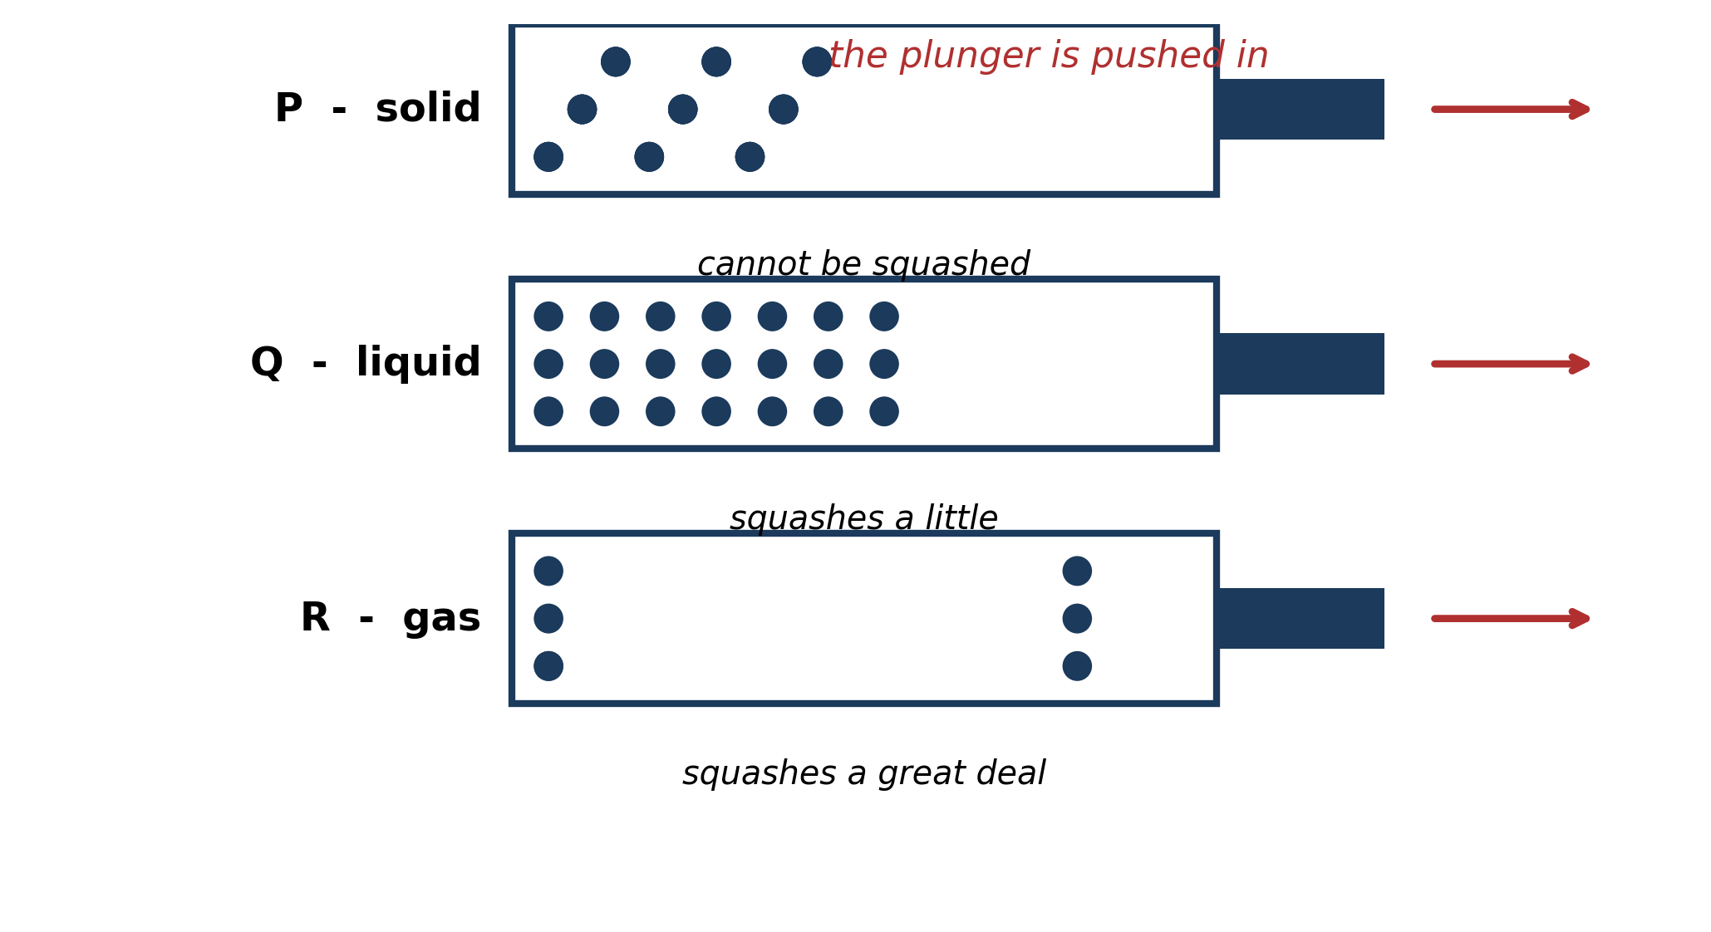
Fig. 2: Three syringes, with the plunger pushed in

1.2 1.2 Properties and Differences Among Solids, Liquids and Gases
4. Explain, in terms of the particles, why syringe R squashes easily but syringe P cannot be squashed at all. [3 marks]
5. The plunger of syringe R is now pulled OUT instead of pushed in. PREDICT what happens to the particles, and explain why it happens. [3 marks]
____________________________________________________________________________________________
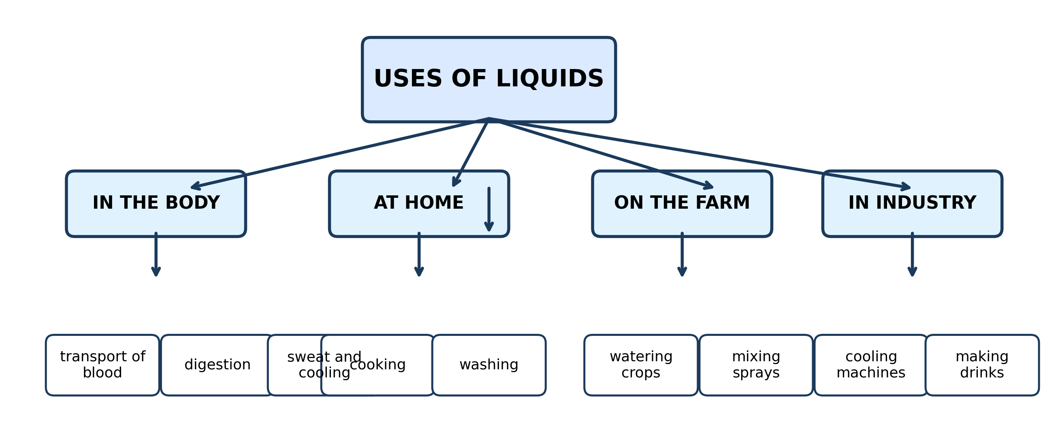
Fig. 3: A concept map of the uses of liquids

1.3 1.3 Importance of Liquids to Human Life
6. Choose TWO uses of liquids from the diagram. For EACH one, name the property of liquids that makes them suitable for that use, and explain why the property matters. [4 marks]
7. Explain why water is used for washing but a solid such as a stone is not. Refer to the properties shown in the diagram. [2 marks]
____________________________________________________________________________________________
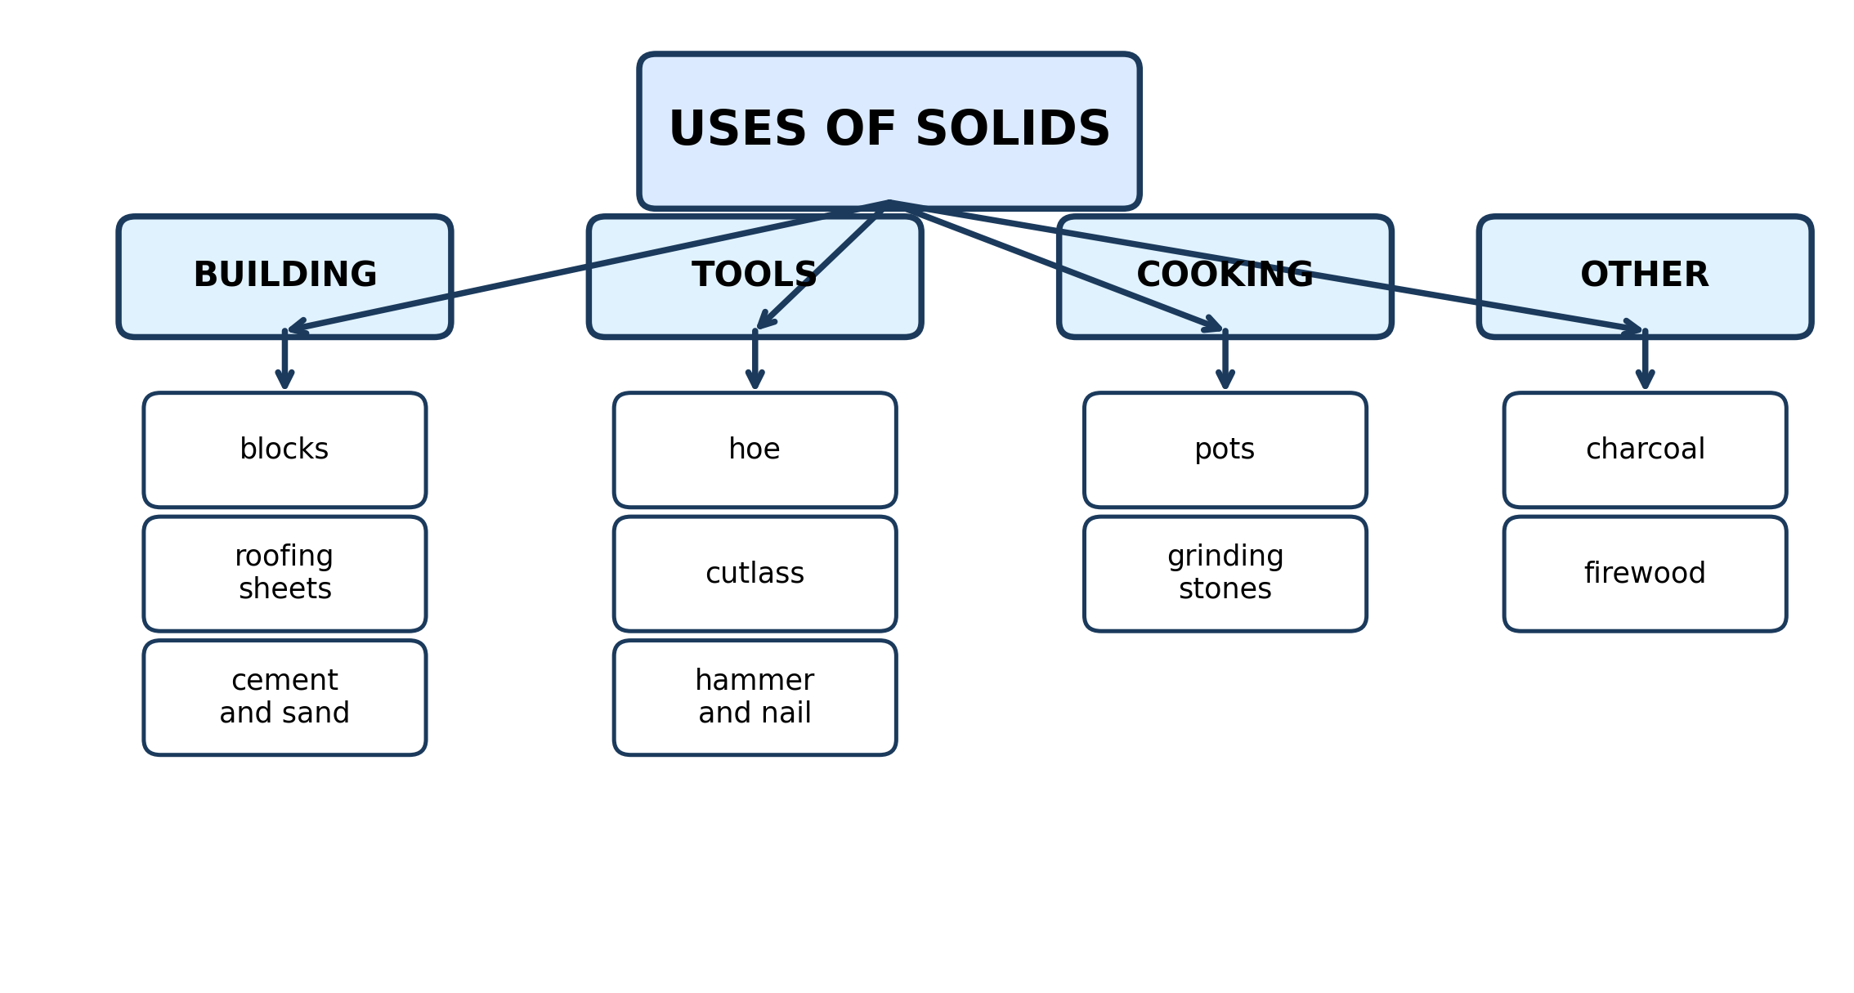
Fig. 4: A concept map of the uses of solids

1.4 1.4 Importance of Solids to Human Life
8. Choose TWO solids from the diagram. For EACH one, explain how one PROPERTY of the solid makes it suitable for the use shown. [4 marks]
9. Give ONE use of solids from the diagram that depends on the solid being HARD, and explain why hardness matters for that use. [2 marks]
____________________________________________________________________________________________
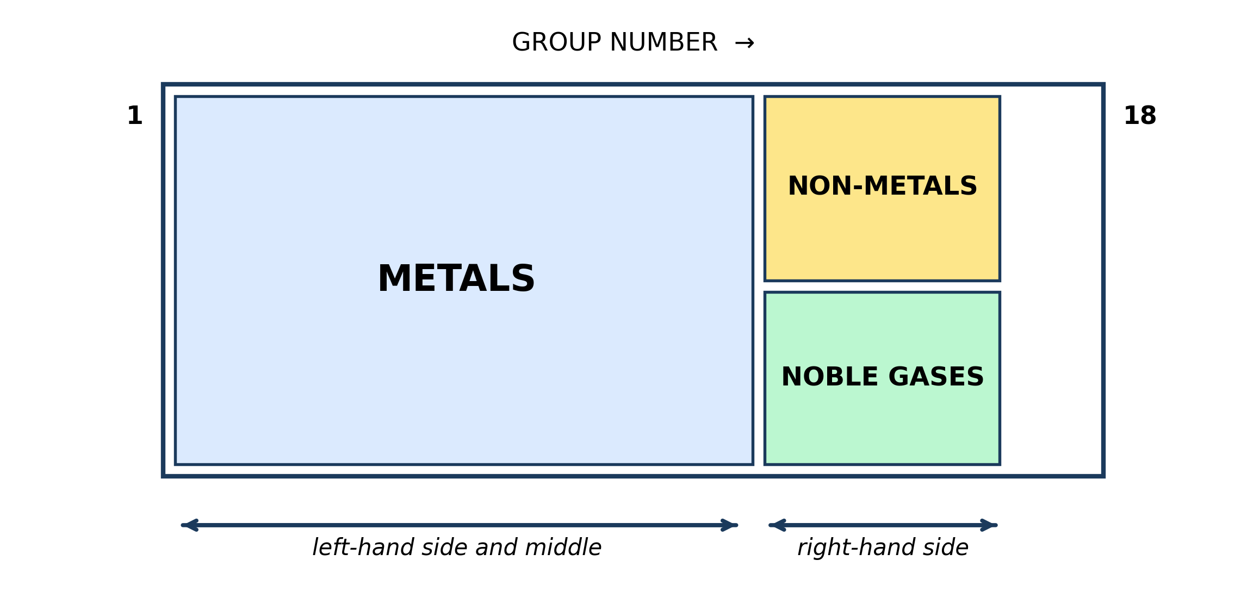
Fig. 5: The main regions of the periodic table

1.5 1.5 The Periodic Table: Metals, Non-Metals and Noble Gases
10. A new element is discovered and placed in Group 18 at the bottom of the table. PREDICT whether it would be a metal or a non-metal, and give the reason from the diagram. [3 marks]
11. Fluorine (F) and lithium (Li) are both near the TOP of the table, yet fluorine is a non-metal and lithium is a metal. Use the diagram to explain why. [3 marks]
____________________________________________________________________________________________
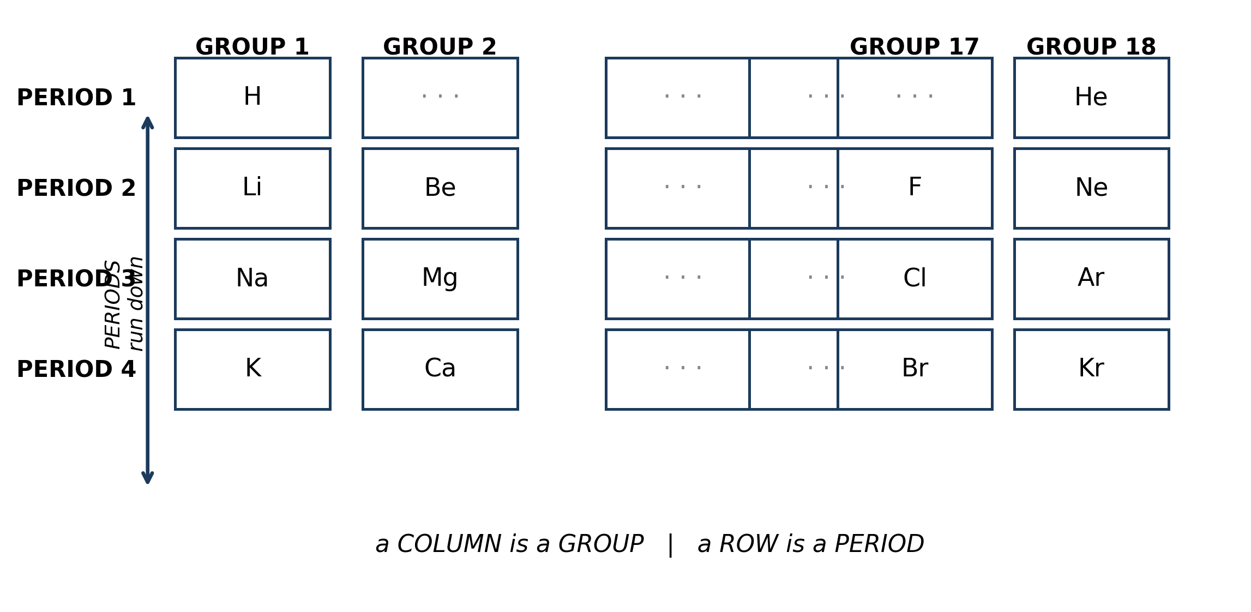
Fig. 6: Periods and groups in the periodic table

1.6 1.6 Arrangement of Elements in the Periodic Table
12. From the diagram, write down the period number and the group number of magnesium (Mg) and of chlorine (Cl). [2 marks]
13. Sodium (Na) and potassium (K) are both in Group 1. Use what the diagram shows about groups to suggest TWO things the two elements would have in common, and give a reason for each. [3 marks]
14. Explain the difference between a period and a group, and say which of the two tells you more about how an element reacts. [2 marks]
____________________________________________________________________________________________
SECTION B - PRACTICAL TASK
Study the apparatus and answer the questions that follow it.
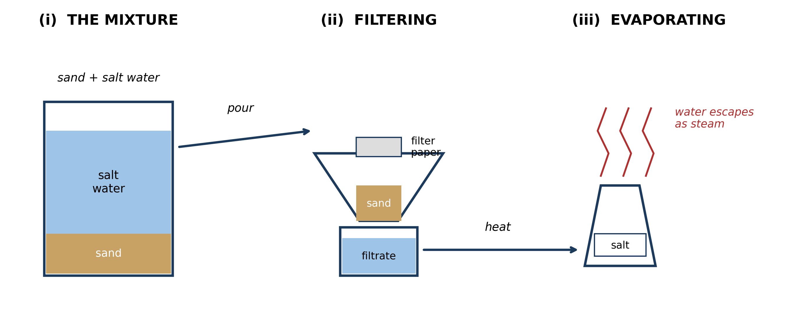
Fig. 7: Apparatus for separating a mixture of sand and salt water

15. Name the process shown at stage (ii). [1 mark]
16. State what is left on the filter paper and what passes through it. [2 marks]
17. Explain, in terms of PARTICLE SIZE, why the sand is held back by the paper but the salt passes through with the water. [3 marks]
18. Describe how you would change the apparatus so that the water is collected instead of being allowed to escape, and name the process it would then be. [2 marks]
19. A pupil heats the salt water very strongly at stage (iii) and the salt spits out of the dish and is lost. Suggest ONE change to the METHOD that would prevent this, and explain why it works. [2 marks]
____________________________________________________________________________________________

ANSWER KEY AND MARKING SCHEME
Accept any other correct and relevant answer. Award marks for correct points, not for repeating the question.
1.1 1.1 States of Matter: Solids, Liquids and Gases
Q1
In a solid the particles are packed closely together in a regular pattern and can only vibrate about fixed positions, so the solid keeps both its shape and its volume. In a gas the particles are far apart with large empty spaces between them, there are almost no forces holding them together, and they move freely and rapidly in all directions. A gas therefore spreads out to fill whatever container it is in - it takes the shape of the container and can be squeezed into a smaller volume, so it has neither a fixed shape nor a fixed volume.
Q2
The particles are exactly the same size in all three states - it is the same substance, only in a different state. What changes is the SPACING between the particles and how much they move, not the size of the particles themselves. In the gas there is a great deal of empty space between particles of unchanged size.
Q3
Arrangement: from a close, regular pattern (solid), to close together but irregular (liquid), to far apart and random (gas). Movement: from vibrating about fixed positions, to sliding past one another, to moving rapidly and freely in all directions.
1.2 1.2 Properties and Differences Among Solids, Liquids and Gases
Q4
In syringe R the substance is a gas, whose particles are far apart with large empty spaces between them, so pushing the plunger simply moves the particles closer together. In syringe P the substance is a solid, whose particles are already packed tightly together with almost no space between them, so there is nowhere for them to move to and the plunger will not go in.
Q5
The particles spread further apart so that they fill the whole of the larger space inside the syringe - the gas expands. This happens because the particles of a gas move rapidly and freely in all directions and are not held together, so they keep moving outwards until they are spread evenly through all the space available to them.
1.3 1.3 Importance of Liquids to Human Life
Q6
Any two, with the property and the reason: TRANSPORT OF BLOOD - liquids can flow, so blood can be pumped round the body carrying oxygen and dissolved food. COOKING - water stays liquid up to 100 degrees Celsius and transfers heat well, so food can be boiled in it. WASHING - a liquid can flow over a surface and dissolve the dirt, and then carry it away. WATERING CROPS - a liquid soaks into the soil and reaches the roots, which a solid could not do. COOLING MACHINES - water takes in a large amount of heat as it warms up, so it carries heat away from the machine.
Q7
A liquid can flow over and around the object being washed and can dissolve the dirt so that it is carried away. A solid cannot flow round the object and cannot dissolve the dirt off it.
1.4 1.4 Importance of Solids to Human Life
Q8
Any two with the property and the reason: IRON FOR A HOE - it is hard and can be sharpened to a cutting edge, and it does not bend when it is pushed into hard soil. BLOCKS FOR BUILDING - they are hard and strong under compression, so they carry the weight of the walls above them without crumbling. GRINDING STONES - they are hard and rough, so they wear the food down without themselves wearing away quickly. CHARCOAL FOR COOKING - it burns slowly and gives out a steady heat. POTS FOR COOKING - they withstand high temperatures without melting or catching fire.
Q9
Any one with a reason: A HOE - it must cut into hard soil without blunting or bending. GRINDING STONES - they must rub the food down without being worn away themselves. BUILDING BLOCKS - they must carry the weight above them without being crushed.
1.5 1.5 The Periodic Table: Metals, Non-Metals and Noble Gases
Q10
It would be a non-metal - specifically a noble gas. The diagram shows that Group 18, the far right-hand column, is the noble gas region, and noble gases are non-metals. Position from left to right decides whether an element is a metal, and Group 18 is at the far right.
Q11
Whether an element is a metal depends on its position from LEFT to RIGHT, not on how high up the table it sits. Lithium is in Group 1, the far left-hand column, which is inside the metal region. Fluorine is over on the right-hand side of the table, which is the non-metal region. Being near the top tells you nothing about whether it is a metal.
1.6 1.6 Arrangement of Elements in the Periodic Table
Q12
Magnesium: Period 3, Group 2. Chlorine: Period 3, Group 17.
Q13
Any two with a reason. They react in a similar way, because elements in the same group have the same number of electrons in the outer shell and it is the outer shell that controls how an element reacts. Both are soft metals that react vigorously with water, for the same reason. Both form compounds with the same ratio of atoms, e.g. with chlorine, because they form ions of the same charge.
Q14
A period is a horizontal ROW of elements; a group is a vertical COLUMN. The GROUP tells you more about how an element reacts, because elements in the same group react in similar ways.
PRACTICAL TASK
Q15
Filtration.
Q16
The sand is left on the filter paper - this is the residue. The salt water passes through - this is the filtrate.
Q17
Sand does not dissolve, so its particles stay clumped together in grains that are far too large to pass through the tiny pores in the filter paper. Salt DISSOLVES in the water, which means its particles are pulled apart and separated from one another, so each one is small enough to pass through the pores along with the water.
Q18
Place a cold surface or a condenser above the evaporating dish so that the water vapour cools, condenses back to a liquid, and runs down into a second container. The process would then be distillation.
Q19
Heat the dish gently, or use a water bath, or take the dish off the heat while there is still a little liquid left and let the last of the water evaporate in the heat of the dish. Any of these makes the water boil steadily instead of boiling violently, so bubbles do not burst and throw the solid crystals out of the dish.

BLUEPRINT / TEST SPECIFICATION
# | Content standard | Code | Items | Marks | % of Marks
1.1 | 1.1 States of Matter: Solids, Liquids and Gases | B7/JHS1.1.1.1 | 3 | 9 | 18%
1.2 | 1.2 Properties and Differences Among Solids, Liquids and Gases | B7/JHS1.1.1.1 | 2 | 6 | 12%
1.3 | 1.3 Importance of Liquids to Human Life | B7/JHS1.1.1.1 | 2 | 6 | 12%
1.4 | 1.4 Importance of Solids to Human Life | B7/JHS1.1.1.1 | 2 | 6 | 12%
1.5 | 1.5 The Periodic Table: Metals, Non-Metals and Noble Gases | B7/JHS1.1.1.2 | 2 | 6 | 12%
1.6 | 1.6 Arrangement of Elements in the Periodic Table | B7/JHS1.1.1.2 | 3 | 7 | 14%
1.2 | Separating mixtures (practical task) | B7/JHS1.1.1.1 | 5 | 10 | 20%
TOTAL | - | - | 19 | 50 | 100%
Distribution by cognitive level
Cognitive level | Marks | % of Marks
Remember | 1 | 2%
Understand | 11 | 22%
Apply | 28 | 56%
Analyse | 10 | 20%
TOTAL | 50 | 100%
Distribution by difficulty
Difficulty | Marks | % of Marks
Easy | 7 | 14%
Moderate | 22 | 44%
Challenging | 21 | 42%
TOTAL | 50 | 100%

QUALITY-CONTROL SUMMARY
1. Is every question answered from a diagram?
Yes. All 19 questions sit under a figure, and each is unanswerable - or at least materially harder - without reading it. Questions 3, 8, 10 and 17 ask pupils to go beyond the diagram, but each still starts from something the figure shows.
2. Is the content within the Basic 7 curriculum?
Yes. Every question traces to standard B7/JHS1.1.1.1 and the six content areas of Materials. The periodic-table questions stop at naming the regions and reading periods and groups, which is the B7 limit.
3. Are the diagrams clear and unambiguous?
Yes. Each is drawn so that only one reading is sensible: the particle boxes differ in spacing alone, the syringes are labelled with how far each squashes, and the periodic table marks the regions in words as well as by position.
4. Is the level right for JHS 1?
Yes. Questions ask pupils to read, describe and explain what is drawn. Only Question 17 asks for an inference beyond the figure, and it is worth 3 of the 40 marks.
5. Do the marks add up?
Yes: 19 questions totalling 50 marks, matching the figure on the front page. The blueprint, cognitive and difficulty tables all sum to the same total.
6. Are the answers correct and complete?
Yes. Each answer states the point the question is worth, with the acceptable alternatives given where a question is open.
EXAMINER NOTES (for the teacher, not for candidates)
- This paper is pitched at the compulsory diagram question of BECE Integrated Science Paper 2. It is deliberately harder than a class test: 42% of the marks are Challenging and 76% are at Apply level or above. Use it for revision and for stretching your strongest pupils, not as a first teaching instrument.
- Only ONE mark in the whole paper is pure recall (Q15, naming filtration). Everything else asks pupils to explain, predict, justify or suggest - which is exactly the shape of the BECE compulsory question.
- Q2 is the key diagnostic. The belief that particles in a gas are LARGER is extremely common and survives right through to SHS. The diagram is drawn deliberately so the particles are the same size in all three boxes; if a pupil still says the gas particles are bigger, they have not grasped that state changes are about spacing and movement.
- Q11 targets the mirror-image error: pupils read the periodic table like a list and assume items near the top share properties. Properties run in columns, not rows. Drill this with lithium against fluorine.
- Q5 and Q19 both ask for a PREDICTION rather than a fact, which is where BECE lives. Pupils find 'predict' and 'suggest' far harder than 'state', because there is nothing to recall - they must reason from the diagram. Give them these two words explicitly before the examination.
- Q17 is the hardest practical question and the one most often answered wrongly. 'It dissolves' scores nothing; the mark is for dissolved particles being SEPARATED and therefore small enough to fit through the pores. Teach the word 'dissolved' as a statement about particle separation.
- The separation in Fig. 7 can be done for real in about twenty minutes using sand, salt, water, a funnel, filter paper and a tin dish. Doing it first turns Q15 to Q19 into near-free marks, and pupils who have seen the salt spit out of the dish answer Q19 from memory of the practical rather than by guessing.

