[SCHOOL NAME]
INTEGRATED SCIENCE (SCIENCE)
PRACTICAL QUESTIONS - DIAGRAM MODE
Science and Industry (18.1 - 18.4)
____________________________________________________________________________________________
CLASS: Basic 7 (JHS 1)
TIME: 1 hour 30 minutes
MARKS: 50 2025/2026 Academic Year
____________________________________________________________________________________________
INSTRUCTIONS TO CANDIDATES
1. Answer ALL the questions in this paper.
2. Every question is based on a diagram. Study each diagram carefully before you answer the questions that follow it.
3. Write your answers in the spaces provided. The marks for each question are printed beside it.
4. Where a question asks for a stated number of points, give that number. Any extra answers will not be marked.
5. You may refer back to any diagram at any time.
____________________________________________________________________________________________
SECTION A - DIAGRAM STUDY
Study each diagram and answer the questions that follow it.
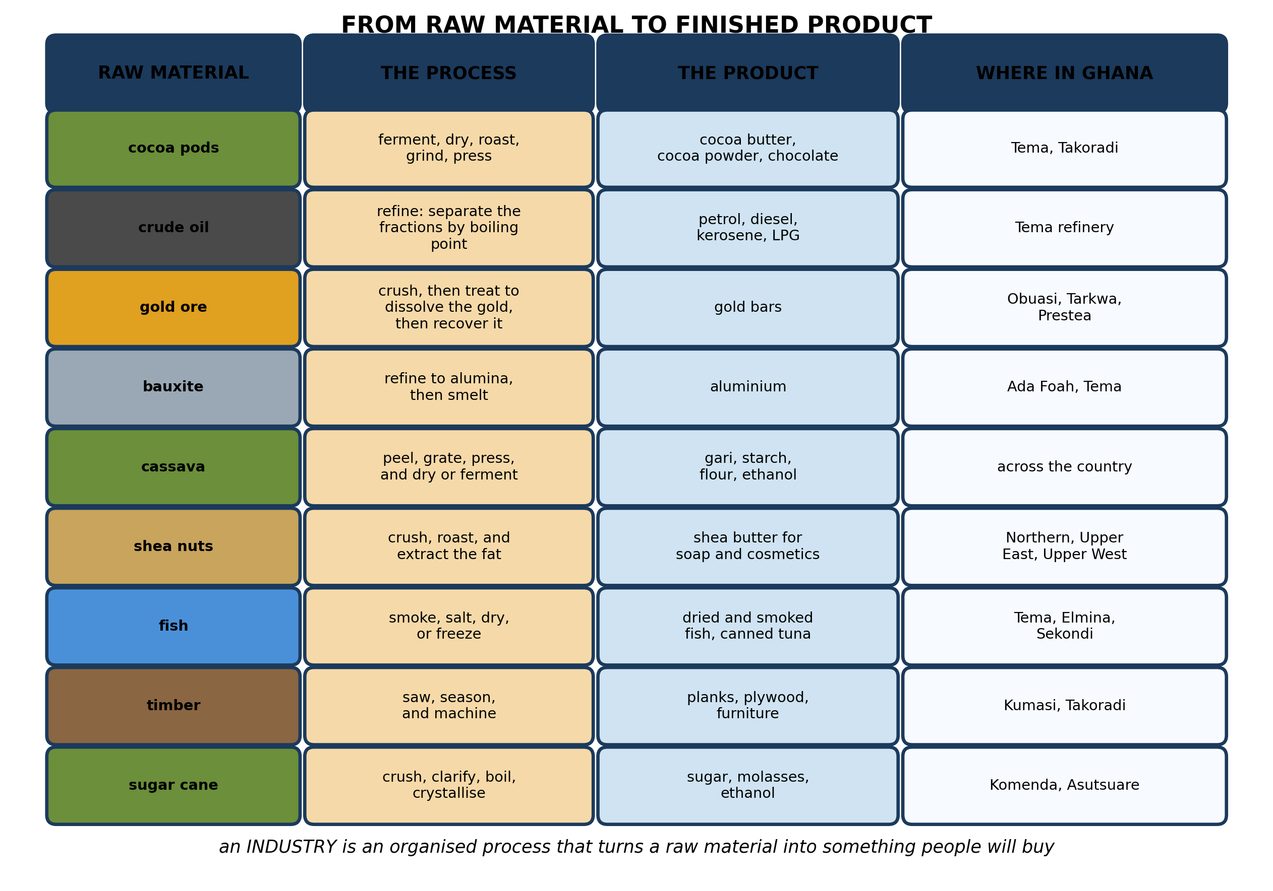
Fig. 1: From raw material to finished product

18.1 18.1 Careers in Science and How They Improve Human Life
1. Explain what is meant by an INDUSTRY, and explain why the cocoa that Ghana exports as raw beans earns less than the cocoa that is finally sold as chocolate. [4 marks]
2. Choose ONE raw material from Fig. 1 that is found in your own region. Describe how it is processed into a product, and suggest TWO difficulties a factory using it would face. [4 marks]
3. Name THREE raw materials shown in the diagram. [3 marks]
4. State what is meant by a RAW MATERIAL, and give TWO examples. [3 marks]
____________________________________________________________________________________________
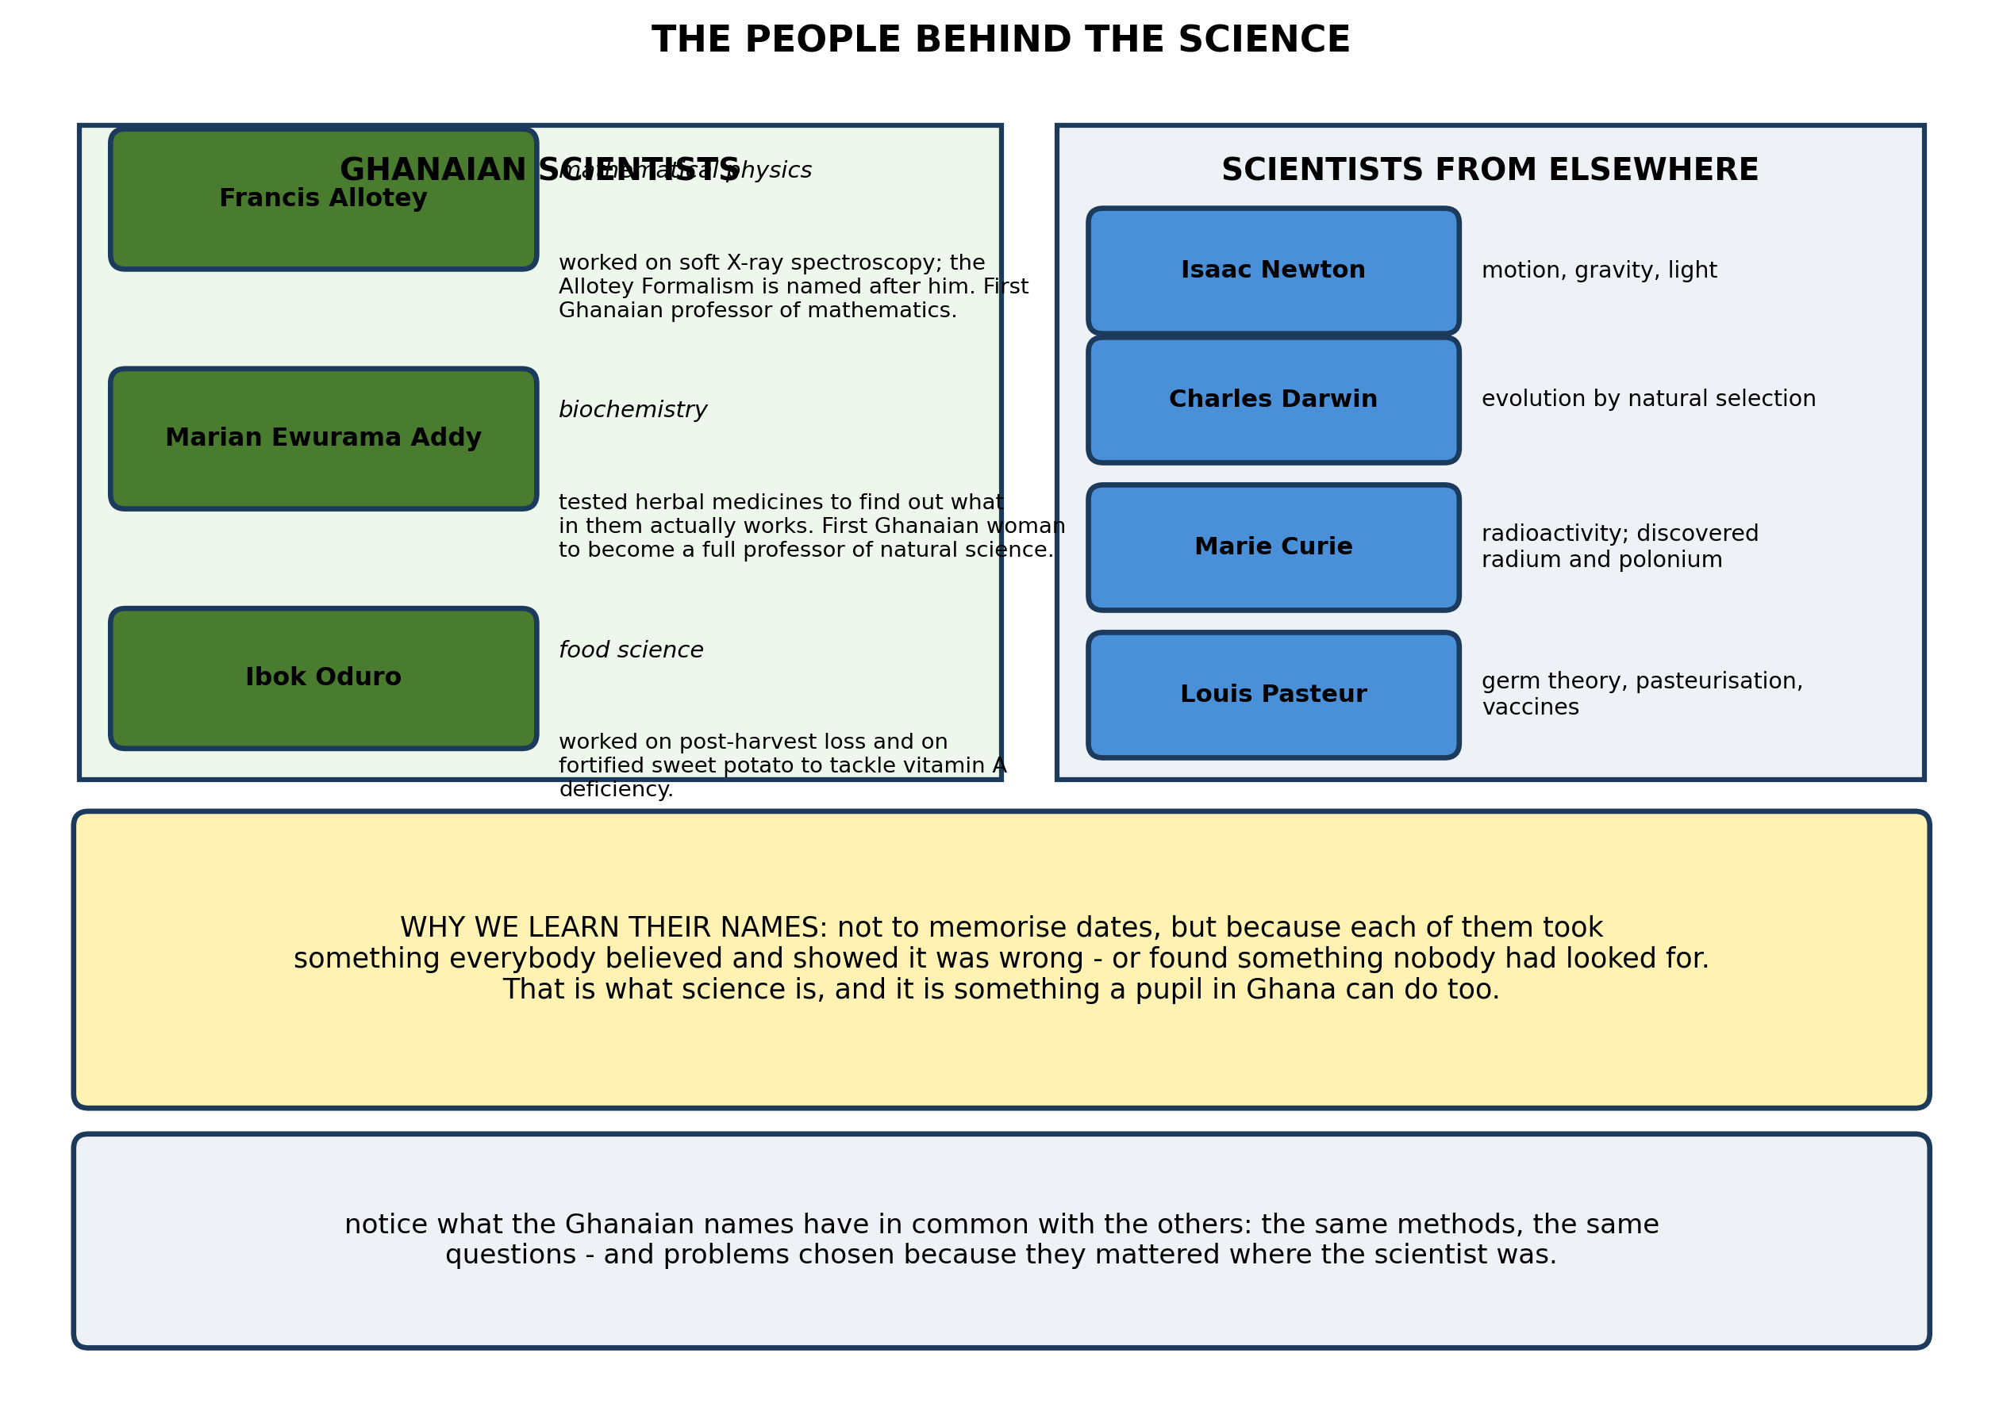
Fig. 2: The people behind the science

18.2 18.2 Ghanaian Scientists and Their Contributions
5. Choose ONE Ghanaian scientist from Fig. 2 and ONE scientist from elsewhere. For each, state what they worked on, and explain why their work mattered to the country they lived in. [4 marks]
6. Name TWO Ghanaian scientists and state the field each worked in. [3 marks]
7. A pupil says that remembering the NAMES of scientists is not real science. Give TWO reasons why learning what they did is still worth doing. [3 marks]
8. State ONE contribution of any scientist named in Fig. 2. [3 marks]
____________________________________________________________________________________________
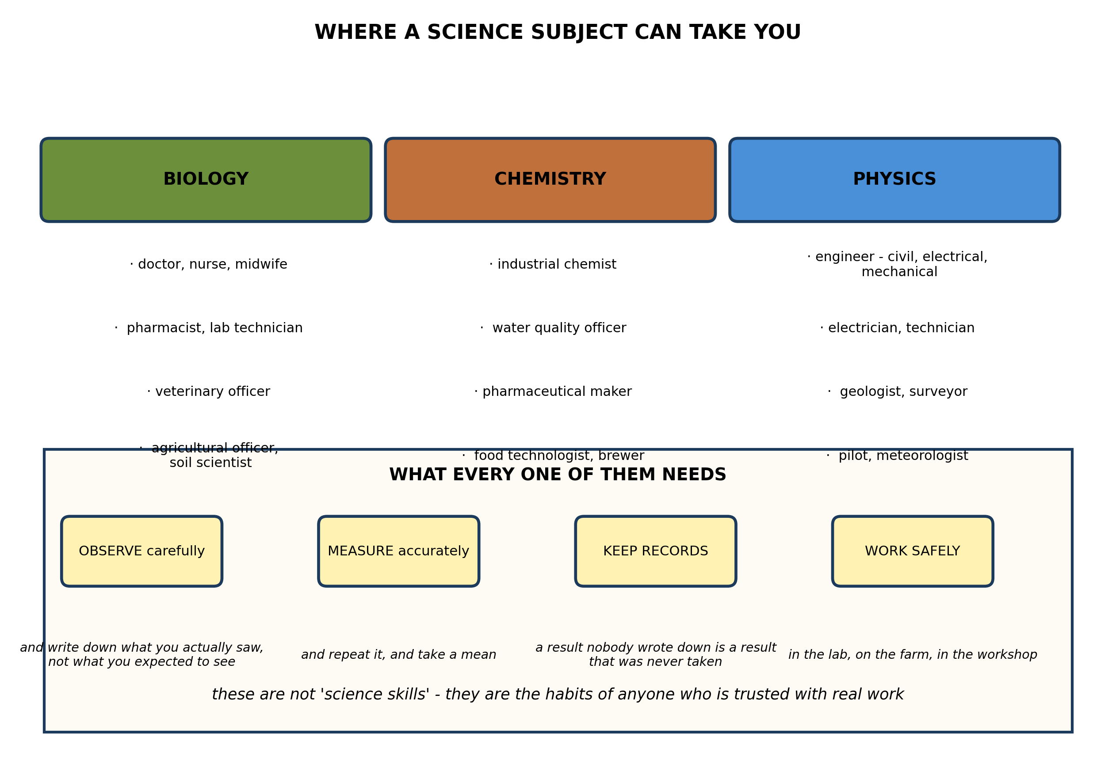
Fig. 3: Where a science subject can take you

18.4 18.4 Science, Technology and Innovation in Ghana
9. A pupil wants to become an AGRICULTURAL OFFICER. State which science subject she must study, describe TWO things she would do in the job, and explain why the skills listed in Fig. 3 matter in that work. [4 marks]
10. State TWO careers that need PHYSICS, and for each say what the person does. [3 marks]
11. Explain why an employer in ANY of these careers would value a pupil who keeps careful records. [3 marks]
____________________________________________________________________________________________
SECTION B - PRACTICAL TASK
Study the apparatus and answer the questions that follow it.
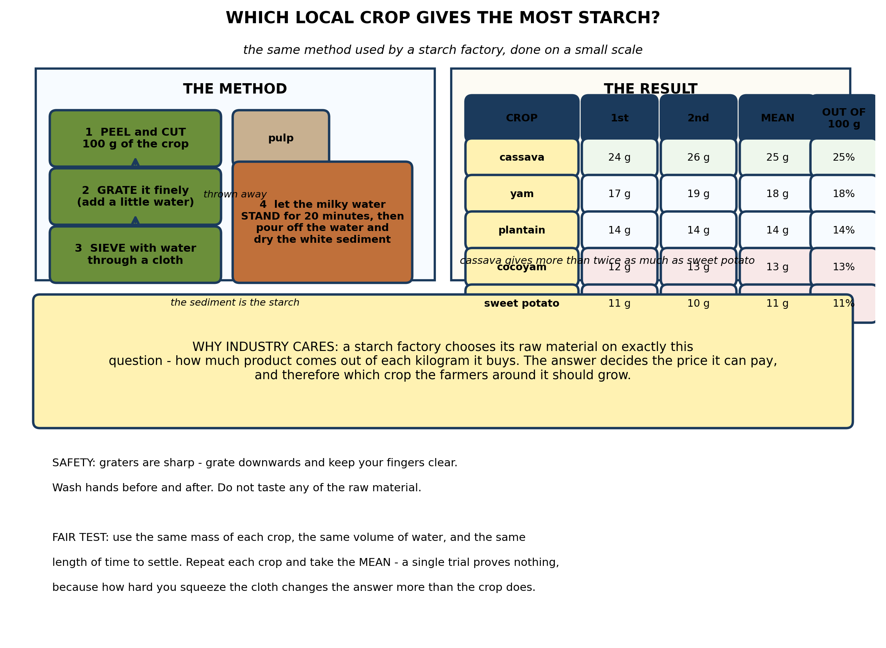
Fig. 4: Which local crop gives the most starch?

12. From the results, state which crop gives the MOST starch and which the LEAST, and explain why a starch factory would care both about this figure and about whether the comparison was FAIR. [4 marks]
13. Explain why each crop was tested TWICE and a mean taken, and suggest ONE other thing the pupils must keep the same. [3 marks]
14. In this method the starch settles to the bottom and the water above is poured off. Explain why the starch settles and the water can be poured away, and explain what would happen if the mixture were shaken instead of left to stand. [3 marks]
15. Suggest TWO improvements to the method that would give a more accurate yield, and explain what each one fixes. [3 marks]
____________________________________________________________________________________________

ANSWER KEY AND MARKING SCHEME
Accept any other correct and relevant answer. Award marks for correct points, not for repeating the question.
18.1 18.1 Careers in Science and How They Improve Human Life
Q1
An industry is an organised process that takes a raw material and, through a series of steps, turns it into a finished product that people will buy. Ghana has traditionally shipped cocoa out as raw beans, so the roasting, grinding and pressing - and the branding, packaging and marketing that come after - have been done in Europe, and the value added at each of those stages has been earned there rather than here. A tonne of raw beans sells for a small fraction of what the chocolate made from that same tonne sells for. That is why grinding and processing cocoa in Ghana keeps more of the money at home. It is not that the beans are worth less; it is that nearly all the value is added after the farm, and whoever does the processing captures it.
Q2
Accept any raw material from the figure, marked on the quality of the processing chain and of the two difficulties. Model answer using cassava: the tubers are peeled, washed and grated; the pulp is pressed to squeeze out the milky liquid; that liquid is left to stand so the starch settles out, and the starch is then dried and bagged. Alternatively the grated pulp is fermented and roasted into gari. Difficulties: cassava spoils within two or three days of harvest, so the factory must be near the farms and must process immediately - it cannot build up a stockpile. And the supply is seasonal, so the plant may stand idle for part of the year. A third: cassava is also a food crop, so when the harvest fails the price rises and the factory is bidding against the food market for the same tubers.
Q3
Any three of: cocoa pods, crude oil, gold ore, bauxite, cassava, shea nuts, fish, timber, sugar cane.
Q4
A raw material is a natural substance, taken from the ground, the sea, the forest or the farm, which an industry processes into a product. Any two examples: cocoa pods, crude oil, gold ore, bauxite, cassava, shea nuts, fish, timber, sugar cane, palm fruit, cotton.
18.2 18.2 Ghanaian Scientists and Their Contributions
Q5
Accept any accurate pair, marked on the accuracy of the work and on the link to a real need. Model answer: Marian Ewurama Addy worked on the biochemistry of herbal medicine, testing plant remedies to find out which of them contain active compounds and what those compounds do. This mattered in Ghana because herbal medicine is what most people actually use, yet almost none of it had been tested; her work began the job of separating the remedies that work from those that do not, and of making them safe and properly dosed. Isaac Newton worked on motion, gravity and light, and showed that the same law governs a falling stone and the orbit of the moon. This mattered because it replaced a collection of separate rules with one law you could calculate with, which is what made engineering and navigation possible. The two are doing the same thing: replacing what people assumed with what could be shown.
Q6
Francis Allotey - mathematical physics. Marian Ewurama Addy - biochemistry. Ibok Oduro - food science and post-harvest technology. (Accept any two with the correct field.)
Q7
Any two, each explained. Their work is the evidence for what we are taught: knowing who established something, and how they showed it, is what separates a fact from an opinion. The way they worked - measuring carefully, repeating, questioning what everyone believed - is the method pupils are being taught, and a real example shows the method better than a definition can. Several of them, notably Addy and Oduro, chose problems that mattered where they lived, which shows that science is not only done in rich countries on abstract questions.
Q8
Accept any one, accurately stated. Francis Allotey: work on soft X-ray spectroscopy, and the Allotey Formalism named after him; the first Ghanaian professor of mathematics. Marian Ewurama Addy: research on the biochemistry of herbal medicines; the first Ghanaian woman to become a full professor of natural science. Ibok Oduro: food science and post-harvest technology, including fortified sweet potato to address vitamin A deficiency. From the international list: Newton - laws of motion and universal gravitation; Darwin - evolution by natural selection; Curie - radioactivity, discovered radium and polonium; Pasteur - germ theory, pasteurisation, vaccines.
18.4 18.4 Science, Technology and Innovation in Ghana
Q9
She needs biology, with some chemistry for soils and fertilisers. In the job she would visit farms to work out why a crop is failing - which means looking closely, taking samples and testing them rather than guessing - and she would advise farmers which variety to plant and when, which depends on records of what has done well in previous seasons. The skills in Fig. 3 matter because they ARE the job. Observing carefully, and writing down what she actually saw rather than what she expected, is the difference between a correct diagnosis and a wasted season for the farmer. Measuring, and repeating - soil samples from several points across a field rather than one - is what stops a wrong recommendation. Keeping records is what lets her say next year whether the advice worked. Working safely applies to handling fertilisers and agrochemicals. An officer who cannot do these things is not an officer, however much biology she knows.
Q10
Any two, each described. An electrical engineer designs and maintains power systems and wiring. A civil engineer designs roads, bridges and buildings and checks that they will carry their loads. An electrician installs and repairs wiring and equipment. A geologist searches for minerals and advises on how to extract them. A surveyor measures land and marks boundaries. A meteorologist measures the weather and forecasts it. A pilot flies aircraft and must understand the forces acting on them.
Q11
Because a result that was not written down is a result that was never taken. It cannot be checked, repeated, compared with last month, or used to show a client or a court what was actually done. In a laboratory, a workshop and on a farm, the record is what makes the work trustworthy, and it is what lets a mistake be traced back to its cause. An employer cannot watch everything a worker does, so the record is also the evidence that the work was done properly at all.
PRACTICAL TASK
Q12
Cassava gives the most, at 25 g of starch from every 100 g of crop - about a quarter of its mass. Sweet potato gives the least, at 11 g, so cassava yields more than twice as much. A factory cares because this is the number that decides its costs: a tonne of cassava gives 250 kg of starch, but a tonne of sweet potato gives only 110 kg, so the cassava is worth more than twice as much per tonne even if both cost the same to buy. That determines the price the factory can afford to pay farmers, and therefore which crop the farmers around it should grow - and whether the factory can compete at all. Fairness matters because the figure is worthless if the comparison was not fair. If one sample was squeezed harder, left to settle for longer, or started with more water, that alone could account for the whole difference. Same mass, same water, same settling time, repeated and averaged - that is not fussiness, it is what makes the number mean anything.
Q13
Repeating and averaging protects against the fact that how hard you squeeze the cloth changes the answer more than the crop does, and against losing a little sediment when the water is poured off. A single trial may be high or low for a reason that has nothing to do with which crop was used. What must be kept the same: the same mass of each crop (100 g), the same volume of water for sieving, the same settling time, and the same way of pouring the water off. If any of those differed, the experiment would be measuring the method rather than the crop.
Q14
Starch grains do not dissolve in water and are denser than it, so given time they sink under gravity and collect at the bottom as a layer of sediment, leaving clear water above that can be poured off. If the mixture were shaken instead, the starch would be stirred back up and dispersed through the water; it would stay in suspension rather than settling, and when the water was poured off most of the starch would go with it. The yield would then appear far lower than it really is. Settling needs the mixture to be left completely still.
Q15
Any two, each explained. Dry the starch completely - in an oven or in the sun - and weigh it again, so the mass is dry starch rather than starch with water still in it; wet starch weighs more and the yield is overstated. Wash the sediment: stir it up in clean water, let it settle again and pour off, which removes fibre and other material carried over and leaves purer starch. Sieve through a finer cloth and do it twice, so less starch is lost in the pulp that is discarded. Weigh each crop after peeling rather than before, since the amount of peel differs between crops and would otherwise distort the comparison.

BLUEPRINT / TEST SPECIFICATION
# | Content standard | Code | Items | Marks | % of Marks
18.1 | 18.1 Careers in Science and How They Improve Human Life | B7/JHS1.5.3.1 | 4 | 14 | 28%
18.2 | 18.2 Ghanaian Scientists and Their Contributions | B7/JHS1.5.3.1 | 4 | 13 | 26%
18.4 | 18.4 Science, Technology and Innovation in Ghana | B7/JHS1.5.3.1 | 3 | 10 | 20%
18.1 | Practical task | B7/JHS1.5.3.1 | 4 | 13 | 26%
TOTAL | - | - | 15 | 50 | 100%
Distribution by cognitive level
Cognitive level | Marks | % of Marks
Understand | 12 | 24%
Apply | 26 | 52%
Analyse | 12 | 24%
TOTAL | 50 | 100%
Distribution by difficulty
Difficulty | Marks | % of Marks
Easy | 3 | 6%
Moderate | 27 | 54%
Challenging | 20 | 40%
TOTAL | 50 | 100%

QUALITY-CONTROL SUMMARY
1. Is every question answered from a diagram?
Yes. All 15 questions sit under a figure, and each is unanswerable - or at least materially harder - without reading it. Questions 3, 8, 10 and 17 ask pupils to go beyond the diagram, but each still starts from something the figure shows.
2. Is the content within the Basic 7 curriculum?
Yes. Every question traces to the content standards for this sub-strand (B7/JHS1.5.3.1), and nothing is tested beyond the depth the Basic 7 syllabus sets for it.
3. Are the diagrams clear and unambiguous?
Yes. Each is drawn so that only one reading is sensible: the particle boxes differ in spacing alone, the syringes are labelled with how far each squashes, and the periodic table marks the regions in words as well as by position.
4. Is the level right for JHS 1?
Yes. Questions ask pupils to read, describe and explain what is drawn. Only Question 17 asks for an inference beyond the figure, and it is worth 3 of the 40 marks.
5. Do the marks add up?
Yes: 15 questions totalling 50 marks, matching the figure on the front page. The blueprint, cognitive and difficulty tables all sum to the same total.
6. Are the answers correct and complete?
Yes. Each answer states the point the question is worth, with the acceptable alternatives given where a question is open.
EXAMINER NOTES (for the teacher, not for candidates)
- Pitched at the compulsory diagram question of BECE Paper 2: 76% of the marks are at Apply level or above and 40% are Challenging.
- Q1 is the question that makes 18.1 worth teaching. Ghana sells cocoa beans and buys back chocolate. The reason is not that the beans are worth less - it is that almost all the value is added after the farm, and whoever does the processing captures it. Pupils grasp this immediately, and it is the whole argument for industrialisation in one example.
- Q2 is deliberately open: it asks the pupil to choose a raw material from their own region. Mark it on the quality of the processing chain and of the two difficulties, not on which crop they picked. The best answers notice that perishability and seasonality are problems for any food-crop factory.
- Q5 and Q8 cover 18.2 and 18.3, which dg_survey flagged as having no drawable content. They are recall of names and contributions, so they are pitched at Understand and Analyse rather than pretending to be application. Q5 is the only way to make the strand worth anything: it asks why the work MATTERED, not just what it was.
- Note on the source material: the curriculum's list includes a 'Paul Ratnei' which I could not trace in any source. No question here tests that name, and it is worth flagging to the curriculum team.
- The starch practical works well with cassava, yam, plantain, cocoyam and sweet potato, all cheap and available. You need graters, cloth for sieving, and a balance. Cassava is genuinely dramatic - it gives more than twice the sweet potato - which makes the point about industrial raw-material choice better than any graph.
- Graters are the real hazard. Brief the class to grate downwards with fingers clear, and consider grating the samples yourself as a demonstration if the group is large.
- If you have no balance accurate to a gram, drying and weighing is still worth doing roughly - the ranking of the crops is robust enough to survive a coarse measurement.

