[SCHOOL NAME]
INTEGRATED SCIENCE (SCIENCE)
PRACTICAL QUESTIONS - DIAGRAM MODE
Simple Machines (14.9 - 14.11)
____________________________________________________________________________________________
CLASS: Basic 7 (JHS 1)
TIME: 1 hour 30 minutes
MARKS: 50 2025/2026 Academic Year
____________________________________________________________________________________________
INSTRUCTIONS TO CANDIDATES
1. Answer ALL the questions in this paper.
2. Every question is based on a diagram. Study each diagram carefully before you answer the questions that follow it.
3. Write your answers in the spaces provided. The marks for each question are printed beside it.
4. Where a question asks for a stated number of points, give that number. Any extra answers will not be marked.
5. You may refer back to any diagram at any time.
____________________________________________________________________________________________
SECTION A - DIAGRAM STUDY
Study each diagram and answer the questions that follow it.
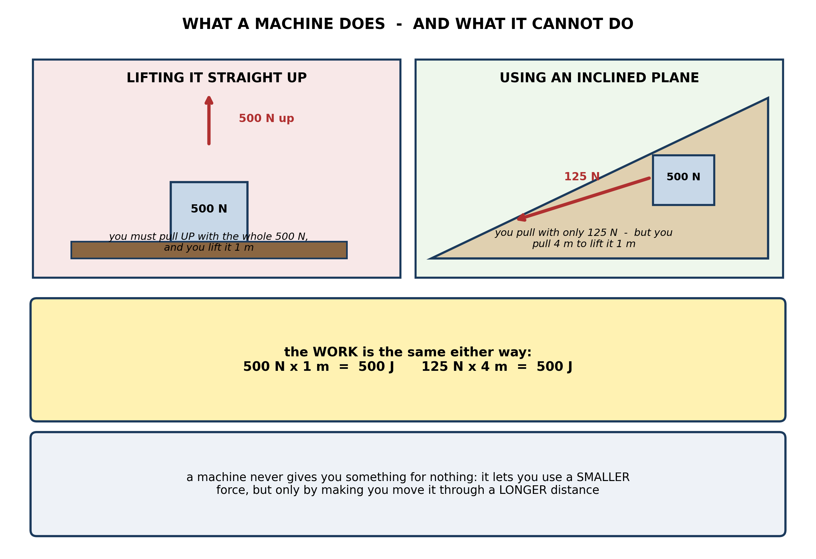
Fig. 1: What a machine does - and what it cannot do

14.9 14.9 Simple Machines and Their Types
1. The diagram shows a 500 N load lifted 1 m straight up, and the same load pushed 4 m up a slope with a force of 125 N. Explain why the slope is said to MAKE THE WORK EASIER when the work done is exactly the same in both cases. [4 marks]
2. State what is meant by a MACHINE, and state the ONE thing no machine can do. [3 marks]
____________________________________________________________________________________________
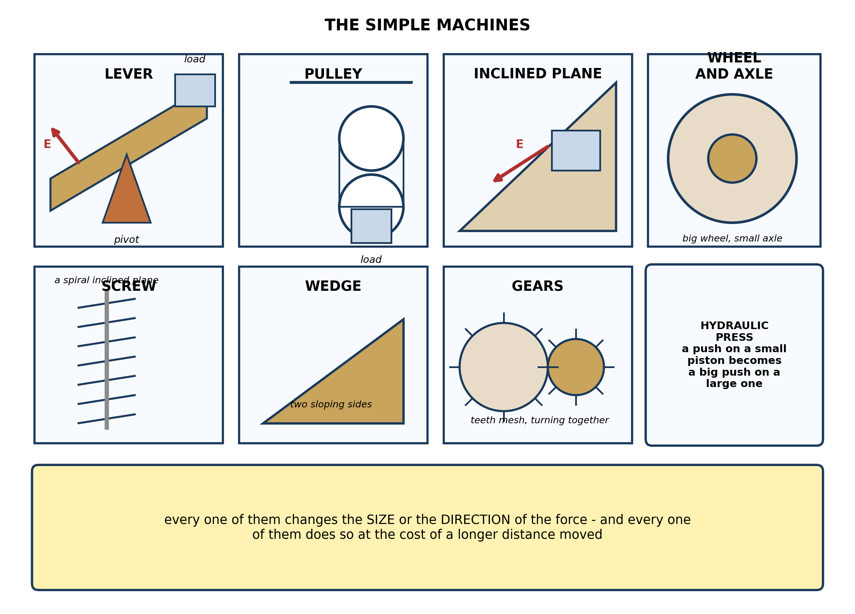
Fig. 2: The simple machines

14.10 14.10 Types and Functions of Levers
3. For each of the following, name the simple machine it is an example of, and say whether it mainly makes the force BIGGER or changes the DIRECTION of the force: (a) a bottle opener; (b) a rope over a wheel at the top of a flag pole; (c) an axe blade; (d) a ramp used to load a truck. [4 marks]
4. Name any THREE simple machines shown in the diagram. [3 marks]
5. Explain why a LONG spanner undoes a tight nut more easily than a short one. [3 marks]
6. A screw is described as a spiral inclined plane. Explain what this means, and explain why a screw with CLOSELY spaced threads is easier to drive in than one with widely spaced threads. [3 marks]
____________________________________________________________________________________________
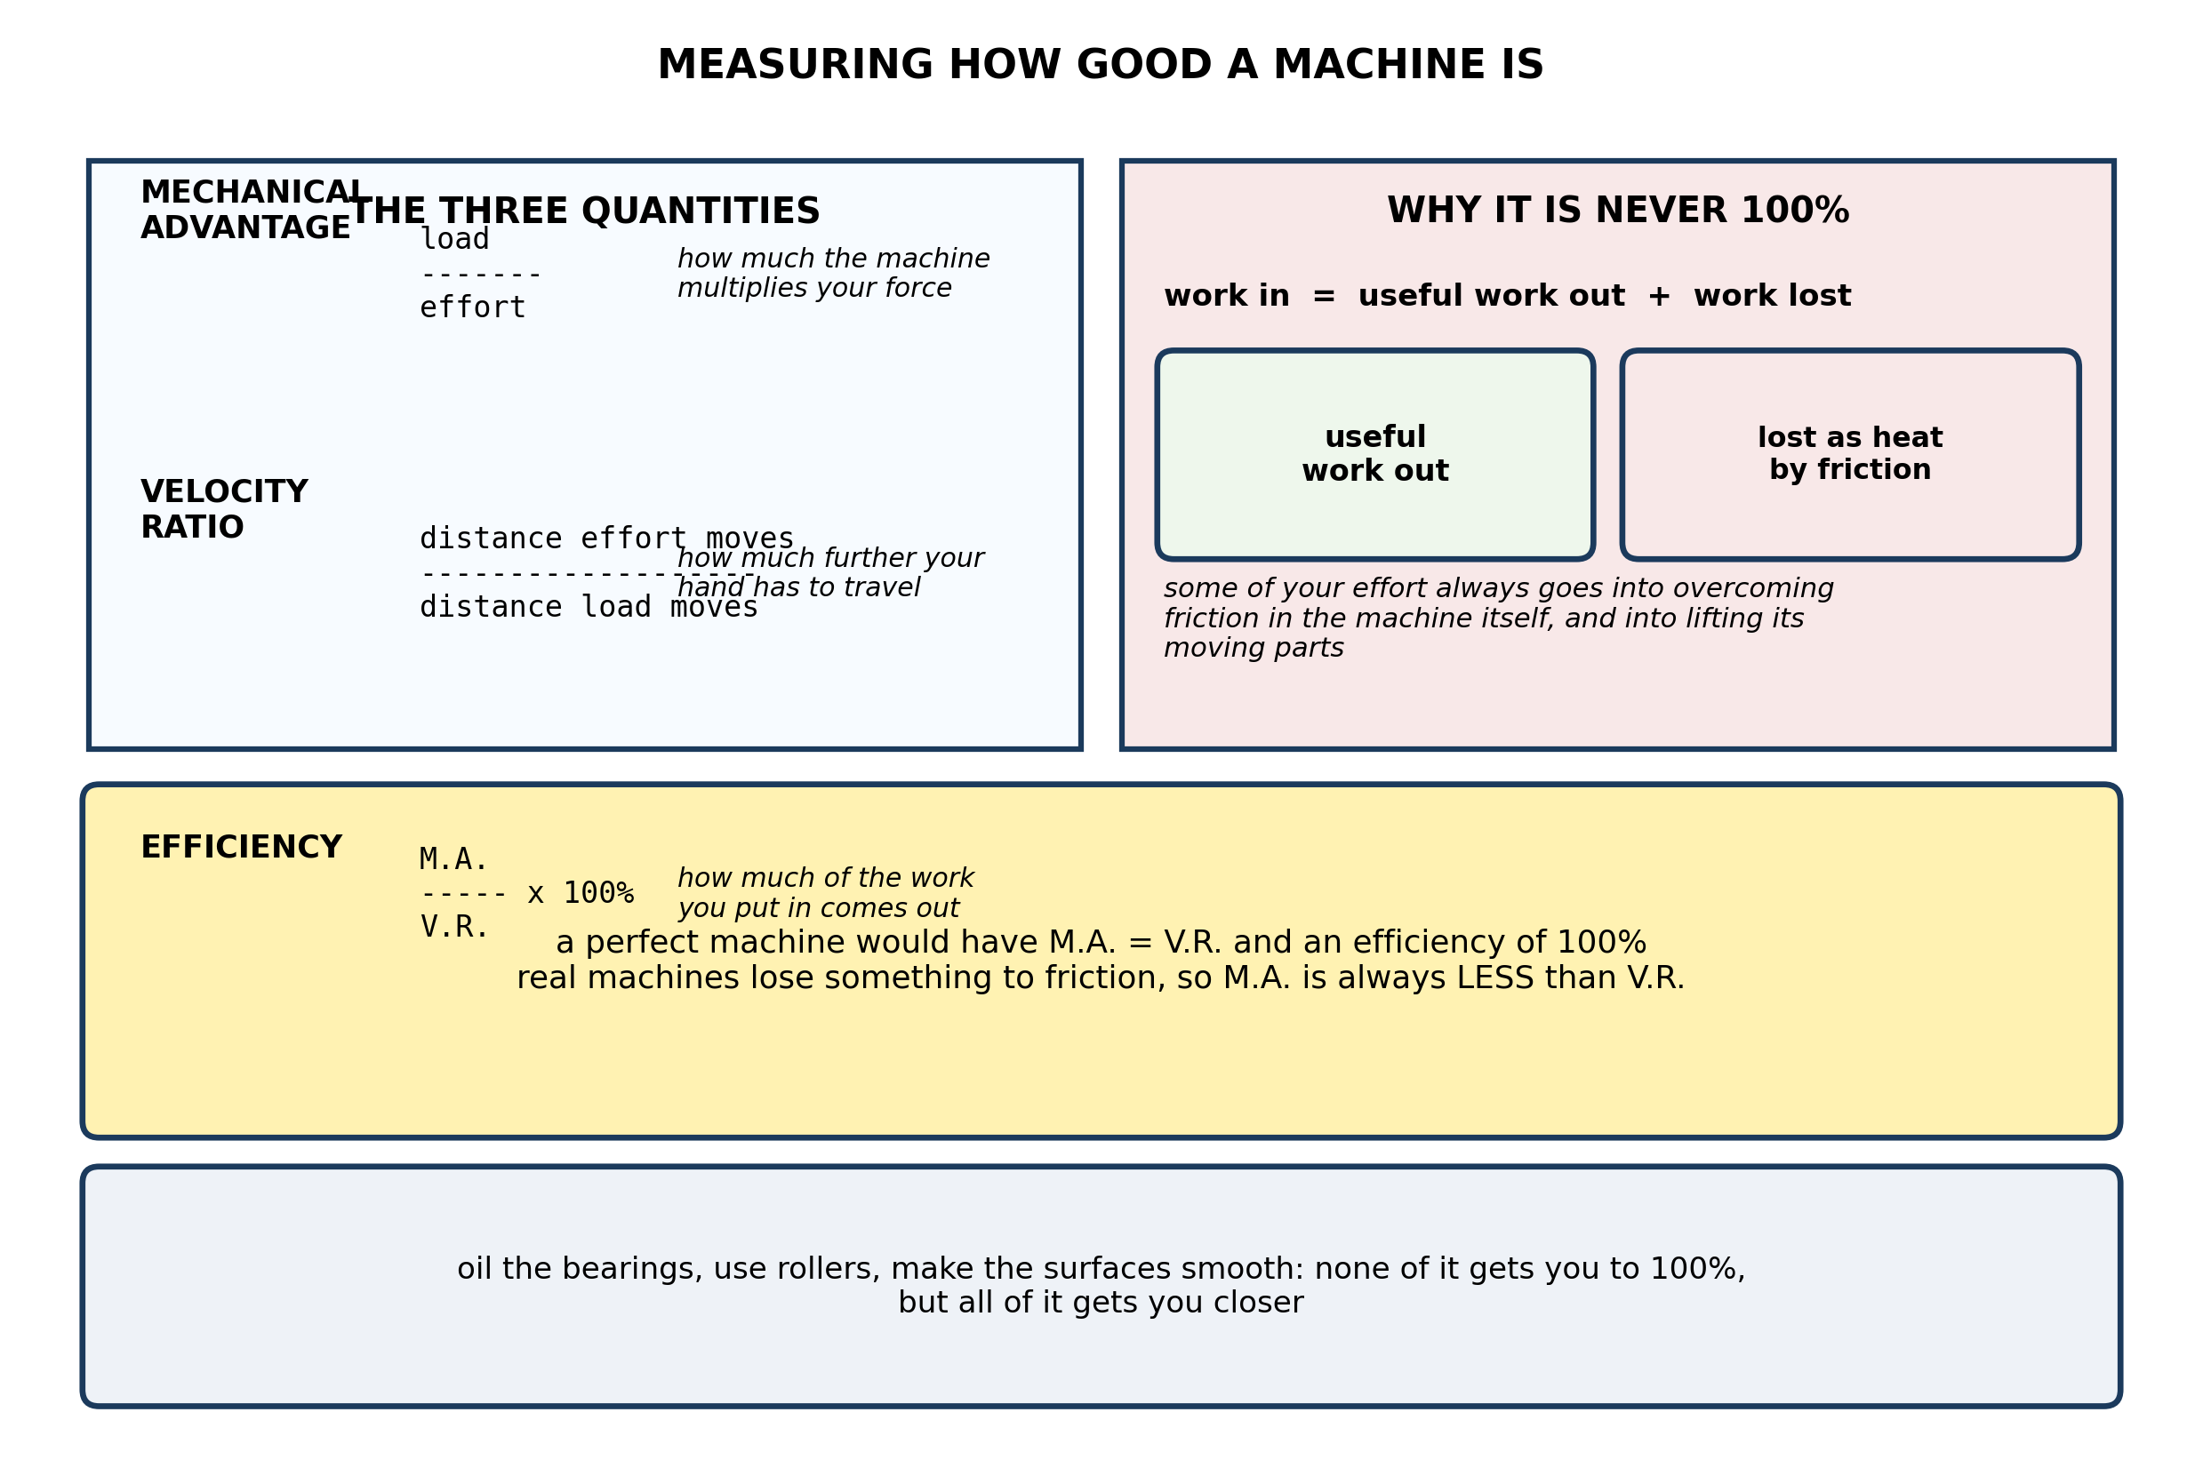
Fig. 3: Measuring how good a machine is

14.11 14.11 Work Input, Work Output and Efficiency
7. Explain why the MECHANICAL ADVANTAGE of a real machine is always less than its VELOCITY RATIO, and explain what has become of the difference. [4 marks]
8. A machine has a velocity ratio of 5. An effort of 50 N lifts a load of 200 N. Calculate the mechanical advantage and the efficiency, and explain what has happened to the missing percentage. [4 marks]
9. Suggest TWO ways of improving the EFFICIENCY of a pulley system, and explain how each one helps. [3 marks]
10. State what is meant by the VELOCITY RATIO of a machine. [3 marks]
____________________________________________________________________________________________
SECTION B - PRACTICAL TASK
Study the apparatus and answer the questions that follow it.
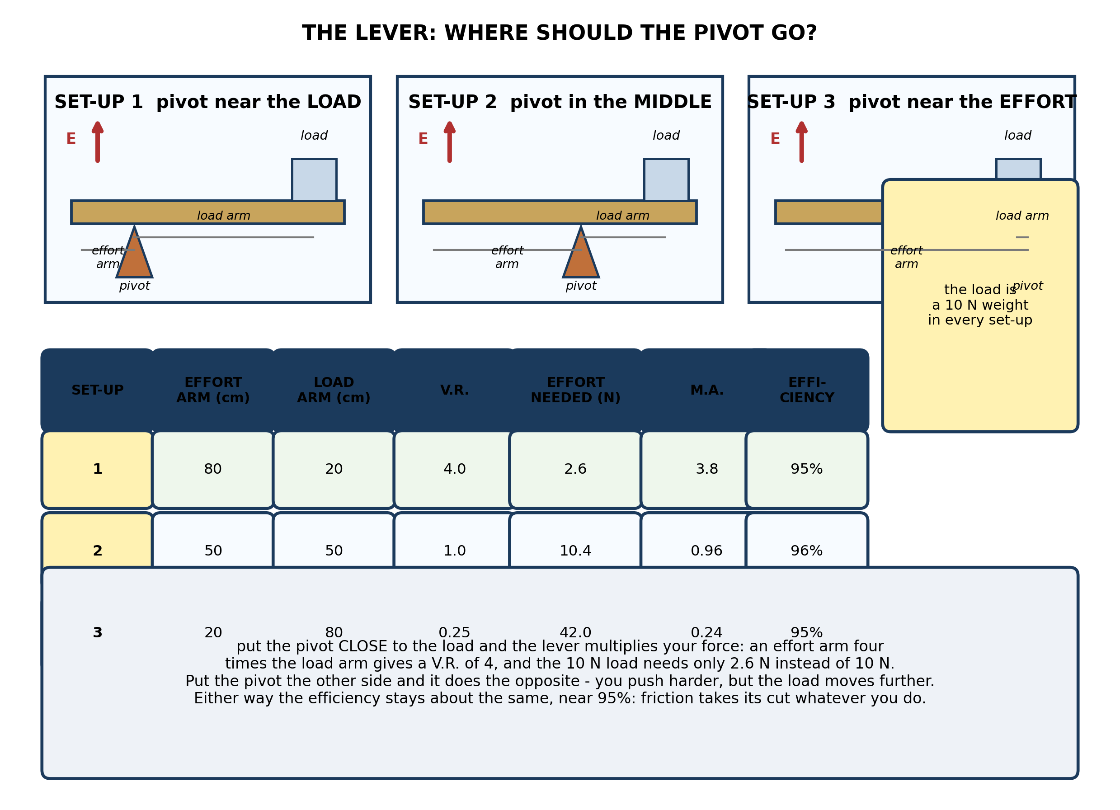
Fig. 4: The lever - where should the pivot go?

11. From the results, explain the relationship between the EFFORT ARM, the LOAD ARM and the EFFORT NEEDED. Refer to all three set-ups. [4 marks]
12. Using the results for SET-UP 1, calculate the velocity ratio, the mechanical advantage and the efficiency. Comment on what the efficiency figure tells you. [4 marks]
13. A pupil wants to use a lever to lift a heavy stone with the SMALLEST possible effort. Describe what he should do with the pivot, and explain what disadvantage this brings. [4 marks]
14. State what is meant by the EFFORT ARM of a lever. [2 marks]
15. State what is meant by the LOAD of a machine. [2 marks]
____________________________________________________________________________________________

ANSWER KEY AND MARKING SCHEME
Accept any other correct and relevant answer. Award marks for correct points, not for repeating the question.
14.9 14.9 Simple Machines and Their Types
Q1
The work is identical: lifting straight up is 500 N x 1 m = 500 J, and pushing up the slope is 125 N x 4 m = 500 J. What the slope changes is not the amount of work but the SIZE OF THE FORCE you must supply at any one moment. Lifting straight up demands a single pull of 500 N, which is beyond one person. The slope lets the same job be done with a pull of only 125 N - a force one person can manage - but you have to keep pushing over 4 m instead of 1 m. So 'easier' means 'with a smaller effort', not 'with less work'. The machine changes the force and charges you in distance; it cannot reduce the total work.
Q2
A machine is a device that makes work easier by changing the size or the direction of a force. No machine can give out more work than is put into it - it cannot produce more energy than it receives, and some of what goes in is always lost as heat.
14.10 14.10 Types and Functions of Levers
Q3
(a) A lever. It makes the force bigger: a small pull on the handle produces a large pull on the cap. (b) A pulley. It changes the direction: you pull down on the rope and the flag travels up. The effort is about the same size as the load, which is the price of that convenience. (c) A wedge. It makes the force bigger and turns it sideways: a downward blow becomes a large splitting force pushing the wood apart. (d) An inclined plane. It makes the force smaller for the same job: pushing the load up the ramp needs far less force than lifting it straight onto the truck, but over a longer distance.
Q4
Any three of: lever, pulley, inclined plane, wheel and axle, screw, wedge, gears, hydraulic press.
Q5
A spanner is a lever, and the turning effect it produces depends on both the force you apply and how far from the pivot - the nut - it acts. With a long spanner, the same push from your hand acts at a greater distance from the nut, so it gives a bigger turning effect and the nut gives way. With a short spanner you would have to push much harder to get the same turning effect, and beyond a point you simply cannot.
Q6
If you could unwrap the thread of a screw and lay it out flat, it would be one long sloping line - an inclined plane wrapped round a cylinder. Driving the screw in is like pushing a load up that slope: the further you push along the slope for each centimetre gained, the less force you need. Closely spaced threads mean many turns for every centimetre the screw advances, so the slope is shallower and the same push gives a larger inward force. The cost is that you must turn the screw many more times to drive it the same depth.
14.11 14.11 Work Input, Work Output and Efficiency
Q7
The velocity ratio is fixed by the geometry of the machine - how much further the effort travels than the load does - and nothing can alter it. The mechanical advantage is the ratio of the load actually lifted to the effort actually needed. In a perfect machine the two would be equal and the efficiency would be 100%. But in a real machine part of your effort goes into overcoming friction between the moving parts, and part into lifting the machine's own moving parts, neither of which benefits the load. So you have to pull harder than the geometry alone demands, the mechanical advantage comes out below the velocity ratio, and the difference is work converted into heat. That gap is precisely what efficiency measures, as M.A. over V.R.
Q8
Mechanical advantage = load / effort = 200 N / 50 N = 4. Velocity ratio = 5. Efficiency = M.A. / V.R. x 100% = 4 / 5 x 100% = 80%. So 80% of the work put in comes out as useful work on the load. The missing 20% has been converted into heat by friction between the moving parts of the machine, and into raising the machine's own moving parts. The energy has not been destroyed - it has simply ended up somewhere useless, warming the machine and the air around it. That is why no machine can ever reach 100% efficiency.
Q9
Any two, each explained. Oil or grease the axle so the sheave turns more freely, which cuts the friction that turns useful work into heat. Fit ball bearings at the axle for the same reason. Use lighter, more flexible rope, so less of the effort is spent lifting and bending the rope itself rather than the load. Lift a heavier load: the effort wasted on friction and on the moving parts stays roughly the same, so as a fraction of a bigger useful output it shrinks, and the efficiency rises.
Q10
The ratio of the distance moved by the effort to the distance moved by the load, measured over the same time. It says how much further your hand has to travel than the load does. Unlike the mechanical advantage it is fixed by the shape and arrangement of the machine and is not affected by friction.
PRACTICAL TASK
Q11
The effort needed depends entirely on how the pivot divides the lever. In set-up 1 the effort arm is 80 cm and the load arm 20 cm - four times as long - and the 10 N load needs only 2.6 N, so the lever is multiplying the effort about fourfold. In set-up 2 the two arms are equal at 50 cm each; there is no multiplication at all and the effort is 10.4 N, essentially the weight of the load plus a little extra for friction. In set-up 3 the arms are reversed, 20 cm and 80 cm, and the effort jumps to 42 N - now the lever works against you and you push roughly four times harder than the load weighs. So the longer the effort arm is compared with the load arm, the less effort is needed, and the ratio of the two arms is the velocity ratio.
Q12
Velocity ratio = effort arm / load arm = 80 cm / 20 cm = 4.0. Mechanical advantage = load / effort = 10 N / 2.6 N = 3.8 (3.85 to 3 s.f.). Efficiency = M.A. / V.R. x 100% = 3.8 / 4.0 x 100% = 95%. An efficiency of about 95% says that nearly all the work put in comes out as useful work lifting the load, and only about 5% is lost. The loss is friction where the lever turns on the pivot, and it is small because a lever has only one rubbing surface. That is why the lever is among the most efficient of the simple machines. Notice too that the efficiency stays near 95% in all three set-ups - the friction is much the same whatever the geometry, so changing the pivot position changes the effort needed but not how much is wasted.
Q13
He should place the pivot as close to the stone as he can get it, leaving the longest possible effort arm and the shortest possible load arm. That gives the largest velocity ratio, so the force-multiplying effect is at its greatest and the effort needed is at its smallest. The disadvantage is distance: because the work is the same either way, gaining force costs movement, so he must now push his end of the lever through a much greater distance to raise the stone by a little. He also needs a longer, stiffer lever, strong enough not to bend, and he needs room to swing it.
Q14
The distance from the pivot to the point where the effort is applied.
Q15
The force that the machine has to overcome - here, the weight of the object being lifted, which is the 10 N weight hanging from the lever.

BLUEPRINT / TEST SPECIFICATION
# | Content standard | Code | Items | Marks | % of Marks
14.9 | 14.9 Simple Machines and Their Types | B7/JHS1.4.4.2 | 2 | 7 | 14%
14.10 | 14.10 Types and Functions of Levers | B7/JHS1.4.4.2 | 4 | 13 | 26%
14.11 | 14.11 Work Input, Work Output and Efficiency | B7/JHS1.4.4.2 | 4 | 14 | 28%
14.9 | Practical task | B7/JHS1.4.4.2 | 5 | 16 | 32%
TOTAL | - | - | 15 | 50 | 100%
Distribution by cognitive level
Cognitive level | Marks | % of Marks
Understand | 13 | 26%
Apply | 21 | 42%
Analyse | 16 | 32%
TOTAL | 50 | 100%
Distribution by difficulty
Difficulty | Marks | % of Marks
Easy | 3 | 6%
Moderate | 27 | 54%
Challenging | 20 | 40%
TOTAL | 50 | 100%

QUALITY-CONTROL SUMMARY
1. Is every question answered from a diagram?
Yes. All 15 questions sit under a figure, and each is unanswerable - or at least materially harder - without reading it. Questions 3, 8, 10 and 17 ask pupils to go beyond the diagram, but each still starts from something the figure shows.
2. Is the content within the Basic 7 curriculum?
Yes. Every question traces to the content standards for this sub-strand (B7/JHS1.4.4.2), and nothing is tested beyond the depth the Basic 7 syllabus sets for it.
3. Are the diagrams clear and unambiguous?
Yes. Each is drawn so that only one reading is sensible: the particle boxes differ in spacing alone, the syringes are labelled with how far each squashes, and the periodic table marks the regions in words as well as by position.
4. Is the level right for JHS 1?
Yes. Questions ask pupils to read, describe and explain what is drawn. Only Question 17 asks for an inference beyond the figure, and it is worth 3 of the 40 marks.
5. Do the marks add up?
Yes: 15 questions totalling 50 marks, matching the figure on the front page. The blueprint, cognitive and difficulty tables all sum to the same total.
6. Are the answers correct and complete?
Yes. Each answer states the point the question is worth, with the acceptable alternatives given where a question is open.
EXAMINER NOTES (for the teacher, not for candidates)
- Pitched at the compulsory diagram question of BECE Paper 2: 74% of the marks are at Apply level or above and 40% are Challenging.
- Q1 is the question the whole strand rests on, and it is worth doing slowly at the board. Pupils come in believing a machine 'saves work'. It does not: 500 J either way. What it does is let you use a smaller force, and it charges you for that in distance. Get this right and mechanical advantage, velocity ratio and efficiency all follow from it; get it wrong and the rest of 14.11 is arithmetic without meaning.
- Q7 and Q8 are a pair. Q7 asks why M.A. is always below V.R.; Q8 makes them calculate it. The sentence to listen for is 'friction takes its cut' - the difference between the two ratios is work turned into heat, not work that vanished.
- Q6 on the screw as a spiral inclined plane is the one pupils enjoy, and it is worth drawing the unwrapped thread on the board. It also explains something they have all noticed: fine threads are easier to drive but take far longer to go in.
- Q12 is the calculation question, and the interesting part is the last sentence. The efficiency stays near 95% across all three set-ups because the friction at the pivot does not care where the pivot is. Pupils expect efficiency to vary with the geometry; it does not, and saying why is worth more than the arithmetic.
- For the lever experiment you need a metre rule or a wooden lath, a triangular or round pivot, a 10 N weight and a spring balance. Drill or notch the rule at 20, 50 and 80 cm so the pivot cannot roll. The awkward measurement is the effort in set-up 3 - 42 N will overload a 10 N balance, so use a 50 N balance for that one, or predict the value first and let pupils discover the problem themselves.
- If balances are short, run the three set-ups as a demonstration with pupils recording the readings, then let groups repeat just one set-up each.

