[SCHOOL NAME]
INTEGRATED SCIENCE (SCIENCE)
PRACTICAL QUESTIONS - DIAGRAM MODE
The Solar System (8.1 - 8.6)
____________________________________________________________________________________________
CLASS: Basic 7 (JHS 1)
TIME: 1 hour 30 minutes
MARKS: 50 2025/2026 Academic Year
____________________________________________________________________________________________
INSTRUCTIONS TO CANDIDATES
1. Answer ALL the questions in this paper.
2. Every question is based on a diagram. Study each diagram carefully before you answer the questions that follow it.
3. Write your answers in the spaces provided. The marks for each question are printed beside it.
4. Where a question asks for a stated number of points, give that number. Any extra answers will not be marked.
5. You may refer back to any diagram at any time.
____________________________________________________________________________________________
SECTION A - DIAGRAM STUDY
Study each diagram and answer the questions that follow it.
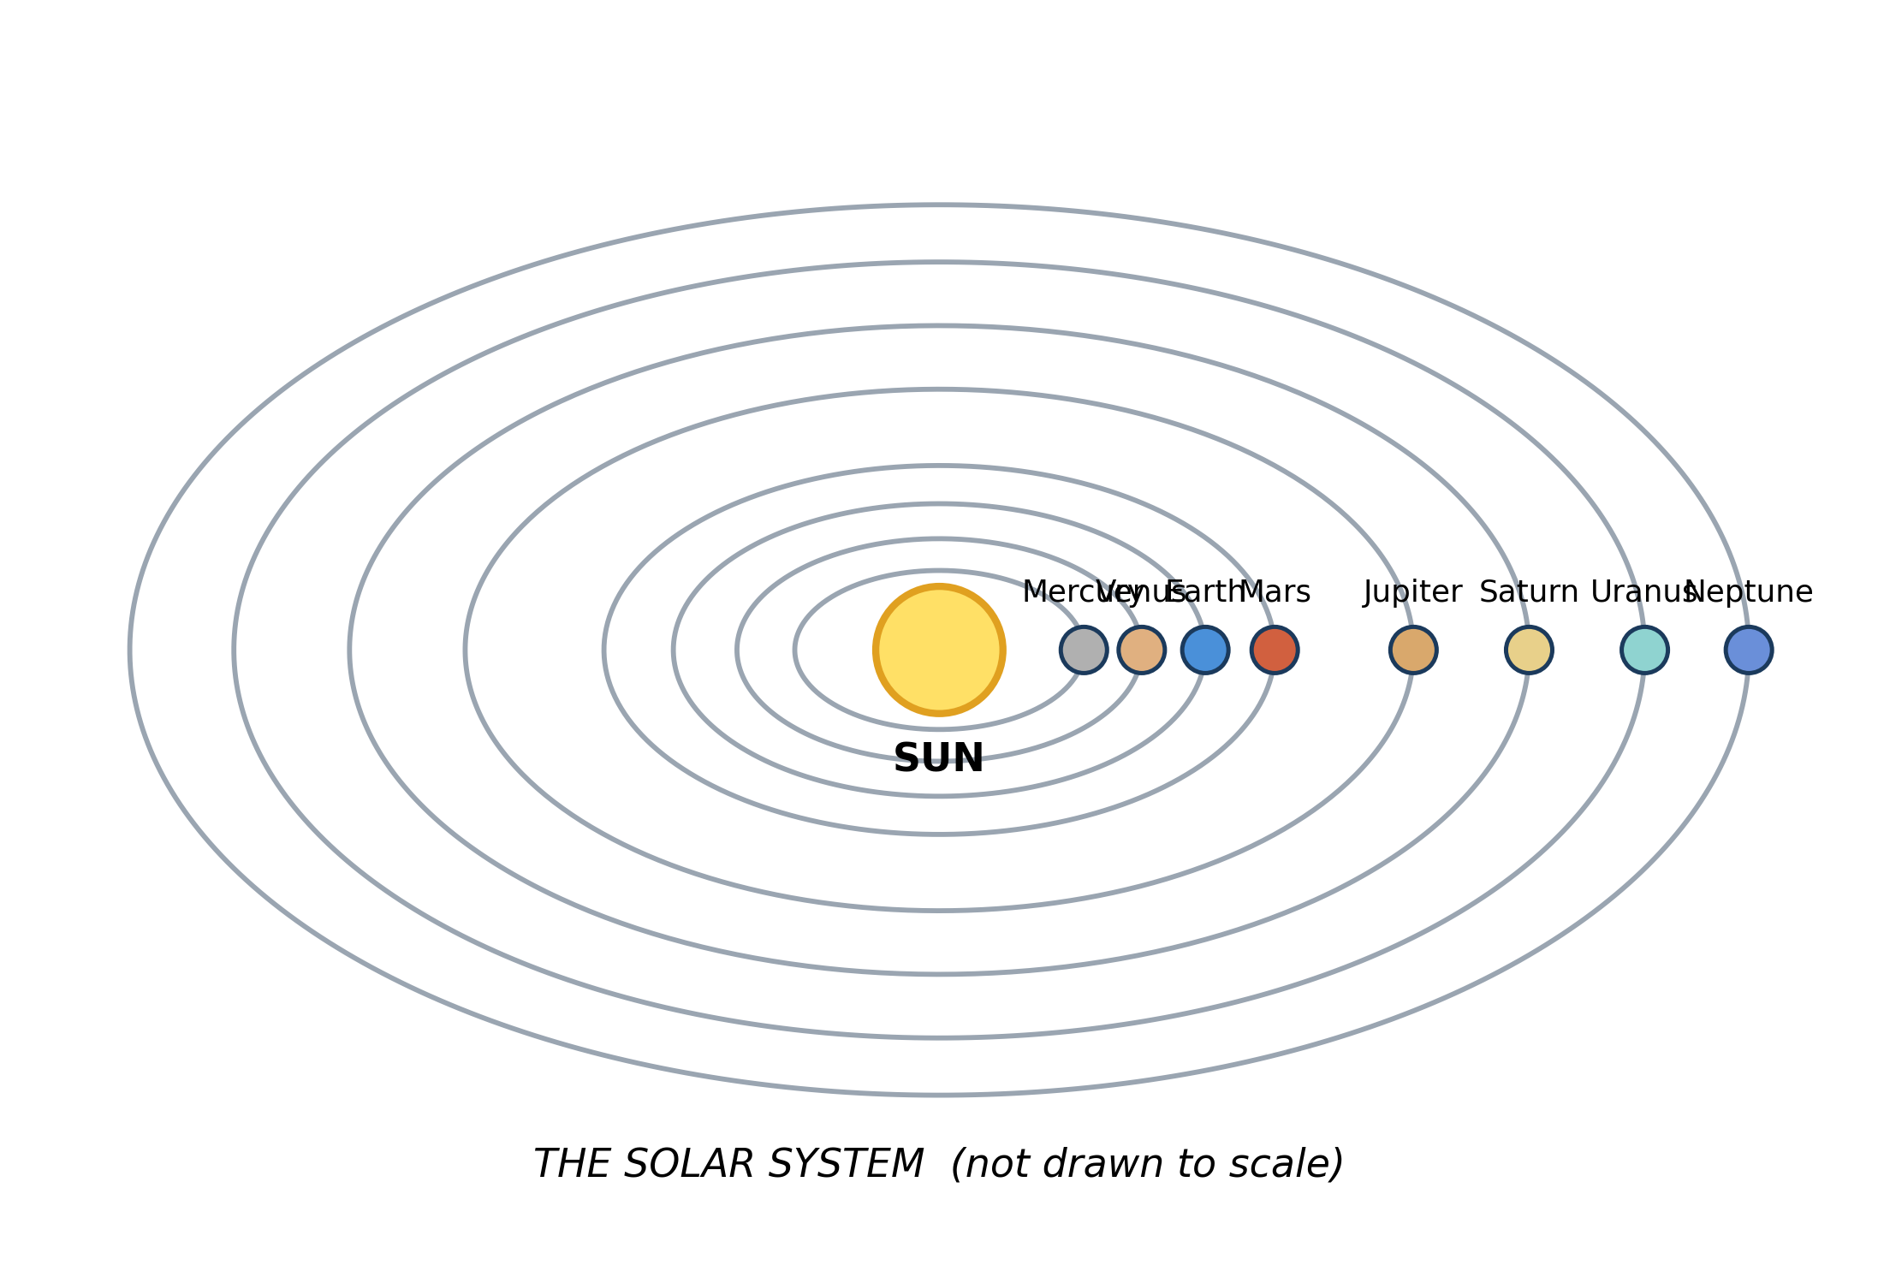
Fig. 1: The solar system

8.1 8.1 What is the Solar System?
1. State what is at the centre of the solar system, and use the diagram to explain why the planets do not fly off into space. [4 marks]
2. Use the diagram to state ONE way the four inner planets differ from the four outer planets, and explain the difference. [3 marks]
____________________________________________________________________________________________
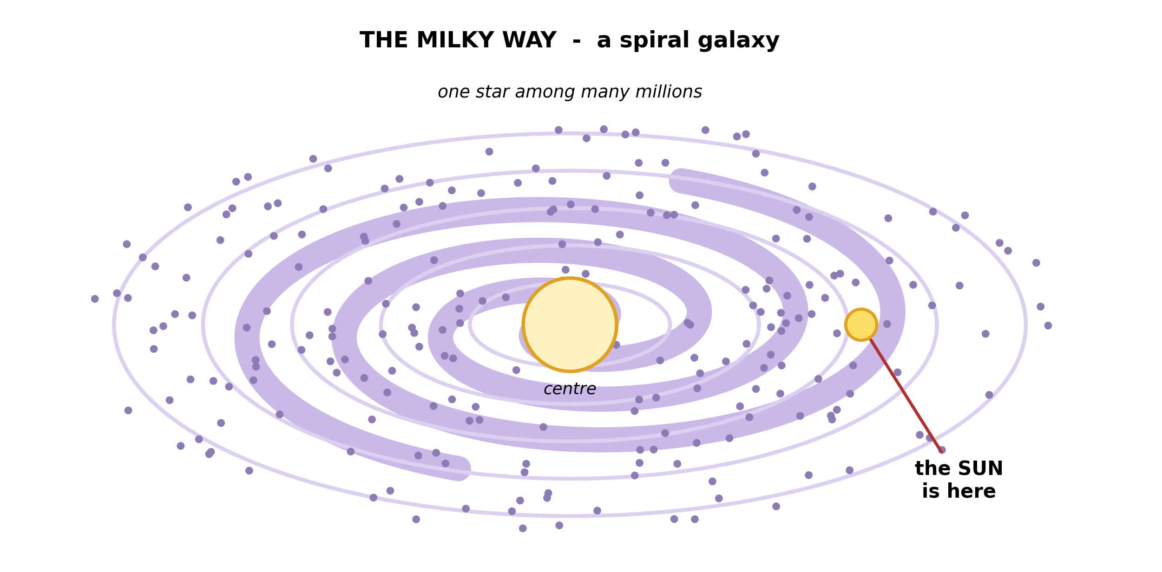
Fig. 2: The Milky Way galaxy

8.2 8.2 The Galaxy and the Milky Way
3. State what the Milky Way is, and mark or describe where the sun is in it. [3 marks]
4. A pupil says that the Milky Way and the solar system are the same thing seen from different places. Explain why this is wrong. [3 marks]
____________________________________________________________________________________________
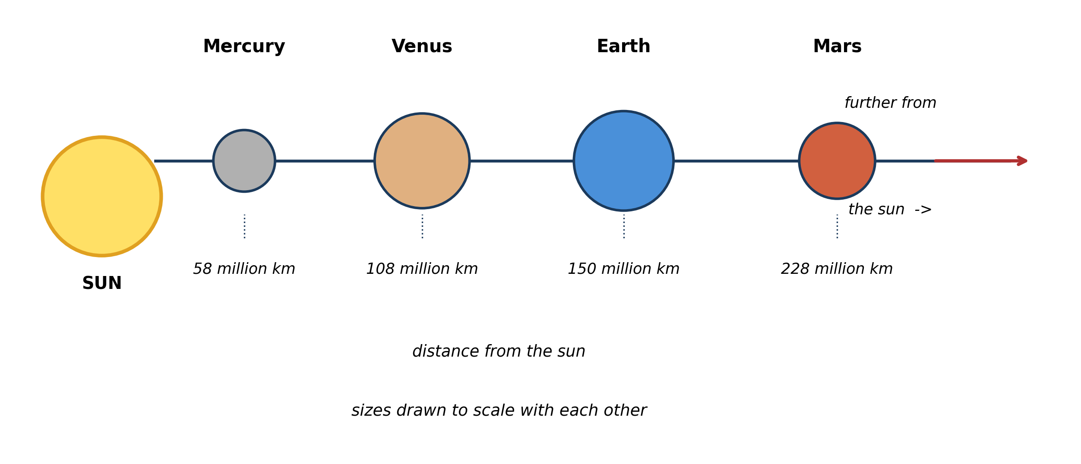
Fig. 3: The four inner planets

8.3 8.3 The Inner Planets: Mercury, Venus, Earth and Mars
5. From the diagram, list the four inner planets in order of distance from the sun, and state which one is nearest. [3 marks]
6. Use the diagram to explain why a YEAR on Mercury is much shorter than a year on the earth. [4 marks]
____________________________________________________________________________________________
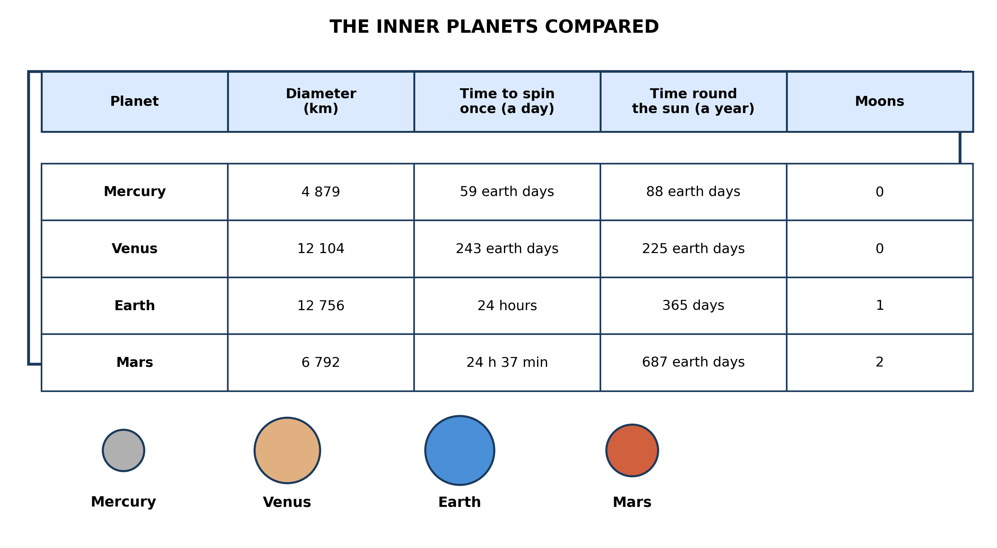
Fig. 4: The inner planets compared

8.4 8.4 Properties of the Inner Planets
7. Use the table to describe how the length of a YEAR changes as you move outwards from Mercury to Mars, and explain why. [4 marks]
8. The table shows that a DAY on Venus is longer than a YEAR on Venus. Explain how this can be true. [3 marks]
____________________________________________________________________________________________
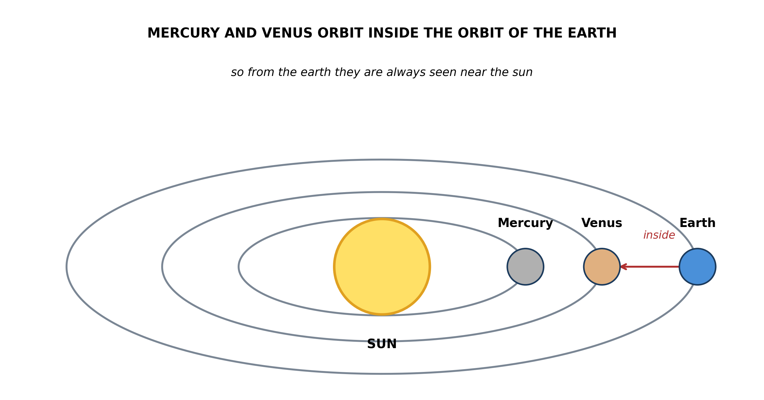
Fig. 5: The orbits of Mercury and Venus

8.5 8.5 Movement of Mercury and Venus Around the Sun
9. Use the diagram to explain why Mercury and Venus are always seen in the sky close to the sun, and are never seen in the middle of the night. [4 marks]
10. From the diagram, work out which of Mercury and Venus takes LESS time to go once round the sun, and explain how you can tell. [3 marks]
____________________________________________________________________________________________
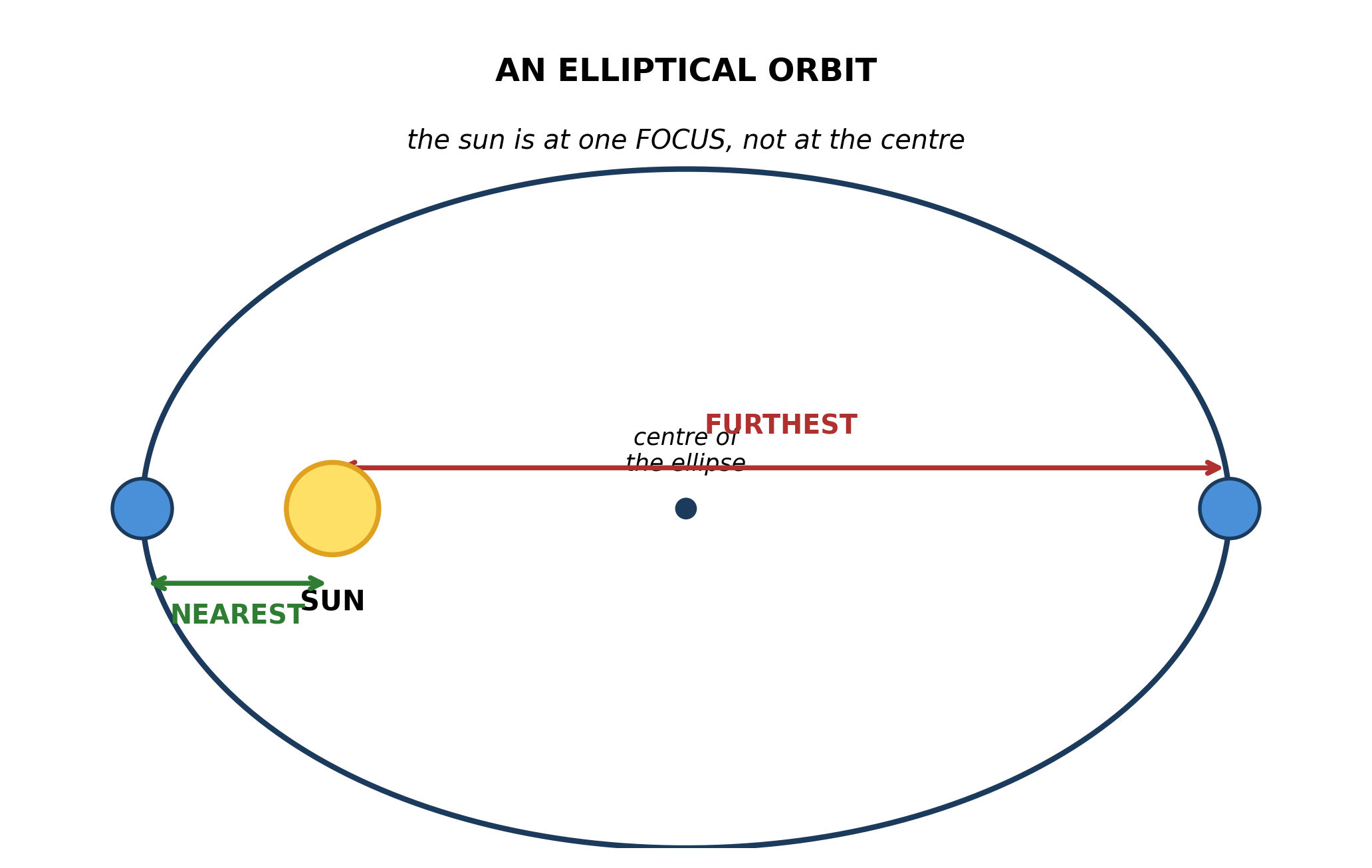
Fig. 6: An elliptical orbit

8.6 8.6 Elliptical Paths of the Planets
11. State what is meant by an ELLIPSE, and state where the sun is in the orbit shown. [3 marks]
12. Explain why the statement 'the earth is always exactly the same distance from the sun' is wrong, using the diagram. [3 marks]
____________________________________________________________________________________________
SECTION B - PRACTICAL TASK
Study the apparatus and answer the questions that follow it.
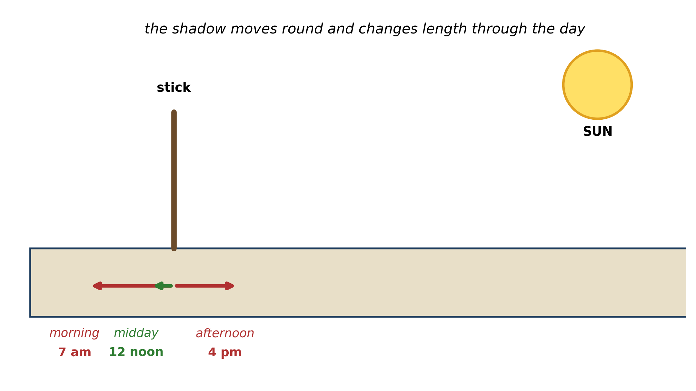
Fig. 7: Watching a shadow through the day

13. Describe how you would use a stick and the sun to show that the EARTH ROTATES, and explain how your observations show it. [4 marks]
14. Explain why the shadow is SHORTEST at midday. [3 marks]
15. State ONE source of error in this experiment, and say how you would reduce it. [3 marks]
____________________________________________________________________________________________

ANSWER KEY AND MARKING SCHEME
Accept any other correct and relevant answer. Award marks for correct points, not for repeating the question.
8.1 8.1 What is the Solar System?
Q1
The sun is at the centre. The sun's gravity pulls on every planet, and that inward pull is what holds each planet in its orbit. Without it, a planet would carry on in a straight line and travel off into space. Each planet is moving forwards, and the sun's pull bends that forward motion into a curve, so the planet goes round the sun instead of either falling into it or flying away.
Q2
Any one with an explanation. The inner four are small and rocky while the outer four are much bigger - the diagram shows the outer orbits are far apart and the planets drawn on them are larger. Or: the outer planets take far longer to go once round the sun, because their orbits are much larger so they have a much greater distance to travel. Or: the inner planets are hot and the outer ones cold, because the inner four are close to the sun.
8.2 8.2 The Galaxy and the Milky Way
Q3
The Milky Way is a galaxy - an enormous collection of many millions of stars held together by gravity. Our sun is ONE of those stars, and it sits out in one of the spiral arms, a long way from the centre of the galaxy, not at the centre of it.
Q4
They are completely different sizes of thing. The solar system is ONE star, the sun, together with the planets, moons and other bodies going round it. The Milky Way is a galaxy containing many millions of stars, and the sun is only one of them. So the solar system sits inside the Milky Way as a tiny part of it - they cannot be the same thing.
8.3 8.3 The Inner Planets: Mercury, Venus, Earth and Mars
Q5
Mercury, Venus, Earth, Mars. Mercury is nearest the sun.
Q6
A year is the time a planet takes to travel once round the sun. Mercury's orbit is much smaller than the earth's because Mercury is much closer to the sun, so it has a far shorter distance to cover. Mercury also travels faster along its orbit than the earth does. Smaller distance and greater speed both mean one complete journey round the sun takes far less time - 88 earth days against the earth's 365.
8.4 8.4 Properties of the Inner Planets
Q7
The year gets longer as you move outwards: 88 earth days on Mercury, 225 on Venus, 365 on Earth, 687 on Mars. The reason is that the further a planet is from the sun, the larger its orbit, so it has a greater distance to travel to get once round. The further planets also move more slowly along their orbits, so the journey takes longer still.
Q8
A day and a year are two completely separate movements, and their lengths do not have to be related. A day is the time the planet takes to spin once on its own axis; a year is the time it takes to travel once round the sun. Venus spins on its axis extremely slowly - more slowly than it goes round the sun - so one spin takes 243 earth days while one orbit takes only 225.
8.5 8.5 Movement of Mercury and Venus Around the Sun
Q9
Both orbits lie INSIDE the orbit of the earth, so Mercury and Venus are always in roughly the same direction from the earth as the sun is. We can therefore only ever see them near the sun in the sky - low in the west just after sunset, or low in the east just before sunrise. At midnight the sun, and with it the direction these planets lie in, is on the far side of the earth, so they cannot be seen then.
Q10
Mercury takes less time. The diagram shows Mercury's orbit is the smaller of the two, so Mercury is closer to the sun and has a shorter distance to travel to complete one orbit. A smaller orbit means a shorter journey, and so a shorter year.
8.6 8.6 Elliptical Paths of the Planets
Q11
An ellipse is an oval shape - like a circle that has been stretched out in one direction. In the orbit shown the sun is not at the centre of the ellipse but at one FOCUS, which is one of the two points set inwards from the ends of the oval.
Q12
Because the orbit is an ellipse and not a circle, and the sun sits at one focus rather than at the centre. That means one end of the orbit is nearer the sun than the other. The diagram shows this: the distance marked NEAREST is shorter than the distance marked FURTHEST, so the earth's distance from the sun changes as it goes round.
PRACTICAL TASK
Q13
Push a stick upright into flat, open ground. Mark the position of the tip of its shadow on the ground every hour, and note the time beside each mark. Through the day the shadow swings round and changes length - long in the morning, shortest at midday, long again in the evening, pointing the other way by late afternoon. The sun is not moving round the earth, so the only way the shadow can swing round like that is if the earth itself is turning. The pattern of marks is the record of the earth's rotation.
Q14
At midday the sun is higher in the sky than at any other time of the day - it is more nearly overhead. The higher the sun is, the more steeply its rays come down, and the more steeply they come down the shorter the shadow they cast. So the shortest shadow marks the moment the sun is highest.
Q15
Any one with a remedy. The ground may not be level, which tilts the stick and falsely changes the shadow length - check with a spirit level or choose the flattest ground you can find. The tip of the shadow is fuzzy and hard to mark exactly - mark the middle of the fuzzy edge, and have the same person judge it every time. The stick may lean over during the day - check it stays upright. Cloud may hide the sun for part of the day - choose a clear day, or repeat on another day and compare.

BLUEPRINT / TEST SPECIFICATION
# | Content standard | Code | Items | Marks | % of Marks
8.1 | 8.1 What is the Solar System? | B7/JHS1.3.2.1 | 2 | 7 | 14%
8.2 | 8.2 The Galaxy and the Milky Way | B7/JHS1.3.2.1 | 2 | 6 | 12%
8.3 | 8.3 The Inner Planets: Mercury, Venus, Earth and Mars | B7/JHS1.3.2.1 | 2 | 7 | 14%
8.4 | 8.4 Properties of the Inner Planets | B7/JHS1.3.2.1 | 2 | 7 | 14%
8.5 | 8.5 Movement of Mercury and Venus Around the Sun | B7/JHS1.3.2.1 | 2 | 7 | 14%
8.6 | 8.6 Elliptical Paths of the Planets | B7/JHS1.3.2.1 | 2 | 6 | 12%
8.1 | Practical task | B7/JHS1.3.2.1 | 3 | 10 | 20%
TOTAL | - | - | 15 | 50 | 100%
Distribution by cognitive level
Cognitive level | Marks | % of Marks
Understand | 12 | 24%
Apply | 21 | 42%
Analyse | 17 | 34%
TOTAL | 50 | 100%
Distribution by difficulty
Difficulty | Marks | % of Marks
Easy | 9 | 18%
Moderate | 22 | 44%
Challenging | 19 | 38%
TOTAL | 50 | 100%

QUALITY-CONTROL SUMMARY
1. Is every question answered from a diagram?
Yes. All 15 questions sit under a figure, and each is unanswerable - or at least materially harder - without reading it. Questions 3, 8, 10 and 17 ask pupils to go beyond the diagram, but each still starts from something the figure shows.
2. Is the content within the Basic 7 curriculum?
Yes. Every question traces to the content standards for this sub-strand (B7/JHS1.3.2.1), and nothing is tested beyond the depth the Basic 7 syllabus sets for it.
3. Are the diagrams clear and unambiguous?
Yes. Each is drawn so that only one reading is sensible: the particle boxes differ in spacing alone, the syringes are labelled with how far each squashes, and the periodic table marks the regions in words as well as by position.
4. Is the level right for JHS 1?
Yes. Questions ask pupils to read, describe and explain what is drawn. Only Question 17 asks for an inference beyond the figure, and it is worth 3 of the 40 marks.
5. Do the marks add up?
Yes: 15 questions totalling 50 marks, matching the figure on the front page. The blueprint, cognitive and difficulty tables all sum to the same total.
6. Are the answers correct and complete?
Yes. Each answer states the point the question is worth, with the acceptable alternatives given where a question is open.
EXAMINER NOTES (for the teacher, not for candidates)
- Pitched at the compulsory diagram question of BECE Paper 2: 70% of the marks are at Apply level or above and 38% are Challenging.
- Q1 is the one pupils answer with 'gravity' and nothing else, and they score one of four. To get the rest they must say what the pull DOES: it bends the planet's forward motion into a curve, so the planet neither falls into the sun nor flies off in a straight line. Teach it as 'forwards plus inwards equals around'.
- Q4 on the Milky Way against the solar system is the confusion I meet most. Pupils use the two words interchangeably. The scale contrast is the cure: the solar system has one star, the galaxy has millions, and the sun is one of them.
- Q8 - a day on Venus longer than its year - is the best 'explain how this can be true' question in the paper, because the answer is that the two movements are independent. Pupils assume a year must be longer than a day and are stuck. Venus spins so slowly that it breaks the assumption.
- Q9, on why Mercury and Venus are never seen at midnight, is genuinely hard and needs the diagram. Their orbits are inside ours, so their direction from us is always close to the sun's direction. Very few pupils reach this without seeing Fig. 5.
- The shadow-stick practical in Fig. 7 is the best astronomy practical available to a school with no equipment at all - a stick, some chalk and a level playground. Run it across a whole school day with hourly marks and Q13 to Q15 become straightforward. It also gives pupils a real record of rotation rather than a diagram they have to believe.
- Note on Q11: 'oval' is worth one mark, but the point pupils miss is the FOCUS - the sun is off-centre, which is exactly why the distance changes in Q12. The two questions are a pair; teach them together.

