[SCHOOL NAME]
INTEGRATED SCIENCE (SCIENCE)
PRACTICAL QUESTIONS - DIAGRAM MODE
Waste Management (16.1 - 16.4)
____________________________________________________________________________________________
CLASS: Basic 7 (JHS 1)
TIME: 1 hour 30 minutes
MARKS: 50 2025/2026 Academic Year
____________________________________________________________________________________________
INSTRUCTIONS TO CANDIDATES
1. Answer ALL the questions in this paper.
2. Every question is based on a diagram. Study each diagram carefully before you answer the questions that follow it.
3. Write your answers in the spaces provided. The marks for each question are printed beside it.
4. Where a question asks for a stated number of points, give that number. Any extra answers will not be marked.
5. You may refer back to any diagram at any time.
____________________________________________________________________________________________
SECTION A - DIAGRAM STUDY
Study each diagram and answer the questions that follow it.
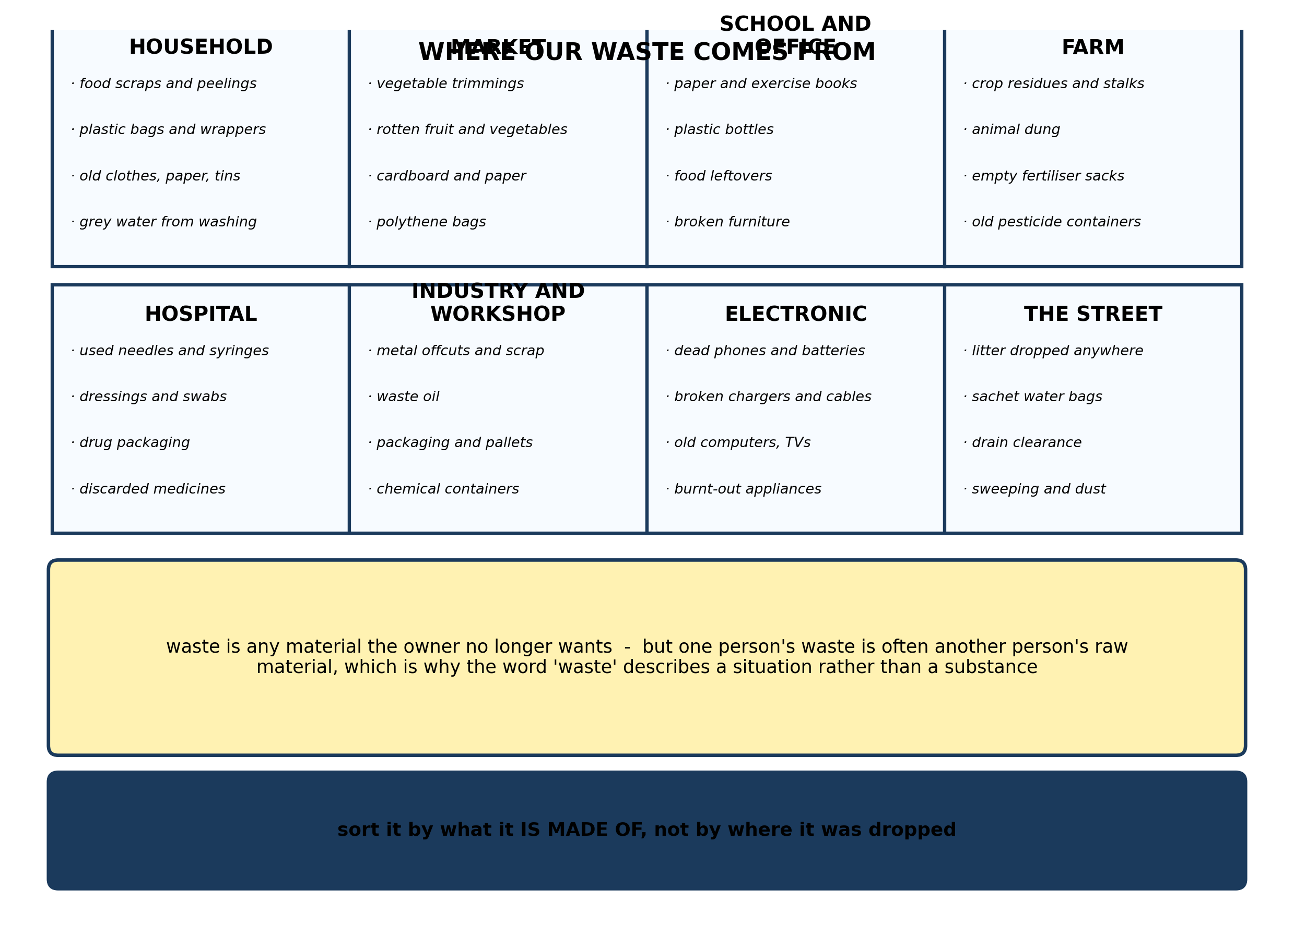
Fig. 1: Where our waste comes from

16.1 16.1 Types of Waste in the Environment
1. Explain why it is better to sort waste by the MATERIAL it is made of rather than by the place it was found, and give an example of two very different wastes produced in the same place. [4 marks]
2. Name THREE sources of waste. [3 marks]
3. For each of the following, say where it comes from and what it is mainly made of: (a) an empty pesticide container; (b) a sachet water bag; (c) a heap of vegetable trimmings. [3 marks]
____________________________________________________________________________________________
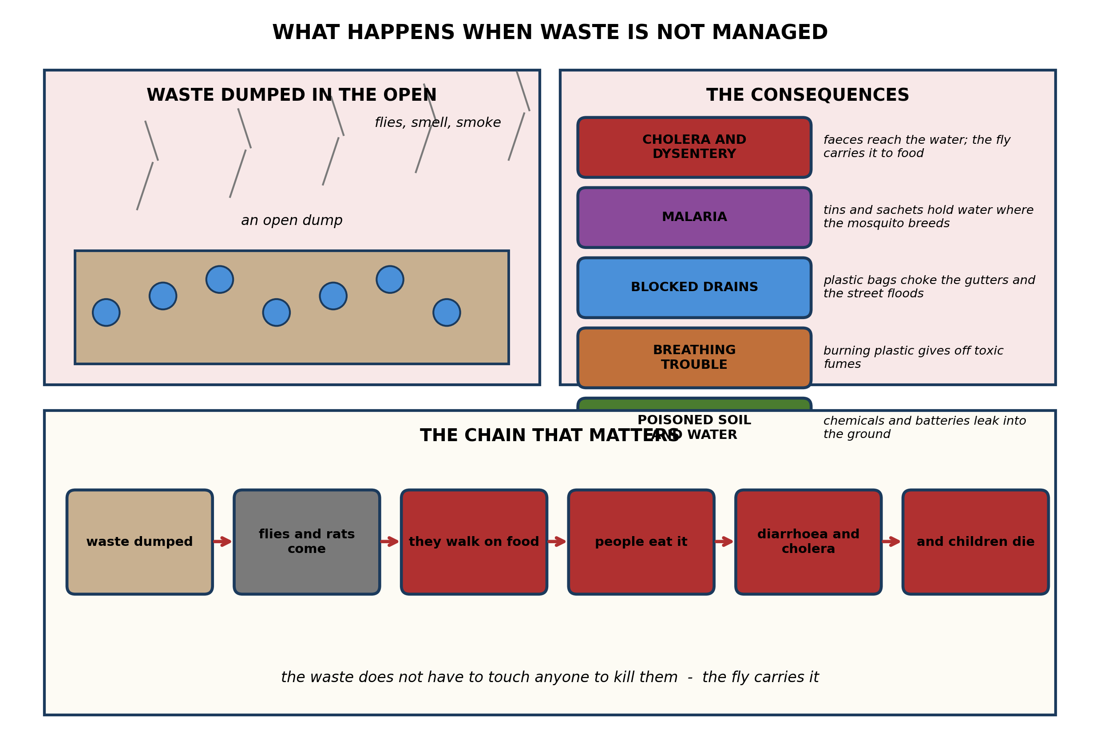
Fig. 2: What happens when waste is not managed

16.2 16.2 Good Waste Management Practices
4. Explain how a heap of household rubbish that nobody touches can give a child cholera. [4 marks]
5. State THREE effects of poor waste management on health. [3 marks]
6. A town's drains are choked with plastic bags and the streets flood every time it rains. Suggest TWO things the town should do, and explain how each helps. [3 marks]
____________________________________________________________________________________________
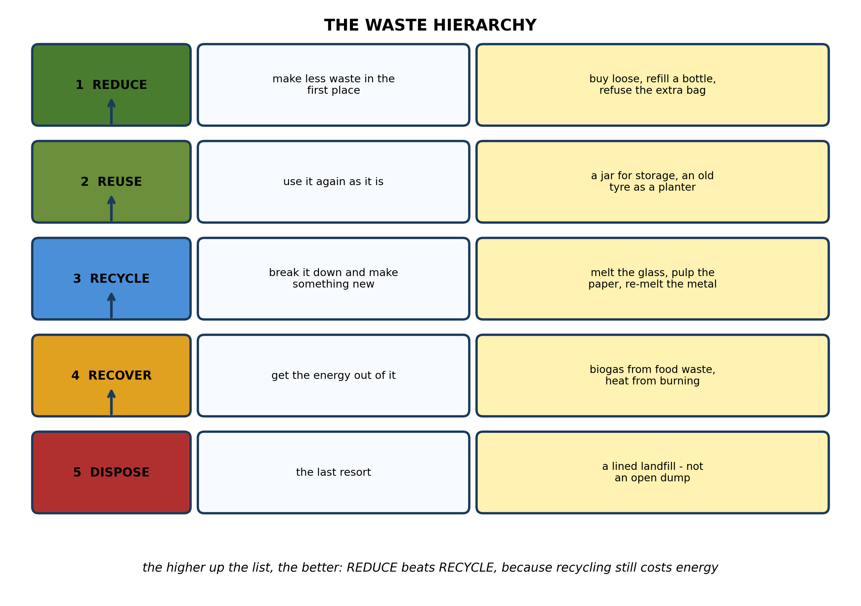
Fig. 3: The waste hierarchy

16.3 16.3 The Science Behind Waste Management
7. The diagram puts REDUCE above RECYCLE. Explain why reducing waste is better than recycling it, even when the recycling works perfectly. [4 marks]
8. For each of the following, say whether it is an example of REDUCE, REUSE or RECYCLE, and give a reason: (a) taking a cloth bag with you when you shop; (b) melting old glass to make new bottles; (c) using an old tyre as a planter. [3 marks]
9. State what is meant by RECYCLING, and name TWO materials that are commonly recycled. [3 marks]
____________________________________________________________________________________________
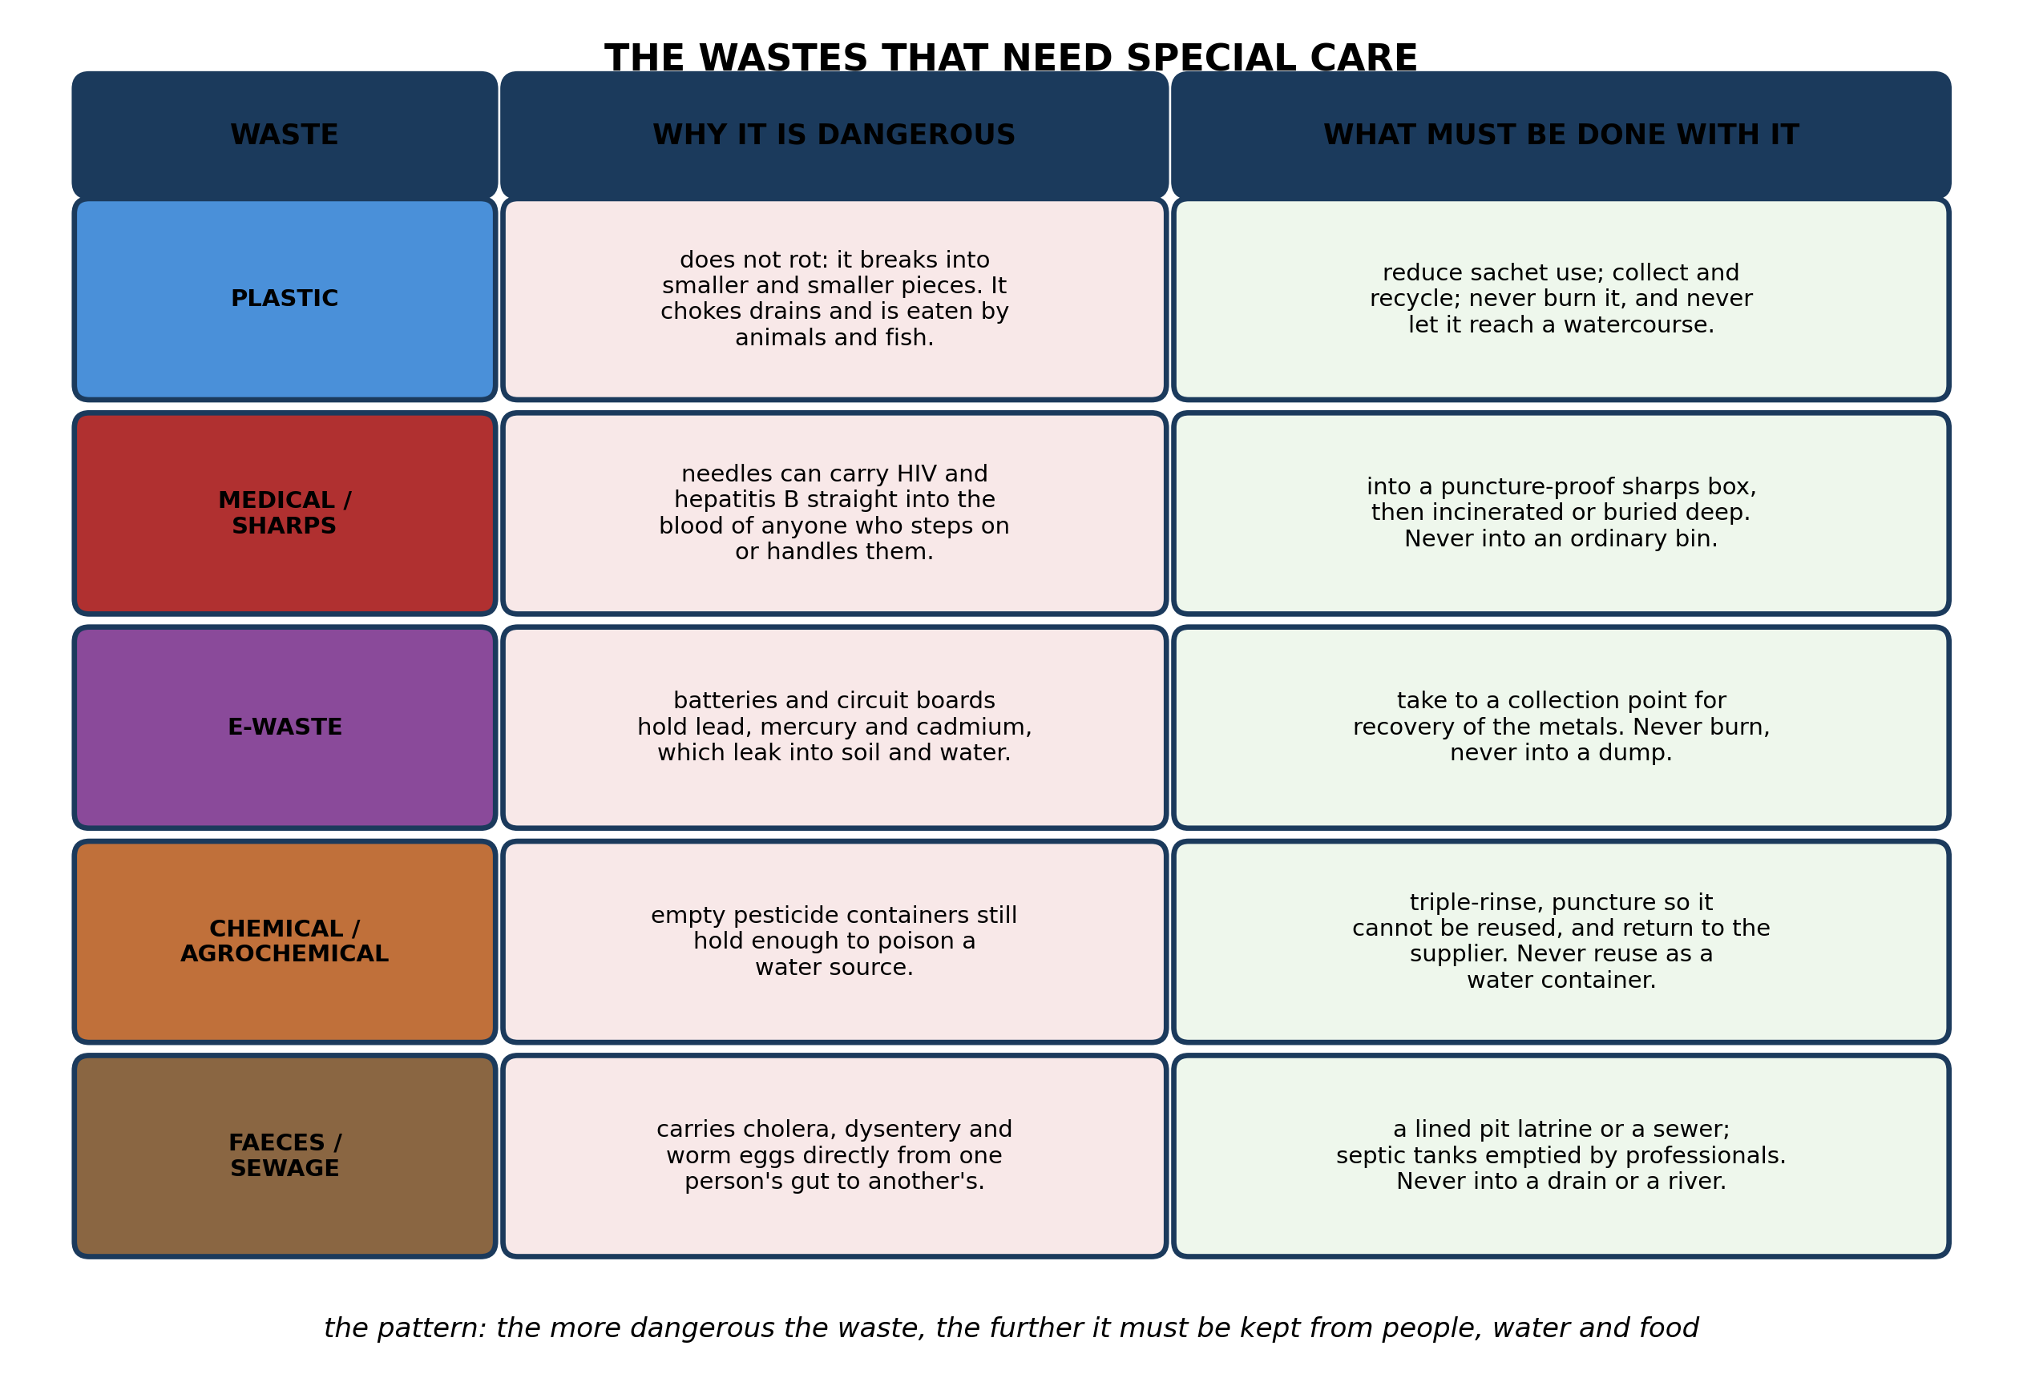
Fig. 4: The wastes that need special care

16.4 16.4 Community Waste Management Projects
10. Explain why a USED NEEDLE needs completely different handling from a FOOD SCRAP, and describe exactly what should be done with each. [4 marks]
11. Explain why an EMPTY PESTICIDE CONTAINER must never be reused to store drinking water, and describe what should be done with it. [3 marks]
12. State why E-WASTE is dangerous, and name TWO items that count as e-waste. [3 marks]
____________________________________________________________________________________________
SECTION B - PRACTICAL TASK
Study the apparatus and answer the questions that follow it.
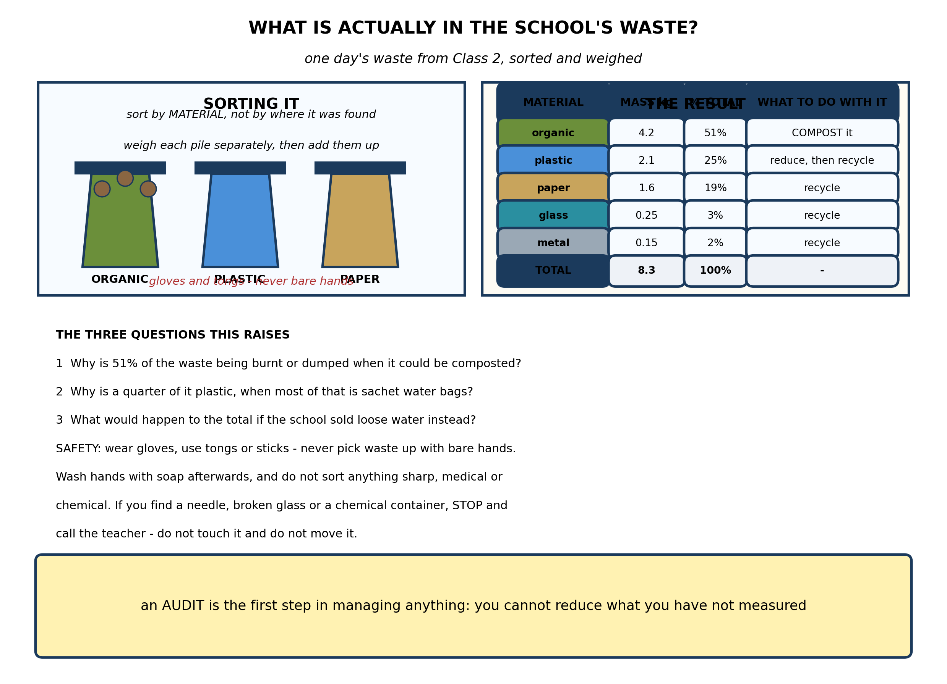
Fig. 5: What is actually in the school's waste?

13. From the results, explain what the audit shows about the school's waste, and explain why MEASURING the waste changes what can be done about it. [4 marks]
14. The school decides to compost the organic fraction. Describe what should be done with it, and explain TWO conditions the heap needs. [3 marks]
15. A quarter of the waste is sachet water bags. Suggest TWO things the school could do to reduce this, and explain the difficulty with each. [3 marks]
____________________________________________________________________________________________

ANSWER KEY AND MARKING SCHEME
Accept any other correct and relevant answer. Award marks for correct points, not for repeating the question.
16.1 16.1 Types of Waste in the Environment
Q1
Sorting by where the waste was found tells you who dropped it, but nothing about what to do with it. Sorting by material tells you what the substance actually is, and therefore what can be done with it: whether it rots, whether it can be melted and remade, whether it is dangerous to touch. A hospital produces both used needles and food scraps from its kitchen. The needles must go into a puncture-proof sharps box and be incinerated; the food scraps can simply be composted. If you sorted them together as 'hospital waste' you would either have to treat both as infectious, which is expensive, or treat both as ordinary, which is dangerous. The material, not the address, decides the disposal route.
Q2
Any three of: household, market, school or office, farm, hospital, industry or workshop, electronic, the street.
Q3
(a) From a farm; made of plastic, with chemical residue still inside. (b) From a household or dropped in the street; made of polythene film, a plastic. (c) From a market or a kitchen; made of plant material, so it is organic and will rot.
16.2 16.2 Good Waste Management Practices
Q4
The rubbish contains faeces - from nappies, from a latrine that has overflowed, from animals. Flies breed in it and then land on food laid out in the house or the market, carrying the bacteria on their feet and mouthparts and depositing them when they feed. The child eats the food and the bacteria reach the gut. Or rain washes the waste into a stream or an open well that the family draws water from, and the child drinks it. Either way the waste never touches the child: the fly, or the water, carries it. That is why the remedy is not to keep children away from the dump - it is to separate faeces from flies and from water in the first place, which means a proper latrine and proper collection.
Q5
Any three, each stated. Cholera and dysentery, spread by flies and by contaminated water. Malaria, because discarded tins and sachets hold water in which mosquitoes breed. Breathing trouble and coughs from the fumes of burning plastic. Blocked drains, which flood the street and leave standing water. Poisoning of soil and water by chemicals and batteries.
Q6
Any two, each explained. Clear the drains and keep them clear, so that water can run away instead of ponding and breeding mosquitoes. Reduce the plastic at source - discourage or ban single-use polythene bags and promote reusable ones - so that the drains do not choke again within a month. Provide enough bins and a reliable collection, so that plastic has somewhere to go other than the gutter. Fit gratings over drain entrances to catch bags before they get in.
16.3 16.3 The Science Behind Waste Management
Q7
Because recycling is not free. Collecting the material, transporting it, sorting it, washing it and then reprocessing it all take energy, and the reprocessing produces waste of its own: paper fibres get shorter every time they are pulped, and plastic degrades every time it is melted. Reducing means the material was never made into a throwaway product in the first place, so none of that is spent - no collection, no transport, no reprocessing, no losses. A bottle refilled a hundred times costs a fraction of a hundred bottles recycled a hundred times. That is why the hierarchy runs reduce, reuse, recycle, recover, dispose: the higher up the list, the less energy is spent and the less waste is created. Recycling is what you do with material you failed to avoid making.
Q8
(a) REDUCE - you avoid taking a new bag, so less waste is created in the first place. (b) RECYCLE - the glass is broken down and reprocessed into something new, which costs energy. (c) REUSE - the tyre is used again just as it is, with no reprocessing at all.
Q9
Recycling is collecting a waste material, reprocessing it, and making it into a new product, so that the material is used again instead of being thrown away. Any two commonly recycled materials: paper and card, glass, metals such as aluminium cans and scrap iron, and some plastics.
16.4 16.4 Community Waste Management Projects
Q10
A food scrap will rot. It is organic and harmless, and left to decompose it becomes compost that can be dug into the garden. A used needle can carry HIV or hepatitis B in the trace of blood inside the barrel, and it delivers that blood straight through the skin into the bloodstream of anyone who steps on it or picks it up. So the two are at opposite ends of the danger scale and cannot go into the same bin. The food scrap goes into a compost pit or an organic waste bin and ends up as manure. The needle goes straight into a puncture-proof sharps box - never into an ordinary bin, where it will injure whoever empties it - and the sealed box is then incinerated or buried deep. The general rule is that the more dangerous the waste, the further it must be kept from people, water and food.
Q11
An empty container still holds a film of the concentrate, visible or not, and rinsing it once leaves more than enough chemical behind to poison anyone who drinks from it. These containers are also attractive to children and look exactly like water containers, which is how accidental poisoning usually happens. What should be done: triple-rinse it, pouring the rinse water into the spray tank so it is used rather than spilled; then puncture or crush it so that nobody can ever reuse it; and return it to the supplier or a designated collection point. It must never be burnt, because the fumes are toxic, and never thrown into a river or the bush.
Q12
Electronic waste contains heavy metals and other hazardous substances - lead in solder and screens, mercury in some switches and lamps, cadmium in batteries. When the item is dumped these leak into the soil and the water; if it is burnt they give off toxic fumes. Any two items: mobile phones, batteries, chargers and cables, computers, televisions, radios, burnt-out appliances.
PRACTICAL TASK
Q13
The audit shows that more than half the waste - 4.2 kg out of 8.3 kg, or 51% - is organic material that rots, and so could be composted rather than burnt or dumped. A further 44% is paper, plastic and glass that could be recycled. Only a small fraction cannot be diverted at all. A quarter of everything is plastic, and most of that is sachet water bags, which points at one specific habit rather than at waste in general. The total is about 0.4 kg per pupil per day, which gives the school a figure to compare against next term. None of this was visible before the weighing. Measuring changes what can be done because you cannot manage what you have not measured. Without the figures, 'we produce too much waste' is a complaint; with them it becomes a target - compost the 4.2 kg, cut the sachets, re-measure in a month and see whether it worked.
Q14
The organic waste should go into a compost pit or heap in layers: a layer of green material such as food scraps and vegetable trimmings, alternating with a layer of dry material such as dry leaves, straw or shredded paper, and turned over every week or two. Two conditions: it must be kept moist but not waterlogged, because the micro-organisms and detritivores doing the rotting need water and cannot work in dry material; and it must have air, which is why it is turned over and why the dry material is layered in to hold the heap open instead of letting it collapse into a slimy, airless, smelly mass. Given both, the heap heats up and the material breaks down into dark crumbly humus in a few months, which the school can dig into its garden.
Q15
Any two, each with a difficulty. Sell or provide water in cups or from a dispenser instead of sachets, so that no plastic is produced at all - the difficulty is that this needs a clean water supply on site, cups that have to be washed, and someone to manage it. Ask pupils to bring a refillable bottle and install a refill point - the difficulty is that pupils forget the bottle, and some families cannot afford one. Collect the sachets for recycling - the difficulty is that sachet film is of low value and hard to recycle, so a collector must be found and paid or the scheme collapses. Ban sachets on the premises - the difficulty is enforcement, and the waste may simply move outside the gate.

BLUEPRINT / TEST SPECIFICATION
# | Content standard | Code | Items | Marks | % of Marks
16.1 | 16.1 Types of Waste in the Environment | B7/JHS1.5.1.1 | 3 | 10 | 20%
16.2 | 16.2 Good Waste Management Practices | B7/JHS1.5.1.1 | 3 | 10 | 20%
16.3 | 16.3 The Science Behind Waste Management | B7/JHS1.5.1.1 | 3 | 10 | 20%
16.4 | 16.4 Community Waste Management Projects | B7/JHS1.5.1.1 | 3 | 10 | 20%
16.1 | Practical task | B7/JHS1.5.1.1 | 3 | 10 | 20%
TOTAL | - | - | 15 | 50 | 100%
Distribution by cognitive level
Cognitive level | Marks | % of Marks
Understand | 12 | 24%
Apply | 22 | 44%
Analyse | 16 | 32%
TOTAL | 50 | 100%
Distribution by difficulty
Difficulty | Marks | % of Marks
Easy | 3 | 6%
Moderate | 27 | 54%
Challenging | 20 | 40%
TOTAL | 50 | 100%

QUALITY-CONTROL SUMMARY
1. Is every question answered from a diagram?
Yes. All 15 questions sit under a figure, and each is unanswerable - or at least materially harder - without reading it. Questions 3, 8, 10 and 17 ask pupils to go beyond the diagram, but each still starts from something the figure shows.
2. Is the content within the Basic 7 curriculum?
Yes. Every question traces to the content standards for this sub-strand (B7/JHS1.5.1.1), and nothing is tested beyond the depth the Basic 7 syllabus sets for it.
3. Are the diagrams clear and unambiguous?
Yes. Each is drawn so that only one reading is sensible: the particle boxes differ in spacing alone, the syringes are labelled with how far each squashes, and the periodic table marks the regions in words as well as by position.
4. Is the level right for JHS 1?
Yes. Questions ask pupils to read, describe and explain what is drawn. Only Question 17 asks for an inference beyond the figure, and it is worth 3 of the 40 marks.
5. Do the marks add up?
Yes: 15 questions totalling 50 marks, matching the figure on the front page. The blueprint, cognitive and difficulty tables all sum to the same total.
6. Are the answers correct and complete?
Yes. Each answer states the point the question is worth, with the acceptable alternatives given where a question is open.
EXAMINER NOTES (for the teacher, not for candidates)
- Pitched at the compulsory diagram question of BECE Paper 2: 76% of the marks are at Apply level or above and 40% are Challenging.
- Q7 on why reduce beats recycle is the intellectual centre of 16.3, and it is the question pupils are least prepared for because every poster they have seen says 'reduce, reuse, recycle' in that order without saying why. The answer is that recycling is not free: collection, transport, sorting and reprocessing all cost energy, and the material degrades each time round. Reducing means none of that was ever spent.
- Q4 on the fly is the best question in 16.2. Pupils assume waste harms you by contact. It mostly does not - it harms you because something carries it. Once they see the chain (dump, flies, food, gut), the whole of sanitation makes sense, and so does the fact that a pit latrine is a waste-management measure rather than a building.
- Q10 on the needle versus the food scrap is deliberately extreme so that the principle shows: the more dangerous the waste, the further it must be kept from people, water and food. That single sentence answers every question in 16.4.
- The waste audit is the most useful practical in the whole strand and the one a school can most easily repeat. You need gloves, tongs, a spring balance or kitchen scales, and a tarpaulin or concrete area to sort on. Brief the class hard beforehand about sharp and medical waste: the rule is stop, do not touch, call the teacher.
- Weighing is what turns this from a tidy-up into data. If you have only one set of scales, weigh each category in turn as the pile is sorted rather than trying to weigh five piles at once.
- Repeat the audit a term later, after whatever changes the class decided on. A number that goes down is worth more to pupils than any poster.

