GHANA EDUCATION SERVICE
WEEKLY LESSON NOTES
MATHEMATICS • BASIC 7 • TERM 1
Twenty-four lesson notes in the GES standards-based format
Every curriculum field pre-filled from the NaCCA Common Core Programme curriculum (February 2020)
School
Name of teacher
Class | Basic 7
Subject | Science
Term / Year | Term 1, 2026/2027

How to use these notes

This volume re-cuts the twenty-four lessons of “Basic 7 Science — Term 1: Comprehensive Lesson Plan and Teaching Guide” into the layout GES expects a teacher to keep and submit. The content is the same; only the format differs.
What is already filled in
- Every curriculum field. Strand, sub-strand, content standard, learning indicator, performance indicator and learning outcomes — quoted verbatim from the NaCCA Science Curriculum for the Common Core Programme (Basic 7–10), February 2020, with the page reference.
- Essential questions. Two per lesson, written in learner language.
- Preparation fields. Key words, prior knowledge, teaching and learning resources, pedagogical exemplars, core competencies.
- The lesson itself. The five 5E phases with timings, teacher activities, learner activities and an assessment column.
- Differentiation. Approaching proficiency (AP), proficient (P) and highly proficient (HP) — the three groups the standards-based curriculum requires you to plan for.
What you complete yourself
- The admin block. Week ending, day, date, period and class size — the blue header rows on every note.
- The bottom of each note. Reflection, remarks and the signature row, after you have taught.
Two notes before you start
- Duration. These notes are written for a 60-minute period, which is what the Term 1 scheme assumes for two lessons a week. If your school runs 40-minute periods, split each note at the EXPLAIN phase: ENGAGE and EXPLORE in the first period, EXPLAIN, ELABORATE and EVALUATE in the second. The timings in the first column assume 60 minutes.
- Where the scheme repeats itself. The scheme as circulated lists B7.1.3.3.1–.2 for BOTH Week 11 and Week 12 — a copy error. Content standard B7.1.3.3 has four indicators, and the second half (dividing fractions) appears nowhere in the scheme at all. These notes therefore teach B7.1.3.3.1–.2 in Week 11 and B7.1.3.3.3–.4 in Week 12, so that the whole standard is covered and no lesson repeats another.
- One strand, twelve weeks. Term 1 Mathematics is entirely the Number strand — twelve weeks on Numeration, Operations and Fractions. There is no Geometry, no Algebra and no Handling of Data until Term 2. Say so to learners who ask; it helps them see the term as one long argument about how numbers work.
Term at a glance
Wk | Lesson titles | Strand | Indicator(s) | Lessons
1 | Modelling Numbers Beyond One Billion; Comparing and Ordering Huge Numbers | Number | B7.1.1.1.1–.2 | L1–L2
2 | Rounding Whole Numbers; Rounding Decimals | Number | B7.1.1.1.3–.4 | L3–L4
3 | Decimal Places and Significant Figures; Multiplying and Dividing by Powers of Ten | Number | B7.1.1.1.5; B7.1.2.1.1 | L5–L6
4 | Mental Mathematics Strategies; Mental Strategies for Word Problems | Number | B7.1.2.1.2–.3 | L7–L8
5 | Adding and Subtracting Four-Digit Numbers; Multiplying and Dividing Multi-Digit Numbers | Number | B7.1.2.2.1–.2 | L9–L10
6 | Story Problems with Decimals; Repeated Factors — The Idea of Powers | Number | B7.1.2.2.3; B7.1.2.3.1 | L11–L12
7 | Writing Numbers as Products and Powers; The Zero Index | Number | B7.1.2.3.2–.3 | L13–L14
8 | Evaluating Numbers in Index Form; Prime Factors and the HCF | Number | B7.1.2.3.4–.5 | L15–L16
9 | Benchmark Fractions, Decimals and Percentages; Comparing and Ordering Fractions | Number | B7.1.3.1.1–.2 | L17–L18
10 | Adding and Subtracting Unlike and Mixed Fractions; Solving Problems with Fractions | Number | B7.1.3.2.1–.2 | L19–L20
11 | Multiplying Fractions; Finding a Fraction of a Quantity | Number | B7.1.3.3.1–.2 | L21–L22
12 | Dividing Fractions; Dividing Quantities and Fractions by Fractions | Number | B7.1.3.3.3–.4 | L23–L24

Weeks 13 to 15 are revision, end-of-term examination and vacation; no new lesson notes are required.

BASIC 7 MATHEMATICS • TERM 1 • WEEKLY LESSON NOTE
LESSON 1 of 24 — Modelling Numbers Beyond One Billion
Week 1 • Number • Numeration Systems • B7.1.1.1.1 • 60 minutes
WEEK ENDING | DAY | DATE | PERIOD | DURATION | CLASS | SUBJECT
 |  |  |  | 60 min | Basic 7 | Mathematics

CLASS SIZE — BOYS | CLASS SIZE — GIRLS | CLASS SIZE — TOTAL

STRAND | Number
SUB-STRAND | Numeration Systems
CONTENT STANDARD | B7.1.1.1 — Demonstrate understanding and the use of place value for expressing quantities recorded as base ten numerals as well as rounding these to given decimal places and significant figures.
LEARNING INDICATOR(S) | B7.1.1.1.1 — Model number quantities more than 1,000,000,000 using graph sheets, isometric papers and multi-base blocks.
PERFORMANCE INDICATOR  (what learners will do) | Learners model and read whole numbers greater than one billion using multi-base blocks, graph sheets and place-value charts.
LEARNING OUTCOMES  (knowledge / skill / value) | • K — state the place-value columns from ones to billions and read any number up to billions.  • S — model a given number greater than one billion with blocks or a chart, and write it in figures and in words.  • A/V — appreciate that very large numbers describe real things — national budgets, populations, distances — and must be read accurately.
CORE COMPETENCIES | Critical Thinking and Problem Solving (CP); Communication and Collaboration (CC).
KEY WORDS | billion, million, place value, period, digit, multi-base block, numeral, expanded form, model
ESSENTIAL QUESTIONS | 1. How big is a billion, really?  2. How do I read a number this long?
PRIOR KNOWLEDGE (R.P.K.) | From Basic 4–6 learners read and write numbers to millions and know the place-value columns up to millions. They have used bundle sticks and base-ten blocks for smaller numbers.
TEACHING / LEARNING RESOURCES  (TLMs) | Multi-base blocks or bundle sticks in bundles of ten; graph paper; a large place-value chart to billions; number cards 0–9; GH₵ notes (20, 50, 100, 200) for the money model; Figure 1.1 enlarged.
PEDAGOGICAL EXEMPLARS (methods) | Inquiry (5E); concrete – pictorial – abstract (CPA) with manipulatives; cooperative group work; questioning and discussion; differentiation by task, support and outcome
REFERENCE | NaCCA Mathematics Curriculum for the Common Core Programme (Basic 7–B9), September 2020 — B7.1.1.1.1, p. 2. Scheme of Learning, Week 1.

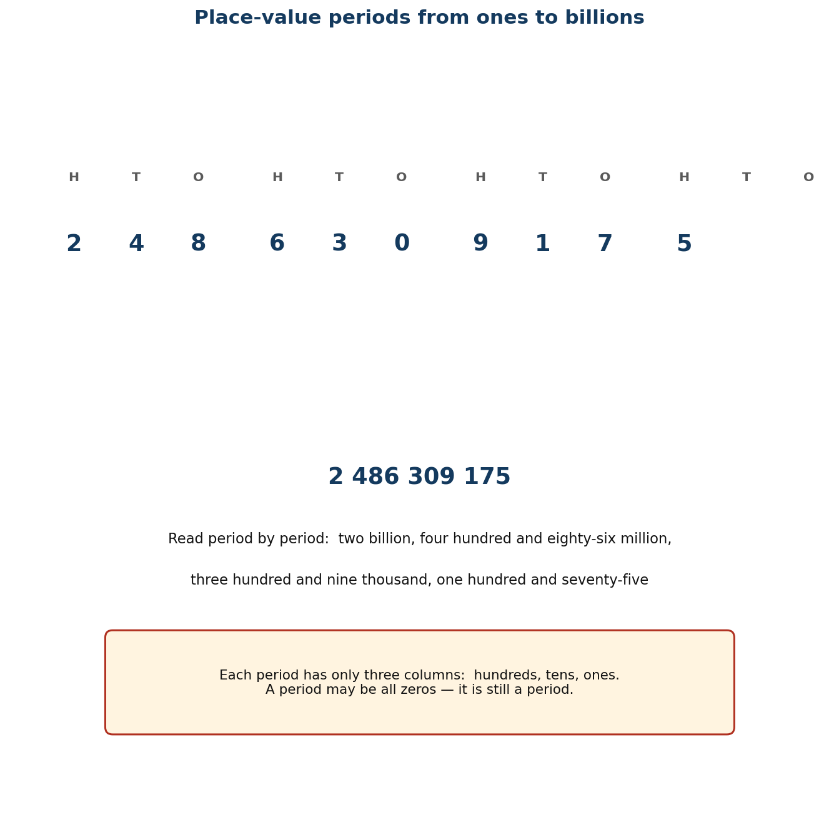
Figure 1.1 Place-value periods from ones to billions.
PHASE / TIME | TEACHER ACTIVITY | LEARNER ACTIVITY | CORE COMP. | ASSESSMENT (DoK)
ENGAGE  8 min | Write 1,000,000,000 on the board and ask: ‘How long would it take you to count to this, counting one number every second?’ Let learners guess, then tell them: over 31 years. Tell a Ghanaian anchor — Ghana's population is about 34 million, so a billion is about 30 Ghanas. Say the performance indicator aloud in learner language: ‘By the end of this lesson you will be able to build any number up to billions with blocks and read it back.’ | Learners guess, react, and then read the number chorally. Each learner writes the figure in their book and underlines where they think the ‘billion’ part ends. | CP; CC | Oral responses; diagnostic check. DoK 1
EXPLORE  16 min | Give each group a place-value chart to billions and a set of number cards. Task: build 2,486,309,175 with the cards, then say it aloud, then write it in words. Circulate and ask ‘which digit is worth the most?’ Do NOT correct yet. Note the two errors you will always see: reading the millions period as thousands, and omitting the zero period in numbers like 3,000,405,000. | Groups lay the cards in the chart, say the number aloud to each other, and write it in words. The Recorder writes the group's wording; the Reporter prepares to read it to the class. | CP; CC | Observation checklist; group record. DoK 2
EXPLAIN  14 min | Take reports, starting with any disagreement. Now teach the structure explicitly using Figure 1.1: columns go in periods of three — ones, thousands, millions, billions — and each period has hundreds, tens, ones. Read the number period by period: ‘two billion, four hundred and eighty-six million, three hundred and nine thousand, one hundred and seventy-five’. Then model with money: how many GH₵ 200 notes make GH₵ 1,000,000,000? (5,000,000 notes.) Confront the zero period explicitly with 3,000,405,000. | Learners correct their own wording in a second colour. They chant the period names and then build two numbers the teacher gives, one with a zero period and one without. | CP; CC | Questioning; corrected work in a second colour. DoK 2
ELABORATE  12 min | Quick-fire: call out a number, groups hold up the digit card for the digit in the ten-millions column, then the hundred-thousands column. Then the extension group writes three real numbers greater than a billion (population of Africa, distance to the Moon in metres, national budget) in words. | Learners respond in groups, then write the sentences in pairs using the frame: ‘The digit ___ is in the ___ column, so it is worth ___.’ | CP; CC | Application task; sentence frames. DoK 2–3
EVALUATE  10 min | Exit ticket: write 5,072,400,318 in words, and write ‘seven billion forty million six thousand and nine’ in figures. Collect and sort into three piles — got it, nearly, not yet. Preview Lesson 2: ‘Tomorrow we put these numbers in order.’ | Learners complete the exit ticket alone and tick: I can read a number to billions / I can write it in words / I can build it with blocks. | CP; CC | Exit ticket or assessed product. DoK 2–3

APPROACHING  PROFICIENCY (AP) | Support — a place-value chart with the periods pre-coloured and a word bank (billion, million, thousand, hundred, and); model numbers to millions first, then extend.
PROFICIENT (P) | Core — as described; model and read numbers to billions including a zero period.
HIGHLY  PROFICIENT (HP) | Extension — work in trillions, and explain why 1,000,000,000 has ten digits but only four periods.

ASSESSMENT (summary) | Observation with checklist C7.1. Exit ticket marked on two successes: reads a number to billions correctly; writes a number in words correctly. Learners who can build but not read have not connected the model to the language — reteach that group with choral reading first.
HOMEWORK / PROJECT WORK | Find one number greater than a billion in a newspaper, on a phone (storage size) or on a packet. Copy it, write it in words, and bring it tomorrow.
CROSS-CUTTING LINKS | English — reading numbers aloud; the hyphen in ‘twenty-four’. Social Studies — national population and budget figures. Values — accuracy matters when the numbers belong to a whole country.
LESSON CLOSURE | Return to the essential questions; two learners summarise, one says what is still unclear; record names for follow-up below.

REFLECTION AND REMARKS (complete after teaching)
What went well — evidence of learning you saw
What I would change next time
Learners who need follow-up, and what I will do
Head of Department remarks

TEACHER — NAME AND SIGNATURE | HEAD OF DEPARTMENT | DATE

BASIC 7 MATHEMATICS • TERM 1 • WEEKLY LESSON NOTE
LESSON 2 of 24 — Comparing and Ordering Huge Numbers
Week 1 • Number • Numeration Systems • B7.1.1.1.2 • 60 minutes
WEEK ENDING | DAY | DATE | PERIOD | DURATION | CLASS | SUBJECT
 |  |  |  | 60 min | Basic 7 | Mathematics

CLASS SIZE — BOYS | CLASS SIZE — GIRLS | CLASS SIZE — TOTAL

STRAND | Number
SUB-STRAND | Numeration Systems
CONTENT STANDARD | B7.1.1.1 — Demonstrate understanding and the use of place value for expressing quantities recorded as base ten numerals as well as rounding these to given decimal places and significant figures.
LEARNING INDICATOR(S) | B7.1.1.1.2 — Compare and order whole numbers more than 1,000,000,000 and represent the comparison using “>, <, or =”.
PERFORMANCE INDICATOR  (what learners will do) | Learners compare and order whole numbers greater than one billion and record the comparison using >, < or =.
LEARNING OUTCOMES  (knowledge / skill / value) | • K — state the rule for comparing two whole numbers (compare the highest place value first).  • S — order a set of at least five numbers greater than a billion and write the comparison with >, < or =.  • A/V — value precision, and appreciate that a single digit can change which of two large quantities is bigger.
CORE COMPETENCIES | Critical Thinking and Problem Solving (CP); Communication and Collaboration (CC).
KEY WORDS | compare, order, greater than, less than, equal to, ascending, descending, digit, most significant
ESSENTIAL QUESTIONS | 1. Which of two huge numbers is bigger?  2. How can I tell without counting every digit?
PRIOR KNOWLEDGE (R.P.K.) | Lesson 1 modelling and reading numbers to billions. Learners have used > and < with smaller numbers since Basic 4.
TEACHING / LEARNING RESOURCES  (TLMs) | Number cards; a washing line and pegs; the place-value chart from Lesson 1; copies of Figure 1.1; a list of real large numbers (populations of African countries, distances in the solar system).
PEDAGOGICAL EXEMPLARS (methods) | Inquiry (5E); concrete – pictorial – abstract (CPA) with manipulatives; cooperative group work; questioning and discussion; differentiation by task, support and outcome
REFERENCE | NaCCA Mathematics Curriculum for the Common Core Programme (Basic 7–B9), September 2020 — B7.1.1.1.2, p. 3. Scheme of Learning, Week 1.

PHASE / TIME | TEACHER ACTIVITY | LEARNER ACTIVITY | CORE COMP. | ASSESSMENT (DoK)
ENGAGE  8 min | Put two numbers on the board: 9,999,999,999 and 10,000,000,000. Ask: ‘Which is bigger?’ Most will say the first because it has more nines. Count the digits deliberately with the class — the second has eleven digits, the first has ten. Say: ‘Today you will learn one rule that settles every argument like this.’ | Learners vote with their hands, then count the digits with the teacher. Several will have changed their minds before the lesson starts. | CP; CC | Oral responses; diagnostic check. DoK 1
EXPLORE  16 min | Give each group six cards with numbers greater than a billion. Task: put them in order from smallest to largest, and be ready to explain how you decided. Circulate and ask ‘how did you know that one goes there?’ Do NOT correct. Look for the two approaches: comparing digit counts, and comparing column by column. | Groups sort the cards and argue the order out. The Recorder writes the final order; the Reporter prepares to justify the first and last. | CP; CC | Observation checklist; group record. DoK 2
EXPLAIN  14 min | Take reports. Now teach the rule: count the digits first — more digits means the bigger number. If the digit counts are the same, compare from the left, column by column, until two digits differ. Work the opening example: 10,000,000,000 has 11 digits, 9,999,999,999 has 10, so 10,000,000,000 > 9,999,999,999. Then teach the crocodile: the symbol opens to the bigger number. Drill with pairs where the digit counts match. | Learners write the rule in their own words and test it on three pairs the teacher writes. They use the frame: ‘___ is greater than ___ because ___.’ | CP; CC | Questioning; corrected work in a second colour. DoK 2
ELABORATE  12 min | Peg the class set of real numbers on a washing line in ascending order — populations of Ghana, Nigeria, Egypt, South Africa and Kenya; then distances of planets from the Sun. Extension group: find two numbers that are equal when rounded to the nearest billion but not equal exactly. | Learners take turns pegging a number in the right place and reading the comparison aloud. The class challenges anything placed wrongly. | CP; CC | Application task; sentence frames. DoK 2–3
EVALUATE  10 min | Exit ticket: put 4,506,200,000; 4,506,020,000 and 45,062,000,000 in ascending order using <. Collect and sort. Preview Lesson 3: ‘Tomorrow we round these numbers, which is what people usually do with them.’ | Learners complete the ticket alone and tick: I can compare two numbers / I can use > and < / I can explain why. | CP; CC | Exit ticket or assessed product. DoK 2–3

APPROACHING  PROFICIENCY (AP) | Support — compare numbers with different digit counts only, and use a place-value chart to line the columns up physically.
PROFICIENT (P) | Core — as described, including equal-digit-count comparisons.
HIGHLY  PROFICIENT (HP) | Extension — justify the rule: explain why the leftmost differing digit always decides, using expanded form.

ASSESSMENT (summary) | Observation with checklist C7.2. Exit ticket marked on ordering accuracy and on correct symbol direction. A learner who writes the symbol backwards has the rule but not the convention — drill the crocodile with that group.
HOMEWORK / PROJECT WORK | Write five numbers greater than a billion in descending order, each with a real-world label (population, distance, money).
CROSS-CUTTING LINKS | English — comparative language and the words ascending/descending. Social Studies — comparing African populations. Values — fairness: the rule is the same for everyone's numbers.
LESSON CLOSURE | Return to the essential questions; two learners summarise, one says what is still unclear; record names for follow-up below.

REFLECTION AND REMARKS (complete after teaching)
What went well — evidence of learning you saw
What I would change next time
Learners who need follow-up, and what I will do
Head of Department remarks

TEACHER — NAME AND SIGNATURE | HEAD OF DEPARTMENT | DATE

BASIC 7 MATHEMATICS • TERM 1 • WEEKLY LESSON NOTE
LESSON 3 of 24 — Rounding Whole Numbers
Week 2 • Number • Numeration Systems • B7.1.1.1.3 • 60 minutes
WEEK ENDING | DAY | DATE | PERIOD | DURATION | CLASS | SUBJECT
 |  |  |  | 60 min | Basic 7 | Mathematics

CLASS SIZE — BOYS | CLASS SIZE — GIRLS | CLASS SIZE — TOTAL

STRAND | Number
SUB-STRAND | Numeration Systems
CONTENT STANDARD | B7.1.1.1 — Demonstrate understanding and the use of place value for expressing quantities recorded as base ten numerals as well as rounding these to given decimal places and significant figures.
LEARNING INDICATOR(S) | B7.1.1.1.3 — Round (off, up, down) whole numbers more than 1,000,000,000 to the nearest hundred-thousand, ten-thousands, thousands, hundreds and tens.
PERFORMANCE INDICATOR  (what learners will do) | Learners round whole numbers greater than one billion to the nearest ten, hundred, thousand, ten-thousand and hundred-thousand.
LEARNING OUTCOMES  (knowledge / skill / value) | • K — state the rounding rule, including what to do when a number is exactly halfway.  • S — round a number greater than one billion to any named place value.  • A/V — understand that rounding trades precision for speed, and say when each is appropriate.
CORE COMPETENCIES | Personal Development and Leadership (PL); Creativity and Innovation (CI).
KEY WORDS | round, round off, round up, round down, nearest, estimate, halfway, boundary, approximate
ESSENTIAL QUESTIONS | 1. Why do people round numbers instead of using the exact one?  2. What happens when a number is exactly halfway?
PRIOR KNOWLEDGE (R.P.K.) | Lessons 1–2 place value and comparing. Learners have rounded to the nearest ten and hundred in Basic 5.
TEACHING / LEARNING RESOURCES  (TLMs) | Number lines drawn on the board and on strips of paper; popsicle-stick bundles; the place-value chart; calculators for checking; Figure 1.2 enlarged.
PEDAGOGICAL EXEMPLARS (methods) | Inquiry (5E); concrete – pictorial – abstract (CPA) with manipulatives; cooperative group work; questioning and discussion; differentiation by task, support and outcome
REFERENCE | NaCCA Mathematics Curriculum for the Common Core Programme (Basic 7–B9), September 2020 — B7.1.1.1.3, p. 4. Scheme of Learning, Week 2.

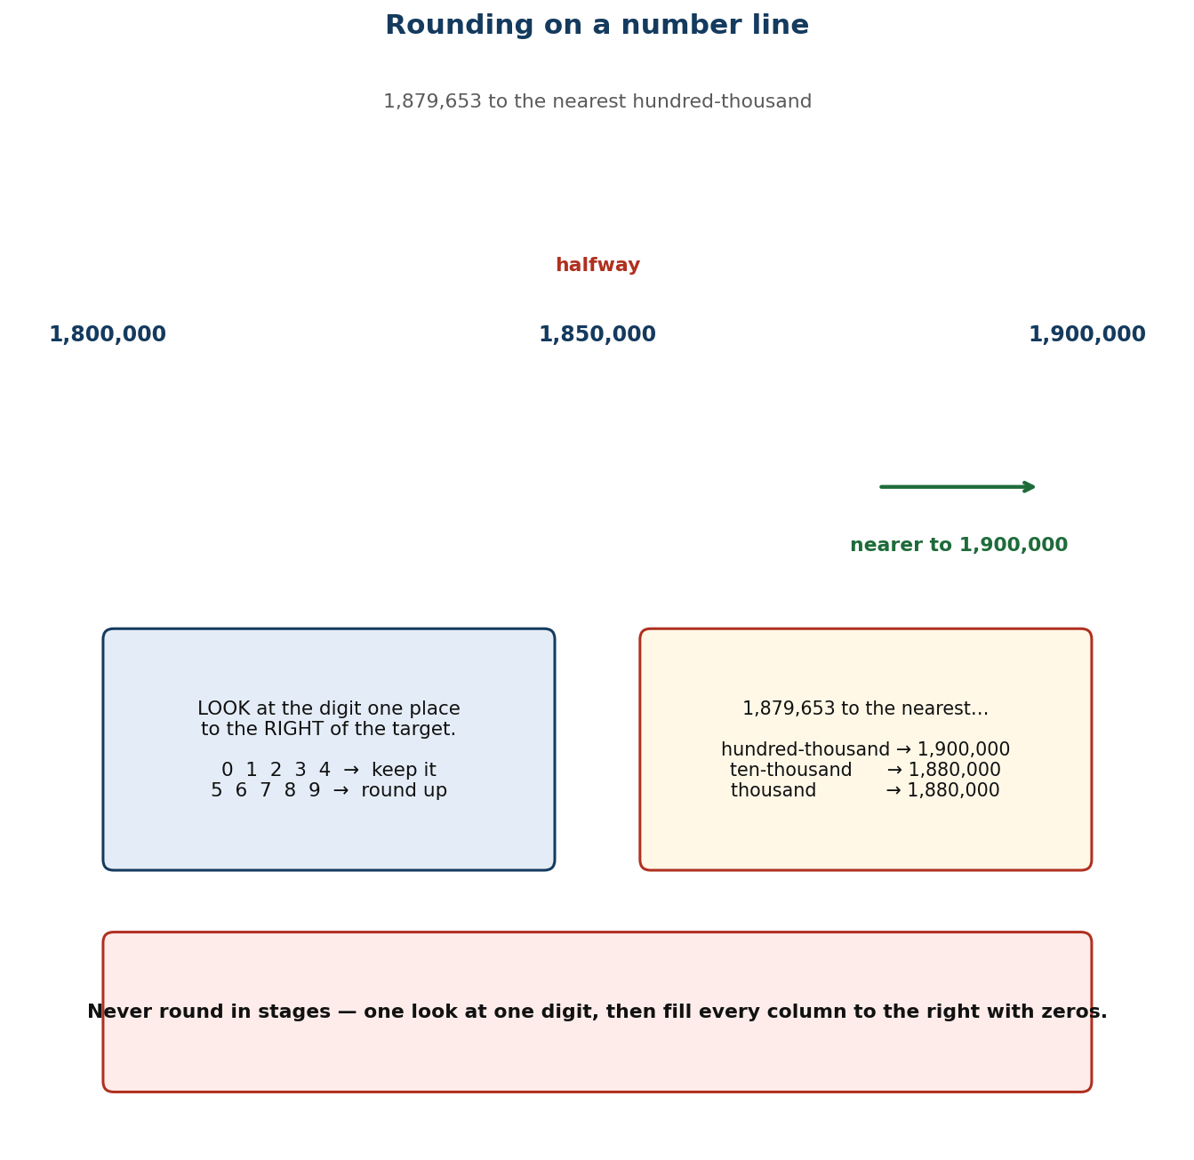
Figure 1.2 Rounding on a number line: the halfway decision.
PHASE / TIME | TEACHER ACTIVITY | LEARNER ACTIVITY | CORE COMP. | ASSESSMENT (DoK)
ENGAGE  8 min | Ask: ‘About how many learners are in this school?’ Then: ‘If I said 847, and someone else said 850, who is right?’ Establish that both can be right for different purposes. Tell them the performance indicator: ‘Today you will round numbers to billions, to any place you are asked for.’ | Learners offer estimates and discuss which answer is ‘right’. They realise the answer depends on how exact you need to be. | PL; CI | Oral responses; diagnostic check. DoK 1
EXPLORE  16 min | Draw an open number line from 1,879,600 to 1,879,700 with the halfway mark at 1,879,650. Ask: where does 1,879,653 sit, and which end is it nearer to? Give each group three numbers and a paper number line. Task: mark each number and write which end it is nearest to. Then deliberately put one number exactly on the halfway mark and see what they do. | Groups mark the numbers and decide. The halfway case produces disagreement — capture it rather than resolving it. | PL; CI | Observation checklist; group record. DoK 2
EXPLAIN  14 min | Resolve the disagreement: the convention is to round up at the halfway point. Then teach the abstract rule using Figure 1.2: (i) find the digit in the place you are rounding to; (ii) look at the digit immediately to its right; (iii) 0–4 keep, 5–9 round up; (iv) everything to the right becomes zero. Work two examples: 1,879,653 to the nearest hundred-thousand is 1,900,000; to the nearest ten-thousand is 1,880,000. Emphasise that you never round in stages — one look, one decision. | Learners write the rule as a four-step list and apply it to the same number rounded to three different places, checking against their number line. | PL; CI | Questioning; corrected work in a second colour. DoK 2
ELABORATE  12 min | Round-off relay: teams receive a number and a target place value and race to write the answer. Then the real-world turn: Ghana's population 34,121,985 — round to the nearest million for a news report, and to the nearest ten for a school register. Discuss which is useful where. Extension: identify the range of numbers that round to 2,500,000 at the nearest hundred-thousand. | Teams race, then pairs discuss the two population answers and report which is appropriate for which audience. | PL; CI | Application task; sentence frames. DoK 2–3
EVALUATE  10 min | Exit ticket: round 7,486,215,063 to the nearest hundred-thousand and to the nearest thousand. Collect and sort. Preview Lesson 4: ‘Tomorrow we round decimals, where the same rule works but the columns have different names.’ | Learners complete the ticket alone and tick: I can find the rounding digit / I can apply the 5-up rule / I can fill with zeros correctly. | PL; CI | Exit ticket or assessed product. DoK 2–3

APPROACHING  PROFICIENCY (AP) | Support — keep the number line visible; round to the nearest ten and hundred only, using numbers under a million, before moving to billions.
PROFICIENT (P) | Core — as described, including hundred-thousand and ten-thousand for numbers over a billion.
HIGHLY  PROFICIENT (HP) | Extension — state the upper and lower bounds of a rounded value, and explain why rounding in stages gives a wrong answer, using 4,449 as the example.

ASSESSMENT (summary) | Observation with checklist C7.3. Exit ticket marked on: correctly identifies the rounding digit; applies the 5-up rule; replaces the digits to the right with zeros. The commonest error — rounding in stages — is anticipated and named in the lesson.
HOMEWORK / PROJECT WORK | Round the same number (choose one over a billion) to five different place values and write a sentence saying which rounded value you would use in a news report, and why.
CROSS-CUTTING LINKS | English — ‘approximately’, ‘about’, ‘roughly’. Social Studies — census figures are always reported rounded. Values — honesty about precision: say when a figure is approximate.
LESSON CLOSURE | Return to the essential questions; two learners summarise, one says what is still unclear; record names for follow-up below.

REFLECTION AND REMARKS (complete after teaching)
What went well — evidence of learning you saw
What I would change next time
Learners who need follow-up, and what I will do
Head of Department remarks

TEACHER — NAME AND SIGNATURE | HEAD OF DEPARTMENT | DATE

BASIC 7 MATHEMATICS • TERM 1 • WEEKLY LESSON NOTE
LESSON 4 of 24 — Rounding Decimals
Week 2 • Number • Numeration Systems • B7.1.1.1.4 • 60 minutes
WEEK ENDING | DAY | DATE | PERIOD | DURATION | CLASS | SUBJECT
 |  |  |  | 60 min | Basic 7 | Mathematics

CLASS SIZE — BOYS | CLASS SIZE — GIRLS | CLASS SIZE — TOTAL

STRAND | Number
SUB-STRAND | Numeration Systems
CONTENT STANDARD | B7.1.1.1 — Demonstrate understanding and the use of place value for expressing quantities recorded as base ten numerals as well as rounding these to given decimal places and significant figures.
LEARNING INDICATOR(S) | B7.1.1.1.4 — Round decimals to the nearest tenth, hundredth, thousandths, etc.
PERFORMANCE INDICATOR  (what learners will do) | Learners round decimal numbers to the nearest tenth, hundredth and thousandth.
LEARNING OUTCOMES  (knowledge / skill / value) | • K — name the first three decimal places and state the rounding rule for decimals.  • S — round a decimal to the nearest tenth, hundredth or thousandth.  • A/V — recognise that rounding money to two decimal places is a legal and commercial convention, not just a classroom rule.
CORE COMPETENCIES | Critical Thinking and Problem Solving (CP).
KEY WORDS | decimal, decimal place, tenth, hundredth, thousandth, round, truncate, recurring, terminating
ESSENTIAL QUESTIONS | 1. How is rounding a decimal different from rounding a whole number?  2. Why does money always stop at two decimal places?
PRIOR KNOWLEDGE (R.P.K.) | Lesson 3 rounding whole numbers. Learners have met tenths and hundredths with money since Basic 4.
TEACHING / LEARNING RESOURCES  (TLMs) | Money (actual GH₵ coins) as the anchor for hundredths; metre rules marked in centimetres and millimetres; number lines; calculators; Figure 1.2 from Lesson 3 for comparison.
PEDAGOGICAL EXEMPLARS (methods) | Inquiry (5E); concrete – pictorial – abstract (CPA) with manipulatives; cooperative group work; questioning and discussion; differentiation by task, support and outcome
REFERENCE | NaCCA Mathematics Curriculum for the Common Core Programme (Basic 7–B9), September 2020 — B7.1.1.1.4, p. 5. Scheme of Learning, Week 2.

PHASE / TIME | TEACHER ACTIVITY | LEARNER ACTIVITY | CORE COMP. | ASSESSMENT (DoK)
ENGAGE  8 min | Hold up a metre rule. Ask: ‘How tall is this desk?’ Measure to the nearest millimetre — say 0.738 m. Then ask: ‘What would you say if I only wanted it to the nearest centimetre?’ Establish 0.74 m. Say: ‘Same rule as Monday, new columns. Today it is decimals.’ | Learners measure their own desk and offer both answers. They notice the second is shorter to say and 'good enough'. | CP | Oral responses; diagnostic check. DoK 1
EXPLORE  16 min | Give each group four measurements in metres to three decimal places and a number line divided into hundredths. Task: mark each measurement and write it to the nearest hundredth. Circulate and ask ‘which digit are you looking at to decide?’ Then give one value ending in exactly 5 in the third place, e.g. 2.345, and see what they do. | Groups mark and round. The exactly-5 case splits the room again — note who applies the round-up convention from Lesson 3. | CP | Observation checklist; group record. DoK 2
EXPLAIN  14 min | Confirm the convention carries over: round up at 5. Name the columns explicitly: tenths, hundredths, thousandths. Work 0.738 → 0.74 (nearest hundredth) and 0.7 (nearest tenth), showing that the answer depends entirely on the target place. Then the crucial distinction: for decimals you drop the digits to the right — you do not replace them with zeros, because 0.740 and 0.74 are the same number but 0.74 written with a trailing zero suggests a precision you did not measure. | Learners round the same measurement to three different places and compare. They note the difference from whole-number rounding in their books. | CP | Questioning; corrected work in a second colour. DoK 2
ELABORATE  12 min | Money round: give prices and quantities, learners compute a bill and round each line to two decimal places as a shop would. Then a calculator investigation: find 2 ÷ 3 and 10 ÷ 7 on a calculator and discuss what the display is hiding. Extension: round 0.9995 to the nearest thousandth and explain the cascade. | Pairs compute bills and compare totals. The calculator investigation produces the idea of recurring decimals, which the class records as a question for later. | CP | Application task; sentence frames. DoK 2–3
EVALUATE  10 min | Exit ticket: round 48.3746 to the nearest thousandth, hundredth and tenth. Collect and sort. Preview Lesson 5: ‘Tomorrow, significant figures — which is how scientists round.’ | Learners complete the ticket alone and tick: I can name the decimal places / I can round decimals / I know to drop rather than zero-fill. | CP | Exit ticket or assessed product. DoK 2–3

APPROACHING  PROFICIENCY (AP) | Support — round money to two decimal places only, using coins as the physical model, before abstract decimals.
PROFICIENT (P) | Core — as described, to thousandths.
HIGHLY  PROFICIENT (HP) | Extension — justify why 2.345 → 2.35 but 2.3449 → 2.34, and explain why the digits to the right of the target place must not be used in stages either.

ASSESSMENT (summary) | Observation with checklist C7.4. Exit ticket marked on: correct target digit; correct 5-up decision; trailing zeros dropped. The trailing-zero error is the specific target of this lesson's teaching.
HOMEWORK / PROJECT WORK | Measure five things at home to the nearest millimetre and write each length three ways: exact, to the nearest hundredth, to the nearest tenth.
CROSS-CUTTING LINKS | Science — measurement and precision. Home Economics / Business — money is always two decimal places. Values — honesty: do not claim more precision than you measured.
LESSON CLOSURE | Return to the essential questions; two learners summarise, one says what is still unclear; record names for follow-up below.

REFLECTION AND REMARKS (complete after teaching)
What went well — evidence of learning you saw
What I would change next time
Learners who need follow-up, and what I will do
Head of Department remarks

TEACHER — NAME AND SIGNATURE | HEAD OF DEPARTMENT | DATE

BASIC 7 MATHEMATICS • TERM 1 • WEEKLY LESSON NOTE
LESSON 5 of 24 — Decimal Places and Significant Figures
Week 3 • Number • Numeration Systems • B7.1.1.1.5 • 60 minutes
WEEK ENDING | DAY | DATE | PERIOD | DURATION | CLASS | SUBJECT
 |  |  |  | 60 min | Basic 7 | Mathematics

CLASS SIZE — BOYS | CLASS SIZE — GIRLS | CLASS SIZE — TOTAL

STRAND | Number
SUB-STRAND | Numeration Systems
CONTENT STANDARD | B7.1.1.1 — Demonstrate understanding and the use of place value for expressing quantities recorded as base ten numerals as well as rounding these to given decimal places and significant figures.
LEARNING INDICATOR(S) | B7.1.1.1.5 — Express decimal numerals to given significant and decimal places.
PERFORMANCE INDICATOR  (what learners will do) | Learners express decimal numbers to a given number of decimal places and to a given number of significant figures.
LEARNING OUTCOMES  (knowledge / skill / value) | • K — distinguish decimal places from significant figures and state the rule for each, including the treatment of leading zeros.  • S — write a given number to a stated number of decimal places and to a stated number of significant figures.  • A/V — choose an appropriate level of precision for a purpose and justify the choice.
CORE COMPETENCIES | Critical Thinking and Problem Solving (CP); Communication and Collaboration (CC); Creativity and Innovation (CI).
KEY WORDS | decimal place, significant figure, leading zero, non-zero digit, precision, round, estimate
ESSENTIAL QUESTIONS | 1. What is the difference between decimal places and significant figures?  2. Does a zero at the front count as significant?
PRIOR KNOWLEDGE (R.P.K.) | Lessons 3–4 rounding whole numbers and decimals. Learners can already round to a named decimal place.
TEACHING / LEARNING RESOURCES  (TLMs) | Calculators; measurement context cards; a wall chart contrasting decimal places with significant figures; newspaper clippings with figures of different precision.
PEDAGOGICAL EXEMPLARS (methods) | Inquiry (5E); concrete – pictorial – abstract (CPA) with manipulatives; cooperative group work; questioning and discussion; differentiation by task, support and outcome
REFERENCE | NaCCA Mathematics Curriculum for the Common Core Programme (Basic 7–B9), September 2020 — B7.1.1.1.5, p. 6. Scheme of Learning, Week 3.

PHASE / TIME | TEACHER ACTIVITY | LEARNER ACTIVITY | CORE COMP. | ASSESSMENT (DoK)
ENGAGE  8 min | Write two sentences: ‘The cocoa arrived in 3.0 kg bags’ and ‘The cocoa arrived in 3 kg bags’. Ask: ‘Are these the same?’ They are not — the first promises the bag was weighed to the nearest tenth. Say: ‘Decimal places count after the point. Significant figures count from the first non-zero digit. Today you learn both, and when to use each.’ | Learners discuss in pairs and report. Several will say the sentences mean the same thing, which sets up the lesson. | CP; CC; CI | Oral responses; diagnostic check. DoK 1
EXPLORE  16 min | Give each group the number 0.04068 and ask them to write it (a) to 2 decimal places and (b) to 2 significant figures, working it out however they like. Circulate. The trap is the leading zeros: learners will count them as significant. Do NOT correct — collect both answers on the board. | Groups work and produce two answers. Most will get (a) right and (b) wrong, because the leading zeros mislead them. | CP; CC; CI | Observation checklist; group record. DoK 2
EXPLAIN  14 min | Take both answers. Teach: decimal places count digits after the point — so 0.04068 to 2 d.p. is 0.04. Significant figures count from the first non-zero digit — so the first significant figure in 0.04068 is the 4, the second is the 0 after it, and the answer is 0.041. Then the key sentence: leading zeros are placeholders, not measurements. Work a whole-number case too: 48,372 to 2 s.f. is 48,000. | Learners write both rules side by side with a worked example of each, and underline the first significant figure in five given numbers. | CP; CC; CI | Questioning; corrected work in a second colour. DoK 2
ELABORATE  12 min | Give a measurement — the length of the football pitch, 104.6 m — and ask pairs to write it to 2 d.p., to 3 s.f. and to 1 s.f., then say which they would use in: a builder's order, a science report, a casual conversation. Extension: explain why a number to 3 s.f. keeps the same precision whatever its size. | Pairs produce three versions and defend their choice for each audience. The class votes on the most appropriate. | CP; CC; CI | Application task; sentence frames. DoK 2–3
EVALUATE  10 min | Exit ticket: write 0.007049 to 2 significant figures and to 3 decimal places. Collect and sort. Preview Lesson 6: ‘Tomorrow, powers of ten — the shortcut behind every decimal calculation.’ | Learners complete the ticket alone and tick: I can use decimal places / I can find the first significant figure / I can explain the difference. | CP; CC; CI | Exit ticket or assessed product. DoK 2–3

APPROACHING  PROFICIENCY (AP) | Support — decimal places only for the first half, then add significant figures with numbers that have no leading zeros.
PROFICIENT (P) | Core — as described, including numbers with leading zeros.
HIGHLY  PROFICIENT (HP) | Extension — explain why 48,000 (2 s.f.) and 48,000 (5 s.f.) look identical but mean different precisions, and how a scientist writes the difference.

ASSESSMENT (summary) | Observation with checklist C7.5. Exit ticket marked on: correct counting from the first non-zero digit; correct rounding; correct zero-filling in whole-number cases. The leading-zero error is the named target of the lesson.
HOMEWORK / PROJECT WORK | Find three numbers in a newspaper or on a packet. Write each to 2 s.f. and to 2 d.p., and say which you think the publisher was using.
CROSS-CUTTING LINKS | Science — significant figures are the language of measurement. English — precision in wording. Values — intellectual honesty about what a figure does and does not claim.
LESSON CLOSURE | Return to the essential questions; two learners summarise, one says what is still unclear; record names for follow-up below.

REFLECTION AND REMARKS (complete after teaching)
What went well — evidence of learning you saw
What I would change next time
Learners who need follow-up, and what I will do
Head of Department remarks

TEACHER — NAME AND SIGNATURE | HEAD OF DEPARTMENT | DATE

BASIC 7 MATHEMATICS • TERM 1 • WEEKLY LESSON NOTE
LESSON 6 of 24 — Multiplying and Dividing by Powers of Ten
Week 3 • Number • Number Operations • B7.1.2.1.1 • 60 minutes
WEEK ENDING | DAY | DATE | PERIOD | DURATION | CLASS | SUBJECT
 |  |  |  | 60 min | Basic 7 | Mathematics

CLASS SIZE — BOYS | CLASS SIZE — GIRLS | CLASS SIZE — TOTAL

STRAND | Number
SUB-STRAND | Number Operations
CONTENT STANDARD | B7.1.2.1 — Apply mental mathematics strategies and number properties used to solve problems.
LEARNING INDICATOR(S) | B7.1.2.1.1 — Multiply and divide given numbers by powers of 10 including decimals and benchmark fractions.
PERFORMANCE INDICATOR  (what learners will do) | Learners multiply and divide whole numbers, decimals and benchmark fractions by 10, 100, 1000 and other powers of ten.
LEARNING OUTCOMES  (knowledge / skill / value) | • K — state that multiplying by 10ⁿ moves digits n places to the left, and dividing moves them n places to the right.  • S — multiply and divide decimals and benchmark fractions by powers of ten without written calculation.  • A/V — appreciate that the digits keep their order — only their place value changes — and reject the ‘just add a zero’ rule.
CORE COMPETENCIES | Communication and Collaboration (CC); Creativity and Innovation (CI).
KEY WORDS | power of ten, index, exponent, digit shift, placeholder, decimal point, benchmark fraction, product, quotient
ESSENTIAL QUESTIONS | 1. What happens to the digits when I multiply by ten?  2. Why is 'just add a zero' wrong for decimals?
PRIOR KNOWLEDGE (R.P.K.) | Place value to billions (Lesson 1) and decimals to thousandths (Lesson 4). Learners have multiplied by 10 and 100 since Basic 3 but may treat it as a trick about adding zeros.
TEACHING / LEARNING RESOURCES  (TLMs) | Place-value slider chart (digits on movable cards with a fixed decimal point); calculators for verification; Figure 1.3 enlarged; cups of beans for the benchmark-fraction case.
PEDAGOGICAL EXEMPLARS (methods) | Inquiry (5E); concrete – pictorial – abstract (CPA) with manipulatives; cooperative group work; questioning and discussion; differentiation by task, support and outcome
REFERENCE | NaCCA Mathematics Curriculum for the Common Core Programme (Basic 7–B9), September 2020 — B7.1.2.1.1, p. 7. Scheme of Learning, Week 3.

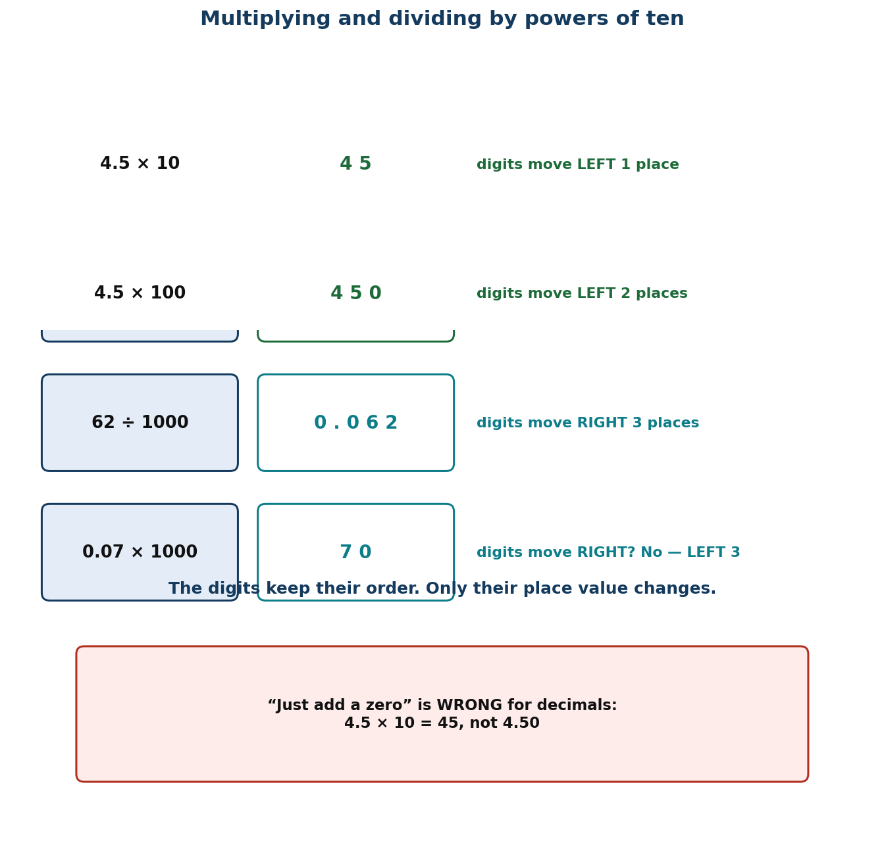
Figure 1.3 Digit shifts when multiplying and dividing by powers of ten.
PHASE / TIME | TEACHER ACTIVITY | LEARNER ACTIVITY | CORE COMP. | ASSESSMENT (DoK)
ENGAGE  8 min | Ask: ‘4.5 × 10.’ Nearly everyone will say 4.50. Write it, then check on a calculator: 45. Let the wrong answer stand for a moment. Say: ‘The rule you were taught — add a zero — works for whole numbers and fails for decimals. Today you replace it with one that always works.’ | Learners answer, then see the calculator disagree. The contradiction is the hook for the whole lesson. | CC; CI | Oral responses; diagnostic check. DoK 1
EXPLORE  16 min | Give each group a place-value slider: digit cards 4, 5 and a fixed decimal point. Task: show 4.5, then show 4.5 × 10 by moving the cards without changing their order. Then try ÷ 10. Circulate and ask ‘what moved, the digits or the point?’ Insist they describe what physically moved. | Groups manipulate the cards. They discover the digits slide and the decimal point appears to stay put — or, if they move the point instead, they see it is equivalent. | CC; CI | Observation checklist; group record. DoK 2
EXPLAIN  14 min | Formalise with Figure 1.3: multiplying by 10ⁿ moves every digit n columns to the LEFT; dividing moves them n columns to the RIGHT. The digits never reorder; only the decimal point stays still. Work three cases: 4.5 × 10 = 45; 4.5 ÷ 10 = 0.45; 0.07 × 1000 = 70. Then the benchmark fraction: ½ × 100 = 50, because ½ of 100 is 50. Emphasise that ‘add a zero’ is a coincidence of whole numbers and must be retired. | Learners write the rule with an arrow diagram and apply it to six examples, checking three on a calculator. | CC; CI | Questioning; corrected work in a second colour. DoK 2
ELABORATE  12 min | Chain race: teams do × 10, then × 100, then ÷ 10 on the same starting number, predicting before they calculate. Then real context: convert GH₵ 245.50 into pesewas (× 100) and 3,450 pesewas back into cedis (÷ 100). Extension: explain why 0.8 × 10 and 0.80 × 10 give the same answer but 0.08 × 10 does not. | Teams race and predict. Pairs do the money conversion, which is the most common real use of the skill in Ghana. | CC; CI | Application task; sentence frames. DoK 2–3
EVALUATE  10 min | Exit ticket: 3.07 × 100; 62 ÷ 1000; ¾ × 1000. Collect and sort. Preview Lesson 7: ‘Tomorrow, mental strategies that use this without writing anything.’ | Learners complete the ticket alone and tick: I know the direction of the shift / I can do it with decimals / I can do it with fractions. | CC; CI | Exit ticket or assessed product. DoK 2–3

APPROACHING  PROFICIENCY (AP) | Support — keep the slider chart in front of them; multiply and divide by 10 and 100 only, with the digits written in a chart, before doing it mentally.
PROFICIENT (P) | Core — as described, including 1000 and benchmark fractions.
HIGHLY  PROFICIENT (HP) | Extension — generalise to 10ⁿ for any n, and explain why dividing by 10ⁿ is the same as multiplying by 10⁽ⁿ.

ASSESSMENT (summary) | Observation with checklist C7.6. Exit ticket marked on correct direction and correct number of places. Any learner still ‘adding a zero’ to a decimal is the specific target for reteaching — pair them with a slider chart.
HOMEWORK / PROJECT WORK | Write ten conversions between cedis and pesewas, and five conversions between metres and centimetres, using the shift rule and no written calculation.
CROSS-CUTTING LINKS | Science — unit conversions are all powers of ten. Business — cedi/pesewa conversion. Values — accuracy with money affects real people's accounts.
LESSON CLOSURE | Return to the essential questions; two learners summarise, one says what is still unclear; record names for follow-up below.

REFLECTION AND REMARKS (complete after teaching)
What went well — evidence of learning you saw
What I would change next time
Learners who need follow-up, and what I will do
Head of Department remarks

TEACHER — NAME AND SIGNATURE | HEAD OF DEPARTMENT | DATE

BASIC 7 MATHEMATICS • TERM 1 • WEEKLY LESSON NOTE
LESSON 7 of 24 — Mental Mathematics Strategies
Week 4 • Number • Number Operations • B7.1.2.1.2 • 60 minutes
WEEK ENDING | DAY | DATE | PERIOD | DURATION | CLASS | SUBJECT
 |  |  |  | 60 min | Basic 7 | Mathematics

CLASS SIZE — BOYS | CLASS SIZE — GIRLS | CLASS SIZE — TOTAL

STRAND | Number
SUB-STRAND | Number Operations
CONTENT STANDARD | B7.1.2.1 — Apply mental mathematics strategies and number properties used to solve problems.
LEARNING INDICATOR(S) | B7.1.2.1.2 — Apply mental mathematics strategies and number properties used to perform calculations.
PERFORMANCE INDICATOR  (what learners will do) | Learners apply mental mathematics strategies and number properties to perform calculations without written methods.
LEARNING OUTCOMES  (knowledge / skill / value) | • K — name at least four mental strategies (partition, compensate, use compatible numbers, double and halve) and the number properties that justify them.  • S — calculate mentally with two-digit and simple three-digit numbers, and explain which strategy they used.  • A/V — value flexibility over procedure, and appreciate that there is usually more than one good way.
CORE COMPETENCIES | Creativity and Innovation (CI); Critical Thinking and Problem Solving (CP).
KEY WORDS | mental strategy, partition, compensate, compatible numbers, doubling, halving, distributive, commutative, associative
ESSENTIAL QUESTIONS | 1. How do people calculate in their heads?  2. Which strategy is quickest for this calculation?
PRIOR KNOWLEDGE (R.P.K.) | Lesson 6 powers of ten. Learners have partitioned numbers since Basic 3 but often default to a written algorithm for everything.
TEACHING / LEARNING RESOURCES  (TLMs) | Nothing per group but paper; a set of flashcards with number sentences; a timer; a ‘strategy wall’ where named strategies go up as the class discovers them.
PEDAGOGICAL EXEMPLARS (methods) | Inquiry (5E); concrete – pictorial – abstract (CPA) with manipulatives; mental mathematics; cooperative group work; questioning and discussion; differentiation by task, support and outcome
REFERENCE | NaCCA Mathematics Curriculum for the Common Core Programme (Basic 7–B9), September 2020 — B7.1.2.1.2, p. 7. Scheme of Learning, Week 4.

PHASE / TIME | TEACHER ACTIVITY | LEARNER ACTIVITY | CORE COMP. | ASSESSMENT (DoK)
ENGAGE  8 min | Write 25 × 16 on the board and say: ‘Hands up who needs paper for this.’ Most hands go up. Then say: ‘Watch. 25 × 4 is 100, and 16 is 4 × 4, so it is 100 × 4 = 400.’ Tell them: ‘Today your brain is the calculator, and I will be timing you.’ | Learners react to the demonstration and admit how many rely on paper. They write the date and the heading ‘Mental strategies’. | CI; CP | Oral responses; diagnostic check. DoK 1
EXPLORE  16 min | Put up six calculations: 47 + 38; 1000 − 476; 25 × 24; 96 ÷ 4; 15 × 18; 7.5 × 8. Task: do as many as you can in your head and write down HOW you did each one. Emphasise that the method matters more than the answer. Circulate and collect distinct approaches — do NOT correct. | Learners work silently then compare in pairs. The variety of methods is the resource for the next phase. | CI; CP | Observation checklist; group record. DoK 2
EXPLAIN  14 min | Harvest the methods and name them on the strategy wall: partition (47 + 38 = 47 + 30 + 8); compensate (1000 − 476 = 1000 − 500 + 24); compatible numbers (25 × 24 = 25 × 4 × 6); double and halve (15 × 18 = 30 × 9). Name the properties that licence them: commutative, associative, distributive. Stress that choosing the strategy is the skill — the calculation is the easy part. | Learners copy the four named strategies with one example each, and label their own explored methods with the matching name. | CI; CP | Questioning; corrected work in a second colour. DoK 2
ELABORATE  12 min | Timed relay: five calculations, one minute each, learners write the answer AND the strategy name. Then ‘same answer, different route’: pairs must find two different ways to do 36 × 25. Extension: construct a calculation where doubling-and-halving is the best route, and one where it is the worst. | Learners work against the clock, then pairs present two routes to the same answer. The class judges which is more efficient and why. | CI; CP | Application task; sentence frames. DoK 2–3
EVALUATE  10 min | Exit ticket: 99 × 7 and 4.5 × 18, each with the strategy named. Collect and sort. Preview Lesson 8: ‘Tomorrow we use these strategies on word problems, where choosing the method is half the difficulty.’ | Learners complete the ticket alone and tick: I can calculate mentally / I can name my strategy / I can choose between strategies. | CI; CP | Exit ticket or assessed product. DoK 2–3

APPROACHING  PROFICIENCY (AP) | Support — partition and compensate only, with two-digit numbers and a written number line to check; allow extra time.
PROFICIENT (P) | Core — as described, all four strategies.
HIGHLY  PROFICIENT (HP) | Extension — justify each strategy by naming the property that permits it, and construct a problem where the obvious strategy is a trap.

ASSESSMENT (summary) | Observation with checklist C7.7, which looks specifically at whether the learner can NAME the strategy, not just produce the answer. A learner who computes correctly but cannot say how has memorised rather than understood.
HOMEWORK / PROJECT WORK | Teach one mental strategy to someone at home and write down their reaction. Do five calculations mentally on the way home and note which strategy you used.
CROSS-CUTTING LINKS | English — explaining a method is a speaking-and-listening task. Business — market traders calculate mentally all day. Values — confidence: everyone can improve at this with practice.
LESSON CLOSURE | Return to the essential questions; two learners summarise, one says what is still unclear; record names for follow-up below.

REFLECTION AND REMARKS (complete after teaching)
What went well — evidence of learning you saw
What I would change next time
Learners who need follow-up, and what I will do
Head of Department remarks

TEACHER — NAME AND SIGNATURE | HEAD OF DEPARTMENT | DATE

BASIC 7 MATHEMATICS • TERM 1 • WEEKLY LESSON NOTE
LESSON 8 of 24 — Mental Strategies for Word Problems
Week 4 • Number • Number Operations • B7.1.2.1.3 • 60 minutes
WEEK ENDING | DAY | DATE | PERIOD | DURATION | CLASS | SUBJECT
 |  |  |  | 60 min | Basic 7 | Mathematics

CLASS SIZE — BOYS | CLASS SIZE — GIRLS | CLASS SIZE — TOTAL

STRAND | Number
SUB-STRAND | Number Operations
CONTENT STANDARD | B7.1.2.1 — Apply mental mathematics strategies and number properties used to solve problems.
LEARNING INDICATOR(S) | B7.1.2.1.3 — Apply mental mathematics strategies to solve word problems.
PERFORMANCE INDICATOR  (what learners will do) | Learners apply mental mathematics strategies to solve word problems.
LEARNING OUTCOMES  (knowledge / skill / value) | • K — identify the operation a word problem requires, and justify the choice from the situation rather than from key words.  • S — solve two-step word problems mentally where the numbers permit, and estimate where they do not.  • A/V — check whether an answer is reasonable in its context before writing it down.
CORE COMPETENCIES | Creativity and Innovation (CI); Critical Thinking and Problem Solving (CP).
KEY WORDS | word problem, operation, estimate, reasonable, context, round, check, unknown
ESSENTIAL QUESTIONS | 1. How do I know which operation a problem needs?  2. How can I tell whether my answer is reasonable?
PRIOR KNOWLEDGE (R.P.K.) | Lesson 7 mental strategies. Learners have solved one-step word problems since Basic 2 but often guess the operation from key words.
TEACHING / LEARNING RESOURCES  (TLMs) | Word-problem cards set in Ghanaian contexts (market, tro-tro fares, school feeding, water tanker deliveries); the strategy wall from Lesson 7; mini whiteboards.
PEDAGOGICAL EXEMPLARS (methods) | Inquiry (5E); concrete – pictorial – abstract (CPA) with manipulatives; mental mathematics; structured problem-solving routine; cooperative group work; questioning and discussion; differentiation by task, support and outcome
REFERENCE | NaCCA Mathematics Curriculum for the Common Core Programme (Basic 7–B9), September 2020 — B7.1.2.1.3, p. 8. Scheme of Learning, Week 4.

PHASE / TIME | TEACHER ACTIVITY | LEARNER ACTIVITY | CORE COMP. | ASSESSMENT (DoK)
ENGAGE  8 min | Write: ‘Ama has 24 oranges and Kwame has 8. How many more does Ama have?’ Ask: ‘Which operation?’ Then: ‘Ama has 24 oranges. Kwame has 8 times as many. How many does Kwame have?’ ‘Now which operation?’ Both say ‘more’. Say: ‘Today we stop guessing from words and start reading the situation.’ | Learners answer both and notice the same word led to different operations. This is the lesson's central idea, surfaced in the first minute. | CI; CP | Oral responses; diagnostic check. DoK 1
EXPLORE  16 min | Give each group four word-problem cards set in a market. Task: for each, write the calculation you would do and one sentence saying why that operation. Circulate and ask ‘what is happening in the story?’ rather than ‘what is the answer?’ Do NOT give answers. | Groups read, discuss and write. They must agree on the WHY, which forces them to picture the situation rather than scan for key words. | CI; CP | Observation checklist; group record. DoK 2
EXPLAIN  14 min | Take one card at a time. Teach the routine explicitly: (i) picture the situation; (ii) say what is being found; (iii) choose the operation and justify it from the picture; (iv) calculate, mentally if the numbers allow; (v) check against the story — is this answer reasonable? Work the tro-tro fare problem: 14 passengers at GH₵ 3.50 each. Mental route: 14 × 3.5 = 14 × 7 ÷ 2 = 98 ÷ 2 = 49. Then check: 14 × 3 = 42, so 49 is reasonable. | Learners copy the five-step routine and apply it to a second problem with the teacher, orally, before trying alone. | CI; CP | Questioning; corrected work in a second colour. DoK 2
ELABORATE  12 min | Pairs solve four more cards, then swap and check each other's reasoning sentence. Then ‘same story, different question’: the teacher keeps one situation and changes the question three times so learners see the operation shift. Extension: write their own two-step problem and the reasoning sentence that goes with it. | Pairs solve and peer-check. The changing-question routine makes the point that the operation lives in the question, not the story. | CI; CP | Application task; sentence frames. DoK 2–3
EVALUATE  10 min | Exit ticket: one two-step word problem, answered with a reasoning sentence and a reasonableness check. Collect and sort. Preview Lesson 9: ‘Tomorrow we return to written methods for numbers too big for the head.’ | Learners complete the ticket alone and tick: I chose the right operation / I explained why / I checked my answer. | CI; CP | Exit ticket or assessed product. DoK 2–3

APPROACHING  PROFICIENCY (AP) | Support — one-step problems with small numbers, and a picture frame to draw the situation before choosing the operation.
PROFICIENT (P) | Core — as described, two-step problems with mental-friendly numbers.
HIGHLY  PROFICIENT (HP) | Extension — problems where two different operations both give a defensible answer, requiring the learner to argue for one.

ASSESSMENT (summary) | Observation with checklist C7.8, weighted towards the reasoning sentence. The exit ticket is marked primarily on the justification and the reasonableness check, not on the arithmetic.
HOMEWORK / PROJECT WORK | Write three word problems set in your own community, with the answer and the reasoning sentence for each.
CROSS-CUTTING LINKS | English — reading comprehension is a mathematics skill here. Social Studies — market economics. Values — checking your work is a responsibility, not an extra.
LESSON CLOSURE | Return to the essential questions; two learners summarise, one says what is still unclear; record names for follow-up below.

REFLECTION AND REMARKS (complete after teaching)
What went well — evidence of learning you saw
What I would change next time
Learners who need follow-up, and what I will do
Head of Department remarks

TEACHER — NAME AND SIGNATURE | HEAD OF DEPARTMENT | DATE

BASIC 7 MATHEMATICS • TERM 1 • WEEKLY LESSON NOTE
LESSON 9 of 24 — Adding and Subtracting Four-Digit Numbers
Week 5 • Number • Number Operations • B7.1.2.2.1 • 60 minutes
WEEK ENDING | DAY | DATE | PERIOD | DURATION | CLASS | SUBJECT
 |  |  |  | 60 min | Basic 7 | Mathematics

CLASS SIZE — BOYS | CLASS SIZE — GIRLS | CLASS SIZE — TOTAL

STRAND | Number
SUB-STRAND | Number Operations
CONTENT STANDARD | B7.1.2.2 — Demonstrate an understanding of addition, subtraction, multiplication and division of (i) whole numbers, and (ii) decimal numbers, to solve problems.
LEARNING INDICATOR(S) | B7.1.2.2.1 — Add and subtract up to four-digit numbers.
PERFORMANCE INDICATOR  (what learners will do) | Learners add and subtract numbers up to four digits, including decimals, using partitioning and place value.
LEARNING OUTCOMES  (knowledge / skill / value) | • K — explain carrying and borrowing as exchanging between columns, not as digits moving on their own.  • S — add and subtract four-digit whole numbers and decimals to two places accurately, and estimate first.  • A/V — check answers by estimating and by using the inverse operation.
CORE COMPETENCIES | Critical Thinking and Problem Solving (CP).
KEY WORDS | partition, expanded form, place value, carry, borrow, exchange, regroup, column method, estimate
ESSENTIAL QUESTIONS | 1. Why do we line numbers up in columns?  2. What am I really doing when I carry or borrow?
PRIOR KNOWLEDGE (R.P.K.) | Place value and rounding (Lessons 1–5). Learners have added and subtracted in columns since Basic 3 but often cannot explain why the method works.
TEACHING / LEARNING RESOURCES  (TLMs) | Base-ten blocks or bundle sticks; place-value charts; mini whiteboards; Figure 1.4 enlarged; a class shop with priced items.
PEDAGOGICAL EXEMPLARS (methods) | Inquiry (5E); concrete – pictorial – abstract (CPA) with manipulatives; cooperative group work; questioning and discussion; differentiation by task, support and outcome
REFERENCE | NaCCA Mathematics Curriculum for the Common Core Programme (Basic 7–B9), September 2020 — B7.1.2.2.1, p. 9. Scheme of Learning, Week 5.

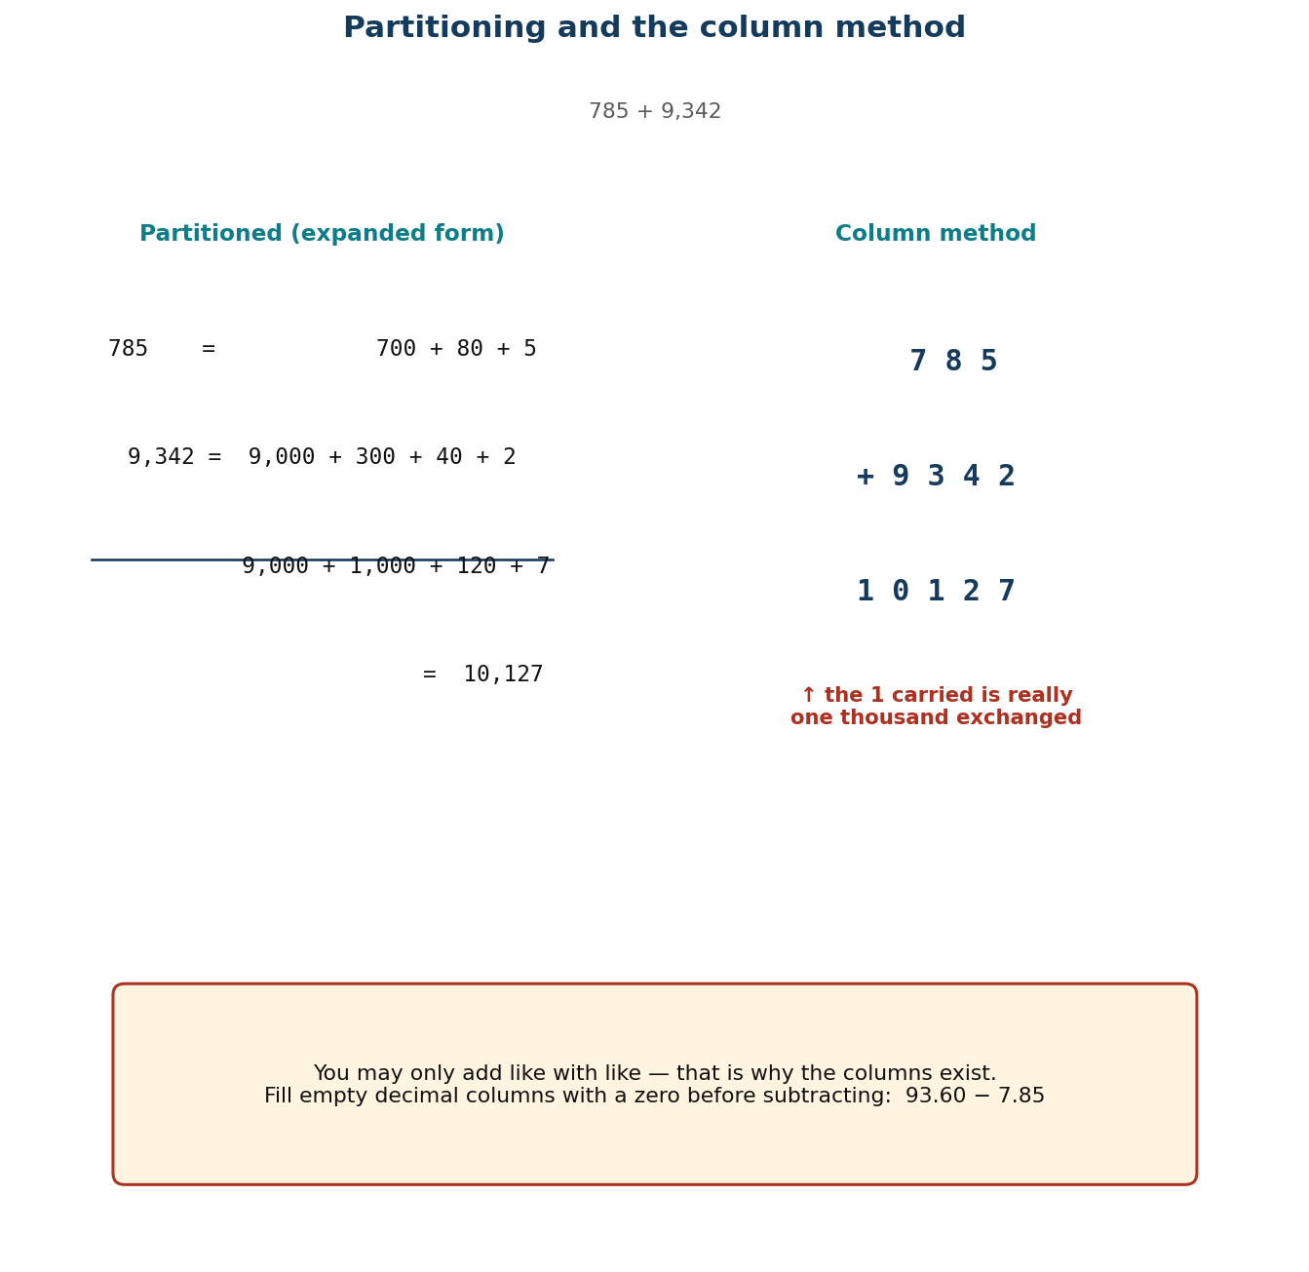
Figure 1.4 Partitioning and the column method side by side.
PHASE / TIME | TEACHER ACTIVITY | LEARNER ACTIVITY | CORE COMP. | ASSESSMENT (DoK)
ENGAGE  8 min | Write 3000 − 1 and ask for the answer. Many will write 3001 or 2001. Then ask: ‘What is 3,000 made of?’ — three thousands. ‘So if I take one away?’ Establish 2,999. Say: ‘Today we make sure the column method is something you understand, not something you do with your fingers.’ | Learners answer, then unpack 3,000 into bundles with the teacher. The error sets up why place value matters. | CP | Oral responses; diagnostic check. DoK 1
EXPLORE  16 min | Give each group base-ten blocks and the calculation 785 + 9,342. Task: do it with the blocks first, then write what you did in columns. Circulate and ask ‘what did you do when a column had more than ten?’ Collect the language they use — ‘carry’, ‘move’, ‘exchange’ — without correcting. | Groups manipulate blocks and record. They physically exchange ten ones for a ten and ten tens for a hundred, which is the concept the column method encodes. | CP | Observation checklist; group record. DoK 2
EXPLAIN  14 min | Formalise with Figure 1.4, using expanded form: 785 = 700 + 80 + 5; 9,342 = 9,000 + 300 + 40 + 2; sum = 9,000 + 1,000 + 120 + 7 = 10,127. Name the idea: you may only add like with like — that is why columns exist. Then subtraction with decimals: 93.6 − 7.85, showing the empty hundredths column must be filled with a zero placeholder first. Reframe ‘borrow’ as ‘exchange one ten for ten ones’. | Learners write both calculations in expanded form alongside the column method, and label each exchange in their own words. | CP | Questioning; corrected work in a second colour. DoK 2
ELABORATE  12 min | Class shop: pairs pick two items, add the prices, and pay with a round amount, calculating the change. Then ‘find the error’: three worked calculations with deliberate mistakes (misaligned columns, missing placeholder zero, wrong exchange) to diagnose. Extension: add three four-digit numbers with two exchanges. | Pairs shop and calculate change. The error-diagnosis task builds the checking habit explicitly. | CP | Application task; sentence frames. DoK 2–3
EVALUATE  10 min | Exit ticket: 5,073 − 2,486 and 45.7 + 8.63, each with an estimate written first. Collect and sort. Preview Lesson 10: ‘Tomorrow, multiplication and division of multi-digit numbers.’ | Learners complete the ticket alone, estimate first, and tick: I aligned the columns / I exchanged correctly / my answer matches my estimate. | CP | Exit ticket or assessed product. DoK 2–3

APPROACHING  PROFICIENCY (AP) | Support — three-digit numbers with blocks always available; no decimals until the whole-number method is secure.
PROFICIENT (P) | Core — as described, four digits and two decimal places.
HIGHLY  PROFICIENT (HP) | Extension — explain why the column method works, in writing, using expanded form; then add and subtract in base five to prove they understand exchange rather than the algorithm.

ASSESSMENT (summary) | Observation with checklist C7.9. Exit ticket marked on: estimate present and sensible; columns aligned; exchanges correct. Misalignment is the commonest failure and is addressed directly in the lesson.
HOMEWORK / PROJECT WORK | Six additions and six subtractions, each with an estimate first and an inverse-operation check afterwards.
CROSS-CUTTING LINKS | Business — shop accounts and change. Science — measurement arithmetic. Values — accuracy with money is a trust issue between people.
LESSON CLOSURE | Return to the essential questions; two learners summarise, one says what is still unclear; record names for follow-up below.

REFLECTION AND REMARKS (complete after teaching)
What went well — evidence of learning you saw
What I would change next time
Learners who need follow-up, and what I will do
Head of Department remarks

TEACHER — NAME AND SIGNATURE | HEAD OF DEPARTMENT | DATE

BASIC 7 MATHEMATICS • TERM 1 • WEEKLY LESSON NOTE
LESSON 10 of 24 — Multiplying and Dividing Multi-Digit Numbers
Week 5 • Number • Number Operations • B7.1.2.2.2 • 60 minutes
WEEK ENDING | DAY | DATE | PERIOD | DURATION | CLASS | SUBJECT
 |  |  |  | 60 min | Basic 7 | Mathematics

CLASS SIZE — BOYS | CLASS SIZE — GIRLS | CLASS SIZE — TOTAL

STRAND | Number
SUB-STRAND | Number Operations
CONTENT STANDARD | B7.1.2.2 — Demonstrate an understanding of addition, subtraction, multiplication and division of (i) whole numbers, and (ii) decimal numbers, to solve problems.
LEARNING INDICATOR(S) | B7.1.2.2.2 — Multiply or divide multi-digit numbers by 1- and 2-digit numbers.
PERFORMANCE INDICATOR  (what learners will do) | Learners multiply and divide multi-digit numbers by one- and two-digit numbers using partitioning, place value and the distributive property.
LEARNING OUTCOMES  (knowledge / skill / value) | • K — explain a partial product and state the divisibility tests for 2, 3, 5, 9 and 10.  • S — multiply a three-digit number by a two-digit number and divide by a one- or two-digit number accurately.  • A/V — choose between methods on the basis of the numbers, and check by estimating.
CORE COMPETENCIES | Critical Thinking and Problem Solving (CP); Personal Development and Leadership (PL).
KEY WORDS | multi-digit, partition, distributive property, partial product, lattice method, divisibility test, quotient, remainder, estimate
ESSENTIAL QUESTIONS | 1. What is a partial product?  2. How can I check a big multiplication?
PRIOR KNOWLEDGE (R.P.K.) | Lesson 9 addition and subtraction with exchange. Learners know their tables but many are unstable on 6–9, which blocks multi-digit work.
TEACHING / LEARNING RESOURCES  (TLMs) | Mini whiteboards; multiplication grids; Figure 1.5 (lattice) enlarged; a times-table warm-up chart; calculators only for checking, never for finding.
PEDAGOGICAL EXEMPLARS (methods) | Inquiry (5E); concrete – pictorial – abstract (CPA) with manipulatives; cooperative group work; questioning and discussion; differentiation by task, support and outcome
REFERENCE | NaCCA Mathematics Curriculum for the Common Core Programme (Basic 7–B9), September 2020 — B7.1.2.2.2, p. 10. Scheme of Learning, Week 5.

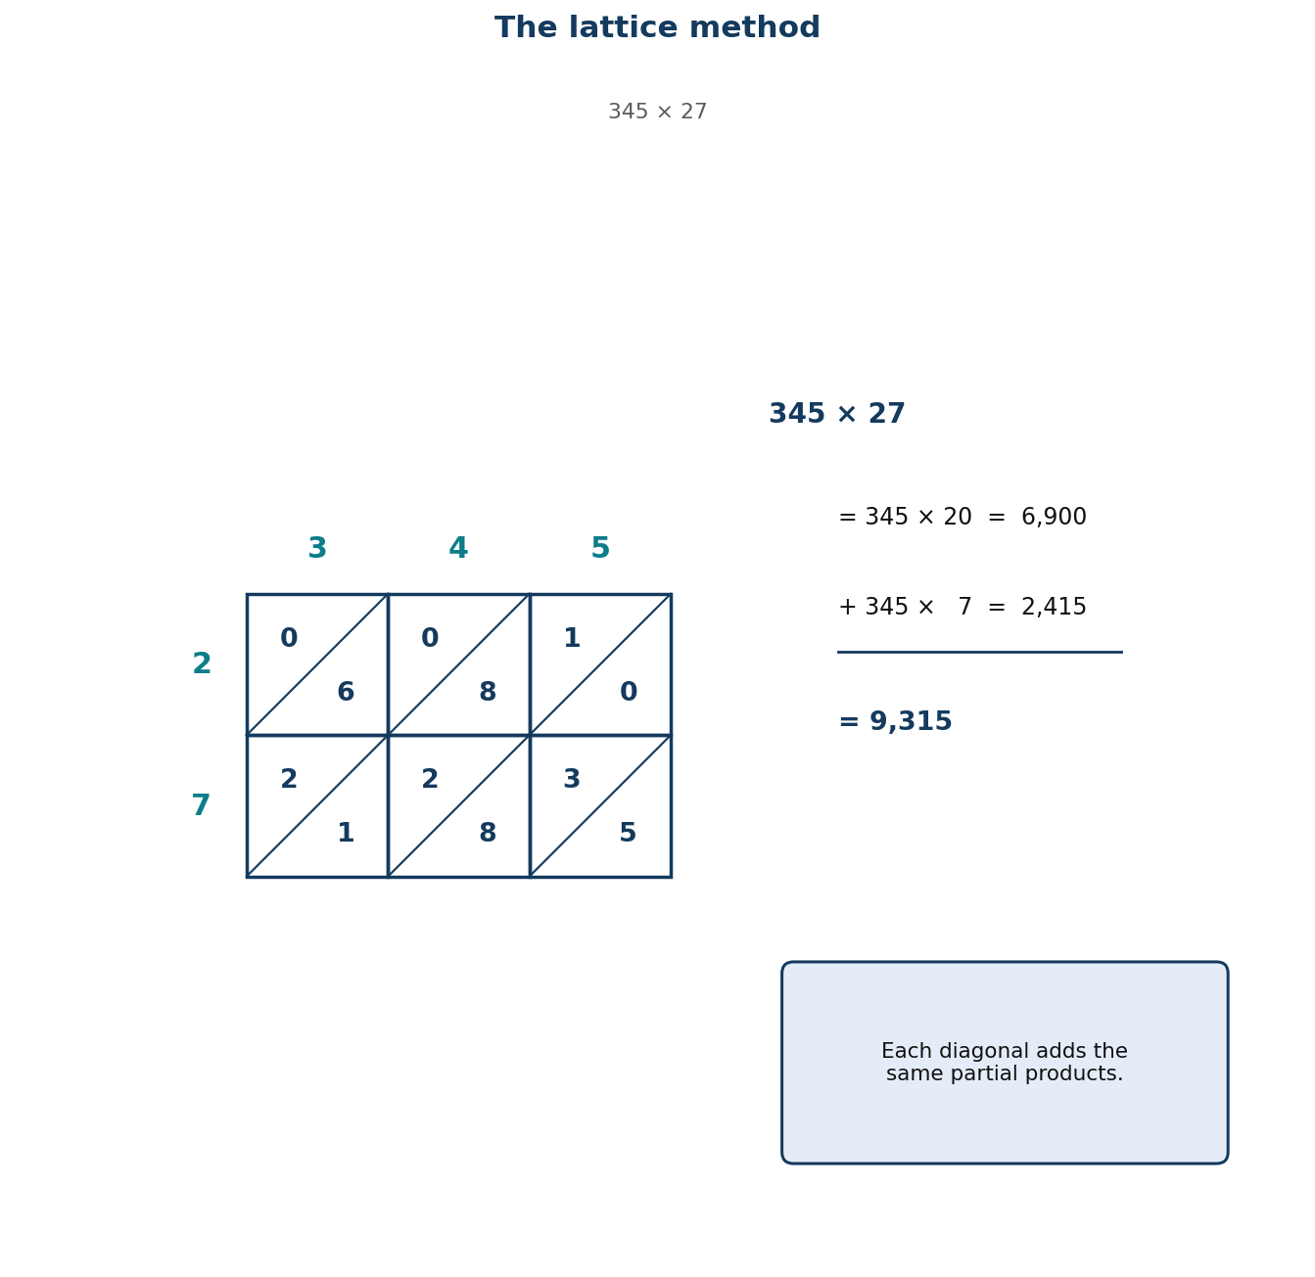
Figure 1.5 The lattice method organises the same partial products.
PHASE / TIME | TEACHER ACTIVITY | LEARNER ACTIVITY | CORE COMP. | ASSESSMENT (DoK)
ENGAGE  8 min | Three-minute times-table warm-up on whiteboards — the 7s and 8s, which are the usual weak spots. Then: ‘325 × 15.’ Say: ‘You already know 325 × 10 and you can halve that for 325 × 5. Add them.’ Model: 3,250 + 1,625 = 4,875. ‘That is the distributive property, and it is the whole lesson.’ | Learners complete the warm-up honestly, then watch the demonstration and try 214 × 15 the same way. | CP; PL | Oral responses; diagnostic check. DoK 1
EXPLORE  16 min | Give the calculation 345 × 27. Task: find the answer by splitting 27 into two easier numbers, and show every partial product. Circulate and ask ‘why did you split it there?’ Expect most to split 20 + 7; note anyone who splits differently. Then ask them to check with a different split — 30 − 3. | Groups produce two different splits and confirm they give the same answer, which is the first real evidence that the method is sound rather than lucky. | CP; PL | Observation checklist; group record. DoK 2
EXPLAIN  14 min | Formalise: 345 × 27 = 345 × 20 + 345 × 7 = 6,900 + 2,415 = 9,315. Name each line a partial product. Show the vertical place-value layout and, using Figure 1.5, the lattice method as an alternative that organises the same partial products. Then division: teach it as the inverse, and add the divisibility tests — 2 (last digit even), 3 (digit sum divisible by 3), 5 (ends 0 or 5), 9 (digit sum divisible by 9), 10 (ends 0) — as a way of predicting before calculating. | Learners write the partial products for two multiplications and test four numbers for divisibility, predicting before they divide. | CP; PL | Questioning; corrected work in a second colour. DoK 2
ELABORATE  12 min | Method choice: give six calculations and ask pairs to choose a method for each and say why — mental, partitioning, vertical or lattice. Then a context: a school buys 27 boxes of chalk at GH₵ 345 each; find the bill and check it by rounding. Extension: prove the divisibility test for 3 using expanded form. | Pairs choose methods and defend them. The point being taught is that method selection is itself a skill. | CP; PL | Application task; sentence frames. DoK 2–3
EVALUATE  10 min | Exit ticket: 468 × 23 using partial products, and 1,176 ÷ 24. Collect and sort. Preview Lesson 11: ‘Tomorrow, story problems with decimals — where choosing the operation is the hard part.’ | Learners complete the ticket alone and tick: I can find partial products / I can add them correctly / my estimate matches. | CP; PL | Exit ticket or assessed product. DoK 2–3

APPROACHING  PROFICIENCY (AP) | Support — two-digit by one-digit, with a written grid for partial products and the tables chart visible; drop the lattice method.
PROFICIENT (P) | Core — as described, three-digit by two-digit and division by two digits.
HIGHLY  PROFICIENT (HP) | Extension — explain why the lattice method works in terms of partial products, and justify the divisibility test for 9.

ASSESSMENT (summary) | Observation with checklist C7.10. Exit ticket marked on: partial products correct and complete; addition of partial products accurate; estimate consistent. Table weakness, not method weakness, is the usual cause of failure here — diagnose before reteaching.
HOMEWORK / PROJECT WORK | Eight multiplications and four divisions, each with an estimate. Then write one sentence saying which method you prefer and why.
CROSS-CUTTING LINKS | Business — invoices and bulk buying. ICT — spreadsheets do this, but you must be able to check them. Values — diligence: multi-digit arithmetic rewards careful, orderly work.
LESSON CLOSURE | Return to the essential questions; two learners summarise, one says what is still unclear; record names for follow-up below.

REFLECTION AND REMARKS (complete after teaching)
What went well — evidence of learning you saw
What I would change next time
Learners who need follow-up, and what I will do
Head of Department remarks

TEACHER — NAME AND SIGNATURE | HEAD OF DEPARTMENT | DATE

BASIC 7 MATHEMATICS • TERM 1 • WEEKLY LESSON NOTE
LESSON 11 of 24 — Story Problems with Decimals
Week 6 • Number • Number Operations • B7.1.2.2.3 • 60 minutes
WEEK ENDING | DAY | DATE | PERIOD | DURATION | CLASS | SUBJECT
 |  |  |  | 60 min | Basic 7 | Mathematics

CLASS SIZE — BOYS | CLASS SIZE — GIRLS | CLASS SIZE — TOTAL

STRAND | Number
SUB-STRAND | Number Operations
CONTENT STANDARD | B7.1.2.2 — Demonstrate an understanding of addition, subtraction, multiplication and division of (i) whole numbers, and (ii) decimal numbers, to solve problems.
LEARNING INDICATOR(S) | B7.1.2.2.3 — Create and solve story problems involving decimals on the four basic operations.
PERFORMANCE INDICATOR  (what learners will do) | Learners create and solve story problems involving decimals using all four operations.
LEARNING OUTCOMES  (knowledge / skill / value) | • K — identify which operation a decimal story problem requires and justify the choice from the situation.  • S — create and solve two-step story problems involving decimals in all four operations.  • A/V — value problems drawn from real life, and check answers against the situation.
CORE COMPETENCIES | Critical Thinking and Problem Solving (CP); Personal Development and Leadership (PL).
KEY WORDS | story problem, operation, decimal, context, reasonable, estimate, check, two-step
ESSENTIAL QUESTIONS | 1. How do I write a problem that needs multiplying?  2. What makes an answer reasonable in a real situation?
PRIOR KNOWLEDGE (R.P.K.) | Lessons 8–10: word problems, four-digit operations with decimals, multi-digit multiplication and division.
TEACHING / LEARNING RESOURCES  (TLMs) | Story-problem cards in Ghanaian settings; blank card templates for learners to write their own; a class price list; mini whiteboards.
PEDAGOGICAL EXEMPLARS (methods) | Inquiry (5E); concrete – pictorial – abstract (CPA) with manipulatives; structured problem-solving routine; cooperative group work; questioning and discussion; differentiation by task, support and outcome
REFERENCE | NaCCA Mathematics Curriculum for the Common Core Programme (Basic 7–B9), September 2020 — B7.1.2.2.3, p. 11. Scheme of Learning, Week 6.

PHASE / TIME | TEACHER ACTIVITY | LEARNER ACTIVITY | CORE COMP. | ASSESSMENT (DoK)
ENGAGE  8 min | Read: ‘Mrs Adamu bought 13.6 kg of meat. Mrs Anderson bought 2.4 kg less. How much did they buy altogether?’ Ask: ‘How many steps is this?’ Establish two — find Mrs Anderson's amount first, then add. Say: ‘Today you write problems as well as solve them, which is harder and shows whether you really understand the operations.’ | Learners identify the two steps and name the operations. They recognise that the second step uses the answer to the first. | CP; PL | Oral responses; diagnostic check. DoK 1
EXPLORE  16 min | Give each group a situation card with data but no question — e.g. a market price list. Task: write two questions: one that needs multiplication and one that needs division. Then solve both. Circulate and ask ‘what makes a question need multiplication rather than division?’ | Groups write questions and solve them. Writing the question forces them to think about what each operation does to a quantity. | CP; PL | Observation checklist; group record. DoK 2
EXPLAIN  14 min | Share the best questions. Teach the structure: in multiplication the quantity repeats; in division it is shared out or measured out; in subtraction it is compared or reduced; in addition it is combined. Work the opening problem fully: 13.6 − 2.4 = 11.2 kg, then 13.6 + 11.2 = 24.8 kg. Check: both amounts are close to 13, so about 25 kg is reasonable. Emphasise the check against the story, not just the arithmetic. | Learners copy the four-operation structure with a keyword-free description of each, and solve a two-step problem with the teacher. | CP; PL | Questioning; corrected work in a second colour. DoK 2
ELABORATE  12 min | Problem exchange: each pair writes one two-step decimal problem on a card, swaps with another pair, solves it, and compares answers. Where the answers differ, the two pairs must find out who misread the problem. Extension: write a problem with a deliberate irrelevant piece of data and see who spots it. | Pairs write, swap, solve and negotiate. The negotiation is where the reasoning becomes visible. | CP; PL | Application task; sentence frames. DoK 2–3
EVALUATE  10 min | Exit ticket: solve one two-step decimal story problem, writing the operation for each step and a reasonableness check. Collect and sort. Preview Lesson 12: ‘Tomorrow we start powers — repeated multiplication.’ | Learners complete the ticket alone and tick: I found both steps / I chose the right operations / my answer is reasonable. | CP; PL | Exit ticket or assessed product. DoK 2–3

APPROACHING  PROFICIENCY (AP) | Support — one-step problems and a three-box frame (what I know / what I need / what I do); decimals to one place only.
PROFICIENT (P) | Core — as described, two-step problems with decimals to two places.
HIGHLY  PROFICIENT (HP) | Extension — write a problem that can only be solved with a particular order of operations, and explain why the order cannot change.

ASSESSMENT (summary) | Observation with checklist C7.11. Exit ticket marked on step identification, operation choice and the reasonableness check. Problems written by learners are assessed with rubric R4.
HOMEWORK / PROJECT WORK | Write two story problems about your own household — one multiplication, one division — with full solutions.
CROSS-CUTTING LINKS | English — precise writing makes a problem solvable. Business — market and shop arithmetic. Values — real problems concern real people's money.
LESSON CLOSURE | Return to the essential questions; two learners summarise, one says what is still unclear; record names for follow-up below.

REFLECTION AND REMARKS (complete after teaching)
What went well — evidence of learning you saw
What I would change next time
Learners who need follow-up, and what I will do
Head of Department remarks

TEACHER — NAME AND SIGNATURE | HEAD OF DEPARTMENT | DATE

BASIC 7 MATHEMATICS • TERM 1 • WEEKLY LESSON NOTE
LESSON 12 of 24 — Repeated Factors — The Idea of Powers
Week 6 • Number • Number Operations • B7.1.2.3.1 • 60 minutes
WEEK ENDING | DAY | DATE | PERIOD | DURATION | CLASS | SUBJECT
 |  |  |  | 60 min | Basic 7 | Mathematics

CLASS SIZE — BOYS | CLASS SIZE — GIRLS | CLASS SIZE — TOTAL

STRAND | Number
SUB-STRAND | Number Operations
CONTENT STANDARD | B7.1.2.3 — Demonstrate understanding and the use of powers of natural numbers in solving problems.
LEARNING INDICATOR(S) | B7.1.2.3.1 — Illustrate with examples the meaning of repeated factors using counting objects such as bottle tops or bundle sticks.
PERFORMANCE INDICATOR  (what learners will do) | Learners illustrate the meaning of repeated factors using concrete objects and write the shorthand index form.
LEARNING OUTCOMES  (knowledge / skill / value) | • K — state that a power records how many times a number is used as a factor, and identify the base and the index.  • S — build repeated products with objects and write them in index form and in expanded form.  • A/V — appreciate that notation exists to make long ideas short, and that the shorthand must never be written before the idea.
CORE COMPETENCIES | Critical Thinking and Problem Solving (CP); Creativity and Innovation (CI).
KEY WORDS | factor, repeated factor, power, index, exponent, base, squared, cubed, product
ESSENTIAL QUESTIONS | 1. What does the little number mean?  2. Is 2³ the same as 2 × 3?
PRIOR KNOWLEDGE (R.P.K.) | Multi-digit multiplication (Lesson 10). Learners have met area as length × width and volume as length × width × height in Basic 6, without index notation.
TEACHING / LEARNING RESOURCES  (TLMs) | Bottle tops or bundle sticks — at least 64 per group; squared paper; Figure 1.6 enlarged; mini whiteboards.
PEDAGOGICAL EXEMPLARS (methods) | Inquiry (5E); concrete – pictorial – abstract (CPA) with manipulatives; cooperative group work; questioning and discussion; differentiation by task, support and outcome
REFERENCE | NaCCA Mathematics Curriculum for the Common Core Programme (Basic 7–B9), September 2020 — B7.1.2.3.1, p. 13. Scheme of Learning, Week 6.

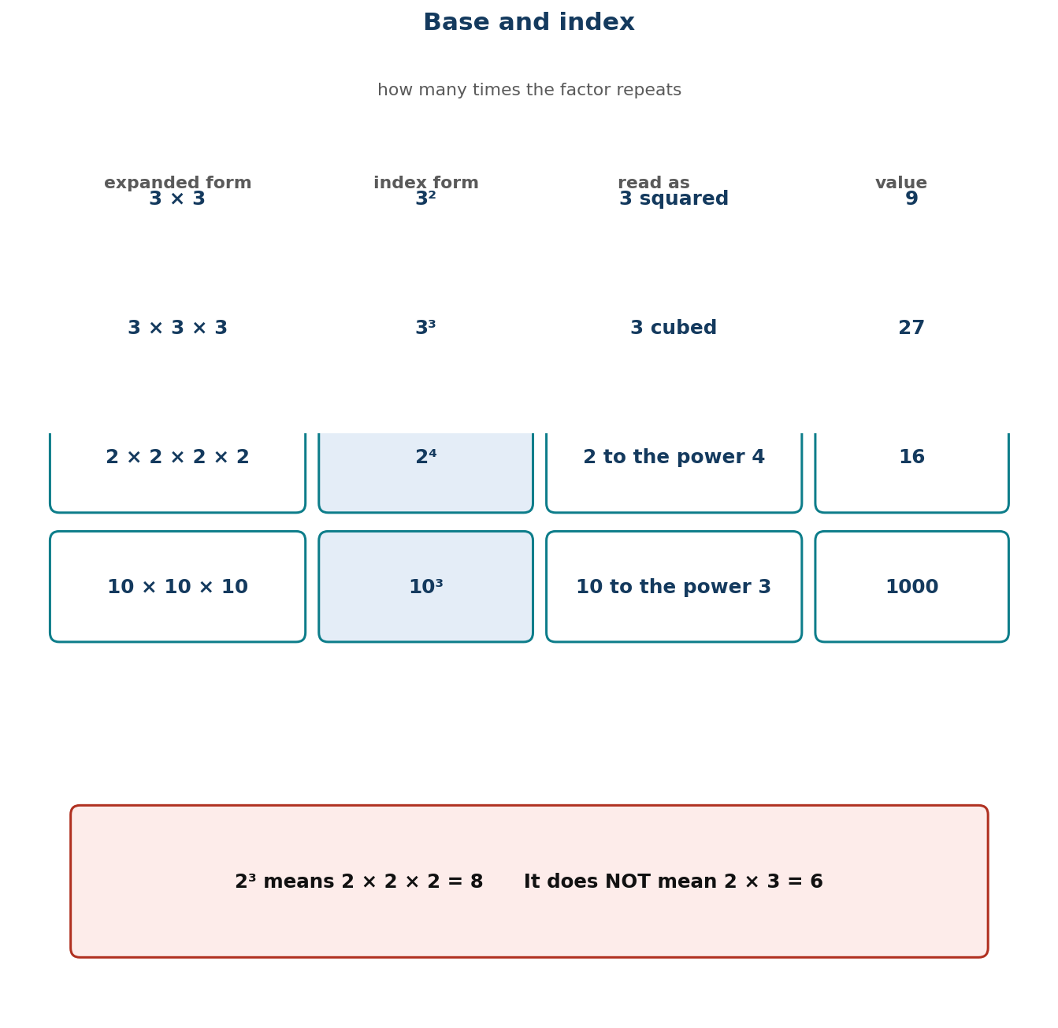
Figure 1.6 Base and index: how many times the factor repeats.
PHASE / TIME | TEACHER ACTIVITY | LEARNER ACTIVITY | CORE COMP. | ASSESSMENT (DoK)
ENGAGE  8 min | Write 2 × 2 × 2 × 2 × 2 × 2 × 2 × 2 on the board. Ask: ‘What is this?’ Then say: ‘Now imagine writing that out for thirty twos. Mathematicians got tired of it too.’ Tell them the performance indicator: ‘Today you invent the shorthand yourself, out of bottle tops.’ | Learners evaluate the long product (256) and agree it is tedious to write. They are ready for the notation because they have felt the need for it. | CP; CI | Oral responses; diagnostic check. DoK 1
EXPLORE  16 min | Give each group 64 bottle tops. Tasks in order: build 3 groups of 3; then build 4 groups of 4; then 3 groups of 3 groups of 3. For each, write the multiplication you have built, count the total, and write how many times the number appears as a factor. Circulate and ask ‘how many times did you use that number?’ | Groups build, count and record. They produce 3 × 3 = 9, 4 × 4 = 16 and 3 × 3 × 3 = 27, and have counted the repetitions themselves. | CP; CI | Observation checklist; group record. DoK 2
EXPLAIN  14 min | Harvest, then introduce the notation with Figure 1.6: the BASE is the number being repeated; the INDEX (or exponent) is how many times it is used as a factor. So 3 × 3 × 3 = 3³ = 27, read ‘three cubed’ or ‘three to the power three’. Special names: 2² is ‘squared’, 3³ is ‘cubed’. Then the essential warning: 2³ means 2 × 2 × 2 = 8, NOT 2 × 3 = 6. Say it twice — this is the single most common error in the whole topic. | Learners write six products in both forms and read them aloud. They write the warning 2³ ≠ 2 × 3 at the top of the page and box it. | CP; CI | Questioning; corrected work in a second colour. DoK 2
ELABORATE  12 min | ‘Build this’: teacher writes 5², 2⁵, 4³, 10² and groups build each with tops and report the value. Then the reverse: given 81, find a way to write it as a power. Extension: find three different numbers that can each be written as a power in two different ways (e.g. 64 = 8² = 4³ = 2⁶). | Groups build and evaluate. The reverse task — finding the power from the value — is the first step towards prime factorisation in Lesson 16. | CP; CI | Application task; sentence frames. DoK 2–3
EVALUATE  10 min | Exit ticket: write 7 × 7 × 7 in index form; evaluate 3⁴; and state what is wrong with 2³ = 6. Collect and sort. Preview Lesson 13: ‘Tomorrow we break numbers down into products of powers.’ | Learners complete the ticket alone and tick: I can identify the base / I can identify the index / I know 2³ is not 6. | CP; CI | Exit ticket or assessed product. DoK 2–3

APPROACHING  PROFICIENCY (AP) | Support — squares and cubes only, always with objects, and an index of 2 or 3; skip indices above 3.
PROFICIENT (P) | Core — as described, indices up to 5.
HIGHLY  PROFICIENT (HP) | Extension — evaluate 2ⁱ⁰ by repeated doubling, and explain why the values grow so fast — linking to the doubling story of the chessboard.

ASSESSMENT (summary) | Observation with checklist C7.12, which checks that the learner can BUILD the power with objects, not only write it. The exit ticket's third item directly tests the 2³ = 6 misconception.
HOMEWORK / PROJECT WORK | Evaluate ten powers with indices up to 4, and write each one out in expanded form as well.
CROSS-CUTTING LINKS | Science — area is squared, volume is cubed. ICT — computer memory uses powers of 2. Values — patience: large results come from repeating small, ordinary steps.
LESSON CLOSURE | Return to the essential questions; two learners summarise, one says what is still unclear; record names for follow-up below.

REFLECTION AND REMARKS (complete after teaching)
What went well — evidence of learning you saw
What I would change next time
Learners who need follow-up, and what I will do
Head of Department remarks

TEACHER — NAME AND SIGNATURE | HEAD OF DEPARTMENT | DATE

BASIC 7 MATHEMATICS • TERM 1 • WEEKLY LESSON NOTE
LESSON 13 of 24 — Writing Numbers as Products and Powers
Week 7 • Number • Number Operations • B7.1.2.3.2 • 60 minutes
WEEK ENDING | DAY | DATE | PERIOD | DURATION | CLASS | SUBJECT
 |  |  |  | 60 min | Basic 7 | Mathematics

CLASS SIZE — BOYS | CLASS SIZE — GIRLS | CLASS SIZE — TOTAL

STRAND | Number
SUB-STRAND | Number Operations
CONTENT STANDARD | B7.1.2.3 — Demonstrate understanding and the use of powers of natural numbers in solving problems.
LEARNING INDICATOR(S) | B7.1.2.3.2 — Express a given number as a product of a given number or numbers, as well as, in the form of a power or two such numbers as product of powers.
PERFORMANCE INDICATOR  (what learners will do) | Learners express a number as a product of factors, and write that product in index form including as a product of powers.
LEARNING OUTCOMES  (knowledge / skill / value) | • K — distinguish prime from composite numbers and state that every whole number above 1 is either prime or a product of primes.  • S — write a number as a product of its factors and then express repeated factors in index form, including products of powers.  • A/V — appreciate that every number has a unique prime building set — the same answer however you break it down.
CORE COMPETENCIES | Critical Thinking and Problem Solving (CP).
KEY WORDS | factor, product, prime, composite, factor pair, index form, base, power, product of powers
ESSENTIAL QUESTIONS | 1. Do I get the same primes however I start breaking the number down?  2. How do I write repeated factors using indices?
PRIOR KNOWLEDGE (R.P.K.) | Lesson 12 base and index. Learners know times tables and have used factor pairs since Basic 5.
TEACHING / LEARNING RESOURCES  (TLMs) | Bottle tops or counters (36 per group); factor-tree templates; mini whiteboards; Figure 1.7 enlarged; a wall chart of the first ten primes.
PEDAGOGICAL EXEMPLARS (methods) | Inquiry (5E); concrete – pictorial – abstract (CPA) with manipulatives; cooperative group work; questioning and discussion; differentiation by task, support and outcome
REFERENCE | NaCCA Mathematics Curriculum for the Common Core Programme (Basic 7–B9), September 2020 — B7.1.2.3.2, p. 13. Scheme of Learning, Week 7.

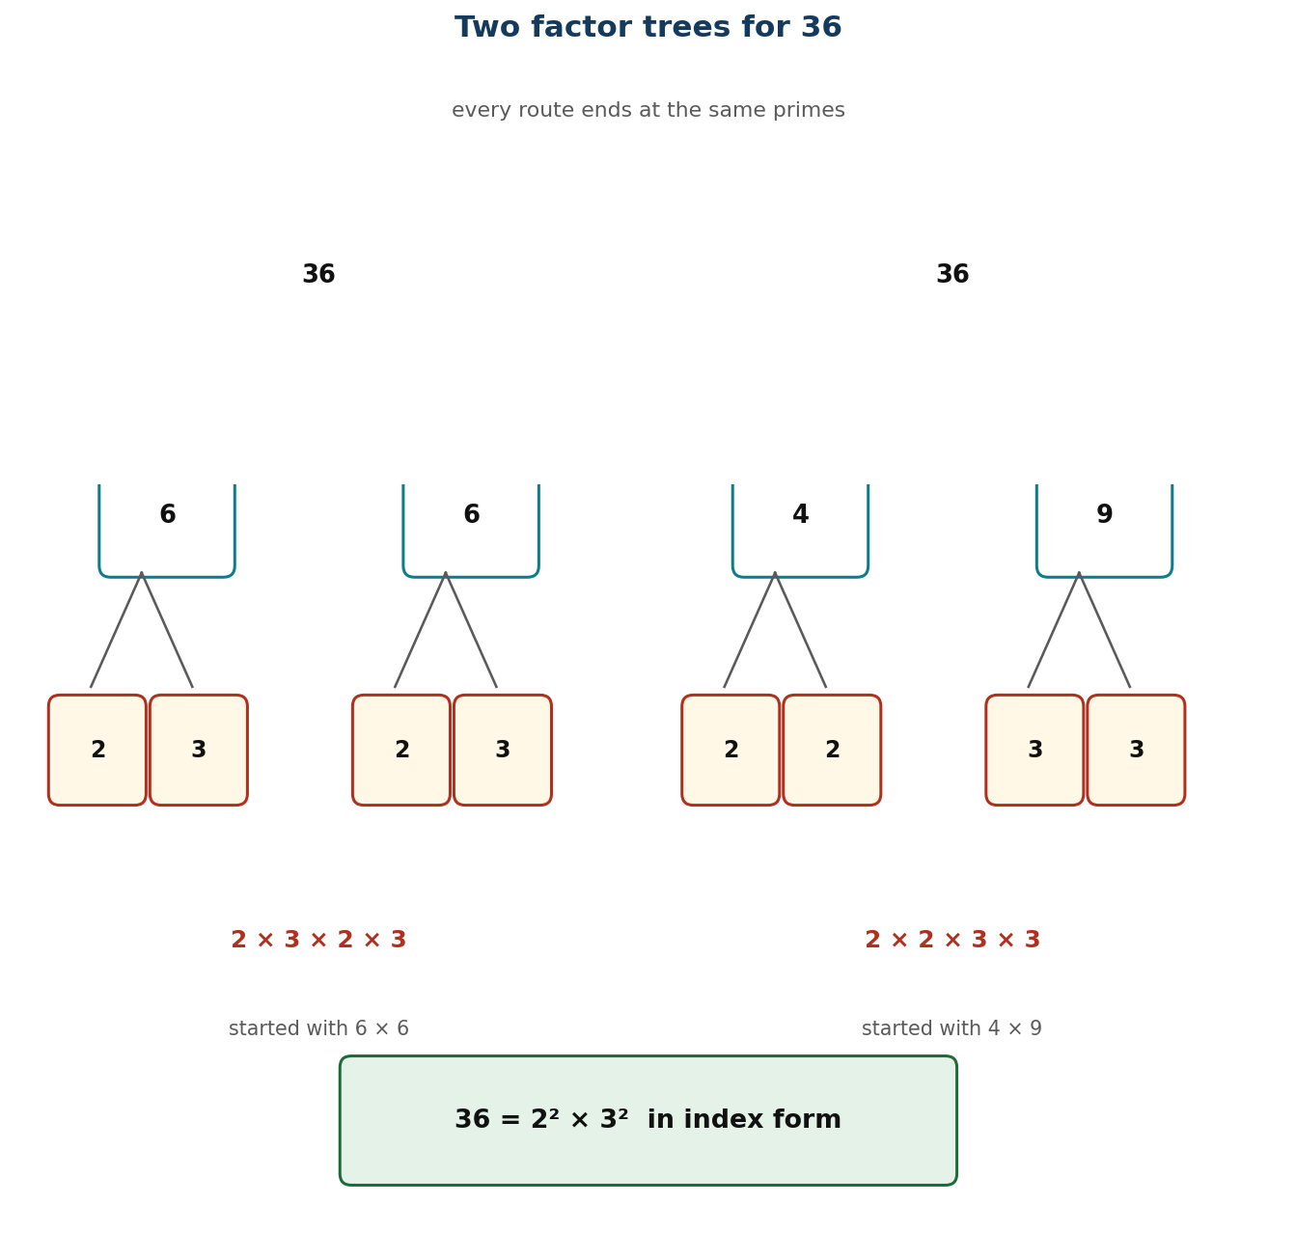
Figure 1.7 Two factor trees for 36, both ending at 2² × 3².
PHASE / TIME | TEACHER ACTIVITY | LEARNER ACTIVITY | CORE COMP. | ASSESSMENT (DoK)
ENGAGE  8 min | Ask: ‘In how many different ways can you arrange 36 bottle tops into equal rows?’ Collect answers — 1×36, 2×18, 3×12, 4×9, 6×6. Say: ‘Those pairs are the factors of 36. Today we break numbers down until they cannot be broken further, and then write the result with indices.’ | Learners arrange the tops and call out the arrangements. They record the factor pairs in their books. | CP | Oral responses; diagnostic check. DoK 1
EXPLORE  16 min | Task: break 36 down into factors, then keep breaking until you cannot go further. Different groups will start differently — 36 = 6 × 6, or 4 × 9, or 2 × 18. Let them, then ask: ‘Compare your final answer with another group that started differently. What do you notice?’ Circulate and ask ‘can you break this one down any more?’ | Groups produce factor trees by different routes and discover they all end at 2 × 2 × 3 × 3. The surprise is the point of the lesson. | CP | Observation checklist; group record. DoK 2
EXPLAIN  14 min | Take the discovery: every route ends in the same primes — 2² × 3². That is not a coincidence; it is a fact about every whole number. Name the primes (numbers with exactly two factors) and composites. Then teach the writing using Figure 1.7: group the repeated primes and write each with an index — 2 × 2 × 3 × 3 = 2² × 3². Then a product of powers with two different bases: 72 = 2³ × 3². | Learners write five numbers as products of powers, checking that the product still equals the original number each time. | CP | Questioning; corrected work in a second colour. DoK 2
ELABORATE  12 min | Factor-tree race: teams race to write 48, 60, 100 and 144 as products of powers, starting from different first splits to prove the answer is the same. Then ‘build a number’: given 2³ × 5², find the number (200). Extension: prove that 97 is prime by showing no prime up to its square root divides it. | Teams race and compare. The reverse task — building the number from the product of powers — is checked by multiplication. | CP | Application task; sentence frames. DoK 2–3
EVALUATE  10 min | Exit ticket: write 120 as a product of powers of primes, and write 2² × 3 × 5 as an ordinary number. Collect and sort. Preview Lesson 14: ‘Tomorrow, the strangest index of all — zero.’ | Learners complete the ticket alone and tick: I can find prime factors / I can write them with indices / I can multiply back to check. | CP | Exit ticket or assessed product. DoK 2–3

APPROACHING  PROFICIENCY (AP) | Support — numbers under 50, with a factor-tree template already drawn and the first ten primes on the desk.
PROFICIENT (P) | Core — as described, numbers up to 144.
HIGHLY  PROFICIENT (HP) | Extension — explain in writing why two different starting splits always end at the same primes, and find the smallest number with exactly six factors.

ASSESSMENT (summary) | Observation with checklist C7.13. Exit ticket marked on: all factors prime; indices correct; product checks back to the original. Learners who stop before reaching primes need the ‘can you break it further?’ question repeated, not the method retaught.
HOMEWORK / PROJECT WORK | Write each of 50, 75, 96 and 200 as a product of powers of primes, and check each by multiplying back.
CROSS-CUTTING LINKS | ICT — prime factorisation underpins encryption. Science — decomposition into elements. Values — persistence: you keep going until you cannot go further.
LESSON CLOSURE | Return to the essential questions; two learners summarise, one says what is still unclear; record names for follow-up below.

REFLECTION AND REMARKS (complete after teaching)
What went well — evidence of learning you saw
What I would change next time
Learners who need follow-up, and what I will do
Head of Department remarks

TEACHER — NAME AND SIGNATURE | HEAD OF DEPARTMENT | DATE

BASIC 7 MATHEMATICS • TERM 1 • WEEKLY LESSON NOTE
LESSON 14 of 24 — The Zero Index
Week 7 • Number • Number Operations • B7.1.2.3.3 • 60 minutes
WEEK ENDING | DAY | DATE | PERIOD | DURATION | CLASS | SUBJECT
 |  |  |  | 60 min | Basic 7 | Mathematics

CLASS SIZE — BOYS | CLASS SIZE — GIRLS | CLASS SIZE — TOTAL

STRAND | Number
SUB-STRAND | Number Operations
CONTENT STANDARD | B7.1.2.3 — Demonstrate understanding and the use of powers of natural numbers in solving problems.
LEARNING INDICATOR(S) | B7.1.2.3.3 — Show that the value of any natural number with zero as its exponent or index is 1 and use it to solve problems.
PERFORMANCE INDICATOR  (what learners will do) | Learners show that any natural number raised to the power zero equals 1, and use this to solve problems.
LEARNING OUTCOMES  (knowledge / skill / value) | • K — state that a⁰ = 1 for any natural number a, and justify it from the division pattern rather than from memory.  • S — evaluate expressions containing a zero index, including with numbers and with letters-free products of powers.  • A/V — value a result that is justified by a pattern rather than accepted on authority.
CORE COMPETENCIES | Critical Thinking and Problem Solving (CP).
KEY WORDS | zero index, exponent, power, pattern, divide by the base, consistent, convention
ESSENTIAL QUESTIONS | 1. What is 3⁰?  2. Why is it not 0, and why is it not 3?
PRIOR KNOWLEDGE (R.P.K.) | Lessons 12–13: base, index, products of powers, and dividing by powers of ten (Lesson 6).
TEACHING / LEARNING RESOURCES  (TLMs) | Mini whiteboards; a large descending-powers chart on the board; calculators (only to confirm, never to discover); Figure 1.8 enlarged.
PEDAGOGICAL EXEMPLARS (methods) | Inquiry (5E); concrete – pictorial – abstract (CPA) with manipulatives; cooperative group work; questioning and discussion; differentiation by task, support and outcome
REFERENCE | NaCCA Mathematics Curriculum for the Common Core Programme (Basic 7–B9), September 2020 — B7.1.2.3.3, p. 14. Scheme of Learning, Week 7.

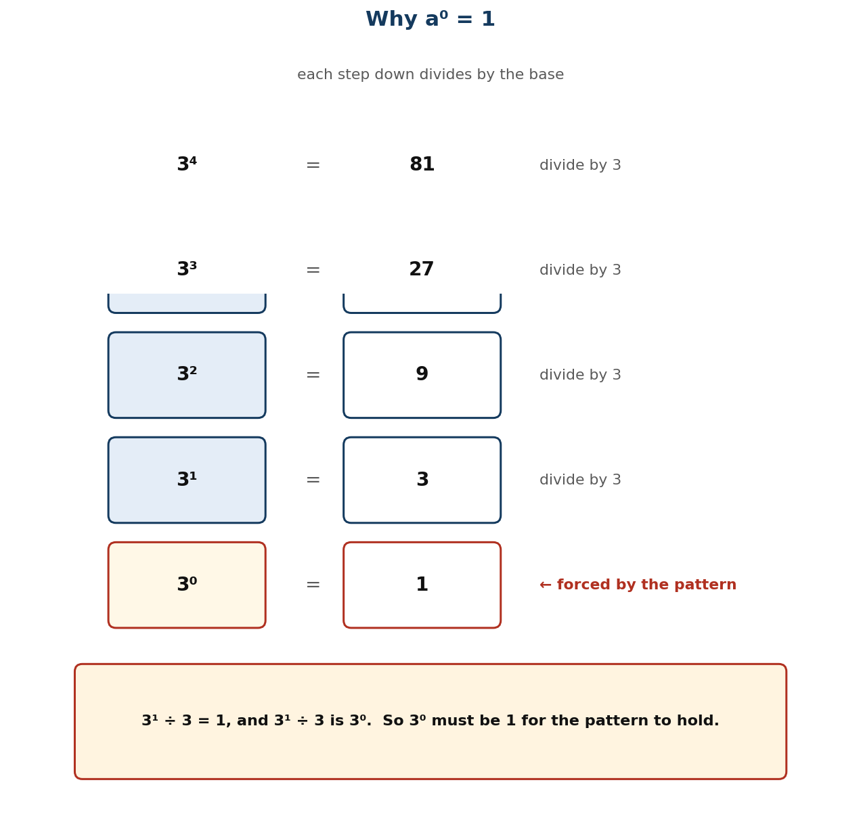
Figure 1.8 Dividing by the base each step down forces a⁰ = 1.
PHASE / TIME | TEACHER ACTIVITY | LEARNER ACTIVITY | CORE COMP. | ASSESSMENT (DoK)
ENGAGE  8 min | Write the descending pattern on the board: 3⁴ = 81, 3³ = 27, 3² = 9, 3¹ = 3. Ask: ‘What is happening each time you go down a row?’ Establish: divide by 3. ‘So what comes next?’ Let them reach 3⁰ before telling them anything. | Learners continue the pattern and arrive at 3⁰ = 1 themselves. They have discovered the result before it is named. | CP | Oral responses; diagnostic check. DoK 1
EXPLORE  16 min | Task: do the same descending pattern starting from 2⁵ and from 5⁴. Write what you get at the zero row for each. Then try 10³, 10², 10¹, 10⁰. Circulate and ask ‘is your zero row always the same number?’ Then ask: ‘why do you think that is?’ | Groups build three patterns and find 1 every time. The repetition across different bases is what makes the generalisation credible. | CP | Observation checklist; group record. DoK 2
EXPLAIN  14 min | Formalise with Figure 1.8: each step down divides by the base, so the step from a¹ = a to a⁰ must be a ÷ a = 1. Therefore a⁰ = 1 for every natural number a. Stress that this is not a definition someone chose — it is forced by the pattern; if we defined it any other way, the pattern would break. Then apply it: 2³ × 3² × 5⁰ = 8 × 9 × 1 = 72. Warn against the two usual errors: thinking a⁰ = 0, and thinking a⁰ = a. | Learners write the justification in their own words and evaluate six expressions containing zero indices, including one where the zero index is on the largest base. | CP | Questioning; corrected work in a second colour. DoK 2
ELABORATE  12 min | ‘Spot the impostor’: eight statements about zero indices, learners sort true from false and correct the false ones (4⁰ = 4; 0⁰ = 0; 7⁰ = 1; x⁰ = 0). Then mixed evaluation: 2⁴ × 5⁰, 3² × 2³ × 7⁰. Extension: ask whether 0⁰ should be 1 by the same argument, and why mathematicians leave it undefined. | Learners sort and correct. The impostor task directly targets the two named misconceptions. | CP | Application task; sentence frames. DoK 2–3
EVALUATE  10 min | Exit ticket: evaluate 6⁰, 2³ × 5⁰ and 9⁰ × 4², and explain in one sentence why 5⁰ = 1. Collect and sort. Preview Lesson 15: ‘Tomorrow we put every index law together.’ | Learners complete the ticket alone and tick: I can evaluate a zero index / I can explain why / I have not confused it with zero. | CP | Exit ticket or assessed product. DoK 2–3

APPROACHING  PROFICIENCY (AP) | Support — stay with the descending pattern and one base (2), evaluating only; skip the symbolic generalisation.
PROFICIENT (P) | Core — as described, with three bases and mixed evaluation.
HIGHLY  PROFICIENT (HP) | Extension — extend the pattern below zero to negative indices (3⁻¹ = ⅓) and explain why the same argument forces that too.

ASSESSMENT (summary) | Observation with checklist C7.14. Exit ticket marked on correct evaluation AND a justification that references dividing by the base. A learner who writes 1 from memory but cannot say why has not met the standard.
HOMEWORK / PROJECT WORK | Evaluate ten expressions with zero indices, and write one paragraph explaining the result to a friend who missed the lesson.
CROSS-CUTTING LINKS | Science — patterns and extrapolation are how scientific laws are found. English — explaining a mathematical reason in prose. Values — demand reasons, not just rules.
LESSON CLOSURE | Return to the essential questions; two learners summarise, one says what is still unclear; record names for follow-up below.

REFLECTION AND REMARKS (complete after teaching)
What went well — evidence of learning you saw
What I would change next time
Learners who need follow-up, and what I will do
Head of Department remarks

TEACHER — NAME AND SIGNATURE | HEAD OF DEPARTMENT | DATE

BASIC 7 MATHEMATICS • TERM 1 • WEEKLY LESSON NOTE
LESSON 15 of 24 — Evaluating Numbers in Index Form
Week 8 • Number • Number Operations • B7.1.2.3.4 • 60 minutes
WEEK ENDING | DAY | DATE | PERIOD | DURATION | CLASS | SUBJECT
 |  |  |  | 60 min | Basic 7 | Mathematics

CLASS SIZE — BOYS | CLASS SIZE — GIRLS | CLASS SIZE — TOTAL

STRAND | Number
SUB-STRAND | Number Operations
CONTENT STANDARD | B7.1.2.3 — Demonstrate understanding and the use of powers of natural numbers in solving problems.
LEARNING INDICATOR(S) | B7.1.2.3.4 — Find the value of a number written in index form.
PERFORMANCE INDICATOR  (what learners will do) | Learners find the value of a number written in index form, including products of powers and zero indices.
LEARNING OUTCOMES  (knowledge / skill / value) | • K — read and interpret index notation including squared, cubed and higher powers, and products of powers.  • S — evaluate expressions in index form accurately, applying the correct order of operations.  • A/V — check answers by estimating the size of the result before calculating.
CORE COMPETENCIES | Creativity and Innovation (CI); Critical Thinking and Problem Solving (CP).
KEY WORDS | index form, evaluate, base, index, exponent, product of powers, order of operations, square, cube
ESSENTIAL QUESTIONS | 1. How do I read and evaluate index notation?  2. Which is bigger, 2⁵ or 5²?
PRIOR KNOWLEDGE (R.P.K.) | Lessons 12–14: base and index, products of powers, zero index. Tables fluency is assumed and is the usual limiting factor.
TEACHING / LEARNING RESOURCES  (TLMs) | Mini whiteboards; a tables chart for anyone who needs it; a set of index cards for the relay; calculators for checking only.
PEDAGOGICAL EXEMPLARS (methods) | Inquiry (5E); concrete – pictorial – abstract (CPA) with manipulatives; cooperative group work; questioning and discussion; differentiation by task, support and outcome
REFERENCE | NaCCA Mathematics Curriculum for the Common Core Programme (Basic 7–B9), September 2020 — B7.1.2.3.4, p. 14. Scheme of Learning, Week 8.

PHASE / TIME | TEACHER ACTIVITY | LEARNER ACTIVITY | CORE COMP. | ASSESSMENT (DoK)
ENGAGE  8 min | Two-minute tables blast on whiteboards — squares up to 12² and cubes up to 5³. Then: ‘Which is bigger, 2⁵ or 5²?’ Most will guess 5². Work both: 32 against 25. Say: ‘The little number is not a multiplier — it is a counter. Today you get fast and accurate at reading it.’ | Learners complete the blast and check their own, then evaluate both numbers and react to the result. | CI; CP | Oral responses; diagnostic check. DoK 1
EXPLORE  16 min | Give each group eight index cards — 2⁵, 3³, 4², 10³, 5², 2³ × 3², 7⁰, 6² × 2⁰. Task: sort them into order of size, and write the value of each. Insist on an estimate before a calculation. Circulate and check whether anyone is doing base × index. | Groups estimate, evaluate and order. The mixed cards with zero indices reveal who is applying Lesson 14. | CI; CP | Observation checklist; group record. DoK 2
EXPLAIN  14 min | Take the order and confirm the values. Teach the routine explicitly: (i) read the base; (ii) read the index and say what it means — how many times the base is a factor; (iii) write it out in expanded form if you are unsure; (iv) multiply; (v) check the size is about right. Work 2³ × 3² = 8 × 9 = 72 slowly, showing that the two powers are evaluated first and then multiplied — the order of operations. | Learners write the five-step routine and apply it to three expressions in full, with expanded form shown. | CI; CP | Questioning; corrected work in a second colour. DoK 2
ELABORATE  12 min | Index relay: teams evaluate a card, run it to the board, and peg it in the right place on a number line. Then ‘make the target’: given the target 144, find as many index expressions as you can that equal it (12², 2⁴ × 3²…). Extension: compare 3⁴ and 4³ and generalise when the bigger base wins. | Teams race and peg. The ‘make the target’ task is open-ended and produces genuine mathematical discussion. | CI; CP | Application task; sentence frames. DoK 2–3
EVALUATE  10 min | Exit ticket: evaluate 5³, 2⁴ × 3 and 4² × 5⁰. Collect and sort. Preview Lesson 16: ‘Tomorrow we use powers of primes to find the highest common factor.’ | Learners complete the ticket alone and tick: I read the index correctly / I evaluated each power / I multiplied in the right order. | CI; CP | Exit ticket or assessed product. DoK 2–3

APPROACHING  PROFICIENCY (AP) | Support — single powers only, indices 2 and 3, with the tables chart visible and expanded form mandatory.
PROFICIENT (P) | Core — as described, including products of powers and zero indices.
HIGHLY  PROFICIENT (HP) | Extension — evaluate 2³ × 2² by two routes and state the index law it suggests.

ASSESSMENT (summary) | Observation with checklist C7.15. Exit ticket marked on correct evaluation. The diagnostic question throughout is whether any learner computes base × index — if so, return to bottle tops from Lesson 12 before going further.
HOMEWORK / PROJECT WORK | Twenty evaluations in index form, including six products of powers and three with a zero index.
CROSS-CUTTING LINKS | Science — scientific notation and very large or small measurements. ICT — powers of 2 in computing. Values — accuracy under pressure comes from a routine, not from rushing.
LESSON CLOSURE | Return to the essential questions; two learners summarise, one says what is still unclear; record names for follow-up below.

REFLECTION AND REMARKS (complete after teaching)
What went well — evidence of learning you saw
What I would change next time
Learners who need follow-up, and what I will do
Head of Department remarks

TEACHER — NAME AND SIGNATURE | HEAD OF DEPARTMENT | DATE

BASIC 7 MATHEMATICS • TERM 1 • WEEKLY LESSON NOTE
LESSON 16 of 24 — Prime Factors and the Highest Common Factor
Week 8 • Number • Number Operations • B7.1.2.3.5 • 60 minutes
WEEK ENDING | DAY | DATE | PERIOD | DURATION | CLASS | SUBJECT
 |  |  |  | 60 min | Basic 7 | Mathematics

CLASS SIZE — BOYS | CLASS SIZE — GIRLS | CLASS SIZE — TOTAL

STRAND | Number
SUB-STRAND | Number Operations
CONTENT STANDARD | B7.1.2.3 — Demonstrate understanding and the use of powers of natural numbers in solving problems.
LEARNING INDICATOR(S) | B7.1.2.3.5 — Apply the concept of powers of numbers (product of prime) to find Highest Common Factor (HCF).
PERFORMANCE INDICATOR  (what learners will do) | Learners use prime factorisation to find the Highest Common Factor of two or more numbers.
LEARNING OUTCOMES  (knowledge / skill / value) | • K — define the highest common factor and explain why it is found by taking the smallest power of each COMMON prime.  • S — find the HCF of two or three numbers using prime factorisation in index form.  • A/V — appreciate that the structured method beats listing, especially as numbers get larger.
CORE COMPETENCIES | Critical Thinking and Problem Solving (CP).
KEY WORDS | prime factor, prime factorisation, highest common factor, HCF, common factor, product of primes, index form, Venn
ESSENTIAL QUESTIONS | 1. What is the biggest number that divides into both?  2. Why do I take the smallest power of each prime?
PRIOR KNOWLEDGE (R.P.K.) | Lessons 13 and 15: prime factorisation and evaluating index form. Learners have found HCF by listing factors since Basic 6.
TEACHING / LEARNING RESOURCES  (TLMs) | Factor-tree templates from Lesson 13; two interlocking hoops or a printed Venn diagram; Figure 1.9 enlarged; mini whiteboards; a wall chart of primes to 50.
PEDAGOGICAL EXEMPLARS (methods) | Inquiry (5E); concrete – pictorial – abstract (CPA) with manipulatives; cooperative group work; questioning and discussion; differentiation by task, support and outcome
REFERENCE | NaCCA Mathematics Curriculum for the Common Core Programme (Basic 7–B9), September 2020 — B7.1.2.3.5, p. 15. Scheme of Learning, Week 8.

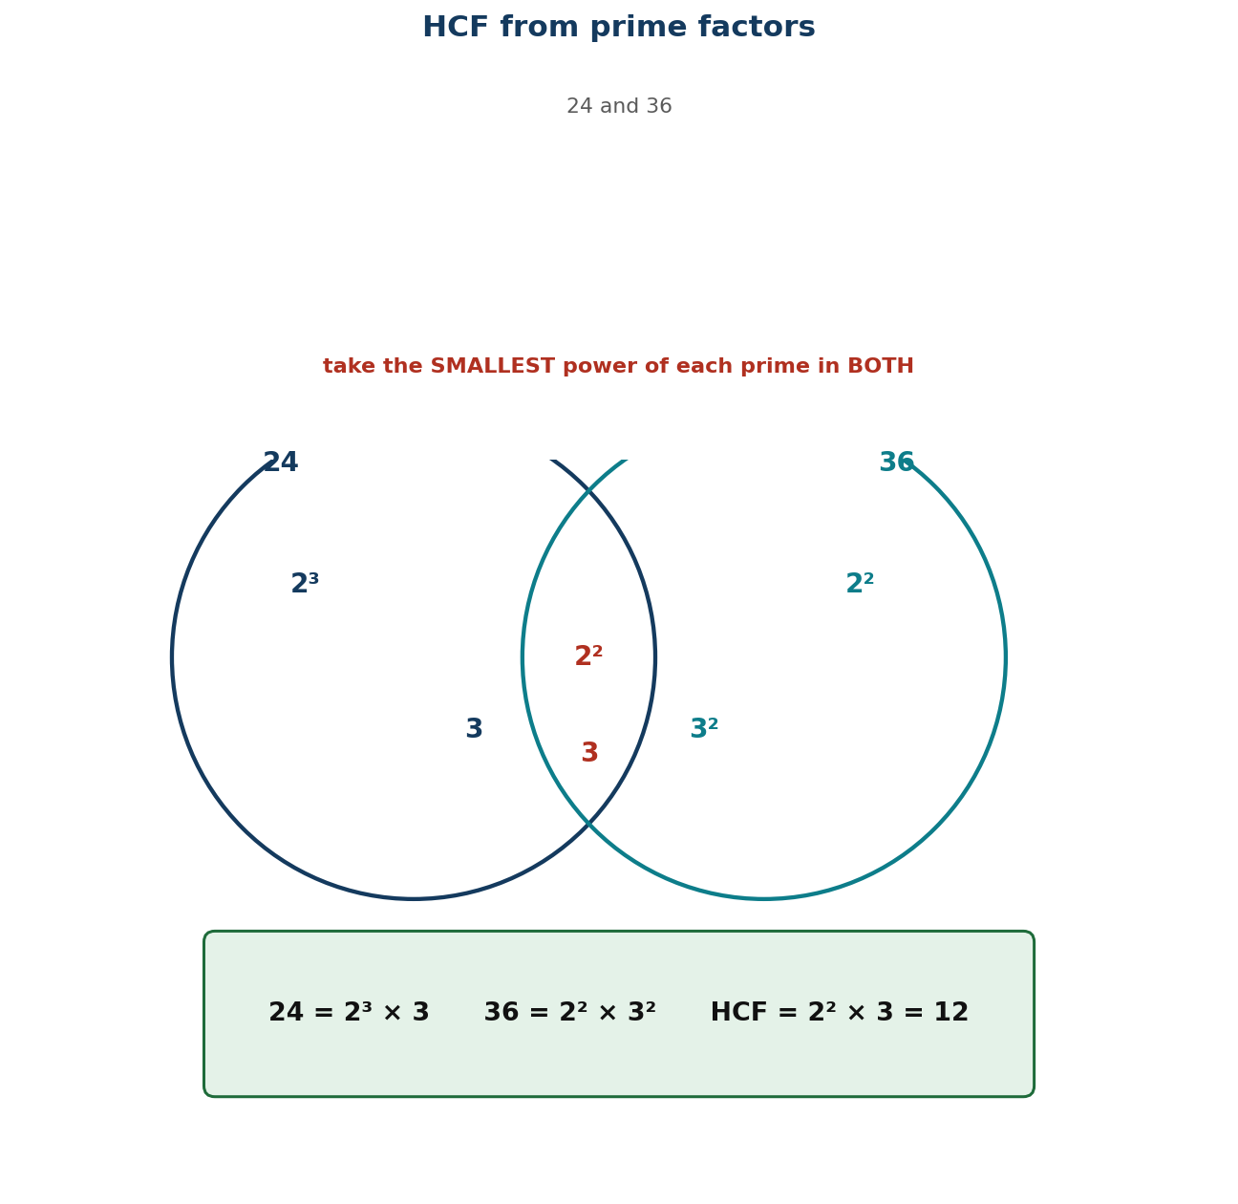
Figure 1.9 HCF from prime factors: the smallest power of each common prime.
PHASE / TIME | TEACHER ACTIVITY | LEARNER ACTIVITY | CORE COMP. | ASSESSMENT (DoK)
ENGAGE  8 min | Ask: ‘You have 24 oranges and 36 apples. You want identical fruit baskets with nothing left over. What is the largest number of baskets you can make?’ Let pairs try it. Most will guess-and-check. Say: ‘Today you learn a method that works even when the numbers are far too big to guess.’ | Pairs work on the fruit-basket problem and report. They will find 12 by trial, which sets up the need for a reliable method. | CP | Oral responses; diagnostic check. DoK 1
EXPLORE  16 min | Task: write 24 and 36 each as a product of powers of primes. Now look at the two answers side by side. Which primes appear in BOTH? What is the smallest power of each that appears in both? Circulate and ask ‘why the smallest, not the largest?’ Do NOT give the method. | Groups produce 24 = 2³ × 3 and 36 = 2² × 3², and identify 2² and 3 as the shared minimum. The reasoning is theirs before it is named. | CP | Observation checklist; group record. DoK 2
EXPLAIN  14 min | Formalise with Figure 1.9: to find the HCF, take each prime that appears in BOTH factorisations, raised to the SMALLEST power with which it appears. So HCF(24, 36) = 2² × 3 = 12. Explain the logic: the common factor cannot use more of any prime than the smaller supply allows. Then check: 12 divides both 24 and 36, and nothing bigger does. Contrast with the largest power, which gives the lowest common multiple — name it but do not teach it now. | Learners write the rule and apply it to two pairs, checking each answer by division. | CP | Questioning; corrected work in a second colour. DoK 2
ELABORATE  12 min | Venn diagrams: pairs put the prime factors of two numbers into two hoops, with the intersection giving the HCF directly. Then the context: tile a 240 cm by 360 cm floor with identical square tiles — what is the largest tile? Extension: find the HCF of three numbers, and explain why the method still works. | Pairs use the hoops and then solve the tiling problem, which is the most concrete application of HCF there is. | CP | Application task; sentence frames. DoK 2–3
EVALUATE  10 min | Exit ticket: find the HCF of 60 and 84 by prime factorisation, and check it by division. Collect and sort. Preview Lesson 17: ‘Tomorrow we leave whole numbers for a while and start fractions.’ | Learners complete the ticket alone and tick: I factorised correctly / I chose the smallest powers / I checked by division. | CP | Exit ticket or assessed product. DoK 2–3

APPROACHING  PROFICIENCY (AP) | Support — numbers under 50 with factor trees already drawn; find the HCF by listing common factors first so the answer is known before the method is taught.
PROFICIENT (P) | Core — as described, numbers up to 200, two numbers.
HIGHLY  PROFICIENT (HP) | Extension — three numbers, and an explanation in writing of why taking the LARGEST power would give the lowest common multiple instead.

ASSESSMENT (summary) | Observation with checklist C7.16. Exit ticket marked on: correct prime factorisation; smallest powers selected; check by division. The commonest error — taking the largest power — is named and contrasted in the lesson.
HOMEWORK / PROJECT WORK | Find the HCF of five pairs using prime factors, and check each by division. Then write the tiling problem from the lesson with your own numbers.
CROSS-CUTTING LINKS | Design and Technology — tiling and cutting materials without waste. Business — sharing goods into equal lots. Values — fairness: equal shares for everyone.
LESSON CLOSURE | Return to the essential questions; two learners summarise, one says what is still unclear; record names for follow-up below.

REFLECTION AND REMARKS (complete after teaching)
What went well — evidence of learning you saw
What I would change next time
Learners who need follow-up, and what I will do
Head of Department remarks

TEACHER — NAME AND SIGNATURE | HEAD OF DEPARTMENT | DATE

BASIC 7 MATHEMATICS • TERM 1 • WEEKLY LESSON NOTE
LESSON 17 of 24 — Benchmark Fractions, Decimals and Percentages
Week 9 • Number • Fractions • B7.1.3.1.1 • 60 minutes
WEEK ENDING | DAY | DATE | PERIOD | DURATION | CLASS | SUBJECT
 |  |  |  | 60 min | Basic 7 | Mathematics

CLASS SIZE — BOYS | CLASS SIZE — GIRLS | CLASS SIZE — TOTAL

STRAND | Number
SUB-STRAND | Fractions
CONTENT STANDARD | B7.1.3.1 — Simplify, compare and order a mixture of positive fractions (i.e. common, percent and decimal) by changing all to equivalent (i) fractions, (ii) decimals, or (iii) percentages.
LEARNING INDICATOR(S) | B7.1.3.1.1 — Determine and recall the percentages and decimals of given benchmark fractions (i.e. tenths, fifths, fourths, thirds and halves) and use these to compare quantities.
PERFORMANCE INDICATOR  (what learners will do) | Learners recall the decimal and percentage equivalents of benchmark fractions and use them to compare quantities.
LEARNING OUTCOMES  (knowledge / skill / value) | • K — recall the decimal and percentage equivalents of halves, thirds, quarters, fifths and tenths.  • S — convert between common fractions, decimals and percentages for benchmark values, and use them to compare quantities.  • A/V — appreciate that three notations describe the same quantity, and choose the one that suits the situation.
CORE COMPETENCIES | Critical Thinking and Problem Solving (CP); Creativity and Innovation (CI).
KEY WORDS | benchmark fraction, equivalent, common fraction, decimal fraction, percentage, tenth, fifth, quarter, third, half, convert
ESSENTIAL QUESTIONS | 1. Is ¾ the same as 0.75 and as 75%?  2. Why is a third not 33%?
PRIOR KNOWLEDGE (R.P.K.) | Rounding decimals (Lesson 4) and percentages from Basic 6. Learners usually know ½ = 0.5 = 50% but not the thirds.
TEACHING / LEARNING RESOURCES  (TLMs) | Fraction walls; strips of paper folded into halves, thirds, quarters, fifths and tenths; a large benchmark chart for the wall; Figure 1.10 enlarged; scissors and glue.
PEDAGOGICAL EXEMPLARS (methods) | Inquiry (5E); concrete – pictorial – abstract (CPA) with manipulatives; cooperative group work; questioning and discussion; differentiation by task, support and outcome
REFERENCE | NaCCA Mathematics Curriculum for the Common Core Programme (Basic 7–B9), September 2020 — B7.1.3.1.1, p. 17. Scheme of Learning, Week 9.

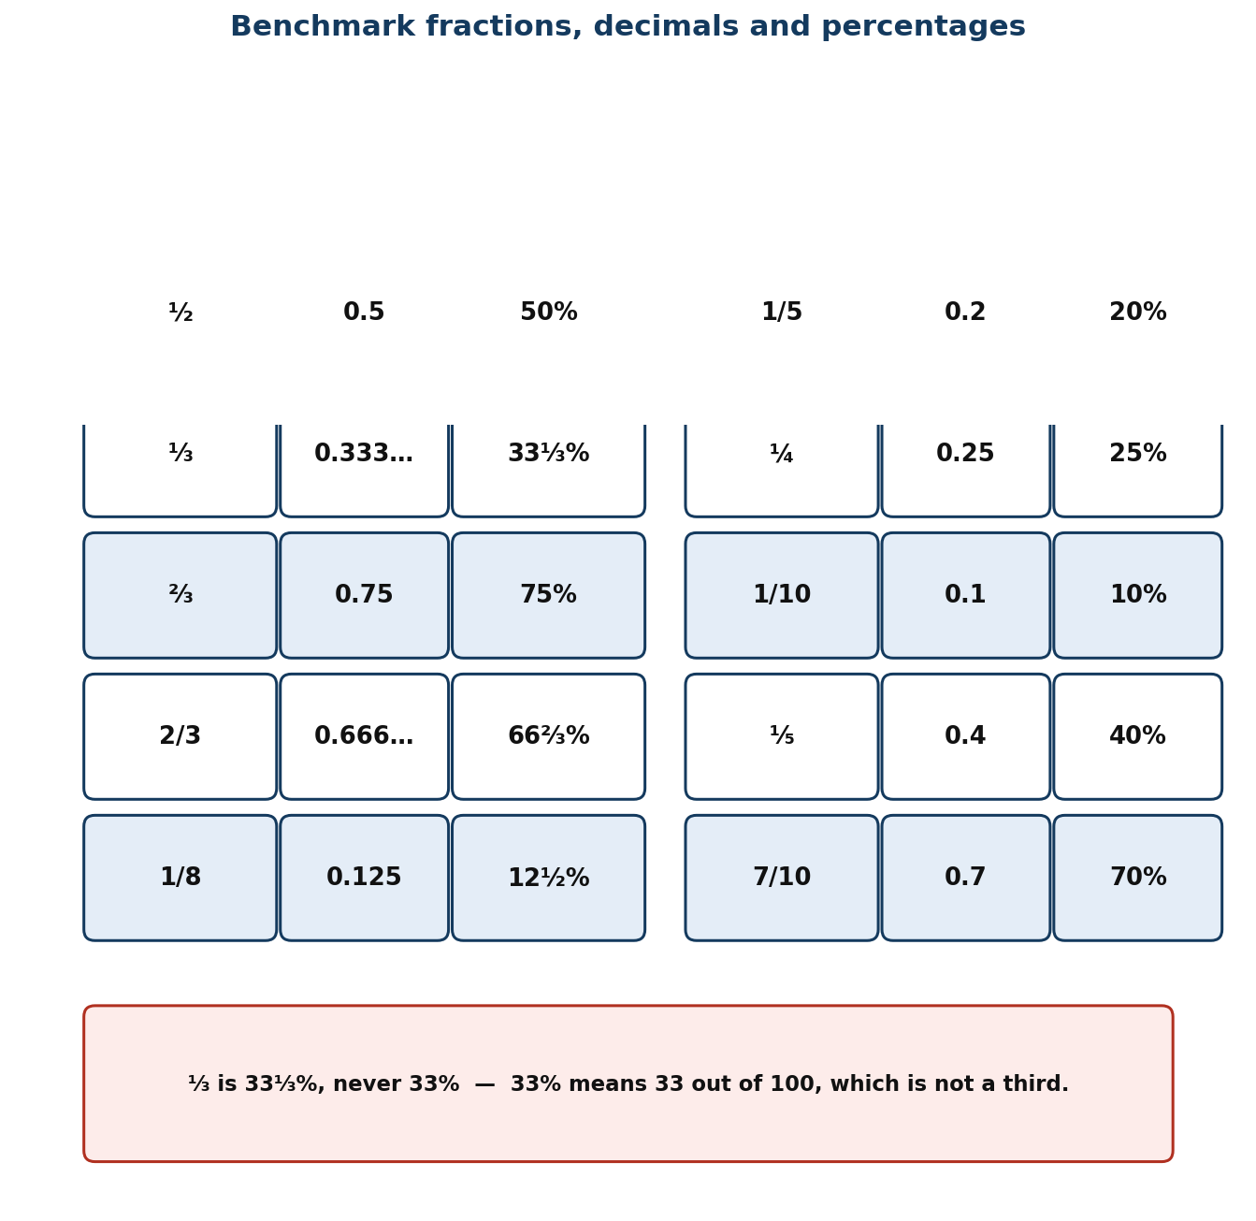
Figure 1.10 Benchmark fractions with their decimal and percentage equivalents.
PHASE / TIME | TEACHER ACTIVITY | LEARNER ACTIVITY | CORE COMP. | ASSESSMENT (DoK)
ENGAGE  8 min | Ask: ‘Which is bigger, ⅔ or 0.7?’ Let them vote. Then: ‘Which is bigger, ⅔ or 70%?’ Watch the votes change even though it is the same question. Say: ‘That is why we need one notation we can all picture. Today you build the benchmark chart you will keep all term.’ | Learners vote twice and notice their own inconsistency. They begin the benchmark chart in their books. | CP; CI | Oral responses; diagnostic check. DoK 1
EXPLORE  16 min | Give each group five paper strips of equal length. Task: fold one into halves, one into thirds, one into quarters, one into fifths and one into tenths. Label each fold with the fraction, then work out the decimal and the percentage for that fraction. Circulate and ask ‘how would you get the percentage from the decimal?’ | Groups fold, label and convert. Thirds produce 0.333…, which raises the recurring decimal question naturally. | CP; CI | Observation checklist; group record. DoK 2
EXPLAIN  14 min | Build the class chart with Figure 1.10: ½ = 0.5 = 50%; ⅓ = 0.333… = 33⅓%; ¼ = 0.25 = 25%; ⅕ = 0.2 = 20%; 1/10 = 0.1 = 10%. Teach the conversions: fraction → decimal by dividing top by bottom; decimal → percentage by multiplying by 100; percentage → fraction by putting it over 100 and simplifying. Insist that thirds are written 33⅓% and never 33%, because 33% is 33/100, not a third. | Learners complete the chart and then drill it in pairs — one says a fraction, the other gives the decimal and the percentage. | CP; CI | Questioning; corrected work in a second colour. DoK 2
ELABORATE  12 min | Give pairs mixed sets — ⅔, 0.8, 65%, ⅓, 0.4 — and ask them to sort into order, converting everything to percentages first. Then a real comparison: is a 30% discount better than a third off? Extension: find a fraction that is exactly halfway between ⅓ and ½. | Pairs sort and explain their conversion choice. The discount question shows why the skill matters outside school. | CP; CI | Application task; sentence frames. DoK 2–3
EVALUATE  10 min | Exit ticket: fill in a four-column table (fraction, decimal, percentage) for ⅓, ⅔, 1/5 and 7/10. Collect and sort. Preview Lesson 18: ‘Tomorrow we compare and order any fractions, not just the benchmarks.’ | Learners complete the ticket alone and tick: I know the benchmarks / I can convert / I can compare across notations. | CP; CI | Exit ticket or assessed product. DoK 2–3

APPROACHING  PROFICIENCY (AP) | Support — halves, quarters and tenths only, with the folded strips always available; leave thirds until last.
PROFICIENT (P) | Core — as described, including thirds and fifths.
HIGHLY  PROFICIENT (HP) | Extension — explain why ⅓ cannot be written as an exact decimal, and what that means for money calculations involving thirds.

ASSESSMENT (summary) | Observation with checklist C7.17. Exit ticket marked on accurate conversion. The 33% for ⅓ error is anticipated and corrected explicitly in the lesson; check for it specifically when marking.
HOMEWORK / PROJECT WORK | Complete a benchmark chart for halves, thirds, quarters, fifths, eighths and tenths, and learn it — you will use it every lesson for the rest of term.
CROSS-CUTTING LINKS | Business — discounts, interest and shares. Home Economics — recipe quantities. Values — clarity: three notations, one meaning.
LESSON CLOSURE | Return to the essential questions; two learners summarise, one says what is still unclear; record names for follow-up below.

REFLECTION AND REMARKS (complete after teaching)
What went well — evidence of learning you saw
What I would change next time
Learners who need follow-up, and what I will do
Head of Department remarks

TEACHER — NAME AND SIGNATURE | HEAD OF DEPARTMENT | DATE

BASIC 7 MATHEMATICS • TERM 1 • WEEKLY LESSON NOTE
LESSON 18 of 24 — Comparing and Ordering Fractions
Week 9 • Number • Fractions • B7.1.3.1.2 • 60 minutes
WEEK ENDING | DAY | DATE | PERIOD | DURATION | CLASS | SUBJECT
 |  |  |  | 60 min | Basic 7 | Mathematics

CLASS SIZE — BOYS | CLASS SIZE — GIRLS | CLASS SIZE — TOTAL

STRAND | Number
SUB-STRAND | Fractions
CONTENT STANDARD | B7.1.3.1 — Simplify, compare and order a mixture of positive fractions (i.e. common, percent and decimal) by changing all to equivalent (i) fractions, (ii) decimals, or (iii) percentages.
LEARNING INDICATOR(S) | B7.1.3.1.2 — Compare and order fractions (i.e. common, percent and decimal fractions up to thousandths) limit to the benchmark fractions.
PERFORMANCE INDICATOR  (what learners will do) | Learners compare and order common, decimal and percentage fractions, limited to the benchmarks, by converting them all to the same form.
LEARNING OUTCOMES  (knowledge / skill / value) | • K — state that fractions can only be compared when they are written in the same form, and name two ways to achieve that.  • S — order a mixed set of common fractions, decimals and percentages up to thousandths.  • A/V — choose the most efficient common form for a given set rather than defaulting to one method.
CORE COMPETENCIES | Communication and Collaboration (CC); Critical Thinking and Problem Solving (CP).
KEY WORDS | compare, order, ascending, descending, common denominator, equivalent, benchmark, convert, thousandth
ESSENTIAL QUESTIONS | 1. How do I compare a fraction with a decimal?  2. Does a bigger denominator mean a bigger fraction?
PRIOR KNOWLEDGE (R.P.K.) | Lesson 17 benchmark conversions. Learners have compared fractions with the same denominator since Basic 5 and often over-generalise ‘bigger denominator means bigger fraction’.
TEACHING / LEARNING RESOURCES  (TLMs) | Fraction walls and folded strips from Lesson 17; mini whiteboards; number lines marked in tenths; Figure 1.10 from Lesson 17 for reference.
PEDAGOGICAL EXEMPLARS (methods) | Inquiry (5E); concrete – pictorial – abstract (CPA) with manipulatives; cooperative group work; questioning and discussion; differentiation by task, support and outcome
REFERENCE | NaCCA Mathematics Curriculum for the Common Core Programme (Basic 7–B9), September 2020 — B7.1.3.1.2, p. 19. Scheme of Learning, Week 9.

PHASE / TIME | TEACHER ACTIVITY | LEARNER ACTIVITY | CORE COMP. | ASSESSMENT (DoK)
ENGAGE  8 min | Ask: ‘Which is bigger, 1/3 or 1/4?’ Everyone gets that. Then: ‘Which is bigger, 3/8 or 2/5?’ Hands hesitate. Then: ‘Which is bigger, 1/8 or 1/5?’ — and note that the smaller denominator wins here, contradicting the rule many learners carry from whole numbers. Say: ‘Today you build one reliable method that never fails.’ | Learners answer the first confidently and struggle with the second. The contradiction in the third question exposes the fragile rule. | CC; CP | Oral responses; diagnostic check. DoK 1
EXPLORE  16 min | Give each group the set ⅔, 0.6, 2/3, 55%, 0.62. Task: put them in order and be ready to explain how you did it. Circulate and note the strategies — converting to decimals, to percentages, or drawing bars. Do NOT correct or rank the strategies yet. | Groups order the set by whatever means they choose. The variety is the material for the next phase. | CC; CP | Observation checklist; group record. DoK 2
EXPLAIN  14 min | Harvest and compare the strategies. Teach: you may only compare like with like, so put everything into one form. Percentages are usually fastest because they are out of 100 and easy to picture; decimals are fastest if you already have decimals; a common denominator works but is slower. Work the example to percentages: ⅔ = 75%, 0.6 = 60%, 2/3 = 66⅓%, 55%, 0.62 = 62%. Order: 55% < 0.6 < 0.62 < 2/3 < ⅔. Then show the common denominator route on one pair to prove it agrees. | Learners reorder the set using percentages and check against their original answer. They write the ‘like with like’ rule at the top of the page. | CC; CP | Questioning; corrected work in a second colour. DoK 2
ELABORATE  12 min | Ordering relay: three sets, increasing difficulty, teams convert and peg in order on a number line. Then ‘find the missing one’: give four ordered values and ask for a fifth that fits between the second and third. Extension: put a set in order where two are exactly equal and must be identified as such. | Teams race and peg. The ‘find the missing one’ task requires genuine understanding of the order, not just a procedure. | CC; CP | Application task; sentence frames. DoK 2–3
EVALUATE  10 min | Exit ticket: order 0.45, ½, 47%, 2/5 and 0.5 from smallest to largest. Collect and sort. Preview Lesson 19: ‘Tomorrow we start adding and subtracting fractions with different denominators.’ | Learners complete the ticket alone and tick: I converted to one form / I ordered correctly / I spotted any equal values. | CC; CP | Exit ticket or assessed product. DoK 2–3

APPROACHING  PROFICIENCY (AP) | Support — fractions and decimals only, always with the fraction wall, and converting everything to decimals.
PROFICIENT (P) | Core — as described, mixed notations up to thousandths.
HIGHLY  PROFICIENT (HP) | Extension — order a set that includes a fraction whose decimal recurs, and explain how much precision is needed to place it correctly.

ASSESSMENT (summary) | Observation with checklist C7.18. Exit ticket marked on correct conversion and correct order. The key diagnostic is whether the learner converts before comparing — if they compare numerators across different denominators, that is the target for reteaching.
HOMEWORK / PROJECT WORK | Order five mixed sets at home, and write one sentence for each saying which common form you chose and why.
CROSS-CUTTING LINKS | Science — comparing measurements given in different units. Business — comparing discounts. Values — fairness in comparison requires a common measure.
LESSON CLOSURE | Return to the essential questions; two learners summarise, one says what is still unclear; record names for follow-up below.

REFLECTION AND REMARKS (complete after teaching)
What went well — evidence of learning you saw
What I would change next time
Learners who need follow-up, and what I will do
Head of Department remarks

TEACHER — NAME AND SIGNATURE | HEAD OF DEPARTMENT | DATE

BASIC 7 MATHEMATICS • TERM 1 • WEEKLY LESSON NOTE
LESSON 19 of 24 — Adding and Subtracting Unlike and Mixed Fractions
Week 10 • Number • Fractions • B7.1.3.2.1 • 60 minutes
WEEK ENDING | DAY | DATE | PERIOD | DURATION | CLASS | SUBJECT
 |  |  |  | 60 min | Basic 7 | Mathematics

CLASS SIZE — BOYS | CLASS SIZE — GIRLS | CLASS SIZE — TOTAL

STRAND | Number
SUB-STRAND | Fractions
CONTENT STANDARD | B7.1.3.2 — Demonstrate an understanding of the process of addition and/or subtraction of fractions and apply this in solving problems.
LEARNING INDICATOR(S) | B7.1.3.2.1 — Explain the process of addition and subtraction of two or three unlike and mixed fractions.
PERFORMANCE INDICATOR  (what learners will do) | Learners explain and carry out addition and subtraction of two or three unlike and mixed fractions.
LEARNING OUTCOMES  (knowledge / skill / value) | • K — explain why fractions must share a denominator before they can be added, and state how to convert a mixed number to an improper fraction.  • S — add and subtract two or three unlike and mixed fractions, simplifying the result.  • A/V — value the estimation check: is the answer roughly the size it should be?
CORE COMPETENCIES | Critical Thinking and Problem Solving (CP); Communication and Collaboration (CC).
KEY WORDS | unlike fraction, mixed number, improper fraction, common denominator, lowest common multiple, equivalent, simplify, rename
ESSENTIAL QUESTIONS | 1. Why can I not just add the tops and add the bottoms?  2. What size of piece do both fractions share?
PRIOR KNOWLEDGE (R.P.K.) | Lessons 17–18 equivalent fractions and ordering. Learners have added like fractions since Basic 5 and often add denominators as well as numerators.
TEACHING / LEARNING RESOURCES  (TLMs) | Fraction strips and circles; squared paper for area models; Figure 1.11 enlarged; mini whiteboards; a chart of the first ten multiples.
PEDAGOGICAL EXEMPLARS (methods) | Inquiry (5E); concrete – pictorial – abstract (CPA) with manipulatives; cooperative group work; questioning and discussion; differentiation by task, support and outcome
REFERENCE | NaCCA Mathematics Curriculum for the Common Core Programme (Basic 7–B9), September 2020 — B7.1.3.2.1, p. 19. Scheme of Learning, Week 10.

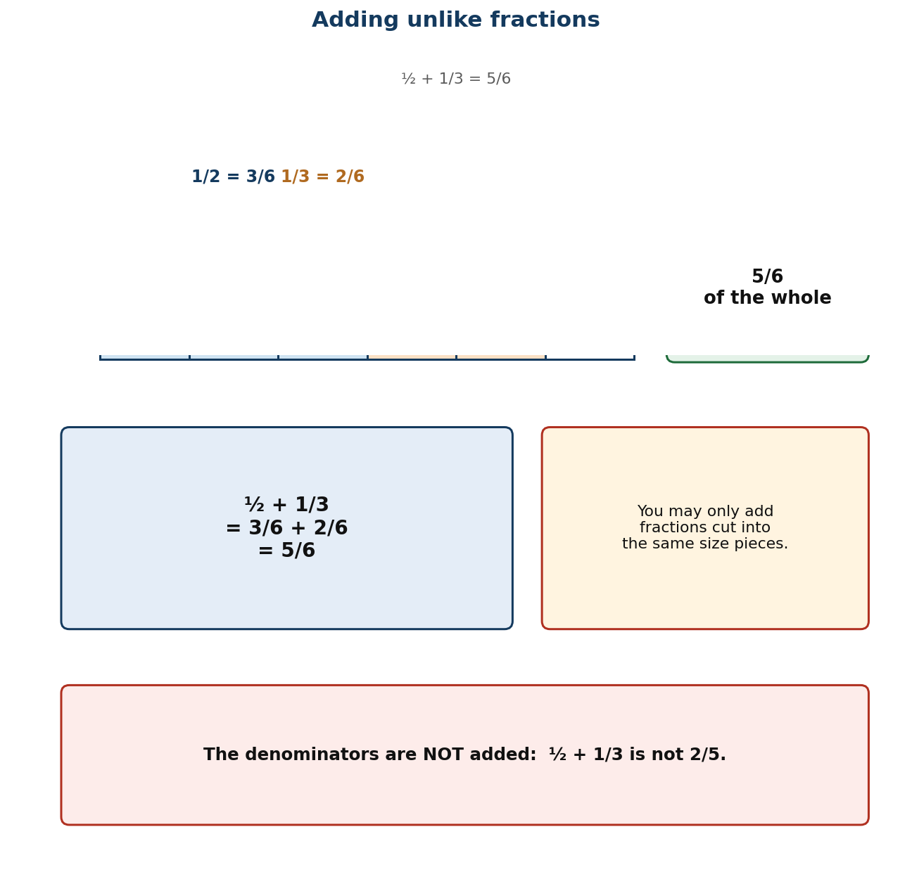
Figure 1.11 Adding unlike fractions: rename in a common denominator first.
PHASE / TIME | TEACHER ACTIVITY | LEARNER ACTIVITY | CORE COMP. | ASSESSMENT (DoK)
ENGAGE  8 min | Write ½ + ¼ on the board and ask for the answer. Collect ⅔ and also the classic error 2/6. Then hold up half a paper circle and a quarter circle and push them together: ‘Look. It is three quarters. Whatever 2/6 is, it is not this.’ Say: ‘Today you will be able to say why the wrong answer is wrong.’ | Learners offer both answers and see the model contradict one of them. The visual settles the argument before any rule is stated. | CP; CC | Oral responses; diagnostic check. DoK 1
EXPLORE  16 min | Task with fraction strips: show ½ + 1/3. Find a way to describe both pieces using the same size of small piece. Groups will find sixths. Then: show 2¼ − 1⅔ with the strips. Circulate and ask ‘what size of small piece fits both?’ Do NOT name the lowest common multiple yet. | Groups manipulate strips and discover sixths for the first and twelfths (or quarters) for the second. They have found the common denominator physically. | CP; CC | Observation checklist; group record. DoK 2
EXPLAIN  14 min | Formalise with Figure 1.11: fractions can only be added when they are cut into pieces of the same size, so find a common denominator — ideally the lowest common multiple of the denominators. Work ½ + 1/3 = 3/6 + 2/6 = 5/6. Then mixed numbers, teaching both routes explicitly: (i) subtract the whole numbers and then the fractions, borrowing if needed; (ii) convert both to improper fractions first. Work 2⅔ − 1½ both ways and compare. Stress the estimate: 2⅔ − 1½ is about 3 − 2 = 1. | Learners write both methods for mixed numbers and solve one example each way, checking that the answers agree. | CP; CC | Questioning; corrected work in a second colour. DoK 2
ELABORATE  12 min | Pairs solve six problems, three addition and three subtraction, mixed numbers included, with an estimate written first. Then ‘diagnose the error’: three worked solutions containing the classic mistakes (adding denominators, forgetting to convert the whole number when borrowing, not simplifying). Extension: add three unlike fractions. | Pairs solve and estimate, then hunt errors. Naming the classic mistakes out loud is the most effective defence against them. | CP; CC | Application task; sentence frames. DoK 2–3
EVALUATE  10 min | Exit ticket: 2/3 + 3/4 and 3⅔ − 1½, each with an estimate. Collect and sort. Preview Lesson 20: ‘Tomorrow we use this on real problems.’ | Learners complete the ticket alone and tick: I found a common denominator / I simplified / my answer matches my estimate. | CP; CC | Exit ticket or assessed product. DoK 2–3

APPROACHING  PROFICIENCY (AP) | Support — unlike proper fractions only, with strips always available and denominators limited to 2, 3, 4, 6, 8, 12; leave mixed numbers to a second session.
PROFICIENT (P) | Core — as described, including mixed numbers and three fractions.
HIGHLY  PROFICIENT (HP) | Extension — explain in writing why the denominators are not added, using the area model as evidence.

ASSESSMENT (summary) | Observation with checklist C7.19. Exit ticket marked on: common denominator found; numerators handled correctly; answer simplified; estimate present. Adding denominators is the misconception named and treated in the lesson.
HOMEWORK / PROJECT WORK | Eight additions and eight subtractions of unlike and mixed fractions, each with an estimate written first.
CROSS-CUTTING LINKS | Home Economics — recipes use mixed quantities constantly. Carpentry — measurements in fractions of an inch. Values — care with small pieces prevents big waste.
LESSON CLOSURE | Return to the essential questions; two learners summarise, one says what is still unclear; record names for follow-up below.

REFLECTION AND REMARKS (complete after teaching)
What went well — evidence of learning you saw
What I would change next time
Learners who need follow-up, and what I will do
Head of Department remarks

TEACHER — NAME AND SIGNATURE | HEAD OF DEPARTMENT | DATE

BASIC 7 MATHEMATICS • TERM 1 • WEEKLY LESSON NOTE
LESSON 20 of 24 — Solving Problems with Fraction Addition and Subtraction
Week 10 • Number • Fractions • B7.1.3.2.2 • 60 minutes
WEEK ENDING | DAY | DATE | PERIOD | DURATION | CLASS | SUBJECT
 |  |  |  | 60 min | Basic 7 | Mathematics

CLASS SIZE — BOYS | CLASS SIZE — GIRLS | CLASS SIZE — TOTAL

STRAND | Number
SUB-STRAND | Fractions
CONTENT STANDARD | B7.1.3.2 — Demonstrate an understanding of the process of addition and/or subtraction of fractions and apply this in solving problems.
LEARNING INDICATOR(S) | B7.1.3.2.2 — Solve problems involving addition or subtraction of fractions.
PERFORMANCE INDICATOR  (what learners will do) | Learners solve word problems involving the addition and subtraction of fractions.
LEARNING OUTCOMES  (knowledge / skill / value) | • K — decide whether a word problem calls for addition or subtraction, and justify the choice from the situation.  • S — solve one- and two-step word problems involving fractions, including mixed numbers.  • A/V — check the answer against the situation and state whether it is reasonable.
CORE COMPETENCIES | Critical Thinking and Problem Solving (CP); Digital Literacy (DL).
KEY WORDS | word problem, operation, remaining, altogether, difference, estimate, check, unit
ESSENTIAL QUESTIONS | 1. Is this problem adding or subtracting?  2. How do I know my answer is about the right size?
PRIOR KNOWLEDGE (R.P.K.) | Lesson 19 adding and subtracting unlike and mixed fractions. Learners have solved one-step fraction problems since Basic 6.
TEACHING / LEARNING RESOURCES  (TLMs) | Problem cards set in Ghanaian contexts (recipes, cloth, farmland, water tanks, feeding programmes); blank cards for learners to write their own; mini whiteboards.
PEDAGOGICAL EXEMPLARS (methods) | Inquiry (5E); concrete – pictorial – abstract (CPA) with manipulatives; structured problem-solving routine; ICT / digital resources; cooperative group work; questioning and discussion; differentiation by task, support and outcome
REFERENCE | NaCCA Mathematics Curriculum for the Common Core Programme (Basic 7–B9), September 2020 — B7.1.3.2.2, p. 20. Scheme of Learning, Week 10.

PHASE / TIME | TEACHER ACTIVITY | LEARNER ACTIVITY | CORE COMP. | ASSESSMENT (DoK)
ENGAGE  8 min | Read: ‘A tailor has 12½ metres of cloth. She uses 4¾ metres for a dress. How much is left?’ Ask: ‘Before you calculate — roughly how much is left?’ Establish about 7½ metres. Say: ‘Estimating first is not an extra step. It is how you catch the mistakes that matter.’ | Learners estimate before calculating, then compute to check. The estimate makes a wrong answer visible. | CP; DL | Oral responses; diagnostic check. DoK 1
EXPLORE  16 min | Give each group four problem cards. Task: for each, write the calculation, the estimate, and one sentence saying why that operation. Circulate and ask ‘what is happening to the quantity in the story — is it being combined or taken away?’ Collect the reasoning sentences, not the answers. | Groups solve and justify. The one-sentence justification forces them to picture the situation before choosing an operation. | CP; DL | Observation checklist; group record. DoK 2
EXPLAIN  14 min | Take two cards. Teach the routine: (i) estimate; (ii) say whether the quantities are being combined (add) or one is being removed or compared (subtract); (iii) calculate with a common denominator; (iv) check against the estimate and the story. Work the tailor problem fully: 12½ − 4¾ = 12 2/4 − 4¾; borrow one whole — 11 6/4 − 4¾ = 7¾. Check: 7¾ is close to the estimate of 7½. Then a two-step problem: a tank holds 5/8 full, 1/4 is drawn off, how much remains? | Learners copy the four-step routine and apply it to a second problem with the teacher before working alone. | CP; DL | Questioning; corrected work in a second colour. DoK 2
ELABORATE  12 min | Problem swap: pairs write a problem, swap, solve, and compare reasoning. Where answers differ, the pairs must find out which reading of the problem caused it. Extension: write a problem where the answer must be found by subtracting two mixed numbers that require borrowing twice. | Pairs write, swap, solve and negotiate. The negotiation exposes ambiguous wording, which is itself a mathematical insight. | CP; DL | Application task; sentence frames. DoK 2–3
EVALUATE  10 min | Exit ticket: one two-step fraction word problem with an estimate and a reasoning sentence. Collect and sort. Preview Lesson 21: ‘Tomorrow, multiplying fractions — which is easier than adding them.’ | Learners complete the ticket alone and tick: I estimated / I chose the right operation / my answer is reasonable. | CP; DL | Exit ticket or assessed product. DoK 2–3

APPROACHING  PROFICIENCY (AP) | Support — one-step problems with proper fractions and a ‘what is happening?’ picture frame; denominators limited to halves, quarters and eighths.
PROFICIENT (P) | Core — as described, two-step problems with mixed numbers.
HIGHLY  PROFICIENT (HP) | Extension — rewrite a given problem so that it needs the opposite operation, and explain what changed in the wording.

ASSESSMENT (summary) | Observation with checklist C7.20. Exit ticket marked primarily on the estimate and the reasoning sentence, with arithmetic accuracy second. Problems written by learners are assessed with rubric R4.
HOMEWORK / PROJECT WORK | Write two fraction word problems set at home or in the market, with full solutions and estimates.
CROSS-CUTTING LINKS | Home Economics — recipes and dressmaking. Agriculture — land measurement. Values — careful estimating prevents waste in the home and in business.
LESSON CLOSURE | Return to the essential questions; two learners summarise, one says what is still unclear; record names for follow-up below.

REFLECTION AND REMARKS (complete after teaching)
What went well — evidence of learning you saw
What I would change next time
Learners who need follow-up, and what I will do
Head of Department remarks

TEACHER — NAME AND SIGNATURE | HEAD OF DEPARTMENT | DATE

BASIC 7 MATHEMATICS • TERM 1 • WEEKLY LESSON NOTE
LESSON 21 of 24 — Multiplying Fractions
Week 11 • Number • Fractions • B7.1.3.3.1 • 60 minutes
WEEK ENDING | DAY | DATE | PERIOD | DURATION | CLASS | SUBJECT
 |  |  |  | 60 min | Basic 7 | Mathematics

CLASS SIZE — BOYS | CLASS SIZE — GIRLS | CLASS SIZE — TOTAL

STRAND | Number
SUB-STRAND | Fractions
CONTENT STANDARD | B7.1.3.3 — Demonstrate an understanding of the process of multiplying and dividing positive fractions and apply this in solving problems.
LEARNING INDICATOR(S) | B7.1.3.3.1 — Explain the process of multiplying a fraction (i.e. common, percent and decimal fractions up to thousandths) by a whole number and by a fraction.
PERFORMANCE INDICATOR  (what learners will do) | Learners explain and carry out multiplication of a fraction by a whole number and by another fraction.
LEARNING OUTCOMES  (knowledge / skill / value) | • K — state the rule for multiplying fractions and explain why ‘of’ means multiply.  • S — multiply a fraction by a whole number and by another fraction, simplifying before or after.  • A/V — accept that multiplying by a fraction makes a quantity smaller, and say when that is the right result.
CORE COMPETENCIES | Critical Thinking and Problem Solving (CP).
KEY WORDS | multiply, numerator, denominator, of, product, simplify, cancel, area model, improper fraction
ESSENTIAL QUESTIONS | 1. Does multiplying always make things bigger?  2. What does 'of' mean in mathematics?
PRIOR KNOWLEDGE (R.P.K.) | Lesson 19 fraction addition (so they know multiplication is different), and Lesson 10 multi-digit multiplication. Learners usually expect multiplication to make things bigger.
TEACHING / LEARNING RESOURCES  (TLMs) | Squared paper for area models; coloured pencils; fraction strips; Figure 1.12 enlarged; mini whiteboards.
PEDAGOGICAL EXEMPLARS (methods) | Inquiry (5E); concrete – pictorial – abstract (CPA) with manipulatives; cooperative group work; questioning and discussion; differentiation by task, support and outcome
REFERENCE | NaCCA Mathematics Curriculum for the Common Core Programme (Basic 7–B9), September 2020 — B7.1.3.3.1, p. 20. Scheme of Learning, Week 11.

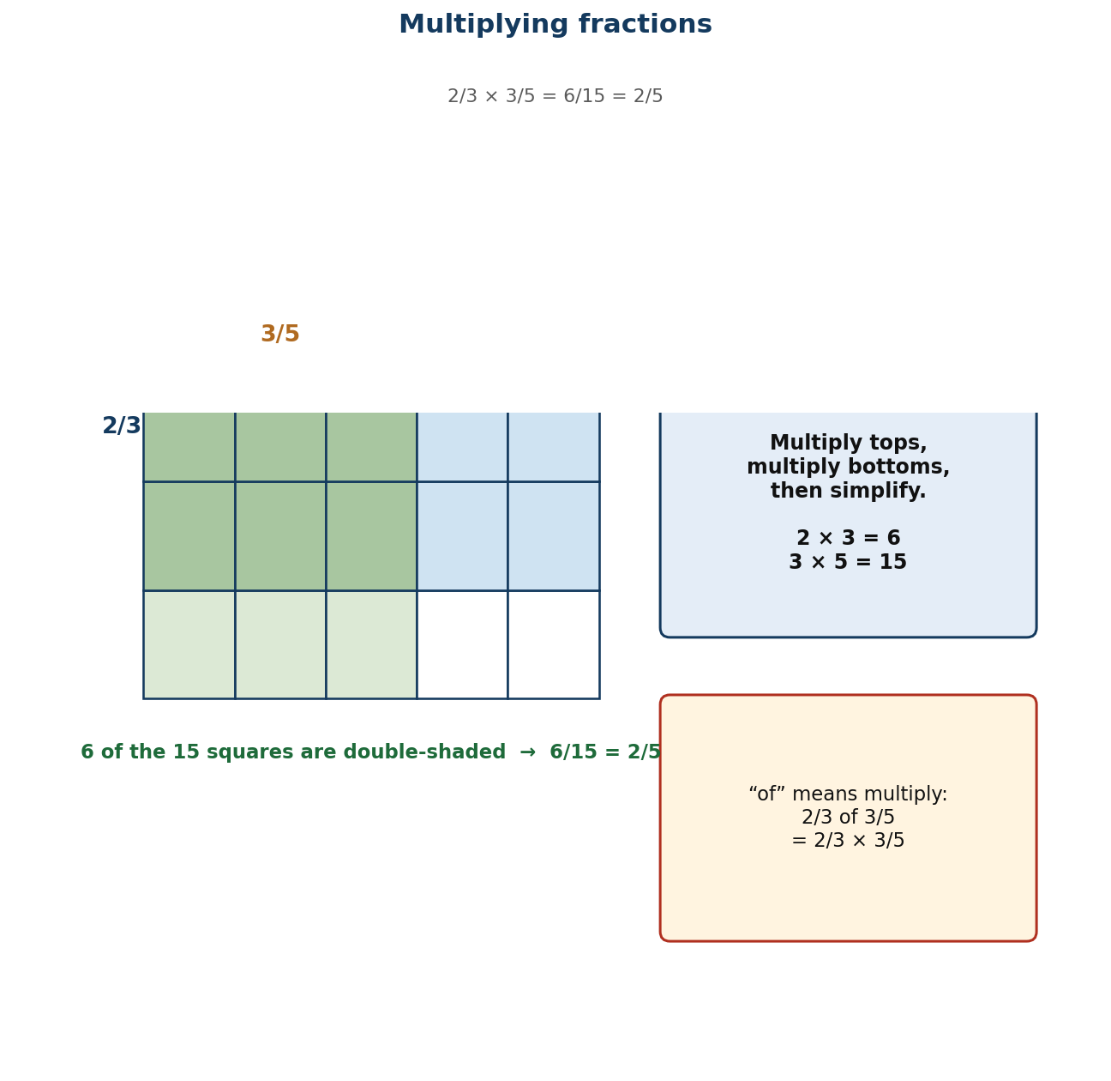
Figure 1.12 The area model: multiplying fractions means taking a part of a part.
PHASE / TIME | TEACHER ACTIVITY | LEARNER ACTIVITY | CORE COMP. | ASSESSMENT (DoK)
ENGAGE  8 min | Ask: ‘Does multiplying always make a number bigger?’ Most will say yes. Then: ‘What is half of 20?’ — 10. ‘And half OF 20 is ½ × 20.’ Show that the answer got smaller. Say: ‘Today, ‘of’ means multiply, and multiplying by a fraction takes a part of something.’ | Learners answer, then see the counter-example. The surprise is worth the two minutes it costs. | CP | Oral responses; diagnostic check. DoK 1
EXPLORE  16 min | Area-model task: draw a rectangle 1 by 1. Shade ½ of it. Now shade ½ of the shaded part in a second colour. What fraction of the whole square is double-shaded? Then repeat with 2/3 × 3/5 on a 3-by-5 grid. Circulate and ask ‘how many pieces is the whole cut into now, and how many are double-shaded?’ | Groups draw and shade. They count 1 out of 4 for the first and 6 out of 15 for the second, discovering the rule from the picture. | CP | Observation checklist; group record. DoK 2
EXPLAIN  14 min | Formalise with Figure 1.12: multiply the numerators, multiply the denominators, then simplify. So ½ × ½ = ¼ and 2/3 × 3/5 = 6/15 = 2/5. Then the whole-number case: 2/3 × 5 = 2/3 × 5/1 = 10/3 = 3⅓. Teach cancelling BEFORE multiplying as the efficient route — 3/8 × 4/9: cancel 3 and 9, and 4 and 8, leaving 1/6. Insist that ‘of’ and ‘×’ are the same instruction. | Learners write the rule, then do four multiplications twice — once multiplying first then simplifying, and once cancelling first — to see which is easier. | CP | Questioning; corrected work in a second colour. DoK 2
ELABORATE  12 min | Pairs do eight multiplications, choosing their own route. Then the context: a farmer has ¾ of a hectare and plants maize on 2/3 of it — how much is planted? Extension: explain why cancelling before multiplying gives the same answer, using the area model. | Pairs calculate and then solve the farm problem, checking against a sketch of the land. | CP | Application task; sentence frames. DoK 2–3
EVALUATE  10 min | Exit ticket: 3/8 × 4/9 and 2/3 × 7, both simplified. Collect and sort. Preview Lesson 22: ‘Tomorrow, finding a fraction of an amount of money or objects.’ | Learners complete the ticket alone and tick: I multiplied numerators / I multiplied denominators / I simplified. | CP | Exit ticket or assessed product. DoK 2–3

APPROACHING  PROFICIENCY (AP) | Support — fraction by whole number only, with the area model every time; leave fraction-by-fraction until the whole-number case is fluent.
PROFICIENT (P) | Core — as described, including cancelling before multiplying.
HIGHLY  PROFICIENT (HP) | Extension — justify the rule with the area model in writing, and show why cross-cancelling works.

ASSESSMENT (summary) | Observation with checklist C7.21. Exit ticket marked on correct products and simplification. The key diagnostic is whether any learner is finding a common denominator — a sure sign they have carried the addition rule across.
HOMEWORK / PROJECT WORK | Ten fraction multiplications, including four word problems using ‘of’.
CROSS-CUTTING LINKS | Agriculture — fractions of farmland. Home Economics — scaling recipes. Values — taking a fair share is the same mathematics as taking a fraction.
LESSON CLOSURE | Return to the essential questions; two learners summarise, one says what is still unclear; record names for follow-up below.

REFLECTION AND REMARKS (complete after teaching)
What went well — evidence of learning you saw
What I would change next time
Learners who need follow-up, and what I will do
Head of Department remarks

TEACHER — NAME AND SIGNATURE | HEAD OF DEPARTMENT | DATE

BASIC 7 MATHEMATICS • TERM 1 • WEEKLY LESSON NOTE
LESSON 22 of 24 — Finding a Fraction of a Quantity
Week 11 • Number • Fractions • B7.1.3.3.2 • 60 minutes
WEEK ENDING | DAY | DATE | PERIOD | DURATION | CLASS | SUBJECT
 |  |  |  | 60 min | Basic 7 | Mathematics

CLASS SIZE — BOYS | CLASS SIZE — GIRLS | CLASS SIZE — TOTAL

STRAND | Number
SUB-STRAND | Fractions
CONTENT STANDARD | B7.1.3.3 — Demonstrate an understanding of the process of multiplying and dividing positive fractions and apply this in solving problems.
LEARNING INDICATOR(S) | B7.1.3.3.2 — Find a fraction of given quantity (i.e. money or given quantity of objects).
PERFORMANCE INDICATOR  (what learners will do) | Learners find a fraction of a given quantity of money or objects.
LEARNING OUTCOMES  (knowledge / skill / value) | • K — state the two-step routine for finding a fraction of a quantity: divide by the denominator, then multiply by the numerator.  • S — find a fraction of an amount of money or of a set of objects, including cases with remainders.  • A/V — use the skill to check whether a stated share is fair.
CORE COMPETENCIES | Critical Thinking and Problem Solving (CP).
KEY WORDS | fraction of, quantity, share, denominator, numerator, unit fraction, divide then multiply, remainder
ESSENTIAL QUESTIONS | 1. How do I find ⅔ of an amount of money?  2. Do I divide first or multiply first?
PRIOR KNOWLEDGE (R.P.K.) | Lesson 21 multiplying fractions, including fraction × whole number. Learners have shared quantities equally since Basic 3.
TEACHING / LEARNING RESOURCES  (TLMs) | Real or play money (GH₵ notes and coins); counters or beans; bar-model templates; market price cards; mini whiteboards.
PEDAGOGICAL EXEMPLARS (methods) | Inquiry (5E); concrete – pictorial – abstract (CPA) with manipulatives; cooperative group work; questioning and discussion; differentiation by task, support and outcome
REFERENCE | NaCCA Mathematics Curriculum for the Common Core Programme (Basic 7–B9), September 2020 — B7.1.3.3.2, p. 21. Scheme of Learning, Week 11.

PHASE / TIME | TEACHER ACTIVITY | LEARNER ACTIVITY | CORE COMP. | ASSESSMENT (DoK)
ENGAGE  8 min | Put 24 counters on the desk. Ask: ‘Give me ¼ of these.’ Take the answer (6) and then: ‘Now give me 3/4.’ Most will fetch another 6. Ask: ‘How did you know?’ Establish: find ¼ first, then multiply by 3. Say: ‘That is the whole method — divide by the bottom, multiply by the top.’ | Learners hand over the counters and articulate the method themselves before it is named. | CP | Oral responses; diagnostic check. DoK 1
EXPLORE  16 min | With money: find 3/5 of GH₵ 240. Give groups notes and coins and let them do it physically — split into five equal piles, then take three. Then: find ⅔ of GH₵ 500 and 2/3 of 45 mangoes. Circulate and ask ‘what did you do first, and why?’ | Groups split the money into piles and count. The physical split makes the denominator meaningful rather than procedural. | CP | Observation checklist; group record. DoK 2
EXPLAIN  14 min | Formalise: divide by the denominator to get one part, then multiply by the numerator to get the number of parts you need. Work 3/5 of 240: 240 ÷ 5 = 48, 48 × 3 = 144. Then link it back to Lesson 21: this is the same as 3/5 × 240. Set out the bar model — five boxes, total 240, each box 48, three boxes 144. Then the remainder case: 2/3 of 45 is 30, but 2/3 of 46 is 30⅔ — teach that the share can be fractional even when the objects cannot be cut. | Learners draw bar models for three problems and write the two-step calculation beside each. | CP | Questioning; corrected work in a second colour. DoK 2
ELABORATE  12 min | Market task: pairs receive price cards and must work out discounts — ¼ off, 1/3 off, 10% off — and the final price. Then ‘is it fair?’: three children share GH₵ 60 as ½, 1/3 and the rest — check the shares add up. Extension: find a quantity when given the fraction: if 3/5 of a number is 144, what is the number? | Pairs work the discounts and then audit the shares, which is the most natural use of the skill in daily life. | CP | Application task; sentence frames. DoK 2–3
EVALUATE  10 min | Exit ticket: find 5/8 of GH₵ 320 and 2/3 of 51 books. Collect and sort. Preview Lesson 23: ‘Tomorrow we turn it round and divide by fractions.’ | Learners complete the ticket alone and tick: I divided by the denominator / I multiplied by the numerator / my answer is reasonable. | CP | Exit ticket or assessed product. DoK 2–3

APPROACHING  PROFICIENCY (AP) | Support — unit fractions only (½, ¼, 1/3, 1/5) with counters or coins physically shared; move to non-unit fractions when the sharing is fluent.
PROFICIENT (P) | Core — as described, including money and objects with remainder cases.
HIGHLY  PROFICIENT (HP) | Extension — solve reverse problems (find the whole given a fraction of it) using the bar model.

ASSESSMENT (summary) | Observation with checklist C7.22. Exit ticket marked on both steps being shown separately — a learner who writes only the answer cannot be diagnosed. The bar model is the reteaching tool for anyone who reverses the two steps.
HOMEWORK / PROJECT WORK | Ten ‘fraction of’ questions, five with money and five with objects, each with a bar model.
CROSS-CUTTING LINKS | Business — discounts and commissions. Social Studies — sharing resources. Values — fairness: check that shares add up to the whole.
LESSON CLOSURE | Return to the essential questions; two learners summarise, one says what is still unclear; record names for follow-up below.

REFLECTION AND REMARKS (complete after teaching)
What went well — evidence of learning you saw
What I would change next time
Learners who need follow-up, and what I will do
Head of Department remarks

TEACHER — NAME AND SIGNATURE | HEAD OF DEPARTMENT | DATE

BASIC 7 MATHEMATICS • TERM 1 • WEEKLY LESSON NOTE
LESSON 23 of 24 — Dividing Fractions
Week 12 • Number • Fractions • B7.1.3.3.3 • 60 minutes
WEEK ENDING | DAY | DATE | PERIOD | DURATION | CLASS | SUBJECT
 |  |  |  | 60 min | Basic 7 | Mathematics

CLASS SIZE — BOYS | CLASS SIZE — GIRLS | CLASS SIZE — TOTAL

STRAND | Number
SUB-STRAND | Fractions
CONTENT STANDARD | B7.1.3.3 — Demonstrate an understanding of the process of multiplying and dividing positive fractions and apply this in solving problems.
LEARNING INDICATOR(S) | B7.1.3.3.3 — Explain the process of dividing a fraction (i.e. common, percent and decimal fractions up to thousandths) by a 1-digit whole number and by a fraction.
PERFORMANCE INDICATOR  (what learners will do) | Learners explain and carry out division of a fraction by a one-digit whole number and by another fraction.
LEARNING OUTCOMES  (knowledge / skill / value) | • K — state that dividing by a fraction is equivalent to multiplying by its reciprocal, and explain why from the ‘how many times does it fit?’ model.  • S — divide a fraction by a one-digit whole number and by another fraction.  • A/V — check division answers by multiplying back, and accept that dividing can make a quantity bigger.
CORE COMPETENCIES | Critical Thinking and Problem Solving (CP).
KEY WORDS | divide, reciprocal, invert, divisor, dividend, quotient, how many times, numerator, denominator
ESSENTIAL QUESTIONS | 1. Why does dividing by a fraction give a bigger answer?  2. How many quarters are there in three?
PRIOR KNOWLEDGE (R.P.K.) | Lessons 21–22 multiplying fractions and finding a fraction of a quantity. Division is the inverse of multiplication and learners know this for whole numbers.
TEACHING / LEARNING RESOURCES  (TLMs) | Paper strips for the ‘how many groups’ model; fraction strips; Figure 1.13 enlarged; mini whiteboards; calculators for checking only.
PEDAGOGICAL EXEMPLARS (methods) | Inquiry (5E); concrete – pictorial – abstract (CPA) with manipulatives; cooperative group work; questioning and discussion; differentiation by task, support and outcome
REFERENCE | NaCCA Mathematics Curriculum for the Common Core Programme (Basic 7–B9), September 2020 — B7.1.3.3.3, p. 22. Scheme of Learning, Week 12.

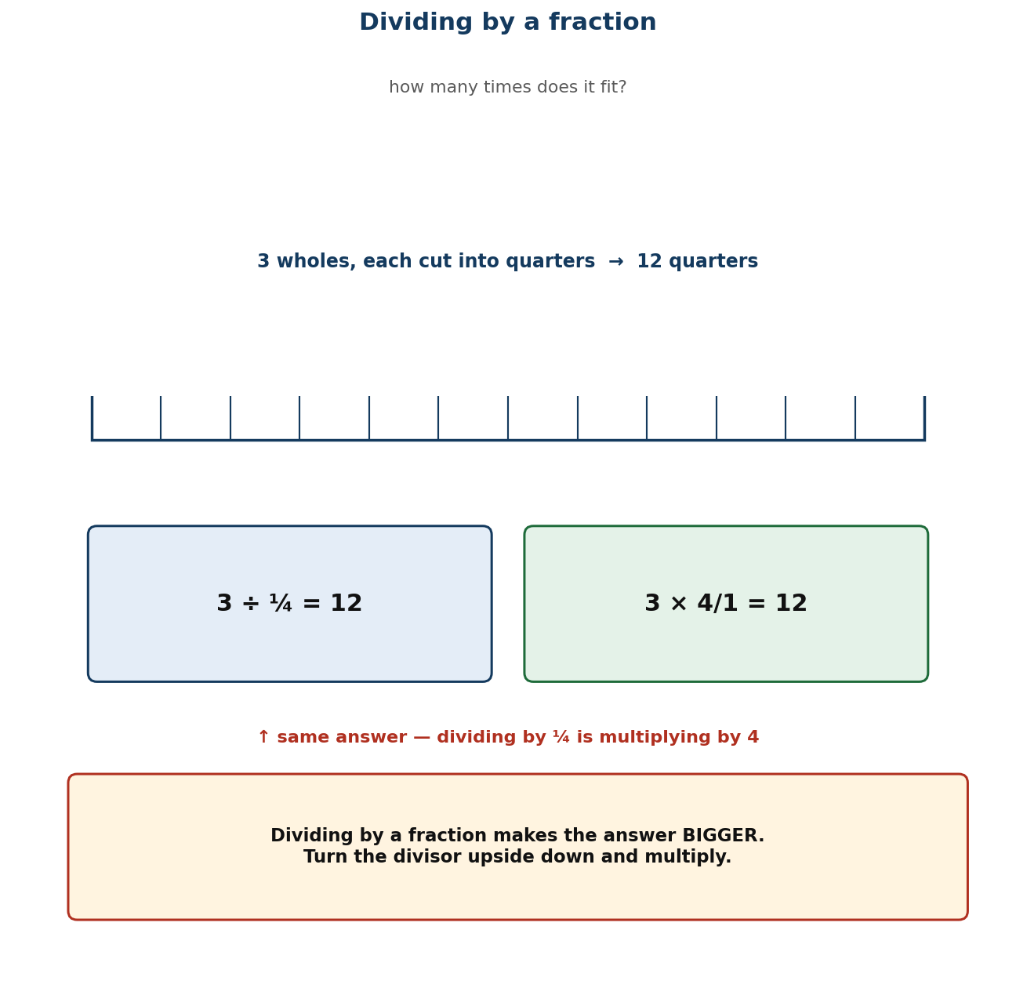
Figure 1.13 Dividing by a fraction: how many times does it fit?
PHASE / TIME | TEACHER ACTIVITY | LEARNER ACTIVITY | CORE COMP. | ASSESSMENT (DoK)
ENGAGE  8 min | Hold up a strip of paper one metre long. Ask: ‘How many ¼-metre pieces can I cut from it?’ — four. Write 1 ÷ ¼ = 4. Then: ‘How many ½-metre pieces?’ — two. ‘So dividing by a fraction gives a BIGGER answer. Today we find out why, and turn it into a method you can always use.’ | Learners predict and then see the physical strips confirm the answers. The surprising size of the answer is the hook. | CP | Oral responses; diagnostic check. DoK 1
EXPLORE  16 min | With strips, task: 3 ÷ ¼. How many quarters are in three wholes? Count twelve. Then: ½ ÷ ⅔. How much of a quarter fits into a half? Groups will struggle with the second — let them. Ask: ‘is the answer more than one or less than one?’ Circulate and collect approaches. | Groups cut and count. The first is easy; the second forces them to think in terms of ‘how many times does it fit’ rather than sharing. | CP | Observation checklist; group record. DoK 2
EXPLAIN  14 min | Formalise with Figure 1.13: a ÷ b/c means ‘how many b/c are in a’, and the answer is a × c/b — multiply by the reciprocal. Justify it: dividing by ¼ is the same as multiplying by 4, because there are four quarters in every whole. Work both examples: 3 ÷ ¼ = 3 × 4/1 = 12; ½ ÷ ⅔ = ½ × 4/3 = 4/6 = 2/3. Then the whole-number divisor: ⅔ ÷ 3 = ⅔ × 1/3 = ⅔⁄₃ = 1/12 — note the answer is smaller here, which is the contrast that catches people out. | Learners write the rule with the justification and do six divisions, checking three by multiplying back. | CP | Questioning; corrected work in a second colour. DoK 2
ELABORATE  12 min | Pairs do eight divisions, mixed between whole-number and fraction divisors, and check each by multiplying back — the check is the point. Then the context: 9½ litres of juice shared into ¼-litre cups — how many cups? Extension: explain why dividing by a fraction can make the answer bigger while dividing by a whole number makes it smaller. | Pairs calculate, check by multiplying back, and solve the juice problem, which is the clearest real use of fraction division. | CP | Application task; sentence frames. DoK 2–3
EVALUATE  10 min | Exit ticket: 5 ÷ ½ and 3/8 ÷ 2, each checked by multiplying back. Collect and sort. Preview Lesson 24: ‘Tomorrow, dividing quantities by fractions — the last lesson of the term.’ | Learners complete the ticket alone and tick: I used the reciprocal / I simplified / my check works. | CP | Exit ticket or assessed product. DoK 2–3

APPROACHING  PROFICIENCY (AP) | Support — dividing fractions by whole numbers only (the smaller-answer case), with strips; leave fraction divisors to a second session.
PROFICIENT (P) | Core — as described, both cases, with the multiply-back check.
HIGHLY  PROFICIENT (HP) | Extension — justify the reciprocal rule in writing using the identity b/c × c/b = 1.

ASSESSMENT (summary) | Observation with checklist C7.23. Exit ticket marked on correct reciprocal, correct product, and a working check. A learner who inverts the wrong fraction is the specific target — reteach with the ‘how many fit’ question, not the rule.
HOMEWORK / PROJECT WORK | Ten fraction divisions, each checked by multiplying back. Note which ones give bigger answers and which give smaller.
CROSS-CUTTING LINKS | Home Economics — how many portions from a quantity. Carpentry — how many lengths from a board. Values — checking by reversing is honest work.
LESSON CLOSURE | Return to the essential questions; two learners summarise, one says what is still unclear; record names for follow-up below.

REFLECTION AND REMARKS (complete after teaching)
What went well — evidence of learning you saw
What I would change next time
Learners who need follow-up, and what I will do
Head of Department remarks

TEACHER — NAME AND SIGNATURE | HEAD OF DEPARTMENT | DATE

BASIC 7 MATHEMATICS • TERM 1 • WEEKLY LESSON NOTE
LESSON 24 of 24 — Dividing Quantities and Fractions by Fractions
Week 12 • Number • Fractions • B7.1.3.3.4 • 60 minutes
WEEK ENDING | DAY | DATE | PERIOD | DURATION | CLASS | SUBJECT
 |  |  |  | 60 min | Basic 7 | Mathematics

CLASS SIZE — BOYS | CLASS SIZE — GIRLS | CLASS SIZE — TOTAL

STRAND | Number
SUB-STRAND | Fractions
CONTENT STANDARD | B7.1.3.3 — Demonstrate an understanding of the process of multiplying and dividing positive fractions and apply this in solving problems.
LEARNING INDICATOR(S) | B7.1.3.3.4 — Determine the result of dividing a quantity (i.e. money or objects) or a fraction by a fraction.
PERFORMANCE INDICATOR  (what learners will do) | Learners determine the result of dividing a quantity of money or objects, or a fraction, by a fraction.
LEARNING OUTCOMES  (knowledge / skill / value) | • K — state that dividing a quantity by a fraction answers the question ‘how many of this portion are in it?’  • S — divide quantities of money or objects, and fractions, by fractions, and interpret the answer in context.  • A/V — decide what to do with a fractional remainder — round up, round down, or report it as a fraction — and justify the choice.
CORE COMPETENCIES | Critical Thinking and Problem Solving (CP).
KEY WORDS | divide, quantity, reciprocal, quotient, share, portion, unit, context, interpret
ESSENTIAL QUESTIONS | 1. Am I sharing something out or measuring it out?  2. What do I do when the remainder is a fraction?
PRIOR KNOWLEDGE (R.P.K.) | Lesson 23 dividing fractions. This lesson applies it to quantities with units, where interpreting the answer matters as much as calculating it.
TEACHING / LEARNING RESOURCES  (TLMs) | Real or play money; counters; measuring jugs or cups for the juice context; bar-model templates; problem cards; mini whiteboards.
PEDAGOGICAL EXEMPLARS (methods) | Inquiry (5E); concrete – pictorial – abstract (CPA) with manipulatives; cooperative group work; questioning and discussion; differentiation by task, support and outcome
REFERENCE | NaCCA Mathematics Curriculum for the Common Core Programme (Basic 7–B9), September 2020 — B7.1.3.3.4, p. 23. Scheme of Learning, Week 12.

PHASE / TIME | TEACHER ACTIVITY | LEARNER ACTIVITY | CORE COMP. | ASSESSMENT (DoK)
ENGAGE  8 min | Read: ‘A set of stacked plates weighs 10 kg. Each plate weighs ¼ kg. How many plates are in the stack?’ Ask: ‘Is this a sharing question or a measuring question?’ Establish: measuring — how many quarters in ten? Say: ‘Today you will not only calculate these, you will decide what the answer MEANS.’ | Learners classify the problem and predict the size of the answer. They recognise the structure from Lesson 23 immediately. | CP | Oral responses; diagnostic check. DoK 1
EXPLORE  16 min | Task in pairs: 9½ litres of fruit juice is shared equally among 38 learners. How many millilitres does each get? Then: the same juice is poured into ¼-litre cups. How many cups? Circulate and ask ‘why are these different questions even though both have 9½ litres in them?’ Do NOT give either answer. | Pairs solve both and discover that one shares (divide by 38) and one measures (divide by ¼). The contrast is the lesson's core. | CP | Observation checklist; group record. DoK 2
EXPLAIN  14 min | Take both. Dividing by a WHOLE number shares; dividing by a FRACTION measures how many portions fit. Work the juice: 9½ ÷ ¼ = 9½ × 4 = 38 cups. Work the plates: 10 ÷ ¼ = 10 × 4 = 40 plates. Then the awkward case that matters most: 10 ÷ ⅔ = 10 × 4/3 = 40/3 = 13⅓. You cannot have 13⅓ plates — so the answer is 13 full plates with ¼ kg left over. Teach explicitly that the decision to round down, round up or keep the fraction depends on what is being counted. | Learners work three problems and write, for each, whether they rounded and why. | CP | Questioning; corrected work in a second colour. DoK 2
ELABORATE  12 min | Problem circuit: six cards round the room, each a quantity-divided-by-fraction problem drawn from Ghanaian settings — cement in bags, rice in cups, cloth in dress lengths, water in buckets. Pairs solve and record the interpretation decision for each. Extension: write a problem whose answer must be rounded UP, and explain why rounding down would be wrong. | Pairs move round the circuit. The interpretation decision is recorded for every problem, not just the arithmetic. | CP | Application task; sentence frames. DoK 2–3
EVALUATE  10 min | Exit ticket: a 6 kg bag of rice is packed into ⅔ kg bags. How many bags? Then: how many 2/5 m lengths can be cut from 3 m of ribbon, and what is left over? Collect and sort. Then close the term: a five-minute review of the four fraction operations. | Learners complete the ticket alone, state the rounding decision for each, and tick: I chose the right operation / I used the reciprocal / I interpreted the answer. | CP | Exit ticket or assessed product. DoK 2–3

APPROACHING  PROFICIENCY (AP) | Support — unit-fraction divisors only (½, ¼, 1/3), with counters, and whole-number answers only; the remainder decision is discussed but not assessed.
PROFICIENT (P) | Core — as described, including non-unit divisors and remainder decisions.
HIGHLY  PROFICIENT (HP) | Extension — construct and solve a two-step problem combining a fraction of a quantity with a division by a fraction.

ASSESSMENT (summary) | Observation with checklist C7.24. Exit ticket marked on the calculation AND the interpretation. The capstone task — the end-of-unit test — weights interpretation heavily, because that is where this indicator is genuinely hard.
HOMEWORK / PROJECT WORK | Six problems: three sharing, three measuring, with the interpretation decision written for each. Then revise for the end-of-term examination.
CROSS-CUTTING LINKS | Business — packaging and pricing. Home Economics — portions and recipes. Values — the decision about a remainder affects people, not just numbers.
LESSON CLOSURE | Return to the essential questions; two learners summarise, one says what is still unclear; record names for follow-up below.

REFLECTION AND REMARKS (complete after teaching)
What went well — evidence of learning you saw
What I would change next time
Learners who need follow-up, and what I will do
Head of Department remarks

TEACHER — NAME AND SIGNATURE | HEAD OF DEPARTMENT | DATE

