GHANA EDUCATION SERVICE • NaCCA COMMON CORE PROGRAMME
BASIC 7 • MATHEMATICS
TERM 1
COMPREHENSIVE LESSON PLAN
AND TEACHING GUIDE
Twenty-four lessons · four units · twelve teaching weeks
Every content standard and indicator quoted verbatim from the NaCCA curriculum, with page references
Class | Basic 7 (JHS 1)
Subject | Mathematics
Term | Term 1, 2026/2027
Strand | Number (the whole of Term 1)
Structure | 12 teaching weeks of two 60-minute lessons, then revision and examination
Source | NaCCA Mathematics Curriculum for the Common Core Programme (B7–B9), September 2020

Contents

Four parts. Part A is the teaching guide — read it once, then refer to it. Part B is the term's lesson plans. Part C is what you photocopy. Part D is the coverage audit and the record sheets you hand in.
PART A — TEACHING GUIDE
 | Section | What is in it
A1 | Curriculum Alignment and Term Map | Every content standard and indicator quoted verbatim with page references; the Week 12 duplication in the circulated scheme, and what to do about it.
A2 | The Term at a Glance | Four units, twelve weeks, the assessed product for each unit.
A3 | Educational Philosophies Behind This Term | Five traditions, and what each one changes about what you do on Monday.
A4 | Teaching Methods and Strategies | The five-phase lesson, and the eight methods used across the term.
A5 | Inclusion, Differentiation and Scaffolding | The three proficiency groups, and six barriers with free adjustments.
A6 | Assessment Plan for the Term | The assessment calendar, how the term mark is built, and feedback that changes learning.
A7 | Resources and Low-Cost Improvisation | What to gather, what to make, and the one thing worth asking for.
A8 | Common Misconceptions and How to Shift Them | Twelve real misconceptions, why learners hold them, and the experience that shifts each one.
A9 | Glossary of Key Terms | Thirty terms for the mathematics word wall.

PART B — LESSON PLANS (24 lessons)
 | Section | What is in it
Unit 1 | Number: Numeration Systems | Weeks 1–3 · Lessons 1–5
Unit 2 | Number: Operations | Weeks 3–6 · Lessons 6–11
Unit 3 | Number: Powers | Weeks 6–8 · Lessons 12–16
Unit 4 | Number: Fractions | Weeks 9–12 · Lessons 17–24

PART C — ANNEXES (photocopy these)
 | Section | What is in it
C1 | Unit Tests | Four tests — 20, 30, 20 and 30 marks — with full marking schemes.
C2 | End-of-Term Examination and Week 13 Revision | Twenty multiple-choice and five structured questions, with a complete marking scheme and a four-station revision plan.
C3 | Rubrics | Three four-level rubrics, written so learners can read them before they start.
C4 | Observation Checklists | One line per lesson — what to look for during group work.

PART D — COVERAGE AND RECORDS
 | Section | What is in it
D1 | Curriculum Coverage Matrix | Every standard and indicator with the lesson that teaches it, the assessment that measures it, and a column for the date taught.
D2 | Weekly Record of Work | One line per week for Weeks 1–15, with a signature block.
D3 | Class Assessment Record | Blank grid for 45 learners.

PART A
TEACHING GUIDE
Curriculum alignment · methods · differentiation · assessment · resources · misconceptions · glossary

A1 Curriculum Alignment and Term Map

Every content standard and indicator below is quoted verbatim from the NaCCA Mathematics Curriculum for the Common Core Programme (B7–B9), September 2020. The page number is the printed page in that document. Where the circulated scheme of learning and the curriculum disagree, the curriculum has been followed and the difference is set out in A1.3.
A1.1 The term at a glance
Week | Sub-strand | Content standard | Indicator(s) | Lessons
1 | Numeration Systems | B7.1.1.1 | B7.1.1.1.1–.2 | L1–L2
2 | Numeration Systems | B7.1.1.1 | B7.1.1.1.3–.4 | L3–L4
3 | Numeration Systems; Number Operations | B7.1.1.1; B7.1.2.1 | B7.1.1.1.5; B7.1.2.1.1 | L5–L6
4 | Number Operations | B7.1.2.1 | B7.1.2.1.2–.3 | L7–L8
5 | Number Operations | B7.1.2.2 | B7.1.2.2.1–.2 | L9–L10
6 | Number Operations | B7.1.2.2; B7.1.2.3 | B7.1.2.2.3; B7.1.2.3.1 | L11–L12
7 | Number Operations | B7.1.2.3 | B7.1.2.3.2–.3 | L13–L14
8 | Number Operations | B7.1.2.3 | B7.1.2.3.4–.5 | L15–L16
9 | Fractions | B7.1.3.1 | B7.1.3.1.1–.2 | L17–L18
10 | Fractions | B7.1.3.2 | B7.1.3.2.1–.2 | L19–L20
11 | Fractions | B7.1.3.3 | B7.1.3.3.1–.2 | L21–L22
12 | Fractions | B7.1.3.3 | B7.1.3.3.3–.4* | L23–L24

* Week 12 as circulated lists B7.1.3.3.1–.2 again — see A1.3.
Twelve teaching weeks of two 60-minute lessons, then Week 13 revision and Weeks 14–15 examination and vacation. All twelve weeks sit in one strand — Number. There is no Geometry, no Algebra and no Handling of Data in Term 1.
A1.2 Content standards and indicators, verbatim
Content standard B7.1.1.1 (p. 2)
Demonstrate understanding and the use of place value for expressing quantities recorded as base ten numerals as well as rounding these to given decimal places and significant figures.
Indicator | Statement (verbatim) | Page
B7.1.1.1.1 | Model number quantities more than 1,000,000,000 using graph sheets, isometric papers and multi-base blocks. | 2
B7.1.1.1.2 | Compare and order whole numbers more than 1,000,000,000 and represent the comparison using “>, <, or =”. | 3
B7.1.1.1.3 | Round (off, up, down) whole numbers more than 1,000,000,000 to the nearest hundred-thousand, ten-thousands, thousands, hundreds and tens. | 4
B7.1.1.1.4 | Round decimals to the nearest tenth, hundredth, thousandths, etc. | 5
B7.1.1.1.5 | Express decimal numerals to given significant and decimal places. | 6

Content standard B7.1.2.1 (p. 7)
Apply mental mathematics strategies and number properties used to solve problems.
Indicator | Statement (verbatim) | Page
B7.1.2.1.1 | Multiply and divide given numbers by powers of 10 including decimals and benchmark fractions. | 7
B7.1.2.1.2 | Apply mental mathematics strategies and number properties used to perform calculations. | 7
B7.1.2.1.3 | Apply mental mathematics strategies to solve word problems. | 8

Content standard B7.1.2.2 (p. 9)
Demonstrate an understanding of addition, subtraction, multiplication and division of (i) whole numbers, and (ii) decimal numbers, to solve problems.
Indicator | Statement (verbatim) | Page
B7.1.2.2.1 | Add and subtract up to four-digit numbers. | 9
B7.1.2.2.2 | Multiply or divide multi-digit numbers by 1- and 2-digit numbers. | 10
B7.1.2.2.3 | Create and solve story problems involving decimals on the four basic operations. | 11

Content standard B7.1.2.3 (p. 13)
Demonstrate understanding and the use of powers of natural numbers in solving problems.
Indicator | Statement (verbatim) | Page
B7.1.2.3.1 | Illustrate with examples the meaning of repeated factors using counting objects such as bottle tops or bundle sticks. | 13
B7.1.2.3.2 | Express a given number as a product of a given number or numbers, as well as, in the form of a power or two such numbers as product of powers. | 13
B7.1.2.3.3 | Show that the value of any natural number with zero as its exponent or index is 1 and use it to solve problems. | 14
B7.1.2.3.4 | Find the value of a number written in index form. | 14
B7.1.2.3.5 | Apply the concept of powers of numbers (product of prime) to find Highest Common Factor (HCF). | 15

Content standard B7.1.3.1 (p. 17)
Simplify, compare and order a mixture of positive fractions (i.e. common, percent and decimal) by changing all to equivalent (i) fractions, (ii) decimals, or (iii) percentages.
Indicator | Statement (verbatim) | Page
B7.1.3.1.1 | Determine and recall the percentages and decimals of given benchmark fractions (i.e. tenths, fifths, fourths, thirds and halves) and use these to compare quantities. | 17
B7.1.3.1.2 | Compare and order fractions (i.e. common, percent and decimal fractions up to thousandths) limit to the benchmark fractions. | 19

Content standard B7.1.3.2 (p. 19)
Demonstrate an understanding of the process of addition and/or subtraction of fractions and apply this in solving problems.
Indicator | Statement (verbatim) | Page
B7.1.3.2.1 | Explain the process of addition and subtraction of two or three unlike and mixed fractions. | 19
B7.1.3.2.2 | Solve problems involving addition or subtraction of fractions. | 20

Content standard B7.1.3.3 (p. 20)
Demonstrate an understanding of the process of multiplying and dividing positive fractions and apply this in solving problems.
Indicator | Statement (verbatim) | Page
B7.1.3.3.1 | Explain the process of multiplying a fraction (i.e. common, percent and decimal fractions up to thousandths) by a whole number and by a fraction. | 20
B7.1.3.3.2 | Find a fraction of given quantity (i.e. money or given quantity of objects). | 21
B7.1.3.3.3 | Explain the process of dividing a fraction (i.e. common, percent and decimal fractions up to thousandths) by a 1-digit whole number and by a fraction. | 22
B7.1.3.3.4 | Determine the result of dividing a quantity (i.e. money or objects) or a fraction by a fraction. | 23

A1.3 Where the scheme of learning and the curriculum disagree
Week 12 is printed twice
The circulated scheme lists B7.1.3.3.1–.2 against BOTH Week 11 and Week 12. That is a copy error, and it matters because content standard B7.1.3.3 has four indicators, not two — the second pair (B7.1.3.3.3 dividing a fraction, and B7.1.3.3.4 dividing a quantity by a fraction) appears nowhere else in the scheme at all. A teacher following the printed scheme would teach multiplying fractions twice and never teach dividing them, which would leave learners unable to answer a substantial part of the end-of-term examination.
This pack therefore teaches B7.1.3.3.1–.2 in Week 11 and B7.1.3.3.3–.4 in Week 12. Every indicator in the standard is covered exactly once.

A second, smaller point: the curriculum itself prints two codes with typographical errors — B7.1.1.1.2 appears as ‘B7.1.1.2’ and B7.1.2.2 as ‘B.7.1.2.2’ — and B7.1.2.2.2 is printed as ‘B71.2.2.2’. This pack uses the correct code throughout, since that is what the scheme of learning and the lesson notes must reference.

A2 The Term at a Glance

Unit | Title | Weeks | Lessons | Assessed by
Unit 1 | Number: Numeration Systems | Weeks 1–3 | L1–L5 | Unit Test 1 (20 marks)
Unit 1 | Number: Operations | Weeks 3–6 | L6–L11 | Unit Test 2 (30 marks)
Unit 1 | Number: Powers | Weeks 6–8 | L12–L16 | Unit Test 3 (20 marks)
Unit 1 | Number: Fractions | Weeks 9–12 | L17–L24 | Unit Test 4 (30 marks)

Each unit ends with a unit test, marked with the assessment weighting set out in A6. Every unit also carries one assessed product — a chart, a problem bank, a display or an investigation — which is marked with a rubric rather than a mark out of twenty, because the point of it is the reasoning and not the answer.

A3 Educational Philosophies Behind This Term

NaCCA's own position is that the Common Core Programme is inquiry-hinged and learner-centred, with the teacher as facilitator and the learner as a constructor of knowledge rather than a recipient of it. Four traditions do most of the work in a Mathematics term, and each one changes something specific about what you do on Monday.
Tradition | Its claim | What it means for this term
Piaget — constructivism | Learners build understanding; telling them a rule does not install it. | Every new idea starts with objects — bottle tops for powers, paper strips for fractions, money for decimals — and the notation arrives last, once learners have felt the need for it. Lesson 12 invents index notation rather than receiving it.
Bruner — enactive, iconic, symbolic | Understanding moves from doing, to pictures, to symbols. | The CPA sequence is built into every lesson: concrete manipulatives, then a bar or area model, then the symbols. Skipping the middle step is the commonest cause of fraction failure in Basic 7.
Vygotsky — the zone of proximal development | What a learner can do with help today, they can do alone tomorrow. | The EXPLORE phase is deliberately paired and the teacher circulates asking questions rather than giving answers. The AP / P / HP differentiation on every lesson note is this idea written down.
Skemp — relational vs instrumental understanding | Knowing a rule and knowing why it works are different things, and only one of them survives. | This is why every lesson's EXPLAIN phase asks why, not just how, and why the assessment checklists ask learners to justify. A learner who can evaluate 3⁴ but cannot say what the 4 means has instrumental understanding only.
Polya — problem solving | Solving problems is a craft with stages, not a talent you have or lack. | Lessons 8, 11, 20 and 24 teach an explicit routine — picture it, decide, do, check — because learners who are told to 'think carefully' do not know what to do with the instruction.

A philosophy statement you may copy into your file
I teach Mathematics as something learners construct rather than receive. New ideas begin with objects and pictures and only become symbols once the idea is secure. I expect learners to explain why a method works, not only to produce an answer, and I plan for three groups in every lesson — those approaching proficiency, those who are proficient, and those who are highly proficient. Mistakes are treated as evidence about thinking, and the commonest ones are anticipated and named before they are made.

A4 Teaching Methods and Strategies

A4.1 The five-phase lesson
Every lesson in Part B runs on the same five phases. The timings total 60 minutes and assume a double period; if your school runs 40-minute periods, split at the EXPLAIN phase.
Phase | Time | What the teacher does | What it is for
ENGAGE | 8 min | A short question, puzzle or demonstration that exposes a gap or a contradiction. | Makes the lesson worth having. In Mathematics this is often a deliberate wrong answer the class can see is wrong.
EXPLORE | 16 min | A task with objects or pictures. Circulate and ask questions. Do NOT correct. | This is where the idea is built. The errors you observe here are your assessment data for the whole lesson.
EXPLAIN | 14 min | Harvest the methods, name them, formalise the rule and worked examples. | Connects what learners discovered to the mathematical convention, including its vocabulary and notation.
ELABORATE | 12 min | Application, often timed or in pairs, plus a harder variation for the HP group. | Moves the idea from 'I can do it with help' to 'I can do it and choose when to use it'.
EVALUATE | 10 min | A short exit ticket, marked against two or three named success criteria. | Tells you tomorrow morning who needs the reteach, before the next lesson rather than after the test.

A4.2 Methods used in this term
Method | Where it is used | Why it works here
Concrete – Pictorial – Abstract (CPA) | Powers (L12–16), fractions (L17–24) | Fractions and indices are where symbolic-only teaching fails most reliably. The manipulative is not a reward for slow learners; it is how the idea gets in.
Mental mathematics | L6–8 | Forces learners to look at the numbers before choosing a method, and builds the number sense that every later topic depends on.
Number talks | L7, L8, L15 | Learners explain their route to an answer; the teacher records them all without judging. Makes strategy choice visible and discussable.
Bar modelling | L22, L24 | Turns a word problem into a picture, which is the single most effective intervention for learners who freeze at word problems.
Error diagnosis | L9, L10, L19, L23 | Learners hunt mistakes in worked solutions. Naming a mistake out loud is a stronger defence against it than any amount of correct practice.
Problem-posing | L11, L20 | Learners write the problems. Writing a question that needs division is a harder and more revealing task than answering one.
Timed relays and drills | L6, L10, L15, L17 | Builds fluency, which frees working memory for reasoning. Keep it short and keep it light — fluency is the means, not the goal.
Investigation and display | Unit products, L13, L16 | Gives the assessed product a purpose beyond a mark, and gives the classroom something to refer back to for the rest of the term.

A5 Inclusion, Differentiation and Scaffolding

The standards-based curriculum expects you to plan for three groups in every lesson: learners approaching proficiency (AP), learners who are proficient (P), and learners who are highly proficient (HP). These are not fixed ability groups — a learner can be HP on place value and AP on fractions — and they should change as the topic changes.
Group | What they need | What it looks like in this term
AP | Smaller numbers, concrete materials kept in front of them, one idea at a time, and more time. | Rounding to tens and hundreds with a number line before billions; unit fractions with counters before non-unit fractions; factors of numbers under 50.
P | The core task as written, plus the demand to explain. | Full lesson as set out in Part B, including the reasoning sentence and the reasonableness check.
HP | Harder variations and, more importantly, the demand to justify and to generalise. | Bounds of a rounded value; why cancelling before multiplying works; proving a number is prime; writing problems with a deliberate trap.

A5.1 Six barriers that are common in Basic 7 Mathematics
Barrier | Adjustment that costs nothing
Weak times tables | Tables chart on the desk for any learner who needs it. Do not let a tables gap be mistaken for a methods gap — diagnose before you reteach, because the two need different fixes.
Weak reading | Read word problems aloud. Give the problem orally first, then on paper. Many 'cannot do fractions' learners can do the arithmetic and cannot read the question.
Cannot write quickly | Mini whiteboards for working, exercise book only for the finished method. Reduces the load on learners whose ideas arrive faster than their handwriting.
Visual or hearing difficulty | Sit forward; face the class when speaking; write every number you say on the board. Never give an instruction orally alone.
Mathematics anxiety | Never cold-call for an answer. Use pairs and whiteboards so everyone answers and no one is exposed. Praise the method, not the speed.
Mother-tongue dominance | Allow discussion in the home language during EXPLORE, then insist on the English mathematical vocabulary in EXPLAIN. Bilingual discussion improves reasoning; it does not interfere with it.

A6 Assessment Plan for the Term

Assessment for learning happens inside every lesson through the exit ticket; assessment as learning happens when learners use the checklists and rubrics themselves; assessment of learning is the four unit tests and the end-of-term examination.
Assessment | When | Marks | What it tells you
Exit ticket | Every lesson | — | Who needs the reteach tomorrow. Sorted into three piles overnight: got it, nearly, not yet.
Observation checklist | Every practical or group task | — | Whether the learner can explain as well as calculate.
Unit Test 1 | End of Week 3 | 20 | Numeration and place value.
Unit Test 2 | End of Week 6 | 30 | Operations — mental, written and decimals.
Unit Test 3 | End of Week 8 | 20 | Powers, indices and HCF.
Unit Test 4 | End of Week 12 | 30 | Fractions — all four operations.
Rubrics R1–R3 | Across the term | 10–20 | Explanation, presentation and investigation — the reasoning, not the arithmetic.
End-of-term examination | Week 14 | 100 | The whole term, weighted as below.

Suggested weighting
Classwork (unit tests, rubrics, class exercises and investigations) 50% · End-of-term examination 50%. Change it in the Settings sheet of the assessment tracker if your school uses a different split — every figure recalculates.

A7 Resources, Apparatus and Low-Cost Improvisation

Mathematics needs less apparatus than any other subject, and almost none of it has to be bought. Everything below can be made in a staffroom in an afternoon.
Apparatus | How to improvise it
Multi-base blocks | Bundle sticks in tens and hundreds; rolled newspaper tightly bound with string; bottle tops glued in tens onto card.
Place-value chart to billions | Chalked on the board or painted on the wall. Better permanent than paper — you will use it every week of Term 1.
Number lines | A washing line and pegs across the classroom. Learners peg numbers in order — it makes ordering physical.
Fraction strips | Paper strips folded and labelled, one set per group. Laminate if you can, or slip them into a plastic sleeve.
Fraction walls | Squared paper cut into strips, or drawn on the board as a permanent reference above the chalkboard.
Counters | Bottle tops, beans, pebbles, maize grains — anything countable and identical. Two colours is better than one.
Play money | Old cedi notes are useless for decimals; draw notes on card, or use paper cut to size. Money is the best model for hundredths there is.
Area-model grids | Squared paper from any exercise book, or grids ruled on the board. Essential for multiplying fractions.
Dice and cards | Made from card. Number cards 0–9 in four colours cover most games you will want to play.

The one thing worth asking for
A permanent place-value chart and a permanent benchmark-fraction chart, both painted or pasted above the board. They are used in almost every lesson of Term 1, and having them always visible is worth more than any single piece of bought equipment.

A8 Common Misconceptions and How to Shift Them

Every misconception below is one real Basic 7 learners hold. None of them is shifted by being told the right answer twice — each needs an experience that makes the wrong answer visibly fail.
The misconception | Why learners hold it | The experience that shifts it
Adding denominators as well as numerators: 1/2 + 1/3 = 2/5 | Fractions look like two whole numbers sitting on top of each other, so learners add them the way they always have. | Push half a paper circle and a third of one together against a whole. The result is visibly more than a half; 2/5 is not. Say out loud that 2/5 is wrong and why.
Multiplying by ten means adding a zero: 4.5 × 10 = 4.50 | The rule works for whole numbers and is taught as a rule, so it generalises wrongly. | A place-value slider: the digits physically slide and the decimal point stays put. Then 4.50 on a calculator beside 45 — the contradiction does the work.
2³ = 6 | The index looks like a multiplier. | Build 2 × 2 × 2 with bottle tops and count: eight, not six. Write the warning 2³ ≠ 2 × 3 and box it.
a⁰ = 0, or a⁰ = a | Zero in an answer usually means zero, and the index has just been taught as a counter, so a count of zero suggests nothing. | The descending pattern: 3³, 3², 3¹, each dividing by 3. The next row is forced to be 1 by the pattern, not by the teacher.
A bigger denominator means a bigger fraction | Over-generalised from whole numbers, where bigger digits mean bigger numbers. | Fraction strips: 1/8 is visibly shorter than 1/5. Then ask which they would rather have — an eighth of a cake or a fifth of one.
Multiplying always makes the answer bigger | True for whole numbers above 1, and never contradicted. | Ask 'what is half of 20?' — then write it as 1/2 × 20 = 10. The surprise is the lesson.
A third is 33% | 33% is close to a third, and calculators show 0.33. | Three learners share GH₵ 100. 33% each comes to 99 — one cedi is missing. Where did it go? It went to the rounding.
Rounding in stages: 4.449 → 4.45 → 4.5 | It feels more careful, not less. | Round the same number to two places in one look and in stages, and show the answers differ. One look, one decision.
0.04068 has five significant figures | Leading zeros look like digits that have been measured. | Ask what the zeros are for — they only hold the place. Count from the first digit that was actually measured: the 4.
HCF found by taking the largest power of each prime | Largest feels right for a 'highest' common factor. | The supplies argument: a common factor cannot use more of a prime than the smaller supply allows. Then check by division.
Borrowing is a digit moving on its own | The column algorithm is taught as a procedure. | Base-ten blocks: physically exchange one ten for ten ones. Then write the exchange in expanded form beside it.
Dividing by a fraction makes things smaller | Every prior experience of division made the answer smaller. | How many quarter-metre pieces can you cut from a one-metre strip? Four. The answer is bigger than you started with — now explain that.

A9 Glossary of Key Terms

Term | Meaning
Ascending / descending | Going up in size / going down in size.
Base | The number that is being repeated in a power; in 3⁴ the base is 3.
Benchmark fraction | A fraction used as a reference point — halves, thirds, quarters, fifths, tenths.
Common denominator | A denominator two or more fractions share, so they can be added or compared.
Composite number | A whole number with more than two factors.
Decimal place | The position of a digit after the decimal point.
Denominator | The bottom number of a fraction; how many equal parts the whole is cut into.
Distributive property | a × (b + c) = (a × b) + (a × c). The basis of every mental and written multiplication method.
Estimate | An answer that is close enough for the purpose, found by rounding first.
Expanded form | Writing a number as the sum of its place values, e.g. 785 = 700 + 80 + 5.
Exponent / index | The small raised number in a power; how many times the base is used as a factor.
Factor | A whole number that divides exactly into another.
Fraction of a quantity | A part of an amount; found by dividing by the denominator and multiplying by the numerator.
Highest Common Factor (HCF) | The largest number that divides exactly into two or more numbers.
Improper fraction | A fraction where the numerator is larger than the denominator.
Index form | A number written using a base and an index, e.g. 2³ × 3².
Mixed number | A whole number and a fraction together, e.g. 2¾.
Multi-base block | Apparatus showing ones, tens, hundreds and thousands as physical sizes.
Numerator | The top number of a fraction; how many parts you have.
Partial product | One part of a multiplication before the parts are added.
Partition | Splitting a number into parts that are easier to work with.
Percentage | A number out of 100.
Place value | The value of a digit determined by its position.
Power | A number written with a base and an index; the result of repeated multiplication.
Prime number | A whole number with exactly two factors: 1 and itself.
Prime factorisation | Writing a number as a product of prime numbers.
Reciprocal | What you multiply a number by to get 1; found by turning a fraction upside down.
Recurring decimal | A decimal that repeats forever, e.g. 0.333…
Rounding | Replacing a number with a simpler one of about the same size.
Significant figure | A digit that carries meaning about the precision of a measurement; counted from the first non-zero digit.
Simplify | Writing a fraction with the smallest possible numbers.

PART B
LESSON PLANS
Twenty-four lessons, four units, twelve teaching weeks
Every lesson built on the five-phase inquiry cycle and mapped to the NaCCA indicators

UNIT 1 — NUMBER: NUMERATION SYSTEMS
Weeks 1–3 • Lessons 1–5

The term opens with the largest and the smallest numbers learners will meet all year. The thinking skill underneath all five lessons is the same: a digit's value depends entirely on where it sits. Round a number and you are choosing how much precision you need; that choice is a judgement, not a rule, and it is worth teaching as one.
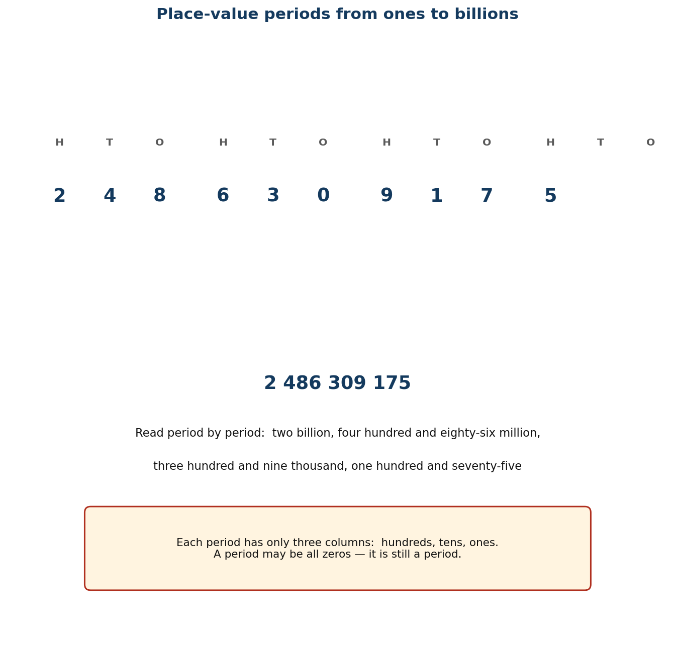
Figure 1.1 Place-value periods from ones to billions.
Unit objectives
- Learners model and read whole numbers greater than one billion using multi-base blocks, graph sheets and place-value charts.
- Learners compare and order whole numbers greater than one billion and record the comparison using >, < or =.
- Learners round whole numbers greater than one billion to the nearest ten, hundred, thousand, ten-thousand and hundred-thousand.
- Learners round decimal numbers to the nearest tenth, hundredth and thousandth.
- Learners express decimal numbers to a given number of decimal places and to a given number of significant figures.
Assessed unit product
A place-value wall chart to billions, built by the class, and a rounding decisions poster that says when to round and when not to.
LESSON 1  Week 1 | Modelling Numbers Beyond One Billion  60 minutes (double period)

Strand | Number
Sub-strand | Numeration Systems
Content standard | B7.1.1.1 — Demonstrate understanding and the use of place value for expressing quantities recorded as base ten numerals as well as rounding these to given decimal places and significant figures.
Indicator(s) | B7.1.1.1.1 — Model number quantities more than 1,000,000,000 using graph sheets, isometric papers and multi-base blocks.
Performance indicator  (what learners can do) | Learners model and read whole numbers greater than one billion using multi-base blocks, graph sheets and place-value charts.
Core competencies | Critical Thinking and Problem Solving (CP); Communication and Collaboration (CC).
Key vocabulary | billion, million, place value, period, digit, multi-base block, numeral, expanded form, model
Prior knowledge | From Basic 4–6 learners read and write numbers to millions and know the place-value columns up to millions. They have used bundle sticks and base-ten blocks for smaller numbers.
Resources / TLM | Multi-base blocks or bundle sticks in bundles of ten; graph paper; a large place-value chart to billions; number cards 0–9; GH₵ notes (20, 50, 100, 200) for the money model; Figure 1.1 enlarged.

Learning objectives — by the end of this lesson every learner will be able to:
- K — state the place-value columns from ones to billions and read any number up to billions.
- S — model a given number greater than one billion with blocks or a chart, and write it in figures and in words.
- A/V — appreciate that very large numbers describe real things — national budgets, populations, distances — and must be read accurately.

Phase / time | Teacher activity | Learner activity
ENGAGE  8 min | Write 1,000,000,000 on the board and ask: ‘How long would it take you to count to this, counting one number every second?’ Let learners guess, then tell them: over 31 years. Tell a Ghanaian anchor — Ghana's population is about 34 million, so a billion is about 30 Ghanas. Say the performance indicator aloud in learner language: ‘By the end of this lesson you will be able to build any number up to billions with blocks and read it back.’ | Learners guess, react, and then read the number chorally. Each learner writes the figure in their book and underlines where they think the ‘billion’ part ends.
EXPLORE  16 min | Give each group a place-value chart to billions and a set of number cards. Task: build 2,486,309,175 with the cards, then say it aloud, then write it in words. Circulate and ask ‘which digit is worth the most?’ Do NOT correct yet. Note the two errors you will always see: reading the millions period as thousands, and omitting the zero period in numbers like 3,000,405,000. | Groups lay the cards in the chart, say the number aloud to each other, and write it in words. The Recorder writes the group's wording; the Reporter prepares to read it to the class.
EXPLAIN  14 min | Take reports, starting with any disagreement. Now teach the structure explicitly using Figure 1.1: columns go in periods of three — ones, thousands, millions, billions — and each period has hundreds, tens, ones. Read the number period by period: ‘two billion, four hundred and eighty-six million, three hundred and nine thousand, one hundred and seventy-five’. Then model with money: how many GH₵ 200 notes make GH₵ 1,000,000,000? (5,000,000 notes.) Confront the zero period explicitly with 3,000,405,000. | Learners correct their own wording in a second colour. They chant the period names and then build two numbers the teacher gives, one with a zero period and one without.
ELABORATE  12 min | Quick-fire: call out a number, groups hold up the digit card for the digit in the ten-millions column, then the hundred-thousands column. Then the extension group writes three real numbers greater than a billion (population of Africa, distance to the Moon in metres, national budget) in words. | Learners respond in groups, then write the sentences in pairs using the frame: ‘The digit ___ is in the ___ column, so it is worth ___.’
EVALUATE  10 min | Exit ticket: write 5,072,400,318 in words, and write ‘seven billion forty million six thousand and nine’ in figures. Collect and sort into three piles — got it, nearly, not yet. Preview Lesson 2: ‘Tomorrow we put these numbers in order.’ | Learners complete the exit ticket alone and tick: I can read a number to billions / I can write it in words / I can build it with blocks.

Figure 1.1 Place-value periods from ones to billions.
Differentiation
Support — a place-value chart with the periods pre-coloured and a word bank (billion, million, thousand, hundred, and); model numbers to millions first, then extend.
Core — as described; model and read numbers to billions including a zero period.
Extension — work in trillions, and explain why 1,000,000,000 has ten digits but only four periods.

Assessment and success criteria
Observation with checklist C7.1. Exit ticket marked on two successes: reads a number to billions correctly; writes a number in words correctly. Learners who can build but not read have not connected the model to the language — reteach that group with choral reading first.
Homework / project
Find one number greater than a billion in a newspaper, on a phone (storage size) or on a packet. Copy it, write it in words, and bring it tomorrow.
Cross-curricular links and values
English — reading numbers aloud; the hyphen in ‘twenty-four’. Social Studies — national population and budget figures. Values — accuracy matters when the numbers belong to a whole country.
Teacher reflection (complete after the lesson)
What worked well: ______________________________________________________________________________
Who did not meet the success criteria, and what I will do next lesson: ______________________________________________________________________________
What I will change when I teach this again: ______________________________________________________________________________

LESSON 2  Week 1 | Comparing and Ordering Huge Numbers  60 minutes (double period)

Strand | Number
Sub-strand | Numeration Systems
Content standard | B7.1.1.1 — Demonstrate understanding and the use of place value for expressing quantities recorded as base ten numerals as well as rounding these to given decimal places and significant figures.
Indicator(s) | B7.1.1.1.2 — Compare and order whole numbers more than 1,000,000,000 and represent the comparison using “>, <, or =”.
Performance indicator  (what learners can do) | Learners compare and order whole numbers greater than one billion and record the comparison using >, < or =.
Core competencies | Critical Thinking and Problem Solving (CP); Communication and Collaboration (CC).
Key vocabulary | compare, order, greater than, less than, equal to, ascending, descending, digit, most significant
Prior knowledge | Lesson 1 modelling and reading numbers to billions. Learners have used > and < with smaller numbers since Basic 4.
Resources / TLM | Number cards; a washing line and pegs; the place-value chart from Lesson 1; copies of Figure 1.1; a list of real large numbers (populations of African countries, distances in the solar system).

Learning objectives — by the end of this lesson every learner will be able to:
- K — state the rule for comparing two whole numbers (compare the highest place value first).
- S — order a set of at least five numbers greater than a billion and write the comparison with >, < or =.
- A/V — value precision, and appreciate that a single digit can change which of two large quantities is bigger.

Phase / time | Teacher activity | Learner activity
ENGAGE  8 min | Put two numbers on the board: 9,999,999,999 and 10,000,000,000. Ask: ‘Which is bigger?’ Most will say the first because it has more nines. Count the digits deliberately with the class — the second has eleven digits, the first has ten. Say: ‘Today you will learn one rule that settles every argument like this.’ | Learners vote with their hands, then count the digits with the teacher. Several will have changed their minds before the lesson starts.
EXPLORE  16 min | Give each group six cards with numbers greater than a billion. Task: put them in order from smallest to largest, and be ready to explain how you decided. Circulate and ask ‘how did you know that one goes there?’ Do NOT correct. Look for the two approaches: comparing digit counts, and comparing column by column. | Groups sort the cards and argue the order out. The Recorder writes the final order; the Reporter prepares to justify the first and last.
EXPLAIN  14 min | Take reports. Now teach the rule: count the digits first — more digits means the bigger number. If the digit counts are the same, compare from the left, column by column, until two digits differ. Work the opening example: 10,000,000,000 has 11 digits, 9,999,999,999 has 10, so 10,000,000,000 > 9,999,999,999. Then teach the crocodile: the symbol opens to the bigger number. Drill with pairs where the digit counts match. | Learners write the rule in their own words and test it on three pairs the teacher writes. They use the frame: ‘___ is greater than ___ because ___.’
ELABORATE  12 min | Peg the class set of real numbers on a washing line in ascending order — populations of Ghana, Nigeria, Egypt, South Africa and Kenya; then distances of planets from the Sun. Extension group: find two numbers that are equal when rounded to the nearest billion but not equal exactly. | Learners take turns pegging a number in the right place and reading the comparison aloud. The class challenges anything placed wrongly.
EVALUATE  10 min | Exit ticket: put 4,506,200,000; 4,506,020,000 and 45,062,000,000 in ascending order using <. Collect and sort. Preview Lesson 3: ‘Tomorrow we round these numbers, which is what people usually do with them.’ | Learners complete the ticket alone and tick: I can compare two numbers / I can use > and < / I can explain why.

Differentiation
Support — compare numbers with different digit counts only, and use a place-value chart to line the columns up physically.
Core — as described, including equal-digit-count comparisons.
Extension — justify the rule: explain why the leftmost differing digit always decides, using expanded form.

Assessment and success criteria
Observation with checklist C7.2. Exit ticket marked on ordering accuracy and on correct symbol direction. A learner who writes the symbol backwards has the rule but not the convention — drill the crocodile with that group.
Homework / project
Write five numbers greater than a billion in descending order, each with a real-world label (population, distance, money).
Cross-curricular links and values
English — comparative language and the words ascending/descending. Social Studies — comparing African populations. Values — fairness: the rule is the same for everyone's numbers.
Teacher reflection (complete after the lesson)
What worked well: ______________________________________________________________________________
Who did not meet the success criteria, and what I will do next lesson: ______________________________________________________________________________
What I will change when I teach this again: ______________________________________________________________________________

LESSON 3  Week 2 | Rounding Whole Numbers  60 minutes (double period)

Strand | Number
Sub-strand | Numeration Systems
Content standard | B7.1.1.1 — Demonstrate understanding and the use of place value for expressing quantities recorded as base ten numerals as well as rounding these to given decimal places and significant figures.
Indicator(s) | B7.1.1.1.3 — Round (off, up, down) whole numbers more than 1,000,000,000 to the nearest hundred-thousand, ten-thousands, thousands, hundreds and tens.
Performance indicator  (what learners can do) | Learners round whole numbers greater than one billion to the nearest ten, hundred, thousand, ten-thousand and hundred-thousand.
Core competencies | Personal Development and Leadership (PL); Creativity and Innovation (CI).
Key vocabulary | round, round off, round up, round down, nearest, estimate, halfway, boundary, approximate
Prior knowledge | Lessons 1–2 place value and comparing. Learners have rounded to the nearest ten and hundred in Basic 5.
Resources / TLM | Number lines drawn on the board and on strips of paper; popsicle-stick bundles; the place-value chart; calculators for checking; Figure 1.2 enlarged.

Learning objectives — by the end of this lesson every learner will be able to:
- K — state the rounding rule, including what to do when a number is exactly halfway.
- S — round a number greater than one billion to any named place value.
- A/V — understand that rounding trades precision for speed, and say when each is appropriate.

Phase / time | Teacher activity | Learner activity
ENGAGE  8 min | Ask: ‘About how many learners are in this school?’ Then: ‘If I said 847, and someone else said 850, who is right?’ Establish that both can be right for different purposes. Tell them the performance indicator: ‘Today you will round numbers to billions, to any place you are asked for.’ | Learners offer estimates and discuss which answer is ‘right’. They realise the answer depends on how exact you need to be.
EXPLORE  16 min | Draw an open number line from 1,879,600 to 1,879,700 with the halfway mark at 1,879,650. Ask: where does 1,879,653 sit, and which end is it nearer to? Give each group three numbers and a paper number line. Task: mark each number and write which end it is nearest to. Then deliberately put one number exactly on the halfway mark and see what they do. | Groups mark the numbers and decide. The halfway case produces disagreement — capture it rather than resolving it.
EXPLAIN  14 min | Resolve the disagreement: the convention is to round up at the halfway point. Then teach the abstract rule using Figure 1.2: (i) find the digit in the place you are rounding to; (ii) look at the digit immediately to its right; (iii) 0–4 keep, 5–9 round up; (iv) everything to the right becomes zero. Work two examples: 1,879,653 to the nearest hundred-thousand is 1,900,000; to the nearest ten-thousand is 1,880,000. Emphasise that you never round in stages — one look, one decision. | Learners write the rule as a four-step list and apply it to the same number rounded to three different places, checking against their number line.
ELABORATE  12 min | Round-off relay: teams receive a number and a target place value and race to write the answer. Then the real-world turn: Ghana's population 34,121,985 — round to the nearest million for a news report, and to the nearest ten for a school register. Discuss which is useful where. Extension: identify the range of numbers that round to 2,500,000 at the nearest hundred-thousand. | Teams race, then pairs discuss the two population answers and report which is appropriate for which audience.
EVALUATE  10 min | Exit ticket: round 7,486,215,063 to the nearest hundred-thousand and to the nearest thousand. Collect and sort. Preview Lesson 4: ‘Tomorrow we round decimals, where the same rule works but the columns have different names.’ | Learners complete the ticket alone and tick: I can find the rounding digit / I can apply the 5-up rule / I can fill with zeros correctly.

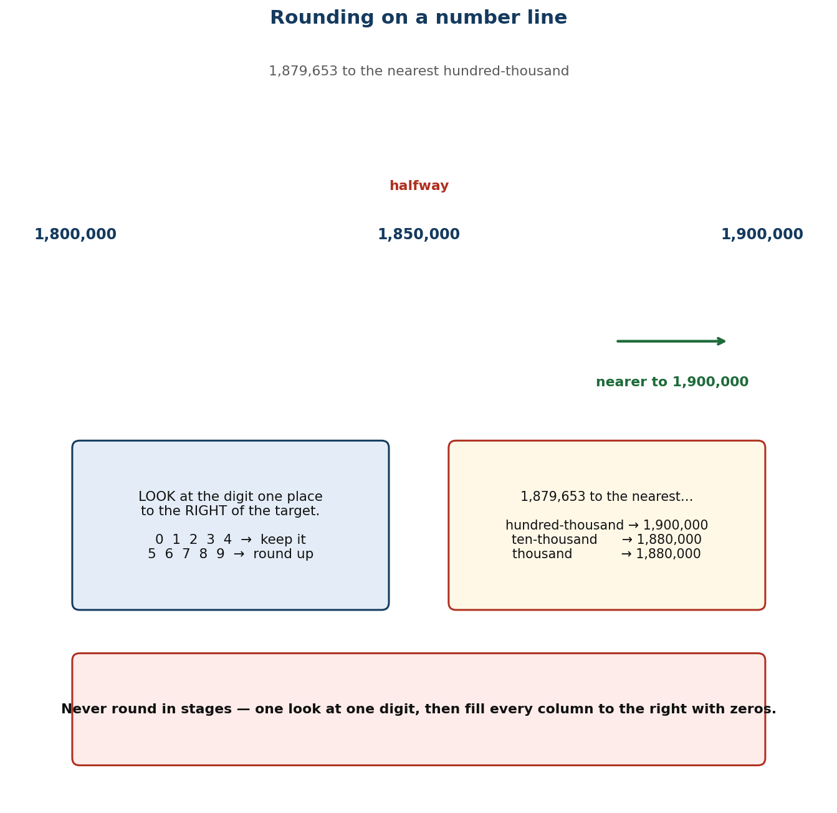
Figure 1.2 Rounding on a number line: the halfway decision.
Differentiation
Support — keep the number line visible; round to the nearest ten and hundred only, using numbers under a million, before moving to billions.
Core — as described, including hundred-thousand and ten-thousand for numbers over a billion.
Extension — state the upper and lower bounds of a rounded value, and explain why rounding in stages gives a wrong answer, using 4,449 as the example.

Assessment and success criteria
Observation with checklist C7.3. Exit ticket marked on: correctly identifies the rounding digit; applies the 5-up rule; replaces the digits to the right with zeros. The commonest error — rounding in stages — is anticipated and named in the lesson.
Homework / project
Round the same number (choose one over a billion) to five different place values and write a sentence saying which rounded value you would use in a news report, and why.
Cross-curricular links and values
English — ‘approximately’, ‘about’, ‘roughly’. Social Studies — census figures are always reported rounded. Values — honesty about precision: say when a figure is approximate.
Teacher reflection (complete after the lesson)
What worked well: ______________________________________________________________________________
Who did not meet the success criteria, and what I will do next lesson: ______________________________________________________________________________
What I will change when I teach this again: ______________________________________________________________________________

LESSON 4  Week 2 | Rounding Decimals  60 minutes (double period)

Strand | Number
Sub-strand | Numeration Systems
Content standard | B7.1.1.1 — Demonstrate understanding and the use of place value for expressing quantities recorded as base ten numerals as well as rounding these to given decimal places and significant figures.
Indicator(s) | B7.1.1.1.4 — Round decimals to the nearest tenth, hundredth, thousandths, etc.
Performance indicator  (what learners can do) | Learners round decimal numbers to the nearest tenth, hundredth and thousandth.
Core competencies | Critical Thinking and Problem Solving (CP).
Key vocabulary | decimal, decimal place, tenth, hundredth, thousandth, round, truncate, recurring, terminating
Prior knowledge | Lesson 3 rounding whole numbers. Learners have met tenths and hundredths with money since Basic 4.
Resources / TLM | Money (actual GH₵ coins) as the anchor for hundredths; metre rules marked in centimetres and millimetres; number lines; calculators; Figure 1.2 from Lesson 3 for comparison.

Learning objectives — by the end of this lesson every learner will be able to:
- K — name the first three decimal places and state the rounding rule for decimals.
- S — round a decimal to the nearest tenth, hundredth or thousandth.
- A/V — recognise that rounding money to two decimal places is a legal and commercial convention, not just a classroom rule.

Phase / time | Teacher activity | Learner activity
ENGAGE  8 min | Hold up a metre rule. Ask: ‘How tall is this desk?’ Measure to the nearest millimetre — say 0.738 m. Then ask: ‘What would you say if I only wanted it to the nearest centimetre?’ Establish 0.74 m. Say: ‘Same rule as Monday, new columns. Today it is decimals.’ | Learners measure their own desk and offer both answers. They notice the second is shorter to say and 'good enough'.
EXPLORE  16 min | Give each group four measurements in metres to three decimal places and a number line divided into hundredths. Task: mark each measurement and write it to the nearest hundredth. Circulate and ask ‘which digit are you looking at to decide?’ Then give one value ending in exactly 5 in the third place, e.g. 2.345, and see what they do. | Groups mark and round. The exactly-5 case splits the room again — note who applies the round-up convention from Lesson 3.
EXPLAIN  14 min | Confirm the convention carries over: round up at 5. Name the columns explicitly: tenths, hundredths, thousandths. Work 0.738 → 0.74 (nearest hundredth) and 0.7 (nearest tenth), showing that the answer depends entirely on the target place. Then the crucial distinction: for decimals you drop the digits to the right — you do not replace them with zeros, because 0.740 and 0.74 are the same number but 0.74 written with a trailing zero suggests a precision you did not measure. | Learners round the same measurement to three different places and compare. They note the difference from whole-number rounding in their books.
ELABORATE  12 min | Money round: give prices and quantities, learners compute a bill and round each line to two decimal places as a shop would. Then a calculator investigation: find 2 ÷ 3 and 10 ÷ 7 on a calculator and discuss what the display is hiding. Extension: round 0.9995 to the nearest thousandth and explain the cascade. | Pairs compute bills and compare totals. The calculator investigation produces the idea of recurring decimals, which the class records as a question for later.
EVALUATE  10 min | Exit ticket: round 48.3746 to the nearest thousandth, hundredth and tenth. Collect and sort. Preview Lesson 5: ‘Tomorrow, significant figures — which is how scientists round.’ | Learners complete the ticket alone and tick: I can name the decimal places / I can round decimals / I know to drop rather than zero-fill.

Differentiation
Support — round money to two decimal places only, using coins as the physical model, before abstract decimals.
Core — as described, to thousandths.
Extension — justify why 2.345 → 2.35 but 2.3449 → 2.34, and explain why the digits to the right of the target place must not be used in stages either.

Assessment and success criteria
Observation with checklist C7.4. Exit ticket marked on: correct target digit; correct 5-up decision; trailing zeros dropped. The trailing-zero error is the specific target of this lesson's teaching.
Homework / project
Measure five things at home to the nearest millimetre and write each length three ways: exact, to the nearest hundredth, to the nearest tenth.
Cross-curricular links and values
Science — measurement and precision. Home Economics / Business — money is always two decimal places. Values — honesty: do not claim more precision than you measured.
Teacher reflection (complete after the lesson)
What worked well: ______________________________________________________________________________
Who did not meet the success criteria, and what I will do next lesson: ______________________________________________________________________________
What I will change when I teach this again: ______________________________________________________________________________

LESSON 5  Week 3 | Decimal Places and Significant Figures  60 minutes (double period)

Strand | Number
Sub-strand | Numeration Systems
Content standard | B7.1.1.1 — Demonstrate understanding and the use of place value for expressing quantities recorded as base ten numerals as well as rounding these to given decimal places and significant figures.
Indicator(s) | B7.1.1.1.5 — Express decimal numerals to given significant and decimal places.
Performance indicator  (what learners can do) | Learners express decimal numbers to a given number of decimal places and to a given number of significant figures.
Core competencies | Critical Thinking and Problem Solving (CP); Communication and Collaboration (CC); Creativity and Innovation (CI).
Key vocabulary | decimal place, significant figure, leading zero, non-zero digit, precision, round, estimate
Prior knowledge | Lessons 3–4 rounding whole numbers and decimals. Learners can already round to a named decimal place.
Resources / TLM | Calculators; measurement context cards; a wall chart contrasting decimal places with significant figures; newspaper clippings with figures of different precision.

Learning objectives — by the end of this lesson every learner will be able to:
- K — distinguish decimal places from significant figures and state the rule for each, including the treatment of leading zeros.
- S — write a given number to a stated number of decimal places and to a stated number of significant figures.
- A/V — choose an appropriate level of precision for a purpose and justify the choice.

Phase / time | Teacher activity | Learner activity
ENGAGE  8 min | Write two sentences: ‘The cocoa arrived in 3.0 kg bags’ and ‘The cocoa arrived in 3 kg bags’. Ask: ‘Are these the same?’ They are not — the first promises the bag was weighed to the nearest tenth. Say: ‘Decimal places count after the point. Significant figures count from the first non-zero digit. Today you learn both, and when to use each.’ | Learners discuss in pairs and report. Several will say the sentences mean the same thing, which sets up the lesson.
EXPLORE  16 min | Give each group the number 0.04068 and ask them to write it (a) to 2 decimal places and (b) to 2 significant figures, working it out however they like. Circulate. The trap is the leading zeros: learners will count them as significant. Do NOT correct — collect both answers on the board. | Groups work and produce two answers. Most will get (a) right and (b) wrong, because the leading zeros mislead them.
EXPLAIN  14 min | Take both answers. Teach: decimal places count digits after the point — so 0.04068 to 2 d.p. is 0.04. Significant figures count from the first non-zero digit — so the first significant figure in 0.04068 is the 4, the second is the 0 after it, and the answer is 0.041. Then the key sentence: leading zeros are placeholders, not measurements. Work a whole-number case too: 48,372 to 2 s.f. is 48,000. | Learners write both rules side by side with a worked example of each, and underline the first significant figure in five given numbers.
ELABORATE  12 min | Give a measurement — the length of the football pitch, 104.6 m — and ask pairs to write it to 2 d.p., to 3 s.f. and to 1 s.f., then say which they would use in: a builder's order, a science report, a casual conversation. Extension: explain why a number to 3 s.f. keeps the same precision whatever its size. | Pairs produce three versions and defend their choice for each audience. The class votes on the most appropriate.
EVALUATE  10 min | Exit ticket: write 0.007049 to 2 significant figures and to 3 decimal places. Collect and sort. Preview Lesson 6: ‘Tomorrow, powers of ten — the shortcut behind every decimal calculation.’ | Learners complete the ticket alone and tick: I can use decimal places / I can find the first significant figure / I can explain the difference.

Differentiation
Support — decimal places only for the first half, then add significant figures with numbers that have no leading zeros.
Core — as described, including numbers with leading zeros.
Extension — explain why 48,000 (2 s.f.) and 48,000 (5 s.f.) look identical but mean different precisions, and how a scientist writes the difference.

Assessment and success criteria
Observation with checklist C7.5. Exit ticket marked on: correct counting from the first non-zero digit; correct rounding; correct zero-filling in whole-number cases. The leading-zero error is the named target of the lesson.
Homework / project
Find three numbers in a newspaper or on a packet. Write each to 2 s.f. and to 2 d.p., and say which you think the publisher was using.
Cross-curricular links and values
Science — significant figures are the language of measurement. English — precision in wording. Values — intellectual honesty about what a figure does and does not claim.
Teacher reflection (complete after the lesson)
What worked well: ______________________________________________________________________________
Who did not meet the success criteria, and what I will do next lesson: ______________________________________________________________________________
What I will change when I teach this again: ______________________________________________________________________________

UNIT 2 — NUMBER: OPERATIONS
Weeks 3–6 • Lessons 6–11

Six lessons on calculating, and the thread through them is choose your method, don't reach for one. Mental strategies first, because they are quickest and because they force learners to look at the numbers before attacking them; then written methods for the numbers that are too big for the head, taught so learners can explain why they work and not only how.
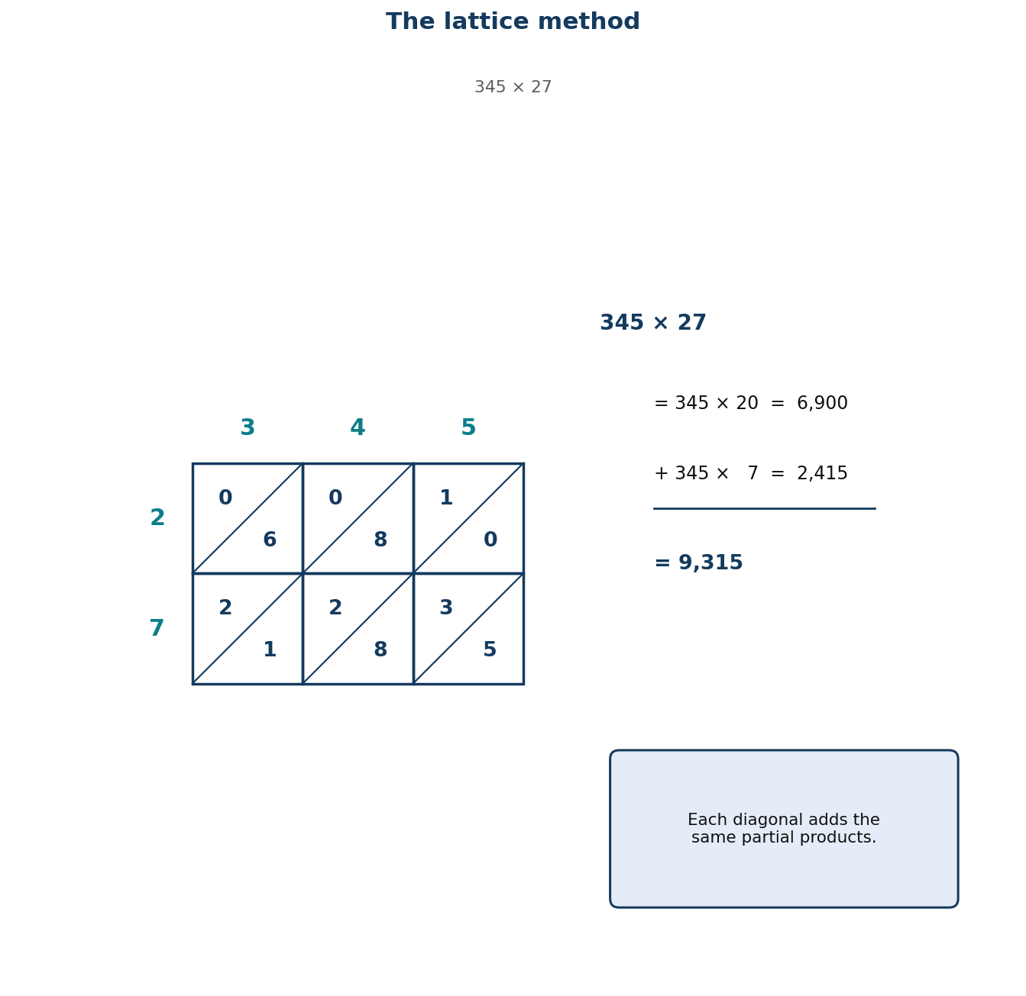
Figure 1.5 The lattice method organises the same partial products.
Unit objectives
- Learners multiply and divide whole numbers, decimals and benchmark fractions by 10, 100, 1000 and other powers of ten.
- Learners apply mental mathematics strategies and number properties to perform calculations without written methods.
- Learners apply mental mathematics strategies to solve word problems.
- Learners add and subtract numbers up to four digits, including decimals, using partitioning and place value.
- Learners multiply and divide multi-digit numbers by one- and two-digit numbers using partitioning, place value and the distributive property.
Assessed unit product
A strategy wall the class builds and keeps, plus a set of learner-written story problems collected into a class problem bank.
LESSON 6  Week 3 | Multiplying and Dividing by Powers of Ten  60 minutes (double period)

Strand | Number
Sub-strand | Number Operations
Content standard | B7.1.2.1 — Apply mental mathematics strategies and number properties used to solve problems.
Indicator(s) | B7.1.2.1.1 — Multiply and divide given numbers by powers of 10 including decimals and benchmark fractions.
Performance indicator  (what learners can do) | Learners multiply and divide whole numbers, decimals and benchmark fractions by 10, 100, 1000 and other powers of ten.
Core competencies | Communication and Collaboration (CC); Creativity and Innovation (CI).
Key vocabulary | power of ten, index, exponent, digit shift, placeholder, decimal point, benchmark fraction, product, quotient
Prior knowledge | Place value to billions (Lesson 1) and decimals to thousandths (Lesson 4). Learners have multiplied by 10 and 100 since Basic 3 but may treat it as a trick about adding zeros.
Resources / TLM | Place-value slider chart (digits on movable cards with a fixed decimal point); calculators for verification; Figure 1.3 enlarged; cups of beans for the benchmark-fraction case.

Learning objectives — by the end of this lesson every learner will be able to:
- K — state that multiplying by 10ⁿ moves digits n places to the left, and dividing moves them n places to the right.
- S — multiply and divide decimals and benchmark fractions by powers of ten without written calculation.
- A/V — appreciate that the digits keep their order — only their place value changes — and reject the ‘just add a zero’ rule.

Phase / time | Teacher activity | Learner activity
ENGAGE  8 min | Ask: ‘4.5 × 10.’ Nearly everyone will say 4.50. Write it, then check on a calculator: 45. Let the wrong answer stand for a moment. Say: ‘The rule you were taught — add a zero — works for whole numbers and fails for decimals. Today you replace it with one that always works.’ | Learners answer, then see the calculator disagree. The contradiction is the hook for the whole lesson.
EXPLORE  16 min | Give each group a place-value slider: digit cards 4, 5 and a fixed decimal point. Task: show 4.5, then show 4.5 × 10 by moving the cards without changing their order. Then try ÷ 10. Circulate and ask ‘what moved, the digits or the point?’ Insist they describe what physically moved. | Groups manipulate the cards. They discover the digits slide and the decimal point appears to stay put — or, if they move the point instead, they see it is equivalent.
EXPLAIN  14 min | Formalise with Figure 1.3: multiplying by 10ⁿ moves every digit n columns to the LEFT; dividing moves them n columns to the RIGHT. The digits never reorder; only the decimal point stays still. Work three cases: 4.5 × 10 = 45; 4.5 ÷ 10 = 0.45; 0.07 × 1000 = 70. Then the benchmark fraction: ½ × 100 = 50, because ½ of 100 is 50. Emphasise that ‘add a zero’ is a coincidence of whole numbers and must be retired. | Learners write the rule with an arrow diagram and apply it to six examples, checking three on a calculator.
ELABORATE  12 min | Chain race: teams do × 10, then × 100, then ÷ 10 on the same starting number, predicting before they calculate. Then real context: convert GH₵ 245.50 into pesewas (× 100) and 3,450 pesewas back into cedis (÷ 100). Extension: explain why 0.8 × 10 and 0.80 × 10 give the same answer but 0.08 × 10 does not. | Teams race and predict. Pairs do the money conversion, which is the most common real use of the skill in Ghana.
EVALUATE  10 min | Exit ticket: 3.07 × 100; 62 ÷ 1000; ¾ × 1000. Collect and sort. Preview Lesson 7: ‘Tomorrow, mental strategies that use this without writing anything.’ | Learners complete the ticket alone and tick: I know the direction of the shift / I can do it with decimals / I can do it with fractions.

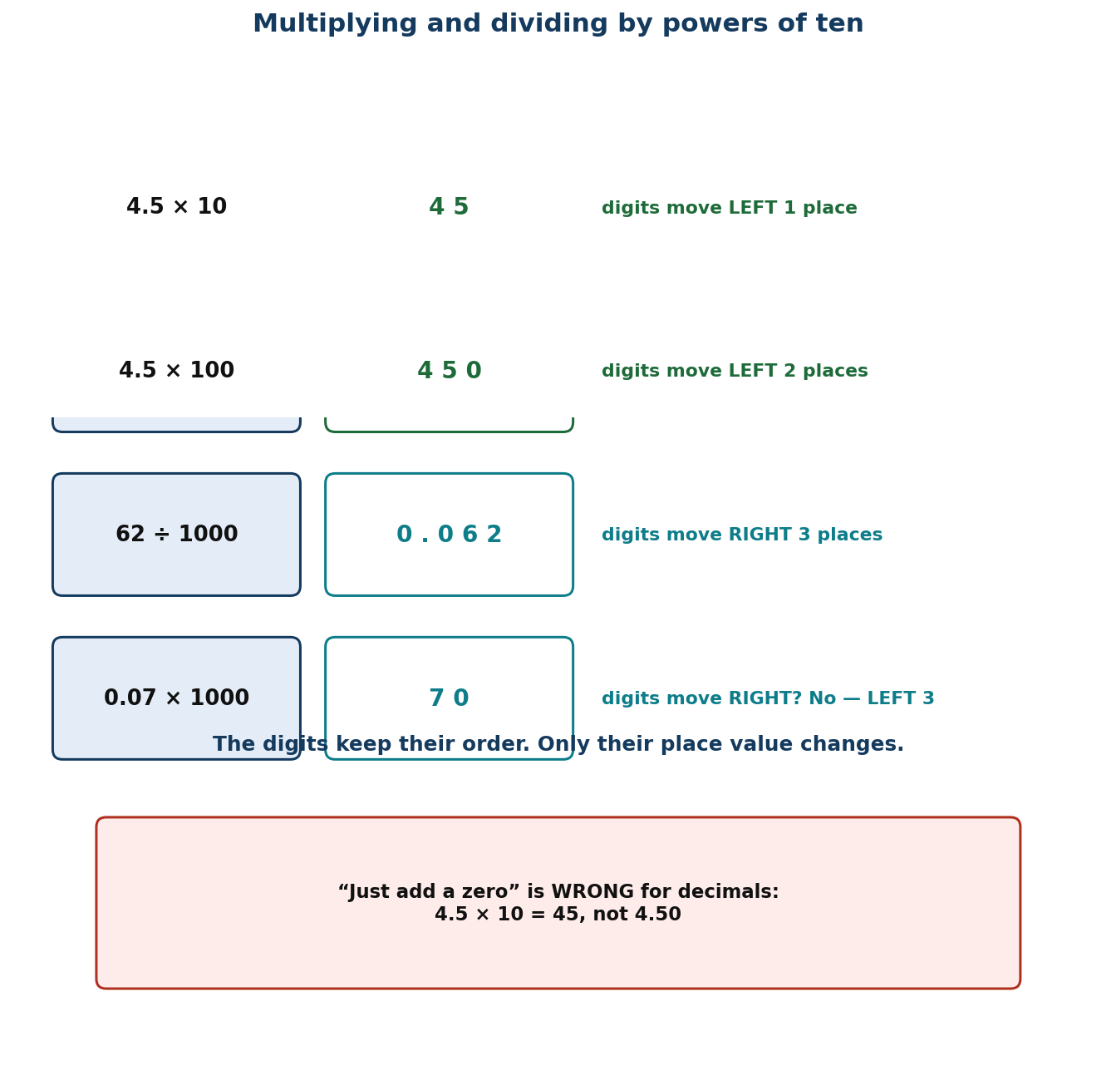
Figure 1.3 Digit shifts when multiplying and dividing by powers of ten.
Differentiation
Support — keep the slider chart in front of them; multiply and divide by 10 and 100 only, with the digits written in a chart, before doing it mentally.
Core — as described, including 1000 and benchmark fractions.
Extension — generalise to 10ⁿ for any n, and explain why dividing by 10ⁿ is the same as multiplying by 10⁽ⁿ.

Assessment and success criteria
Observation with checklist C7.6. Exit ticket marked on correct direction and correct number of places. Any learner still ‘adding a zero’ to a decimal is the specific target for reteaching — pair them with a slider chart.
Homework / project
Write ten conversions between cedis and pesewas, and five conversions between metres and centimetres, using the shift rule and no written calculation.
Cross-curricular links and values
Science — unit conversions are all powers of ten. Business — cedi/pesewa conversion. Values — accuracy with money affects real people's accounts.
Teacher reflection (complete after the lesson)
What worked well: ______________________________________________________________________________
Who did not meet the success criteria, and what I will do next lesson: ______________________________________________________________________________
What I will change when I teach this again: ______________________________________________________________________________

LESSON 7  Week 4 | Mental Mathematics Strategies  60 minutes (double period)

Strand | Number
Sub-strand | Number Operations
Content standard | B7.1.2.1 — Apply mental mathematics strategies and number properties used to solve problems.
Indicator(s) | B7.1.2.1.2 — Apply mental mathematics strategies and number properties used to perform calculations.
Performance indicator  (what learners can do) | Learners apply mental mathematics strategies and number properties to perform calculations without written methods.
Core competencies | Creativity and Innovation (CI); Critical Thinking and Problem Solving (CP).
Key vocabulary | mental strategy, partition, compensate, compatible numbers, doubling, halving, distributive, commutative, associative
Prior knowledge | Lesson 6 powers of ten. Learners have partitioned numbers since Basic 3 but often default to a written algorithm for everything.
Resources / TLM | Nothing per group but paper; a set of flashcards with number sentences; a timer; a ‘strategy wall’ where named strategies go up as the class discovers them.

Learning objectives — by the end of this lesson every learner will be able to:
- K — name at least four mental strategies (partition, compensate, use compatible numbers, double and halve) and the number properties that justify them.
- S — calculate mentally with two-digit and simple three-digit numbers, and explain which strategy they used.
- A/V — value flexibility over procedure, and appreciate that there is usually more than one good way.

Phase / time | Teacher activity | Learner activity
ENGAGE  8 min | Write 25 × 16 on the board and say: ‘Hands up who needs paper for this.’ Most hands go up. Then say: ‘Watch. 25 × 4 is 100, and 16 is 4 × 4, so it is 100 × 4 = 400.’ Tell them: ‘Today your brain is the calculator, and I will be timing you.’ | Learners react to the demonstration and admit how many rely on paper. They write the date and the heading ‘Mental strategies’.
EXPLORE  16 min | Put up six calculations: 47 + 38; 1000 − 476; 25 × 24; 96 ÷ 4; 15 × 18; 7.5 × 8. Task: do as many as you can in your head and write down HOW you did each one. Emphasise that the method matters more than the answer. Circulate and collect distinct approaches — do NOT correct. | Learners work silently then compare in pairs. The variety of methods is the resource for the next phase.
EXPLAIN  14 min | Harvest the methods and name them on the strategy wall: partition (47 + 38 = 47 + 30 + 8); compensate (1000 − 476 = 1000 − 500 + 24); compatible numbers (25 × 24 = 25 × 4 × 6); double and halve (15 × 18 = 30 × 9). Name the properties that licence them: commutative, associative, distributive. Stress that choosing the strategy is the skill — the calculation is the easy part. | Learners copy the four named strategies with one example each, and label their own explored methods with the matching name.
ELABORATE  12 min | Timed relay: five calculations, one minute each, learners write the answer AND the strategy name. Then ‘same answer, different route’: pairs must find two different ways to do 36 × 25. Extension: construct a calculation where doubling-and-halving is the best route, and one where it is the worst. | Learners work against the clock, then pairs present two routes to the same answer. The class judges which is more efficient and why.
EVALUATE  10 min | Exit ticket: 99 × 7 and 4.5 × 18, each with the strategy named. Collect and sort. Preview Lesson 8: ‘Tomorrow we use these strategies on word problems, where choosing the method is half the difficulty.’ | Learners complete the ticket alone and tick: I can calculate mentally / I can name my strategy / I can choose between strategies.

Differentiation
Support — partition and compensate only, with two-digit numbers and a written number line to check; allow extra time.
Core — as described, all four strategies.
Extension — justify each strategy by naming the property that permits it, and construct a problem where the obvious strategy is a trap.

Assessment and success criteria
Observation with checklist C7.7, which looks specifically at whether the learner can NAME the strategy, not just produce the answer. A learner who computes correctly but cannot say how has memorised rather than understood.
Homework / project
Teach one mental strategy to someone at home and write down their reaction. Do five calculations mentally on the way home and note which strategy you used.
Cross-curricular links and values
English — explaining a method is a speaking-and-listening task. Business — market traders calculate mentally all day. Values — confidence: everyone can improve at this with practice.
Teacher reflection (complete after the lesson)
What worked well: ______________________________________________________________________________
Who did not meet the success criteria, and what I will do next lesson: ______________________________________________________________________________
What I will change when I teach this again: ______________________________________________________________________________

LESSON 8  Week 4 | Mental Strategies for Word Problems  60 minutes (double period)

Strand | Number
Sub-strand | Number Operations
Content standard | B7.1.2.1 — Apply mental mathematics strategies and number properties used to solve problems.
Indicator(s) | B7.1.2.1.3 — Apply mental mathematics strategies to solve word problems.
Performance indicator  (what learners can do) | Learners apply mental mathematics strategies to solve word problems.
Core competencies | Creativity and Innovation (CI); Critical Thinking and Problem Solving (CP).
Key vocabulary | word problem, operation, estimate, reasonable, context, round, check, unknown
Prior knowledge | Lesson 7 mental strategies. Learners have solved one-step word problems since Basic 2 but often guess the operation from key words.
Resources / TLM | Word-problem cards set in Ghanaian contexts (market, tro-tro fares, school feeding, water tanker deliveries); the strategy wall from Lesson 7; mini whiteboards.

Learning objectives — by the end of this lesson every learner will be able to:
- K — identify the operation a word problem requires, and justify the choice from the situation rather than from key words.
- S — solve two-step word problems mentally where the numbers permit, and estimate where they do not.
- A/V — check whether an answer is reasonable in its context before writing it down.

Phase / time | Teacher activity | Learner activity
ENGAGE  8 min | Write: ‘Ama has 24 oranges and Kwame has 8. How many more does Ama have?’ Ask: ‘Which operation?’ Then: ‘Ama has 24 oranges. Kwame has 8 times as many. How many does Kwame have?’ ‘Now which operation?’ Both say ‘more’. Say: ‘Today we stop guessing from words and start reading the situation.’ | Learners answer both and notice the same word led to different operations. This is the lesson's central idea, surfaced in the first minute.
EXPLORE  16 min | Give each group four word-problem cards set in a market. Task: for each, write the calculation you would do and one sentence saying why that operation. Circulate and ask ‘what is happening in the story?’ rather than ‘what is the answer?’ Do NOT give answers. | Groups read, discuss and write. They must agree on the WHY, which forces them to picture the situation rather than scan for key words.
EXPLAIN  14 min | Take one card at a time. Teach the routine explicitly: (i) picture the situation; (ii) say what is being found; (iii) choose the operation and justify it from the picture; (iv) calculate, mentally if the numbers allow; (v) check against the story — is this answer reasonable? Work the tro-tro fare problem: 14 passengers at GH₵ 3.50 each. Mental route: 14 × 3.5 = 14 × 7 ÷ 2 = 98 ÷ 2 = 49. Then check: 14 × 3 = 42, so 49 is reasonable. | Learners copy the five-step routine and apply it to a second problem with the teacher, orally, before trying alone.
ELABORATE  12 min | Pairs solve four more cards, then swap and check each other's reasoning sentence. Then ‘same story, different question’: the teacher keeps one situation and changes the question three times so learners see the operation shift. Extension: write their own two-step problem and the reasoning sentence that goes with it. | Pairs solve and peer-check. The changing-question routine makes the point that the operation lives in the question, not the story.
EVALUATE  10 min | Exit ticket: one two-step word problem, answered with a reasoning sentence and a reasonableness check. Collect and sort. Preview Lesson 9: ‘Tomorrow we return to written methods for numbers too big for the head.’ | Learners complete the ticket alone and tick: I chose the right operation / I explained why / I checked my answer.

Differentiation
Support — one-step problems with small numbers, and a picture frame to draw the situation before choosing the operation.
Core — as described, two-step problems with mental-friendly numbers.
Extension — problems where two different operations both give a defensible answer, requiring the learner to argue for one.

Assessment and success criteria
Observation with checklist C7.8, weighted towards the reasoning sentence. The exit ticket is marked primarily on the justification and the reasonableness check, not on the arithmetic.
Homework / project
Write three word problems set in your own community, with the answer and the reasoning sentence for each.
Cross-curricular links and values
English — reading comprehension is a mathematics skill here. Social Studies — market economics. Values — checking your work is a responsibility, not an extra.
Teacher reflection (complete after the lesson)
What worked well: ______________________________________________________________________________
Who did not meet the success criteria, and what I will do next lesson: ______________________________________________________________________________
What I will change when I teach this again: ______________________________________________________________________________

LESSON 9  Week 5 | Adding and Subtracting Four-Digit Numbers  60 minutes (double period)

Strand | Number
Sub-strand | Number Operations
Content standard | B7.1.2.2 — Demonstrate an understanding of addition, subtraction, multiplication and division of (i) whole numbers, and (ii) decimal numbers, to solve problems.
Indicator(s) | B7.1.2.2.1 — Add and subtract up to four-digit numbers.
Performance indicator  (what learners can do) | Learners add and subtract numbers up to four digits, including decimals, using partitioning and place value.
Core competencies | Critical Thinking and Problem Solving (CP).
Key vocabulary | partition, expanded form, place value, carry, borrow, exchange, regroup, column method, estimate
Prior knowledge | Place value and rounding (Lessons 1–5). Learners have added and subtracted in columns since Basic 3 but often cannot explain why the method works.
Resources / TLM | Base-ten blocks or bundle sticks; place-value charts; mini whiteboards; Figure 1.4 enlarged; a class shop with priced items.

Learning objectives — by the end of this lesson every learner will be able to:
- K — explain carrying and borrowing as exchanging between columns, not as digits moving on their own.
- S — add and subtract four-digit whole numbers and decimals to two places accurately, and estimate first.
- A/V — check answers by estimating and by using the inverse operation.

Phase / time | Teacher activity | Learner activity
ENGAGE  8 min | Write 3000 − 1 and ask for the answer. Many will write 3001 or 2001. Then ask: ‘What is 3,000 made of?’ — three thousands. ‘So if I take one away?’ Establish 2,999. Say: ‘Today we make sure the column method is something you understand, not something you do with your fingers.’ | Learners answer, then unpack 3,000 into bundles with the teacher. The error sets up why place value matters.
EXPLORE  16 min | Give each group base-ten blocks and the calculation 785 + 9,342. Task: do it with the blocks first, then write what you did in columns. Circulate and ask ‘what did you do when a column had more than ten?’ Collect the language they use — ‘carry’, ‘move’, ‘exchange’ — without correcting. | Groups manipulate blocks and record. They physically exchange ten ones for a ten and ten tens for a hundred, which is the concept the column method encodes.
EXPLAIN  14 min | Formalise with Figure 1.4, using expanded form: 785 = 700 + 80 + 5; 9,342 = 9,000 + 300 + 40 + 2; sum = 9,000 + 1,000 + 120 + 7 = 10,127. Name the idea: you may only add like with like — that is why columns exist. Then subtraction with decimals: 93.6 − 7.85, showing the empty hundredths column must be filled with a zero placeholder first. Reframe ‘borrow’ as ‘exchange one ten for ten ones’. | Learners write both calculations in expanded form alongside the column method, and label each exchange in their own words.
ELABORATE  12 min | Class shop: pairs pick two items, add the prices, and pay with a round amount, calculating the change. Then ‘find the error’: three worked calculations with deliberate mistakes (misaligned columns, missing placeholder zero, wrong exchange) to diagnose. Extension: add three four-digit numbers with two exchanges. | Pairs shop and calculate change. The error-diagnosis task builds the checking habit explicitly.
EVALUATE  10 min | Exit ticket: 5,073 − 2,486 and 45.7 + 8.63, each with an estimate written first. Collect and sort. Preview Lesson 10: ‘Tomorrow, multiplication and division of multi-digit numbers.’ | Learners complete the ticket alone, estimate first, and tick: I aligned the columns / I exchanged correctly / my answer matches my estimate.

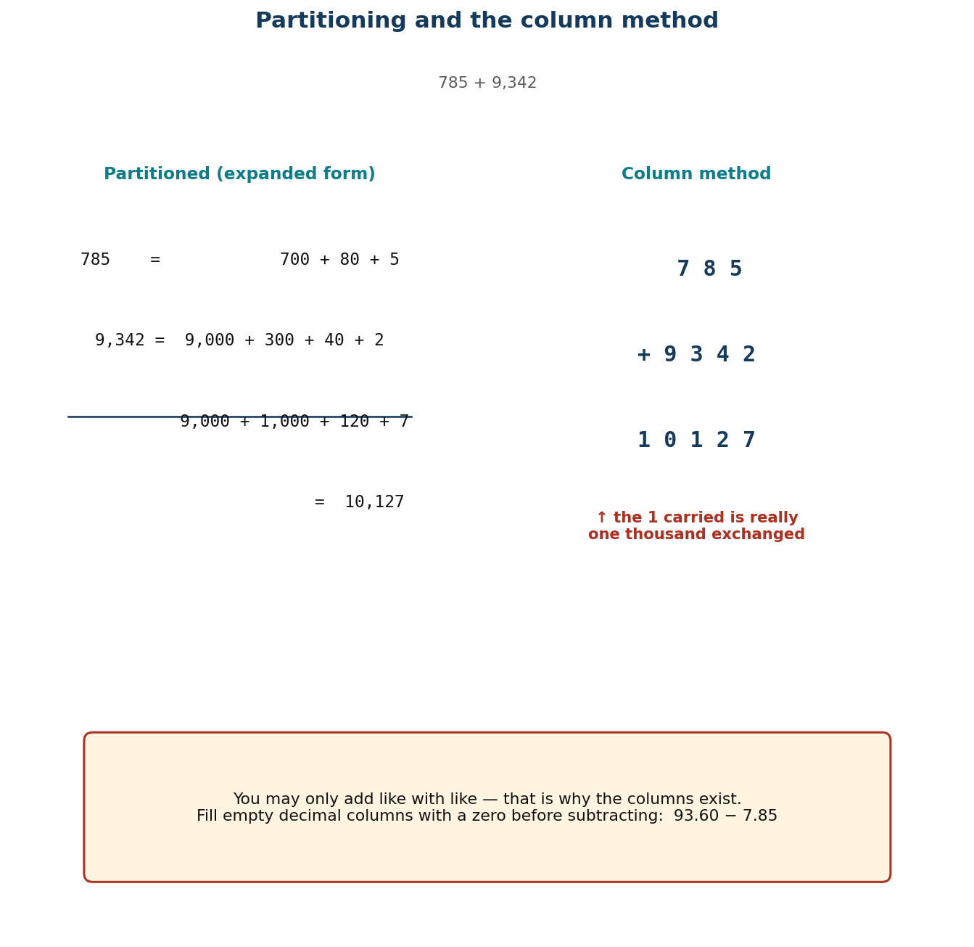
Figure 1.4 Partitioning and the column method side by side.
Differentiation
Support — three-digit numbers with blocks always available; no decimals until the whole-number method is secure.
Core — as described, four digits and two decimal places.
Extension — explain why the column method works, in writing, using expanded form; then add and subtract in base five to prove they understand exchange rather than the algorithm.

Assessment and success criteria
Observation with checklist C7.9. Exit ticket marked on: estimate present and sensible; columns aligned; exchanges correct. Misalignment is the commonest failure and is addressed directly in the lesson.
Homework / project
Six additions and six subtractions, each with an estimate first and an inverse-operation check afterwards.
Cross-curricular links and values
Business — shop accounts and change. Science — measurement arithmetic. Values — accuracy with money is a trust issue between people.
Teacher reflection (complete after the lesson)
What worked well: ______________________________________________________________________________
Who did not meet the success criteria, and what I will do next lesson: ______________________________________________________________________________
What I will change when I teach this again: ______________________________________________________________________________

LESSON 10  Week 5 | Multiplying and Dividing Multi-Digit Numbers  60 minutes (double period)

Strand | Number
Sub-strand | Number Operations
Content standard | B7.1.2.2 — Demonstrate an understanding of addition, subtraction, multiplication and division of (i) whole numbers, and (ii) decimal numbers, to solve problems.
Indicator(s) | B7.1.2.2.2 — Multiply or divide multi-digit numbers by 1- and 2-digit numbers.
Performance indicator  (what learners can do) | Learners multiply and divide multi-digit numbers by one- and two-digit numbers using partitioning, place value and the distributive property.
Core competencies | Critical Thinking and Problem Solving (CP); Personal Development and Leadership (PL).
Key vocabulary | multi-digit, partition, distributive property, partial product, lattice method, divisibility test, quotient, remainder, estimate
Prior knowledge | Lesson 9 addition and subtraction with exchange. Learners know their tables but many are unstable on 6–9, which blocks multi-digit work.
Resources / TLM | Mini whiteboards; multiplication grids; Figure 1.5 (lattice) enlarged; a times-table warm-up chart; calculators only for checking, never for finding.

Learning objectives — by the end of this lesson every learner will be able to:
- K — explain a partial product and state the divisibility tests for 2, 3, 5, 9 and 10.
- S — multiply a three-digit number by a two-digit number and divide by a one- or two-digit number accurately.
- A/V — choose between methods on the basis of the numbers, and check by estimating.

Phase / time | Teacher activity | Learner activity
ENGAGE  8 min | Three-minute times-table warm-up on whiteboards — the 7s and 8s, which are the usual weak spots. Then: ‘325 × 15.’ Say: ‘You already know 325 × 10 and you can halve that for 325 × 5. Add them.’ Model: 3,250 + 1,625 = 4,875. ‘That is the distributive property, and it is the whole lesson.’ | Learners complete the warm-up honestly, then watch the demonstration and try 214 × 15 the same way.
EXPLORE  16 min | Give the calculation 345 × 27. Task: find the answer by splitting 27 into two easier numbers, and show every partial product. Circulate and ask ‘why did you split it there?’ Expect most to split 20 + 7; note anyone who splits differently. Then ask them to check with a different split — 30 − 3. | Groups produce two different splits and confirm they give the same answer, which is the first real evidence that the method is sound rather than lucky.
EXPLAIN  14 min | Formalise: 345 × 27 = 345 × 20 + 345 × 7 = 6,900 + 2,415 = 9,315. Name each line a partial product. Show the vertical place-value layout and, using Figure 1.5, the lattice method as an alternative that organises the same partial products. Then division: teach it as the inverse, and add the divisibility tests — 2 (last digit even), 3 (digit sum divisible by 3), 5 (ends 0 or 5), 9 (digit sum divisible by 9), 10 (ends 0) — as a way of predicting before calculating. | Learners write the partial products for two multiplications and test four numbers for divisibility, predicting before they divide.
ELABORATE  12 min | Method choice: give six calculations and ask pairs to choose a method for each and say why — mental, partitioning, vertical or lattice. Then a context: a school buys 27 boxes of chalk at GH₵ 345 each; find the bill and check it by rounding. Extension: prove the divisibility test for 3 using expanded form. | Pairs choose methods and defend them. The point being taught is that method selection is itself a skill.
EVALUATE  10 min | Exit ticket: 468 × 23 using partial products, and 1,176 ÷ 24. Collect and sort. Preview Lesson 11: ‘Tomorrow, story problems with decimals — where choosing the operation is the hard part.’ | Learners complete the ticket alone and tick: I can find partial products / I can add them correctly / my estimate matches.

Figure 1.5 The lattice method organises the same partial products.
Differentiation
Support — two-digit by one-digit, with a written grid for partial products and the tables chart visible; drop the lattice method.
Core — as described, three-digit by two-digit and division by two digits.
Extension — explain why the lattice method works in terms of partial products, and justify the divisibility test for 9.

Assessment and success criteria
Observation with checklist C7.10. Exit ticket marked on: partial products correct and complete; addition of partial products accurate; estimate consistent. Table weakness, not method weakness, is the usual cause of failure here — diagnose before reteaching.
Homework / project
Eight multiplications and four divisions, each with an estimate. Then write one sentence saying which method you prefer and why.
Cross-curricular links and values
Business — invoices and bulk buying. ICT — spreadsheets do this, but you must be able to check them. Values — diligence: multi-digit arithmetic rewards careful, orderly work.
Teacher reflection (complete after the lesson)
What worked well: ______________________________________________________________________________
Who did not meet the success criteria, and what I will do next lesson: ______________________________________________________________________________
What I will change when I teach this again: ______________________________________________________________________________

LESSON 11  Week 6 | Story Problems with Decimals  60 minutes (double period)

Strand | Number
Sub-strand | Number Operations
Content standard | B7.1.2.2 — Demonstrate an understanding of addition, subtraction, multiplication and division of (i) whole numbers, and (ii) decimal numbers, to solve problems.
Indicator(s) | B7.1.2.2.3 — Create and solve story problems involving decimals on the four basic operations.
Performance indicator  (what learners can do) | Learners create and solve story problems involving decimals using all four operations.
Core competencies | Critical Thinking and Problem Solving (CP); Personal Development and Leadership (PL).
Key vocabulary | story problem, operation, decimal, context, reasonable, estimate, check, two-step
Prior knowledge | Lessons 8–10: word problems, four-digit operations with decimals, multi-digit multiplication and division.
Resources / TLM | Story-problem cards in Ghanaian settings; blank card templates for learners to write their own; a class price list; mini whiteboards.

Learning objectives — by the end of this lesson every learner will be able to:
- K — identify which operation a decimal story problem requires and justify the choice from the situation.
- S — create and solve two-step story problems involving decimals in all four operations.
- A/V — value problems drawn from real life, and check answers against the situation.

Phase / time | Teacher activity | Learner activity
ENGAGE  8 min | Read: ‘Mrs Adamu bought 13.6 kg of meat. Mrs Anderson bought 2.4 kg less. How much did they buy altogether?’ Ask: ‘How many steps is this?’ Establish two — find Mrs Anderson's amount first, then add. Say: ‘Today you write problems as well as solve them, which is harder and shows whether you really understand the operations.’ | Learners identify the two steps and name the operations. They recognise that the second step uses the answer to the first.
EXPLORE  16 min | Give each group a situation card with data but no question — e.g. a market price list. Task: write two questions: one that needs multiplication and one that needs division. Then solve both. Circulate and ask ‘what makes a question need multiplication rather than division?’ | Groups write questions and solve them. Writing the question forces them to think about what each operation does to a quantity.
EXPLAIN  14 min | Share the best questions. Teach the structure: in multiplication the quantity repeats; in division it is shared out or measured out; in subtraction it is compared or reduced; in addition it is combined. Work the opening problem fully: 13.6 − 2.4 = 11.2 kg, then 13.6 + 11.2 = 24.8 kg. Check: both amounts are close to 13, so about 25 kg is reasonable. Emphasise the check against the story, not just the arithmetic. | Learners copy the four-operation structure with a keyword-free description of each, and solve a two-step problem with the teacher.
ELABORATE  12 min | Problem exchange: each pair writes one two-step decimal problem on a card, swaps with another pair, solves it, and compares answers. Where the answers differ, the two pairs must find out who misread the problem. Extension: write a problem with a deliberate irrelevant piece of data and see who spots it. | Pairs write, swap, solve and negotiate. The negotiation is where the reasoning becomes visible.
EVALUATE  10 min | Exit ticket: solve one two-step decimal story problem, writing the operation for each step and a reasonableness check. Collect and sort. Preview Lesson 12: ‘Tomorrow we start powers — repeated multiplication.’ | Learners complete the ticket alone and tick: I found both steps / I chose the right operations / my answer is reasonable.

Differentiation
Support — one-step problems and a three-box frame (what I know / what I need / what I do); decimals to one place only.
Core — as described, two-step problems with decimals to two places.
Extension — write a problem that can only be solved with a particular order of operations, and explain why the order cannot change.

Assessment and success criteria
Observation with checklist C7.11. Exit ticket marked on step identification, operation choice and the reasonableness check. Problems written by learners are assessed with rubric R4.
Homework / project
Write two story problems about your own household — one multiplication, one division — with full solutions.
Cross-curricular links and values
English — precise writing makes a problem solvable. Business — market and shop arithmetic. Values — real problems concern real people's money.
Teacher reflection (complete after the lesson)
What worked well: ______________________________________________________________________________
Who did not meet the success criteria, and what I will do next lesson: ______________________________________________________________________________
What I will change when I teach this again: ______________________________________________________________________________

UNIT 3 — NUMBER: POWERS
Weeks 6–8 • Lessons 12–16

Five lessons that take learners from bottle tops to the highest common factor. Powers are the one topic in the term where the notation must never arrive before the idea, so Lesson 12 builds them with objects and the shorthand is invented because the class needs it. The zero index in Lesson 14 is the best argument in the whole syllabus for mathematics being discovered rather than memorised.
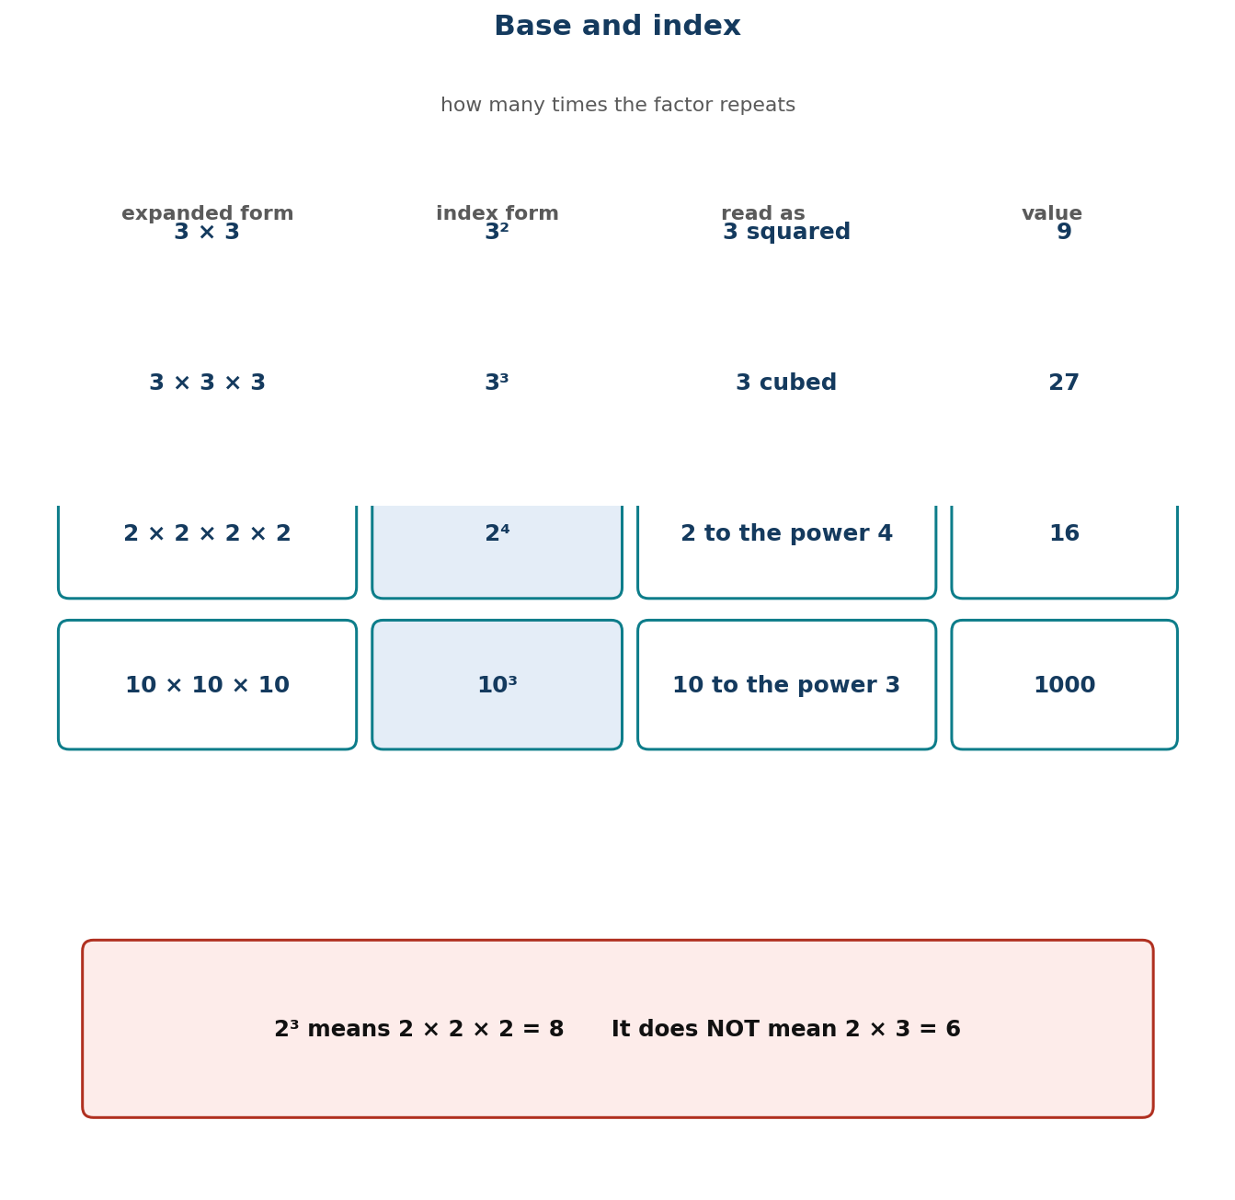
Figure 1.6 Base and index: how many times the factor repeats.
Unit objectives
- Learners illustrate the meaning of repeated factors using concrete objects and write the shorthand index form.
- Learners express a number as a product of factors, and write that product in index form including as a product of powers.
- Learners show that any natural number raised to the power zero equals 1, and use this to solve problems.
- Learners find the value of a number written in index form, including products of powers and zero indices.
- Learners use prime factorisation to find the Highest Common Factor of two or more numbers.
Assessed unit product
A factor-tree display showing that every route through a number ends at the same primes, and an HCF investigation using a real tiling problem.
LESSON 12  Week 6 | Repeated Factors — The Idea of Powers  60 minutes (double period)

Strand | Number
Sub-strand | Number Operations
Content standard | B7.1.2.3 — Demonstrate understanding and the use of powers of natural numbers in solving problems.
Indicator(s) | B7.1.2.3.1 — Illustrate with examples the meaning of repeated factors using counting objects such as bottle tops or bundle sticks.
Performance indicator  (what learners can do) | Learners illustrate the meaning of repeated factors using concrete objects and write the shorthand index form.
Core competencies | Critical Thinking and Problem Solving (CP); Creativity and Innovation (CI).
Key vocabulary | factor, repeated factor, power, index, exponent, base, squared, cubed, product
Prior knowledge | Multi-digit multiplication (Lesson 10). Learners have met area as length × width and volume as length × width × height in Basic 6, without index notation.
Resources / TLM | Bottle tops or bundle sticks — at least 64 per group; squared paper; Figure 1.6 enlarged; mini whiteboards.

Learning objectives — by the end of this lesson every learner will be able to:
- K — state that a power records how many times a number is used as a factor, and identify the base and the index.
- S — build repeated products with objects and write them in index form and in expanded form.
- A/V — appreciate that notation exists to make long ideas short, and that the shorthand must never be written before the idea.

Phase / time | Teacher activity | Learner activity
ENGAGE  8 min | Write 2 × 2 × 2 × 2 × 2 × 2 × 2 × 2 on the board. Ask: ‘What is this?’ Then say: ‘Now imagine writing that out for thirty twos. Mathematicians got tired of it too.’ Tell them the performance indicator: ‘Today you invent the shorthand yourself, out of bottle tops.’ | Learners evaluate the long product (256) and agree it is tedious to write. They are ready for the notation because they have felt the need for it.
EXPLORE  16 min | Give each group 64 bottle tops. Tasks in order: build 3 groups of 3; then build 4 groups of 4; then 3 groups of 3 groups of 3. For each, write the multiplication you have built, count the total, and write how many times the number appears as a factor. Circulate and ask ‘how many times did you use that number?’ | Groups build, count and record. They produce 3 × 3 = 9, 4 × 4 = 16 and 3 × 3 × 3 = 27, and have counted the repetitions themselves.
EXPLAIN  14 min | Harvest, then introduce the notation with Figure 1.6: the BASE is the number being repeated; the INDEX (or exponent) is how many times it is used as a factor. So 3 × 3 × 3 = 3³ = 27, read ‘three cubed’ or ‘three to the power three’. Special names: 2² is ‘squared’, 3³ is ‘cubed’. Then the essential warning: 2³ means 2 × 2 × 2 = 8, NOT 2 × 3 = 6. Say it twice — this is the single most common error in the whole topic. | Learners write six products in both forms and read them aloud. They write the warning 2³ ≠ 2 × 3 at the top of the page and box it.
ELABORATE  12 min | ‘Build this’: teacher writes 5², 2⁵, 4³, 10² and groups build each with tops and report the value. Then the reverse: given 81, find a way to write it as a power. Extension: find three different numbers that can each be written as a power in two different ways (e.g. 64 = 8² = 4³ = 2⁶). | Groups build and evaluate. The reverse task — finding the power from the value — is the first step towards prime factorisation in Lesson 16.
EVALUATE  10 min | Exit ticket: write 7 × 7 × 7 in index form; evaluate 3⁴; and state what is wrong with 2³ = 6. Collect and sort. Preview Lesson 13: ‘Tomorrow we break numbers down into products of powers.’ | Learners complete the ticket alone and tick: I can identify the base / I can identify the index / I know 2³ is not 6.

Figure 1.6 Base and index: how many times the factor repeats.
Differentiation
Support — squares and cubes only, always with objects, and an index of 2 or 3; skip indices above 3.
Core — as described, indices up to 5.
Extension — evaluate 2ⁱ⁰ by repeated doubling, and explain why the values grow so fast — linking to the doubling story of the chessboard.

Assessment and success criteria
Observation with checklist C7.12, which checks that the learner can BUILD the power with objects, not only write it. The exit ticket's third item directly tests the 2³ = 6 misconception.
Homework / project
Evaluate ten powers with indices up to 4, and write each one out in expanded form as well.
Cross-curricular links and values
Science — area is squared, volume is cubed. ICT — computer memory uses powers of 2. Values — patience: large results come from repeating small, ordinary steps.
Teacher reflection (complete after the lesson)
What worked well: ______________________________________________________________________________
Who did not meet the success criteria, and what I will do next lesson: ______________________________________________________________________________
What I will change when I teach this again: ______________________________________________________________________________

LESSON 13  Week 7 | Writing Numbers as Products and Powers  60 minutes (double period)

Strand | Number
Sub-strand | Number Operations
Content standard | B7.1.2.3 — Demonstrate understanding and the use of powers of natural numbers in solving problems.
Indicator(s) | B7.1.2.3.2 — Express a given number as a product of a given number or numbers, as well as, in the form of a power or two such numbers as product of powers.
Performance indicator  (what learners can do) | Learners express a number as a product of factors, and write that product in index form including as a product of powers.
Core competencies | Critical Thinking and Problem Solving (CP).
Key vocabulary | factor, product, prime, composite, factor pair, index form, base, power, product of powers
Prior knowledge | Lesson 12 base and index. Learners know times tables and have used factor pairs since Basic 5.
Resources / TLM | Bottle tops or counters (36 per group); factor-tree templates; mini whiteboards; Figure 1.7 enlarged; a wall chart of the first ten primes.

Learning objectives — by the end of this lesson every learner will be able to:
- K — distinguish prime from composite numbers and state that every whole number above 1 is either prime or a product of primes.
- S — write a number as a product of its factors and then express repeated factors in index form, including products of powers.
- A/V — appreciate that every number has a unique prime building set — the same answer however you break it down.

Phase / time | Teacher activity | Learner activity
ENGAGE  8 min | Ask: ‘In how many different ways can you arrange 36 bottle tops into equal rows?’ Collect answers — 1×36, 2×18, 3×12, 4×9, 6×6. Say: ‘Those pairs are the factors of 36. Today we break numbers down until they cannot be broken further, and then write the result with indices.’ | Learners arrange the tops and call out the arrangements. They record the factor pairs in their books.
EXPLORE  16 min | Task: break 36 down into factors, then keep breaking until you cannot go further. Different groups will start differently — 36 = 6 × 6, or 4 × 9, or 2 × 18. Let them, then ask: ‘Compare your final answer with another group that started differently. What do you notice?’ Circulate and ask ‘can you break this one down any more?’ | Groups produce factor trees by different routes and discover they all end at 2 × 2 × 3 × 3. The surprise is the point of the lesson.
EXPLAIN  14 min | Take the discovery: every route ends in the same primes — 2² × 3². That is not a coincidence; it is a fact about every whole number. Name the primes (numbers with exactly two factors) and composites. Then teach the writing using Figure 1.7: group the repeated primes and write each with an index — 2 × 2 × 3 × 3 = 2² × 3². Then a product of powers with two different bases: 72 = 2³ × 3². | Learners write five numbers as products of powers, checking that the product still equals the original number each time.
ELABORATE  12 min | Factor-tree race: teams race to write 48, 60, 100 and 144 as products of powers, starting from different first splits to prove the answer is the same. Then ‘build a number’: given 2³ × 5², find the number (200). Extension: prove that 97 is prime by showing no prime up to its square root divides it. | Teams race and compare. The reverse task — building the number from the product of powers — is checked by multiplication.
EVALUATE  10 min | Exit ticket: write 120 as a product of powers of primes, and write 2² × 3 × 5 as an ordinary number. Collect and sort. Preview Lesson 14: ‘Tomorrow, the strangest index of all — zero.’ | Learners complete the ticket alone and tick: I can find prime factors / I can write them with indices / I can multiply back to check.

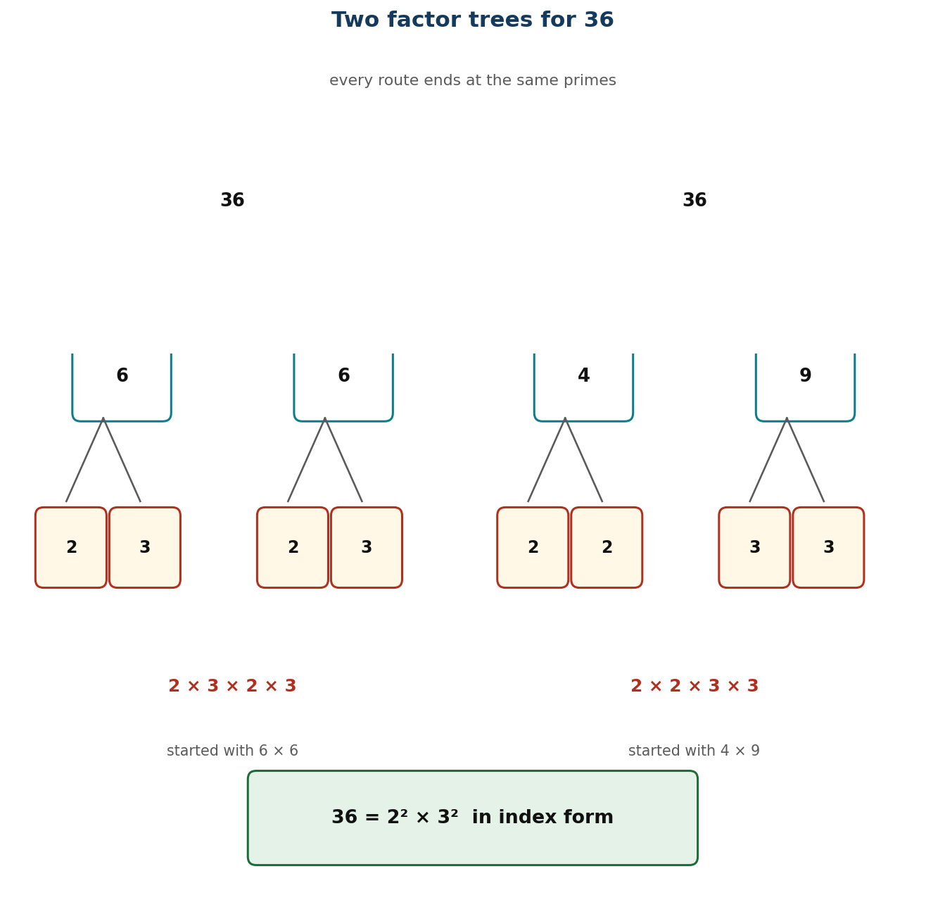
Figure 1.7 Two factor trees for 36, both ending at 2² × 3².
Differentiation
Support — numbers under 50, with a factor-tree template already drawn and the first ten primes on the desk.
Core — as described, numbers up to 144.
Extension — explain in writing why two different starting splits always end at the same primes, and find the smallest number with exactly six factors.

Assessment and success criteria
Observation with checklist C7.13. Exit ticket marked on: all factors prime; indices correct; product checks back to the original. Learners who stop before reaching primes need the ‘can you break it further?’ question repeated, not the method retaught.
Homework / project
Write each of 50, 75, 96 and 200 as a product of powers of primes, and check each by multiplying back.
Cross-curricular links and values
ICT — prime factorisation underpins encryption. Science — decomposition into elements. Values — persistence: you keep going until you cannot go further.
Teacher reflection (complete after the lesson)
What worked well: ______________________________________________________________________________
Who did not meet the success criteria, and what I will do next lesson: ______________________________________________________________________________
What I will change when I teach this again: ______________________________________________________________________________

LESSON 14  Week 7 | The Zero Index  60 minutes (double period)

Strand | Number
Sub-strand | Number Operations
Content standard | B7.1.2.3 — Demonstrate understanding and the use of powers of natural numbers in solving problems.
Indicator(s) | B7.1.2.3.3 — Show that the value of any natural number with zero as its exponent or index is 1 and use it to solve problems.
Performance indicator  (what learners can do) | Learners show that any natural number raised to the power zero equals 1, and use this to solve problems.
Core competencies | Critical Thinking and Problem Solving (CP).
Key vocabulary | zero index, exponent, power, pattern, divide by the base, consistent, convention
Prior knowledge | Lessons 12–13: base, index, products of powers, and dividing by powers of ten (Lesson 6).
Resources / TLM | Mini whiteboards; a large descending-powers chart on the board; calculators (only to confirm, never to discover); Figure 1.8 enlarged.

Learning objectives — by the end of this lesson every learner will be able to:
- K — state that a⁰ = 1 for any natural number a, and justify it from the division pattern rather than from memory.
- S — evaluate expressions containing a zero index, including with numbers and with letters-free products of powers.
- A/V — value a result that is justified by a pattern rather than accepted on authority.

Phase / time | Teacher activity | Learner activity
ENGAGE  8 min | Write the descending pattern on the board: 3⁴ = 81, 3³ = 27, 3² = 9, 3¹ = 3. Ask: ‘What is happening each time you go down a row?’ Establish: divide by 3. ‘So what comes next?’ Let them reach 3⁰ before telling them anything. | Learners continue the pattern and arrive at 3⁰ = 1 themselves. They have discovered the result before it is named.
EXPLORE  16 min | Task: do the same descending pattern starting from 2⁵ and from 5⁴. Write what you get at the zero row for each. Then try 10³, 10², 10¹, 10⁰. Circulate and ask ‘is your zero row always the same number?’ Then ask: ‘why do you think that is?’ | Groups build three patterns and find 1 every time. The repetition across different bases is what makes the generalisation credible.
EXPLAIN  14 min | Formalise with Figure 1.8: each step down divides by the base, so the step from a¹ = a to a⁰ must be a ÷ a = 1. Therefore a⁰ = 1 for every natural number a. Stress that this is not a definition someone chose — it is forced by the pattern; if we defined it any other way, the pattern would break. Then apply it: 2³ × 3² × 5⁰ = 8 × 9 × 1 = 72. Warn against the two usual errors: thinking a⁰ = 0, and thinking a⁰ = a. | Learners write the justification in their own words and evaluate six expressions containing zero indices, including one where the zero index is on the largest base.
ELABORATE  12 min | ‘Spot the impostor’: eight statements about zero indices, learners sort true from false and correct the false ones (4⁰ = 4; 0⁰ = 0; 7⁰ = 1; x⁰ = 0). Then mixed evaluation: 2⁴ × 5⁰, 3² × 2³ × 7⁰. Extension: ask whether 0⁰ should be 1 by the same argument, and why mathematicians leave it undefined. | Learners sort and correct. The impostor task directly targets the two named misconceptions.
EVALUATE  10 min | Exit ticket: evaluate 6⁰, 2³ × 5⁰ and 9⁰ × 4², and explain in one sentence why 5⁰ = 1. Collect and sort. Preview Lesson 15: ‘Tomorrow we put every index law together.’ | Learners complete the ticket alone and tick: I can evaluate a zero index / I can explain why / I have not confused it with zero.

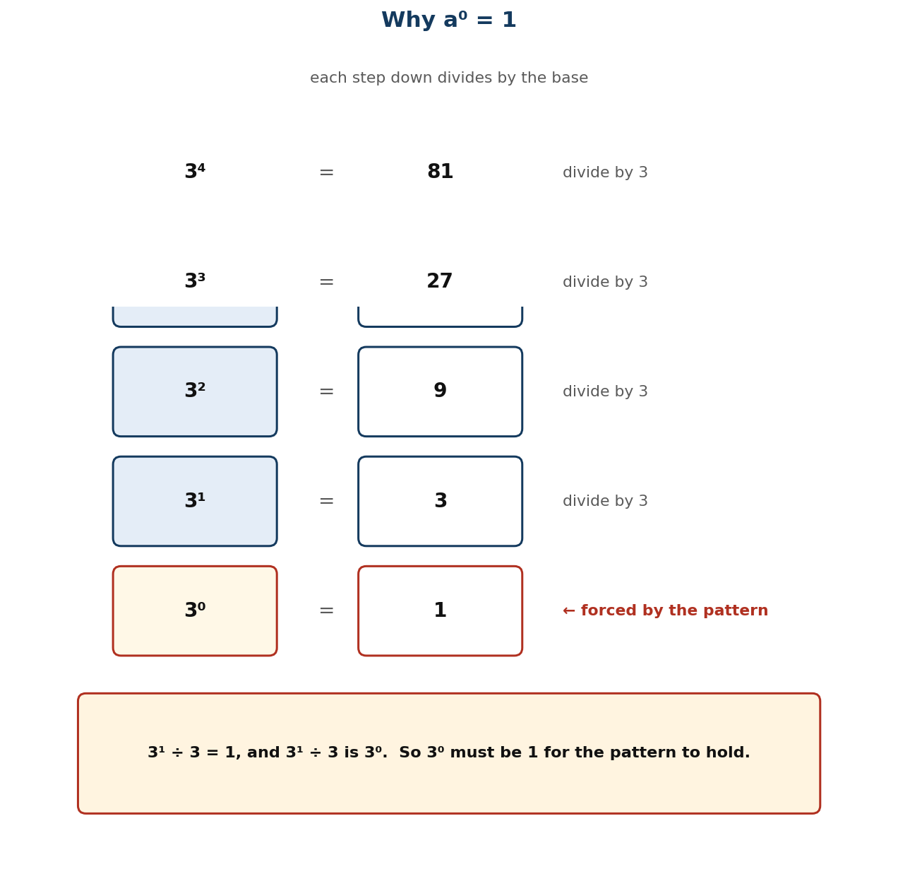
Figure 1.8 Dividing by the base each step down forces a⁰ = 1.
Differentiation
Support — stay with the descending pattern and one base (2), evaluating only; skip the symbolic generalisation.
Core — as described, with three bases and mixed evaluation.
Extension — extend the pattern below zero to negative indices (3⁻¹ = ⅓) and explain why the same argument forces that too.

Assessment and success criteria
Observation with checklist C7.14. Exit ticket marked on correct evaluation AND a justification that references dividing by the base. A learner who writes 1 from memory but cannot say why has not met the standard.
Homework / project
Evaluate ten expressions with zero indices, and write one paragraph explaining the result to a friend who missed the lesson.
Cross-curricular links and values
Science — patterns and extrapolation are how scientific laws are found. English — explaining a mathematical reason in prose. Values — demand reasons, not just rules.
Teacher reflection (complete after the lesson)
What worked well: ______________________________________________________________________________
Who did not meet the success criteria, and what I will do next lesson: ______________________________________________________________________________
What I will change when I teach this again: ______________________________________________________________________________

LESSON 15  Week 8 | Evaluating Numbers in Index Form  60 minutes (double period)

Strand | Number
Sub-strand | Number Operations
Content standard | B7.1.2.3 — Demonstrate understanding and the use of powers of natural numbers in solving problems.
Indicator(s) | B7.1.2.3.4 — Find the value of a number written in index form.
Performance indicator  (what learners can do) | Learners find the value of a number written in index form, including products of powers and zero indices.
Core competencies | Creativity and Innovation (CI); Critical Thinking and Problem Solving (CP).
Key vocabulary | index form, evaluate, base, index, exponent, product of powers, order of operations, square, cube
Prior knowledge | Lessons 12–14: base and index, products of powers, zero index. Tables fluency is assumed and is the usual limiting factor.
Resources / TLM | Mini whiteboards; a tables chart for anyone who needs it; a set of index cards for the relay; calculators for checking only.

Learning objectives — by the end of this lesson every learner will be able to:
- K — read and interpret index notation including squared, cubed and higher powers, and products of powers.
- S — evaluate expressions in index form accurately, applying the correct order of operations.
- A/V — check answers by estimating the size of the result before calculating.

Phase / time | Teacher activity | Learner activity
ENGAGE  8 min | Two-minute tables blast on whiteboards — squares up to 12² and cubes up to 5³. Then: ‘Which is bigger, 2⁵ or 5²?’ Most will guess 5². Work both: 32 against 25. Say: ‘The little number is not a multiplier — it is a counter. Today you get fast and accurate at reading it.’ | Learners complete the blast and check their own, then evaluate both numbers and react to the result.
EXPLORE  16 min | Give each group eight index cards — 2⁵, 3³, 4², 10³, 5², 2³ × 3², 7⁰, 6² × 2⁰. Task: sort them into order of size, and write the value of each. Insist on an estimate before a calculation. Circulate and check whether anyone is doing base × index. | Groups estimate, evaluate and order. The mixed cards with zero indices reveal who is applying Lesson 14.
EXPLAIN  14 min | Take the order and confirm the values. Teach the routine explicitly: (i) read the base; (ii) read the index and say what it means — how many times the base is a factor; (iii) write it out in expanded form if you are unsure; (iv) multiply; (v) check the size is about right. Work 2³ × 3² = 8 × 9 = 72 slowly, showing that the two powers are evaluated first and then multiplied — the order of operations. | Learners write the five-step routine and apply it to three expressions in full, with expanded form shown.
ELABORATE  12 min | Index relay: teams evaluate a card, run it to the board, and peg it in the right place on a number line. Then ‘make the target’: given the target 144, find as many index expressions as you can that equal it (12², 2⁴ × 3²…). Extension: compare 3⁴ and 4³ and generalise when the bigger base wins. | Teams race and peg. The ‘make the target’ task is open-ended and produces genuine mathematical discussion.
EVALUATE  10 min | Exit ticket: evaluate 5³, 2⁴ × 3 and 4² × 5⁰. Collect and sort. Preview Lesson 16: ‘Tomorrow we use powers of primes to find the highest common factor.’ | Learners complete the ticket alone and tick: I read the index correctly / I evaluated each power / I multiplied in the right order.

Differentiation
Support — single powers only, indices 2 and 3, with the tables chart visible and expanded form mandatory.
Core — as described, including products of powers and zero indices.
Extension — evaluate 2³ × 2² by two routes and state the index law it suggests.

Assessment and success criteria
Observation with checklist C7.15. Exit ticket marked on correct evaluation. The diagnostic question throughout is whether any learner computes base × index — if so, return to bottle tops from Lesson 12 before going further.
Homework / project
Twenty evaluations in index form, including six products of powers and three with a zero index.
Cross-curricular links and values
Science — scientific notation and very large or small measurements. ICT — powers of 2 in computing. Values — accuracy under pressure comes from a routine, not from rushing.
Teacher reflection (complete after the lesson)
What worked well: ______________________________________________________________________________
Who did not meet the success criteria, and what I will do next lesson: ______________________________________________________________________________
What I will change when I teach this again: ______________________________________________________________________________

LESSON 16  Week 8 | Prime Factors and the Highest Common Factor  60 minutes (double period)

Strand | Number
Sub-strand | Number Operations
Content standard | B7.1.2.3 — Demonstrate understanding and the use of powers of natural numbers in solving problems.
Indicator(s) | B7.1.2.3.5 — Apply the concept of powers of numbers (product of prime) to find Highest Common Factor (HCF).
Performance indicator  (what learners can do) | Learners use prime factorisation to find the Highest Common Factor of two or more numbers.
Core competencies | Critical Thinking and Problem Solving (CP).
Key vocabulary | prime factor, prime factorisation, highest common factor, HCF, common factor, product of primes, index form, Venn
Prior knowledge | Lessons 13 and 15: prime factorisation and evaluating index form. Learners have found HCF by listing factors since Basic 6.
Resources / TLM | Factor-tree templates from Lesson 13; two interlocking hoops or a printed Venn diagram; Figure 1.9 enlarged; mini whiteboards; a wall chart of primes to 50.

Learning objectives — by the end of this lesson every learner will be able to:
- K — define the highest common factor and explain why it is found by taking the smallest power of each COMMON prime.
- S — find the HCF of two or three numbers using prime factorisation in index form.
- A/V — appreciate that the structured method beats listing, especially as numbers get larger.

Phase / time | Teacher activity | Learner activity
ENGAGE  8 min | Ask: ‘You have 24 oranges and 36 apples. You want identical fruit baskets with nothing left over. What is the largest number of baskets you can make?’ Let pairs try it. Most will guess-and-check. Say: ‘Today you learn a method that works even when the numbers are far too big to guess.’ | Pairs work on the fruit-basket problem and report. They will find 12 by trial, which sets up the need for a reliable method.
EXPLORE  16 min | Task: write 24 and 36 each as a product of powers of primes. Now look at the two answers side by side. Which primes appear in BOTH? What is the smallest power of each that appears in both? Circulate and ask ‘why the smallest, not the largest?’ Do NOT give the method. | Groups produce 24 = 2³ × 3 and 36 = 2² × 3², and identify 2² and 3 as the shared minimum. The reasoning is theirs before it is named.
EXPLAIN  14 min | Formalise with Figure 1.9: to find the HCF, take each prime that appears in BOTH factorisations, raised to the SMALLEST power with which it appears. So HCF(24, 36) = 2² × 3 = 12. Explain the logic: the common factor cannot use more of any prime than the smaller supply allows. Then check: 12 divides both 24 and 36, and nothing bigger does. Contrast with the largest power, which gives the lowest common multiple — name it but do not teach it now. | Learners write the rule and apply it to two pairs, checking each answer by division.
ELABORATE  12 min | Venn diagrams: pairs put the prime factors of two numbers into two hoops, with the intersection giving the HCF directly. Then the context: tile a 240 cm by 360 cm floor with identical square tiles — what is the largest tile? Extension: find the HCF of three numbers, and explain why the method still works. | Pairs use the hoops and then solve the tiling problem, which is the most concrete application of HCF there is.
EVALUATE  10 min | Exit ticket: find the HCF of 60 and 84 by prime factorisation, and check it by division. Collect and sort. Preview Lesson 17: ‘Tomorrow we leave whole numbers for a while and start fractions.’ | Learners complete the ticket alone and tick: I factorised correctly / I chose the smallest powers / I checked by division.

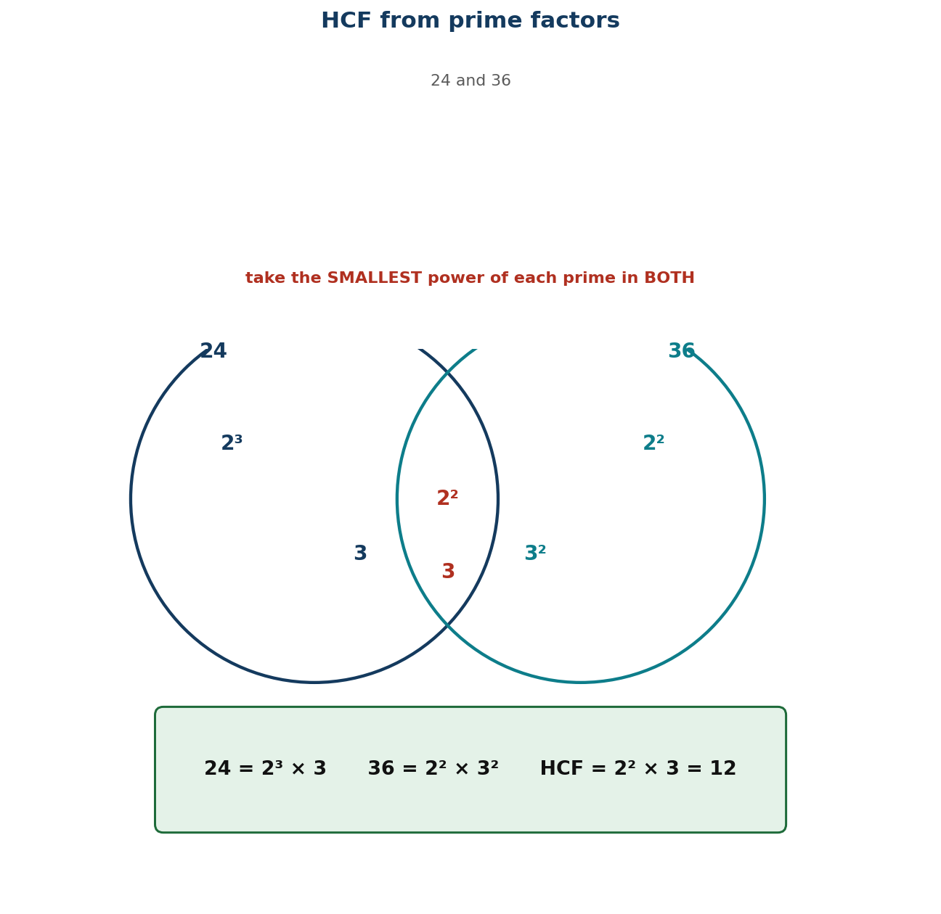
Figure 1.9 HCF from prime factors: the smallest power of each common prime.
Differentiation
Support — numbers under 50 with factor trees already drawn; find the HCF by listing common factors first so the answer is known before the method is taught.
Core — as described, numbers up to 200, two numbers.
Extension — three numbers, and an explanation in writing of why taking the LARGEST power would give the lowest common multiple instead.

Assessment and success criteria
Observation with checklist C7.16. Exit ticket marked on: correct prime factorisation; smallest powers selected; check by division. The commonest error — taking the largest power — is named and contrasted in the lesson.
Homework / project
Find the HCF of five pairs using prime factors, and check each by division. Then write the tiling problem from the lesson with your own numbers.
Cross-curricular links and values
Design and Technology — tiling and cutting materials without waste. Business — sharing goods into equal lots. Values — fairness: equal shares for everyone.
Teacher reflection (complete after the lesson)
What worked well: ______________________________________________________________________________
Who did not meet the success criteria, and what I will do next lesson: ______________________________________________________________________________
What I will change when I teach this again: ______________________________________________________________________________

UNIT 4 — NUMBER: FRACTIONS
Weeks 9–12 • Lessons 17–24

Eight lessons, and the hardest content of the term. Fractions fail in Basic 7 for two reasons: learners add denominators, and learners believe multiplication always makes things bigger. Both are addressed head-on with area models and paper strips, and both are named out loud as wrong before the right method is taught. The last two lessons add the judgement that examination questions actually test — what to do with a remainder that is a fraction.
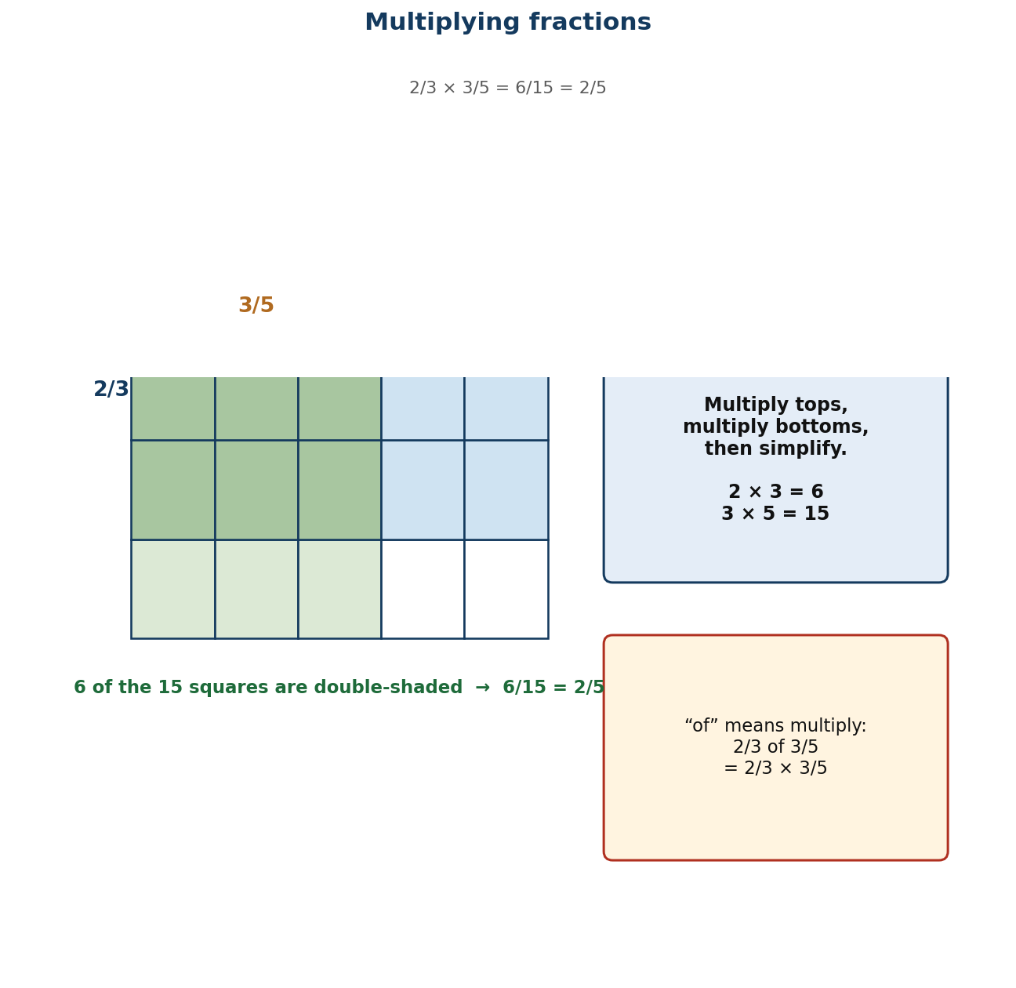
Figure 1.12 The area model: multiplying fractions means taking a part of a part.
Unit objectives
- Learners recall the decimal and percentage equivalents of benchmark fractions and use them to compare quantities.
- Learners compare and order common, decimal and percentage fractions, limited to the benchmarks, by converting them all to the same form.
- Learners explain and carry out addition and subtraction of two or three unlike and mixed fractions.
- Learners solve word problems involving the addition and subtraction of fractions.
- Learners explain and carry out multiplication of a fraction by a whole number and by another fraction.
Assessed unit product
A completed benchmark chart that learners keep and use for the rest of the year, and a fraction-of-a-quantity investigation set in the learners' own community.
LESSON 17  Week 9 | Benchmark Fractions, Decimals and Percentages  60 minutes (double period)

Strand | Number
Sub-strand | Fractions
Content standard | B7.1.3.1 — Simplify, compare and order a mixture of positive fractions (i.e. common, percent and decimal) by changing all to equivalent (i) fractions, (ii) decimals, or (iii) percentages.
Indicator(s) | B7.1.3.1.1 — Determine and recall the percentages and decimals of given benchmark fractions (i.e. tenths, fifths, fourths, thirds and halves) and use these to compare quantities.
Performance indicator  (what learners can do) | Learners recall the decimal and percentage equivalents of benchmark fractions and use them to compare quantities.
Core competencies | Critical Thinking and Problem Solving (CP); Creativity and Innovation (CI).
Key vocabulary | benchmark fraction, equivalent, common fraction, decimal fraction, percentage, tenth, fifth, quarter, third, half, convert
Prior knowledge | Rounding decimals (Lesson 4) and percentages from Basic 6. Learners usually know ½ = 0.5 = 50% but not the thirds.
Resources / TLM | Fraction walls; strips of paper folded into halves, thirds, quarters, fifths and tenths; a large benchmark chart for the wall; Figure 1.10 enlarged; scissors and glue.

Learning objectives — by the end of this lesson every learner will be able to:
- K — recall the decimal and percentage equivalents of halves, thirds, quarters, fifths and tenths.
- S — convert between common fractions, decimals and percentages for benchmark values, and use them to compare quantities.
- A/V — appreciate that three notations describe the same quantity, and choose the one that suits the situation.

Phase / time | Teacher activity | Learner activity
ENGAGE  8 min | Ask: ‘Which is bigger, ⅔ or 0.7?’ Let them vote. Then: ‘Which is bigger, ⅔ or 70%?’ Watch the votes change even though it is the same question. Say: ‘That is why we need one notation we can all picture. Today you build the benchmark chart you will keep all term.’ | Learners vote twice and notice their own inconsistency. They begin the benchmark chart in their books.
EXPLORE  16 min | Give each group five paper strips of equal length. Task: fold one into halves, one into thirds, one into quarters, one into fifths and one into tenths. Label each fold with the fraction, then work out the decimal and the percentage for that fraction. Circulate and ask ‘how would you get the percentage from the decimal?’ | Groups fold, label and convert. Thirds produce 0.333…, which raises the recurring decimal question naturally.
EXPLAIN  14 min | Build the class chart with Figure 1.10: ½ = 0.5 = 50%; ⅓ = 0.333… = 33⅓%; ¼ = 0.25 = 25%; ⅕ = 0.2 = 20%; 1/10 = 0.1 = 10%. Teach the conversions: fraction → decimal by dividing top by bottom; decimal → percentage by multiplying by 100; percentage → fraction by putting it over 100 and simplifying. Insist that thirds are written 33⅓% and never 33%, because 33% is 33/100, not a third. | Learners complete the chart and then drill it in pairs — one says a fraction, the other gives the decimal and the percentage.
ELABORATE  12 min | Give pairs mixed sets — ⅔, 0.8, 65%, ⅓, 0.4 — and ask them to sort into order, converting everything to percentages first. Then a real comparison: is a 30% discount better than a third off? Extension: find a fraction that is exactly halfway between ⅓ and ½. | Pairs sort and explain their conversion choice. The discount question shows why the skill matters outside school.
EVALUATE  10 min | Exit ticket: fill in a four-column table (fraction, decimal, percentage) for ⅓, ⅔, 1/5 and 7/10. Collect and sort. Preview Lesson 18: ‘Tomorrow we compare and order any fractions, not just the benchmarks.’ | Learners complete the ticket alone and tick: I know the benchmarks / I can convert / I can compare across notations.

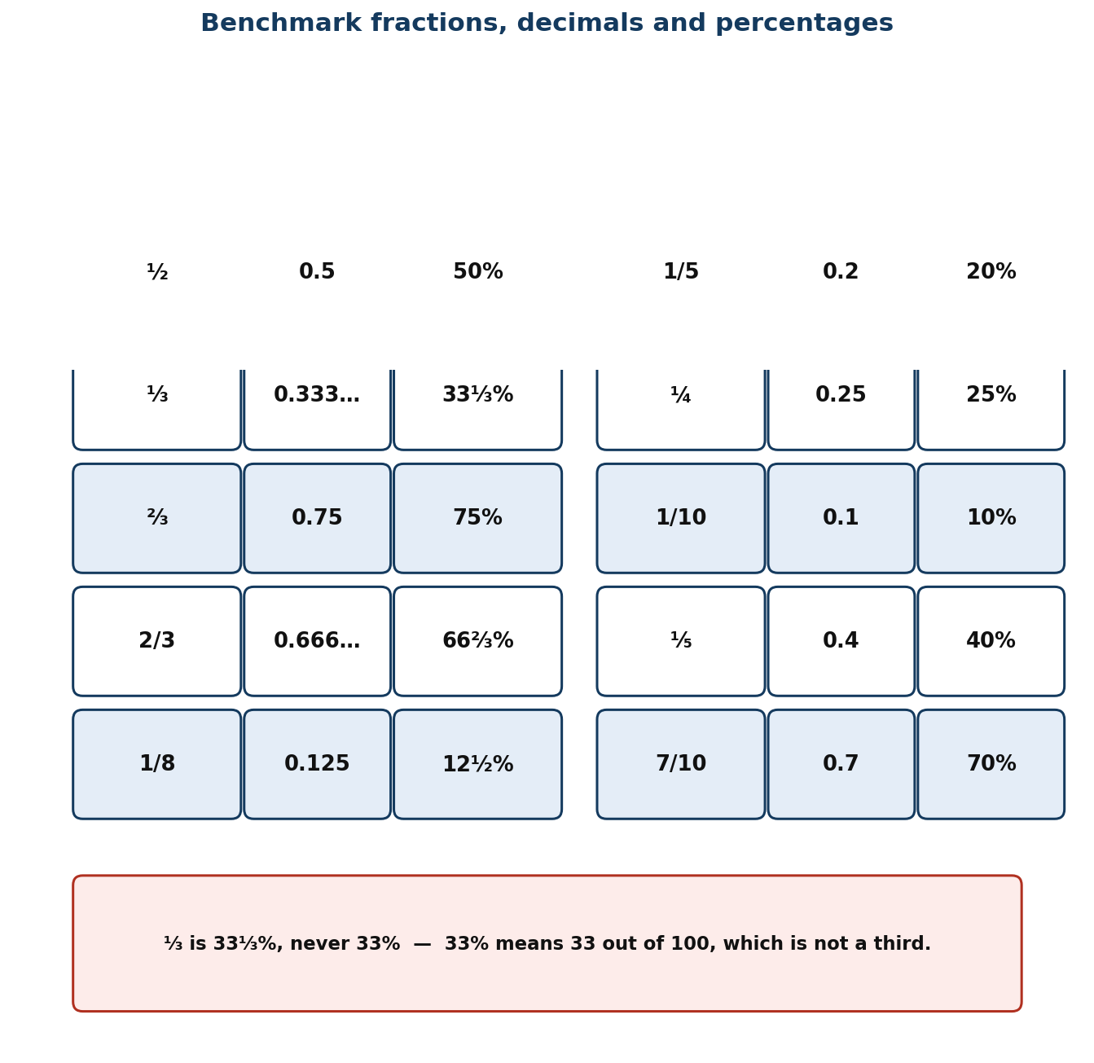
Figure 1.10 Benchmark fractions with their decimal and percentage equivalents.
Differentiation
Support — halves, quarters and tenths only, with the folded strips always available; leave thirds until last.
Core — as described, including thirds and fifths.
Extension — explain why ⅓ cannot be written as an exact decimal, and what that means for money calculations involving thirds.

Assessment and success criteria
Observation with checklist C7.17. Exit ticket marked on accurate conversion. The 33% for ⅓ error is anticipated and corrected explicitly in the lesson; check for it specifically when marking.
Homework / project
Complete a benchmark chart for halves, thirds, quarters, fifths, eighths and tenths, and learn it — you will use it every lesson for the rest of term.
Cross-curricular links and values
Business — discounts, interest and shares. Home Economics — recipe quantities. Values — clarity: three notations, one meaning.
Teacher reflection (complete after the lesson)
What worked well: ______________________________________________________________________________
Who did not meet the success criteria, and what I will do next lesson: ______________________________________________________________________________
What I will change when I teach this again: ______________________________________________________________________________

LESSON 18  Week 9 | Comparing and Ordering Fractions  60 minutes (double period)

Strand | Number
Sub-strand | Fractions
Content standard | B7.1.3.1 — Simplify, compare and order a mixture of positive fractions (i.e. common, percent and decimal) by changing all to equivalent (i) fractions, (ii) decimals, or (iii) percentages.
Indicator(s) | B7.1.3.1.2 — Compare and order fractions (i.e. common, percent and decimal fractions up to thousandths) limit to the benchmark fractions.
Performance indicator  (what learners can do) | Learners compare and order common, decimal and percentage fractions, limited to the benchmarks, by converting them all to the same form.
Core competencies | Communication and Collaboration (CC); Critical Thinking and Problem Solving (CP).
Key vocabulary | compare, order, ascending, descending, common denominator, equivalent, benchmark, convert, thousandth
Prior knowledge | Lesson 17 benchmark conversions. Learners have compared fractions with the same denominator since Basic 5 and often over-generalise ‘bigger denominator means bigger fraction’.
Resources / TLM | Fraction walls and folded strips from Lesson 17; mini whiteboards; number lines marked in tenths; Figure 1.10 from Lesson 17 for reference.

Learning objectives — by the end of this lesson every learner will be able to:
- K — state that fractions can only be compared when they are written in the same form, and name two ways to achieve that.
- S — order a mixed set of common fractions, decimals and percentages up to thousandths.
- A/V — choose the most efficient common form for a given set rather than defaulting to one method.

Phase / time | Teacher activity | Learner activity
ENGAGE  8 min | Ask: ‘Which is bigger, 1/3 or 1/4?’ Everyone gets that. Then: ‘Which is bigger, 3/8 or 2/5?’ Hands hesitate. Then: ‘Which is bigger, 1/8 or 1/5?’ — and note that the smaller denominator wins here, contradicting the rule many learners carry from whole numbers. Say: ‘Today you build one reliable method that never fails.’ | Learners answer the first confidently and struggle with the second. The contradiction in the third question exposes the fragile rule.
EXPLORE  16 min | Give each group the set ⅔, 0.6, 2/3, 55%, 0.62. Task: put them in order and be ready to explain how you did it. Circulate and note the strategies — converting to decimals, to percentages, or drawing bars. Do NOT correct or rank the strategies yet. | Groups order the set by whatever means they choose. The variety is the material for the next phase.
EXPLAIN  14 min | Harvest and compare the strategies. Teach: you may only compare like with like, so put everything into one form. Percentages are usually fastest because they are out of 100 and easy to picture; decimals are fastest if you already have decimals; a common denominator works but is slower. Work the example to percentages: ⅔ = 75%, 0.6 = 60%, 2/3 = 66⅓%, 55%, 0.62 = 62%. Order: 55% < 0.6 < 0.62 < 2/3 < ⅔. Then show the common denominator route on one pair to prove it agrees. | Learners reorder the set using percentages and check against their original answer. They write the ‘like with like’ rule at the top of the page.
ELABORATE  12 min | Ordering relay: three sets, increasing difficulty, teams convert and peg in order on a number line. Then ‘find the missing one’: give four ordered values and ask for a fifth that fits between the second and third. Extension: put a set in order where two are exactly equal and must be identified as such. | Teams race and peg. The ‘find the missing one’ task requires genuine understanding of the order, not just a procedure.
EVALUATE  10 min | Exit ticket: order 0.45, ½, 47%, 2/5 and 0.5 from smallest to largest. Collect and sort. Preview Lesson 19: ‘Tomorrow we start adding and subtracting fractions with different denominators.’ | Learners complete the ticket alone and tick: I converted to one form / I ordered correctly / I spotted any equal values.

Differentiation
Support — fractions and decimals only, always with the fraction wall, and converting everything to decimals.
Core — as described, mixed notations up to thousandths.
Extension — order a set that includes a fraction whose decimal recurs, and explain how much precision is needed to place it correctly.

Assessment and success criteria
Observation with checklist C7.18. Exit ticket marked on correct conversion and correct order. The key diagnostic is whether the learner converts before comparing — if they compare numerators across different denominators, that is the target for reteaching.
Homework / project
Order five mixed sets at home, and write one sentence for each saying which common form you chose and why.
Cross-curricular links and values
Science — comparing measurements given in different units. Business — comparing discounts. Values — fairness in comparison requires a common measure.
Teacher reflection (complete after the lesson)
What worked well: ______________________________________________________________________________
Who did not meet the success criteria, and what I will do next lesson: ______________________________________________________________________________
What I will change when I teach this again: ______________________________________________________________________________

LESSON 19  Week 10 | Adding and Subtracting Unlike and Mixed Fractions  60 minutes (double period)

Strand | Number
Sub-strand | Fractions
Content standard | B7.1.3.2 — Demonstrate an understanding of the process of addition and/or subtraction of fractions and apply this in solving problems.
Indicator(s) | B7.1.3.2.1 — Explain the process of addition and subtraction of two or three unlike and mixed fractions.
Performance indicator  (what learners can do) | Learners explain and carry out addition and subtraction of two or three unlike and mixed fractions.
Core competencies | Critical Thinking and Problem Solving (CP); Communication and Collaboration (CC).
Key vocabulary | unlike fraction, mixed number, improper fraction, common denominator, lowest common multiple, equivalent, simplify, rename
Prior knowledge | Lessons 17–18 equivalent fractions and ordering. Learners have added like fractions since Basic 5 and often add denominators as well as numerators.
Resources / TLM | Fraction strips and circles; squared paper for area models; Figure 1.11 enlarged; mini whiteboards; a chart of the first ten multiples.

Learning objectives — by the end of this lesson every learner will be able to:
- K — explain why fractions must share a denominator before they can be added, and state how to convert a mixed number to an improper fraction.
- S — add and subtract two or three unlike and mixed fractions, simplifying the result.
- A/V — value the estimation check: is the answer roughly the size it should be?

Phase / time | Teacher activity | Learner activity
ENGAGE  8 min | Write ½ + ¼ on the board and ask for the answer. Collect ⅔ and also the classic error 2/6. Then hold up half a paper circle and a quarter circle and push them together: ‘Look. It is three quarters. Whatever 2/6 is, it is not this.’ Say: ‘Today you will be able to say why the wrong answer is wrong.’ | Learners offer both answers and see the model contradict one of them. The visual settles the argument before any rule is stated.
EXPLORE  16 min | Task with fraction strips: show ½ + 1/3. Find a way to describe both pieces using the same size of small piece. Groups will find sixths. Then: show 2¼ − 1⅔ with the strips. Circulate and ask ‘what size of small piece fits both?’ Do NOT name the lowest common multiple yet. | Groups manipulate strips and discover sixths for the first and twelfths (or quarters) for the second. They have found the common denominator physically.
EXPLAIN  14 min | Formalise with Figure 1.11: fractions can only be added when they are cut into pieces of the same size, so find a common denominator — ideally the lowest common multiple of the denominators. Work ½ + 1/3 = 3/6 + 2/6 = 5/6. Then mixed numbers, teaching both routes explicitly: (i) subtract the whole numbers and then the fractions, borrowing if needed; (ii) convert both to improper fractions first. Work 2⅔ − 1½ both ways and compare. Stress the estimate: 2⅔ − 1½ is about 3 − 2 = 1. | Learners write both methods for mixed numbers and solve one example each way, checking that the answers agree.
ELABORATE  12 min | Pairs solve six problems, three addition and three subtraction, mixed numbers included, with an estimate written first. Then ‘diagnose the error’: three worked solutions containing the classic mistakes (adding denominators, forgetting to convert the whole number when borrowing, not simplifying). Extension: add three unlike fractions. | Pairs solve and estimate, then hunt errors. Naming the classic mistakes out loud is the most effective defence against them.
EVALUATE  10 min | Exit ticket: 2/3 + 3/4 and 3⅔ − 1½, each with an estimate. Collect and sort. Preview Lesson 20: ‘Tomorrow we use this on real problems.’ | Learners complete the ticket alone and tick: I found a common denominator / I simplified / my answer matches my estimate.

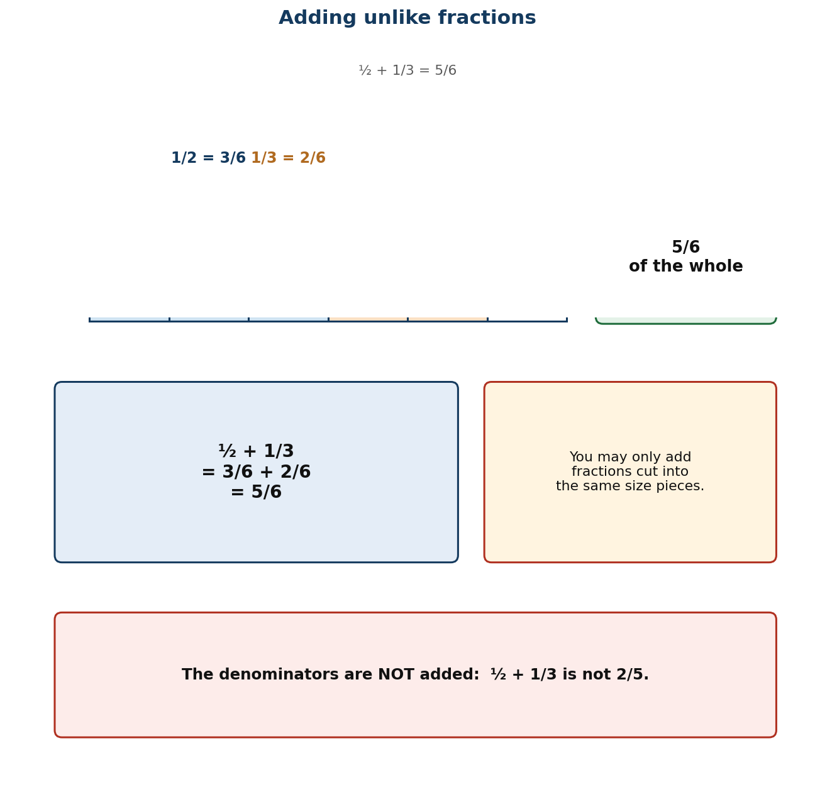
Figure 1.11 Adding unlike fractions: rename in a common denominator first.
Differentiation
Support — unlike proper fractions only, with strips always available and denominators limited to 2, 3, 4, 6, 8, 12; leave mixed numbers to a second session.
Core — as described, including mixed numbers and three fractions.
Extension — explain in writing why the denominators are not added, using the area model as evidence.

Assessment and success criteria
Observation with checklist C7.19. Exit ticket marked on: common denominator found; numerators handled correctly; answer simplified; estimate present. Adding denominators is the misconception named and treated in the lesson.
Homework / project
Eight additions and eight subtractions of unlike and mixed fractions, each with an estimate written first.
Cross-curricular links and values
Home Economics — recipes use mixed quantities constantly. Carpentry — measurements in fractions of an inch. Values — care with small pieces prevents big waste.
Teacher reflection (complete after the lesson)
What worked well: ______________________________________________________________________________
Who did not meet the success criteria, and what I will do next lesson: ______________________________________________________________________________
What I will change when I teach this again: ______________________________________________________________________________

LESSON 20  Week 10 | Solving Problems with Fraction Addition and Subtraction  60 minutes (double period)

Strand | Number
Sub-strand | Fractions
Content standard | B7.1.3.2 — Demonstrate an understanding of the process of addition and/or subtraction of fractions and apply this in solving problems.
Indicator(s) | B7.1.3.2.2 — Solve problems involving addition or subtraction of fractions.
Performance indicator  (what learners can do) | Learners solve word problems involving the addition and subtraction of fractions.
Core competencies | Critical Thinking and Problem Solving (CP); Digital Literacy (DL).
Key vocabulary | word problem, operation, remaining, altogether, difference, estimate, check, unit
Prior knowledge | Lesson 19 adding and subtracting unlike and mixed fractions. Learners have solved one-step fraction problems since Basic 6.
Resources / TLM | Problem cards set in Ghanaian contexts (recipes, cloth, farmland, water tanks, feeding programmes); blank cards for learners to write their own; mini whiteboards.

Learning objectives — by the end of this lesson every learner will be able to:
- K — decide whether a word problem calls for addition or subtraction, and justify the choice from the situation.
- S — solve one- and two-step word problems involving fractions, including mixed numbers.
- A/V — check the answer against the situation and state whether it is reasonable.

Phase / time | Teacher activity | Learner activity
ENGAGE  8 min | Read: ‘A tailor has 12½ metres of cloth. She uses 4¾ metres for a dress. How much is left?’ Ask: ‘Before you calculate — roughly how much is left?’ Establish about 7½ metres. Say: ‘Estimating first is not an extra step. It is how you catch the mistakes that matter.’ | Learners estimate before calculating, then compute to check. The estimate makes a wrong answer visible.
EXPLORE  16 min | Give each group four problem cards. Task: for each, write the calculation, the estimate, and one sentence saying why that operation. Circulate and ask ‘what is happening to the quantity in the story — is it being combined or taken away?’ Collect the reasoning sentences, not the answers. | Groups solve and justify. The one-sentence justification forces them to picture the situation before choosing an operation.
EXPLAIN  14 min | Take two cards. Teach the routine: (i) estimate; (ii) say whether the quantities are being combined (add) or one is being removed or compared (subtract); (iii) calculate with a common denominator; (iv) check against the estimate and the story. Work the tailor problem fully: 12½ − 4¾ = 12 2/4 − 4¾; borrow one whole — 11 6/4 − 4¾ = 7¾. Check: 7¾ is close to the estimate of 7½. Then a two-step problem: a tank holds 5/8 full, 1/4 is drawn off, how much remains? | Learners copy the four-step routine and apply it to a second problem with the teacher before working alone.
ELABORATE  12 min | Problem swap: pairs write a problem, swap, solve, and compare reasoning. Where answers differ, the pairs must find out which reading of the problem caused it. Extension: write a problem where the answer must be found by subtracting two mixed numbers that require borrowing twice. | Pairs write, swap, solve and negotiate. The negotiation exposes ambiguous wording, which is itself a mathematical insight.
EVALUATE  10 min | Exit ticket: one two-step fraction word problem with an estimate and a reasoning sentence. Collect and sort. Preview Lesson 21: ‘Tomorrow, multiplying fractions — which is easier than adding them.’ | Learners complete the ticket alone and tick: I estimated / I chose the right operation / my answer is reasonable.

Differentiation
Support — one-step problems with proper fractions and a ‘what is happening?’ picture frame; denominators limited to halves, quarters and eighths.
Core — as described, two-step problems with mixed numbers.
Extension — rewrite a given problem so that it needs the opposite operation, and explain what changed in the wording.

Assessment and success criteria
Observation with checklist C7.20. Exit ticket marked primarily on the estimate and the reasoning sentence, with arithmetic accuracy second. Problems written by learners are assessed with rubric R4.
Homework / project
Write two fraction word problems set at home or in the market, with full solutions and estimates.
Cross-curricular links and values
Home Economics — recipes and dressmaking. Agriculture — land measurement. Values — careful estimating prevents waste in the home and in business.
Teacher reflection (complete after the lesson)
What worked well: ______________________________________________________________________________
Who did not meet the success criteria, and what I will do next lesson: ______________________________________________________________________________
What I will change when I teach this again: ______________________________________________________________________________

LESSON 21  Week 11 | Multiplying Fractions  60 minutes (double period)

Strand | Number
Sub-strand | Fractions
Content standard | B7.1.3.3 — Demonstrate an understanding of the process of multiplying and dividing positive fractions and apply this in solving problems.
Indicator(s) | B7.1.3.3.1 — Explain the process of multiplying a fraction (i.e. common, percent and decimal fractions up to thousandths) by a whole number and by a fraction.
Performance indicator  (what learners can do) | Learners explain and carry out multiplication of a fraction by a whole number and by another fraction.
Core competencies | Critical Thinking and Problem Solving (CP).
Key vocabulary | multiply, numerator, denominator, of, product, simplify, cancel, area model, improper fraction
Prior knowledge | Lesson 19 fraction addition (so they know multiplication is different), and Lesson 10 multi-digit multiplication. Learners usually expect multiplication to make things bigger.
Resources / TLM | Squared paper for area models; coloured pencils; fraction strips; Figure 1.12 enlarged; mini whiteboards.

Learning objectives — by the end of this lesson every learner will be able to:
- K — state the rule for multiplying fractions and explain why ‘of’ means multiply.
- S — multiply a fraction by a whole number and by another fraction, simplifying before or after.
- A/V — accept that multiplying by a fraction makes a quantity smaller, and say when that is the right result.

Phase / time | Teacher activity | Learner activity
ENGAGE  8 min | Ask: ‘Does multiplying always make a number bigger?’ Most will say yes. Then: ‘What is half of 20?’ — 10. ‘And half OF 20 is ½ × 20.’ Show that the answer got smaller. Say: ‘Today, ‘of’ means multiply, and multiplying by a fraction takes a part of something.’ | Learners answer, then see the counter-example. The surprise is worth the two minutes it costs.
EXPLORE  16 min | Area-model task: draw a rectangle 1 by 1. Shade ½ of it. Now shade ½ of the shaded part in a second colour. What fraction of the whole square is double-shaded? Then repeat with 2/3 × 3/5 on a 3-by-5 grid. Circulate and ask ‘how many pieces is the whole cut into now, and how many are double-shaded?’ | Groups draw and shade. They count 1 out of 4 for the first and 6 out of 15 for the second, discovering the rule from the picture.
EXPLAIN  14 min | Formalise with Figure 1.12: multiply the numerators, multiply the denominators, then simplify. So ½ × ½ = ¼ and 2/3 × 3/5 = 6/15 = 2/5. Then the whole-number case: 2/3 × 5 = 2/3 × 5/1 = 10/3 = 3⅓. Teach cancelling BEFORE multiplying as the efficient route — 3/8 × 4/9: cancel 3 and 9, and 4 and 8, leaving 1/6. Insist that ‘of’ and ‘×’ are the same instruction. | Learners write the rule, then do four multiplications twice — once multiplying first then simplifying, and once cancelling first — to see which is easier.
ELABORATE  12 min | Pairs do eight multiplications, choosing their own route. Then the context: a farmer has ¾ of a hectare and plants maize on 2/3 of it — how much is planted? Extension: explain why cancelling before multiplying gives the same answer, using the area model. | Pairs calculate and then solve the farm problem, checking against a sketch of the land.
EVALUATE  10 min | Exit ticket: 3/8 × 4/9 and 2/3 × 7, both simplified. Collect and sort. Preview Lesson 22: ‘Tomorrow, finding a fraction of an amount of money or objects.’ | Learners complete the ticket alone and tick: I multiplied numerators / I multiplied denominators / I simplified.

Figure 1.12 The area model: multiplying fractions means taking a part of a part.
Differentiation
Support — fraction by whole number only, with the area model every time; leave fraction-by-fraction until the whole-number case is fluent.
Core — as described, including cancelling before multiplying.
Extension — justify the rule with the area model in writing, and show why cross-cancelling works.

Assessment and success criteria
Observation with checklist C7.21. Exit ticket marked on correct products and simplification. The key diagnostic is whether any learner is finding a common denominator — a sure sign they have carried the addition rule across.
Homework / project
Ten fraction multiplications, including four word problems using ‘of’.
Cross-curricular links and values
Agriculture — fractions of farmland. Home Economics — scaling recipes. Values — taking a fair share is the same mathematics as taking a fraction.
Teacher reflection (complete after the lesson)
What worked well: ______________________________________________________________________________
Who did not meet the success criteria, and what I will do next lesson: ______________________________________________________________________________
What I will change when I teach this again: ______________________________________________________________________________

LESSON 22  Week 11 | Finding a Fraction of a Quantity  60 minutes (double period)

Strand | Number
Sub-strand | Fractions
Content standard | B7.1.3.3 — Demonstrate an understanding of the process of multiplying and dividing positive fractions and apply this in solving problems.
Indicator(s) | B7.1.3.3.2 — Find a fraction of given quantity (i.e. money or given quantity of objects).
Performance indicator  (what learners can do) | Learners find a fraction of a given quantity of money or objects.
Core competencies | Critical Thinking and Problem Solving (CP).
Key vocabulary | fraction of, quantity, share, denominator, numerator, unit fraction, divide then multiply, remainder
Prior knowledge | Lesson 21 multiplying fractions, including fraction × whole number. Learners have shared quantities equally since Basic 3.
Resources / TLM | Real or play money (GH₵ notes and coins); counters or beans; bar-model templates; market price cards; mini whiteboards.

Learning objectives — by the end of this lesson every learner will be able to:
- K — state the two-step routine for finding a fraction of a quantity: divide by the denominator, then multiply by the numerator.
- S — find a fraction of an amount of money or of a set of objects, including cases with remainders.
- A/V — use the skill to check whether a stated share is fair.

Phase / time | Teacher activity | Learner activity
ENGAGE  8 min | Put 24 counters on the desk. Ask: ‘Give me ¼ of these.’ Take the answer (6) and then: ‘Now give me 3/4.’ Most will fetch another 6. Ask: ‘How did you know?’ Establish: find ¼ first, then multiply by 3. Say: ‘That is the whole method — divide by the bottom, multiply by the top.’ | Learners hand over the counters and articulate the method themselves before it is named.
EXPLORE  16 min | With money: find 3/5 of GH₵ 240. Give groups notes and coins and let them do it physically — split into five equal piles, then take three. Then: find ⅔ of GH₵ 500 and 2/3 of 45 mangoes. Circulate and ask ‘what did you do first, and why?’ | Groups split the money into piles and count. The physical split makes the denominator meaningful rather than procedural.
EXPLAIN  14 min | Formalise: divide by the denominator to get one part, then multiply by the numerator to get the number of parts you need. Work 3/5 of 240: 240 ÷ 5 = 48, 48 × 3 = 144. Then link it back to Lesson 21: this is the same as 3/5 × 240. Set out the bar model — five boxes, total 240, each box 48, three boxes 144. Then the remainder case: 2/3 of 45 is 30, but 2/3 of 46 is 30⅔ — teach that the share can be fractional even when the objects cannot be cut. | Learners draw bar models for three problems and write the two-step calculation beside each.
ELABORATE  12 min | Market task: pairs receive price cards and must work out discounts — ¼ off, 1/3 off, 10% off — and the final price. Then ‘is it fair?’: three children share GH₵ 60 as ½, 1/3 and the rest — check the shares add up. Extension: find a quantity when given the fraction: if 3/5 of a number is 144, what is the number? | Pairs work the discounts and then audit the shares, which is the most natural use of the skill in daily life.
EVALUATE  10 min | Exit ticket: find 5/8 of GH₵ 320 and 2/3 of 51 books. Collect and sort. Preview Lesson 23: ‘Tomorrow we turn it round and divide by fractions.’ | Learners complete the ticket alone and tick: I divided by the denominator / I multiplied by the numerator / my answer is reasonable.

Differentiation
Support — unit fractions only (½, ¼, 1/3, 1/5) with counters or coins physically shared; move to non-unit fractions when the sharing is fluent.
Core — as described, including money and objects with remainder cases.
Extension — solve reverse problems (find the whole given a fraction of it) using the bar model.

Assessment and success criteria
Observation with checklist C7.22. Exit ticket marked on both steps being shown separately — a learner who writes only the answer cannot be diagnosed. The bar model is the reteaching tool for anyone who reverses the two steps.
Homework / project
Ten ‘fraction of’ questions, five with money and five with objects, each with a bar model.
Cross-curricular links and values
Business — discounts and commissions. Social Studies — sharing resources. Values — fairness: check that shares add up to the whole.
Teacher reflection (complete after the lesson)
What worked well: ______________________________________________________________________________
Who did not meet the success criteria, and what I will do next lesson: ______________________________________________________________________________
What I will change when I teach this again: ______________________________________________________________________________

LESSON 23  Week 12 | Dividing Fractions  60 minutes (double period)

Strand | Number
Sub-strand | Fractions
Content standard | B7.1.3.3 — Demonstrate an understanding of the process of multiplying and dividing positive fractions and apply this in solving problems.
Indicator(s) | B7.1.3.3.3 — Explain the process of dividing a fraction (i.e. common, percent and decimal fractions up to thousandths) by a 1-digit whole number and by a fraction.
Performance indicator  (what learners can do) | Learners explain and carry out division of a fraction by a one-digit whole number and by another fraction.
Core competencies | Critical Thinking and Problem Solving (CP).
Key vocabulary | divide, reciprocal, invert, divisor, dividend, quotient, how many times, numerator, denominator
Prior knowledge | Lessons 21–22 multiplying fractions and finding a fraction of a quantity. Division is the inverse of multiplication and learners know this for whole numbers.
Resources / TLM | Paper strips for the ‘how many groups’ model; fraction strips; Figure 1.13 enlarged; mini whiteboards; calculators for checking only.

Learning objectives — by the end of this lesson every learner will be able to:
- K — state that dividing by a fraction is equivalent to multiplying by its reciprocal, and explain why from the ‘how many times does it fit?’ model.
- S — divide a fraction by a one-digit whole number and by another fraction.
- A/V — check division answers by multiplying back, and accept that dividing can make a quantity bigger.

Phase / time | Teacher activity | Learner activity
ENGAGE  8 min | Hold up a strip of paper one metre long. Ask: ‘How many ¼-metre pieces can I cut from it?’ — four. Write 1 ÷ ¼ = 4. Then: ‘How many ½-metre pieces?’ — two. ‘So dividing by a fraction gives a BIGGER answer. Today we find out why, and turn it into a method you can always use.’ | Learners predict and then see the physical strips confirm the answers. The surprising size of the answer is the hook.
EXPLORE  16 min | With strips, task: 3 ÷ ¼. How many quarters are in three wholes? Count twelve. Then: ½ ÷ ⅔. How much of a quarter fits into a half? Groups will struggle with the second — let them. Ask: ‘is the answer more than one or less than one?’ Circulate and collect approaches. | Groups cut and count. The first is easy; the second forces them to think in terms of ‘how many times does it fit’ rather than sharing.
EXPLAIN  14 min | Formalise with Figure 1.13: a ÷ b/c means ‘how many b/c are in a’, and the answer is a × c/b — multiply by the reciprocal. Justify it: dividing by ¼ is the same as multiplying by 4, because there are four quarters in every whole. Work both examples: 3 ÷ ¼ = 3 × 4/1 = 12; ½ ÷ ⅔ = ½ × 4/3 = 4/6 = 2/3. Then the whole-number divisor: ⅔ ÷ 3 = ⅔ × 1/3 = ⅔⁄₃ = 1/12 — note the answer is smaller here, which is the contrast that catches people out. | Learners write the rule with the justification and do six divisions, checking three by multiplying back.
ELABORATE  12 min | Pairs do eight divisions, mixed between whole-number and fraction divisors, and check each by multiplying back — the check is the point. Then the context: 9½ litres of juice shared into ¼-litre cups — how many cups? Extension: explain why dividing by a fraction can make the answer bigger while dividing by a whole number makes it smaller. | Pairs calculate, check by multiplying back, and solve the juice problem, which is the clearest real use of fraction division.
EVALUATE  10 min | Exit ticket: 5 ÷ ½ and 3/8 ÷ 2, each checked by multiplying back. Collect and sort. Preview Lesson 24: ‘Tomorrow, dividing quantities by fractions — the last lesson of the term.’ | Learners complete the ticket alone and tick: I used the reciprocal / I simplified / my check works.

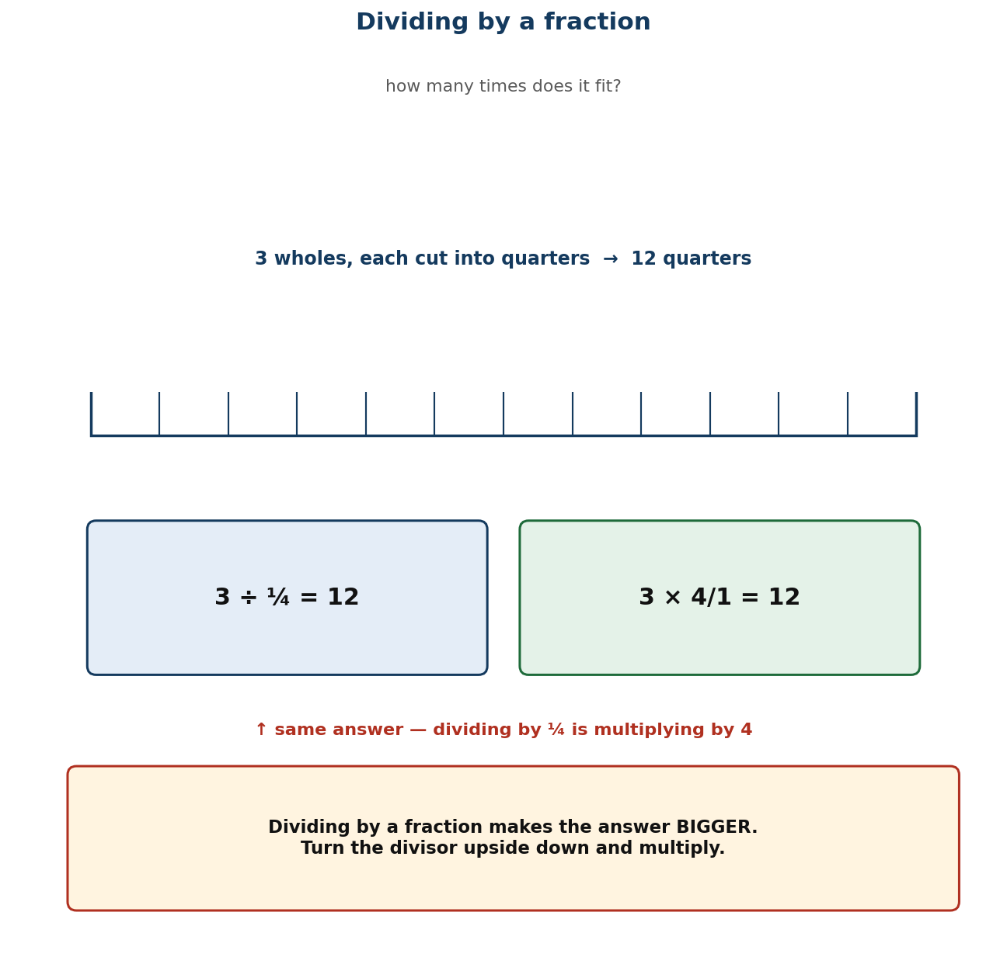
Figure 1.13 Dividing by a fraction: how many times does it fit?
Differentiation
Support — dividing fractions by whole numbers only (the smaller-answer case), with strips; leave fraction divisors to a second session.
Core — as described, both cases, with the multiply-back check.
Extension — justify the reciprocal rule in writing using the identity b/c × c/b = 1.

Assessment and success criteria
Observation with checklist C7.23. Exit ticket marked on correct reciprocal, correct product, and a working check. A learner who inverts the wrong fraction is the specific target — reteach with the ‘how many fit’ question, not the rule.
Homework / project
Ten fraction divisions, each checked by multiplying back. Note which ones give bigger answers and which give smaller.
Cross-curricular links and values
Home Economics — how many portions from a quantity. Carpentry — how many lengths from a board. Values — checking by reversing is honest work.
Teacher reflection (complete after the lesson)
What worked well: ______________________________________________________________________________
Who did not meet the success criteria, and what I will do next lesson: ______________________________________________________________________________
What I will change when I teach this again: ______________________________________________________________________________

LESSON 24  Week 12 | Dividing Quantities and Fractions by Fractions  60 minutes (double period)

Strand | Number
Sub-strand | Fractions
Content standard | B7.1.3.3 — Demonstrate an understanding of the process of multiplying and dividing positive fractions and apply this in solving problems.
Indicator(s) | B7.1.3.3.4 — Determine the result of dividing a quantity (i.e. money or objects) or a fraction by a fraction.
Performance indicator  (what learners can do) | Learners determine the result of dividing a quantity of money or objects, or a fraction, by a fraction.
Core competencies | Critical Thinking and Problem Solving (CP).
Key vocabulary | divide, quantity, reciprocal, quotient, share, portion, unit, context, interpret
Prior knowledge | Lesson 23 dividing fractions. This lesson applies it to quantities with units, where interpreting the answer matters as much as calculating it.
Resources / TLM | Real or play money; counters; measuring jugs or cups for the juice context; bar-model templates; problem cards; mini whiteboards.

Learning objectives — by the end of this lesson every learner will be able to:
- K — state that dividing a quantity by a fraction answers the question ‘how many of this portion are in it?’
- S — divide quantities of money or objects, and fractions, by fractions, and interpret the answer in context.
- A/V — decide what to do with a fractional remainder — round up, round down, or report it as a fraction — and justify the choice.

Phase / time | Teacher activity | Learner activity
ENGAGE  8 min | Read: ‘A set of stacked plates weighs 10 kg. Each plate weighs ¼ kg. How many plates are in the stack?’ Ask: ‘Is this a sharing question or a measuring question?’ Establish: measuring — how many quarters in ten? Say: ‘Today you will not only calculate these, you will decide what the answer MEANS.’ | Learners classify the problem and predict the size of the answer. They recognise the structure from Lesson 23 immediately.
EXPLORE  16 min | Task in pairs: 9½ litres of fruit juice is shared equally among 38 learners. How many millilitres does each get? Then: the same juice is poured into ¼-litre cups. How many cups? Circulate and ask ‘why are these different questions even though both have 9½ litres in them?’ Do NOT give either answer. | Pairs solve both and discover that one shares (divide by 38) and one measures (divide by ¼). The contrast is the lesson's core.
EXPLAIN  14 min | Take both. Dividing by a WHOLE number shares; dividing by a FRACTION measures how many portions fit. Work the juice: 9½ ÷ ¼ = 9½ × 4 = 38 cups. Work the plates: 10 ÷ ¼ = 10 × 4 = 40 plates. Then the awkward case that matters most: 10 ÷ ⅔ = 10 × 4/3 = 40/3 = 13⅓. You cannot have 13⅓ plates — so the answer is 13 full plates with ¼ kg left over. Teach explicitly that the decision to round down, round up or keep the fraction depends on what is being counted. | Learners work three problems and write, for each, whether they rounded and why.
ELABORATE  12 min | Problem circuit: six cards round the room, each a quantity-divided-by-fraction problem drawn from Ghanaian settings — cement in bags, rice in cups, cloth in dress lengths, water in buckets. Pairs solve and record the interpretation decision for each. Extension: write a problem whose answer must be rounded UP, and explain why rounding down would be wrong. | Pairs move round the circuit. The interpretation decision is recorded for every problem, not just the arithmetic.
EVALUATE  10 min | Exit ticket: a 6 kg bag of rice is packed into ⅔ kg bags. How many bags? Then: how many 2/5 m lengths can be cut from 3 m of ribbon, and what is left over? Collect and sort. Then close the term: a five-minute review of the four fraction operations. | Learners complete the ticket alone, state the rounding decision for each, and tick: I chose the right operation / I used the reciprocal / I interpreted the answer.

Differentiation
Support — unit-fraction divisors only (½, ¼, 1/3), with counters, and whole-number answers only; the remainder decision is discussed but not assessed.
Core — as described, including non-unit divisors and remainder decisions.
Extension — construct and solve a two-step problem combining a fraction of a quantity with a division by a fraction.

Assessment and success criteria
Observation with checklist C7.24. Exit ticket marked on the calculation AND the interpretation. The capstone task — the end-of-unit test — weights interpretation heavily, because that is where this indicator is genuinely hard.
Homework / project
Six problems: three sharing, three measuring, with the interpretation decision written for each. Then revise for the end-of-term examination.
Cross-curricular links and values
Business — packaging and pricing. Home Economics — portions and recipes. Values — the decision about a remainder affects people, not just numbers.
Teacher reflection (complete after the lesson)
What worked well: ______________________________________________________________________________
Who did not meet the success criteria, and what I will do next lesson: ______________________________________________________________________________
What I will change when I teach this again: ______________________________________________________________________________

PART C
ANNEXES
Unit tests and marking schemes · end-of-term examination · rubrics · checklists

C1 Unit Tests

Four tests, one per unit. Share the success criteria with learners before the test, and mark strictly against the scheme so the results are comparable across classes.
C1.1 Unit Test 1 — Numeration Systems (20 marks, 30 minutes)
Questions
Question | Answer / mark scheme
1. Write 4,027,350,918 in words. (2) | Four billion, twenty-seven million, three hundred and fifty thousand, nine hundred and eighteen. [1 for the millions period, 1 for the rest]
2. Write ‘six billion forty million six thousand and nine’ in figures. (2) | 6,040,006,009
3. What is the value of the digit 7 in 37,482,105,600? (1) | 7 hundred million (700,000,000)
4. Model 2,400,000,000 using GH₵ 200 notes. How many notes? (2) | 12,000,000 notes [2,400,000,000 ÷ 200]
5. Put a correct sign (<, > or =) between 9,999,999,999 and 10,000,000,000. (1) | <
6. Arrange in ascending order: 4,506,200,000; 4,506,020,000; 45,062,000,000. (2) | 4,506,020,000 < 4,506,200,000 < 45,062,000,000
7. Round 7,486,215,063 to the nearest hundred-thousand. (2) | 7,486,200,000
8. Round 7,486,215,063 to the nearest thousand. (2) | 7,486,215,000
9. Round 48.3746 to (a) the nearest tenth, (b) the nearest hundredth. (2) | (a) 48.4 (b) 48.37
10. Write 0.04068 to (a) 2 decimal places, (b) 2 significant figures. (2) | (a) 0.04 (b) 0.041
11. Explain why 0.740 and 0.74 are the same number, but 0.740 suggests a different precision. (2) | Trailing zeros after a decimal do not change the value, but writing 0.740 claims the measurement was made to the nearest thousandth.

C1.2 Unit Test 2 — Number Operations (30 marks, 40 minutes)
Questions
Question | Answer / mark scheme
1. Work out 3.07 × 100. (1) | 307
2. Work out 62 ÷ 1000. (1) | 0.062
3. Work out ¾ × 1000. (1) | 750
4. Calculate 99 × 7 mentally. Name the strategy you used. (2) | 693. Compensate: 100 × 7 = 700, then 700 − 7 = 693.
5. Calculate 25 × 24 mentally. (2) | 600. Compatible numbers: 25 × 4 = 100, and 24 = 4 × 6, so 100 × 6 = 600.
6. A tro-tro carries 14 passengers at GH₵ 3.50 each. How much is collected? (2) | GH₵ 49.00 [14 × 3.5 = 14 × 7 ÷ 2 = 49]
7. Work out 5,073 − 2,486. (2) | 2,587
8. Work out 45.7 + 8.63. (2) | 54.33
9. Work out 468 × 23 using partial products. (3) | 468 × 20 = 9,360; 468 × 3 = 1,404; total = 10,764
10. Work out 1,176 ÷ 24. (2) | 49
11. Is 4,572 divisible by 3? Explain how you know. (2) | Yes. Digit sum 4+5+7+2 = 18, and 18 is divisible by 3.
12. Mrs Adamu bought 13.6 kg of meat. Mrs Anderson bought 2.4 kg less. How much did they buy altogether? (3) | 13.6 − 2.4 = 11.2 kg, then 13.6 + 11.2 = 24.8 kg
13. A group of 215 men and 784 women attend a rally. Each pays GH₵ 2.50. How much is collected in total? (3) | 215 + 784 = 999 people; 999 × 2.50 = GH₵ 2,497.50
14. Write a story problem of your own that needs division and involves a decimal. Then solve it. (3) | Any sensible two-step problem with a correct solution. Credit the structure: a situation, a division, and a reasonable answer.

C1.3 Unit Test 3 — Powers and Index Form (20 marks, 30 minutes)
Questions
Question | Answer / mark scheme
1. Write 3 × 3 × 3 × 3 in index form. (1) | 3⁴
2. Evaluate 2⁵. (1) | 32
3. Explain why 2³ is not equal to 6. (2) | 2³ means 2 × 2 × 2 = 8. The index counts how many times the base is used as a factor; it is not a multiplier.
4. Write 72 as a product of powers of primes. (3) | 2³ × 3²
5. Write 120 as a product of powers of primes. (3) | 2³ × 3 × 5
6. Evaluate 5⁰. (1) | 1
7. Explain, using the pattern, why 7⁰ = 1. (2) | 7³ = 343, 7² = 49, 7¹ = 7 — each step divides by 7, so the next step is 7 ÷ 7 = 1.
8. Evaluate 2³ × 3² × 5⁰. (2) | 8 × 9 × 1 = 72
9. Find the value of 4³ × 2². (2) | 64 × 4 = 256
10. Find the HCF of 60 and 84 using prime factors. (3) | 60 = 2² × 3 × 5; 84 = 2² × 3 × 7; HCF = 2² × 3 = 12

C1.4 Unit Test 4 — Fractions (30 marks, 40 minutes)
Questions
Question | Answer / mark scheme
1. Write ⅓ as a decimal and as a percentage. (2) | 0.333… and 33⅓%
2. Write ⅔ as a decimal and as a percentage. (2) | 0.75 and 75%
3. Order from smallest to largest: 0.45, ½, 47%, 2/5. (2) | 2/5 (0.4) < 0.45 < 47% < ½ (0.5)
4. Work out 2/3 + 3/4. (3) | 8/12 + 9/12 = 17/12 = 1 5/12
5. Work out 3⅔ − 1½. (3) | 3⅔ − 1 2/4 = 2¼ (or 9/4)
6. A tailor has 12½ m of cloth and uses 4¾ m. How much is left? (3) | 12 2/4 − 4¾ = 11 6/4 − 4¾ = 7¾ m
7. Work out 3/8 × 4/9, cancelling first. (3) | Cancel 3 and 9, and 4 and 8: 1/2 × 1/3 = 1/6
8. Work out 2/3 × 7. (2) | 14/3 = 4 2/3
9. Find ⅔ of GH₵ 320. (3) | 320 ÷ 4 = 80; 80 × 3 = GH₵ 240
10. Find 2/3 of 51 books. (2) | 51 ÷ 3 = 17; 17 × 2 = 34 books
11. Work out 5 ÷ ½ and explain what the question is asking. (3) | 5 × 2 = 10. The question asks how many halves there are in 5.
12. Work out ½ ÷ ⅔. (2) | ½ × 4/3 = 4/6 = 2/3
13. A 6 kg bag of rice is packed into ⅔ kg bags. How many bags? (3) | 6 ÷ ⅔ = 6 × 4/3 = 24/3 = 8 bags
14. How many 2/5 m lengths can be cut from 3 m of ribbon, and what is left over? (4) | 3 ÷ 2/5 = 3 × 5/2 = 15/2 = 7½, so 7 full lengths, with 1/5 m left over.

C2 End-of-Term Examination

Section A: ten multiple-choice questions, 2 marks each. Section B: five structured questions, 40 marks. Total 100 marks, 1½ hours.
C2.1 Section A — multiple choice (20 marks)
Question | Ans | Options
1. Write 5,072,400,318 in words. | B | A. Five billion, seventy-two million, four hundred thousand, three hundred and eighteen B. Five billion, seven hundred and twenty-four million, three hundred and eighteen C. Five million, seventy-two thousand, four hundred and eighteen D. Five billion, seventy-two million, four hundred and eighteen
2. Round 48,637,215 to the nearest hundred-thousand. | A | A. 48,600,000 B. 48,700,000 C. 48,640,000 D. 49,000,000
3. Work out 0.062 × 1000. | C | A. 0.62 B. 6.2 C. 62 D. 620
4. Which is the largest? | D | A. ½ B. 0.45 C. 47% D. 0.5
5. Evaluate 3⁰. | B | A. 0 B. 1 C. 3 D. undefined
6. Work out 2/3 + ¾. | C | A. 5/7 B. 1 5/12 C. 1 5/7 D. 1 1/12
7. Find ⅔ of GH₵ 240. | A | A. GH₵ 180 B. GH₵ 60 C. GH₵ 320 D. GH₵ 160
8. Work out 6 ÷ ¼. | D | A. 1½ B. ½ C. 24 D. 8
9. What is the HCF of 24 and 36? | B | A. 6 B. 12 C. 72 D. 4
10. Evaluate 2³ × 3². | C | A. 36 B. 48 C. 72 D. 108

C2.2 Section B — structured questions (40 marks)
Questions and marking scheme
Question | Answer / mark scheme
1. (a) Write 120 as a product of powers of primes. (3)  (b) Hence, or otherwise, find the HCF of 120 and 84. (3) | (a) 120 = 2³ × 3 × 5 [3]  (b) 84 = 2² × 3 × 7, so HCF = 2² × 3 = 12 [3]
2. A school buys 27 boxes of chalk at GH₵ 345 per box.  (a) Find the total cost. (3)  (b) Estimate the answer by rounding, and say whether your exact answer is reasonable. (3) | (a) 345 × 27 = 345 × 20 + 345 × 7 = 6,900 + 2,415 = GH₵ 9,315 [3]  (b) 300 × 30 = 9,000, so 9,315 is reasonable [3]
3. (a) Work out 3 1/5 − 1 7/10. (4)  (b) Check your answer by adding it back to 1 7/10. (2) | (a) 3 2/10 − 1 7/10 = 2 12/10 − 1 7/10 = 1 5/10 = 1½ [4]  (b) 1½ + 1 7/10 = 1 5/10 + 1 7/10 = 2 12/10 = 3 1/5 ✓ [2]
4. A farmer has ¾ hectare of land and plants maize on 2/3 of it.  (a) What fraction of a hectare is planted with maize? (3)  (b) Draw or describe an area model that shows your answer. (3) | (a) 2/3 × 3/4 = 6/12 = ½ hectare [3]  (b) A rectangle cut into quarters with three shaded, then two-thirds of the shaded part shaded again — 6 of 12 small pieces [3]
5. A tank holds 9½ litres of juice.  (a) How many ¼-litre cups can be filled from it? (3)  (b) If the same juice is shared equally among 38 learners, how many millilitres does each get? (3) | (a) 9½ ÷ ¼ = 9½ × 4 = 38 cups [3]  (b) 9.5 L = 9,500 mL; 9,500 ÷ 38 = 250 mL each [3]

Revision for Week 13
Four revision stations, one per unit, 30 minutes each: (1) place value and rounding relay; (2) mental-strategy and written-method clinic; (3) powers and factors card sort; (4) fraction operations with area models. Learners rotate, then sit Unit Tests 1–4 as timed practice in the final two periods.

C3 Rubrics

Share every rubric with learners BEFORE they start the task. A rubric handed out with the work is a marking tool; a rubric handed out before the work is a teaching tool.
C3.1 Oral contribution and mathematical explanation (10 marks)
Criterion | 1 — Beginning | 2 — Approaching | 3 — Meeting | 4 — Exceeding
Accuracy of the mathematics | Statements contain clear errors. | Some statements are correct but incomplete. | Statements are accurate and mostly complete. | Statements are accurate, complete and use correct mathematical vocabulary throughout.
Clarity of explanation | Cannot explain the method used. | Describes the steps but not the reasons. | Explains the steps and gives a reason for the main one. | Explains every step with a reason, and can say why an alternative would be wrong.
Use of examples and models | No example or model offered. | An example is offered but does not support the point. | A relevant example or a bar/area model is used. | Examples and models are chosen deliberately to make the difficult step clear.

C3.2 Poster or presentation on a number topic (10 marks)
Criterion | 1 — Beginning | 2 — Approaching | 3 — Meeting | 4 — Exceeding
Mathematical content | Content contains errors. | Content is correct but thin. | Content is accurate and covers the topic. | Content is accurate, complete and includes an extension beyond what was taught.
Organisation and clarity | Difficult to follow. | Information is present but poorly ordered. | Clearly organised and easy to follow. | Exceptionally clear, with headings, worked examples and a summary.
Presentation and effort | Rushed or incomplete. | Meets the basic requirement. | Neat, complete and visually clear. | Attractive, careful and designed with an audience in mind.

C3.3 Investigation report — fraction of a quantity (20 marks)
Criterion | 1 — Beginning | 2 — Approaching | 3 — Meeting | 4 — Exceeding
Question and plan | No clear question. | A question is stated but the plan is unclear. | A clear question with a workable plan. | A focused question, a plan, and a stated prediction.
Collection and use of data | No data, or data irrelevant to the question. | Some data collected; limited relevance. | Relevant data collected and recorded accurately. | Sufficient, relevant and carefully recorded data, including units.
Calculation and accuracy | Calculations largely incorrect. | Some correct calculations with errors. | Calculations correct with minor slips. | All calculations correct, shown clearly, and checked.
Interpretation and conclusion | No conclusion, or one unsupported by the data. | A conclusion is given but not linked to the data. | Conclusion answers the question and is supported by the data. | Conclusion is justified, acknowledges limitations, and suggests a next question.

Converting a rubric level to a mark
Divide the total marks for the task by the number of criteria, then multiply by the level achieved. Level 3 on a four-criterion, 20-mark task is 3 × 5 = 15.

C4 Observation Checklists

One line per lesson — what to look for during the EXPLORE and ELABORATE phases. Tick, date and move on; you are looking for evidence of understanding, not completion.
Check | Lesson | What to look for
C7.1 | L1 — Modelling Numbers Beyond One Billi | Learners model and read whole numbers greater than one billion using multi-base blocks, graph sheets and place-value charts.
C7.2 | L2 — Comparing and Ordering Huge Number | Learners compare and order whole numbers greater than one billion and record the comparison using >, < or =.
C7.3 | L3 — Rounding Whole Numbers | Learners round whole numbers greater than one billion to the nearest ten, hundred, thousand, ten-thousand and hundred-thousand.
C7.4 | L4 — Rounding Decimals | Learners round decimal numbers to the nearest tenth, hundredth and thousandth.
C7.5 | L5 — Decimal Places and Significant Fig | Learners express decimal numbers to a given number of decimal places and to a given number of significant figures.
C7.6 | L6 — Multiplying and Dividing by Powers | Learners multiply and divide whole numbers, decimals and benchmark fractions by 10, 100, 1000 and other powers of ten.
C7.7 | L7 — Mental Mathematics Strategies | Learners apply mental mathematics strategies and number properties to perform calculations without written methods.
C7.8 | L8 — Mental Strategies for Word Problem | Learners apply mental mathematics strategies to solve word problems.
C7.9 | L9 — Adding and Subtracting Four-Digit | Learners add and subtract numbers up to four digits, including decimals, using partitioning and place value.
C7.10 | L10 — Multiplying and Dividing Multi-Dig | Learners multiply and divide multi-digit numbers by one- and two-digit numbers using partitioning, place value and the distributive property.
C7.11 | L11 — Story Problems with Decimals | Learners create and solve story problems involving decimals using all four operations.
C7.12 | L12 — Repeated Factors — The Idea of Pow | Learners illustrate the meaning of repeated factors using concrete objects and write the shorthand index form.
C7.13 | L13 — Writing Numbers as Products and Po | Learners express a number as a product of factors, and write that product in index form including as a product of powers.
C7.14 | L14 — The Zero Index | Learners show that any natural number raised to the power zero equals 1, and use this to solve problems.
C7.15 | L15 — Evaluating Numbers in Index Form | Learners find the value of a number written in index form, including products of powers and zero indices.
C7.16 | L16 — Prime Factors and the Highest Comm | Learners use prime factorisation to find the Highest Common Factor of two or more numbers.
C7.17 | L17 — Benchmark Fractions, Decimals and | Learners recall the decimal and percentage equivalents of benchmark fractions and use them to compare quantities.
C7.18 | L18 — Comparing and Ordering Fractions | Learners compare and order common, decimal and percentage fractions, limited to the benchmarks, by converting them all to the same form.
C7.19 | L19 — Adding and Subtracting Unlike and | Learners explain and carry out addition and subtraction of two or three unlike and mixed fractions.
C7.20 | L20 — Solving Problems with Fraction Add | Learners solve word problems involving the addition and subtraction of fractions.
C7.21 | L21 — Multiplying Fractions | Learners explain and carry out multiplication of a fraction by a whole number and by another fraction.
C7.22 | L22 — Finding a Fraction of a Quantity | Learners find a fraction of a given quantity of money or objects.
C7.23 | L23 — Dividing Fractions | Learners explain and carry out division of a fraction by a one-digit whole number and by another fraction.
C7.24 | L24 — Dividing Quantities and Fractions | Learners determine the result of dividing a quantity of money or objects, or a fraction, by a fraction.

PART D
COVERAGE AND RECORDS
Curriculum coverage matrix · weekly record of work · class assessment record

D1 Curriculum Coverage Matrix

The audit trail. Every content standard and indicator timetabled for Term 1 appears here once, with the lesson that teaches it, the assessment that measures it and the annex that supports it. Use it in Week 1 to check the plan is complete, at the end of each unit to record what you actually taught, and at the end of term to show your head of department that the syllabus was covered.
Code | Content standard / indicator (verbatim) | Lesson | Wk | Assessed by | Annexes | Date
UNIT 1 — NUMBER: NUMERATION SYSTEMS Weeks 1–3 • Lessons 1–5
B7.1.1.1 | Demonstrate understanding and the use of place value for expressing quantities recorded as base ten numerals as well as rounding these to given decimal places and significant figures. | L1–L5 | 1 | Unit Test 1 | UT1
B7.1.1.1.1 | Model number quantities more than 1,000,000,000 using graph sheets, isometric papers and multi-base blocks. | L1 | 1 | Checklist C7.1; Unit Test 1 | Fig. 1.1;
B7.1.1.1.2 | Compare and order whole numbers more than 1,000,000,000 and represent the comparison using “>, <, or =”. | L2 | 1 | Checklist C7.2; Unit Test 1
B7.1.1.1.3 | Round (off, up, down) whole numbers more than 1,000,000,000 to the nearest hundred-thousand, ten-thousands, thousands, hundreds and tens. | L3 | 2 | Checklist C7.3; Unit Test 1 | Fig. 1.2;
B7.1.1.1.4 | Round decimals to the nearest tenth, hundredth, thousandths, etc. | L4 | 2 | Checklist C7.4; Unit Test 1
B7.1.1.1.5 | Express decimal numerals to given significant and decimal places. | L5 | 3 | Checklist C7.5; Unit Test 1
UNIT 2 — NUMBER: OPERATIONS Weeks 3–6 • Lessons 6–11
B7.1.2.1 | Apply mental mathematics strategies and number properties used to solve problems. | L6–L11 | 3 | Unit Test 2 | UT2
B7.1.2.1.1 | Multiply and divide given numbers by powers of 10 including decimals and benchmark fractions. | L6 | 3 | Checklist C7.6; Unit Test 2 | Fig. 1.3;
B7.1.2.1.2 | Apply mental mathematics strategies and number properties used to perform calculations. | L7 | 4 | Checklist C7.7; Unit Test 2
B7.1.2.1.3 | Apply mental mathematics strategies to solve word problems. | L8 | 4 | Checklist C7.8; Unit Test 2
B7.1.2.2 | Demonstrate an understanding of addition, subtraction, multiplication and division of (i) whole numbers, and (ii) decimal numbers, to solve problems. | L6–L11 | 5 | Unit Test 2 | UT2
B7.1.2.2.1 | Add and subtract up to four-digit numbers. | L9 | 5 | Checklist C7.9; Unit Test 2 | Fig. 1.4;
B7.1.2.2.2 | Multiply or divide multi-digit numbers by 1- and 2-digit numbers. | L10 | 5 | Checklist C7.10; Unit Test 2 | Fig. 1.5;
B7.1.2.2.3 | Create and solve story problems involving decimals on the four basic operations. | L11 | 6 | Checklist C7.11; Unit Test 2
UNIT 3 — NUMBER: POWERS Weeks 6–8 • Lessons 12–16
B7.1.2.3 | Demonstrate understanding and the use of powers of natural numbers in solving problems. | L12–L16 | 6 | Unit Test 3 | UT3
B7.1.2.3.1 | Illustrate with examples the meaning of repeated factors using counting objects such as bottle tops or bundle sticks. | L12 | 6 | Checklist C7.12; Unit Test 3 | Fig. 1.6;
B7.1.2.3.2 | Express a given number as a product of a given number or numbers, as well as, in the form of a power or two such numbers as product of powers. | L13 | 7 | Checklist C7.13; Unit Test 3 | Fig. 1.7;
B7.1.2.3.3 | Show that the value of any natural number with zero as its exponent or index is 1 and use it to solve problems. | L14 | 7 | Checklist C7.14; Unit Test 3 | Fig. 1.8;
B7.1.2.3.4 | Find the value of a number written in index form. | L15 | 8 | Checklist C7.15; Unit Test 3
B7.1.2.3.5 | Apply the concept of powers of numbers (product of prime) to find Highest Common Factor (HCF). | L16 | 8 | Checklist C7.16; Unit Test 3 | Fig. 1.9;
UNIT 4 — NUMBER: FRACTIONS Weeks 9–12 • Lessons 17–24
B7.1.3.1 | Simplify, compare and order a mixture of positive fractions (i.e. common, percent and decimal) by changing all to equivalent (i) fractions, (ii) decimals, or (iii) percentages. | L17–L24 | 9 | Unit Test 4 | UT4
B7.1.3.1.1 | Determine and recall the percentages and decimals of given benchmark fractions (i.e. tenths, fifths, fourths, thirds and halves) and use these to compare quantities. | L17 | 9 | Checklist C7.17; Unit Test 4 | Fig. 1.10;
B7.1.3.1.2 | Compare and order fractions (i.e. common, percent and decimal fractions up to thousandths) limit to the benchmark fractions. | L18 | 9 | Checklist C7.18; Unit Test 4
B7.1.3.2 | Demonstrate an understanding of the process of addition and/or subtraction of fractions and apply this in solving problems. | L17–L24 | 10 | Unit Test 4 | UT4
B7.1.3.2.1 | Explain the process of addition and subtraction of two or three unlike and mixed fractions. | L19 | 10 | Checklist C7.19; Unit Test 4 | Fig. 1.11;
B7.1.3.2.2 | Solve problems involving addition or subtraction of fractions. | L20 | 10 | Checklist C7.20; Unit Test 4
B7.1.3.3 | Demonstrate an understanding of the process of multiplying and dividing positive fractions and apply this in solving problems. | L17–L24 | 11 | Unit Test 4 | UT4
B7.1.3.3.1 | Explain the process of multiplying a fraction (i.e. common, percent and decimal fractions up to thousandths) by a whole number and by a fraction. | L21 | 11 | Checklist C7.21; Unit Test 4 | Fig. 1.12;
B7.1.3.3.2 | Find a fraction of given quantity (i.e. money or given quantity of objects). | L22 | 11 | Checklist C7.22; Unit Test 4
B7.1.3.3.3 | Explain the process of dividing a fraction (i.e. common, percent and decimal fractions up to thousandths) by a 1-digit whole number and by a fraction. | L23 | 12 | Checklist C7.23; Unit Test 4 | Fig. 1.13;
B7.1.3.3.4 | Determine the result of dividing a quantity (i.e. money or objects) or a fraction by a fraction. | L24 | 12 | Checklist C7.24; Unit Test 4

Key: UT = unit test (C1) · R = rubric (C3) · C7.x = observation checklist (C6) · Fig. = the figure of that number in Part B.

D2 Weekly Record of Work

Wk | Date | Lessons | Indicators taught | Assessment / homework set | Notes
1 |  | L1 / L2 | B7.1.1.1.1; .1.1.2 | Exit tickets; L1 homework
2 |  | L3 / L4 | B7.1.1.1.3; .1.1.4 | Exit tickets; rounding homework
3 |  | L5 / L6 | B7.1.1.1.5; B7.1.2.1.1 | Exit tickets; UT1
4 |  | L7 / L8 | B7.1.2.1.2; .1.3 | Exit tickets; own word problems
5 |  | L9 / L10 | B7.1.2.2.1; .2.2 | Checklists C7.9, C7.10
6 |  | L11 / L12 | B7.1.2.2.3; B7.1.2.3.1 | R2 poster; UT2
7 |  | L13 / L14 | B7.1.2.3.2; .3.3 | Checklists C7.13, C7.14
8 |  | L15 / L16 | B7.1.2.3.4; .3.5 | Checklists C7.15, C7.16; UT3
9 |  | L17 / L18 | B7.1.3.1.1; .1.2 | Benchmark chart due
10 |  | L19 / L20 | B7.1.3.2.1; .2.2 | Checklists C7.19, C7.20; R4
11 |  | L21 / L22 | B7.1.3.3.1; .3.2 | Checklists C7.21, C7.22
12 |  | L23 / L24 | B7.1.3.3.3; .3.4 | Checklist C7.24; UT4
13 |  | Revision | All indicators | Unit Tests 1–4; revision stations
14 |  | Examination | — | End-of-term examination
15 |  | Vacation | — | Marking; moderation; next-term preparation

Class teacher | ..................................................................... Date: ...............
Head of Department | ..................................................................... Date: ...............
Head teacher / Principal | ..................................................................... Date: ...............

D3 Class Assessment Record

A blank grid for one class of up to 45 learners. A live version with formulas, per-indicator analysis and an automatic grade distribution is supplied as “Basic 7 Mathematics Term 1 Assessment Tracker.xlsx”.
# | Learner name | UT1 | UT2 | UT3 | UT4 | R1 | R2 | R3 | Exam | Term %
1
2
3
4
5
6
7
8
9
10
11
12
13
14
15
16
17
18
19
20
21
22
23
24
25
26
27
28
29
30
31
32
33
34
35
36
37
38
39
40
41
42
43
44
45

Maxima: UT1 20 · UT2 30 · UT3 20 · UT4 30 · R1 10 · R2 10 · R3 20 · end-of-term examination 100.

Sources

Every curriculum statement in this pack is quoted from the NaCCA Mathematics Curriculum for the Common Core Programme (B7–B9), September 2020, published by the National Council for Curriculum and Assessment, Ministry of Education, Ghana, and available from nacca.gov.gh. Page numbers are the printed page numbers in that document.
Lesson sequencing follows the circulated Basic 7 scheme of learning uploaded with this commission, with one correction: Week 12, which the scheme duplicates, carries B7.1.3.3.3–.4 instead. The reasoning is set out in A1.3.
Where the scheme and the curriculum disagree, the curriculum has been followed and the difference is flagged rather than silently corrected.

