GHANA EDUCATION SERVICE
WEEKLY LESSON NOTES
SCIENCE • BASIC 7 • TERM 1
Twenty-four lesson notes in the GES standards-based format
Every curriculum field pre-filled from the NaCCA Common Core Programme curriculum (February 2020)
School
Name of teacher
Class | Basic 7
Subject | Science
Term / Year | Term 1, 2026/2027

How to use these notes

This volume re-cuts the twenty-four lessons of “Basic 7 Science — Term 1: Comprehensive Lesson Plan and Teaching Guide” into the layout GES expects a teacher to keep and submit. The content is the same; only the format differs.
What is already filled in
- Every curriculum field. Strand, sub-strand, content standard, learning indicator, performance indicator and learning outcomes — quoted verbatim from the NaCCA Science Curriculum for the Common Core Programme (Basic 7–10), February 2020, with the page reference.
- Essential questions. Two per lesson, written in learner language.
- Preparation fields. Key words, prior knowledge, teaching and learning resources, pedagogical exemplars, core competencies.
- The lesson itself. The five 5E phases with timings, teacher activities, learner activities and an assessment column.
- Differentiation. Approaching proficiency (AP), proficient (P) and highly proficient (HP) — the three groups the standards-based curriculum requires you to plan for.
What you complete yourself
- The admin block. Week ending, day, date, period and class size — the blue header rows on every note.
- The bottom of each note. Reflection, remarks and the signature row, after you have taught.
Two notes before you start
- Duration. These notes are written for a 60-minute period, which is what the Term 1 scheme assumes for two lessons a week. If your school runs 40-minute periods, split each note at the EXPLAIN phase: ENGAGE and EXPLORE in the first period, EXPLAIN, ELABORATE and EVALUATE in the second. The timings in the first column assume 60 minutes.
- Where the scheme and the curriculum disagree. Two indicators in this term — B7.2.1.1.1 (how the water cycle occurs) and B7.1.2.1 (plant cell) — are placed differently here than in some circulated schemes of learning, because the scheme as printed leaves a gap or runs two indicators together. The reasoning is set out in section A1.3 of the companion teaching guide.
Term at a glance
Wk | Lesson titles | Strand | Indicator(s) | Lesson no.
1 | States of Matter; Why Liquids Matter | Diversity of Matter | B7.1.1.1.1–.2 | L1–L2
2 | Solids That Keep Us Alive; The Periodic Table | Diversity of Matter | B7.1.1.1.3; B7.1.1.2.1 | L3–L4
3 | Inside an Animal Cell; Inside a Plant Cell | Diversity of Matter | B7.1.2.1.1–.2 | L5–L6
4 | The Inner Planets; Building the Solar System | Systems | B7.3.2.1.1 | L7–L8
5 | Mercury and Venus; Day, Night and the Year | Systems | B7.3.2.1.2 | L9–L10
6 | The Water Cycle; Why the Water Cycle Matters | Cycles | B7.2.1.1.1–.2 | L11–L12
7 | Life Cycle of the Housefly; Rearing and Recording | Cycles | B7.2.2.1.1 | L13–L14
8 | The Housefly as a Menace; Designing the Intervention | Cycles | B7.2.2.1.2 | L15–L16
9 | Plant Nutrient Sources; How Each Nutrient Is Applied | Cycles | B7.2.3.1.1–.2 | L17–L18
10 | School Garden Practical; Cycles in Review | Cycles | B7.2.3.1.2 | L19–L20
11 | Forms of Energy; Energy in Daily Life | Forces and Energy | B7.4.1.1.1–.2 | L21–L22
12 | Light — Straight Lines; Dispersion | Forces and Energy | B7.4.1.3.1 | L23–L24

Weeks 13 to 15 are revision, end-of-term examination and vacation; no new lesson notes are required.

BASIC 7 SCIENCE • TERM 1 • WEEKLY LESSON NOTE
LESSON 1 of 24 — States of Matter — Sorting the Material World
Week 1 • Diversity of Matter • Materials • B7.1.1.1.1 • 60 minutes
WEEK ENDING | DAY | DATE | PERIOD | DURATION | CLASS | SUBJECT
 |  |  |  | 60 min | Basic 7 | Science

CLASS SIZE — BOYS | CLASS SIZE — GIRLS | CLASS SIZE — TOTAL

STRAND | Diversity of Matter
SUB-STRAND | Materials
CONTENT STANDARD | B7.1.1.1 — Recognize materials as important resources for providing human needs.
LEARNING INDICATOR(S) | B7.1.1.1.1 — Classify materials into liquids, solids and gases.
PERFORMANCE INDICATOR  (what learners will do) | Learners can group materials in the environment into liquids, solids and gases.
LEARNING OUTCOMES  (knowledge / skill / value) | • K — name the three states of matter and state one property of each.  • S — observe, classify and record at least twelve materials in a table, giving a reason for each classification.  • A/V — appreciate that the materials around us are resources worth knowing about and preserving.
CORE COMPETENCIES | Critical Thinking and Problem Solving (CP); Communication and Collaboration (CC); Creativity and Innovation (CI).
KEY WORDS | matter, material, solid, liquid, gas, state, particle, property, classify
ESSENTIAL QUESTIONS | 1. What is everything around us made of?  2. How can I tell whether something is a solid, a liquid or a gas?
PRIOR KNOWLEDGE (R.P.K.) | From Basic 4–6 learners know the names of common materials and some of their properties and uses. They can observe and record in a simple table.
TEACHING / LEARNING RESOURCES  (TLMs) | One tray per group of six containing 12–15 materials: stone, chalk, pencil, sand, maize grain, water in a bottle, cooking oil, milk, melted margarine, an empty sealed transparent bag, a balloon blown up, a sponge, table salt, a piece of foam, and (teacher-held) a perfume spray or smouldering paper for smoke. Hand lenses. Sorting cards. Figure 1.1 enlarged to A3. A balance if available.
PEDAGOGICAL EXEMPLARS (methods) | Inquiry (5E); hands-on practical work; cooperative group work; questioning and discussion; differentiation by task, support and outcome
REFERENCE | NaCCA Science Curriculum for the Common Core Programme (Basic 7–10), February 2020 — B7.1.1.1.1, p. 2. Scheme of Learning, Week 1.

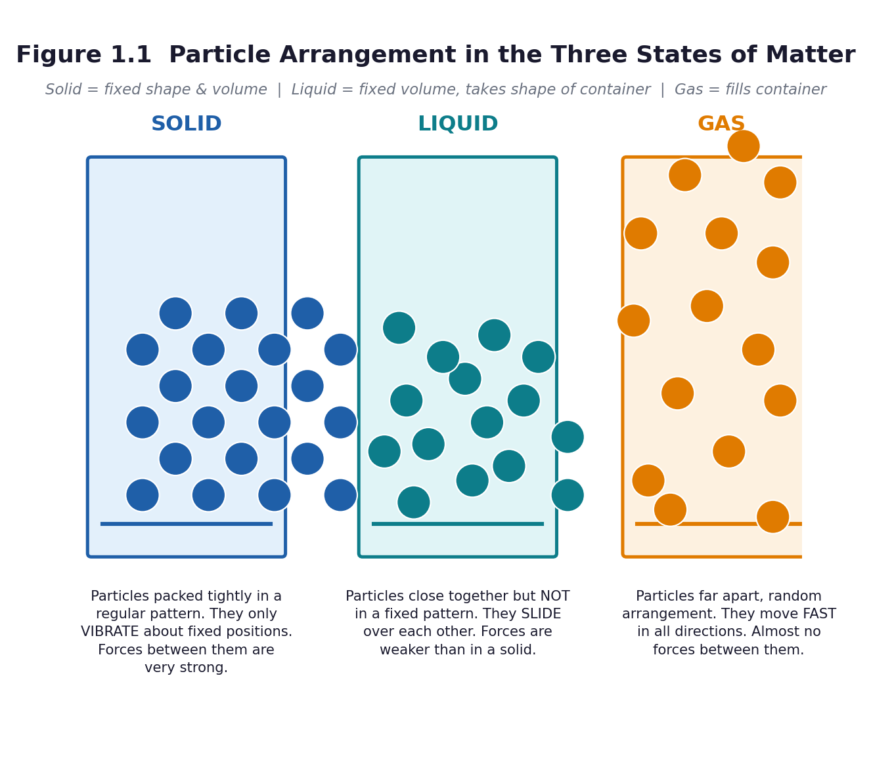
Figure 1.1 Particle arrangement in the three states of matter.
PHASE / TIME | TEACHER ACTIVITY | LEARNER ACTIVITY | CORE COMP. | ASSESSMENT (DoK)
ENGAGE  8 min | Hold up a sealed transparent bag that looks empty. Ask: ‘Is there anything in this bag?’ Squeeze it, then open it slightly near a learner's cheek and push the air out. Tell learners: ‘You felt something you could not see. That is a gas, and it is matter.’ Write the three words on the board. Share the performance indicator in learner language: ‘By the end of this lesson you will be able to sort any material into solid, liquid or gas, and say why.’ | Learners feel the air from the bag on their cheek and answer. They call out materials they can see in the classroom, then materials they cannot see. Each learner writes the three state words at the top of a page. | CP; CC; CI | Oral responses; diagnostic check. DoK 1
EXPLORE  18 min | Give each group a tray. Task: first sort the materials any way you like, then re-sort them into solid, liquid and gas and record in a table: material | what I observed | state | my reason. Circulate and ask ‘why did you put this one here?’ Do NOT correct. Deliberately note which groups struggle with the sponge, the foam, the salt and the smoke — these are the diagnostic cases. | Groups handle, observe with hand lenses, discuss and sort. They record in a table. They must reach agreement as a group, so they have to justify their choices to each other. The Recorder writes; the Reporter prepares to explain one disputed item. | CP; CC; CI | Observation checklist; group record. DoK 2
EXPLAIN  12 min | Groups report, starting with the items they disagreed about. Now introduce the formal ideas with Figure 1.1: a solid keeps its shape and volume; a liquid keeps its volume but takes the shape of its container; a gas fills its container. Then add the particle explanation, and act it out: particles packed tight and vibrating; close together and sliding; far apart and moving fast. Confront the difficult cases explicitly: a powder is a solid that pours; a sponge is a solid with air trapped in it; foam is gas in a liquid; smoke is tiny solids carried in a gas. | Learners correct their own tables in a second colour. They stand and model the three particle arrangements with their bodies — packed shoulder to shoulder, then moving but touching, then spread across the room. | CP; CC; CI | Questioning; corrected work in a second colour. DoK 2
ELABORATE  12 min | Quick-fire ‘three in a row’: call out a material, groups hold up one, two or three fingers for solid, liquid or gas. Include the hard ones — jelly, smoke, cloud, steam, honey, a coconut, a candle flame. Then give the extension group the four ambiguous materials and ask them to write one sentence for each explaining why it is difficult to classify. | Learners respond as a group, then explain the disputed cases in pairs using the sentence frame: ‘I think ___ is a ___ because ___.’ | CP; CC; CI | Application task; sentence frames. DoK 2–3
EVALUATE  10 min | Exit ticket on a slip of paper: name one solid, one liquid and one gas found in your home, and give one reason for each choice. Collect and sort into three piles overnight — got it, nearly, not yet. Preview the next lesson: ‘Tomorrow we ask why liquids matter so much to human life’. | Learners complete the exit ticket individually and self-assess against the success criteria by ticking: I can name the three states / I can classify a material / I can give a reason. | CP; CC; CI | Exit ticket or assessed product. DoK 2–3

APPROACHING  PROFICIENCY (AP) | Support — give picture sorting cards with the three state names printed on them, and a word bank of observation words (hard, runny, invisible, keeps its shape, pours, spreads).
PROFICIENT (P) | Core — as described; twelve materials classified with reasons.
HIGHLY  PROFICIENT (HP) | Extension — classify a sponge, jelly, smoke and foam, and write one sentence explaining why each is difficult. Then: is a cloud a liquid or a gas? Argue both sides.

ASSESSMENT (summary) | Observation during the sorting task using checklist C7.1 (classifying and recording). Exit ticket marked against three success criteria: names the three states; classifies at least two materials correctly; gives a reason. Anyone who cannot give a reason has memorised labels without understanding — reteach that group in the first five minutes of Lesson 2.
HOMEWORK / PROJECT WORK | Record (do not collect) five materials at home or in the compound, with the state and one use of each. Bring the list, not the objects. Bring one clean, dry, empty plastic bottle to the next lesson.
SAFETY | Nothing is to be tasted, ever. Never smell a substance directly — waft the air towards the nose with the hand. The teacher handles any spray or smoke demonstration; learners observe from their seats.
CROSS-CUTTING LINKS | English — recording observations in a table and using comparative language. Mathematics — tallying and sorting data. Values — materials are resources, not rubbish; the curriculum asks learners to explain the need to preserve useful materials.
LESSON CLOSURE | Return to the essential questions; two learners summarise, one says what is still unclear; record names for follow-up below.

REFLECTION AND REMARKS (complete after teaching)
What went well — evidence of learning you saw
What I would change next time
Learners who need follow-up, and what I will do
Head of Department remarks

TEACHER — NAME AND SIGNATURE | HEAD OF DEPARTMENT | DATE

BASIC 7 SCIENCE • TERM 1 • WEEKLY LESSON NOTE
LESSON 2 of 24 — Why Liquids Matter — Water, Oil, Blood and Sap
Week 1 • Diversity of Matter • Materials • B7.1.1.1.2 • 60 minutes
WEEK ENDING | DAY | DATE | PERIOD | DURATION | CLASS | SUBJECT
 |  |  |  | 60 min | Basic 7 | Science

CLASS SIZE — BOYS | CLASS SIZE — GIRLS | CLASS SIZE — TOTAL

STRAND | Diversity of Matter
SUB-STRAND | Materials
CONTENT STANDARD | B7.1.1.1 — Recognize materials as important resources for providing human needs.
LEARNING INDICATOR(S) | B7.1.1.1.2 — Discuss the importance of liquids in the life of humans.
PERFORMANCE INDICATOR  (what learners will do) | Learners can explain why liquids are essential to human life and identify liquids used in their community.
LEARNING OUTCOMES  (knowledge / skill / value) | • K — name at least four liquids used by humans and state a use for each.  • S — present a short report, in a group, on the importance of liquids to human life.  • A/V — appreciate that clean water is a scarce resource that must be preserved and not wasted.
CORE COMPETENCIES | Communication and Collaboration (CC); Critical Thinking and Problem Solving (CP).
KEY WORDS | liquid, solvent, dissolve, beverage, sap, preserve, dehydration, essential
ESSENTIAL QUESTIONS | 1. What would happen to us if there were no liquids?  2. Which liquids do we depend on at home and in our community?
PRIOR KNOWLEDGE (R.P.K.) | Lesson 1 — the three states of matter and how to classify a material.
TEACHING / LEARNING RESOURCES  (TLMs) | The empty plastic bottles learners brought. A clear glass of water, cooking oil, milk, a soft drink, palm oil, a leaf (to show sap), iodine or ink for demonstration. A chart with three columns: Liquid | Where we get it | What we use it for. Figure 1.1 and 1.2.
PEDAGOGICAL EXEMPLARS (methods) | Inquiry (5E); hands-on practical work; cooperative group work; questioning and discussion; differentiation by task, support and outcome
REFERENCE | NaCCA Science Curriculum for the Common Core Programme (Basic 7–10), February 2020 — B7.1.1.1.2, p. 3. Scheme of Learning, Week 1.

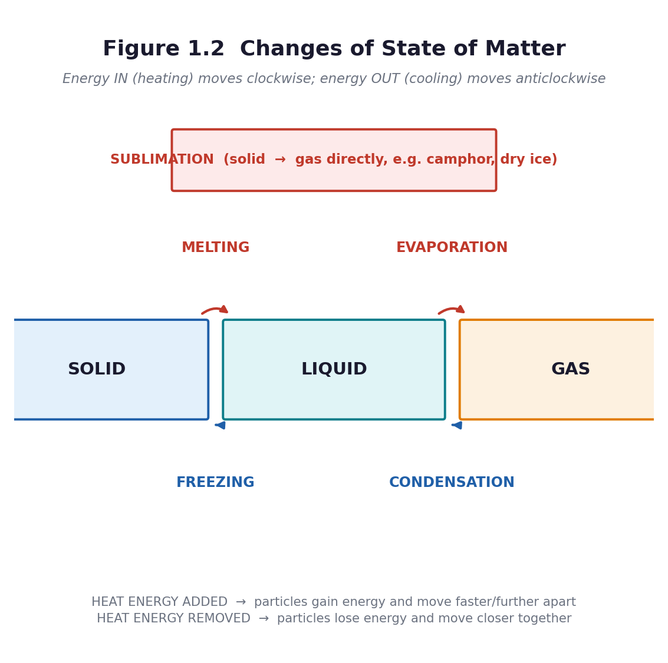
Figure 1.2 Changes of state — how a liquid becomes a gas and back again.
PHASE / TIME | TEACHER ACTIVITY | LEARNER ACTIVITY | CORE COMP. | ASSESSMENT (DoK)
ENGAGE  8 min | Ask: ‘How long can a person live without water?’ Take answers, then give the figure: about three days, and less in the heat. Then: ‘Name every liquid you have used since you woke up this morning.’ Build a long list on the board. Share the performance indicator. | Learners guess, then react to the answer. They call out the liquids they have used — water for bathing and drinking, tea, milk, oil for cooking, soap, kerosene, petrol, medicine. | CC; CP | Oral responses; diagnostic check. DoK 1
EXPLORE  18 min | In groups, learners build a three-column chart: liquid | where we get it | what we use it for, aiming for at least eight liquids. Then set the harder question: ‘Which of these could a person live without, and which could they not?’ Groups must sort their list into essential and non-essential and defend the split. Circulate and challenge: ‘Could you cook your food without any liquid at all?’ | Groups research from their own experience, from textbooks and from any chart on the wall. They debate the essential/non-essential split and prepare a two-minute group report. | CC; CP | Observation checklist; group record. DoK 2
EXPLAIN  12 min | Groups report. Draw out four functions of liquids that learners may not have named: drinking and hydration; carrying dissolved substances (blood carries food and oxygen, sap carries food in a plant); cooking and dissolving (you cannot extract palm oil, brew tea or dissolve salt without a liquid); and cleaning and cooling. Introduce the word solvent. Ask why a hospital needs so much liquid. | Learners add the new functions to their charts in a second colour. They answer: what happens to a person who loses too much water? (Thirst, weakness, dehydration.) | CC; CP | Questioning; corrected work in a second colour. DoK 2
ELABORATE  12 min | The harder question: ‘What if the water in your community ran dry for a week?’ Groups list the consequences, then list three things a household can do to preserve or save liquid. Use the empty bottles: a one-litre bottle filled with water and put inside a pit latrine cistern or a flushing tank displaces a litre every flush — a real, free saving. | Groups produce a short list of consequences and of preservation actions. They fill a bottle with water, cap it, and write a label: ‘Save 1 litre every flush’. | CC; CP | Application task; sentence frames. DoK 2–3
EVALUATE  10 min | Each group gives its one-minute report: the most important liquid, why, and one way to preserve it. Peer-assess with ‘two stars and a wish’. Exit ticket: ‘Give two reasons why liquids are important to human life.’ | Learners present, listen and give structured peer feedback. They complete the exit ticket and self-assess against the success criteria. | CC; CP | Exit ticket or assessed product. DoK 2–3

APPROACHING  PROFICIENCY (AP) | Support — a picture chart of liquids to sort; sentence frame ‘___ is important because ___’; work with a partner.
PROFICIENT (P) | Core — eight liquids identified, classified as essential or not, with reasons.
HIGHLY  PROFICIENT (HP) | Extension — explain why blood and plant sap count as liquids that carry substances, and research one Ghanaian community with a water shortage and what is being done about it.

ASSESSMENT (summary) | Group report assessed with rubric R4 (oral presentation). Exit ticket: two valid reasons. Observation of the essential/non-essential reasoning — the reasoning is the learning, not the list.
HOMEWORK / PROJECT WORK | Keep a ‘liquid diary’ for one day: every liquid you use, how much, and whether it was wasted. Bring it to Lesson 4 for the materials-conservation discussion.
SAFETY | If you demonstrate with iodine or ink, the teacher handles it. No tasting of any liquid in the classroom, including water brought from home.
CROSS-CUTTING LINKS | English — the group report and the persuasive register. Social Studies — water as a community resource. Values — the curriculum exemplar asks learners to describe the need to preserve liquids for human use.
LESSON CLOSURE | Return to the essential questions; two learners summarise, one says what is still unclear; record names for follow-up below.

REFLECTION AND REMARKS (complete after teaching)
What went well — evidence of learning you saw
What I would change next time
Learners who need follow-up, and what I will do
Head of Department remarks

TEACHER — NAME AND SIGNATURE | HEAD OF DEPARTMENT | DATE

BASIC 7 SCIENCE • TERM 1 • WEEKLY LESSON NOTE
LESSON 3 of 24 — Solids That Keep Us Alive — And Why We Must Preserve Them
Week 2 • Diversity of Matter • Materials • B7.1.1.1.3 • 60 minutes
WEEK ENDING | DAY | DATE | PERIOD | DURATION | CLASS | SUBJECT
 |  |  |  | 60 min | Basic 7 | Science

CLASS SIZE — BOYS | CLASS SIZE — GIRLS | CLASS SIZE — TOTAL

STRAND | Diversity of Matter
SUB-STRAND | Materials
CONTENT STANDARD | B7.1.1.1 — Recognize materials as important resources for providing human needs.
LEARNING INDICATOR(S) | B7.1.1.1.3 — Discuss the importance of specific solids to life.
PERFORMANCE INDICATOR  (what learners will do) | Learners can identify solids in the environment that support the survival of humans and other life forms.
LEARNING OUTCOMES  (knowledge / skill / value) | • K — identify at least six solids in the environment that support human survival and other life forms.  • S — describe solids by texture, appearance, colour, smell and shape, and model a useful object from solid material.  • A/V — explain why useful solid materials must be preserved and reused rather than wasted.
CORE COMPETENCIES | Critical Thinking and Problem Solving (CP); Creativity and Innovation (CI).
KEY WORDS | solid, rigid, preserve, reuse, recycle, resource, structure, texture
ESSENTIAL QUESTIONS | 1. Which solids do we depend on to stay alive?  2. Why must we preserve the solids we use?
PRIOR KNOWLEDGE (R.P.K.) | Lessons 1 and 2 — states of matter; the importance of liquids.
TEACHING / LEARNING RESOURCES  (TLMs) | A tray of solid materials: iron nail or bar, wood, rock, glass, salt, sugar, chalk, clay, charcoal, a metal spoon, a piece of cloth, dry maize, a shell. Hand lenses. Scrap materials for modelling: cardboard, wire, string, foil, empty tins, clay. Figure 1.1.
PEDAGOGICAL EXEMPLARS (methods) | Inquiry (5E); hands-on practical work; cooperative group work; questioning and discussion; differentiation by task, support and outcome
REFERENCE | NaCCA Science Curriculum for the Common Core Programme (Basic 7–10), February 2020 — B7.1.1.1.3, p. 3. Scheme of Learning, Week 2.

PHASE / TIME | TEACHER ACTIVITY | LEARNER ACTIVITY | CORE COMP. | ASSESSMENT (DoK)
ENGAGE  8 min | Ask learners to look around the classroom and name everything holding it together: the block, the roof iron sheet, the desk, the chalk, the door hinge. Then: ‘Now imagine every solid in this room disappeared. What is left?’ Nothing — not even the floor. Share the performance indicator. | Learners call out solids. They realise that solids are not just objects in a tray; they are the structure of everything built. | CP; CI | Oral responses; diagnostic check. DoK 1
EXPLORE  18 min | Groups receive a tray of solids. Task one: describe each one by texture, appearance, colour, smell and shape and record in a table. Task two: for each solid, write what it is used for and whether it supports human survival. Task three (creative): choose one solid and model an object from it that would be useful to humans or to other living things. | Groups handle and describe the materials precisely, moving beyond ‘hard’ and ‘rough’. They sort by use. They design and make a small model — a tool, a shelter, a container, a bird feeder. | CP; CI | Observation checklist; group record. DoK 2
EXPLAIN  12 min | Groups present their models and their tables. Draw out the categories of solid that support survival: building materials (rock, wood, iron, clay); tools and machines (iron, steel); food and food preservation (salt, sugar); soil and its minerals; the bones and shells that support other living things. Then raise preservation: iron rusts, wood rots or is burnt, glass breaks, soil is washed away, and each of these is a loss to the community. | Learners add preservations to their tables: what would happen to this material if it were wasted, and how can it be preserved, reused or recycled? They use the frame ‘We should preserve ___ because ___’. | CP; CI | Questioning; corrected work in a second colour. DoK 2
ELABORATE  12 min | A jigsaw: five groups each take one preservation method — reuse, repair, recycle, reduce, and substitute (use a local alternative). They prepare a one-minute pitch to the class on why their method matters for ONE named solid material found in Ghana. | Groups prepare and deliver short pitches. The class votes on the method it thinks the school should adopt first, and gives a reason. | CP; CI | Application task; sentence frames. DoK 2–3
EVALUATE  10 min | Exit ticket: ‘Name three solids that support human life, and one way to preserve each.’ Then the gallery walk: models are left on display with a sticky note for one peer comment each. | Learners complete the exit ticket, then walk the gallery and write one specific comment: what the object is for, and one improvement. | CP; CI | Exit ticket or assessed product. DoK 2–3

APPROACHING  PROFICIENCY (AP) | Support — a word bank of texture words (smooth, rough, shiny, dull, grainy, hard, brittle) and a partially completed table.
PROFICIENT (P) | Core — six solids described by five properties and linked to a use.
HIGHLY  PROFICIENT (HP) | Extension — explain why salt has been historically important to Ghanaian communities for preserving food, and connect this to the chemistry of preserving.

ASSESSMENT (summary) | The classification table (checklist C7.2). The model assessed with rubric R5 (design and make). Exit ticket: three solids plus one preservation method each.
HOMEWORK / PROJECT WORK | Find three solid objects at home that are no longer used. For each, say whether it could be reused, repaired or recycled — and bring one of them to school for the class reuse box.
SAFETY | No tasting of salt or sugar in the classroom. Handle any broken glass or sharp metal yourself; check trays before they go out.
CROSS-CUTTING LINKS | Creative Arts and Design — the modelling task. Social Studies — resources and their management. Values — the curriculum exemplar explicitly requires learners to explain the need to preserve useful solid materials.
LESSON CLOSURE | Return to the essential questions; two learners summarise, one says what is still unclear; record names for follow-up below.

REFLECTION AND REMARKS (complete after teaching)
What went well — evidence of learning you saw
What I would change next time
Learners who need follow-up, and what I will do
Head of Department remarks

TEACHER — NAME AND SIGNATURE | HEAD OF DEPARTMENT | DATE

BASIC 7 SCIENCE • TERM 1 • WEEKLY LESSON NOTE
LESSON 4 of 24 — The Periodic Table — Twenty Elements in Their Place
Week 2 • Diversity of Matter • Materials • B7.1.1.2.1 • 60 minutes
WEEK ENDING | DAY | DATE | PERIOD | DURATION | CLASS | SUBJECT
 |  |  |  | 60 min | Basic 7 | Science

CLASS SIZE — BOYS | CLASS SIZE — GIRLS | CLASS SIZE — TOTAL

STRAND | Diversity of Matter
SUB-STRAND | Materials
CONTENT STANDARD | B7.1.1.2 — Understand the periodic table as different elements made up of metals and non-metals and noble gases arranged in an order.
LEARNING INDICATOR(S) | B7.1.1.2.1 — Demonstrate the knowledge of the orderly arrangement of metals, non-metals and noble gases in the periodic table.
PERFORMANCE INDICATOR  (what learners will do) | Learners can identify the first twenty elements in the periodic table and say which are metals, non-metals and noble gases.
LEARNING OUTCOMES  (knowledge / skill / value) | • K — name and write the chemical symbol of the first twenty elements.  • S — identify metals, non-metals and noble gases on the periodic table and state that elements are arranged in order of atomic number.  • A/V — appreciate that the periodic table is one of the great organising achievements of science, and that it belongs to everyone.
CORE COMPETENCIES | Digital Literacy (DL); Critical Thinking and Problem Solving (CP).
KEY WORDS | element, atom, atomic number, chemical symbol, metal, non-metal, noble gas, group, period, periodic table
ESSENTIAL QUESTIONS | 1. How are the elements arranged in the periodic table?  2. How can I tell whether an element is a metal, a non-metal or a noble gas?
PRIOR KNOWLEDGE (R.P.K.) | Lessons 1–3 — materials and their states. Learners will have heard of oxygen and carbon but usually do not know what makes something an element.
TEACHING / LEARNING RESOURCES  (TLMs) | A large printed periodic table (the pack's Figure 1.3 enlarged to A3, or any wall chart). Element flashcards for the first twenty, one per learner. A set of ten real objects labelled with their element: an aluminium pan, a copper wire, an iron nail, charcoal (carbon), a sulphur stick if available, a helium balloon if available, a bottle of water (H and O), salt (Na and Cl).
PEDAGOGICAL EXEMPLARS (methods) | Inquiry (5E); hands-on practical work; ICT / digital resources; cooperative group work; questioning and discussion; differentiation by task, support and outcome
REFERENCE | NaCCA Science Curriculum for the Common Core Programme (Basic 7–10), February 2020 — B7.1.1.2.1, p. 4. Scheme of Learning, Week 2.

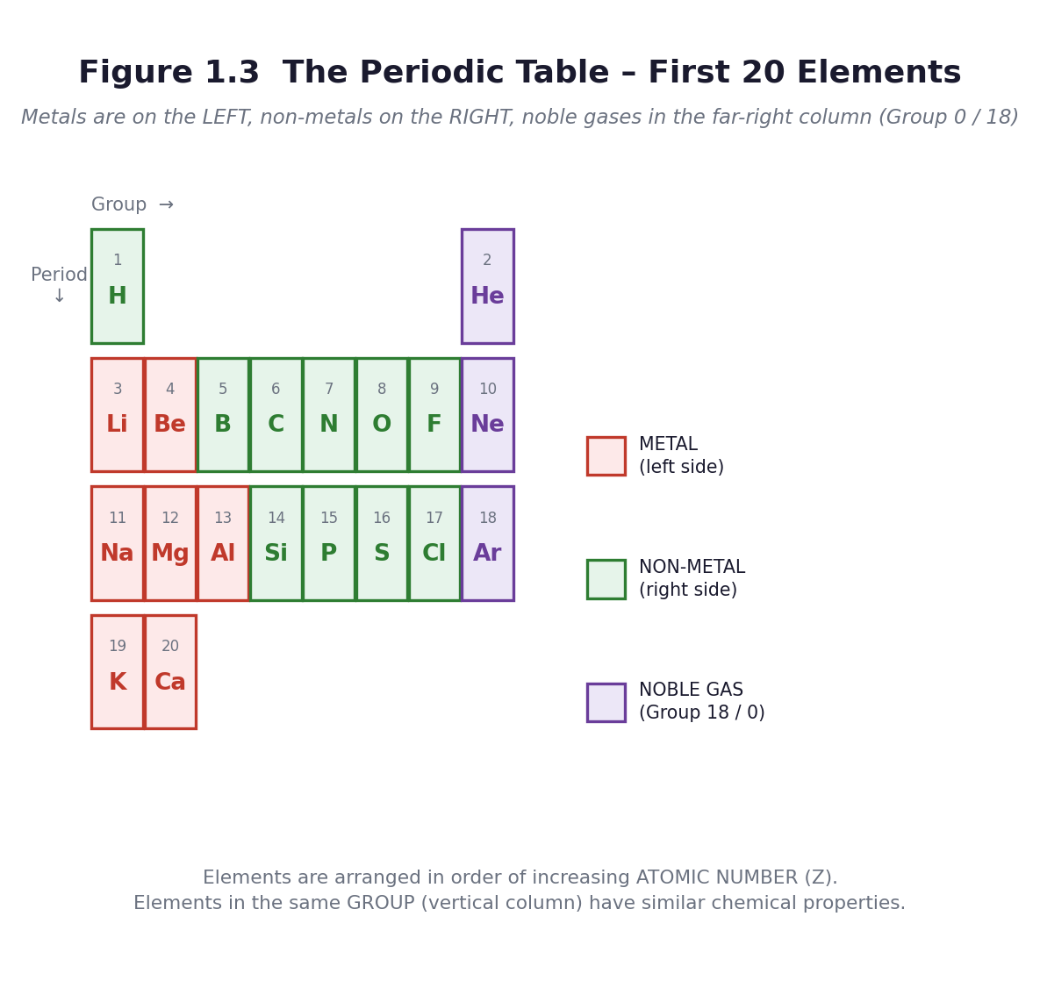
Figure 1.3 The first twenty elements. Metals on the left, non-metals on the right, noble gases in the far-right column.
PHASE / TIME | TEACHER ACTIVITY | LEARNER ACTIVITY | CORE COMP. | ASSESSMENT (DoK)
ENGAGE  8 min | Hold up an aluminium pan, an iron nail and a piece of charcoal. Ask: ‘What are these three things made of?’ Go one level down: aluminium, iron, carbon. Then: ‘Aluminium and iron are metals. Carbon is not. Why do scientists put them in different parts of the same table?’ Show the big periodic table. Share the performance indicator. | Learners name the materials, then the substances. They look at the chart and notice the colours, the numbers, the staircase and the block on the right. | DL; CP | Oral responses; diagnostic check. DoK 1
EXPLORE  18 min | Give each group a copy of Figure 1.3 and a set of flashcards. Task: put the first twenty elements in order of atomic number, then find three patterns: where are the metals? where are the non-metals? where are the noble gases? Circulate and ask ‘what do the numbers going up by one each time tell you?’ and ‘what is odd about the last column?’ | Groups order the cards, colour-code them into three families, and record three observations. They notice that the noble gases sit in a single column on the far right, and that metals are on the left. | DL; CP | Observation checklist; group record. DoK 2
EXPLAIN  12 min | Now formalise. An element is a substance made of only one kind of atom. The atomic number is the number of protons, and it is the number the table is ordered by. A chemical symbol is the shorthand — note that some come from Latin (Na from natrium, K from kalium, Fe from ferrum), which is why Na is not ‘S’ for sodium. Groups are the columns: elements in the same group behave similarly. Periods are the rows. Then name the three families: metals on the left and in the middle; non-metals on the right; noble gases in Group 18 — unreactive, which is why helium is safe in a balloon and argon fills light bulbs. | Learners label their own copy of the table with the three families, and write the rule for a symbol: first letter always capital, second letter always small (Co is cobalt; CO is carbon monoxide — a completely different thing). | DL; CP | Questioning; corrected work in a second colour. DoK 2
ELABORATE  12 min | Element bingo: learners make a 3×3 grid and fill it with nine symbols from the first twenty. Call out names — ‘sodium’, ‘calcium’, ‘neon’ — learners mark the symbol. Then the real-world round: hold up an object and ask which element or elements it contains. | Learners play bingo, then match objects to elements: water is H and O; salt is Na and Cl; an aluminium pan is Al; charcoal is C; a copper wire is Cu. | DL; CP | Application task; sentence frames. DoK 2–3
EVALUATE  10 min | Five-question quick quiz on mini-whiteboards or paper: write the symbol for potassium; write the name for Mg; is chlorine a metal, a non-metal or a noble gas? which group are the noble gases in? what does the atomic number tell you? Preview Lesson 5: ‘tomorrow we look inside a living thing, and find that it too is made of parts with jobs’. | Learners answer individually, then swap and mark against the answers on the board. They record their score out of five in their journal. | DL; CP | Exit ticket or assessed product. DoK 2–3

APPROACHING  PROFICIENCY (AP) | Support — give a partially filled table and ask for the first ten elements only. Provide the symbols; ask for the names.
PROFICIENT (P) | Core — the first twenty names and symbols, and the three families identified.
HIGHLY  PROFICIENT (HP) | Extension — explain why elements in the same group behave similarly, using Group 1 (lithium, sodium, potassium) as the example, and find out why the noble gases were the last to be discovered.

ASSESSMENT (summary) | The ordered and colour-coded table (checklist C7.3). The five-question quiz. Retrieval: repeat the same five questions, plus five more, at the start of Lesson 5 — spaced retrieval is what makes the symbols stick.
HOMEWORK / PROJECT WORK | Learn the first ten element names and symbols for a quiz next week. Write one sentence saying what your favourite element is used for in everyday life.
SAFETY | If you use real samples, check them first. Do not bring reactive metals (sodium, potassium) into a Basic 7 classroom under any circumstances — show them in a video instead.
CROSS-CUTTING LINKS | Mathematics — ordering numbers, the structure of a grid, coordinates. Computing — digital literacy is a named competency for this indicator; if you have access, let learners explore an interactive periodic table. English — the etymology of symbols.
LESSON CLOSURE | Return to the essential questions; two learners summarise, one says what is still unclear; record names for follow-up below.

REFLECTION AND REMARKS (complete after teaching)
What went well — evidence of learning you saw
What I would change next time
Learners who need follow-up, and what I will do
Head of Department remarks

TEACHER — NAME AND SIGNATURE | HEAD OF DEPARTMENT | DATE

BASIC 7 SCIENCE • TERM 1 • WEEKLY LESSON NOTE
LESSON 5 of 24 — Inside an Animal Cell
Week 3 • Diversity of Matter • Living Cells • B7.1.2.1.1 • 60 minutes
WEEK ENDING | DAY | DATE | PERIOD | DURATION | CLASS | SUBJECT
 |  |  |  | 60 min | Basic 7 | Science

CLASS SIZE — BOYS | CLASS SIZE — GIRLS | CLASS SIZE — TOTAL

STRAND | Diversity of Matter
SUB-STRAND | Living Cells
CONTENT STANDARD | B7.1.2.1 — Demonstrate understanding of the structure of organisms and functions of cells in living systems.
LEARNING INDICATOR(S) | B7.1.2.1.1 — Describe the structure and function of living cells of an animal.
PERFORMANCE INDICATOR  (what learners will do) | Learners can identify, draw and label an animal cell and state the function of each organelle.
LEARNING OUTCOMES  (knowledge / skill / value) | • K — name five parts of an animal cell and state the function of each.  • S — observe an animal cell using a magnifier or microscope, and draw and label what is seen.  • A/V — appreciate that all animals, including humans, are made of cells working together.
CORE COMPETENCIES | Digital Literacy (DL); Communication and Collaboration (CC); Critical Thinking and Problem Solving (CP); Creativity and Innovation (CI).
KEY WORDS | cell, organism, organelle, cell membrane, cytoplasm, nucleus, mitochondrion, vacuole, function, magnify
ESSENTIAL QUESTIONS | 1. What is the smallest unit of life?  2. What are the parts of an animal cell, and what does each part do?
PRIOR KNOWLEDGE (R.P.K.) | Lesson 4 — elements are the building blocks of matter. Learners know from Basic 6 that living things are made of cells, but most will not know what is inside one.
TEACHING / LEARNING RESOURCES  (TLMs) | Figure 1.4 enlarged to A3. Hand lenses, one per pair. A microscope if the department has one, with prepared slides or a cheek-cell sample collected safely. Onion or tomato for comparison in Lesson 6. A clear plastic bag filled with water and a few floating objects, to model the cell. Clay or modelling dough.
PEDAGOGICAL EXEMPLARS (methods) | Inquiry (5E); hands-on practical work; ICT / digital resources; cooperative group work; questioning and discussion; differentiation by task, support and outcome
REFERENCE | NaCCA Science Curriculum for the Common Core Programme (Basic 7–10), February 2020 — B7.1.2.1.1, p. 5. Scheme of Learning, Week 3.

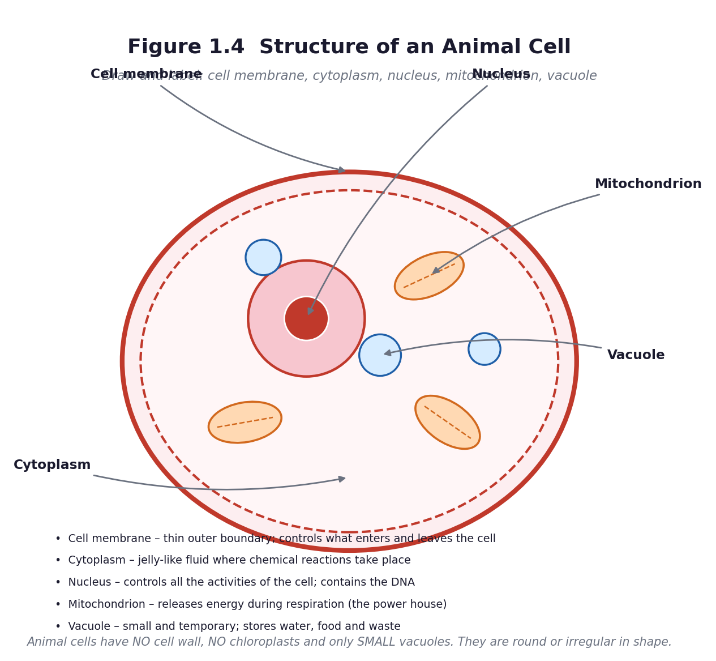
Figure 1.4 Structure of an animal cell.
PHASE / TIME | TEACHER ACTIVITY | LEARNER ACTIVITY | CORE COMP. | ASSESSMENT (DoK)
ENGAGE  8 min | Retrieval: five element questions on mini-whiteboards (from Lesson 4). Then hold up the sealed water-filled bag with objects floating in it. ‘If this bag were alive, what would have to be inside it?’ Collect answers — a control centre, a way to make energy, somewhere for things to happen, a skin to hold it all in. Say: everything you have just named is really there. Share the performance indicator. | Learners answer the retrieval questions, then brainstorm what a living unit would need. They usually get close to the real answer, which is the point — the biology is not arbitrary. | DL; CC; CP; CI | Oral responses; diagnostic check. DoK 1
EXPLORE  18 min | Set up looking stations: prepared slides or fresh samples under a microscope if available, and printed micrographs and Figure 1.4 if not. Task: look carefully, then draw exactly what you can see — not what you expect to see. Then a second task: give each group a set of unlabelled organelle cards and ask them to match each card to the part of the drawing they think it belongs to. | Learners take turns at the microscope or magnifier, draw what they observe, and compare drawings in pairs. They argue about which card goes where, using the shape and position as evidence. | DL; CC; CP; CI | Observation checklist; group record. DoK 2
EXPLAIN  12 min | Reveal the answers with Figure 1.4. For each organelle, give the name, the shape cue for remembering it, and the job — the function is what is assessed, not the name. Cell membrane: the gate keeper. Cytoplasm: the workshop floor where reactions happen. Nucleus: the control room with the instructions. Mitochondrion: the power house, releasing energy in respiration. Vacuole: the store room. Drill: learners close books and name the function when you give the name, and the name when you give the function. | Learners label their drawings, correcting in a second colour. They chant or pair-test the name–function pairs. They write the one-line function beside each label, not just the word. | DL; CC; CP; CI | Questioning; corrected work in a second colour. DoK 2
ELABORATE  12 min | Two tasks. First, the analogy task: in groups, learners compare the cell to something familiar — a school, a household, a chop bar, a market — and produce a table matching each organelle to its counterpart. Second, the model task: with clay, learners build a flat animal cell showing all five parts, to be finished as homework if time runs short. | Groups produce an analogy table (nucleus = the head teacher's office; membrane = the school gate; mitochondrion = the kitchen or the generator; cytoplasm = the compound; vacuole = the store). They begin the clay model. | DL; CC; CP; CI | Application task; sentence frames. DoK 2–3
EVALUATE  10 min | Organelle snap or a five-question name-the-function quiz. Then the exit ticket: draw an animal cell from memory with five labels. Preview Lesson 6: ‘a plant cell has everything an animal cell has, plus three things that change everything’. | Learners play, then complete the exit ticket. They self-assess: I can name five parts / I can state the function of each / I can draw and label one. | DL; CC; CP; CI | Exit ticket or assessed product. DoK 2–3

APPROACHING  PROFICIENCY (AP) | Support — give a labelled outline to complete rather than a blank page; allow the analogy task as the main output.
PROFICIENT (P) | Core — five organelles named, function stated for each, drawing labelled.
HIGHLY  PROFICIENT (HP) | Extension — explain why a muscle cell would have far more mitochondria than a skin cell, linking structure to function.

ASSESSMENT (summary) | The labelled drawing marked against five correct labels plus five correct functions (checklist C7.4). The analogy table is a check on genuine understanding: a learner who says the nucleus is ‘the brain’ without being able to say why has a slogan, not a concept.
HOMEWORK / PROJECT WORK | Finish the clay model of the animal cell. Learn the five organelles and their functions for a quiz.
SAFETY | No mouth swabs unless you have sterile swabs and a disposal plan. Use onion epidermis, tomato pulp or a printed micrograph instead. If glass slides are used, check them for chips and collect them back in person. Wash hands with soap after the lesson.
CROSS-CUTTING LINKS | Creative Arts — the model. English — analogy and comparison. Values — respect for life; the interdependence of parts, which the curriculum lists as a specific aim of the science programme.
LESSON CLOSURE | Return to the essential questions; two learners summarise, one says what is still unclear; record names for follow-up below.

REFLECTION AND REMARKS (complete after teaching)
What went well — evidence of learning you saw
What I would change next time
Learners who need follow-up, and what I will do
Head of Department remarks

TEACHER — NAME AND SIGNATURE | HEAD OF DEPARTMENT | DATE

BASIC 7 SCIENCE • TERM 1 • WEEKLY LESSON NOTE
LESSON 6 of 24 — Inside a Plant Cell, and How the Two Differ
Week 3 • Diversity of Matter • Living Cells • B7.1.2.1.2 • 60 minutes
WEEK ENDING | DAY | DATE | PERIOD | DURATION | CLASS | SUBJECT
 |  |  |  | 60 min | Basic 7 | Science

CLASS SIZE — BOYS | CLASS SIZE — GIRLS | CLASS SIZE — TOTAL

STRAND | Diversity of Matter
SUB-STRAND | Living Cells
CONTENT STANDARD | B7.1.2.1 — Demonstrate understanding of the structure of organisms and functions of cells in living systems.
LEARNING INDICATOR(S) | B7.1.2.1.2 — State the functions of each organelle in a plant cell.
PERFORMANCE INDICATOR  (what learners will do) | Learners can identify, draw, label and model a plant cell, state the function of each organelle, and compare it with an animal cell.
LEARNING OUTCOMES  (knowledge / skill / value) | • K — name the parts of a plant cell, including the cell wall, chloroplasts and the large central vacuole, and state each function.  • S — compare a plant cell with an animal cell using a Venn diagram, and develop a model of a plant cell.  • A/V — appreciate that structure is related to function — a plant cell's extra parts are exactly the parts that let it make its own food and stand upright.
CORE COMPETENCIES | Digital Literacy (DL); Communication and Collaboration (CC); Creativity and Innovation (CI); Critical Thinking and Problem Solving (CP).
KEY WORDS | cell wall, cellulose, chloroplast, chlorophyll, photosynthesis, large central vacuole, turgid, organelle, sap
ESSENTIAL QUESTIONS | 1. How is a plant cell different from an animal cell?  2. Which parts does a plant cell have that an animal cell does not?
PRIOR KNOWLEDGE (R.P.K.) | Lesson 5 — animal cell structure and function. Basic 6 work on plant parts.
TEACHING / LEARNING RESOURCES  (TLMs) | Onion bulbs or any fleshy leaf, forceps or fingers, hand lenses, a microscope with slides if available, iodine or a drop of diluted ink to stain. Figure 1.5 and 1.6 enlarged to A3. Materials for the model: cardboard, clay, beads, beans, bottle tops, string, foil, pap, anything local.
PEDAGOGICAL EXEMPLARS (methods) | Inquiry (5E); hands-on practical work; ICT / digital resources; cooperative group work; questioning and discussion; differentiation by task, support and outcome
REFERENCE | NaCCA Science Curriculum for the Common Core Programme (Basic 7–10), February 2020 — B7.1.2.1.2, p. 6. Scheme of Learning, Week 3.

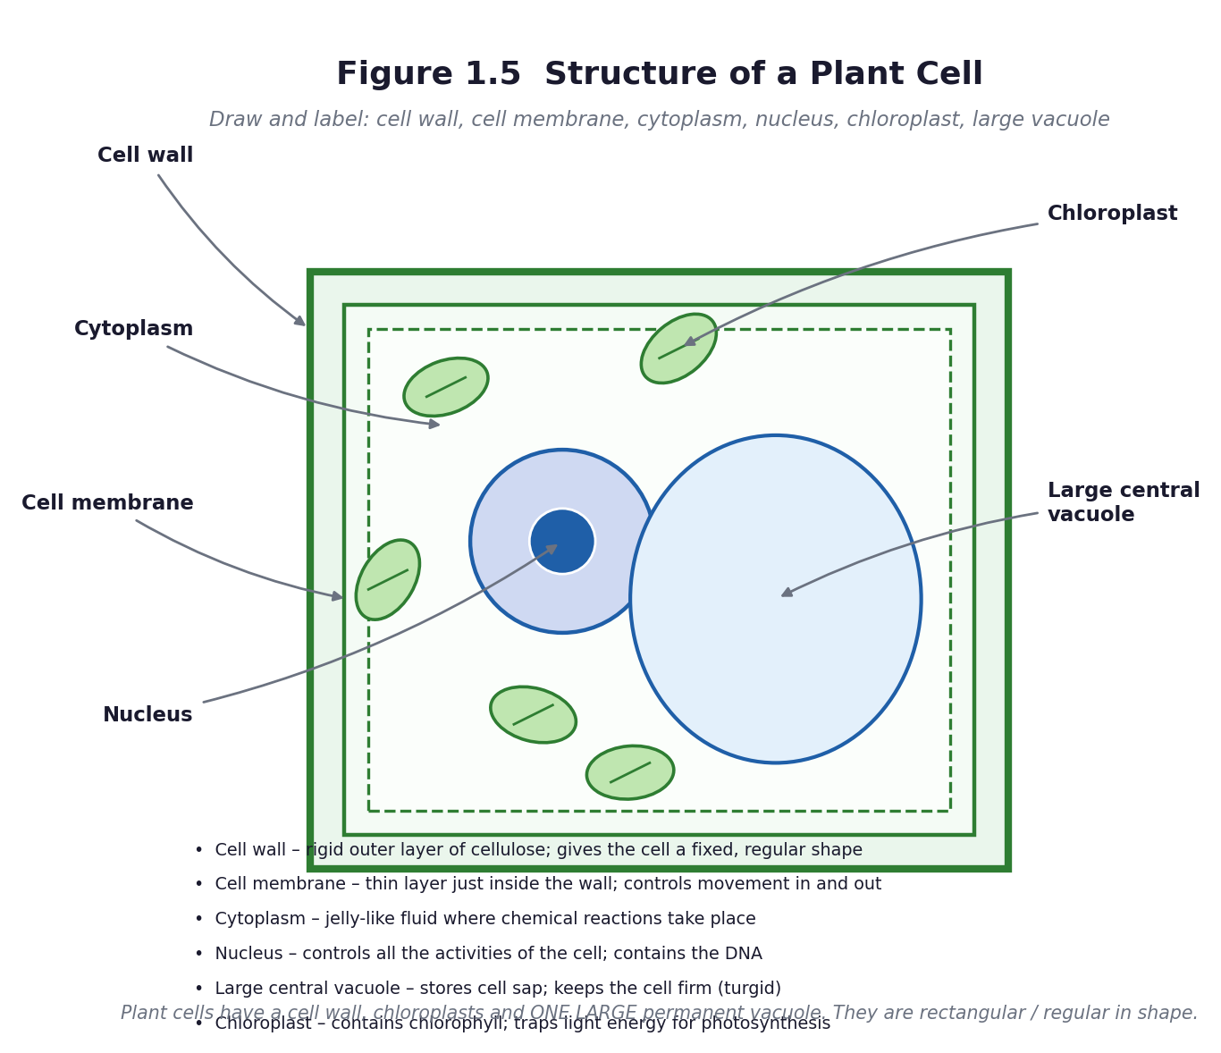
Figure 1.5 Structure of a plant cell.
PHASE / TIME | TEACHER ACTIVITY | LEARNER ACTIVITY | CORE COMP. | ASSESSMENT (DoK)
ENGAGE  8 min | Retrieval: name the five parts of an animal cell and the job of each. Then ask: ‘A maize plant stands upright without a skeleton, and it makes its own food. An animal cannot do either. What must be inside a plant cell that is not inside yours?’ Share the performance indicator. | Learners answer the retrieval questions, then reason from what plants can DO to what they must HAVE inside their cells. This is the structure-and-function link, and arriving at it by reasoning beats being told. | DL; CC; CI; CP | Oral responses; diagnostic check. DoK 1
EXPLORE  18 min | Practical: peel a thin, transparent layer from the inner surface of an onion scale leaf, place it on a slide in a drop of water with a drop of stain, and look under a hand lens or microscope. Task: draw exactly what you see, and note that the cells are rectangular and regular, not round and irregular as the animal cells were. Ask: what is holding them in that shape? | Learners prepare their own slides, observe, draw, and compare across the room. They notice the regular brick-like arrangement and the dark stained nucleus in each cell. | DL; CC; CI; CP | Observation checklist; group record. DoK 2
EXPLAIN  12 min | Introduce Figure 1.5. Name the three extras and give each one a reason: cell wall (cellulose) — rigid, so the plant stands up without a skeleton; chloroplast (containing chlorophyll) — traps light energy to make food by photosynthesis; large central vacuole — stores cell sap and pushes the cell firm (turgid), which is what holds a leaf out flat. Note that the plant cell also has everything the animal cell has. Then build the Venn diagram in Figure 1.6 together. | Learners label a plant-cell diagram, then complete the Venn diagram: animal only, plant only, both. They write the function beside every label. | DL; CC; CI; CP | Questioning; corrected work in a second colour. DoK 2
ELABORATE  12 min | The model task — this is the assessed Unit 1 product and an explicit curriculum exemplar. Groups build a three-dimensional plant cell from local materials. Set the criteria from rubric R2 before they start: all organelles present, correctly shaped and positioned; every one labelled; a one-line function for each; and craft. | Groups plan, gather materials and build. Roles rotate: one builds, one makes labels, one writes the function cards, one checks against the criteria on the board. | DL; CC; CI; CP | Application task; sentence frames. DoK 2–3
EVALUATE  10 min | Each group presents its model in two minutes: name each organelle, point to it, and state its function. Peer assessment with rubric R2. Then the individual exit ticket: ‘Give two differences between a plant cell and an animal cell, and explain why each difference matters.’ | Learners present and are assessed by peers and teacher. They complete the exit ticket and tick the success criteria. | DL; CC; CI; CP | Exit ticket or assessed product. DoK 2–3

APPROACHING  PROFICIENCY (AP) | Support — a labelled outline to complete; the Venn diagram with the headings and one example in each region; allow the model as the main assessment.
PROFICIENT (P) | Core — all organelles named and labelled, function stated, three differences given.
HIGHLY  PROFICIENT (HP) | Extension — explain why a leaf cell has many chloroplasts but a root cell has none, and what happens to a plant when its vacuoles lose water (wilting).

ASSESSMENT (summary) | The model assessed with rubric R2 (20 marks: accuracy 8, labelling 4, functions 4, craft 4). The Venn diagram. The exit ticket. This is the end of Unit 1 — administer Unit Test 1 (Part C1) in the first twenty minutes of the next science period.
HOMEWORK / PROJECT WORK | Finish the model and the function cards. Revise Unit 1 using the revision cards: three states, twenty elements, animal cell, plant cell.
SAFETY | Onion juice irritates the eyes — warn learners before they peel. The teacher handles the stain. No mouth swabs. Wash hands afterwards. Collect all slides back in person.
CROSS-CUTTING LINKS | Creative Arts and Design — the model is a design-and-make task. English — comparison and contrast. Values — interdependence: the plant makes the food that the animal cannot make.
LESSON CLOSURE | Return to the essential questions; two learners summarise, one says what is still unclear; record names for follow-up below.

REFLECTION AND REMARKS (complete after teaching)
What went well — evidence of learning you saw
What I would change next time
Learners who need follow-up, and what I will do
Head of Department remarks

TEACHER — NAME AND SIGNATURE | HEAD OF DEPARTMENT | DATE

BASIC 7 SCIENCE • TERM 1 • WEEKLY LESSON NOTE
LESSON 7 of 24 — The Inner Planets — Four Worlds Close to the Sun
Week 4 • Systems • The Solar System • B7.3.2.1.1 • 60 minutes
WEEK ENDING | DAY | DATE | PERIOD | DURATION | CLASS | SUBJECT
 |  |  |  | 60 min | Basic 7 | Science

CLASS SIZE — BOYS | CLASS SIZE — GIRLS | CLASS SIZE — TOTAL

STRAND | Systems
SUB-STRAND | The Solar System
CONTENT STANDARD | B7.3.2.1 — Demonstrate knowledge of the inner planets of the solar system and understand their movement in the system.
LEARNING INDICATOR(S) | B7.3.2.1.1 — Identify the inner planets of the solar system and describe their properties.
PERFORMANCE INDICATOR  (what learners will do) | Learners can identify the inner planets of the solar system and describe their properties.
LEARNING OUTCOMES  (knowledge / skill / value) | • K — name the four inner planets in order from the Sun and state one property of each.  • S — describe the Milky Way galaxy and the elliptical shape of planetary paths, and locate the inner planets on a diagram.  • A/V — appreciate the scale and order of the solar system, and that the Earth is one planet among others.
CORE COMPETENCIES | Digital Literacy (DL); Critical Thinking and Problem Solving (CP); Communication and Collaboration (CC); Creativity and Innovation (CI).
KEY WORDS | solar system, Sun, planet, orbit, elliptical, inner planet, terrestrial, Mercury, Venus, Earth, Mars, galaxy, Milky Way, rotate, revolve
ESSENTIAL QUESTIONS | 1. Which planets are the inner planets?  2. What makes each inner planet different from the others?
PRIOR KNOWLEDGE (R.P.K.) | Learners will have met day and night and the Sun in primary science. Most will know some planet names from television. Many will believe the Sun orbits the Earth, because that is what their eyes show them.
TEACHING / LEARNING RESOURCES  (TLMs) | Figure 2.1 enlarged to A3. A torch or lamp, a ball, and four balls of very different sizes. A solar system chart or projected image. Planet fact cards. String and chalk for the next lesson.
PEDAGOGICAL EXEMPLARS (methods) | Inquiry (5E); hands-on practical work; ICT / digital resources; cooperative group work; questioning and discussion; differentiation by task, support and outcome
REFERENCE | NaCCA Science Curriculum for the Common Core Programme (Basic 7–10), February 2020 — B7.3.2.1.1, p. 19. Scheme of Learning, Week 4.

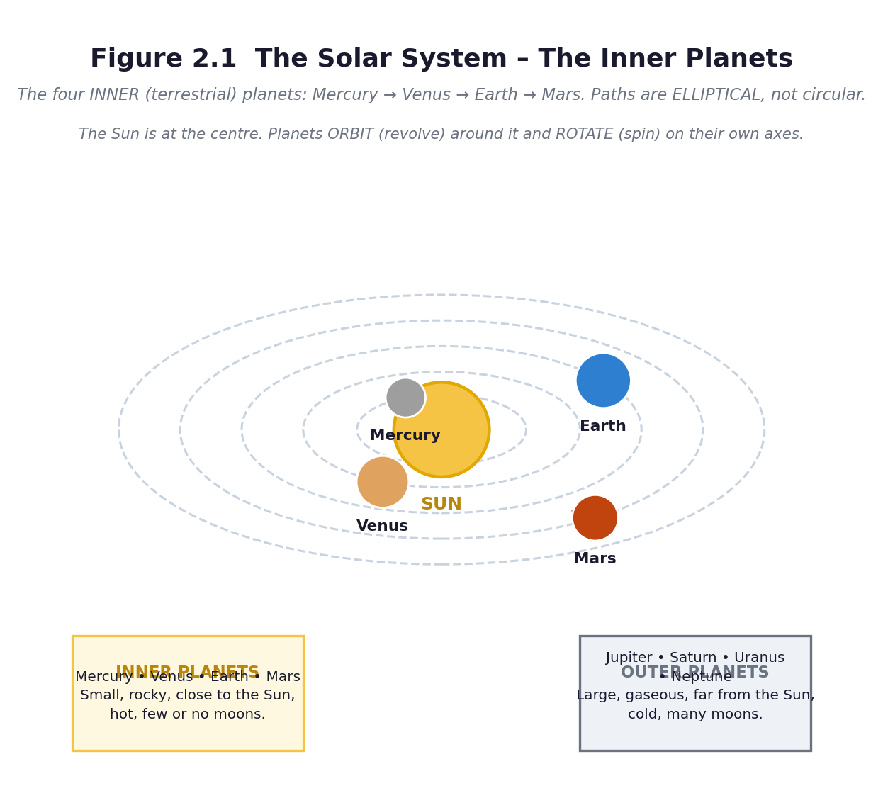
Figure 2.1 The solar system — the four inner planets.
PHASE / TIME | TEACHER ACTIVITY | LEARNER ACTIVITY | CORE COMP. | ASSESSMENT (DoK)
ENGAGE  8 min | Diagnostic (keep these — you will return to them after the learning tour). Ask learners to write: ‘What is the Sun? Where is the Earth? Does the Sun move, or does the Earth?’ Collect without comment. Then show Figure 2.1 and say only: ‘Everything you are looking at is moving.’ Share the performance indicator. | Learners write their answers. They look at the diagram and call out what they recognise. Most will identify Earth; fewer will place Mercury correctly. | DL; CP; CC; CI | Oral responses; diagnostic check. DoK 1
EXPLORE  18 min | Jigsaw: four groups, one planet each — Mercury, Venus, Earth, Mars. Each group gets a fact card and must produce a group poster: distance from the Sun, size compared with Earth, how long a year is, temperature, number of moons, one surprising fact. They then teach their planet to the rest of the class. Circulate and ask each group: ‘how long would it take you to get there?’ | Groups research from cards, textbooks and any digital source, produce a poster, and prepare a one-minute teaching slot. Each learner must be able to say one thing about each of the four planets by the end. | DL; CP; CC; CI | Observation checklist; group record. DoK 2
EXPLAIN  12 min | Groups teach. Then formalise with Figure 2.1. The Sun is a star at the centre. The four inner planets are Mercury, Venus, Earth, Mars — small and rocky, close together, hot, with few or no moons. The four outer planets are large and gaseous, far apart and cold. Introduce the two words the exam will test: elliptical, meaning oval, not circular; and the pair rotate (spin on an axis) and revolve (travel around something). Then the galaxy: the Sun is one star among billions in the Milky Way. | Learners take notes on a structured sheet, add the two key words to the word wall, and demonstrate the difference between rotating and revolving with their own bodies — spin on the spot, then walk around a chair. | DL; CP; CC; CI | Questioning; corrected work in a second colour. DoK 2
ELABORATE  12 min | The scale challenge. If the Sun were a football and the Earth a peppercorn, how far apart would they be? Work it out roughly together, then go outside if you can and pace out a scaled-down version: Mercury, Venus, Earth, Mars at the correct relative distances. Even a compressed version is a revelation — learners discover that the planets are tiny and the gaps are enormous. | Learners estimate, then pace out the model on the field, holding balls of different sizes at the right distances. They note how much empty space there is. | DL; CP; CC; CI | Application task; sentence frames. DoK 2–3
EVALUATE  10 min | Exit ticket: name the four inner planets in order from the Sun; state one property of each; and explain the difference between rotate and revolve in one sentence each. Preview Lesson 8: ‘tomorrow we build the model’. | Learners complete the exit ticket and self-assess. They keep the diagnostic card for the post-tour comparison in Lesson 9 or 10. | DL; CP; CC; CI | Exit ticket or assessed product. DoK 2–3

APPROACHING  PROFICIENCY (AP) | Support — a mnemonic for the order (My Very Educated Mother, or learners invent their own, ideally in a Ghanaian language); a completed fact card to read from.
PROFICIENT (P) | Core — four planets in order, one property each, elliptical and rotate/revolve defined.
HIGHLY  PROFICIENT (HP) | Extension — why is Venus hotter than Mercury, even though Mercury is closer to the Sun? Answer: Venus has a thick carbon-dioxide atmosphere that traps heat.

ASSESSMENT (summary) | Group poster assessed with rubric R4. Exit ticket. The Engage diagnostic is not scored — it is your evidence of conceptual change when you repeat it at the end of the unit.
HOMEWORK / PROJECT WORK | Learn the order of the four inner planets. If the sky is clear, look for the brightest object in the western sky just after sunset — that is usually Venus. Never look at the Sun.
SAFETY | No learner may look directly at the Sun, or at the Sun through any lens, telescope or binoculars, at any time. If you observe the Sun, project its image onto a white card. This rule is non-negotiable and must be stated before any outdoor astronomy.
CROSS-CUTTING LINKS | Mathematics — scale, ratio, relative distance. Social Studies — mapping and position. Values — Ghana's own space science programme: the Ghana Space Science and Technology Institute is a real employer of Ghanaian scientists.
LESSON CLOSURE | Return to the essential questions; two learners summarise, one says what is still unclear; record names for follow-up below.

REFLECTION AND REMARKS (complete after teaching)
What went well — evidence of learning you saw
What I would change next time
Learners who need follow-up, and what I will do
Head of Department remarks

TEACHER — NAME AND SIGNATURE | HEAD OF DEPARTMENT | DATE

BASIC 7 SCIENCE • TERM 1 • WEEKLY LESSON NOTE
LESSON 8 of 24 — Building the Solar System — The Model Task
Week 4 • Systems • The Solar System • B7.3.2.1.1 • 60 minutes
WEEK ENDING | DAY | DATE | PERIOD | DURATION | CLASS | SUBJECT
 |  |  |  | 60 min | Basic 7 | Science

CLASS SIZE — BOYS | CLASS SIZE — GIRLS | CLASS SIZE — TOTAL

STRAND | Systems
SUB-STRAND | The Solar System
CONTENT STANDARD | B7.3.2.1 — Demonstrate knowledge of the inner planets of the solar system and understand their movement in the system.
LEARNING INDICATOR(S) | B7.3.2.1.1 — Identify the inner planets of the solar system and describe their properties.
PERFORMANCE INDICATOR  (what learners will do) | Learners can design and construct a model of the solar system and explain what it shows.
LEARNING OUTCOMES  (knowledge / skill / value) | • K — state what a model can and cannot show about the solar system.  • S — design and construct a model showing the four inner planets in order, in elliptical paths, with the Sun at the centre.  • A/V — work productively in a group and evaluate the model honestly against criteria.
CORE COMPETENCIES | Creativity and Innovation (CI); Communication and Collaboration (CC); Critical Thinking and Problem Solving (CP).
KEY WORDS | model, scale, orbit, ellipse, axis, tilt, relative distance, represent
ESSENTIAL QUESTIONS | 1. How can I show the order and the movement of the planets?  2. Why is the Sun at the centre of the solar system?
PRIOR KNOWLEDGE (R.P.K.) | Lesson 7 — the inner planets, their order and properties; elliptical orbits; rotation and revolution.
TEACHING / LEARNING RESOURCES  (TLMs) | Cardboard, string, wire, foil, paint, clay or pap, bottle tops, polystyrene balls, balls of different sizes, rulers, compasses or string-and-pencil for ellipses, glue, sticky tape. Figure 2.1 and 2.2. A copy of rubric R3 on the wall.
PEDAGOGICAL EXEMPLARS (methods) | Inquiry (5E); hands-on practical work; design and make; cooperative group work; questioning and discussion; differentiation by task, support and outcome
REFERENCE | NaCCA Science Curriculum for the Common Core Programme (Basic 7–10), February 2020 — B7.3.2.1.1, p. 19. Scheme of Learning, Week 4.

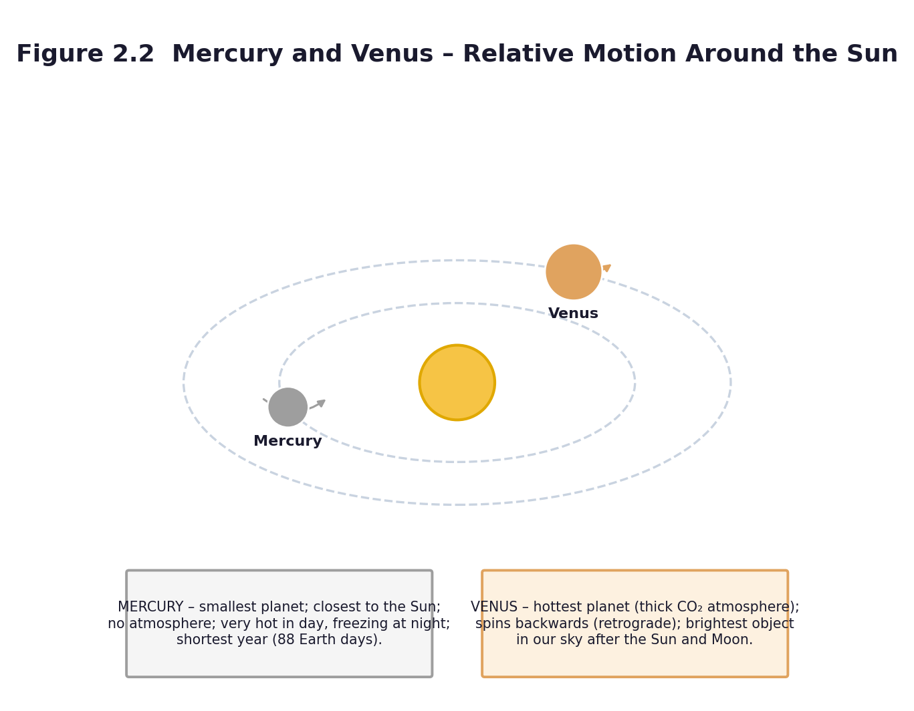
Figure 2.2 Mercury and Venus — relative motion around the Sun.
PHASE / TIME | TEACHER ACTIVITY | LEARNER ACTIVITY | CORE COMP. | ASSESSMENT (DoK)
ENGAGE  8 min | Show two models: a good one and a deliberately wrong one (planets out of order, all the same size, circular paths very close together). Ask: ‘Which is right, and how do you know?’ Then the key question: ‘Is a model the truth?’ Establish: a model is a tool for thinking, not a copy of reality, and every model leaves something out. Share rubric R3 now, before they build. | Learners spot the errors and justify their judgement. They read the rubric together and discuss what 'excellent' would look like. | CI; CC; CP | Oral responses; diagnostic check. DoK 1
EXPLORE  18 min | Design phase: each group draws a plan before touching materials — the order of the planets, their relative sizes, the shape and spacing of the paths, and what they will use for each. Teacher approves each plan. Then build. Circulate and ask: ‘which part of this is to scale and which part is not?’ — that question is worth more than any comment on neatness. | Groups plan on paper, get approval, collect materials and build. Roles: builder, measurer, label maker, checker against the rubric. | CI; CC; CP | Observation checklist; group record. DoK 2
EXPLAIN  12 min | Halfway stop. Groups hold up their models. Address the two most common errors explicitly: circular rather than elliptical paths, and equal spacing rather than increasing gaps. Show how to draw an ellipse with two pins and a loop of string. Remind them that the paths must be elliptical, as the curriculum requires, and that the Sun sits at a focus, not the centre of the ellipse. | Learners compare models, identify the two common errors in their own and others' work, and correct their paths with the string-and-pins method. | CI; CC; CP | Questioning; corrected work in a second colour. DoK 2
ELABORATE  12 min | Finish the models and add the labels and the two movement arrows: a curved arrow round the Sun for revolution, and a small curved arrow on each planet for rotation. Add a caption underneath stating one thing the model shows well and one thing it shows badly — this is the sophisticated part, and it is where the highest marks in the rubric are earned. | Groups complete, label and caption their models. The caption must contain both a strength and a limitation, for example: ‘This model shows the order of the planets correctly, but the planets are far too big compared with the distances between them.’ | CI; CC; CP | Application task; sentence frames. DoK 2–3
EVALUATE  10 min | Gallery walk: models on display, each learner places one sticky note with ‘one thing done well’ and one with ‘one improvement’. Then each group gives its two-minute oral explanation. Assess with rubric R3. | Learners walk the gallery, read, and write specific comments. Each group presents: order, properties, what the model shows and what it cannot. | CI; CC; CP | Exit ticket or assessed product. DoK 2–3

APPROACHING  PROFICIENCY (AP) | Support — provide a template with the Sun drawn and the four positions marked; the group adds the planets and labels.
PROFICIENT (P) | Core — as described; correct order, elliptical paths, labelled, with a caption.
HIGHLY  PROFICIENT (HP) | Extension — make the model to scale for distance (even if the planet sizes then become invisible), and calculate how far away Neptune would be on that scale.

ASSESSMENT (summary) | The model and the oral explanation, marked with rubric R3 (20 marks). Peer comments from the gallery walk contribute to the process-skills mark. Keep the models for the Week 5 revision and for the school's science exhibition.
HOMEWORK / PROJECT WORK | Write a paragraph: ‘What my model shows well, and what it cannot show.’ Revise the order of the planets.
SAFETY | Scissors and wire: a tool talk before starting. No hot glue without supervision. Clear walkways.
CROSS-CUTTING LINKS | Creative Arts and Design — the model is a design-and-make task assessed partly on craft. Mathematics — scale, ratio, drawing an ellipse. English — the caption and the oral explanation.
LESSON CLOSURE | Return to the essential questions; two learners summarise, one says what is still unclear; record names for follow-up below.

REFLECTION AND REMARKS (complete after teaching)
What went well — evidence of learning you saw
What I would change next time
Learners who need follow-up, and what I will do
Head of Department remarks

TEACHER — NAME AND SIGNATURE | HEAD OF DEPARTMENT | DATE

BASIC 7 SCIENCE • TERM 1 • WEEKLY LESSON NOTE
LESSON 9 of 24 — Mercury and Venus — Properties and Relative Motion
Week 5 • Systems • The Solar System • B7.3.2.1.2 • 60 minutes
WEEK ENDING | DAY | DATE | PERIOD | DURATION | CLASS | SUBJECT
 |  |  |  | 60 min | Basic 7 | Science

CLASS SIZE — BOYS | CLASS SIZE — GIRLS | CLASS SIZE — TOTAL

STRAND | Systems
SUB-STRAND | The Solar System
CONTENT STANDARD | B7.3.2.1 — Demonstrate knowledge of the inner planets of the solar system and understand their movement in the system.
LEARNING INDICATOR(S) | B7.3.2.1.2 — Discuss the properties and the relative motions of the planets Mercury and Venus.
PERFORMANCE INDICATOR  (what learners will do) | Learners can outline the properties of Mercury and Venus and describe their movement around the Sun.
LEARNING OUTCOMES  (knowledge / skill / value) | • K — state at least three properties peculiar to each of Mercury and Venus.  • S — describe and demonstrate the movement of Mercury and Venus around the Sun, and explain why their apparent motion differs from their real motion.  • A/V — appreciate that careful observation over time is how astronomers discovered these motions.
CORE COMPETENCIES | Digital Literacy (DL); Critical Thinking and Problem Solving (CP); Communication and Collaboration (CC); Creativity and Innovation (CI).
KEY WORDS | Mercury, Venus, atmosphere, carbon dioxide, retrograde, relative motion, orbit, revolution, rotation, greenhouse effect, orbit period
ESSENTIAL QUESTIONS | 1. What are Mercury and Venus like?  2. How do Mercury and Venus move around the Sun?
PRIOR KNOWLEDGE (R.P.K.) | Lessons 7 and 8 — the inner planets, the model, elliptical orbits, rotation and revolution. Note: if the class went on Tour 1 (A10.5), start here by revisiting the visit.
TEACHING / LEARNING RESOURCES  (TLMs) | Figure 2.2 enlarged to A3. The models from Lesson 8. A lamp for the Sun, and two learners holding balls to represent Mercury and Venus. Comparison tables. Any photographs or notes from the learning tour.
PEDAGOGICAL EXEMPLARS (methods) | Inquiry (5E); ICT / digital resources; cooperative group work; questioning and discussion; differentiation by task, support and outcome
REFERENCE | NaCCA Science Curriculum for the Common Core Programme (Basic 7–10), February 2020 — B7.3.2.1.2, p. 20. Scheme of Learning, Week 5.

Figure 2.2 Mercury and Venus — properties and relative motion.
PHASE / TIME | TEACHER ACTIVITY | LEARNER ACTIVITY | CORE COMP. | ASSESSMENT (DoK)
ENGAGE  8 min | If the class went on the tour, open with: ‘What did you see that you did not expect?’ and revisit the pre-visit diagnostic cards, crossing out what was wrong. If not, ask: ‘Which is the hottest planet?’ Most will say Mercury, because it is closest. Say: ‘It is not. Let us find out why.’ Share the performance indicator. | Learners share tour memories or answer the question. They write down their prediction for the hottest planet and the reason for it. | DL; CP; CC; CI | Oral responses; diagnostic check. DoK 1
EXPLORE  18 min | Pairs research Mercury and Venus and complete a comparison table: distance from the Sun, diameter, length of a day, length of a year, surface temperature, atmosphere, moons, and one odd fact. Then the movement task: one learner is the Sun holding a lamp, two walk the orbits. The class times each lap. Mercury's lap must be much shorter than Venus's. | Learners complete the table from cards, books and any digital source. Three learners act out the orbits while the rest time the laps and record how many laps each completes in a set time. | DL; CP; CC; CI | Observation checklist; group record. DoK 2
EXPLAIN  12 min | Formalise with Figure 2.2. Mercury: smallest planet, closest to the Sun, almost no atmosphere, scorching by day and freezing by night, the shortest year at about 88 Earth days, no moons. Venus: similar in size to Earth, wrapped in a thick carbon-dioxide atmosphere that traps heat so it is the hottest planet at about 465 °C, spins backwards compared with the other planets, and is the brightest natural object in our sky after the Sun and Moon — which is why it is called the morning or evening star. | Learners correct and complete their tables, add the two planets to their models with movement arrows, and answer the prediction question: why is Venus hotter than Mercury? | DL; CP; CC; CI | Questioning; corrected work in a second colour. DoK 2
ELABORATE  12 min | The relative-motion problem. Ask: ‘If Mercury goes round the Sun faster than we do, why does it not simply disappear from our sky?’ Model it: three learners walk their orbits at the correct relative speeds while a fourth, as Earth, calls out what Mercury and Venus look like from where she is standing. Learners see that the two inner planets always stay near the Sun in our sky, which is why we only ever see them near dawn or dusk. | Learners act out the relative motion and record what the observer on Earth would see: Mercury and Venus never appear far from the Sun, and they show phases like the Moon. | DL; CP; CC; CI | Application task; sentence frames. DoK 2–3
EVALUATE  10 min | Exit ticket: three facts about Mercury, three about Venus, and one sentence on how their motions differ from Earth's. Then revisit the Lesson 7 diagnostic card for anyone who has not yet corrected the ‘the Sun goes round the Earth’ idea. | Learners complete the exit ticket, then check their original diagnostic answers against what they now know and write one sentence about what changed. | DL; CP; CC; CI | Exit ticket or assessed product. DoK 2–3

APPROACHING  PROFICIENCY (AP) | Support — a comparison table with the headings and some entries filled in; sentence frames for each fact.
PROFICIENT (P) | Core — three properties each, plus a correct description of their orbital motion.
HIGHLY  PROFICIENT (HP) | Extension — explain the greenhouse effect on Venus in terms of incoming and outgoing energy, and connect it to climate change on Earth — this is the same physics.

ASSESSMENT (summary) | The comparison table (checklist C7.5). The acted-out relative motion, observed. The exit ticket. The Lesson 7 diagnostic revisited — evidence of conceptual change is the most satisfying assessment data you will collect all term.
HOMEWORK / PROJECT WORK | Write a short dialogue between Mercury and Venus in which each boasts about why it is the more remarkable planet. Include at least three true facts about each.
SAFETY | No Sun-gazing, ever. If you go outside to model the orbits, use a lamp or a yellow ball for the Sun, never the real Sun.
CROSS-CUTTING LINKS | English — the comparison table and the dialogue. Mathematics — relative speed and orbital period. Values — careful observation over time; the Ghanaian astronomers at GSSTI who do this work.
LESSON CLOSURE | Return to the essential questions; two learners summarise, one says what is still unclear; record names for follow-up below.

REFLECTION AND REMARKS (complete after teaching)
What went well — evidence of learning you saw
What I would change next time
Learners who need follow-up, and what I will do
Head of Department remarks

TEACHER — NAME AND SIGNATURE | HEAD OF DEPARTMENT | DATE

BASIC 7 SCIENCE • TERM 1 • WEEKLY LESSON NOTE
LESSON 10 of 24 — Day, Night and the Year — Consolidation and Unit 2 Assessment
Week 5 • Systems • The Solar System • B7.3.2.1.2 • 60 minutes
WEEK ENDING | DAY | DATE | PERIOD | DURATION | CLASS | SUBJECT
 |  |  |  | 60 min | Basic 7 | Science

CLASS SIZE — BOYS | CLASS SIZE — GIRLS | CLASS SIZE — TOTAL

STRAND | Systems
SUB-STRAND | The Solar System
CONTENT STANDARD | B7.3.2.1 — Demonstrate knowledge of the inner planets of the solar system and understand their movement in the system.
LEARNING INDICATOR(S) | B7.3.2.1.2 — Discuss the properties and the relative motions of the planets Mercury and Venus.
PERFORMANCE INDICATOR  (what learners will do) | Learners can explain day and night and the year in terms of rotation and revolution, and demonstrate their understanding with a model.
LEARNING OUTCOMES  (knowledge / skill / value) | • K — explain day and night as a consequence of the Earth's rotation, and the year as a consequence of its revolution round the Sun.  • S — demonstrate both motions with a model and use evidence from a shadow to support the explanation.  • A/V — appreciate that a simple observation — a moving shadow — is evidence for a large and invisible process.
CORE COMPETENCIES | Communication and Collaboration (CC); Critical Thinking and Problem Solving (CP); Creativity and Innovation (CI).
KEY WORDS | rotation, revolution, axis, day, year, orbit, elliptical, shadow, seasons
ESSENTIAL QUESTIONS | 1. Why do we have day and night?  2. What is the difference between rotation and revolution?
PRIOR KNOWLEDGE (R.P.K.) | Lessons 7–9 — all the Unit 2 content.
TEACHING / LEARNING RESOURCES  (TLMs) | The models from Lesson 8. A lamp or torch, a ball or globe, sticky tack. The shadow-stick data if you ran the zero-cost outdoor activity (A10.9). Unit Test 2 (Part C1), one copy per learner. Rubric R3.
PEDAGOGICAL EXEMPLARS (methods) | Inquiry (5E); hands-on practical work; cooperative group work; questioning and discussion; differentiation by task, support and outcome
REFERENCE | NaCCA Science Curriculum for the Common Core Programme (Basic 7–10), February 2020 — B7.3.2.1.2, p. 20. Scheme of Learning, Week 5.

PHASE / TIME | TEACHER ACTIVITY | LEARNER ACTIVITY | CORE COMP. | ASSESSMENT (DoK)
ENGAGE  8 min | Darken the room as far as you can. Put the lamp in the middle and hold up the globe. Ask: ‘It is noon in Accra. Where on this globe is it midnight?’ Then rotate the globe slowly and let learners call out when a marked point enters the light and when it leaves. Share the performance indicator. | Learners identify the lit and dark halves, find the terminator, and predict which places are experiencing sunrise, noon and midnight. | CC; CP; CI | Oral responses; diagnostic check. DoK 1
EXPLORE  18 min | Two investigations. Station A: rotate the globe and record how long a marked point stays in the light — that is a day. Station B: keeping the globe's axis tilted and always pointing the same way, walk it once round the lamp and record what happens to the amount of light at the marked point — that is a year. Groups rotate between stations and record on a sheet. | Learners work the models, record observations, and answer: what causes day and night? What causes the year? Which motion are you copying in each case? | CC; CP; CI | Observation checklist; group record. DoK 2
EXPLAIN  12 min | Formalise the two sentences that the exam wants: day and night are caused by the Earth rotating on its axis once every 24 hours; the year is caused by the Earth revolving once round the Sun in about 365 days, in an elliptical path. Then use the shadow-stick evidence if you have it: the shadow moved through the day, and it was shortest at midday — that is direct evidence that the Earth turned. | Learners write the two sentences, underline the key words, and add the shadow evidence to their sheets. They rehearse both sentences aloud to a partner. | CC; CP; CI | Questioning; corrected work in a second colour. DoK 2
ELABORATE  12 min | Unit 2 revision circuit: four stations round the room — (1) order the planets from flashcards; (2) match the property to the planet; (3) label Figure 2.1; (4) sort statements into rotation or revolution. Groups have three minutes at each. Then address the two commonest exam errors: confusing rotate with revolve, and describing orbits as circles. | Groups rotate round the four stations and self-mark against answers pinned at each station. They record which station they found hardest — that tells you what to reteach before the test. | CC; CP; CI | Application task; sentence frames. DoK 2–3
EVALUATE  10 min | Unit Test 2 (Part C1) — twenty marks. If time is short, run it in the first twenty minutes of the next science period. After the test, whole-class feedback: write the four commonest errors on the board and give five minutes for learners to correct their own work in a different colour. | Learners complete the test, then self-correct against the board feedback and record their score in their journal. | CC; CP; CI | Exit ticket or assessed product. DoK 2–3

APPROACHING  PROFICIENCY (AP) | Support — a cloze version of the two key sentences; a partner to rehearse with.
PROFICIENT (P) | Core — both motions explained correctly with a model demonstration.
HIGHLY  PROFICIENT (HP) | Extension — explain why the axis tilt gives seasons, and why Ghana, close to the equator, does not have four seasons in the European sense but has rainy and dry seasons instead.

ASSESSMENT (summary) | Unit Test 2 (20 marks) plus the model and oral from Lesson 8 (rubric R3, 20 marks). The revision station self-assessment tells you what to reteach in Week 13.
HOMEWORK / PROJECT WORK | Revise Unit 2 for the test if it was not completed in class. Bring in any clean scrap material (cardboard, string, bottle tops) for the Unit 3 water-cycle model.
SAFETY | The lamp can get hot — use a low-wattage bulb or an LED and warn learners not to touch it. No Sun-gazing.
CROSS-CUTTING LINKS | Mathematics — time, angles, the 24-hour clock. Geography / Social Studies — position on the globe, the equator. English — explaining a process in sequence.
LESSON CLOSURE | Return to the essential questions; two learners summarise, one says what is still unclear; record names for follow-up below.

REFLECTION AND REMARKS (complete after teaching)
What went well — evidence of learning you saw
What I would change next time
Learners who need follow-up, and what I will do
Head of Department remarks

TEACHER — NAME AND SIGNATURE | HEAD OF DEPARTMENT | DATE

BASIC 7 SCIENCE • TERM 1 • WEEKLY LESSON NOTE
LESSON 11 of 24 — The Water Cycle — How It Happens
Week 6 • Cycles • Earth Science • B7.2.1.1.1 • 60 minutes
WEEK ENDING | DAY | DATE | PERIOD | DURATION | CLASS | SUBJECT
 |  |  |  | 60 min | Basic 7 | Science

CLASS SIZE — BOYS | CLASS SIZE — GIRLS | CLASS SIZE — TOTAL

STRAND | Cycles
SUB-STRAND | Earth Science
CONTENT STANDARD | B7.2.1.1 — Recognise that the water cycle is an example of repeated patterns of change in nature and understand how it occurs.
LEARNING INDICATOR(S) | B7.2.1.1.1 — Explain how the water cycle occurs as a repeated pattern in nature.
PERFORMANCE INDICATOR  (what learners will do) | Learners can identify the stages of the water cycle, explain how they are linked, and demonstrate the process of transpiration and cloud formation.
LEARNING OUTCOMES  (knowledge / skill / value) | • K — name the four stages of the water cycle in order and state what drives it.  • S — demonstrate evaporation and condensation, and draw a flow chart showing the order of the stages and how they are linked.  • A/V — appreciate that the water we use today is the same water that has been cycling for millions of years.
CORE COMPETENCIES | Critical Thinking and Problem Solving (CP); Digital Literacy (DL); Creativity and Innovation (CI).
KEY WORDS | water cycle, evaporation, condensation, precipitation, transpiration, collection, run-off, water vapour, cloud, repeated pattern
ESSENTIAL QUESTIONS | 1. Where does the water in the clouds come from?  2. What are the stages of the water cycle, and how are they linked?
PRIOR KNOWLEDGE (R.P.K.) | Lesson 2 — liquids and their importance. Basic 6 work on water and weather. Note: this indicator is a prerequisite for Week 6's timetabled indicator and is not itself timetabled in the scheme — see A1.3, Gap 1. It must be taught.
TEACHING / LEARNING RESOURCES  (TLMs) | A large transparent bowl or jar with a lid or cling film, warm water, a cold plate or ice, salt. A leafy plant in a clear plastic bag. Figure 3.1 enlarged to A3. If possible, the sealed-bowl set up a week earlier so learners can see the result.
PEDAGOGICAL EXEMPLARS (methods) | Inquiry (5E); hands-on practical work; ICT / digital resources; cooperative group work; questioning and discussion; differentiation by task, support and outcome
REFERENCE | NaCCA Science Curriculum for the Common Core Programme (Basic 7–10), February 2020 — B7.2.1.1.1, p. 7. Scheme of Learning, Week 6.

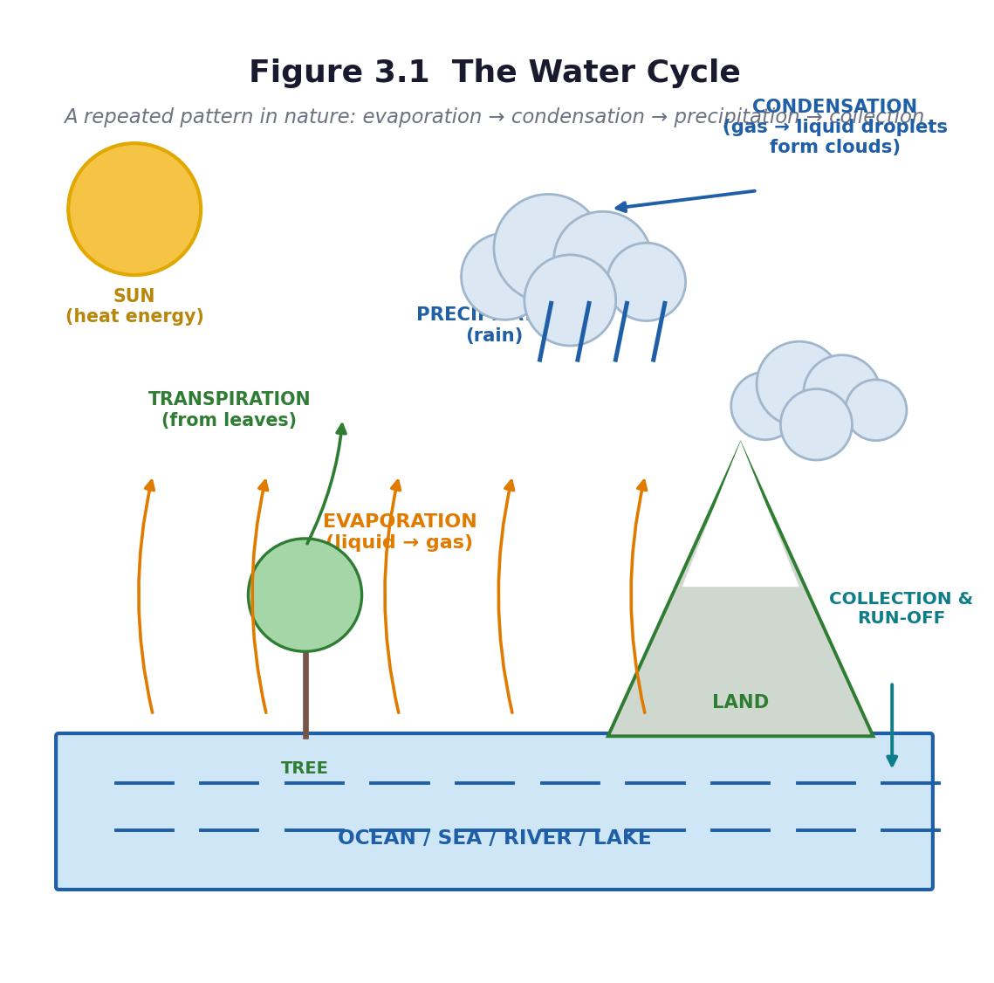
Figure 3.1 The water cycle.
PHASE / TIME | TEACHER ACTIVITY | LEARNER ACTIVITY | CORE COMP. | ASSESSMENT (DoK)
ENGAGE  8 min | POE (predict–observe–explain). Show a bowl of warm water and a cold plate held above it. Ask: ‘What will appear on the underside of the plate, and where will it come from?’ Learners write a prediction and a reason BEFORE you do it. Then hold the cold plate above the steam for sixty seconds and let them see the droplets. Share the performance indicator. | Learners write predictions individually. They observe the droplets forming. Those who predicted ‘nothing’ or ‘the water is leaking through the plate’ have now had their idea made to fail — which is the necessary first step. | CP; DL; CI | Oral responses; diagnostic check. DoK 1
EXPLORE  18 min | Two demonstrations plus one investigation. Demonstration 1: the sealed bowl — warm water in a transparent bowl, covered with cling film or a lid, with ice or a cold plate on top, left in the sun. Demonstration 2: a leafy plant branch sealed in a clear plastic bag, left in the sun. Set both up at the start of the lesson and return to them at the end. Meanwhile, groups do the investigation: put equal volumes of water in three identical containers — one wide, one narrow, one covered — and predict which will lose most water by tomorrow. | Learners set up or observe the demonstrations, make and record predictions about the three containers, and record the starting water level with a marker pen on each container. | CP; DL; CI | Observation checklist; group record. DoK 2
EXPLAIN  12 min | Return to the demonstrations. Name the process: evaporation (liquid to gas, from the surface, driven by the Sun's heat), condensation (gas to liquid on a cold surface, forming clouds), precipitation (water falling as rain), collection and run-off (water gathering in rivers, lakes, oceans and underground). Add transpiration — water lost from leaves, shown by the bagged plant. Draw Figure 3.1 with the class, arrow by arrow, and stress the word cycle: it has no beginning and no end. | Learners draw and label the cycle, add the four processes as verb labels on the arrows (not just nouns), and answer: what drives the whole cycle? (The Sun's energy.) | CP; DL; CI | Questioning; corrected work in a second colour. DoK 2
ELABORATE  12 min | Two tasks. First, the mime: groups of six physically act out the cycle — learners are water molecules moving from the sea to the cloud to the rain to the river and back. Second, the hard question: ‘Where does the water in your borehole come from, and where does it go after you bathe?’ Trace the local water, not an abstract one. | Groups perform the cycle mime to each other. Then they trace their own community's water on a simple map or in a written chain. | CP; DL; CI | Application task; sentence frames. DoK 2–3
EVALUATE  10 min | Exit ticket: draw the water cycle with four labelled arrows. Then ‘one thing I still wonder’ — collect these; they often produce the best question of the term. Preview Lesson 12: ‘tomorrow, why the cycle matters — and what happens when it breaks’. | Learners complete the exit ticket and write one question. They self-assess against three criteria. | CP; DL; CI | Exit ticket or assessed product. DoK 2–3

APPROACHING  PROFICIENCY (AP) | Support — a flow-chart template with the four stage names to sequence and arrows to label.
PROFICIENT (P) | Core — four stages in order, each explained, with the Sun identified as the driver.
HIGHLY  PROFICIENT (HP) | Extension — explain why the water cycle is described as a *repeated pattern* rather than a process with a beginning and an end, and research what happens to the cycle when forest is cleared.

ASSESSMENT (summary) | The labelled diagram (checklist C7.6). The POE prediction sheet — compare prediction with observation to see whose thinking changed. The three-container investigation is checked next lesson.
HOMEWORK / PROJECT WORK | Check the three containers and record which lost the most water, and why. Leave the sealed bowl on the windowsill for a week and observe it daily.
SAFETY | The teacher handles all warm water and any heat source. Ice is fine; learners must not handle it for long. Keep the floor dry — wet floors and forty-five twelve-year-olds do not mix.
CROSS-CUTTING LINKS | Mathematics — measuring volumes and recording change over time. Social Studies — water as a resource, rivers and rainfall in Ghana. Values — protecting water sources is everyone's business.
LESSON CLOSURE | Return to the essential questions; two learners summarise, one says what is still unclear; record names for follow-up below.

REFLECTION AND REMARKS (complete after teaching)
What went well — evidence of learning you saw
What I would change next time
Learners who need follow-up, and what I will do
Head of Department remarks

TEACHER — NAME AND SIGNATURE | HEAD OF DEPARTMENT | DATE

BASIC 7 SCIENCE • TERM 1 • WEEKLY LESSON NOTE
LESSON 12 of 24 — Why the Water Cycle Matters
Week 6 • Cycles • Earth Science • B7.2.1.1.2 • 60 minutes
WEEK ENDING | DAY | DATE | PERIOD | DURATION | CLASS | SUBJECT
 |  |  |  | 60 min | Basic 7 | Science

CLASS SIZE — BOYS | CLASS SIZE — GIRLS | CLASS SIZE — TOTAL

STRAND | Cycles
SUB-STRAND | Earth Science
CONTENT STANDARD | B7.2.1.1 — Recognise that the water cycle is an example of repeated patterns of change in nature and understand how it occurs.
LEARNING INDICATOR(S) | B7.2.1.1.2 — Describe the importance of the water cycle in nature.
PERFORMANCE INDICATOR  (what learners will do) | Learners can describe the importance of the water cycle in terms of energy, nutrients, the water table, weather and clean water.
LEARNING OUTCOMES  (knowledge / skill / value) | • K — state five ways in which the water cycle is important in nature.  • S — illustrate the importance of the water cycle in the community with a diagram and a short report.  • A/V — appreciate that human activity can damage the cycle, and that protecting water sources protects people.
CORE COMPETENCIES | Communication and Collaboration (CC); Digital Literacy (DL); Creativity and Innovation (CI); Critical Thinking and Problem Solving (CP).
KEY WORDS | water table, groundwater, nutrient, weather pattern, drought, flood, reservoir, filtration, purification
ESSENTIAL QUESTIONS | 1. Why is the water cycle important to life?  2. What would happen if the water cycle stopped?
PRIOR KNOWLEDGE (R.P.K.) | Lesson 11 — the four stages of the water cycle and the Sun as its driver.
TEACHING / LEARNING RESOURCES  (TLMs) | The sealed bowl from Lesson 11, the three-container results, Figure 3.1, a diagram of a well showing the water table, posters or photographs of a Ghanaian river, reservoir or treatment plant. Any material gathered on Tour 2 (A10.6).
PEDAGOGICAL EXEMPLARS (methods) | Inquiry (5E); ICT / digital resources; cooperative group work; questioning and discussion; differentiation by task, support and outcome
REFERENCE | NaCCA Science Curriculum for the Common Core Programme (Basic 7–10), February 2020 — B7.2.1.1.2, p. 8. Scheme of Learning, Week 6.

Figure 3.1 The water cycle — the same diagram, now annotated with why each stage matters.
PHASE / TIME | TEACHER ACTIVITY | LEARNER ACTIVITY | CORE COMP. | ASSESSMENT (DoK)
ENGAGE  8 min | Check the three containers and discuss the results. Then ask: ‘Suppose the water cycle stopped tomorrow. What would happen first?’ Take answers and build a chain of consequences on the board — no rain, no crops, no water in the taps, no hydroelectricity, no boreholes. Share the performance indicator. | Learners report their measurements, then brainstorm consequences. The chain usually gets bleak quickly, which is the point: importance is best understood by imagining absence. | CC; DL; CI; CP | Oral responses; diagnostic check. DoK 1
EXPLORE  18 min | Groups investigate one of five ways the cycle matters, using textbooks, any digital sources, and their own knowledge: (1) energy — the cycle releases and moves heat around the planet; (2) carrier of nutrients — water moves dissolved minerals from soil into plants and through ecosystems; (3) improving the water table — rain soaks into the ground and refills the groundwater that wells and boreholes draw on; (4) regulating weather patterns; (5) provision of clean water — evaporation leaves salts and dirt behind, so rain is naturally distilled. | Each group becomes expert on one importance and prepares to teach it, producing a diagram and a one-minute explanation. | CC; DL; CI; CP | Observation checklist; group record. DoK 2
EXPLAIN  12 min | Groups teach, in the order 1 to 5. Add the evidence: hold up the sealed bowl — the water that condensed on the cold top is pure, and the salt and dirt stayed behind in the bowl. That is distillation, and it is why rain is fresh even though it comes from the salty sea. Show the water table diagram: the borehole water learners drink fell as rain, perhaps years ago, perhaps far away. | Learners take notes on all five importances, and add the distillation evidence to their own diagrams. They connect the water table drawing to their own community's water source. | CC; DL; CI; CP | Questioning; corrected work in a second colour. DoK 2
ELABORATE  12 min | The threat task. Ask: ‘What do people in this community do that damages the water cycle?’ Groups list: cutting down trees, dumping refuse in drains and streams, building on watercourses, burning, over-pumping boreholes. Then each group chooses one threat and produces a poster showing the threat, the consequence, and one action the school could take. | Groups list threats, choose one, and design a poster with a clear message and one concrete action. | CC; DL; CI; CP | Application task; sentence frames. DoK 2–3
EVALUATE  10 min | Gallery walk of the posters with structured peer feedback. Exit ticket: ‘Give three reasons why the water cycle is important.’ Then the individual assessed piece: a diagram illustrating the importance of the water cycle in the community, with labels. | Learners walk the gallery, write one specific comment per poster, complete the exit ticket, and begin the assessed diagram. | CC; DL; CI; CP | Exit ticket or assessed product. DoK 2–3

APPROACHING  PROFICIENCY (AP) | Support — a sentence frame for each importance: ‘The water cycle is important because ___, which means that ___.’
PROFICIENT (P) | Core — five importances described, with a labelled diagram of one.
HIGHLY  PROFICIENT (HP) | Extension — research and present one Ghanaian case: a river or reservoir under pressure, what is causing it, and what is being done.

ASSESSMENT (summary) | The assessed diagram (10 marks) plus the exit ticket. The poster contributes to the process-skills and values record. If the class went on Tour 2, the post-visit writing task in A10.6 substitutes for the homework.
HOMEWORK / PROJECT WORK | Write a short piece: ‘Where my water comes from, and one thing I will do to protect it.’ Optional extended task: make a rain gauge from a cut bottle and record rainfall daily for two weeks.
SAFETY | No tasting of any water. If you collected rainwater for inspection, do not drink it.
CROSS-CUTTING LINKS | Social Studies — water resources, rivers, sanitation. English — the persuasive poster. Values — environmental responsibility, and the curriculum's own aim of developing ‘a humane and responsible attitude towards the use of all resources in Ghana’.
LESSON CLOSURE | Return to the essential questions; two learners summarise, one says what is still unclear; record names for follow-up below.

REFLECTION AND REMARKS (complete after teaching)
What went well — evidence of learning you saw
What I would change next time
Learners who need follow-up, and what I will do
Head of Department remarks

TEACHER — NAME AND SIGNATURE | HEAD OF DEPARTMENT | DATE

BASIC 7 SCIENCE • TERM 1 • WEEKLY LESSON NOTE
LESSON 13 of 24 — The Life Cycle of the Housefly
Week 7 • Cycles • Life Cycle of Organisms • B7.2.2.1.1 • 60 minutes
WEEK ENDING | DAY | DATE | PERIOD | DURATION | CLASS | SUBJECT
 |  |  |  | 60 min | Basic 7 | Science

CLASS SIZE — BOYS | CLASS SIZE — GIRLS | CLASS SIZE — TOTAL

STRAND | Cycles
SUB-STRAND | Life Cycle of Organisms
CONTENT STANDARD | B7.2.2.1 — Demonstrate the skills of carrying out activities to show the stages of the life cycle of a housefly, the effects of its activities on humans and how to reduce them.
LEARNING INDICATOR(S) | B7.2.2.1.1 — Describe the life cycle of the housefly.
PERFORMANCE INDICATOR  (what learners will do) | Learners can identify and describe the stages of the life cycle of the housefly and arrange them in the correct order.
LEARNING OUTCOMES  (knowledge / skill / value) | • K — name and describe the four stages of the housefly life cycle in the correct order.  • S — arrange flashcards or cut-outs to show the order, and draw the cycle with arrows linking the stages.  • A/V — appreciate that flies breed in specific places, and that knowing the life cycle is the key to controlling them.
CORE COMPETENCIES | Communication and Collaboration (CC); Digital Literacy (DL); Creativity and Innovation (CI).
KEY WORDS | life cycle, egg, larva, maggot, pupa, adult, metamorphosis, breed, stage, moult
ESSENTIAL QUESTIONS | 1. Where do houseflies come from?  2. What are the stages in the life of a housefly?
PRIOR KNOWLEDGE (R.P.K.) | Unit 1 — living things are made of cells. Basic 6 — life cycles of a butterfly, a frog or a chicken. Many learners will believe that maggots are generated spontaneously by rotting meat — this lesson is designed to break that idea.
TEACHING / LEARNING RESOURCES  (TLMs) | Figure 3.2 enlarged to A3. Stage cards (egg, larva, pupa, adult) for sequencing. Any photographs or video. Two jars prepared a week earlier: one with meat or fruit open to flies, one sealed with fine cloth — this is the Redi experiment and it is the single most valuable artefact you can bring to this lesson. Larvae or pupae if available. Set up the jars in Week 5 so they are ready now.
PEDAGOGICAL EXEMPLARS (methods) | Inquiry (5E); hands-on practical work; ICT / digital resources; cooperative group work; questioning and discussion; differentiation by task, support and outcome
REFERENCE | NaCCA Science Curriculum for the Common Core Programme (Basic 7–10), February 2020 — B7.2.2.1.1, p. 9. Scheme of Learning, Week 7.

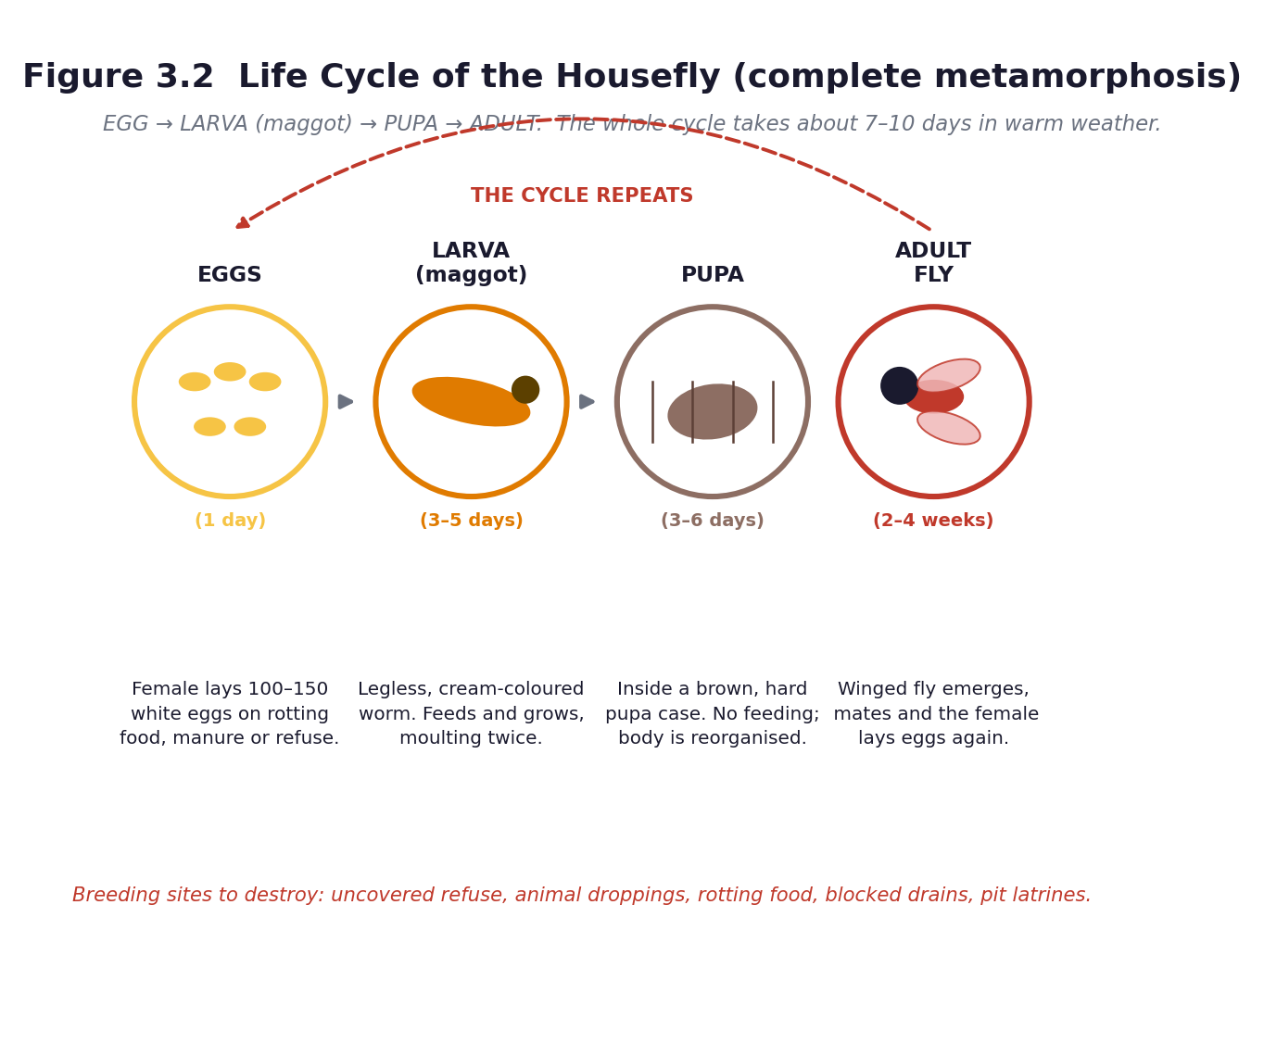
Figure 3.2 Life cycle of the housefly: egg → larva → pupa → adult.
PHASE / TIME | TEACHER ACTIVITY | LEARNER ACTIVITY | CORE COMP. | ASSESSMENT (DoK)
ENGAGE  8 min | Bring out the two jars — the open one with maggots, the sealed one with none. Ask: ‘Same meat, same day, same place. Why does one jar have maggots and the other does not?’ Do not answer. Let the argument run. Then say: ‘Everything alive comes from something else alive. Let us find out what came into this jar.’ Share the performance indicator. | Learners observe both jars and argue about the cause. Most will say the meat ‘turned into’ maggots. Write the competing explanations on the board — you will return to them. | CC; DL; CI | Oral responses; diagnostic check. DoK 1
EXPLORE  18 min | Sequencing task: each group receives four stage cards with a picture and a description, shuffled. They must put them in order and justify the order. Then the observation task: examine the jar closely with a hand lens — without opening it — and draw what they see at each level: the eggs (tiny white grains), the larvae (cream-coloured, legless, feeding), the pupae (brown, oval, still), and any adults. | Groups sequence the cards and defend their order. They observe the jar from outside and draw each stage they can identify, recording the day and what they see. | CC; DL; CI | Observation checklist; group record. DoK 2
EXPLAIN  12 min | Formalise with Figure 3.2. Eggs — a female lays 100 to 150 white eggs on rotting food, manure or refuse; they hatch in about a day. Larva (maggot) — legless, cream-coloured, feeds and grows for three to five days, moulting twice. Pupa — inside a hard brown case, no feeding, the body is reorganised, three to six days. Adult — the winged fly emerges, mates, and the female lays eggs again. The whole cycle takes about seven to ten days in warm weather. Name it: this is complete metamorphosis. Now return to the two jars: the flies laid eggs on the open meat; the cloth kept them out of the sealed jar. Maggots do not come from meat. | Learners correct their sequences, draw the cycle as a circle with arrows, and write one line of notes on each stage. They then re-answer the jar question in writing. | CC; DL; CI | Questioning; corrected work in a second colour. DoK 2
ELABORATE  12 min | Two tasks. First, the comparison: how is the housefly cycle like the water cycle? Both are cycles, both repeat, both have stages — but one is a *life* cycle and the other is not. Second, the timing calculation: if one female lays 150 eggs and the cycle takes ten days, why can a single uncovered bin produce thousands of flies in a month? | Groups make the comparison and then work out, roughly, why fly numbers explode so fast. They record the reasoning, not just the number. | CC; DL; CI | Application task; sentence frames. DoK 2–3
EVALUATE  10 min | Exit ticket: draw and label the four stages in order, with arrows. Then one question: ‘What is the weakest point in the cycle, if you wanted to stop flies breeding?’ Collect the answers — they feed directly into Lesson 16. | Learners complete the exit ticket and answer the control question from what they now know. | CC; DL; CI | Exit ticket or assessed product. DoK 2–3

APPROACHING  PROFICIENCY (AP) | Support — a sequencing strip with the four stages to cut and stick in order; a word bank for the descriptions.
PROFICIENT (P) | Core — four stages in order, each described in one sentence, drawn as a cycle.
HIGHLY  PROFICIENT (HP) | Extension — compare the housefly's complete metamorphosis with the incomplete metamorphosis of a grasshopper (egg → nymph → adult), and explain why there is no pupal stage in the second.

ASSESSMENT (summary) | The sequencing task and the labelled cycle diagram (checklist C7.7). The re-answer to the jar question is the real assessment: it shows whether conceptual change happened.
HOMEWORK / PROJECT WORK | Write notes on each of the four stages. For homework observation: find one place near your home where flies are breeding, and note what it is — do not touch anything.
SAFETY | The jar stays sealed, always, and is never opened in the classroom. No learner touches the contents. Keep it away from direct sun. At the end of the unit, dispose of it by sealing the whole jar in a bag and putting it in the refuse, or by burying it deep. Everyone washes hands with soap after every session involving the jar.
CROSS-CUTTING LINKS | Mathematics — the timing calculation and rates of increase. English — sequencing and descriptive writing. Values — evidence over assumption: this lesson is a lesson about how science settles an argument.
LESSON CLOSURE | Return to the essential questions; two learners summarise, one says what is still unclear; record names for follow-up below.

REFLECTION AND REMARKS (complete after teaching)
What went well — evidence of learning you saw
What I would change next time
Learners who need follow-up, and what I will do
Head of Department remarks

TEACHER — NAME AND SIGNATURE | HEAD OF DEPARTMENT | DATE

BASIC 7 SCIENCE • TERM 1 • WEEKLY LESSON NOTE
LESSON 14 of 24 — Rearing and Recording — The Housefly Diary
Week 7 • Cycles • Life Cycle of Organisms • B7.2.2.1.1 • 60 minutes
WEEK ENDING | DAY | DATE | PERIOD | DURATION | CLASS | SUBJECT
 |  |  |  | 60 min | Basic 7 | Science

CLASS SIZE — BOYS | CLASS SIZE — GIRLS | CLASS SIZE — TOTAL

STRAND | Cycles
SUB-STRAND | Life Cycle of Organisms
CONTENT STANDARD | B7.2.2.1 — Demonstrate the skills of carrying out activities to show the stages of the life cycle of a housefly, the effects of its activities on humans and how to reduce them.
LEARNING INDICATOR(S) | B7.2.2.1.1 — Describe the life cycle of the housefly.
PERFORMANCE INDICATOR  (what learners will do) | Learners can observe, record and interpret the stages of the housefly life cycle over time.
LEARNING OUTCOMES  (knowledge / skill / value) | • K — state the approximate duration of each stage of the housefly life cycle.  • S — observe systematically over time, record data in a table, and draw a conclusion from the evidence.  • A/V — appreciate that scientific knowledge is built by patient, careful observation.
CORE COMPETENCIES | Critical Thinking and Problem Solving (CP); Communication and Collaboration (CC); Creativity and Innovation (CI).
KEY WORDS | observe, record, diary, data, duration, evidence, variable, change
ESSENTIAL QUESTIONS | 1. How can I observe and record the life cycle of a housefly?  2. What does each stage look like, and how long does it last?
PRIOR KNOWLEDGE (R.P.K.) | Lesson 13 — the four stages and their order. The two jars set up in Week 5.
TEACHING / LEARNING RESOURCES  (TLMs) | The sealed rearing jar(s). Hand lenses. Rulers. A camera phone. The housefly diary sheet (Worksheet WS6, Part C4). Graph paper. Figure 3.2. Gloves if available.
PEDAGOGICAL EXEMPLARS (methods) | Inquiry (5E); hands-on practical work; sustained observation over time; cooperative group work; questioning and discussion; differentiation by task, support and outcome
REFERENCE | NaCCA Science Curriculum for the Common Core Programme (Basic 7–10), February 2020 — B7.2.2.1.1, p. 9. Scheme of Learning, Week 7.

Figure 3.2 Timing of the housefly life cycle.
PHASE / TIME | TEACHER ACTIVITY | LEARNER ACTIVITY | CORE COMP. | ASSESSMENT (DoK)
ENGAGE  8 min | Show the jar. Ask: ‘What has changed since we last looked, and how long did it take?’ Then the discipline question: ‘Why does a scientist write it down instead of just remembering?’ Establish: memory fades, and data can be checked by someone else. Share the performance indicator. | Learners compare the jar with their drawings from Lesson 13 and note the changes. They discuss why written records matter. | CP; CC; CI | Oral responses; diagnostic check. DoK 1
EXPLORE  18 min | Observation stations around the jar. Each group has five minutes to observe, measure and record: date and day number; what stages are present; how many of each if countable; size of the largest larva in millimetres; colour; and any behaviour (feeding, moulting, moving to the surface, pupating). If you have a camera, photograph the jar — the photographs become a time-lapse record on the classroom wall. | Groups rotate through the observation station, fill in the diary sheet, and add their row to the class data table on the board. | CP; CC; CI | Observation checklist; group record. DoK 2
EXPLAIN  12 min | Pool the class data into one table: day number against stage observed. Ask learners to read the pattern: which stage came first, which lasted longest, and how the stages overlapped. Introduce the approximate durations from Figure 3.2 and compare them with the class's own observations — the class data will not match exactly, and discussing why (temperature, food, species) is genuine scientific reasoning. | Learners transfer the class data to their own sheets, identify the pattern, and write one sentence comparing their observations with the textbook figures. | CP; CC; CI | Questioning; corrected work in a second colour. DoK 2
ELABORATE  12 min | Draw a bar chart or a timeline of the class data showing how long each stage lasted. Then the harder question: ‘Would the cycle be faster in Accra in March or in Bolgatanga in December? Why?’ This introduces temperature as a variable and links the biology to real Ghanaian conditions. | Learners draw the chart in their books or on graph paper, and answer the temperature question in writing, giving a reason. | CP; CC; CI | Application task; sentence frames. DoK 2–3
EVALUATE  10 min | Each learner writes a conclusion: one paragraph beginning ‘My evidence shows that…’. Peer-mark against three criteria: uses the data, states the pattern, and gives a reason. Preview Lesson 15: ‘now that we know how they breed, what harm do they do?’ | Learners write conclusions, swap and peer-mark against the three criteria. | CP; CC; CI | Exit ticket or assessed product. DoK 2–3

APPROACHING  PROFICIENCY (AP) | Support — a structured diary sheet with headings and a worked example row.
PROFICIENT (P) | Core — a complete diary with at least four observations and a conclusion using the data.
HIGHLY  PROFICIENT (HP) | Extension — design a fair test of the effect of temperature on the speed of the life cycle, stating the variables that must be controlled.

ASSESSMENT (summary) | The housefly diary (checklist C7.8 — recording and interpreting). The conclusion marked against three criteria. This is the strongest piece of process-skills evidence in Unit 3, and it counts towards the practical component of the term mark.
HOMEWORK / PROJECT WORK | Add one more observation to the diary tomorrow if the jar is accessible before school. Begin the breeding-site survey started in Lesson 13 and complete it for Lesson 15.
SAFETY | Jar sealed at all times. No opening, no touching, no smelling. Gloves for anyone handling the jar. Hands washed with soap immediately afterwards. At the end of the unit the jar is sealed in a bag for refuse or buried deep — never emptied loosely.
CROSS-CUTTING LINKS | Mathematics — data tables, bar charts and timelines. Computing — photographing and storing the record. English — writing a conclusion from evidence.
LESSON CLOSURE | Return to the essential questions; two learners summarise, one says what is still unclear; record names for follow-up below.

REFLECTION AND REMARKS (complete after teaching)
What went well — evidence of learning you saw
What I would change next time
Learners who need follow-up, and what I will do
Head of Department remarks

TEACHER — NAME AND SIGNATURE | HEAD OF DEPARTMENT | DATE

BASIC 7 SCIENCE • TERM 1 • WEEKLY LESSON NOTE
LESSON 15 of 24 — The Housefly as a Menace
Week 8 • Cycles • Life Cycle of Organisms • B7.2.2.1.2 • 60 minutes
WEEK ENDING | DAY | DATE | PERIOD | DURATION | CLASS | SUBJECT
 |  |  |  | 60 min | Basic 7 | Science

CLASS SIZE — BOYS | CLASS SIZE — GIRLS | CLASS SIZE — TOTAL

STRAND | Cycles
SUB-STRAND | Life Cycle of Organisms
CONTENT STANDARD | B7.2.2.1 — Demonstrate the skills of carrying out activities to show the stages of the life cycle of a housefly, the effects of its activities on humans and how to reduce them.
LEARNING INDICATOR(S) | B7.2.2.1.2 — Discuss the activities of the housefly as a menace to humans and show how to reduce the effects of those activities.
PERFORMANCE INDICATOR  (what learners will do) | Learners can describe how the housefly's feeding habits and activities affect humans, and identify the diseases it can transfer.
LEARNING OUTCOMES  (knowledge / skill / value) | • K — describe the feeding habits of the housefly and name three diseases it can transfer.  • S — explain how the fly transfers disease, and present an argument in a structured debate.  • A/V — appreciate that sanitation is a community responsibility, not only a government one.
CORE COMPETENCIES | Creativity and Innovation (CI); Communication and Collaboration (CC); Digital Literacy (DL).
KEY WORDS | menace, pathogen, dysentery, diarrhoea, cholera, typhoid, food poisoning, contaminate, sanitation, nuisance, vomit, faeces
ESSENTIAL QUESTIONS | 1. How does the housefly affect human beings?  2. Which diseases can the housefly transfer?
PRIOR KNOWLEDGE (R.P.K.) | Lessons 13 and 14 — the life cycle and the breeding sites. The completed breeding-site survey.
TEACHING / LEARNING RESOURCES  (TLMs) | The completed surveys. Figure 3.2. Pictures or drawings of a fly's hairy legs and mouthparts. A district or national sanitation poster if available. Materials for the debate. Optional: a visiting environmental health officer (A7.3).
PEDAGOGICAL EXEMPLARS (methods) | Inquiry (5E); ICT / digital resources; cooperative group work; questioning and discussion; differentiation by task, support and outcome
REFERENCE | NaCCA Science Curriculum for the Common Core Programme (Basic 7–10), February 2020 — B7.2.2.1.2, p. 10. Scheme of Learning, Week 8.

Figure 3.2 Breaking the cycle is the control strategy.
PHASE / TIME | TEACHER ACTIVITY | LEARNER ACTIVITY | CORE COMP. | ASSESSMENT (DoK)
ENGAGE  8 min | Ask: ‘A fly lands on faeces. Ten minutes later it lands on your kenkey. What exactly does it carry across?’ If possible, show a magnified image of a fly's hairy legs and sponging mouthparts. Then: ‘It does not bite. So how does it make you ill?’ Share the performance indicator. | Learners react — usually with disgust, which is a good hook for this particular lesson — and propose mechanisms. They look at the image and note the hairs. | CI; CC; DL | Oral responses; diagnostic check. DoK 1
EXPLORE  18 min | Groups collate the breeding-site surveys on a large map of the school and its surroundings: where are the flies breeding, and how close are they to where food is prepared or sold? Then, using textbooks and any other sources, groups research the three mechanisms: (a) transfer of disease organisms — the fly picks up pathogens on its legs and body and vomits and defecates on food as it feeds; (b) food poisoning; (c) nuisance. | Groups map the breeding sites, discuss the distances, and research the mechanisms, preparing a one-minute presentation with real examples. | CI; CC; DL | Observation checklist; group record. DoK 2
EXPLAIN  12 min | Groups present. Formalise the mechanism step by step: the fly feeds by spitting digestive fluid onto solid food and sponging it back up, which is why it both picks up and deposits organisms; it carries bacteria on the hairs of its legs and body; it defecates and vomits on food as it feeds. Name the diseases: dysentery, diarrhoea, cholera, typhoid, and food poisoning. Connect to the breeding sites: the closer the breeding site to the food, the greater the risk. | Learners build a flow diagram: breeding site → fly → food → person → illness. They add the disease names and mark the distances on the class map. | CI; CC; DL | Questioning; corrected work in a second colour. DoK 2
ELABORATE  12 min | Structured debate: ‘This school should ban all food sold outside the compound.’ Two sides prepare for five minutes. Then, midway, sides swap — each must now argue the other position. This forces learners to engage with the opposing evidence rather than rehearse one side, and it reliably produces better reasoning than a straight debate. | Learners argue their assigned side, then swap and argue the opposite. They conclude by writing the strongest point made by the other side. | CI; CC; DL | Application task; sentence frames. DoK 2–3
EVALUATE  10 min | Exit ticket: ‘Explain, in three sentences, how a housefly that has never bitten anyone can make a person ill.’ Then a whole-class synthesis: what is the one change that would most reduce the risk at this school? | Learners complete the exit ticket and vote on the single most effective change, justifying their choice. | CI; CC; DL | Exit ticket or assessed product. DoK 2–3

APPROACHING  PROFICIENCY (AP) | Support — a sequence strip of the transmission chain to order; a word bank of disease names.
PROFICIENT (P) | Core — feeding habit described, three diseases named, transmission explained.
HIGHLY  PROFICIENT (HP) | Extension — research one of the named diseases — its cause, symptoms, treatment and prevention — and present it as a health-education poster.

ASSESSMENT (summary) | The exit ticket and the flow diagram (checklist C7.9). The debate assessed with rubric R1 (oral and participation) — assess the quality of the reasoning and the use of evidence, not confidence or volume.
HOMEWORK / PROJECT WORK | Design a short, clear message — a sentence or a slogan — that would convince a food seller to cover her food. Bring it to Lesson 16.
SAFETY | No learner handles the rearing jar. If a visiting officer brings samples, the teacher controls them.
CROSS-CUTTING LINKS | Social Studies — sanitation as a community issue. English — debate, persuasion, and the register of a public-health message. Values — personal and community responsibility for hygiene; the curriculum asks learners to design an intervention and educate their community about it.
LESSON CLOSURE | Return to the essential questions; two learners summarise, one says what is still unclear; record names for follow-up below.

REFLECTION AND REMARKS (complete after teaching)
What went well — evidence of learning you saw
What I would change next time
Learners who need follow-up, and what I will do
Head of Department remarks

TEACHER — NAME AND SIGNATURE | HEAD OF DEPARTMENT | DATE

BASIC 7 SCIENCE • TERM 1 • WEEKLY LESSON NOTE
LESSON 16 of 24 — Designing the Intervention — Breaking the Cycle
Week 8 • Cycles • Life Cycle of Organisms • B7.2.2.1.2 • 60 minutes
WEEK ENDING | DAY | DATE | PERIOD | DURATION | CLASS | SUBJECT
 |  |  |  | 60 min | Basic 7 | Science

CLASS SIZE — BOYS | CLASS SIZE — GIRLS | CLASS SIZE — TOTAL

STRAND | Cycles
SUB-STRAND | Life Cycle of Organisms
CONTENT STANDARD | B7.2.2.1 — Demonstrate the skills of carrying out activities to show the stages of the life cycle of a housefly, the effects of its activities on humans and how to reduce them.
LEARNING INDICATOR(S) | B7.2.2.1.2 — Discuss the activities of the housefly as a menace to humans and show how to reduce the effects of those activities.
PERFORMANCE INDICATOR  (what learners will do) | Learners can design an intervention that reduces the effects of the housefly's activities on humans, and educate their community about it.
LEARNING OUTCOMES  (knowledge / skill / value) | • K — name at least four ways to reduce the harm done by houseflies, and explain which stage of the life cycle each one attacks.  • S — design an intervention suited to a real audience, and produce a poster to educate the community about it.  • A/V — take responsibility for a problem in their own environment and act on it.
CORE COMPETENCIES | Creativity and Innovation (CI); Communication and Collaboration (CC); Digital Literacy (DL); Critical Thinking and Problem Solving (CP).
KEY WORDS | intervention, control, prevent, breeding site, cover, drain, bin, larvicide, evaluate, target audience
ESSENTIAL QUESTIONS | 1. How can we reduce the harm the housefly causes?  2. What can our class do to educate our community?
PRIOR KNOWLEDGE (R.P.K.) | Lessons 13 to 15 — the life cycle, the breeding sites, and the harm flies do.
TEACHING / LEARNING RESOURCES  (TLMs) | Cardboard, markers, old newspapers or flipchart paper, glue, scissors. The class breeding-site map. Rubric R6 (poster and intervention design) on the wall before they start. Scrap materials for any physical prototype — wire, net, bottles, string.
PEDAGOGICAL EXEMPLARS (methods) | Inquiry (5E); hands-on practical work; design and make; ICT / digital resources; cooperative group work; questioning and discussion; differentiation by task, support and outcome
REFERENCE | NaCCA Science Curriculum for the Common Core Programme (Basic 7–10), February 2020 — B7.2.2.1.2, p. 10. Scheme of Learning, Week 8.

PHASE / TIME | TEACHER ACTIVITY | LEARNER ACTIVITY | CORE COMP. | ASSESSMENT (DoK)
ENGAGE  8 min | Read the curriculum exemplar aloud: ‘Design an intervention that can reduce the effects of the activities of the housefly on humans and educate people of your community about the intervention.’ Then say: this is not a poster about flies. It is a plan to change something real, and you are going to carry it out. Share the performance indicator and rubric R6. | Learners read the rubric and identify what ‘excellent’ looks like. They look again at the breeding-site map of their own school. | CI; CC; DL; CP | Oral responses; diagnostic check. DoK 1
EXPLORE  18 min | Groups brainstorm every possible control measure, then sort them by which stage of the life cycle they attack: covering refuse and food (stops egg-laying), draining standing water and cleaning drains (removes breeding sites), disposing of manure and animal droppings (removes breeding sites), using tight lids and bins (stops egg-laying), fly screens and covered food (stops contact with food), traps, and keeping the compound clean generally. Then each group picks the two measures that would work best at this school, and says why. | Groups generate and sort measures, then choose two for this specific school and justify the choice with evidence from their own map. | CI; CC; DL; CP | Observation checklist; group record. DoK 2
EXPLAIN  12 min | Groups present their two chosen measures. Formalise the principle: the most effective control attacks the breeding site, not the adult fly. Killing adult flies feels productive and changes little, because the female has already laid 150 eggs. Stopping egg-laying or removing the breeding site breaks the cycle. Introduce ‘attacking the weakest link’ as the general strategy. | Learners record the principle and apply it: for each of their two measures, state which stage it attacks and why that is effective. | CI; CC; DL; CP | Questioning; corrected work in a second colour. DoK 2
ELABORATE  12 min | The design task — the assessed product. Groups design the intervention itself (a covered-bin system, a drain-clearing rota, a food-covering campaign, a trap built from a cut bottle, a composting system that does not breed flies) and produce a poster to educate their target audience. The poster must name the audience, carry one clear action, and be readable from three metres. | Groups plan, build or draw the intervention, and produce the poster. They check their own work against rubric R6 as they go. | CI; CC; DL; CP | Application task; sentence frames. DoK 2–3
EVALUATE  10 min | Gallery walk and peer assessment with rubric R6. Then the commitment: each group states one action the class will actually carry out this term — and the teacher commits the class to it. Follow-through is what makes this lesson different from a poster exercise. | Learners assess each other's posters with rubric R6, then agree as a class on one real action and who will do it. | CI; CC; DL; CP | Exit ticket or assessed product. DoK 2–3

APPROACHING  PROFICIENCY (AP) | Support — a list of control measures to choose from with pictures; the poster template with headings already in place.
PROFICIENT (P) | Core — an intervention matched to a stage of the life cycle, plus a clear, accurate and readable poster.
HIGHLY  PROFICIENT (HP) | Extension — build a working prototype and test it; or carry out a small evaluation by counting flies at a site before and after the intervention.

ASSESSMENT (summary) | The intervention and poster, marked with rubric R6 (20 marks: scientific accuracy 6, targeting the life cycle 4, clarity and design 6, audience awareness 4). The class action is recorded in the teacher's journal as evidence of the values and citizenship strand.
HOMEWORK / PROJECT WORK | Take the poster home and explain it to one adult. If the class agreed on an action, carry out your part of it this week.
SAFETY | If any group builds a trap, the teacher checks it. No handling of the rearing jar. Gloves and hand washing for anything that touches soil or refuse.
CROSS-CUTTING LINKS | Creative Arts and Design — the poster is a graphic-design task. Social Studies — civic responsibility and community action. English — writing for a specific audience. Values — this is the most Freirean lesson of the term: learners investigate their own community's problem and act on it.
LESSON CLOSURE | Return to the essential questions; two learners summarise, one says what is still unclear; record names for follow-up below.

REFLECTION AND REMARKS (complete after teaching)
What went well — evidence of learning you saw
What I would change next time
Learners who need follow-up, and what I will do
Head of Department remarks

TEACHER — NAME AND SIGNATURE | HEAD OF DEPARTMENT | DATE

BASIC 7 SCIENCE • TERM 1 • WEEKLY LESSON NOTE
LESSON 17 of 24 — Plant Nutrient Sources — Organic and Inorganic
Week 9 • Cycles • Crop Production • B7.2.3.1.1 • 60 minutes
WEEK ENDING | DAY | DATE | PERIOD | DURATION | CLASS | SUBJECT
 |  |  |  | 60 min | Basic 7 | Science

CLASS SIZE — BOYS | CLASS SIZE — GIRLS | CLASS SIZE — TOTAL

STRAND | Cycles
SUB-STRAND | Crop Production
CONTENT STANDARD | B7.2.3.1 — Demonstrate understanding of the different plant nutrients (organic and inorganic fertilizers) and their application in school farming (school gardening).
LEARNING INDICATOR(S) | B7.2.3.1.1 — Observe and list all plant nutrient sources available in a community and categorise them into organic and inorganic nutrient sources.
PERFORMANCE INDICATOR  (what learners will do) | Learners can observe and list plant nutrient sources in the community, categorise them as organic or inorganic, and explain the difference.
LEARNING OUTCOMES  (knowledge / skill / value) | • K — list at least six plant nutrient sources and classify each as organic or inorganic.  • S — create a table explaining the differences between organic and inorganic plant nutrients.  • A/V — appreciate that soil fertility is a resource that can be built up or used up.
CORE COMPETENCIES | Communication and Collaboration (CC); Critical Thinking and Problem Solving (CP); Creativity and Innovation (CI).
KEY WORDS | nutrient, fertiliser, organic, inorganic, compost, manure, NPK, urea, nitrogen, phosphorus, potassium, crop residue, green manure
ESSENTIAL QUESTIONS | 1. What nutrients do plants need to grow well?  2. How do organic and inorganic nutrients differ?
PRIOR KNOWLEDGE (R.P.K.) | Unit 1 — plant cells, and that plants make their own food by photosynthesis. Basic 6 — plants need water, light and soil. Many learners will not know that soil can run out of nutrients.
TEACHING / LEARNING RESOURCES  (TLMs) | Real samples on trays: compost, poultry manure, cow dung, dry crop residue or cocoa husk, kitchen waste, wood ash, and NPK 15-15-15, urea, sulphate of ammonia if obtainable — each in a clearly labelled, sealed container and handled only by the teacher. Hand lenses. Figure 3.3. Sorting cards.
PEDAGOGICAL EXEMPLARS (methods) | Inquiry (5E); hands-on practical work; cooperative group work; questioning and discussion; differentiation by task, support and outcome
REFERENCE | NaCCA Science Curriculum for the Common Core Programme (Basic 7–10), February 2020 — B7.2.3.1.1, p. 11. Scheme of Learning, Week 9.

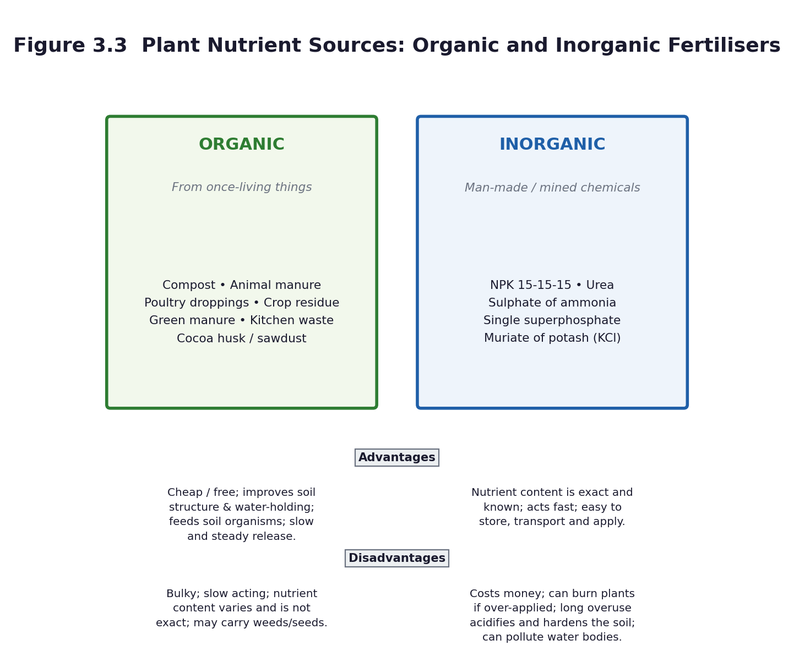
Figure 3.3 Organic and inorganic plant nutrients compared.
PHASE / TIME | TEACHER ACTIVITY | LEARNER ACTIVITY | CORE COMP. | ASSESSMENT (DoK)
ENGAGE  8 min | Hold up two things: a handful of dark compost and a spoonful of NPK granules. Ask: ‘Both of these make a maize plant grow. Where does each one come from?’ Then the key question: ‘If you plant maize on the same plot year after year without adding anything, what happens to the harvest?’ Establish: the soil runs out. Share the performance indicator. | Learners identify the sources — one from once-living things, one from a factory — and discuss what they have observed about repeated planting on the same land. | CC; CP; CI | Oral responses; diagnostic check. DoK 1
EXPLORE  18 min | Observation stations with real samples. Groups rotate and record, for each sample: name, where it comes from, colour, texture, smell, form (powder, granules, crumbly, fibrous), and organic or inorganic? — with a reason. The teacher handles the chemical fertilisers; learners observe and smell from a distance. Then the community task: list every nutrient source available in this community, including ones not on the tray. | Groups observe and record on a table, then extend the list with local sources — poultry droppings from a nearby farm, cocoa husk, market waste, household compost, the local agro-chemical shop. | CC; CP; CI | Observation checklist; group record. DoK 2
EXPLAIN  12 min | Formalise the definitions. Organic nutrient sources come from once-living things: compost, animal manure, poultry droppings, crop residue, green manure, kitchen waste, cocoa husk. Inorganic fertilisers are manufactured or mined: NPK 15-15-15, urea, sulphate of ammonia, single superphosphate, muriate of potash. Explain the NPK numbers — the three percentages are nitrogen, phosphorus and potassium, the three nutrients plants need most. Build the comparison table in Figure 3.3 together. | Learners complete the comparison table: advantages and disadvantages of each type. They learn what the three numbers on a fertiliser bag mean. | CC; CP; CI | Questioning; corrected work in a second colour. DoK 2
ELABORATE  12 min | The comparison task: ‘Compare the volumes of organic and inorganic nutrient source required by different plants.’ Groups are given a scenario — a 10 m × 10 m maize plot — and must work out roughly how much compost would be needed versus how much NPK. The contrast is dramatic: tonnes versus kilograms. Discuss what that means for a smallholder farmer. | Groups work out the quantities, compare, and discuss the implications: organic is bulky but cheap or free; inorganic is concentrated but must be bought and can burn the crop. | CC; CP; CI | Application task; sentence frames. DoK 2–3
EVALUATE  10 min | Exit ticket: name three organic and three inorganic nutrient sources and give one advantage and one disadvantage of each type. Preview Lesson 18: ‘tomorrow, how each one is actually applied in the field’. | Learners complete the exit ticket and self-assess. They sort the sample cards into two piles as a final check. | CC; CP; CI | Exit ticket or assessed product. DoK 2–3

APPROACHING  PROFICIENCY (AP) | Support — picture cards to sort into two hoops labelled organic and inorganic; a table with the headings filled in.
PROFICIENT (P) | Core — six sources listed and classified correctly, with a completed comparison table.
HIGHLY  PROFICIENT (HP) | Extension — explain why nitrogen, phosphorus and potassium are the three nutrients that matter most, and what each does for the plant (leaves and growth; roots, flowers and fruit; overall health and disease resistance).

ASSESSMENT (summary) | The observation table and the comparison table (checklist C7.10). The exit ticket. If the class went on Tour 3 (A10.7), the field-trip nutrient table substitutes for or supplements this work.
HOMEWORK / PROJECT WORK | Ask at home or at a farm what fertiliser is used, how much, and what it costs. Bring the answer to Lesson 18.
SAFETY | The teacher handles all chemical fertiliser. No learner applies or tastes any fertiliser. Learners observe and smell from a distance only; do not pass open containers around. Wash hands after handling compost or manure.
CROSS-CUTTING LINKS | Career Technology / Agriculture — soil fertility and crop production. Mathematics — quantity, area and cost. Social Studies — food security and farming as a livelihood. Values — sustainable use of resources.
LESSON CLOSURE | Return to the essential questions; two learners summarise, one says what is still unclear; record names for follow-up below.

REFLECTION AND REMARKS (complete after teaching)
What went well — evidence of learning you saw
What I would change next time
Learners who need follow-up, and what I will do
Head of Department remarks

TEACHER — NAME AND SIGNATURE | HEAD OF DEPARTMENT | DATE

BASIC 7 SCIENCE • TERM 1 • WEEKLY LESSON NOTE
LESSON 18 of 24 — How Each Nutrient Is Applied in the Field
Week 9 • Cycles • Crop Production • B7.2.3.1.2 • 60 minutes
WEEK ENDING | DAY | DATE | PERIOD | DURATION | CLASS | SUBJECT
 |  |  |  | 60 min | Basic 7 | Science

CLASS SIZE — BOYS | CLASS SIZE — GIRLS | CLASS SIZE — TOTAL

STRAND | Cycles
SUB-STRAND | Crop Production
CONTENT STANDARD | B7.2.3.1 — Demonstrate understanding of the different plant nutrients (organic and inorganic fertilizers) and their application in school farming (school gardening).
LEARNING INDICATOR(S) | B7.2.3.1.2 — Describe the physical characteristics of different plant nutrients (organic and inorganic) and how each is applied to plants in the field.
PERFORMANCE INDICATOR  (what learners will do) | Learners can describe the physical characteristics of organic and inorganic nutrients and how each is applied to plants in the field.
LEARNING OUTCOMES  (knowledge / skill / value) | • K — describe how the physical characteristics of each nutrient determine how it is applied.  • S — describe in a group, and then demonstrate, how each type of nutrient is applied to plants in the field.  • A/V — appreciate the need for care and accuracy, because too much fertiliser destroys the crop it was meant to feed.
CORE COMPETENCIES | Digital Literacy (DL); Communication and Collaboration (CC); Creativity and Innovation (CI).
KEY WORDS | broadcasting, side-dressing, ring application, top-dressing, basal application, composting, mulch, granule, powder, dilute, scorch
ESSENTIAL QUESTIONS | 1. How is each nutrient applied to plants in the field?  2. What do organic and inorganic nutrients look like?
PRIOR KNOWLEDGE (R.P.K.) | Lesson 17 — organic and inorganic nutrient sources and their advantages and disadvantages. The homework on what farmers actually use.
TEACHING / LEARNING RESOURCES  (TLMs) | The samples from Lesson 17. The school garden or a prepared plot. Tools: hand trowels, hoes, a watering can, a measuring cup or a marked bottle, string and pegs for marking out beds. Gloves if available. Figure 3.3. Soap and water for washing.
PEDAGOGICAL EXEMPLARS (methods) | Inquiry (5E); hands-on practical work; ICT / digital resources; cooperative group work; questioning and discussion; differentiation by task, support and outcome
REFERENCE | NaCCA Science Curriculum for the Common Core Programme (Basic 7–10), February 2020 — B7.2.3.1.2, p. 11. Scheme of Learning, Week 9.

Figure 3.3 Physical characteristics determine the method of application.
PHASE / TIME | TEACHER ACTIVITY | LEARNER ACTIVITY | CORE COMP. | ASSESSMENT (DoK)
ENGAGE  8 min | Show a fine powder and a coarse granule, and a crumbly fibrous compost. Ask: ‘If you had to get each of these onto the roots of a maize plant, would you use the same method?’ Then: the homework — what did farmers say they use, and how much? Share the performance indicator. | Learners compare the physical forms and predict different methods. They report the homework findings, which usually vary a great deal and make a good discussion. | DL; CC; CI | Oral responses; diagnostic check. DoK 1
EXPLORE  18 min | Groups are given one nutrient each and must work out how its physical form determines how it is applied. Compost and manure are bulky and fibrous — they are spread and worked into the soil before planting, or used as mulch. Urea and NPK are concentrated granules or powders — they are applied in small, measured amounts, either in a ring around the plant, in a band beside the row, or broadcast and watered in. Groups prepare a demonstration for the class. | Groups handle their nutrient (teacher supervising any chemical), note its physical characteristics, and work out and rehearse the correct method. | DL; CC; CI | Observation checklist; group record. DoK 2
EXPLAIN  12 min | Groups demonstrate. Formalise the four methods with their names: broadcasting (scattered evenly over the whole plot before planting or as a top-dressing), ring application (in a circle around the plant, not touching the stem), side-dressing / banding (in a shallow furrow beside the row, covered with soil), and composting / mulching (spread on the surface or dug in before planting). Stress the reason for each: keep the fertiliser off the stem and leaves, place it where the roots are, and water it in. | Learners record the four methods with a labelled sketch of each, and note which nutrient suits which method and why. | DL; CC; CI | Questioning; corrected work in a second colour. DoK 2
ELABORATE  12 min | The over-application problem. Ask: ‘If a little fertiliser is good, is twice as much twice as good?’ Explain what happens: the salt draws water out of the roots, the plant scorches and dies — the crop is killed by kindness. Then the timing question: when in the plant's life should each nutrient be given? Set up the four-bed trial to start next lesson. | Groups mark out four beds with string and pegs and label them: control (nothing), compost, manure, NPK — plus, if space allows, a fifth deliberately over-dosed bed. They record the starting condition of each bed. | DL; CC; CI | Application task; sentence frames. DoK 2–3
EVALUATE  10 min | Exit ticket: ‘Describe two ways of applying fertiliser, and say why fertiliser must not be placed against the stem.’ Then groups present their method demonstrations to the class. | Learners complete the exit ticket and demonstrate their method, using the correct vocabulary. | DL; CC; CI | Exit ticket or assessed product. DoK 2–3

APPROACHING  PROFICIENCY (AP) | Support — a card-matching task: nutrient picture, characteristic, and method; a demonstration to copy rather than a method to work out.
PROFICIENT (P) | Core — characteristics described and the correct method named and demonstrated for each type.
HIGHLY  PROFICIENT (HP) | Extension — plan the fertiliser schedule for a whole maize season: what, how much, when, and by which method, with a reason for each decision.

ASSESSMENT (summary) | The method demonstration observed against checklist C7.11. The labelled sketches. The exit ticket. The marked-out trial beds are the set-up for the Lesson 19 practical and the Lesson 20 report.
HOMEWORK / PROJECT WORK | Bring a hand trowel or a small hoe if you have one, and old clothes, for the garden practical next lesson. Read the safety rules for the school-garden session.
SAFETY | The teacher measures and issues all chemical fertiliser; learners do not handle it directly without supervision. Tools: a tool talk first, blades away from the body, no horseplay. Gloves where possible. No tasting, ever. Wash hands thoroughly with soap afterwards and cover any cut before going out.
CROSS-CUTTING LINKS | Career Technology / Agriculture — real farming practice. Mathematics — measuring area, quantity and spacing. Values — care, accuracy and responsibility with materials that can do harm as well as good.
LESSON CLOSURE | Return to the essential questions; two learners summarise, one says what is still unclear; record names for follow-up below.

REFLECTION AND REMARKS (complete after teaching)
What went well — evidence of learning you saw
What I would change next time
Learners who need follow-up, and what I will do
Head of Department remarks

TEACHER — NAME AND SIGNATURE | HEAD OF DEPARTMENT | DATE

BASIC 7 SCIENCE • TERM 1 • WEEKLY LESSON NOTE
LESSON 19 of 24 — School Garden Practical — Applying What We Learned
Week 10 • Cycles • Crop Production • B7.2.3.1.2 • 60 minutes
WEEK ENDING | DAY | DATE | PERIOD | DURATION | CLASS | SUBJECT
 |  |  |  | 60 min | Basic 7 | Science

CLASS SIZE — BOYS | CLASS SIZE — GIRLS | CLASS SIZE — TOTAL

STRAND | Cycles
SUB-STRAND | Crop Production
CONTENT STANDARD | B7.2.3.1 — Demonstrate understanding of the different plant nutrients (organic and inorganic fertilizers) and their application in school farming (school gardening).
LEARNING INDICATOR(S) | B7.2.3.1.2 — Describe the physical characteristics of different plant nutrients (organic and inorganic) and how each is applied to plants in the field.
PERFORMANCE INDICATOR  (what learners will do) | Learners can demonstrate the practical application of each type of plant nutrient to plants in the field, and run a fair test of their effects.
LEARNING OUTCOMES  (knowledge / skill / value) | • K — state what makes a test fair, and identify the control in the class experiment.  • S — apply each nutrient correctly by the correct method, and set up and record a fair test.  • A/V — work safely and cooperatively out of doors, and take responsibility for a living thing over several weeks.
CORE COMPETENCIES | Creativity and Innovation (CI); Critical Thinking and Problem Solving (CP); Communication and Collaboration (CC).
KEY WORDS | fair test, control, variable, observation, measurement, record, conclusion, germination, height, yield
ESSENTIAL QUESTIONS | 1. How do we apply each nutrient correctly and safely?  2. How can we test which nutrient works best?
PRIOR KNOWLEDGE (R.P.K.) | Lessons 17 and 18 — nutrient sources, their characteristics and their methods of application. The four marked-out beds.
TEACHING / LEARNING RESOURCES  (TLMs) | The four (or five) marked beds. Seedlings or seeds — maize, beans or okra. Compost, manure, NPK. Trowels, hoes, watering cans, a metre rule or measuring tape, string, pegs, labels, gloves, soap and water. The garden log sheet (Worksheet WS8).
PEDAGOGICAL EXEMPLARS (methods) | Inquiry (5E); hands-on practical work; design and make; cooperative group work; questioning and discussion; differentiation by task, support and outcome
REFERENCE | NaCCA Science Curriculum for the Common Core Programme (Basic 7–10), February 2020 — B7.2.3.1.2, p. 11. Scheme of Learning, Week 10.

PHASE / TIME | TEACHER ACTIVITY | LEARNER ACTIVITY | CORE COMP. | ASSESSMENT (DoK)
ENGAGE  8 min | Out at the beds. Ask: ‘If we put different things on these beds, how will we know which one actually made the difference?’ Draw out: same seeds, same number, same spacing, same water, same sunlight, same soil, same day — and one bed with nothing added at all. That bed is the control, and without it the experiment tells us nothing. Share the performance indicator. | Learners look at the beds and propose what must be kept the same. They name the control bed and explain why it matters. | CI; CP; CC | Oral responses; diagnostic check. DoK 1
EXPLORE  18 min | The practical. Each group takes one bed. Tasks, in order: (1) prepare the bed; (2) plant the same number of seeds or seedlings at the same spacing; (3) apply that bed's nutrient by the correct method — the teacher measures and issues any chemical fertiliser; (4) water equally; (5) label the bed; (6) record the starting measurements. The over-dose bed, if used, is set up by the teacher deliberately to show what happens. | Groups work their beds, applying the correct method for their nutrient. The Recorder completes the garden log: date, bed, treatment, number planted, spacing, amount applied, method, and the starting measurements. | CI; CP; CC | Observation checklist; group record. DoK 2
EXPLAIN  12 min | Back in the classroom or in the shade. Check the log as a class: is every variable except the nutrient the same? Identify any that slipped — a bed in the shade, a bed that got more water — and record them honestly as limitations. Explain that the trial runs for four weeks and that measurements are taken at the same time and in the same way each week. | Learners check their logs against the class list of variables, note any limitations, and agree the measurement routine: height of each plant in centimetres, number of leaves, colour, weekly, at the same time of day. | CI; CP; CC | Questioning; corrected work in a second colour. DoK 2
ELABORATE  12 min | Prediction task. Each learner writes: ‘I predict that bed ___ will grow best because ___. I predict that bed ___ will grow worst because ___.’ Predictions are recorded, dated and kept — they will be compared with the results in Lesson 20, and being wrong in an interesting way is worth as much as being right. | Learners write and date their predictions with reasons, and file them. | CI; CP; CC | Application task; sentence frames. DoK 2–3
EVALUATE  10 min | Safety and tidy-up check, then a two-minute reflection each: what did I do, what did I learn, what could have gone better? Preview Lesson 20: ‘we measure, report and assess Unit 3’. | Learners complete the reflection in their journals and help return the tools. | CI; CP; CC | Exit ticket or assessed product. DoK 2–3

APPROACHING  PROFICIENCY (AP) | Support — paired with a confident partner; a checklist of the six steps to tick off.
PROFICIENT (P) | Core — the nutrient applied by the correct method, the log completed accurately, and a prediction with a reason.
HIGHLY  PROFICIENT (HP) | Extension — design the data table for the four-week trial, including the columns for height, number of leaves, colour and any problems, and justify each column.

ASSESSMENT (summary) | The garden log (checklist C7.12). Observation of the practical, including safe tool use. The prediction with a reason. This is the assessed practical for Unit 3 and carries the practical component of the term mark.
HOMEWORK / PROJECT WORK | Water your group's bed on the rota for the next four weeks and record the date each time. Bring measurements to every science lesson.
SAFETY | Tool talk before any tool is touched. Blades away from the body; carry a trowel or hoe with the blade down and to the side. The teacher measures and issues all chemical fertiliser. Gloves where possible. No tasting. Wash hands with soap immediately after the session. Cover any cut before going out. Count tools back in before anyone leaves.
CROSS-CUTTING LINKS | Career Technology / Agriculture — genuine farming practice. Mathematics — measurement, fair testing, data tables. Science — designing experiments is one of NaCCA's fifteen process skills and this is where it is properly developed.
LESSON CLOSURE | Return to the essential questions; two learners summarise, one says what is still unclear; record names for follow-up below.

REFLECTION AND REMARKS (complete after teaching)
What went well — evidence of learning you saw
What I would change next time
Learners who need follow-up, and what I will do
Head of Department remarks

TEACHER — NAME AND SIGNATURE | HEAD OF DEPARTMENT | DATE

BASIC 7 SCIENCE • TERM 1 • WEEKLY LESSON NOTE
LESSON 20 of 24 — Cycles in Review — Unit 3 Assessment and Showcase
Week 10 • Cycles • Earth Science; Life Cycle of Organisms; Crop Production • B7.2.1.1.1–.2; B7.2.2.1.1–.2; B7.2.3.1.1–.2 • 60 minutes
WEEK ENDING | DAY | DATE | PERIOD | DURATION | CLASS | SUBJECT
 |  |  |  | 60 min | Basic 7 | Science

CLASS SIZE — BOYS | CLASS SIZE — GIRLS | CLASS SIZE — TOTAL

STRAND | Cycles
SUB-STRAND | Earth Science; Life Cycle of Organisms; Crop Production
CONTENT STANDARD | B7.2.1.1; B7.2.2.1; B7.2.3.1 — All three Unit 3 content standards.
LEARNING INDICATOR(S) | B7.2.1.1.1–.2; B7.2.2.1.1–.2; B7.2.3.1.1–.2 — All Unit 3 indicators.
PERFORMANCE INDICATOR  (what learners will do) | Learners can compare the three cycles studied in this unit, report the results of the garden trial, and demonstrate mastery of the Unit 3 content.
LEARNING OUTCOMES  (knowledge / skill / value) | • K — compare the water cycle, the housefly life cycle and the nutrient cycle, identifying what the three have in common.  • S — present the results of the garden trial as a bar chart with a conclusion, and complete the Unit 3 assessment.  • A/V — appreciate that recognising a pattern across different contexts is what scientific thinking is for.
CORE COMPETENCIES | Critical Thinking and Problem Solving (CP); Communication and Collaboration (CC); Creativity and Innovation (CI).
KEY WORDS | cycle, pattern, repeated, transfer, synthesis, compare, evidence, conclusion
ESSENTIAL QUESTIONS | 1. How are the water cycle, the life cycle and the nutrient cycle alike?  2. What did our school-garden trial show?
PRIOR KNOWLEDGE (R.P.K.) | Lessons 11 to 19 — the whole of Unit 3.
TEACHING / LEARNING RESOURCES  (TLMs) | The garden trial data. The housefly posters and diaries. The water-cycle diagrams. Figures 3.1, 3.2 and 3.3. Unit Test 3 (Part C1, 30 marks), one copy per learner. Graph paper.
PEDAGOGICAL EXEMPLARS (methods) | Inquiry (5E); sustained observation over time; cooperative group work; questioning and discussion; differentiation by task, support and outcome
REFERENCE | NaCCA Science Curriculum for the Common Core Programme (Basic 7–10), February 2020 — B7.2.1.1.1–.2, pp. 7–8; B7.2.2.1.1–.2, pp. 9–10; B7.2.3.1.1–.2, p. 11. Scheme of Learning, Week 10.

PHASE / TIME | TEACHER ACTIVITY | LEARNER ACTIVITY | CORE COMP. | ASSESSMENT (DoK)
ENGAGE  8 min | Put three diagrams on the board at once: the water cycle, the housefly life cycle, and the nutrient cycle. Ask: ‘What is the one thing all three have in common?’ Give them two minutes of thinking time — this is a synthesis question and it is genuinely hard. Share the performance indicator. | Learners think individually, then pair, then share. The answer they are reaching for: all three are repeated patterns with linked stages and no true beginning or end. | CP; CC; CI | Oral responses; diagnostic check. DoK 1
EXPLORE  18 min | Synthesis task. Groups build a three-column comparison table: what moves round the cycle; what drives it; what the stages are; what happens if one stage is broken; and whether it is a living cycle or not. This is the intellectual payoff of the whole unit — the pattern recognised three times and then abstracted. | Groups complete the comparison table, and each group adds one question of its own that the table raises. | CP; CC; CI | Observation checklist; group record. DoK 2
EXPLAIN  12 min | Groups present their tables. Draw out the differences as well as the similarities: the water cycle is driven by the Sun and involves no life; the housefly cycle is a life cycle, driven by reproduction; the nutrient cycle is driven partly by decay and partly by human action. Then: what happens if a stage is broken in each? — drought, no flies, exhausted soil. | Learners correct and complete their tables, and write one paragraph comparing two of the three cycles. | CP; CC; CI | Questioning; corrected work in a second colour. DoK 2
ELABORATE  12 min | The garden trial results. Groups plot their four weeks of data as a bar chart — mean plant height by bed — and write a conclusion beginning ‘The evidence suggests that…’. They then compare the result with the prediction they wrote in Lesson 19. If the trial did not work — and sometimes it does not — that is a valuable lesson in itself: discuss why. | Groups draw the bar chart, write the conclusion, and compare it honestly with their prediction. | CP; CC; CI | Application task; sentence frames. DoK 2–3
EVALUATE  10 min | Unit Test 3 (Part C1), 30 marks. If time is short, use the first thirty minutes of the next science period. After the test, whole-class feedback: the four commonest errors on the board, five minutes to self-correct in a different colour. | Learners complete the test, then self-correct against the board feedback and record their score. | CP; CC; CI | Exit ticket or assessed product. DoK 2–3

APPROACHING  PROFICIENCY (AP) | Support — a comparison table with the headings given and one row completed as an example.
PROFICIENT (P) | Core — the comparison table completed and the bar chart with a conclusion.
HIGHLY  PROFICIENT (HP) | Extension — identify a fourth cycle not studied this term (the carbon cycle, the rock cycle, the nitrogen cycle) and explain why it fits the pattern.

ASSESSMENT (summary) | Unit Test 3 (30 marks). The comparison table and the garden-trial report (rubric R7). The housefly poster (rubric R6) and the water-cycle diagram are also counted in the Unit 3 mark.
HOMEWORK / PROJECT WORK | Revise Units 1 to 3 using the revision cards. Bring scrap materials for the Unit 4 energy audit.
SAFETY | If you visit the garden, the same tool and hygiene rules as Lesson 19 apply.
CROSS-CUTTING LINKS | Mathematics — bar charts, means, comparison. English — synthesis and comparison. Values — the curriculum's specific aim of showing ‘concern and understanding of the interdependence of all living things and the Earth on which they live’.
LESSON CLOSURE | Return to the essential questions; two learners summarise, one says what is still unclear; record names for follow-up below.

REFLECTION AND REMARKS (complete after teaching)
What went well — evidence of learning you saw
What I would change next time
Learners who need follow-up, and what I will do
Head of Department remarks

TEACHER — NAME AND SIGNATURE | HEAD OF DEPARTMENT | DATE

BASIC 7 SCIENCE • TERM 1 • WEEKLY LESSON NOTE
LESSON 21 of 24 — Forms of Energy and How They Are Related
Week 11 • Forces and Energy • Energy • B7.4.1.1.1 • 60 minutes
WEEK ENDING | DAY | DATE | PERIOD | DURATION | CLASS | SUBJECT
 |  |  |  | 60 min | Basic 7 | Science

CLASS SIZE — BOYS | CLASS SIZE — GIRLS | CLASS SIZE — TOTAL

STRAND | Forces and Energy
SUB-STRAND | Energy
CONTENT STANDARD | B7.4.1.1 — Demonstrate an understanding of forms of energy and their daily applications.
LEARNING INDICATOR(S) | B7.4.1.1.1 — Identify the various forms of energy and show how they are related.
PERFORMANCE INDICATOR  (what learners will do) | Learners can list the forms of energy and demonstrate, with diagrams, how potential energy and kinetic energy are related.
LEARNING OUTCOMES  (knowledge / skill / value) | • K — list nine forms of energy and state that energy is the ability to do work, measured in joules.  • S — show with a diagram how potential energy and kinetic energy are related, and state that mechanical energy equals PE plus KE.  • A/V — appreciate that energy is never created or destroyed, only changed from one form to another.
CORE COMPETENCIES | Digital Literacy (DL); Cultural Identity and Global Citizenship (CG); Communication and Collaboration (CC).
KEY WORDS | energy, work, joule, potential energy, kinetic energy, mechanical energy, heat, sound, solar, electrical, nuclear, chemical, light, conversion
ESSENTIAL QUESTIONS | 1. What are the different forms of energy?  2. How are potential energy and kinetic energy related?
PRIOR KNOWLEDGE (R.P.K.) | Unit 3 — the Sun drives the water cycle. Unit 2 — the Sun is a star. Most learners use the word energy daily but cannot define it.
TEACHING / LEARNING RESOURCES  (TLMs) | Figure 4.1 enlarged to A3. A ball, a rubber band or catapult, a wound-up clockwork toy or a rubber-band car, a torch and battery, a matchbox, a maize cob or any food, a bell or any object that makes a sound, a solar calculator if available. Energy-form cards for matching.
PEDAGOGICAL EXEMPLARS (methods) | Inquiry (5E); hands-on practical work; ICT / digital resources; cooperative group work; questioning and discussion; differentiation by task, support and outcome
REFERENCE | NaCCA Science Curriculum for the Common Core Programme (Basic 7–10), February 2020 — B7.4.1.1.1, p. 26. Scheme of Learning, Week 11.

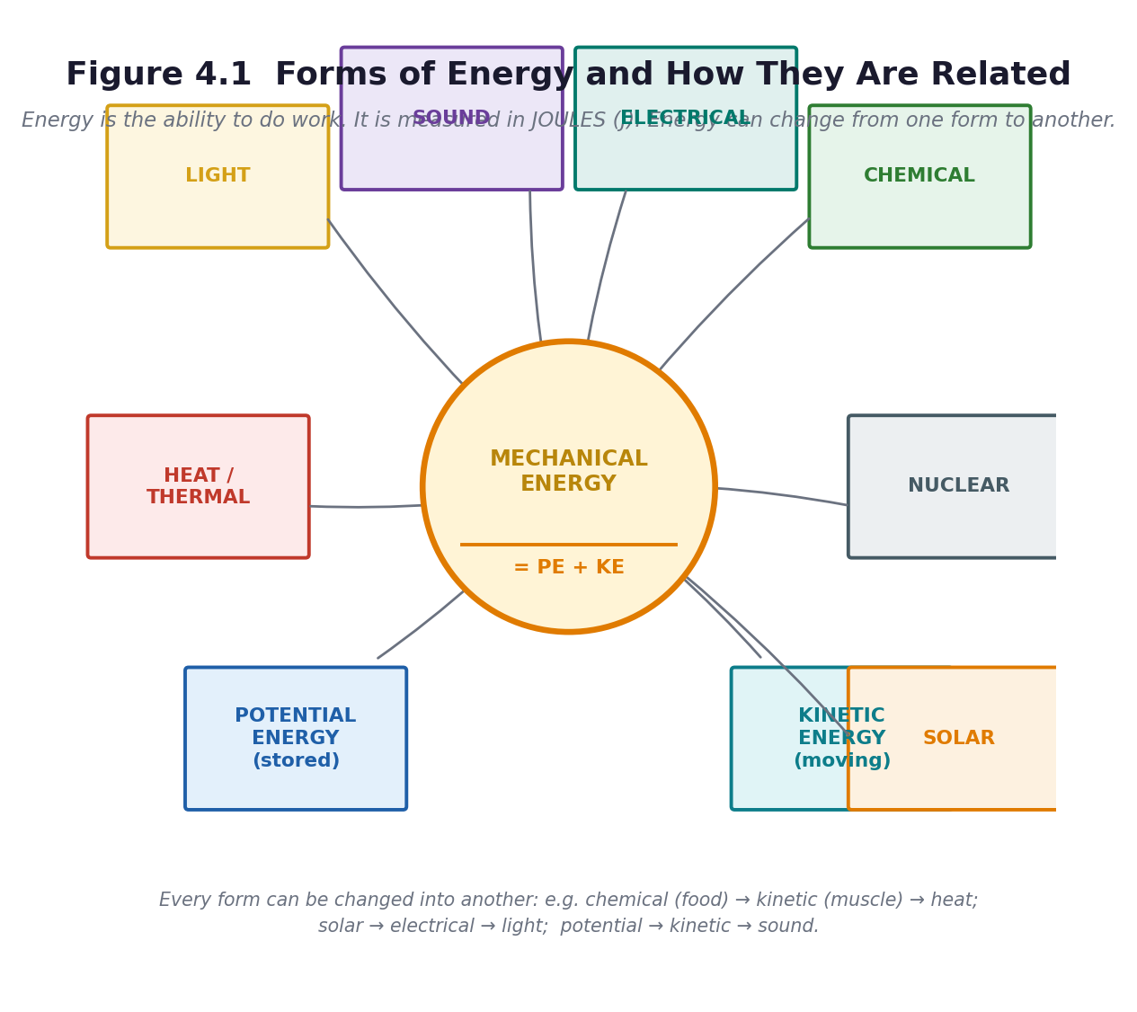
Figure 4.1 Forms of energy and how they are related.
PHASE / TIME | TEACHER ACTIVITY | LEARNER ACTIVITY | CORE COMP. | ASSESSMENT (DoK)
ENGAGE  8 min | Ask: ‘List everything you have used energy for since you woke up this morning.’ Build a long list. Then the definition question: ‘What IS energy?’ Take answers and settle on: the ability to do work, measured in joules (J). Then the puzzle that drives the lesson: ‘Where did the energy in your arm come from?’ Trace it back: food, then the sun, then nuclear fusion. Share the performance indicator. | Learners list their uses of energy, then trace the chain backwards from muscle to food to plant to sunlight — and are usually surprised where it ends. | DL; CG; CC | Oral responses; diagnostic check. DoK 1
EXPLORE  18 min | Jigsaw: nine groups, one form of energy each — potential, kinetic, heat, sound, solar, electrical, nuclear, chemical, light. Each group gets an object or a card and must produce: a definition in one sentence, one Ghanaian example, and a demonstration for the class. Then the conversion task: each group must show one conversion — what its form changes into, and what changes into it. | Groups research, prepare and rehearse a one-minute slot with a demonstration. They identify the conversions into and out of their form. | DL; CG; CC | Observation checklist; group record. DoK 2
EXPLAIN  12 min | Groups teach in turn. Build Figure 4.1 on the board as they go. Then focus on the relationship the curriculum specifically requires: mechanical energy = potential energy + kinetic energy. Demonstrate: hold a ball high (it has stored, or potential, energy because of its position); release it (the stored energy becomes movement, or kinetic, energy); at the bottom it has maximum kinetic and minimum potential. Total mechanical energy stays the same. | Learners copy Figure 4.1, and draw the three-position ball diagram showing PE and KE trading places while the total stays constant. | DL; CG; CC | Questioning; corrected work in a second colour. DoK 2
ELABORATE  12 min | The conversion relay. Call out a device; groups write the energy chain. A torch: chemical → electrical → light and heat. A maize mill: electrical → kinetic → sound and heat. Akosombo: potential → kinetic → electrical. A person eating: chemical → kinetic and heat. A solar panel: light → electrical. Then the harder question: where does the ‘wasted’ energy go? | Groups write energy chains for ten devices, and identify the wasted output in each — almost always heat and sound. | DL; CG; CC | Application task; sentence frames. DoK 2–3
EVALUATE  10 min | Exit ticket: name five forms of energy; state the relationship between PE and KE in one sentence; give one complete energy chain for a device in your home. Preview Lesson 22: ‘tomorrow we calculate it, and we audit the school’. | Learners complete the exit ticket and self-assess against three criteria. | DL; CG; CC | Exit ticket or assessed product. DoK 2–3

APPROACHING  PROFICIENCY (AP) | Support — matching cards with the form and a picture; the energy chain given as a partially completed template.
PROFICIENT (P) | Core — nine forms named, the PE/KE relationship stated, one complete energy chain.
HIGHLY  PROFICIENT (HP) | Extension — explain why no conversion is ever 100 per cent efficient, and where the missing energy goes.

ASSESSMENT (summary) | The Figure 4.1 diagram and the energy chains (checklist C7.13). The exit ticket. Retrieval at the start of Lesson 22: name the nine forms from memory.
HOMEWORK / PROJECT WORK | Learn the nine forms of energy. At home, find three devices and write the energy chain for each.
SAFETY | The teacher handles any flame or hot object. If you use a rubber-band catapult, no firing at people, and only under supervision.
CROSS-CUTTING LINKS | Mathematics — the relationship expressed as a sum. Social Studies — Ghana's electricity: hydro at Akosombo, Kpong and Bui; thermal; solar. Values — the curriculum's aim of using materials ‘in a sustainable manner’.
LESSON CLOSURE | Return to the essential questions; two learners summarise, one says what is still unclear; record names for follow-up below.

REFLECTION AND REMARKS (complete after teaching)
What went well — evidence of learning you saw
What I would change next time
Learners who need follow-up, and what I will do
Head of Department remarks

TEACHER — NAME AND SIGNATURE | HEAD OF DEPARTMENT | DATE

BASIC 7 SCIENCE • TERM 1 • WEEKLY LESSON NOTE
LESSON 22 of 24 — Energy in Daily Life, and Calculating PE and KE
Week 11 • Forces and Energy • Energy • B7.4.1.1.2 • 60 minutes
WEEK ENDING | DAY | DATE | PERIOD | DURATION | CLASS | SUBJECT
 |  |  |  | 60 min | Basic 7 | Science

CLASS SIZE — BOYS | CLASS SIZE — GIRLS | CLASS SIZE — TOTAL

STRAND | Forces and Energy
SUB-STRAND | Energy
CONTENT STANDARD | B7.4.1.1 — Demonstrate an understanding of forms of energy and their daily applications.
LEARNING INDICATOR(S) | B7.4.1.1.2 — Explain daily applications of forms of energy.
PERFORMANCE INDICATOR  (what learners will do) | Learners can match forms of energy to appliances used at school, at home and in the community, and use PE = mgh and KE = ½mv² to solve simple problems.
LEARNING OUTCOMES  (knowledge / skill / value) | • K — match forms of energy to appliances used daily at school, at home and in the community.  • S — use PE = mgh and KE = ½mv² to solve simple problems involving mechanical energy, and carry out an energy audit.  • A/V — recognise that wasted energy costs money and harms the environment, and that individuals can act.
CORE COMPETENCIES | Digital Literacy (DL); Cultural Identity and Global Citizenship (CG); Communication and Collaboration (CC); Creativity and Innovation (CI).
KEY WORDS | appliance, mass, height, velocity, gravity, joule, calculate, audit, efficiency, waste
ESSENTIAL QUESTIONS | 1. Which form of energy does each appliance use?  2. How do I calculate potential energy and kinetic energy?
PRIOR KNOWLEDGE (R.P.K.) | Lesson 21 — the nine forms of energy, the PE/KE relationship, energy chains. Mathematics: substitution into a formula, and the idea of a variable.
TEACHING / LEARNING RESOURCES  (TLMs) | Figure 4.2. A metre rule, a spring balance or a rubber-band scale, a known mass (a 1 kg bag of rice or sugar), string, a stopwatch or phone. A copy of the school's electricity bill if the office will share it. Appliance cards. Calculators if available.
PEDAGOGICAL EXEMPLARS (methods) | Inquiry (5E); hands-on practical work; ICT / digital resources; cooperative group work; questioning and discussion; differentiation by task, support and outcome
REFERENCE | NaCCA Science Curriculum for the Common Core Programme (Basic 7–10), February 2020 — B7.4.1.1.2, p. 27. Scheme of Learning, Week 11.

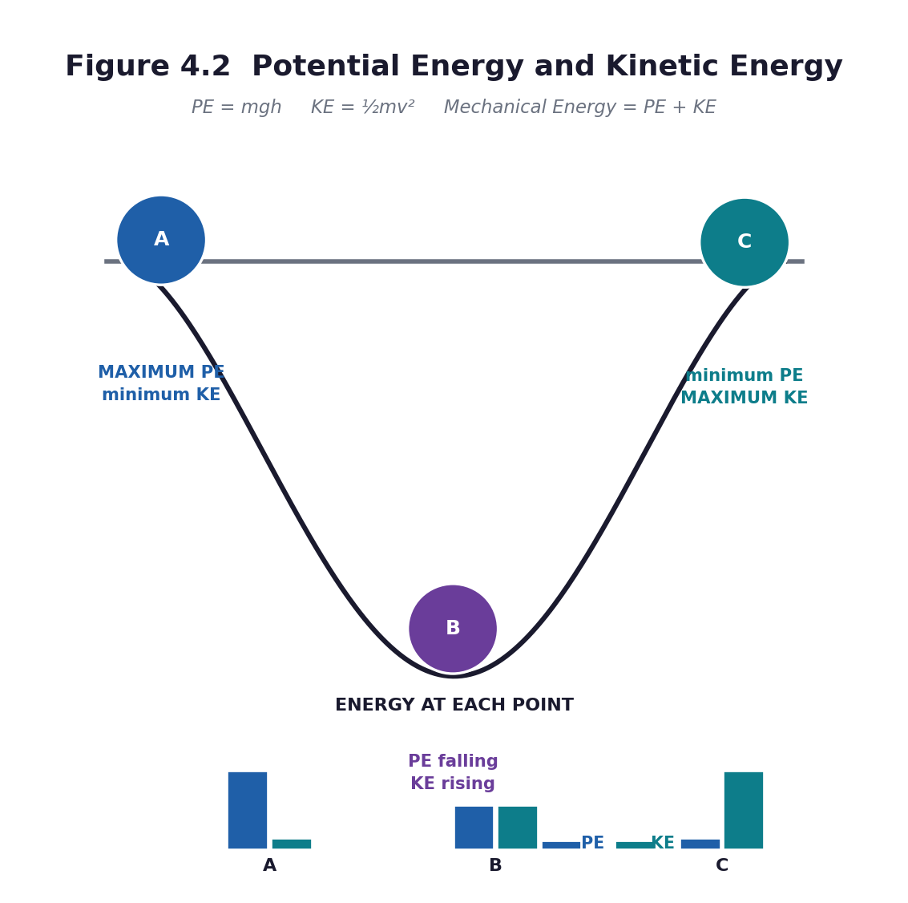
Figure 4.2 Potential energy and kinetic energy. PE = mgh; KE = ½mv²; mechanical energy = PE + KE.
PHASE / TIME | TEACHER ACTIVITY | LEARNER ACTIVITY | CORE COMP. | ASSESSMENT (DoK)
ENGAGE  8 min | Retrieval: name the nine forms of energy from memory. Then hold up a phone charger, a fan and a mortar and pestle. Ask: ‘Which form goes in, and which comes out, for each?’ Share the performance indicator. | Learners answer the retrieval questions and identify input and output forms for each object. | DL; CG; CC; CI | Oral responses; diagnostic check. DoK 1
EXPLORE  18 min | The energy audit. Groups are given a zone — the classroom, the kitchen, the office, the compound, the staff room — and ten minutes to list every appliance or use of energy there, with the input form, the useful output, and the wasted output. They bring the data back and the class builds one big table on the board. | Groups survey their zones and record: item | energy in | useful energy out | wasted energy out. They report back and build the class table. | DL; CG; CC; CI | Observation checklist; group record. DoK 2
EXPLAIN  12 min | Now the calculations, using the gradual-release sequence: I do, we do, you do together, you do alone. Write PE = mgh and KE = ½mv² and define every symbol and every unit: m in kilograms, h in metres, g as 10 m/s² (use 10 for B7 — the curriculum does not require 9.8), v in metres per second, and the answer in joules. Work one example fully on the board: a 2 kg stone held 5 m up — PE = 2 × 10 × 5 = 100 J. Then a second together. Then three for them. | Learners copy the two formulae and the units, work one example with the teacher, one together on whiteboards, and then three alone. They check each other's answers. | DL; CG; CC; CI | Questioning; corrected work in a second colour. DoK 2
ELABORATE  12 min | The pendulum or the ramp: swing or roll an object and identify where PE is greatest, where KE is greatest, and where they are equal. Then the applied problem: ‘A 40 kg learner climbs 3 m of stairs. How much potential energy has she gained?’ (40 × 10 × 3 = 1200 J.) Then ‘where did that energy come from?’ — breakfast. | Learners predict and observe the energy exchange, then solve the applied problem and connect it back to the energy chains from Lesson 21. | DL; CG; CC; CI | Application task; sentence frames. DoK 2–3
EVALUATE  10 min | Five calculation questions, marked by swapping. Then the campaign task: from the audit, each group identifies the three biggest sources of wasted energy in the school and designs a switch-off poster for one of them. | Learners complete and swap-mark the calculations, then design the poster, which is the assessed Unit 4 product. | DL; CG; CC; CI | Exit ticket or assessed product. DoK 2–3

APPROACHING  PROFICIENCY (AP) | Support — a formula triangle for each equation, a calculator, and a worked example to copy; use whole numbers only.
PROFICIENT (P) | Core — three calculations correct with units, and the energy table completed.
HIGHLY  PROFICIENT (HP) | Extension — find the school's monthly electricity units and cost if available, and calculate what a 20 per cent reduction would save in a year.

ASSESSMENT (summary) | The calculations (checklist C7.14). The energy audit table. The switch-off poster assessed with rubric R6. This completes the energy sub-standard, which is the assessed product for B7.4.1.1.
HOMEWORK / PROJECT WORK | Complete the switch-off poster. Revise the two formulae and learn what each symbol means and what unit it is measured in.
SAFETY | If learners climb stairs or drop objects for the calculation, the teacher controls it and the object is soft and heavy enough not to bounce. No throwing.
CROSS-CUTTING LINKS | Mathematics — substitution, units, and decimals. Social Studies — the cost of energy and Ghana's generating mix. Values — sustainable use of resources and personal responsibility.
LESSON CLOSURE | Return to the essential questions; two learners summarise, one says what is still unclear; record names for follow-up below.

REFLECTION AND REMARKS (complete after teaching)
What went well — evidence of learning you saw
What I would change next time
Learners who need follow-up, and what I will do
Head of Department remarks

TEACHER — NAME AND SIGNATURE | HEAD OF DEPARTMENT | DATE

BASIC 7 SCIENCE • TERM 1 • WEEKLY LESSON NOTE
LESSON 23 of 24 — Light — Straight Lines, Reflection and Refraction
Week 12 • Forces and Energy • Energy • B7.4.1.3.1 • 60 minutes
WEEK ENDING | DAY | DATE | PERIOD | DURATION | CLASS | SUBJECT
 |  |  |  | 60 min | Basic 7 | Science

CLASS SIZE — BOYS | CLASS SIZE — GIRLS | CLASS SIZE — TOTAL

STRAND | Forces and Energy
SUB-STRAND | Energy
CONTENT STANDARD | B7.4.1.3 — Demonstrate understanding of characteristics of light, such as travelling in a straight line, reflection, refraction and dispersion.
LEARNING INDICATOR(S) | B7.4.1.3.1 — Demonstrate how light travels in a straight line.
PERFORMANCE INDICATOR  (what learners will do) | Learners can perform experiments showing that light travels in a straight line and can be reflected and refracted, and produce reports, posters or diagrams.
LEARNING OUTCOMES  (knowledge / skill / value) | • K — state that light travels in straight lines, and define reflection and refraction.  • S — perform experiments to show straight-line travel, reflection and refraction, and record the results as labelled ray diagrams.  • A/V — appreciate that a claim about light needs an experiment behind it, not just an opinion.
CORE COMPETENCIES | Digital Literacy (DL); Communication and Collaboration (CC); Critical Thinking and Problem Solving (CP); Creativity and Innovation (CI).
KEY WORDS | light, straight line, ray, beam, reflection, refraction, dispersion, mirror, incident ray, reflected ray, normal, angle of incidence, angle of reflection, medium
ESSENTIAL QUESTIONS | 1. Does light really travel in a straight line?  2. What happens to light when it is reflected and when it is refracted?
PRIOR KNOWLEDGE (R.P.K.) | Lesson 21 — light is a form of energy. Everyday experience of shadows and mirrors. Mathematics: angles.
TEACHING / LEARNING RESOURCES  (TLMs) | Torches, one per group if possible. Three pieces of card with a pinhole in each, mounted on Plasticine or in a lump of clay. A plane mirror (or a mirrored tile, or foil glued flat to card). A transparent bowl or glass of water. A clear plastic ruler or a glass block. A protractor. White paper. Figure 4.3.
PEDAGOGICAL EXEMPLARS (methods) | Inquiry (5E); hands-on practical work; ICT / digital resources; cooperative group work; questioning and discussion; differentiation by task, support and outcome
REFERENCE | NaCCA Science Curriculum for the Common Core Programme (Basic 7–10), February 2020 — B7.4.1.3.1, p. 29. Scheme of Learning, Week 12.

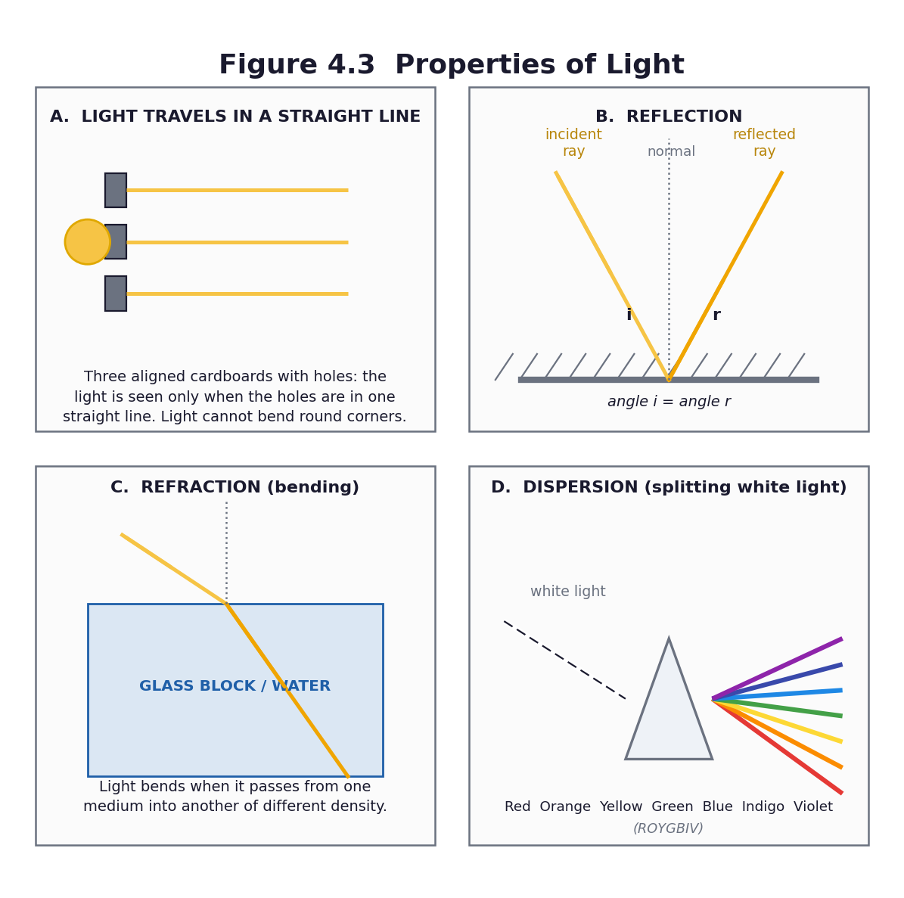
Figure 4.3 Properties of light: straight-line travel, reflection, refraction and dispersion.
PHASE / TIME | TEACHER ACTIVITY | LEARNER ACTIVITY | CORE COMP. | ASSESSMENT (DoK)
ENGAGE  8 min | POE. Show three cards with holes, held apart, and a torch. Ask: ‘If I put the cards in a crooked line and shine the torch through, will the light get through all three?’ Learners predict and write a reason. Then do it — the light stops. Then straighten the cards and the light gets through. Share the performance indicator. | Learners predict and reason, observe both outcomes, and explain the difference. The crooked-card result is immediate, visible and memorable. | DL; CC; CP; CI | Oral responses; diagnostic check. DoK 1
EXPLORE  18 min | Three experiments at three stations. Station 1 — straight lines: the three-card experiment, plus a torch shone through dusty air or chalk dust to see the beam. Station 2 — reflection: a torch beam onto a plane mirror on paper; trace the incident ray, the reflected ray and the normal; measure the two angles. Station 3 — refraction: a pencil or a ruler standing in a bowl of water, viewed from the side; and a torch beam entering water at an angle. | Groups rotate through the stations, perform each experiment, and record what they observe as a labelled diagram with a one-sentence finding. | DL; CC; CP; CI | Observation checklist; group record. DoK 2
EXPLAIN  12 min | Groups report. Formalise the three findings with Figure 4.3. Light travels in straight lines — which is why shadows have sharp edges and why you cannot see round a corner. Reflection — light bounces off a surface, and the angle of incidence equals the angle of reflection, both measured from the normal. Refraction — light bends when it passes from one medium into another of different density, which is why a pencil in water looks broken and why a pool looks shallower than it is. | Learners complete labelled ray diagrams for all three, using a ruler and a protractor, and write the rule for each in one sentence. | DL; CC; CP; CI | Questioning; corrected work in a second colour. DoK 2
ELABORATE  12 min | Two application tasks. First, the periscope: using two mirrors at 45°, can a group see over the top of a book or round a corner? Building one makes the reflection rule concrete. Second, the explanation task: why does a river look shallower than it is, and why is that dangerous? | Groups build a simple periscope from two mirrors and a folded card tube, then explain the shallow-river illusion using refraction. | DL; CC; CP; CI | Application task; sentence frames. DoK 2–3
EVALUATE  10 min | Exit ticket: state that light travels in straight lines and give the evidence; draw a labelled reflection diagram with the two equal angles marked; explain in one sentence why a pencil in water looks bent. Preview Lesson 24: ‘tomorrow we split light into colours’. | Learners complete the exit ticket and self-assess. They begin the experiment report. | DL; CC; CP; CI | Exit ticket or assessed product. DoK 2–3

APPROACHING  PROFICIENCY (AP) | Support — pre-drawn ray diagrams to complete; angle measurement with a protractor supported by a partner.
PROFICIENT (P) | Core — all three experiments performed, with a labelled diagram and a correct one-sentence finding for each.
HIGHLY  PROFICIENT (HP) | Extension — measure the angle of incidence and reflection at five different angles, record in a table, and state the relationship as a general rule with the data as evidence.

ASSESSMENT (summary) | The three labelled ray diagrams and the findings (checklist C7.15). The periscope. The exit ticket. This is the first half of the light report that forms the Unit 4 assessed product.
HOMEWORK / PROJECT WORK | Complete the diagrams for the three experiments. Find one example of reflection and one of refraction at home, and write a sentence about each.
SAFETY | Never shine a torch into anyone's eyes. Use mirrors on a flat surface, not held up; collect any chipped or broken mirror immediately and sweep glass with a brush and pan, never fingers. No looking at the Sun, through anything, ever.
CROSS-CUTTING LINKS | Mathematics — angles, measurement, and the equality of two angles. Creative Arts — periscope construction. English — the experiment report.
LESSON CLOSURE | Return to the essential questions; two learners summarise, one says what is still unclear; record names for follow-up below.

REFLECTION AND REMARKS (complete after teaching)
What went well — evidence of learning you saw
What I would change next time
Learners who need follow-up, and what I will do
Head of Department remarks

TEACHER — NAME AND SIGNATURE | HEAD OF DEPARTMENT | DATE

BASIC 7 SCIENCE • TERM 1 • WEEKLY LESSON NOTE
LESSON 24 of 24 — Dispersion — Splitting White Light, and Unit 4 Assessment
Week 12 • Forces and Energy • Energy • B7.4.1.3.1 • 60 minutes
WEEK ENDING | DAY | DATE | PERIOD | DURATION | CLASS | SUBJECT
 |  |  |  | 60 min | Basic 7 | Science

CLASS SIZE — BOYS | CLASS SIZE — GIRLS | CLASS SIZE — TOTAL

STRAND | Forces and Energy
SUB-STRAND | Energy
CONTENT STANDARD | B7.4.1.3 — Demonstrate understanding of characteristics of light, such as travelling in a straight line, reflection, refraction and dispersion.
LEARNING INDICATOR(S) | B7.4.1.3.1 — Demonstrate how light travels in a straight line.
PERFORMANCE INDICATOR  (what learners will do) | Learners can perform an experiment to show the dispersion of light into colours, and report on all four characteristics of light studied this term.
LEARNING OUTCOMES  (knowledge / skill / value) | • K — state that white light is made of seven colours and name them in order.  • S — perform an experiment to show the dispersion of light and record it as a labelled diagram.  • A/V — appreciate that a phenomenon they have seen all their lives has a scientific explanation.
CORE COMPETENCIES | Creativity and Innovation (CI); Communication and Collaboration (CC); Critical Thinking and Problem Solving (CP); Digital Literacy (DL).
KEY WORDS | dispersion, spectrum, prism, white light, rainbow, ROYGBIV, wavelength, refract, bend
ESSENTIAL QUESTIONS | 1. Is white light really white?  2. What are the four characteristics of light we have studied this term?
PRIOR KNOWLEDGE (R.P.K.) | Lesson 23 — straight-line travel, reflection and refraction. Most learners have seen a rainbow and will not know what causes it.
TEACHING / LEARNING RESOURCES  (TLMs) | A glass prism if available; otherwise a CD or DVD, a mirror in a bowl of water, or a bevel-edged mirror. Torches. White card or paper as a screen. A bowl of water. Figure 4.3. Unit Test 4 (Part C1), one copy per learner.
PEDAGOGICAL EXEMPLARS (methods) | Inquiry (5E); hands-on practical work; ICT / digital resources; cooperative group work; questioning and discussion; differentiation by task, support and outcome
REFERENCE | NaCCA Science Curriculum for the Common Core Programme (Basic 7–10), February 2020 — B7.4.1.3.1, p. 29. Scheme of Learning, Week 12.

Figure 4.3 All four characteristics of light, including dispersion.
PHASE / TIME | TEACHER ACTIVITY | LEARNER ACTIVITY | CORE COMP. | ASSESSMENT (DoK)
ENGAGE  8 min | Ask: ‘Have you ever seen a rainbow? What makes it?’ Take answers — you will hear a range of explanations, some of them cultural and worth respecting. Then: ‘Where are the colours hiding when the light is white? They are not being added. They are already there.’ Share the performance indicator. | Learners describe rainbows they have seen and offer explanations. They record their own explanation, which they will compare with the scientific one at the end. | CI; CC; CP; DL | Oral responses; diagnostic check. DoK 1
EXPLORE  18 min | Dispersion experiments at stations. Station 1: a prism in a beam of light from a torch or a window, with white card as the screen — adjust until the spectrum appears. Station 2: a mirror half-submerged at an angle in a bowl of water, with sunlight or a torch, projecting onto a white card or a shaded wall. Station 3: a CD or DVD tilted in the light. Groups rotate and record what they see. | Groups work the stations, adjust patiently, and record the order of colours they observe on white card. | CI; CC; CP; DL | Observation checklist; group record. DoK 2
EXPLAIN  12 min | Groups report the colours they saw and in what order. Formalise with Figure 4.3D: white light is a mixture of seven colours — red, orange, yellow, green, blue, indigo, violet. The prism bends each colour by a different amount, so they spread out. Violet bends most, red least. This is dispersion. Then connect it to the rainbow: a raindrop does the job of the prism — refracting, reflecting and dispersing the sunlight. | Learners draw and label the dispersion diagram with the seven colours in the correct order, and write the explanation: refraction splits the white light because each colour bends by a different amount. | CI; CC; CP; DL | Questioning; corrected work in a second colour. DoK 2
ELABORATE  12 min | Two tasks. First, the Newton's disc or a colour wheel: spin a disc painted in the seven colours and watch it appear whitish — the reverse of dispersion, and strong evidence that white light is a mixture. Second, the synthesis: in groups, produce a single summary poster of the four characteristics of light — straight line, reflection, refraction, dispersion — each with a diagram and a one-sentence rule. | Groups spin the colour wheel and discuss what it shows. They produce the summary poster, which doubles as a revision aid for Week 13. | CI; CC; CP; DL | Application task; sentence frames. DoK 2–3
EVALUATE  10 min | Unit Test 4 (Part C1), 20 marks. Then the term review: each learner writes one sentence on what they now understand that they did not in September. Collect these — they are the best evidence you will have of the term's work, and the best thing to read before the parent meeting. | Learners complete the test, then write the reflection sentence. | CI; CC; CP; DL | Exit ticket or assessed product. DoK 2–3

APPROACHING  PROFICIENCY (AP) | Support — a labelled spectrum diagram to complete with the seven colour names; work with a partner at the stations.
PROFICIENT (P) | Core — the experiment performed and recorded, seven colours named in order, one-sentence explanation.
HIGHLY  PROFICIENT (HP) | Extension — explain why violet bends more than red, and research why the sky is blue and sunsets are red — the same physics of scattering.

ASSESSMENT (summary) | The dispersion diagram and the summary poster. Unit Test 4 (20 marks). The light report (all four experiments with diagrams) is the assessed product for B7.4.1.3 and completes the Unit 4 mark.
HOMEWORK / PROJECT WORK | Complete the light report: four experiments, four labelled diagrams, four one-sentence findings. Begin revision for the end-of-term examination using the Week 13 revision plan (Part C2).
SAFETY | Never shine a torch into anyone's eyes. Never look at the Sun or at sunlight reflected into a mirror or prism. Handle the prism and any mirror by the edges; sweep up any broken glass with a brush and pan.
CROSS-CUTTING LINKS | Creative Arts — colour theory and the colour wheel. English — the report and the explanation. Values — science explains a phenomenon that learners have seen all their lives, which is one of the great pleasures of the subject.
LESSON CLOSURE | Return to the essential questions; two learners summarise, one says what is still unclear; record names for follow-up below.

REFLECTION AND REMARKS (complete after teaching)
What went well — evidence of learning you saw
What I would change next time
Learners who need follow-up, and what I will do
Head of Department remarks

TEACHER — NAME AND SIGNATURE | HEAD OF DEPARTMENT | DATE

