REPUBLIC OF GHANA • MINISTRY OF EDUCATION • GHANA EDUCATION SERVICE
NATIONAL COUNCIL FOR CURRICULUM AND ASSESSMENT (NaCCA)

BASIC 7 (JHS 1)
SCIENCE
TERM 1 — 2026 / 2027 ACADEMIC YEAR

COMPREHENSIVE LESSON PLAN
AND TEACHING GUIDE
24 fully worked lesson plans · 12 teaching weeks · 4 units
complete assessment pack · learning tours · diagrams · worksheets

Curriculum basis: NaCCA, Ministry of Education, Science – Common Core Programme Curriculum (Basic 7–10), February 2020
Scheme of learning: Annual Scheme of Learning for the 2026/2027 Academic Year for Junior High Schools (Basic 7)
Strands covered: Diversity of Matter · Systems · Cycles · Forces and Energy
Teaching weeks: Weeks 1–12, with Week 13 revision and Weeks 14–15 examination and vacation
Lessons: 24 lessons of 60 minutes (two per week), built on the 5E inquiry cycle
School: ______________________________________________________
Teacher: ______________________________________________________
Class: Basic 7 ________ Class size: ________
Term begins: ______________________________________________________

Prepared as a working document for classroom use.
Photocopy freely within your school. Adapt to your class and your context — that is what it is for.

Contents

The pack has four parts. Part A is the teaching guide — read it once, then refer to it. Part B is the term's lesson plans. Part C is everything you photocopy. Part D is the coverage audit and the record sheets you hand in.
PART A — TEACHING GUIDE (reference and revision)
 | Section | What is in it
A1 | Curriculum Alignment and Term Map | Every content standard and indicator quoted in full; two gaps between the scheme and the national curriculum, and what to do about them.
A2 | The Term at a Glance | Four units, twelve weeks, the assessed product for each unit.
A3 | Educational Philosophies Behind This Term | Fourteen traditions, from NaCCA's own inquiry mandate to Vygotsky, Bruner, Dewey, Gardner, Freire and Rosenshine — and what each one means for what you do on Monday. Includes a philosophy statement you may copy.
A4 | Teaching Methods and Strategies | The 5E spine, an eighteen-method catalogue with a Term 1 example for each, a method-by-unit matrix, NaCCA's fifteen process skills, question stems and sentence frames.
A5 | Inclusion, Differentiation and Scaffolding | The three levers, eight common barriers with free adjustments, gender-responsive teaching, and the six NaCCA scaffolding strategies applied.
A6 | Assessment Plan for the Term | Assessment for, as and of learning; the assessment calendar; how the term mark is built; feedback that changes learning.
A7 | Resources, Apparatus and Low-Cost Improvisation | What to gather, what to substitute, and the free expertise within reach of every school.
A8 | Safety and Classroom Management for Practical Work | Ten rules, the specific hazards in Term 1, the Sun rule, and managing forty-five learners with one set of apparatus.
A9 | Cross-Curricular Links, the 4Rs and National Values | Genuine links to six subjects; the six core competencies; values woven in rather than bolted on.
A10 | Learning Tours and Outdoor Learning | Why to go, how much to attempt, four planned tours with objectives and contacts, the reusable planning package with risk assessment and permission letter, zero-cost local alternatives, and a regional menu for schools outside Accra.
A11 | Common Misconceptions and How to Shift Them | Fifteen real misconceptions, why learners hold them, and the experience that shifts each one.
A12 | Glossary of Key Terms | Forty-three terms for the science word wall.

PART B — LESSON PLANS (24 lessons)
Unit | Title | Weeks | Lessons
Unit 1 | Diversity of Matter — Materials and Living Cells | Weeks 1–3 | Lessons 1–6
Unit 2 | Systems — The Solar System | Weeks 4–5 | Lessons 7–10
Unit 3 | Cycles — Water, Housefly, Crop Production | Weeks 6–10 | Lessons 11–20
Unit 4 | Forces and Energy — Energy and Light | Weeks 11–12 | Lessons 21–24

Every lesson carries the strand, sub-strand, content standard and indicator quoted verbatim; a performance indicator in learner language; key vocabulary; prior knowledge; resources; the five 5E phases in a teacher-activity / learner-activity grid; differentiation by support, core and extension; assessment and success criteria; homework; safety; cross-curricular links; and a reflection box to complete afterwards.
PART C — ANNEXES (photocopy these)
 | Section | What is in it
C1 | Unit Tests | Four tests — 20, 20, 30 and 20 marks — with full marking schemes.
C2 | End-of-Term Examination and Week 13 Revision | Table of specification, a fifty-mark examination with twenty multiple-choice and five structured questions, complete marking scheme, and a four-period revision plan.
C3 | Rubrics | Seven four-level rubrics for every assessed product, written so learners can read them before they start.
C4 | Reproducible Worksheets | Twelve worksheets, WS1 to WS12.
C5 | Practical Activity Cards | Six laminatable cards, P1 to P6.
C6 | Observation Checklists and the Exit Ticket | What to look for in each practical, a reproducible observation sheet, and the exit-ticket template.
C7 | Games, Retrieval Practice and the Record of Work | Six retrieval games, the weekly record-of-work pro-forma, and a scheme-coverage check.

PART D — COVERAGE AND RECORDS (auditable)
 | Section | What is in it
D1 | Curriculum Coverage Matrix | Every content standard and indicator for Term 1, verbatim, with the lesson that teaches it, the week, the assessment that measures it, the annex that supports it, and a column for the date taught. This is your evidence of coverage.
D2 | Weekly Record of Work | One line per week for Weeks 1–15, with a signature block.
D3 | Class Assessment Record | Blank grid for 45 learners across eleven assessments, plus what to do with the numbers once you have them.

PART 0 How to Use This Pack

This is a working document, not a compliance document. It is long because Term 1 is twelve weeks of teaching and you should not have to plan any of it from scratch. Use it like this:
When | What to do with the pack
Once, before term starts | Read A1 to A4 and A10. Read the twelve-week map. Decide now which learning tour you will run and start the permission process in Week 1 — it takes three weeks and the visit must land while the unit is being taught, not after it.
Each weekend | Read next week's two lessons. Gather the resources — most are free and most need collecting a few days ahead. Note anything you must prepare in advance: the onion slides, the two jars for the housefly, the sealed bowl for the water cycle, the marked-out garden beds.
Each lesson | Take the plan with you. The five phases have times on them, but treat the times as a guide, not a straitjacket — if the Explore phase is going well, let it run and cut the Extension task.
After each lesson | Spend ninety seconds on the reflection box at the foot of the plan. It is the only professional development that reliably changes practice.
At the end of each unit | Administer the unit test, mark it, and run the whole-class feedback in C1 before moving on. Do not postpone this — a test that is never fed back to learners changes nothing.
Week 13 | Run the revision circuit in C2.3 and the examination technique clinic. Then the end-of-term examination in C2.2.

Five ways to adapt it
- Periods. Each week has two 60-minute lessons. If you have three single periods, split each 5E plan across two periods and use the third for the practical, the project or retrieval practice.
- Resources. If you have no laboratory, every practical has an alternative in A7.2 or a demonstration version in the plan. The no-technology version of every lesson is written first.
- Attainment. Every lesson shows the minimum standard and an extension. The minimum is not negotiable — every learner is entitled to the whole curriculum — but the route to it can vary (A5).
- Time. If your class is behind, cut the extension tasks and the second elaboration, not the Explore phase. The Explore phase is where the learning happens; the rest supports it.
- Context. Every local example in this pack is a suggestion. Replace it with your own: your water source, your farm, your market, your refuse site. The closer the example, the better the lesson.
What this pack assumes about you
It assumes you are a subject teacher with a large class, limited apparatus, an unreliable electricity supply and a real curriculum to cover. It does not assume you have a laboratory, a projector, internet access or a budget for a field trip. Every single lesson in Part B can be taught with things found in a Ghanaian classroom, a market and a school compound.
One request
Teach the Explore phase properly. It is the part that gets skipped when time is short, and it is the part the curriculum is actually asking for. If a visitor walked into your lesson and found learners handling materials, arguing about what they observed, and being asked ‘how do you know?’ — then the philosophy in A3 is working, whatever the lesson plan on your desk says.

PART A
TEACHING GUIDE
Reference and revision — philosophies, methods, inclusion, assessment,
resources, safety, cross-curricular links, learning tours, misconceptions, glossary

A1 Curriculum Alignment and Term Map

This pack is built on two sources and nothing else:
- the National Council for Curriculum and Assessment (NaCCA), Ministry of Education, Science – Common Core Programme Curriculum (Basic 7–10), February 2020. Every content standard and indicator below is quoted from that document.
- the Annual Scheme of Learning for 2026/2027 Academic Year for Junior High Schools (Basic 7) supplied with this pack, which distributes those standards across the three terms.
Where the scheme of learning and the national curriculum disagree, the national curriculum wins. Two such gaps are flagged in A1.3 and both are handled explicitly in the lesson plans.
A1.1 Master alignment grid – Term 1, week by week
Week | Strand | Sub-strand | Content standard | Indicator(s) | Lesson in this pack
1 | Diversity of Matter | Materials | B7.1.1.1 | B7.1.1.1.1 – .2 | L1, L2
2 | Diversity of Matter | Materials | B7.1.1.1 / B7.1.1.2 | B7.1.1.1.3; B7.1.1.2.1 | L3, L4
3 | Diversity of Matter | Living Cells | B7.1.2.1 | B7.1.2.1.1 – .2 | L5, L6
4 | Systems | The Solar System | B7.3.2.1 | B7.3.2.1.1 | L7, L8
5 | Systems | The Solar System | B7.3.2.1 | B7.3.2.1.2 | L9, L10
6 | Cycles | Earth Science | B7.2.1.1 | B7.2.1.1.1 – .2 | L11, L12
7 | Cycles | Life Cycle of Organisms | B7.2.2.1 | B7.2.2.1.1 | L13, L14
8 | Cycles | Life Cycle of Organisms | B7.2.2.1 | B7.2.2.1.2 | L15, L16
9 | Cycles | Crop Production | B7.2.3.1 | B7.2.3.1.1 – .2 | L17, L18
10 | Cycles | Crop Production | B7.2.3.1 | B7.2.3.1.2 | L19, L20
11 | Forces and Energy | Energy | B7.4.1.1 | B7.4.1.1.1 – .2 | L21, L22
12 | Forces and Energy | Energy (Light) | B7.4.1.3 | B7.4.1.3.1 | L23, L24
13 | — | Revision | — | — | C2 revision plan
14–15 | — | Examination / Vacation | — | — | C2 exam paper

L1–L24 are the twenty-four lesson plans in Part B. Each week carries two lessons of 60 minutes (a double period). If your timetable gives Science three single periods, split each 5E plan across two periods and keep the third for the practical, the project or retrieval practice.
A1.2 Content standards and indicators quoted in full
Copy these verbatim into your lesson notes and your record of work. The code is the reference; the statement is what you must teach.
UNIT 1 — DIVERSITY OF MATTER
Code | Statement (verbatim from the NaCCA Science CCP Curriculum, February 2020)
B7.1.1.1 | Recognize materials as important resources for providing human needs.
B7.1.1.1.1 | Classify materials into liquids, solids and gases.
B7.1.1.1.2 | Discuss the importance of liquids in the life of humans.
B7.1.1.1.3 | Discuss the importance of specific solids to life.
B7.1.1.2 | Understand the periodic table as different elements made up of metals and non-metals and noble gases arranged in an order.
B7.1.1.2.1 | Demonstrate the knowledge of the orderly arrangement of metals, non-metals and noble gases in the periodic table.
B7.1.2.1 | Demonstrate understanding of the structure of organisms and functions of cells in living systems.
B7.1.2.1.1 | Describe the structure and function of living cells of an animal.
B7.1.2.1.2 | State the functions of each organelle in a plant cell.

UNIT 2 — SYSTEMS: THE SOLAR SYSTEM
Code | Statement (verbatim from the NaCCA Science CCP Curriculum, February 2020)
B7.3.2.1 | Demonstrate knowledge of the inner planets of the solar system and understand their movement in the system.
B7.3.2.1.1 | Identify the inner planets of the solar system and describe their properties.
B7.3.2.1.2 | Discuss the properties and the relative motions of the planets Mercury and Venus.

UNIT 3 — CYCLES
Code | Statement (verbatim from the NaCCA Science CCP Curriculum, February 2020)
B7.2.1.1 | Recognise that the water cycle is an example of repeated patterns of change in nature and understand how it occurs.
B7.2.1.1.1 | Explain how the water cycle occurs as a repeated pattern in nature.
B7.2.1.1.2 | Describe the importance of the water cycle in nature.
B7.2.2.1 | Demonstrate the skills of carrying out activities to show the stages of the life cycle of a housefly, the effects of its activities on humans and how to reduce them.
B7.2.2.1.1 | Describe the life cycle of the housefly.
B7.2.2.1.2 | Discuss the activities of the housefly as a menace to humans and show how to reduce the effects of those activities.
B7.2.3.1 | Demonstrate understanding of the different plant nutrients (organic and inorganic fertilizers) and their application in school farming (school gardening).
B7.2.3.1.1 | Observe and list all plant nutrient sources available in a community and categorise them into organic and inorganic nutrient sources.
B7.2.3.1.2 | Describe the physical characteristics of different plant nutrients (organic and inorganic) and how each is applied to plants in the field.

UNIT 4 — FORCES AND ENERGY
Code | Statement (verbatim from the NaCCA Science CCP Curriculum, February 2020)
B7.4.1.1 | Demonstrate an understanding of forms of energy and their daily applications.
B7.4.1.1.1 | Identify the various forms of energy and show how they are related.
B7.4.1.1.2 | Explain daily applications of forms of energy.
B7.4.1.3 | Demonstrate understanding of characteristics of light, such as travelling in a straight line, reflection, refraction and dispersion.
B7.4.1.3.1 | Demonstrate how light travels in a straight line.

A1.3 Two gaps between the scheme of learning and the national curriculum — and what to do
GAP 1 — Week 6 skips the water cycle process
The scheme of learning lists only indicator B7.2.1.1.2 (Describe the importance of the water cycle in nature) for Week 6. But you cannot describe why the cycle matters until learners know what the cycle is. Indicator B7.2.1.1.1 (Explain how the water cycle occurs as a repeated pattern in nature) is the prerequisite and is not timetabled anywhere in Term 1. This pack therefore teaches B7.2.1.1.1 in Week 6 Lesson 11 and B7.2.1.1.2 in Week 6 Lesson 12. Both are examined, so both must be taught.

GAP 2 — Week 3 lists the Living Cells indicators as one code
The scheme prints B7.1.2.1.1.2 for Week 3. This is two indicators run together: B7.1.2.1.1 (animal cell) and B7.1.2.1.2 (plant cell). They are separate standards with separate exemplars. This pack gives the animal cell its own lesson (L5) and the plant cell its own lesson (L6), plus a comparison task. Model-building is an explicit exemplar for both, so it is built into L6.

A third, smaller point: Week 12 lists content standard B7.4.1.3 (light) under the sub-strand heading “Energy”. That is correct in the national curriculum — B7.4.1.3 sits inside Sub-strand 1: Energy. Treat light as the final physical-science topic of the term, not as a stray extra.

A2 The Term at a Glance

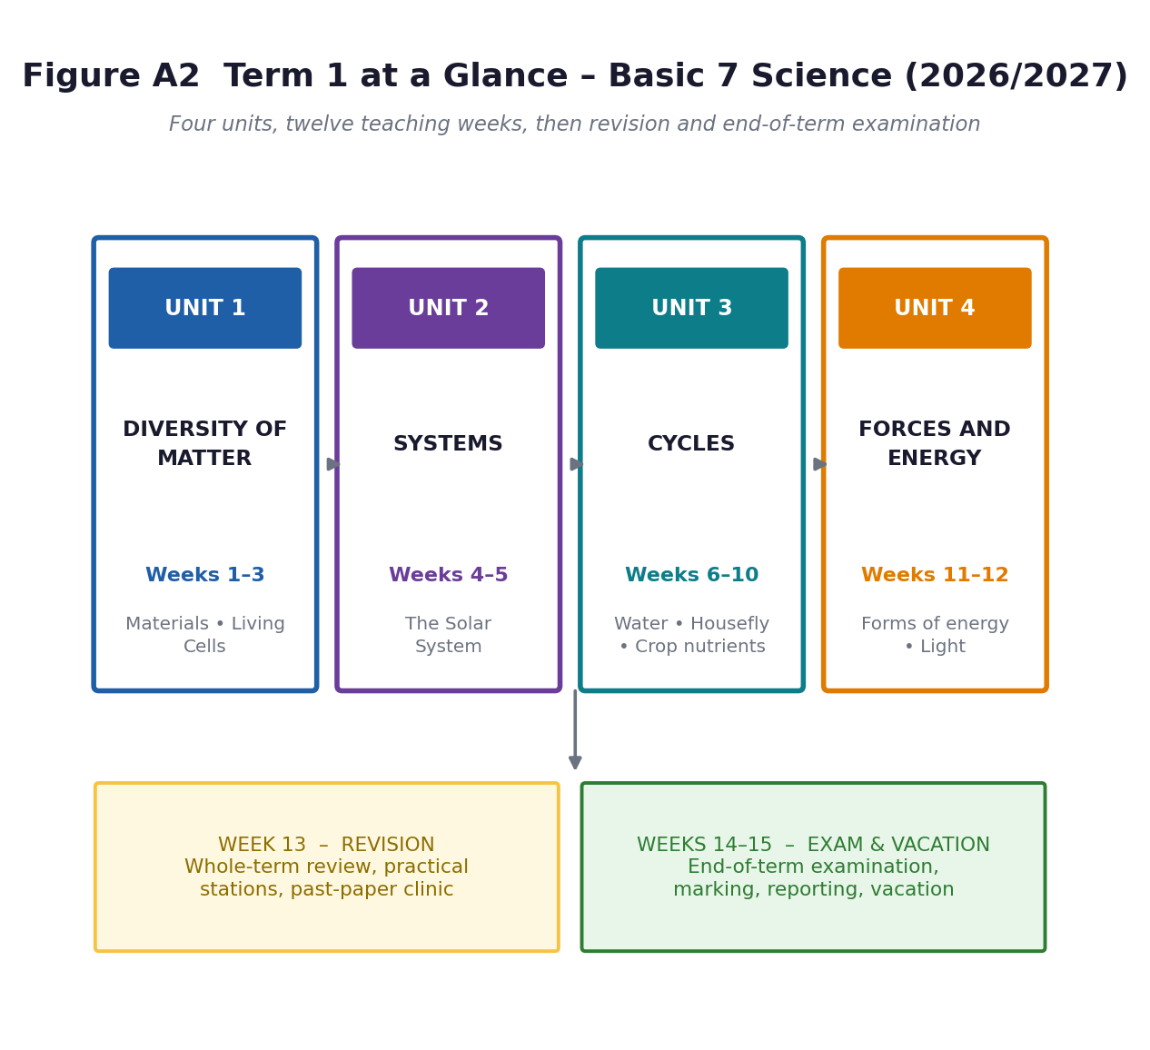
Figure A2. Four units, twelve teaching weeks, then revision and the end-of-term examination.
A2.1 Unit structure
Unit | Title | Weeks | Sub-strands | The big idea | Unit product (assessed)
1 | Diversity of Matter | 1–3 | Materials;  Living Cells | Everything around us is made of matter that exists as solids, liquids or gases, is built from elements, and — if it is alive — is made of cells. | A labelled 3-D model of a plant cell or animal cell built from locally available materials.
2 | Systems | 4–5 | The Solar System | The Sun is at the centre of a system of planets that move in regular, predictable, elliptical paths. | A scale model of the inner solar system plus an oral explanation of orbits and rotation.
3 | Cycles | 6–10 | Earth Science;  Life Cycle of Organisms;  Crop Production | Nature works in repeated patterns — water cycling through the environment, insects developing through fixed stages, nutrients returning to the soil. | A water-cycle diagram, a housefly breeding-site survey with a control poster, and a school-garden fertiliser trial.
4 | Forces and Energy | 11–12 | Energy | Energy is the ability to do work. It comes in different forms, changes from one form to another, and light behaves in predictable ways. | An energy audit of the school and a light-experiments report with diagrams.

A2.2 Why the units are ordered this way
The scheme of learning order is sound and this pack follows it, but it is worth knowing the logic so you can justify it to a head teacher or circuit supervisor:
- Unit 1 starts with what learners can touch. Solids, liquids and gases are in every classroom. Concrete before abstract — the particle model only makes sense after learners have handled the stuff itself.
- Unit 2 moves from the very small (particles, cells) to the very large (planets). Both ask learners to reason about things they cannot see directly — the same thinking skill, applied at two opposite scales.
- Unit 3 is the longest unit because three sub-strands share one idea: a cycle is a pattern that repeats. Water, a housefly's life and nutrients in soil are three instances of the same structure. Teach the pattern once, then transfer it twice.
- Unit 4 ends the term with energy, which quietly explains the other three units: heat drives changes of state, the Sun drives the water cycle and holds the solar system together, and light is the energy plants trap in food. It is the best possible place to finish.

A3 Educational Philosophies Behind This Term

You do not need to name Piaget in front of a Basic 7 class. But you do need to know why you are asking learners to handle maize grains instead of copying notes, because that choice is philosophical, not practical. NaCCA has already made the choice for you — this section explains it, and gives you the vocabulary to defend it in a lesson-observation debrief or an appraisal.
A3.1 What the curriculum itself says — the non-negotiable starting point
NaCCA Science CCP Curriculum (Feb 2020), “Philosophy”
“Ghana believes that an effective education in science needed for sustainable development should be hinged on inquiry. Thus, science education must provide learners with opportunities to expand, change, enhance and modify the ways in which they view the world. It should be pivoted on a learner-centred approach to teaching that engages learners physically and cognitively in the knowledge-acquisition process, in a rich and rigorous inquiry-driven environment.”
“Science learning is an active contextualised process of constructing knowledge based on learners’ experiences rather than acquiring it. Learners are information and knowledge constructors who operate as researchers. Teachers serve as facilitators by providing the enabling environment that promotes the construction of learners’ own knowledge, based on their prior experiences.”

Three commitments follow from those two paragraphs and every lesson in Part B honours them: (1) inquiry before instruction, (2) the learner's existing experience is the raw material, and (3) the teacher facilitates rather than transmits.
A3.2 The schools of thought behind the method
Fourteen traditions bear on this term. The table is the summary; the notes that follow expand the eight that matter most for your week-to-week decisions.
Tradition | Associated with | The core idea, in one line | How it drives THIS term
Inquiry-based science education | NaCCA 2020;  BSCS 5E (Bybee) | Learners investigate a real question and construct the answer, rather than receive it. | The spine of every lesson in Part B.
Cognitive constructivism | Jean Piaget  (1896–1980) | Learners build mental schemas by assimilation and accommodation; new ideas must clash with old ones to be learned. | Abstract models — particles, cells, orbits — always after a concrete experience.
Social constructivism; ZPD | Lev Vygotsky  (1896–1934) | Learning appears first between people, then inside the individual. Scaffolding inside the Zone of Proximal Development moves learners from what they can do with help to what they can do alone. | Group practicals, talk-for-learning, sentence frames, gradual release of responsibility.
Discovery learning; spiral curriculum | Jerome Bruner  (1915–2016) | Learners understand best what they discover for themselves; any idea can be revisited at greater depth. | States of matter from B4–B6 revisited as the particle model in B7.
Progressivism; learning by doing | John Dewey  (1859–1952) | Education must start from the learner's own experience and connect to real life, or it is not education. | School-garden fertiliser trial; housefly survey of the learners' own community.
Experiential learning cycle | David Kolb  (b. 1939) | Concrete experience → reflective observation → abstract conceptualisation → active experimentation. | The shape of every practical in Units 1, 3 and 4.
Meaningful learning; advance organisers | David Ausubel  (1918–2008) | New knowledge sticks only if it is anchored to something the learner already knows. | Every Starter phase activates prior knowledge before new content is introduced.
Multiple intelligences | Howard Gardner  (b. 1943) | Learners differ in profile — verbal, logical, spatial, kinaesthetic, interpersonal, naturalist and more — and each is a route into the same concept. | Choice of product: model, poster, song, role-play, diagram, report.
Critical pedagogy; problem-posing | Paulo Freire  (1921–1997) | Reject the “banking model” of depositing facts. Education is dialogue about the learners' real world, aimed at changing it. | Unit 3: learners investigate their own community's refuse and design an intervention.
Explicit / direct instruction | B. F. Skinner;  Barak Rosenshine | For factual fluency and procedures, modelling, guided practice, retrieval and immediate feedback beat pure discovery. | Element symbols drill, PE = mgh worked examples, safety rules, spellings of organelles.
Ethnoscience / indigenous knowledge | Ghanaian science-  education scholarship | The knowledge a learner brings from home — farming, food preservation, weather signs — is a valid and powerful starting point for science. | Composting, animal manure, local weather lore, local names for the planets and for insects.
Universal Design for Learning | CAST; Rose & Meyer | Plan from the start for multiple means of representation, engagement and expression, rather than retro-fitting support. | See A5 — inclusion by design, not by afterthought.
Montessori sensory method | Maria Montessori  (1870–1952) | Self-directed exploration with hands-on, self-correcting materials in a prepared environment. | Sorting trays, matching cards, station teaching.
Situated learning | Lave & Wenger | Knowledge is most powerful when learned in the setting where it is used, alongside real practitioners. | The learning tours in A10; visiting a lab technician, an extension officer, a farmer.

A3.3 The eight that will actually change what you do on Monday
1. Constructivism — and why it forbids you from starting with the definition
Piaget's finding is uncomfortable for teachers: telling a learner a correct fact rarely dislodges an incorrect idea they already hold. The wrong idea has to be made to fail first. A twelve-year-old will tell you a gas has no mass because you cannot see it; you can say “gases are matter” fifty times and it will not shift. Weigh a deflated football, pump it up, weigh it again, and the idea shifts in ninety seconds. That is why Unit 1 Lesson 1 opens with objects on a table and not with a definition of matter. Build the concept; name it afterwards.
2. Vygotsky's ZPD — the reason for group work and for talk
There is a gap between what a learner can do alone and what they can do with a more capable person. That gap is where teaching happens. In a B7 science class of forty-five, you cannot be the more capable person for everyone at once — so you build the scaffolding into the task: a worked example on the board, a word bank on the wall, a partner who checks, a sentence frame (“I think ___ because ___”). Everything in A5 on scaffolding comes from this one idea.
3. Bruner's spiral — why B7 revisits primary science instead of replacing it
Bruner argued that any idea can be taught honestly at any age, at increasing depth. Your learners met solids, liquids and gases in Basic 4 and 5. In Basic 7 the same content returns with a new layer: the particle explanation of why the three states behave differently. Do not apologise for revisiting it — say openly, “You already know the three states. This term you learn why.” That sentence alone raises engagement.
4. Dewey — science that is not about their lives is not science education
Dewey's objection was to knowledge cut off from experience. Ghana gives you an unusually strong version of this argument: the water cycle is why the rains fail and the maize fails; the housefly life cycle is why a household gets dysentery; plant nutrients are the difference between a harvest and a hunger season. Every unit in Term 1 has a live, local stake. Use it, and you will not have to manage behaviour as much.
5. Kolb's cycle — the four moves inside every practical
A practical that ends when the equipment is put away has delivered half its value. The learning is in the reflection and the re-test, not in the doing. Kolb's four moves map directly onto the practical write-up structure used throughout Part B: (i) What did we do? (ii) What did we notice? (iii) What does it mean — what is the science? (iv) What would we do differently, or where else does this apply?
6. Gardner — one concept, several doors
Gardner's contribution here is not “teach to learning styles” — that claim has not held up in research. His useful point is that a concept can be entered through several routes and expressed in several forms, and that offering a choice raises achievement without lowering standards. So the plant cell can be assessed as a 3-D model, a labelled drawing, a written comparison, an oral explanation or a role-play in which learners are organelles. Same standard, five doors.
7. Freire — the housefly unit is the most Freirean thing on the scheme
Freire called the transmission model “banking” — the teacher deposits, the learner stores. B7.2.2.1.2 asks learners to “design an intervention that can reduce the effects of the activities of the housefly on humans and educate people of your community about the intervention.” That is problem-posing education written into a national standard. Lessons 15 and 16 treat it seriously: learners survey their own environment, decide what to do about it, and act. If you only ever do one genuinely pupil-led lesson this term, do this one.
8. Rosenshine and explicit instruction — the corrective to naive discovery
Pure discovery fails for facts and procedures. Nobody discovers that magnesium's symbol is Mg. For the first twenty element symbols, for PE = mgh and KE = ½mv², for the safety rules of the laboratory, use the direct-instruction sequence: model it, do one together, do several with support, check, then re-check a week later. Notice the implication — this pack mixes traditions deliberately. Inquiry for concepts, explicit instruction for facts. That is not inconsistency; it is matching the method to the learning outcome.
A3.4 A philosophy statement you may copy into your lesson notes or appraisal
Ready to paste
My teaching of Basic 7 Science this term is inquiry-led and learner-centred, as the NaCCA Common Core Programme requires. Learners construct understanding from concrete experiences with real materials before they are given scientific vocabulary, and they work collaboratively within their zone of proximal development with scaffolding that is withdrawn as competence grows. Concepts are introduced through the 5E cycle; factual fluency (element symbols, formulae, safety rules) is secured through explicit modelling, guided practice and spaced retrieval. Learning is anchored in Ghanaian contexts and learners’ indigenous knowledge — the school garden, local water sources, local farming practice — so that science is seen as useful rather than foreign. Assessment is continuous and formative, feeding forward into the next lesson, and tasks are differentiated by task, support and outcome so that every learner can access the standard.

A4 Teaching Methods and Strategies for This Term

A4.1 The default lesson shape: the 5E inquiry cycle
Every one of the twenty-four lessons in Part B uses the BSCS 5E model, mapped onto the three-phase structure Ghanaianscience lesson notes are expected to show (Starter / Main / Plenary).
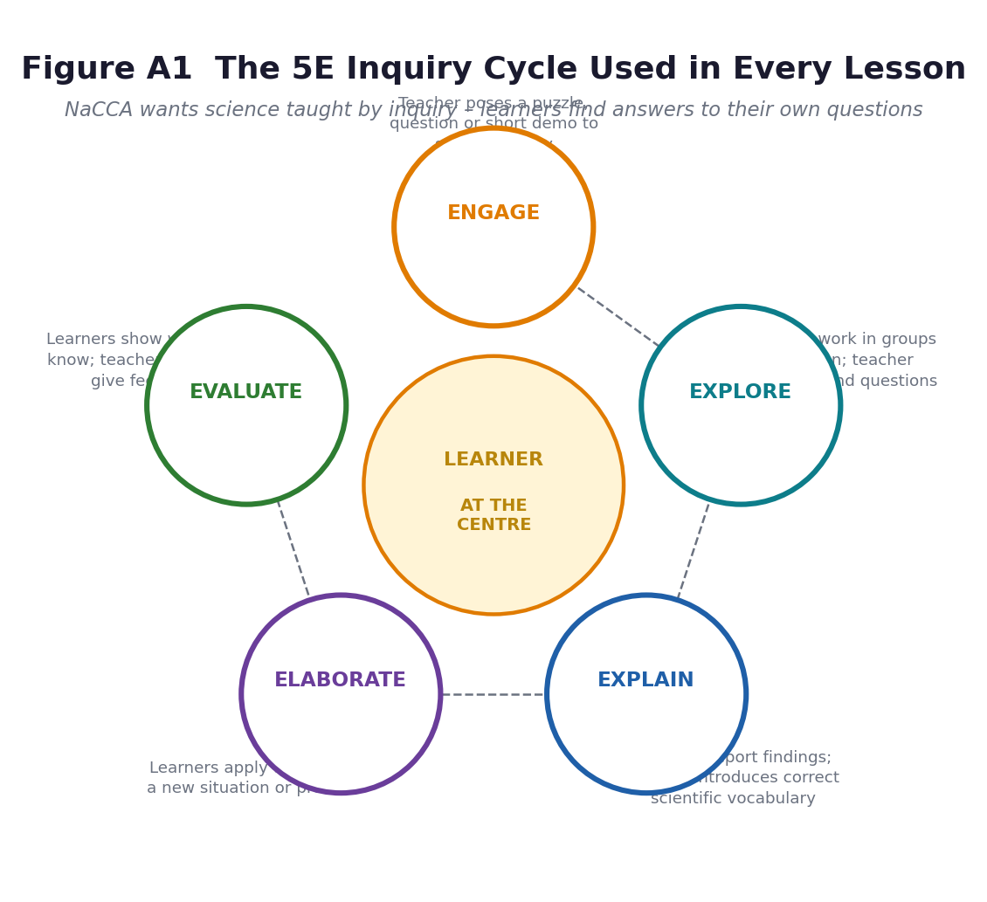
Figure A4. The 5E cycle. The learner is at the centre; the teacher orchestrates.
Phase | Time | NaCCA phase | What the teacher does / what learners do
ENGAGE | 8 min | Phase 1 – Starter | A puzzle, a question, a surprising demo, a short story or a real object. The teacher finds out what learners already think and shares the performance indicator. No answers given yet.
EXPLORE | 18 min | Phase 2 – Main (a) | Learners work in groups, hands-on, testing their own predictions. The teacher circulates, questions, and deliberately does NOT correct — she collects evidence of thinking.
EXPLAIN | 12 min | Phase 2 – Main (b) | Groups report. Only now does the teacher introduce the correct scientific term, definition, diagram or formula, and explicitly name and correct the misconceptions she heard during Explore.
ELABORATE | 12 min | Phase 2 – Main (c) | Learners apply the new idea to a fresh situation — a new problem, a new context, a worked example, a short investigation. This is where transfer is tested.
EVALUATE | 10 min | Phase 3 – Plenary | Learners show what they know: exit ticket, quick quiz, diagram to label, oral explanation, peer assessment against the success criteria. Feedback is given and the next lesson is previewed.

A4.2 The method catalogue
Eighteen methods are used across the term. For each: what it is, when to reach for it, and the exact Term 1 example.
Method | What it is | When to reach for it | Where it appears in Term 1
1. Guided inquiry / 5E | The default. Teacher poses the question, learners design and run the investigation, teacher formalises afterwards. | Default for concepts. Not for memorising facts. | All 24 lessons.
2. Predict–Observe–Explain (POE) | Learners write a prediction and a reason BEFORE seeing the demonstration, then observe, then explain any mismatch. Very high yield for misconception-busting. | Any demonstration; best when a wrong prediction is likely. | L11 evaporation; L23 light and the three cardboards; L19 fertiliser on seedlings.
3. Practical / hands-on group investigation | Learners handle apparatus and materials, collect data, and draw a conclusion. Groups of 4–6 with assigned roles. | Whenever the indicator contains a verb like observe, demonstrate, carry out, examine. | L1 sorting materials; L14 rearing housefly stages; L19 applying fertiliser; L23 light experiments.
4. Teacher demonstration | The teacher performs, learners observe and record. Use it when apparatus is scarce, the process is hazardous, or the technique is too fine for twelve-year-olds. | Scarce or dangerous apparatus. | L12 distillation/condensation on a small stove; L24 dispersion with a prism.
5. Concept mapping / graphic organiser | Learners build a visual structure — tree, Venn, flow chart, cycle, Frayer model — showing how ideas connect. | Consolidation, comparison, revision, and as a diagnostic. | L6 Venn: plant vs animal cell; L9 dual-coding the planets; W3 revision concept map.
6. Think–Pair–Share | Individual think time (30–60 s, silent) → pair discussion → report to class. Cheapest way in existence to raise the number of learners who actually think. | Any question; especially before a whole-class answer. | Used at least once in every lesson in Part B.
7. Jigsaw | Each group becomes expert on one sub-topic, then regroups so that each new group has one expert on each sub-topic and teaches the others. | Content that splits cleanly into parallel parts. | L21 — nine forms of energy, nine expert groups; L3 — categories of solid materials.
8. Gallery walk / carousel | Posters or models around the room; groups rotate, read, and add sticky-note comments or ticks. | Presenting many products quickly; peer feedback. | L16 housefly intervention posters; L20 Unit 3 showcase.
9. Role play, drama and body modelling | Learners physically become the thing: particles, planets, water molecules, organelles. | Abstract, invisible, or spatial ideas. | L1 learners as particles (packed / sliding / flying); L8 playground orbits; L11 water cycle mime.
10. Structured debate | Two sides argue a motion with evidence, then swap or reach a synthesis. | Socio-scientific issues with no single right answer. | L15 “The school should ban food sold outside the compound”; L18 organic vs inorganic fertiliser.
11. Project-Based Learning | A sustained task over 2–4 weeks with a public product and an authentic audience. | The assessed unit products; whenever the exemplar says ‘design’. | Unit products in A2.1; the housefly intervention (L15–L16); the school-garden trial (L18–L19).
12. Fieldwork / learning tour | Structured learning outside the classroom — see A10 for the full planning package. | When the real thing is better than any model of it. | Tours 1–4 in A10.
13. Talk-for-Learning | Scaffolded scientific talk: sentence frames, word banks, “say it again better”, reasoning without hands up. | Building scientific vocabulary and reasoning in every lesson. | A4.4 sentence frames; used in every Explain phase.
14. Dialogic questioning | Questions that expose thinking rather than test recall; the teacher follows up rather than moving on. | Whole-class discussion; probing during Explore. | A4.5 question stems.
15. Retrieval games | Bingo, snap, matching cards, quiz-quiz-trade, mini-whiteboard showdown, 5-question Friday. | Securing factual fluency with repetition that does not bore. | L4 first-20 element bingo; L5/L6 organelle snap; L21 energy-form matching cards.
16. Worked-example / gradual release | I do → we do → you do together → you do alone. | Calculations and procedures. | L22 PE = mgh and KE = ½mv².
17. Station teaching | Four to six stations around the room; groups rotate on a timer. Solves the one-set-of-apparatus problem. | When equipment is limited; for revision. | L24 light stations (straight line / reflection / refraction / dispersion); Week 13 revision stations.
18. Reflective writing / science journal | A short structured reflection at the end of a lesson or practical: what I did, what I found, what I still wonder. | Metacognition; evidence for assessment as learning. | L14 housefly diary; L19 garden log; every Evaluate phase exit ticket.

A4.3 Which method for which unit
A practical planning aid. ✓✓ = a core method for that unit; ✓ = used occasionally; blank = not needed.
Method | Unit 1  Matter & Cells | Unit 2  Solar System | Unit 3  Cycles | Unit 4  Energy & Light
Guided inquiry / 5E | ✓✓ | ✓✓ | ✓✓ | ✓✓
Predict–Observe–Explain | ✓✓ | ✓ | ✓✓ | ✓✓
Practical investigation | ✓✓ | ✓ | ✓✓ | ✓✓
Teacher demonstration | ✓ | ✓ | ✓✓ | ✓✓
Concept mapping | ✓✓ | ✓✓ | ✓✓ | ✓
Think–Pair–Share | ✓✓ | ✓✓ | ✓✓ | ✓✓
Jigsaw | ✓✓ | ✓ | ✓ | ✓✓
Gallery walk | ✓ | ✓ | ✓✓ | ✓
Role play / body modelling | ✓✓ | ✓✓ | ✓✓ | ✓
Structured debate | ✓ |  | ✓✓ | ✓
Project-Based Learning | ✓ | ✓ | ✓✓ | ✓
Fieldwork / learning tour | ✓ | ✓✓ | ✓✓ | ✓✓
Talk-for-Learning | ✓✓ | ✓✓ | ✓✓ | ✓✓
Dialogic questioning | ✓✓ | ✓✓ | ✓✓ | ✓✓
Retrieval games | ✓✓ | ✓✓ | ✓ | ✓✓
Worked example / gradual release | ✓ | ✓ |  | ✓✓
Station teaching | ✓ |  | ✓ | ✓✓
Reflective journal | ✓ | ✓ | ✓✓ | ✓

A4.4 NaCCA's fifteen science process skills — where each is practised this term
NaCCA defines process skills as “the core of inquiry-based learning” and lists them as benchmarks for planning lessons. You should be able to point to the lesson in which each is deliberately developed, not merely hoped for.
Process skill | What it means | Deliberately developed in
Observing | Using the senses — and instruments that extend them — to gather information. | L1 (materials table), L5/L6 (cells under a magnifier), L14 (housefly stages), L19 (seedlings)
Classifying | Grouping objects or events by common characteristics. | L1 (solid/liquid/gas), L4 (metal / non-metal / noble gas), L17 (organic / inorganic)
Comparing | Identifying similarities and differences. | L6 (plant vs animal cell), L9 (Mercury vs Venus), L18 (fertiliser types)
Measuring | Using standard and non-standard instruments accurately. | L19 (measuring fertiliser, plant height), L22 (mass, height, velocity)
Communicating / Reporting | Presenting information clearly, in words, tables, pictures or graphs. | L3 poster, L12 report, L16 community poster, L24 experiment report
Predicting | Assessing the likely outcome from prior knowledge. | L11 (POE on evaporation), L23 (POE on light through three cards), L19 (fertiliser trial)
Analysing | Identifying parts and the patterns and relationships between them. | L4 (periodic trends), L13 (stage order), L21 (energy relationships)
Generating possibilities | Exploring options beyond the obvious one. | L16 (housefly interventions), L18 (local alternatives to chemical fertiliser)
Evaluating | Assessing the reasonableness, accuracy and quality of information or ideas. | L18 (merits of fertiliser types), L22 (energy audit), L16 (peer review of posters)
Designing | Visualising and creating a mental or physical model. | L6 (cell model), L8 (solar system model), L16 (fly trap design)
Designing of Experiments | Forming hypotheses, planning and modifying investigations to reach a conclusion. | L19 (school-garden fertiliser trial), L23 (light experiments)
Recording | Drawing and tabulating boldly, clearly and with labels. | L5/L6 (labelled cell drawings), L11 (water-cycle diagram), L24 (ray diagrams)
Interpreting | Organising and evaluating data, making inferences and drawing conclusions. | L14 (housefly diary data), L19 (plant growth results), L22 (energy audit data)
Generalising | Applying a conclusion from one situation to similar ones. | L12 (water cycle applies everywhere), L20 (all cycles share a structure)
Equipment handling | Knowing the function and limits of apparatus and selecting and handling it appropriately. | L5/L6 (magnifier / microscope), L19 (garden tools), L24 (prism, mirror, cards)

A4.5 Questioning: stems that get thinking instead of guessing
The single cheapest improvement to any Ghanaian science lesson is to stop asking “any questions?” and start using planned stems. Keep this table on your desk.
Level | Stems and worked examples from Term 1
Recall — ‘what’ | What are the three states of matter? Name the four inner planets. What does the nucleus do?
Understand — ‘explain’ | Explain in your own words why a gas fills its container. Describe what happens to water vapour high in the sky.
Apply — ‘use it’ | A coconut is hard and keeps its shape. Which state is it, and how do you know? Which form of energy does a mortar and pestle use?
Analyse — ‘take it apart’ | What is the same and what is different about the water cycle and the housefly life cycle? Why are metals on one side of the periodic table?
Evaluate — ‘judge it’ | Which is the better fertiliser for a school garden, compost or NPK? Give two reasons for and one against. How strong is the evidence for your claim?
Create — ‘make it’ | Design a poster that would convince a chop-bar owner to cover her refuse bin. Invent a model of a plant cell using only things from home.

Sentence frames to put on the wall (Talk-for-Learning)
I think ___ because ___. | My evidence is ___. | I agree with ___ because ___. | I disagree with ___ because ___. | I predicted ___ but I observed ___, so ___. | This is similar to ___ because ___. | A question I still have is ___.
Insist on the full sentence, every time. The frame is not a crutch to be removed in a week — it is the scaffold Vygotsky described, and it is withdrawn gradually across the term as learners internalise the pattern of scientific reasoning.
A4.6 Grouping forty-five learners with one set of apparatus
- Base groups for practical work — four to six learners, with named roles that rotate each lesson: Leader (keeps the group on task), Recorder (writes), Reporter (speaks for the group), Resources Officer (collects and returns apparatus), Safety Officer (checks the rules). Rotate every lesson so that by Week 12 everyone has done every job.
- Half-class rotation for whole-class practicals, split the class in half: Group A runs the practical while Group B does the recording sheet and the analysis, then swap at the next station or next lesson.
- The one-set rule when you have exactly one demonstration. The teacher demos while learners record on a structured observation sheet; then learners repeat it themselves at stations over the following two lessons if apparatus allows.
- Mixed attainment, deliberately pair a confident reader with a struggling one for reading tasks only. Never ability-group for the whole lesson — it damages the self-concept of the lower group and the NaCCA inclusion principle is explicit that all learners are entitled to the same broad and balanced curriculum.
- Access first if you have a learner with a hearing or visual impairment, seat them where they can see both the board and your face, and give the group a written copy of every instruction — see A5.
A4.7 ICT — and what to do when the projector fails
NaCCA integrates ICT as a teaching and learning tool, not as an add-on. But plan for the day the electricity is off, because it will be off.
Purpose | With technology | Without technology (always prepare this)
Seeing cells | Projected micrographs or a short video of onion cells under a microscope. | Learners examine onion epidermis with a hand lens or low-power microscope; textbook chart; the labelled diagrams in this pack (Figures 1.4 and 1.5).
The solar system | Stellarium or a solar-system animation; GSSTI/planetarium visit. | Playground scale model with chalked orbits; balls of different sizes; the diagrams in Figures 2.1 and 2.2.
The water cycle | Animation of evaporation and condensation. | A sealed transparent bowl of water on the windowsill in the sun with a cold plate on top — droplets form within an hour. Nothing beats it.
Housefly life cycle | Time-lapse video. | Rear real larvae in a jar (see L14) — two weeks and learners watch every stage.
Energy and light | Simulation or video of a prism; torch-and-mirror practicals. | Real torch, real mirror, real glass block, a bowl of water, a CD as a diffraction grating. All cheap and all work in daylight.
Research | Internet search on water-cycle importance or electricity generation in Ghana. | Printed extracts, textbooks, GMet radio bulletins, a visiting speaker, the class library.

Offline-first rule
Prepare the no-technology version of every lesson FIRST, then add ICT as an enhancement. A lesson that collapses when the projector does not work was never a lesson — it was a slideshow.

A5 Inclusion, Differentiation and Scaffolding

NaCCA: “Inclusion is ensuring access and learning for all learners, especially those disadvantaged. All learners are entitled to a broad and balanced curriculum in every school in Ghana.” This section turns that into what you do on Monday.
A5.1 The three levers of differentiation
NaCCA names three: differentiation by task, by support, and by outcome. Every lesson plan in Part B carries a line for each.
Lever | What it means | Term 1 example
By TASK | Different learners get different tasks aimed at the SAME standard — not easier content, a different route to the same destination. | In the plant-cell lesson some learners draw the cell freehand, some label a prepared outline, some build it in 3-D. All must name every organelle and state its function.
By SUPPORT | The amount and kind of help varies: word banks, worked examples, a teacher-led small group, extra time, peer buddy, referral to the Guidance and Counselling Unit. | A word bank of the nine forms of energy for learners who are still building English; a calculator and a step-by-step card for PE = mgh; pre-teaching key vocabulary the day before.
By OUTCOME | The minimum standard is fixed, but the ceiling is open. Weaker learners are given more time; stronger learners are pushed to explain, justify, apply or design rather than simply do more of the same. | Everyone classifies materials into three states. Extension: justify the classification of a foam sponge, a jelly, and smoke — and explain where the three-state model breaks down.

A5.2 Common barriers and what actually works
Barrier | What this looks like in a B7 science lesson | Adjustments that cost nothing
Visual impairment (low vision / blind) | Cannot see the demonstration, the board diagram, or the fine detail of a specimen. | Let them handle the real object first and describe it aloud. Verbalise everything you write. Give a raised-line or tactile model (clay cell, string-and-bead orbits). Pair with a describer for demonstrations. Enlarge diagrams to A3. Never say ‘look at this’ — say ‘feel this’.
Hearing impairment / deaf | Misses verbal instructions and group discussion; may appear inattentive. | Face the class when speaking; never talk while writing on the board. Write every instruction on the board. Use visual cues and gestures. Seat near the front. Assign a signing or note-taking buddy. Use the many visual diagrams in this pack.
Physical disability / limited mobility | Cannot reach the bench, carry apparatus, or move around stations. | Keep one station at a bench accessible without steps. Give the group role of Recorder or Reporter rather than Resources Officer. Ensure the school-garden session has a task that can be done seated (measuring, recording, seed sorting).
Dyslexia / reading difficulty | Slow, laboured reading; cannot copy from the board and listen at the same time; poor spelling hides good science. | Pre-teach key vocabulary. Provide word banks and diagrams to label rather than paragraphs to copy. Accept oral answers and voice-recorded work. Use sans-serif font, enlarged. Assess science, not spelling, in formative tasks. Give reading tasks to a partner.
Attention difficulty (e.g. ADHD) | Off-task during explanation; impulsive with apparatus. | Short, varied phases (the 5E structure does this for you). Give a physical job — apparatus officer, timekeeper. Seat near the teacher. Use timers and visible countdowns. Praise the behaviour you want, specifically and immediately.
English as an additional language | Understands the science but cannot express it, so appears to know nothing. | Allow answers in the home/Ghanaian language first, then build the English term alongside. Keep a bilingual science word wall. Use diagrams, demonstrations and practical work — they carry meaning without words. This is a resource, not a deficit: local knowledge of farming and weather is real science capital.
Gifted and high-attaining | Finishes in five minutes and then disrupts. | Do not simply give more of the same. Ask ‘why’ and ‘what if’: What if the Earth stopped rotating? Why is Venus hotter than Mercury? Design a better experiment. Give them the evaluation criteria and let them design their own assessment task.
Learners who are behind (the silent majority) | Copy notes beautifully, understand almost nothing, never ask. | Check understanding every 8 minutes — mini-whiteboards, thumb signals, exit tickets. Use Think–Pair–Share so they can rehearse before answering in public. Re-teach in a small group at the back while others work. Never accept a silent class as a sign of understanding.

A5.3 Gender-responsive science teaching
Girls in Ghanaian JHS do at least as well as boys in science when they are taught well, and then drift away from it at senior high. Small, deliberate acts in a B7 classroom change that trajectory.
- call on girls and boys equally and wait the same three seconds for an answer.
- never let boys monopolise apparatus. Rotate the Resources Officer and Safety Officer roles so girls handle the equipment as often as boys do.
- choose examples that cross gender lines — a mortar and pestle and a bicycle pump and a sewing machine are all machines; cooking is chemistry; market trading is applied measurement.
- name Ghanaian women scientists when the chance arises — Professor Elsie Effah Kaufmann (biomedical engineering, University of Ghana), Professor Aba Andam (physics, KNUST), the late Professor Mary Ewurama Addy (biochemistry and science education), Professor Frances Owusu-Daaku (pharmacy, KNUST), Dr Nana Ama Browne Klutse (climate science, University of Ghana), and the women astronomers celebrated by the Ghana Planetarium's outreach programme.
- watch your own language. “Science is hard” and “you need to be brilliant” push learners out. Say “this is hard, and you can do hard things” instead.
A5.4 Scaffolding: the six strategies NaCCA lists, applied
NaCCA scaffolding strategy | How it appears in this pack
Give a simplified version first, then increase complexity. | Unit 1 teaches the three states by handling objects, then the particle explanation, then changes of state, then the periodic table. Unit 4 teaches energy forms, then relationships, then the PE/KE formula.
Describe or illustrate a concept in multiple ways. | Every core concept in this pack has a diagram, a practical, an analogy and a written definition — four routes in.
Give learners an exemplar or model of what they must produce. | Every assessed product has a worked exemplar and a rubric in Part C, shared with learners BEFORE they start.
Give a vocabulary lesson before a difficult text. | Key vocabulary is listed at the top of all 24 lessons and pre-taught in the Engage phase.
Describe the purpose of the activity and the learning goals clearly. | Every lesson opens with the performance indicator shared in learner language: “By the end of this lesson you will be able to…”
Explain explicitly how the new lesson builds on previous learning. | Every lesson states its prior-knowledge link, and Unit introductions state the progression across the term.

A6 Assessment Plan for the Term

NaCCA requires assessment for learning, as learning and of learning. Most Ghanaian classrooms do the third and call it the whole job. This section gives you all three, with the instruments in Part C.
A6.1 The three purposes
Type | What it is | When | Instruments in this pack
Assessment FOR  learning (AfL) | Seeking and interpreting evidence so you and the learner can decide where they are, where they need to be, and how to get there. Feedback changes the next lesson. | Continuously — in every phase of every lesson. | Exit tickets; observation checklist; POE prediction sheets; mini-whiteboard checks; thumbs-up confidence signals; the ‘next lesson I need to…’ line on every plan.
Assessment AS  learning (AaL) | Learners take ownership: they self-assess, peer-assess and reflect, and so understand their own learning better. | At the end of each task and each unit. | Self-assessment against success criteria; peer feedback on posters and models; science journal; rubrics shared in advance (C3); portfolio review.
Assessment OF  learning (AoL) | A picture of achieved standards at the end of a unit or the term, for grading, reporting and accountability. | End of each unit; Weeks 13–14. | Four unit tests (C1); the end-of-term examination with table of specification and marking scheme (C2); assessed practical; project marks.

A6.2 The assessment calendar
When | What | Purpose and how it is used
Week 1, L1 | Diagnostic probe: ‘What is matter? Draw and label a plant.’ | Reveals prior knowledge and misconceptions before you teach. Not scored. Directly shapes how you pitch L1 and L5.
Every lesson | Exit ticket (one question, two minutes) | AfL. Sort into three piles overnight — got it, nearly, not yet. Reteach the ‘not yet’ group at the start of the next lesson.
Every practical | Observation checklist (C7) | AfL on process skills — observing, measuring, recording, equipment handling — which a written test can never see.
End of Unit 1 (Wk 3) | Unit 1 test (20 marks) + cell model (rubric, 20 marks) | AoL. The model is the NaCCA exemplar ‘develop a model to represent a plant cell’.
End of Unit 2 (Wk 5) | Unit 2 test (20 marks) + solar system model with oral defence (20 marks) | AoL. The oral defence is where you find out whether they understand orbits or just glued balls.
End of Unit 3 (Wk 10) | Unit 3 test (30 marks) + garden trial report + housefly poster (20 marks) | AoL. Three strands of the unit assessed through three different products.
End of Unit 4 (Wk 12) | Unit 4 test (20 marks) + light experiments report (20 marks) | AoL.
Week 13 | Revision: station circuit + past-paper clinic + learner-made revision cards | AfL. The station circuit tells you what to reteach; the clinic teaches exam technique, not content.
Week 14 | End-of-term examination (C2), 50 marks, 1 hour | AoL. Feeds the terminal report.

A6.3 How the term mark is built
A defensible continuous assessment weighting for one term. Adjust to your school's policy, but keep the principle: a learner should be able to do well through practical work and projects, not only through written tests.
Component | Weight | Notes
Continuous assessment — class exercises and exit tickets | 10% | Best eight of twelve scores.
Practical work and process skills (observation checklist) | 15% | Six scored practicals across the term.
Project / model work (four unit products) | 20% | Marked with the rubrics in C3, shared with learners in advance.
Four unit tests | 25% | Unit 3 weighted double because it is the longest unit.
End-of-term examination | 30% | Set from the table of specification in C2.
TOTAL | 100%

A6.4 Feedback that changes learning
- Give a next step. Write a comment and a next step, not a mark alone. “14/20” tells a learner nothing; “You can name the stages but you have not explained what drives the cycle — add the role of the Sun” tells them exactly what to do.
- Mark the gap. A learner who writes “water evaporates and becomes clouds” has the right idea and one missing link. Mark the gap, not the whole answer.
- Feed the class, not only the child. Whole-class feedback is more efficient than individual marking. After a test, write the four most common errors on the board with the correction, and give five minutes for learners to fix their own work in a different colour.
- Use peer marking. Learners mark each other's exit tickets against the success criteria. They learn the criteria far better by applying them than by reading them.
- Keep it structured. “Two stars and a wish” — two things done well, one thing to improve. Train them to be specific; ban “good work”.
A6.5 Reporting to parents
The terminal report should say more than a score. For each learner, be ready to state, in one sentence each: what they can now do that they could not do in September; the one skill they most need next term; and what the parent can do at home. The second and third of these are the ones parents remember.

A7 Resources, Apparatus and Low-Cost Improvisation

Every practical in this pack can be run from a market, a farm and a refuse bin. Where a piece of proper apparatus genuinely matters, it is marked [E] — borrow it from the nearest senior high school if your department does not have one.
A7.1 Master resource list by unit
Unit | From the local environment (free) | Equipment to gather in advance
1 — Matter & Cells | Stones, sand, water, cooking oil, melted margarine, ice, smoke, a balloon, maize grains, beads, onion bulb, cheek cells on a swab, empty matchboxes, clay or pap. | Hand lenses [E], a microscope [E] if available, glass slides and coverslips [E], methylene blue or iodine solution [E], a printed periodic table, element flashcards, a balance [E].
2 — Solar System | Balls of different sizes (orange, tennis, marble, peppercorn), string, chalk, sand for a playground model, cardboard, foil, paint. | A printed periodic chart is not needed here — you need a solar system poster or chart, string, and a torch for the day/night demonstration.
3 — Cycles | A transparent bowl or jar with a lid, water, a cold plate, soil, seedlings (maize or beans), compost, poultry manure, NPK fertiliser, overripe fruit in a jar for housefly stages, a fine net or old stocking, a hand trowel, watering can. | Clear plastic containers with lids, hand lenses [E], a magnifier, measuring cylinder or a marked bottle [E], a metre rule, a camera phone for the diary.
4 — Energy & Light | A torch, a mirror, a bowl of water, a CD or DVD, a glass block or a clear plastic ruler [E], three pieces of cardboard, a pin, a ball, a rubber band, a matchbox car, cooking oil and a spoon. | Prism [E], ray box [E] if available, plane mirror [E], a spring balance [E], a stopwatch, a thermometer [E].

A7.2 Improvisation: what to substitute for what
If you do not have… | Use…
A microscope | A hand lens, or a smartphone camera held over a hand lens. Onion epidermis is visible with a ×5 lens if it is thin and stained.
Glass slides and coverslips | Clear stiff plastic cut from a mineral-water bottle; a drop of water and a piece of clear sticky tape.
Stain (iodine / methylene blue) | A tiny drop of diluted ink, or tincture of iodine from the pharmacy — a few drops in water.
A measuring cylinder | A marked plastic bottle with a strip of tape and a pen; volume marked in millilitres using a kitchen measuring cup.
A balance | A homemade equal-arm balance from a ruler, a pencil fulcrum and two yogurt cups. It compares mass honestly, which is most of what B7 needs.
A prism | A glass of water in bright sunlight, a CD held at an angle, or a bevel-edged mirror in water. All three produce a spectrum.
A ray box | A torch with a slit cut from cardboard taped over the lens, or a hole punched in card.
A plane mirror | A new mirrored tile from a hardware shop, or aluminium foil glued flat onto glass or cardboard.
A thermometer | Borrow one from the school sick bay for the lesson; or use touch and a comparison of two objects — adequate for ‘hotter/colder’ but not for data.
A spring balance | A rubber band with a paper-clip hook and a hand-drawn scale, calibrated with known masses.
A stopwatch | Any mobile phone. One per group of six is enough.
A bell jar / vacuum pump | You do not need one. For ‘gases have mass’ use a balloon on a balance; for ‘sound needs a medium’ a ringing phone in a sealed plastic bag under water.

A7.3 Human resources — free expertise within reach
The most under-used resource in Ghanaian science teaching is the people. Ask them to come for twenty minutes, not to teach the lesson — to answer learners' questions.
- An agricultural extension officer, the school farm attendant or the community agricultural extension officer — Unit 3, fertilisers.
- The district environmental health officer the environmental health officer or assembly waste officer — Unit 3, housefly control.
- A lab technician a laboratory technician from the nearest SHS — Unit 1, microscopes and safety.
- A tradesperson an electrician, a solar installer or a fitter from the local market — Unit 4, energy.
- A grandparent an older relative who can name the stars, read the weather or preserve food — every unit. Treat indigenous knowledge as a starting point for science, not as folklore to be dismissed.
Ask them one thing
When you invite a visitor, brief them with a single sentence: ‘Tell them what you do all day and why it matters, and let them ask you questions.’ Visitors who try to teach the syllabus lose the class in four minutes.

A8 Safety and Classroom Management for Practical Work

A8.1 The ten rules, to be displayed and rehearsed before the first practical
# | Rule
1 | Walk in the laboratory or practical area. Never run.
2 | Do not touch, taste or smell anything until the teacher says it is safe.
3 | Read the instruction twice before you touch the apparatus.
4 | Never point a test tube, a bottle or a torch beam at anyone's face.
5 | Report every spill, cut, breakage or burn to the teacher at once — no matter how small.
6 | Tie back long hair, tuck in loose clothing, and put bags under the bench.
7 | Wash your hands with soap after every practical, especially before eating.
8 | Use tools (trowels, knives, scissors, pins) with the blade or point away from your own body.
9 | Keep walkways clear. Stand, do not sit on benches.
10 | At the end, the Resources Officer counts the apparatus back in before anyone leaves.

A8.2 Specific hazards in Term 1
Activity | Hazard | Control
Sorting and heating materials (L1–L3) | Heat from a stove or candle; melted margarine or wax. | Teacher handles all heating. Learners observe from arm's length. Keep water and sand available.
Onion / cheek cell microscopy (L5–L6) | Glass slides can cut; stains irritate skin and eyes; never re-use a slide that touched a mouth swab. | Collect swabs on a clean disposable stick; dispose in a covered bin. No mouth swabs unless you have sterile swabs and a disposal plan — use onion, tomato or leaf epidermis instead.
Water cycle demonstrations (L11–L12) | Hot water and steam; a hot plate or stove. | Teacher pours and lifts. Use a heat-proof mat. Keep faces away from steam.
Rearing housefly larvae (L13–L16) | Pathogens from manure and rotting matter; flies escaping into the classroom. | Keep the jar sealed with fine net or cloth secured by a rubber band. Never open the jar in class. Learners do NOT touch the contents — observation only. Hands washed after every session. Dispose by burying deep or sealing in a bag for refuse, at the end of the unit.
School-garden fertiliser work (L17–L19) | Cuts from tools; chemical fertiliser in the eyes; tetanus from soil. | Tool talk before going out. Gloves if available, washing afterwards without fail. No learner applies chemical fertiliser by hand without supervision. Check tetanus status is not your job — but insist on washing and on covering any cut immediately.
Energy and light (L21–L24) | Never look directly at the Sun. Broken glass from mirrors or prisms. Rolling balls. | ABSOLUTE RULE: no learner looks at the Sun directly, through a telescope, or through a lens — project the image instead. Sweep up glass with a brush and pan, never fingers.
Learning tour (A10) | Travel, water, sun, getting lost, crowds. | See the risk assessment in A10.4. Named buddy pairs; headcount at every transition; first-aid kit and a charged phone with emergency numbers.
General | Class of 45 with limited space. | Maximum six per group; clear walkways; a visible signal for ‘stop and listen’; apparatus issued only on the teacher's word.

The Sun rule — non-negotiable
Ghanaian skies are bright and Unit 2 is about the Sun. No learner may ever look directly at the Sun, and no learner may look at the Sun through a telescope, binoculars, a lens or a camera. Permanent retinal damage happens in seconds and is painless, so learners will not stop on their own. If you observe the Sun, do it only by projection — project the image onto a white card at arm's length. The GSSTI outreach programme uses exactly this method with Celestron telescopes. If you are not fully confident, do not attempt solar observation at all — use the planetarium or a scale model instead.

A8.3 Managing 45 learners through a practical
- Brief first, apparatus second. Nothing is handed out until the instruction has been given and checked. Apparatus in hands during a briefing is the single commonest cause of a lost lesson.
- One task at a time. Give step 1, wait until every group has done it, then give step 2. It feels slow and it is much faster than re-explaining six times.
- Use a visible timer. Write the remaining minutes on the board. It removes the argument and keeps the pace.
- The five-minute warning, then a hard stop. “Two more minutes to finish your recording.” Then the stop signal, then quiet, then debrief. Practise the stop signal until it is automatic.
- Debrief before clearing up. The learning is in the talking; if you let them clear up first the thinking is lost.
- Apparatus counted back in by the Resources Officer before anyone leaves. Two minutes of ritual saves an hour of searching.

A9 Cross-Curricular Links, the 4Rs and National Values

A9.1 The 4Rs across the curriculum
NaCCA requires Reading, wRiting, aRithmetic and cReativity in every learning area. Science is one of the strongest places to deliver them.
The R | How Term 1 Science delivers it
READING | Reading the periodic table; reading a diagram; reading a question carefully enough to see which indicator it tests; reading a GMet bulletin or a fertiliser label.
wRITING | Labelled drawings with captions; a science journal; a practical report in the four-part structure; a persuasive poster for the community; the end-of-term examination.
aRITHMETIC | Counting and ordering atomic numbers; measuring mass, height, volume and temperature; the PE = mgh and KE = ½mv² calculations; drawing a bar chart of plant growth; scaling the solar system model.
cREATIVITY | Building models from scrap; designing a housefly intervention; inventing a mnemonic for the first twenty elements; composing a song about the water cycle; designing a poster.

A9.2 Subject links
Subject | Genuine link — not a token one
Mathematics | Number operations and numeration (atomic numbers, ordering, place value); measurement (mass, length, volume, temperature, time); handling data (tables and bar charts from the garden trial); substitution into formulae (PE = mgh); ratio and scale (solar system model).
Computing | Searching for and evaluating information (digital literacy is a named core competency for every indicator in this term); producing the report in Word and the data in a spreadsheet; drawing the water cycle with a graphics tool.
English Language | Scientific register and precise vocabulary; writing a report in the passive and in the past tense; oral presentation; debate (L15, L18); reading comprehension of science texts.
Creative Arts and Design | The cell model and the solar system model are design-and-make tasks judged on both accuracy and craft; the housefly poster is graphic design.
Social Studies | Mapping skills (the school and community surveys); environmental issues and sanitation (the housefly unit is literally a sanitation unit); sources of energy in Ghana (Unit 4).
Career Technology | Agricultural tools and practices (Unit 3); energy choices and their environmental cost (Unit 4); the wide range of science and engineering careers met on the learning tours (A10).

A9.3 Core competencies — the six NaCCA lists, in this term
Competency | Developed through
Critical thinking and problem solving (CP) | The named competency for nearly every indicator this term. Developed through POE, the garden trial (control of variables), and evaluating evidence about housefly control.
Creativity and innovation (CI) | The named competency for model-building (L6, L8) and for “design an intervention” (L16). Developed through the unit products and the choice of assessment form.
Communication and collaboration (CC) | Group roles in every practical; the oral defence of the solar system model; the debate in L15 and L18; the community poster in L16.
Cultural identity and global citizenship (CG) | Indigenous knowledge of farming and weather; electricity generation in Ghana (Akosombo, Kpong, solar); local water sources; Ghana's own space science programme (GSSTI).
Personal development and leadership (PL) | Rotating group roles; leading a station; reflecting in the science journal; the learner-led community intervention in Unit 3.
Digital literacy (DL) | Finding, evaluating and using information (DL 5.1 appears explicitly in the curriculum for the water cycle, the solar system and energy); producing digital reports and diagrams where possible.

A9.4 Values woven in, not bolted on
- Responsibility — Unit 3. Learners who design and run a refuse-covering campaign in their own community are practising citizenship, not just biology.
- Care for the environment — Unit 1 (do not waste useful solid materials, an explicit curriculum exemplar) and Unit 4 (the school energy audit and the switch-off campaign).
- Honesty — every practical. Reporting every breakage and spill without fear of punishment.
- Respect for evidence and expertise — Unit 2. Learning from the scientists at GSSTI and the planetarium, and from the farmer and the extension officer, as people with real expertise.
- Patriotism — Unit 3 Crop Production and Unit 4, both of which sit inside Ghana's own development priorities: food security and energy security.

A10 Learning Tours (Field Trips) and Outdoor Learning

NaCCA: “The CCP places emphasis on engagement of learners in the classroom activities, projects (in and outside the classrooms).” A learning tour is not a day off and it is not a reward. It is a lesson that happens to take place somewhere else — and for some indicators in this term, no classroom task can match it.
A10.1 Why this term is unusually well suited to going out
Three of the four units describe things learners cannot bring into a classroom.
- The Solar System. You can draw a solar system. You cannot feel the scale of one. Standing under a planetarium dome, or beside a 32-metre radio telescope, does something to a twelve-year-old's sense of scale that no diagram achieves. Astronomy outreach to JHS learners in Ghana has been shown to raise interest in STEM and to stick in memory long after the lesson is forgotten.
- The Water Cycle. The cycle is happening, right now, at the school's own water source and on the windowsill. Seeing a treatment works, a reservoir or a meteorological station turns an abstract diagram into a public utility they depend on.
- The Housefly. Learners can and should rear the larvae in a jar. But the control measures only make sense standing at the actual refuse site where the flies are breeding — and the curriculum's own exemplar asks them to design an intervention for their community.
- Energy. A maize mill, a solar panel, a mechanic's workshop, a fitting shop — the whole informal economy is an applied physics lesson within walking distance of most schools.
A10.2 How much to attempt
Be realistic about cost, transport and the permission process. The pack is designed so you can do any one of the following and still meet every indicator:
Ambition | What it means | Comment
Minimum — the 10-minute tour | One outdoor activity per unit inside the school compound: a materials hunt, a shadow-stick experiment, a visit to the school's water tank and refuse site, an energy walk of the school. | Costs nothing, needs no permission beyond the head teacher, and meets the standard. Do this even if you do nothing else.
Recommended — the walkable tour | One off-compound tour of 2–3 hours within walking distance or one tro-tro fare: the community water source, a farm, a workshop, the district assembly's sanitation office. | Realistic for almost every school in Ghana, including rural ones. Needs a permission letter and a risk assessment, not a budget.
Full — the destination tour | One full-day educational visit per term to a science institution, plus the walkable tours. | This is what section A10.5 to A10.8 plan in detail. Start the permission process in Week 1 so the visit can happen when the unit is actually being taught.

A10.3 The four recommended tours at a glance
Tour | Destination | Curriculum link | Best week | Estimated cost per learner | Priority
1 | Ghana Planetarium Science Centre, Osu — and/or GSSTI / the 32 m radio telescope at Kuntunse | B7.3.2.1.1–.2 — The Solar System | Week 4 or 5 | Transport + any entrance fee (confirm current charges) | ★★★ Highest — no classroom substitute
2 | CSIR Water Research Institute, Airport Residential — or a community water source / treatment plant / the Ghana Meteorological Agency | B7.2.1.1.1–.2 — The Water Cycle | Week 6 | Transport only (many institutions host school groups free by arrangement) | ★★★ High
3 | A school farm, community farm, agricultural Extension Officer's demo plot, or the University of Ghana / Legon Botanical Gardens | B7.2.3.1.1–.2 — Crop Production | Week 9 or 10 | Transport only; possibly a small donation to the farmer | ★★★ High — and the cheapest
4 | Museum of Science and Technology, Barnes Road / Liberia Road, Adabraka | B7.4.1.1.1–.2 and B7.4.1.3.1 — Energy and Light. Also supports Unit 1 (materials). | Week 11 or 12 | Transport + museum entry (confirm) | ★★ Good — best combined with Tour 1 if funds allow only one trip

Verify before you book
Opening hours, entrance fees, telephone numbers and visitor policies at Ghanaian institutions change, and some departments require several weeks' notice for school groups. The contacts given here are the published ones — always telephone to confirm before you commit, get the booking in writing (even by SMS or email), and confirm the fee the day before. Where an institution is named, the curriculum link is the reason to go; the practical arrangements are yours to confirm.

A10.4 The reusable planning package
Use this for every tour, whatever the destination.
(a) Timeline
When | Action
T – 4 weeks | Choose the destination against the curriculum (A10.3). Telephone to ask: do you host school groups, what days, what notice, what fee, is there a guide, is there space to eat, is there a toilet?
T – 3 weeks | Write to the head teacher for approval, attaching the objectives, the risk assessment and the budget. Book transport in writing. Confirm with the venue in writing.
T – 2 weeks | Send the permission letter home (A10.4c). Start collecting contributions if any. Check the first-aid kit and charge a phone. Recruit accompanying adults — aim for one adult per fifteen learners minimum, more for younger or larger groups.
T – 1 week | Chase missing permission slips. Assign buddy pairs and groups. Brief the learners on behaviour, dress and what they will see. Confirm transport and venue again.
T – 2 days | Run the pre-visit lesson (see each tour below). Issue the field-trip worksheet. Check the weather forecast. Collect the money and record it.
T – 1 day | Final headcount list in triplicate (teacher, accompanying adult, school office). Confirm emergency contact numbers for every learner. Pack the kit (A10.4f).
T – the day | Headcount at school, at the venue on arrival, at every transition, on departure, and on return to school. Collect worksheets. Debrief briefly on site.
T + 1 to 3 days | Run the post-visit lesson (see each tour). Mark the worksheets against the criteria. Learners produce the assessed product. Thank-you letter to the venue.

(b) Risk assessment — complete this and file it
Hazard | Who is at risk | Risk level | Control measure | Residual risk / action
Road traffic accident during travel | All | High | Reputable driver, roadworthy vehicle, seatbelts where fitted, no standing, no leaning out of windows, travel in daylight.
Learner separated from the group / lost | All | Medium | Named buddy pairs; headcount at every transition; hi-vis or identical caps; each learner carries the school name and a contact number; regroup signal agreed in advance.
Sun and heat — sunburn, heat exhaustion | All | Medium | Hats, water bottles, shade breaks, avoid the hottest part of the day, sunscreen if available.
Water hazard (reservoir, stream, borehole, treatment tank) | All | High | No learner goes within arm's length of open water; the group stays behind barriers; the teacher positions herself between the group and the water.
Machinery, apparatus, exhibits | All | Medium | No touching unless invited; the venue's guide leads; the teacher walks at the back of the line to see the whole group.
Slips, trips, uneven ground (farm, forest) | All | Medium | Sensible footwear required in the letter; walk, do not run; a quick site check by the teacher on arrival.
Illness, existing conditions (asthma, epilepsy, allergies) | Named learners | Medium | Parents declare conditions on the permission slip; medication carried by the teacher with written instructions; parent contact numbers held.
Animals and insects (farm, botanical garden) | All | Low–Medium | Do not touch or feed animals; no learner handles manure or soil without gloves; wash hands before eating.

(c) Parent / guardian permission letter — copy and adapt
Reproducible letter
[SCHOOL LETTERHEAD]
Date: ______________
Dear Parent / Guardian,
EDUCATIONAL LEARNING TOUR — BASIC 7 SCIENCE
As part of the Basic 7 Science curriculum, our class will visit ________________________________ on ______________ (date), leaving school at ______ and returning at approximately ______.
Purpose. This visit directly supports content standard __________ of the NaCCA Common Core Science Curriculum: ________________________________. Learners will ________________________________. They will complete a worksheet during the visit and a follow-up assessment afterwards, both of which count towards their continuous assessment.
Cost. GH₵ ________ per learner, covering transport and entry. Please pay to the class teacher by ______________.
What your child must bring. A notebook and pen, a water bottle, a hat, and sensible closed shoes. School uniform must be worn. No phones or valuables.
Consent and medical information. Please complete the slip below and return it by ______________. A child without a signed slip cannot travel.
Yours faithfully,
_____________________ _____________________
Class Teacher Head Teacher
───────────────────────────────────────────────
PERMISSION SLIP — return to the class teacher
Learner's name: ____________________________________ Class: Basic 7
I give permission for my child / ward to take part in the learning tour described above.
I confirm that my child is fit to travel. Yes ☐ No ☐
Medical conditions, allergies or medication (including inhalers): ___________________________________________
________________________________________________________________________
Emergency contact number on the day: ________________________________
Signed (Parent / Guardian): ____________________ Date: ____________

(d) Learner briefing — read this aloud before the visit
- You represent your school. Everyone is watching how you behave.
- Stay with your buddy at all times. If you cannot see your buddy or your group leader, stop where you are and call out.
- Listen to the guide. Ask questions — that is why you are there. But do not interrupt other visitors.
- Do not touch anything unless you are told you may.
- Write while you are there. Your worksheet is marked. Draw, note numbers, copy labels, record what surprised you.
- No buying food unless the teacher says it is allowed. Carry your own water.
- If you feel unwell, tell an adult immediately. Do not wait.
- At every headcount, stop, face the teacher, and be counted silently.
(e) During the visit — keeping it a lesson, not an outing
- Groups of six with a named leader and a named adult where possible. Each group has one worksheet writer and one question-asker.
- Give each group TWO specific questions to answer before you go in. Idle observation produces nothing; a question to answer produces a reporter.
- Build in a five-minute “stop and sketch” at the most important exhibit. Drawing forces looking.
- Arrange for learners to speak to a real person — a technician, a guide, a farmer. Two minutes of “what is your job?” does more for career awareness than an assembly.
- Take photographs (with permission) to use in the post-visit lesson and on the classroom wall.
- Debrief on site for five minutes before boarding: what is the one thing you will tell your family tonight?
(f) The teacher's kit bag
Headcount register in triplicate • permission slips and emergency numbers • worksheets and clipboards • pens and a spare pencil • first-aid kit (plasters, antiseptic wipes, gauze, scissors, gloves, painkiller if policy allows, any learner's inhaler or medication with written consent) • phone, charged, with the venue number, the driver's number and the head teacher's number • water • a whistle • cash for the fee and for emergencies • refuse bag • the school's letter of introduction • spare copies of the risk assessment.
A10.5 TOUR 1 — The Solar System (recommended: Week 4 or 5)
 | Detail
Primary destination | Ghana Planetarium Science Centre, 12 Osu Avenue Extension, Cantonments, Accra (the road behind the Police Headquarters and behind Christ the King Church and School; it shares a compound with Quality Distance Learning — look out for the giraffes on the wall). It is the only planetarium in West Africa and the single most effective way to teach the inner planets, because it can show the sky at any time and place and make orbital motion visible.  Contact: 0302 769 204 / 0302 770 600; mobile 054 090 6817; ghanaplanetarium@yahoo.com; ghanaplanetarium.com.  How to book: school visits must be booked at least three days ahead. Give the number of learners, their ages, and the mobile and office numbers of the teacher in charge. Confirm the current entrance fee when you book.
Strong alternative / addition | Ghana Space Science and Technology Institute (GSSTI), Ghana Atomic Energy Commission, Atomic–Haatsɔ / Kwabenya Road, Accra (P.O. Box LG 80, Legon). GSSTI runs school outreach and has hosted JHS groups for astronomy workshops and tours.  Contact: +233 30 295 1830; gssti@gaec.gov.gh; gssti.org. Open Monday to Friday, 8:30 – 16:30.  Nearby is the Ghana Radio Astronomy Observatory (GRAO) at Kuntunse, off the Accra–Nsawam road, home of the 32-metre radio telescope — JHS groups have visited it, built model telescopes and made scale models of the solar system there. Confirm the location and whether a group can be received when you book.
Curriculum link | B7.3.2.1 — Demonstrate knowledge of the inner planets of the solar system and understand their movement in the system. Indicators B7.3.2.1.1 (identify the inner planets and describe their properties) and B7.3.2.1.2 (discuss the properties and relative motions of Mercury and Venus).
Objectives — by the end of the visit learners will be able to | 1. Name the four inner planets in order from the Sun, and name the Sun as the centre of the system.  2. State at least two properties of each of Mercury and Venus.  3. Explain in their own words what an orbit is, and demonstrate it with their own bodies.  4. Distinguish rotation from revolution.  5. Name one Ghanaian institution that does astronomy or space science, and one job done there.
Pre-visit lesson (30 min) | Run L7 first. Then: (i) learners write down three things they think they know about the Sun and planets — collect these as your diagnostic; (ii) teach the scale-model activity on the playground so that the dome makes sense; (iii) hand out the worksheet and read it through; (iv) assign each group its two questions (one group: Mercury. one: Venus. one: orbits and ellipses. one: how do we know all this? one: what jobs are there here?).
During the visit | Worksheet tasks: sketch the dome and what you saw on it; record the order of the planets; record three facts about Mercury and three about Venus; draw and label one orbit; write one question you asked a staff member and the answer you got; write the name of one job someone does at this place.
Post-visit assessment | 1. Each group gives a two-minute oral report answering its own two questions (this is the oral component of the Unit 2 mark).  2. Individually: a labelled diagram of the inner solar system with the order correct and one property each for Mercury and Venus.  3. Whole class: correct the pre-visit list. Cross out what was wrong, underline what was right. This is the single most valuable five minutes of the whole tour.
Logistics | Half to full day including travel. Needs a bus or tro-tro. Indoor, so weather-proof. Toilets and shade — confirm when booking. Book at least two weeks ahead; earlier if you want a specific week.
Safety | Travel risk is the main one. Inside the venue, low lighting — tell learners to find a seat immediately and not to move about in the dark. Rehearse the headcount routine before you enter.

A10.6 TOUR 2 — The Water Cycle (recommended: Week 6)
 | Detail
Primary destination | CSIR Water Research Institute (CSIR-WRI), 2nd CSIR Close, behind Golden Tulip / Lancaster Hotel, Airport Residential, Accra (GPS GA-018-9651; P.O. Box AH 38, Achimota). WRI is one of the thirteen institutes of the Council for Scientific and Industrial Research and researches Ghana's water resources.  Contact: (233-302) 775351 / 775352 / 775511 / 779514 / 779515; info@csir-water.com; csir-water.com. Published hours disagree (8:00–17:00 Monday to Friday on some pages, 10:00–18:00 with Friday closed on others), so telephone to confirm before you plan.  Write or telephone the Public Relations / outreach office well in advance to ask whether they can receive a school group and what they can show you.
Alternatives | The Ghana Meteorological Agency head office in Accra (which reads the weather that drives the cycle) — arrange through your district education office. Or, far simpler and often better for younger learners: your community's own water source — a borehole, a hand-dug well, a stream, a small treatment plant, the school's own water tank and gutters.
Curriculum link | B7.2.1.1 — Recognise that the water cycle is an example of repeated patterns of change in nature and understand how it occurs. Indicators B7.2.1.1.1 (explain how the water cycle occurs as a repeated pattern in nature) and B7.2.1.1.2 (describe the importance of the water cycle in nature).
Objectives | 1. Name the four stages of the water cycle and state what drives it.  2. Identify where their own community's water comes from, and where it goes.  3. Explain why the water cycle is described as a repeated pattern rather than a straight line.  4. State three ways the cycle is important (energy, nutrients, water table, weather, clean water).  5. Name one way human activity damages the cycle, and one way to protect it.
Pre-visit lesson (30 min) | Run L11 first (the sealed-bowl condensation experiment and the POE on evaporation). Then: (i) learners draw the water cycle from memory — collect as diagnostic; (ii) homework: ask at home where your water comes from and where the wastewater goes; (iii) issue the worksheet; (iv) groups are assigned: evaporation, condensation, precipitation, collection and run-off, human impact.
During the visit | Worksheet: where does this water come from? Where does it go next? What is it used for? How is it tested or treated? Sketch one piece of equipment and label it. Record one number (a volume, a rainfall figure, a depth, a population served). Ask the guide: what happens in the dry season?
Post-visit assessment | 1. Redraw the water cycle and compare it to the pre-visit version — learners annotate what changed and why.  2. A short piece of writing: ‘Where my water comes from and what I will do to protect it’ (this covers B7.2.1.1.2, importance, and the values strand).  3. Extended task: a rainfall recorder made from a cut bottle, read daily for two weeks — links to Mathematics data handling and to Computing.
Logistics | Half day. Mostly outdoors at a reservoir or source, so check the forecast and bring hats and water. If you visit a treatment works or open water, the water hazard control in A10.4(b) is mandatory.
Safety | No learner within arm's length of open water or tanks. Do not allow any tasting of untreated water, however clean it looks — this is a hard rule and worth saying twice.

A10.7 TOUR 3 — Plant Nutrients and Crop Production (recommended: Week 9 or 10)
 | Detail
Primary destination | A working farm — your own school farm or school garden if you have one, the district's agricultural Extension Officer's demonstration plot, a commercial vegetable farm on the outskirts of Accra, or a university teaching farm. Closer than you think, cheapest of the four tours, and for this particular standard the most useful.
Urban alternative | The University of Ghana, Legon — the Botanical Gardens and the Department of Plant and Environmental Biology — or the Legon Botanical Gardens with its canopy walkway, which also serves the Living Cells strand (leaf epidermal peels from real plants). Arrange through the University's public affairs office.
Curriculum link | B7.2.3.1 — Demonstrate understanding of the different plant nutrients (organic and inorganic fertilizers) and their application in school farming (school gardening). Indicators B7.2.3.1.1 (observe and list plant nutrient sources available in a community and categorise them into organic and inorganic) and B7.2.3.1.2 (describe the physical characteristics of different plant nutrients and how each is applied to plants in the field).
Objectives | 1. Name at least four plant nutrient sources found in the community.  2. Classify each as organic or inorganic and give a reason.  3. Describe the physical characteristics of each (colour, texture, smell, form, packaging).  4. Demonstrate or describe correctly how each is applied — broadcasting, side-dressing, ring application, composting, top-dressing — and when.  5. Explain one risk of over-application and one way to avoid it.
Pre-visit lesson (30 min) | Run L17 first (the classification activity with real samples on trays). Then: (i) each group is given a nutrient to research — compost, poultry manure, cow dung, NPK 15-15-15, urea; (ii) groups prepare the questions they will ask the farmer; (iii) learners predict how each is applied and how much, and write their predictions down.
During the visit | Worksheet: sample table with columns — nutrient source / where it comes from / organic or inorganic / colour, texture, smell / how it is applied / how much / cost. Plus: sketch a heap of compost or a bag of fertiliser and copy the label. Ask the farmer three questions: what do you use, why, and what happens if you use too much?
Post-visit assessment | 1. Complete and submit the table as the assessed product for B7.2.3.1.1.  2. Run the school-garden trial from L19 — four beds, control, compost, manure, NPK — measured weekly for four weeks. This is a real investigation with a control, and it is the best single piece of science your class will do all term.  3. Present results as a bar chart (Mathematics) and as a short report (English).
Logistics | Half day, walking distance for many schools. Take a small token for the farmer — a written thank-you note from the class costs nothing and is always valued. Gloves and a hand-washing arrangement are essential.
Safety | Tools: a tool talk first, blades away from the body. Soil: no touching the face, wash hands thoroughly. Chemical fertiliser: teacher handles it, learners observe; no hand-application without supervision. No tasting of anything, ever.

A10.8 TOUR 4 — Energy and Light (recommended: Week 11 or 12)
 | Detail
Primary destination | Museum of Science and Technology (MST), Ghana Museums and Monuments Board, at the Barnes Road / Liberia Road intersection by the TUC Hall, Adabraka, Accra (P.O. Box GP 3343, Accra). It is Ghana's national science museum, established in 1963, with exhibits across physics, biology, chemistry, engineering, energy and space, a library, and — the two objects learners always remember — a model of the human heart and a piece of rock from the Moon. It runs workshops and science-fair activities for schoolchildren.  Contact: +233 30 394 3038 / +233 24 447 4651; gmmb.gov.gh. GMMB lists 9:00–16:30 on weekdays, while other listings give Tuesday to Sunday 9:00–18:00 with Monday closed — telephone to confirm hours and school rates.  It is within walking distance of the National Museum and the Kwame Nkrumah Memorial Park, so a combined visit is possible.
Also supports | Unit 1: Diversity of Matter. The museum's materials and industry exhibits make an excellent consolidation visit for solids, liquids, gases and the elements. If your budget allows only ONE destination trip this term, consider this one, because it serves two units.
Curriculum link | B7.4.1.1 — Demonstrate an understanding of forms of energy and their daily applications (indicators .1.1 identify the forms of energy and show how they are related; .1.2 explain daily applications). B7.4.1.3 — Demonstrate understanding of characteristics of light, such as travelling in a straight line, reflection, refraction and dispersion (indicator .1).
Objectives | 1. Name at least six forms of energy and give a Ghanaian example of each.  2. Show how one form is converted into another, with a real example.  3. Describe how electricity is generated in Ghana — hydro (Akosombo, Kpong, Bui), thermal, solar — and state one advantage and one disadvantage of each.  4. State that light travels in a straight line, and give evidence.  5. Name three behaviours of light: reflection, refraction, dispersion.
Pre-visit lesson (30 min) | Run L21 and L23 first. Then: (i) learners list every form of energy they used between waking up and arriving at school — this is always a revelation; (ii) issue the worksheet; (iii) groups are assigned: transport energy, home energy, industry, light and optics, electricity generation, Ghanaian scientists and inventors.
During the visit | Worksheet: for each of six exhibits — name it, which form of energy, what it converts it into, and how it is used in Ghana. Sketch one machine and label the energy change. Find one exhibit about light and explain what it shows. Write the name of one Ghanaian scientist or inventor you learned about, or one job you would like.
Post-visit assessment | 1. The school energy audit (L22) — walk the school, list every energy use, and produce a switch-off campaign poster. Real audience, real effect.  2. A table of energy conversions: input → device → useful output → wasted output, for ten devices.  3. The light experiments report from L24.
Logistics | Half day; central Accra, so reachable by tro-tro from most of the metropolis. Indoor, so weather-proof. Confirm the rate for school groups and whether a guide is available when you book.
Safety | Do not touch unless invited. Some exhibits are fragile. Crowd control in a public museum is the main management issue — brief the buddy system firmly before you go in.

A10.9 The zero-cost tour: one outdoor activity per unit, inside or beside the school
If there is no budget, no transport and no permission, you can still take learners out. Every one of these takes under forty minutes and needs nothing but a worksheet.
Unit | Activity | Where | What learners do
1 — Matter | The materials hunt | School compound and its edge | In six minutes collect or record fifteen different materials. Classify each as solid, liquid or gas. For each solid, state what it is used for and whether it should be preserved or reused. (Directly meets B7.1.1.1.1 and B7.1.1.1.3, whose exemplar asks learners to identify solids that support human survival.)
2 — Solar System | The shadow stick and the playground orrery | School field | Drive a stick into the ground at 9 a.m. and mark the shadow; return at 11 a.m., 1 p.m. and 3 p.m. The shadow moves — the Earth has turned. Then chalk four elliptical orbits on the ground and walk them: learners become Mercury, Venus, Earth and Mars, and time each other's laps. Scale: if Earth is 10 m from the Sun, Mercury is 4 m and Venus 7 m.
3 — Cycles | The water and flies walk | The school's water tank or source, its drainage, and its refuse site | Trace the water: where does it come from, where does the wastewater go, what happens after rain? Then stand at the refuse site and count flies in one minute. Locate every breeding site within 50 m. Learners then design the intervention (B7.2.2.1.2). Nothing makes that indicator real faster.
4 — Energy | The energy walk and the light hunt | Around the school | Count every place energy is used: lights, fans, a borehole pump, the kitchen, phones charging, a motorbike. Name the form and the conversion at each. Then hunt for evidence that light travels in straight lines: shadows, a torch beam in dust, sunbeams through a window, the sharp edge of a shadow.

A10.10 A menu for schools outside Greater Accra
Every region has something. Name it, telephone it, and ask the question: can my Basic 7 class come and see how you work?
Region / area | Places worth approaching (verify contact and access first)
Central | University of Cape Coast (School of Biological Sciences, Department of Physics); Kakum National Park canopy walkway for ecosystems and plant life; Cape Coast and Elmina treatment plants; the region's agricultural extension demonstration plots.
Ashanti | KNUST, Kumasi — science faculties, the engineering workshops and the Botanic Gardens; CSIR Crops Research Institute and the Plant Genetic Resources Research Institute at Fumesua — the national centre for crop research, ideal for Unit 3; the Kumasi Zoo for life cycles; local cocoa and oil-palm farms.
Northern / Savannah | Savanna Agricultural Research Institute at Nyankpala — outstanding for Unit 3; UDS facilities in Tamale; the region's irrigation schemes and dams; shea and groundnut processing; the vividly clear northern sky for the solar system unit.
Volta / Oti | The Akosombo and Kpong hydroelectric dams — the best single energy-education site in Ghana and directly relevant to B7.4.1.1; Volta River Authority visitor arrangements (book well ahead); the region's rope and kente workshops for materials; Mount Afadja and local waterfalls for the water cycle.
Western / Western North | Oil and gas installations and the thermal plant near Takoradi (arrange far in advance); regional science resource centres; Ankasa and Bia for ecosystems; rubber and oil-palm plantations for crop production.
Eastern | Kpong and Akosombo dams; Boti Falls and the Akuapem ridge for the water cycle and for weather observation; Aburi Botanical Gardens — excellent for Living Cells and plant nutrients, and easily reached from Accra.
Upper East / Upper West | The region's dams and irrigation schemes; the Tono and Vea irrigation projects; the very dark night sky, ideal for the solar system unit; shea-butter and groundnut processing; the Paga crocodile pond and the region's guinea-fowl and livestock farms.
Bono / Bono East / Ahafo | Sunyani and the region's agricultural stations; the Bui Dam; cocoa farms and cocoa research stations; Techiman's markets for materials classification.
Everywhere | The district assembly — the environmental health and sanitation department will talk to learners about flies and refuse for free. The nearest senior high school — its laboratory, and its technician. The nearest health centre — for the disease link in the housefly unit. The nearest farm. The nearest water source. These four are available to every school in Ghana.

A10.11 The generic field-trip worksheet — photocopy this
LEARNING TOUR WORKSHEET — BASIC 7 SCIENCE
Name ______________________________ Class: B7 Date __________
Place visited: ____________________________________________________
Unit / content standard this visit is for: __________________________
1. BEFORE (answered in class)
a) What I already know about this topic: __________________________________________
___________________________________________________________________
b) My prediction / what I expect to see: __________________________________________
2. DURING
c) Sketch the most important thing you saw. Label it.
[ large empty box for drawing ]
d) Four things I observed (what I saw, heard, smelled or measured):
1. _________________________________________ 2. _________________________________________
3. _________________________________________ 4. _________________________________________
e) One number I recorded: ________ and what it means: ___________________________
f) A question I asked, and the answer:
Q: ______________________________________________________________
A: ______________________________________________________________
g) Something that surprised me: __________________________________________________
3. AFTER
h) The science behind what I saw: ________________________________________________
___________________________________________________________________
i) One thing I believed before that I now know was wrong: _________________________
j) How this is used in Ghana: ____________________________________________________
k) One job I saw someone doing, and what I would need to study to do it: __________
l) My one-sentence summary for my family tonight: ________________________________

A10.12 If you genuinely cannot go
A virtual tour is a fallback, not an equivalent. But it is far better than nothing, and it can be run well.
- Prepare beforehand — a letter or short video to the institution asking for photographs, a staff profile, and answers to three learner questions. Most Ghanaian institutions will respond to a polite request from a school.
- Use Stellarium free or low-cost astronomy software such as Stellarium lets you show the real sky at any date and time, from anywhere in Ghana — excellent for the solar system and for showing where Mercury and Venus actually appear.
- Structure it a video of a scientific site without a task is entertainment. Give each group a question to answer from it, and pause every two minutes.
- Invite a person in a visitor is better than a video. A twenty-minute visit from an extension officer, a lab technician or an electrician beats a watched documentary every time.
- Name the gap honestly. Tell learners: “We could not go, so we are doing the next best thing.” They respect that far more than a pretence.

A11 Common Misconceptions and How to Shift Them

Every misconception below is one real twelve-year-olds hold. None of them is shifted by being told the correct answer — that is the central finding of forty years of research on conceptual change. They are shifted by making the wrong idea fail in front of the learner. The POE (predict–observe–explain) structure exists for exactly this.
Learners commonly think… | Why they think it | The experience that shifts it
Gases are not matter — they are “nothing” or “air”, and have no mass. | Most gases are invisible, so the senses give no evidence of substance. | Weigh a deflated ball, pump it up, weigh it again. The reading goes up. Or weigh a bottle of water, shake it to make bubbles, weigh again — same mass, so the gas came from the liquid, not from nowhere.
A gas has no particles; it is continuous stuff. | No direct experience of particles at all. | Learners themselves become particles in the classroom (packed, sliding, flying). Then beads in a jar: shake and they spread out. Particles are a model, and the model has to be acted before it is believed.
Melting and dissolving are the same thing. | Both involve a solid ‘disappearing’ into a liquid. | Melt margarine and dissolve salt in separate dishes, then let both dry in the sun. The salt comes back; the margarine does not behave the same way. Ask which one you could get back.
The bubbles in boiling water are “air”. | Bubbles are familiar from blowing air into water. | Boil water in a clear pot and watch where bubbles form — on the bottom, from the hot surface, before any boiling starts. Then hold a cold plate above and collect the droplets: it is water, not air.
All cells look the same; cells are just little boxes. | Textbook drawings of a single generic cell. | Look at real onion epidermis, tomato pulp, and a leaf scrape under a hand lens, then compare with a cheek-cell or a printed animal cell. The differences are visible, not abstract.
A plant cell is an animal cell with a green colour added. | Superficial similarity of the diagrams. | The Venn diagram task (L6) forces them to place each organelle in the right region, and the questions ‘which one can make its own food? which one is firm?’ make the difference functional rather than cosmetic.
The Sun goes round the Earth, because we see it move. | Direct daily sensory evidence. | Do not argue. Set up the playground model with a lamp and let the learner who is Earth rotate while another walks the orbit, then ask: which of these matches what you see every morning?
The Moon is a planet / the Sun is a planet. | Loose everyday use of ‘planet’. | Sorting activity: Sun (a star — it makes its own light), Earth and Mars (planets — they reflect light and orbit a star), Moon (a satellite — it orbits a planet).
Planets move in circles, at the same speed, and are all about the same size. | Every classroom poster is drawn that way, to scale for nothing. | The scale-model task: if the Sun is a football, Mercury is a grain of sand 10 m away and Neptune is 300 m away. Learners pace it out. The curriculum explicitly requires the word ‘elliptical’, so teach it.
Summer is when the Earth is closest to the Sun; the Sun is a ball of fire. | Confusion of distance with warmth; everyday language about fire. | A torch held flat on a surface versus held at an angle — the same light spread over a bigger area is dimmer. That is the real mechanism, and it also explains why the equator is hotter than the poles.
Clouds are made of steam, or of smoke. | White fluffy things that come from kettles and fires. | The cold-plate-over-warm-water experiment produces real droplets on a cold surface. Then: where did the water come from, and why did it only form on the cold plate?
Rain ‘falls from holes in the sky’; the sea and the rain are different waters. | No experience of water changing state invisibly. | Run the sealed-bowl cycle over a week and measure the water level: it drops even with a lid on, because it escaped as vapour and came back on the cold top.
Maggots come from rotting meat — spontaneous generation. | It genuinely looks that way. | Two jars with identical meat: one open, one sealed with fine cloth. Only the open one gets maggots. This is the classic Redi experiment and twelve-year-olds can run it themselves. It is also a lesson about evidence.
Fertiliser is plant food, so more fertiliser means more food — and fertiliser and manure are the same thing. | ‘Plant food’ is a misleading everyday term. | The four-bed trial: control, compost, manure, NPK — plus an extra bed deliberately over-dosed. Learners see the over-dosed plants scorch. That single observation teaches more than a page of notes.
Energy is a substance that is used up; a battery ‘has energy’ and a wall ‘has none’. | Everyday language treats energy as a fuel. | Track the conversions: chemical in the battery → electrical → light and heat. Nothing disappears; it spreads out. Then ask where the energy in a wound-up rubber band is, and where it goes.

The habit that matters more than any single correction
Ask ‘How do you know?’ every single time a learner gives an answer, right or wrong. Science is not a set of correct statements; it is a set of statements backed by evidence. A class that expects to be asked for its evidence starts looking for evidence on its own, and that habit outlasts every fact in this pack.

A12 Glossary of Key Terms, Basic 7 Term 1

Put these on the science word wall. Add the Ghanaian-language equivalent alongside each one — a bilingual word wall is one of the strongest supports for learners working in a second language.
Term | Meaning
Atom | The smallest particle of an element that can take part in a chemical reaction.
Atomic number | The number of protons in an atom; the number by which elements are ordered in the periodic table.
Cell | The basic unit of structure and function in a living thing.
Cell membrane | The thin outer boundary of a cell that controls what enters and leaves.
Cell wall | The rigid outer layer of cellulose around a plant cell; gives it a fixed shape.
Chemical symbol | The one- or two-letter shorthand for an element, e.g. H, O, Na, Ca.
Chlorophyll | The green pigment in chloroplasts that traps light energy for photosynthesis.
Chloroplast | The organelle in a plant cell that contains chlorophyll and carries out photosynthesis.
Compost | Decayed organic matter used as a plant nutrient.
Condensation | The change of a gas into a liquid on cooling.
Cytoplasm | The jelly-like substance inside a cell where chemical reactions take place.
Dispersion | The splitting of white light into its seven colours.
Element | A substance made of only one kind of atom; it cannot be broken down into anything simpler by chemical means.
Elliptical | Oval-shaped. The planets move in elliptical paths, not circles.
Evaporation | The change of a liquid into a gas at any temperature, from the surface only.
Fertiliser | Any material added to soil to supply plant nutrients.
Gas | A state of matter with no fixed shape and no fixed volume; it fills its container.
Inorganic fertiliser | A man-made or mined chemical fertiliser, e.g. NPK, urea.
Kinetic energy | The energy a body has because it is moving. KE = ½mv².
Larva | The young stage of an insect that hatches from the egg; a housefly larva is a maggot.
Liquid | A state of matter with a fixed volume but no fixed shape; it takes the shape of its container.
Matter | Anything that has mass and occupies space.
Metamorphosis | A change of form during development. A housefly shows complete metamorphosis: egg → larva → pupa → adult.
Mitochondrion | The organelle that releases energy during respiration; the power house of the cell.
Noble gas | An element in Group 18 of the periodic table; very unreactive, e.g. helium, neon, argon.
Nucleus | The organelle that controls the activities of the cell and contains the DNA.
Nutrient | A substance that a living thing needs in order to grow and stay healthy.
Orbit | The curved path one body follows around another. Also called revolution.
Organelle | A specialised part of a cell with a particular job.
Organic fertiliser | A fertiliser from once-living material, e.g. compost, manure, crop residue.
Organism | A living thing.
Periodic table | The table in which all the elements are arranged in order of atomic number, with elements of similar properties in the same group.
Photosynthesis | The process by which a plant uses light energy to make food from carbon dioxide and water.
Potential energy | Stored energy — energy a body has because of its position or condition. PE = mgh.
Precipitation | Water falling from the atmosphere as rain, hail or snow.
Pupa | The resting stage in the life cycle of an insect, inside a case, during which the body is reorganised.
Reflection | The bouncing of light off a surface.
Refraction | The bending of light as it passes from one medium into another of different density.
Revolution | The movement of one body around another. The Earth revolves round the Sun once a year.
Rotation | The spinning of a body on its own axis. The Earth rotates once a day, giving day and night.
Solid | A state of matter with a fixed shape and a fixed volume.
Transpiration | The loss of water vapour from the leaves of a plant.
Vacuole | A fluid-filled space in a cell. Large and permanent in plant cells; small and temporary in animal cells.

PART B
LESSON PLANS
Twenty-four lessons, four units, twelve teaching weeks
Every lesson built on the 5E inquiry cycle and mapped to the NaCCA indicators

UNIT 1 — DIVERSITY OF MATTER
Weeks 1–3 • Sub-strands: Materials; Living Cells

Ghanaian learners have met solids, liquids and gases in Basic 4 to 6. In Basic 7 the same content returns with a new layer underneath it: the particle explanation of why the three states behave as they do. The unit then moves down one more level of scale — from matter to the living cell — and out to the periodic table, where the elements that make all matter are ordered. The thread is scale: big enough to hold, too small to see, and how scientists reason about both.
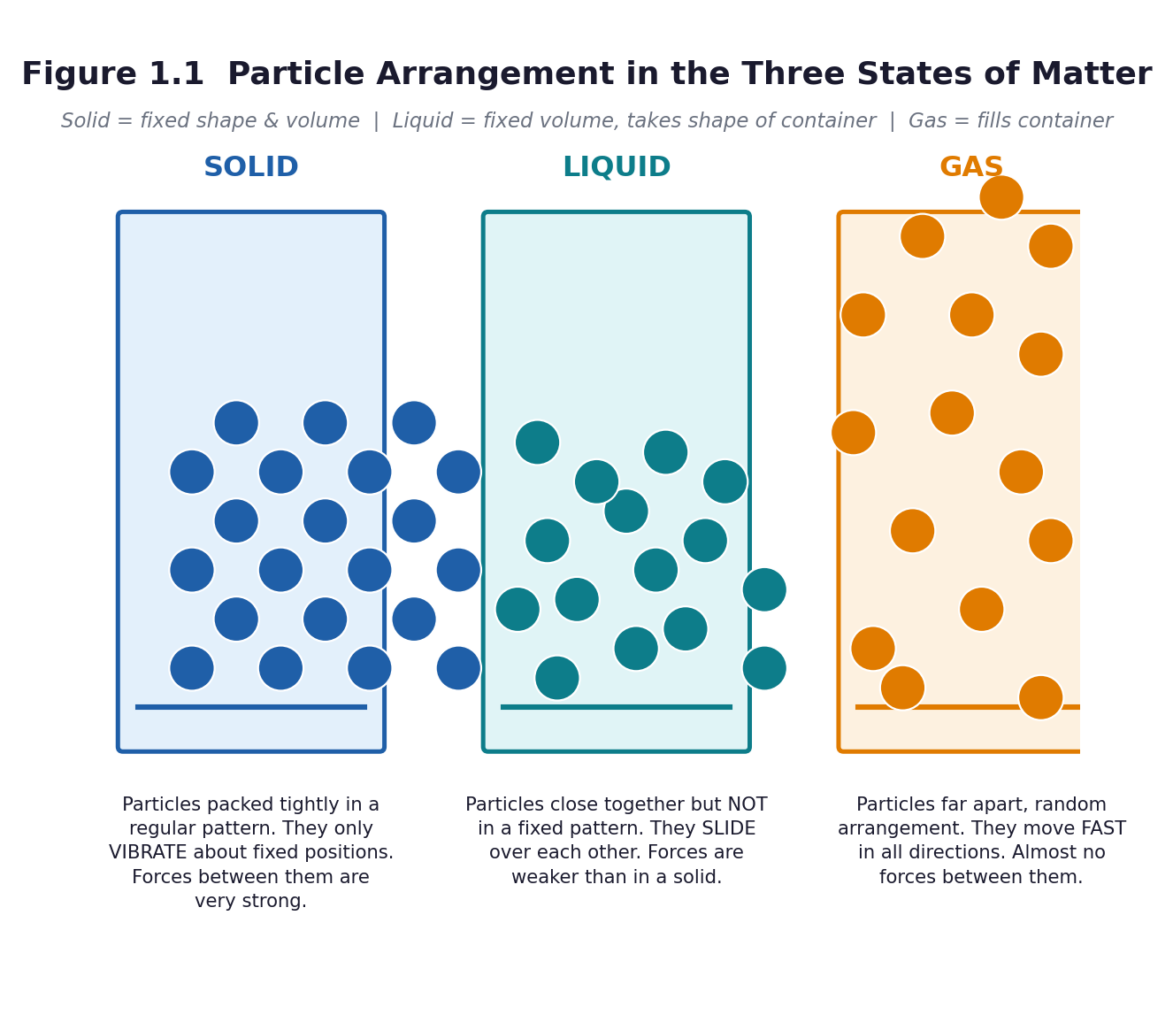
Figure 1.1 Particle arrangement in the three states of matter — the model that explains everything else in this unit.
Unit objectives
- Classify materials found in the environment into liquids, solids and gases, and justify the classification.
- Discuss the importance of liquids and of specific solids to human life, and explain why useful materials must be preserved.
- Name and write the chemical symbols of the first twenty elements and identify metals, non-metals and noble gases in the periodic table.
- Describe the structure of an animal cell and of a plant cell, state the function of each organelle, and build a model of a plant cell.
Assessed unit product
A labelled three-dimensional model of a plant cell or animal cell, built from locally available materials, plus a two-minute oral explanation of each organelle's function. Marked with rubric R2 (Part C3), 20 marks.
LESSON 1  Week 1 | States of Matter — Sorting the Material World  60 minutes (double period)

Strand | Diversity of Matter
Sub-strand | Materials
Content standard | B7.1.1.1 — Recognize materials as important resources for providing human needs.
Indicator(s) | B7.1.1.1.1 — Classify materials into liquids, solids and gases.
Performance indicator  (what learners can do) | Learners can group materials in the environment into liquids, solids and gases.
Core competencies | Critical Thinking and Problem Solving (CP); Communication and Collaboration (CC); Creativity and Innovation (CI).
Key vocabulary | matter, material, solid, liquid, gas, state, particle, property, classify
Prior knowledge | From Basic 4–6 learners know the names of common materials and some of their properties and uses. They can observe and record in a simple table.
Resources / TLM | One tray per group of six containing 12–15 materials: stone, chalk, pencil, sand, maize grain, water in a bottle, cooking oil, milk, melted margarine, an empty sealed transparent bag, a balloon blown up, a sponge, table salt, a piece of foam, and (teacher-held) a perfume spray or smouldering paper for smoke. Hand lenses. Sorting cards. Figure 1.1 enlarged to A3. A balance if available.

Learning objectives — by the end of this lesson every learner will be able to:
- K — name the three states of matter and state one property of each.
- S — observe, classify and record at least twelve materials in a table, giving a reason for each classification.
- A/V — appreciate that the materials around us are resources worth knowing about and preserving.

Phase / time | Teacher activity | Learner activity
ENGAGE  8 min | Hold up a sealed transparent bag that looks empty. Ask: ‘Is there anything in this bag?’ Squeeze it, then open it slightly near a learner's cheek and push the air out. Tell learners: ‘You felt something you could not see. That is a gas, and it is matter.’ Write the three words on the board. Share the performance indicator in learner language: ‘By the end of this lesson you will be able to sort any material into solid, liquid or gas, and say why.’ | Learners feel the air from the bag on their cheek and answer. They call out materials they can see in the classroom, then materials they cannot see. Each learner writes the three state words at the top of a page.
EXPLORE  18 min | Give each group a tray. Task: first sort the materials any way you like, then re-sort them into solid, liquid and gas and record in a table: material | what I observed | state | my reason. Circulate and ask ‘why did you put this one here?’ Do NOT correct. Deliberately note which groups struggle with the sponge, the foam, the salt and the smoke — these are the diagnostic cases. | Groups handle, observe with hand lenses, discuss and sort. They record in a table. They must reach agreement as a group, so they have to justify their choices to each other. The Recorder writes; the Reporter prepares to explain one disputed item.
EXPLAIN  12 min | Groups report, starting with the items they disagreed about. Now introduce the formal ideas with Figure 1.1: a solid keeps its shape and volume; a liquid keeps its volume but takes the shape of its container; a gas fills its container. Then add the particle explanation, and act it out: particles packed tight and vibrating; close together and sliding; far apart and moving fast. Confront the difficult cases explicitly: a powder is a solid that pours; a sponge is a solid with air trapped in it; foam is gas in a liquid; smoke is tiny solids carried in a gas. | Learners correct their own tables in a second colour. They stand and model the three particle arrangements with their bodies — packed shoulder to shoulder, then moving but touching, then spread across the room.
ELABORATE  12 min | Quick-fire ‘three in a row’: call out a material, groups hold up one, two or three fingers for solid, liquid or gas. Include the hard ones — jelly, smoke, cloud, steam, honey, a coconut, a candle flame. Then give the extension group the four ambiguous materials and ask them to write one sentence for each explaining why it is difficult to classify. | Learners respond as a group, then explain the disputed cases in pairs using the sentence frame: ‘I think ___ is a ___ because ___.’
EVALUATE  10 min | Exit ticket on a slip of paper: name one solid, one liquid and one gas found in your home, and give one reason for each choice. Collect and sort into three piles overnight — got it, nearly, not yet. Preview the next lesson: ‘Tomorrow we ask why liquids matter so much to human life’. | Learners complete the exit ticket individually and self-assess against the success criteria by ticking: I can name the three states / I can classify a material / I can give a reason.

Figure 1.1 Particle arrangement in the three states of matter.
Differentiation
Support — give picture sorting cards with the three state names printed on them, and a word bank of observation words (hard, runny, invisible, keeps its shape, pours, spreads).
Core — as described; twelve materials classified with reasons.
Extension — classify a sponge, jelly, smoke and foam, and write one sentence explaining why each is difficult. Then: is a cloud a liquid or a gas? Argue both sides.

Assessment and success criteria
Observation during the sorting task using checklist C7.1 (classifying and recording). Exit ticket marked against three success criteria: names the three states; classifies at least two materials correctly; gives a reason. Anyone who cannot give a reason has memorised labels without understanding — reteach that group in the first five minutes of Lesson 2.
Homework / project
Record (do not collect) five materials at home or in the compound, with the state and one use of each. Bring the list, not the objects. Bring one clean, dry, empty plastic bottle to the next lesson.
Safety
Nothing is to be tasted, ever. Never smell a substance directly — waft the air towards the nose with the hand. The teacher handles any spray or smoke demonstration; learners observe from their seats.
Cross-curricular links and values
English — recording observations in a table and using comparative language. Mathematics — tallying and sorting data. Values — materials are resources, not rubbish; the curriculum asks learners to explain the need to preserve useful materials.
Teacher reflection (complete after the lesson)
What worked well: ______________________________________________________________________________
Who did not meet the success criteria, and what I will do next lesson: ______________________________________________________________________________
What I will change when I teach this again: ______________________________________________________________________________

LESSON 2  Week 1 | Why Liquids Matter — Water, Oil, Blood and Sap  60 minutes (double period)

Strand | Diversity of Matter
Sub-strand | Materials
Content standard | B7.1.1.1 — Recognize materials as important resources for providing human needs.
Indicator(s) | B7.1.1.1.2 — Discuss the importance of liquids in the life of humans.
Performance indicator  (what learners can do) | Learners can explain why liquids are essential to human life and identify liquids used in their community.
Core competencies | Communication and Collaboration (CC); Critical Thinking and Problem Solving (CP).
Key vocabulary | liquid, solvent, dissolve, beverage, sap, preserve, dehydration, essential
Prior knowledge | Lesson 1 — the three states of matter and how to classify a material.
Resources / TLM | The empty plastic bottles learners brought. A clear glass of water, cooking oil, milk, a soft drink, palm oil, a leaf (to show sap), iodine or ink for demonstration. A chart with three columns: Liquid | Where we get it | What we use it for. Figure 1.1 and 1.2.

Learning objectives — by the end of this lesson every learner will be able to:
- K — name at least four liquids used by humans and state a use for each.
- S — present a short report, in a group, on the importance of liquids to human life.
- A/V — appreciate that clean water is a scarce resource that must be preserved and not wasted.

Phase / time | Teacher activity | Learner activity
ENGAGE  8 min | Ask: ‘How long can a person live without water?’ Take answers, then give the figure: about three days, and less in the heat. Then: ‘Name every liquid you have used since you woke up this morning.’ Build a long list on the board. Share the performance indicator. | Learners guess, then react to the answer. They call out the liquids they have used — water for bathing and drinking, tea, milk, oil for cooking, soap, kerosene, petrol, medicine.
EXPLORE  18 min | In groups, learners build a three-column chart: liquid | where we get it | what we use it for, aiming for at least eight liquids. Then set the harder question: ‘Which of these could a person live without, and which could they not?’ Groups must sort their list into essential and non-essential and defend the split. Circulate and challenge: ‘Could you cook your food without any liquid at all?’ | Groups research from their own experience, from textbooks and from any chart on the wall. They debate the essential/non-essential split and prepare a two-minute group report.
EXPLAIN  12 min | Groups report. Draw out four functions of liquids that learners may not have named: drinking and hydration; carrying dissolved substances (blood carries food and oxygen, sap carries food in a plant); cooking and dissolving (you cannot extract palm oil, brew tea or dissolve salt without a liquid); and cleaning and cooling. Introduce the word solvent. Ask why a hospital needs so much liquid. | Learners add the new functions to their charts in a second colour. They answer: what happens to a person who loses too much water? (Thirst, weakness, dehydration.)
ELABORATE  12 min | The harder question: ‘What if the water in your community ran dry for a week?’ Groups list the consequences, then list three things a household can do to preserve or save liquid. Use the empty bottles: a one-litre bottle filled with water and put inside a pit latrine cistern or a flushing tank displaces a litre every flush — a real, free saving. | Groups produce a short list of consequences and of preservation actions. They fill a bottle with water, cap it, and write a label: ‘Save 1 litre every flush’.
EVALUATE  10 min | Each group gives its one-minute report: the most important liquid, why, and one way to preserve it. Peer-assess with ‘two stars and a wish’. Exit ticket: ‘Give two reasons why liquids are important to human life.’ | Learners present, listen and give structured peer feedback. They complete the exit ticket and self-assess against the success criteria.

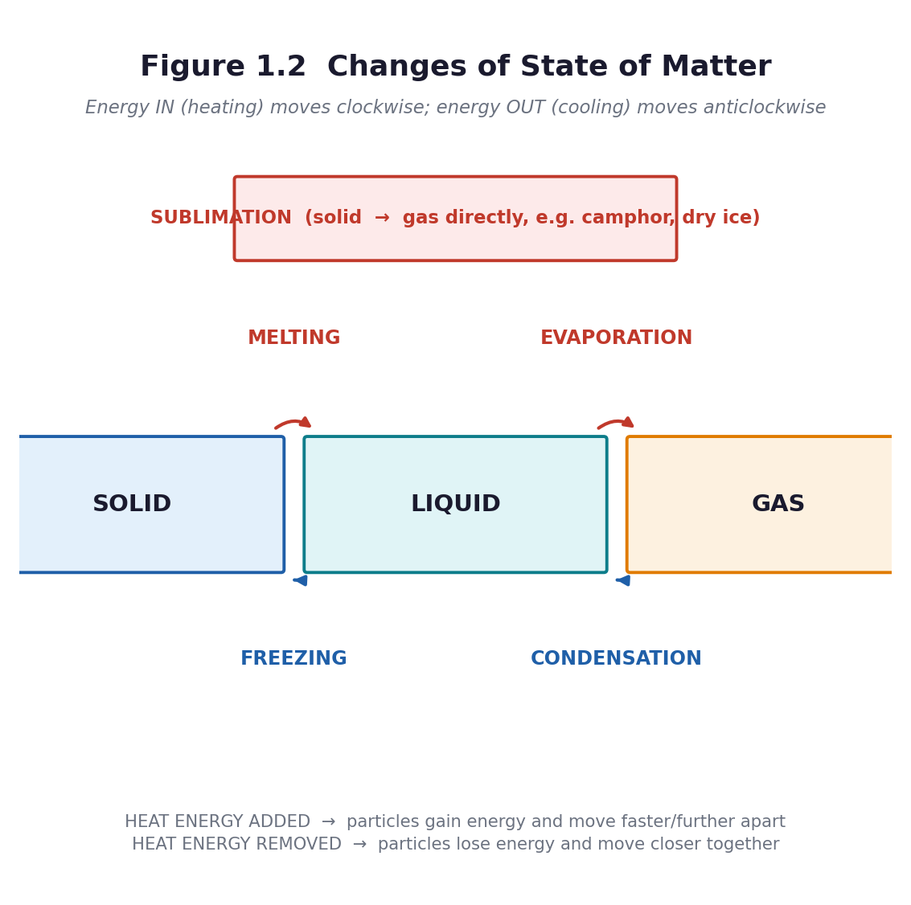
Figure 1.2 Changes of state — how a liquid becomes a gas and back again.
Differentiation
Support — a picture chart of liquids to sort; sentence frame ‘___ is important because ___’; work with a partner.
Core — eight liquids identified, classified as essential or not, with reasons.
Extension — explain why blood and plant sap count as liquids that carry substances, and research one Ghanaian community with a water shortage and what is being done about it.

Assessment and success criteria
Group report assessed with rubric R4 (oral presentation). Exit ticket: two valid reasons. Observation of the essential/non-essential reasoning — the reasoning is the learning, not the list.
Homework / project
Keep a ‘liquid diary’ for one day: every liquid you use, how much, and whether it was wasted. Bring it to Lesson 4 for the materials-conservation discussion.
Safety
If you demonstrate with iodine or ink, the teacher handles it. No tasting of any liquid in the classroom, including water brought from home.
Cross-curricular links and values
English — the group report and the persuasive register. Social Studies — water as a community resource. Values — the curriculum exemplar asks learners to describe the need to preserve liquids for human use.
Teacher reflection (complete after the lesson)
What worked well: ______________________________________________________________________________
Who did not meet the success criteria, and what I will do next lesson: ______________________________________________________________________________
What I will change when I teach this again: ______________________________________________________________________________

LESSON 3  Week 2 | Solids That Keep Us Alive — And Why We Must Preserve Them  60 minutes (double period)

Strand | Diversity of Matter
Sub-strand | Materials
Content standard | B7.1.1.1 — Recognize materials as important resources for providing human needs.
Indicator(s) | B7.1.1.1.3 — Discuss the importance of specific solids to life.
Performance indicator  (what learners can do) | Learners can identify solids in the environment that support the survival of humans and other life forms.
Core competencies | Critical Thinking and Problem Solving (CP); Creativity and Innovation (CI).
Key vocabulary | solid, rigid, preserve, reuse, recycle, resource, structure, texture
Prior knowledge | Lessons 1 and 2 — states of matter; the importance of liquids.
Resources / TLM | A tray of solid materials: iron nail or bar, wood, rock, glass, salt, sugar, chalk, clay, charcoal, a metal spoon, a piece of cloth, dry maize, a shell. Hand lenses. Scrap materials for modelling: cardboard, wire, string, foil, empty tins, clay. Figure 1.1.

Learning objectives — by the end of this lesson every learner will be able to:
- K — identify at least six solids in the environment that support human survival and other life forms.
- S — describe solids by texture, appearance, colour, smell and shape, and model a useful object from solid material.
- A/V — explain why useful solid materials must be preserved and reused rather than wasted.

Phase / time | Teacher activity | Learner activity
ENGAGE  8 min | Ask learners to look around the classroom and name everything holding it together: the block, the roof iron sheet, the desk, the chalk, the door hinge. Then: ‘Now imagine every solid in this room disappeared. What is left?’ Nothing — not even the floor. Share the performance indicator. | Learners call out solids. They realise that solids are not just objects in a tray; they are the structure of everything built.
EXPLORE  18 min | Groups receive a tray of solids. Task one: describe each one by texture, appearance, colour, smell and shape and record in a table. Task two: for each solid, write what it is used for and whether it supports human survival. Task three (creative): choose one solid and model an object from it that would be useful to humans or to other living things. | Groups handle and describe the materials precisely, moving beyond ‘hard’ and ‘rough’. They sort by use. They design and make a small model — a tool, a shelter, a container, a bird feeder.
EXPLAIN  12 min | Groups present their models and their tables. Draw out the categories of solid that support survival: building materials (rock, wood, iron, clay); tools and machines (iron, steel); food and food preservation (salt, sugar); soil and its minerals; the bones and shells that support other living things. Then raise preservation: iron rusts, wood rots or is burnt, glass breaks, soil is washed away, and each of these is a loss to the community. | Learners add preservations to their tables: what would happen to this material if it were wasted, and how can it be preserved, reused or recycled? They use the frame ‘We should preserve ___ because ___’.
ELABORATE  12 min | A jigsaw: five groups each take one preservation method — reuse, repair, recycle, reduce, and substitute (use a local alternative). They prepare a one-minute pitch to the class on why their method matters for ONE named solid material found in Ghana. | Groups prepare and deliver short pitches. The class votes on the method it thinks the school should adopt first, and gives a reason.
EVALUATE  10 min | Exit ticket: ‘Name three solids that support human life, and one way to preserve each.’ Then the gallery walk: models are left on display with a sticky note for one peer comment each. | Learners complete the exit ticket, then walk the gallery and write one specific comment: what the object is for, and one improvement.

Differentiation
Support — a word bank of texture words (smooth, rough, shiny, dull, grainy, hard, brittle) and a partially completed table.
Core — six solids described by five properties and linked to a use.
Extension — explain why salt has been historically important to Ghanaian communities for preserving food, and connect this to the chemistry of preserving.

Assessment and success criteria
The classification table (checklist C7.2). The model assessed with rubric R5 (design and make). Exit ticket: three solids plus one preservation method each.
Homework / project
Find three solid objects at home that are no longer used. For each, say whether it could be reused, repaired or recycled — and bring one of them to school for the class reuse box.
Safety
No tasting of salt or sugar in the classroom. Handle any broken glass or sharp metal yourself; check trays before they go out.
Cross-curricular links and values
Creative Arts and Design — the modelling task. Social Studies — resources and their management. Values — the curriculum exemplar explicitly requires learners to explain the need to preserve useful solid materials.
Teacher reflection (complete after the lesson)
What worked well: ______________________________________________________________________________
Who did not meet the success criteria, and what I will do next lesson: ______________________________________________________________________________
What I will change when I teach this again: ______________________________________________________________________________

LESSON 4  Week 2 | The Periodic Table — Twenty Elements in Their Place  60 minutes (double period)

Strand | Diversity of Matter
Sub-strand | Materials
Content standard | B7.1.1.2 — Understand the periodic table as different elements made up of metals and non-metals and noble gases arranged in an order.
Indicator(s) | B7.1.1.2.1 — Demonstrate the knowledge of the orderly arrangement of metals, non-metals and noble gases in the periodic table.
Performance indicator  (what learners can do) | Learners can identify the first twenty elements in the periodic table and say which are metals, non-metals and noble gases.
Core competencies | Digital Literacy (DL); Critical Thinking and Problem Solving (CP).
Key vocabulary | element, atom, atomic number, chemical symbol, metal, non-metal, noble gas, group, period, periodic table
Prior knowledge | Lessons 1–3 — materials and their states. Learners will have heard of oxygen and carbon but usually do not know what makes something an element.
Resources / TLM | A large printed periodic table (the pack's Figure 1.3 enlarged to A3, or any wall chart). Element flashcards for the first twenty, one per learner. A set of ten real objects labelled with their element: an aluminium pan, a copper wire, an iron nail, charcoal (carbon), a sulphur stick if available, a helium balloon if available, a bottle of water (H and O), salt (Na and Cl).

Learning objectives — by the end of this lesson every learner will be able to:
- K — name and write the chemical symbol of the first twenty elements.
- S — identify metals, non-metals and noble gases on the periodic table and state that elements are arranged in order of atomic number.
- A/V — appreciate that the periodic table is one of the great organising achievements of science, and that it belongs to everyone.

Phase / time | Teacher activity | Learner activity
ENGAGE  8 min | Hold up an aluminium pan, an iron nail and a piece of charcoal. Ask: ‘What are these three things made of?’ Go one level down: aluminium, iron, carbon. Then: ‘Aluminium and iron are metals. Carbon is not. Why do scientists put them in different parts of the same table?’ Show the big periodic table. Share the performance indicator. | Learners name the materials, then the substances. They look at the chart and notice the colours, the numbers, the staircase and the block on the right.
EXPLORE  18 min | Give each group a copy of Figure 1.3 and a set of flashcards. Task: put the first twenty elements in order of atomic number, then find three patterns: where are the metals? where are the non-metals? where are the noble gases? Circulate and ask ‘what do the numbers going up by one each time tell you?’ and ‘what is odd about the last column?’ | Groups order the cards, colour-code them into three families, and record three observations. They notice that the noble gases sit in a single column on the far right, and that metals are on the left.
EXPLAIN  12 min | Now formalise. An element is a substance made of only one kind of atom. The atomic number is the number of protons, and it is the number the table is ordered by. A chemical symbol is the shorthand — note that some come from Latin (Na from natrium, K from kalium, Fe from ferrum), which is why Na is not ‘S’ for sodium. Groups are the columns: elements in the same group behave similarly. Periods are the rows. Then name the three families: metals on the left and in the middle; non-metals on the right; noble gases in Group 18 — unreactive, which is why helium is safe in a balloon and argon fills light bulbs. | Learners label their own copy of the table with the three families, and write the rule for a symbol: first letter always capital, second letter always small (Co is cobalt; CO is carbon monoxide — a completely different thing).
ELABORATE  12 min | Element bingo: learners make a 3×3 grid and fill it with nine symbols from the first twenty. Call out names — ‘sodium’, ‘calcium’, ‘neon’ — learners mark the symbol. Then the real-world round: hold up an object and ask which element or elements it contains. | Learners play bingo, then match objects to elements: water is H and O; salt is Na and Cl; an aluminium pan is Al; charcoal is C; a copper wire is Cu.
EVALUATE  10 min | Five-question quick quiz on mini-whiteboards or paper: write the symbol for potassium; write the name for Mg; is chlorine a metal, a non-metal or a noble gas? which group are the noble gases in? what does the atomic number tell you? Preview Lesson 5: ‘tomorrow we look inside a living thing, and find that it too is made of parts with jobs’. | Learners answer individually, then swap and mark against the answers on the board. They record their score out of five in their journal.

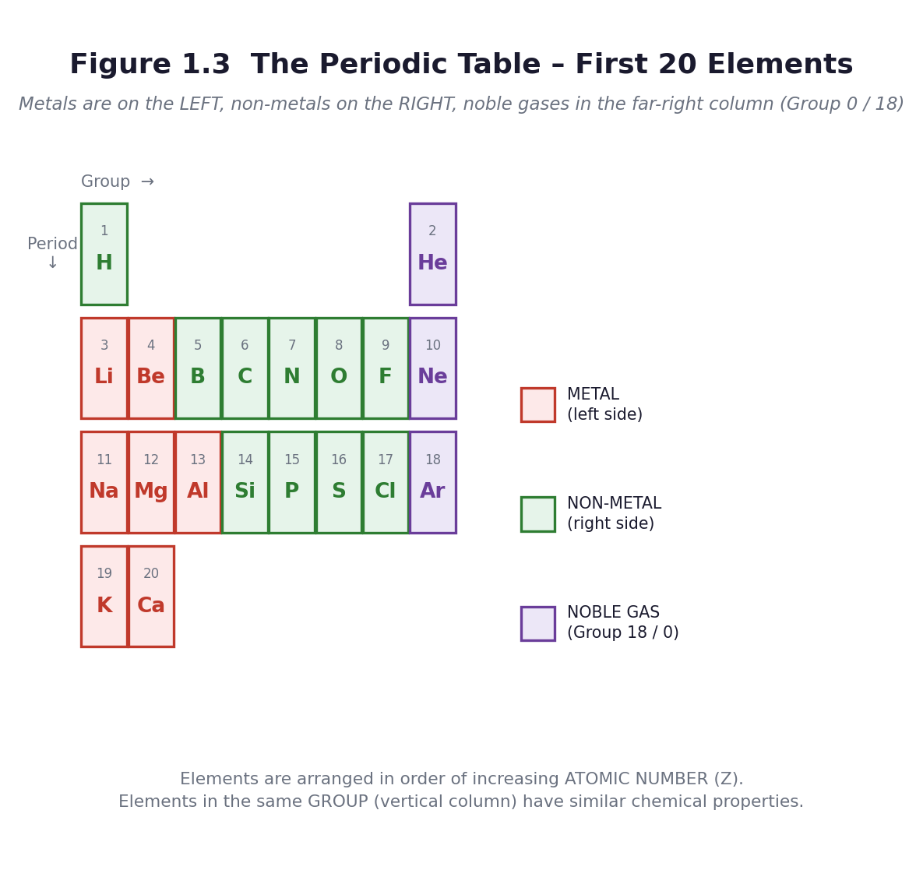
Figure 1.3 The first twenty elements. Metals on the left, non-metals on the right, noble gases in the far-right column.
Differentiation
Support — give a partially filled table and ask for the first ten elements only. Provide the symbols; ask for the names.
Core — the first twenty names and symbols, and the three families identified.
Extension — explain why elements in the same group behave similarly, using Group 1 (lithium, sodium, potassium) as the example, and find out why the noble gases were the last to be discovered.

Assessment and success criteria
The ordered and colour-coded table (checklist C7.3). The five-question quiz. Retrieval: repeat the same five questions, plus five more, at the start of Lesson 5 — spaced retrieval is what makes the symbols stick.
Homework / project
Learn the first ten element names and symbols for a quiz next week. Write one sentence saying what your favourite element is used for in everyday life.
Safety
If you use real samples, check them first. Do not bring reactive metals (sodium, potassium) into a Basic 7 classroom under any circumstances — show them in a video instead.
Cross-curricular links and values
Mathematics — ordering numbers, the structure of a grid, coordinates. Computing — digital literacy is a named competency for this indicator; if you have access, let learners explore an interactive periodic table. English — the etymology of symbols.
Teacher reflection (complete after the lesson)
What worked well: ______________________________________________________________________________
Who did not meet the success criteria, and what I will do next lesson: ______________________________________________________________________________
What I will change when I teach this again: ______________________________________________________________________________

LESSON 5  Week 3 | Inside an Animal Cell  60 minutes (double period)

Strand | Diversity of Matter
Sub-strand | Living Cells
Content standard | B7.1.2.1 — Demonstrate understanding of the structure of organisms and functions of cells in living systems.
Indicator(s) | B7.1.2.1.1 — Describe the structure and function of living cells of an animal.
Performance indicator  (what learners can do) | Learners can identify, draw and label an animal cell and state the function of each organelle.
Core competencies | Digital Literacy (DL); Communication and Collaboration (CC); Critical Thinking and Problem Solving (CP); Creativity and Innovation (CI).
Key vocabulary | cell, organism, organelle, cell membrane, cytoplasm, nucleus, mitochondrion, vacuole, function, magnify
Prior knowledge | Lesson 4 — elements are the building blocks of matter. Learners know from Basic 6 that living things are made of cells, but most will not know what is inside one.
Resources / TLM | Figure 1.4 enlarged to A3. Hand lenses, one per pair. A microscope if the department has one, with prepared slides or a cheek-cell sample collected safely. Onion or tomato for comparison in Lesson 6. A clear plastic bag filled with water and a few floating objects, to model the cell. Clay or modelling dough.

Learning objectives — by the end of this lesson every learner will be able to:
- K — name five parts of an animal cell and state the function of each.
- S — observe an animal cell using a magnifier or microscope, and draw and label what is seen.
- A/V — appreciate that all animals, including humans, are made of cells working together.

Phase / time | Teacher activity | Learner activity
ENGAGE  8 min | Retrieval: five element questions on mini-whiteboards (from Lesson 4). Then hold up the sealed water-filled bag with objects floating in it. ‘If this bag were alive, what would have to be inside it?’ Collect answers — a control centre, a way to make energy, somewhere for things to happen, a skin to hold it all in. Say: everything you have just named is really there. Share the performance indicator. | Learners answer the retrieval questions, then brainstorm what a living unit would need. They usually get close to the real answer, which is the point — the biology is not arbitrary.
EXPLORE  18 min | Set up looking stations: prepared slides or fresh samples under a microscope if available, and printed micrographs and Figure 1.4 if not. Task: look carefully, then draw exactly what you can see — not what you expect to see. Then a second task: give each group a set of unlabelled organelle cards and ask them to match each card to the part of the drawing they think it belongs to. | Learners take turns at the microscope or magnifier, draw what they observe, and compare drawings in pairs. They argue about which card goes where, using the shape and position as evidence.
EXPLAIN  12 min | Reveal the answers with Figure 1.4. For each organelle, give the name, the shape cue for remembering it, and the job — the function is what is assessed, not the name. Cell membrane: the gate keeper. Cytoplasm: the workshop floor where reactions happen. Nucleus: the control room with the instructions. Mitochondrion: the power house, releasing energy in respiration. Vacuole: the store room. Drill: learners close books and name the function when you give the name, and the name when you give the function. | Learners label their drawings, correcting in a second colour. They chant or pair-test the name–function pairs. They write the one-line function beside each label, not just the word.
ELABORATE  12 min | Two tasks. First, the analogy task: in groups, learners compare the cell to something familiar — a school, a household, a chop bar, a market — and produce a table matching each organelle to its counterpart. Second, the model task: with clay, learners build a flat animal cell showing all five parts, to be finished as homework if time runs short. | Groups produce an analogy table (nucleus = the head teacher's office; membrane = the school gate; mitochondrion = the kitchen or the generator; cytoplasm = the compound; vacuole = the store). They begin the clay model.
EVALUATE  10 min | Organelle snap or a five-question name-the-function quiz. Then the exit ticket: draw an animal cell from memory with five labels. Preview Lesson 6: ‘a plant cell has everything an animal cell has, plus three things that change everything’. | Learners play, then complete the exit ticket. They self-assess: I can name five parts / I can state the function of each / I can draw and label one.

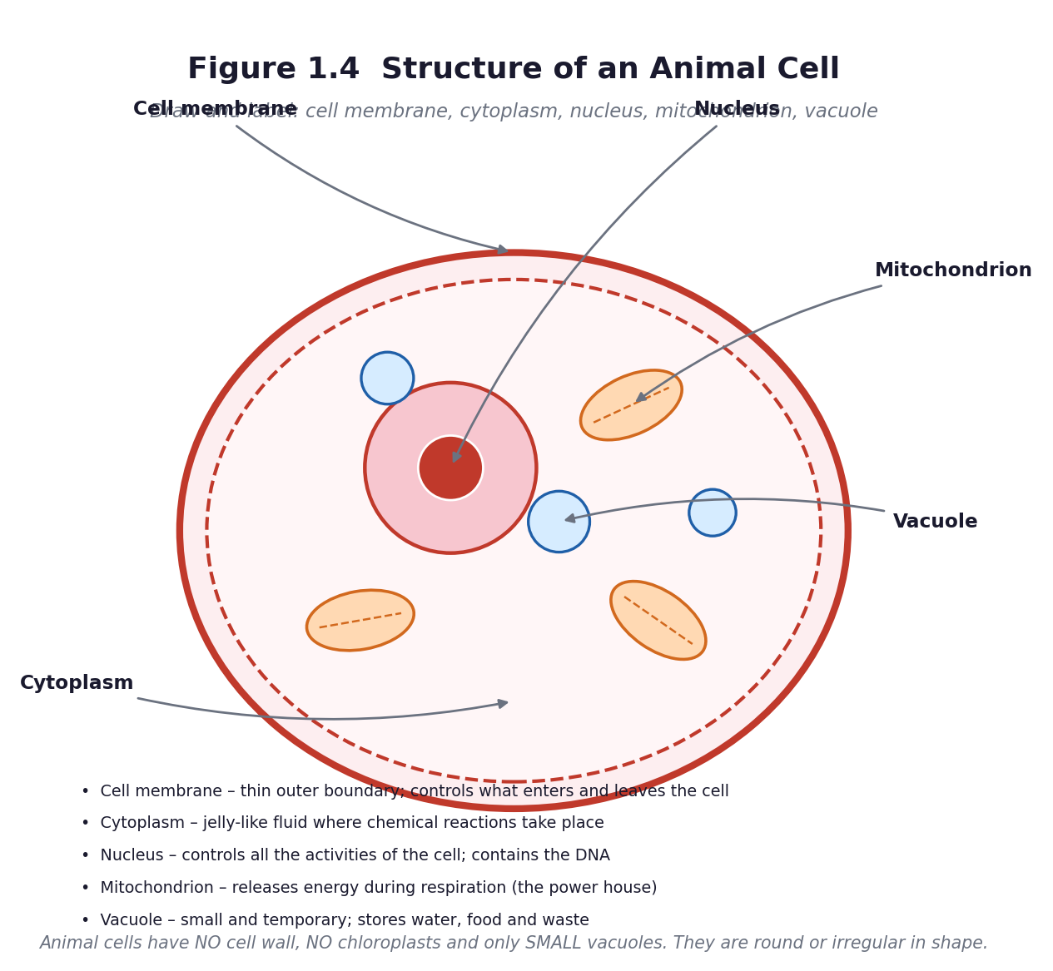
Figure 1.4 Structure of an animal cell.
Differentiation
Support — give a labelled outline to complete rather than a blank page; allow the analogy task as the main output.
Core — five organelles named, function stated for each, drawing labelled.
Extension — explain why a muscle cell would have far more mitochondria than a skin cell, linking structure to function.

Assessment and success criteria
The labelled drawing marked against five correct labels plus five correct functions (checklist C7.4). The analogy table is a check on genuine understanding: a learner who says the nucleus is ‘the brain’ without being able to say why has a slogan, not a concept.
Homework / project
Finish the clay model of the animal cell. Learn the five organelles and their functions for a quiz.
Safety
No mouth swabs unless you have sterile swabs and a disposal plan. Use onion epidermis, tomato pulp or a printed micrograph instead. If glass slides are used, check them for chips and collect them back in person. Wash hands with soap after the lesson.
Cross-curricular links and values
Creative Arts — the model. English — analogy and comparison. Values — respect for life; the interdependence of parts, which the curriculum lists as a specific aim of the science programme.
Teacher reflection (complete after the lesson)
What worked well: ______________________________________________________________________________
Who did not meet the success criteria, and what I will do next lesson: ______________________________________________________________________________
What I will change when I teach this again: ______________________________________________________________________________

LESSON 6  Week 3 | Inside a Plant Cell, and How the Two Differ  60 minutes (double period)

Strand | Diversity of Matter
Sub-strand | Living Cells
Content standard | B7.1.2.1 — Demonstrate understanding of the structure of organisms and functions of cells in living systems.
Indicator(s) | B7.1.2.1.2 — State the functions of each organelle in a plant cell.
Performance indicator  (what learners can do) | Learners can identify, draw, label and model a plant cell, state the function of each organelle, and compare it with an animal cell.
Core competencies | Digital Literacy (DL); Communication and Collaboration (CC); Creativity and Innovation (CI); Critical Thinking and Problem Solving (CP).
Key vocabulary | cell wall, cellulose, chloroplast, chlorophyll, photosynthesis, large central vacuole, turgid, organelle, sap
Prior knowledge | Lesson 5 — animal cell structure and function. Basic 6 work on plant parts.
Resources / TLM | Onion bulbs or any fleshy leaf, forceps or fingers, hand lenses, a microscope with slides if available, iodine or a drop of diluted ink to stain. Figure 1.5 and 1.6 enlarged to A3. Materials for the model: cardboard, clay, beads, beans, bottle tops, string, foil, pap, anything local.

Learning objectives — by the end of this lesson every learner will be able to:
- K — name the parts of a plant cell, including the cell wall, chloroplasts and the large central vacuole, and state each function.
- S — compare a plant cell with an animal cell using a Venn diagram, and develop a model of a plant cell.
- A/V — appreciate that structure is related to function — a plant cell's extra parts are exactly the parts that let it make its own food and stand upright.

Phase / time | Teacher activity | Learner activity
ENGAGE  8 min | Retrieval: name the five parts of an animal cell and the job of each. Then ask: ‘A maize plant stands upright without a skeleton, and it makes its own food. An animal cannot do either. What must be inside a plant cell that is not inside yours?’ Share the performance indicator. | Learners answer the retrieval questions, then reason from what plants can DO to what they must HAVE inside their cells. This is the structure-and-function link, and arriving at it by reasoning beats being told.
EXPLORE  18 min | Practical: peel a thin, transparent layer from the inner surface of an onion scale leaf, place it on a slide in a drop of water with a drop of stain, and look under a hand lens or microscope. Task: draw exactly what you see, and note that the cells are rectangular and regular, not round and irregular as the animal cells were. Ask: what is holding them in that shape? | Learners prepare their own slides, observe, draw, and compare across the room. They notice the regular brick-like arrangement and the dark stained nucleus in each cell.
EXPLAIN  12 min | Introduce Figure 1.5. Name the three extras and give each one a reason: cell wall (cellulose) — rigid, so the plant stands up without a skeleton; chloroplast (containing chlorophyll) — traps light energy to make food by photosynthesis; large central vacuole — stores cell sap and pushes the cell firm (turgid), which is what holds a leaf out flat. Note that the plant cell also has everything the animal cell has. Then build the Venn diagram in Figure 1.6 together. | Learners label a plant-cell diagram, then complete the Venn diagram: animal only, plant only, both. They write the function beside every label.
ELABORATE  12 min | The model task — this is the assessed Unit 1 product and an explicit curriculum exemplar. Groups build a three-dimensional plant cell from local materials. Set the criteria from rubric R2 before they start: all organelles present, correctly shaped and positioned; every one labelled; a one-line function for each; and craft. | Groups plan, gather materials and build. Roles rotate: one builds, one makes labels, one writes the function cards, one checks against the criteria on the board.
EVALUATE  10 min | Each group presents its model in two minutes: name each organelle, point to it, and state its function. Peer assessment with rubric R2. Then the individual exit ticket: ‘Give two differences between a plant cell and an animal cell, and explain why each difference matters.’ | Learners present and are assessed by peers and teacher. They complete the exit ticket and tick the success criteria.

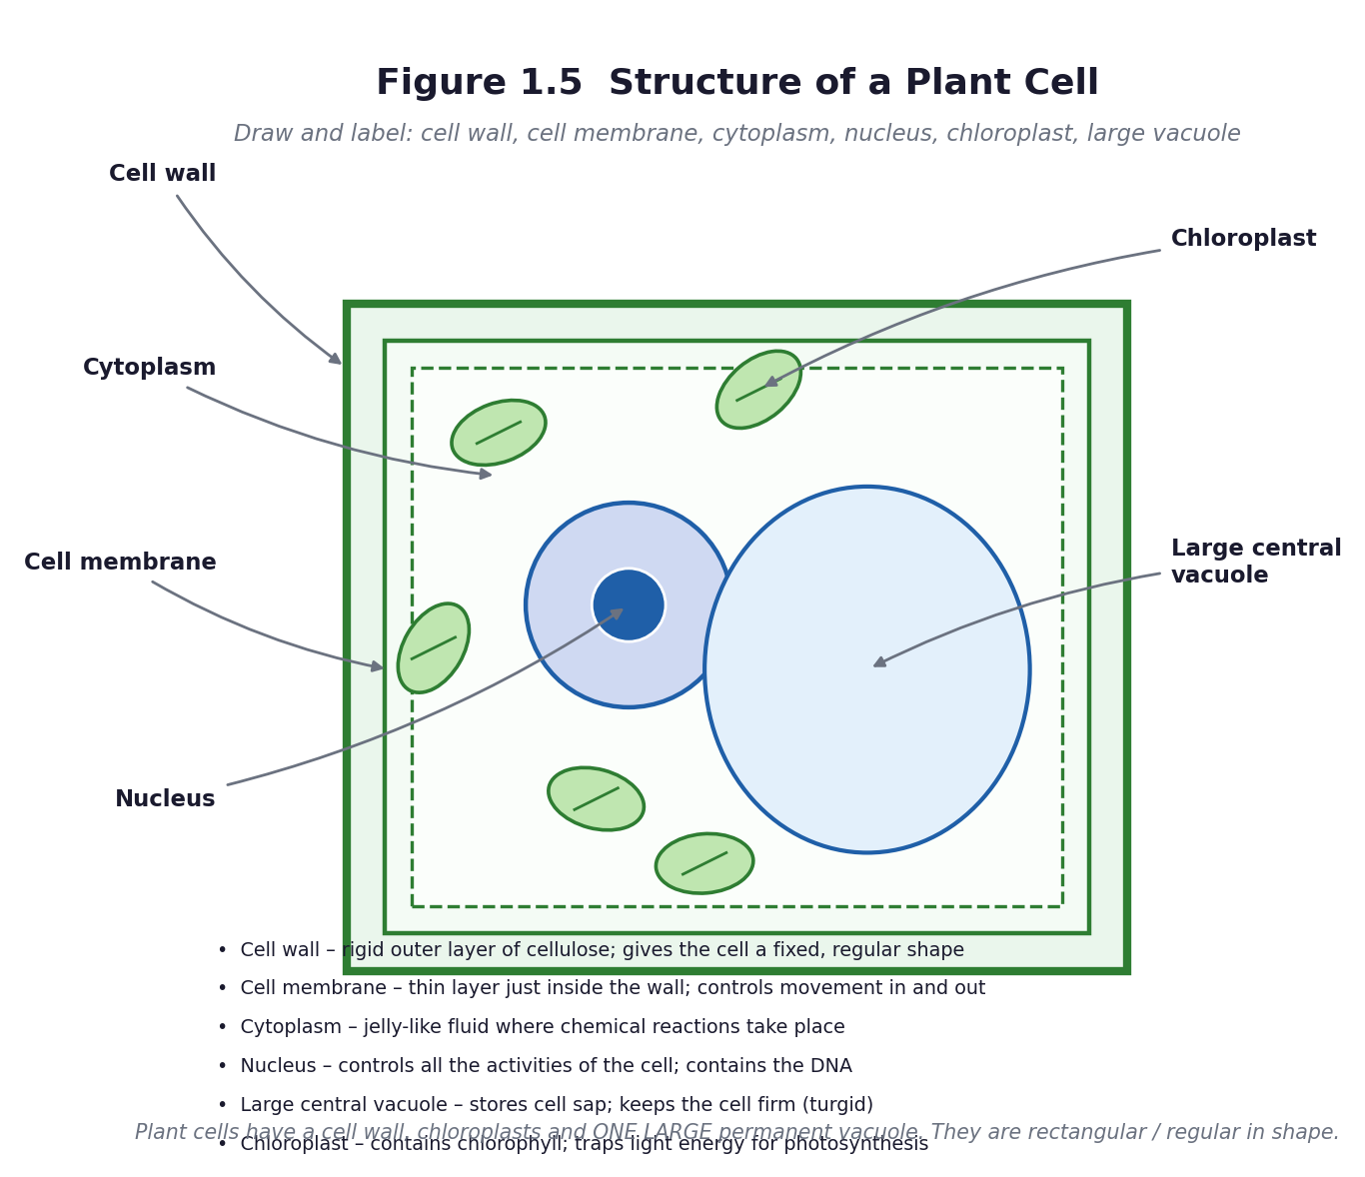
Figure 1.5 Structure of a plant cell.
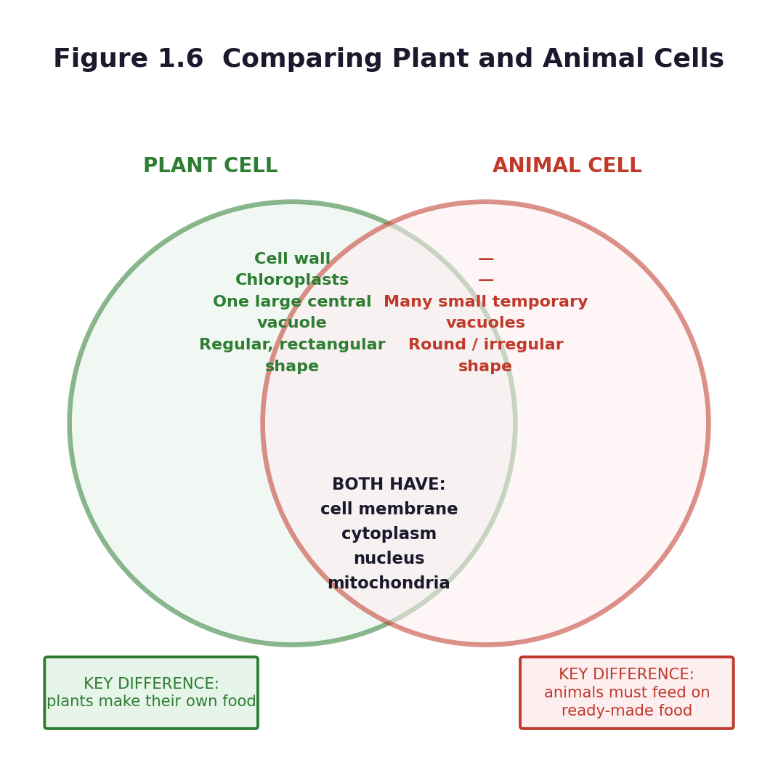
Figure 1.6 Venn diagram: comparing plant and animal cells.
Differentiation
Support — a labelled outline to complete; the Venn diagram with the headings and one example in each region; allow the model as the main assessment.
Core — all organelles named and labelled, function stated, three differences given.
Extension — explain why a leaf cell has many chloroplasts but a root cell has none, and what happens to a plant when its vacuoles lose water (wilting).

Assessment and success criteria
The model assessed with rubric R2 (20 marks: accuracy 8, labelling 4, functions 4, craft 4). The Venn diagram. The exit ticket. This is the end of Unit 1 — administer Unit Test 1 (Part C1) in the first twenty minutes of the next science period.
Homework / project
Finish the model and the function cards. Revise Unit 1 using the revision cards: three states, twenty elements, animal cell, plant cell.
Safety
Onion juice irritates the eyes — warn learners before they peel. The teacher handles the stain. No mouth swabs. Wash hands afterwards. Collect all slides back in person.
Cross-curricular links and values
Creative Arts and Design — the model is a design-and-make task. English — comparison and contrast. Values — interdependence: the plant makes the food that the animal cannot make.
Teacher reflection (complete after the lesson)
What worked well: ______________________________________________________________________________
Who did not meet the success criteria, and what I will do next lesson: ______________________________________________________________________________
What I will change when I teach this again: ______________________________________________________________________________

UNIT 2 — SYSTEMS: THE SOLAR SYSTEM
Weeks 4–5 • Sub-strand: The Solar System

Unit 1 went down in scale; Unit 2 goes up. The thinking skill is the same — reasoning carefully about things you cannot see and cannot handle — which is why these two units sit side by side on the scheme. The content standard asks for the inner planets and their movement, and the curriculum is precise about two words: the paths are elliptical, and planets both rotate and revolve. Confusing those two is the commonest error in the end-of-term exam, so it is worth teaching explicitly rather than in passing.
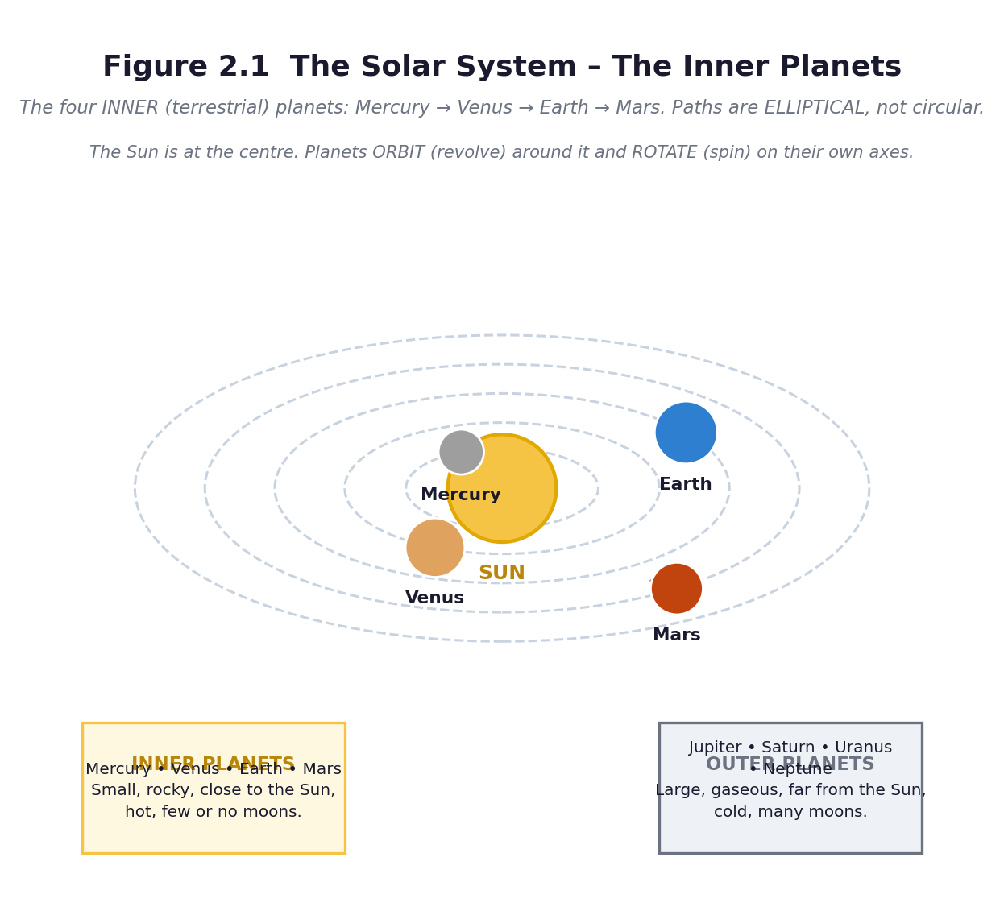
Figure 2.1 The inner planets. The Sun is at the centre; the paths are ellipses, not circles.
Unit objectives
- Identify the four inner planets of the solar system in order from the Sun and describe their properties.
- Describe the galaxy, the Milky Way, and the elliptical shape of the paths of the inner planets.
- Design and construct a model of the solar system.
- Discuss the properties and the relative motions of the planets Mercury and Venus.
Assessed unit product
A scale model of the inner solar system, plus a two-minute oral explanation in which the learner distinguishes rotation from revolution and demonstrates an orbit. Marked with rubric R3 (Part C3), 20 marks. If the class went on Tour 1, the oral component is the post-visit group report.
LESSON 7  Week 4 | The Inner Planets — Four Worlds Close to the Sun  60 minutes (double period)

Strand | Systems
Sub-strand | The Solar System
Content standard | B7.3.2.1 — Demonstrate knowledge of the inner planets of the solar system and understand their movement in the system.
Indicator(s) | B7.3.2.1.1 — Identify the inner planets of the solar system and describe their properties.
Performance indicator  (what learners can do) | Learners can identify the inner planets of the solar system and describe their properties.
Core competencies | Digital Literacy (DL); Critical Thinking and Problem Solving (CP); Communication and Collaboration (CC); Creativity and Innovation (CI).
Key vocabulary | solar system, Sun, planet, orbit, elliptical, inner planet, terrestrial, Mercury, Venus, Earth, Mars, galaxy, Milky Way, rotate, revolve
Prior knowledge | Learners will have met day and night and the Sun in primary science. Most will know some planet names from television. Many will believe the Sun orbits the Earth, because that is what their eyes show them.
Resources / TLM | Figure 2.1 enlarged to A3. A torch or lamp, a ball, and four balls of very different sizes. A solar system chart or projected image. Planet fact cards. String and chalk for the next lesson.

Learning objectives — by the end of this lesson every learner will be able to:
- K — name the four inner planets in order from the Sun and state one property of each.
- S — describe the Milky Way galaxy and the elliptical shape of planetary paths, and locate the inner planets on a diagram.
- A/V — appreciate the scale and order of the solar system, and that the Earth is one planet among others.

Phase / time | Teacher activity | Learner activity
ENGAGE  8 min | Diagnostic (keep these — you will return to them after the learning tour). Ask learners to write: ‘What is the Sun? Where is the Earth? Does the Sun move, or does the Earth?’ Collect without comment. Then show Figure 2.1 and say only: ‘Everything you are looking at is moving.’ Share the performance indicator. | Learners write their answers. They look at the diagram and call out what they recognise. Most will identify Earth; fewer will place Mercury correctly.
EXPLORE  18 min | Jigsaw: four groups, one planet each — Mercury, Venus, Earth, Mars. Each group gets a fact card and must produce a group poster: distance from the Sun, size compared with Earth, how long a year is, temperature, number of moons, one surprising fact. They then teach their planet to the rest of the class. Circulate and ask each group: ‘how long would it take you to get there?’ | Groups research from cards, textbooks and any digital source, produce a poster, and prepare a one-minute teaching slot. Each learner must be able to say one thing about each of the four planets by the end.
EXPLAIN  12 min | Groups teach. Then formalise with Figure 2.1. The Sun is a star at the centre. The four inner planets are Mercury, Venus, Earth, Mars — small and rocky, close together, hot, with few or no moons. The four outer planets are large and gaseous, far apart and cold. Introduce the two words the exam will test: elliptical, meaning oval, not circular; and the pair rotate (spin on an axis) and revolve (travel around something). Then the galaxy: the Sun is one star among billions in the Milky Way. | Learners take notes on a structured sheet, add the two key words to the word wall, and demonstrate the difference between rotating and revolving with their own bodies — spin on the spot, then walk around a chair.
ELABORATE  12 min | The scale challenge. If the Sun were a football and the Earth a peppercorn, how far apart would they be? Work it out roughly together, then go outside if you can and pace out a scaled-down version: Mercury, Venus, Earth, Mars at the correct relative distances. Even a compressed version is a revelation — learners discover that the planets are tiny and the gaps are enormous. | Learners estimate, then pace out the model on the field, holding balls of different sizes at the right distances. They note how much empty space there is.
EVALUATE  10 min | Exit ticket: name the four inner planets in order from the Sun; state one property of each; and explain the difference between rotate and revolve in one sentence each. Preview Lesson 8: ‘tomorrow we build the model’. | Learners complete the exit ticket and self-assess. They keep the diagnostic card for the post-tour comparison in Lesson 9 or 10.

Figure 2.1 The solar system — the four inner planets.
Differentiation
Support — a mnemonic for the order (My Very Educated Mother, or learners invent their own, ideally in a Ghanaian language); a completed fact card to read from.
Core — four planets in order, one property each, elliptical and rotate/revolve defined.
Extension — why is Venus hotter than Mercury, even though Mercury is closer to the Sun? Answer: Venus has a thick carbon-dioxide atmosphere that traps heat.

Assessment and success criteria
Group poster assessed with rubric R4. Exit ticket. The Engage diagnostic is not scored — it is your evidence of conceptual change when you repeat it at the end of the unit.
Homework / project
Learn the order of the four inner planets. If the sky is clear, look for the brightest object in the western sky just after sunset — that is usually Venus. Never look at the Sun.
Safety
No learner may look directly at the Sun, or at the Sun through any lens, telescope or binoculars, at any time. If you observe the Sun, project its image onto a white card. This rule is non-negotiable and must be stated before any outdoor astronomy.
Cross-curricular links and values
Mathematics — scale, ratio, relative distance. Social Studies — mapping and position. Values — Ghana's own space science programme: the Ghana Space Science and Technology Institute is a real employer of Ghanaian scientists.
Teacher reflection (complete after the lesson)
What worked well: ______________________________________________________________________________
Who did not meet the success criteria, and what I will do next lesson: ______________________________________________________________________________
What I will change when I teach this again: ______________________________________________________________________________

LESSON 8  Week 4 | Building the Solar System — The Model Task  60 minutes (double period)

Strand | Systems
Sub-strand | The Solar System
Content standard | B7.3.2.1 — Demonstrate knowledge of the inner planets of the solar system and understand their movement in the system.
Indicator(s) | B7.3.2.1.1 — Identify the inner planets of the solar system and describe their properties.
Performance indicator  (what learners can do) | Learners can design and construct a model of the solar system and explain what it shows.
Core competencies | Creativity and Innovation (CI); Communication and Collaboration (CC); Critical Thinking and Problem Solving (CP).
Key vocabulary | model, scale, orbit, ellipse, axis, tilt, relative distance, represent
Prior knowledge | Lesson 7 — the inner planets, their order and properties; elliptical orbits; rotation and revolution.
Resources / TLM | Cardboard, string, wire, foil, paint, clay or pap, bottle tops, polystyrene balls, balls of different sizes, rulers, compasses or string-and-pencil for ellipses, glue, sticky tape. Figure 2.1 and 2.2. A copy of rubric R3 on the wall.

Learning objectives — by the end of this lesson every learner will be able to:
- K — state what a model can and cannot show about the solar system.
- S — design and construct a model showing the four inner planets in order, in elliptical paths, with the Sun at the centre.
- A/V — work productively in a group and evaluate the model honestly against criteria.

Phase / time | Teacher activity | Learner activity
ENGAGE  8 min | Show two models: a good one and a deliberately wrong one (planets out of order, all the same size, circular paths very close together). Ask: ‘Which is right, and how do you know?’ Then the key question: ‘Is a model the truth?’ Establish: a model is a tool for thinking, not a copy of reality, and every model leaves something out. Share rubric R3 now, before they build. | Learners spot the errors and justify their judgement. They read the rubric together and discuss what 'excellent' would look like.
EXPLORE  18 min | Design phase: each group draws a plan before touching materials — the order of the planets, their relative sizes, the shape and spacing of the paths, and what they will use for each. Teacher approves each plan. Then build. Circulate and ask: ‘which part of this is to scale and which part is not?’ — that question is worth more than any comment on neatness. | Groups plan on paper, get approval, collect materials and build. Roles: builder, measurer, label maker, checker against the rubric.
EXPLAIN  12 min | Halfway stop. Groups hold up their models. Address the two most common errors explicitly: circular rather than elliptical paths, and equal spacing rather than increasing gaps. Show how to draw an ellipse with two pins and a loop of string. Remind them that the paths must be elliptical, as the curriculum requires, and that the Sun sits at a focus, not the centre of the ellipse. | Learners compare models, identify the two common errors in their own and others' work, and correct their paths with the string-and-pins method.
ELABORATE  12 min | Finish the models and add the labels and the two movement arrows: a curved arrow round the Sun for revolution, and a small curved arrow on each planet for rotation. Add a caption underneath stating one thing the model shows well and one thing it shows badly — this is the sophisticated part, and it is where the highest marks in the rubric are earned. | Groups complete, label and caption their models. The caption must contain both a strength and a limitation, for example: ‘This model shows the order of the planets correctly, but the planets are far too big compared with the distances between them.’
EVALUATE  10 min | Gallery walk: models on display, each learner places one sticky note with ‘one thing done well’ and one with ‘one improvement’. Then each group gives its two-minute oral explanation. Assess with rubric R3. | Learners walk the gallery, read, and write specific comments. Each group presents: order, properties, what the model shows and what it cannot.

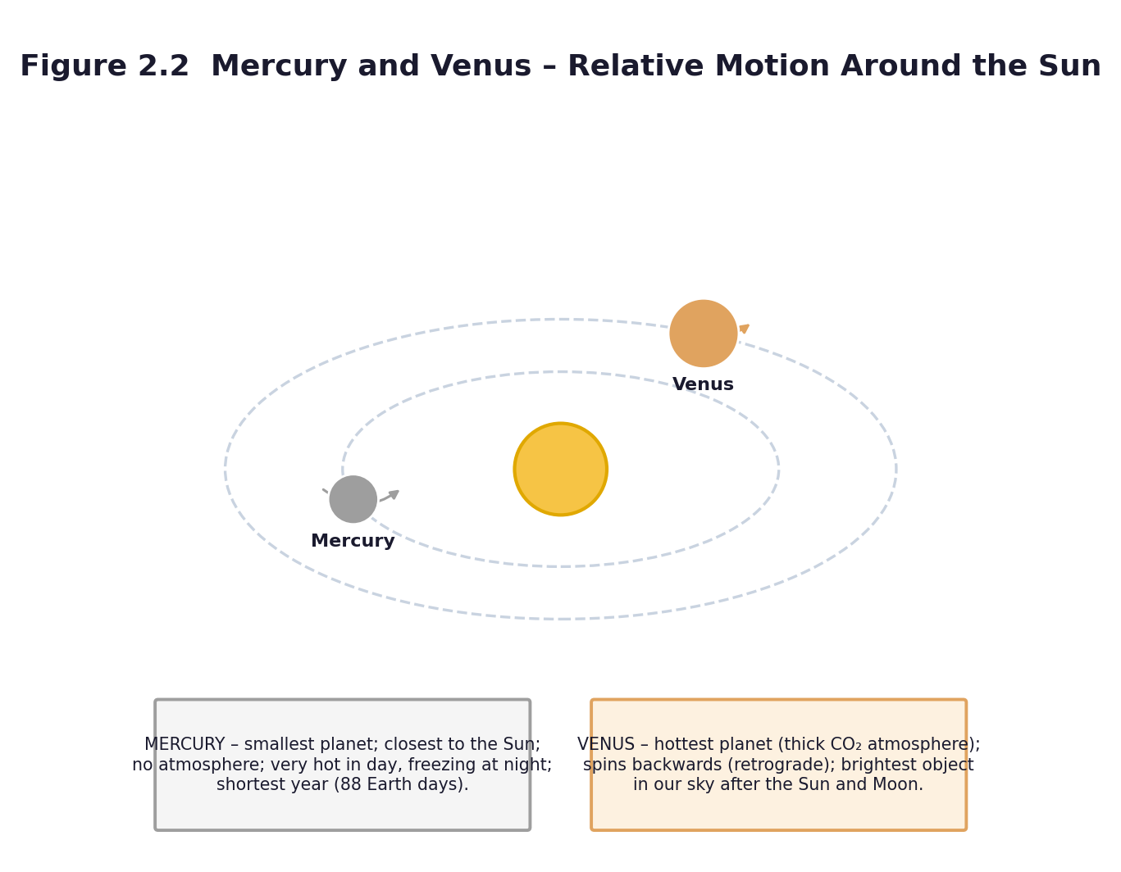
Figure 2.2 Mercury and Venus — relative motion around the Sun.
Differentiation
Support — provide a template with the Sun drawn and the four positions marked; the group adds the planets and labels.
Core — as described; correct order, elliptical paths, labelled, with a caption.
Extension — make the model to scale for distance (even if the planet sizes then become invisible), and calculate how far away Neptune would be on that scale.

Assessment and success criteria
The model and the oral explanation, marked with rubric R3 (20 marks). Peer comments from the gallery walk contribute to the process-skills mark. Keep the models for the Week 5 revision and for the school's science exhibition.
Homework / project
Write a paragraph: ‘What my model shows well, and what it cannot show.’ Revise the order of the planets.
Safety
Scissors and wire: a tool talk before starting. No hot glue without supervision. Clear walkways.
Cross-curricular links and values
Creative Arts and Design — the model is a design-and-make task assessed partly on craft. Mathematics — scale, ratio, drawing an ellipse. English — the caption and the oral explanation.
Teacher reflection (complete after the lesson)
What worked well: ______________________________________________________________________________
Who did not meet the success criteria, and what I will do next lesson: ______________________________________________________________________________
What I will change when I teach this again: ______________________________________________________________________________

LESSON 9  Week 5 | Mercury and Venus — Properties and Relative Motion  60 minutes (double period)

Strand | Systems
Sub-strand | The Solar System
Content standard | B7.3.2.1 — Demonstrate knowledge of the inner planets of the solar system and understand their movement in the system.
Indicator(s) | B7.3.2.1.2 — Discuss the properties and the relative motions of the planets Mercury and Venus.
Performance indicator  (what learners can do) | Learners can outline the properties of Mercury and Venus and describe their movement around the Sun.
Core competencies | Digital Literacy (DL); Critical Thinking and Problem Solving (CP); Communication and Collaboration (CC); Creativity and Innovation (CI).
Key vocabulary | Mercury, Venus, atmosphere, carbon dioxide, retrograde, relative motion, orbit, revolution, rotation, greenhouse effect, orbit period
Prior knowledge | Lessons 7 and 8 — the inner planets, the model, elliptical orbits, rotation and revolution. Note: if the class went on Tour 1 (A10.5), start here by revisiting the visit.
Resources / TLM | Figure 2.2 enlarged to A3. The models from Lesson 8. A lamp for the Sun, and two learners holding balls to represent Mercury and Venus. Comparison tables. Any photographs or notes from the learning tour.

Learning objectives — by the end of this lesson every learner will be able to:
- K — state at least three properties peculiar to each of Mercury and Venus.
- S — describe and demonstrate the movement of Mercury and Venus around the Sun, and explain why their apparent motion differs from their real motion.
- A/V — appreciate that careful observation over time is how astronomers discovered these motions.

Phase / time | Teacher activity | Learner activity
ENGAGE  8 min | If the class went on the tour, open with: ‘What did you see that you did not expect?’ and revisit the pre-visit diagnostic cards, crossing out what was wrong. If not, ask: ‘Which is the hottest planet?’ Most will say Mercury, because it is closest. Say: ‘It is not. Let us find out why.’ Share the performance indicator. | Learners share tour memories or answer the question. They write down their prediction for the hottest planet and the reason for it.
EXPLORE  18 min | Pairs research Mercury and Venus and complete a comparison table: distance from the Sun, diameter, length of a day, length of a year, surface temperature, atmosphere, moons, and one odd fact. Then the movement task: one learner is the Sun holding a lamp, two walk the orbits. The class times each lap. Mercury's lap must be much shorter than Venus's. | Learners complete the table from cards, books and any digital source. Three learners act out the orbits while the rest time the laps and record how many laps each completes in a set time.
EXPLAIN  12 min | Formalise with Figure 2.2. Mercury: smallest planet, closest to the Sun, almost no atmosphere, scorching by day and freezing by night, the shortest year at about 88 Earth days, no moons. Venus: similar in size to Earth, wrapped in a thick carbon-dioxide atmosphere that traps heat so it is the hottest planet at about 465 °C, spins backwards compared with the other planets, and is the brightest natural object in our sky after the Sun and Moon — which is why it is called the morning or evening star. | Learners correct and complete their tables, add the two planets to their models with movement arrows, and answer the prediction question: why is Venus hotter than Mercury?
ELABORATE  12 min | The relative-motion problem. Ask: ‘If Mercury goes round the Sun faster than we do, why does it not simply disappear from our sky?’ Model it: three learners walk their orbits at the correct relative speeds while a fourth, as Earth, calls out what Mercury and Venus look like from where she is standing. Learners see that the two inner planets always stay near the Sun in our sky, which is why we only ever see them near dawn or dusk. | Learners act out the relative motion and record what the observer on Earth would see: Mercury and Venus never appear far from the Sun, and they show phases like the Moon.
EVALUATE  10 min | Exit ticket: three facts about Mercury, three about Venus, and one sentence on how their motions differ from Earth's. Then revisit the Lesson 7 diagnostic card for anyone who has not yet corrected the ‘the Sun goes round the Earth’ idea. | Learners complete the exit ticket, then check their original diagnostic answers against what they now know and write one sentence about what changed.

Figure 2.2 Mercury and Venus — properties and relative motion.
Differentiation
Support — a comparison table with the headings and some entries filled in; sentence frames for each fact.
Core — three properties each, plus a correct description of their orbital motion.
Extension — explain the greenhouse effect on Venus in terms of incoming and outgoing energy, and connect it to climate change on Earth — this is the same physics.

Assessment and success criteria
The comparison table (checklist C7.5). The acted-out relative motion, observed. The exit ticket. The Lesson 7 diagnostic revisited — evidence of conceptual change is the most satisfying assessment data you will collect all term.
Homework / project
Write a short dialogue between Mercury and Venus in which each boasts about why it is the more remarkable planet. Include at least three true facts about each.
Safety
No Sun-gazing, ever. If you go outside to model the orbits, use a lamp or a yellow ball for the Sun, never the real Sun.
Cross-curricular links and values
English — the comparison table and the dialogue. Mathematics — relative speed and orbital period. Values — careful observation over time; the Ghanaian astronomers at GSSTI who do this work.
Teacher reflection (complete after the lesson)
What worked well: ______________________________________________________________________________
Who did not meet the success criteria, and what I will do next lesson: ______________________________________________________________________________
What I will change when I teach this again: ______________________________________________________________________________

LESSON 10  Week 5 | Day, Night and the Year — Consolidation and Unit 2 Assessment  60 minutes (double period)

Strand | Systems
Sub-strand | The Solar System
Content standard | B7.3.2.1 — Demonstrate knowledge of the inner planets of the solar system and understand their movement in the system.
Indicator(s) | B7.3.2.1.2 — Discuss the properties and the relative motions of the planets Mercury and Venus.
Performance indicator  (what learners can do) | Learners can explain day and night and the year in terms of rotation and revolution, and demonstrate their understanding with a model.
Core competencies | Communication and Collaboration (CC); Critical Thinking and Problem Solving (CP); Creativity and Innovation (CI).
Key vocabulary | rotation, revolution, axis, day, year, orbit, elliptical, shadow, seasons
Prior knowledge | Lessons 7–9 — all the Unit 2 content.
Resources / TLM | The models from Lesson 8. A lamp or torch, a ball or globe, sticky tack. The shadow-stick data if you ran the zero-cost outdoor activity (A10.9). Unit Test 2 (Part C1), one copy per learner. Rubric R3.

Learning objectives — by the end of this lesson every learner will be able to:
- K — explain day and night as a consequence of the Earth's rotation, and the year as a consequence of its revolution round the Sun.
- S — demonstrate both motions with a model and use evidence from a shadow to support the explanation.
- A/V — appreciate that a simple observation — a moving shadow — is evidence for a large and invisible process.

Phase / time | Teacher activity | Learner activity
ENGAGE  8 min | Darken the room as far as you can. Put the lamp in the middle and hold up the globe. Ask: ‘It is noon in Accra. Where on this globe is it midnight?’ Then rotate the globe slowly and let learners call out when a marked point enters the light and when it leaves. Share the performance indicator. | Learners identify the lit and dark halves, find the terminator, and predict which places are experiencing sunrise, noon and midnight.
EXPLORE  18 min | Two investigations. Station A: rotate the globe and record how long a marked point stays in the light — that is a day. Station B: keeping the globe's axis tilted and always pointing the same way, walk it once round the lamp and record what happens to the amount of light at the marked point — that is a year. Groups rotate between stations and record on a sheet. | Learners work the models, record observations, and answer: what causes day and night? What causes the year? Which motion are you copying in each case?
EXPLAIN  12 min | Formalise the two sentences that the exam wants: day and night are caused by the Earth rotating on its axis once every 24 hours; the year is caused by the Earth revolving once round the Sun in about 365 days, in an elliptical path. Then use the shadow-stick evidence if you have it: the shadow moved through the day, and it was shortest at midday — that is direct evidence that the Earth turned. | Learners write the two sentences, underline the key words, and add the shadow evidence to their sheets. They rehearse both sentences aloud to a partner.
ELABORATE  12 min | Unit 2 revision circuit: four stations round the room — (1) order the planets from flashcards; (2) match the property to the planet; (3) label Figure 2.1; (4) sort statements into rotation or revolution. Groups have three minutes at each. Then address the two commonest exam errors: confusing rotate with revolve, and describing orbits as circles. | Groups rotate round the four stations and self-mark against answers pinned at each station. They record which station they found hardest — that tells you what to reteach before the test.
EVALUATE  10 min | Unit Test 2 (Part C1) — twenty marks. If time is short, run it in the first twenty minutes of the next science period. After the test, whole-class feedback: write the four commonest errors on the board and give five minutes for learners to correct their own work in a different colour. | Learners complete the test, then self-correct against the board feedback and record their score in their journal.

Differentiation
Support — a cloze version of the two key sentences; a partner to rehearse with.
Core — both motions explained correctly with a model demonstration.
Extension — explain why the axis tilt gives seasons, and why Ghana, close to the equator, does not have four seasons in the European sense but has rainy and dry seasons instead.

Assessment and success criteria
Unit Test 2 (20 marks) plus the model and oral from Lesson 8 (rubric R3, 20 marks). The revision station self-assessment tells you what to reteach in Week 13.
Homework / project
Revise Unit 2 for the test if it was not completed in class. Bring in any clean scrap material (cardboard, string, bottle tops) for the Unit 3 water-cycle model.
Safety
The lamp can get hot — use a low-wattage bulb or an LED and warn learners not to touch it. No Sun-gazing.
Cross-curricular links and values
Mathematics — time, angles, the 24-hour clock. Geography / Social Studies — position on the globe, the equator. English — explaining a process in sequence.
Teacher reflection (complete after the lesson)
What worked well: ______________________________________________________________________________
Who did not meet the success criteria, and what I will do next lesson: ______________________________________________________________________________
What I will change when I teach this again: ______________________________________________________________________________

UNIT 3 — CYCLES
Weeks 6–10 • Sub-strands: Earth Science; Life Cycle of Organisms; Crop Production

The longest unit of the term, and the one with the clearest single idea: a cycle is a pattern that repeats. Water, a housefly's life and nutrients in soil are three instances of the same structure. Teach the pattern thoroughly once, in Week 6, and Weeks 7 to 10 become an exercise in transfer — which is exactly the kind of thinking the critical-thinking competency is for. This is also the most practical unit and the one with the strongest claim on a learning tour: water sources, refuse sites and farms are all within reach of every school in Ghana.
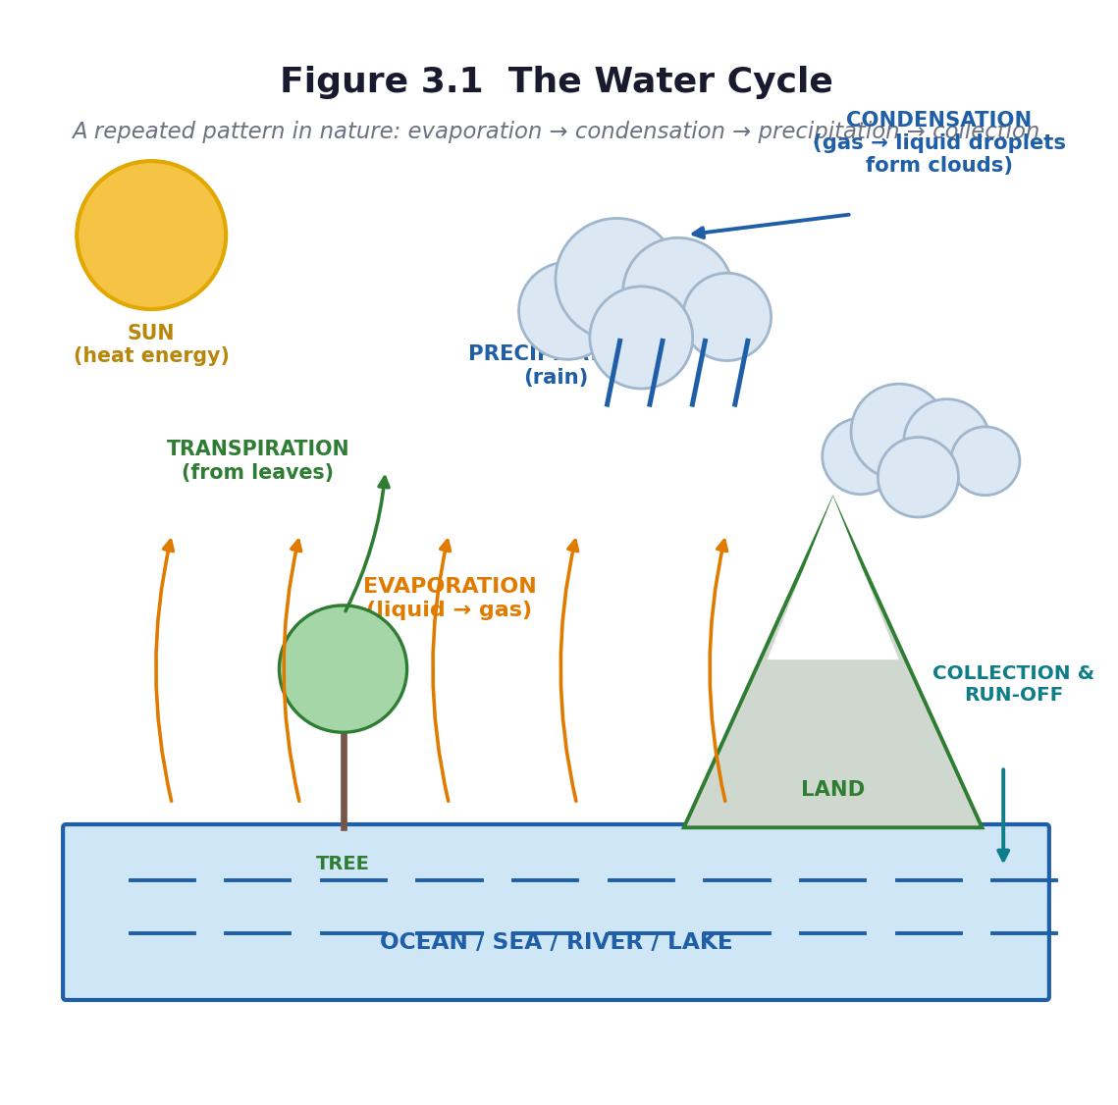
Figure 3.1 The water cycle — evaporation, condensation, precipitation, collection.
Unit objectives
- Explain how the water cycle occurs as a repeated pattern in nature, and describe its importance.
- Describe the life cycle of the housefly (egg → larva → pupa → adult) and draw it as a complete cycle.
- Discuss the activities of the housefly as a menace to humans and design an intervention to reduce them.
- Observe and list plant nutrient sources in the community, categorise them as organic or inorganic, and describe how each is applied to plants in the field.
Assessed unit product
Three assessed pieces: a labelled water-cycle diagram; a housefly breeding-site survey with a community intervention poster (rubric R6); and the school-garden fertiliser trial report with a bar chart of results. Unit Test 3 (30 marks) closes the unit.
LESSON 11  Week 6 | The Water Cycle — How It Happens  60 minutes (double period)

Strand | Cycles
Sub-strand | Earth Science
Content standard | B7.2.1.1 — Recognise that the water cycle is an example of repeated patterns of change in nature and understand how it occurs.
Indicator(s) | B7.2.1.1.1 — Explain how the water cycle occurs as a repeated pattern in nature.
Performance indicator  (what learners can do) | Learners can identify the stages of the water cycle, explain how they are linked, and demonstrate the process of transpiration and cloud formation.
Core competencies | Critical Thinking and Problem Solving (CP); Digital Literacy (DL); Creativity and Innovation (CI).
Key vocabulary | water cycle, evaporation, condensation, precipitation, transpiration, collection, run-off, water vapour, cloud, repeated pattern
Prior knowledge | Lesson 2 — liquids and their importance. Basic 6 work on water and weather. Note: this indicator is a prerequisite for Week 6's timetabled indicator and is not itself timetabled in the scheme — see A1.3, Gap 1. It must be taught.
Resources / TLM | A large transparent bowl or jar with a lid or cling film, warm water, a cold plate or ice, salt. A leafy plant in a clear plastic bag. Figure 3.1 enlarged to A3. If possible, the sealed-bowl set up a week earlier so learners can see the result.

Learning objectives — by the end of this lesson every learner will be able to:
- K — name the four stages of the water cycle in order and state what drives it.
- S — demonstrate evaporation and condensation, and draw a flow chart showing the order of the stages and how they are linked.
- A/V — appreciate that the water we use today is the same water that has been cycling for millions of years.

Phase / time | Teacher activity | Learner activity
ENGAGE  8 min | POE (predict–observe–explain). Show a bowl of warm water and a cold plate held above it. Ask: ‘What will appear on the underside of the plate, and where will it come from?’ Learners write a prediction and a reason BEFORE you do it. Then hold the cold plate above the steam for sixty seconds and let them see the droplets. Share the performance indicator. | Learners write predictions individually. They observe the droplets forming. Those who predicted ‘nothing’ or ‘the water is leaking through the plate’ have now had their idea made to fail — which is the necessary first step.
EXPLORE  18 min | Two demonstrations plus one investigation. Demonstration 1: the sealed bowl — warm water in a transparent bowl, covered with cling film or a lid, with ice or a cold plate on top, left in the sun. Demonstration 2: a leafy plant branch sealed in a clear plastic bag, left in the sun. Set both up at the start of the lesson and return to them at the end. Meanwhile, groups do the investigation: put equal volumes of water in three identical containers — one wide, one narrow, one covered — and predict which will lose most water by tomorrow. | Learners set up or observe the demonstrations, make and record predictions about the three containers, and record the starting water level with a marker pen on each container.
EXPLAIN  12 min | Return to the demonstrations. Name the process: evaporation (liquid to gas, from the surface, driven by the Sun's heat), condensation (gas to liquid on a cold surface, forming clouds), precipitation (water falling as rain), collection and run-off (water gathering in rivers, lakes, oceans and underground). Add transpiration — water lost from leaves, shown by the bagged plant. Draw Figure 3.1 with the class, arrow by arrow, and stress the word cycle: it has no beginning and no end. | Learners draw and label the cycle, add the four processes as verb labels on the arrows (not just nouns), and answer: what drives the whole cycle? (The Sun's energy.)
ELABORATE  12 min | Two tasks. First, the mime: groups of six physically act out the cycle — learners are water molecules moving from the sea to the cloud to the rain to the river and back. Second, the hard question: ‘Where does the water in your borehole come from, and where does it go after you bathe?’ Trace the local water, not an abstract one. | Groups perform the cycle mime to each other. Then they trace their own community's water on a simple map or in a written chain.
EVALUATE  10 min | Exit ticket: draw the water cycle with four labelled arrows. Then ‘one thing I still wonder’ — collect these; they often produce the best question of the term. Preview Lesson 12: ‘tomorrow, why the cycle matters — and what happens when it breaks’. | Learners complete the exit ticket and write one question. They self-assess against three criteria.

Figure 3.1 The water cycle.
Differentiation
Support — a flow-chart template with the four stage names to sequence and arrows to label.
Core — four stages in order, each explained, with the Sun identified as the driver.
Extension — explain why the water cycle is described as a *repeated pattern* rather than a process with a beginning and an end, and research what happens to the cycle when forest is cleared.

Assessment and success criteria
The labelled diagram (checklist C7.6). The POE prediction sheet — compare prediction with observation to see whose thinking changed. The three-container investigation is checked next lesson.
Homework / project
Check the three containers and record which lost the most water, and why. Leave the sealed bowl on the windowsill for a week and observe it daily.
Safety
The teacher handles all warm water and any heat source. Ice is fine; learners must not handle it for long. Keep the floor dry — wet floors and forty-five twelve-year-olds do not mix.
Cross-curricular links and values
Mathematics — measuring volumes and recording change over time. Social Studies — water as a resource, rivers and rainfall in Ghana. Values — protecting water sources is everyone's business.
Teacher reflection (complete after the lesson)
What worked well: ______________________________________________________________________________
Who did not meet the success criteria, and what I will do next lesson: ______________________________________________________________________________
What I will change when I teach this again: ______________________________________________________________________________

LESSON 12  Week 6 | Why the Water Cycle Matters  60 minutes (double period)

Strand | Cycles
Sub-strand | Earth Science
Content standard | B7.2.1.1 — Recognise that the water cycle is an example of repeated patterns of change in nature and understand how it occurs.
Indicator(s) | B7.2.1.1.2 — Describe the importance of the water cycle in nature.
Performance indicator  (what learners can do) | Learners can describe the importance of the water cycle in terms of energy, nutrients, the water table, weather and clean water.
Core competencies | Communication and Collaboration (CC); Digital Literacy (DL); Creativity and Innovation (CI); Critical Thinking and Problem Solving (CP).
Key vocabulary | water table, groundwater, nutrient, weather pattern, drought, flood, reservoir, filtration, purification
Prior knowledge | Lesson 11 — the four stages of the water cycle and the Sun as its driver.
Resources / TLM | The sealed bowl from Lesson 11, the three-container results, Figure 3.1, a diagram of a well showing the water table, posters or photographs of a Ghanaian river, reservoir or treatment plant. Any material gathered on Tour 2 (A10.6).

Learning objectives — by the end of this lesson every learner will be able to:
- K — state five ways in which the water cycle is important in nature.
- S — illustrate the importance of the water cycle in the community with a diagram and a short report.
- A/V — appreciate that human activity can damage the cycle, and that protecting water sources protects people.

Phase / time | Teacher activity | Learner activity
ENGAGE  8 min | Check the three containers and discuss the results. Then ask: ‘Suppose the water cycle stopped tomorrow. What would happen first?’ Take answers and build a chain of consequences on the board — no rain, no crops, no water in the taps, no hydroelectricity, no boreholes. Share the performance indicator. | Learners report their measurements, then brainstorm consequences. The chain usually gets bleak quickly, which is the point: importance is best understood by imagining absence.
EXPLORE  18 min | Groups investigate one of five ways the cycle matters, using textbooks, any digital sources, and their own knowledge: (1) energy — the cycle releases and moves heat around the planet; (2) carrier of nutrients — water moves dissolved minerals from soil into plants and through ecosystems; (3) improving the water table — rain soaks into the ground and refills the groundwater that wells and boreholes draw on; (4) regulating weather patterns; (5) provision of clean water — evaporation leaves salts and dirt behind, so rain is naturally distilled. | Each group becomes expert on one importance and prepares to teach it, producing a diagram and a one-minute explanation.
EXPLAIN  12 min | Groups teach, in the order 1 to 5. Add the evidence: hold up the sealed bowl — the water that condensed on the cold top is pure, and the salt and dirt stayed behind in the bowl. That is distillation, and it is why rain is fresh even though it comes from the salty sea. Show the water table diagram: the borehole water learners drink fell as rain, perhaps years ago, perhaps far away. | Learners take notes on all five importances, and add the distillation evidence to their own diagrams. They connect the water table drawing to their own community's water source.
ELABORATE  12 min | The threat task. Ask: ‘What do people in this community do that damages the water cycle?’ Groups list: cutting down trees, dumping refuse in drains and streams, building on watercourses, burning, over-pumping boreholes. Then each group chooses one threat and produces a poster showing the threat, the consequence, and one action the school could take. | Groups list threats, choose one, and design a poster with a clear message and one concrete action.
EVALUATE  10 min | Gallery walk of the posters with structured peer feedback. Exit ticket: ‘Give three reasons why the water cycle is important.’ Then the individual assessed piece: a diagram illustrating the importance of the water cycle in the community, with labels. | Learners walk the gallery, write one specific comment per poster, complete the exit ticket, and begin the assessed diagram.

Figure 3.1 The water cycle — the same diagram, now annotated with why each stage matters.
Differentiation
Support — a sentence frame for each importance: ‘The water cycle is important because ___, which means that ___.’
Core — five importances described, with a labelled diagram of one.
Extension — research and present one Ghanaian case: a river or reservoir under pressure, what is causing it, and what is being done.

Assessment and success criteria
The assessed diagram (10 marks) plus the exit ticket. The poster contributes to the process-skills and values record. If the class went on Tour 2, the post-visit writing task in A10.6 substitutes for the homework.
Homework / project
Write a short piece: ‘Where my water comes from, and one thing I will do to protect it.’ Optional extended task: make a rain gauge from a cut bottle and record rainfall daily for two weeks.
Safety
No tasting of any water. If you collected rainwater for inspection, do not drink it.
Cross-curricular links and values
Social Studies — water resources, rivers, sanitation. English — the persuasive poster. Values — environmental responsibility, and the curriculum's own aim of developing ‘a humane and responsible attitude towards the use of all resources in Ghana’.
Teacher reflection (complete after the lesson)
What worked well: ______________________________________________________________________________
Who did not meet the success criteria, and what I will do next lesson: ______________________________________________________________________________
What I will change when I teach this again: ______________________________________________________________________________

LESSON 13  Week 7 | The Life Cycle of the Housefly  60 minutes (double period)

Strand | Cycles
Sub-strand | Life Cycle of Organisms
Content standard | B7.2.2.1 — Demonstrate the skills of carrying out activities to show the stages of the life cycle of a housefly, the effects of its activities on humans and how to reduce them.
Indicator(s) | B7.2.2.1.1 — Describe the life cycle of the housefly.
Performance indicator  (what learners can do) | Learners can identify and describe the stages of the life cycle of the housefly and arrange them in the correct order.
Core competencies | Communication and Collaboration (CC); Digital Literacy (DL); Creativity and Innovation (CI).
Key vocabulary | life cycle, egg, larva, maggot, pupa, adult, metamorphosis, breed, stage, moult
Prior knowledge | Unit 1 — living things are made of cells. Basic 6 — life cycles of a butterfly, a frog or a chicken. Many learners will believe that maggots are generated spontaneously by rotting meat — this lesson is designed to break that idea.
Resources / TLM | Figure 3.2 enlarged to A3. Stage cards (egg, larva, pupa, adult) for sequencing. Any photographs or video. Two jars prepared a week earlier: one with meat or fruit open to flies, one sealed with fine cloth — this is the Redi experiment and it is the single most valuable artefact you can bring to this lesson. Larvae or pupae if available. Set up the jars in Week 5 so they are ready now.

Learning objectives — by the end of this lesson every learner will be able to:
- K — name and describe the four stages of the housefly life cycle in the correct order.
- S — arrange flashcards or cut-outs to show the order, and draw the cycle with arrows linking the stages.
- A/V — appreciate that flies breed in specific places, and that knowing the life cycle is the key to controlling them.

Phase / time | Teacher activity | Learner activity
ENGAGE  8 min | Bring out the two jars — the open one with maggots, the sealed one with none. Ask: ‘Same meat, same day, same place. Why does one jar have maggots and the other does not?’ Do not answer. Let the argument run. Then say: ‘Everything alive comes from something else alive. Let us find out what came into this jar.’ Share the performance indicator. | Learners observe both jars and argue about the cause. Most will say the meat ‘turned into’ maggots. Write the competing explanations on the board — you will return to them.
EXPLORE  18 min | Sequencing task: each group receives four stage cards with a picture and a description, shuffled. They must put them in order and justify the order. Then the observation task: examine the jar closely with a hand lens — without opening it — and draw what they see at each level: the eggs (tiny white grains), the larvae (cream-coloured, legless, feeding), the pupae (brown, oval, still), and any adults. | Groups sequence the cards and defend their order. They observe the jar from outside and draw each stage they can identify, recording the day and what they see.
EXPLAIN  12 min | Formalise with Figure 3.2. Eggs — a female lays 100 to 150 white eggs on rotting food, manure or refuse; they hatch in about a day. Larva (maggot) — legless, cream-coloured, feeds and grows for three to five days, moulting twice. Pupa — inside a hard brown case, no feeding, the body is reorganised, three to six days. Adult — the winged fly emerges, mates, and the female lays eggs again. The whole cycle takes about seven to ten days in warm weather. Name it: this is complete metamorphosis. Now return to the two jars: the flies laid eggs on the open meat; the cloth kept them out of the sealed jar. Maggots do not come from meat. | Learners correct their sequences, draw the cycle as a circle with arrows, and write one line of notes on each stage. They then re-answer the jar question in writing.
ELABORATE  12 min | Two tasks. First, the comparison: how is the housefly cycle like the water cycle? Both are cycles, both repeat, both have stages — but one is a *life* cycle and the other is not. Second, the timing calculation: if one female lays 150 eggs and the cycle takes ten days, why can a single uncovered bin produce thousands of flies in a month? | Groups make the comparison and then work out, roughly, why fly numbers explode so fast. They record the reasoning, not just the number.
EVALUATE  10 min | Exit ticket: draw and label the four stages in order, with arrows. Then one question: ‘What is the weakest point in the cycle, if you wanted to stop flies breeding?’ Collect the answers — they feed directly into Lesson 16. | Learners complete the exit ticket and answer the control question from what they now know.

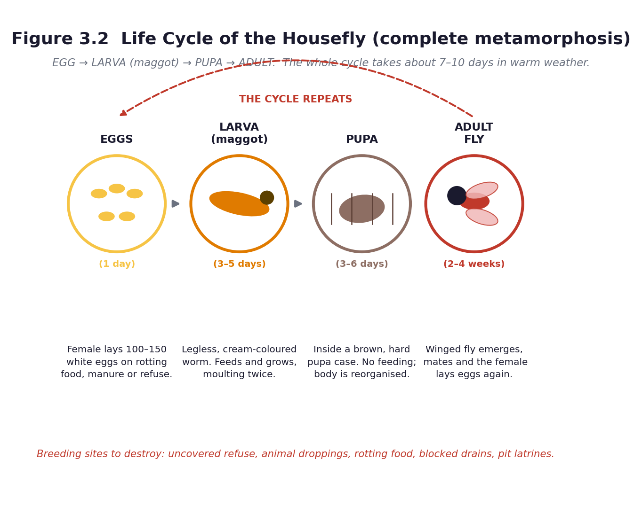
Figure 3.2 Life cycle of the housefly: egg → larva → pupa → adult.
Differentiation
Support — a sequencing strip with the four stages to cut and stick in order; a word bank for the descriptions.
Core — four stages in order, each described in one sentence, drawn as a cycle.
Extension — compare the housefly's complete metamorphosis with the incomplete metamorphosis of a grasshopper (egg → nymph → adult), and explain why there is no pupal stage in the second.

Assessment and success criteria
The sequencing task and the labelled cycle diagram (checklist C7.7). The re-answer to the jar question is the real assessment: it shows whether conceptual change happened.
Homework / project
Write notes on each of the four stages. For homework observation: find one place near your home where flies are breeding, and note what it is — do not touch anything.
Safety
The jar stays sealed, always, and is never opened in the classroom. No learner touches the contents. Keep it away from direct sun. At the end of the unit, dispose of it by sealing the whole jar in a bag and putting it in the refuse, or by burying it deep. Everyone washes hands with soap after every session involving the jar.
Cross-curricular links and values
Mathematics — the timing calculation and rates of increase. English — sequencing and descriptive writing. Values — evidence over assumption: this lesson is a lesson about how science settles an argument.
Teacher reflection (complete after the lesson)
What worked well: ______________________________________________________________________________
Who did not meet the success criteria, and what I will do next lesson: ______________________________________________________________________________
What I will change when I teach this again: ______________________________________________________________________________

LESSON 14  Week 7 | Rearing and Recording — The Housefly Diary  60 minutes (double period)

Strand | Cycles
Sub-strand | Life Cycle of Organisms
Content standard | B7.2.2.1 — Demonstrate the skills of carrying out activities to show the stages of the life cycle of a housefly, the effects of its activities on humans and how to reduce them.
Indicator(s) | B7.2.2.1.1 — Describe the life cycle of the housefly.
Performance indicator  (what learners can do) | Learners can observe, record and interpret the stages of the housefly life cycle over time.
Core competencies | Critical Thinking and Problem Solving (CP); Communication and Collaboration (CC); Creativity and Innovation (CI).
Key vocabulary | observe, record, diary, data, duration, evidence, variable, change
Prior knowledge | Lesson 13 — the four stages and their order. The two jars set up in Week 5.
Resources / TLM | The sealed rearing jar(s). Hand lenses. Rulers. A camera phone. The housefly diary sheet (Worksheet WS6, Part C4). Graph paper. Figure 3.2. Gloves if available.

Learning objectives — by the end of this lesson every learner will be able to:
- K — state the approximate duration of each stage of the housefly life cycle.
- S — observe systematically over time, record data in a table, and draw a conclusion from the evidence.
- A/V — appreciate that scientific knowledge is built by patient, careful observation.

Phase / time | Teacher activity | Learner activity
ENGAGE  8 min | Show the jar. Ask: ‘What has changed since we last looked, and how long did it take?’ Then the discipline question: ‘Why does a scientist write it down instead of just remembering?’ Establish: memory fades, and data can be checked by someone else. Share the performance indicator. | Learners compare the jar with their drawings from Lesson 13 and note the changes. They discuss why written records matter.
EXPLORE  18 min | Observation stations around the jar. Each group has five minutes to observe, measure and record: date and day number; what stages are present; how many of each if countable; size of the largest larva in millimetres; colour; and any behaviour (feeding, moulting, moving to the surface, pupating). If you have a camera, photograph the jar — the photographs become a time-lapse record on the classroom wall. | Groups rotate through the observation station, fill in the diary sheet, and add their row to the class data table on the board.
EXPLAIN  12 min | Pool the class data into one table: day number against stage observed. Ask learners to read the pattern: which stage came first, which lasted longest, and how the stages overlapped. Introduce the approximate durations from Figure 3.2 and compare them with the class's own observations — the class data will not match exactly, and discussing why (temperature, food, species) is genuine scientific reasoning. | Learners transfer the class data to their own sheets, identify the pattern, and write one sentence comparing their observations with the textbook figures.
ELABORATE  12 min | Draw a bar chart or a timeline of the class data showing how long each stage lasted. Then the harder question: ‘Would the cycle be faster in Accra in March or in Bolgatanga in December? Why?’ This introduces temperature as a variable and links the biology to real Ghanaian conditions. | Learners draw the chart in their books or on graph paper, and answer the temperature question in writing, giving a reason.
EVALUATE  10 min | Each learner writes a conclusion: one paragraph beginning ‘My evidence shows that…’. Peer-mark against three criteria: uses the data, states the pattern, and gives a reason. Preview Lesson 15: ‘now that we know how they breed, what harm do they do?’ | Learners write conclusions, swap and peer-mark against the three criteria.

Figure 3.2 Timing of the housefly life cycle.
Differentiation
Support — a structured diary sheet with headings and a worked example row.
Core — a complete diary with at least four observations and a conclusion using the data.
Extension — design a fair test of the effect of temperature on the speed of the life cycle, stating the variables that must be controlled.

Assessment and success criteria
The housefly diary (checklist C7.8 — recording and interpreting). The conclusion marked against three criteria. This is the strongest piece of process-skills evidence in Unit 3, and it counts towards the practical component of the term mark.
Homework / project
Add one more observation to the diary tomorrow if the jar is accessible before school. Begin the breeding-site survey started in Lesson 13 and complete it for Lesson 15.
Safety
Jar sealed at all times. No opening, no touching, no smelling. Gloves for anyone handling the jar. Hands washed with soap immediately afterwards. At the end of the unit the jar is sealed in a bag for refuse or buried deep — never emptied loosely.
Cross-curricular links and values
Mathematics — data tables, bar charts and timelines. Computing — photographing and storing the record. English — writing a conclusion from evidence.
Teacher reflection (complete after the lesson)
What worked well: ______________________________________________________________________________
Who did not meet the success criteria, and what I will do next lesson: ______________________________________________________________________________
What I will change when I teach this again: ______________________________________________________________________________

LESSON 15  Week 8 | The Housefly as a Menace  60 minutes (double period)

Strand | Cycles
Sub-strand | Life Cycle of Organisms
Content standard | B7.2.2.1 — Demonstrate the skills of carrying out activities to show the stages of the life cycle of a housefly, the effects of its activities on humans and how to reduce them.
Indicator(s) | B7.2.2.1.2 — Discuss the activities of the housefly as a menace to humans and show how to reduce the effects of those activities.
Performance indicator  (what learners can do) | Learners can describe how the housefly's feeding habits and activities affect humans, and identify the diseases it can transfer.
Core competencies | Creativity and Innovation (CI); Communication and Collaboration (CC); Digital Literacy (DL).
Key vocabulary | menace, pathogen, dysentery, diarrhoea, cholera, typhoid, food poisoning, contaminate, sanitation, nuisance, vomit, faeces
Prior knowledge | Lessons 13 and 14 — the life cycle and the breeding sites. The completed breeding-site survey.
Resources / TLM | The completed surveys. Figure 3.2. Pictures or drawings of a fly's hairy legs and mouthparts. A district or national sanitation poster if available. Materials for the debate. Optional: a visiting environmental health officer (A7.3).

Learning objectives — by the end of this lesson every learner will be able to:
- K — describe the feeding habits of the housefly and name three diseases it can transfer.
- S — explain how the fly transfers disease, and present an argument in a structured debate.
- A/V — appreciate that sanitation is a community responsibility, not only a government one.

Phase / time | Teacher activity | Learner activity
ENGAGE  8 min | Ask: ‘A fly lands on faeces. Ten minutes later it lands on your kenkey. What exactly does it carry across?’ If possible, show a magnified image of a fly's hairy legs and sponging mouthparts. Then: ‘It does not bite. So how does it make you ill?’ Share the performance indicator. | Learners react — usually with disgust, which is a good hook for this particular lesson — and propose mechanisms. They look at the image and note the hairs.
EXPLORE  18 min | Groups collate the breeding-site surveys on a large map of the school and its surroundings: where are the flies breeding, and how close are they to where food is prepared or sold? Then, using textbooks and any other sources, groups research the three mechanisms: (a) transfer of disease organisms — the fly picks up pathogens on its legs and body and vomits and defecates on food as it feeds; (b) food poisoning; (c) nuisance. | Groups map the breeding sites, discuss the distances, and research the mechanisms, preparing a one-minute presentation with real examples.
EXPLAIN  12 min | Groups present. Formalise the mechanism step by step: the fly feeds by spitting digestive fluid onto solid food and sponging it back up, which is why it both picks up and deposits organisms; it carries bacteria on the hairs of its legs and body; it defecates and vomits on food as it feeds. Name the diseases: dysentery, diarrhoea, cholera, typhoid, and food poisoning. Connect to the breeding sites: the closer the breeding site to the food, the greater the risk. | Learners build a flow diagram: breeding site → fly → food → person → illness. They add the disease names and mark the distances on the class map.
ELABORATE  12 min | Structured debate: ‘This school should ban all food sold outside the compound.’ Two sides prepare for five minutes. Then, midway, sides swap — each must now argue the other position. This forces learners to engage with the opposing evidence rather than rehearse one side, and it reliably produces better reasoning than a straight debate. | Learners argue their assigned side, then swap and argue the opposite. They conclude by writing the strongest point made by the other side.
EVALUATE  10 min | Exit ticket: ‘Explain, in three sentences, how a housefly that has never bitten anyone can make a person ill.’ Then a whole-class synthesis: what is the one change that would most reduce the risk at this school? | Learners complete the exit ticket and vote on the single most effective change, justifying their choice.

Figure 3.2 Breaking the cycle is the control strategy.
Differentiation
Support — a sequence strip of the transmission chain to order; a word bank of disease names.
Core — feeding habit described, three diseases named, transmission explained.
Extension — research one of the named diseases — its cause, symptoms, treatment and prevention — and present it as a health-education poster.

Assessment and success criteria
The exit ticket and the flow diagram (checklist C7.9). The debate assessed with rubric R1 (oral and participation) — assess the quality of the reasoning and the use of evidence, not confidence or volume.
Homework / project
Design a short, clear message — a sentence or a slogan — that would convince a food seller to cover her food. Bring it to Lesson 16.
Safety
No learner handles the rearing jar. If a visiting officer brings samples, the teacher controls them.
Cross-curricular links and values
Social Studies — sanitation as a community issue. English — debate, persuasion, and the register of a public-health message. Values — personal and community responsibility for hygiene; the curriculum asks learners to design an intervention and educate their community about it.
Teacher reflection (complete after the lesson)
What worked well: ______________________________________________________________________________
Who did not meet the success criteria, and what I will do next lesson: ______________________________________________________________________________
What I will change when I teach this again: ______________________________________________________________________________

LESSON 16  Week 8 | Designing the Intervention — Breaking the Cycle  60 minutes (double period)

Strand | Cycles
Sub-strand | Life Cycle of Organisms
Content standard | B7.2.2.1 — Demonstrate the skills of carrying out activities to show the stages of the life cycle of a housefly, the effects of its activities on humans and how to reduce them.
Indicator(s) | B7.2.2.1.2 — Discuss the activities of the housefly as a menace to humans and show how to reduce the effects of those activities.
Performance indicator  (what learners can do) | Learners can design an intervention that reduces the effects of the housefly's activities on humans, and educate their community about it.
Core competencies | Creativity and Innovation (CI); Communication and Collaboration (CC); Digital Literacy (DL); Critical Thinking and Problem Solving (CP).
Key vocabulary | intervention, control, prevent, breeding site, cover, drain, bin, larvicide, evaluate, target audience
Prior knowledge | Lessons 13 to 15 — the life cycle, the breeding sites, and the harm flies do.
Resources / TLM | Cardboard, markers, old newspapers or flipchart paper, glue, scissors. The class breeding-site map. Rubric R6 (poster and intervention design) on the wall before they start. Scrap materials for any physical prototype — wire, net, bottles, string.

Learning objectives — by the end of this lesson every learner will be able to:
- K — name at least four ways to reduce the harm done by houseflies, and explain which stage of the life cycle each one attacks.
- S — design an intervention suited to a real audience, and produce a poster to educate the community about it.
- A/V — take responsibility for a problem in their own environment and act on it.

Phase / time | Teacher activity | Learner activity
ENGAGE  8 min | Read the curriculum exemplar aloud: ‘Design an intervention that can reduce the effects of the activities of the housefly on humans and educate people of your community about the intervention.’ Then say: this is not a poster about flies. It is a plan to change something real, and you are going to carry it out. Share the performance indicator and rubric R6. | Learners read the rubric and identify what ‘excellent’ looks like. They look again at the breeding-site map of their own school.
EXPLORE  18 min | Groups brainstorm every possible control measure, then sort them by which stage of the life cycle they attack: covering refuse and food (stops egg-laying), draining standing water and cleaning drains (removes breeding sites), disposing of manure and animal droppings (removes breeding sites), using tight lids and bins (stops egg-laying), fly screens and covered food (stops contact with food), traps, and keeping the compound clean generally. Then each group picks the two measures that would work best at this school, and says why. | Groups generate and sort measures, then choose two for this specific school and justify the choice with evidence from their own map.
EXPLAIN  12 min | Groups present their two chosen measures. Formalise the principle: the most effective control attacks the breeding site, not the adult fly. Killing adult flies feels productive and changes little, because the female has already laid 150 eggs. Stopping egg-laying or removing the breeding site breaks the cycle. Introduce ‘attacking the weakest link’ as the general strategy. | Learners record the principle and apply it: for each of their two measures, state which stage it attacks and why that is effective.
ELABORATE  12 min | The design task — the assessed product. Groups design the intervention itself (a covered-bin system, a drain-clearing rota, a food-covering campaign, a trap built from a cut bottle, a composting system that does not breed flies) and produce a poster to educate their target audience. The poster must name the audience, carry one clear action, and be readable from three metres. | Groups plan, build or draw the intervention, and produce the poster. They check their own work against rubric R6 as they go.
EVALUATE  10 min | Gallery walk and peer assessment with rubric R6. Then the commitment: each group states one action the class will actually carry out this term — and the teacher commits the class to it. Follow-through is what makes this lesson different from a poster exercise. | Learners assess each other's posters with rubric R6, then agree as a class on one real action and who will do it.

Differentiation
Support — a list of control measures to choose from with pictures; the poster template with headings already in place.
Core — an intervention matched to a stage of the life cycle, plus a clear, accurate and readable poster.
Extension — build a working prototype and test it; or carry out a small evaluation by counting flies at a site before and after the intervention.

Assessment and success criteria
The intervention and poster, marked with rubric R6 (20 marks: scientific accuracy 6, targeting the life cycle 4, clarity and design 6, audience awareness 4). The class action is recorded in the teacher's journal as evidence of the values and citizenship strand.
Homework / project
Take the poster home and explain it to one adult. If the class agreed on an action, carry out your part of it this week.
Safety
If any group builds a trap, the teacher checks it. No handling of the rearing jar. Gloves and hand washing for anything that touches soil or refuse.
Cross-curricular links and values
Creative Arts and Design — the poster is a graphic-design task. Social Studies — civic responsibility and community action. English — writing for a specific audience. Values — this is the most Freirean lesson of the term: learners investigate their own community's problem and act on it.
Teacher reflection (complete after the lesson)
What worked well: ______________________________________________________________________________
Who did not meet the success criteria, and what I will do next lesson: ______________________________________________________________________________
What I will change when I teach this again: ______________________________________________________________________________

LESSON 17  Week 9 | Plant Nutrient Sources — Organic and Inorganic  60 minutes (double period)

Strand | Cycles
Sub-strand | Crop Production
Content standard | B7.2.3.1 — Demonstrate understanding of the different plant nutrients (organic and inorganic fertilizers) and their application in school farming (school gardening).
Indicator(s) | B7.2.3.1.1 — Observe and list all plant nutrient sources available in a community and categorise them into organic and inorganic nutrient sources.
Performance indicator  (what learners can do) | Learners can observe and list plant nutrient sources in the community, categorise them as organic or inorganic, and explain the difference.
Core competencies | Communication and Collaboration (CC); Critical Thinking and Problem Solving (CP); Creativity and Innovation (CI).
Key vocabulary | nutrient, fertiliser, organic, inorganic, compost, manure, NPK, urea, nitrogen, phosphorus, potassium, crop residue, green manure
Prior knowledge | Unit 1 — plant cells, and that plants make their own food by photosynthesis. Basic 6 — plants need water, light and soil. Many learners will not know that soil can run out of nutrients.
Resources / TLM | Real samples on trays: compost, poultry manure, cow dung, dry crop residue or cocoa husk, kitchen waste, wood ash, and NPK 15-15-15, urea, sulphate of ammonia if obtainable — each in a clearly labelled, sealed container and handled only by the teacher. Hand lenses. Figure 3.3. Sorting cards.

Learning objectives — by the end of this lesson every learner will be able to:
- K — list at least six plant nutrient sources and classify each as organic or inorganic.
- S — create a table explaining the differences between organic and inorganic plant nutrients.
- A/V — appreciate that soil fertility is a resource that can be built up or used up.

Phase / time | Teacher activity | Learner activity
ENGAGE  8 min | Hold up two things: a handful of dark compost and a spoonful of NPK granules. Ask: ‘Both of these make a maize plant grow. Where does each one come from?’ Then the key question: ‘If you plant maize on the same plot year after year without adding anything, what happens to the harvest?’ Establish: the soil runs out. Share the performance indicator. | Learners identify the sources — one from once-living things, one from a factory — and discuss what they have observed about repeated planting on the same land.
EXPLORE  18 min | Observation stations with real samples. Groups rotate and record, for each sample: name, where it comes from, colour, texture, smell, form (powder, granules, crumbly, fibrous), and organic or inorganic? — with a reason. The teacher handles the chemical fertilisers; learners observe and smell from a distance. Then the community task: list every nutrient source available in this community, including ones not on the tray. | Groups observe and record on a table, then extend the list with local sources — poultry droppings from a nearby farm, cocoa husk, market waste, household compost, the local agro-chemical shop.
EXPLAIN  12 min | Formalise the definitions. Organic nutrient sources come from once-living things: compost, animal manure, poultry droppings, crop residue, green manure, kitchen waste, cocoa husk. Inorganic fertilisers are manufactured or mined: NPK 15-15-15, urea, sulphate of ammonia, single superphosphate, muriate of potash. Explain the NPK numbers — the three percentages are nitrogen, phosphorus and potassium, the three nutrients plants need most. Build the comparison table in Figure 3.3 together. | Learners complete the comparison table: advantages and disadvantages of each type. They learn what the three numbers on a fertiliser bag mean.
ELABORATE  12 min | The comparison task: ‘Compare the volumes of organic and inorganic nutrient source required by different plants.’ Groups are given a scenario — a 10 m × 10 m maize plot — and must work out roughly how much compost would be needed versus how much NPK. The contrast is dramatic: tonnes versus kilograms. Discuss what that means for a smallholder farmer. | Groups work out the quantities, compare, and discuss the implications: organic is bulky but cheap or free; inorganic is concentrated but must be bought and can burn the crop.
EVALUATE  10 min | Exit ticket: name three organic and three inorganic nutrient sources and give one advantage and one disadvantage of each type. Preview Lesson 18: ‘tomorrow, how each one is actually applied in the field’. | Learners complete the exit ticket and self-assess. They sort the sample cards into two piles as a final check.

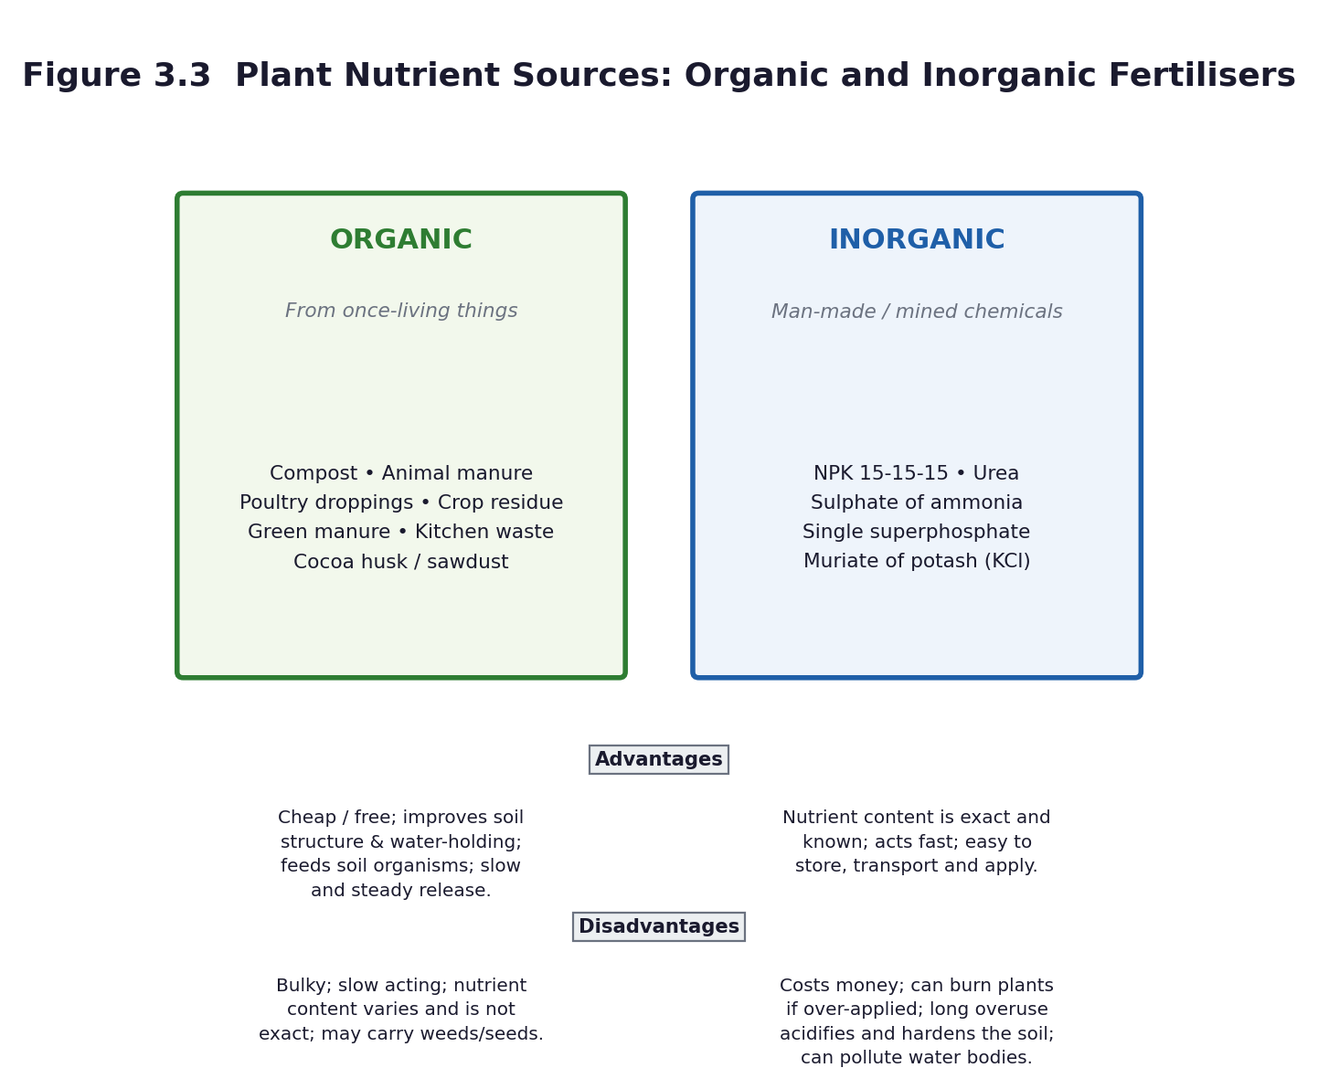
Figure 3.3 Organic and inorganic plant nutrients compared.
Differentiation
Support — picture cards to sort into two hoops labelled organic and inorganic; a table with the headings filled in.
Core — six sources listed and classified correctly, with a completed comparison table.
Extension — explain why nitrogen, phosphorus and potassium are the three nutrients that matter most, and what each does for the plant (leaves and growth; roots, flowers and fruit; overall health and disease resistance).

Assessment and success criteria
The observation table and the comparison table (checklist C7.10). The exit ticket. If the class went on Tour 3 (A10.7), the field-trip nutrient table substitutes for or supplements this work.
Homework / project
Ask at home or at a farm what fertiliser is used, how much, and what it costs. Bring the answer to Lesson 18.
Safety
The teacher handles all chemical fertiliser. No learner applies or tastes any fertiliser. Learners observe and smell from a distance only; do not pass open containers around. Wash hands after handling compost or manure.
Cross-curricular links and values
Career Technology / Agriculture — soil fertility and crop production. Mathematics — quantity, area and cost. Social Studies — food security and farming as a livelihood. Values — sustainable use of resources.
Teacher reflection (complete after the lesson)
What worked well: ______________________________________________________________________________
Who did not meet the success criteria, and what I will do next lesson: ______________________________________________________________________________
What I will change when I teach this again: ______________________________________________________________________________

LESSON 18  Week 9 | How Each Nutrient Is Applied in the Field  60 minutes (double period)

Strand | Cycles
Sub-strand | Crop Production
Content standard | B7.2.3.1 — Demonstrate understanding of the different plant nutrients (organic and inorganic fertilizers) and their application in school farming (school gardening).
Indicator(s) | B7.2.3.1.2 — Describe the physical characteristics of different plant nutrients (organic and inorganic) and how each is applied to plants in the field.
Performance indicator  (what learners can do) | Learners can describe the physical characteristics of organic and inorganic nutrients and how each is applied to plants in the field.
Core competencies | Digital Literacy (DL); Communication and Collaboration (CC); Creativity and Innovation (CI).
Key vocabulary | broadcasting, side-dressing, ring application, top-dressing, basal application, composting, mulch, granule, powder, dilute, scorch
Prior knowledge | Lesson 17 — organic and inorganic nutrient sources and their advantages and disadvantages. The homework on what farmers actually use.
Resources / TLM | The samples from Lesson 17. The school garden or a prepared plot. Tools: hand trowels, hoes, a watering can, a measuring cup or a marked bottle, string and pegs for marking out beds. Gloves if available. Figure 3.3. Soap and water for washing.

Learning objectives — by the end of this lesson every learner will be able to:
- K — describe how the physical characteristics of each nutrient determine how it is applied.
- S — describe in a group, and then demonstrate, how each type of nutrient is applied to plants in the field.
- A/V — appreciate the need for care and accuracy, because too much fertiliser destroys the crop it was meant to feed.

Phase / time | Teacher activity | Learner activity
ENGAGE  8 min | Show a fine powder and a coarse granule, and a crumbly fibrous compost. Ask: ‘If you had to get each of these onto the roots of a maize plant, would you use the same method?’ Then: the homework — what did farmers say they use, and how much? Share the performance indicator. | Learners compare the physical forms and predict different methods. They report the homework findings, which usually vary a great deal and make a good discussion.
EXPLORE  18 min | Groups are given one nutrient each and must work out how its physical form determines how it is applied. Compost and manure are bulky and fibrous — they are spread and worked into the soil before planting, or used as mulch. Urea and NPK are concentrated granules or powders — they are applied in small, measured amounts, either in a ring around the plant, in a band beside the row, or broadcast and watered in. Groups prepare a demonstration for the class. | Groups handle their nutrient (teacher supervising any chemical), note its physical characteristics, and work out and rehearse the correct method.
EXPLAIN  12 min | Groups demonstrate. Formalise the four methods with their names: broadcasting (scattered evenly over the whole plot before planting or as a top-dressing), ring application (in a circle around the plant, not touching the stem), side-dressing / banding (in a shallow furrow beside the row, covered with soil), and composting / mulching (spread on the surface or dug in before planting). Stress the reason for each: keep the fertiliser off the stem and leaves, place it where the roots are, and water it in. | Learners record the four methods with a labelled sketch of each, and note which nutrient suits which method and why.
ELABORATE  12 min | The over-application problem. Ask: ‘If a little fertiliser is good, is twice as much twice as good?’ Explain what happens: the salt draws water out of the roots, the plant scorches and dies — the crop is killed by kindness. Then the timing question: when in the plant's life should each nutrient be given? Set up the four-bed trial to start next lesson. | Groups mark out four beds with string and pegs and label them: control (nothing), compost, manure, NPK — plus, if space allows, a fifth deliberately over-dosed bed. They record the starting condition of each bed.
EVALUATE  10 min | Exit ticket: ‘Describe two ways of applying fertiliser, and say why fertiliser must not be placed against the stem.’ Then groups present their method demonstrations to the class. | Learners complete the exit ticket and demonstrate their method, using the correct vocabulary.

Figure 3.3 Physical characteristics determine the method of application.
Differentiation
Support — a card-matching task: nutrient picture, characteristic, and method; a demonstration to copy rather than a method to work out.
Core — characteristics described and the correct method named and demonstrated for each type.
Extension — plan the fertiliser schedule for a whole maize season: what, how much, when, and by which method, with a reason for each decision.

Assessment and success criteria
The method demonstration observed against checklist C7.11. The labelled sketches. The exit ticket. The marked-out trial beds are the set-up for the Lesson 19 practical and the Lesson 20 report.
Homework / project
Bring a hand trowel or a small hoe if you have one, and old clothes, for the garden practical next lesson. Read the safety rules for the school-garden session.
Safety
The teacher measures and issues all chemical fertiliser; learners do not handle it directly without supervision. Tools: a tool talk first, blades away from the body, no horseplay. Gloves where possible. No tasting, ever. Wash hands thoroughly with soap afterwards and cover any cut before going out.
Cross-curricular links and values
Career Technology / Agriculture — real farming practice. Mathematics — measuring area, quantity and spacing. Values — care, accuracy and responsibility with materials that can do harm as well as good.
Teacher reflection (complete after the lesson)
What worked well: ______________________________________________________________________________
Who did not meet the success criteria, and what I will do next lesson: ______________________________________________________________________________
What I will change when I teach this again: ______________________________________________________________________________

LESSON 19  Week 10 | School Garden Practical — Applying What We Learned  60 minutes (double period)

Strand | Cycles
Sub-strand | Crop Production
Content standard | B7.2.3.1 — Demonstrate understanding of the different plant nutrients (organic and inorganic fertilizers) and their application in school farming (school gardening).
Indicator(s) | B7.2.3.1.2 — Describe the physical characteristics of different plant nutrients (organic and inorganic) and how each is applied to plants in the field.
Performance indicator  (what learners can do) | Learners can demonstrate the practical application of each type of plant nutrient to plants in the field, and run a fair test of their effects.
Core competencies | Creativity and Innovation (CI); Critical Thinking and Problem Solving (CP); Communication and Collaboration (CC).
Key vocabulary | fair test, control, variable, observation, measurement, record, conclusion, germination, height, yield
Prior knowledge | Lessons 17 and 18 — nutrient sources, their characteristics and their methods of application. The four marked-out beds.
Resources / TLM | The four (or five) marked beds. Seedlings or seeds — maize, beans or okra. Compost, manure, NPK. Trowels, hoes, watering cans, a metre rule or measuring tape, string, pegs, labels, gloves, soap and water. The garden log sheet (Worksheet WS8).

Learning objectives — by the end of this lesson every learner will be able to:
- K — state what makes a test fair, and identify the control in the class experiment.
- S — apply each nutrient correctly by the correct method, and set up and record a fair test.
- A/V — work safely and cooperatively out of doors, and take responsibility for a living thing over several weeks.

Phase / time | Teacher activity | Learner activity
ENGAGE  8 min | Out at the beds. Ask: ‘If we put different things on these beds, how will we know which one actually made the difference?’ Draw out: same seeds, same number, same spacing, same water, same sunlight, same soil, same day — and one bed with nothing added at all. That bed is the control, and without it the experiment tells us nothing. Share the performance indicator. | Learners look at the beds and propose what must be kept the same. They name the control bed and explain why it matters.
EXPLORE  18 min | The practical. Each group takes one bed. Tasks, in order: (1) prepare the bed; (2) plant the same number of seeds or seedlings at the same spacing; (3) apply that bed's nutrient by the correct method — the teacher measures and issues any chemical fertiliser; (4) water equally; (5) label the bed; (6) record the starting measurements. The over-dose bed, if used, is set up by the teacher deliberately to show what happens. | Groups work their beds, applying the correct method for their nutrient. The Recorder completes the garden log: date, bed, treatment, number planted, spacing, amount applied, method, and the starting measurements.
EXPLAIN  12 min | Back in the classroom or in the shade. Check the log as a class: is every variable except the nutrient the same? Identify any that slipped — a bed in the shade, a bed that got more water — and record them honestly as limitations. Explain that the trial runs for four weeks and that measurements are taken at the same time and in the same way each week. | Learners check their logs against the class list of variables, note any limitations, and agree the measurement routine: height of each plant in centimetres, number of leaves, colour, weekly, at the same time of day.
ELABORATE  12 min | Prediction task. Each learner writes: ‘I predict that bed ___ will grow best because ___. I predict that bed ___ will grow worst because ___.’ Predictions are recorded, dated and kept — they will be compared with the results in Lesson 20, and being wrong in an interesting way is worth as much as being right. | Learners write and date their predictions with reasons, and file them.
EVALUATE  10 min | Safety and tidy-up check, then a two-minute reflection each: what did I do, what did I learn, what could have gone better? Preview Lesson 20: ‘we measure, report and assess Unit 3’. | Learners complete the reflection in their journals and help return the tools.

Differentiation
Support — paired with a confident partner; a checklist of the six steps to tick off.
Core — the nutrient applied by the correct method, the log completed accurately, and a prediction with a reason.
Extension — design the data table for the four-week trial, including the columns for height, number of leaves, colour and any problems, and justify each column.

Assessment and success criteria
The garden log (checklist C7.12). Observation of the practical, including safe tool use. The prediction with a reason. This is the assessed practical for Unit 3 and carries the practical component of the term mark.
Homework / project
Water your group's bed on the rota for the next four weeks and record the date each time. Bring measurements to every science lesson.
Safety
Tool talk before any tool is touched. Blades away from the body; carry a trowel or hoe with the blade down and to the side. The teacher measures and issues all chemical fertiliser. Gloves where possible. No tasting. Wash hands with soap immediately after the session. Cover any cut before going out. Count tools back in before anyone leaves.
Cross-curricular links and values
Career Technology / Agriculture — genuine farming practice. Mathematics — measurement, fair testing, data tables. Science — designing experiments is one of NaCCA's fifteen process skills and this is where it is properly developed.
Teacher reflection (complete after the lesson)
What worked well: ______________________________________________________________________________
Who did not meet the success criteria, and what I will do next lesson: ______________________________________________________________________________
What I will change when I teach this again: ______________________________________________________________________________

LESSON 20  Week 10 | Cycles in Review — Unit 3 Assessment and Showcase  60 minutes (double period)

Strand | Cycles
Sub-strand | Earth Science; Life Cycle of Organisms; Crop Production
Content standard | B7.2.1.1; B7.2.2.1; B7.2.3.1 — All three Unit 3 content standards.
Indicator(s) | B7.2.1.1.1–.2; B7.2.2.1.1–.2; B7.2.3.1.1–.2 — All Unit 3 indicators.
Performance indicator  (what learners can do) | Learners can compare the three cycles studied in this unit, report the results of the garden trial, and demonstrate mastery of the Unit 3 content.
Core competencies | Critical Thinking and Problem Solving (CP); Communication and Collaboration (CC); Creativity and Innovation (CI).
Key vocabulary | cycle, pattern, repeated, transfer, synthesis, compare, evidence, conclusion
Prior knowledge | Lessons 11 to 19 — the whole of Unit 3.
Resources / TLM | The garden trial data. The housefly posters and diaries. The water-cycle diagrams. Figures 3.1, 3.2 and 3.3. Unit Test 3 (Part C1, 30 marks), one copy per learner. Graph paper.

Learning objectives — by the end of this lesson every learner will be able to:
- K — compare the water cycle, the housefly life cycle and the nutrient cycle, identifying what the three have in common.
- S — present the results of the garden trial as a bar chart with a conclusion, and complete the Unit 3 assessment.
- A/V — appreciate that recognising a pattern across different contexts is what scientific thinking is for.

Phase / time | Teacher activity | Learner activity
ENGAGE  8 min | Put three diagrams on the board at once: the water cycle, the housefly life cycle, and the nutrient cycle. Ask: ‘What is the one thing all three have in common?’ Give them two minutes of thinking time — this is a synthesis question and it is genuinely hard. Share the performance indicator. | Learners think individually, then pair, then share. The answer they are reaching for: all three are repeated patterns with linked stages and no true beginning or end.
EXPLORE  18 min | Synthesis task. Groups build a three-column comparison table: what moves round the cycle; what drives it; what the stages are; what happens if one stage is broken; and whether it is a living cycle or not. This is the intellectual payoff of the whole unit — the pattern recognised three times and then abstracted. | Groups complete the comparison table, and each group adds one question of its own that the table raises.
EXPLAIN  12 min | Groups present their tables. Draw out the differences as well as the similarities: the water cycle is driven by the Sun and involves no life; the housefly cycle is a life cycle, driven by reproduction; the nutrient cycle is driven partly by decay and partly by human action. Then: what happens if a stage is broken in each? — drought, no flies, exhausted soil. | Learners correct and complete their tables, and write one paragraph comparing two of the three cycles.
ELABORATE  12 min | The garden trial results. Groups plot their four weeks of data as a bar chart — mean plant height by bed — and write a conclusion beginning ‘The evidence suggests that…’. They then compare the result with the prediction they wrote in Lesson 19. If the trial did not work — and sometimes it does not — that is a valuable lesson in itself: discuss why. | Groups draw the bar chart, write the conclusion, and compare it honestly with their prediction.
EVALUATE  10 min | Unit Test 3 (Part C1), 30 marks. If time is short, use the first thirty minutes of the next science period. After the test, whole-class feedback: the four commonest errors on the board, five minutes to self-correct in a different colour. | Learners complete the test, then self-correct against the board feedback and record their score.

Differentiation
Support — a comparison table with the headings given and one row completed as an example.
Core — the comparison table completed and the bar chart with a conclusion.
Extension — identify a fourth cycle not studied this term (the carbon cycle, the rock cycle, the nitrogen cycle) and explain why it fits the pattern.

Assessment and success criteria
Unit Test 3 (30 marks). The comparison table and the garden-trial report (rubric R7). The housefly poster (rubric R6) and the water-cycle diagram are also counted in the Unit 3 mark.
Homework / project
Revise Units 1 to 3 using the revision cards. Bring scrap materials for the Unit 4 energy audit.
Safety
If you visit the garden, the same tool and hygiene rules as Lesson 19 apply.
Cross-curricular links and values
Mathematics — bar charts, means, comparison. English — synthesis and comparison. Values — the curriculum's specific aim of showing ‘concern and understanding of the interdependence of all living things and the Earth on which they live’.
Teacher reflection (complete after the lesson)
What worked well: ______________________________________________________________________________
Who did not meet the success criteria, and what I will do next lesson: ______________________________________________________________________________
What I will change when I teach this again: ______________________________________________________________________________

UNIT 4 — FORCES AND ENERGY
Weeks 11–12 • Sub-strand: Energy

Energy is the best possible place to end the term, because it quietly explains the other three units: heat drives changes of state, the Sun drives the water cycle and holds the solar system together, and light is the energy that plants trap in food. The content standard asks learners to identify the forms of energy and show how they are related, and to explain their daily applications — so every abstract idea must be attached to something Ghanaian learners actually use. The light sub-standard (B7.4.1.3) then gives the term a hands-on, experimental finish.
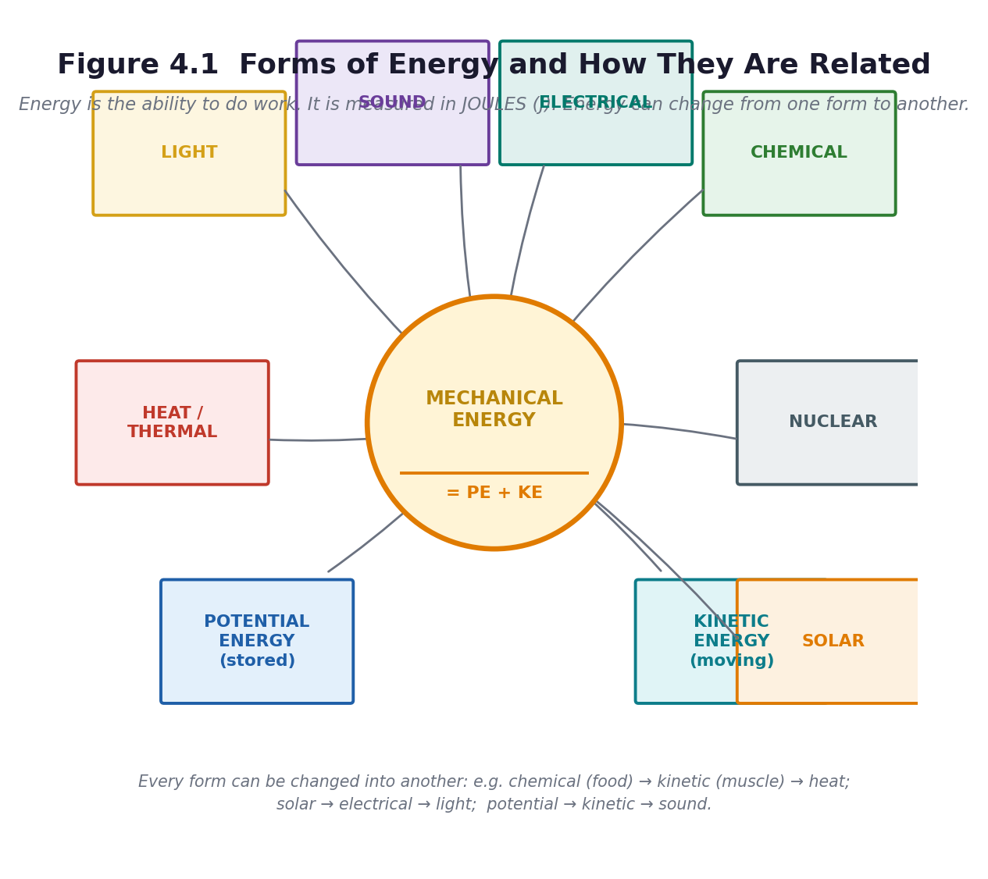
Figure 4.1 Forms of energy and how they are related.
Unit objectives
- Identify the various forms of energy — potential, kinetic, heat, sound, solar, electrical, nuclear, chemical and light — and show how they are related.
- Explain daily applications of forms of energy, and use PE = mgh and KE = ½mv² to solve simple problems on mechanical energy.
- Demonstrate that light travels in a straight line, and that it can be reflected, refracted and dispersed.
Assessed unit product
An energy audit of the school with a switch-off campaign poster, and a report on the four light experiments with labelled ray diagrams. Unit Test 4 (20 marks).
LESSON 21  Week 11 | Forms of Energy and How They Are Related  60 minutes (double period)

Strand | Forces and Energy
Sub-strand | Energy
Content standard | B7.4.1.1 — Demonstrate an understanding of forms of energy and their daily applications.
Indicator(s) | B7.4.1.1.1 — Identify the various forms of energy and show how they are related.
Performance indicator  (what learners can do) | Learners can list the forms of energy and demonstrate, with diagrams, how potential energy and kinetic energy are related.
Core competencies | Digital Literacy (DL); Cultural Identity and Global Citizenship (CG); Communication and Collaboration (CC).
Key vocabulary | energy, work, joule, potential energy, kinetic energy, mechanical energy, heat, sound, solar, electrical, nuclear, chemical, light, conversion
Prior knowledge | Unit 3 — the Sun drives the water cycle. Unit 2 — the Sun is a star. Most learners use the word energy daily but cannot define it.
Resources / TLM | Figure 4.1 enlarged to A3. A ball, a rubber band or catapult, a wound-up clockwork toy or a rubber-band car, a torch and battery, a matchbox, a maize cob or any food, a bell or any object that makes a sound, a solar calculator if available. Energy-form cards for matching.

Learning objectives — by the end of this lesson every learner will be able to:
- K — list nine forms of energy and state that energy is the ability to do work, measured in joules.
- S — show with a diagram how potential energy and kinetic energy are related, and state that mechanical energy equals PE plus KE.
- A/V — appreciate that energy is never created or destroyed, only changed from one form to another.

Phase / time | Teacher activity | Learner activity
ENGAGE  8 min | Ask: ‘List everything you have used energy for since you woke up this morning.’ Build a long list. Then the definition question: ‘What IS energy?’ Take answers and settle on: the ability to do work, measured in joules (J). Then the puzzle that drives the lesson: ‘Where did the energy in your arm come from?’ Trace it back: food, then the sun, then nuclear fusion. Share the performance indicator. | Learners list their uses of energy, then trace the chain backwards from muscle to food to plant to sunlight — and are usually surprised where it ends.
EXPLORE  18 min | Jigsaw: nine groups, one form of energy each — potential, kinetic, heat, sound, solar, electrical, nuclear, chemical, light. Each group gets an object or a card and must produce: a definition in one sentence, one Ghanaian example, and a demonstration for the class. Then the conversion task: each group must show one conversion — what its form changes into, and what changes into it. | Groups research, prepare and rehearse a one-minute slot with a demonstration. They identify the conversions into and out of their form.
EXPLAIN  12 min | Groups teach in turn. Build Figure 4.1 on the board as they go. Then focus on the relationship the curriculum specifically requires: mechanical energy = potential energy + kinetic energy. Demonstrate: hold a ball high (it has stored, or potential, energy because of its position); release it (the stored energy becomes movement, or kinetic, energy); at the bottom it has maximum kinetic and minimum potential. Total mechanical energy stays the same. | Learners copy Figure 4.1, and draw the three-position ball diagram showing PE and KE trading places while the total stays constant.
ELABORATE  12 min | The conversion relay. Call out a device; groups write the energy chain. A torch: chemical → electrical → light and heat. A maize mill: electrical → kinetic → sound and heat. Akosombo: potential → kinetic → electrical. A person eating: chemical → kinetic and heat. A solar panel: light → electrical. Then the harder question: where does the ‘wasted’ energy go? | Groups write energy chains for ten devices, and identify the wasted output in each — almost always heat and sound.
EVALUATE  10 min | Exit ticket: name five forms of energy; state the relationship between PE and KE in one sentence; give one complete energy chain for a device in your home. Preview Lesson 22: ‘tomorrow we calculate it, and we audit the school’. | Learners complete the exit ticket and self-assess against three criteria.

Figure 4.1 Forms of energy and how they are related.
Differentiation
Support — matching cards with the form and a picture; the energy chain given as a partially completed template.
Core — nine forms named, the PE/KE relationship stated, one complete energy chain.
Extension — explain why no conversion is ever 100 per cent efficient, and where the missing energy goes.

Assessment and success criteria
The Figure 4.1 diagram and the energy chains (checklist C7.13). The exit ticket. Retrieval at the start of Lesson 22: name the nine forms from memory.
Homework / project
Learn the nine forms of energy. At home, find three devices and write the energy chain for each.
Safety
The teacher handles any flame or hot object. If you use a rubber-band catapult, no firing at people, and only under supervision.
Cross-curricular links and values
Mathematics — the relationship expressed as a sum. Social Studies — Ghana's electricity: hydro at Akosombo, Kpong and Bui; thermal; solar. Values — the curriculum's aim of using materials ‘in a sustainable manner’.
Teacher reflection (complete after the lesson)
What worked well: ______________________________________________________________________________
Who did not meet the success criteria, and what I will do next lesson: ______________________________________________________________________________
What I will change when I teach this again: ______________________________________________________________________________

LESSON 22  Week 11 | Energy in Daily Life, and Calculating PE and KE  60 minutes (double period)

Strand | Forces and Energy
Sub-strand | Energy
Content standard | B7.4.1.1 — Demonstrate an understanding of forms of energy and their daily applications.
Indicator(s) | B7.4.1.1.2 — Explain daily applications of forms of energy.
Performance indicator  (what learners can do) | Learners can match forms of energy to appliances used at school, at home and in the community, and use PE = mgh and KE = ½mv² to solve simple problems.
Core competencies | Digital Literacy (DL); Cultural Identity and Global Citizenship (CG); Communication and Collaboration (CC); Creativity and Innovation (CI).
Key vocabulary | appliance, mass, height, velocity, gravity, joule, calculate, audit, efficiency, waste
Prior knowledge | Lesson 21 — the nine forms of energy, the PE/KE relationship, energy chains. Mathematics: substitution into a formula, and the idea of a variable.
Resources / TLM | Figure 4.2. A metre rule, a spring balance or a rubber-band scale, a known mass (a 1 kg bag of rice or sugar), string, a stopwatch or phone. A copy of the school's electricity bill if the office will share it. Appliance cards. Calculators if available.

Learning objectives — by the end of this lesson every learner will be able to:
- K — match forms of energy to appliances used daily at school, at home and in the community.
- S — use PE = mgh and KE = ½mv² to solve simple problems involving mechanical energy, and carry out an energy audit.
- A/V — recognise that wasted energy costs money and harms the environment, and that individuals can act.

Phase / time | Teacher activity | Learner activity
ENGAGE  8 min | Retrieval: name the nine forms of energy from memory. Then hold up a phone charger, a fan and a mortar and pestle. Ask: ‘Which form goes in, and which comes out, for each?’ Share the performance indicator. | Learners answer the retrieval questions and identify input and output forms for each object.
EXPLORE  18 min | The energy audit. Groups are given a zone — the classroom, the kitchen, the office, the compound, the staff room — and ten minutes to list every appliance or use of energy there, with the input form, the useful output, and the wasted output. They bring the data back and the class builds one big table on the board. | Groups survey their zones and record: item | energy in | useful energy out | wasted energy out. They report back and build the class table.
EXPLAIN  12 min | Now the calculations, using the gradual-release sequence: I do, we do, you do together, you do alone. Write PE = mgh and KE = ½mv² and define every symbol and every unit: m in kilograms, h in metres, g as 10 m/s² (use 10 for B7 — the curriculum does not require 9.8), v in metres per second, and the answer in joules. Work one example fully on the board: a 2 kg stone held 5 m up — PE = 2 × 10 × 5 = 100 J. Then a second together. Then three for them. | Learners copy the two formulae and the units, work one example with the teacher, one together on whiteboards, and then three alone. They check each other's answers.
ELABORATE  12 min | The pendulum or the ramp: swing or roll an object and identify where PE is greatest, where KE is greatest, and where they are equal. Then the applied problem: ‘A 40 kg learner climbs 3 m of stairs. How much potential energy has she gained?’ (40 × 10 × 3 = 1200 J.) Then ‘where did that energy come from?’ — breakfast. | Learners predict and observe the energy exchange, then solve the applied problem and connect it back to the energy chains from Lesson 21.
EVALUATE  10 min | Five calculation questions, marked by swapping. Then the campaign task: from the audit, each group identifies the three biggest sources of wasted energy in the school and designs a switch-off poster for one of them. | Learners complete and swap-mark the calculations, then design the poster, which is the assessed Unit 4 product.

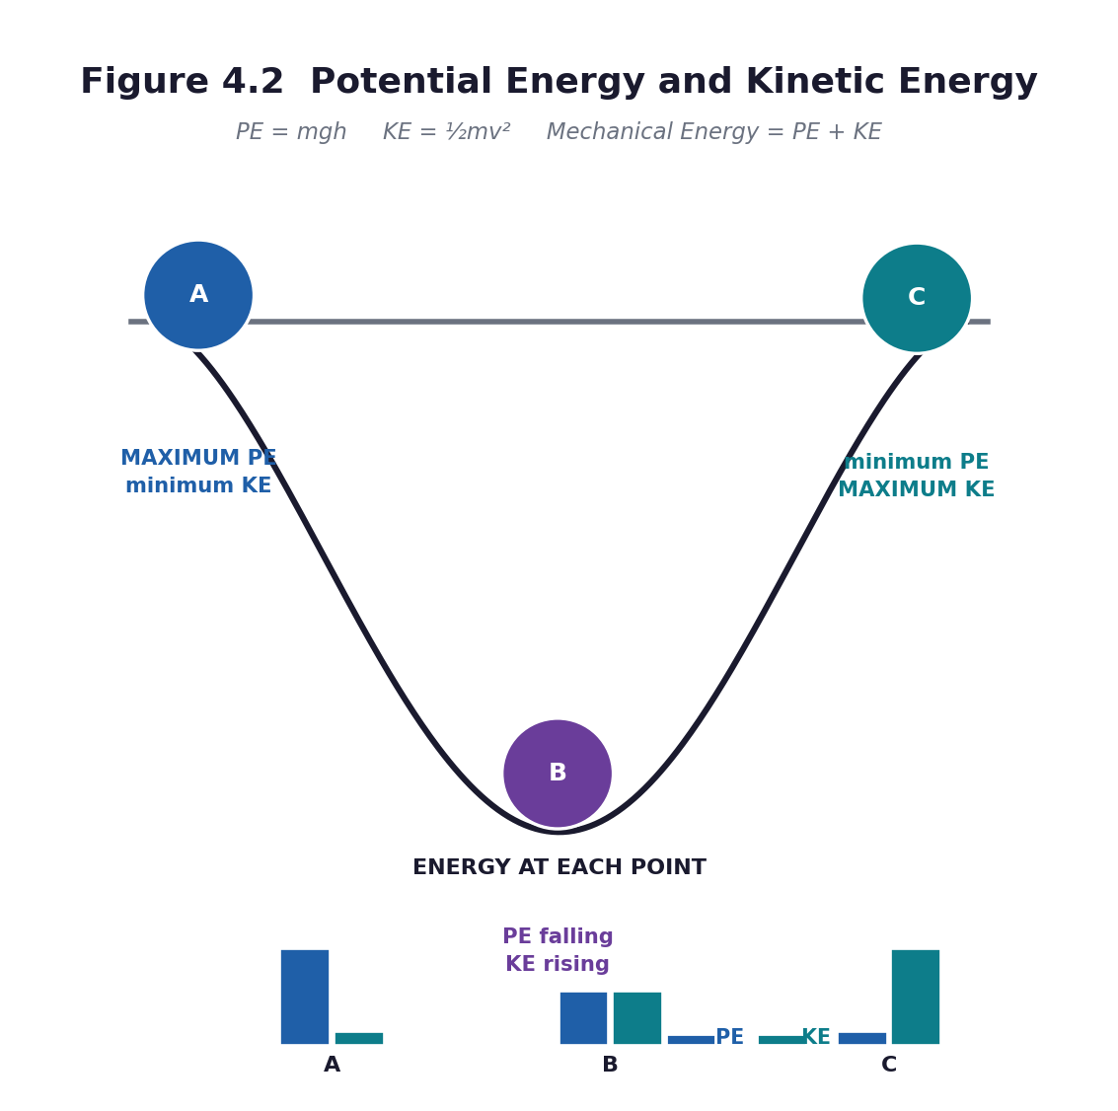
Figure 4.2 Potential energy and kinetic energy. PE = mgh; KE = ½mv²; mechanical energy = PE + KE.
Differentiation
Support — a formula triangle for each equation, a calculator, and a worked example to copy; use whole numbers only.
Core — three calculations correct with units, and the energy table completed.
Extension — find the school's monthly electricity units and cost if available, and calculate what a 20 per cent reduction would save in a year.

Assessment and success criteria
The calculations (checklist C7.14). The energy audit table. The switch-off poster assessed with rubric R6. This completes the energy sub-standard, which is the assessed product for B7.4.1.1.
Homework / project
Complete the switch-off poster. Revise the two formulae and learn what each symbol means and what unit it is measured in.
Safety
If learners climb stairs or drop objects for the calculation, the teacher controls it and the object is soft and heavy enough not to bounce. No throwing.
Cross-curricular links and values
Mathematics — substitution, units, and decimals. Social Studies — the cost of energy and Ghana's generating mix. Values — sustainable use of resources and personal responsibility.
Teacher reflection (complete after the lesson)
What worked well: ______________________________________________________________________________
Who did not meet the success criteria, and what I will do next lesson: ______________________________________________________________________________
What I will change when I teach this again: ______________________________________________________________________________

LESSON 23  Week 12 | Light — Straight Lines, Reflection and Refraction  60 minutes (double period)

Strand | Forces and Energy
Sub-strand | Energy
Content standard | B7.4.1.3 — Demonstrate understanding of characteristics of light, such as travelling in a straight line, reflection, refraction and dispersion.
Indicator(s) | B7.4.1.3.1 — Demonstrate how light travels in a straight line.
Performance indicator  (what learners can do) | Learners can perform experiments showing that light travels in a straight line and can be reflected and refracted, and produce reports, posters or diagrams.
Core competencies | Digital Literacy (DL); Communication and Collaboration (CC); Critical Thinking and Problem Solving (CP); Creativity and Innovation (CI).
Key vocabulary | light, straight line, ray, beam, reflection, refraction, dispersion, mirror, incident ray, reflected ray, normal, angle of incidence, angle of reflection, medium
Prior knowledge | Lesson 21 — light is a form of energy. Everyday experience of shadows and mirrors. Mathematics: angles.
Resources / TLM | Torches, one per group if possible. Three pieces of card with a pinhole in each, mounted on Plasticine or in a lump of clay. A plane mirror (or a mirrored tile, or foil glued flat to card). A transparent bowl or glass of water. A clear plastic ruler or a glass block. A protractor. White paper. Figure 4.3.

Learning objectives — by the end of this lesson every learner will be able to:
- K — state that light travels in straight lines, and define reflection and refraction.
- S — perform experiments to show straight-line travel, reflection and refraction, and record the results as labelled ray diagrams.
- A/V — appreciate that a claim about light needs an experiment behind it, not just an opinion.

Phase / time | Teacher activity | Learner activity
ENGAGE  8 min | POE. Show three cards with holes, held apart, and a torch. Ask: ‘If I put the cards in a crooked line and shine the torch through, will the light get through all three?’ Learners predict and write a reason. Then do it — the light stops. Then straighten the cards and the light gets through. Share the performance indicator. | Learners predict and reason, observe both outcomes, and explain the difference. The crooked-card result is immediate, visible and memorable.
EXPLORE  18 min | Three experiments at three stations. Station 1 — straight lines: the three-card experiment, plus a torch shone through dusty air or chalk dust to see the beam. Station 2 — reflection: a torch beam onto a plane mirror on paper; trace the incident ray, the reflected ray and the normal; measure the two angles. Station 3 — refraction: a pencil or a ruler standing in a bowl of water, viewed from the side; and a torch beam entering water at an angle. | Groups rotate through the stations, perform each experiment, and record what they observe as a labelled diagram with a one-sentence finding.
EXPLAIN  12 min | Groups report. Formalise the three findings with Figure 4.3. Light travels in straight lines — which is why shadows have sharp edges and why you cannot see round a corner. Reflection — light bounces off a surface, and the angle of incidence equals the angle of reflection, both measured from the normal. Refraction — light bends when it passes from one medium into another of different density, which is why a pencil in water looks broken and why a pool looks shallower than it is. | Learners complete labelled ray diagrams for all three, using a ruler and a protractor, and write the rule for each in one sentence.
ELABORATE  12 min | Two application tasks. First, the periscope: using two mirrors at 45°, can a group see over the top of a book or round a corner? Building one makes the reflection rule concrete. Second, the explanation task: why does a river look shallower than it is, and why is that dangerous? | Groups build a simple periscope from two mirrors and a folded card tube, then explain the shallow-river illusion using refraction.
EVALUATE  10 min | Exit ticket: state that light travels in straight lines and give the evidence; draw a labelled reflection diagram with the two equal angles marked; explain in one sentence why a pencil in water looks bent. Preview Lesson 24: ‘tomorrow we split light into colours’. | Learners complete the exit ticket and self-assess. They begin the experiment report.

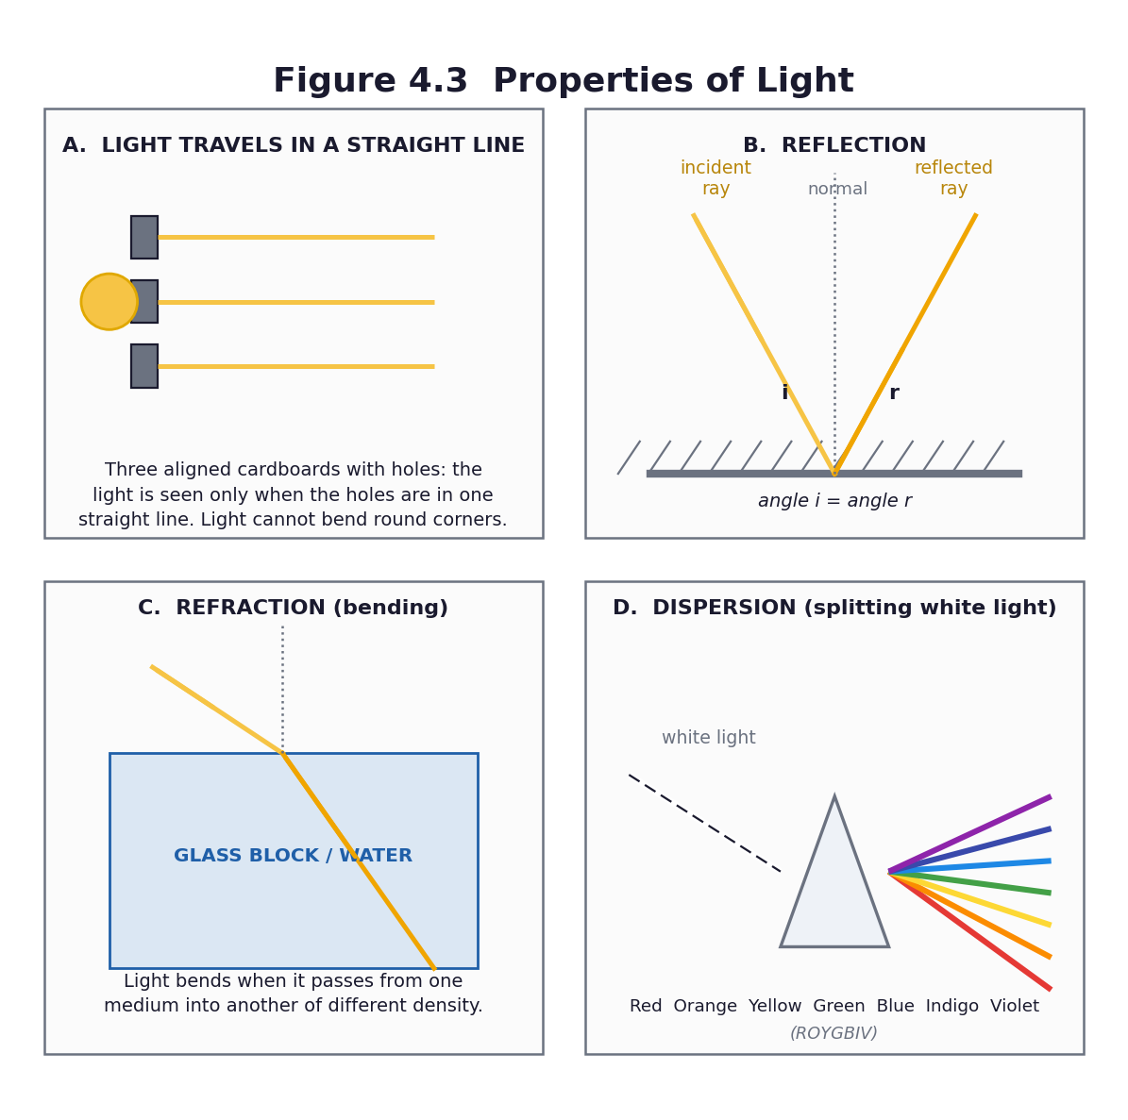
Figure 4.3 Properties of light: straight-line travel, reflection, refraction and dispersion.
Differentiation
Support — pre-drawn ray diagrams to complete; angle measurement with a protractor supported by a partner.
Core — all three experiments performed, with a labelled diagram and a correct one-sentence finding for each.
Extension — measure the angle of incidence and reflection at five different angles, record in a table, and state the relationship as a general rule with the data as evidence.

Assessment and success criteria
The three labelled ray diagrams and the findings (checklist C7.15). The periscope. The exit ticket. This is the first half of the light report that forms the Unit 4 assessed product.
Homework / project
Complete the diagrams for the three experiments. Find one example of reflection and one of refraction at home, and write a sentence about each.
Safety
Never shine a torch into anyone's eyes. Use mirrors on a flat surface, not held up; collect any chipped or broken mirror immediately and sweep glass with a brush and pan, never fingers. No looking at the Sun, through anything, ever.
Cross-curricular links and values
Mathematics — angles, measurement, and the equality of two angles. Creative Arts — periscope construction. English — the experiment report.
Teacher reflection (complete after the lesson)
What worked well: ______________________________________________________________________________
Who did not meet the success criteria, and what I will do next lesson: ______________________________________________________________________________
What I will change when I teach this again: ______________________________________________________________________________

LESSON 24  Week 12 | Dispersion — Splitting White Light, and Unit 4 Assessment  60 minutes (double period)

Strand | Forces and Energy
Sub-strand | Energy
Content standard | B7.4.1.3 — Demonstrate understanding of characteristics of light, such as travelling in a straight line, reflection, refraction and dispersion.
Indicator(s) | B7.4.1.3.1 — Demonstrate how light travels in a straight line.
Performance indicator  (what learners can do) | Learners can perform an experiment to show the dispersion of light into colours, and report on all four characteristics of light studied this term.
Core competencies | Creativity and Innovation (CI); Communication and Collaboration (CC); Critical Thinking and Problem Solving (CP); Digital Literacy (DL).
Key vocabulary | dispersion, spectrum, prism, white light, rainbow, ROYGBIV, wavelength, refract, bend
Prior knowledge | Lesson 23 — straight-line travel, reflection and refraction. Most learners have seen a rainbow and will not know what causes it.
Resources / TLM | A glass prism if available; otherwise a CD or DVD, a mirror in a bowl of water, or a bevel-edged mirror. Torches. White card or paper as a screen. A bowl of water. Figure 4.3. Unit Test 4 (Part C1), one copy per learner.

Learning objectives — by the end of this lesson every learner will be able to:
- K — state that white light is made of seven colours and name them in order.
- S — perform an experiment to show the dispersion of light and record it as a labelled diagram.
- A/V — appreciate that a phenomenon they have seen all their lives has a scientific explanation.

Phase / time | Teacher activity | Learner activity
ENGAGE  8 min | Ask: ‘Have you ever seen a rainbow? What makes it?’ Take answers — you will hear a range of explanations, some of them cultural and worth respecting. Then: ‘Where are the colours hiding when the light is white? They are not being added. They are already there.’ Share the performance indicator. | Learners describe rainbows they have seen and offer explanations. They record their own explanation, which they will compare with the scientific one at the end.
EXPLORE  18 min | Dispersion experiments at stations. Station 1: a prism in a beam of light from a torch or a window, with white card as the screen — adjust until the spectrum appears. Station 2: a mirror half-submerged at an angle in a bowl of water, with sunlight or a torch, projecting onto a white card or a shaded wall. Station 3: a CD or DVD tilted in the light. Groups rotate and record what they see. | Groups work the stations, adjust patiently, and record the order of colours they observe on white card.
EXPLAIN  12 min | Groups report the colours they saw and in what order. Formalise with Figure 4.3D: white light is a mixture of seven colours — red, orange, yellow, green, blue, indigo, violet. The prism bends each colour by a different amount, so they spread out. Violet bends most, red least. This is dispersion. Then connect it to the rainbow: a raindrop does the job of the prism — refracting, reflecting and dispersing the sunlight. | Learners draw and label the dispersion diagram with the seven colours in the correct order, and write the explanation: refraction splits the white light because each colour bends by a different amount.
ELABORATE  12 min | Two tasks. First, the Newton's disc or a colour wheel: spin a disc painted in the seven colours and watch it appear whitish — the reverse of dispersion, and strong evidence that white light is a mixture. Second, the synthesis: in groups, produce a single summary poster of the four characteristics of light — straight line, reflection, refraction, dispersion — each with a diagram and a one-sentence rule. | Groups spin the colour wheel and discuss what it shows. They produce the summary poster, which doubles as a revision aid for Week 13.
EVALUATE  10 min | Unit Test 4 (Part C1), 20 marks. Then the term review: each learner writes one sentence on what they now understand that they did not in September. Collect these — they are the best evidence you will have of the term's work, and the best thing to read before the parent meeting. | Learners complete the test, then write the reflection sentence.

Figure 4.3 All four characteristics of light, including dispersion.
Differentiation
Support — a labelled spectrum diagram to complete with the seven colour names; work with a partner at the stations.
Core — the experiment performed and recorded, seven colours named in order, one-sentence explanation.
Extension — explain why violet bends more than red, and research why the sky is blue and sunsets are red — the same physics of scattering.

Assessment and success criteria
The dispersion diagram and the summary poster. Unit Test 4 (20 marks). The light report (all four experiments with diagrams) is the assessed product for B7.4.1.3 and completes the Unit 4 mark.
Homework / project
Complete the light report: four experiments, four labelled diagrams, four one-sentence findings. Begin revision for the end-of-term examination using the Week 13 revision plan (Part C2).
Safety
Never shine a torch into anyone's eyes. Never look at the Sun or at sunlight reflected into a mirror or prism. Handle the prism and any mirror by the edges; sweep up any broken glass with a brush and pan.
Cross-curricular links and values
Creative Arts — colour theory and the colour wheel. English — the report and the explanation. Values — science explains a phenomenon that learners have seen all their lives, which is one of the great pleasures of the subject.
Teacher reflection (complete after the lesson)
What worked well: ______________________________________________________________________________
Who did not meet the success criteria, and what I will do next lesson: ______________________________________________________________________________
What I will change when I teach this again: ______________________________________________________________________________

PART C
ANNEXES
Tests and marking schemes · end-of-term examination · rubrics
worksheets · practical cards · checklists · record of work

C1 Unit Tests

Four unit tests, one per unit. Each is short enough to complete in twenty to thirty minutes so that it does not swallow a teaching period. Marking schemes follow each test. The questions deliberately mirror the wording of the indicators — learners must get used to the register of the examination.
C1.1 Unit Test 1 — Diversity of Matter (20 marks, 30 minutes)
Section A — choose the correct answer. (10 marks)
1. Which of the following is a gas? [1]
(a) stone
(b) water
(c) oxygen
(d) salt
2. The particles in a solid … [1]
(a) move about freely
(b) vibrate about fixed positions
(c) slide over each other
(d) are very far apart
3. What is the chemical symbol for sodium? [1]
(a) S
(b) Na
(c) So
(d) Sd
4. Which of these is a noble gas? [1]
(a) oxygen
(b) nitrogen
(c) neon
(d) carbon
5. Elements in the periodic table are arranged in order of their … [1]
(a) mass
(b) atomic number
(c) chemical symbol
(d) date of discovery
6. The part of the cell that controls all its activities is the … [1]
(a) cytoplasm
(b) nucleus
(c) vacuole
(d) cell membrane
7. Which part of a plant cell traps light energy for photosynthesis? [1]
(a) large vacuole
(b) cell wall
(c) chloroplast
(d) nucleus
8. Which of these is NOT found in an animal cell? [1]
(a) nucleus
(b) cell wall
(c) cytoplasm
(d) mitochondrion
9. The change of a liquid into a gas is called … [1]
(a) freezing
(b) melting
(c) evaporation
(d) condensation
10. Metals are found mainly on the … side of the periodic table. [1]
(a) left
(b) right
(c) top
(d) bottom
Section B — answer all questions. (10 marks)
11. Classify each of these materials as a solid, a liquid or a gas: cooking oil; oxygen; an iron nail; milk; charcoal; kerosene. [4]
12. State TWO ways in which liquids are important in the life of humans. [2]
13. Give ONE reason why useful solid materials should be preserved, and ONE way of preserving them. [2]
14. Draw and label a plant cell. Show and name any FOUR parts, and state the function of each one you have labelled. [6]
Answers / marking scheme
1. c — oxygen. 2. b. 3. b — Na. 4. c — neon. 5. b — atomic number. 6. b — nucleus. 7. c — chloroplast. 8. b — cell wall. 9. c — evaporation. 10. a — left.
11. Cooking oil — liquid; oxygen — gas; iron nail — solid; milk — liquid; charcoal — solid; kerosene — liquid. [1 mark each, any four; or ½ mark each for all six]
12. Any two from: drinking and hydration; cooking; dissolving substances; carrying dissolved substances such as blood and plant sap; cleaning; cooling. [1 mark each]
13. Reason: because they support human survival and other life forms / because they are limited / because they take a long time to form. Way: reuse; repair; recycle; reduce consumption; substitute a local alternative. [1 + 1]
14. Award 1 mark for each correctly drawn and named part, and ½ mark for a correct function, up to 6. Accept: cell wall (rigid, gives shape); cell membrane (controls what enters and leaves); cytoplasm (where chemical reactions take place); nucleus (controls the cell's activities, contains DNA); chloroplast (traps light for photosynthesis); large central vacuole (stores cell sap, keeps the cell firm); mitochondrion (releases energy during respiration).
C1.2 Unit Test 2 — Systems: The Solar System (20 marks, 30 minutes)
Section A — choose the correct answer. (10 marks)
1. How many inner planets are there? [1]
(a) three
(b) four
(c) five
(d) eight
2. The planet nearest to the Sun is … [1]
(a) Venus
(b) Earth
(c) Mercury
(d) Mars
3. The shape of a planet's path around the Sun is … [1]
(a) circular
(b) elliptical
(c) square
(d) spiral
4. The movement of a planet around the Sun is called … [1]
(a) rotation
(b) revolution
(c) spinning
(d) orbiting an axis
5. The spinning of the Earth on its own axis is called … [1]
(a) rotation
(b) revolution
(c) orbit
(d) ellipse
6. Which planet is the hottest in the solar system? [1]
(a) Mercury
(b) Venus
(c) Earth
(d) Mars
7. Which is the smallest planet in the solar system? [1]
(a) Mercury
(b) Venus
(c) Earth
(d) Mars
8. Day and night are caused by … [1]
(a) the Earth revolving round the Sun
(b) the Earth rotating on its axis
(c) the Sun moving round the Earth
(d) the Moon blocking the Sun
9. Our galaxy is called … [1]
(a) the Solar System
(b) the Milky Way
(c) the Universe
(d) the Orion
10. Which of these is NOT one of the inner planets? [1]
(a) Mercury
(b) Venus
(c) Jupiter
(d) Mars
Section B — answer all questions. (10 marks)
11. Name the four inner planets in order, starting from the one nearest the Sun. [4]
12. State TWO properties of Mercury and TWO properties of Venus. [4]
13. Explain the difference between rotation and revolution, in one sentence each. [2]
Answers / marking scheme
1. b — four. 2. c — Mercury. 3. b — elliptical. 4. b — revolution. 5. a — rotation. 6. b — Venus. 7. a — Mercury. 8. b — the Earth rotating on its axis. 9. b — the Milky Way. 10. c — Jupiter.
11. Mercury, Venus, Earth, Mars. [1 mark each; 1 mark deducted if the order is wrong]
12. Mercury — any two from: smallest planet; closest to the Sun; almost no atmosphere; very hot by day and freezing by night; shortest year (about 88 Earth days); no moons. Venus — any two from: similar in size to Earth; thick carbon-dioxide atmosphere; hottest planet (about 465 °C); spins backwards compared with the other planets; brightest natural object in our sky after the Sun and Moon. [1 mark each, any four]
13. Rotation is the spinning of a body on its own axis; revolution is the movement of one body around another in an orbit. [1 + 1]
C1.3 Unit Test 3 — Cycles (30 marks, 40 minutes)
Section A — choose the correct answer. (10 marks)
1. The change of liquid water into water vapour is called … [1]
(a) condensation
(b) precipitation
(c) evaporation
(d) transpiration
2. Water vapour changing back into liquid water is called … [1]
(a) condensation
(b) evaporation
(c) precipitation
(d) collection
3. Water falling from clouds as rain is called … [1]
(a) transpiration
(b) precipitation
(c) condensation
(d) evaporation
4. The loss of water vapour from the leaves of a plant is called … [1]
(a) transpiration
(b) evaporation
(c) condensation
(d) precipitation
5. What drives the water cycle? [1]
(a) the Moon
(b) the wind
(c) the Sun
(d) gravity
6. The stage of the housefly life cycle that comes after the egg is the … [1]
(a) pupa
(b) adult
(c) larva
(d) nymph
7. During the pupa stage the housefly … [1]
(a) feeds heavily
(b) does not feed
(c) lays eggs
(d) grows wings and flies
8. A female housefly may lay about … eggs at a time. [1]
(a) 10
(b) 100–150
(c) 1 000
(d) 10 000
9. Which of the following is an ORGANIC plant nutrient source? [1]
(a) NPK 15-15-15
(b) urea
(c) compost
(d) muriate of potash
10. NPK 15-15-15 is an example of … [1]
(a) an organic fertiliser
(b) an inorganic fertiliser
(c) a pesticide
(d) a green manure
Section B — answer all questions. (20 marks)
11. Draw a diagram of the water cycle. Label the four stages and add an arrow to show the direction of the cycle. Name the source of energy that drives it. [6]
12. Draw the life cycle of the housefly as a complete cycle. Label the four stages and indicate roughly how long each stage lasts. [6]
13. Give THREE differences between organic and inorganic plant nutrient sources. [3]
14. State TWO ways in which the housefly is a menace to humans, and TWO ways of reducing the harm it does. [5]
Answers / marking scheme
1. c. 2. a. 3. b. 4. a. 5. c — the Sun. 6. c — larva. 7. b — does not feed. 8. b — 100–150. 9. c — compost. 10. b — an inorganic fertiliser.
11. Award 1 mark each for: evaporation, condensation, precipitation and collection/run-off correctly shown and labelled; 1 mark for correct arrows making it a cycle; 1 mark for naming the Sun as the energy source. Accept transpiration as an additional stage.
12. Award 1 mark each for egg, larva (maggot), pupa and adult; 1 mark for arrows making it a closed cycle; 1 mark for approximate durations (egg about 1 day, larva 3–5 days, pupa 3–6 days, total about 7–10 days).
13. Any three, 1 mark each: organic comes from once-living things while inorganic is manufactured or mined; organic is bulky and required in large volumes while inorganic is concentrated and required in small amounts; organic has a variable nutrient content while inorganic has an exact stated content; organic is slow-acting while inorganic is fast; organic improves soil structure while over-use of inorganic can damage the soil; organic is cheap or free while inorganic must be bought.
14. Menace — any two, 1 mark each: transfers disease organisms such as those causing dysentery, diarrhoea, cholera and typhoid; causes food poisoning; is a nuisance. Reduction — any two, 1½ marks each: cover refuse and food to prevent egg-laying; remove or drain breeding sites; dispose properly of manure and animal droppings; clean drains; use fly screens and food covers; use traps. Award the extra ½ mark where the answer correctly links the measure to the stage of the life cycle it attacks.
C1.4 Unit Test 4 — Forces and Energy (20 marks, 30 minutes)
Section A — choose the correct answer. (10 marks)
1. Energy is defined as … [1]
(a) the ability to do work
(b) a force
(c) movement
(d) heat
2. Energy is measured in … [1]
(a) newtons
(b) joules
(c) watts
(d) metres
3. Stored energy is called … [1]
(a) kinetic energy
(b) potential energy
(c) heat energy
(d) sound energy
4. The energy a body has because it is moving is called … [1]
(a) potential energy
(b) kinetic energy
(c) chemical energy
(d) nuclear energy
5. Mechanical energy is equal to … [1]
(a) PE × KE
(b) PE – KE
(c) PE + KE
(d) KE – PE
6. The energy stored in food and in a battery is … [1]
(a) chemical energy
(b) solar energy
(c) sound energy
(d) nuclear energy
7. Energy from the Sun is called … [1]
(a) electrical energy
(b) nuclear energy
(c) solar energy
(d) heat energy
8. Light travels … [1]
(a) in curves
(b) in straight lines
(c) round corners
(d) only through air
9. The bouncing of light off a shiny surface is called … [1]
(a) refraction
(b) dispersion
(c) reflection
(d) absorption
10. The splitting of white light into seven colours is called … [1]
(a) reflection
(b) refraction
(c) dispersion
(d) diffraction
Section B — answer all questions. (10 marks)
11. A stone of mass 5 kg is lifted to a height of 4 m. Calculate its potential energy. (Take g = 10 m/s².) Show your working. [3]
12. A ball of mass 2 kg is moving at 3 m/s. Calculate its kinetic energy, using KE = ½mv². Show your working. [3]
13. Name THREE forms of energy and give ONE daily application of each in Ghana. [3]
14. Draw a ray diagram to show reflection from a plane mirror. Label the incident ray, the reflected ray, the normal, the angle of incidence i and the angle of reflection r. State the relationship between i and r. [5]
Answers / marking scheme
1. a. 2. b — joules. 3. b — potential energy. 4. b — kinetic energy. 5. c — PE + KE. 6. a — chemical energy. 7. c — solar energy. 8. b — in straight lines. 9. c — reflection. 10. c — dispersion.
11. PE = mgh = 5 × 10 × 4 = 200 J. [formula 1, substitution 1, answer with unit 1]
12. KE = ½mv² = ½ × 2 × 3² = ½ × 2 × 9 = 9 J. [formula 1, substitution 1, answer with unit 1]
13. 1 mark each for a correctly named form with a sensible Ghanaian application. Examples: solar — solar panels, drying fish and crops; electrical — lights, fans, a maize mill; chemical — food, batteries, charcoal, LPG; kinetic — a moving tro-tro, a bicycle; heat — cooking, ironing; sound — radio, church bells, drums; light — seeing, growing crops; potential — water behind the Akosombo dam; nuclear — the reactor at the Ghana Atomic Energy Commission.
14. Award 1 mark each for a correct plane mirror, incident ray with arrow, reflected ray with arrow, the normal at 90° to the mirror, and i and r correctly marked and measured from the normal. 1 mark for stating i = r (the angle of incidence equals the angle of reflection).

C2 End-of-Term Examination and Week 13 Revision

C2.1 Table of specification
A table of specification keeps the examination honest: it forces you to match the marks to the content you actually taught, and it stops the commonest fault in school-made papers — setting forty per cent of the marks on one small topic because it is easy to examine.
Strand / unit | Knowledge  (remembering) | Understanding | Application and  higher order | Total marks
1. Diversity of Matter — materials and living cells | 4 | 4 | 2 | 10
2. Systems — the solar system | 3 | 4 | 3 | 10
3. Cycles — water, housefly, crop production | 5 | 6 | 4 | 15
4. Forces and Energy — energy and light | 4 | 4 | 7 | 15
TOTAL | 16 | 18 | 16 | 50

C2.2 End-of-term examination — Basic 7 Science, Term 1 (50 marks, 1 hour)
Section A — twenty multiple-choice questions. (20 marks)
1. Which state of matter has a fixed shape and a fixed volume? [1]
A. Liquid
B. Gas
C. Solid
D. Plasma
2. The process by which a liquid changes into a gas at its surface is called [1]
A. condensation
B. evaporation
C. freezing
D. melting
3. Which of the following is a noble gas? [1]
A. Oxygen
B. Hydrogen
C. Argon
D. Nitrogen
4. Elements in the periodic table are arranged in order of [1]
A. atomic number
B. atomic mass
C. date of discovery
D. alphabetical order
5. Which part of a cell releases energy during respiration? [1]
A. Nucleus
B. Mitochondrion
C. Vacuole
D. Cell membrane
6. A plant cell differs from an animal cell because it has [1]
A. a nucleus and cytoplasm
B. a cell wall, chloroplasts and a large vacuole
C. mitochondria and a nucleus
D. only a cell membrane
7. The planets move around the Sun in paths that are [1]
A. circular
B. elliptical
C. straight
D. square
8. The four inner planets in order from the Sun are [1]
A. Venus, Mercury, Earth, Mars
B. Mercury, Venus, Earth, Mars
C. Earth, Mars, Venus, Mercury
D. Mars, Earth, Venus, Mercury
9. Day and night are caused by the Earth's [1]
A. revolution round the Sun
B. rotation on its axis
C. distance from the Sun
D. elliptical orbit
10. The hottest planet in the solar system is [1]
A. Mercury
B. Mars
C. Venus
D. Earth
11. What provides the energy that drives the water cycle? [1]
A. The Moon
B. The Sun
C. The wind
D. The ocean
12. Water vapour turning back into liquid droplets to form clouds is called [1]
A. evaporation
B. transpiration
C. condensation
D. precipitation
13. The correct order of the housefly life cycle is [1]
A. egg → pupa → larva → adult
B. egg → larva → pupa → adult
C. larva → egg → pupa → adult
D. adult → egg → larva → pupa
14. The housefly larva is commonly called a [1]
A. maggot
B. grub
C. nymph
D. caterpillar
15. Which of the following is an inorganic fertiliser? [1]
A. Compost
B. Poultry manure
C. NPK 15-15-15
D. Cocoa husk
16. The biggest disadvantage of over-applying inorganic fertiliser is that it [1]
A. makes the soil too dark
B. can scorch and kill the plant and damage the soil
C. makes the fruit too large
D. stops the rain
17. Energy is measured in [1]
A. newtons
B. joules
C. watts
D. kilograms
18. A stone held high above the ground has mainly [1]
A. kinetic energy
B. potential energy
C. sound energy
D. nuclear energy
19. When light bounces off a mirror, the angle of incidence is [1]
A. greater than the angle of reflection
B. less than the angle of reflection
C. equal to the angle of reflection
D. always 90°
20. The splitting of white light into seven colours by a prism is called [1]
A. reflection
B. refraction
C. dispersion
D. absorption
Section B — answer ALL five questions. (30 marks)
21. (a) Classify each of the following as a solid, a liquid or a gas: palm oil; carbon dioxide; a piece of charcoal; kerosene; the air in a balloon. (5)
(b) State TWO reasons why useful solid materials should be preserved. (2)
(c) Name the first FOUR elements of the periodic table and give the chemical symbol of each. (4)
TOTAL (11) [11]
22. (a) Name the four inner planets in order, starting from the Sun. (4)
(b) Explain, in one sentence each, the difference between rotation and revolution. (2)
(c) State TWO properties of Mercury and TWO properties of Venus. (4)
TOTAL (10) [10]
23. (a) Draw a fully labelled diagram of the water cycle, showing the four main stages and the direction of the cycle. (5)
(b) State THREE ways in which the water cycle is important in nature. (3)
TOTAL (8) [8]
24. (a) Draw the life cycle of the housefly as a complete cycle, labelling the four stages. (4)
(b) Explain how a housefly, which does not bite, can make a person ill. (3)
(c) Describe TWO ways of reducing the harm done by houseflies, and for each one state which stage of the life cycle it attacks. (4)
TOTAL (11) [11]
25. (a) Define energy and state the unit in which it is measured. (2)
(b) A bag of rice of mass 10 kg is lifted onto a shelf 2 m high. Calculate its potential energy. (Take g = 10 m/s².) (3)
(c) A girl of mass 40 kg runs at 4 m/s. Calculate her kinetic energy. (3)
(d) State what is meant by dispersion of light, and name the seven colours of the spectrum in the correct order. (2)
TOTAL (10) [10]
Answers / marking scheme
Section A — 1 mark each.
1. C 2. B 3. C 4. A 5. B 6. B 7. B 8. B 9. B 10. C 11. B 12. C 13. B 14. A 15. C 16. B 17. B 18. B 19. C 20. C
21(a) Palm oil — liquid; carbon dioxide — gas; charcoal — solid; kerosene — liquid; air in a balloon — gas. [1 each]
21(b) Any two, 1 each: solids support human survival and other life forms; they are used for building, tools, food and food preservation; many are limited and take a long time to form or replace; wasting them costs the community money and resources.
21(c) Hydrogen H; Helium He; Lithium Li; Beryllium Be. [½ for the name and ½ for the correct symbol; symbols must be written with the second letter lower case]
22(a) Mercury, Venus, Earth, Mars. [1 each; deduct 1 if the order is wrong]
22(b) Rotation is the spinning of a body on its own axis; revolution is the movement of one body around another in an orbit. [1 each]
22(c) Mercury — any two: smallest planet; closest to the Sun; almost no atmosphere; extreme day–night temperature range; shortest year (about 88 Earth days); no moons. Venus — any two: similar in size to Earth; thick carbon-dioxide atmosphere; hottest planet (about 465 °C); rotates backwards; brightest object in our sky after the Sun and Moon. [1 each]
23(a) 1 mark each for evaporation, condensation, precipitation and collection correctly placed and labelled, and 1 mark for arrows showing a continuous cycle. Accept transpiration as an extra stage.
23(b) Any three, 1 each: it distributes and releases energy, warming the environment; it carries nutrients; it replenishes the water table and groundwater; it regulates weather patterns; evaporation distils water, so it provides clean fresh water.
24(a) 1 mark each for egg, larva, pupa and adult correctly drawn, named and placed in order; 1 further mark for arrows that close the cycle. [4]
24(b) The fly feeds by spitting digestive fluid onto food and sponging it back up; it carries disease organisms on the hairs of its legs and body from refuse and faeces; it vomits and defecates on the food as it feeds. This contaminates food with pathogens that cause dysentery, diarrhoea, cholera, typhoid and food poisoning. [1 mark for each of three correct points]
24(c) 2 marks each: 1 for naming the measure, 1 for correctly identifying the stage attacked. Accept: covering refuse and food (prevents egg-laying — attacks the egg/adult stage); removing or draining breeding sites (removes the place where eggs and larvae develop); proper disposal of manure and droppings (removes breeding sites); cleaning blocked drains; using food covers and screens; using traps.
25(a) Energy is the ability to do work. [1] It is measured in joules (J). [1]
25(b) PE = mgh = 10 × 10 × 2 = 200 J. [formula 1, substitution 1, answer with unit 1]
25(c) KE = ½mv² = ½ × 40 × 4² = ½ × 40 × 16 = 320 J. [formula 1, substitution 1, answer with unit 1]
25(d) Dispersion is the splitting of white light into its seven colours. [1] Red, orange, yellow, green, blue, indigo, violet. [1 — in the correct order]
C2.3 Week 13 — the revision plan
Do not spend Week 13 reading notes aloud. Run a circuit.
Session | Activity | Detail
Period 1 | Diagnostic circuit | Six stations round the room, one per sub-strand, each with six questions. Groups spend five minutes at each and self-mark against answers pinned face-down. Every learner fills in a ‘red / amber / green’ card for each station. You now know exactly what to teach.
Period 2 | Reteach the red topics | Teach only what the cards showed was weak — usually the periodic table, the PE/KE calculations, and rotation versus revolution. Small-group reteaching at the back while the rest work on past questions.
Period 3 | Practical recall | Re-run the four quickest practicals as a carousel: the sealed-bowl water cycle, the three-card light experiment, the sorting of organic and inorganic nutrients, and the balloon-on-a-balance trick. Learners must write the conclusion for each, not just do it.
Period 4 | Examination technique clinic | How to read the question: underline the command word, count the marks, and write that many points. The difference between ‘name’, ‘state’, ‘describe’, ‘explain’ and ‘draw and label’. Practise on five real questions, marking each other's answers against the scheme.

Learner-made revision cards — the highest-yield homework of the term
Give each learner six index cards and one instruction per card:
- Card 1 — the three states of matter, with a particle sketch of each.
- Card 2 — the first twenty elements, symbols only — to be filled in from memory and checked.
- Card 3 — a labelled plant cell and a labelled animal cell, back to back, with the three differences.
- Card 4 — the four inner planets in order, with one fact each, and rotation versus revolution.
- Card 5 — the water cycle on one side and the housefly life cycle on the other.
- Card 6 — the two formulae, PE = mgh and KE = ½mv², with what each symbol means and its unit, plus the four behaviours of light.
Making the card is the revision. Carrying it for a week and testing a partner twice is the retention. This works because it is retrieval practice, not re-reading — and retrieval practice is one of the best-evidenced findings in the science of learning.

C3 Rubrics

Share every rubric with learners BEFORE they start the task. A rubric handed out with the work is a marking tool; a rubric handed out before the work is a teaching tool. Each rubric below is written so that a learner can read it and know what excellent looks like.
R1 — Oral contribution, debate and group discussion (10 marks) (10 marks)
Criterion | Emerging 1 | Developing 2 | Proficient 3 | Exemplary 4
Scientific accuracy | Statements contain clear errors. | Some statements are correct but incomplete. | Statements are accurate and mostly complete. | Statements are accurate, complete and use correct scientific vocabulary throughout.
Use of evidence | No evidence offered. | Evidence offered but not linked to the point. | Evidence offered and generally linked to the point. | Evidence is specific, relevant and explicitly linked to each claim.
Listening and response | Does not respond to others. | Responds but repeats rather than builds. | Responds to others and builds on their points. | Engages directly with the strongest opposing point and answers it.
Clarity of communication | Difficult to follow. | Audible and partly clear. | Clear, well-paced and audible. | Clear, well-structured, confident and adapted to the audience.

R2 — Cell model — plant or animal cell (20 marks) (20 marks)
Criterion | Emerging 1 | Developing 2 | Proficient 3 | Exemplary 4
Accuracy of structure (8) | Fewer than three organelles present. | Three or four organelles, some wrongly shaped or placed. | Five or more organelles present and mostly correct. | All required organelles present, correctly shaped, sized and positioned.
Labelling (4) | No labels. | Some labels, several incorrect. | Most labels present and correct. | Every part clearly and correctly labelled.
Functions (4) | No functions given. | One or two functions, some wrong. | Functions correct for most parts. | A clear one-line function for every part, all correct.
Craft and use of materials (4) | Unfinished or careless. | Made from limited materials; untidy. | Well made from appropriate materials. | Well made, tidy, durable and inventive in its use of local materials.

R3 — Solar system model and oral explanation (20 marks) (20 marks)
Criterion | Emerging 1 | Developing 2 | Proficient 3 | Exemplary 4
Order and content (5) | Planets out of order or missing. | Two or three planets in the right order. | Four inner planets present and in the correct order. | All four inner planets correctly ordered, with the Sun shown at the centre.
Orbits and motion (5) | No paths shown. | Paths shown but circular and unlabelled. | Paths elliptical and labelled. | Elliptical paths labelled, with rotation and revolution clearly distinguished and demonstrated.
Oral explanation (6) | Cannot explain the model. | Explains with prompts; several errors. | Explains the order and one motion clearly. | Explains order, properties and both motions confidently, using correct vocabulary.
Insight into the model (4) | No comment on what the model shows. | States one thing shown correctly. | States what is shown well and one limitation. | Evaluates the model perceptively, naming both strengths and limitations of scale.

R4 — Group presentation or poster (10 marks) (10 marks)
Criterion | Emerging 1 | Developing 2 | Proficient 3 | Exemplary 4
Content | Little relevant content; errors present. | Some relevant content; several gaps. | Covers the main points accurately. | Comprehensive, accurate and well beyond the minimum.
Organisation | No clear structure. | Structure is hard to follow. | Clear structure with headings or sections. | Logical, well-sequenced and easy to follow.
Visual clarity | Illegible or cluttered. | Readable but untidy. | Clear, tidy and readable from a distance. | Exceptionally clear; diagrams support the text effectively.
Teamwork | One learner did the work. | Uneven contribution. | All contributed. | Roles evident; every member can explain any part of the work.

R5 — Design and make — object modelled from solid materials (10 marks) (10 marks)
Criterion | Emerging 1 | Developing 2 | Proficient 3 | Exemplary 4
Fitness for purpose | The object does not work for its stated use. | Partly works. | Works as intended. | Works well and shows thought about the user.
Use of materials | Materials unsuitable. | Workable but poorly chosen. | Appropriate materials, competently used. | Inventive, appropriate use of local or recycled materials.
Craft | Falls apart or unfinished. | Loose or untidy joints. | Sound and tidy. | Well finished and durable.
Explanation | Cannot explain the choice of material. | Brief explanation. | Explains the choice of material. | Justifies the choice of material in terms of its properties.

R6 — Housefly intervention and community poster (20 marks) (20 marks)
Criterion | Emerging 1 | Developing 2 | Proficient 3 | Exemplary 4
Scientific accuracy (6) | Control measures are ineffective or wrong. | Some measures effective; reasoning weak. | Measures are effective and the reasoning is sound. | Measures are effective, correctly explained, and the best one is justified.
Targets the life cycle (4) | No link to the life cycle. | Generic advice with no stage identified. | Links at least one measure to a stage. | Every measure is explicitly linked to the stage of the life cycle it attacks.
Clarity and design (6) | Message unclear or illegible. | Readable but cluttered. | Clear message, readable from three metres. | One unmistakable message, superbly clear, and memorable.
Audience awareness (4) | No identifiable audience. | Audience named but the message does not suit it. | Message suits the named audience. | Message precisely targeted at a named audience, with an action they can actually take.

R7 — Investigation report — the school-garden trial (20 marks) (20 marks)
Criterion | Emerging 1 | Developing 2 | Proficient 3 | Exemplary 4
Question and prediction (3) | No question or prediction. | Prediction with no reason. | Prediction with a simple reason. | Clear question and a prediction justified with a scientific reason.
Fair testing (5) | No control; variables uncontrolled. | Control present but other variables vary. | Control present and most variables held constant. | Control present, all key variables controlled, and limitations honestly identified.
Recording (5) | Data missing or unreadable. | Some data, poorly organised. | Data complete and in a clear table. | Complete, accurate, clearly tabulated data with units and dates.
Presentation of data (3) | No chart. | Chart attempted but wrong type or unlabelled. | Bar chart drawn and labelled. | Accurate bar chart with a title, labelled axes and units.
Conclusion (4) | No conclusion. | Conclusion not supported by the data. | Conclusion drawn from the data. | Conclusion drawn from the data, acknowledging uncertainty and suggesting a next step.

C3.1 Grading the levels
For a criterion worth 1 mark per level, award the level number directly. For a criterion weighted above 1 — for example ‘Accuracy of structure (8)’ in R2 — multiply the level by the number of marks per level (here, 2 marks per level). Record the criterion scores and the total on the work itself, alongside one written next step. A learner who receives only a number cannot act on it.

C4 Reproducible Worksheets

Twelve worksheets, one or two per week. Photocopy or copy onto the board. Each takes fifteen to thirty minutes.
WS1 — Sorting materials (Lesson 1)
Name ____________________ Class: B7 Date __________

Part A — Observe and classify. Handle each material on your group's tray. Complete the table.

Material | What I observed (colour, texture, shape, smell) | Solid / Liquid / Gas | My reason
__________|__________________________________________________|______________________|______________
(10 rows)

Part B — The difficult ones. For each, say which state it is AND why it is hard to classify.
A sponge: ______________________________________________________________
Smoke: ______________________________________________________________
Foam: ______________________________________________________________
Salt: ______________________________________________________________

Part C — Particles. In the three boxes below, draw how the particles are arranged in a solid, a liquid and a gas. Add one sentence under each saying how the particles move.
[ three empty boxes ]

WS2 — Why liquids matter (Lesson 2)
Name ____________________ Class: B7 Date __________

1. List eight liquids used by people.
2. For each, write WHERE we get it and WHAT we use it for.
3. Sort your list into two groups: LIQUIDS A PERSON CANNOT LIVE WITHOUT, and LIQUIDS WE COULD MANAGE WITHOUT. Give a reason for each liquid you put in the second group.
4. Answer in full sentences: (a) What happens to a person who does not drink enough water? (b) How does a liquid help a plant? (c) Why does a hospital need so much liquid?
5. Name THREE ways a household can preserve or save liquid.
6. Extension. Find out where the water in your community comes from. Write one paragraph.

WS3 — The first twenty elements (Lesson 4)
Name ____________________ Class: B7 Date __________

1. Write the symbol for each element. H ___ He ___ Li ___ Be ___ B ___ C ___ N ___ O ___ F ___ Ne ___ Na ___ Mg ___ Al ___ Si ___ P ___ S ___ Cl ___ Ar ___ K ___ Ca ___

2. Write the name for each symbol. Mg ______ K ______ Na ______ Cl ______ Ca ______ Al ______ Ne ______ Ar ______

3. Sort these into three groups — METAL, NON-METAL, NOBLE GAS:
iron, oxygen, neon, calcium, sulphur, helium, aluminium, argon, carbon, potassium, chlorine, silicon

4. Answer: (a) What does the atomic number tell you? (b) In what order are the elements arranged in the periodic table? (c) Why is the symbol for sodium Na and not S? (d) Which group are the noble gases in, and what is special about them?

5. Bingo grid. Choose nine symbols from the first twenty and write one in each square.
[ 3 × 3 empty grid ]

WS4 — The animal cell (Lesson 5)
Name ____________________ Class: B7 Date __________

1. Label the parts of the animal cell on the diagram below. [ unlabelled cell ]

2. Match the part to its job.
Controls everything the cell does ..................... ______________
The jelly where reactions happen ....................... ______________
Releases energy during respiration .................... ______________
Controls what enters and leaves ....................... ______________
Stores water, food and waste .......................... ______________

3. Complete: An animal cell has a ______________, ______________, ______________, ______________ and small ______________. It does NOT have a ______________ or any ______________.

4. Extension. A muscle cell has far more mitochondria than a skin cell. Explain why.

WS5 — The plant cell, and comparing the two (Lesson 6)
Name ____________________ Class: B7 Date __________

1. Label the parts of the plant cell. [ unlabelled plant cell ]

2. Name the three parts a plant cell has that an animal cell does not, and give the job of each.
(a) ______________ — ______________________________________________
(b) ______________ — ______________________________________________
(c) ______________ — ______________________________________________

3. Venn diagram. Put each of these in the correct place: nucleus, cytoplasm, cell membrane, mitochondrion, cell wall, chloroplast, large central vacuole.
ANIMAL ONLY | BOTH | PLANT ONLY
[ three-column Venn ]

4. Answer: (a) Why is a plant cell a regular, rectangular shape? (b) Why can a plant stand upright without a skeleton? (c) Why can a plant make its own food and an animal cannot?

WS6 — Housefly observation diary (Lessons 13–14)
Name ____________________ Class: B7
The jar must NEVER be opened. Observe through the glass only.

Date | Day no. | Stages I can see (egg / larva / pupa / adult) | How many | Size of largest larva (mm) | Colour | What I noticed
______|___________|_______________________________________________|___________|________________________|_________|__________________
(8 rows)

Conclusion. Write one paragraph beginning: *My evidence shows that …* You must: use your data, state the pattern, and give a reason.
__________________________________________________________________________
__________________________________________________________________________

WS7 — Housefly breeding-site survey (Lessons 13–16)
Name ____________________ Class: B7 Group ______

Walk the school compound and its edge. For each site where flies could breed, complete a row. Do not touch anything.

Place | What is there? (refuse, food, droppings, standing water, drains) | Flies counted in 1 minute | Distance to nearest food | Risk (low / medium / high)
_______|___________________________________________________________________|________________________|_________________________|___________________
(10 rows)

Analysis. (a) Which three sites are the highest risk? (b) Why are they high risk? (c) Which stage of the life cycle would you attack at each? (d) What is the ONE change that would make the biggest difference at this school?

WS8 — School-garden log (Lessons 18–20)
Name ____________________ Class: B7 Group ______ Bed: ______

Set-up. Crop ____________ Date planted __________ Treatment (control / compost / manure / NPK / over-dose) ____________
Number planted ______ Spacing ______ cm Amount of nutrient applied ____________ Method ____________________

Week | Date | Mean height (cm) | Mean number of leaves | Colour (green / pale / yellow) | Problems | Watered by
______|________|____________________|________________________|____________________________|___________|____________
(6 rows)

Prediction (written before the trial). I predict that bed ______ will grow best because ___________________________________. I predict that bed ______ will grow worst because __________________________________.

Conclusion. The evidence suggests that _________________________________________________

WS9 — The water cycle (Lessons 11–12)
Name ____________________ Class: B7 Date __________

1. Label the diagram. [ unlabelled water-cycle diagram ]

2. Explain each stage in one sentence.
Evaporation — ______________________________________________________________
Condensation — _____________________________________________________________
Precipitation — ____________________________________________________________
Collection — _______________________________________________________________
Transpiration — ____________________________________________________________

3. What energy drives the water cycle? ______________
4. Why is the water cycle called a CYCLE and not a process? __________________________
5. Give FIVE ways the water cycle is important in nature.
6. Name TWO things people do that damage the water cycle, and ONE action your class could take.

WS10 — Energy audit of the school (Lessons 21–22)
Name ____________________ Class: B7 Group ______ Zone: ________________

Item / appliance | Energy IN (which form) | Useful energy OUT | Wasted energy OUT | On when not needed?
_________________|__________________________|_____________________|____________________|__________________
(12 rows)

Calculations. PE = mgh KE = ½mv² g = 10 m/s²
(a) A 5 kg stone is lifted 4 m. PE = __________ J
(b) A 2 kg ball moves at 3 m/s. KE = __________ J
(c) A 40 kg learner climbs 3 m of stairs. PE gained = __________ J
(d) Where did the energy in (c) come from? __________________________

Campaign. Identify the THREE biggest sources of wasted energy at this school and write one slogan to reduce the worst of them.

WS11 — Light experiments record (Lessons 23–24)
Name ____________________ Class: B7 Date __________

Experiment 1 — straight lines. Prediction: _______________________________________ Observation: _______________________________________ Conclusion: _______________________________________

Experiment 2 — reflection. Draw the ray diagram below and label the incident ray, the reflected ray, the normal, i and r. State the relationship between i and r.
[ space for diagram ]

Experiment 3 — refraction. Draw what you saw with the pencil in water. Conclusion: _______________________________________ Give one everyday example: _______________________________________

Experiment 4 — dispersion. List the seven colours in the order in which they appeared: _______________________________________ Explain in one sentence why white light splits: _______________________________________

WS12 — Plant nutrients: organic and inorganic (Lessons 17–18)
Name ____________________ Class: B7 Date __________

Sample | Where it comes from | Colour | Texture | Smell | Form | Organic or inorganic? | How it is applied
________|______________________|__________|___________|_________|________|_______________________|__________________
(10 rows)

Comparison table.
| ORGANIC | INORGANIC
Examples | |
Two advantages | |
Two disadvantages | |
How much is needed | |
How it is applied | |

What do the three numbers on a bag of NPK 15-15-15 mean? __________________________________________
Why must fertiliser not be placed against the stem of a plant? __________________________________

C5 Practical Activity Cards

Six cards. Copy one per group and laminate if you can. Each runs in fifteen to twenty minutes and uses only what is listed.
CARD P1 | Does a gas have mass?
Aim | To show that a gas is matter and has mass.
Apparatus | A balance (or a ruler-and-yogurt-cup equal-arm balance), a football or a balloon, a pump, a bottle of water, a straw.
Method | 1. Weigh the deflated ball and record the mass. 2. Pump it up. 3. Weigh it again and record. 4. Shake a sealed half-full bottle of water to make bubbles and watch the level.
What to record | Mass before: ______ g Mass after: ______ g Difference: ______ g
Conclusion | The mass increases because air has been added. A gas is matter and has mass.
SAFETY | Do not over-inflate — the ball can burst. No tasting. Keep the floor dry.

CARD P2 | Making a water cycle in a bowl
Aim | To show evaporation, condensation and precipitation.
Apparatus | A large transparent bowl, warm water, cling film or a lid, a cold plate or ice, salt, a lamp or sunlight.
Method | 1. Put warm, slightly salty water in the bowl. 2. Cover tightly with cling film or a lid. 3. Place a cold plate or ice on top. 4. Leave in the sun or under a lamp for thirty minutes.
What to record | Draw what forms on the underside of the cover. Taste — NO. Describe the droplets. Where did they come from?
Conclusion | Water evaporated from the warm surface, condensed on the cold cover and fell back as droplets. The cycle repeats. The Sun drives it.
SAFETY | The teacher handles warm water and any heat source. Keep hands away from the lamp. Never taste any water used in a science lesson.

CARD P3 | Looking at plant cells
Aim | To observe cells and see that plants are made of cells.
Apparatus | An onion bulb, forceps or fingers, a slide and coverslip (or clear stiff plastic), a dropper, water, iodine or diluted ink, a hand lens or microscope, paper towel.
Method | 1. Peel a thin, transparent layer from the inner surface of an onion scale leaf. 2. Lay it flat in a drop of water on the slide. 3. Add one drop of stain. 4. Lower the coverslip gently. 5. Look with a hand lens first, then a microscope if available. 6. Draw exactly what you see.
What to record | Draw five cells. Label the cell wall, the cytoplasm and the nucleus. Note the regular, brick-like shape.
Conclusion | Plants are made of cells. The cells are regular in shape because each has a rigid cell wall.
SAFETY | Onion juice irritates the eyes — do not rub them. The teacher handles the stain. Slides are collected back in person. Wash hands with soap afterwards.

CARD P4 | Where do maggots come from? (Redi's experiment)
Aim | To test whether maggots come from rotting meat or from eggs laid by flies.
Apparatus | Two identical jars, two identical pieces of meat or overripe fruit, fine cloth or net, rubber bands, a hand lens. Prepared one week before the lesson.
Method | 1. Put the same meat in both jars. 2. Leave one jar open. 3. Cover the mouth of the other with fine cloth secured by a rubber band. 4. Put both in the same warm place. 5. Observe daily for a week — through the glass only.
What to record | Record what appears in each jar and on which day. Count or estimate the maggots in the open jar. Note anything on the cloth.
Conclusion | Maggots appear only in the open jar, because flies could reach the meat and lay eggs. Maggots come from eggs, not from the meat.
SAFETY | The jars are never opened in the classroom. No touching, no smelling. At the end of the unit, seal the whole jar in a bag for refuse or bury it deep. Wash hands with soap every time.

CARD P5 | Does light travel in straight lines?
Aim | To show that light travels in a straight line and cannot bend round corners.
Apparatus | Three pieces of card, each with a pinhole at the same height; Plasticine or clay to stand them; a torch; a ruler; chalk dust or a little flour for the air.
Method | 1. Stand the three cards in a CROOKED line. 2. Shine the torch through and look at the far side. 3. Now line the three holes up exactly in a straight line, checked with a ruler. 4. Shine again. 5. Shake a little chalk dust into the beam to see it.
What to record | Record whether light reached the far side in each case, and draw both set-ups.
Conclusion | Light passes only when the holes are in one straight line. Light travels in straight lines.
SAFETY | Never shine a torch into anyone's eyes. The teacher handles the torch. Do not inhale chalk dust deliberately.

CARD P6 | Splitting white light
Aim | To show that white light is a mixture of seven colours.
Apparatus | A glass prism, or a small mirror in a bowl of water, or a CD; a torch or a beam of sunlight; white card as a screen; a dark corner of the room helps.
Method | 1. Place the prism in the beam. 2. Move the white card until a band of colour appears. 3. Adjust the angle patiently. 4. Record the order of the colours. Alternative: half-submerge a mirror at an angle in a bowl of water and project onto the card or a shaded wall.
What to record | Draw the spectrum and label the seven colours in order.
Conclusion | White light is a mixture of seven colours, spread out because each colour bends by a different amount. This is dispersion.
SAFETY | Never look at the Sun, and never look at sunlight reflected from a mirror or prism. Handle the prism and mirror by the edges; sweep up any broken glass with a brush and pan.

C6 Observation Checklists and the Exit Ticket

C6.1 What to look for in each assessed practical
These are the codes referred to in the assessment line of each lesson plan in Part B. Each names the specific evidence to collect. You do not need a mark for every one — tick, tick-with-a-question-mark, or cross is enough, plus one written next step for the group.
Code | Lesson | Evidence to collect
C7.1 | L1 | Classifies at least twelve materials and records a reason for each; uses observation words rather than only labels.
C7.2 | L3 | Describes solids by five properties (texture, appearance, colour, smell, shape) and links each to a use and to a preservation action.
C7.3 | L4 | Orders the first twenty elements by atomic number and correctly identifies the three families (metal, non-metal, noble gas).
C7.4 | L5 | Draws and labels the animal cell; states a correct function for each of the five organelles.
C7.5 | L9 | Completes the Mercury/Venus comparison table with at least three properties each and describes the orbital motion.
C7.6 | L11 | Draws the water cycle with the four stages labelled and the arrows forming a closed cycle; names the Sun as the driver.
C7.7 | L13 | Sequences the four housefly stages correctly and draws them as a cycle with arrows.
C7.8 | L14 | Records dated observations systematically in the diary; interprets the pattern; writes a conclusion that uses the data.
C7.9 | L15 | Explains the transmission chain (breeding site → fly → food → person) and names at least two diseases.
C7.10 | L17 | Classifies at least six nutrient sources correctly and completes the organic/inorganic comparison table.
C7.11 | L18 | Applies each nutrient by the correct method; uses the correct vocabulary (broadcasting, ring, side-dressing, mulching); explains why it must not touch the stem.
C7.12 | L19 | Completes the garden log accurately; keeps variables constant; states a prediction with a reason.
C7.13 | L21 | Names the nine forms of energy; states PE + KE = mechanical energy; writes at least one complete energy chain.
C7.14 | L22 | Substitutes correctly into PE = mgh and KE = ½mv² with correct units; completes the energy audit table.
C7.15 | L23/24 | Produces labelled ray diagrams for straight-line travel, reflection, refraction and dispersion, with a correct one-sentence finding for each.

C6.2 Reproducible observation sheet
Group / learner | Observing | Recording | Equipment handling | Working with others | Next step
 | ☐ | ☐ | ☐ | ☐
 | ☐ | ☐ | ☐ | ☐
 | ☐ | ☐ | ☐ | ☐
 | ☐ | ☐ | ☐ | ☐
 | ☐ | ☐ | ☐ | ☐
 | ☐ | ☐ | ☐ | ☐
 | ☐ | ☐ | ☐ | ☐

Tick the box when the behaviour is seen. One ‘next step’ per group, written during the lesson while you can still act on it — not three days later.
C6.3 The exit ticket
Two minutes, one slip of paper, every lesson
At the end of every lesson, every learner answers ONE question on a slip of paper and hands it in on the way out. Sort the slips into three piles before the next lesson — got it, nearly, not yet. Start the next lesson by reteaching whatever the ‘not yet’ pile revealed, for five minutes, in a small group at the back while the rest begin the task.
This is the highest-return habit in the whole pack. It costs two minutes a lesson and it is the only assessment that reliably tells you what to do tomorrow.
Template slip:
Name ______________ Lesson ______ Date ______
Today's question: ____________________________________________________
My answer: __________________________________________________________
___________________________________________________________________
How sure am I? Certain ☐ Fairly sure ☐ Not sure ☐
One thing I still do not understand: ________________________________

C7 Games, Retrieval Practice and the Record of Work

C7.1 Six retrieval games that need nothing but paper
Game | How to play | Use it for
Element bingo | Each learner draws a 3×3 grid and fills it with nine symbols from the first twenty. The teacher calls out the names; learners cross off the matching symbol. First complete row wins. | The first twenty elements (L4). Repeat weekly until the end of term — it takes four minutes.
Organelle snap | Cards with the organelle name on one set and the function on another. Played in threes: turn over, shout ‘snap’ when the name matches the function, and say why. | Animal and plant cell parts (L5, L6).
Quiz-quiz-trade | Each learner has one question card. They move round the room, quiz a partner, swap cards, and move on. Sixty seconds per round, six rounds. | Any factual set — the water cycle stages, planet facts, the forms of energy.
Mini-whiteboard showdown | One question, everyone writes, everyone holds up at the same time. The teacher sees every answer in two seconds. | Calculations (L22) — the only way to check thirty answers in thirty seconds.
Sorting relay | Two teams race to sort twenty cards into three hoops — solid / liquid / gas, or metal / non-metal / noble gas, or organic / inorganic. | Classification, which is half of Term 1.
Five-question Friday | Every Friday, five questions: one from this week, three from earlier weeks, one from last term. Self-marked. Score recorded. | Spaced retrieval — the single most reliable way to make knowledge stick.

C7.2 Record of work — weekly pro-forma
Copy one page per week into your record of work book.
Week | Date / period | Strand, sub-strand and content standard | Indicator(s) taught | What learners did | Notes: who needs what next

C7.3 Scheme check — have I covered the scheme of learning?
Tick each week as you complete it. This is the page a circuit supervisor will want to see, and it is also the honest answer to ‘did I actually finish the syllabus?’
Week | Sub-strand | Indicators covered | Done
1 | Materials | B7.1.1.1.1 – .2 — classify materials; importance of liquids | ☐
2 | Materials | B7.1.1.1.3; B7.1.1.2.1 — importance of solids; the periodic table | ☐
3 | Living Cells | B7.1.2.1.1 – .2 — the animal cell; the plant cell | ☐
4 | The Solar System | B7.3.2.1.1 — the inner planets and their properties | ☐
5 | The Solar System | B7.3.2.1.2 — Mercury and Venus: properties and motion | ☐
6 | Earth Science | B7.2.1.1.1 – .2 — the water cycle and its importance | ☐
7 | Life Cycle of Organisms | B7.2.2.1.1 — the life cycle of the housefly | ☐
8 | Life Cycle of Organisms | B7.2.2.1.2 — the housefly as a menace; interventions | ☐
9 | Crop Production | B7.2.3.1.1 – .2 — nutrient sources and their characteristics | ☐
10 | Crop Production | B7.2.3.1.2 — application of nutrients in the school garden | ☐
11 | Energy | B7.4.1.1.1 – .2 — forms of energy and daily applications | ☐
12 | Energy (Light) | B7.4.1.3.1 — light: straight line, reflection, refraction, dispersion | ☐

PART D
COVERAGE AND RECORDS
Curriculum coverage matrix · weekly record of work · class assessment record
Evidence that every indicator was taught, assessed and recorded

D1 Curriculum Coverage Matrix

This is the audit trail. Every content standard and indicator timetabled for Term 1 appears here once, with the lesson that teaches it, the assessment that measures it, and the annex that supports it. Use it three times a term: in Week 1 to check the plan is complete, at the end of each unit to record what you actually taught, and at the end of term to show your head of department or circuit supervisor that the syllabus was covered.
How to use it
Fill the four right-hand columns in pencil or by hand as the term runs. Where the planned week slipped — and it always does somewhere — note the actual date. A coverage matrix that records reality is far more useful than one that records intentions, and it is the document that protects you if a supervisor asks why Unit 3 ran a week late.

Code | Content standard / indicator (verbatim) | Lesson | Wk | Assessed by | Annexes | Date
UNIT 1 — DIVERSITY OF MATTER Weeks 1–3 • Lessons 1–6
B7.1.1.1 | Recognize materials as important resources for providing human needs. | L1–L3 | 1–2 | Unit Test 1 (20 marks) | UT1; WS1, WS2
B7.1.1.1.1 | Classify materials into liquids, solids and gases. | L1 | 1 | C7.1 observation checklist; exit ticket L1 | WS1; D1; P1
B7.1.1.1.2 | Discuss the importance of liquids in the life of humans. | L2 | 1 | Exit ticket L2; R1 oral contribution | WS2; D2; P1
B7.1.1.1.3 | Discuss the importance of specific solids to life. | L3 | 2 | C7.2 observation checklist; R5 design-and-make | R5
B7.1.1.2 | Understand the periodic table as different elements made up of metals and non-metals and noble gases arranged in an order. | L4 | 2 | Unit Test 1 (20 marks) | UT1; WS3
B7.1.1.2.1 | Demonstrate the knowledge of the orderly arrangement of metals, non-metals and noble gases in the periodic table. | L4 | 2 | C7.3 observation checklist; UT1 | WS3; D3
B7.1.2.1 | Demonstrate understanding of the structure of organisms and functions of cells in living systems. | L5–L6 | 3 | Unit Test 1 (20 marks) | UT1; WS4, WS5
B7.1.2.1.1 | Describe the structure and function of living cells of an animal. | L5 | 3 | C7.4 checklist; R2 cell model (20 marks) | WS4; D4, D6
B7.1.2.1.2 | State the functions of each organelle in a plant cell. | L6 | 3 | R2 cell model (20 marks); C7.4 | WS5; D5, D6; P3
UNIT 2 — SYSTEMS: THE SOLAR SYSTEM Weeks 4–5 • Lessons 7–10
B7.3.2.1 | Demonstrate knowledge of the inner planets of the solar system and understand their movement in the system. | L7–L10 | 4–5 | Unit Test 2 (20 marks) | UT2; Learning Tour 1
B7.3.2.1.1 | Identify the inner planets of the solar system and describe their properties. | L7, L8 | 4 | R3 solar-system model (20 marks); exit ticket L7 | D7; R3; Tour 1
B7.3.2.1.2 | Discuss the properties and the relative motions of the planets Mercury and Venus. | L9, L10 | 5 | C7.5 observation checklist; Unit Test 2 | D8; R3
UNIT 3 — CYCLES Weeks 6–10 • Lessons 11–20
B7.2.1.1 | Recognise that the water cycle is an example of repeated patterns of change in nature and understand how it occurs. | L11–L12 | 6 | Unit Test 3 (30 marks) | UT3; WS9
B7.2.1.1.1 | Explain how the water cycle occurs as a repeated pattern in nature. | L11 | 6 | C7.6 observation checklist; Learning Tour 2 task | WS9; D9; P2; Tour 2
B7.2.1.1.2 | Describe the importance of the water cycle in nature. | L12 | 6 | Unit Test 3; R4 group presentation | WS9; D9
B7.2.2.1 | Demonstrate the skills of carrying out activities to show the stages of the life cycle of a housefly, the effects of its activities on humans and how to reduce them. | L13–L16 | 7–8 | Unit Test 3 (30 marks) | UT3; WS6, WS7
B7.2.2.1.1 | Describe the life cycle of the housefly. | L13, L14 | 7 | C7.7 and C7.8 checklists; housefly diary | WS6; D10; P4; Tour 3
B7.2.2.1.2 | Discuss the activities of the housefly as a menace to humans and show how to reduce the effects of those activities. | L15, L16 | 8 | R6 intervention and poster (20 marks); C7.9 | WS7; D10; R6
B7.2.3.1 | Demonstrate understanding of the different plant nutrients (organic and inorganic fertilizers) and their application in school farming (school gardening). | L17–L20 | 9–10 | Unit Test 3 (30 marks) | UT3; WS12, WS8
B7.2.3.1.1 | Observe and list all plant nutrient sources available in a community and categorise them into organic and inorganic nutrient sources. | L17, L18 | 9 | C7.10 and C7.11 checklists; R7 garden trial | WS12; D11; Tour 3
B7.2.3.1.2 | Describe the physical characteristics of different plant nutrients (organic and inorganic) and how each is applied to plants in the field. | L19, L20 | 10 | R7 investigation report (20 marks); C7.12 | WS8; D11
UNIT 4 — FORCES AND ENERGY Weeks 11–12 • Lessons 21–24
B7.4.1.1 | Demonstrate an understanding of forms of energy and their daily applications. | L21–L22 | 11 | Unit Test 4 (20 marks) | UT4; WS10; Tour 4
B7.4.1.1.1 | Identify the various forms of energy and show how they are related. | L21 | 11 | C7.13 observation checklist; energy audit | WS10; D12
B7.4.1.1.2 | Explain daily applications of forms of energy. | L22 | 11 | C7.14 checklist — PE = mgh and KE = ½mv²; UT4 | WS10; D13
B7.4.1.3 | Demonstrate understanding of characteristics of light, such as travelling in a straight line, reflection, refraction and dispersion. | L23–L24 | 12 | Unit Test 4 (20 marks) | UT4; WS11
B7.4.1.3.1 | Demonstrate how light travels in a straight line. | L23, L24 | 12 | C7.15 checklist — ray diagrams; end-of-term exam | WS11; D14; P5, P6

Key: UT = unit test (C1) · R = rubric (C3) · WS = worksheet (C4) · P = practical card (C5) · C7.x = observation checklist (C6) · Tour = learning tour (A10) · D = diagram (Part B).
D1.1 Standards coverage at a glance
Nine content standards and fourteen indicators are timetabled for Term 1. The table below condenses the matrix above into the one question a supervisor actually asks: has every indicator been taught and assessed?
Unit | Content standards | Indicators | Lessons | Weeks | Unit test
Unit 1 — Diversity of Matter  (Materials; Living Cells) | B7.1.1.1; B7.1.1.2; B7.1.2.1 | B7.1.1.1.1–.3; .2.1; B7.1.2.1.1–.2 (6) | L1–L6 | 1–3 | UT1 / 20
Unit 2 — Systems  (The Solar System) | B7.3.2.1 | B7.3.2.1.1–.2 (2) | L7–L10 | 4–5 | UT2 / 20
Unit 3 — Cycles  (Earth Science; Life Cycle; Crop Production) | B7.2.1.1; B7.2.2.1; B7.2.3.1 | B7.2.1.1.1–.2; B7.2.2.1.1–.2; B7.2.3.1.1–.2 (6) | L11–L20 | 6–10 | UT3 / 30
Unit 4 — Forces and Energy  (Energy; Light) | B7.4.1.1; B7.4.1.3 | B7.4.1.1.1–.2; B7.4.1.3.1 (3) | L21–L24 | 11–12 | UT4 / 20

Total: 9 content standards, 14 indicators, 24 lessons, 12 teaching weeks, four unit tests, one end-of-term examination.

D2 Weekly Record of Work

One line per teaching week, filled in as you go. Schools differ in whether this is called a record of work, a diary or a log — the content is the same, and NaCCA's expectation is that planning, teaching and assessment can be traced to each other. Keep it next to the coverage matrix (D1).
Wk | Date | Lessons | Indicators taught | Assessment / homework set | Notes
1 |  | L1 / L2 | B7.1.1.1.1; B7.1.1.1.2 | WS1; WS2; P1; C7.1
2 |  | L3 / L4 | B7.1.1.1.3; B7.1.1.2.1 | WS3; R5; C7.2; C7.3
3 |  | L5 / L6 | B7.1.2.1.1; B7.1.2.1.2 | WS4; WS5; R2; P3; C7.4; UT1
4 |  | L7 / L8 | B7.3.2.1.1 | R3 model; C7.5; Learning Tour 1
5 |  | L9 / L10 | B7.3.2.1.2 | R3 model due; UT2
6 |  | L11 / L12 | B7.2.1.1.1; B7.2.1.1.2 | WS9; P2; R4; C7.6; Learning Tour 2
7 |  | L13 / L14 | B7.2.2.1.1 | WS6; P4; C7.7; C7.8; fly diary
8 |  | L15 / L16 | B7.2.2.1.2 | WS7; R6 poster; C7.9; Learning Tour 3
9 |  | L17 / L18 | B7.2.3.1.1 | WS12; C7.10; C7.11; farm tour
10 |  | L19 / L20 | B7.2.3.1.2 | WS8 garden log; R7; C7.12; UT3
11 |  | L21 / L22 | B7.4.1.1.1; B7.4.1.1.2 | WS10; C7.13; C7.14; Learning Tour 4
12 |  | L23 / L24 | B7.4.1.3.1 | WS11; P5; P6; C7.15; UT4
13 |  | Revision | All indicators | Unit Tests 1–4; revision stations (C2.3)
14 |  | Examination | — | End-of-term examination (50 marks)
15 |  | Vacation | — | Marking; moderation; next-term preparation

Signature block
Class teacher | ..................................................................................... Date: ...............
Head of Department | ..................................................................................... Date: ...............
Head teacher / Principal | ............................................................................. Date: ...............

D3 Class Assessment Record

A blank grid for one class of up to 45 learners. Enter scores out of the maxima listed below the grid. Where an assessment is a rubric (R1, R3, R4, R6, R7) rather than a mark, enter the level achieved — 4 exceeding, 3 meeting, 2 approaching, 1 — or convert it to the mark shown on that rubric's front sheet.
# | Learner name | UT1 | UT2 | UT3 | UT4 | R1 | R3 | R4 | R6 | R7 | Exam | Term %
1
2
3
4
5
6
7
8
9
10
11
12
13
14
15
16
17
18
19
20
21
22
23
24
25
26
27
28
29
30
31
32
33
34
35
36
37
38
39
40
41
42
43
44
45

Maxima: UT1 20 · UT2 20 · UT3 30 · UT4 20 · R1 10 · R3 20 · R4 10 · R6 20 · R7 20 · end-of-term examination 100.

Suggested term weighting
Classroom assessments (unit tests, rubrics, worksheets, practical work) 50% · End-of-term examination 50%. If your school uses a different weighting, write it here: ........................................................ and adjust the Term % column accordingly.

D3.1 Analysis after marking — what to do with the numbers
The record is only worth keeping if it changes what you do next. Spend thirty minutes on it once the term's marks are in.
- Find the weakest indicator. Which indicator has the lowest mean score across the class? Find it in the coverage matrix (D1) and re-teach it in the first week of next term — a five-minute diagnostic re-test first, then the re-teaching.
- Identify the bottom quartile. Which learners scored below 40% on two or more unit tests? These are not the same as the learners who are quiet in class. List them by name and plan the support: paired work, a simplified worksheet, a lunchtime clinic, or a conversation with the Special Educational Needs coordinator.
- Check the top. Are the highest scorers being stretched? If a learner is above 85% on all four unit tests, the work is too easy for them. Use the extension column in the lesson plans, or give them the 'design your own investigation' version of the next practical.
- Write the summary. Write one sentence for the head teacher: what was taught, what was achieved, what you will do differently. That sentence is the whole point of the record.

Sources and Acknowledgements

Every curriculum statement in this pack is quoted from, or directly derived from, the following documents. Where the scheme of learning and the national curriculum disagree, the national curriculum has been followed and the difference is flagged in A1.3.
Source | Used for
National Council for Curriculum and Assessment (NaCCA), Ministry of Education, Republic of Ghana, “Science – Common Core Programme Curriculum (Basic 7 – 10)”, February 2020. | All content standards, indicators and exemplars. The rationale, philosophy, general and specific aims, the fifteen process skills, the assessment framework, the creative pedagogical approaches, the core competencies and the instructional expectations quoted throughout Part A.
Annual Scheme of Learning for the 2026/2027 Academic Year for Junior High Schools (Basic 7), based on the new syllabus — 2020. | The week-by-week distribution of strands, sub-strands and indicators across the three terms, which structures Part B.
Published information on Ghanaian science institutions — the Ghana Planetarium Science Centre; the Ghana Space Science and Technology Institute (GSSTI) of the Ghana Atomic Energy Commission; the Ghana Radio Astronomy Observatory; the CSIR Water Research Institute; and the Museum of Science and Technology of the Ghana Museums and Monuments Board. | The learning-tour destinations in A10. Contact details are the published ones and should be verified before booking.
Published accounts of astronomy outreach to Junior High School learners in Ghana, including school visits to the Ghana Radio Astronomy Observatory and the planetarium. | The rationale for Tour 1 in A10.5 and the statement in A10.1 about the effect on learners' interest in STEM.

A note on the diagrams
All sixteen diagrams in this pack were drawn for Basic 7 and are deliberately simple: they are meant to be reproduced on a chalkboard in two minutes as well as printed. Every one can be copied, enlarged to A3, or redrawn by hand. The diagram index below lists them in order.

Figure | Lesson | What it shows
1.1 | L1 | Particle arrangement in solids, liquids and gases
1.2 | L2 | Changes of state — melting, evaporation, condensation, freezing, sublimation
1.3 | L4 | The periodic table — the first twenty elements, by family
1.4 | L5 | Structure of an animal cell, labelled
1.5 | L6 | Structure of a plant cell, labelled
1.6 | L6 | Venn diagram comparing plant and animal cells
2.1 | L7–8 | The solar system — the four inner planets in elliptical orbits
2.2 | L9 | Mercury and Venus — properties and relative motion
3.1 | L11–12 | The water cycle
3.2 | L13–15 | Life cycle of the housefly, with durations
3.3 | L17–18 | Organic and inorganic plant nutrients compared
4.1 | L21 | Forms of energy and how they are related
4.2 | L22 | Potential and kinetic energy; PE = mgh; KE = ½mv²
4.3 | L23–24 | Light: straight lines, reflection, refraction, dispersion
A2 | A2 | Term 1 at a glance — four units, twelve weeks
A4 | A4 | The 5E inquiry cycle used in every lesson

