DOCUMENTATION

non-tangible materials all hosted on GitHub: https://github.com/beaflowers/CART398-Live-Coding/blob/main/KellyPark

So I spent three days wiring, prototyping, and coding some sensors that I had originally intended to be sewn into the dress. But ultimately I didn't have enough time.

First built a prototype using tilt sensors and photoresistors. Then scrapped the tilt sensor, final product was two photoresistors and an MPU 6050 to track acceleration along the y axis to replicate data movement around the park.
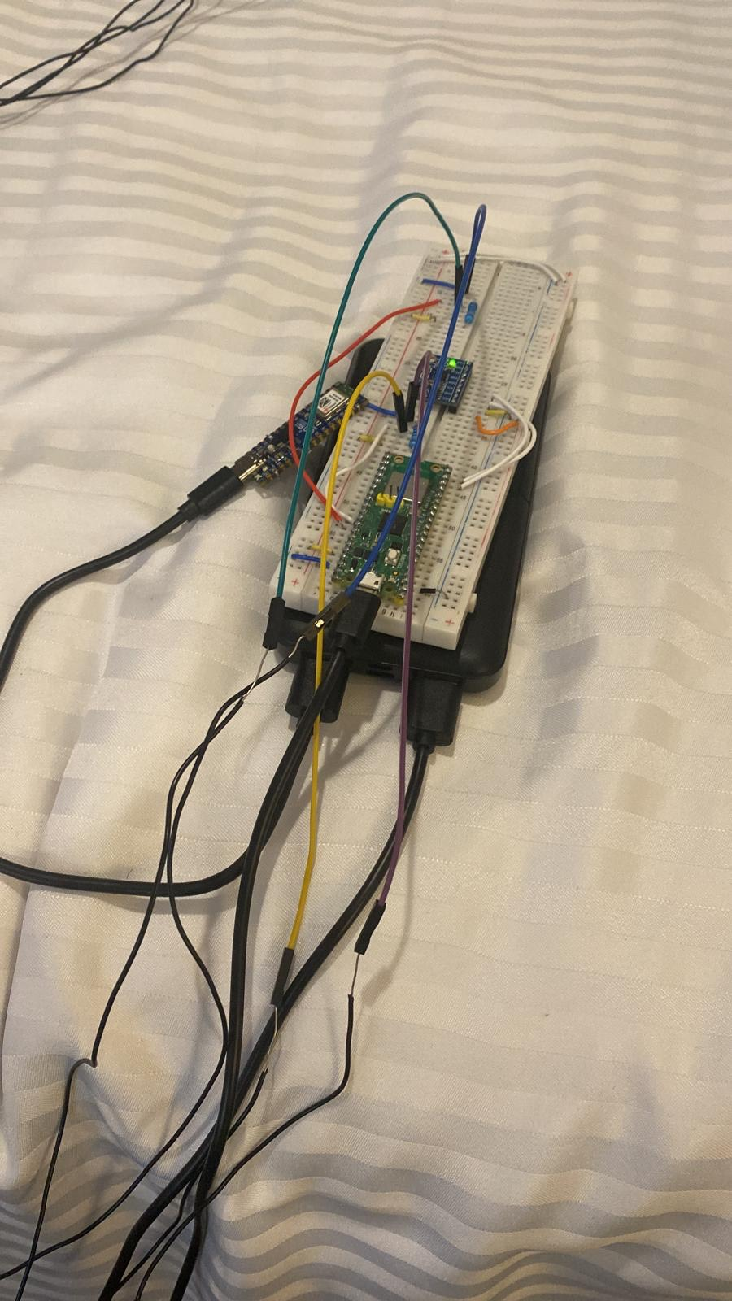

Included code to connect to ESP32 and use that as a router to transmit data to TouchDesigner.
Final result is relatively condensed and simple - this tracks photo sensors and accelerometer, and sends UDP data to Touch Designer in terms of /label - data.

import board
import busio
import analogio
import time
import wifi
import socketpool
import adafruit_mpu6050

#mpu6050 bus
i2c = busio.I2C(board.GP15, board.GP14)
mpu = adafruit_mpu6050.MPU6050(i2c)

#wifi connectivity
# SSID = "!!Kelly's_Day_In_The_Park!!"
# PASSWORD = "guestGuest"
#
# wifi.radio.connect(SSID, PASSWORD)
# pool = socketpool.SocketPool(wifi.radio)
# UDP_IP = "192.168.4.2" # your computer IP
# UDP_PORT = 8000 vcvvcccvccvcvcvvcffgfgggggggggggggggggggggggggggggggggggggggggooxoxoxooxgggfgoxfggoggggggggxoxogoxgxoxoxoxox5555555555555555555555555555555555555555555555555555555555556
#
# sock = pool.socket(pool.AF_INET, pool.SOCK_DGRAM)

#photoresistor

start = time.monotonic()

def td():
#send to UDP in TD
msg = f"/light1 {light1}"
sock.sendto(msg.encode(), (UDP_IP, UDP_PORT))

msg = f"/light2 {light2}"
sock.sendto(msg.encode(), (UDP_IP, UDP_PORT))

msg = f"/accel {accel_y}"
sock.sendto(msg.encode(), (UDP_IP, UDP_PORT))

while True:
# print("My IP:", wifi.radio.ipv4_address)
current_time = time.monotonic() - start

accel_x, accel_y, accel_z = mpu.acceleration
gyro_x, gyro_y, gyro_z = mpu.gyro

#save to file
line = "{:.2f},{},{}\n".format(
accel_x,
accel_y,
accel_z
)
print(line)

# td()
print("send")

time.sleep(1)

Very pleased I got things transmitting to TD, honestly. Big potential there and I'm glad I learned.
Dress situation is where it got chaotic - simply no time for Kelly to make the dress AND for me to wire up the dress. Plus I didn't even have a perfboard, so things in the protoboard kept falling out. Disaster as soon as movement occurred.

I think the most brilliant moment of these week was trashing the circuitry and turning purely to live coding, rather than forcing something to work that clearly was not going to result in a good performance.

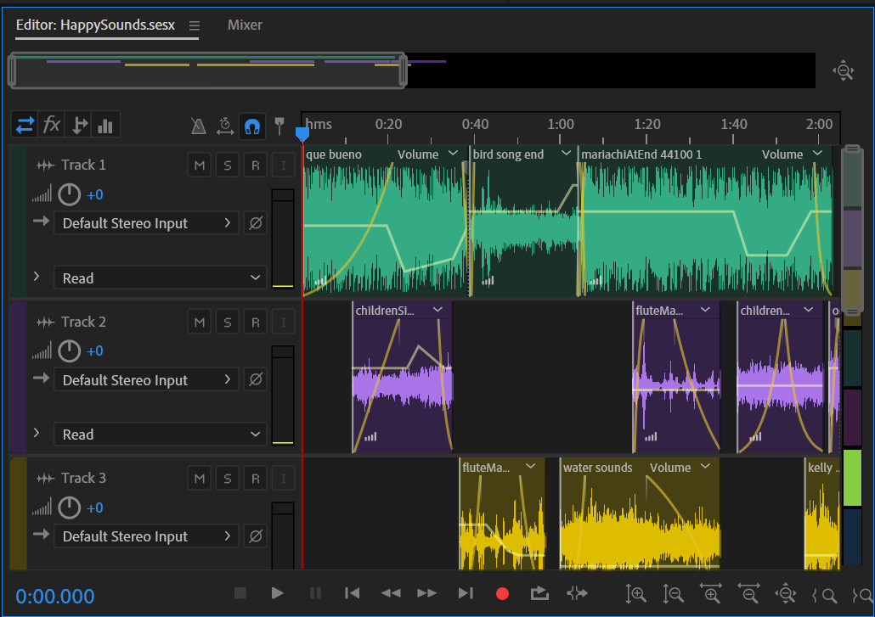
Built one of the soundscapes for the final performance, very simple, built using various recordings from around the park and joyous moments for our group.

Pivoted to Hydra video editing of video taken from the park.

Intention was to create a paranoid / antisocial version, the tourist perspective, and a joyful/integrated perspective, which is Kelly embodying the park. As James switched from the dark, moody "looking at a phone" soundtrack to the tourist soundtrack, I would switch between videos and alter certain aspects to fit the current moment. One is more colorful, with a slow expansive shape, the other is dark and clouded, with a pinhole vision quickly expanding and contracting to represent anxiety.

Full code here: https://tinyurl.com/mvkkw2p4 Press Ctrl+Shift+Enter to activate.

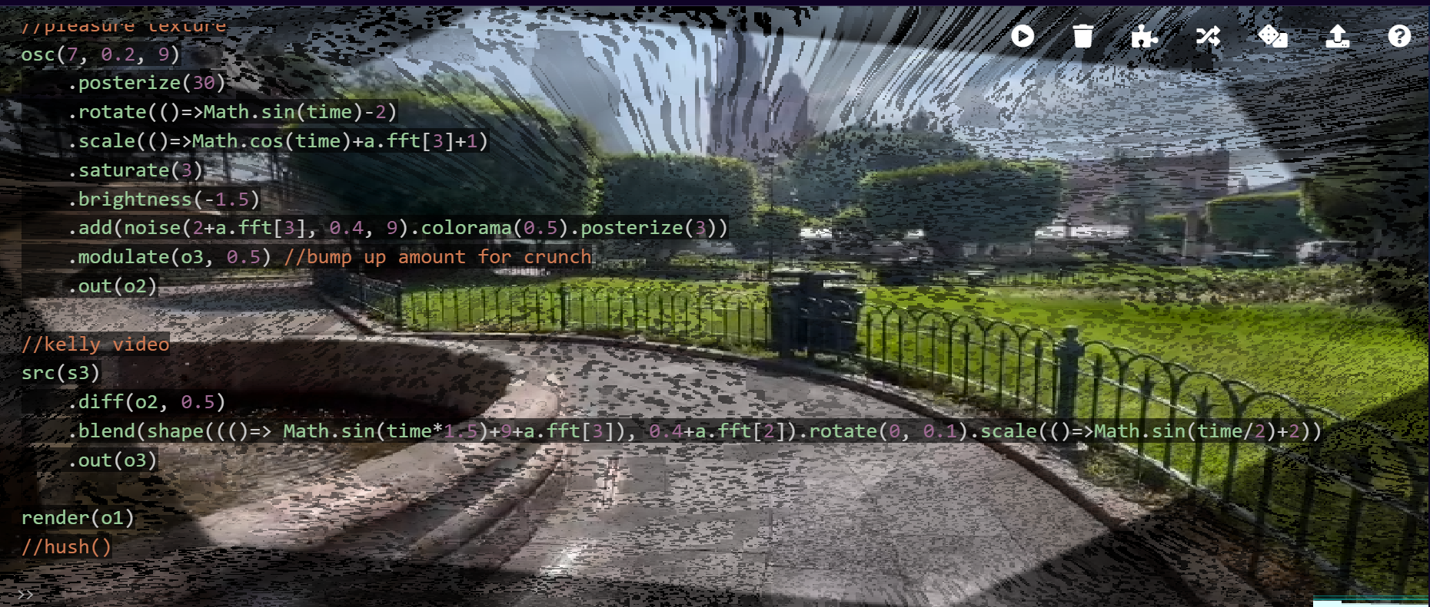
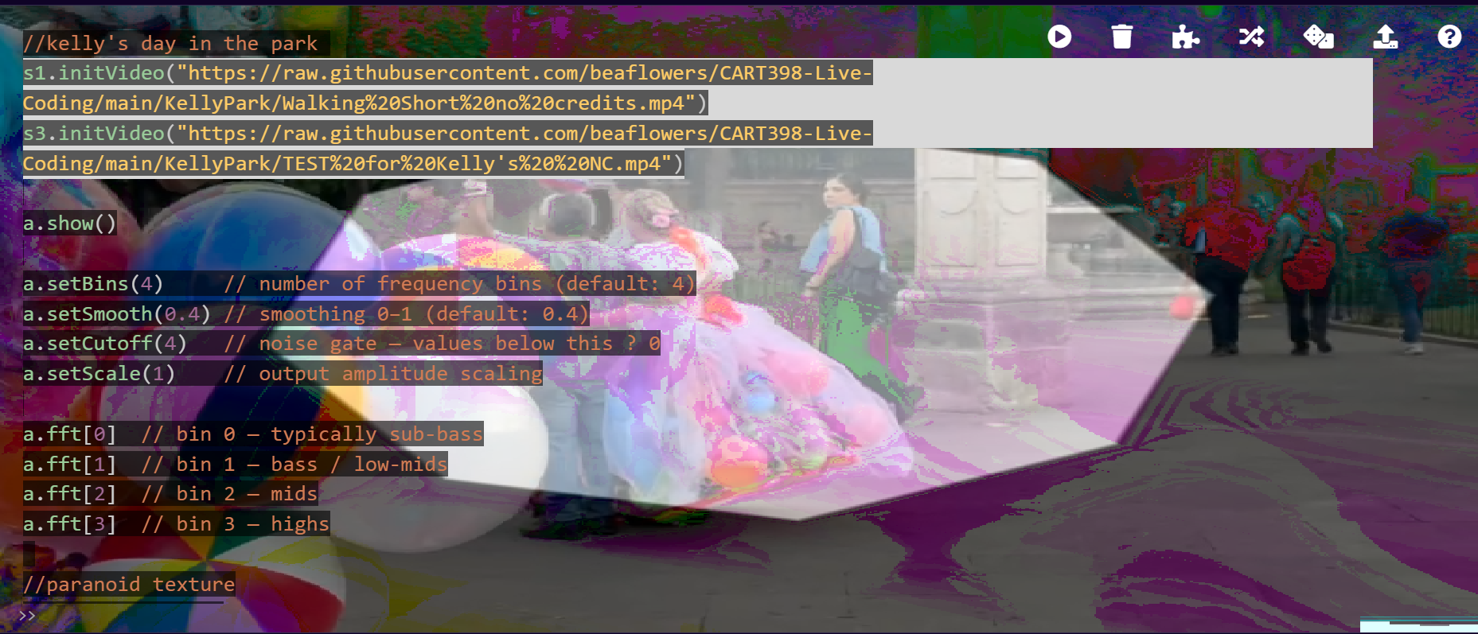


Fun to write! Had some audio reactivity that didn't seem to work during the live performance, unsure why. I've never had audio reactivity work during a performance, despite always having it go successfully in dress rehearsals.

//kelly's day in the park
// s1.initVideo("https://raw.githubusercontent.com/beaflowers/CART398-Live-Coding/main/KellyPark/Walking%20Short%20no%20credits.mp4")
// s3.initVideo("https://raw.githubusercontent.com/beaflowers/CART398-Live-Coding/main/KellyPark/TEST%20for%20Kelly's%20%20NC.mp4")

a.show()

a.setBins(4) // number of frequency bins (default: 4)
a.setSmooth(0.4) // smoothing 0–1 (default: 0.4)
a.setCutoff(4) // noise gate — values below this ? 0
a.setScale(1) // output amplitude scaling

a.fft[0] // bin 0 — typically sub-bass
a.fft[1] // bin 1 — bass / low-mids
a.fft[2] // bin 2 — mids
a.fft[3] // bin 3 — highs

//paranoid texture
voronoi(350,0.55)
//.modulateScale(osc(4).rotate(Math.sin(time/2)),.8)
.thresh(.5)
//.modulateRotate(osc(3),.2)
.diff(src(o0).scale(5.8))
.modulateScale(osc(10).modulateRotate(osc(3),.4, 4))
//.diff(src(o0).rotate([3,1,2,4]).scrollY(0,[-1,0])) //dizzy spinning
.brightness([-.2,-.57].smooth().fast(.5))
//.color(() => Math.sin(time) + 1,1,() => Math.cos(time) + 1)
.saturate(22)
.add(voronoi(10, 2, 1.2))
.blend(shape([4, 6, 9, 12], 0.4+a.fft[2]).rotate(0, 0.1).scale(()=>Math.sin(time*8)+a.fft[3]+1.5))
.out(o0)

//walking video
src(s1)
.mask(src(o0), 8)
.out(o1)

//pleasure texture
osc(7, 0.2, 9)
.posterize(30)
.rotate(()=>Math.sin(time)-2)
.scale(()=>Math.cos(time)+a.fft[3]+1)
.saturate(3)
.brightness(-1.5)
.add(noise(2+a.fft[3], 0.4, 9).colorama(0.5).posterize(3))
.modulate(o3, 0.5) //bump up amount for crunch
.out(o2)

//kelly video
src(s3)
.diff(o2, 0.5)
.blend(shape((()=> Math.sin(time*1.5)+9+a.fft[3]), 0.4+a.fft[2]).rotate(0, 0.1).scale(()=>Math.sin(time/2)+2))
.out(o3)

render(o3)
//hush()

