Launch file notes (outline of lidar processing)

Created: Gregory Beale November 10, 2021
This document will outline each process that is currently spun up with the excuse_me processing launch file. This launch file is copied for each snipped merge bag file and run on VTTI’s computing cluster ‘Deepthought’. Each section of the launch file and a short description is provided. This will give a good overview of the processes included for the reader.
- URDF specifications (typical process included in ROS)
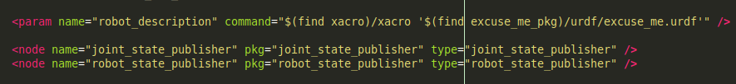
I was provided a urdf file by HEL that outlines the joints and static transforms between different parts of the vehicle. This includes sensor positions (lidar, cameras, gps, MobileEye) as well as tire position and the common base_link and base_link_ground transforms. The base_link frame coincides with the middle of the rear axle of the vehicle, while the base_link_ground frame is the same thing except the height value corresponds to the ground beneath the rear axle.
Common coordinate frames of x-forward y-right z down is used I believe.
The ROS system takes in this urdf file in xml format and will publish static transforms based on the poses outlined. The launch file first finds the urdf file, which I have included in the excuse_me_pkg in the workspace, sets it as a parameter name, and then brings up the joint state publisher and robot state publisher nodes.
- Rosbag playback (typical process included in ROS)
This node is responsible for playing back the collected and then snipped ROS .bag file that has all the sensor data in it. You need to give it a location for the file (in this case in the corresponding vtti project folders), while a number of other options are available. For this project, I’ve chosen to play the bag back at 0.1x the speed to allow all processing to be done for each frame without hitting the limits of computational times. The -r flag for rosbag play node controls the playback rate. We have also nulled out the /tf and /tf_static transforms that were already being broadcast as part of the original bag so we can supply our own without having to worry about unique topic and transform names.
- Lidar Point Cloud transformers (ROS node available in Autoware)
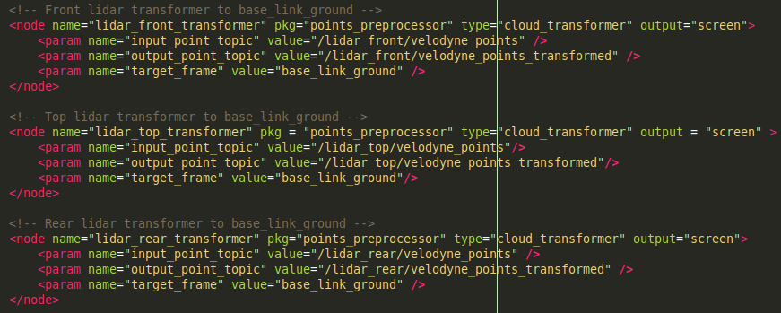
The point clouds from the lidars need to be transformed into a common frame. Here we choose to transform then into the base_link_ground frame using the cloud transformer node included in autoware in the points_preprocessor package within core_perception. We supply it with an input name for the point cloud topic and then a name for the output topic for the transformed point cloud as well as the name of the frame we want them transformed to. Each lidar published point clouds on the topic /lidar_xxx/velodyne_points depending on whether it is the top lidar, front lidar, or rear lidar. We append the tag transformed on to the end of the topic to indicate it has been transformed. Each instance of the same node in a package needs to have a different name, so we have named them based on which lidar it is transforming.
- GPS localizer (ROS node taken from AutonomousStuff)
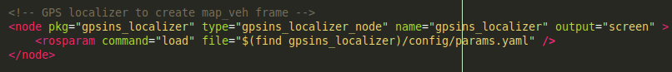
Because we don’t have any pre-made lidar maps to localize with, we need to use the GPS to put the vehicle on the world map somewhere. This node, taken from an AutonomousStuff git repo, takes in the novatel DGPS messages and creates the map_veh frame based on the first GPS messages we get. To do this, we first create a world frame that has its origin in the middle of the earth, and then uses some geospatial libraries to transform lat lon alt from the gps into that world frame. We can then plant the origin of the map_veh frame at the first transformed gps point we get making sure to orient the direction correctly. The node then continues to publish the current pose and velocity of the vehicle with respect to that map_veh frame.
This node then allows us to map our vehicle’s movement to a stationary waypoint. And with the already provided transforms from the urdf, the lidar point clouds can move along with the vehicle as well. The node was written to pull in parameters from a yaml file that include the origin topics of the gps and gps/imu as well as whether to create the map_veh frame or not. In the configuration file we want to set the correct gps/imu topic, tell it to broadcast the transforms, create that map frame, name the map frame we want it to create (this is a custom configuration value I added myself; here map_veh because the name ‘map’ will be used by the actual map if it is included in the data processing), tell it to not publish gpsm transform, supply it with the correct gps frame (‘measured_gps_frame’ and ‘static_gps_frame’), and false for the final three configurations.
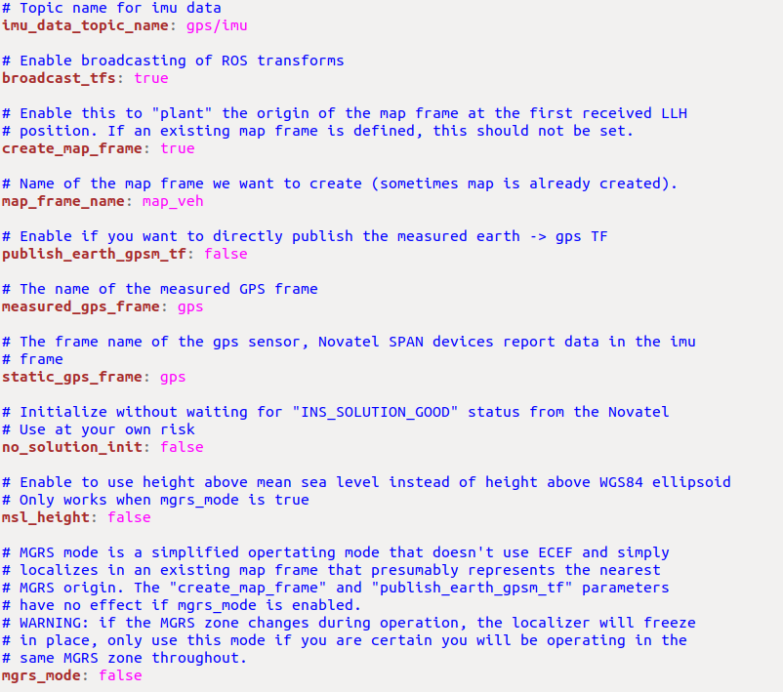
Autoware includes a gps localizing node, but it seems like it only works for Japan. There was a parameter that specified a ‘plane number’ that was unclear what it was actually for, so the included AutonomousStuff node worked better and gave more functionality anway.
We called the stationary frame map_veh because the map frame will be used for the vector map that outlines the lane lines later on. (I think many ROS users typically call this the Odom frame.)
***IMPORTANT***. I had to change some of the hard coded values in this node to correct the frame names. This consisted of adding the custom map frame name parameter, and then applying that changeable map name to the code in the source files.
- Vector Map Transformer (Custom ROS node)
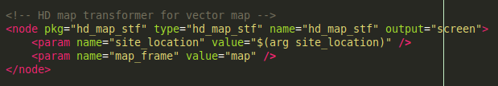
IF YOU ARE USING THE A MAP, the vector map needs to be loaded and placed within the world as to coincide with the actual road. This custom node I made creates the correct transform between the world frame and where the map should go. However, there are a few manual steps that need to taken to transform the XODR maps into the usable vector maps Autoware.ai can work with. (See the corresponding notes file on map transforms I wrote in the git repository for details.)
The xodr and vector map files already have a lat lon coordinate associated with them, we just needed to create this node to calculate and publish that transform based on which site location the map is from using those origin locations. In the code itself, I’ve hard coded the sites we collected data from and saved their lat/lon/alt origin codes and applied some logic to automatically pick, based on incoming gps points, which site we’re at. The origin coords for each site were taken from the xodr files and manually adjusted to fit better with the actual GPS data from the subject vehicle. (Right now most of the maps are somewhat off as they were made by GCAPS from satellite images. They are working on better map creation so I won’t have to go in and manually tweek origin positions.) This is largely a manual process at this point. We also need to specify the name of the frame we want to create. Here we’ve chosen ‘map’.
So now we have a complete transform tree in ros that relates the world/earth coords with the vehicle/sensors frames and the lane line information. Any transform can be looked up between any of the frames now.
- Clip low points for front and rear LiDAR (ROS node included in Autoware)
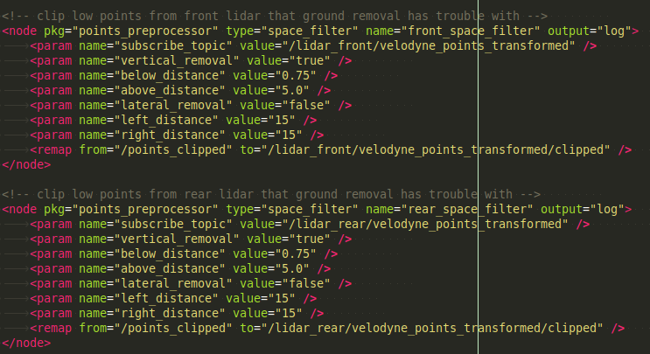
I’ve chosen to clip out a lot of the points from the front and rear lidars that are below 1.0 and 0.75m respectively. The ground filter does a good job at picking out the areas in space that contain vehicles and other objects that protrude upward, but many times it includes part of the ground returns in those clusters. It was especially bad for the front and rear lidars leading to clusters that were bigger than they should be and sometimes combining clusters together in close proximity (like high density traffic). Thus, I just cut off the majority of the points that make up the ground for those two lidars. We still get a lot of points from those lidars from the vehicle, just not ones that close to the ground, which helps the accuracy of the ground plane removal. Also, we still have the 128 beam lidar on the top that does not have any height cut offs around the ground plane, so we still have a lot of points that can be used to identify the ground plane. The 128 beam is supplying the majority of points for the overall process anyway, particularly with the rear lidar tilted close to 90 degrees.
There is an autoware filter node in the points_preprocessor package that deals with space filtering. We can specify whether we want to clip values based on height or lateral distance, or both. And we just give it the topic of the point cloud we want to filter, the filtering parameters, and then the name of the outgoing topic. The current parameter values are shown in the picture (as of 5/26/2022).
Admittedly, the ground filters for the front and rear lidars won’t have much to do since I’m cutting off the majority of the ground before performing the ground plane removal.
- Ground plane removal (ROS node included in Autoware)
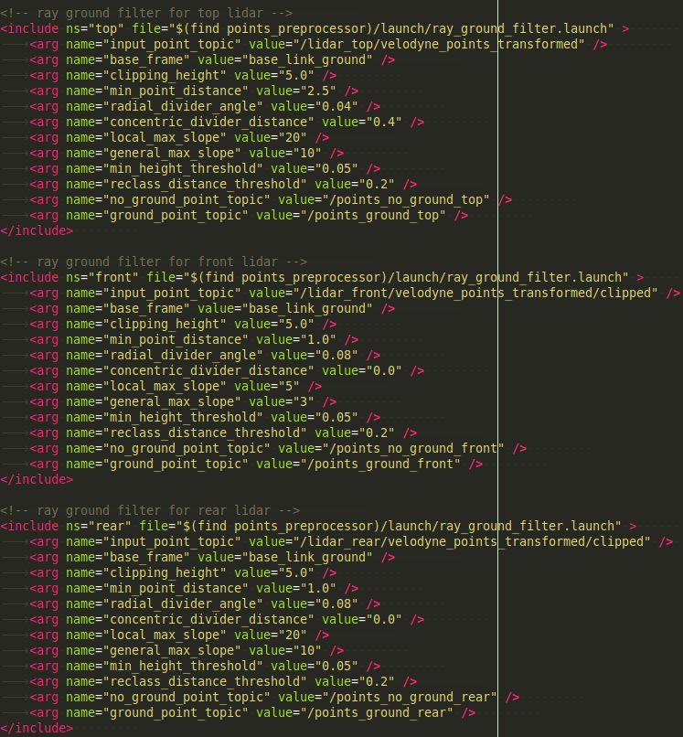
The ground plane is removed from each lidars point cloud individually using the ray ground filter included in the autoware points_preprocessor package. The node works by dividing up the lidar’s FOV into radial and concentric zones, sort of like a dart board. Then it can compare the height values of the points in that zone to thresholds for the overall point cloud and height thresholds for each individual zone. Based on height values, the points are either marked as ground or not ground.
The parameters of the node include: the topic that the point cloud we want to filter is publishing on; the base_frame that corresponds to the base_link of your vehicle; a clipping height where we can cut off vertical points (here 5.0 refers to 5m above the base_link_ground frame); a minimum point distance for discarding any points that are closer than this parameter from the base_link_ground frame; radial angle divider that splits up the 360 degree FOV into radial lines emitting from the origin; concentric divider distance specifies the radial distances that create circles around the FOV (here if we set to 0 that means the FOV is only cut into wedges by the radial angle); local max slope specifies the maximum slope between points for each division (if a point has a slope higher than that, it’s considered a candidate for non-ground); general max slope specifies the maximum slope for the points in the entire point cloud to be considered part of the ground (the node first goes over each division to identify possible non-ground points and then goes back over all those points and can reclassify them based on this parameter to determine if it’s part of the ground plane removal); the minimum height threshold between points to be considered non-ground; the reclass distance threshold specifies the distance between points at which reclassification can occur; and then finally the topic names that the node will publish for the no_ground and ground point clouds for other nodes to use.
I’ve tried to tune each individual ground plane removal node for its specific lidar. The most important values to change is the local max slope and the general max slope (I find that having a higher local max slope than the general max slop works well for changing slopes during the merges.) Also useful to change is the radial divider angle and the concentric circle distances. With the clipping node in place, the top lidar should be the one that needs the most ground plane removal (luckily it’s also the lidar giving out the most points).
- Concatenate the non-ground point clouds (ROS node included in Autoware)
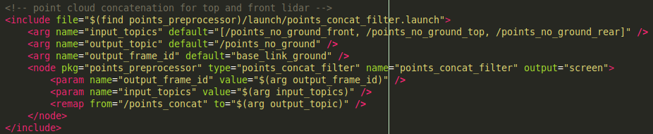
Because the ground removal works on each point cloud individually, we should put the output point clouds from these nodes together to make it easier to work with down the line. Autoware includes a points_concat_filter node in the points_preprocessor package that helps with this. We just need to give it the topic names of each of the point clouds we want to put together as well as the name of the output topic and the frame we want that point cloud transformed into. After this node is launched we will have all the non-ground points from the lidar in one topic that we can send to the clusterer.
- Lidar point cloud clustering (ROS node included in Autoware)
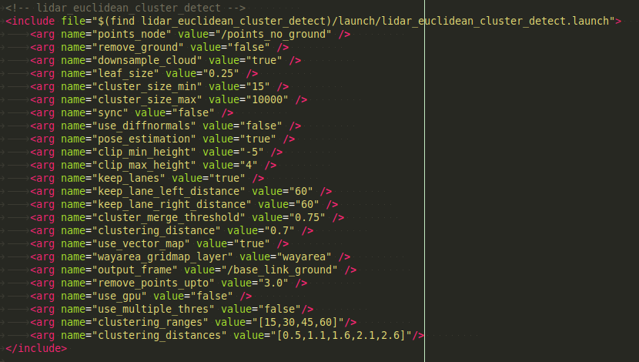
The next step is to launch the clusterer to start the object detection process. Autoware includes clustering node in the core perception directory that does just this using euclidean space between points to determine clusters. If a point is within a certain distance from another point it will belong to a cluster with that other point.
The parameter are mostly straight forward for this node. We supply the name of the topic we want to cluster; specify if we want to downsample the point cloud (we do), tell the node the leaf size of the voxel grid to use (here 0.25m); the minimum amount of points needed to make a cluster; the maximum amount of points allowed in a cluster (if a cluster has too many points, it and all of its points will be thrown out, not broken up into smaller clusters); we don’t need to sync anything; after some debate, we don’t want to use difference of normals to remove really large flat clusters (this can help with removing extra ground points, but it was wrongly removing the trailers of trucks from the clusters); clipping height for values; keep lanes indicator (true means we can cut off points laterally); the left and right distances to cut off points; the cluster merge threshold that can merge clusters together if their centroids are within are certain distance; the clustering distance that determines the distance a point can be from another to be part of that cluster; whether we want to use the grid map to pare down clusters based on the drivable area (which can be very useful if you have a map in place); the output frame we want to publish the clusters on (usually the base_link_ground frame); remove points up to threshold that throws out points closer than this value before clustering; whether to use the gpu; and whether to use multiple clustering thresholds at specified distances.
The clustering works pretty well, and works even better if you use the map to throw out clusters outside the driving area. The cluster-er is still dependent on the performance of the ground plane remove though. Some downsides is that when guard rails are close to the lanes sometimes the vehicles and the guardrail get clustered together into one big cluster. Also, using a density based threshold instead of a distance based threshold system could help to improve it because all it takes is one point between two clusters to be within the threshold of a point from both clusters for the algorithm to assume it’s all one big cluster, which isn’t always correct.
The clusterer automatically publishes clusters to the topic /detection/lidar_detector/objects.
- Object tracking, IMM UKF PDA tracker (ROS node included in Autoware)
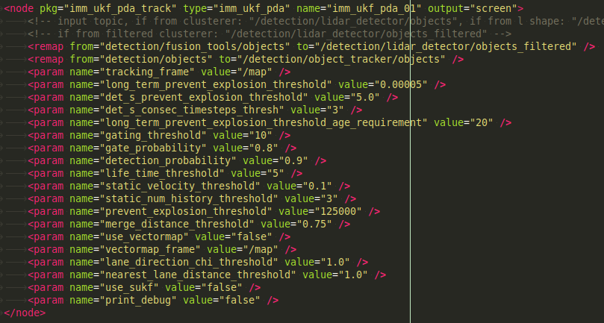
The output of the clusters is fed into the multi-object lidar tracker. It tracks the x and y position, as well as the speed, yaw angle, and angular velocity of each object (which is inherently very hard to do with just lidar points!! but the node is pretty decent at it). The tracker is based off an unscented kalman filter with an interactive multi-motion model scheme. However, you can choose to just use a simple unscented kalman filter instead of using the IMM. It’s important that you bring up the node in the launch file using the node tag and not the include tag, as the parameters were not being passed in correctly. The way it stands now, the tracker is being sent all clusters from the euclidean cluster node, they are not being filtered based on the drivable area. If you had a map, this could be done and it leads to better tracking as there is less clutter or errant objects (e.g. roadside objects such as signs or guardrails, or errant points from the ground plane removal that get clustered that aren’t really there) that can get in the way of each other during the tracking phase. There are a number of parameters that can be passed in to the tracker, but there are also a few that are hardcoded into the ukf.cpp file that are important as well.
The remap tags set up the tracker’s input and output topics; the tracking_frame specifies the frame we actually perform the tracking (the cluster points are transformed into that frame to determine overall speed and direction, so that frame should be one of the local stationary frames like map or map_veh).
The ‘long_term_prevent_explosion_threshold’ is a custom parameter I put in to remove detected objects based on their covariance values. After a certain age an object will be removed if the covariance value is bigger than this. This helps when the tracker begins to lose a vehicle after tracking it for a long time and was mostly seen when using maps to aid the tracking.
The ‘det_s_prevent_explosion_threshold’ is another custom parameter I added to remove errant objects from the tracking list. This is specific to the internal workings of the UKF and was not visible to users before but was being checked in the code, so I made it visible. This parameter will only apply to objects that are certain age threshold. Each time an object ID is seen to have a covariance value greater than this threshold (and is older than the age threshold) it will be noted. If it is seen higher than the threshold for a specified consecutive number of timestamps, it will be removed.
The ‘det_s_consec_timesteps’ is the number of timesteps in a row an object ID is allowed to have a higher covariance value than the ‘det_s_prevent_explosion_threshold’. If the covariance of an object ID is seen for more timesteps in a row than this threshold, and the object is older than the age threshold, it will be removed.
The ‘long_term_prevent_explosion_threshold_age_requirement’ threshold separates older objects from new objects. If the age of the object (in timesteps) is larger than this value, then the ‘det_s_prevent_explosion_threshold’ and the ‘det_s_consec_timesteps’ will come in to play. I’ve separated the det_s explosion threshold and the normal prevent explosion threshold because newer objects need higher levels of covariance in the tracker to persist (harder to track an object that may be moving fast in an unknown direction, need bigger error acceptance) than those objects that have been tracked for a few seconds already.
The gating threshold limits one object’s possible associated detections to an area less than that of the parameter; the gate probability and detection probability have to do with the permanence of the object and should be relatively high (close to 1); the life time threshold values will keep an object in the tracker’s memory up to that many timesteps before deleting it from the tracklist if it’s not seen anymore; the prevent explosion threshold sets the max value for some of the determinants within the calculations of the tracker (I’ve found it should be relatively high to track high moving vehicles); the merge distance threshold will merge obstacles together whose centroids are within the set distance of each other; we can choose to use the vector maps and specify its frame; and we can help the tracker by using the lane directions of the map (unconfirmed); and we can choose to just use the simple ukf (the simple ukf is often better at much lower speeds than the imm ukf is);
In the ukf.cpp file, the process noise values for acceleration, yaw angle, and angular speed are specified for each motion model: constant velocity, constant turn, and random motion. I mostly left them alone. The measurement errors (in standard deviations) were also hard coded for the lidar cluster centroids in x and y. Originally they were at 0.15m but I felt that was too small, and bumped them up to around 0.75m which seemed more realistic given the centroid of the vehicle we are observing can change a decent amount based on the angle we see it. A higher measurement noise value will favor trusting the motion model more. The original ukf node had equal mixing weights for the three motion models, though I think we should favor the constant velocity motion mode more because almost all the vehicle we are observing are driving on the highway at speeds greater than 25mph so maneuverability is limited and a constant velocity motion model with acceptable process noise values should be able to track it well enough. So I changed the mixing probabilities to 90% constant velocity, 5% constant turn, and 5% random motion. I think this largely comes in to play when the tracker is first initialized with a cluster and doesn’t know it’s speed, which can lead to tracks being initialized facing directions that don’t always line up with the direction of travel. Depending on the motion model, the tracker may be able to converge on the true pose and direction quicker (but this is unconfirmed, just an observation). This could also limit the tracker’s ability to give the best yaw estimate when a detected vehicle is changing lanes.
Finally, the ukf file specifies an initial covariance value for each initial track. I increased the values slightly to indicate to the tracker that we aren’t as confident in the initial measurement value (especially since we have no velocity information). Hopefully, an increased initial covariance value will lead to the tracker being more lenient in correcting to the next associated position.
Currently all these parameters are being tuned to try and find the best combinations for the tracker over multiple merging scenarios. Tuning parameters is also very hard given the wide number of parameters to tune, and the fact that they can cause convoluted results. You also need a good ground truth labeling system to compare to. But to reiterate, the tracker is the most important node in the whole processing pipeline because we get the most value from it!
- Tracker Associated nodes (ROS nodes included in Autopware)
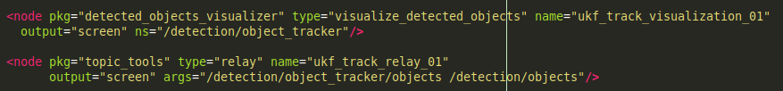
These two nodes are needed to 1) visualize the tracks coming from the tracker; and 2) relay the information coming out of the tracker to the correct topic.
- Map file nodes (ROS nodes included in Autoware)
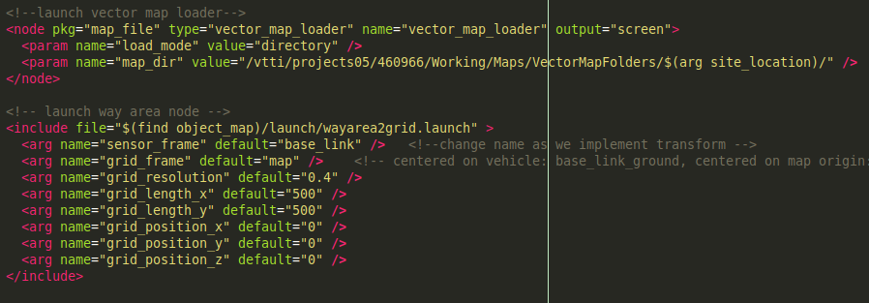
IF YOU ARE USING MAPS IN THE PIPELINE PROCESS
These two nodes, in tandem with the static map transform publisher, are needed to bring in the vector maps of each site location and create the drivable area grid layer. The first node, vector_map_loader, is included in autoware and is responsible for actually publishing the parts of the vector map. We just need to indicate the load mode (in this case from folder location) and give the actual name/location of that folder that contains the vector map files (in this case the vtti project folder they are stored).
The second node uses the information published by the vector map loader and creates the drivable area. We can choose to either have that part of the map be stationary based on the map or have it move along with the vehicle. In the second case, we can have the drivable area being drawn for 500m in front and behind the vehicle and 500m to the left and right of the vehicle as it drives through the map. This is useful because sometimes the vector maps can be large and there’s no need to draw the drivable area within the lane lines for the entire map when the vehicle can only really see objects that are a couple 100 meters around it at best. We can adjust the resolution of this drivable grid area and the area we draw it over. Note that the resolution and area size can have performance problems if the area is too large or the resolution too fine. The drivable area is transformed each frame by this node so there’s a decent amount of calculations going on each time that needs to be limited. This node is essential for any region of interest filter to work.
Currently we generated vector maps from xodr files from online conversion tools and autowares lanelet to aisan (vector map) conversion node, but for some reason the height values are lost at some point during this conversion. Each vector map thus only has lane lines that are 2D (flat). This isn’t too much of a problem since the maps aren’t too big (no bigger than about 1.5km) and the ROI nodes only use x and y vals to remove objects, but this could be improved in the future to look/work better. Most of the merges only have at most 10-15m of vertical change as well.
The maps were originally created by GCAPS and we’ve noticed that there may be some perspective distortion or angle offsets in the map that need to be fixed for them to line up correctly. Some maps are better than others. Currently the maps are not being used in the live processing pipeline.
- ROI Filters (ROS node included in Autoware)
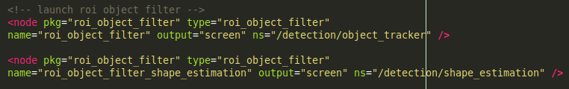
These are two instances of the same node that does region of interest (ROI) filtering. The ROI filter only allows detected objects that lie within the drivable are to pass through, so it’s important that the map file lines up correctly with the actual road. Another node like this is automatically spun up when you indicate you want to use the vector map for the clustering node (it will only publish clusters that are on the drivable area). These nodes are very useful in limiting the processing load on the pipeline and can make visualizing the output much easier. These nodes will automatically add a ‘/objects_filtered’ tag to the end of the given namespace topic.
These nodes also make it easy to get the important vehicles in the scenario when recording the output to csv’s. We can subscribe to the out put of this node instead of a node that may be publishing detected vehicle information for all locations around the vehicle. (If you indicate you want to filter clusters based on the vector map at the clustering stage, everything down the line from that will only be tracking objects on the roadway, but if you don’t then your tracker will be tracking everything in the fov and you will need to use and ROI filter to throw out tracked objects outside the roadway.)
- Visualize detected objects (ROS node included in Autoware)
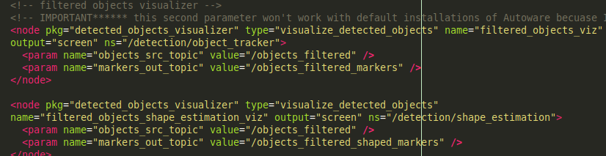
ONLY FOR VISUALIZATION NOT NEEDED FOR ACTUAL DATA PROCESSING
These nodes help visualize detected objects coming from either the tracker or the ROI node. Because autoware uses custom messages, RVIZ doesn’t inherently know how to display them, so these nodes convert them into visualization markers that RVIZ can display. We just need to give them the src topic and output topic. (I added the custom output topic name parameter because, if you have a few different detected objects topic being published from the same namespace, the visualization node didn’t originally have a way to publish them to different topics.) These are not necessary for the pipeline, but just for visualizing results in RVIZ (important when developing everything, but on the cluster no visualization occurs).
- Recording Outputs to CSV files (custom ROS node)
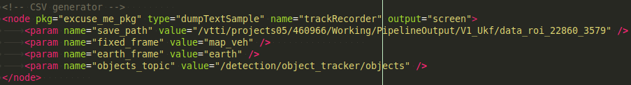
The final step of the process is to record the trackers output to csv files that be analyzed afterwards in other develop environments (such as matlab or R or python). This is a custom package I wrote that takes in the specified topic from the tracker, as well as the name of the static map_veh and world/earth frame (created by the gpins localizer) and records the detected object information in three different frames: relative to base_link, relative to the map_veh frame (stationary), and in lat lon alt. This node also records pose information from the subject vehicle’s GPS in lat lon alt coords as well as coords relative to the map_veh frame. Each scenario will generate the two csv files. One for all the detected objects, and one for the subject vehicle (also referred to as the ego vehicle).
Each detected object reported by the tracker has several useful data characteristics. These include the timestamp, object ID, the frame associated with the information, the bounding box dimensions in x y z, the position of the centroid in x y z, the yaw angle (direction of the vehicle), the angular velocity, and the overall speed of the object. For those characteristics we can report them in either the base_link (moving) frame or the map_veh (stationary) frame. Only the centroid position can be converted into lat lon alt coords. Also, the overall speed is always the same no matter the frame. The tracker does not break down the speeds into x y and z components. Also many times the angular speed is always 0 for any of the detected objects in either the x y and z components.
The subject vehicle information includes the timestamp, frame ID, x y z position, yaw, overall speed, yaw angle, and angular velocity in the x y and z directions. We can also report the position in lat lon and alt as well. The pose of the subject vehicle is reported about 5 times more often than the tracker does. The gps is pulling positions at about 50Hz while the lidars are only set to run at 10Hz.
Each csv file has included headers and the name is supplied by the parameter to this node and the ROS playback node. Each snipped merge has its own launch file with a name ‘data_roi_xxx_yyy’ that is created with some python code. The string ‘_trackingResult’ and ‘trackingResultEgoVeh’ is appended to each file name for the appropriate file.

