Docker notes

To create the docker file for our processing code:

To deploy the developed code on the VTTI cluster we need to create our own image with Autoware, the changes I’ve made to Autoware, and the extra code I’ve added to the Autoware workspace. Luckily, Autoware already has a docker image repository we can build off, we just need to adjust them to get our changes in there. To do so, I forked their docker repository.

Here are the changes I made after forking:

Follow instruction #3 from the gitlab for autoware: link
- git clone into home directory
- cd docker
  - open the ‘dependencies’ file and add the novatel msg depencies
    - ros-$ROS_DISTRO-novatel-gps-msgs
    - ros-$ROS_DISTRO-novatel-oem7-msgs
- cd docker/generic
  - open build.sh script
    - added ‘ –network=host \’ to the docker build command at the end under the ‘–rm \ line’ near the bottom
  - open the run.sh script
    - where the ‘VOLUMES’ variable is set to add a few different volumes, need to add another line to mount the network files
    - added ‘--volume=/vtti/projects05:/home/autoware/data’ after the last –volume entry
    - takes in path on the left and mounts it to path on the right
    - you can customize this path, BUT the launch file in ros needs to know what you called it!!
  - continue to edit the run.sh script
    - under the ‘docker run \’ command
    - add ‘--net=host \’ if not already there after the ‘--env … \’ calls
    - add ‘--privileged \’ after ‘--net… \’ line
    - add ‘--user=12343 \’ after ‘--privileged \’ call
      - VERY IMPORTANT this needs to be the users UID (i.e. the UID supplied by the VTTI network for each user, mine is gbeale) can be found by using ‘echo $UID’ in a terminal window
      - This allows the docker container to run with those user privileges, this is important when trying to read from the network, need the right permissions
      - This will need to be checked (e.g. make sure you can enter the docker image after its built and access the files within)
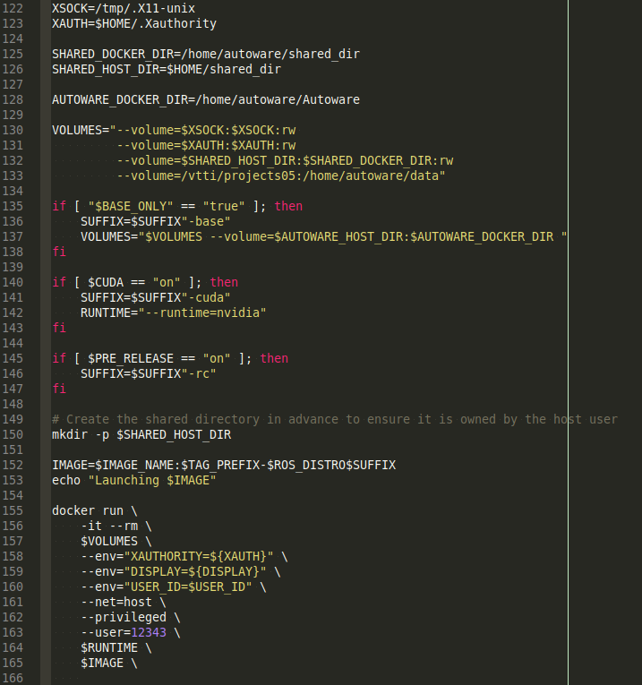
  - open the entrypoint.sh script
    - comment out the ‘chroot --userspec=autoware:autoware --skip-chdir / "$@"’ if it’s there at the end
    - add ‘export HOME=”/home/autoware/”’ at the end or leave it there if it’s already there
    - cd into the autoware directory and source it:
      - ‘cd /home/autoware/Autoware’
      - ‘source install/setup.bash’
    - add ‘exec “$@”’ after the ‘export...’ line at the end
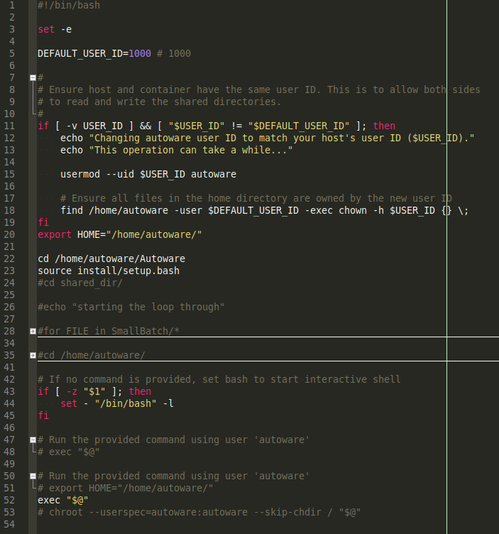
  - open the Dockerfile in docker/generic
    - this is where we will put our code we’ve developed to add on to autoware
    - this will change as repos change, so make sure were pulling from the right github repository
    - as of right now here are the changes:
      - change the ‘wget’ command to pull from my specific atuoware repos I’ve forked
        - the original just points to the master version of autoware which won’t work b/c I’ve changed the ‘core_perception’ package
      - after ‘vs import …. \’ add ‘cd src; \’ to put us in the src folder of the downloaded autoware code
      - add ‘git clone https://github.com/bealeg/processingCode.git; \’ to download the processing code I developed on top of autoware
        - repo url may change as necessary
      - then we source ros and build the code with ‘colcon build --cmake-args -DCMAKE_BUILD_TYPE=Release; \’
      - after building we need to add ‘chmod 777 /home/autoware -R; \’
        - This makes sure everyone can read and write to the docker container home folder
        - This often can take at least an hour to run but is essential to get everything talking correctly to eachother
      - after ‘chmod ...’ add anopther ‘source /opt/ros/$ROS_DISTRO/setup.bash;’ again
      - we want to COPY our script that runs through the launch files into the home directory of the container (in this example is is called example.sh)
- This should be all changes that you need to make to the docker build and run code
- We should be ready to build the images now

Run ‘./build.sh -c off -i excuseme -t 1.0’
- the build script will automatically pick up that we want ros melodic, though you can specify. This project uses melodic
- ‘-c off’ indicates that we don’t want to build using CUDA
- ‘-i excuseme’ sets the docker image name to ‘excuseme’, need to carry this over to the run script. You can change this however you want.
- ‘-t 1.0’ sets the tag prefix for the image, carry this over to the run script, can change this as necessary
- ‘-v xxx’ can set the version though the default is ‘master’, this means by default the ‘master’ branch of autoware will be downloaded and installed. This is fine for this project.
- This will build the entire image based on what is needed. The base ros melodic image is built first (as specified in the dokcerfile.base file). This usually takes around 15 minutes to complete the build
- Then the autoware image gets built on top of that. Downloading the code into the image is quick, the building of that code will usually take around 19 minutes.
- After that the chmod command will be executed. Unfortunately this takes about an hour to execute.
- Given no errors during this, we are ready to run it.
- You can use the docker commands to view the containers created
  - the total image size is around 6.8 GB
- FOR REMOVING DOCKER IMAGES
  - Use the command ‘docker rmi 270cd1f67a32’ where the given name of the image (image ID) is placed after the ‘rmi’
  - Use ‘docker image ls’ to list the docker images on the system when in the home directory
  - Look at the Image ID value

Run ‘./run.sh -c off -i excuseme -t 1.0 -s’
- This run script will spin up the entrypoint.sh script with the right docker run attributes we provide
- ‘-c off’ indicates we don’t want to run with CUDA
- ‘-i excuseme’ indicates that name of the image (from the build script)
- ‘-t 1.0’ indicates the tag prefix of the image (from the build script)
- ‘-s’ indicates we don’t want to do the uid modification. The uid modification is supposed to have the docker run with the same uid as the user, but I could not get this to work and have to use the chmod command as a workaround.
- The run script will run whatever commands are in the entrypoint.sh script

From work with Calvin on running on the cluster

New ‘Example’ script that loops through and runs launch files in the docker
- We created a new script in the /home/gbeale/docker/generic folder called ‘example.sh’
  - This script loops through a directory of launch files and roslaunches them
  - It takes in the directory as an argument (assuming there are a bunch of launch files in that directory)
  - To include this with the docker file (when pushing to a repository) we needed to modify the Dockerfile as follows
    - When COPY ing the entrypoint.sh file removed ‘/tmp/’ and just replaced it with ‘/’ (i.e. the home directory in the container)
    - Added ‘COPY ./example.sh /’ to the end after ‘ENTRYPOINT ["/entrypoint.sh"]’ so the new script will be included when the image is built

Clean up of entrypoint.sh script
- We removed the scripting elements I added earlier to entrypoint.sh. It should just export the home folder to /home/autoware and that’s it.
  - It should have the ‘interactive shell’ and ‘commands’ still in their
  - The scripting I did in their was better off in the ‘example.sh’ script

Rebuild Docker with new script included
- At this point we built the docker image again. It was a quick build because all we did was change the entrypoint.sh and add/copy the example.sh to the image.
  - Can use the usual ‘./build.sh -c off -i excuseme -t 1.0’ command to build it
  - We don’t really need to worry about running it anymore since we are mostly concerned about sending it to the cluster instead.
  - Any future changes in the ROS code will require a rebuild of autoware packages, everything else should be quick. Launch files will need to be changed if new packages or nodes are used using the python script.

Auto generate launch scripts file paths
- I created a python script that generates launch files based on the nodes we need to run on the cluster (no visualization, no rviz stuff)
  - I had to manually add the launch file as one big string in python with the correct parameters and then save it for each recording we had.
  - Every time a tuning parameter changes in the processing code, it needs to be changed in that code
- Created a repository for this as well
- See the python script for details
  - File paths need to be specified for where the snipped merge bag files are, where they are mounted in the container, and where the csv output files need to be.
    - In this way launch files can be generated to run locally with autoware and no docker, to run locally on docker, and to run on the cluster with output on the cluster
- Once generated put the docker launch files on the vtti project network in the working directory
  - I usually just copy and paste to the correct directory
- I modified the csv generator nodes to take in a parameter that defines where the csv’s will be written to allow for flexibility
- It’s best to test on your local machine a few of these scrips to make sure they run, and then also put a few in a testing folder and let the docker image run through them
  - If you know how, you can also put a few in the mounted shared directory on your local machine so you can access them in the docker image and have them launch from there
    - Just be sure to change the directories in the generated launch files to match up with wherever you are testing them

Separate launch files into batches
- To break down the parallelization of running the launch files on the cluster we decided its easiest to just break up the lunch files into some number of around 10 in each folder on the network.
  - This way a cluster job can be spun up and run on each of those subfolders.
  - To do this we need to take the launch files (not separated into folders) and actually separate them into the subfoldersfolders
    - To do this run ‘find ../EuclidTrackRecordDockerCluster/ -type f -name '*.launch' | xargs -n 9 --process-slot-var=job -P 300 bash -c 'mkdir $job; cp $@ $job; sleep 10' _’
    - This looks for launch files in the specified directory separates them into folders of about 9.
    - Had to add the ‘_’ at the end to make sure ALL the file names were being passed in as parameters to the script within xargs
    - We would run this in the folder we want the launch files to be written into. So whatever folder the raw launch files are in, pass that into the command after the ‘find’ tag (here the original folder of launch files is one directory up)
    - -P is max number of folders (I think)
    - Calvin said make sure the -P value is bigger than the -n value
  - Now the launch file are separated into folders

Push docker image to repository on gitlab
- The next step we needed to do was put the docker image up on a repository so it could be eventually pulled onto the cluster to run
  - We generated the access tokens on my gitlab user for vtti (gbeale) saved locally on my linux cpu
    - This allows for easier pushing and pulling to the gitlab registry
  - We first needed to login to the docker registry using ‘docker login registry.gitlab.vtti.vt.edu’
    - Input my username and paste the token as a password
  - We then needed to tag the docker image properly to allow it to be pushed to a registry by running the following: ‘docker tag excuseme:1.0-melodic registry.gitlab.vtti.vt.edu/cavs/projects/excuse_me/lidar-processing/lidarpostprocessing/excuseme:1.0-melodic’
    - This names the image ‘1.0-melodic’
    - ‘excuseme:1.0-melodic’ was the existing image name and tag
    - The rest is the target image, which consists of the registry destination (vtti gitlab container repository) and applicable tag name
  - Once we’ve properly tagged it we can push to the vtti gitlab repository
    - run ‘docker push registry.gitlab.vtti.vt.edu/cavs/projects/excuse_me/lidar-processing/lidarpostprocessing/excuseme:1.0-melodic’
    - this actually pushes it to the gitlab container repository

Pull repository onto deepthought cluster
- Next we need to start getting deepthough ready to use the docker image
  - The idea is to pull the docker image into the scratch folder and use singularity to run it (not userdocker)
    - This way the docker image can live in that scratch folder and not need to be downloaded from gitlab every time we spin up a node on the cluster.
  - cd into /vtti/scratch/gbeale
  - Run ‘module load singularity’ to make sure we can use singularity in the ssh session
  - Run ‘singularity pull --docker-login docker://registry.gitlab.vtti.vt.edu/cavs/projects/excuse_me/lidar-processing/lidarpostprocessing/excuseme:1.0-melodic’
    - Put in user name and paste access token as necessary
    - you may need to try docker login first
    - make sure to use the correct image tag if there are multiple updates
  - This should start to pull that image into the scratch/gbeale folder
    - It also builds the image (I think)
  - (we don’t have to run the next part to build it, I think the pull command does it already)
    - Next step is to build the singularity image
    - run ‘singularity build excuseme-v1.0-melodic.simg docker://registry.gitlab.vtti.vt.edu/cavs/projects/excuse_me/lidar-processing/lidarpostprocessing/excuseme’
      - you can specify the name after the build word
      - this should build our docker image with singularity

Create Batch file that spins up the image
- Next we need to create a batch file that actually runs the image on the cluster
- This file is called something_batch.sh and is in the /vtti/scratch/gbeale folder on the cluster
  - Takes in one argument which is the folder of the batch of launch files we want to run through
  - Loads singularity
  - Picks a random port for the ROS MASTER (there were problems with ports being in use for some reason)
  - Uses singularity run command to start the process
    - ‘singularity run --writable-tmpfs -B /vtti:/vtti -B /vtti/projects05:/home/autoware/data excuseme_1.0-melodic.sif bash -c 'ROS_LOG_DIR=/tmp/roslog /example.sh '$1’
    - We had some issues where we needed no make a writable tmpfs file system and point the ROS_LOG_DIR to a writable directory
    - -B mounts the folders to the right places
    - We give it the name of the singularity image file
    - And in the ‘bash -c’ we give it some commands such as setting the right ROS log directory and then telling it we want to run the example.sh script
    - $1 will correspond to the folder of the launch files passed in from the command line
- AS A TEST
  - Once this batch file is ready we can run it from the command line using:
  - ‘sbatch -n 2 something_batch.sh /vtti/projects05/460966/Working/LaunchScripts/launchScriptExamples/EuclidDockerClusterChunked/0’
    - This will only run through that folders launch files though, can use it as a test run
    - Use ‘sbatch’ command to launch it (slurm)
    - ‘-n’ specifies how many cores
    - Provide it with the actual batch script (something_batch.sh)
    - Provide argument to script (i.e. the folder of launch files)

Generate sbatch commands for all the launch file folders
- THIS WILL RUN ALL THE RECORDINGS THROUGH THE ROS PROCESSING
- To process all the launch files in their folders we need to run that sbatch command for however many sub folders of launch files there are
- We can do that in one line on the command line:
  - ‘find /vtti/projects05/460966/Working/LaunchScripts/launchScriptExamples/EuclidDockerClusterChunked/ -maxdepth 1 -mindepth 1 | xargs -n 1 -t sbatch -n 2 something_batch.sh’
  - This finds all the folders with the launch files and then, using xargs, launches that sbatch command with that folder
    - Still using -n 2 for 2 cores
    - For xargs echos the output so we see what jobs we are submitting
- So with that command we just pushed x amount of jobs to the cluster (corresponding to the number of the launch file folders.)

