**SECTION 1**

Dear Future intern,

I have recently been notified of your hiring to take over my current position at WEEL.

My name is Max and I’ve been an intern at the company for 5 months.  
Before you get started, I have been instructed to bring you up to speed on everything you need to know to make your integration within the company as smooth as possible. Please take your time to read my mail as I will be detailing out some import aspects about the company that you will need to keep in mind.

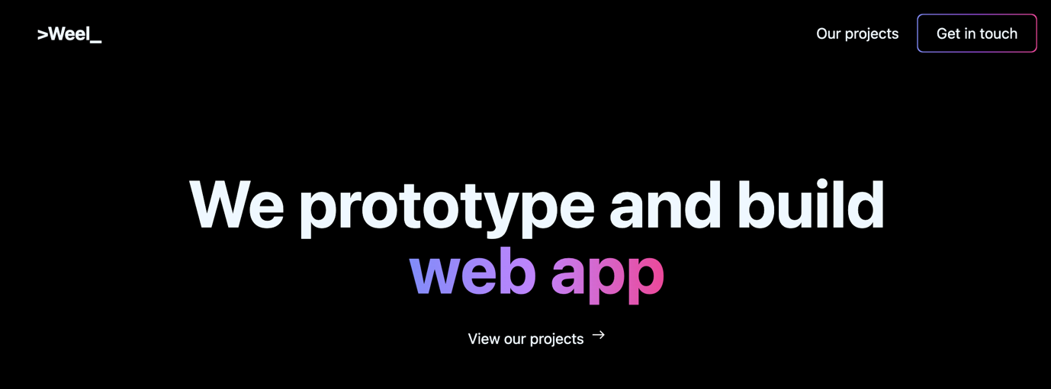

(Weweel.dev website)

WEEL is a small company mainly based in France but we also have a presence in Luxembourg. The company was created 3 years ago by two Epitech students. The students were bright minded and wanted to become entrepreneurs and start a company. The company’s main function is to help other companies or individuals with IT solutions for their needs. A good example would be creating a website or creating a mobile application for a company. WEEL will develop these solutions for them and be available for on the long-term to assist them with any upgrade, issue or improvement they request.

Here at WEEL we are a team of five people including me, we all work remotely as of now but the team is soon planning to move into an office space as we look to grow and venture into new topics and opportunities. For communication we are generally all connected together on a group call using Discord for the majority of the day where we make can talk freely and easily among us. 



(Discord logo)

You will be working Mondays to Fridays and have weekends off. We usually start work between 9:00 and 9:30. For the work schedule, the rule of thumb is that as long as you work properly, you can log on a little bit late in the mornings, as long as you don’t come in too late. Know your limits! And of course, you can take an hour’s lunch breaks at around mid-day.

As you may already know, at WEEL our main project at the moment is developing tools for individuals in the sports betting industry. These tools facilitate the viewing and searching of sports analytic data, thus facilitating the analysis and prediction of sporting event such as tennis, soccer and basketball events. WEEL has developed a fully fledges mobile app that facilitates the viewing and searching of the latest sporting events to come and to help users easily compare statistical information on the participants or teams facing each other. The type of information we provide can be very beneficial to a sport bettor and will help him/her increase the odds of their bets and make more money.

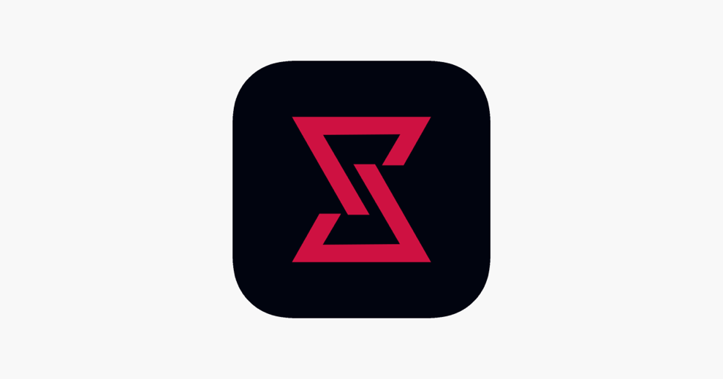

(Sportero app logo)

The app is called Sportero and is available on the Appstore and PlayStore. Within the app we let all users view the latest sporting events and we provide statistics for all those events. But not all event statistics are free to view. We let free users view statistical data on a certain number of events and the rest are all locked for the premium tier users. The premium tier option is available through a subscription model put in place within the app allowing customers to pay monthly quarterly or yearly for access to locked event statistics and other features with discounts for longer subscription period. As I just mentioned premium tier users have the ability unlock all upcoming events and have free access to all features of the app including one special feature called the “Screener”. The screener allows users to filter events based on defined criteria called “Pre-sets”. A user can create a certain number of pre-sets that he can then check or uncheck to easily view all the events based on their pre-sets. The team has a few projects in the works, Sportero is one of them, and it’s the one I’ve been assigned to. I’ve worked on the project for about a month and have very much enjoyed it.

As you will be soon working on this project, I will inform you of what you will need to get started. It would highly advice you to upgrade your personal computer to 16 gigabytes of ram if it is not the case and of course if it is possible for you. This is mainly due to the fact that you will be working with resource intensive android and iPhone emulators. You should be more comfortable with the increased memory capacity and should be able to avoid any slowdowns and consequently work more efficiently!

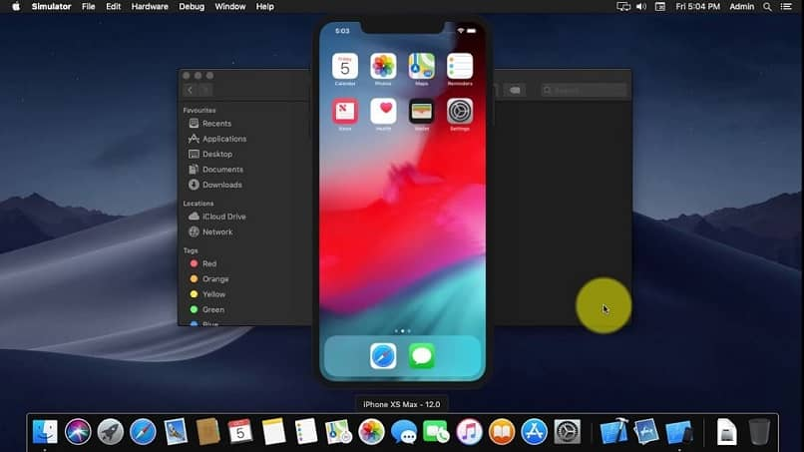

(iPhone emulator example)

Before you start contributing to the development you will have to setup your work environment by downloading the project folder and opening it up in your preferred IDE (independent development environment).

To run the app, you will need to install an emulator. An emulator will let you open a virtual android or iPhone device on your desktop that you can use to test the app without needing an external device. The emulators are quite resource intensive especially buggy for the android ones hence why I suggested 16 gigabytes of ram. Choose the pixel 4xl emulator for the best experience. And an iPhone 13 mini if you work on an apple computer as the smaller screen will ensure your interface is adaptable to the smallest form factors.

Once that’s done you should be able to start the app locally with a simple command.



(Gitlab logo)

All project folders can be found on Gitlab so ask your supervisor to give your account access. During the time that I’ve spend on the project we have undergone a good amount of UI changes all around the app to improve the overall aesthetic and user experience.

There has also been changes in the overall theme of the app and how it is presented to the user. UX* has been an important topic of discussion within the team as we try to maximise ease of use and understanding for new and current users. The app is growing and developing positively each day with these changes and the feedback from users is very much taken into account. In the last few weeks, I have personally worked on the new design for one of our most important features, that is the screener. The screener page was not very comprehensible and the team wanted make it more interesting. It was decided that a new design was to be built and that we would intergrade the ability to have custom filter (“pre-sets”). As I have already explained their utility above you should already know about them.

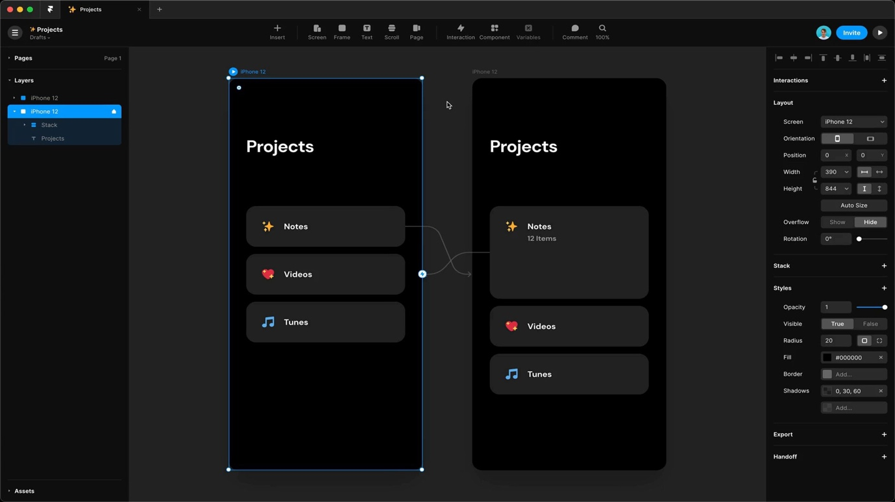

(Framer tool)

The screener’s new design was visualized by one of the team members using framer, which is a popular online interface designing tool. Once we had the finalised design, I went to work on implementing in within the app. I made sure to develop the interface cleanly within the code base of the app and to write as few lines of code as possible. This makes it easier for future developers like you or for the supervisor to go over your work and easily understand it. As you might infer from what I just said, your supervisor will check and go over all of your work before integrating it.



(Git logo)

GIT* is a tool that makes this a simple process. When your work is done, you will be asked to upload it to what is called a branch. Your supervisor will be able to review the details of your changes within the branch and then add it to the main branch of the project if he deems the work to be good. If you happen to have a little trouble understanding this process, I would highly advise you to read through GIT’s documentation. Within the team we all use an app to make this easy, a UI implementation of the git tool that I would highly recommend, is available under the name GitKraken. The tool is free for students so be sure you claim your student software pack on github.com.



(GitKraken logo)

There are some details I will explain about app’s structure and how it works. First of all, we have multiple databases in place to store user data and statistical data for each sport. These databases are accessed on a cloud server running an API that the team designed and built.  
The API allows the app to fetch data based on the needs of the APP on any given user device. When the app needs to request statistical data on a particular event it contacts the API which then consults the database to return the correct information. You might also be wondering where we find all of our statistical sports data, well every so often one of the team supervisors will start a crawling script. This script is specifically designed to connect with multiple sports data providers from large organisations that are at the forefront of these sporting events recording all the various details of the events as they happen.

It will then download all that information and ingest it into our own databases. This process is usually done automatically but unexpected issues often occur that requires one of the team members attentions to fix. These issues are generally due to data providers changing the way they provide certain pieces of information thus creating errors in the automated script. In most cases it is a simple fix, but there is nothing the team can do about this particular inconvenience at the moment, we just have to deal with it. Within the API we also manipulate various key data points to calculate our own special statistical data before sending it to the user’s app. For example, we have a few special mathematical formulas to determine a player’s overall strength in tennis versus another opponent and this data can be used to easily compare overall performance of different tennis players. You will most probably be working on some API features that I’ve developed. You will be required to learn how to use a database library called PRISMA.



(Prisma logo)

This library is used to interface with the database within the API’s code. In our use case we use it to easily communication with an SQL type database without having the fuss of writing SQL style code. This enables us to write clean efficient code that is easier to comprehend. I’m sure you will like it as it’s pretty easy to comprehend and is very intuitive. Within the API’s project folder, every file is organised in a defined order. There are multiple folders where the code should be organised. The most important are the “routes” folder and “controllers” folder. Inside the “routes” folder is where you can find all the API’s endpoints for each service. These endpoints then communicate to functions stored in the “controller” folder. This way the traffic routing and code logic is neatly separated for an easier readability and understanding of the code. Functions that are of general purpose and that are recursively used throughout the codebase are stored within a “Utils” folder to indicated their general-purpose nature.



(Trello logo)

When you start your work at WEEL, you will be assigned tasks. These tasks will be available on a web platform called Trello. This website is used for organising tasks within a team or company into sticky notes which are organised into columns based on their status and priority. You can easily organise the sticky notes in between the different columns. A sticky note represents a task or an idea and can be assigned to multiple people. On our Trello account we have 6 columns which include “icebox”, “sprint”, “WIP”, “testing”, “done”, “ideas”. Each column has a purpose and I will briefly explain them to you.  
“Icebox” us for notes about big or tedious features that are to be implemented in the distant future. Sprint is designated for tasks that need to be done. “WIP” if for tasks that are in progress as the acronym suggests “Work in progress”. “Testing” is for completed tasks that need to be tested before releasing to production use. And “Done” is for tasks that have been completed and tested. When one of your supervisors needs to assign you a task the sticky notes representing the task will be assigned to your name. When you start a task, you can move it to the “WIP” column to indicate you have started the task. That’s it for Trello, it’s all around pretty simple and if you have any questions, you can always ask your supervisor.  
As I have mentioned above, WEEL works with multiple projects at a time. You could be assigned to a different project based on the current needs and priorities of the company. But you will most definitely be working on Sportero for some amount of time. Before you take over my position, I would encourage you to download the app and use it a little bit, this will help you get familiar with it before you start working on it. However, I will still give you a basic rundown of the app to be sure. Sportero has a small community that is growing steadily.  
The team tried to come up with new ideas on how to improve the feature set of the app, and also on how to better polish the app intuitiveness. Any suggestion you could make would be very welcome. The team is open to advice and criticism.

1. First of all, when you open the app, you will be greeted with a basic tutorial which will allow you to set a preferred language, get a basic explanation the interface and watch the included tutorial video that explains some key features of the app. Once you have clicked through the tutorial screens you will land on the home page. On this page you have the ability to quickly select what sport you want to explore as well as define a couple of settings used for filtering sporting events.

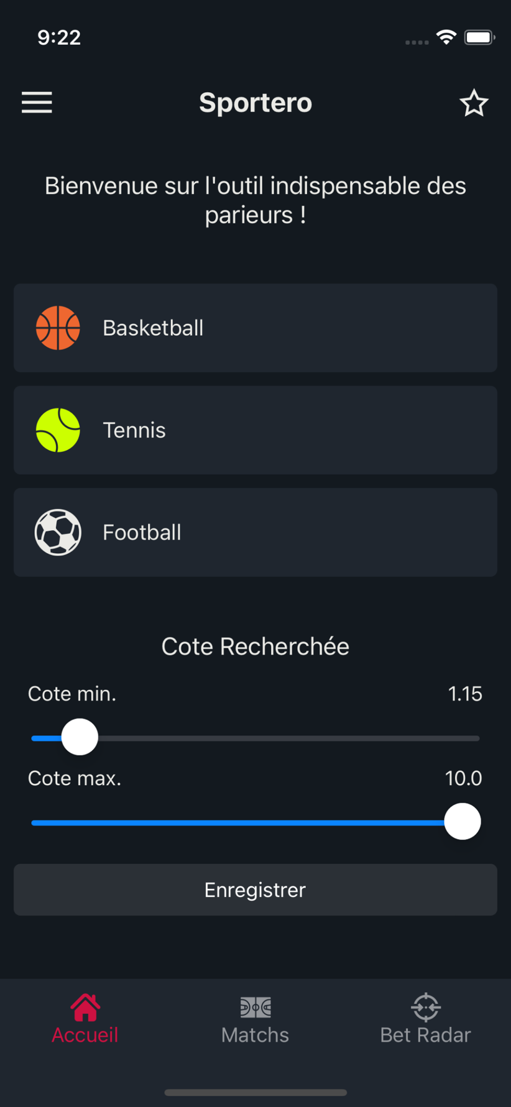

2. Swiping right from the left of the screen will open the side menu where you can find the login, setting, subscription button and contact/social media links and other useful options.

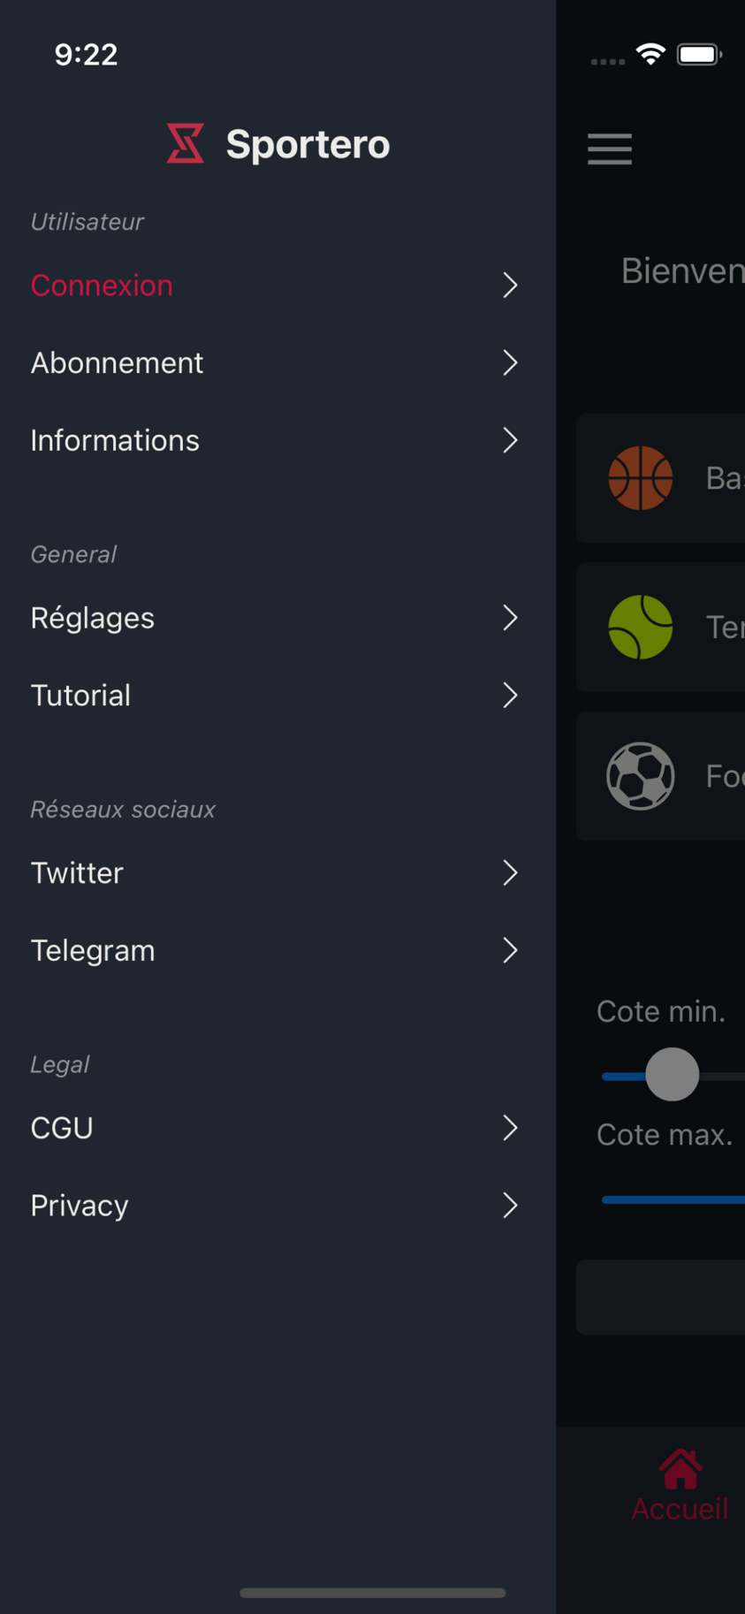

3. When you click on the events button you will find the events page. Here you can see upcoming events for the selected sport. Only events within a 7 days period are viewable. And some events are only accessible to premium tier users. A popup will show if a free user tries to access a locked event asking if the user wants to subscribe.

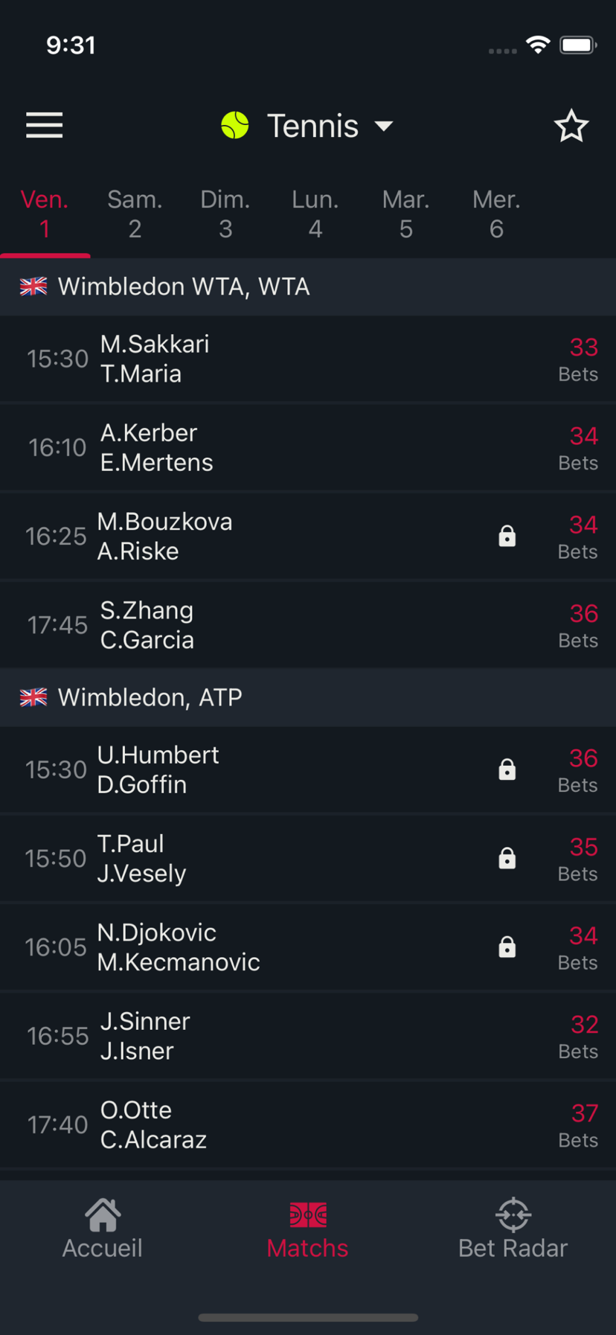

4. On the last option of the navigation bar we have the Screener page. On this page the user can find high probability bets based on different risk levels and parameters called pre-sets.

Free users are restricted to the default pre-sets and cannot create their own. Premium users can. They are limited to a maximum of 12 pre-sets that each be modified on the fly. When a pre-set is created it appears in the pre-set selection bar next to the two default pre-sets called “Value” and “Hot value”.

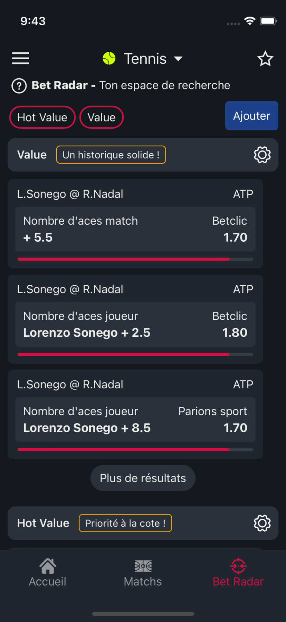

5. When you click on a bet you can access statistical data on the event and premium tier member get a special estimation carefully crafted by Sportero using an algorithm.

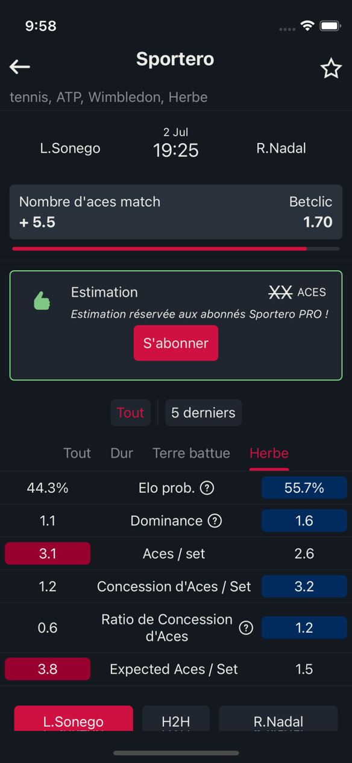 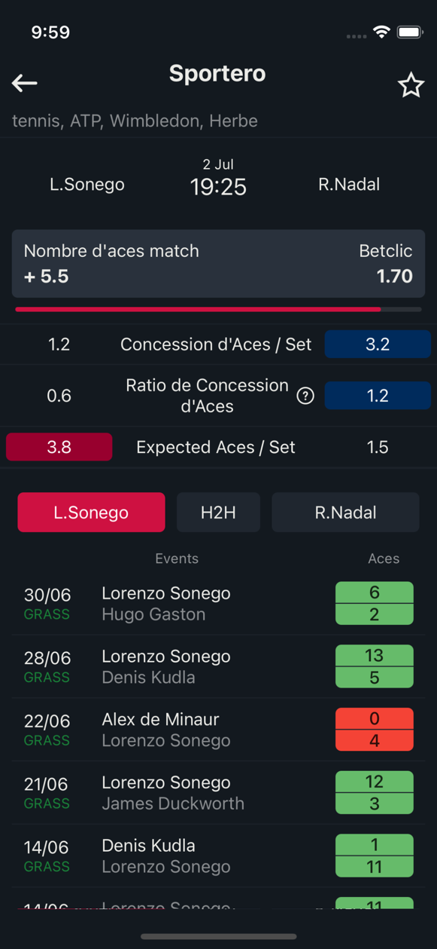

6. Clicking on an event within the events page will bring you to a page where you can view various data on the event and players.

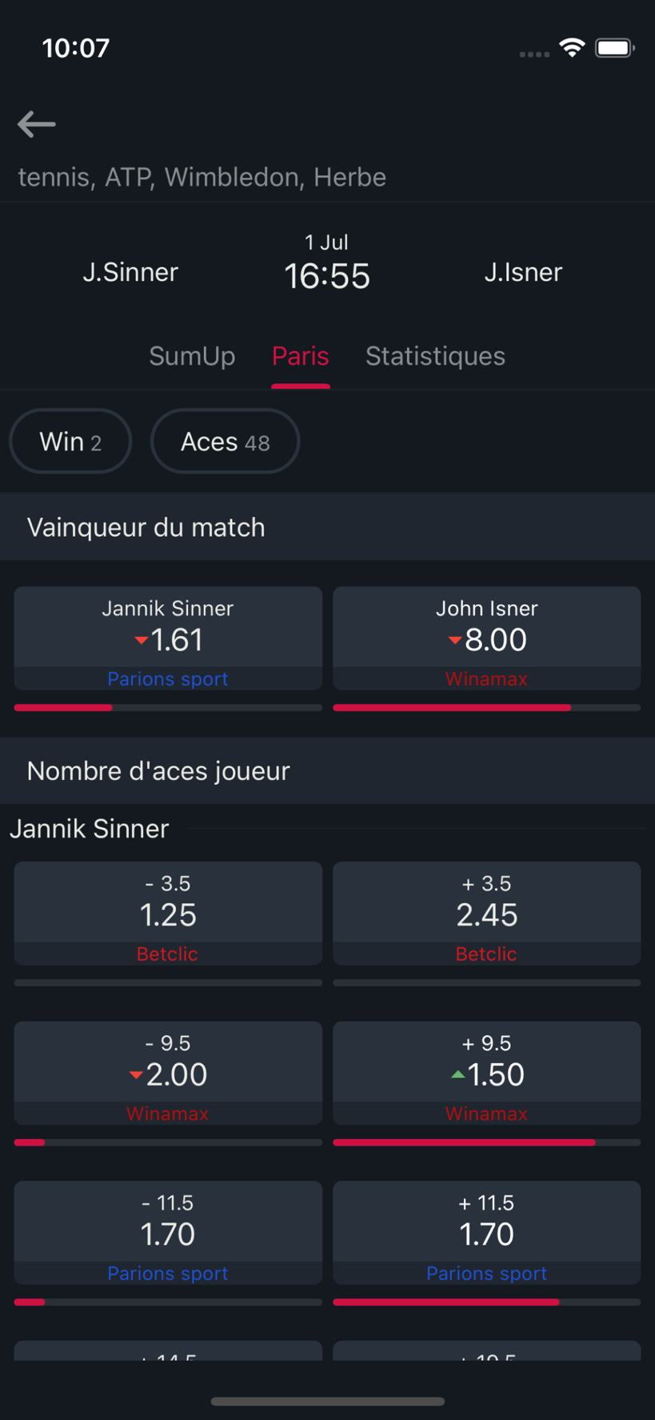

To conclude I really hope I’ve touched base on most of the important things you need to know. The team is very nice and you will surely get along very well with them.

If you have any question before you start, feel free to send me an email.

I wish you the very best and good luck on the internship.

Kind regards

**Samuel PALMER**

WEEL SAS Intern

samuel.palmer@epitech.eu

**SECTION 2**

*FROM:* [*samuel.palmer@epitech.eu*](mailto:samuel.palmer@epitech.eu)

*TO:* [*tony.miers@weel.io*](mailto:tony.miers@weel.io)

*DATE: 05/04/2022*

*SUBJECT: Participation request for the upcoming project*

Dear Supervisor,

During yesterday’s meeting you briefed the team on the new upcoming secure chat app project that you were envisioning for a while now. Although it is an ambitious project I am, very much confident of the potential it has.

David told me that you were looking to put together a team to build this project. And My interest suddenly peaked. I really enjoy working on Sportero’s user interface and I think I did a good job. I strongly believe that detail is an important factor to bringing the best experience to the user. My current contributions on Sportero‘s interface is in my opinion a good reflection of the quality of work that I am capable of. I can assure you that I will work seriously if I am given the opportunity to join this team. I’m sure you are aware that my work is not only detailed on the visual level but also in the coding style. I try to code as cleanly and logically as possible to make readability for my colleagues simple. The interfaces I design are minimal and written in as few lines of code as necessary. I have been thinking of many potential features to implement for the app and would love to share them with you. The workload on Sportero is minimal at the moment, and I am sure I can be much more useful and valuable on the new project.

I have learned a lot while working on Sportero and I think I have enough experience to be able to contribute in a meaningful way to the new project. I have learned a lot of new things in the react native programming language while working on Sportero and I was able to further develop my skills with the JavaScript framework NodeJS. I know that these languages will most likely be used to build the new app. In addition, I have also developed my skills using the Prisma framework. I am not fully comfortable with all of its features yet but I think I have advanced enough with it to be able to use it confidently.

From our most recent discussions, you seemed very satisfied with my organisation and with the quality of my work. During my internship I have learned how to properly work within a team. I know how to adapt myself in different situations and how to fix my mistake when I make them.

I am confident I can bring a real contribution to the project and I would truly be honoured if I were to be accepted. Thank you for your time and hope you have a great rest of your day.

Kind regards

**Samuel PALMER**

WEEL SAS Intern

samuel.palmer@epitech.eu