SALCA 27Nov 2016

laser power and profile measurements

20:39

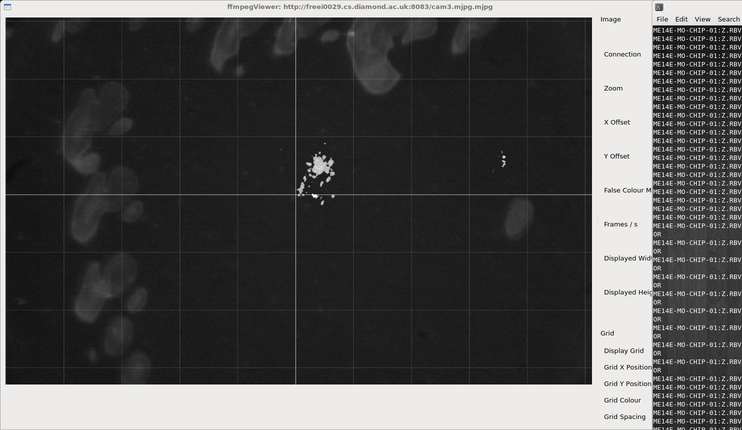
spot centre right

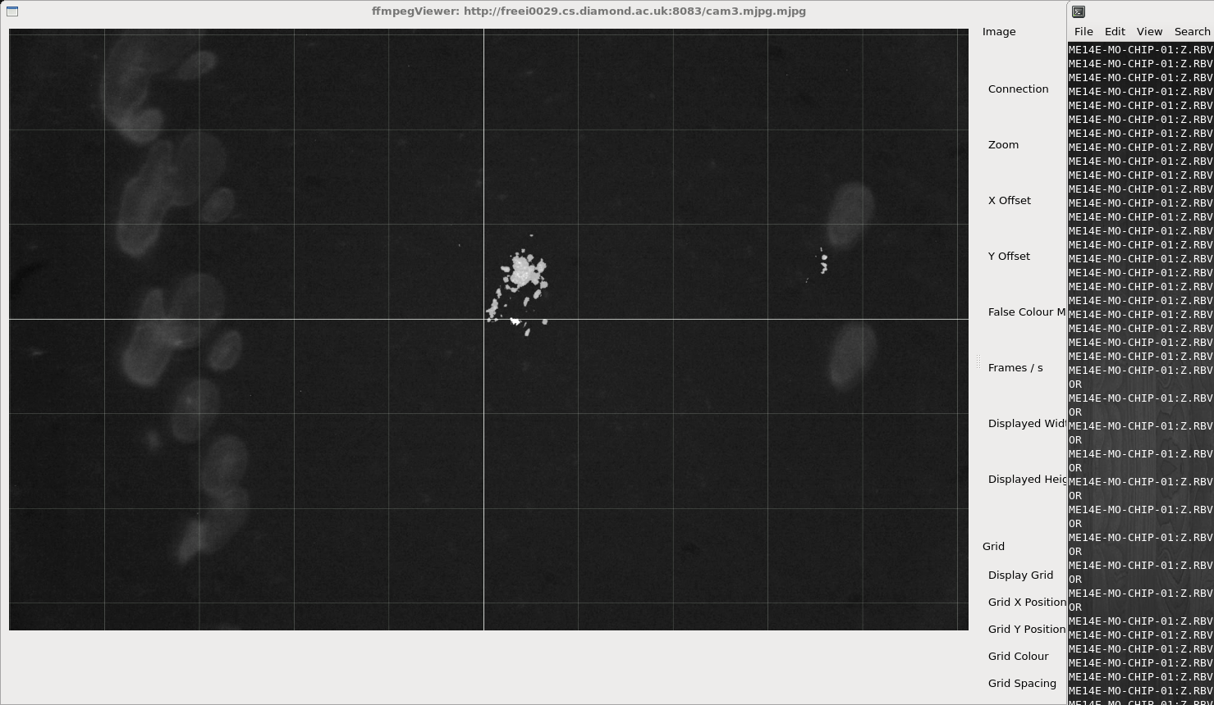
lower spot centre right
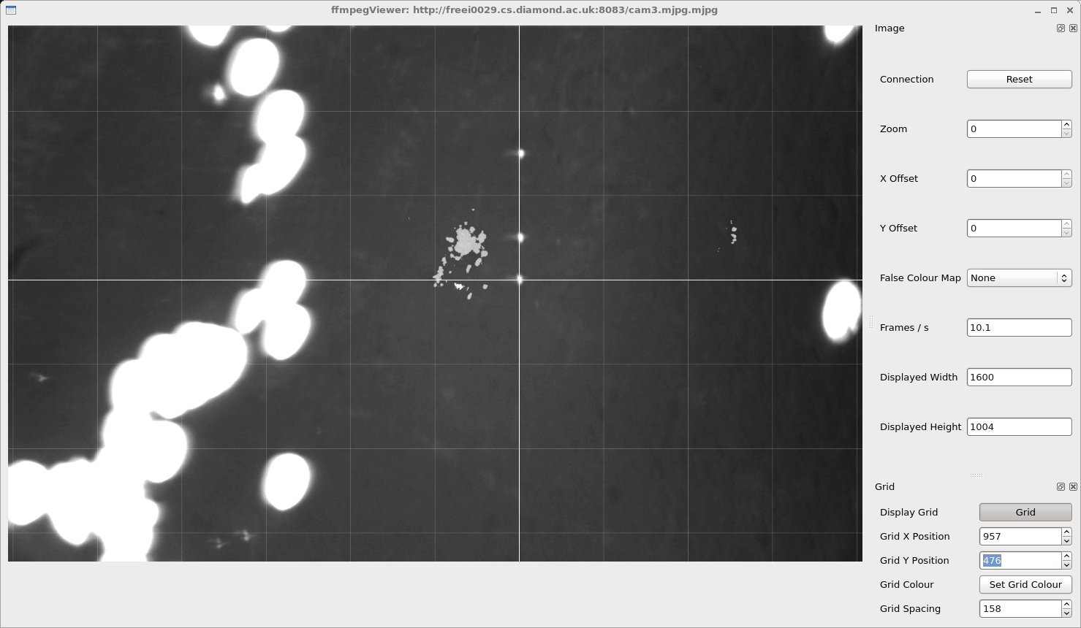
alignment step1.
X-ray is hole on cross hair. Laser centre right.

Translation iteratation 1

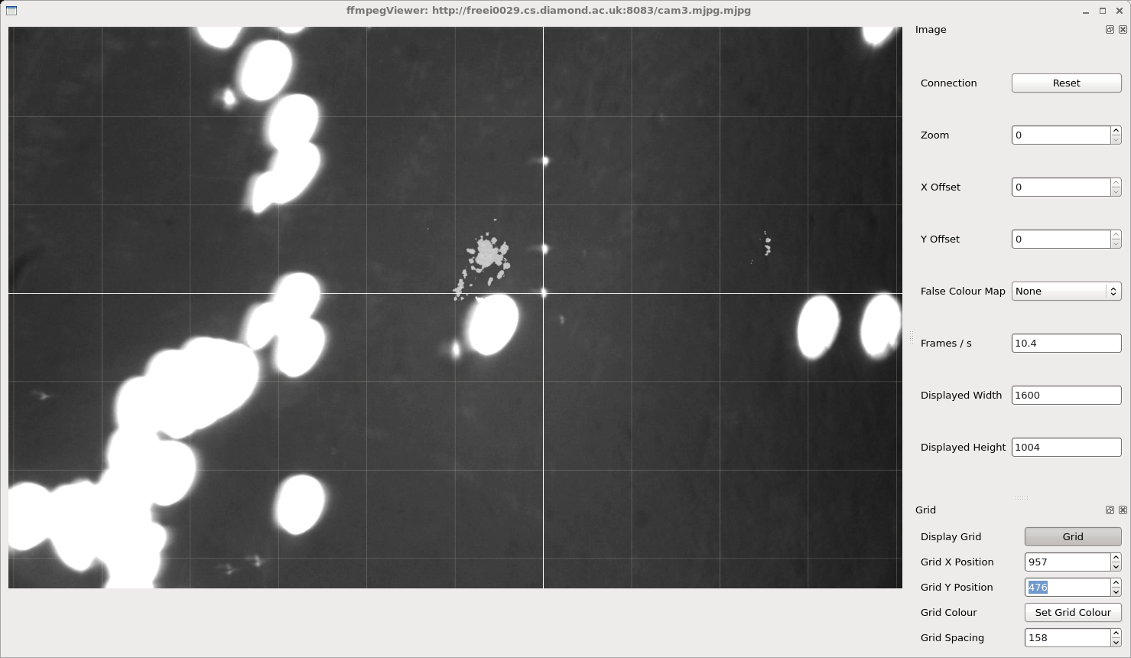
iteration 2

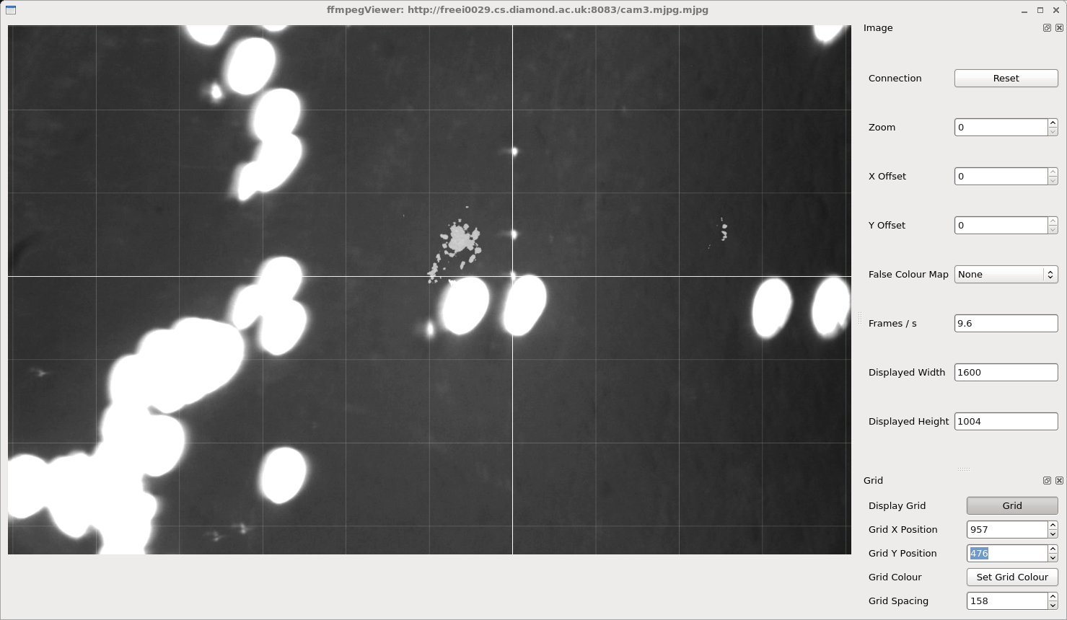
iteration 3

