Diffraction volume tracking and macroscopic strain measurement using Digital Image Correlation

# Introduction

This documentation provides instructions for the digital image correlation (DIC) scripts that can be used to track a diffraction volume during an in-situ experiment.

# Program Layout and Operation

There are four main Matlab m-files in the folder.

* “cpcorr_APS.m” – modified version of the “cpcorr.m” file to allow subpixel resolution.
* “DIC_disp_strain.m” – script that loads, analyzes, and determines the displacement of the region of interest (ROI) and the macroscopic strain. There are also other m-files with different prefixes for example cases.
* “Findpeak_APS.m” – modified version of the “Findpeak.m” file to allow subpixel resolution.
* “ViewDIC.m” – script that loads and visualizes pixel movement. Most of the features in this script are available in “DIC_disp_strain.m”. This script will be discontinued as the scripts and functions are organized and developed further.

There are three subdirectories in this folder.

* “DIC” – digital image correlation images from Michigan State University (MSU) in-situ experiments. This folder may not be available depending on the distribution.
* “References” – some background information and relevant papers.
* “smallTensileYield” – digital image correlation images provided by Professor A. Beaudoin at UIUC. This folder may not be available depending on the distribution.

Some relevant references are in the “References” folder. Readers are encouraged to look at the references.

* Chu, T.C. et al., “Applications of Digital-Image-Correlation Techniques to Experimental Mechanics”, Experimental Mechanics, 1985.

There are several others in the “References” folder.

**ViewDIC.m**

This script allows the user to compare two images to determine the displacement.

Before making many changes, it is suggested that the user run the script to get a feel for how the script runs.

Modify the following.

* “pname” – path name of the folder where the DIC images are located.
* “fname0” – file name of the reference DIC image.
* “fname” – file name the DIC image of interest that will be compared to the reference DIC image.
* “ri” – starting row number of the ROI.
* “rf” – end row number of the ROI.
* “ci” – starting column number of the ROI.
* “cf” – end column number of the ROI.

With appropriate changes, the script should generate at least one figure with two subplots, one showing the ROI in the reference DIC image and one showing the same ROI in the DIC image of interest.

**DIC_disp_strain.m**

This script allows the user to designate a series of DIC images so that they are all analyzed to produce a displacement and strain history.

Note that the images are loaded as is. If the camera was positioned such that the displacement was along the horizontal, displacement in the horizontal direction should show the largest displacement.

Before making many changes, it is suggested that the user run the script to get a feel for how the script runs.

Modify the following.

* “pname” – path name of the folder where the DIC images are located.
* “froot” – root file name or file naming pattern used to take the DIC images.
* “ext” – DIC image file extension.
* “ndigits” – number of digits in the file naming pattern.
* “fini” – start number of the DIC file series.
* “ffin” – end number of the DIC file series.
* “finc” – DIC file series number increment step.
* “delta_h” –spacing between control points in horizontal direction in the DIC images.
* “delta_v” – spacing between control points in vertical direction in the DIC images.
* “Hctr” – center point in horizontal direction.
* “Vctr” – center point in vertical direction.
* “ws_h” – number of control points in the horizontal direction spaced by “delta_h”
* “ws_v” – number of control points in the vertical direction spaced by “delta_v”

It is advised that the “return” command in the vicinity of line 170 (after generating figure(1)) is commented in to check the ROI before going ahead with the full analysis.

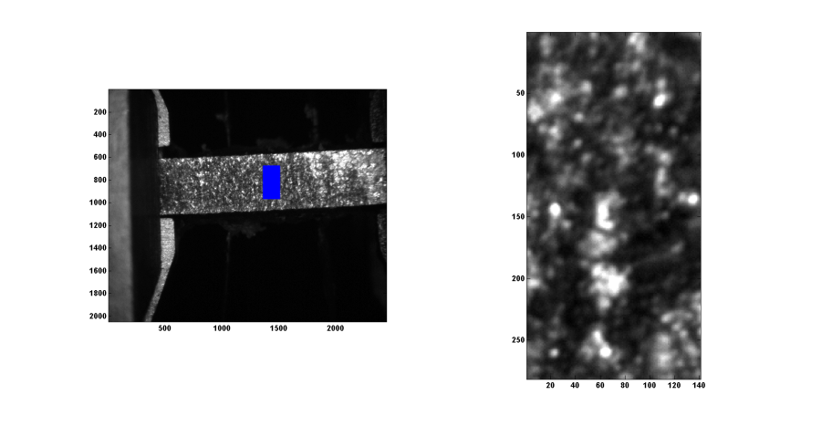

Figure 1 - An example of the ROI figure (figure (1) in the Matlab script).

Once the ROI looks reasonable, comment out the “return” command to proceed.

When the MSU DIC images are analyzed, two images show up at the end (they get updated at each step in the for-loop). The first is the Displacement field map. This shows the displacement determined through DIC method. The arrows point in the direction of the displacement.

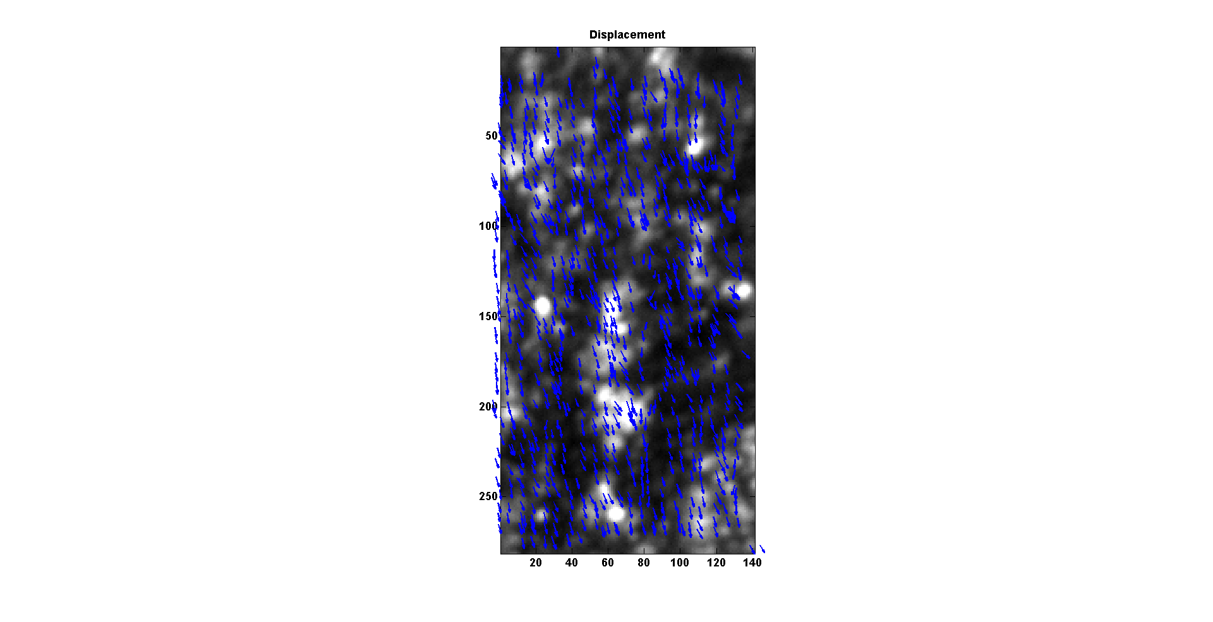

Figure 2 - Displacement field figure for the last loat step in the in-situ experiment. In this figure, the displacement is pointing down indicating that the sample was translating in the transverse direction.

The second is the displacement vs. image number, partials vs. image number, and deviation vs. image number plots. The displacement usually shows only two data sets: average u and average v displacements. In this case, there is a third data set (samY), which is the motor record of the actual samY motor movement that the MSU users performed to correct for the diffraction volume movement. Note that the blue line (the horizontal movement) tracks the samY movement reasonably well. The constant offset needs to be investigated (user error?, conversion error?, ???). Checking the displacement in blue with the actual images shows that the horizontal displacement shown in blue is consistent with the actual pixel movements.

The partials are related to the strains. In this case, the strains are engineering strains obtained from a least squares fit of the displacement data. This needs to be further developed for proper strain measurement.

The errors are related to how well the least squares fit worked with the data. This again needs further development.

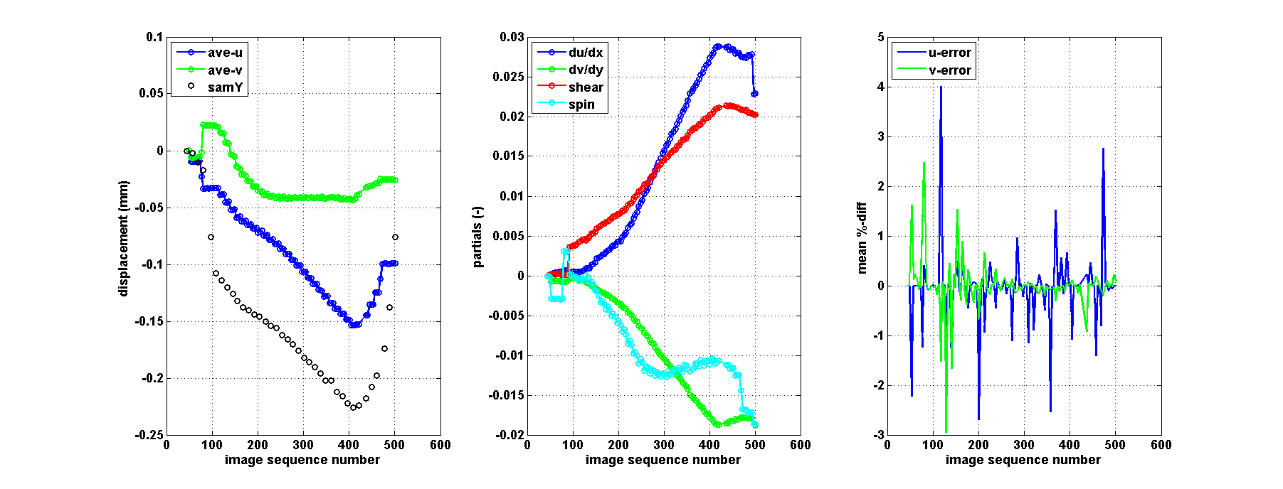

Figure 3 - Second figure generated by the script.

# Example 1

The MSU data set used in the previous section results in the following stress vs. strain curve.

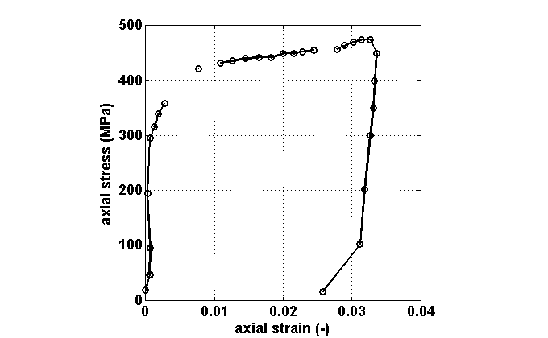

Figure 4 – Stress vs. strain curve obtained from the MSU data set.

It is worthwhile to note the following.

* The curve looks reasonable at a glance.
* Missing points are due to failure in DIC. Choosing a difference ROI can improve this result.
* As indicated in several references, measuring small strains using DIC is difficult and the initial loading shows some large non-linearity. However, the nonlinearity may also be from poor mechanical testing (the sample was extracted from a 4-point bend sample).
* Unloading curve looks fairly reasonable. The slope is approximately 130 GPa (depends highly on which points one chooses for a line fit).

# Example 2

Miller_June13 data set is a reasonable data set to work with to compare and contrast the strains obtained by the DIC method and an extensometer. The DIC images are located at “W:\Miller_June13\DIC”. The data of interest are from “Ti64_state4_” series. A sample Matlab code that can be used is “DIC_disp_strain_Miller_201306.m”.

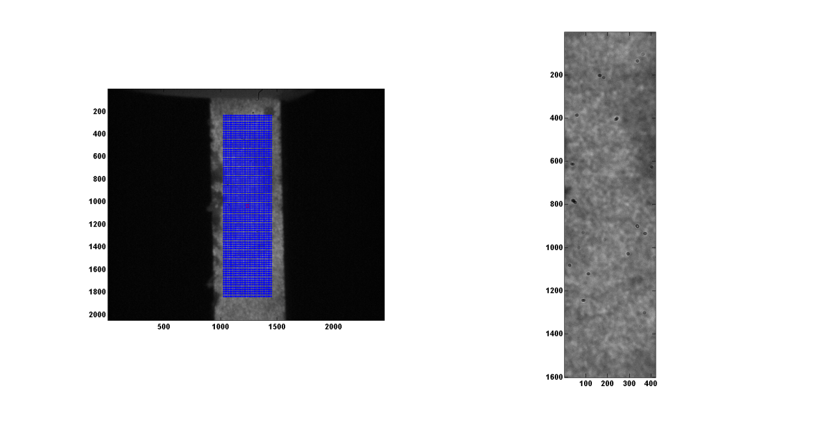

Figure 4 – A sample DIC image. Blue dots show the control points. Image on the right shows the image used for DIC.

Figure 4 shows an example of the images used in this analysis. The image quality is not ideal and better focusing is necessary.

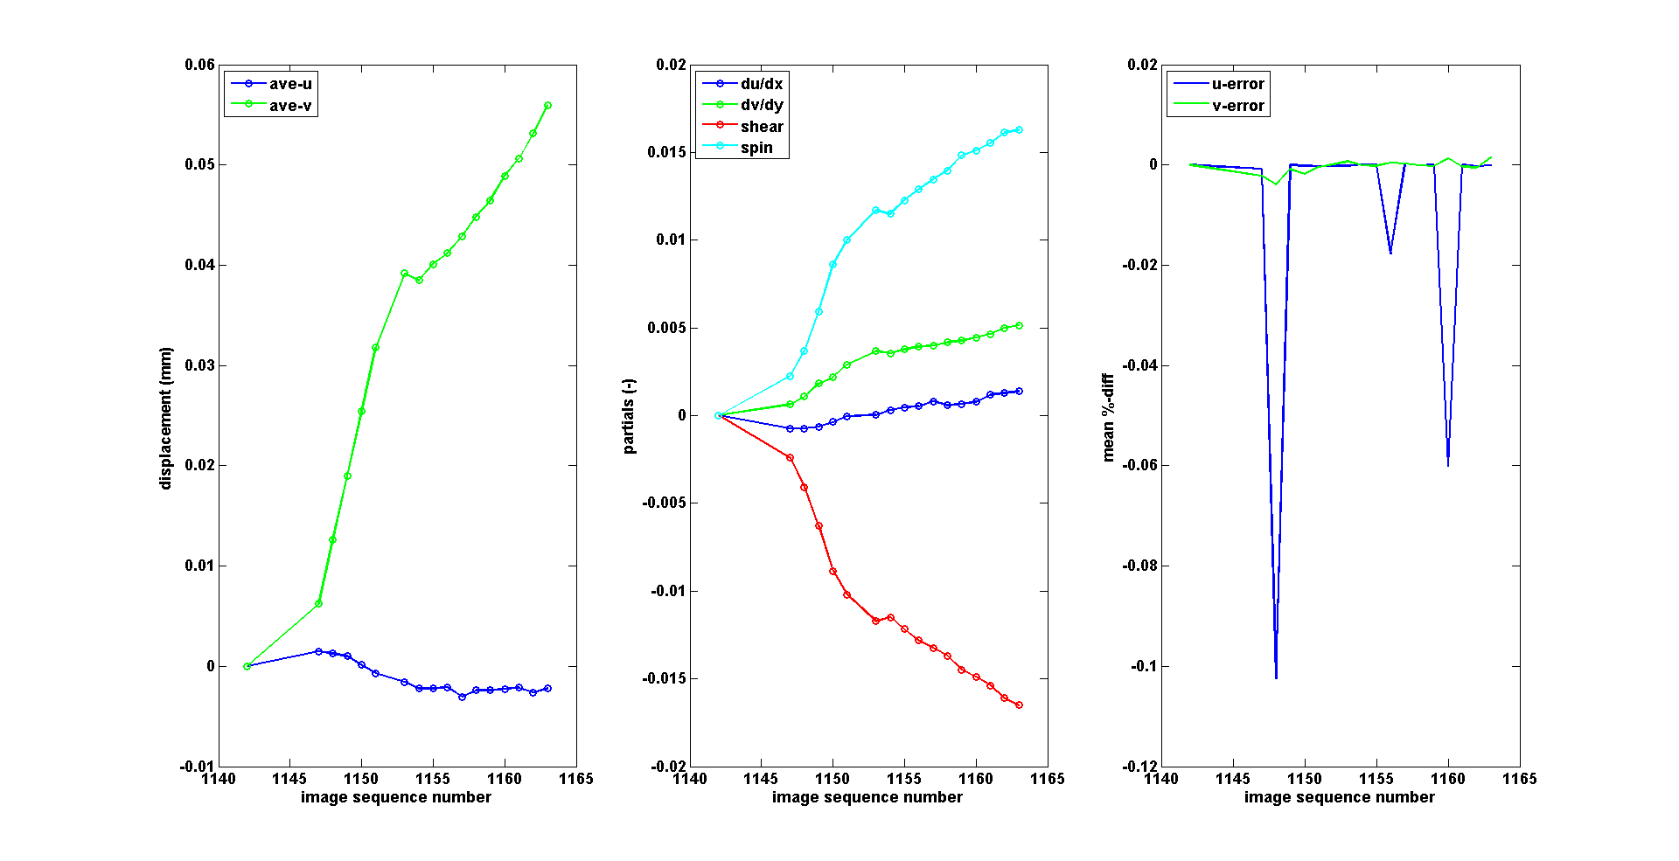

Figure 5 – Displacement, partials, and error measures for the image series.

Figure 5 shows the displacement, partials, and error measures for the image series. The large spikes in the error measure needs to be investigated.

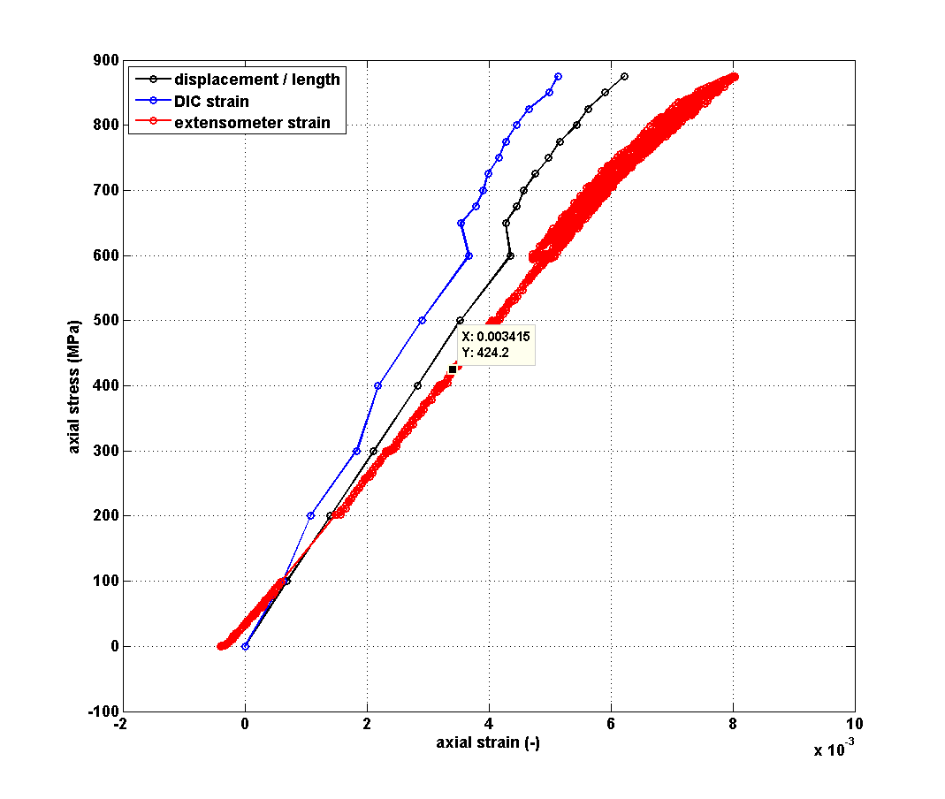

Figure 6 – Stress vs. strain curves for the Ti64_state4_ material obtained using DIC displacement, DIC partials, and an extensometer placed on the sample.

Figure 6 shows the stress vs. strain curves for the Ti64_state4_ material obtained using DIC displacement, DIC partials, and an extensometer placed on the sample. The general trends between the three agree. However, the moduli from the three curves are significantly different. The extensometer stress vs. strain curve is ~115 GPa, the stress vs. strain curve obtained by the DIC displacement is ~142 GPa, and the stress vs. strain curve obtained by the DIC partials is 172 GPa. The modulus of typical Ti64 is ~114 GPa.

Choosing a different ROI changes the result. In Figure 7, the two moduli are more comparable. This illustrates the importance of choose appropriate ROI.

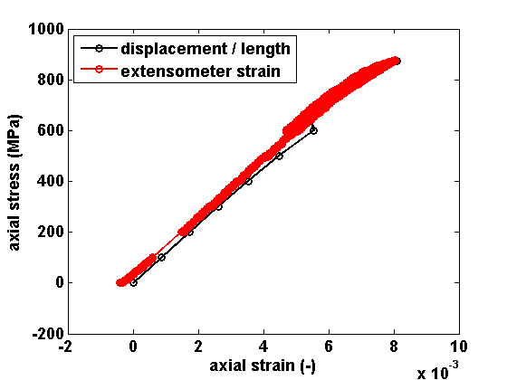

Figure – Stress vs. strain curves for the Ti64_state4_ material obtained using DIC displacement, and an extensometer placed on the sample.