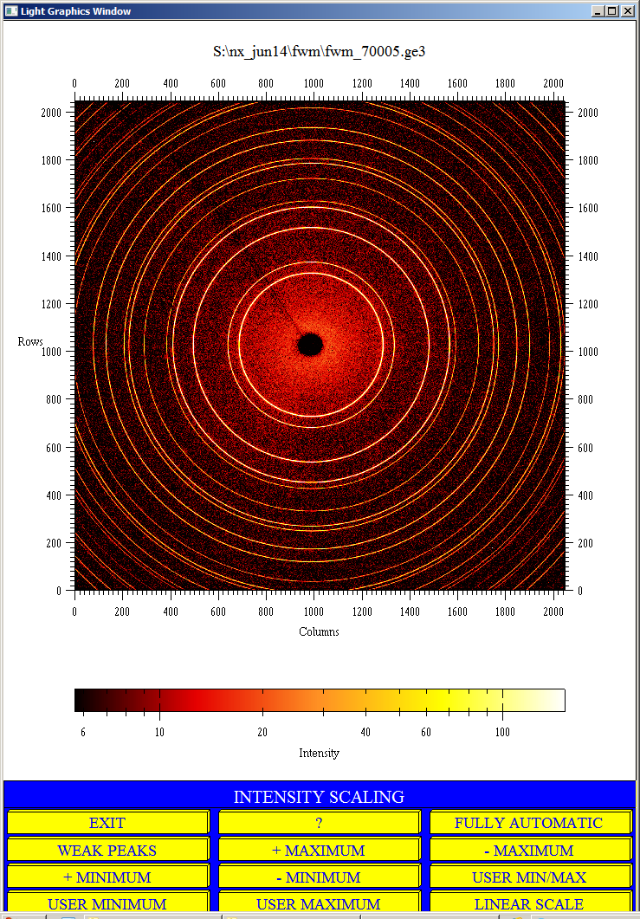Image must have the following coordinate system. If it is not, flipping operations need to be performed to make the images coincide with the coordinate system.

UP

OB

NO CHANGE : OPTION 0

FLIP LEFT / RIGHT: OPTION 1

FLIP TOP/BOTTOM: OPTION 2

TRANSPOSE: OPTION 3