Object ranging and subsequent tracking in 2d space using inexpensive audio hardware
UFCFXK-30-3 Digital Systems Project Report 2021/22
Benedict Ramage-Mangles
University Of The West of England

Abstract
The goal of this project was to create a piece of software that could track a the position of a moving microphone on a 2d plane in relation to two static speakers, using time of flight measurements and trigonometry.
It turned out to be quite difficult to get the ranging working in the first place, and the end result was only capable of ranging in one dimension, but the project is still fairly useful due to

Acknowledgements
I’d like to thank Moritz Uehling, Finn Erdmann and Julian (Qwasyx) for their help with some of the technical aspects of this project, and I’d also like to thank Joey Jarvis, Charles Edwards and Jacob Allen for their help motivating me to work despite my impressive ability to procrastinate.

Table of Contents
Abstract 2
Acknowledgements 2
Contents 2
Figures 2
Tables 2
Introduction – 500wd 3
Literature Review – 1500wd 3
Requirements Analysis - 1500wd 3
Product Design - 1500wd 3
Development, Implementation and Testing - 3000 wd 3
Evaluation, Further work, conclusions – 1000 wd; 3

Figures

Tables

Introduction – 500wd
In the field of tracking objects indoors, without reference to GPS, and with 5cm level accuracy or better, there are many options. A lot of research has taken place recently due to the advent of modern head-and-hand tracked virtual reality devices, often involving some variation on the formula of an IMU and infrared-based tracking in relation to fixed external reference points. This project will investigate the practicality of using sound instead, since this seems to be a relatively unexplored field.
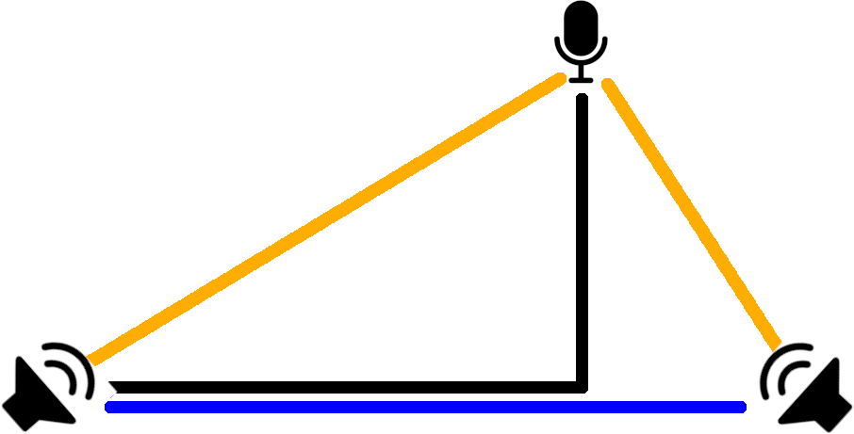Figure 1: An illustration of the basic trigonometry I expect to be using
The way to do this is to measure time of flight from two stationary speakers positioned in a room. This should be fairly practical, since preliminary testing suggests that a time shift of 1ms or better should be detectable without much difficulty.

The project has a few things that need to be achieved. These are, in order:
- To find a mechanism for generating a tone precisely every second to facilitate tracking by measuring the shift in arrival time.
- To detect arrival time given audio from a microphone,
- To determine distances given a series of arrival times
- To do the above, but in real-time
- To triangulate a position based on two such distances from two separate speakers.
- Potentially export this data to SteamVR if it turns out to be precise, accurate and reliable enough.
A review of existing literature suggested one of three solutions: Either use a Fast Fourier transform on a sliding window of the data (100 samples, for instance), use the Goertzel Algorithm on the same or apply band passing for instance using a Butterworth filter and measure amplitude.
- FFT is the default solution used in similar projects in the past – There’s going to be a lot of wasted effort calculating the energy values of frequencies we don’t want.
- Goertzel essentially calculates FFT at a specific frequency and thus takes less time than a comparable FFT unless you are looking for lots of frequencies, which we aren’t doing – but a future expansion of this project might.
- Bandpassing via High/Lowpass filters ie Butterworth, which has the advantage of being much faster since it can be done on the data before windowing, but you have to do it once for every frequency you’re looking for.
In the end, I went with FFT as this was the simplest solution to implement, as well as the easy scalability in future for multiple frequencies. Dealing with precise audio timing turns out to be quite difficult in a multitasking OS especially when the CPU has variable load, so we pass this task off to the soundcard. To generate a beep every second, we send it one second’s worth of samples at a time, and this process has to only happen when the buffer falls below a certain size, which is conveniently handled for me by the python library we’re using.
On top of this, it turns out to be necessary to ensure timing remains consistent between different clocks – since quartz oscillators will drift apart, we make sure either that the same clock is being used for transmission and reception or a correction factor is applied to
Finally, I needed to make a mechanism for converting ping arrival times to distances. This turned out to be fairly simple in the end, and I discuss it further in the design section.

Literature Review – 1500wd
Systems similar to this are really very uncommon due to the fact that in most cases a better alternative exists, such as a webcam with fiducial markers or something like SteamVR’s Lighthouse system. Of course, as with most things the more money you spend on a system like this the better the results are. At the high end, you can expect a high level of sensor fusion involving an IMU and some form of external tracking such as SteamVR Lighthouses, or possibly inside-out tracking as used on Oculus’s Quest.
Of course, at the very low end we often don’t have access to any new hardware at all. For my project, I chose to attempt to track an object using only 1-2 speakers and a microphone. I’ve already explained the idea in principle, and much of my methodology was inspired by a paper from 2012 [cite] which deals with the specific problem of detecting who in a car is holding a mobile phone.
The way they did this was in short to connect to the car’s speakers over Bluetooth and send “Customised high frequency beeps” from the left and right hand speakers, then measure the difference in time of arrival on the same phone that sent the pings.
The frequency chosen was 18khz and they used a Fourier transform with a width of 32 samples. This could not give a specific position due to only having two speakers and the fact that the transmission time was not known, but it would position the microphone along one of several three-dimensional hyperbolic arcs, in a fashion not entirely unlike certain early radio navigation systems (GEE/LORAN etc).
The choice of how many samples to run the FFT on requires a compromise between computational cost, resolution in the frequency space and resolution in the time space. 32 samples will give a very precise time and thus distance measurement (at worst 30cm of distance), at the cost of potentially picking up noise in a wider band.
Another paper from 2012 [cite] used an alternate system requiring two mid-2000s mobile devices. Both devices would beep at each other at agreed upon times, and would record audio until they had picked up the arrival of both beeps. Each device would then calculate the difference in samples between the arrivals of the beeps, and the result can be converted into a time delta and then into a distance. This is necessary, because they did not have a real-time OS on the hardware they were working on, and so could never be sure to within more than 3ms or so when your instruction to start playing audio is executed, which introduces about a meter of error.
This paper also went into some detail about the method they used for location once ranges between devices were established, which is very interesting and their results were encouraging although none of their proposed uses have yet become mainstream.
They also conducted a frequency response analysis of their specific devices, and found that they might have issues using ultrasound due to the technical limitations of their low cost microphones that sacrificed higher frequency response. Another thing they discovered was -
“that the sound waveform being played out has very large distortion during the initial few milliseconds. We believe that this is caused by the speaker diaphragm inertia. To address this issue, we precede the chirp signal with a 5-millisecond, 2kHz cosine waveform to warm up the speaker.”
This information will be valuable as well, and I’ll take it into account when selecting my beep frequency. One final thing they found was that using earphones counter-intuitively gave the system a longer effective range due to having less distortion.
A further issue they found was multipathing. My very limited testing and discussion with my supervisor had implied this would be a problem, but I don’t think there’s much I can do to deal with that beyond better noise rejection. I found that the system wasn’t really functional in loud environments either, but it would obviously vary based on the circumstances

Requirements Analysis – 1500wd
Functional
- Generate a tone every second
- Record audio, extract timestamps for beeps based on either
- Determine a delta between expected and actual arrival times
- Calculate a distance
- Triangulate a position based on two such distances from two separate speakers.
Non-functional
- Operate in realtime on a machine with variable load without much degradation of performance
- Export distance values in a useful format, potentially to something like SteamVR
- Be fairly unobtrusive when functioning in order to minimise inconvenience to users
- Not cause harm to users due to excessively loud noises
- Use a minimal amount of processing power to achieve the task

Product Design - 1500wd

Development, Implementation and Testing - 3000 wd
The first stage of development involved the creation of what was essentially a metronome. The goal here was to produce something that could generate beeps at a specific frequency spaced exactly one second apart, and the naive approach to this looks like this:
blocking_play(beep.wav) #beep for 1/20th of a second
sleep(0.95)
This obvious solution will drift out of sync over time because, per the python docs:
The actual suspension time may be less than that requested because any caught signal will terminate the sleep() following execution of that signal’s catching routine. Also, the suspension time may be longer than requested by an arbitrary amount because of the scheduling of other activity in the system.
(Unless the version of python is newer than 3.5 in which case it can only ever be longer than requested.)

Some improvements on this solution include

Evaluation, Further work, conclusions – 1000 wd;

