**SAS Studio for Modern Regression Methods**

For STAT 5100 we’ll be using SAS Studio through a SAS OnDemand for Academics course called “Stat 5100 – MW1 (Fall 2020)”.

As a first step, please create your account for SAS OnDemand for Academics. To register, visit <https://odamid.oda.sas.com> and click on “Register or check account”. Note that the system will prompt you to create a SAS profile if you have not already done so.

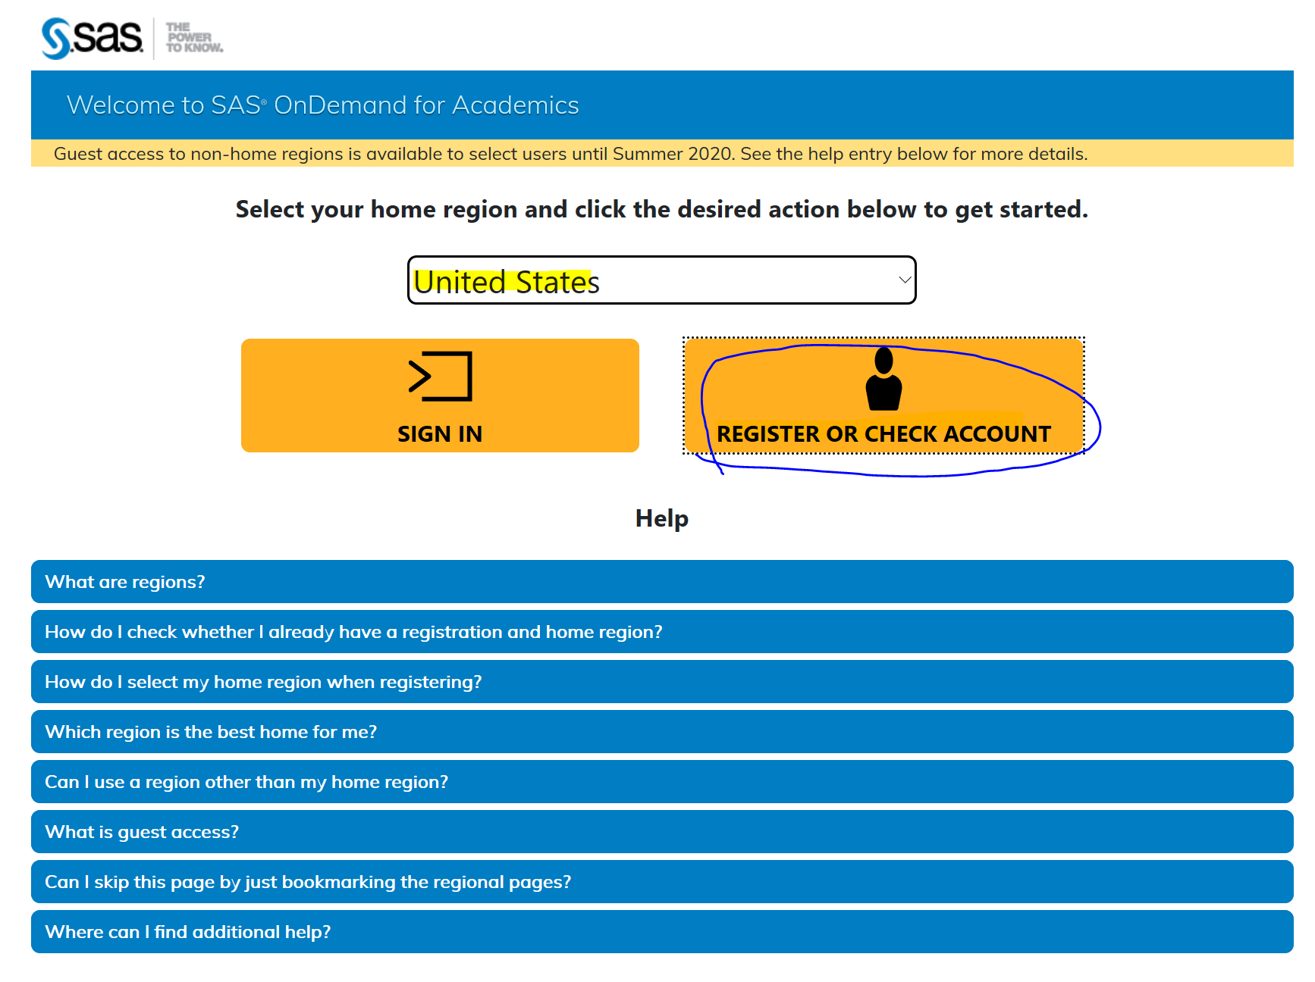

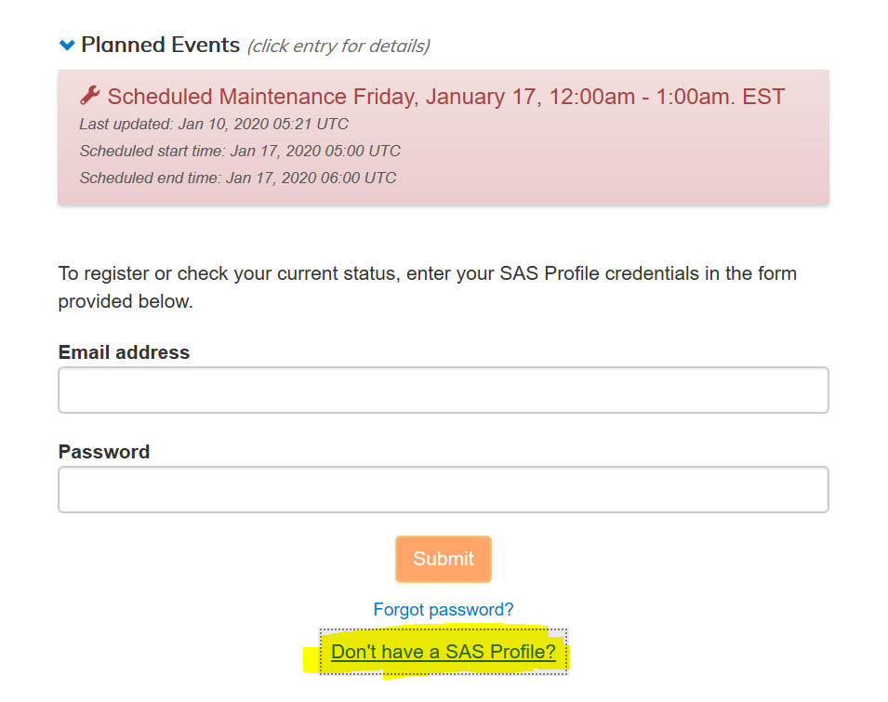

After you have successfully created your account, follow these steps:

1. Sign on to the Control Center at <https://odamid.oda.sas.com>.
2. Look for the Enroll in a course link in the "Enrollments" section near the bottom of the page. Click this link to start the enrollment.

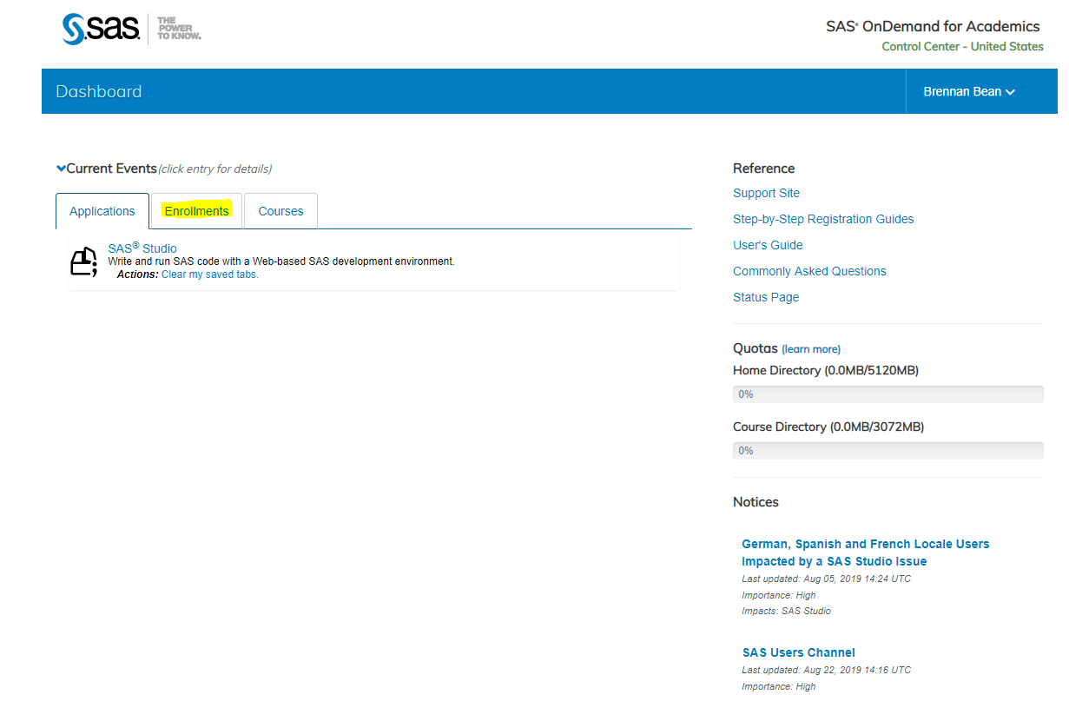

1. Enter the course code: **72ed604c-838b-4bd4-893c-d0f65465e222**

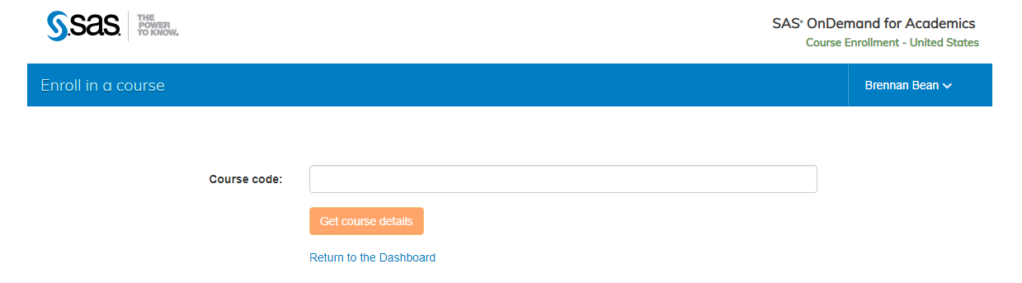

1. Submit the form.
2. Confirm that this is the correct course and then click the button to finish enrolling.

Once you are successfully enrolled (should only need to do this once), in subsequent sessions you should be able to login directly to SAS Studio at <https://odamid.oda.sas.com/SASStudio>. *Note that there may be a short wait (5-10) for SAS to send the final confirmation email before you can log in.*

For more information about SAS OnDemand for Academics, including step-by-step registration instructions, visit <http://support.sas.com/ondemand>.