**2.2.2: SAS - Linear Regression Remedial Measures**

Dr. Bean – Stat 5100

Example: Age and plasma level for 25 healthy children in a study are reported. Of interest is how plasma level depends on age. (Text Table 3.8 – first column is age; second column is plasma level)

|  |  |
| --- | --- |
|  | The SGPlot Procedure |

**/\***

**data plasma;**

**infile "[File Path]/Table3.8.plasma.txt";**

**input age level;**

**run;**

**\*/**

**data plasma; input age level @@; cards;**

**0 13.44 0 12.84 0 11.91 0 20.09 0 15.60**

**1.0 10.11 1.0 11.38 1.0 10.28 1.0 8.96 1.0 8.59**

**2.0 9.83 2.0 9.00 2.0 8.65 2.0 7.85 2.0 8.88**

**3.0 7.94 3.0 6.01 3.0 5.14 3.0 6.90 3.0 6.77**

**4.0 4.86 4.0 5.10 4.0 5.67 4.0 5.75 4.0 6.23**

**;**

**/\* Fit regression model and check assumptions \*/**

**proc reg data=plasma;**

**model level = age;**

**output out=out1 r=resid p=pred;**

**title1 'Simple model for plasma data';**

**run;**

|  |  |  |  |  |  |  |  |  |  |  |  |  |  |  |  |  |  |  |  |  |  |  |  |  |  |  |  |  |  |  |  |  |  |  |  |  |  |  |  |  |  |  |  |  |  |  |  |  |  |  |  |  |  |  |  |  |  |  |  |  |  |  |  |  |  |  |  |
| --- | --- | --- | --- | --- | --- | --- | --- | --- | --- | --- | --- | --- | --- | --- | --- | --- | --- | --- | --- | --- | --- | --- | --- | --- | --- | --- | --- | --- | --- | --- | --- | --- | --- | --- | --- | --- | --- | --- | --- | --- | --- | --- | --- | --- | --- | --- | --- | --- | --- | --- | --- | --- | --- | --- | --- | --- | --- | --- | --- | --- | --- | --- | --- | --- | --- | --- | --- |
| |  | | --- | | ***Simple model for plasma data*** |  | **Analysis of Variance** | | | | | | | --- | --- | --- | --- | --- | --- | | **Source** | **DF** | **Sum of Squares** | **Mean Square** | **F Value** | **Pr > F** | | **Model** | 1 | 238.05620 | 238.05620 | 70.21 | <.0001 | | **Error** | 23 | 77.98306 | 3.39057 |  |  | | **Corrected Total** | 24 | 316.03926 |  |  |  |      |  |  |  |  | | --- | --- | --- | --- | | **Root MSE** | 1.84135 | **R-Square** | 0.7532 | | **Dependent Mean** | 9.11120 | **Adj R-Sq** | 0.7425 | | **Coeff Var** | 20.20974 |  |  |      | **Parameter Estimates** | | | | | | | --- | --- | --- | --- | --- | --- | | **Variable** | **DF** | **Parameter Estimate** | **Standard Error** | **t Value** | **Pr > |t|** | | **Intercept** | **1** | 13.47520 | 0.63786 | 21.13 | <.0001 | | **age** | **1** | -2.18200 | 0.26041 | -8.38 | <.0001 |   Scatter plot of residuals by age for level.  Panel of fit diagnostics for level.  Scatterplot of level by age overlaid with the fit line, a 95% confidence band and lower and upper 95% prediction limits. |

**/\* Define shortcut macro, using line copied from**

**[File Path]/resid\_num\_diag\_1line.sas**

**\*/**

**%macro resid\_num\_diag(dataset,...**

**/\* Call shortcut macro \*/**

**%*resid\_num\_diag*(dataset=out1, datavar=resid, label='Residual',**

**predvar=pred, predlabel='Predicted Value');**

|  |  |  |  |  |  |  |  |  |  |  |  |  |  |  |  |  |  |  |  |  |  |  |  |  |  |  |  |  |  |  |  |  |  |  |
| --- | --- | --- | --- | --- | --- | --- | --- | --- | --- | --- | --- | --- | --- | --- | --- | --- | --- | --- | --- | --- | --- | --- | --- | --- | --- | --- | --- | --- | --- | --- | --- | --- | --- | --- |
| |  | | --- | | ***P-value for Brown-Forsythe test of constant variance*** | | ***in Residual vs. Predicted Value*** |  | **Obs** | **t\_BF** | **BF\_pvalue** | | --- | --- | --- | | **1** | 1.50583 | 0.14572 |  |  | | --- | | ***Output for correlation test of normality of Residual*** | | ***(Check text Table B.6 for threshold)*** |      | **Pearson Correlation Coefficients, N = 25  Prob > |r| under H0: Rho=0** | | | | --- | --- | --- | |  | **resid** | **expectNorm** | | |  | | --- | | **resid** | | Residual | | |  | | --- | | 1.00000 | |  | | |  | | --- | | 0.90360 | | <.0001 | | | |  | | --- | | **expectNorm** | |  | | |  | | --- | | 0.90360 | | <.0001 | | |  | | --- | | 1.00000 | |  | | |

**/\* F-test for lack of fit**

**Options:**

**Covar=1 - specifies the first variable on the right**

**Hand side of the equation is linear**

**(default is quadratic)**

**Noopt - suppresses rsreg output not associated**

**with the F-test for lack of fit \*/**

**proc rsreg data=plasma;**

**model level = age / lackfit covar=1 noopt;**

**title1 'F-test for lack of fit';**

**run;**

|  |  |  |  |  |  |  |  |  |  |  |  |  |  |  |  |  |  |  |  |  |  |  |  |  |
| --- | --- | --- | --- | --- | --- | --- | --- | --- | --- | --- | --- | --- | --- | --- | --- | --- | --- | --- | --- | --- | --- | --- | --- | --- |
| | **Residual** | **DF** | **Sum of Squares** | **Mean Square** | **F Value** | **Pr > F** | | --- | --- | --- | --- | --- | --- | | **Lack of Fit** | 3 | 22.748784 | 7.582928 | 2.75 | 0.0699 | | **Pure Error** | 20 | 55.234280 | 2.761714 |  |  | | **Total Error** | 23 | 77.983064 | 3.390568 |  |  | |

**/\* Look at sequence plot \*/**

**data temp; set out1;**

**order = \_n\_;**

**proc sgplot data=temp;**

**series x=order y=resid / lineattrs=(pattern=solid) ;**

**xaxis label='Order in Data';**

**yaxis label='Residual Value';**

**title1 'Sequence plot of residuals';**

**run;**

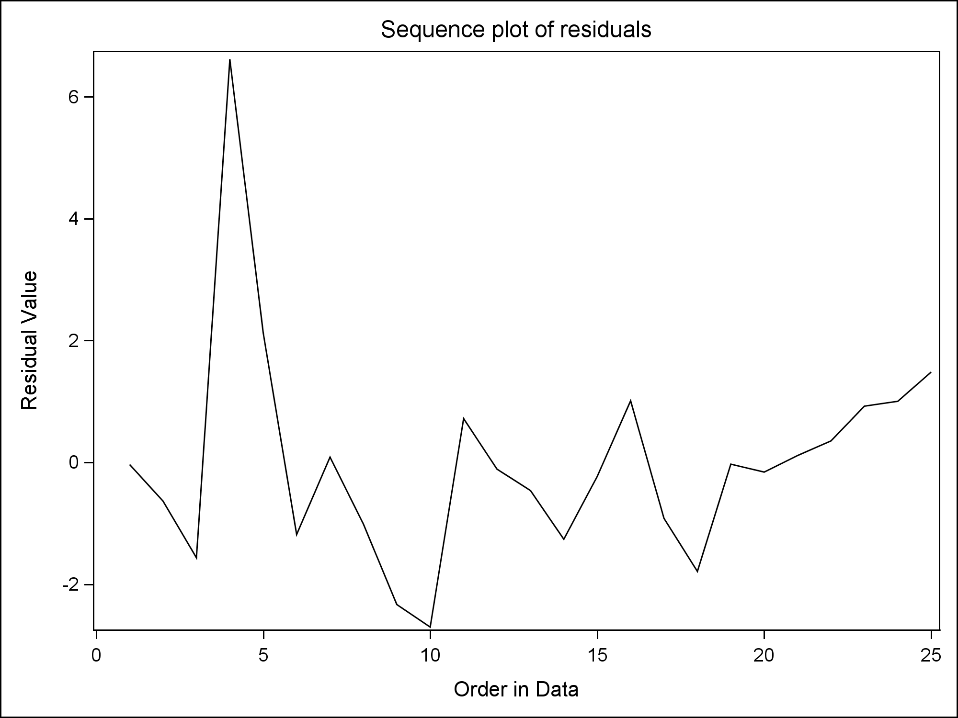

**/\*\*\*\*\*\*\*\*\*\* Consider Transformations \*\*\*\*\*\*\*\*\*\*\*\*\*\*\*\*/**

**proc transreg data=plasma;**

**model boxcox(level / lambda=-1 to 1 by 0.1)**

**= identity(age);**

**title1 'Box-Cox Transformation: Regressing Level on Age';**

**run;**

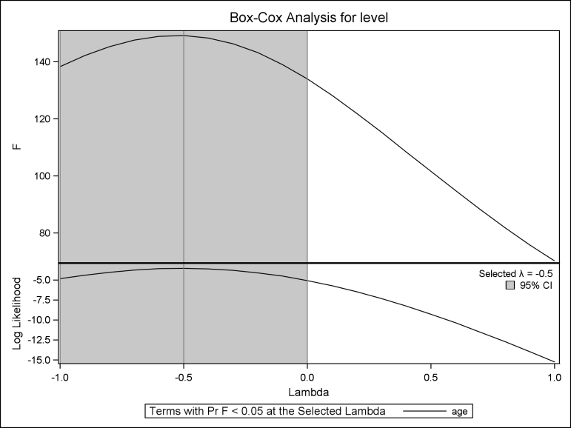

**data plasma; set plasma;**

**log\_level = log(level);**

**invsqrt\_level = -1/sqrt(level);**

**run;**

**/\* Inverse square root \*/**

**proc reg data=plasma;**

**model invsqrt\_level = age;**

**output out=out2 r=resid p=pred;**

**title1 'Simple model for negative inverse root plasma data';**

**run;**

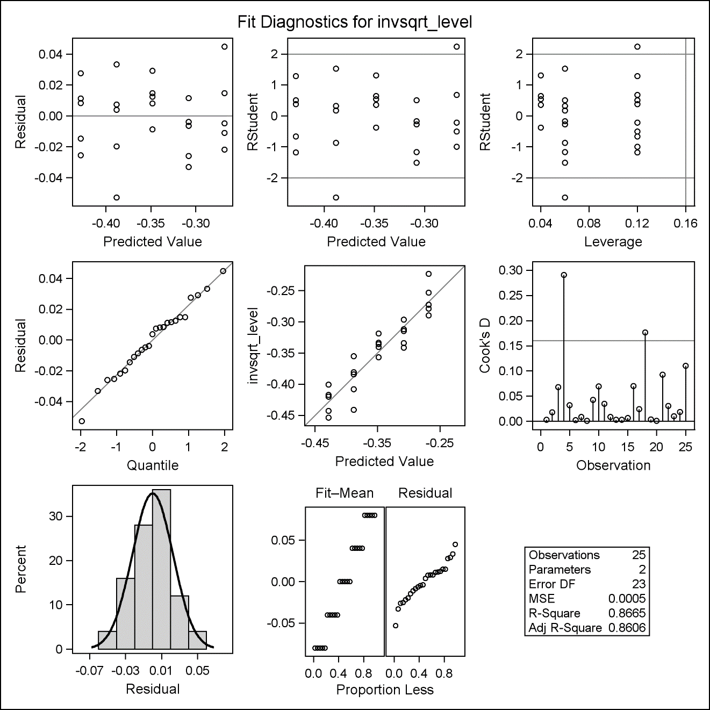

**%*resid\_num\_diag*(dataset=out2, datavar=resid,**

**label='Residual (neg. inverse root)',**

**predvar=pred, predlabel='Predicted Value (neg. inverse root)');**

|  |  |  |  |  |  |  |  |  |  |  |  |  |  |  |  |  |  |  |  |  |  |  |  |  |  |  |  |  |  |  |  |  |  |  |
| --- | --- | --- | --- | --- | --- | --- | --- | --- | --- | --- | --- | --- | --- | --- | --- | --- | --- | --- | --- | --- | --- | --- | --- | --- | --- | --- | --- | --- | --- | --- | --- | --- | --- | --- |
| |  | | --- | | ***P-value for Brown-Forsythe test of constant variance*** | | ***in Residual (neg. inverse root) vs. Predicted Value (neg. inverse root)*** |  | **Obs** | **t\_BF** | **BF\_pvalue** | | --- | --- | --- | | **1** | 0.16654 | 0.86918 |  |  | | --- | | ***Output for correlation test of normality of Residual (neg. inverse root)*** | | ***(Check text Table B.6 for threshold)*** |  | **Pearson Correlation Coefficients, N = 25  Prob > |r| under H0: Rho=0** | | | | --- | --- | --- | |  | **resid** | **expectNorm** | | |  | | --- | | **resid** | | Residual (neg. inverse root) | | |  | | --- | | 1.00000 | |  | | |  | | --- | | 0.99188 | | <.0001 | | | |  | | --- | | **expectNorm** | |  | | |  | | --- | | 0.99188 | | <.0001 | | |  | | --- | | 1.00000 | |  | | |

**proc rsreg data=plasma;**

**model invsqrt\_level = age / lackfit covar=1 noopt;**

**title1 'F-test for lack of fit (neg. inverse root)';**

**run;**

|  |  |  |  |  |  |  |  |  |  |  |  |  |  |  |  |  |  |  |  |  |  |  |  |  |  |
| --- | --- | --- | --- | --- | --- | --- | --- | --- | --- | --- | --- | --- | --- | --- | --- | --- | --- | --- | --- | --- | --- | --- | --- | --- | --- |
| |  | | --- | | ***F-test for lack of fit (neg. inverse root)*** |      | **Residual** | **DF** | **Sum of Squares** | **Mean Square** | **F Value** | **Pr > F** | | --- | --- | --- | --- | --- | --- | | **Lack of Fit** | 3 | 0.001556 | 0.000519 | 0.96 | 0.4312 | | **Pure Error** | 20 | 0.010813 | 0.000541 |  |  | | **Total Error** | 23 | 0.012369 | 0.000538 |  |  | |

**/\* Log \*/**

**proc reg data=plasma;**

**model log\_level = age;**

**output out=out3 r=resid p=pred;**

**title1 'Simple model for log plasma data';**

**run;**

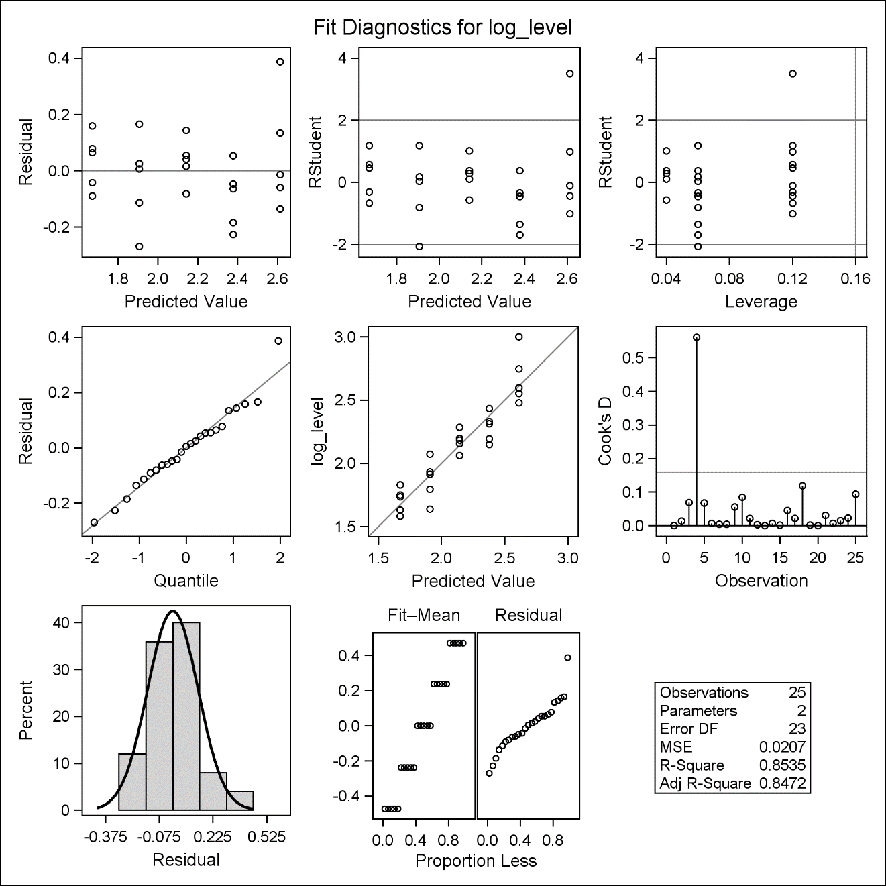

**%*resid\_num\_diag*(dataset=out3, datavar=resid, label='Residual (log)',**

**predvar=pred, predlabel='Predicted Value (log)');**

|  |  |  |  |  |  |  |  |  |  |  |  |  |  |  |  |  |  |  |  |  |  |  |  |  |  |  |  |  |  |  |  |  |  |  |
| --- | --- | --- | --- | --- | --- | --- | --- | --- | --- | --- | --- | --- | --- | --- | --- | --- | --- | --- | --- | --- | --- | --- | --- | --- | --- | --- | --- | --- | --- | --- | --- | --- | --- | --- |
| |  | | --- | | ***P-value for Brown-Forsythe test of constant variance*** | | ***in Residual (log) vs. Predicted Value (log)*** |  | **Obs** | **t\_BF** | **BF\_pvalue** | | --- | --- | --- | | **1** | 0.95179 | 0.35110 |  |  | | --- | | ***Output for correlation test of normality of Residual (log)*** | | ***(Check text Table B.6 for threshold)*** |      | **Pearson Correlation Coefficients, N = 25  Prob > |r| under H0: Rho=0** | | | | --- | --- | --- | |  | **resid** | **expectNorm** | | |  | | --- | | **resid** | | Residual (log) | | |  | | --- | | 1.00000 | |  | | |  | | --- | | 0.98071 | | <.0001 | | | |  | | --- | | **expectNorm** | |  | | |  | | --- | | 0.98071 | | <.0001 | | |  | | --- | | 1.00000 | |  | | |

**proc rsreg data=plasma;**

**model log\_level = age / lackfit covar=1 noopt;**

**title1 'F-test for lack of fit (log)';**

**run;**

|  |  |  |  |  |  |  |  |  |  |  |  |  |  |  |  |  |  |  |  |  |  |  |  |  |  |
| --- | --- | --- | --- | --- | --- | --- | --- | --- | --- | --- | --- | --- | --- | --- | --- | --- | --- | --- | --- | --- | --- | --- | --- | --- | --- |
| |  | | --- | | ***F-test for lack of fit (log)*** |      | **Residual** | **DF** | **Sum of Squares** | **Mean Square** | **F Value** | **Pr > F** | | --- | --- | --- | --- | --- | --- | | **Lack of Fit** | 3 | 0.081944 | 0.027315 | 1.39 | 0.2758 | | **Pure Error** | 20 | 0.394004 | 0.019700 |  |  | | **Total Error** | 23 | 0.475948 | 0.020693 |  |  | |

**/\* Probably go with inverse square root \*/**

**proc reg data=plasma;**

**model invsqrt\_level = age;**

**title1 'Negative inverse root plasma data';**

**run;**

|  |  |  |  |  |  |  |  |  |  |  |  |  |  |  |  |  |  |  |  |  |  |  |  |  |  |  |  |  |  |  |  |  |  |  |  |  |  |  |  |  |  |  |  |  |  |  |  |  |  |  |  |  |  |  |  |  |  |  |  |
| --- | --- | --- | --- | --- | --- | --- | --- | --- | --- | --- | --- | --- | --- | --- | --- | --- | --- | --- | --- | --- | --- | --- | --- | --- | --- | --- | --- | --- | --- | --- | --- | --- | --- | --- | --- | --- | --- | --- | --- | --- | --- | --- | --- | --- | --- | --- | --- | --- | --- | --- | --- | --- | --- | --- | --- | --- | --- | --- | --- |
| |  | | --- | | ***Negative inverse root plasma data*** |  | **Analysis of Variance** | | | | | | | --- | --- | --- | --- | --- | --- | | **Source** | **DF** | **Sum of Squares** | **Mean Square** | **F Value** | **Pr > F** | | **Model** | 1 | 0.08025 | 0.08025 | 149.22 | <.0001 | | **Error** | 23 | 0.01237 | 0.00053778 |  |  | | **Corrected Total** | 24 | 0.09262 |  |  |  |      |  |  |  |  | | --- | --- | --- | --- | | **Root MSE** | 0.02319 | **R-Square** | 0.8665 |      | **Parameter Estimates** | | | | | | | --- | --- | --- | --- | --- | --- | | **Variable** | **DF** | **Parameter Estimate** | **Standard Error** | **t Value** | **Pr > |t|** | | **Intercept** | **1** | -0.26803 | 0.00803 | -33.36 | <.0001 | | **age** | **1** | -0.04006 | 0.00328 | -12.22 | <.0001 |   Scatterplot of invsqrt_level by age overlaid with the fit line, a 95% confidence band and lower and upper 95% prediction limits. |