**6.1.1 – SAS: Time Series**

Example 1: “Bush and the price of gas”

* <http://www.leftbusinessobserver.com/BushNGas.html>
* “…no occupant of the White House has ever seen his popularity so closely tied to the price of gas.”
* “There's no precedent for this tight relationship.”

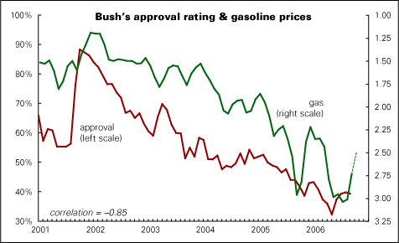

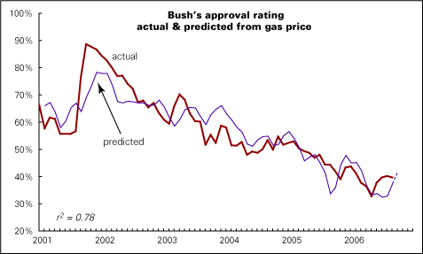

But – can we justify a conclusion that gas price significantly affects approval rating?

(HW 7 will address this more completely)

|  |  |  |  |  |  |  |  |  |  |  |  |  |  |  |  |  |  |  |  |  |  |  |  |  |  |
| --- | --- | --- | --- | --- | --- | --- | --- | --- | --- | --- | --- | --- | --- | --- | --- | --- | --- | --- | --- | --- | --- | --- | --- | --- | --- |
| |  | | --- | | ***Presidential Approval Ratings and Gas Price*** |        | **Parameter Estimates** | | | | | | | --- | --- | --- | --- | --- | --- | | **Variable** | **DF** | **Parameter Estimate** | **Standard Error** | **t Value** | **Pr > |t|** | | **Intercept** | **1** | 88.80015 | 2.82573 | 31.43 | <.0001 | | **price** | **1** | -0.18281 | 0.01242 | -14.72 | <.0001 | |
|  |

**Example 2:** General Electric’s gross investment (in millions of dollars) for years 1935 – 1954. Originally presented in Grunfeld, Y. (1958), "The Determinants of Corporate Investment," Ph.D. dissertation, University of Chicago; discussed in Boot, J.C.G. (1960), "Investment Demand: An Empirical Contribution to the Aggregation Problem," International Economic Review, 1, 3-30. See also Damodar N. Gujarati, Basic Econometrics, Third Edition, 1995, McGraw-Hill, [1995, pp. 522-525].

**data GE; input year GEinv @@; cards;**

**1935 33.1 1936 45.0 1937 77.2 1938 44.6 1939 48.1**

**1940 74.4 1941 113.0 1942 91.9 1943 61.3 1944 56.8**

**1945 93.6 1946 159.9 1947 147.2 1948 146.3 1949 98.3**

**1950 93.5 1951 135.2 1952 157.3 1953 179.5 1954 189.6**

**;**

**proc sgplot data=GE noautolegend;**

**scatter y=GEinv x=year /**

**markerattrs=(symbol=CIRCLEFILLED size=8pt);**

**series y=GEinv x=year / lineattrs=(pattern=solid);**

**xaxis label='Year';**

**yaxis label='GE gross investment (millions)';**

**title1 'GE gross investment';**

**run;**

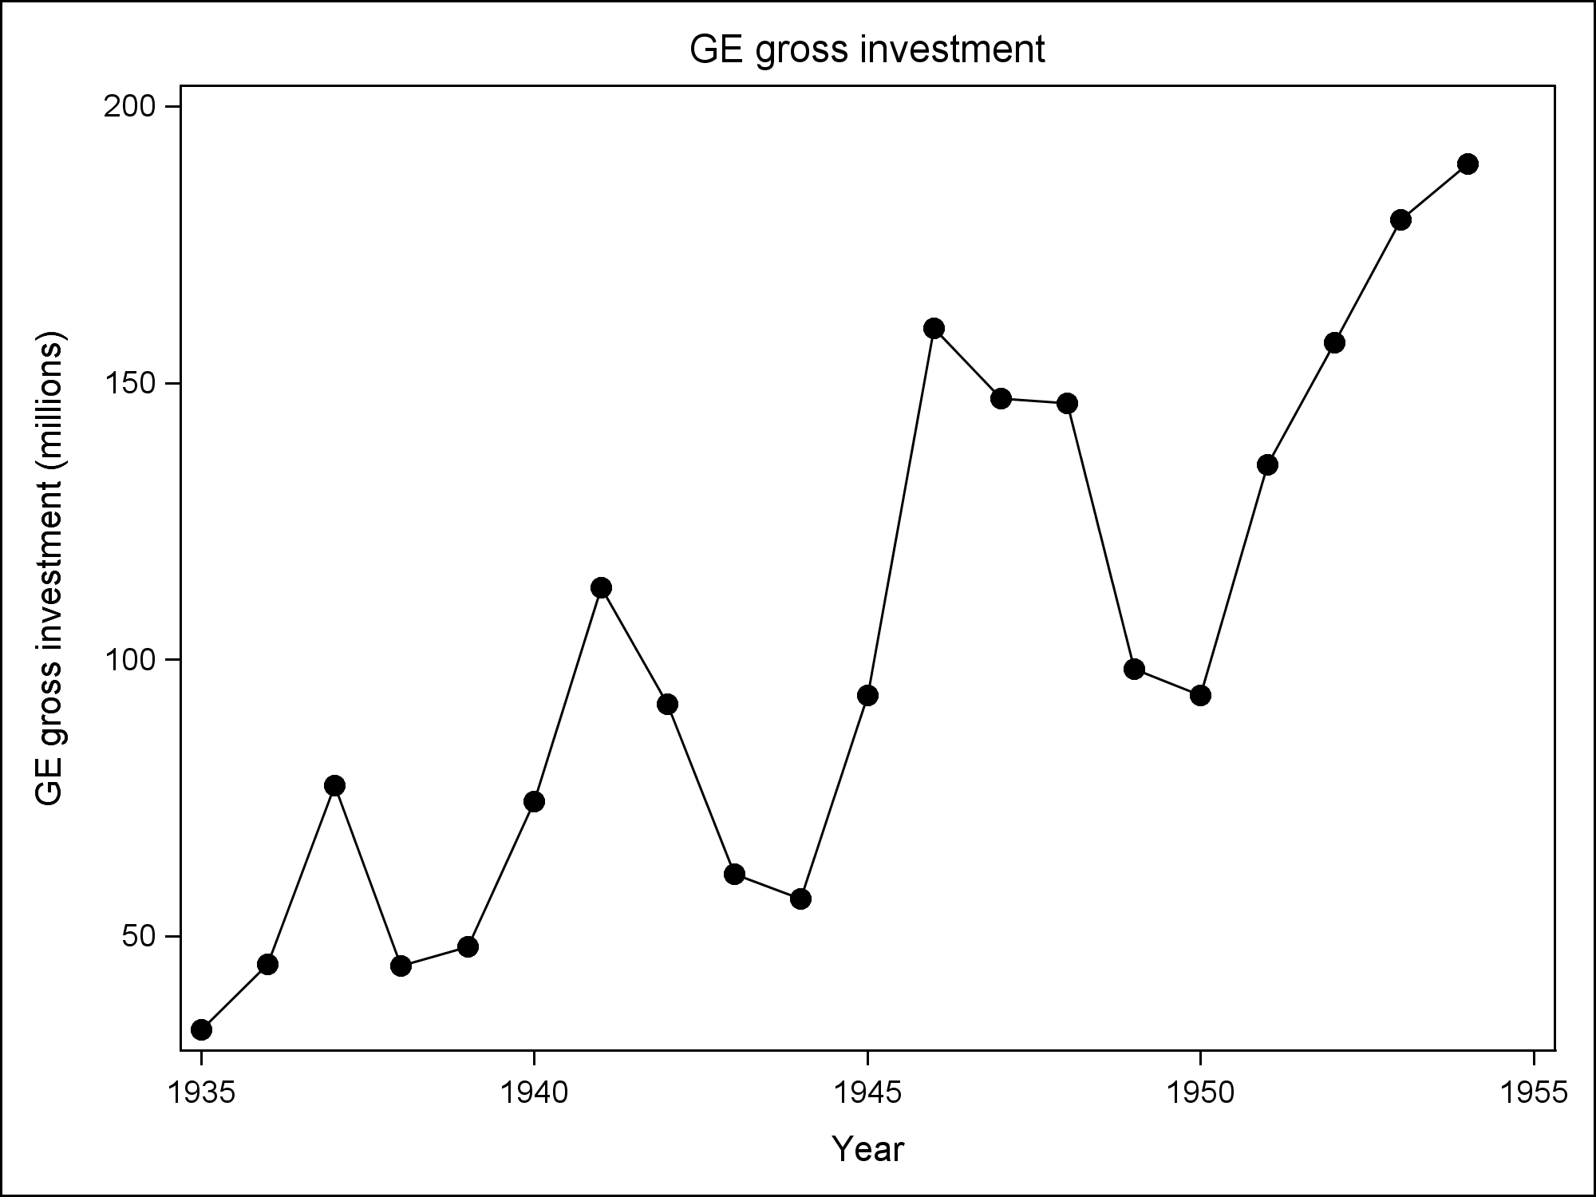

**/* 1. Make data stationary */**

**proc reg data=GE noprint;**

**model GEinv=year; output out=a1 r=resid;**

**title1 'simple regression on time';**

**proc sgplot data=a1 noautolegend;**

**scatter y=resid x=year /**

**markerattrs=(symbol=CIRCLEFILLED size=8pt);**

**series y=resid x=year / lineattrs=(pattern=solid);**

**xaxis label='Year'; yaxis label='Residual';**

**title1 'GE gross investment after accounting for time';**

**run;**

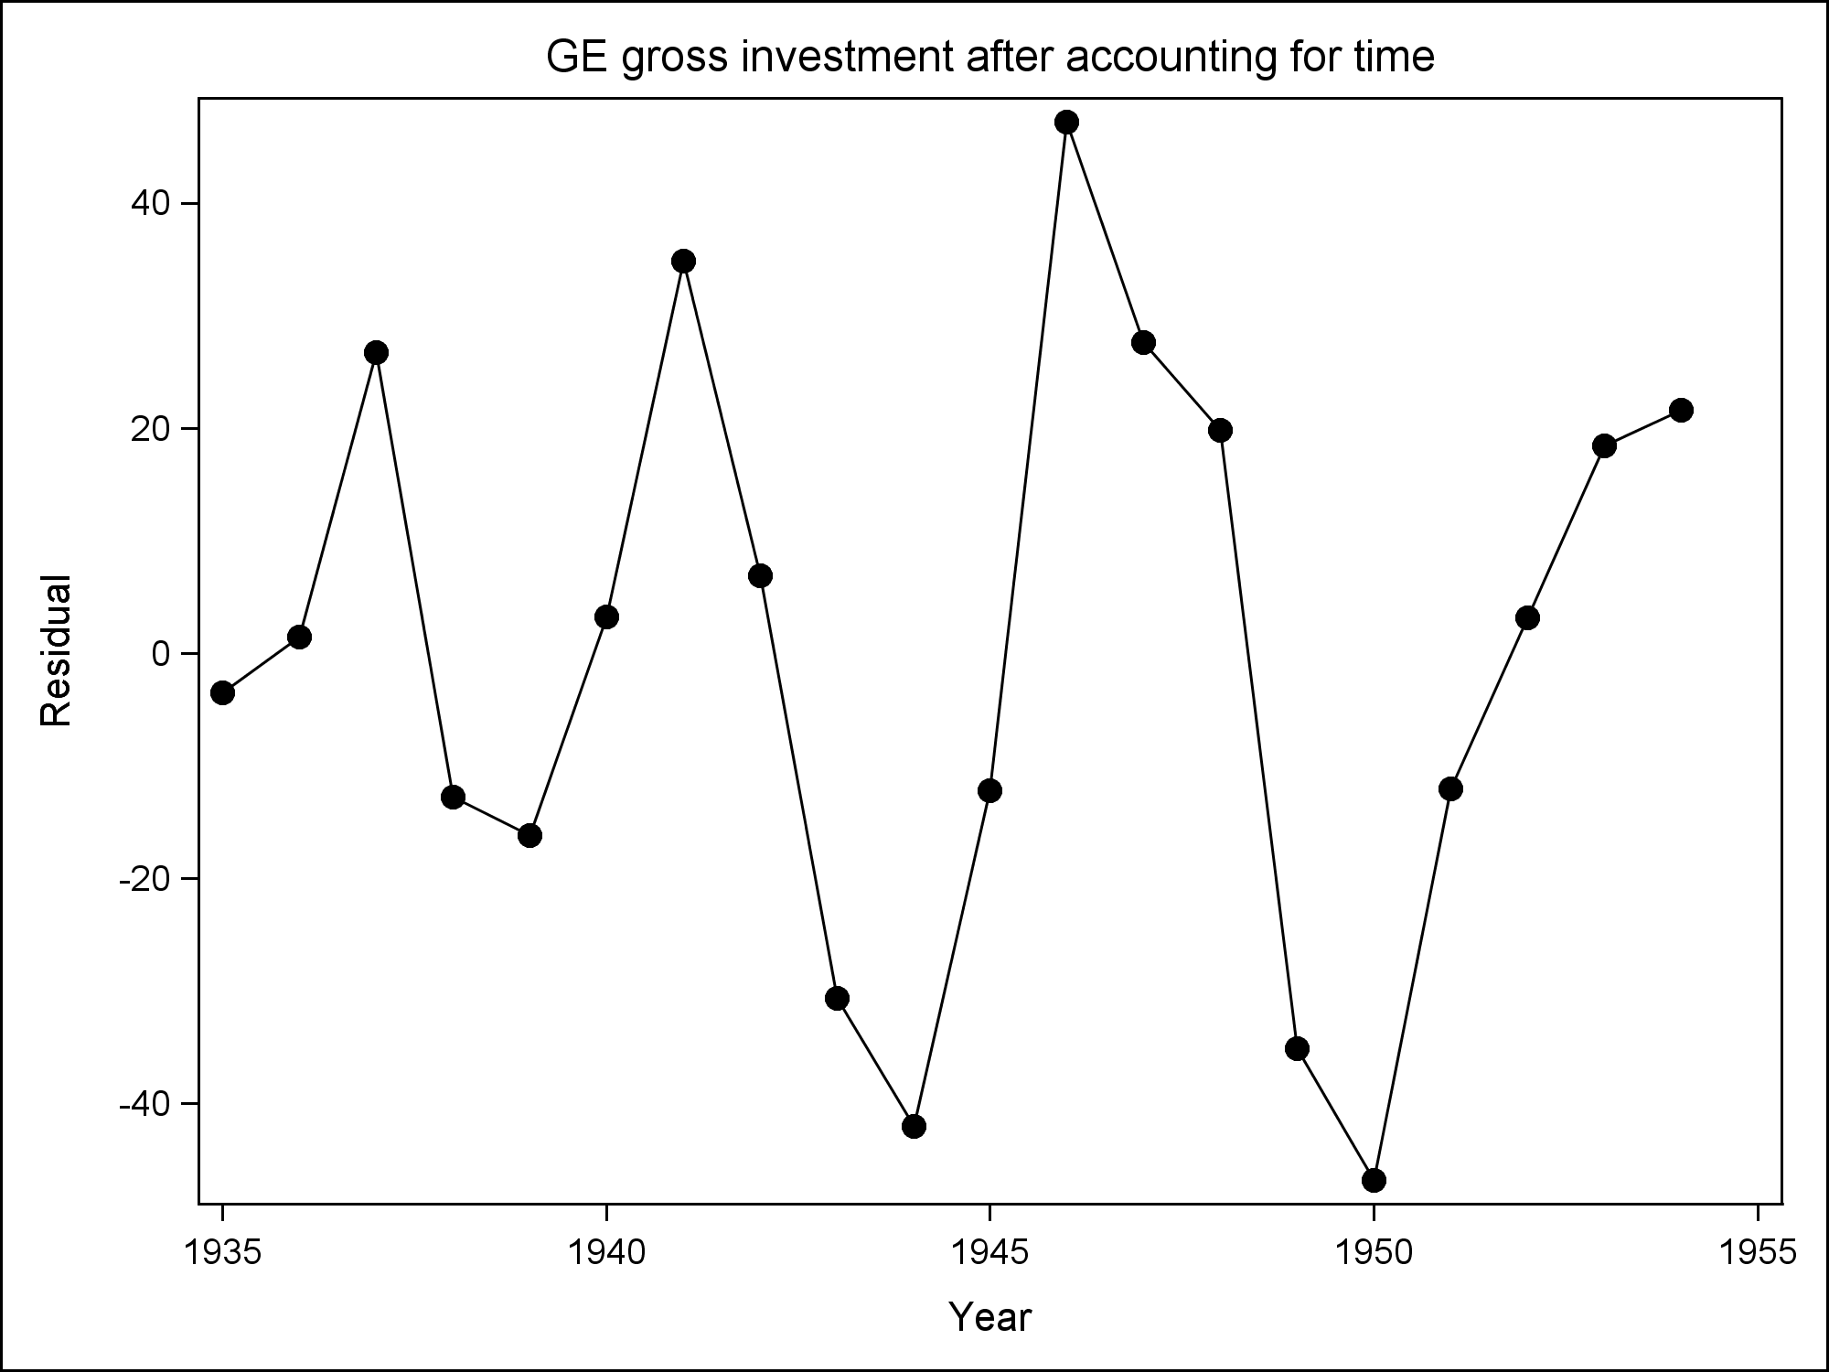

**data GE; set GE; logGEinv=log(GEinv);**

**proc reg data=GE noprint;**

**model logGEinv=year; output out=a2 r=resid;**

**title1 'simple regression on time, using log';**

**proc sgplot data=a2 noautolegend;**

**scatter y=resid x=year /**

**markerattrs=(symbol=CIRCLEFILLED size=8pt);**

**series y=resid x=year / lineattrs=(pattern=solid);**

**xaxis label='Year'; yaxis label='Residual';**

**title1 'GE gross investment after accounting for time, using log';**

**run;**

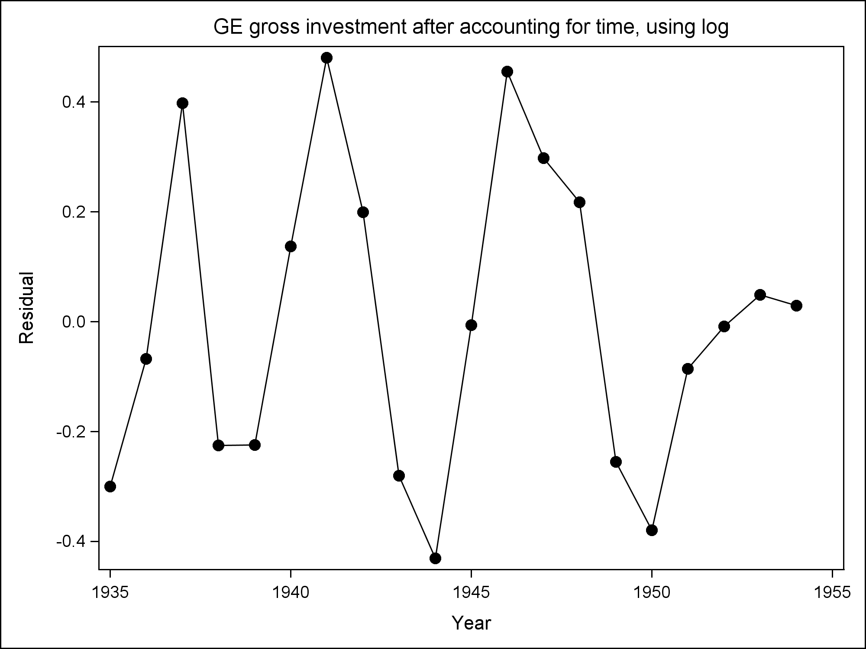

**/* 2. Test for independence and**

**3. Investigate potential dependence structures */**

**data newuse; set a2;**

**Z = resid;**

**proc arima data=newuse;**

**identify var=Z nlag=12 ;**

**title1 'Look at SPAC: AR(2)';**

**run;**

|  |  |  |  |  |  |  |  |  |  |  |  |  |  |  |  |  |  |  |  |  |  |  |  |  |  |  |  |  |  |  |  |  |  |  |  |  |  |  |  |  |  |
| --- | --- | --- | --- | --- | --- | --- | --- | --- | --- | --- | --- | --- | --- | --- | --- | --- | --- | --- | --- | --- | --- | --- | --- | --- | --- | --- | --- | --- | --- | --- | --- | --- | --- | --- | --- | --- | --- | --- | --- | --- | --- |
| |  | | --- | | ***Look at SPAC: AR(2)*** |   The ARIMA Procedure     | **Autocorrelation Check for White Noise** | | | | | | | | | | | --- | --- | --- | --- | --- | --- | --- | --- | --- | --- | | **To Lag** | **Chi-Square** | **DF** | **Pr > ChiSq** | **Autocorrelations** | | | | | | | **6** | 20.42 | 6 | 0.0023 | 0.290 | -0.517 | -0.535 | -0.070 | 0.310 | 0.225 | | **12** | 21.33 | 12 | 0.0457 | -0.030 | -0.127 | -0.040 | -0.016 | 0.040 | -0.049 | |

**/* 4. Fit dependence structure and assess model adequacy */**

**proc arima data=newuse;**

**identify var=logGEinv crosscorr=(year) nlag=12;**

**estimate p=2 input=(year) method=uls plot;**

**title1 'AR(2) model fit to log of GE data';**

**run;**

|  |  |  |  |  |  |  |  |  |  |  |  |  |  |  |  |  |  |  |  |  |  |  |  |  |  |  |  |  |  |  |  |  |  |  |  |  |  |  |  |  |  |  |  |  |  |  |  |  |  |  |  |  |  |  |  |  |  |  |  |  |  |  |  |  |  |  |  |  |  |  |  |  |  |  |  |  |  |  |  |  |  |  |  |  |  |  |  |  |  |  |  |  |  |  |  |  |  |  |  |  |  |  |  |  |  |
| --- | --- | --- | --- | --- | --- | --- | --- | --- | --- | --- | --- | --- | --- | --- | --- | --- | --- | --- | --- | --- | --- | --- | --- | --- | --- | --- | --- | --- | --- | --- | --- | --- | --- | --- | --- | --- | --- | --- | --- | --- | --- | --- | --- | --- | --- | --- | --- | --- | --- | --- | --- | --- | --- | --- | --- | --- | --- | --- | --- | --- | --- | --- | --- | --- | --- | --- | --- | --- | --- | --- | --- | --- | --- | --- | --- | --- | --- | --- | --- | --- | --- | --- | --- | --- | --- | --- | --- | --- | --- | --- | --- | --- | --- | --- | --- | --- | --- | --- | --- | --- | --- | --- | --- | --- | --- |
| |  | | --- | | ***AR(2) model fit to log of GE data*** |  | **Unconditional Least Squares Estimation** | | | | | | | | | --- | --- | --- | --- | --- | --- | --- | --- | | **Parameter** | **Estimate** | **Standard Error** | **t Value** | **Approx Pr > |t|** | **Lag** | **Variable** | **Shift** | | **MU** | -135.17006 | 14.84188 | -9.11 | <.0001 | 0 | logGEinv | 0 | | **AR1,1** | 0.51014 | 0.18639 | 2.74 | 0.0146 | 1 | logGEinv | 0 | | **AR1,2** | -0.71635 | 0.17516 | -4.09 | 0.0009 | 2 | logGEinv | 0 | | **NUM1** | 0.07183 | 0.0076327 | 9.41 | <.0001 | 0 | year | 0 |      |  |  | | --- | --- | | **Constant Estimate** | -163.042 | | **Variance Estimate** | 0.044281 | | **Std Error Estimate** | 0.210431 |  | **Autocorrelation Check of Residuals** | | | | | | | | | | | --- | --- | --- | --- | --- | --- | --- | --- | --- | --- | | **To Lag** | **Chi-Square** | **DF** | **Pr > ChiSq** | **Autocorrelations** | | | | | | | **6** | 3.11 | 4 | 0.5395 | -0.176 | -0.019 | -0.086 | -0.269 | 0.018 | 0.078 | | **12** | 9.44 | 10 | 0.4910 | 0.122 | -0.032 | 0.094 | -0.343 | 0.065 | -0.026 | | **18** | 14.23 | 16 | 0.5815 | -0.140 | 0.189 | -0.037 | 0.005 | 0.074 | -0.004 | |

**/* 5. Forecast */**

**data fout1; set fout1;**

**time = _n_ + 1934;**

**proc sgplot data=fout1;**

**series x=time y=logGEinv /**

**lineattrs=(pattern=solid thickness=5);**

**series x=time y=forecast / lineattrs=(pattern=solid);**

**series x=time y=l90 / lineattrs=(pattern=dash);**

**series x=time y=u90 / lineattrs=(pattern=dash);**

**xaxis label='Year' values=(1930 to 1960 by 5);**

**yaxis label='log of GE gross investment (millions)';**

**title1 'Model fit: ARIMA(2,0,0), or AR(2)';**

**title2 'Forecast with 90 percent confidence intervals';**

**run;**



**proc arima data=newuse;**

**identify var=logGEinv crosscorr=(year) nlag=12;**

**estimate p=1 q=1 input=(year) method=uls plot;**

**title1 'ARMA(1,1) model fit to log of GE data';**

**title2 '(for comparison)';**

**run;**

|  |  |  |  |  |  |  |  |  |  |  |  |  |  |  |  |  |  |  |  |  |  |  |  |  |  |  |  |  |  |  |  |  |  |  |  |  |  |  |  |  |  |  |  |  |  |  |  |  |  |  |  |  |  |  |  |  |  |  |  |  |  |  |  |  |  |  |  |  |  |  |  |  |  |  |  |  |  |  |  |  |  |  |  |  |  |  |  |  |  |  |  |  |  |  |
| --- | --- | --- | --- | --- | --- | --- | --- | --- | --- | --- | --- | --- | --- | --- | --- | --- | --- | --- | --- | --- | --- | --- | --- | --- | --- | --- | --- | --- | --- | --- | --- | --- | --- | --- | --- | --- | --- | --- | --- | --- | --- | --- | --- | --- | --- | --- | --- | --- | --- | --- | --- | --- | --- | --- | --- | --- | --- | --- | --- | --- | --- | --- | --- | --- | --- | --- | --- | --- | --- | --- | --- | --- | --- | --- | --- | --- | --- | --- | --- | --- | --- | --- | --- | --- | --- | --- | --- | --- | --- | --- | --- | --- | --- | --- |
| ***ARMA(1,1) model fit to log of GE data***  ***(for comparison)***   | **Unconditional Least Squares Estimation** | | | | | | | | | --- | --- | --- | --- | --- | --- | --- | --- | | **Parameter** | **Estimate** | **Standard Error** | **t Value** | **Approx Pr > |t|** | **Lag** | **Variable** | **Shift** | | **MU** | -136.13361 | 27.32905 | -4.98 | 0.0001 | 0 | logGEinv | 0 | | **MA1,1** | -0.99998 | 0.50174 | -1.99 | 0.0636 | 1 | logGEinv | 0 | | **AR1,1** | -0.26677 | 0.25864 | -1.03 | 0.3177 | 1 | logGEinv | 0 | | **NUM1** | 0.07233 | 0.01405 | 5.15 | <.0001 | 0 | year | 0 |  |  |  | | --- | --- | | **Constant Estimate** | -172.45 | | **Variance Estimate** | 0.057055 | | **Std Error Estimate** | 0.238861 |  | **Autocorrelation Check of Residuals** | | | | | | | | | | | --- | --- | --- | --- | --- | --- | --- | --- | --- | --- | | **To Lag** | **Chi-Square** | **DF** | **Pr > ChiSq** | **Autocorrelations** | | | | | | | **6** | 9.31 | 4 | 0.0537 | -0.031 | -0.243 | -0.476 | 0.032 | 0.182 | 0.177 | | **12** | 10.60 | 10 | 0.3893 | -0.026 | -0.100 | 0.016 | -0.084 | 0.088 | -0.062 | |