**6.1.2 - SAS: Time Series Case Study**

Data: Weekly sales (in thousands of units) of Super Tech Videocassette Tapes over 161 weeks [see Bowerman & O’Connell “Forecasting and Time Series: An Applied Approach”, 3rd Edition, Section 10.4 Case Study.

Goal: Want to forecast sales 25 weeks beyond end of data

**data sales; input weekly @@; cards;**

**45.9 45.4 42.8 34.4 31.9 36.6 39.2 41.4 40.3 43.1 43.2**

**41.2 38.4 38.3 41.9 37.1 34.5 31.3 30.2 28.3 25.9 26.6**

**26.2 29 34.8 36.8 37.2 41.7 41.2 40.7 39.5 40.4 38**

**35.6 33.9 35.2 41.8 42.4 38.9 42.1 41.7 39.2 38.5 42.5**

**47.9 48.6 52 53.5 53.5 52.9 53.4 52.8 51.4 52.5 52.4**

**51.5 51.7 53.3 55.4 56.9 60 60.8 62.3 62.6 63.1 62.8**

**64.7 66.3 63 65.5 70.6 76 80.1 78.6 78.3 78.1 73.6**

**68.8 64.4 62.4 61.1 63.1 65.3 68.3 72.5 73.2 72.9 70.5**

**69.4 68.2 69.3 72.3 73.5 70.3 68.3 64.1 62.5 62.6 60.4**

**61.1 64.7 65.1 61.5 64.2 67.8 66.8 64.1 66.4 68 71**

**76.9 84.1 85.9 85.2 86.2 85.7 81.3 75.9 75 72.5 69.6**

**67.3 69.8 72.2 75.2 77.2 76.8 72.4 69.4 68.7 65.1 64.4**

**64.2 63.2 62.1 65.8 73.7 77.1 76 74.6 70.6 67.5 67.9**

**68.9 67.8 65.1 65 67.6 67.9 66.5 68.2 71.7 71.3 68.9**

**70 73.1 69.1 67.3 72.9 78.6 82.3**

**;**

**run;**

**/********************************************************/**

**/* Look at original data and check stationarity */**

**data sales; set sales;**

**Time = _N_;**

**proc arima data=sales;**

**identify var=weekly nlag=24;**

**title1 'Look for Stationarity in SAC; Original Time Series';**

**run;**

|  |  |  |  |  |  |  |  |  |  |  |  |  |  |  |  |  |  |  |  |  |  |  |  |  |  |  |  |  |  |  |  |  |  |  |  |  |  |  |  |  |  |  |  |  |  |  |  |  |  |  |  |  |  |  |  |  |  |  |  |  |  |  |  |  |  |
| --- | --- | --- | --- | --- | --- | --- | --- | --- | --- | --- | --- | --- | --- | --- | --- | --- | --- | --- | --- | --- | --- | --- | --- | --- | --- | --- | --- | --- | --- | --- | --- | --- | --- | --- | --- | --- | --- | --- | --- | --- | --- | --- | --- | --- | --- | --- | --- | --- | --- | --- | --- | --- | --- | --- | --- | --- | --- | --- | --- | --- | --- | --- | --- | --- | --- |
| |  | | --- | | ***Look for Stationarity in SAC; Original Time Series*** |   The ARIMA Procedure   | **Name of Variable = weekly** | | | --- | --- | | **Number of Observations** | 161 |      | **Autocorrelation Check for White Noise** | | | | | | | | | | | --- | --- | --- | --- | --- | --- | --- | --- | --- | --- | | **To Lag** | **Chi-Square** | **DF** | **Pr > ChiSq** | **Autocorrelations** | | | | | | | **6** | 779.33 | 6 | <.0001 | 0.974 | 0.935 | 0.899 | 0.862 | 0.825 | 0.794 | | **12** | 1366.70 | 12 | <.0001 | 0.777 | 0.765 | 0.753 | 0.745 | 0.739 | 0.730 | | **18** | 1845.25 | 18 | <.0001 | 0.715 | 0.695 | 0.676 | 0.654 | 0.634 | 0.614 | | **24** | 2177.35 | 24 | <.0001 | 0.594 | 0.575 | 0.556 | 0.535 | 0.508 | 0.480 |     Trend and Correlation Analysis for weekly |

**/* Remove linear effect of time */**

**proc reg data=sales noprint;**

**model weekly = time;**

**output out=out1 r=residtime;**

**proc arima data=out1;**

**identify var=residtime nlag=24;**

**title1 'Look for Stationarity in SAC; Removed Linear Time';**

**run;**

|  |  |  |  |  |  |  |  |  |  |  |  |  |  |  |  |  |  |  |  |  |  |  |  |  |  |  |  |  |  |  |  |  |  |  |  |  |  |  |  |  |  |
| --- | --- | --- | --- | --- | --- | --- | --- | --- | --- | --- | --- | --- | --- | --- | --- | --- | --- | --- | --- | --- | --- | --- | --- | --- | --- | --- | --- | --- | --- | --- | --- | --- | --- | --- | --- | --- | --- | --- | --- | --- | --- |
| |  | | --- | | ***Look for Stationarity in SAC; Removed Linear Time*** |      | **Autocorrelation Check for White Noise** | | | | | | | | | | | --- | --- | --- | --- | --- | --- | --- | --- | --- | --- | | **To Lag** | **Chi-Square** | **DF** | **Pr > ChiSq** | **Autocorrelations** | | | | | | | **6** | 523.89 | 6 | <.0001 | 0.944 | 0.843 | 0.746 | 0.654 | 0.567 | 0.501 | | **12** | 720.33 | 12 | <.0001 | 0.469 | 0.447 | 0.434 | 0.427 | 0.422 | 0.409 |     Trend and Correlation Analysis for residtime |

**/* Try to remove cyclic behavior**

**-- there appears to be a 2-year cycle */**

**data sales; set sales;**

**sin1 = sin(2*3.14*time/104);**

**cos1 = cos(2*3.14*time/104);**

**proc reg data=sales noprint;**

**model weekly = time sin1 cos1;**

**output out=out2 r=residTimeTrig;**

**proc arima data=out2;**

**identify var=residTimeTrig nlag=24;**

**title1 'Look for Stationarity in SAC; Removed Linear & Trig. Time';**

**run;**

|  |  |
| --- | --- |
| |  | | --- | | ***Look for Stationarity in SAC; Removed Linear & Trig. Time*** |     Trend and Correlation Analysis for residTimeTrig |

**/* It doesn't look like this will work**

**-- need to consider differencing */**

**data sales; set sales;**

**weeklyd1 = weekly - lag(weekly);**

**weeklyd2 = weeklyd1 - lag(weeklyd1);**

**run;**

**proc arima data=sales;**

**identify var=weeklyd1 nlag=24;**

**title1 'Look for Stationarity in SAC; First Difference';**

**run;**

|  |  |  |  |  |  |  |  |  |  |  |  |  |  |  |  |  |  |  |  |  |  |  |  |  |  |  |  |  |  |  |  |
| --- | --- | --- | --- | --- | --- | --- | --- | --- | --- | --- | --- | --- | --- | --- | --- | --- | --- | --- | --- | --- | --- | --- | --- | --- | --- | --- | --- | --- | --- | --- | --- |
| |  | | --- | | ***Look for Stationarity in SAC; First Difference*** |      | **Autocorrelation Check for White Noise** | | | | | | | | | | | --- | --- | --- | --- | --- | --- | --- | --- | --- | --- | | **To Lag** | **Chi-Square** | **DF** | **Pr > ChiSq** | **Autocorrelations** | | | | | | | **6** | 59.37 | 6 | <.0001 | 0.435 | -0.008 | 0.002 | -0.017 | -0.239 | -0.336 |     Trend and Correlation Analysis for weeklyd1 |

**proc arima data=sales;**

**identify var=weeklyd2 nlag=24;**

**title1 'Look for Stationarity in SAC; Second Difference';**

**run**;

|  |  |  |  |  |  |  |  |  |  |  |  |  |  |  |  |  |  |  |  |  |  |  |  |  |  |  |  |  |  |  |  |
| --- | --- | --- | --- | --- | --- | --- | --- | --- | --- | --- | --- | --- | --- | --- | --- | --- | --- | --- | --- | --- | --- | --- | --- | --- | --- | --- | --- | --- | --- | --- | --- |
| |  | | --- | | ***Look for Stationarity in SAC; Second Difference*** |  | **Autocorrelation Check for White Noise** | | | | | | | | | | | --- | --- | --- | --- | --- | --- | --- | --- | --- | --- | | **To Lag** | **Chi-Square** | **DF** | **Pr > ChiSq** | **Autocorrelations** | | | | | | | **6** | 51.55 | 6 | <.0001 | -0.115 | -0.408 | 0.047 | 0.190 | -0.130 | -0.281 |     Trend and Correlation Analysis for weeklyd2 |

**/* Now look for ARMA errors in first difference */**

**proc arima data=sales;**

**identify var=weeklyd1 nlag=15;**

**title1 'Look for ARMA errors with first difference';**

**run;**

|  |  |  |  |  |  |  |  |  |  |  |  |  |  |  |  |  |  |  |  |  |  |  |  |  |  |  |  |  |  |  |  |  |  |  |  |  |  |  |  |  |  |
| --- | --- | --- | --- | --- | --- | --- | --- | --- | --- | --- | --- | --- | --- | --- | --- | --- | --- | --- | --- | --- | --- | --- | --- | --- | --- | --- | --- | --- | --- | --- | --- | --- | --- | --- | --- | --- | --- | --- | --- | --- | --- |
| |  | | --- | | ***Look for ARMA errors with first difference*** |  | **Autocorrelation Check for White Noise** | | | | | | | | | | | --- | --- | --- | --- | --- | --- | --- | --- | --- | --- | | **To Lag** | **Chi-Square** | **DF** | **Pr > ChiSq** | **Autocorrelations** | | | | | | | **6** | 59.37 | 6 | <.0001 | 0.435 | -0.008 | 0.002 | -0.017 | -0.239 | -0.336 | | **12** | 68.80 | 12 | <.0001 | -0.113 | -0.066 | -0.080 | -0.019 | 0.092 | 0.149 |   Trend and Correlation Analysis for weeklyd1 |

**/* Model 1: ARIMA(2,1,0), based on**

**SAC's damped exponential / sine pattern,**

**and SPAC spikes at 1 and 2 */**

**proc arima data=sales;**

**identify var=weekly(1);**

**estimate p=2 plot method=uls;**

**forecast lead=25 alpha=0.05 noprint out=f1;**

**title1 'Model 1: ARIMA(2,1,0)';**

**run;**

|  |  |  |  |  |  |  |  |  |  |  |  |  |  |  |  |  |  |  |  |  |  |  |  |  |  |  |  |  |  |  |  |  |  |  |  |  |  |  |  |  |  |  |  |  |  |  |  |  |  |  |  |  |  |  |  |  |  |  |  |  |  |  |  |  |  |  |  |  |  |  |  |  |  |  |  |  |  |  |  |  |  |  |  |  |  |  |  |  |  |  |  |  |  |  |  |  |  |  |  |  |  |  |  |  |  |  |  |
| --- | --- | --- | --- | --- | --- | --- | --- | --- | --- | --- | --- | --- | --- | --- | --- | --- | --- | --- | --- | --- | --- | --- | --- | --- | --- | --- | --- | --- | --- | --- | --- | --- | --- | --- | --- | --- | --- | --- | --- | --- | --- | --- | --- | --- | --- | --- | --- | --- | --- | --- | --- | --- | --- | --- | --- | --- | --- | --- | --- | --- | --- | --- | --- | --- | --- | --- | --- | --- | --- | --- | --- | --- | --- | --- | --- | --- | --- | --- | --- | --- | --- | --- | --- | --- | --- | --- | --- | --- | --- | --- | --- | --- | --- | --- | --- | --- | --- | --- | --- | --- | --- | --- | --- | --- | --- | --- | --- |
| |  | | --- | | ***Model 1: ARIMA(2,1,0)*** |      | **Unconditional Least Squares Estimation** | | | | | | | --- | --- | --- | --- | --- | --- | | **Parameter** | **Estimate** | **Standard Error** | **t Value** | **Approx Pr > |t|** | **Lag** | | **MU** | 0.22900 | 0.27904 | 0.82 | 0.4131 | 0 | | **AR1,1** | 0.54277 | 0.07749 | 7.00 | <.0001 | 1 | | **AR1,2** | -0.24502 | 0.07844 | -3.12 | 0.0021 | 2 |      |  |  | | --- | --- | | **Constant Estimate** | 0.160818 | | **Variance Estimate** | 6.147007 | | **Std Error Estimate** | 2.479316 |      | **Autocorrelation Check of Residuals** | | | | | | | | | | | --- | --- | --- | --- | --- | --- | --- | --- | --- | --- | | **To Lag** | **Chi-Square** | **DF** | **Pr > ChiSq** | **Autocorrelations** | | | | | | | **6** | 23.06 | 4 | 0.0001 | 0.035 | -0.087 | 0.090 | 0.065 | -0.151 | -0.306 | | **12** | 27.19 | 10 | 0.0024 | 0.053 | -0.063 | -0.074 | -0.014 | 0.059 | 0.089 | | **18** | 30.84 | 16 | 0.0141 | 0.057 | 0.017 | 0.056 | -0.111 | -0.019 | -0.032 | | **24** | 37.90 | 22 | 0.0188 | 0.035 | -0.080 | -0.058 | 0.140 | 0.034 | -0.077 | | **30** | 42.29 | 28 | 0.0407 | 0.107 | 0.092 | -0.042 | 0.000 | -0.030 | -0.006 |     Residual Correlation Diagnostics for weekly(1) |

**/* Model 2: ARIMA(2,1,(6)), based on**

**RSAC/RSPAC spikes in Model 1 */**

**proc arima data=sales;**

**identify var=weekly(1);**

**estimate p=2 q=(6) plot method=uls;**

**forecast lead=25 alpha=0.05 noprint out=f2;**

**title1 'Model 2: ARIMA(2,1,(6))';**

**run;**

|  |  |  |  |  |  |  |  |  |  |  |  |  |  |  |  |  |  |  |  |  |  |  |  |  |  |  |  |  |  |  |  |  |  |  |  |  |  |  |  |  |  |  |  |  |  |  |  |  |  |  |  |  |  |  |  |  |  |  |  |  |  |  |  |  |  |  |  |  |  |  |  |  |  |  |  |  |  |  |  |  |  |  |  |  |  |  |  |  |  |  |  |  |  |  |  |  |  |  |  |  |  |  |  |  |  |  |  |  |  |  |  |  |  |
| --- | --- | --- | --- | --- | --- | --- | --- | --- | --- | --- | --- | --- | --- | --- | --- | --- | --- | --- | --- | --- | --- | --- | --- | --- | --- | --- | --- | --- | --- | --- | --- | --- | --- | --- | --- | --- | --- | --- | --- | --- | --- | --- | --- | --- | --- | --- | --- | --- | --- | --- | --- | --- | --- | --- | --- | --- | --- | --- | --- | --- | --- | --- | --- | --- | --- | --- | --- | --- | --- | --- | --- | --- | --- | --- | --- | --- | --- | --- | --- | --- | --- | --- | --- | --- | --- | --- | --- | --- | --- | --- | --- | --- | --- | --- | --- | --- | --- | --- | --- | --- | --- | --- | --- | --- | --- | --- | --- | --- | --- | --- | --- | --- | --- |
| |  | | --- | | ***Model 2: ARIMA(2,1,(6))*** |      | **Unconditional Least Squares Estimation** | | | | | | | --- | --- | --- | --- | --- | --- | | **Parameter** | **Estimate** | **Standard Error** | **t Value** | **Approx Pr > |t|** | **Lag** | | **MU** | 0.22841 | 0.16843 | 1.36 | 0.1770 | 0 | | **MA1,1** | 0.34955 | 0.07858 | 4.45 | <.0001 | 6 | | **AR1,1** | 0.52984 | 0.07798 | 6.79 | <.0001 | 1 | | **AR1,2** | -0.26407 | 0.07901 | -3.34 | 0.0010 | 2 |      |  |  | | --- | --- | | **Constant Estimate** | 0.167703 | | **Variance Estimate** | 5.54486 | | **Std Error Estimate** | 2.354753 |      | **Autocorrelation Check of Residuals** | | | | | | | | | | | --- | --- | --- | --- | --- | --- | --- | --- | --- | --- | | **To Lag** | **Chi-Square** | **DF** | **Pr > ChiSq** | **Autocorrelations** | | | | | | | **6** | 7.13 | 3 | 0.0679 | 0.032 | -0.082 | 0.121 | 0.022 | -0.142 | 0.007 | | **12** | 11.84 | 9 | 0.2226 | 0.085 | -0.103 | -0.033 | -0.034 | 0.015 | 0.084 | | **18** | 16.27 | 15 | 0.3645 | 0.114 | -0.040 | 0.028 | -0.087 | -0.013 | -0.041 | | **24** | 23.44 | 21 | 0.3210 | 0.101 | -0.060 | -0.067 | 0.105 | 0.023 | -0.092 | | **30** | 29.05 | 27 | 0.3584 | 0.110 | 0.078 | -0.078 | 0.005 | -0.046 | -0.050 |     Residual Correlation Diagnostics for weekly(1) |

**/* Model 3: ARIMA(0,1,(1,6)), based on**

**alternative reading of first diff. SAC */**

**proc arima data=sales;**

**identify var=weekly(1);**

**estimate p=0 q=(1,6) plot method=uls;**

**forecast lead=25 alpha=0.05 noprint out=f3;**

**title1 'Model 3: ARIMA(0,1,(1,6))';**

**run;**

|  |  |  |  |  |  |  |  |  |  |  |  |  |  |  |  |  |  |  |  |  |  |  |  |  |  |  |  |  |  |  |  |  |  |  |  |  |  |  |  |  |  |  |  |  |  |  |  |  |  |  |  |  |  |  |  |  |  |  |  |  |  |  |  |  |  |  |  |  |  |  |  |  |  |  |  |  |  |  |  |  |  |  |  |  |  |  |  |  |  |  |  |  |  |  |  |  |  |  |  |  |  |  |  |  |  |  |  |
| --- | --- | --- | --- | --- | --- | --- | --- | --- | --- | --- | --- | --- | --- | --- | --- | --- | --- | --- | --- | --- | --- | --- | --- | --- | --- | --- | --- | --- | --- | --- | --- | --- | --- | --- | --- | --- | --- | --- | --- | --- | --- | --- | --- | --- | --- | --- | --- | --- | --- | --- | --- | --- | --- | --- | --- | --- | --- | --- | --- | --- | --- | --- | --- | --- | --- | --- | --- | --- | --- | --- | --- | --- | --- | --- | --- | --- | --- | --- | --- | --- | --- | --- | --- | --- | --- | --- | --- | --- | --- | --- | --- | --- | --- | --- | --- | --- | --- | --- | --- | --- | --- | --- | --- | --- | --- | --- | --- |
| |  | | --- | | ***Model 3: ARIMA(0,1,(1,6))*** |      | **Unconditional Least Squares Estimation** | | | | | | | --- | --- | --- | --- | --- | --- | | **Parameter** | **Estimate** | **Standard Error** | **t Value** | **Approx Pr > |t|** | **Lag** | | **MU** | 0.24618 | 0.22800 | 1.08 | 0.2819 | 0 | | **MA1,1** | -0.63823 | 0.09741 | -6.55 | <.0001 | 1 | | **MA1,2** | 0.36176 | 0.07368 | 4.91 | <.0001 | 6 |      |  |  | | --- | --- | | **Constant Estimate** | 0.246183 | | **Variance Estimate** | 5.026094 | | **Std Error Estimate** | 2.241895 |      | **Autocorrelation Check of Residuals** | | | | | | | | | | | --- | --- | --- | --- | --- | --- | --- | --- | --- | --- | | **To Lag** | **Chi-Square** | **DF** | **Pr > ChiSq** | **Autocorrelations** | | | | | | | **6** | 1.76 | 4 | 0.7793 | -0.000 | -0.014 | 0.007 | -0.009 | -0.098 | -0.026 | | **12** | 6.12 | 10 | 0.8055 | -0.084 | 0.008 | -0.063 | -0.061 | 0.059 | 0.083 | | **18** | 10.37 | 16 | 0.8464 | 0.056 | 0.036 | -0.008 | -0.118 | 0.039 | -0.062 | | **24** | 16.05 | 22 | 0.8135 | 0.055 | -0.030 | -0.084 | 0.105 | 0.037 | -0.083 | | **30** | 21.87 | 28 | 0.7873 | 0.120 | 0.066 | -0.061 | 0.035 | -0.076 | -0.019 |     Residual Correlation Diagnostics for weekly(1) |

**/* Forecasts from Model 2: ARIMA(2,1,(6)) */**

**data f2; set f2;**

**time = _n_;**

**proc sgplot data=f2;**

**series x=time y=weekly / lineattrs=(pattern=solid thickness=5);**

**series x=time y=forecast / lineattrs=(pattern=solid);**

**series x=time y=l95 / lineattrs=(pattern=dash);**

**series x=time y=u95 / lineattrs=(pattern=dash);**

**xaxis label='Time' values=(0 to 190 by 25);**

**yaxis label='Weekly Sales' values=(0 to 190 by 50);**

**title1 'Model 2: ARIMA(2,1,(6))';**

**title2 'Forecast with 95 percent confidence intervals';**

**run;**

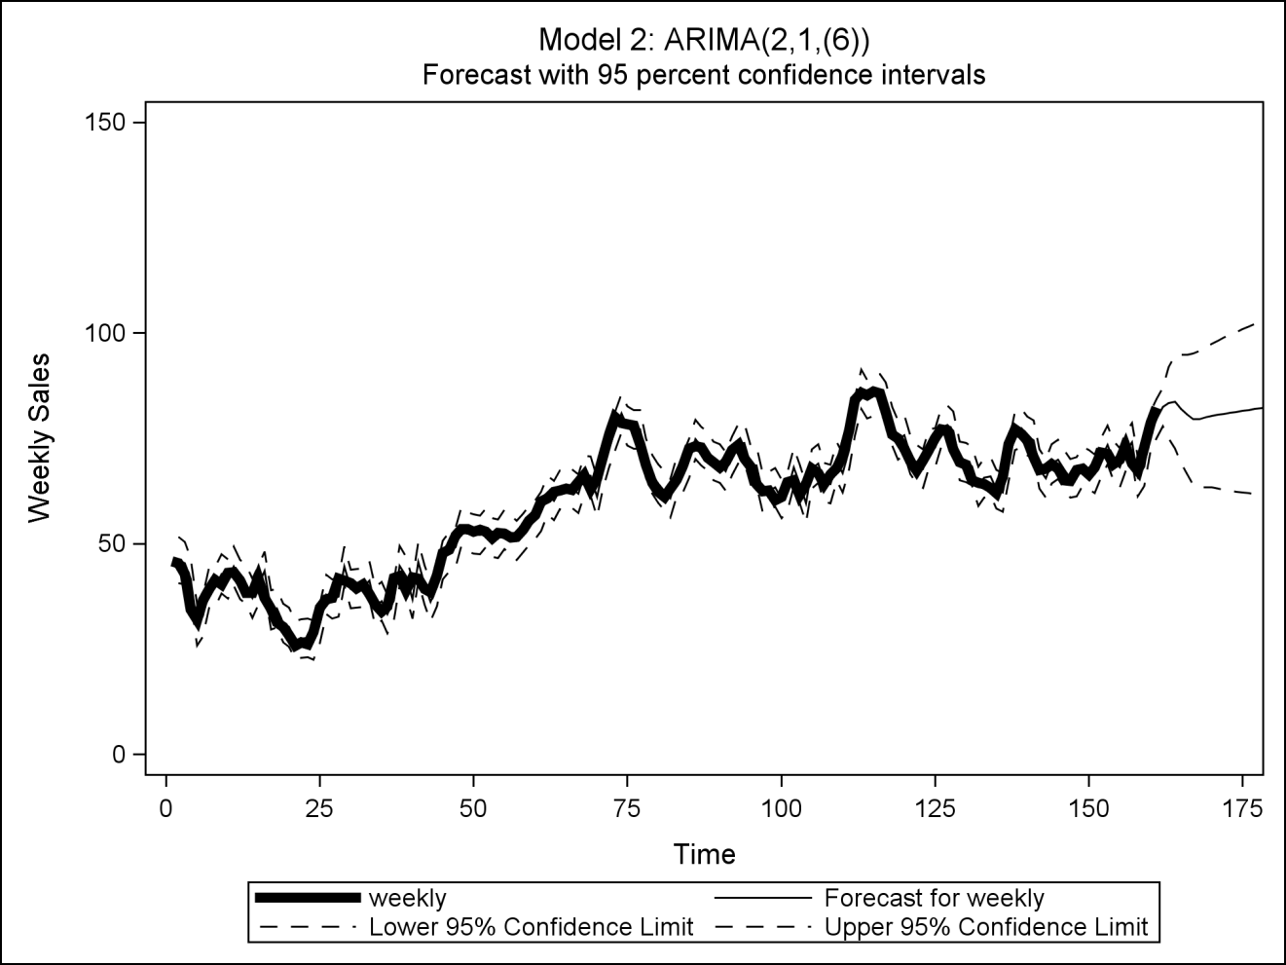

**proc print data=f2;**

**where time>159;**

**var time weekly forecast l95 u95 std residual;**

**title1 'Model 2: Forecasts from ARIMA(2,1,(6))';**

**run;**

|  |  |  |  |  |  |  |  |  |  |  |  |  |  |  |  |  |  |  |  |  |  |  |  |  |  |  |  |  |  |  |  |  |  |  |  |  |  |  |  |  |  |  |  |  |  |  |  |  |  |  |  |  |  |  |  |  |  |  |  |  |  |  |  |  |  |  |  |  |  |  |  |  |  |  |  |  |  |  |  |  |  |  |  |  |  |  |  |  |  |  |  |  |  |  |  |  |  |  |  |  |  |  |  |  |  |  |  |  |  |  |  |  |  |  |  |  |  |  |  |  |  |  |  |  |  |  |  |  |  |  |  |  |  |  |  |  |  |  |  |  |  |  |  |  |  |
| --- | --- | --- | --- | --- | --- | --- | --- | --- | --- | --- | --- | --- | --- | --- | --- | --- | --- | --- | --- | --- | --- | --- | --- | --- | --- | --- | --- | --- | --- | --- | --- | --- | --- | --- | --- | --- | --- | --- | --- | --- | --- | --- | --- | --- | --- | --- | --- | --- | --- | --- | --- | --- | --- | --- | --- | --- | --- | --- | --- | --- | --- | --- | --- | --- | --- | --- | --- | --- | --- | --- | --- | --- | --- | --- | --- | --- | --- | --- | --- | --- | --- | --- | --- | --- | --- | --- | --- | --- | --- | --- | --- | --- | --- | --- | --- | --- | --- | --- | --- | --- | --- | --- | --- | --- | --- | --- | --- | --- | --- | --- | --- | --- | --- | --- | --- | --- | --- | --- | --- | --- | --- | --- | --- | --- | --- | --- | --- | --- | --- | --- | --- | --- | --- | --- | --- | --- | --- | --- | --- | --- | --- | --- | --- | --- | --- |
| |  | | --- | | ***Model 2: Forecasts from ARIMA(2,1,(6))*** |  | **Obs** | **time** | **weekly** | **FORECAST** | **L95** | **U95** | **STD** | **RESIDUAL** | | --- | --- | --- | --- | --- | --- | --- | --- | | **160** | 160 | 78.6 | 76.8043 | 72.1891 | 81.420 | 2.3548 | 1.79569 | | **161** | 161 | 82.3 | 79.6317 | 75.0165 | 84.247 | 2.3548 | 2.66829 | | **162** | 162 | . | 82.4544 | 77.8392 | 87.070 | 2.3548 | . | | **163** | 163 | . | 83.4632 | 75.0281 | 91.898 | 4.3037 | . | | **164** | 164 | . | 83.6356 | 72.5860 | 94.685 | **5.6377** | . | | **165** | 165 | . | 82.0292 | 69.1930 | 94.865 | **6.5492** | . | | **166** | 166 | . | 80.6726 | 66.4211 | 94.924 | **7.2713** | . | | **167** | 167 | . | 79.6130 | 64.0830 | 95.143 | **7.9236** | . | | **168** | 168 | . | 79.5775 | 63.3702 | 95.785 | **8.2692** | . | | **169** | 169 | . | 80.0062 | 63.3527 | 96.660 | **8.4968** | . | | **…** |  |  |  |  |  |  |  | | **181** | 181 | . | 82.9144 | 61.1051 | 104.724 | **11.1274** | . | | **182** | 182 | . | 83.1429 | 60.9536 | 105.332 | **11.3213** | . | | **183** | 183 | . | 83.3713 | 60.8085 | 105.934 | **11.5119** | . | | **184** | 184 | . | 83.5997 | 60.6694 | 106.530 | **11.6993** | . | | **185** | 185 | . | 83.8281 | 60.5362 | 107.120 | **11.8839** | . | | **186** | 186 | . | 84.0565 | 60.4085 | 107.705 | **12.0656** | . | |

**/* Forecasts from Model 3: ARIMA(0,1,(1,6)) */**

**data f3; set f3;**

**time = _n_;**

**proc sgplot data=f3;**

**series x=time y=weekly / lineattrs=(pattern=solid thickness=5);**

**series x=time y=forecast / lineattrs=(pattern=solid);**

**series x=time y=l95 / lineattrs=(pattern=dash);**

**series x=time y=u95 / lineattrs=(pattern=dash);**

**xaxis label='Time' values=(0 to 190 by 25);**

**yaxis label='Weekly Sales' values=(0 to 190 by 50);**

**title1 'Model 3: ARIMA(0,1,(1,6))';**

**title2 'Forecast with 95 percent confidence intervals';**

**run;**

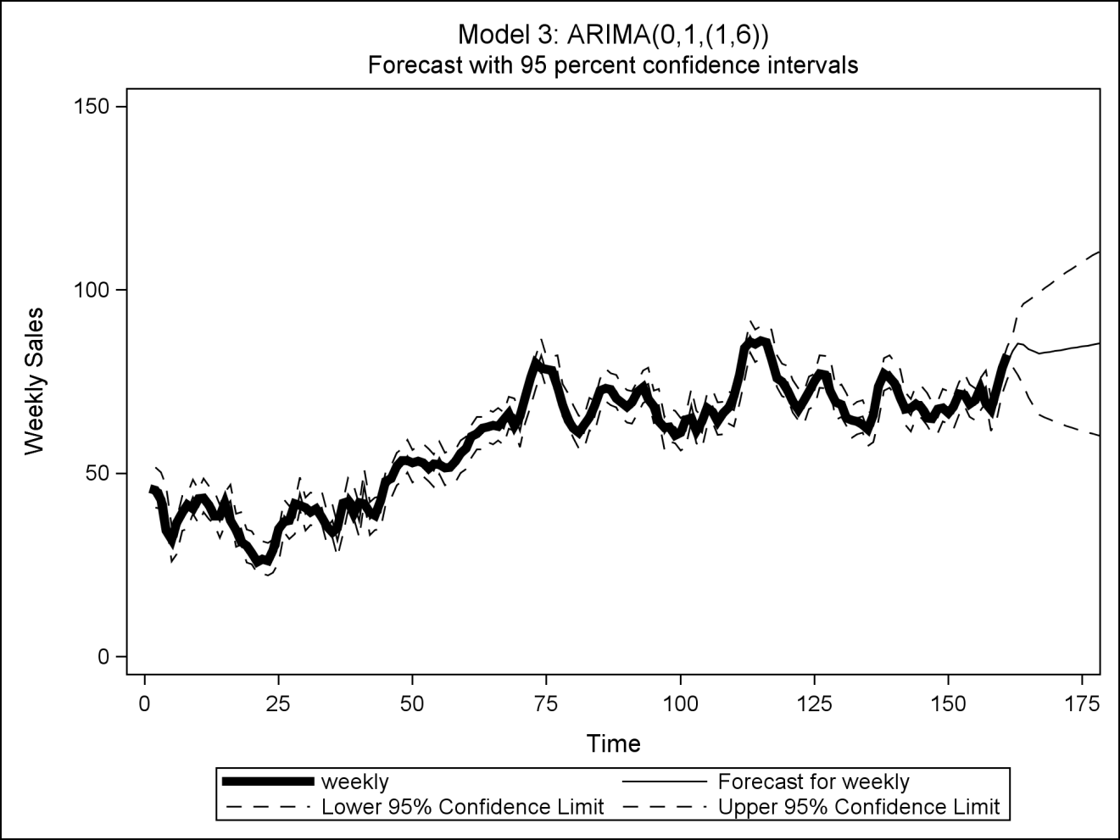

**proc print data=f3;**

**where time>159;**

**var time weekly forecast l95 u95 std residual;**

**title1 'Model 3: Forecasts from ARIMA(0,1,(1,6))';**

**run;**

|  |  |  |  |  |  |  |  |  |  |  |  |  |  |  |  |  |  |  |  |  |  |  |  |  |  |  |  |  |  |  |  |  |  |  |  |  |  |  |  |  |  |  |  |  |  |  |  |  |  |  |  |  |  |  |  |  |  |  |  |  |  |  |  |  |  |  |  |  |  |  |  |  |  |  |  |  |  |  |  |  |  |  |  |  |  |  |  |  |  |  |  |  |  |  |  |  |  |  |  |  |  |  |  |  |  |  |  |  |  |  |  |  |  |  |  |  |  |  |  |  |  |  |  |  |  |  |  |  |  |  |  |  |  |  |  |  |  |  |  |  |  |  |  |  |  |
| --- | --- | --- | --- | --- | --- | --- | --- | --- | --- | --- | --- | --- | --- | --- | --- | --- | --- | --- | --- | --- | --- | --- | --- | --- | --- | --- | --- | --- | --- | --- | --- | --- | --- | --- | --- | --- | --- | --- | --- | --- | --- | --- | --- | --- | --- | --- | --- | --- | --- | --- | --- | --- | --- | --- | --- | --- | --- | --- | --- | --- | --- | --- | --- | --- | --- | --- | --- | --- | --- | --- | --- | --- | --- | --- | --- | --- | --- | --- | --- | --- | --- | --- | --- | --- | --- | --- | --- | --- | --- | --- | --- | --- | --- | --- | --- | --- | --- | --- | --- | --- | --- | --- | --- | --- | --- | --- | --- | --- | --- | --- | --- | --- | --- | --- | --- | --- | --- | --- | --- | --- | --- | --- | --- | --- | --- | --- | --- | --- | --- | --- | --- | --- | --- | --- | --- | --- | --- | --- | --- | --- | --- | --- | --- | --- | --- |
| |  | | --- | | ***Model 3: Forecasts from ARIMA(0,1,(1,6))*** |  | **Obs** | **time** | **weekly** | **FORECAST** | **L95** | **U95** | **STD** | **RESIDUAL** | | --- | --- | --- | --- | --- | --- | --- | --- | | **160** | 160 | 78.6 | 76.0198 | 71.6123 | 80.427 | 2.2488 | 2.58023 | | **161** | 161 | 82.3 | 80.0402 | 75.6328 | 84.448 | 2.2487 | 2.25981 | | **162** | 162 | . | 83.4161 | 79.0221 | 87.810 | **2.2419** | . | | **163** | 163 | . | 85.3235 | 76.8899 | 93.757 | **4.3029** | . | | **164** | 164 | . | 85.0879 | 74.0000 | 96.176 | 5.6572 | . | | **165** | 165 | . | 83.8918 | 70.6721 | 97.112 | 6.7449 | . | | **166** | 166 | . | 83.2053 | 68.1528 | 98.258 | 7.6800 | . | | **167** | 167 | . | 82.6389 | 65.9537 | 99.324 | 8.5130 | . | | **168** | 168 | . | 82.8851 | 65.2824 | 100.488 | 8.9811 | . | | **169** | 169 | . | 83.1313 | 64.6566 | 101.606 | 9.4260 | . | | **…** |  |  |  |  |  |  |  | | **181** | 181 | . | 86.0855 | 59.2746 | 112.896 | 13.6793 | . | | **182** | 182 | . | 86.3317 | 58.9403 | 113.723 | 13.9754 | . | | **183** | 183 | . | 86.5779 | 58.6182 | 114.538 | 14.2654 | . | | **184** | 184 | . | 86.8241 | 58.3073 | 115.341 | 14.5496 | . | | **185** | 185 | . | 87.0702 | 58.0071 | 116.133 | 14.8284 | . | | **186** | 186 | . | 87.3164 | 57.7170 | 116.916 | 15.1020 | . | |

**Rough script:**

**0. Introduce data and express desire to forecast 25 weeks.**

**1. See need for stationarity based on time plot and**

**SAC (p. 2).**

**Try linear trend, see remaining ~2 year cycle (p. 3).**

**Try linear + trigonometric trends (p. 4).**

**-- But still see problems with 1st-order stationarity.**

**2. See stubbornness of time trends (p. 4), and need for**

**differencing; first diff. appears sufficient (pp. 5-6).**

**3. See need for dependence structure after white noise**

**check in first difference (p. 7).**

**4. Model 1: ARIMA(2,1,0), based on mixture of damped**

**exp. decay and sine waves in SAC, and SPAC cuts off**

**after lag 2 -- note may have additional spikes at lags 5**

**and 6 (pp. 8-9).**

**Goodness of fit checks: parameters significant, but**

**model is inadequate (p. 8).**

**5. Model 2: ARIMA(2,1,(6)), based on spike in RSAC of**

**Model 1 (pp. 10-11).**

**Goodness of fit checks: no evidence of model**

**inadequacy (pp. 8-9) (? -- note Ljung-Box p-value).**

**6. Model 3: ARIMA(0,1,(1,6)), based on alternative reading**

**of SAC and SPAC of first difference -- on page 7, SAC**

**spikes at lags 1 and 6, SPAC dies down in oscillating**

**fashion. (pp. 12-13).**

**Goodness of fit checks: no evidence of model inadequacy**

**(pp. 12-13).**

**7. Compare forecasts from two 'adequate' models (pp 14-17):**

**Model 3 better only for short-term (2 week) forecasts,**

**based on tighter confidence intervals (smaller STD for**

**forecasts only for weeks 162-163).**

**Model 2 has tighter confidence intervals (smaller STD)**

**for longer-term forecasts (weeks 164-186).**

**Model summaries:**

**Model 1: S=2.48, Q=23.06 (P=.0001),**

**RSAC & RSPAC have spike at lag 6**

**Model 2: S=2.35, Q=7.13 (P=.07),**

**RSAC & RSPAC have 'nothing'**

**Model 3: S=2.24, Q=1.76 (P=.78),**

**RSAC & RSPAC have 'less nothing'**

**Conclude: Model 1 inadequate,**

**Model 2 best for longer-term forecasts,**

**Model 3 best for short-term forecasts**