上 海 电 力 大 学

面向对象程序设计(JAVA)-实验报告
（2025/2026学年第2学期）

课程编号 2505190
课程名称 面向对象程序设计(JAVA)
院 （系） 人工智能学部
专 业 计算机科学与技术
班 级 2025051
学 号 20251916
姓 名 张鸿毅
实验名称 综合实验1 类和对象练习I
任课老师 张挺

综合实验1 类和对象练习I
1【实验目的】
掌握JAVA的类与对象。
2【实验内容】
注意：下面每个实验题除了写出要求的类之外，均应该写一个含有main函数的主类进行功能测试。
1. 编写房屋类及家具类，要求：
1）房子有户型，总面积和家具名称列表，新房子没有任何的家具。
2）家具有名字和占地面积，家具可以增加不同种类和型号，其中初始值：
床：占4平米,衣柜：占2平米,餐桌：占1.5平米
3）打印房子时，要求输出:户型，总面积，剩余面积，家具名称列表。
2. 编写士兵类及枪类，要求：
1）初始士兵叫Ryan，默认有一把AK47;
2）士兵可以开火(士兵开火扣动的是扳机);
3）枪能够发射子弹(作为参数),有子弹才能射击(要进行是否有子弹的判断);
4）枪能够装填子弹，增加子弹的数量.
3. 编写程序, 编写一个学生类,教师类和一个图书类，要求：
(1)图书类包含图书名、出版社、作者、价格等信息，教师和学生可以获得上述信息。
(2)学生具有学号、班级、姓名、性别等信息，教师可以获得上述信息。
(3)教师具有所代课程名、班级、姓名、性别等信息，学生可以获得上述信息。
4. 设计一个图书管理系统类和用户类，要求具有以下功能：
(1). 查询和修改图书信息。
(2). 增加和删除图书信息。
(3). 个人借阅信息查询。
(4). 图书归还功能
(5). 用户管理功能和退出程序功能(注：用户信息可以保存在内存即可)
5．输入某年某月某日，判断这一天是这一年的第几天。(通过设计Date类实现)
3【实验步骤和结果】(含源码和界面截图)
1.
import java.util.ArrayList;

class House
{
public String type;
public double size;
public double remainingSize;
public ArrayList<String> furniture;

public House(String type, double size)
{
this.type = type;
this.size = size;
this.remainingSize = size;
this.furniture = new ArrayList<>();
}

public void printInfo()
{
System.out.println("户型：" + type);
System.out.println("总面积：" + size + " 平方米");
System.out.println("剩余面积：" + remainingSize + " 平方米");
System.out.println("家具名称列表：" + furniture);
}

public void addFurniture(Furniture item)
{
this.furniture.add(item.name);
this.remainingSize -= item.area;
}
}

class Furniture
{
public String name;
public double area;

public Furniture(String name, double area)
{
this.name = name;
this.area = area;
}
}

public class HouseInfo
{
public static void main(String[] args)
{
House house1 = new House("三室一厅", 101);
house1.printInfo();

Furniture fur1 = new Furniture("床", 4);
Furniture fur2 = new Furniture("衣柜", 2);
Furniture fur3 = new Furniture("餐桌", 1.5);

house1.addFurniture(fur1);
house1.addFurniture(fur2);
house1.addFurniture(fur3);

System.out.println("\n添加家具后：\n");
house1.printInfo();
}
}
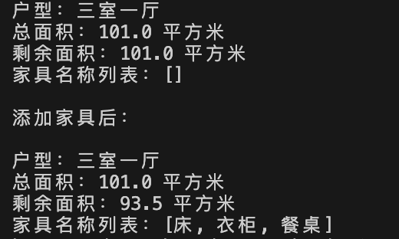

2.
class Soldier
{
public String name;
public Gun gun;

public Soldier(String name, Gun gun)
{
this.name = name;
this.gun = gun;
}
}

class Gun
{
public String name;
public int bullet;
public int remainingBullet;

public Gun(String name, int bullet)
{
this.name = name;
this.bullet = bullet;
this.remainingBullet = bullet;
}

public void fire()
{
if (bullet > 0)
{
System.out.println("Fire!");
remainingBullet -= 1;
System.out.println("剩余子弹：" + remainingBullet);
}
}

public void reload()
{
System.out.println("装填弹药...");
remainingBullet = bullet;
}
}

public class Fire
{
public static void main(String[] args)
{
Gun ak47 = new Gun("AK47", 30);
Soldier ryan = new Soldier("Ryan", ak47);

ryan.gun.fire();
ryan.gun.fire();
ryan.gun.fire();
ryan.gun.reload();
ryan.gun.fire();
}
}
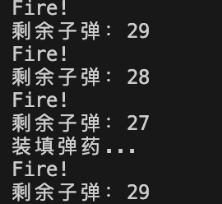

3.
class Book
{
private String bookName;
private String pressName;
private String author;
private double price;

public Book(String bookName, String pressName, String author, double price)
{
this.bookName = bookName;
this.pressName = pressName;
this.author = author;
this.price = price;
}

public void showInfo()
{
System.out.println("书名：" + bookName);
System.out.println("出版社：" + pressName);
System.out.println("作者：" + author);
System.out.println("价格：" + price);
}
}

class Teacher
{
private String subject;
private String classString;
private String name;
private String gender;

public Teacher(String subject, String classString, String name, String gender)
{
this.subject = subject;
this.classString = classString;
this.name = name;
this.gender = gender;
}

public void showInfo()
{
System.out.println("姓名：" + name);
System.out.println("性别：" + gender);
System.out.println("班级：" + classString);
System.out.println("所代课程名：" + subject);
}

public void searchBook(Book book)
{
book.showInfo();
}

public void searchStudent(Student student)
{
student.showInfo();
}
}

class Student
{
private String number;
private String classString;
private String name;
private String gender;

public Student(String number, String classString, String name, String gender)
{
this.number= number;
this.classString = classString;
this.name = name;
this.gender = gender;
}

public void showInfo()
{
System.out.println("姓名：" + name);
System.out.println("性别：" + gender);
System.out.println("班级：" + classString);
System.out.println("学号：" + number);
}

public void searchBook(Book book)
{
book.showInfo();
}

public void searchTeacher(Teacher teacher)
{
teacher.showInfo();
}
}

public class GetInfo
{
public static void main(String[] args)
{
Book book = new Book("离散数学", "清华大学出版社", "王老师", 49.99);
Teacher teacher = new Teacher("高等数学", "2025051", "王老师", "男");
Student student = new Student("20251916", "2025051", "张同学", "男");
System.out.println("\n测试老师查询书籍和学生");
teacher.searchBook(book);
System.out.println();
teacher.searchStudent(student);
System.out.println("\n测试学生查询书籍和老师");
student.searchBook(book);
System.out.println();
student.searchTeacher(teacher);
}
}
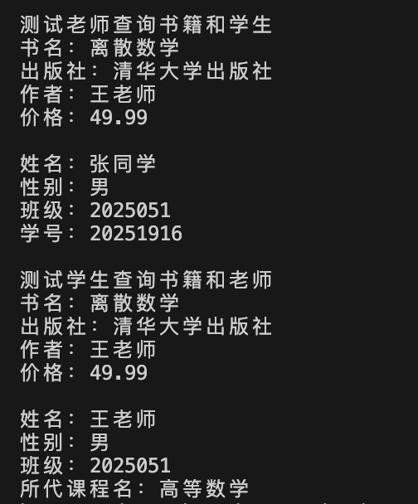

4.
package Library;

public class Book
{
private String bookTitle;
private String author;
private String bookId;
private boolean isBorrowed;

public Book(String bookTitile, String author, String bookId, boolean isBorrowed)
{
this.bookTitle = bookTitile;
this.author = author;
this.bookId = bookId;
this.isBorrowed = false;
}

public String getBookTitle()
{
return bookTitle;
}

public void setBookTitle(String bookTitle)
{
this.bookTitle = bookTitle;
}

public String getAuthor()
{
return author;
}

public void setAuthor(String author)
{
this.author = author;
}

public String getBookId()
{
return bookId;
}

public void setBookId(String bookId)
{
this.bookId = bookId;
}

public boolean getIsBorrowed()
{
return isBorrowed;
}

public void setIsBorrowed(boolean isBorrowed)
{
this.isBorrowed = isBorrowed;
}

public void showInfo()
{
String status = isBorrowed ? "已借出" : "在馆";
System.out.println("编号: " + bookId + " | 书名: 《" + bookTitle + "》 | 作者: " + author + " | 状态: " + status);
}
}

package Library;

import java.util.ArrayList;

public class User
{
private String userId;
private String name;
private ArrayList<Book> borrowedBooks;

public User(String userId, String name, ArrayList<Book> borrowedBooks)
{
this.userId = userId;
this.name = name;
this.borrowedBooks = borrowedBooks;
}

public String getUserId()
{
return userId;
}

public String name()
{
return name;
}

public ArrayList<Book> getBorrowedBooks()
{
return borrowedBooks;
}

public void showBorrowedBooks()
{
System.out.println(name + " 的借阅清单: ");
for (Book book: borrowedBooks)
{
book.showInfo();
}
}
}

package Library;

import java.util.ArrayList;

public class LibrarySystem
{
public void returnBook(User user, Book book)
{
if (user.getBorrowedBooks().contains(book))
{
user.getBorrowedBooks().remove(book);
book.setIsBorrowed(false);
System.out.println("成功归还图书");
}
else
{
System.out.println("该书未被借阅");
}
}

private ArrayList<User> userList = new ArrayList<>();

public void registerUser(String userId, String name, ArrayList<Book> borrowedBooks)
{
User newUser = new User(userId, name, borrowedBooks);
userList.add(newUser);
System.out.println("注册成功！");
}
}

package Library;

import java.util.ArrayList;

public class LibraryTest
{
public static void main(String[] args)
{
LibrarySystem library = new LibrarySystem();
Book book1 = new Book("高等数学", "王老师", "001", true);
Book book2 = new Book("大学英语", "张老师", "002", true);

System.out.println("测试图书信息查询：");
book1.showInfo();

System.out.println("测试修改图书信息：");
book2.setAuthor("李老师");
book2.showInfo();

System.out.println("测试个人借阅信息查询：");
ArrayList<Book> list = new ArrayList<>();
list.add(book1);
list.add(book2);
User user1 = new User("001", "小张", list);
user1.showBorrowedBooks();

System.out.println("测试归还书籍：");
library.returnBook(user1, book1);
}
}
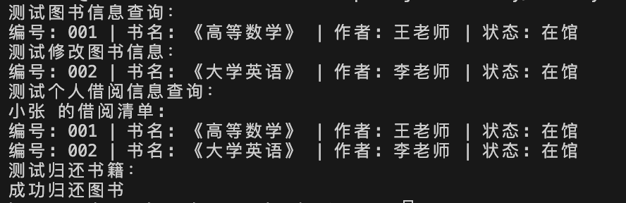

5.
import java.util.Scanner;

class Today
{
private static final int[] MONTH_DAYS = {0, 31, 28, 31, 30, 31, 30, 31, 31, 30, 31, 30, 31};
private int year;
private int month;
private int day;

public Today(int year, int month, int day)
{
this.year = year;
this.month = month;
this.day = day;
}

public int calculateDays()
{
int totalDays = 0;

for (int i = 0; i < month; i ++)
if (i == 2 && ((year % 4 == 0 && year % 100 != 0) || (year % 400 == 0)))
{
totalDays += 29;
}
else
{
totalDays += MONTH_DAYS[i];
}
totalDays += day;
return totalDays;
}

}

public class Data
{
public static void main(String[] agrs)
{
Scanner sc = new Scanner(System.in);
System.out.println("请分别输入年月日");
int year = sc.nextInt();
int month = sc.nextInt();
int day = sc.nextInt();

Today date = new Today(year, month, day);
int result = date.calculateDays();
System.out.printf("这是%d年的第%d天\n", year, result);

sc.close();
}
}
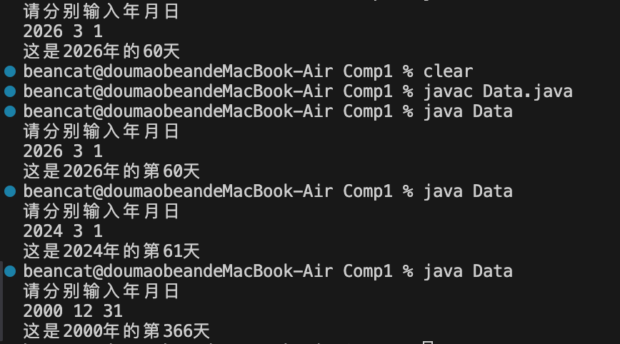

4【实验要求】
将本次实验报告文件命名为“Java综合实验1_学号_姓名”上交。

