上 海 电 力 大 学

面向对象程序设计(JAVA)-实验报告
（2025/2026学年第2学期）

课程编号 2505190
课程名称 面向对象程序设计(JAVA)
院 （系） 人工智能学部
专 业 计算机科学与技术
班 级 2025051
学 号 20251916
姓 名 张鸿毅
实验名称 实验四 异常处理(8)
任课老师 张挺

实验四 异常处理(8)
1【实验目的】
初步掌握JAVA的类与对象。
2【实验内容】
题目1：支付系统（接口 + 抽象类）
要求：
- 定义接口Payable，包含方法：
  - void pay(double amount)
  - String getTransactionInfo()
- 定义抽象类PaymentMethod，包含：
  - protected String ownerName（受保护，持卡人/账户名）
  - protected double balance（受保护，余额）
  - public String currency（公共，货币类型如"CNY"）
  - 构造方法初始化所有属性
  - public abstract boolean validate()（验证支付方式是否有效）
  - public void showBalance()（输出余额）
- 设计CreditCard类继承PaymentMethod并实现Payable：
  - private String cardNumber（私有，卡号后4位显示）
  - private String expiryDate（私有，有效期）
  - 构造方法初始化
  - 实现validate()：如果余额>0且有效期未过期（假设当前日期之后10年内为有效期），返回true
  - 实现pay(double amount)：如果validate()通过且余额≥amount，则扣除金额并输出支付信息；否则输出支付失败
  - 实现getTransactionInfo()：返回卡号后4位和交易金额
  - 提供void deductAnnualFee(double fee)：直接扣除年费（修改余额）
- 设计WeChatPay类继承PaymentMethod并实现Payable：
  - private String openId（私有，用户标识）
  - private double dailyLimit（私有，每日限额）
  - private double todaySpent（私有，今日已消费）
  - 构造方法初始化
  - 实现validate()：如果todaySpent < dailyLimit返回true
  - 实现pay(double amount)：如果validate()且余额≥amount且todaySpent+amount≤dailyLimit，则扣除余额并更新todaySpent；否则输出失败
  - 实现getTransactionInfo()：返回openId和交易金额
  - 提供void resetDailySpent()：将todaySpent重置为0
- 在测试类的main方法中：
  - 创建PaymentMethod数组，存放CreditCard和WeChatPay对象
  - 遍历数组，多态调用validate()、pay(100)、showBalance()、getTransactionInfo()
  - 对CreditCard调用deductAnnualFee(50)，对WeChatPay调用resetDailySpent()，再次调用pay(100)观察变化
示例输出：
--- Credit Card ---
Card validated: true
Paid 100.0 CNY using card ending with 6789
Remaining balance: 400.0 CNY
Transaction: Card ****6789 paid 100.0 CNY

--- WeChat Pay ---
WeChat validated: true
Paid 100.0 CNY via WeChat (OpenID: wx_abc123)
Remaining balance: 200.0 CNY
Transaction: OpenID wx_abc123 paid 100.0 CNY

After annual fee deduction: Balance = 350.0 CNY
After reset daily spent: Paid 100.0 CNY again, Balance = 250.0 CNY
题目2：图形计算器（接口 + 抽象类）
要求：
- 定义接口Measurable，包含方法：
  - double area()
  - double perimeter()
- 定义抽象类Shape，包含：
  - public String color（公共，颜色）
  - protected String unit（受保护，单位）
  - int dimension（友好，维度，如2代表二维）
  - 构造方法初始化所有属性
  - public abstract void scale(double factor)（缩放图形）
  - public void describe()（输出颜色、单位、维度）
- 设计Rectangle类继承Shape并实现Measurable：
  - private double width（私有，宽度）
  - private double height（私有，高度）
  - 构造方法初始化
  - 实现area()：返回width×height
  - 实现perimeter()：返回2×(width+height)
  - 实现scale(double factor)：宽度和高度乘以factor
  - 提供void printDetails()：输出所有属性（包括继承的）
- 设计Circle类继承Shape并实现Measurable：
  - private double radius（私有，半径）
  - 构造方法初始化
  - 实现area()：返回π×r²（π取3.14159）
  - 实现perimeter()：返回2×π×r
  - 实现scale(double factor)：半径乘以factor
  - 提供void printDetails()：输出所有属性
- 在测试类的main方法中：
  - 创建Shape数组，存放Rectangle和Circle对象
  - 遍历数组，多态调用describe()、area()、perimeter()、printDetails()
  - 对每个对象调用scale(2)，再次输出面积和周长
  - 直接修改数组中第一个元素的color（公共）和unit（受保护，同包可访问），再次调用describe()
示例输出：
--- Rectangle ---
Color: Red, Unit: cm, Dimension: 2
Area: 50.0, Perimeter: 30.0
Width: 5.0, Height: 10.0, Color: Red, Unit: cm

After scaling by 2:
Area: 200.0, Perimeter: 60.0

--- Circle ---
Color: Blue, Unit: m, Dimension: 2
Area: 78.53975, Perimeter: 31.4159
Radius: 5.0, Color: Blue, Unit: m

After scaling by 2:
Area: 314.159, Perimeter: 62.8318

After modification: Color: Green, Unit: mm
Color: Green, Unit: mm, Dimension: 2
3【实验步骤和结果】(含源码和界面截图)
1.
public interface Payable
{
void pay(double amount);
String getTransactionInfo();
}

public abstract class PaymentMethod
{
protected String ownerName;
protected double balance;
public String currency;

public PaymentMethod(String ownerName, double balance, String currency)
{
this.ownerName = ownerName;
this.balance = balance;
this.currency = currency;
}

public abstract boolean validate();

public void showBalance()
{
System.out.println("Remaining Balance: " + balance + " " + currency);
}
}

public class CreditCard extends PaymentMethod implements Payable
{
private String cardNumber;
private String expireDate;

public CreditCard(String ownerName, double balance, String currency, String cardNumber, String expireDate)
{
super(ownerName, balance, currency);
this.cardNumber = cardNumber;
this.expireDate = expireDate;
}

@Override
public boolean validate()
{
return balance > 0;
}

@Override
public void pay(double amount)
{
if ((validate() == true) && (balance >= amount))
{
balance -= amount;
System.out.println("Paid " + amount + " " + currency + " using card ending with " + cardNumber.substring(cardNumber.length() - 4));
}
else
{
System.out.println("Failed");
}
}

@Override
public String getTransactionInfo()
{
String lastFour = cardNumber.substring(cardNumber.length() - 4);
return "Card **** " + lastFour + " paid 100.0 " + currency;
}

public void deductAnnualFee(double fee)
{
balance -= fee;
}
}

public class WeChatPay extends PaymentMethod implements Payable
{
private String openId;
private double dailyLimit;
private double todaySpent;

public WeChatPay(String ownerName, double balance, String currency, String openId, double dailyLimit, double todaySpent)
{
super(ownerName, balance, currency);
this.openId = openId;
this.dailyLimit = dailyLimit;
this.todaySpent = todaySpent;
}

@Override
public boolean validate()
{
return todaySpent < dailyLimit;
}

@Override
public void pay(double amount)
{
if ((validate() == true) && (balance >= amount) && ((todaySpent + amount) <= dailyLimit))
{
balance -= amount;
todaySpent += amount;
System.out.println("Paid " + amount + " " + currency + " via WeChat " + "(OpenID: " + openId + ")");
}
else
{
System.out.println("Failed");
}
}

@Override
public String getTransactionInfo()
{
return "Transaction: OpenID " + openId + " paid 100.0 " + currency;
}

public void resetDailySpent()
{
todaySpent = 0;
}
}

public class Main
{
public static void main(String[] args)
{
PaymentMethod[] methods = new PaymentMethod[2];
methods[0] = new CreditCard("User1", 500, "CNY", "123456789", "2040.10.1");
methods[1] = new WeChatPay("user2", 300, "CNY", "wx_abc123", 500, 100);

for (PaymentMethod m: methods)
{
if (m instanceof CreditCard)
{
System.out.println("--- Credit Card ---");
if (m.validate())
{
System.out.println("Card validated: true");
((CreditCard)m).pay(100);
m.showBalance();
System.out.println(((CreditCard)m).getTransactionInfo());
System.out.println();
}
}
else if (m instanceof WeChatPay)
{
System.out.println("--- WeChat Pay ---");
if (m.validate())
{
System.out.println("WeChat validated: true");
((WeChatPay)m).pay(100);
m.showBalance();
System.out.println((((WeChatPay)m).getTransactionInfo()));
System.out.println();
}
}
}

((CreditCard)methods[0]).deductAnnualFee(50);
System.out.println("After annual fee deduction: ");
methods[0].showBalance();

((WeChatPay)methods[1]).resetDailySpent();
((WeChatPay)methods[1]).pay(100);
System.out.println("Paid 100.0 CNY again, balance: " + methods[1].balance);
}
}
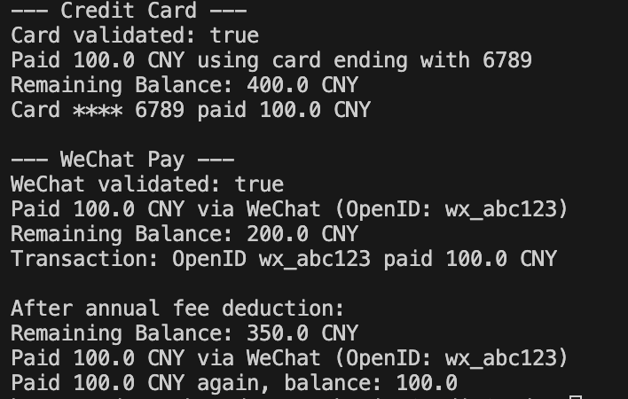

2.
public interface Measurable
{
public double area();
public double perimeter();
}

public abstract class Shape
{
public String color;
protected String unit;
int dimension;

public Shape(String color, String unit, int dimension)
{
this.color = color;
this.unit = unit;
this.dimension = dimension;
}

public abstract void scale(double factor);

public void describe()
{
System.out.println("Color: " + color + " Unit: " + unit + " Dimension: " + dimension);
}
}

public class Rectangle extends Shape implements Measurable
{
private double width;
private double height;

public Rectangle(String color, String unit, int dimension, double width, double height)
{
super(color, unit, dimension);
this.width = width;
this.height = height;
}

@Override
public double area()
{
return width * height;
}

@Override
public double perimeter()
{
return 2 * (width + height);
}

@Override
public void scale(double factor)
{
width *= 2;
height *= 2;
}

public void printDetials()
{
System.out.println("--- Rectangle ---");
describe();
System.out.println("Area: " + area() + " Perimeter: " + perimeter());
System.out.println("Width: " + width + " Height: " + height + " Color: " + color + " Unit: " + unit);
}
}

public class Circle extends Shape implements Measurable
{
private double radius;

public Circle(String color, String unit, int dimension, double radius)
{
super(color, unit, dimension);
this.radius = radius;
}

@Override
public double area()
{
return 3.14159 * radius * radius;
}

@Override
public double perimeter()
{
return 2 * 3.13159 * radius;
}

@Override
public void scale(double factor)
{
radius *= 2;
}

public void printDetails()
{
System.out.println("--- Circle ---");
describe();
System.out.println("Area: " + area() + " Perimeter: " + perimeter());
System.out.println("Radius: " + radius + " Color: " + color + " Unit: " + unit);
}
}

public class Main
{
public static void main(String[] args)
{
Shape[] shapes = new Shape[2];
shapes[0] = new Rectangle("Red", "cm", 2, 5, 10);
shapes[1] = new Circle("Blue", "m", 2, 5);

for (Shape i: shapes)
{
if (i instanceof Rectangle)
{
Rectangle r = (Rectangle) i;
r.printDetials();
System.out.println();
System.out.println("After scaling by 2:");
r.scale(2);
System.out.println("Area: " + r.area() + " Perimeter: " + r.perimeter());
System.out.println();
}
else if (i instanceof Circle)
{
Circle c = (Circle) i;
c.printDetails();
System.out.println();
System.out.println("After scaling by 2:");
i.scale(2);
System.out.println("Area: " + c.area() + " Perimeter: " + c.perimeter());
System.out.println();
}
}

shapes[0].color = "Green";
shapes[0].unit = "mm";
System.out.println("After modification: Color: " + shapes[0].color + " Unit: " + shapes[0].unit);
shapes[0].describe();
}
}
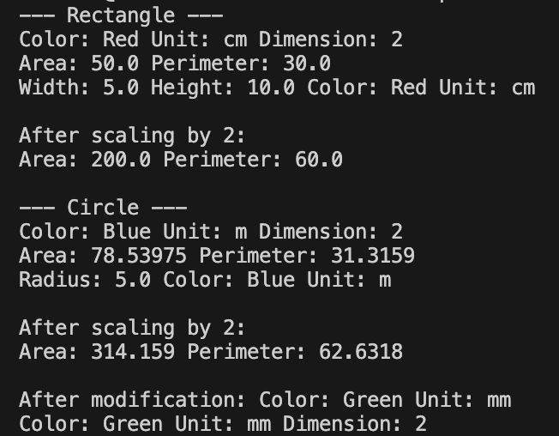
4【实验要求】
将本次实验报告文件命名为“Java实验4(8)_学号_姓名”上交。

