
SPOTLIGHT OS
User Manual
Account access, role-aware navigation, projects, finance, liquidation, and testing

Version 1.0 | September 2026
For internal user training and acceptance testing

START | How to use this manual

What Spotlight OS is
Spotlight OS is a project-first operating system for the full life of an account: opportunity, project creation, cost estimate, approvals, releases, execution, billing, collection, liquidation, and closeout. What a person sees is determined by both role and record scope.

Recommended training order
1. Give each participant an account with the correct department, role, record scope, and reporting line.
2. Explain the navigation and dashboard before asking anyone to enter records.
3. Run one test project from creation through collection and liquidation.
4. Confirm that each role sees the correct records and can perform only its assigned actions.
5. Log issues using the exact page, role, record, action, and expected result.

Core access rule
Term | Meaning
Assigned | The user always sees records they created plus records specifically assigned to them.
Team | A supervisor sees their own and assigned records plus the records of direct and indirect reports.
All | The user sees company-wide records, subject to the pages and actions allowed by the role.
CEO mode | Executive operations, business performance, approvals, projects, finance, and audit views.
Admin mode | Account creation, role and scope assignment, password resets, suspension, and activity logs.
Heads and supervisors automatically receive visibility over the work beneath their reporting line. A subordinate does not automatically see a head-only record.

ACCESS | Sign in and first-time password setup

Sign in
1. Enter the company-issued email address and the temporary password supplied by the CEO in Admin mode.
2. Use the eye icon to show or hide the password while typing.
3. Select Remember me only on a trusted work device.
4. Choose Login. On first access, create a private password that replaces the temporary password.
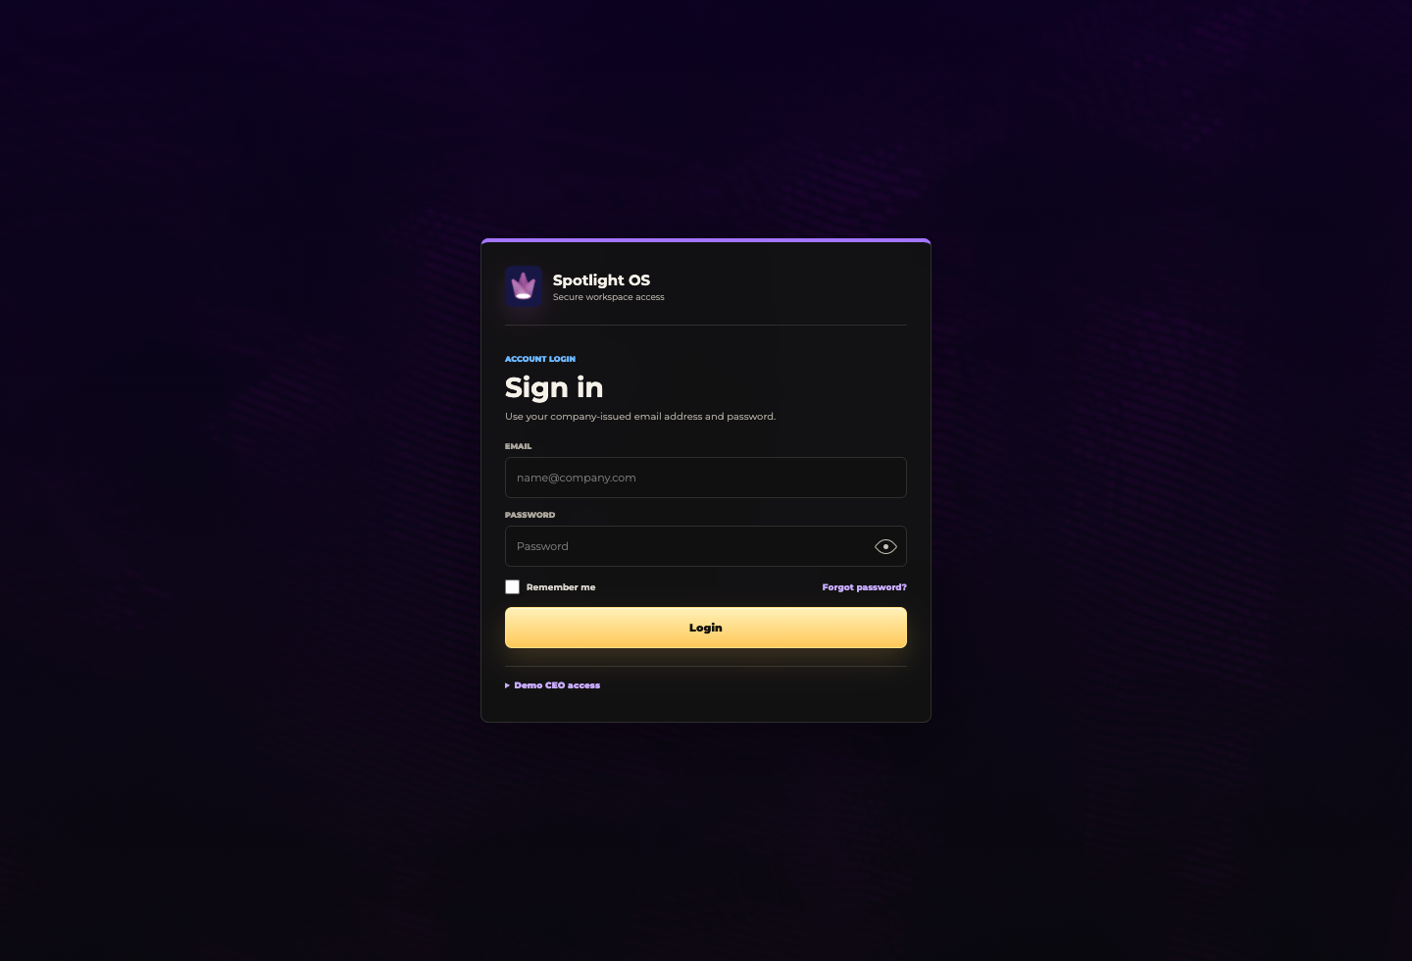
Login screen with password visibility, Remember me, and password-reset request.

Forgot password
Enter the company email first, then select Forgot password. The request becomes visible to the CEO in Admin mode. The CEO resets the account and gives the user a new temporary password.

NAVIGATE | The shared workspace

Navigation pane
- Search is directly below the signed-in account and can locate projects, clients, brands, suppliers, invoices, cost estimates, and employees.
- Projects expands by phase and then by project, allowing a direct jump without returning to the Project Master page.
- The page list changes by role. A missing page usually means the role does not have visibility.
- Rows and line items that support review are clickable; selecting the row performs the same action as View.

CEO and Admin mode
The CEO uses the switch beneath the signed-in identity. CEO mode and Admin mode are intentionally separate so executive decisions are not mixed with account administration.
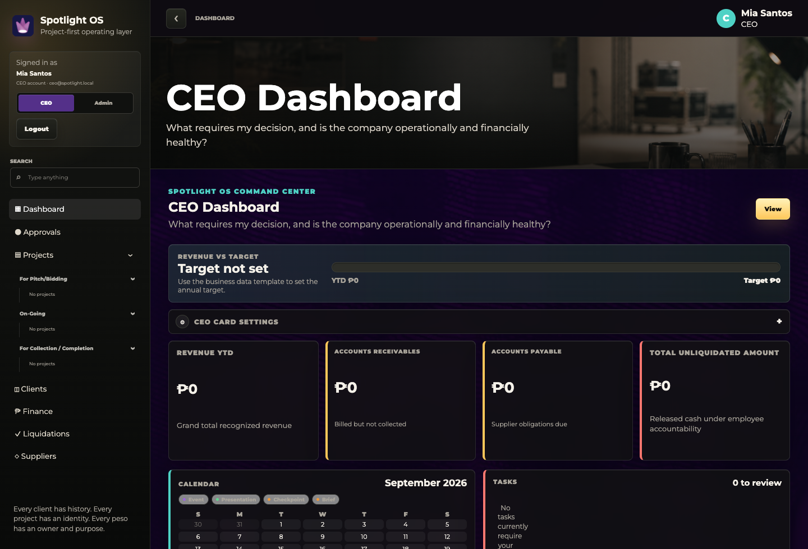
CEO mode: business information and executive work remain separate from system administration.

DASHBOARD | Read the role-aware dashboard

What every dashboard is doing
A dashboard summarizes the records within the signed-in user's scope. It does not expand access. An Assigned user sees assigned work, a Team user sees team work, and an All user sees company-wide information permitted by the role.

Shared dashboard patterns
Term | Meaning
Attention cards | Critical, due soon, at risk, and next event indicators for the user's scope.
Calendar | Brief, checkpoint, presentation, and event dates. When dates overlap, calendar priority is Event, Presentation, Checkpoint/Brief, then Today.
Task bucket | Open work requiring the user to review, approve, submit, follow up, or complete an assigned action.
Row color | Green is on track, yellow is attention, orange is at risk or upcoming, red is critical or overdue, and purple is review or approval.
Question mark | Hover over the question mark beside a financial term to read its definition.
Selecting a dashboard item should open the corresponding project or operational record. Report any item that looks clickable but does not navigate.

PROJECTS | Project Master and project phases

Project Master
Projects are grouped into For Pitch/Bidding, On-Going, and For Collection/Completion. The phase header color is consistent throughout the system: orange, green, and purple.
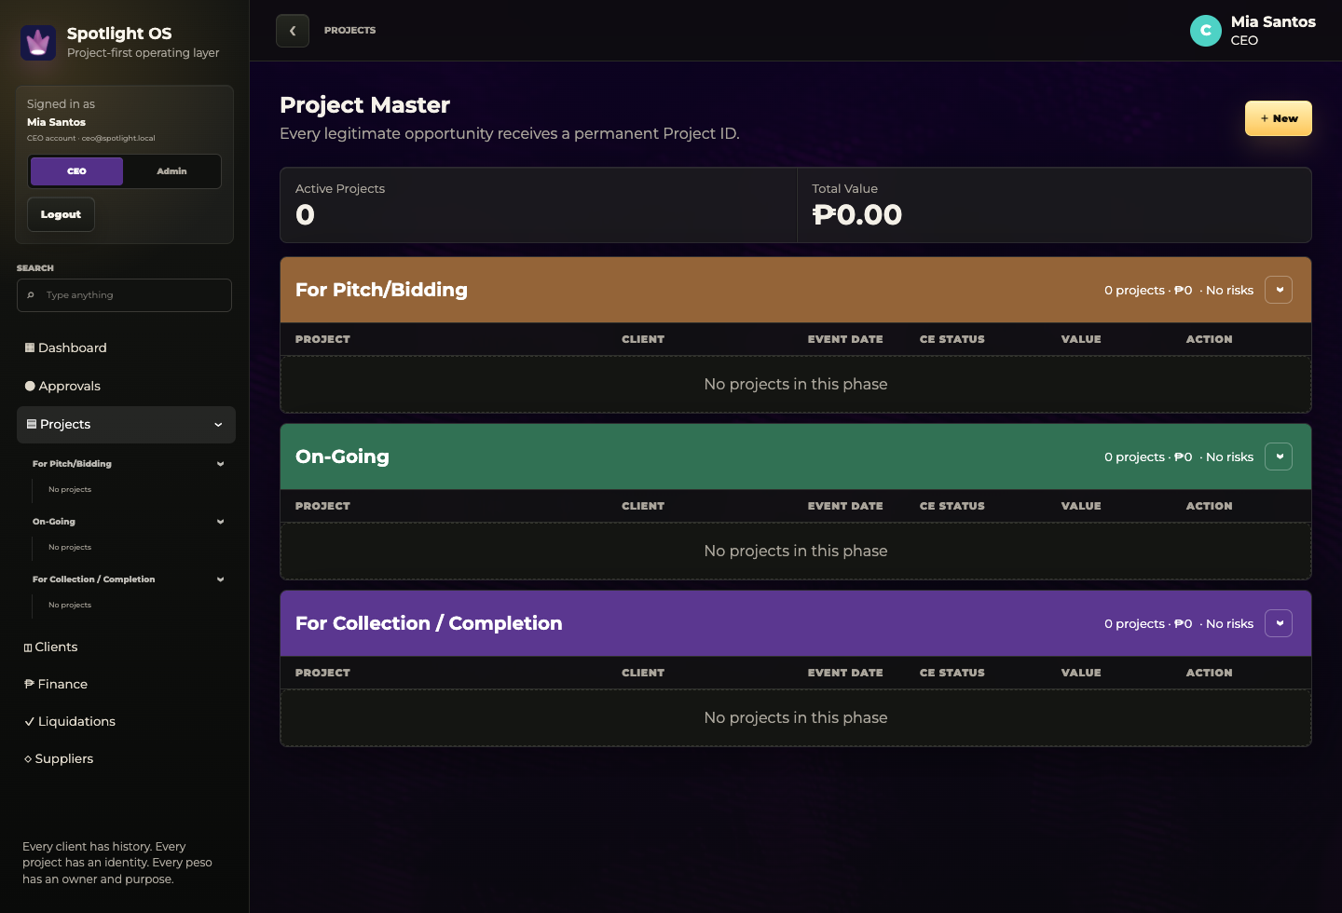
Project Master after the clean reset. New test projects will appear in the correct phase.

Open a project
- Select a project row or View to enter Project 360.
- Use the project tabs for overview, brief, cost estimates, budget requests, fund releases, liquidations, suppliers, billing, and post-audit.
- A project should remain traceable using one permanent Project ID across every tab.

CREATE | Create a project

Required setup
1. Open Projects and select New.
2. Enter Company/Brand Name, Client Name, Designation, venue, event date, event type, and project budget.
3. Assign the account, project, production, and creative owners from the available users.
4. Complete the overview, objectives, one-line project description, implementation checklist, and attached materials.
5. Select Submit, then confirm that the project appears in For Pitch/Bidding and in the navigation accordion.
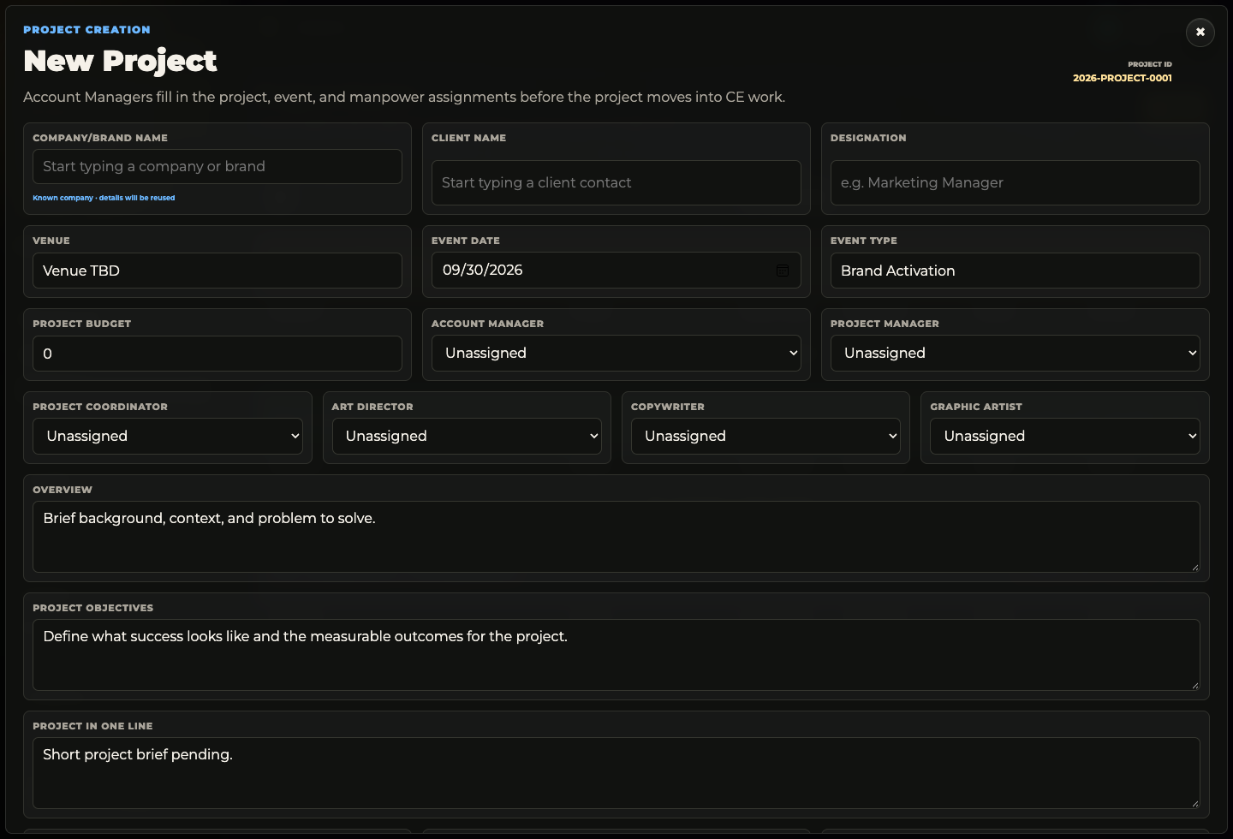
New Project form. Known companies and contacts are reused as the database grows.

Attachments
Brand logo, font guide, color palette, and reference images may be uploaded or pasted from the clipboard. Verify that a preview appears before submitting.

CLIENTS | Client database and annual archive

How the database is built
Client records are generated as projects are created. Company/Brand Name identifies the organization or brand; Client Name identifies the contact person; Designation records the contact's role.
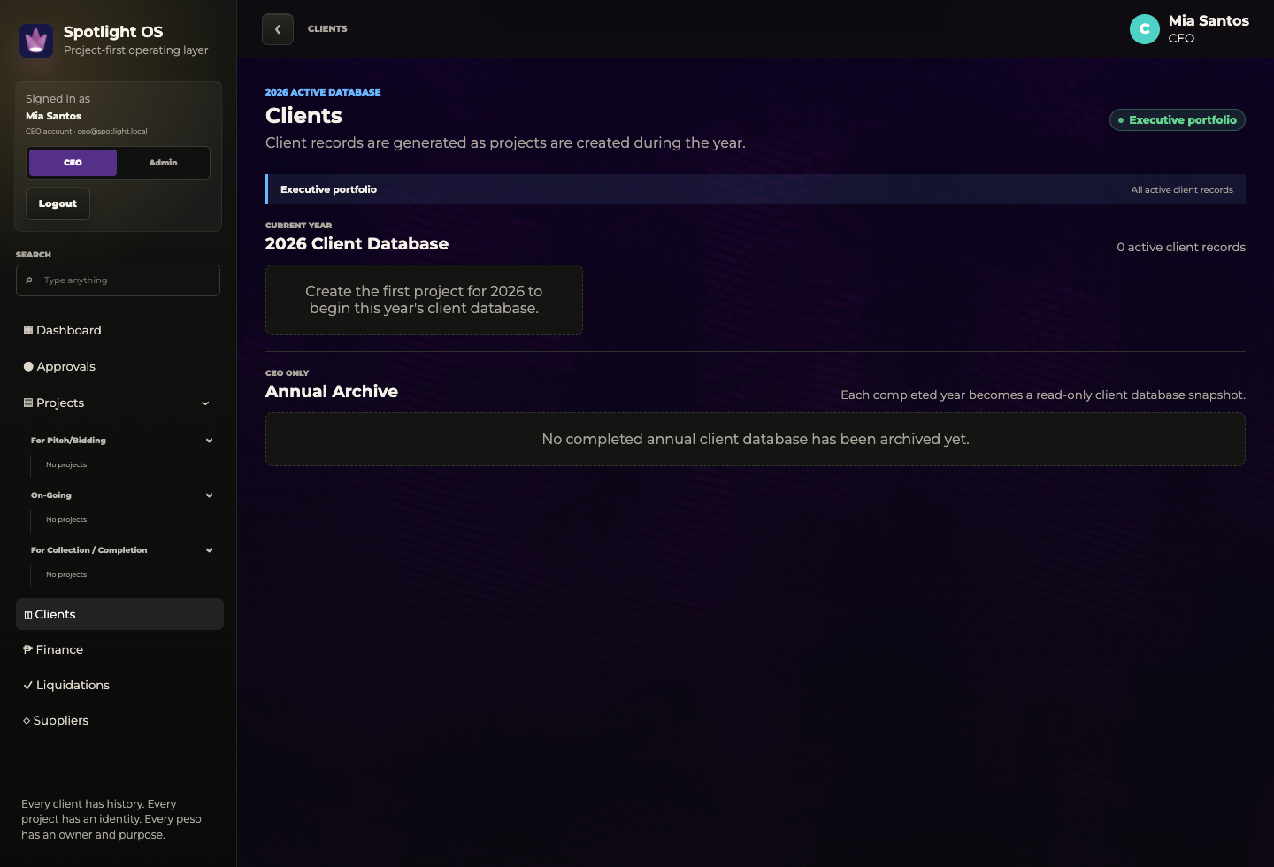
The active-year client database and the CEO-only annual archive.

Year-end behavior
- The current-year database remains active while projects are being created.
- At year-end, the completed client database becomes a read-only annual archive.
- Only the CEO can see archived years; operating users continue with the new active year.

FINANCE | Business financial health

CEO financial view
Finance shows the life of the business: collection, savings, forecasted revenue, receivables, payables, working capital, project economics, and liquidation exposure. Finance visibility remains role controlled.
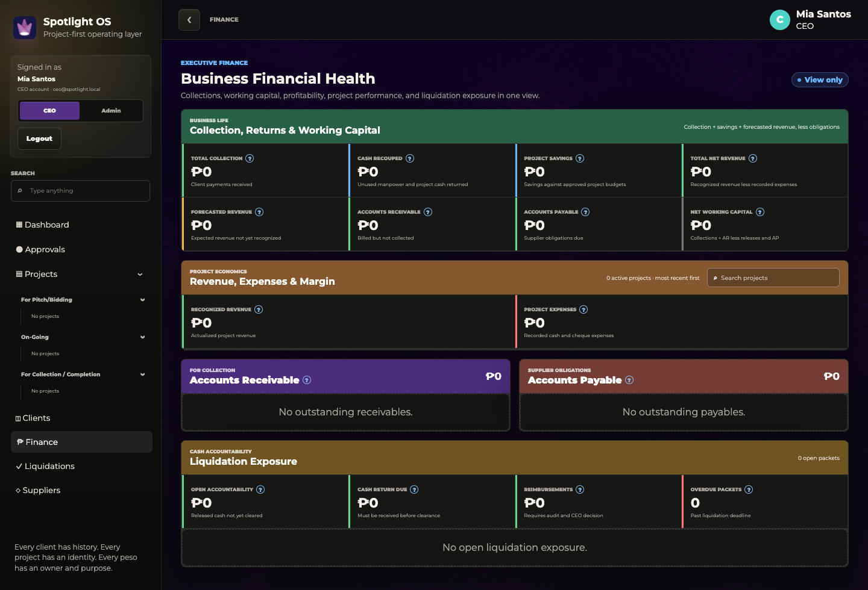
Business Financial Health with zeroed totals ready for the first test dataset.

Key definitions
Term | Meaning
Total Collection | Client payments already received.
Cash Recouped | Unused manpower or project cash returned to the company.
Project Savings | Savings recorded against approved project budgets.
Forecasted Revenue | Expected project revenue that has not yet been recognized.
Accounts Receivable | Billed amounts not yet collected, including aging days.
Accounts Payable | Supplier obligations due, including aging days.
Net Working Capital | Collection and receivables less releases and payables.
LIQUIDATION | Submit, supervise, audit, and clear

What the page controls
Liquidations track released funds that still require receipts, cash returns, reimbursements, audit decisions, or final clearance. Visibility follows reporting relationships: employees see their own and assigned packets; supervisors see their teams; authorized executives and finance roles see wider scopes.
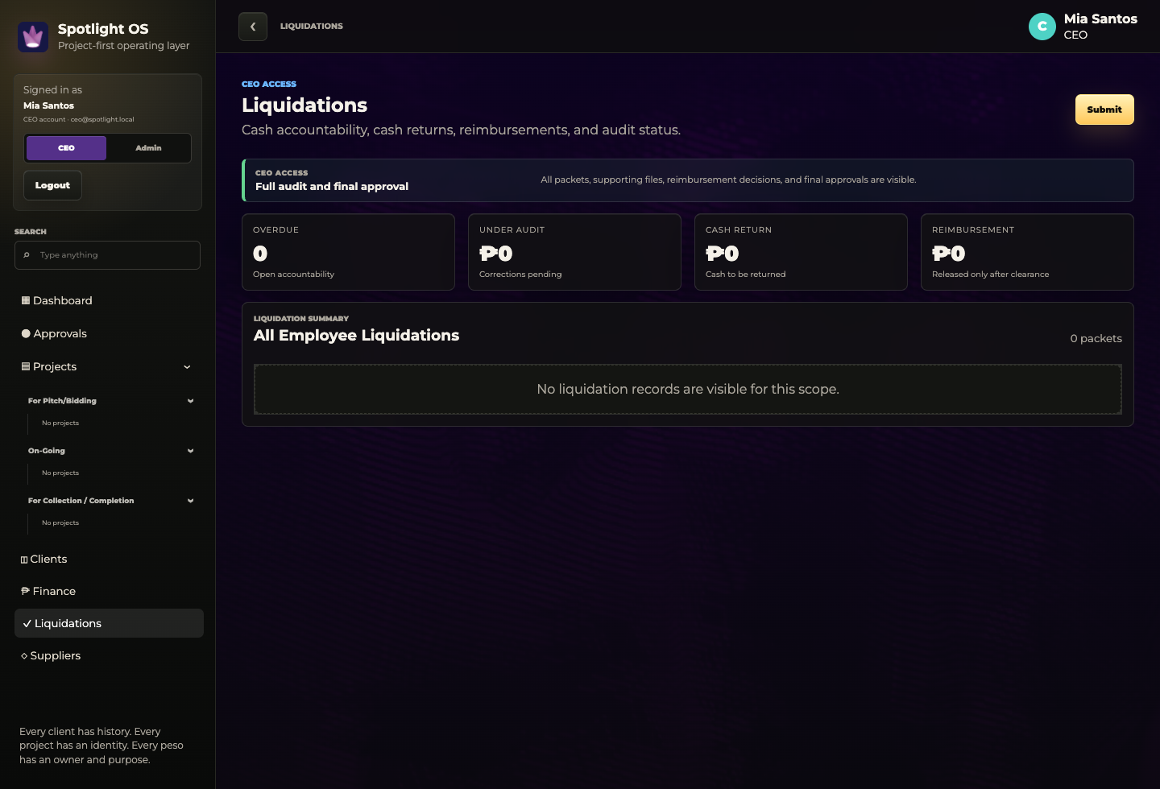
CEO liquidation summary and the current scope banner.

Review behavior
- Open a project accordion to see exposure by person and aging days.
- Selecting a finance liquidation item opens the matching project or line item here.
- Approving a line item should preserve the user's position instead of returning to the top.
- Use Cash Return when unused funds must be returned; use Reimbursement when the employee spent personal funds that require clearance.

ADMIN | Account administration

Switch to Admin mode
Only the CEO account can enter Admin mode. This mode is for governance and account management, not executive operating decisions.
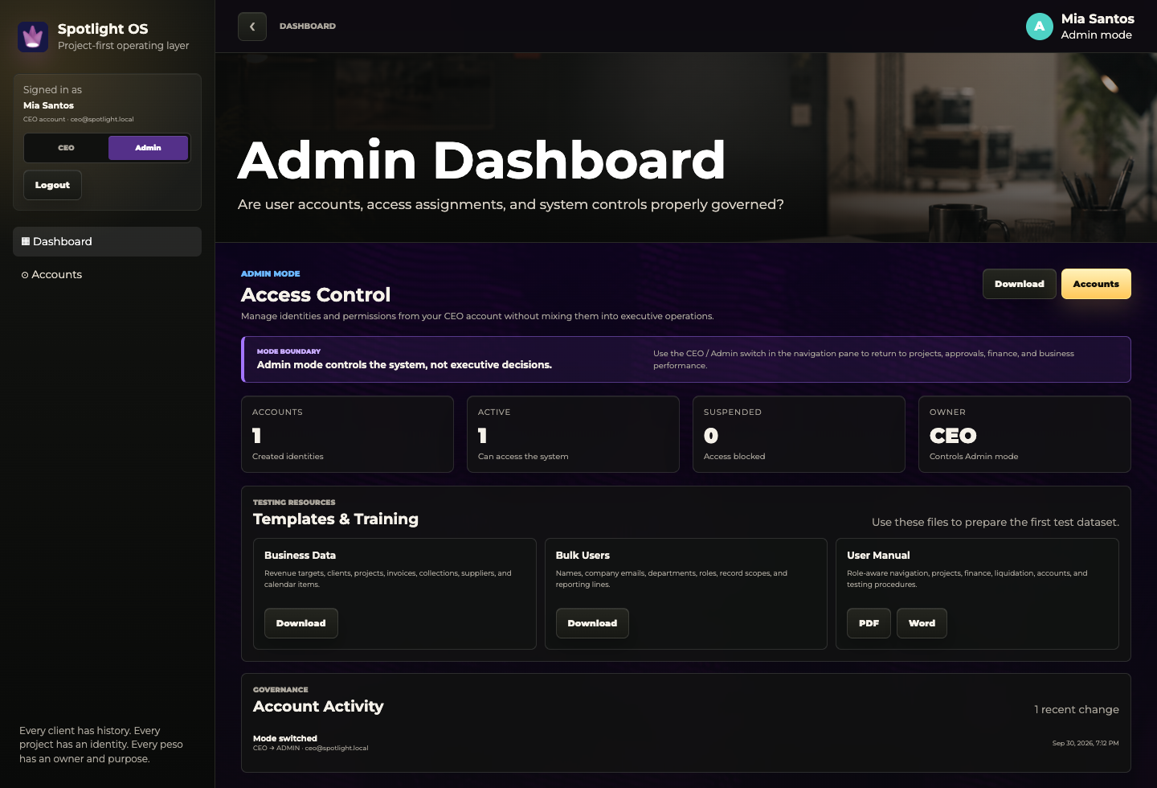
Admin Dashboard with account totals, testing resources, and account activity.

Create and manage accounts
1. Open Accounts.
2. Enter the employee's full name and company email.
3. Choose the role and record scope: Assigned, Team, or All.
4. Select Create. Give the temporary password only to the intended employee.
5. Use Edit, Reset, or account status controls for later maintenance.

ACCOUNTS | Roles, scope, and activity
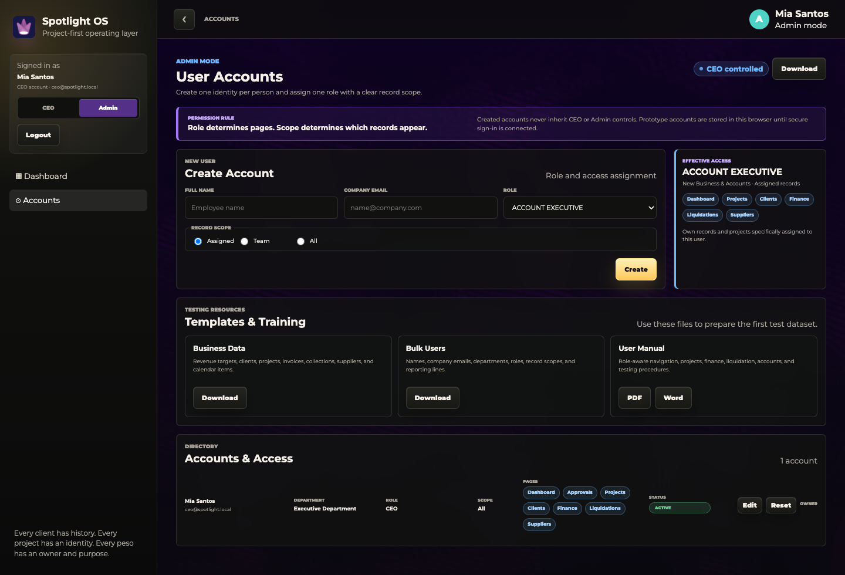
Accounts page showing role-based pages, record scope, status, and owner controls.

Bulk account preparation
Use Spotlight_Bulk_User_Template.xlsx for a larger rollout. Do not enter passwords in the workbook. The system should generate a temporary password when each account is created.

Activity log
- The log records sign-ins, mode switches, password resets, account creation, edits, and suspensions.
- The CEO can download the activity log for review.
- A reset password is temporary and must be replaced by the user at the next login.

TESTING | Load the first test dataset

Files provided
Term | Meaning
Business Data Template | Revenue targets, clients, projects, invoices, collections, suppliers, and calendar items.
Bulk User Template | Names, company emails, departments, roles, record scopes, reporting lines, and account status.

Recommended loading sequence
1. Complete the Users workbook and confirm every company email, role, scope, and reporting line.
2. Create or import the accounts and have test users complete first-time password setup.
3. Complete Revenue Targets and Clients.
4. Add Projects, then Invoices, Suppliers, and Calendar items using matching project codes and emails.
5. Open the CEO dashboard and confirm Revenue vs Target, finance totals, project phases, calendar points, and task buckets.

Data preparation rules
- Do not rename workbook tabs or column headers.
- Purple headers are required; white headers are optional unless your process requires them.
- Use MM/DD/YYYY for dates and numeric values for amounts.
- Keep unavailable optional fields blank instead of entering zero or N/A.
- Use company emails consistently so assignments resolve to the correct people.

UAT | Role-based acceptance test

Test one complete project
Term | Meaning
Access | User can sign in, change the temporary password, and see only allowed pages and records.
Project | Account user creates a project, assigns people, adds brief content, and attaches reference material.
CE | The correct roles upload, review, revise, and approve the cost estimate without duplicate ASF display.
Funding | Budget requests and releases use the correct labels, attachments, and approvals.
Execution | Assigned and team users see the correct calendar dates, tasks, statuses, and project rows.
Billing | Invoice amount, due date, collection, and aging appear in the correct financial views.
Liquidation | Employee submits; supervisor sees team summary; finance audits; CEO sees final exposure and decisions.
Closeout | Project moves to collection/completion and the client/project history remains traceable.

Log an issue with five facts
- Role used
- Page and record
- Action attempted
- What happened
- What should have happened
Include a screenshot when the problem is visual, a value is incorrect, or a button is missing or disabled.

REFERENCE | Quick operating rules

Use this as the training closeout
Term | Meaning
One identity | Each person receives one company account. Do not share credentials.
One project ID | All project activity must remain linked to the permanent Project ID.
One source of truth | Edit records in Spotlight OS rather than maintaining conflicting copies.
Role controls action | Visibility does not automatically mean approval authority.
Scope controls records | Assigned, Team, and All determine which permitted records appear.
Rows open records | Use the full row or View to move from a summary to the working page.
Color indicates urgency | Green on track; yellow attention; orange at risk/upcoming; red critical/overdue; purple review/approval.
Ask before overriding | Use override or exception controls only when the business reason is recorded.

Training completion
A user is ready when they can sign in, explain their scope, locate an assigned project, open a dashboard item, complete one role-specific action, and identify where to request help or password reset.

SPOTLIGHT OS
Every client has history. Every project has an identity. Every peso has an owner and purpose.

